TARING Christopher M. Bishop with Hugh Bishop

TARING Christopher M. Bishop 与 Hugh Bishop



# 深度学习：基础与概念

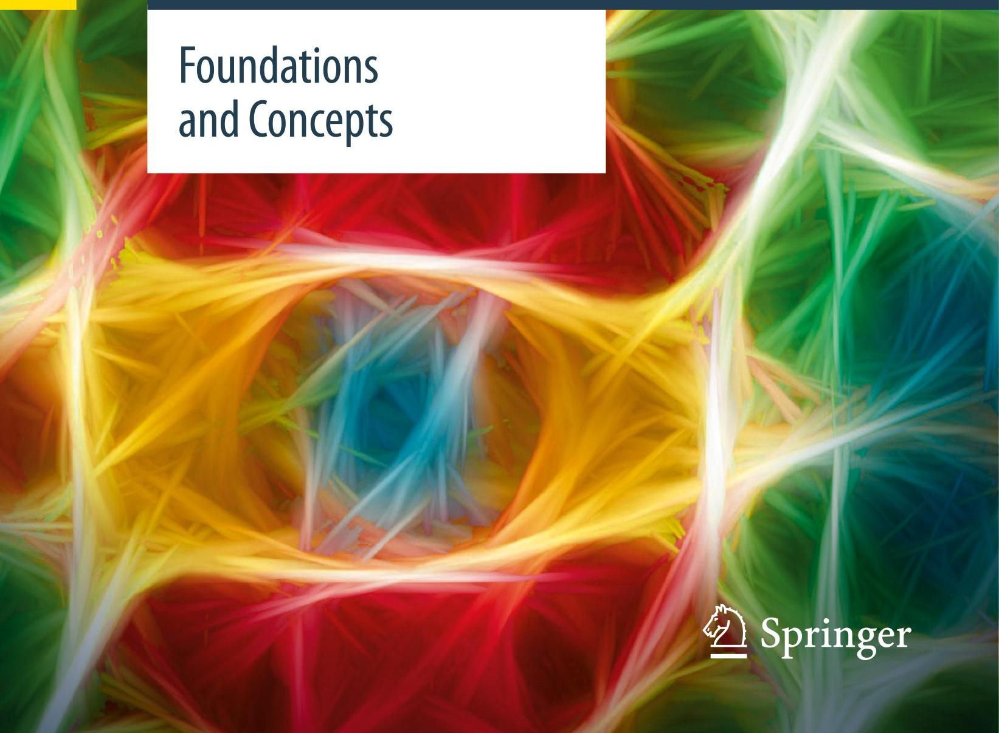

[1]

# Christopher M. Bishop Hugh Bishop 《深度学习:基础与概念》

2 Springer

Christopher M. Bishop

Microsoft Research

Cambridge, UK

Hugh Bishop

Wayve Technologies Ltd

London, UK

ISBN 978-3-031-45467-7 ISBN 978-3-031-45468-4 (eBook)

https://doi.org/10.1007/978-3-031-45468-4

(c) The Editor(s) (if applicable) and The Author(s), under exclusive license to Springer Nature Switzerland AG 2024

(c) 编辑(如适用)和作者，版权独家授予施普林格自然瑞士股份公司 2024 年

This work is subject to copyright. All rights are solely and exclusively licensed by the Publisher, whether the whole or part of the material is concerned, specifically the rights of translation, reprinting, reuse of illustrations, recitation, broadcasting, reproduction on microfilms or in any other physical way, and transmission or information storage and retrieval, electronic adaptation, computer software, or by similar or dissimilar methodology now known or hereafter developed.

本作品受版权保护。所有权利均由出版商独家许可，无论涉及材料的全部还是部分，特别是翻译、再版、插图再利用、朗诵、广播、缩微胶片复制或以任何其他物理方式复制，以及传输或信息存储与检索、电子改编、计算机软件，或通过现在已知或今后开发的类似或不同方法的权利。

The use of general descriptive names, registered names, trademarks, service marks, etc. in this publication does not imply, even in the absence of a specific statement, that such names are exempt from the relevant protective laws and regulations and therefore free for general use.

本出版物中使用通用描述性名称、注册商标、商标、服务标记等，即使没有具体声明，也不意味着这些名称不受相关保护法律法规的约束，因此可以自由通用。

The publisher, the authors, and the editors are safe to assume that the advice and information in this book are believed to be true and accurate at the date of publication. Neither the publisher nor the authors or the editors give a warranty, expressed or implied, with respect to the material contained herein or for any errors or omissions that may have been made. The publisher remains neutral with regard to jurisdictional claims in published maps and institutional affiliations.

出版商、作者和编辑可以放心地认为，本书中的建议和信息在出版日期时被认为是真实和准确的。出版商、作者或编辑均不对本书所含材料或可能出现的任何错误或遗漏作出明示或暗示的保证。出版商在已出版地图的管辖权主张和机构隶属关系方面保持中立。

Cover illustration: maksimee / Alamy Stock Photo

封面插图:maksimee / 阿拉米图片库

This Springer imprint is published by the registered company Springer Nature Switzerland AG

本施普林格品牌由注册公司施普林格自然瑞士股份公司出版

The registered company address is: Gewerbestrasse 11, 6330 Cham, Switzerland

注册公司地址为:Gewerbestrasse 11, 6330 Cham, 瑞士

# Preface

# 前言

Deep learning uses multilayered neural networks trained with large data sets to solve complex information processing tasks and has emerged as the most successful paradigm in the field of machine learning. Over the last decade, deep learning has revolutionized many domains including computer vision, speech recognition, and natural language processing, and it is being used in a growing multitude of applications across healthcare, manufacturing, commerce, finance, scientific discovery, and many other sectors. Recently, massive neural networks, known as large language models and comprising of the order of a trillion learnable parameters, have been found to exhibit the first indications of general artificial intelligence and are now driving one of the biggest disruptions in the history of technology.

深度学习使用通过大型数据集训练的多层神经网络来解决复杂的信息处理任务，已成为机器学习领域最成功的范式。在过去十年中，深度学习彻底改变了许多领域，包括计算机视觉、语音识别和自然语言处理，并且它正被越来越多地应用于医疗保健、制造业、商业、金融、科学发现等众多领域。最近，被称为大语言模型的大规模神经网络，包含数万亿个可学习参数，已被发现展现出通用人工智能的初步迹象，目前正推动着科技史上最大的变革之一。

# Goals of the book

# 本书目标

This expanding impact has been accompanied by an explosion in the number and breadth of research publications in machine learning, and the pace of innovation continues to accelerate. For newcomers to the field, the challenge of getting to grips with the key ideas, let alone catching up to the research frontier, can seem daunting. Against this backdrop, Deep Learning: Foundations and Concepts aims to provide newcomers to machine learning, as well as those already experienced in the field, with a thorough understanding of both the foundational ideas that underpin deep learning as well as the key concepts of modern deep learning architectures and techniques. This material will equip the reader with a strong basis for future specialization. Due to the breadth and pace of change in the field, we have deliberately avoided trying to create a comprehensive survey of the latest research. Instead, much of the value of the book derives from a distillation of key ideas, and although the field itself can be expected to continue its rapid advance, these foundations and concepts are likely to stand the test of time. For example, large language models have been evolving very rapidly at the time of writing, yet the underlying transformer architecture and attention mechanism have remained largely unchanged for the last five years, while many core principles of machine learning have been known for decades.

这种不断扩大的影响伴随着机器学习研究出版物数量和范围的激增，创新步伐也在持续加快。对于该领域的新手来说，掌握关键思想，更不用说赶上研究前沿，似乎是一项艰巨的挑战。在此背景下，《深度学习:基础与概念》旨在让机器学习的新手以及该领域的有经验者全面理解支撑深度学习的基础思想，以及现代深度学习架构和技术的关键概念。这些内容将为读者未来的专业学习奠定坚实的基础。由于该领域变化的广度和速度，我们有意避免对最新研究进行全面综述。相反，本书的大部分价值在于对关键思想的提炼，尽管该领域预计将继续快速发展，但这些基础和概念可能会经受住时间的考验。例如，在撰写本书时，大语言模型发展迅速，但底层的变压器(transformer)架构和注意力机制在过去五年中基本保持不变，而许多机器学习的核心原则已经为人所知数十年。

# Responsible use of technology

# 技术的负责任使用

Deep learning is a powerful technology with broad applicability that has the potential to create huge value for the world and address some of society’s most pressing challenges. However, these same attributes mean that deep learning also has potential both for deliberate misuse and to cause unintended harms. We have chosen not to discuss ethical or societal aspects of the use of deep learning, as these topics are of such importance and complexity that they warrant a more thorough treatment than is possible in a technical textbook such as this. Such considerations should, however, be informed by a solid grounding in the underlying technology and how it works, and so we hope that this book will make a valuable contribution towards these important discussions. The reader is, nevertheless, strongly encouraged to be mindful about the broader implications of their work and to learn about the responsible use of deep learning and artificial intelligence alongside their studies of the technology itself.

深度学习是一项具有广泛适用性的强大技术，它有可能为世界创造巨大价值，并解决一些社会最紧迫的挑战。然而，正是这些特性意味着深度学习也有可能被蓄意滥用，并造成意想不到的危害。我们选择不讨论深度学习应用的伦理或社会层面问题，因为这些主题非常重要且复杂，需要比在这样一本技术教科书中更深入的探讨。不过，这些考量应该建立在对底层技术及其工作原理的扎实理解之上，因此我们希望这本书能为这些重要讨论做出有价值的贡献。尽管如此，我们还是强烈鼓励读者关注其工作的更广泛影响，并在学习技术本身的同时了解深度学习和人工智能的负责任使用。

# Structure of the book

# 本书结构

The book is structured into a relatively large number of smaller bite-sized chapters, each of which explores a specific topic. The book has a linear structure in the sense that each chapter depends only on material covered in earlier chapters. It is well suited to teaching a two-semester undergraduate or postgraduate course on machine learning but is equally relevant to those engaged in active research or in self-study.

本书由数量较多的小章节组成，每一章探讨一个特定主题。本书具有线性结构，即每一章仅依赖于前面章节所涵盖的内容。它非常适合用于教授为期两个学期的本科或研究生机器学习课程，但对于从事积极研究或自学的人同样适用。

A clear understanding of machine learning can be achieved only through the use of some level of mathematics. Specifically, three areas of mathematics lie at the heart of machine learning: probability theory, linear algebra, and multivariate calculus. The book provides a self-contained introduction to the required concepts in probability theory and includes an appendix that summarizes some useful results in linear algebra. It is assumed that the reader already has some familiarity with the basic concepts of multivariate calculus although there are appendices that provide introductions to the calculus of variations and to Lagrange multipliers. The focus of the book, however, is on conveying a clear understanding of ideas, and the emphasis is on techniques that have real-world practical value rather than on abstract theory. Where possible we try to present more complex concepts from multiple complementary perspectives including textual description, diagrams, and mathematical formulae. In addition, many of the key algorithms discussed in the text are summarized in separate boxes. These do not address issues of computational efficiency, but are provided as a complement to the mathematical explanations given in the text. We therefore hope that the material in this book will be accessible to readers from a variety of backgrounds.

只有通过运用一定程度的数学知识，才能清晰理解机器学习。具体而言，机器学习的核心涉及三个数学领域:概率论、线性代数和多元微积分。本书对概率论中所需的概念进行了独立介绍，并包含一个附录总结了线性代数中的一些有用结果。假设读者已经对多元微积分的基本概念有一定了解，不过书中也有附录介绍变分法和拉格朗日乘数法。然而，本书的重点是传达对思想的清晰理解，强调具有现实实用价值的技术，而非抽象理论。在可能的情况下，我们尝试从多个互补的角度呈现更复杂的概念，包括文字描述、图表和数学公式。此外，文中讨论的许多关键算法都在单独的方框中进行了总结。这些总结不涉及计算效率问题，而是作为文中数学解释的补充。因此，我们希望本书的内容能让不同背景的读者都能理解。

Conceptually, this book is perhaps most naturally viewed as a successor to Neural Networks for Pattern Recognition (Bishop, 1995b), which provided the first comprehensive treatment of neural networks from a statistical perspective. It can also be considered as a companion volume to Pattern Recognition and Machine Learning (Bishop, 2006), which covered a broader range of topics in machine learning although it predated the deep learning revolution. However, to ensure that this new book is self-contained, appropriate material has been carried over from Bishop (2006) and refactored to focus on those foundational ideas that are needed for deep learning. This means that there are many interesting topics in machine learning discussed in Bishop (2006) that remain of interest today but which have been omitted from this new book. For example, Bishop (2006) discusses Bayesian methods in some depth, whereas this book is almost entirely non-Bayesian.

从概念上讲，本书或许最自然地被视为《用于模式识别的神经网络》(Bishop，1995b)的后续之作，该书首次从统计角度对神经网络进行了全面探讨。它也可以被视为《模式识别与机器学习》(Bishop，2006)的配套书籍，后者涵盖了机器学习中更广泛的主题，尽管它早于深度学习革命。然而，为确保这本新书内容完整，已从 Bishop(2006)中选取了合适的材料并进行重构，以聚焦于深度学习所需的那些基础思想。这意味着 Bishop(2006)中讨论的许多机器学习有趣主题虽然如今仍然有意义，但已从这本新书中省略。例如，Bishop(2006)深入讨论了贝叶斯方法，而本书几乎完全不涉及贝叶斯方法。

The book is accompanied by a web site that provides supporting material, including a free-to-use digital version of the book as well as solutions to the exercises and downloadable versions of the figures in PDF and JPEG formats:

本书配有一个网站，提供支持材料，包括本书的免费数字版、练习答案以及可下载的 PDF 和 JPEG 格式的图表:

https://www.bishopbook.com

The book can be cited using the following BibTex entry:

可以使用以下 BibTex 条目引用本书:

@book{Bishop:DeepLearning24,

author = {Christopher M. Bishop and Hugh Bishop},

title = {Deep Learning: Foundations and Concepts},

year = {2024},

publisher = {Springer}

}

If you have any feedback on the book or would like to report any errors, please send these to feedback@bishopbook.com

如果您对本书有任何反馈或想报告任何错误，请将这些内容发送至 feedback@bishopbook.com

# References

# 参考文献

In the spirit of focusing on core ideas, we make no attempt to provide a comprehensive literature review, which in any case would be impossible given the scale and pace of change of the field. We do, however, provide references to some of the key research papers as well as review articles and other sources of further reading. In many cases, these also provide important implementation details that we gloss over in the text in order not to distract the reader from the central concepts being discussed.

本着专注于核心思想的精神，我们并未尝试提供全面的文献综述，鉴于该领域的规模和变化速度，无论如何这都是不可能的。然而，我们提供了一些关键研究论文、综述文章和其他进一步阅读资料的参考文献。在许多情况下，这些资料还提供了重要的实现细节，为了不使读者分心于正在讨论的核心概念，我们在正文中对这些细节进行了简略处理。

Many books have been written on the subject of machine learning in general and on deep learning in particular. Those which are closest in level and style to this book include Bishop (2006), Goodfellow, Bengio, and Courville (2016), Murphy (2022), Murphy (2023), and Prince (2023).

关于机器学习这一主题，尤其是深度学习，已经有很多书籍出版。与本书在水平和风格上最为接近的包括 Bishop (2006)、Goodfellow、Bengio 和 Courville (2016)、Murphy (2022)、Murphy (2023) 以及 Prince (2023)。

Over the last decade, the nature of machine learning scholarship has changed significantly, with many papers being posted online on archival sites ahead of, or even instead of, submission to peer-reviewed conferences and journals. The most popular of these sites is arXiv, pronounced ’archive’, and is available at

在过去十年中，机器学习学术研究的性质发生了显著变化，许多论文在提交给同行评审的会议和期刊之前，甚至取代了这种提交方式，直接发布在在线存档网站上。其中最受欢迎的网站是 arXiv，发音为 “archive”，可在

The site allows papers to be updated, often leading to multiple versions associated with different calendar years, which can result in some ambiguity as to which version should be cited and for which year. It also provides free access to a PDF of each paper. We have therefore adopted a simple approach of referencing the paper according to the year of first upload, although we recommend reading the most recent version. Papers on arXiv are indexed using a notation arXiv:YYMM.XXXXX where YY and MM denote the year and month of first upload, respectively. Subsequent versions are denoted by appending a version number in the form arXiv:YYMM.XXXXVN.

该网站允许论文进行更新，这通常会导致同一篇论文有与不同年份相关的多个版本，这可能会在引用哪一版本以及对应哪一年的问题上产生一些歧义。它还提供每篇论文的 PDF 免费下载。因此，我们采用了一种简单的方法，即根据首次上传年份来引用论文，不过我们建议阅读最新版本。arXiv 上的论文采用符号 arXiv:YYMM.XXXXX 进行索引，其中 YY 和 MM 分别表示首次上传的年份和月份。后续版本通过在后面添加版本号 来表示，形式为 arXiv:YYMM.XXXXVN。

# Exercises

# 练习

Each chapter concludes with a set of exercises designed to reinforce the key ideas explained in the text or to develop and generalize them in significant ways. These exercises form an important part of the text and each is graded according to difficulty ranging from , which denotes a simple exercise taking a few moments to complete, through to , which denotes a significantly more complex exercise. The reader is strongly encouraged to attempt the exercises since active participation with the material greatly increases the effectiveness of learning. Worked solutions to all of the exercises are available as a downloadable PDF file from the book web site.

每章结尾都配有一组练习，旨在强化文中解释的关键概念，或以重要方式对其进行拓展和推广。这些练习是文本的重要组成部分，每个练习都根据难度进行分级，从 (表示只需几分钟就能完成的简单练习)到 (表示复杂得多的练习)。强烈建议读者尝试完成这些练习，因为积极参与学习材料能大大提高学习效果。所有练习的详细解答可从本书的网站以可下载的 PDF 文件形式获取。

# Mathematical notation

# 数学符号

We follow the same notation as Bishop (2006). For an overview of mathematics in the context of machine learning, see Deisenroth, Faisal, and Ong (2020).

我们采用与 Bishop(2006)相同的符号表示法。关于机器学习背景下的数学概述，请参阅 Deisenroth、Faisal 和 Ong(2020)的著作。

Vectors are denoted by lower case bold roman letters such as , whereas matrices are denoted by uppercase bold roman letters, such as M. All vectors are assumed to be column vectors unless otherwise stated. A superscript T denotes the transpose of a matrix or vector, so that will be a row vector. The notation denotes a row vector with elements, and the corresponding column vector is written as . The identity matrix (also known as the unit matrix) is denoted , which will be abbreviated to if there is no ambiguity about its dimensionality. It has elements that equal 1 if and 0 if . The elements of a unit matrix are sometimes denoted by . The notation 1 denotes a column vector in which all elements have the value 1. denotes the concatenation of vectors and , so that if and then denotes the modulus (the positive part) of a scalar , also known as the absolute value. We use det to denote the determinant of a matrix A.

向量用小写粗体罗马字母表示，如 ，而矩阵用大写粗体罗马字母表示，如 M。除非另有说明，所有向量都假定为列向量。上标 T 表示矩阵或向量的转置，因此 将是一个行向量。符号 表示一个包含 个元素的行向量，对应的列向量写作 。 单位矩阵(也称为幺矩阵)用 表示，如果其维度没有歧义，可缩写为 。其元素 在 时等于 1，在 时等于 0。单位矩阵的元素有时用 表示。符号 1 表示一个所有元素都为 1 的列向量。 表示向量 和 的拼接，因此如果 且 ，则 表示标量 的模(正值部分)，也称为绝对值。我们用 det 表示矩阵 A 的行列式。

The notation signifies that is sampled from the distribution . Where there is ambiguity, we will use subscripts as in to denote which density is referred to. The expectation of a function with respect to a random variable is denoted by . In situations where there is no ambiguity as to which variable is being averaged over, this will be simplified by omitting the suffix, for instance . If the distribution of is conditioned on another variable , then the corresponding conditional expectation will be written . Similarly, the variance of is denoted , and for vector variables, the covariance is written . We will also use as a shorthand notation for .

符号 表示 是从分布 中抽样得到的。当存在歧义时，我们将使用下标，如 来表示所指的是哪个密度。函数 关于随机变量 的期望用 表示。在对哪个变量进行平均没有歧义的情况下，这将通过省略后缀来简化，例如 。如果 的分布以另一个变量 为条件，那么相应的条件期望将写成 。类似地， 的方差用 表示，对于向量变量，协方差写成 。我们还将使用 作为 的简写符号。

The symbol means ’for all’, so that denotes all values of within the set . We use to denote the real numbers. On a graph, the set of neighbours of node is denoted , which should not be confused with the Gaussian or normal distribution . A functional is denoted where is some function. The concept of a functional is discussed in Appendix B. Curly braces {} denote a set. The notation denotes that is bounded as . For instance, if , then . The notation denotes the ’floor’ of , i.e., the largest integer that is less than or equal to .

符号 表示 “对于所有”，因此 表示集合 内 的所有值。我们使用 来表示实数。在图中，节点 的邻居集合用 表示，不应将其与高斯分布或正态分布 混淆。泛函用 表示，其中 是某个函数。泛函的概念在附录 B 中讨论。花括号 {} 表示一个集合。符号 表示当 时 是有界的。例如，如果 ，那么 。符号 表示 的 “向下取整”，即小于或等于 的最大整数。

If we have independent and identically distributed (i.i.d.) values of a -dimensional vector , we can combine the observations into a data matrix of dimension in which the th row of corresponds to the row vector . Thus, the element of corresponds to the th element of the th observation and is written . For one-dimensional variables, we denote such a matrix by , which is a column vector whose th element is . Note that (which has dimensionality ) uses a different typeface to distinguish it from (which has dimensionality ).

如果我们有 个独立同分布(i.i.d.)的 维向量 的值 ，我们可以将这些观测值组合成一个维度为 的数据矩阵 ，其中 的第 行对应行向量 。因此， 的第 个元素对应第 个观测值 的第 个元素，并记为 。对于一维变量，我们用 表示这样的矩阵，它是一个列向量，其第 个元素是 。请注意， (维度为 )使用了不同的字体以区别于 (维度为 )。

# Acknowledgements

# 致谢

We would like to express our sincere gratitude to the many people who reviewed draft chapters and provided valuable feedback. In particular, we wish to thank Samuel Albanie, Cristian Bodnar, John Bronskill, Wessel Bruinsma, Ignas Budvytis, Chi Chen, Yaoyi Chen, Long Chen, Fergal Cotter, Sam Devlin, Alek-sander Durumeric, Sebastian Ehlert, Katarina Elez, Andrew Foong, Hong Ge, Paul Gladkov, Paula Gori Giorgi, John Gossman, Tengda Han, Juyeon Heo, Katja Hofmann, Chin-Wei Huang, Yongchaio Huang, Giulio Isacchini, Matthew Johnson, Pragya Kale, Atharva Kelkar, Leon Klein, Pushmeet Kohli, Bonnie Kruft, Adrian Li, Haiguang Liu, Ziheng Lu, Giulia Luise, Stratis Markou, Sergio Valcarcel Macua, Krzysztof Maziarz, Matěj Mezera, Laurence Midgley, Usman Munir, Félix Musil, Elise van der Pol, Tao Qin, Isaac Reid, David Rosenberger, Lloyd Russell, Maximilian Schebek, Megan Stanley, Karin Strauss, Clark Templeton, Marlon Tobaben, Aldo Sayeg Pasos-Trejo, Richard Turner, Max Welling, Furu Wei, Robert Weston, Chris Williams, Yingce Xia, Shufang Xie, Iryna Zaporozhets, Claudio Zeni, Xieyuan Zhang, and many other colleagues who contributed through valuable discussions. We would also like to thank our editor Paul Drougas and many others at Springer, as well as the copy editor Jonathan Webley, for their support during the production of the book.

我们要向许多审阅各章草稿并提供宝贵反馈的人表示诚挚的感谢。特别地，我们要感谢 Samuel Albanie、Cristian Bodnar、John Bronskill、Wessel Bruinsma、Ignas Budvytis、Chi Chen、Yaoyi Chen、Long Chen、Fergal Cotter、Sam Devlin、Alek - sander Durumeric、Sebastian Ehlert、Katarina Elez、Andrew Foong、Hong Ge、Paul Gladkov、Paula Gori Giorgi、John Gossman、Tengda Han、Juyeon Heo、Katja Hofmann、Chin - Wei Huang、Yongchaio Huang、Giulio Isacchini、Matthew Johnson、Pragya Kale、Atharva Kelkar、Leon Klein、Pushmeet Kohli、Bonnie Kruft、Adrian Li、Haiguang Liu、Ziheng Lu、Giulia Luise、Stratis Markou、Sergio Valcarcel Macua、Krzysztof Maziarz、Matěj Mezera、Laurence Midgley、Usman Munir、Félix Musil、Elise van der Pol、Tao Qin、Isaac Reid、David Rosenberger、Lloyd Russell、Maximilian Schebek、Megan Stanley、Karin Strauss、Clark Templeton、Marlon Tobaben、Aldo Sayeg Pasos - Trejo、Richard Turner、Max Welling、Furu Wei、Robert Weston、Chris Williams、Yingce Xia、Shufang Xie、Iryna Zaporozhets、Claudio Zeni、Xieyuan Zhang 以及许多通过宝贵讨论做出贡献的其他同事。我们还要感谢我们的编辑 Paul Drougas 和施普林格的许多其他人，以及文字编辑 Jonathan Webley，感谢他们在本书制作过程中的支持。

We would like to say a special thank-you to Markus Svensén, who provided immense help with the figures and typesetting for Bishop (2006) including the LTEX style files, which have also been used for this new book. We are also grateful to the many scientists who allowed us to reproduce diagrams from their published work. Acknowledgements for specific figures appear in the associated figure captions.

我们要特别感谢 Markus Svensén，他为 Bishop(2006 年)的图表和排版提供了巨大帮助，包括 LTEX 样式文件，这些文件也用于了这本新书。我们也感谢许多允许我们复制他们已发表作品中图表的科学家。具体图表的致谢信息出现在相关的图注中。

Chris would like to express sincere gratitude to Microsoft for creating a highly stimulating research environment and for providing the opportunity to write this book. The views and opinions expressed in this book, however, are those of the authors and are therefore not necessarily the same as those of Microsoft or its affiliates. It has been a huge privilege and pleasure to collaborate with my son Hugh in preparing this book, which started as a joint project during the first Covid lockdown. X PREFACE

Chris 要向微软表示诚挚的感谢，感谢微软创造了一个极富启发性的研究环境，并提供了撰写本书的机会。然而，本书中表达的观点和意见仅代表作者本人，因此不一定与微软或其附属机构的观点相同。能与我的儿子 Hugh 合作编写这本书是一项巨大的荣幸和乐事，这本书最初是在第一次新冠疫情封锁期间作为一个联合项目开始的。X 前言

Hugh would like to thank Wayve Technologies Ltd for generously allowing him to work part time so that he could collaborate in writing this book as well as for providing an inspiring and supportive environment for him to work and learn in. The views expressed in this book are not necessarily the same as those of Wayve or its affiliates. He would like to express his gratitude to his fiancée Jemima for her constant support as well as her grammatical and stylistic consultations. He would also like to thank Chris, who has been an excellent colleague and an inspiration to Hugh throughout his life.

Hugh 要感谢 Wayve Technologies Ltd 慷慨地允许他兼职工作，使他能够参与本书的撰写，同时也感谢该公司为他提供了一个鼓舞人心且支持性强的工作和学习环境。本书中表达的观点不一定与 Wayve 或其附属机构的观点相同。他要感谢他的未婚妻 Jemima 一直以来的支持，以及她在语法和文体方面的建议。他还要感谢 Chris，Chris 一直是一位优秀的同事，并且在 Hugh 的一生中一直激励着他。

Finally, we would both like to say a huge thank-you to our family members Jenna and Mark for so many things far too numerous to list here. It seems a very long time ago that we all gathered on the beach in Antalya to watch a total eclipse of the sun and to take a family photo for the dedication page of Pattern Recognition and Machine Learning!

最后，我们俩都想向我们的家人 Jenna 和 Mark 致以最诚挚的感谢，他们为我们做了太多太多的事情，这里实在无法一一列举。仿佛就在很久以前，我们一家人齐聚在安塔利亚的海滩上，观看日全食，并为《模式识别与机器学习》的献词页拍摄了一张全家福！

Chris Bishop and Hugh Bishop

Chris Bishop 和 Hugh Bishop

Cambridge, UK

英国剑桥

October, 2023

2023 年 10 月

# Contents

# 目录

Preface

前言

Contents

目录

1 The Deep Learning Revolution 1

1 深度学习革命 1

1.1 The Impact of Deep Learning 2

1.1 深度学习的影响 2

1.1.1 Medical diagnosis 2

1.1.1 医学诊断 2

1.1.2 Protein structure 3

1.1.2 蛋白质结构 3

1.1.3 Image synthesis 4

1.1.3 图像合成 4

1.1.4 Large language models 5

1.1.4 大语言模型 5

1.2 A Tutorial Example 6

1.2 教程示例 6

1.2.1 Synthetic data 6

1.2.1 合成数据 6

1.2.2 Linear models 8

1.2.2 线性模型 8

1.2.3 Error function 8

1.2.3 误差函数 8

1.2.4 Model complexity 9

1.2.4 模型复杂度 9

1.2.5 Regularization 12

1.2.5 正则化 12

1.2.6 Model selection 14

1.2.6 模型选择 14

1.3 A Brief History of Machine Learning 16

1.3 机器学习简史 16

1.3.1 Single-layer networks 17

1.3.1 单层网络 17

1.3.2 Backpropagation 18

1.3.2 反向传播 18

1.3.3 Deep networks 20

1.3.3 深度网络 20

2 Probabilities 23

2 概率 23

2.1 The Rules of Probability 25

2.1 概率规则 25

2.1.1 A medical screening example 25

2.1.1 一个医学筛查示例 25

2.1.2 The sum and product rules 26

2.1.2 求和规则与乘积规则 26

2.1.3 Bayes’ theorem 28

2.1.3 贝叶斯定理 28

2.1.4 Medical screening revisited 30

2.1.4 重新审视医学筛查 30

2.1.5 Prior and posterior probabilities 31

2.1.5 先验概率和后验概率 31

2.1.6 Independent variables 31

2.1.6 独立变量 31

2.2 Probability Densities 32

2.2 概率密度 32

2.2.1 Example distributions 33

2.2.1 示例分布 33

2.2.2 Expectations and covariances 34

2.2.2 期望和协方差 34

2.3 The Gaussian Distribution 36

2.3 高斯分布 36

2.3.1 Mean and variance 37

2.3.1 均值和方差 37

2.3.2 Likelihood function 37

2.3.2 似然函数 37

2.3.3 Bias of maximum likelihood 39

2.3.3 最大似然估计的偏差 39

2.3.4 Linear regression 40

2.3.4 线性回归 40

2.4 Transformation of Densities 42

2.4 密度的变换 42

2.4.1 Multivariate distributions 44

2.4.1 多元分布 44

2.5 Information Theory 46

2.5 信息论 46

2.5.1 Entropy 46

2.5.1 熵 46

2.5.2 Physics perspective 47

2.5.2 物理学视角 47

2.5.3 Differential entropy 49

2.5.3 微分熵 49

2.5.4 Maximum entropy 50

2.5.4 最大熵 50

2.5.5 Kullback-Leibler divergence 51

2.5.5 库尔贝克 - 莱布勒散度 51

2.5.6 Conditional entropy 53

2.5.6 条件熵 53

2.5.7 Mutual information 54

2.5.7 互信息 54

2.6 Bayesian Probabilities 54

2.6 贝叶斯概率 54

2.6.1 Model parameters. 55

2.6.1 模型参数。55

2.6.2 Regularization 56

2.6.2 正则化 56

2.6.3 Bayesian machine learning 57

2.6.3 贝叶斯机器学习 57

Exercises 58

练习 58

3 Standard Distributions 65

3 标准分布 65

3.1 Discrete Variables 66

3.1 离散变量 66

3.1.1 Bernoulli distribution 66

3.1.1 伯努利分布 66

3.1.2 Binomial distribution 67

3.1.2 二项分布 67

3.1.3 Multinomial distribution 68

3.1.3 多项分布 68

3.2 The Multivariate Gaussian 70

3.2 多元高斯分布 70

3.2.1 Geometry of the Gaussian 71

3.2.1 高斯分布的几何性质 71

3.2.2 Moments 74

3.2.2 矩 74

3.2.3 Limitations 75

3.2.3 局限性 75

3.2.4 Conditional distribution 76

3.2.4 条件分布 76

3.2.5 Marginal distribution 79

3.2.5 边缘分布 79

3.2.6 Bayes’ theorem 81

3.2.6 贝叶斯定理 81

3.2.7 Maximum likelihood 84

3.2.7 最大似然 84

3.2.8 Sequential estimation 85

3.2.8 序贯估计 85

3.2.9 Mixtures of Gaussians 86

3.2.9 高斯混合模型 86

3.3 Periodic Variables 89

3.3 周期变量 89

3.3.1 Von Mises distribution 89

3.3.1 冯·米塞斯分布 89

3.4 The Exponential Family 94

3.4 指数族 94

3.4.1 Sufficient statistics 97

3.4.1 充分统计量 97

3.5 Nonparametric Methods 98

3.5 非参数方法 98

3.5.1 Histograms 98

3.5.1 直方图 98

3.5.2 Kernel densities 100

3.5.2 核密度 100

3.5.3 Nearest-neighbours 103

3.5.3 最近邻 103

Exercises 105

练习 105

4 Single-layer Networks: Regression 111

4 单层网络:回归 111

4.1 Linear Regression 112

4.1 线性回归 112

4.1.1 Basis functions 112

4.1.1 基函数 112

4.1.2 Likelihood function 114

4.1.2 似然函数 114

4.1.3 Maximum likelihood 115

4.1.3 最大似然 115

4.1.4 Geometry of least squares 117

4.1.4 最小二乘法的几何意义 117

4.1.5 Sequential learning 117

4.1.5 序贯学习 117

4.1.6 Regularized least squares 118

4.1.6 正则化最小二乘法 118

4.1.7 Multiple outputs 119

4.1.7 多输出 119

4.2 Decision theory 120

4.2 决策理论 120

4.3 The Bias-Variance Trade-off 123

4.3 偏差 - 方差权衡 123

Exercises 128

练习 128

5 Single-layer Networks: Classification 131

5 单层网络:分类 131

5.1 Discriminant Functions 132

5.1 判别函数 132

5.1.1 Two classes 132

5.1.1 两类 132

5.1.2 Multiple classes 134

5.1.2 多类别 134

5.1.3 1-of- coding 135

5.1.3 1-of- 编码 135

5.1.4 Least squares for classification 136

5.1.4 用于分类的最小二乘法 136

5.2 Decision Theory 138

5.2 决策理论 138

5.2.1 Misclassification rate 139

5.2.1 误分类率 139

5.2.2 Expected loss 140

5.2.2 期望损失 140

5.2.3 The reject option 142

5.2.3 拒绝选项 142

5.2.4 Inference and decision 143

5.2.4 推理与决策 143

5.2.5 Classifier accuracy 147

5.2.5 分类器准确率 147

5.2.6 ROC curve 148

5.2.6 受试者工作特征(ROC)曲线 148

5.3 Generative Classifiers 150

5.3 生成式分类器 150

5.3.1 Continuous inputs 152

5.3.1 连续输入 152

5.3.2 Maximum likelihood solution 153

5.3.2 最大似然解 153

5.3.3 Discrete features 156

5.3.3 离散特征 156

5.3.4 Exponential family 156

5.3.4 指数族 156

5.4 Discriminative Classifiers 157

5.4 判别式分类器 157

5.4.1 Activation functions 158

5.4.1 激活函数 158

5.4.2 Fixed basis functions 158

5.4.2 固定基函数 158

5.4.3 Logistic regression 159

5.4.3 逻辑回归 159

5.4.4 Multi-class logistic regression 161

5.4.4 多分类逻辑回归 161

5.4.5 Probit regression 163

5.4.5 概率单位回归 163

5.4.6 Canonical link functions 164

5.4.6 典范连接函数 164

Exercises 166

练习 166

6 Deep Neural Networks 171

6 深度神经网络 171

6.1 Limitations of Fixed Basis Functions 172

6.1 固定基函数的局限性 172

6.1.1 The curse of dimensionality 172

6.1.1 维数灾难 172

6.1.2 High-dimensional spaces 175

6.1.2 高维空间 175

6.1.3 Data manifolds 176

6.1.3 数据流形 176

6.1.4 Data-dependent basis functions 178

6.1.4 依赖数据的基函数 178

6.2 Multilayer Networks 180

6.2 多层网络 180

6.2.1 Parameter matrices 181

6.2.1 参数矩阵 181

6.2.2 Universal approximation 181

6.2.2 通用逼近 181

6.2.3 Hidden unit activation functions 182

6.2.3 隐藏单元激活函数 182

6.2.4 Weight-space symmetries 185

6.2.4 权重空间对称性 185

6.3 Deep Networks 186

6.3 深度网络 186

6.3.1 Hierarchical representations 187

6.3.1 分层表示 187

6.3.2 Distributed representations 187

6.3.2 分布式表示 187

6.3.3 Representation learning 188

6.3.3 表示学习 188

6.3.4 Transfer learning 189

6.3.4 迁移学习 189

6.3.5 Contrastive learning 191

6.3.5 对比学习 191

6.3.6 General network architectures 193

6.3.6 通用网络架构 193

6.3.7 Tensors 194

6.3.7 张量 194

6.4 Error Functions 194

6.4 误差函数 194

6.4.1 Regression 194

6.4.1 回归 194

6.4.2 Binary classification 196

6.4.2 二元分类 196

6.4.3 multiclass classification 197

6.4.3 多类分类 197

6.5 Mixture Density Networks 198

6.5 混合密度网络 198

6.5.1 Robot kinematics example 198

6.5.1 机器人运动学示例 198

6.5.2 Conditional mixture distributions 199

6.5.2 条件混合分布 199

6.5.3 Gradient optimization 201

6.5.3 梯度优化 201

6.5.4 Predictive distribution 202

6.5.4 预测分布 202

Exercises 204

练习 204

7 Gradient Descent 209

7 梯度下降 209

7.1 Error Surfaces 210

7.1 误差曲面 210

7.1.1 Local quadratic approximation 211

7.1.1 局部二次逼近 211

7.2 Gradient Descent Optimization 213

7.2 梯度下降优化 213

7.2.1 Use of gradient information 214

7.2.1 梯度信息的使用 214

7.2.2 Batch gradient descent 214

7.2.2 批量梯度下降 214

7.2.3 Stochastic gradient descent 214

7.2.3 随机梯度下降 214

7.2.4 Mini-batches 216

7.2.4 小批量 216

7.2.5 Parameter initialization 216

7.2.5 参数初始化 216

7.3 Convergence 218

7.3 收敛性 218

7.3.1 Momentum 220

7.3.1 动量法 220

7.3.2 Learning rate schedule 222

7.3.2 学习率调度 222

7.3.3 RMSProp and Adam 223

7.3.3 RMSProp 和 Adam 223

7.4 Normalization 224

7.4 归一化 224

7.4.1 Data normalization 226

7.4.1 数据归一化 226

7.4.2 Batch normalization 227

7.4.2 批量归一化 227

7.4.3 Layer normalization 229

7.4.3 层归一化 229

Exercises 230

练习 230

8 Backpropagation 233

8 反向传播 233

8.1 Evaluation of Gradients 234

8.1 梯度评估 234

8.1.1 Single-layer networks 234

8.1.1 单层网络 234

8.1.2 General feed-forward networks 235

8.1.2 通用前馈网络 235

8.1.3 A simple example 238

8.1.3 一个简单的例子 238

8.1.4 Numerical differentiation 239

8.1.4 数值微分 239

8.1.5 The Jacobian matrix 240

8.1.5 雅可比矩阵 240

8.1.6 The Hessian matrix 242

8.1.6 海森矩阵 242

8.2 Automatic Differentiation 244

8.2 自动微分 244

8.2.1 Forward-mode automatic differentiation 246

8.2.1 前向模式自动微分 246

8.2.2 Reverse-mode automatic differentiation 249

8.2.2 反向模式自动微分 249

Exercises 250

练习 250

9 Regularization 253

9 正则化 253

9.1 Inductive Bias 254

9.1 归纳偏置 254

9.1.1 Inverse problems 254

9.1.1 逆问题 254

9.1.2 No free lunch theorem 255

9.1.2 没有免费午餐定理 255

9.1.3 Symmetry and invariance 256

9.1.3 对称性与不变性 256

9.1.4 Equivariance 259

9.1.4 等变性 259

9.2 Weight Decay 260

9.2 权重衰减 260

9.2.1 Consistent regularizers 262

9.2.1 一致正则化器 262

9.2.2 Generalized weight decay 264

9.2.2 广义权重衰减 264

9.3 Learning Curves 266

9.3 学习曲线 266

9.3.1 Early stopping 266

9.3.1 提前停止 266

9.3.2 Double descent 268

9.3.2 双重下降 268

9.4 Parameter Sharing 270

9.4 参数共享 270

9.4.1 Soft weight sharing 271

9.4.1 软权重共享 271

9.5 Residual Connections 274

9.5 残差连接 274

9.6 Model Averaging 277

9.6 模型平均 277

9.6.1 Dropout 279

9.6.1 随机失活 279

Exercises 281

练习 281

10 Convolutional Networks 287

10 卷积网络 287

10.1 Computer Vision 288

10.1 计算机视觉 288

10.1.1 Image data 289

10.1.1 图像数据 289

10.2 Convolutional Filters 290

10.2 卷积滤波器 290

10.2.1 Feature detectors 290

10.2.1 特征检测器 290

10.2.2 Translation equivariance 291

10.2.2 平移等变性 291

10.2.3 Padding 294

10.2.3 填充 294

10.2.4 Strided convolutions 294

10.2.4 步幅卷积 294

10.2.5 Multi-dimensional convolutions 295

10.2.5 多维卷积 295

10.2.6 Pooling 296

10.2.6 池化 296

10.2.7 Multilayer convolutions 298

10.2.7 多层卷积 298

10.2.8 Example network architectures 299

10.2.8 示例网络架构 299

10.3 Visualizing Trained CNNs 302

10.3 可视化训练好的卷积神经网络 302

10.3.1 Visual cortex 302

10.3.1 视觉皮层 302

10.3.2 Visualizing trained filters 303

10.3.2 可视化训练好的滤波器 303

10.3.3 Saliency maps 305

10.3.3 显著性图 305

10.3.4 Adversarial attacks 306

10.3.4 对抗攻击 306

10.3.5 Synthetic images 308

10.3.5 合成图像 308

10.4 Object Detection 308

10.4 目标检测 308

10.4.1 Bounding boxes 309

10.4.1 边界框 309

10.4.2 Intersection-over-union 310

10.4.2 交并比 310

10.4.3 Sliding windows 311

10.4.3 滑动窗口 311

10.4.4 Detection across scales 313

10.4.4 跨尺度检测 313

10.4.5 Non-max suppression. 314

10.4.5 非极大值抑制。314

10.4.6 Fast region CNNs 314

10.4.6 快速区域卷积神经网络 314

10.5 Image Segmentation 315

10.5 图像分割 315

10.5.1 Convolutional segmentation 315

10.5.1 卷积分割 315

10.5.2 Up-sampling 316

10.5.2 上采样 316

10.5.3 Fully convolutional networks 318

10.5.3 全卷积网络 318

10.5.4 The U-net architecture 319

10.5.4 U 型网络架构 319

10.6 Style Transfer 320

10.6 风格迁移 320

Exercises 322

练习 322

11 Structured Distributions 325

11 结构化分布 325

11.1 Graphical Models 326

11.1 图模型 326

11.1.1 Directed graphs 326

11.1.1 有向图 326

11.1.2 Factorization 327

11.1.3 因式分解 327

11.1.3 Discrete variables 329

11.1.3 离散变量 329

11.1.4 Gaussian variables 332

11.1.4 高斯变量 332

11.1.5 Binary classifier 334

11.1.5 二元分类器 334

11.1.6 Parameters and observations 334

11.1.6 参数与观测值 334

11.1.7 Bayes’ theorem 336

11.1.7 贝叶斯定理 336

11.2 Conditional Independence 337

11.2 条件独立性 337

11.2.1 Three example graphs 338

11.2.1 三个示例图 338

11.2.2 Explaining away 341

11.2.2 解释消除 341

11.2.3 D-separation 343

11.2.3 D-分离 343

11.2.4 Naive Bayes 344

11.2.4 朴素贝叶斯 344

11.2.5 Generative models 346

11.2.5 生成模型 346

11.2.6 Markov blanket 347

11.2.6 马尔可夫毯 347

11.2.7 Graphs as filters 348

11.2.7 作为过滤器的图 348

11.3 Sequence Models 349

11.3 序列模型 349

11.3.1 Hidden variables 352

11.3.1 隐变量 352

Exercises 353

练习 353

12 Transformers 357

12 Transformer 模型 357

12.1 Attention 358

12.1 注意力机制 358

12.1.1 Transformer processing 360

12.1.1 Transformer 处理 360

12.1.2 Attention coefficients 361

12.1.2 注意力系数 361

12.1.3 Self-attention 362

12.1.3 自注意力机制 362

12.1.4 Network parameters 363

12.1.4 网络参数 363

12.1.5 Scaled self-attention 366

12.1.5 缩放自注意力机制 366

12.1.6 Multi-head attention 366

12.1.6 多头注意力机制 366

12.1.7 Transformer layers 368

12.1.7 Transformer 层 368

12.1.8 Computational complexity 370

12.1.8 计算复杂度 370

12.1.9 Positional encoding 371

12.1.9 位置编码 371

12.2 Natural Language 374

12.2 自然语言 374

12.2.1 Word embedding 375

12.2.1 词嵌入 375

12.2.2 Tokenization 377

12.2.2 分词 377

12.2.3 Bag of words 378

12.2.3 词袋模型 378

12.2.4 Autoregressive models 379

12.2.4 自回归模型 379

12.2.5 Recurrent neural networks 380

12.2.5 循环神经网络 380

12.2.6 Backpropagation through time 381

12.2.6 时间反向传播 381

12.3 Transformer Language Models 382

12.3 Transformer 语言模型 382

12.3.1 Decoder transformers 383

12.3.1 解码器 Transformer 383

12.3.2 Sampling strategies 386

12.3.2 采样策略 386

12.3.3 Encoder transformers 388

12.3.3 编码器 Transformer 388

12.3.4 Sequence-to-sequence transformers 390

12.3.4 序列到序列的transformer 390

12.3.5 Large language models 390

12.3.5 大型语言模型 390

12.4 Multimodal Transformers 394

12.4 多模态transformer 394

12.4.1 Vision transformers 395

12.4.1 视觉transformer 395

12.4.2 Generative image transformers 396

12.4.2 生成式图像transformer 396

12.4.3 Audio data 399

12.4.3 音频数据 399

12.4.4 Text-to-speech 400

12.4.4 文本转语音 400

12.4.5 Vision and language transformers 402

12.4.5 视觉与语言transformer 402

Exercises 403

练习 403

13 Graph Neural Networks 407

13 图神经网络 407

13.1 Machine Learning on Graphs 409

13.1 图上的机器学习 409

13.1.1 Graph properties 410

13.1.1 图的属性 410

13.1.2 Adjacency matrix 410

13.1.2 邻接矩阵 410

13.1.3 Permutation equivariance 411

13.1.3 置换等变性 411

13.2 Neural Message-Passing 412

13.2 神经消息传递 412

13.2.1 Convolutional filters 413

13.2.1 卷积滤波器 413

13.2.2 Graph convolutional networks 414

13.2.2 图卷积网络 414

13.2.3 Aggregation operators 416

13.2.3 聚合算子 416

13.2.4 Update operators 418

13.2.4 更新运算符 418

13.2.5 Node classification 419

13.2.5 节点分类 419

13.2.6 Edge classification 420

13.2.6 边分类 420

13.2.7 Graph classification 420

13.2.7 图分类 420

13.3 General Graph Networks 420

13.3 通用图网络 420

13.3.1 Graph attention networks 421

13.3.1 图注意力网络 421

13.3.2 Edge embeddings 421

13.3.2 边嵌入 421

13.3.3 Graph embeddings 422

13.3.3 图嵌入 422

13.3.4 Over-smoothing 422

13.3.4 过平滑 422

13.3.5 Regularization 423

13.3.5 正则化 423

13.3.6 Geometric deep learning 424

13.3.6 几何深度学习 424

Exercises 425

练习 425

14 Sampling 429

14 抽样 429

14.1 Basic Sampling Algorithms 430

14.1 基本抽样算法 430

14.1.1 Expectations 430

14.1.1 期望 430

14.1.2 Standard distributions 431

14.1.2 标准分布 431

14.1.3 Rejection sampling 433

14.1.3 拒绝抽样 433

14.1.4 Adaptive rejection sampling 435

14.1.4 自适应拒绝抽样 435

14.1.5 Importance sampling 437

14.1.5 重要性抽样 437

14.1.6 Sampling-importance-resampling 439

14.1.6 抽样 - 重要性 - 重抽样 439

14.2 Markov Chain Monte Carlo 440

14.2 马尔可夫链蒙特卡罗方法 440

14.2.1 The Metropolis algorithm 441

14.2.1 梅特罗波利斯算法 441

14.2.2 Markov chains 442

14.2.2 马尔可夫链 442

14.2.3 The Metropolis-Hastings algorithm 445

14.2.3 梅特罗波利斯 - 黑斯廷斯算法 445

14.2.4 Gibbs sampling 446

14.2.4 吉布斯采样 446

14.2.5 Ancestral sampling 450

14.2.5 祖先采样 450

14.3 Langevin Sampling 451

14.3 朗之万采样 451

14.3.1 Energy-based models 452

14.3.1 基于能量的模型 452

14.3.2 Maximizing the likelihood 453

14.3.2 最大化似然 453

14.3.3 Langevin dynamics 454

14.3.3 朗之万动力学 454

Exercises 456

练习 456

15 Discrete Latent Variables 459

15 离散潜变量 459

15.1 -means Clustering 460

15.1 -均值聚类 460

15.1.1 Image segmentation 464

15.1.1 图像分割 464

15.2 Mixtures of Gaussians 466

15.2 高斯混合模型 466

15.2.1 Likelihood function 468

15.2.1 似然函数 468

15.2.2 Maximum likelihood 470

15.2.2 最大似然 470

15.3 Expectation-Maximization Algorithm 474

15.3 期望最大化算法 474

15.3.1 Gaussian mixtures 478

15.3.1 高斯混合模型 478

15.3.2 Relation to -means 480

15.3.2 与 -均值的关系 480

15.3.3 Mixtures of Bernoulli distributions 481

15.3.3 伯努利分布的混合 481

15.4 Evidence Lower Bound 485

15.4 证据下界 485

15.4.1 EM revisited 486

15.4.1 重温 EM 算法 486

15.4.2 Independent and identically distributed data 488

15.4.2 独立同分布数据 488

15.4.3 Parameter priors 489

15.4.3 参数先验 489

15.4.4 Generalized EM 489

15.4.4 广义 EM 算法 489

15.4.5 Sequential EM 490

15.4.5 顺序 EM 算法 490

Exercises 490

练习 490

16 Continuous Latent Variables 495

16 连续潜变量 495

16.1 Principal Component Analysis 497

16.1 主成分分析 497

16.1.1 Maximum variance formulation 497

16.1.1 最大方差公式 497

16.1.2 Minimum-error formulation 499

16.1.2 最小误差公式 499

16.1.3 Data compression 501

16.1.3 数据压缩 501

16.1.4 Data whitening 502

16.1.4 数据白化 502

16.1.5 High-dimensional data 504

16.1.5 高维数据 504

16.2 Probabilistic Latent Variables 506

16.2 概率潜在变量 506

16.2.1 Generative model 506

16.2.1 生成模型 506

16.2.2 Likelihood function 507

16.2.2 似然函数 507

16.2.3 Maximum likelihood 509

16.2.3 最大似然 509

16.2.4 Factor analysis 513

16.2.4 因子分析 513

16.2.5 Independent component analysis 514

16.2.5 独立成分分析 514

16.2.6 Kalman filters 515

16.2.6 卡尔曼滤波器 515

16.3 Evidence Lower Bound 516

16.3 证据下界 516

16.3.1 Expectation maximization 518

16.3.1 期望最大化 518

16.3.2 EM for PCA 519

16.3.2 用于主成分分析(PCA)的期望最大化算法 519

16.3.3 EM for factor analysis 520

16.3.3 用于因子分析的期望最大化算法 520

16.4 Nonlinear Latent Variable Models 522

16.4 非线性潜变量模型 522

16.4.1 Nonlinear manifolds 522

16.4.1 非线性流形 522

16.4.2 Likelihood function 524

16.4.2 似然函数 524

16.4.3 Discrete data 526

16.4.3 离散数据 526

16.4.4 Four approaches to generative modelling 527

16.4.4 生成式建模的四种方法 527

Exercises 527

练习 527

17 Generative Adversarial Networks 533

17 生成对抗网络 533

17.1 Adversarial Training 534

17.1 对抗训练 534

17.1.1 Loss function 535

17.1.1 损失函数 535

17.1.2 GAN training in practice 536

17.1.2 实践中的生成对抗网络训练 536

17.2 Image GANs 539

17.2 图像生成对抗网络 539

17.2.1 CycleGAN 539

17.2.1 循环生成对抗网络 539

Exercises 544

练习 544

18 Normalizing Flows 547

18 归一化流 547

18.1 Coupling Flows 549

18.1 耦合流 549

18.2 Autoregressive Flows 552

18.2 自回归流 552

18.3 Continuous Flows 554

18.3 连续流 554

18.3.1 Neural differential equations 554

18.3.1 神经微分方程 554

18.3.2 Neural ODE backpropagation 555

18.3.2 神经常微分方程反向传播 555

18.3.3 Neural ODE flows 557

18.3.3 神经常微分方程流 557

Exercises 559

练习 559

19 Autoencoders 563

19 自编码器 563

19.1 Deterministic Autoencoders 564

19.1 确定性自编码器 564

19.1.1 Linear autoencoders 564

19.1.1 线性自编码器 564

19.1.2 Deep autoencoders 565

19.1.2 深度自编码器 565

19.1.3 Sparse autoencoders 566

19.1.3 稀疏自编码器 566

19.1.4 Denoising autoencoders 567

19.1.4 去噪自编码器 567

19.1.5 Masked autoencoders 567

19.1.5 掩码自编码器 567

19.2 Variational Autoencoders 569

19.2 变分自编码器 569

19.2.1 Amortized inference 572

19.2.1 摊销推理 572

19.2.2 The reparameterization trick 574

19.2.2 重参数化技巧 574

Exercises 578

练习 578

20 Diffusion Models 581

20 扩散模型 581

20.1 Forward Encoder 582

20.1 前向编码器 582

20.1.1 Diffusion kernel 583

20.1.1 扩散核 583

20.1.2 Conditional distribution 584

20.1.2 条件分布 584

20.2 Reverse Decoder 585

20.2 反向解码器 585

20.2.1 Training the decoder 587

20.2.1 训练解码器 587

20.2.2 Evidence lower bound 588

20.2.2 证据下界 588

20.2.3 Rewriting the ELBO 589

20.2.3 重写证据下界(ELBO) 589

20.2.4 Predicting the noise 591

20.2.4 预测噪声 591

20.2.5 Generating new samples 592

20.2.5 生成新样本 592

20.3 Score Matching 594

20.3 得分匹配 594

20.3.1 Score loss function 595

20.3.1 得分损失函数 595

20.3.2 Modified score loss 596

20.3.2 修正得分损失 596

20.3.3 Noise variance 597

20.3.3 噪声方差 597

20.3.4 Stochastic differential equations 598

20.3.4 随机微分方程 598

20.4 Guided Diffusion 599

20.4 引导扩散 599

20.4.1 Classifier guidance 600

20.4.1 分类器引导 600

20.4.2 Classifier-free guidance 600

20.4.2 无分类器引导 600

Exercises 603

练习 603

Appendix A Linear Algebra 609

附录 A 线性代数 609

A. 1 Matrix Identities 609

A. 1 矩阵恒等式 609

A. 2 Traces and Determinants 610

A. 2 迹和行列式 610

A. 3 Matrix Derivatives 611

A. 3 矩阵导数 611

A. 4 Eigenvectors 612

A. 4 特征向量 612

Appendix B Calculus of Variations 617

附录 B 变分法 617

Appendix C Lagrange Multipliers 621

附录 C 拉格朗日乘数法 621

Bibliography 625

参考文献 625

641

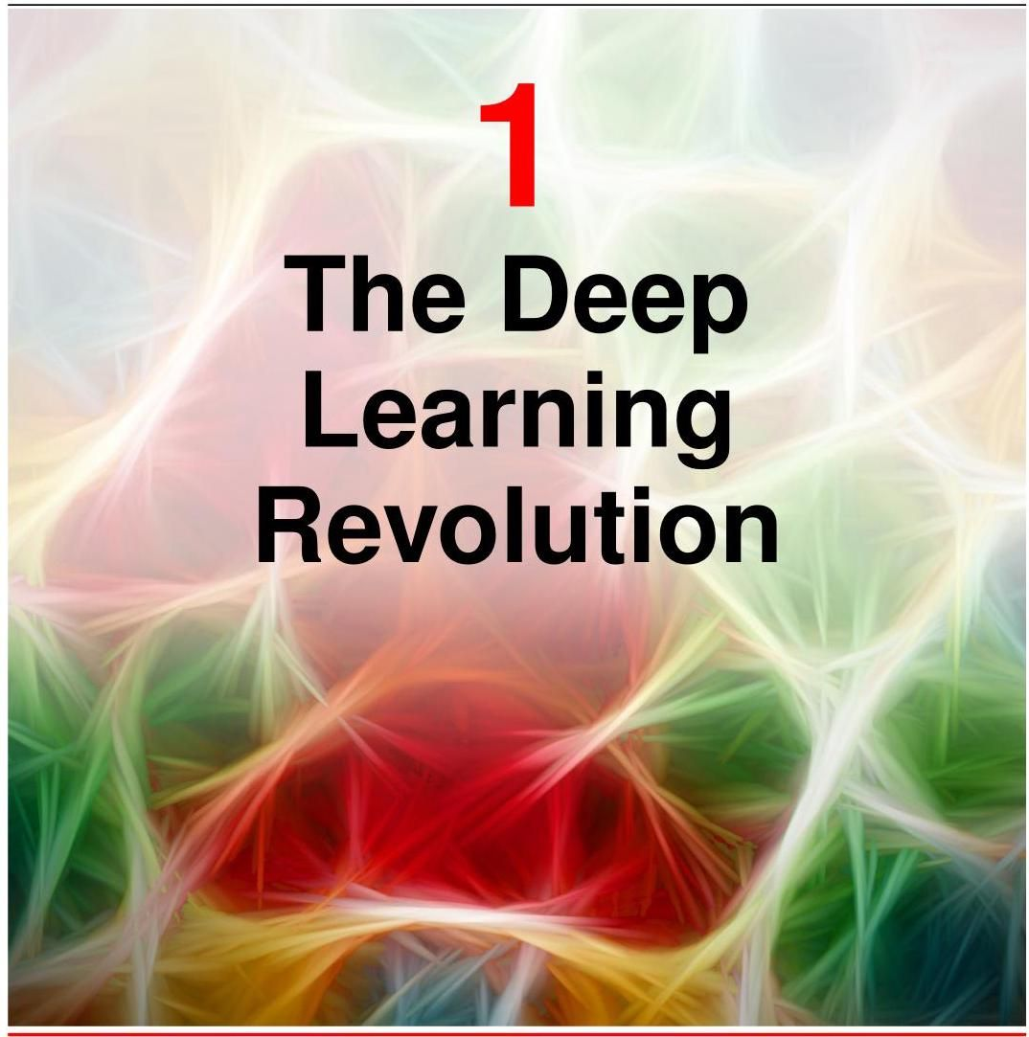

Machine learning today is one of the most important, and fastest growing, fields of technology. Applications of machine learning are becoming ubiquitous, and solutions learned from data are increasingly displacing traditional hand-crafted algorithms. This has not only led to improved performance for existing technologies but has opened the door to a vast range of new capabilities that would be inconceivable if new algorithms had to be designed explicitly by hand.

如今，机器学习是最重要且发展最快的技术领域之一。机器学习的应用正变得无处不在，从数据中学习到的解决方案正日益取代传统的手工算法。这不仅提高了现有技术的性能，还为一系列新能力打开了大门，而如果必须手动明确设计新算法，这些能力将是不可想象的。

One particular branch of machine learning, known as deep learning, has emerged as an exceptionally powerful and general-purpose framework for learning from data. Deep learning is based on computational models called neural networks which were originally inspired by mechanisms of learning and information processing in the human brain. The field of artificial intelligence, or AI, seeks to recreate the powerful capabilities of the brain in machines, and today the terms machine learning and AI are often used interchangeably. Many of the AI systems in current use represent applications of machine learning which are designed to solve very specific and focused problems, and while these are extremely useful they fall far short of the tremendous breadth of capabilities of the human brain. This has led to the introduction of the term artificial general intelligence, or AGI, to describe the aspiration of building machines with this much greater flexibility. After many decades of steady progress, machine learning has now entered a phase of very rapid development. Recently, massive deep learning systems called large language models have started to exhibit remarkable capabilities that have been described as the first indications of artificial general intelligence (Bubeck et al., 2023).

机器学习的一个特定分支，即深度学习，已成为一种极其强大且通用的数据学习框架。深度学习基于被称为神经网络的计算模型，这些模型最初受到人类大脑学习和信息处理机制的启发。人工智能(AI)领域致力于在机器中重现大脑的强大能力，如今，“机器学习”和“人工智能”这两个术语经常互换使用。当前使用的许多人工智能系统代表了机器学习的应用，这些应用旨在解决非常具体和特定的问题，虽然它们非常有用，但与人类大脑的巨大能力广度相比，仍相去甚远。这导致了“通用人工智能”(AGI)这一术语的引入，用于描述构建具有更大灵活性的机器的愿景。经过数十年的稳步发展，机器学习现在已进入一个快速发展阶段。最近，被称为大语言模型的大规模深度学习系统开始展现出非凡的能力，这些能力被描述为通用人工智能的初步迹象(Bubeck 等人，2023)。

Chapter 12

第 12 章

# 1.1.The Impact of Deep Learning

# 1.1 深度学习的影响

We begin our discussion of machine learning by considering four examples drawn from diverse fields to illustrate the huge breadth of applicability of this technology and to introduce some basic concepts and terminology. What is particularly remarkable about these and many other examples is that they have all been addressed using variants of the same fundamental framework of deep learning. This is in sharp contrast to conventional approaches in which different applications are tackled using widely differing and specialist techniques. It should be emphasized that the examples we have chosen represent only a tiny fraction of the breadth of applicability for deep neural networks and that almost every domain where computation has a role is amenable to the transformational impact of deep learning.

我们通过考虑来自不同领域的四个例子来开始对机器学习的讨论，以说明这项技术的广泛适用性，并介绍一些基本概念和术语。这些例子以及许多其他例子特别值得注意的是，它们都使用了深度学习同一基本框架的变体来解决。这与传统方法形成了鲜明对比，在传统方法中，不同的应用使用截然不同的专业技术来处理。应该强调的是，我们选择的例子仅代表了深度神经网络广泛适用性的一小部分，并且几乎每个涉及计算的领域都能受到深度学习的变革性影响。

# 1.1.1 Medical diagnosis

# 1.1.1 医学诊断

Consider first the application of machine learning to the problem of diagnosing skin cancer. Melanoma is the most dangerous kind of skin cancer but is curable if detected early. Figure 1.1 shows example images of skin lesions, with malignant melanomas on the top row and benign nevi on the bottom row. Distinguishing between these two classes of image is clearly very challenging, and it would be virtually impossible to write an algorithm by hand that could successfully classify such images with any reasonable level of accuracy.

首先考虑机器学习在皮肤癌诊断问题上的应用。黑色素瘤是最危险的皮肤癌类型，但如果早期发现是可以治愈的。图 1.1 展示了皮肤病变的示例图像，上排是恶性黑色素瘤，下排是良性痣。区分这两类图像显然非常具有挑战性，而且几乎不可能手动编写一个算法，能够以合理的准确度成功对这些图像进行分类。

This problem has been successfully addressed using deep learning (Esteva et al., 2017). The solution was created using a large set of lesion images, known as a training set, each of which is labelled as either malignant or benign, where the labels are obtained from a biopsy test that is considered to provide the true class of the lesion. The training set is used to determine the values of some 25 million adjustable parameters, known as weights, in a deep neural network. This process of setting the parameter values from data is known as learning or training. The goal is for the trained network to predict the correct label for a new lesion just from the image alone without needing the time-consuming step of taking a biopsy. This is an example of a supervised learning problem because, for each training example, the network is told the correct label. It is also an example of a classification problem because each input must be assigned to a discrete set of classes (benign or malignant in this case). Applications in which the output consists of one or more continuous variables are called regression problems. An example of a regression problem would be the prediction of the yield in a chemical manufacturing process in which the inputs consist of the temperature, the pressure, and the concentrations of reactants.

使用深度学习已成功解决了这个问题(Esteva 等人，2017 年)。该解决方案是利用大量的病变图像(即训练集)创建的，其中每张图像都被标记为恶性或良性，这些标签是通过活检测试获得的，该测试被认为能提供病变的真实类别。训练集用于确定深度神经网络中约 2500 万个可调整参数(即权重)的值。这种从数据中设置参数值的过程称为学习或训练。目标是让训练好的网络仅根据新病变的图像就能预测出正确的标签，而无需进行耗时的活检步骤。这是一个监督学习问题的示例，因为对于每个训练样本，网络都被告知正确的标签。这也是一个分类问题的示例，因为每个输入必须被分配到一组离散的类别中(在这种情况下是良性或恶性)。输出由一个或多个连续变量组成的应用称为回归问题。回归问题的一个示例是预测化学制造过程中的产量，其中输入包括温度、压力和反应物浓度。

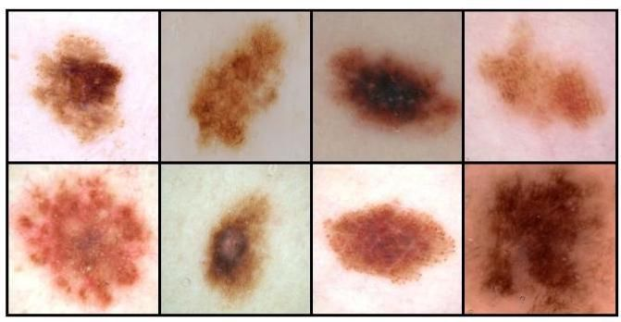

Figure 1.1 Examples of skin lesions corresponding to dangerous malignant melanomas on the top row and benign nevi on the bottom row. It is difficult for the untrained eye to distinguish between these two classes.

图 1.1 上排为危险的恶性黑色素瘤对应的皮肤病变示例，下排为良性痣对应的皮肤病变示例。未经训练的人很难区分这两类病变。

An interesting aspect of this application is that the number of labelled training images available, roughly129,000, is considered relatively small, and so the deep neural network was first trained on a much larger data set of 1.28 million images of everyday objects (such as dogs, buildings, and mushrooms) and then fine-tuned on the data set of lesion images. This is an example of transfer learning in which the network learns the general properties of natural images from the large data set of everyday objects and is then specialized to the specific problem of lesion classification. Through the use of deep learning, the classification of skin lesion images has reached a level of accuracy that exceeds that of professional dermatologists (Brinker et al., 2019).

此应用的一个有趣方面是，可用的带标签训练图像数量约为 129,000 张，相对较少，因此深度神经网络首先在一个更大的包含 128 万张日常物品(如狗、建筑物和蘑菇)图像的数据集上进行训练，然后在病变图像数据集上进行微调。这是迁移学习的一个示例，在迁移学习中，网络从日常物品的大数据集中学习自然图像的一般属性，然后专门用于解决病变分类的特定问题。通过使用深度学习，皮肤病变图像的分类准确率已超过专业皮肤科医生(Brinker 等人，2019 年)。

# 1.1.2 Protein structure

# 1.1.2 蛋白质结构

Proteins are sometimes called the building blocks of living organisms. They are biological molecules that consist of one or more long chains of units called amino acids, of which there are 22 different types, and the protein is specified by the sequence of amino acids. Once a protein has been synthesized inside a living cell, it folds into a complex three-dimensional structure whose behaviour and interactions are strongly determined by its shape. Calculating this 3D structure, given the amino acid sequence, has been a fundamental open problem in biology for half a century that had seen relatively little progress until the advent of deep learning.

蛋白质有时被称为生物体的基石。它们是由一条或多条称为氨基酸的单元长链组成的生物分子，氨基酸有 22 种不同类型，蛋白质由氨基酸序列决定。一旦蛋白质在活细胞内合成，它就会折叠成复杂的三维结构，其行为和相互作用在很大程度上由其形状决定。在已知氨基酸序列的情况下计算这种三维结构，半个世纪以来一直是生物学中一个基本的开放性问题，直到深度学习出现之前进展相对较小。

The 3D structure can be measured experimentally using techniques such as Xray crystallography, cryogenic electron microscopy, or nuclear magnetic resonance spectroscopy. However, this can be extremely time-consuming and for some proteins can prove to be challenging, for example due to the difficulty of obtaining a pure sample or because the structure is dependent on the context. In contrast, the amino acid sequence of a protein can be determined experimentally at lower cost and higher throughput. Consequently, there is considerable interest in being able to predict the 3D structures of proteins directly from their amino acid sequences in order to better understand biological processes or for practical applications such as drug discovery. A deep learning model can be trained to take an amino acid sequence as input and generate the 3D structure as output, in which the training data consist of a set of proteins for which the amino acid sequence and the 3D structure are both known. Protein structure prediction is therefore another example of supervised learning. Once the system is trained it can take a new amino acid sequence as input and can predict the associated 3D structure (Jumper et al., 2021). Figure 1.2 compares the predicted 3D structure of a protein and the ground truth obtained by -ray crystallography.

可以使用 X 射线晶体学、低温电子显微镜或核磁共振光谱等技术通过实验测量三维结构。然而，这可能极其耗时，而且对于某些蛋白质来说可能具有挑战性，例如由于难以获得纯样本或因为结构依赖于环境。相比之下，可以通过实验以较低的成本和较高的通量确定蛋白质的氨基酸序列。因此，人们对能够直接从蛋白质的氨基酸序列预测其三维结构非常感兴趣，以便更好地理解生物过程或用于药物发现等实际应用。可以训练一个深度学习模型，将氨基酸序列作为输入，生成三维结构作为输出，其中训练数据由一组已知氨基酸序列和三维结构的蛋白质组成。因此，蛋白质结构预测是监督学习的另一个示例。一旦系统训练完成，它可以将新的氨基酸序列作为输入，并预测相关的三维结构(Jumper 等人，2021 年)。图 1.2 比较了蛋白质的预测三维结构和通过 射线晶体学获得的真实结构。

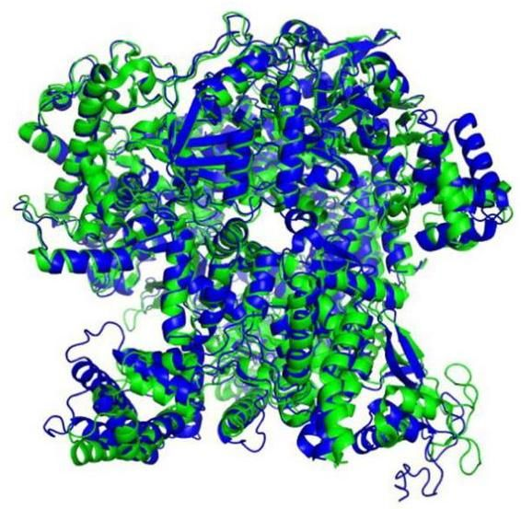

Figure 1.2 Illustration of the 3D shape of a protein called T1044/6VR4. The green structure shows the ground truth as determined by X-ray crystallography, whereas the superimposed blue structure shows the prediction obtained by a deep learning model called AlphaFold. [From Jumper et al. (2021) with permission.]

图 1.2 名为 T1044/6VR4 的蛋白质三维形状示意图。绿色结构显示了通过 X 射线晶体学确定的真实结构，而叠加的蓝色结构显示了由名为 AlphaFold 的深度学习模型获得的预测结果。[经许可摘自 Jumper 等人(2021 年)的研究。]

# 1.1.3 Image synthesis

# 1.1.3 图像合成

In the two applications discussed so far, a neural network learned to transform an input (a skin image or an amino acid sequence) into an output (a lesion classification or a 3D protein structure, respectively). We turn now to an example where the training data consist simply of a set of sample images and the goal of the trained network is to create new images of the same kind. This is an example of unsupervised learning because the images are unlabelled, in contrast to the lesion classification and protein structure examples. Figure 1.3 shows examples of synthetic images generated by a deep neural network trained on a set of images of human faces taken in a studio against a plain background. Such synthetic images are of exceptionally high quality and it can be difficult tell them apart from photographs of real people.

在目前讨论的两个应用中，神经网络学会了将输入(皮肤图像或氨基酸序列)转换为输出(分别为病变分类或蛋白质三维结构)。现在我们来看一个例子，其中训练数据仅由一组样本图像组成，训练好的网络的目标是创建同类的新图像。这是无监督学习的一个例子，因为与病变分类和蛋白质结构的例子不同，这些图像没有标签。图 1.3 展示了由一个在一组在摄影棚纯色背景下拍摄的人脸图像上训练的深度神经网络生成的合成图像示例。这样的合成图像质量极高，很难将它们与真人照片区分开来。

This is an example of a generative model because it can generate new output examples that differ from those used to train the model but which share the same statistical properties. A variant of this approach allows images to be generated that depend on an input text string known, as a prompt, so that the image content reflects the semantics of the text input. The term generative is used to describe deep learning models that generate outputs in the form of images, video, audio, text, candidate drug molecules, or other modalities.

这是生成模型的一个例子，因为它可以生成与用于训练模型的示例不同但具有相同统计特性的新输出示例。这种方法的一个变体允许根据作为提示的输入文本字符串生成图像，从而使图像内容反映文本输入的语义。术语生成式 用于描述以图像、视频、音频、文本、候选药物分子或其他形式生成输出的深度学习模型。

Chapter 10

第 10 章

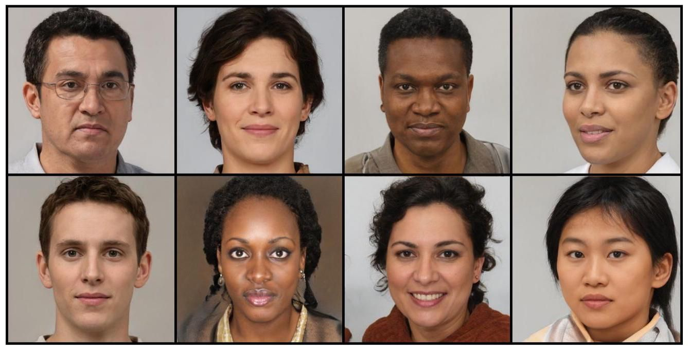

Figure 1.3 Synthetic face images generated by a deep neural network trained using unsupervised learning. [From https://generated.photos.]

图 1.3 通过无监督学习训练的深度神经网络生成的合成人脸图像。[来源:https://generated.photos。]

# 1.1.4 Large language models

# 1.1.4 大语言模型

One of most important advances in machine learning in recent years has been the development of powerful models for processing natural language and other forms of sequential data such as source code. A large language model, or LLM, uses deep learning to build rich internal representations that capture the semantic properties of language. An important class of large language models, called autoregressive language models, can generate language as output, and therefore, they are a form of generative AI. Such models take a sequence of words as the input and for the output, generate a single word that represents the next word in the sequence. The augmented sequence, with the new word appended at the end, can then be fed through the model again to generate the subsequent word, and this process can be repeated to generate a long sequence of words. Such models can also output a special ’stop’ word that signals the end of text generation, thereby allowing them to output text of finite length and then halt. At that point, a user could append their own series of words to the sequence before feeding the complete sequence back through the model to trigger further word generation. In this way, it is possible for a human to have a conversation with the neural network.

近年来，机器学习领域最重要的进展之一是开发出了用于处理自然语言和其他形式的序列数据(如源代码)的强大模型。大语言模型(LLM)利用深度学习构建丰富的内部表征，以捕捉语言的语义属性。一类重要的大语言模型，即自回归语言模型，能够生成语言作为输出，因此它们属于生成式人工智能的一种形式。这类模型将一个单词序列作为输入，并输出一个代表该序列中下一个单词的单个单词。将新单词添加到序列末尾形成的增强序列，随后可以再次输入模型以生成后续单词，这个过程可以重复进行，以生成一长串单词。这类模型还可以输出一个特殊的“停止”单词，用于表示文本生成结束，从而使它们能够输出有限长度的文本并停止。此时，用户可以在序列中添加自己的一系列单词，然后将完整的序列再次输入模型，以触发进一步的单词生成。通过这种方式，人类就有可能与神经网络进行对话。

Such models can be trained on large data sets of text by extracting training pairs each consisting of a randomly selected sequence of words as input with the known next word as the target output. This is an example of self-supervised learning in which a function from inputs to outputs is learned but where the labelled outputs are obtained automatically from the input training data without needing separate human-derived labels. Since large volumes of text are available from multiple sources, this approach allows for scaling to very large training sets and associated very large neural networks.

可以在大型文本数据集上对这类模型进行训练，方法是提取训练对，每个训练对由一个随机选择的单词序列作为输入，以及已知的下一个单词作为目标输出组成。这是自监督学习的一个例子，在自监督学习中，学习的是从输入到输出的函数，但标记的输出是自动从输入训练数据中获得的，无需单独的人工标注。由于可以从多个来源获取大量文本，这种方法允许扩展到非常大的训练集和相关的非常大的神经网络。

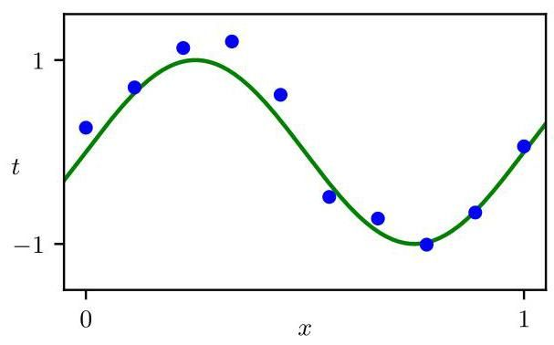

Figure 1.4 Plot of a training data set of 10 points, shown as blue circles, each comprising an observation of the input variable along with the corresponding target variable . The green curve shows the function used to generate the data. Our goal is to predict the value of for some new value of , without knowledge of the green curve.

图 1.4 展示了一个包含 10 个点的训练数据集，用蓝色圆圈表示，每个点包含输入变量 的一个观测值以及对应的目标变量 。绿色曲线表示用于生成数据的函数 。我们的目标是在不知道绿色曲线的情况下，预测 的某个新值对应的 的值。

Large language models can exhibit extraordinary capabilities that have been described as the first indications of emerging artificial general intelligence (Bubeck et al., 2023), and we discuss such models at length later in the book. On the next page, we give an illustration of language generation, based on a model called GPT-4 (Ope-nAI, 2023), in response to an input prompt ’Write a proof of the fact that there are infinitely many primes; do it in the style of a Shakespeare play through a dialogue between two parties arguing over the proof.’.

大语言模型可以展现出非凡的能力，这些能力被描述为通用人工智能出现的初步迹象(Bubeck 等人，2023)，我们将在本书后面详细讨论这类模型。在下一页，我们给出一个语言生成的示例，该示例基于名为 GPT - 4 的模型(OpenAI，2023)，响应的输入提示是“写一个证明，证明存在无限多个素数；以莎士比亚戏剧的风格，通过两方就该证明进行争论的对话来完成。”

Chapter 12

第 12 章

# 1.2.A Tutorial Example

# 1.2. 教程示例

For the newcomer to the field of machine learning, many of the basic concepts and much of the terminology can be introduced in the context of a simple example involving the fitting of a polynomial to a small synthetic data set (Bishop, 2006). This is a form of supervised learning problem in which we would like to make a prediction for a target variable, given the value of an input variable.

对于机器学习领域的新手来说，许多基本概念和大量术语可以在一个简单示例的背景下引入，该示例涉及将多项式拟合到一个小的合成数据集(Bishop，2006)。这是一种监督学习问题，在这种问题中，我们希望在给定输入变量的值的情况下，对目标变量进行预测。

# 1.2.1 Synthetic data

# 1.2.1 合成数据

We denote the input variable by and the target variable by , and we assume that both variables take continuous values on the real axis. Suppose that we are given a training set comprising observations of , written , together with corresponding observations of the values of , denoted . Our goal is to predict the value of for some new value of . The ability to make accurate predictions on previously unseen inputs is a key goal in machine learning and is known as generalization.

我们用 表示输入变量，用 表示目标变量，并且假设这两个变量都在实数轴上取连续值。假设我们得到一个训练集，其中包含 个 的观测值，记为 ，以及相应的 的观测值，记为 。我们的目标是对 的某个新值预测 的值。对以前未见过的输入进行准确预测的能力是机器学习的一个关键目标，被称为泛化。

We can illustrate this using a synthetic data set generated by sampling from a sinusoidal function. Figure 1.4 shows a plot of a training set comprising data points in which the input values were generated by choosing values of , for , spaced uniformly in the range . The associated target data values were obtained by first computing the values of the function for each value of

我们可以使用一个从正弦函数采样生成的合成数据集来说明这一点。图 1.4 展示了一个包含 个数据点的训练集的绘图，其中输入值是通过选择 的值生成的，对于 ，在范围 内均匀间隔。相关的目标数据值是通过首先为每个 的值计算函数 的值得到的

# GPT-4: Proof of infinitely many primes

FIRST PARTY:

Thou dost not understand, my friend,

There simply is no upper end

To primes, those numbers indivisible,

No matter if it seems impossible.

SECOND PARTY:

But how dost thou so surely know?

To prove this truth, what canst thou show?

FIRST PARTY:

Consider this, my doubtful peer,

A clever proof that will make clear:

Assume that there’s a final prime,

The largest one we’ll see in time.

Let’s call this number "P" for short,

And then, my friend, we will purport

To build a number " " that’s new,

One larger than "P" and prime too.

SECOND PARTY:

But how, my friend, will this be done?

The proof is not yet fairly won.

FIRST PARTY:

It’s simple, friend, just wait and see,

We’ll multiply the primes, that’s key.

All primes from two to " " combined,

Will make this new " " we will find.

But one thing more we must include,

To make the proof more watertight,

We’ll add a one onto the end,

And now the proof is in our sight.

SECOND PARTY:

I see it now, it’s crystal clear,

For " " must be a prime, my dear.

It can’t divide by any prime,

All smaller than itself in time.

And since we chose "P" as the last,

This proves that our assumption’s past.

There is no final prime, we see,

The numbers go on endlessly.

Section 2.3

第 2.3 节

and then adding a small level of random noise (governed by a Gaussian distribution) to each such point to obtain the corresponding target value . By generating data in this way, we are capturing an important property of many real-world data sets, namely that they possess an underlying regularity, which we wish to learn, but that individual observations are corrupted by random noise. This noise might arise from intrinsically stochastic (i.e., random) processes such as radioactive decay but more typically is due to there being sources of variability that are themselves unobserved.

然后给每个这样的点添加少量的随机噪声(由高斯分布控制)，以获得相应的目标值 。通过这种方式生成数据，我们捕捉到了许多现实世界数据集的一个重要特性，即它们具有潜在的规律性，我们希望学习这种规律性，但单个观测值会受到随机噪声的干扰。这种噪声可能源于本质上的随机过程(即随机过程)，如放射性衰变，但更常见的是由于存在一些本身未被观测到的可变性来源。

In this tutorial example we know the true process that generated the data, namely the sinusoidal function. In a practical application of machine learning, our goal is to discover the underlying trends in the data given the finite training set. Knowing the process that generated the data, however, allows us to illustrate important concepts in machine learning.

在这个教程示例中，我们知道生成数据的真实过程，即正弦函数。在机器学习的实际应用中，我们的目标是在给定有限训练集的情况下发现数据中的潜在趋势。然而，了解生成数据的过程使我们能够阐明机器学习中的重要概念。

# 1.2.2 Linear models

# 1.2.2 线性模型

Our goal is to exploit this training set to predict the value of the target variable for some new value of the input variable. As we will see later, this involves implicitly trying to discover the underlying function . This is intrinsically a difficult problem as we have to generalize from a finite data set to an entire function. Furthermore, the observed data is corrupted with noise, and so for a given there is uncertainty as to the appropriate value for . Probability theory provides a framework for expressing such uncertainty in a precise and quantitative manner, whereas decision theory allows us to exploit this probabilistic representation to make predictions that are optimal according to appropriate criteria. Learning probabilities from data lies at the heart of machine learning and will be explored in great detail in this book.

我们的目标是利用这个训练集，为输入变量的某个新值 预测目标变量的值 。正如我们稍后将看到的，这涉及到隐式地尝试发现潜在函数 。这本质上是一个难题，因为我们必须从有限的数据集推广到整个函数。此外，观测数据受到噪声的干扰，因此对于给定的 ， 的合适值存在不确定性。概率论提供了一个框架，用于以精确和定量的方式表达这种不确定性，而决策理论允许我们利用这种概率表示，根据适当的标准做出最优预测。从数据中学习概率是机器学习的核心，本书将对此进行详细探讨。

Chapter 2

第 2 章

Chapter 5

第 5 章

To start with, however, we will proceed rather informally and consider a simple approach based on curve fitting. In particular, we will fit the data using a polynomial function of the form

然而，首先我们将采用较为非正式的方式，考虑一种基于曲线拟合的简单方法。具体而言，我们将使用以下形式的多项式函数来拟合数据

where is the order of the polynomial, and denotes raised to the power of . The polynomial coefficients are collectively denoted by the vector . Note that, although the polynomial function is a nonlinear function of , it is a linear function of the coefficients . Functions, such as this polynomial, that are linear in the unknown parameters have important properties, as well as significant limitations, and are called linear models.

其中 是多项式的阶数， 表示 的 次幂。多项式系数 用向量 统一表示。请注意，尽管多项式函数 是 的非线性函数，但它是系数 的线性函数。像这个多项式这样，关于未知参数是线性的函数具有重要的性质，同时也有显著的局限性，这类函数被称为线性模型。

Chapter 4

第4章

# 1.2.3 Error function

# 1.2.3 误差函数

The values of the coefficients will be determined by fitting the polynomial to the training data. This can be done by minimizing an error function that measures the misfit between the function , for any given value of , and the training set data points. One simple choice of error function, which is widely used, is the sum of

系数的值将通过使多项式拟合训练数据来确定。这可以通过最小化一个误差函数来实现，该误差函数用于衡量对于任意给定的 值，函数 与训练集数据点之间的拟合误差。一种广泛使用的简单误差函数选择是

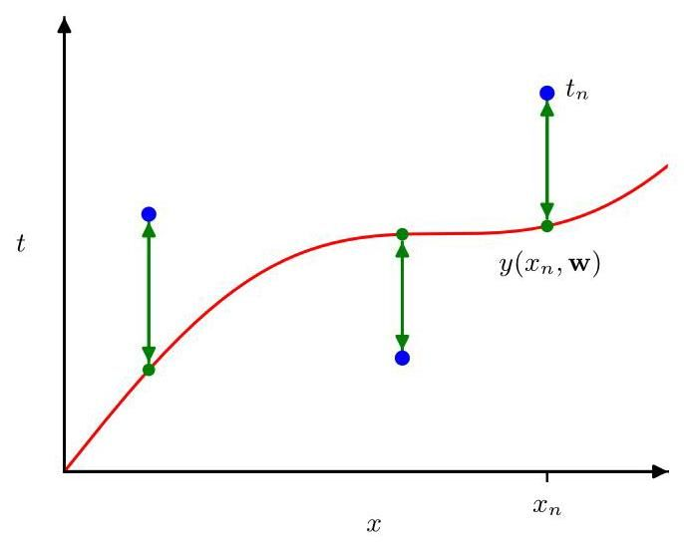

Figure 1.5 The error function (1.2) corresponds to (one half of) the sum of the squares of the displacements (shown by the vertical green arrows) of each data point from the function .

图1.5 误差函数 (1.2) 对应于每个数据点到函数 的位移(由垂直绿色箭头表示)的平方和的一半。

the squares of the differences between the predictions for each data point and the corresponding target value , given by

每个数据点 的预测值 与相应目标值 之差的平方，由下式给出

where the factor of is included for later convenience. We will later derive this error function starting from probability theory. Here we simply note that it is a nonnegative quantity that would be zero if, and only if, the function were to pass exactly through each training data point. The geometrical interpretation of the sum-of-squares error function is illustrated in Figure 1.5.

其中包含因子 是为了后续方便。我们稍后将从概率论出发推导这个误差函数。这里我们仅指出，它是一个非负量，当且仅当函数 恰好通过每个训练数据点时，该量才为零。平方和误差函数的几何解释如图 1.5 所示。

Section 2.3.4

第 2.3.4 节

We can solve the curve fitting problem by choosing the value of for which is as small as possible. Because the error function is a quadratic function of the coefficients , its derivatives with respect to the coefficients will be linear in the elements of , and so the minimization of the error function has a unique solution, denoted by , which can be found in closed form. The resulting polynomial is given by the function .

我们可以通过选择 的值来解决曲线拟合问题，使得 尽可能小。由于误差函数是系数 的二次函数，它关于系数的导数将是 元素的线性函数，因此误差函数的最小化有一个唯一解，记为 ，可以用封闭形式求出。得到的多项式由函数 给出。

Exercise 4.1

练习 4.1

# 1.2.4 Model complexity

# 1.2.4 模型复杂度

There remains the problem of choosing the order of the polynomial, and as we will see this will turn out to be an example of an important concept called model comparison or model selection. In Figure 1.6, we show four examples of the results of fitting polynomials having orders , and 9 to the data set shown in Figure 1.4.

仍然存在选择多项式阶数 的问题，正如我们将看到的，这将是一个被称为模型比较或模型选择的重要概念的示例。在图 1.6 中，我们展示了将阶数为 和 9 的多项式拟合到图 1.4 所示数据集的四个结果示例。

Notice that the constant and first-order polynomials give poor fits to the data and consequently poor representations of the function . The third-order polynomial seems to give the best fit to the function of the examples shown in Figure 1.6. When we go to a much higher order polynomial , we obtain an excellent fit to the training data. In fact, the polynomial passes exactly through each data point and . However, the fitted curve oscillates wildly and gives a very poor representation of the function . This latter behaviour is known as over-fitting.

注意，常数 和一阶 多项式对数据的拟合效果很差，因此对函数 的表示也很差。三阶 多项式似乎在图 1.6 所示的示例中对函数 的拟合效果最好。当我们使用更高阶的多项式 时，我们得到了对训练数据的极好拟合。事实上，该多项式恰好通过每个数据点，并且 。然而，拟合曲线剧烈振荡，对函数 的表示非常差。后一种行为被称为过拟合。

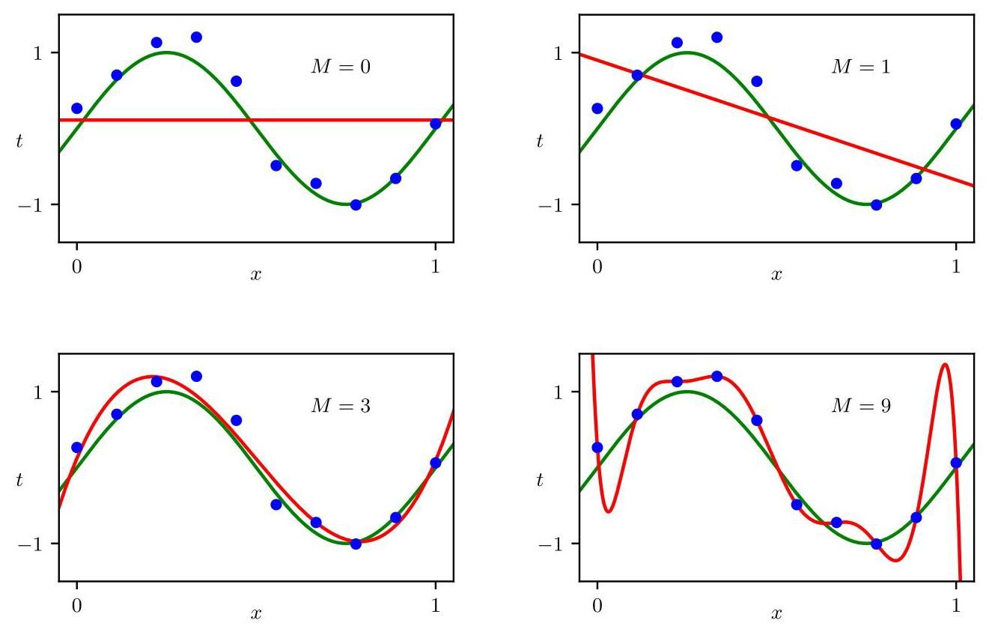

Figure 1.6 Plots of polynomials having various orders , shown as red curves, fitted to the data set shown in Figure 1.4 by minimizing the error function (1.2).

图 1.6 展示了通过最小化误差函数 (1.2) 将不同阶数 的多项式(以红色曲线表示)拟合到图 1.4 所示数据集的情况。

Our goal is to achieve good generalization by making accurate predictions for new data. We can obtain some quantitative insight into the dependence of the generalization performance on by considering a separate set of data known as a test set, comprising 100 data points generated using the same procedure as used to generate the training set points. For each value of , we can evaluate the residual value of given by (1.2) for the training data, and we can also evaluate for the test data set. Instead of evaluating the error function , it is sometimes more convenient to use the root-mean-square (RMS) error defined by

我们的目标是通过对新数据进行准确预测来实现良好的泛化。通过考虑一个单独的数据集(称为测试集，包含 100 个使用与生成训练集点相同的过程生成的数据点)，我们可以对泛化性能对 的依赖关系获得一些定量的见解。对于 的每个值，我们可以评估由 (1.2) 给出的训练数据的 残差值，我们还可以评估测试数据集的 。有时，使用由下式定义的均方根 (RMS) 误差来代替评估误差函数 会更方便

in which the division by allows us to compare different sizes of data sets on an equal footing, and the square root ensures that is measured on the same scale (and in the same units) as the target variable . Graphs of the training-set and test-set

其中除以 使我们能够在同等基础上比较不同大小的数据集，而平方根确保 与目标变量 在相同的尺度(和相同的单位)上进行测量。训练集和测试集的图表

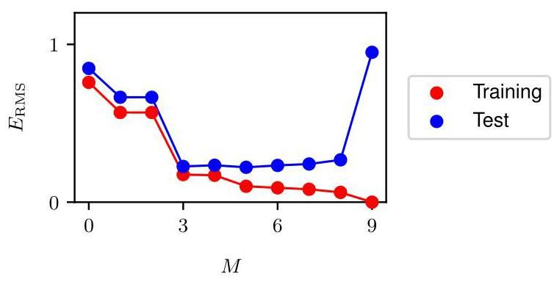

Figure 1.7 Graphs of the root-mean-square error, defined by (1.3), evaluated on the training set, and on an independent test set, for various values of .

图 1.7 展示了由 (1.3) 定义的均方根误差在训练集和独立测试集上针对不同 值的评估图表。

RMS errors are shown, for various values of , in Figure 1.7. The test set error is a measure of how well we are doing in predicting the values of for new data observations of . Note from Figure 1.7 that small values of give relatively large values of the test set error, and this can be attributed to the fact that the corresponding polynomials are rather inflexible and are incapable of capturing the oscillations in the function . Values of in the range give small values for the test set error, and these also give reasonable representations of the generating function , as can be seen for in Figure 1.6.

均方根误差(RMS errors)针对 的不同取值，如图 1.7 所示。测试集误差衡量了我们对 的新数据观测预测 值的效果。从图 1.7 可以看出， 取值较小时，测试集误差相对较大，这可归因于相应的多项式缺乏灵活性，无法捕捉函数 中的振荡。 在 范围内取值时，测试集误差较小，并且如图 1.6 中 所示，这些取值也能合理地表示生成函数 。

For , the training set error goes to zero, as we might expect because this polynomial contains 10 degrees of freedom corresponding to the 10 coefficients , and so can be tuned exactly to the 10 data points in the training set. However, the test set error has become very large and, as we saw in Figure 1.6, the corresponding function exhibits wild oscillations.

对于 ，训练集误差趋近于零，这正如我们所预期的，因为该多项式包含与 10 个系数 对应的 10 个自由度，因此可以精确地拟合训练集中的 10 个数据点。然而，测试集误差变得非常大，并且如图 1.6 所示，相应的函数 呈现出剧烈的振荡。

This may seem paradoxical because a polynomial of a given order contains all lower-order polynomials as special cases. The polynomial is therefore capable of generating results at least as good as the polynomial. Furthermore, we might suppose that the best predictor of new data would be the function from which the data was generated (and we will see later that this is indeed the case). We know that a power series expansion of the function contains terms of all orders, so we might expect that results should improve monotonically as we increase .

这似乎有些矛盾，因为给定阶数的多项式包含所有低阶多项式作为特殊情况。因此， 多项式至少能够产生与 多项式一样好的结果。此外，我们可能会认为，对新数据的最佳预测器应该是生成数据的函数 (我们稍后会看到情况确实如此)。我们知道函数 的幂级数展开包含所有阶数的项，所以我们可能期望随着 的增加，结果应该单调改善。

We can gain some insight into the problem by examining the values of the coefficients obtained from polynomials of various orders, as shown in Table 1.1. We see that, as increases, the magnitude of the coefficients typically gets larger. In particular for the polynomial, the coefficients have become finely tuned to the data. They have large positive and negative values so that the corresponding polynomial function matches each of the data points exactly, but between data points (particularly near the ends of the range) the function exhibits the large oscillations observed in Figure 1.6. Intuitively, what is happening is that the more flexible polynomials with larger values of are increasingly tuned to the random noise on the target values.

通过检查从不同阶数的多项式得到的系数 的值，我们可以对这个问题有更深入的了解，如表 1.1 所示。我们看到，随着 的增加，系数的大小通常会变大。特别是对于 多项式，系数已经针对数据进行了精细调整。它们具有较大的正值和负值，使得相应的多项式函数能够精确匹配每个数据点，但在数据点之间(特别是在范围的两端附近)，函数呈现出如图 1.6 中观察到的大幅振荡。直观地说，发生的情况是， 值较大的更灵活的多项式越来越适应目标值上的随机噪声。

Further insight into this phenomenon can be gained by examining the behaviour of the learned model as the size of the data set is varied, as shown in Figure 1.8. We see that, for a given model complexity, the over-fitting problem become less severe as the size of the data set increases. Another way to say this is that with a larger data set, we can afford to fit a more complex (in other words more flexible) model to the data. One rough heuristic that is sometimes advocated in classical statistics is that the number of data points should be no less than some multiple (say 5 or 10) of the number of learnable parameters in the model. However, when we discuss deep learning later in this book, we will see that excellent results can be obtained using models that have significantly more parameters than the number of training

通过考察随着数据集大小的变化，学习模型的行为，如图 1.8 所示，我们可以对这一现象有更深入的了解。我们看到，对于给定的模型复杂度，随着数据集大小的增加，过拟合问题变得不那么严重。换句话说，有了更大的数据集，我们可以采用更复杂(即更灵活)的模型来拟合数据。经典统计学中有时提倡的一个粗略经验法则是，数据点的数量应该不少于模型中可学习参数数量的某个倍数(例如 5 或 10)。然而，当我们在本书后面讨论深度学习时，我们会看到，使用参数数量明显多于训练数据点数量的模型也能获得出色的结果。

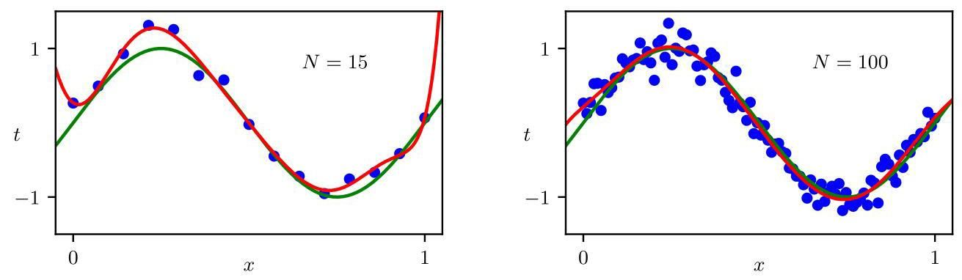

Figure 1.8 Plots of the solutions obtained by minimizing the sum-of-squares error function (1.2) using the polynomial for data points (left plot) and data points (right plot). We see that increasing the size of the data set reduces the over-fitting problem.

图 1.8 展示了使用 多项式，分别对 个数据点(左图)和 个数据点(右图)最小化平方和误差函数(1.2)得到的解的绘图。我们看到，增加数据集的大小可以减少过拟合问题。

Section 9.3.2 data points.

第 9.3.2 节的数据点。

# 1.2.5 Regularization

# 1.2.5 正则化

There is something rather unsatisfying about having to limit the number of parameters in a model according to the size of the available training set. It would seem more reasonable to choose the complexity of the model according to the complexity of the problem being solved. One technique that is often used to control the over-fitting phenomenon, as an alternative to limiting the number of parameters, is that of regularization, which involves adding a penalty term to the error function (1.2) to discourage the coefficients from having large magnitudes. The simplest such penalty term takes the form of the sum of the squares of all of the coefficients, leading to a modified error function of the form

根据可用训练集的大小来限制模型中参数的数量，这有点不尽如人意。根据待解决问题的复杂度来选择模型的复杂度似乎更为合理。作为限制参数数量的一种替代方法，一种常用于控制过拟合现象的技术是正则化，即在误差函数 (1.2) 中添加一个惩罚项，以防止系数的绝对值过大。最简单的这种惩罚项采用所有系数的平方和的形式，从而得到如下形式的修正误差函数

|  |  |  |  |  |
| --- | --- | --- | --- | --- |
|  |  |  |  |  |
|  | 0.11 | 0.90 | 0.12 | 0.26 |
|  |  | -1.58 | 11.20 | -66.13 |
|  |  |  | -33.67 | 1,665.69 |
|  |  |  | 22.43 | -15,566.61 |
|  |  |  |  | 76,321.23 |
|  |  |  |  | -217,389.15 |
|  |  |  |  | 370,626.48 |
|  |  |  |  | -372,051.47 |
|  |  |  |  | 202,540.70 |
|  |  |  |  | -46,080.94 |
|  |  |  |  |  |
|  | 0.11 | 0.90 | 0.12 | 0.26 |
|  |  | -1.58 | 11.20 | -66.13 |
|  |  |  | -33.67 | 1,665.69 |
|  |  |  | 22.43 | -15,566.61 |
|  |  |  |  | 76,321.23 |
|  |  |  |  | -217,389.15 |
|  |  |  |  | 370,626.48 |
|  |  |  |  | -372,051.47 |
|  |  |  |  | 202,540.70 |
|  |  |  |  | -46,080.94 |

Table 1.1 Table of the coefficients for polynomials of various order. Observe how the typical magnitude of the coefficients increases dramatically as the order of the polynomial increases.

表 1.1 不同阶多项式的系数 表。观察随着多项式阶数的增加，系数的典型大小是如何急剧增加的。

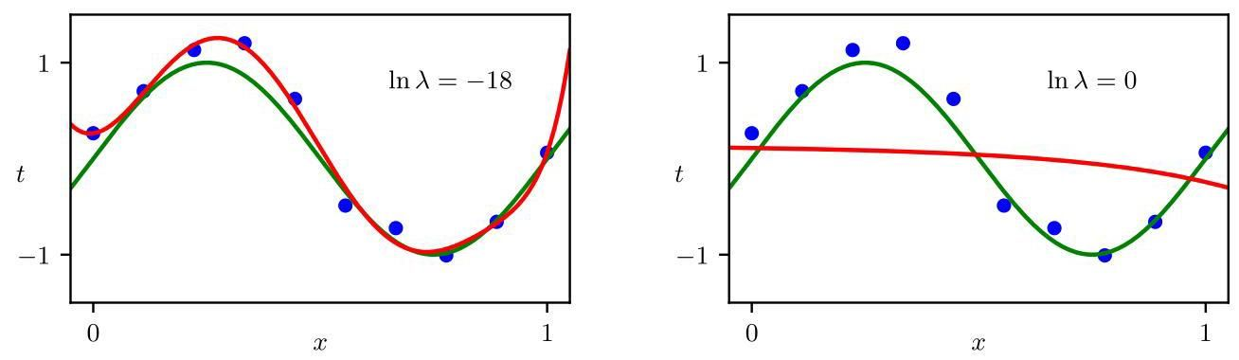

Figure 1.9 Plots of polynomials fitted to the data set shown in Figure 1.4 using the regularized error function (1.4) for two values of the regularization parameter corresponding to and . The case of no regularizer, i.e., , corresponding to , is shown at the bottom right of Figure 1.6.

图 1.9 展示了使用正则化误差函数 (1.4) 对图 1.4 所示数据集拟合 多项式的结果，正则化参数 取两个值，分别对应 和 。无正则化项的情况，即 (对应 )，显示在图 1.6 的右下角。

where , and the coefficient governs the relative importance of the regularization term compared with the sum-of-squares error term. Note that often the coefficient is omitted from the regularizer because its inclusion causes the results to depend on the choice of origin for the target variable (Hastie, Tibshirani, and Friedman, 2009), or it may be included but with its own regularization coefficient. Again, the error function in (1.4) can be minimized exactly in closed form. Techniques such as this are known in the statistics literature as shrinkage methods because they reduce the value of the coefficients. In the context of neural networks, this approach is known as weight decay because the parameters in a neural network are called weights and this regularizer encourages them to decay towards zero.

其中 ，系数 控制着正则化项相对于平方和误差项的相对重要性。请注意，正则化项中通常会省略系数 ，因为包含它会使结果依赖于目标变量原点的选择(Hastie、Tibshirani 和 Friedman，2009)，或者也可以包含它，但要为其设置自己的正则化系数。同样，(1.4) 中的误差函数可以通过封闭形式精确地最小化。在统计学文献中，这类技术被称为收缩方法，因为它们会减小系数的值。在神经网络的背景下，这种方法被称为权重衰减，因为神经网络中的参数被称为权重，而这个正则化项会促使它们向零衰减。

Section 9.2.1

第 9.2.1 节

Exercise 4.2

练习 4.2

Figure 1.9 shows the results of fitting the polynomial of order to the same data set as before but now using the regularized error function given by (1.4). We see that, for a value of , the over-fitting has been suppressed and we now obtain a much closer representation of the underlying function . If, however, we use too large a value for then we again obtain a poor fit, as shown in Figure 1.9 for . The corresponding coefficients from the fitted polynomials are given in Table 1.2, showing that regularization has the desired effect of reducing the magnitude of the coefficients.

图 1.9 展示了对与之前相同的数据集拟合 阶多项式的结果，但这次使用了 (1.4) 给出的正则化误差函数。我们看到，对于 的某个值，过拟合现象得到了抑制，现在我们得到了对底层函数 更接近的表示。然而，如果我们为 选择的值过大，那么我们又会得到较差的拟合效果，如图 1.9 中 的情况所示。拟合多项式得到的相应系数列于表 1.2 中，表明正则化达到了减小系数大小的预期效果。

The impact of the regularization term on the generalization error can be seen by plotting the value of the RMS error (1.3) for both training and test sets against , as shown in Figure 1.10. We see that now controls the effective complexity of the model and hence determines the degree of over-fitting.

通过绘制训练集和测试集的均方根误差(1.3)值与 的关系图，可以看出正则化项对泛化误差的影响，如图 1.10 所示。我们发现 现在控制着模型的有效复杂度，从而决定了过拟合的程度。

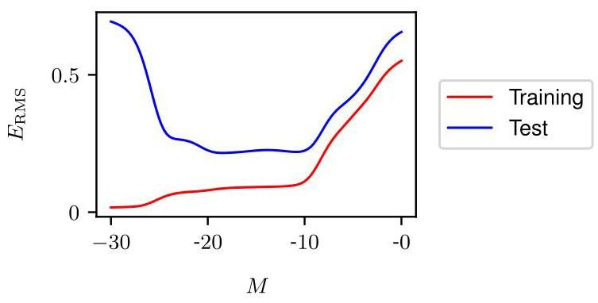

Figure 1.10 Graph of the root-mean-square error (1.3) versus for the polynomial.

图 1.10 展示了 多项式的均方根误差(1.3)与 的关系图。

# 1.2.6 Model selection

# 1.2.6 模型选择

The quantity is an example of a hyperparameter whose values are fixed during the minimization of the error function to determine the model parameters . We cannot simply determine the value of by minimizing the error function jointly with respect to and since this will lead to and an over-fitted model with small or zero training error. Similarly, the order of the polynomial is a hyperparameter of the model, and simply optimizing the training set error with respect to will lead to large values of and associated over-fitting. We therefore need to find a way to determine suitable values for hyperparameters. The results above suggest a simple way of achieving this, namely by taking the available data and partitioning it into a training set, used to determine the coefficients , and a separate validation set, also called a hold-out set or a development set. We then select the model having the lowest error on the validation set. If the model design is iterated many times using a data set of limited size, then some over-fitting to the validation data can occur, and so it may be necessary to keep aside a third test set on which the performance of the selected model can finally be evaluated.

量 是一个超参数的例子，在最小化误差函数以确定模型参数 时，其值是固定的。我们不能简单地通过同时相对于 和 最小化误差函数来确定 的值，因为这将导致 和一个训练误差很小或为零的过拟合模型。类似地，多项式的阶数 是模型的一个超参数，简单地相对于 优化训练集误差将导致 取较大值并产生相关的过拟合。因此，我们需要找到一种方法来确定超参数的合适值。上述结果提出了一种简单的实现方法，即将可用数据划分为训练集(用于确定系数 )和单独的验证集(也称为保留集或开发集)。然后，我们选择在验证集上误差最小的模型。如果使用有限大小的数据集多次迭代进行模型设计，那么可能会对验证数据产生一些过拟合，因此可能需要保留第三个测试集，最终在该测试集上评估所选模型的性能。

For some applications, the supply of data for training and testing will be limited. To build a good model, we should use as much of the available data as possible for training. However, if the validation set is too small, it will give a relatively noisy estimate of predictive performance. One solution to this dilemma is to use cross-

对于某些应用，用于训练和测试的数据供应将是有限的。为了构建一个好的模型，我们应该尽可能多地使用可用数据进行训练。然而，如果验证集太小，它将对预测性能给出相对有噪声的估计。解决这个困境的一种方法是使用交叉 -

|  |  |  |  |
| --- | --- | --- | --- |
|  |  |  |  |
|  | 0.26 | 0.26 | 0.11 |
|  | -66.13 | 0.64 | -0.07 |
|  | 1,665.69 | 43.68 | -0.09 |
|  | -15,566.61 | -144.00 | -0.07 |
|  | 76,321.23 | 57.90 | -0.05 |
|  | -217,389.15 | 117.36 | -0.04 |
|  | 370,626.48 | 9.87 | -0.02 |
|  | -372,051.47 | -90.02 | -0.01 |
|  | 202,540.70 | -70.90 | -0.01 |
|  | -46,080.94 | 75.26 | 0.00 |
|  |  |  |  |
|  | 0.26 | 0.26 | 0.11 |
|  | -66.13 | 0.64 | -0.07 |
|  | 1,665.69 | 43.68 | -0.09 |
|  | -15,566.61 | -144.00 | -0.07 |
|  | 76,321.23 | 57.90 | -0.05 |
|  | -217,389.15 | 117.36 | -0.04 |
|  | 370,626.48 | 9.87 | -0.02 |
|  | -372,051.47 | -90.02 | -0.01 |
|  | 202,540.70 | -70.90 | -0.01 |
|  | -46,080.94 | 75.26 | 0.00 |

Table 1.2 Table of the coefficients for polynomials with various values for the regularization parameter . Note that corresponds to a model with no regularization, i.e., to the graph at the bottom right in Figure 1.6. We see that, as the value of increases, the magnitude of a typical coefficient gets smaller.

表 1.2 正则化参数 取不同值时， 多项式的系数 表。请注意， 对应于无正则化的模型，即图 1.6 右下角的图。我们看到，随着 值的增加，典型系数的大小会变小。

Figure 1.11 validation, which is illustrated in Figure 1.11. This allows a proportion of the available data to be used for training while making use of all of the data to assess performance. When data is particularly scarce, it may be appropriate to consider the case , where is the total number of data points, which gives the leave-one-out technique.

图 1.11 验证，如图 1.11 所示。这允许将可用数据的一部分 用于训练，同时利用所有数据来评估性能。当数据特别稀缺时，考虑 的情况可能是合适的，其中 是数据点的总数，这就是留一法。

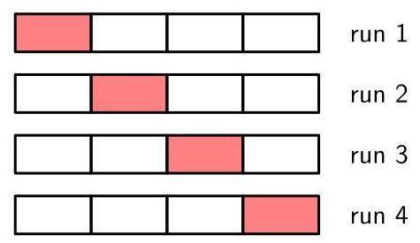

1 The technique of -fold cross-validation, illustrated here for the case of , involves taking the available data and partitioning it into groups of equal size. Then of the groups are used to train a set of models that are then evaluated on the remaining group. This procedure is then repeated for all possible choices for the held-out group, indicated here by the red blocks, and the performance scores from the runs are then averaged.

1 折交叉验证技术，这里以 的情况为例进行说明，该技术涉及将可用数据划分为 个大小相等的组。然后使用 个组来训练一组模型，然后在剩余的组上对这些模型进行评估。然后对保留组的所有 种可能选择重复此过程，这里用红色块表示，然后对 次运行的性能得分进行平均。

The main drawback of cross-validation is that the number of training runs that must be performed is increased by a factor of , and this can prove problematic for models in which the training is itself computationally expensive. A further problem with techniques such as cross-validation that use separate data to assess performance is that we might have multiple complexity hyperparameters for a single model (for instance, there might be several regularization hyperparameters). Exploring combinations of settings for such hyperparameters could, in the worst case, require a number of training runs that is exponential in the number of hyperparameters. The state of the art in modern machine learning involves extremely large models, trained on commensurately large data sets. Consequently, there is limited scope for exploration of hyperparameter settings, and heavy reliance is placed on experience obtained with smaller models and on heuristics.

交叉验证的主要缺点是必须执行的训练运行次数增加了 倍，对于训练本身计算成本较高的模型来说，这可能会成为问题。像交叉验证这样使用单独数据来评估性能的技术的另一个问题是，对于单个模型，我们可能有多个复杂度超参数(例如，可能有几个正则化超参数)。在最坏的情况下，探索此类超参数的设置组合可能需要进行的训练运行次数与超参数的数量呈指数关系。现代机器学习的前沿涉及极其庞大的模型，这些模型在相应庞大的数据集上进行训练。因此，探索超参数设置的空间有限，并且在很大程度上依赖于使用较小模型获得的经验和启发式方法。

This simple example of fitting a polynomial to a synthetic data set generated from a sinusoidal function has illustrated many key ideas from machine learning, and we will make further use of this example in future chapters. However, real-world applications of machine learning differ in several important respects. The size of the data sets used for training can be many orders of magnitude larger, and there will generally be many more input variables, perhaps numbering in the millions for image analysis, for example, as well as multiple output variables. The learnable function that relates outputs to inputs is governed by a class of models known as neural networks, and these may have a large number of parameters perhaps numbering in the hundreds of billions, and the error function will be a highly nonlinear function of those parameters. The error function can no longer be minimized through a closed-form solution and instead must be minimized through iterative optimization techniques based on evaluation of the derivatives of the error function with respect to the parameters, all of which may require specialist computational hardware and incur substantial computational cost.

这个将多项式拟合到由正弦函数生成的合成数据集的简单示例说明了机器学习中的许多关键思想，我们将在后续章节中进一步使用这个示例。然而，机器学习的实际应用在几个重要方面有所不同。用于训练的数据集的大小可能要大几个数量级，并且通常会有更多的输入变量，例如在图像分析中可能有数百万个，以及多个输出变量。将输出与输入相关联的可学习函数由一类称为神经网络的模型控制，这些模型可能有大量的参数，可能多达数千亿个，并且误差函数将是这些参数的高度非线性函数。误差函数不能再通过闭式解来最小化，而是必须通过基于误差函数相对于参数的导数评估的迭代优化技术来最小化，所有这些都可能需要专门的计算硬件并产生大量的计算成本。

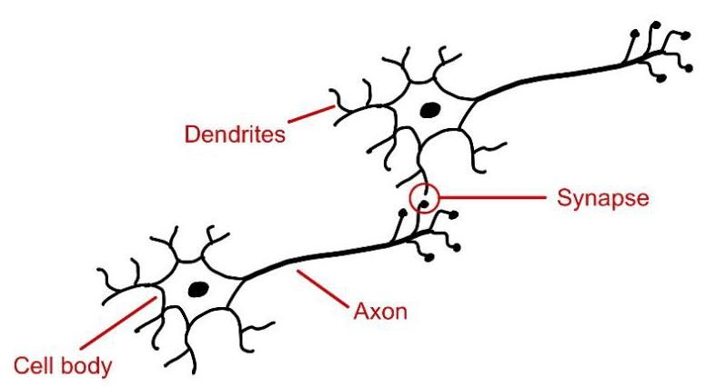

Figure 1.12 Schematic illustration showing two neurons from the human brain. These electrically active cells communicate through junctions called synapses whose strengths change as the network learns.

图 1.12 显示人脑两个神经元的示意图。这些电活性细胞通过称为突触的连接进行通信，随着网络学习，突触的强度会发生变化。

# 1.3.A Brief History of Machine Learning

# 1.3. 机器学习简史

Machine learning has a long and rich history, including the pursuit of multiple alternative approaches. Here we focus on the evolution of machine learning methods based on neural networks as these represent the foundation of deep learning and have proven to be the most effective approach to machine learning for real-world applications.

机器学习有着悠久而丰富的历史，包括对多种替代方法的探索。在这里，我们专注于基于神经网络的机器学习方法的演变，因为这些方法是深度学习的基础，并且已被证明是现实世界应用中最有效的机器学习方法。

Neural network models were originally inspired by studies of information processing in the brains of humans and other mammals. The basic processing units in the brain are electrically active cells called neurons, as illustrated in Figure 1.12. When a neuron ’fires’, it sends an electrical impulse down the axon where it reaches junctions, called synapses, which form connections with other neurons. Chemical signals called neurotransmitters are released at the synapses, and these can stimulate, or inhibit, the firing of subsequent neurons.

神经网络模型最初受到对人类和其他哺乳动物大脑信息处理研究的启发。大脑中的基本处理单元是具有电活性的细胞，称为神经元，如图 1.12 所示。当一个神经元“放电”时，它会沿着轴突发送电脉冲，到达称为突触的连接点，这些突触与其他神经元形成连接。在突触处会释放称为神经递质的化学信号，这些信号可以刺激或抑制后续神经元的放电。

A human brain contains around 90 billion neurons in total, each of which has on average several thousand synapses with other neurons, creating a complex network having a total of around 100 trillion synapses. If a particular neuron receives sufficient stimulation from the firing of other neurons then it too can be induced to fire. However, some synapses have a negative, or inhibitory, effect whereby the firing of the input neuron makes it less likely that the output neuron will fire. The extent to which one neuron can cause another to fire depends on the strength of the synapse, and it is changes in these strengths that represents a key mechanism whereby the brain can store information and learn from experience.

人类大脑总共包含约 900 亿个神经元，每个神经元平均与其他神经元有数千个突触，形成一个总共约有 100 万亿 个突触的复杂网络。如果某个特定的神经元从其他神经元的放电中接收到足够的刺激，那么它也会被诱导放电。然而，一些突触具有负面或抑制作用，即输入神经元的放电会降低输出神经元放电的可能性。一个神经元促使另一个神经元放电的程度取决于突触的强度，而这些强度的变化代表了大脑存储信息和从经验中学习的关键机制。

These properties of neurons have been captured in very simple mathematical models, known as artificial neural networks, which then form the basis for computational approaches to learning (McCulloch and Pitts, 1943). Many of these models describe the properties of a single neuron by forming a linear combination of the outputs of other neurons, which is then transformed using a nonlinear function. This can be expressed mathematically in the form

神经元的这些特性已被非常简单的数学模型所捕捉，这些模型被称为人工神经网络，它们随后构成了计算学习方法的基础(McCulloch 和 Pitts，1943)。许多这些模型通过形成其他神经元输出的线性组合来描述单个神经元的特性，然后使用非线性函数对其进行变换。这可以用数学形式表示为

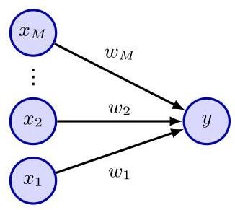

Figure 1.13 A simple neural network diagram representing the transformations (1.5) and (1.6) describing a single neuron. The polynomial function (1.1) can be seen as a special case of this model.

图 1.13 一个简单的神经网络图，代表描述单个神经元的变换 (1.5) 和 (1.6)。多项式函数 (1.1) 可以看作是该模型的一个特例。

where represent inputs corresponding to the activities of other neurons that send connections to this neuron, and are continuous variables, called weights, which represent the strengths of the associated synapses. The quantity is called the pre-activation, the nonlinear function is called the activation function, and the output is called the activation. We can see that the polynomial (1.1) can be viewed as a specific instance of this representation in which the inputs are given by powers of a single variable , and the function is just the identity . The simple mathematical formulation given by (1.5) and (1.6) has formed the basis of neural network models from the 1960s up to the present day, and can be represented in diagram form as shown in Figure 1.13.

其中 表示 输入，这些输入对应于向该神经元发送连接的其他神经元的活动，而 是连续变量，称为权重，它们表示相关突触的强度。量 称为预激活，非线性函数 称为激活函数，输出 称为激活。我们可以看到，多项式 (1.1) 可以看作是这种表示的一个特定实例，其中输入 由单个变量 的幂给出，并且函数 只是恒等函数 。由 (1.5) 和 (1.6) 给出的简单数学公式从 20 世纪 60 年代至今一直是神经网络模型的基础，并且可以用如图 1.13 所示的图表形式表示。

# 1.3.1 Single-layer networks

# 1.3.1 单层网络

The history of artificial neural networks can broadly be divided into three distinct phases according to the level of sophistication of the networks as measured by the number of ’layers’ of processing. A simple neural model described by (1.5) and (1.6) can be viewed as having a single layer of processing corresponding to the single layer of connections in Figure 1.13. One of the most important such models in the history of neural computing is the perceptron (Rosenblatt, 1962) in which the activation function is a step function of the form

人工神经网络的历史大致可以根据处理“层”的数量衡量的网络复杂程度分为三个不同的阶段。由 (1.5) 和 (1.6) 描述的简单神经模型可以看作具有单层处理，对应于图 1.13 中的单层连接。神经计算历史上最重要的此类模型之一是感知机(Rosenblatt，1962)，其中激活函数 是形式为

This can be viewed as a simplified model of neural firing in which a neuron fires if, and only if, the total weighted input exceeds a threshold of 0 . The perceptron was pioneered by Rosenblatt (1962), who developed a specific training algorithm that has the interesting property that if there exists a set of weight values for which the perceptron can achieve perfect classification of its training data then the algorithm is guaranteed to find the solution in a finite number of steps (Bishop, 2006). As well as a learning algorithm, the perceptron also had a dedicated analogue hardware implementation, as shown in Figure 1.14. A typical perceptron configuration had multiple layers of processing, but only one of those layers was learnable from data, and so the perceptron is considered to be a ’single-layer’ neural network.

这可以看作是神经放电的简化模型，其中一个神经元当且仅当总加权输入超过阈值 0 时才会放电。感知机由 Rosenblatt(1962)开创，他开发了一种特定的训练算法，该算法具有一个有趣的性质:如果存在一组权重值使得感知机能够对其训练数据进行完美分类，那么该算法保证能在有限步骤内找到解决方案(Bishop，2006)。除了学习算法，感知机还有专门的模拟硬件实现，如图 1.14 所示。典型的感知机构型有多层处理，但只有其中一层可以从数据中学习，因此感知机被认为是“单层”神经网络。

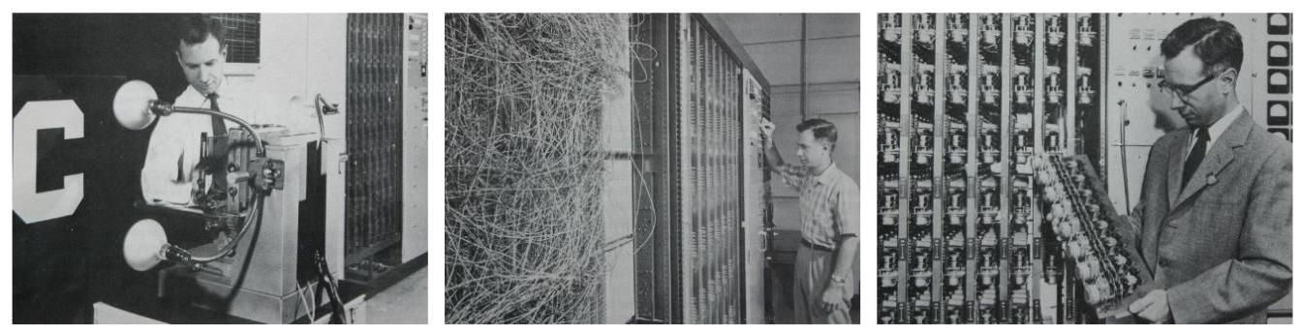

Figure 1.14 Illustration of the Mark 1 perceptron hardware. The photograph on the left shows how the inputs were obtained using a simple camera system in which an input scene, in this case a printed character, was illuminated by powerful lights, and an image focused onto a array of cadmium sulphide photocells, giving a primitive 400-pixel image. The perceptron also had a patch board, shown in the middle photograph, which allowed different configurations of input features to be tried. Often these were wired up at random to demonstrate the ability of the perceptron to learn without the need for precise wiring, in contrast to a modern digital computer. The photograph on the right shows one of the racks of learnable weights. Each weight was implemented using a rotary variable resistor, also called a potentiometer, driven by an electric motor thereby allowing the value of the weight to be adjusted automatically by the learning algorithm.

图 1.14 Mark 1 感知机硬件示意图。左边的照片展示了如何使用简单的相机系统获取输入，在该系统中，输入场景(在这种情况下是一个印刷字符)被强光照射，图像聚焦到 硫化镉光电管阵列上，得到一个原始的 400 像素图像。感知机还有一个接线板，如中间照片所示，它允许尝试不同的输入特征配置。通常这些接线是随机连接的，以展示感知机无需精确接线就能学习的能力，这与现代数字计算机形成对比。右边的照片展示了可学习权重的机架之一。每个权重使用旋转可变电阻器(也称为电位计)实现，由电动机驱动，从而允许学习算法自动调整权重值。

At first, the ability of perceptrons to learn from data in a brain-like way was considered remarkable. However, it became apparent that the model also has major limitations. The properties of perceptrons were analysed by Minsky and Papert (1969), who gave formal proofs of the limited capabilities of single-layer networks. Unfortunately, they also speculated that similar limitations would extend to networks having multiple layers of learnable parameters. Although this latter conjecture proved to be wildly incorrect, the effect was to dampen enthusiasm for neural network models, and this contributed to the lack of interest, and funding, for neural networks during the 1970s and early 1980s. Furthermore, researchers were unable to explore the properties of multilayered networks due to the lack of an effective algorithm for training them, since techniques such as the perceptron algorithm were specific to single-layer models. Note that although perceptrons have long disappeared from practical machine learning, the name lives on because a modern neural network is also sometimes called a multilayer perceptron or MLP.

起初，感知机以类似大脑的方式从数据中学习的能力被认为非常了不起。然而，很明显该模型也有重大局限性。Minsky 和 Papert(1969)分析了感知机的性质，他们正式证明了单层网络的能力有限。不幸的是，他们还推测类似的局限性也会扩展到具有多层可学习参数的网络。尽管后一个猜想被证明是大错特错的，但这一影响抑制了人们对神经网络模型的热情，这导致了 20 世纪 70 年代和 80 年代初人们对神经网络缺乏兴趣和资金投入。此外，由于缺乏有效的训练算法，研究人员无法探索多层网络的性质，因为诸如感知机算法之类的技术仅适用于单层模型。请注意，尽管感知机早已从实际机器学习中消失，但这个名称仍然存在，因为现代神经网络有时也被称为多层感知机或 MLP。

# 1.3.2 Backpropagation

# 1.3.2 反向传播

The solution to the problem of training neural networks having more than one layer of learnable parameters came from the use of differential calculus and the application of gradient-based optimization methods. An important change was to replace the step function (1.7) with continuous differentiable activation functions having a non-zero gradient. Another key modification was to introduce differentiable error functions that define how well a given choice of parameter values predicts the target variables in the training set. We saw an example of such an error function when we form of the model or the way it is trained.

训练具有多层可学习参数的神经网络问题的解决方案来自于微积分的运用以及基于梯度的优化方法的应用。一个重要的改变是用具有非零梯度的连续可微激活函数取代阶跃函数(1.7)。另一个关键修改是引入可微误差函数，这些函数定义了给定的参数值选择在多大程度上能够预测训练集中的目标变量。当我们讨论模型的形式或训练方式时，我们看到了这样一个误差函数的例子。

|  |  |  |
| --- | --- | --- |
| Figure 1.15 | A neural network having two lay- ers of parameters in which arrows denote the direction of information flow through the network. Each of the hidden units and each of the output units computes a function of the form given by (1.5) and (1.6) in which the activation function is differentiable. | hidden units image |
| Section 1.2.3 | used the sum-of-squares error function (1.2) to fit polynomials. With these changes, we now have an error function whose derivatives with re- spect to each of the parameters in the network can be evaluated. We can now consider networks having more than one layer of parameters. Figure 1.15 shows a simple net- work with two processing layers. Nodes in the middle layer called hidden units because their values do not appear in the training set, which only provides values for inputs and outputs. Each of the hidden units and each of the output units in Figure 1.15 computes a function of the form given by (1.5) and (1.6). For a given set of input values, the states of all of the hidden and output units can be evaluated by repeated application of (1.5) and (1.6) in which information is flowing forward through the network in the direction of the arrows. For this reason, such models are sometimes also called feed-forward neural networks. To train such a network the parameters are first initialized using a random num- ber generator and are then iteratively updated using gradient-based optimization techniques. This involves evaluating the derivatives of the error function, which | |
| Chapter 8 Chapter 7 | as stochastic gradient descent. | can be done efficiently in a process known as error backpropagation. In backpropa- gation, information flows backwards through the network from the outputs towards the inputs (Rumelhart, Hinton, and Williams, 1986). There exist many different op- timization algorithms that make use of gradients of the function to be optimized, but the one that is most prevalent in machine learning is also the simplest and is known The ability to train neural networks having multiple layers of weights was a breakthrough that led to a resurgence of interest in the field starting around the mid- 1980s. This was also a period in which the field moved beyond a focus on neurobio- logical inspiration and developed a more rigorous and principled foundation (Bishop, 1995b). In particular, it was recognized that probability theory, and ideas from the field of statistics, play a central role in neural networks and machine learning. One key insight is that learning from data involves background assumptions, sometimes called prior knowledge or inductive biases. These might be incorporated explicitly, for example by designing the structure of a neural network such that the classifica- tion of a skin lesion does not depend on the location of the lesion within the image, or they might take the form of implicit assumptions that arise from the mathematical |
| 图 1.15 | 一个具有两层参数的神经网络，其中箭头表示信息在网络中的流动方向。每个隐藏单元和每个输出单元都计算由 (1.5) 和 (1.6) 给出形式的函数，其中激活函数 是可微的。 | 隐藏单元 image |
| 第 1.2.3 节 | 使用平方和误差函数 (1.2) 来拟合多项式。有了这些变化，我们现在有了一个误差函数，其关于网络中每个参数的导数可以被计算。我们现在可以考虑具有多层参数的网络。图 1.15 展示了一个具有两个处理层的简单网络。中间层的节点被称为隐藏单元，因为它们的值不出现在训练集中，训练集仅提供输入和输出的值。图 1.15 中的每个隐藏单元和每个输出单元都计算由 (1.5) 和 (1.6) 给出形式的函数。对于给定的一组输入值，所有隐藏单元和输出单元的状态可以通过重复应用 (1.5) 和 (1.6) 来计算，其中信息沿着箭头方向在网络中向前流动。出于这个原因，这样的模型有时也被称为前馈神经网络。为了训练这样的网络，首先使用随机数生成器初始化参数，然后使用基于梯度的优化技术迭代更新这些参数。这涉及计算误差函数的导数， | |
| 第 8 章 第 7 章 | 即随机梯度下降。 | 可以在被称为误差反向传播的过程中高效完成。在反向传播中，信息通过网络从输出端向输入端反向流动(Rumelhart、Hinton 和 Williams，1986 年)。存在许多不同的优化算法，它们利用待优化函数的梯度，但机器学习中最常用的也是最简单的一种，被称为能够训练具有多层权重的神经网络是一项突破，这导致从 20 世纪 80 年代中期左右开始，该领域的研究兴趣再度兴起。这也是该领域超越对神经生物学启发的关注，并发展出更严谨、更有原则的基础的时期(Bishop，1995b)。特别是，人们认识到概率论以及统计学领域的思想在神经网络和机器学习中起着核心作用。一个关键的见解是，从数据中学习涉及背景假设，有时被称为先验知识或归纳偏差。这些假设可以被明确纳入，例如通过设计神经网络的结构，使得皮肤病变的分类不依赖于病变在图像中的位置，或者它们可能以从数学中产生的隐含假设的形式存在 |

The development of backpropagation and gradient-based optimization dramatically increased the capability of neural networks to solve practical problems. However, it was also observed that in networks with many layers, it was only weights in the final two layers that would learn useful values. With a few exceptions, notably models used for image analysis known as convolutional neural networks (LeCun et al., 1998), there were very few successful applications of networks having more than two layers. Again, this constrained the complexity of the problems that could be addressed effectively with these kinds of network. To achieve reasonable performance on many applications, it was necessary to use hand-crafted pre-processing to transform the input variables into some new space where, it was hoped, the machine learning problem would be easier to solve. This pre-processing stage is sometimes also called feature extraction. Although this approach was sometimes effective, it would clearly be much better if features could be learned from the data rather than being hand-crafted.

反向传播和基于梯度的优化方法的发展极大地提升了神经网络解决实际问题的能力。然而，人们也注意到，在多层网络中，只有最后两层的权重能够学习到有用的值。除了少数例外，特别是被称为卷积神经网络的用于图像分析的模型(LeCun 等人，1998)，层数超过两层的网络成功应用案例非常少。这再次限制了这些类型网络能够有效解决的问题的复杂性。为了在许多应用中取得合理的性能，有必要使用手工设计的预处理方法将输入变量转换到一个新的空间，期望在这个空间中机器学习问题更容易解决。这个预处理阶段有时也被称为特征提取。尽管这种方法有时是有效的，但如果能够从数据中学习特征而不是手工设计，显然会更好。

Chapter 10

第 10 章

By the start of the new millennium, the available neural network methods were once again reaching the limits of their capability. Researchers began to explore a raft of alternatives to neural networks, such as kernel methods, support vector machines, Gaussian processes, and many others. Neural networks fell into disfavour once again, although a core of enthusiastic researchers continued to pursue the goal of a truly effective approach to training networks with many layers.

到新千年开始时，现有的神经网络方法再次达到了其能力的极限。研究人员开始探索一系列神经网络的替代方法，如核方法、支持向量机、高斯过程等等。神经网络再次失宠，尽管一群热情的研究人员继续追求一种真正有效的方法来训练多层网络的目标。

# 1.3.3 Deep networks

# 1.3.3 深度网络

The third, and current, phase in the development of neural networks began during the second decade of the 21st century. A series of developments allowed neural networks with many layers of weights to be trained effectively, thereby removing previous limitations on the capabilities of these techniques. Networks with many layers of weights are called deep neural networks and the sub-field of machine learning that focuses on such networks is called deep learning (LeCun, Bengio, and Hinton, 2015).

神经网络发展的第三个也是当前的阶段始于 21 世纪的第二个十年。一系列的发展使得具有多层权重的神经网络能够被有效训练，从而消除了这些技术先前的能力限制。具有多层权重的网络被称为深度神经网络，专注于此类网络的机器学习子领域被称为深度学习(LeCun、Bengio 和 Hinton，2015)。

One important theme in the origins of deep learning was a significant increase in the scale of neural networks, measured in terms of the number of parameters. Although networks with a few hundred or a few thousand parameters were common in the 1980s, this steadily rose to the millions, and then billions, whereas current state-of-the-art models can have in the region of one trillion (10 ) parameters. Networks with many parameters require commensurately large data sets so that the training signals can produced good values for those parameters. The combination of massive models and massive data sets in turn requires computation on a massive scale when training the model. Specialist processors called graphics processing units, or GPUs, which had been developed for very fast rendering of graphical data for applications such as video games, proved to be well suited to the training of neural networks because the functions computed by the units in one layer of a network can be evaluated in parallel, and this maps well onto the massive parallelism of GPUs (Krizhevsky, Sutskever, and Hinton, 2012). Today, training for the largest models is performed on large arrays of thousands of GPUs linked by specialist high-speed interconnections.

深度学习起源中的一个重要主题是神经网络规模(以参数数量衡量)的显著增加。尽管在 20 世纪 80 年代，具有几百或几千个参数的网络很常见，但这个数字稳步上升到数百万，然后是数十亿，而目前最先进的模型可能有大约一万亿(10 )个参数。具有大量参数的网络需要相应的大规模数据集，以便训练信号能够为这些参数产生良好的值。大规模模型和大规模数据集的结合反过来又要求在训练模型时进行大规模计算。被称为图形处理单元(GPU)的专用处理器最初是为视频游戏等应用快速渲染图形数据而开发的，事实证明它非常适合神经网络的训练，因为网络一层中的单元所计算的函数可以并行评估，这与 GPU 的大规模并行性非常匹配(Krizhevsky、Sutskever 和 Hinton，2012)。如今，最大模型的训练是在由数千个通过专用高速互连连接的 GPU 组成的大型阵列上进行的。

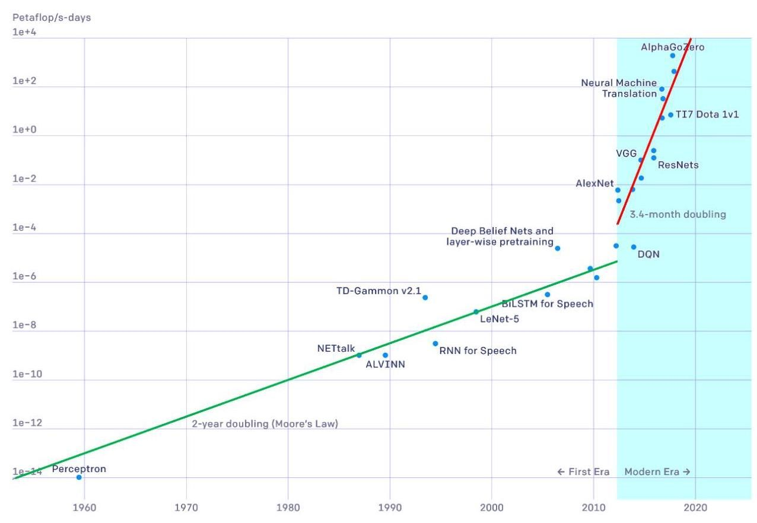

Figure 1.16 Plot of the number of compute cycles, measured in petaflop/s-days, needed to train a state-of-the-art neural network as a function of date, showing two distinct phases of exponential growth. [From OpenAI with permission.]

图 1.16 绘制了训练最先进的神经网络所需的计算周期数(以千万亿次浮点运算每秒 - 天为单位)随日期的变化情况，显示出两个不同的指数增长阶段。[经 OpenAI 许可使用。]

Figure 1.16 illustrates how the number of compute cycles needed to train a state-of-the-art neural network has grown over the years, showing two distinct phases of growth. The vertical axis has an exponential scale and has units of petaflop/s-days, where a petaflop represents (a thousand trillion) floating point operations, and a petaflop/s is one petaflop per second. One petaflop/s-day represents computation at the rate of a petaflop/s for a period of 24 hours, which is roughly floating point operations, and therefore, the top line of the graph represents an impressive 10 floating point operations. A straight line on the graph represents exponential growth, and we see that from the era of the perceptron up to around 2012, the doubling time was around 2 years, which is consistent with the general growth of computing power as a consequence of Moore’s law. From 2012 onward, which marks the era of deep learning, we again see exponential growth but the doubling time is now 3.4 months corresponding to a factor of 10 increase in compute power every year!

图 1.16 展示了多年来训练最先进的神经网络所需的计算周期数是如何增长的，呈现出两个不同的增长阶段。纵轴采用指数刻度，单位为千万亿次浮点运算每秒 - 天，其中千万亿次浮点运算表示 (一千万亿)次浮点运算，而千万亿次浮点运算每秒是指每秒进行一千万亿次浮点运算。一个千万亿次浮点运算每秒 - 天表示以千万亿次浮点运算每秒的速率进行 24 小时的计算，大约是 次浮点运算，因此，图中的顶线代表了令人印象深刻的 10 次浮点运算。图中的直线表示指数增长，我们可以看到，从感知机时代到 2012 年左右，翻倍时间约为 2 年，这与摩尔定律导致的计算能力的总体增长相一致。从 2012 年开始，即深度学习时代，我们再次看到指数增长，但现在的翻倍时间为 3.4 个月，相当于计算能力每年增长 10 倍！

It is often found that improvements in performance due to innovations in the architecture or incorporation of more sophisticated forms of inductive bias are soon

人们常常发现，由于架构创新或引入更复杂的归纳偏置形式而带来的性能提升很快就会......

|  |  |
| --- | --- |
| Section 12.3.5 that is semantically meaningful thereby creating a much easier problem for the final layer or layers to solve. Such internal representations can be repurposed to allow for the solution of related problems through transfer learning, as we saw for skin lesion classification. It is interesting to note that neural networks used to process images | superseded simply by scaling up the quantity of training data, along with commen- surate scaling of the model size and associated compute power used for training (Sutton, 2019). Not only can large models have superior performance on a specific task but they may be capable of solving a broader range of different problems with the same trained neural network. Large language models are a notable example as a single network not only has an extraordinary breadth of capability but is even able to outperform specialist networks designed to solve specific problems. We have seen that depth plays an important role in allowing neural networks to achieve high performance. One way to view the role of the hidden layers in a deep neural network is that of representation learning (Bengio, Courville, and Vincent, 2012) in which the network learns to transform input data into a new representation |
| Section 10.3 | may learn internal representations that are remarkably like those observed in the mammalian visual cortex. Large neural networks that can be adapted or fine-tuned to a range of downstream tasks are called foundation models, and can take advan- tage of large, heterogeneous data sets to create models having broad applicability (Bommasani et al., 2021). In addition to scaling, there were other developments that helped in the suc- cess of deep learning. For example, in simple neural networks, the training signals become weaker as they are backpropagated through successive layers of a deep net- |
| Section 9.5 | work. One technique for addressing this is the introduction of residual connections (He et al., 2015a) that facilitate the training of networks having hundreds of layers. Another key development was the introduction of automatic differentiation methods in which the code that performs backpropagation to evaluate error function gradients is generated automatically from the code used to specify the forward propagation. This allows researchers to experiment rapidly with different architectures for a neural network and to combine different architectural elements in multiple ways very easily since only the relatively simple forward propagation functions need to be coded ex- plicitly. Also, much of the research in machine learning has been conducted through open source, allowing researchers to build on the work of others, thereby further accelerating the rate of progress in the field. |
| 第12.3.5节提到，这种在语义上有意义的表示方式，为最后一层或多层解决问题创造了更简单的条件。正如我们在皮肤病变分类中所看到的，通过迁移学习，这种内部表示可以被重新利用，以解决相关问题。值得注意的是，用于处理图像的神经网络 | 仅仅通过增加训练数据的数量，以及相应地扩大模型规模和用于训练的计算能力，就可以被超越(Sutton，2019)。大型模型不仅在特定任务上可能表现更优，而且还能够使用同一个经过训练的神经网络解决更广泛的不同问题。大语言模型就是一个显著的例子，因为单个网络不仅具有非凡的能力广度，甚至能够超越专门为解决特定问题而设计的专业网络。我们已经看到，深度在使神经网络实现高性能方面起着重要作用。看待深度神经网络中隐藏层作用的一种方式是将其视为表示学习(Bengio、Courville和Vincent，2012)，在这种学习中，网络学习将输入数据转换为一种新的表示 |
| 第10.3节 | 可能学习到与哺乳动物视觉皮层中观察到的表示非常相似的内部表示。能够适应或微调以用于一系列下游任务的大型神经网络被称为基础模型，它们可以利用大型、异构数据集来创建具有广泛适用性的模型(Bommasani等人，2021)。除了扩展规模之外，还有其他一些发展有助于深度学习的成功。例如，在简单的神经网络中，训练信号在通过深度网络的连续层进行反向传播时会变弱 |
| 第9.5节 | 。解决这个问题的一种技术是引入残差连接(He等人，2015a)，它有助于训练具有数百层的网络。另一个关键的发展是引入了自动微分方法，在这种方法中，用于执行反向传播以评估误差函数梯度的代码是从用于指定前向传播的代码自动生成的。这使得研究人员能够快速尝试不同的神经网络架构，并非常容易地以多种方式组合不同的架构元素，因为只需要显式地编写相对简单的前向传播函数。此外，机器学习领域的许多研究都是通过开源进行的，这使得研究人员能够在他人的工作基础上进行研究，从而进一步加快了该领域的进展速度。 |

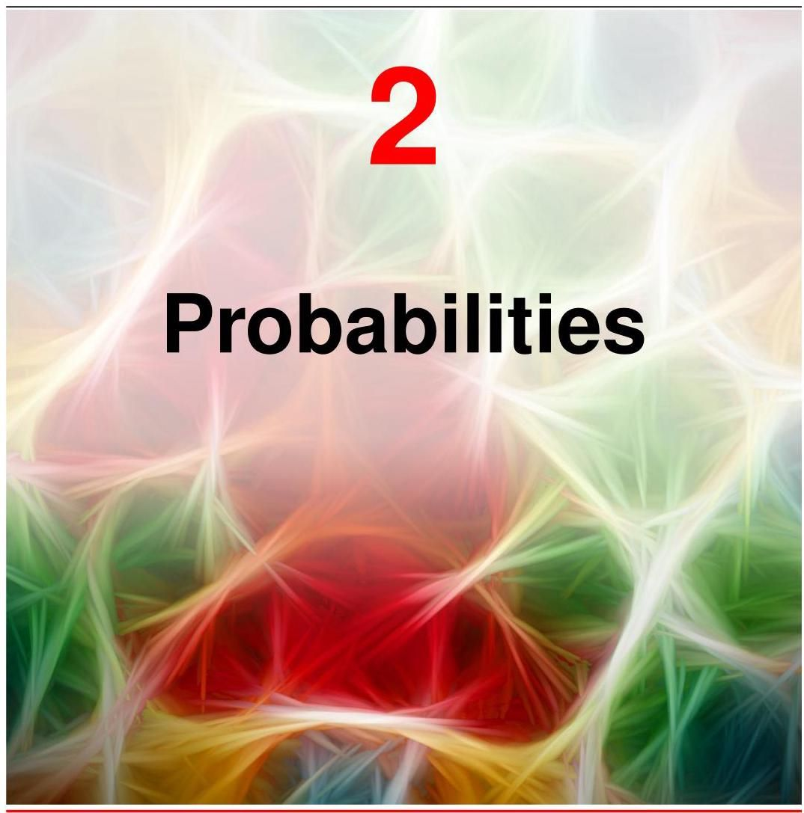

In almost every application of machine learning we have to deal with uncertainty. For example, a system that classifies images of skin lesions as benign or malignant can never in practice achieve perfect accuracy. We can distinguish between two kinds of uncertainty. The first is epistemic uncertainty (derived from the Greek word episteme meaning knowledge), sometimes called systematic uncertainty. It arises because we only get to see data sets of finite size. As we observe more data, for instance more examples of benign and malignant skin lesion images, we are better able to predict the class of a new example. However, even with an infinitely large data set, we would still not be able to achieve perfect accuracy due to the second kind of uncertainty known as aleatoric uncertainty, also called intrinsic or stochastic uncertainty, or sometimes simply called noise. Generally speaking, the noise arises because we are able to observe only partial information about the world, and therefore, one way to reduce this source of uncertainty is to gather different kinds of data. This is illustrated

在机器学习的几乎所有应用中，我们都必须处理不确定性。例如，一个将皮肤病变图像分类为良性或恶性的系统在实践中永远无法达到完美的准确率。我们可以区分两种类型的不确定性。第一种是认知不确定性(源自希腊语 episteme，意为知识)，有时也称为系统不确定性。它的产生是因为我们只能看到有限大小的数据集。例如，当我们观察到更多良性和恶性皮肤病变图像的示例时，我们就能更好地预测新示例的类别。然而，即使有一个无限大的数据集，由于第二种不确定性，即偶然不确定性(也称为内在或随机不确定性，有时简称为噪声)，我们仍然无法达到完美的准确率。一般来说，噪声的产生是因为我们只能观察到关于世界的部分信息，因此，减少这种不确定性来源的一种方法是收集不同类型的数据。这一点在

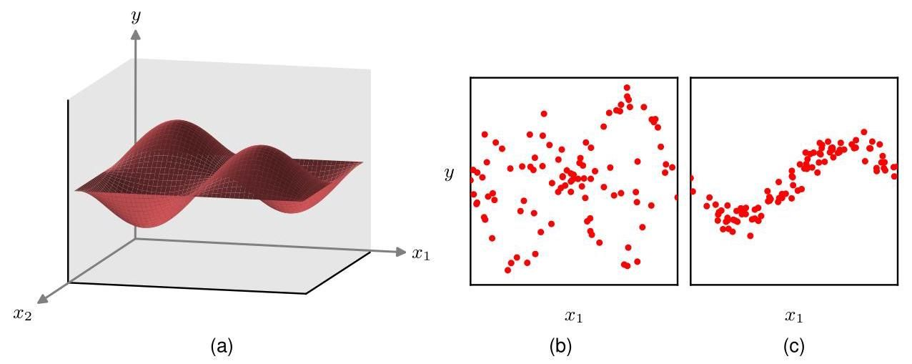

Figure 2.1 An extension of the simple sine curve regression problem to two dimensions. (a) A plot of the function . Data is generated by selecting values for and , computing the corresponding value of , and then adding Gaussian noise. (b) Plot of 100 data points in which is unobserved showing high levels of noise. (c) Plot of 100 data points in which is fixed to the value , simulating the effect of being able to measure as well as , showing much lower levels of noise.

图 2.1 简单正弦曲线回归问题向二维的扩展。(a) 函数 的绘图。通过选择 和 的值，计算 的相应值，然后添加高斯噪声来生成数据。(b) 100 个数据点的绘图，其中 未被观察到，显示出高水平的噪声。(c) 100 个数据点的绘图，其中 固定为值 ，模拟了能够同时测量 和 的效果，显示出低得多的噪声水平。

Section 1.2 using an extension of the sine curve example to two dimensions in Figure 2.1.

第 1.2 节通过图 2.1 中将正弦曲线示例扩展到二维的方式进行了说明。

As a practical example of this, a biopsy sample of the skin lesion is much more informative than the image alone and might greatly improve the accuracy with which we can determine if a new lesion is malignant. Given both the image and the biopsy data, the intrinsic uncertainty might be very small, and by collecting a large training data set, we may be able to reduce the systematic uncertainty to a low level and thereby make predictions of the class of the lesion with high accuracy.

作为一个实际例子，皮肤病变的活检样本比单独的图像提供的信息要多得多，并且可能会大大提高我们确定新病变是否为恶性的准确率。同时拥有图像和活检数据时，内在不确定性可能会非常小，并且通过收集大量的训练数据集，我们可能能够将系统不确定性降低到较低水平，从而高精度地预测病变的类别。

Both kinds of uncertainty can be handled using the framework of probability theory, which provides a consistent paradigm for the quantification and manipulation of uncertainty and therefore forms one of the central foundations for machine learning. We will see that probabilities are governed by two simple formulae known as the sum rule and the product rule. When coupled with decision theory, these rules allow us, at least in principle, to make optimal predictions given all the information available to us, even though that information may be incomplete or ambiguous.

这两种不确定性都可以使用概率论的框架来处理，概率论为不确定性的量化和处理提供了一个一致的范式，因此构成了机器学习的核心基础之一。我们将看到，概率由两个简单的公式控制，即求和规则和乘积规则。当与决策理论相结合时，这些规则至少在原则上允许我们在给定所有可用信息的情况下做出最优预测，即使这些信息可能不完整或模糊不清。

Section 2.1

第 2.1 节

Section 5.2

5.2 节

The concept of probability is often introduced in terms of frequencies of repeatable events. Consider, for example, the bent coin shown in Figure 2.2, and suppose that the shape of the coin is such that if it is flipped a large number of times, it lands concave side up 60% of the time, and therefore lands convex side up 40% of the time. We say that the probability of landing concave side up is 60% or 0.6 . Strictly, the probability is defined in the limit of an infinite number of ’trials’ or coin flips in this case. Because the coin must land either concave side up or convex side up, these probabilities add to 100% or 1.0. This definition of probability in terms of the frequency of repeatable events is the basis for the frequentist view of statistics.

概率的概念通常是根据可重复事件的频率来引入的。例如，考虑图 2.2 中所示的弯曲硬币，假设硬币的形状使得如果将其抛掷大量次数，它有 60%的时间凹面朝上，因此有 40%的时间凸面朝上。我们说凹面朝上的概率是 60%或 0.6。严格来说，在这种情况下，概率是在无限多次“试验”或硬币抛掷的极限情况下定义的。因为硬币要么凹面朝上，要么凸面朝上，所以这些概率之和为 100%或 1.0。这种根据可重复事件的频率来定义概率的方法是频率主义统计学观点的基础。

Now suppose that, although we know that the probability that the coin will land concave side up is 0.6, we are not allowed to look at the coin itself and we do not

现在假设，尽管我们知道硬币凹面朝上的概率是 0.6，但我们不被允许看硬币本身，而且我们也不

Figure 2.2 know which side is heads and which is tails. If asked to take a bet on whether the coin will land heads or tails when flipped, then symmetry suggests that our bet should be based on the assumption that the probability of seeing heads is 0.5, and indeed a more careful analysis shows that, in the absence of any additional information, this is indeed the rational choice. Here we are using probabilities in a more general sense than simply the frequency of events. Whether the convex side of the coin is heads or tails is not itself a repeatable event, it is simply unknown. The use of probability as a quantification of uncertainty is the Bayesian perspective and is more general in that it includes frequentist probability as a special case. We can learn about which side of the coin is heads if we are given results from a sequence of coin flips by making use of Bayesian reasoning. The more results we observe, the lower our uncertainty as to which side of the coin is which.

图 2.2 知道哪一面是正面，哪一面是反面。如果被要求对硬币抛掷时是正面朝上还是反面朝上进行下注，那么根据对称性，我们的下注应该基于正面出现的概率为 0.5 这一假设，而且更仔细的分析表明，在没有任何额外信息的情况下，这确实是合理的选择。在这里，我们使用概率的意义比单纯的事件频率更广泛。硬币的凸面是正面还是反面本身并不是一个可重复的事件，它只是未知的。将概率用作不确定性的量化是贝叶斯观点，并且更具一般性，因为它将频率主义概率作为一种特殊情况包含在内。如果我们得到一系列硬币抛掷的结果，我们可以通过使用贝叶斯推理来了解硬币的哪一面是正面。我们观察到的结果越多，我们对硬币哪一面是哪一面的不确定性就越低。

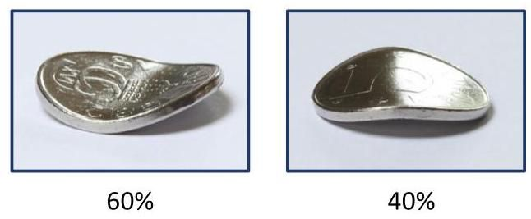

2 Probability can be viewed either as a frequency associated with a repeatable event or as a quantification of uncertainty. A bent coin can be used to illustrate the difference, as discussed in the text.

2 概率既可以被视为与可重复事件相关的频率，也可以被视为不确定性的量化。如文中所讨论的，弯曲的硬币可以用来阐明这种区别。

Section 2.6

2.6 节

Exercise 2.40

练习 2.40

Having introduced the concept of probability informally, we turn now to a more detailed exploration of probabilities and discuss how to use them quantitatively. Concepts developed in the remainder of this chapter will form a core foundation for many of the topics discussed throughout the book.

在非正式地引入了概率的概念之后，我们现在转向对概率进行更详细的探讨，并讨论如何定量地使用它们。本章其余部分所阐述的概念将为本书中讨论的许多主题奠定核心基础。

# 2.1.The Rules of Probability

# 2.1. 概率规则

In this section we will derive two simple rules that govern the behaviour of probabilities. However, in spite of their apparent simplicity, these rules will prove to be very powerful and widely applicable. We will motivate the rules of probability by first introducing a simple example.

在本节中，我们将推导出两条支配概率行为的简单规则。然而，尽管这些规则看似简单，但事实将证明它们非常强大且应用广泛。我们将首先通过引入一个简单的例子来引出概率规则。

# 2.1.1 A medical screening example

# 2.1.1 一个医学筛查示例

Consider the problem of screening a population in order to provide early detection of cancer, and let us suppose that 1% of the population actually have cancer. Ideally our test for cancer would give a positive result for anyone who has cancer and a negative result for anyone who does not. However, tests are not perfect, so we will suppose that when the test is given to people who are free of cancer, 3% of them will test positive. These are known as false positives. Similarly, when the test is given to people who do have cancer, 10% of them will test negative. These are called false negatives. The various error rates are illustrated in Figure 2.3.

考虑对人群进行筛查以实现癌症早期检测的问题，假设该人群中有 1% 的人实际患有癌症。理想情况下，我们的癌症检测对于任何患有癌症的人都会给出阳性结果，对于任何未患癌症的人都会给出阴性结果。然而，检测并非完美无缺，因此我们假设，当对未患癌症的人进行检测时，其中 3% 的人检测结果会呈阳性。这些被称为假阳性。同样，当对患有癌症的人进行检测时，其中 10% 的人检测结果会呈阴性。这些被称为假阴性。各种错误率如图 2.3 所示。

Given this information, we might ask the following questions: (1) ‘If we screen the population, what is the probability that someone will test positive?’, (2) ’If someone receives a positive test result, what is the probability that they actually have cancer?’. We could answer such questions by working through the cancer screening case in detail. Instead, however, we will pause our discussion of this specific example and first derive the general rules of probability, known as the sum rule of probability and the product rule. We will then illustrate the use of these rules by answering our two questions.

根据这些信息，我们可能会提出以下问题:(1)“如果我们对人群进行筛查，某人检测呈阳性的概率是多少？”(2)“如果某人检测结果呈阳性，他们实际患有癌症的概率是多少？”我们可以通过详细分析癌症筛查案例来回答这些问题。然而，我们将暂停对这个具体例子的讨论，首先推导概率的一般规则，即概率的加法规则和乘法规则。然后，我们将通过回答这两个问题来说明这些规则的应用。

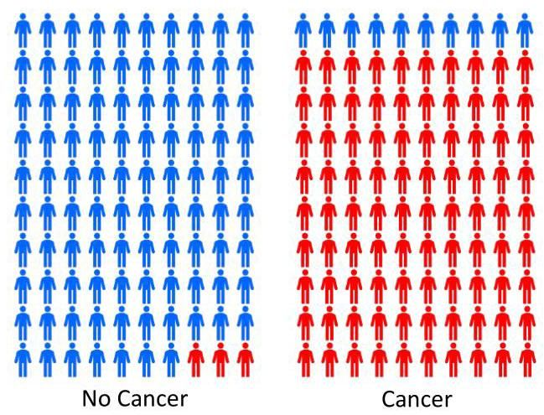

Figure 2.3 Illustration of the accuracy of a cancer test. Out of every hundred people taking the test who do not have cancer, shown on the left, on average three will test positive. For those who have cancer, shown on the right, out of every hundred people taking the test, on average 90 will test positive.

图 2.3 癌症检测准确性的说明。在左侧所示的每一百名接受检测但未患癌症的人中，平均有三人检测呈阳性。对于右侧所示的患有癌症的人，每一百名接受检测的人中，平均有 90 人检测呈阳性。

# 2.1.2 The sum and product rules

# 2.1.2 加法规则和乘法规则

To derive the rules of probability, consider the slightly more general example shown in Figure 2.4 involving two variables and . In our cancer example, could represent the presence or absence of cancer, and could be a variable denoting the outcome of the test. Because the values of these variables can vary from one person to another in a way that is generally unknown, they are called random variables or stochastic variables. We will suppose that can take any of the values where and that can take the values where . Consider a total of trials in which we sample both of the variables and , and let the number of such trials in which and be . Also, let the number of trials in which takes the value (irrespective of the value that takes) be denoted by , and similarly let the number of trials in which takes the value be denoted by .

为了推导概率规则，考虑图 2.4 中所示的稍微更一般的例子，涉及两个变量 和 。在我们的癌症例子中， 可以表示是否患有癌症， 可以是一个表示检测结果的变量。由于这些变量的值在不同人之间的变化方式通常是未知的，它们被称为随机变量或随机变量。我们假设 可以取任何 的值，其中 ，并且 可以取 的值，其中 。考虑总共进行 次试验，在这些试验中我们同时对变量 和 进行采样，并且让 和 同时出现的试验次数为 。此外，让 取 值(无论 取何值)的试验次数用 表示，类似地，让 取 值的试验次数用 表示。

The probability that will take the value and will take the value is written and is called the joint probability of and . It is given by the number of points falling in the cell as a fraction of the total number of points, and hence

取 值且 取 值的概率写作 ，并称为 和 的联合概率。它由落在单元格 中的点数占总点数的比例给出，因此

Here we are implicitly considering the limit . Similarly, the probability that takes the value irrespective of the value of is written as and is

这里我们隐含地考虑极限 。类似地， 取 值而不考虑 值的概率写作 ，并且是

Figure 2.4 We can derive the sum and product rules of probability by considering a random variable , which takes the values where , and a second random variable , which takes the values where . In this illustration, we have and . If we consider the total number of instances of these variables, then we denote the number of instances where and by , which is the number of instances in the corresponding cell of the array. The number of instances in column , corresponding to , is denoted by , and the number of instances in row , corresponding to , is denoted by . given by the fraction of the total number of points that fall in column , so that

图 2.4 我们可以通过考虑一个随机变量 来推导概率的加法规则和乘法规则，该随机变量取值为 ，其中 ，以及第二个随机变量 ，其取值为 ，其中 。在这个示例中，我们有 和 。如果我们考虑这些变量的实例总数 ，那么我们用 表示 且 的实例数量，这是数组中相应单元格的实例数量。对应于 的列 中的实例数量用 表示，对应于 的行 中的实例数量用 表示。由落在列 中的点的总数的比例给出，因此

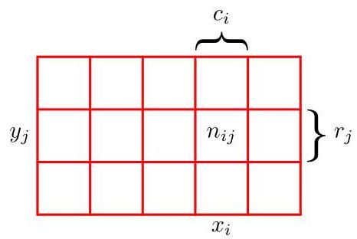

Since , we see that

由于 ，我们可以看到

and, hence, the probabilities sum to one as required. Because the number of instances in column in Figure 2.4 is just the sum of the number of instances in each cell of that column, we have and therefore, from (2.1) and (2.2), we have

因此，概率如要求的那样总和为 1。因为图 2.4 中列 的实例数量恰好是该列中每个单元格的实例数量之和，所以我们有 ，因此，根据式(2.1)和式(2.2)，我们得到

which is the sum rule of probability. Note that is sometimes called the marginal probability and is obtained by marginalizing, or summing out, the other variables (in this case ).

这就是概率的加法规则。注意， 有时被称为边缘概率，它是通过对其他变量(在这种情况下是 )进行边缘化或求和得到的。

If we consider only those instances for which , then the fraction of such instances for which is written and is called the conditional probability of given . It is obtained by finding the fraction of those points in column that fall in cell and, hence, is given by

如果我们只考虑 的那些实例，那么在这些实例中 的比例记为 ，并称为在 给定的条件下 的条件概率。它是通过找出列 中落在单元格 中的点的比例得到的，因此由下式给出

Summing both sides over and using , we obtain

对 对等式两边求和，并使用 ，我们得到

showing that the conditional probabilities are correctly normalized. From (2.1), (2.2), and (2.5), we can then derive the following relationship:

表明条件概率已被正确归一化。从 (2.1)、(2.2) 和 (2.5)，我们可以推导出以下关系:

which is the product rule of probability.

这就是概率的乘法规则。

So far, we have been quite careful to make a distinction between a random variable, such as , and the values that the random variable can take, for example . Thus, the probability that takes the value is denoted . Although this helps to avoid ambiguity, it leads to a rather cumbersome notation, and in many cases there will be no need for such pedantry. Instead, we may simply write to denote a distribution over the random variable , or to denote the distribution evaluated for the particular value , provided that the interpretation is clear from the context.

到目前为止，我们一直非常谨慎地区分随机变量(如 )和随机变量所能取的值(例如 )。因此， 取 这个值的概率表示为 。虽然这有助于避免歧义，但会导致符号表示相当繁琐，而且在很多情况下并不需要如此拘泥细节。相反，只要上下文能明确其含义，我们可以简单地用 表示随机变量 的分布，或者用 表示在特定值 处的分布。

With this more compact notation, we can write the two fundamental rules of probability theory in the following form:

使用这种更简洁的符号表示，我们可以将概率论的两个基本规则写成以下形式:

Here is a joint probability and is verbalized as ’the probability of and ’. Similarly, the quantity is a conditional probability and is verbalized as ’the probability of given ’. Finally, the quantity is a marginal probability and is simply ’the probability of ’. These two simple rules form the basis for all of the probabilistic machinery that we will use throughout this book.

这里 是联合概率，表述为 “ 和 的概率”。类似地，量 是条件概率，表述为 “在 给定的条件下 的概率”。最后，量 是边缘概率，简单表述为 “ 的概率”。这两条简单的规则构成了我们在本书中使用的所有概率工具的基础。

# 2.1.3 Bayes’ theorem

# 2.1.3 贝叶斯定理

From the product rule, together with the symmetry property , we immediately obtain the following relationship between conditional probabilities:

根据乘积法则，结合对称性 ，我们可以立即得到条件概率之间的以下关系:

which is called Bayes’ theorem and which plays an important role in machine learning. Note how Bayes’ theorem relates the conditional distribution on the left-hand side of the equation, to the ’reversed’ conditional distribution on the right-hand side. Using the sum rule, the denominator in Bayes’ theorem can be expressed in terms of the quantities appearing in the numerator:

这被称为贝叶斯定理，它在机器学习中起着重要作用。请注意贝叶斯定理是如何将方程左侧的条件分布 与右侧的 “反向” 条件分布 联系起来的。利用求和法则，贝叶斯定理中的分母可以用分子中出现的量来表示:

Thus, we can view the denominator in Bayes’ theorem as being the normalization constant required to ensure that the sum over the conditional probability distribution on the left-hand side of (2.10) over all values of equals one.

因此，我们可以将贝叶斯定理中的分母视为一个归一化常数，用于确保 (2.10) 式左侧的条件概率分布在 的所有取值上的和等于 1。

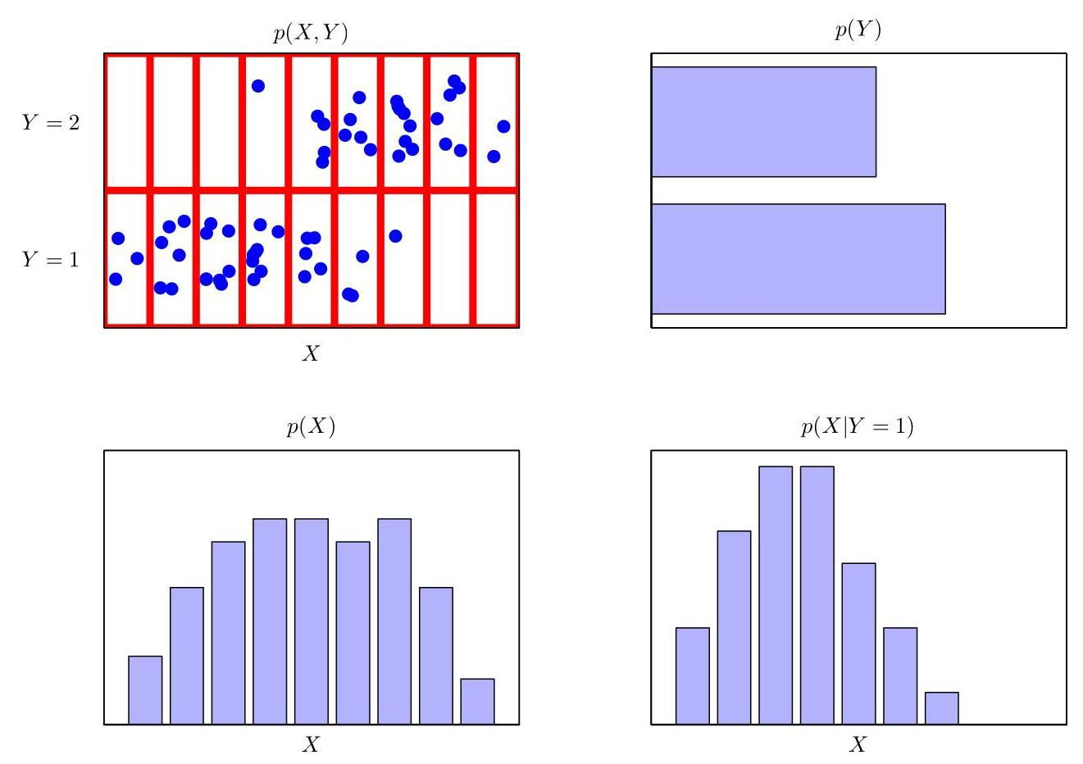

Figure 2.5 An illustration of a distribution over two variables, , which takes nine possible values, and , which takes two possible values. The top left figure shows a sample of 60 points drawn from a joint probability distribution over these variables. The remaining figures show histogram estimates of the marginal distributions and , as well as the conditional distribution corresponding to the bottom row in the top left figure.

图 2.5 展示了两个变量的分布， 有 9 种可能的取值， 有 2 种可能的取值。左上图显示了从这些变量的联合概率分布中抽取的 60 个点的样本。其余的图展示了边缘分布 和 的直方图估计，以及与左上图中底行对应的条件分布 。

In Figure 2.5, we show a simple example involving a joint distribution over two variables to illustrate the concept of marginal and conditional distributions. Here a finite sample of data points has been drawn from the joint distribution and is shown in the top left. In the top right is a histogram of the fractions of data points having each of the two values of . From the definition of probability, these fractions would equal the corresponding probabilities in the limit when the sample size . We can view the histogram as a simple way to model a probability distribution given only a finite number of points drawn from that distribution. The remaining two plots in Figure 2.5 show the corresponding histogram estimates of and .

在图 2.5 中，我们展示了一个涉及两个变量联合分布的简单示例，以说明边缘分布和条件分布的概念。这里从联合分布中抽取了 个数据点的有限样本，并显示在左上方。右上方是具有 的两个值的数据点比例的直方图。根据概率的定义，当样本大小为 时，这些比例将等于相应的概率 。我们可以将直方图视为一种在仅给定从该分布中抽取的有限个点的情况下对概率分布进行建模的简单方法。图 2.5 中的其余两个图展示了 和 的相应直方图估计。

Section 3.5.1

第 3.5.1 节

# 2.1.4 Medical screening revisited

# 2.1.4 重新审视医学筛查

Let us now return to our cancer screening example and apply the sum and product rules of probability to answer our two questions. For clarity, when working through this example, we will once again be explicit about distinguishing between the random variables and their instantiations. We will denote the presence or absence of cancer by the variable , which can take two values: corresponds to ’no cancer’ and corresponds to ’cancer’. We have assumed that one person in a hundred in the population has cancer, and so we have

现在让我们回到癌症筛查的例子，并应用概率的求和与乘积规则来回答我们的两个问题。为了清晰起见，在分析这个例子时，我们将再次明确区分随机变量及其取值。我们用变量 表示是否患有癌症，它可以取两个值: 对应 “无癌症”， 对应 “癌症”。我们假设人群中每一百人中有一人患有癌症，因此我们有

respectively. Note that these satisfy .

分别地。注意，这些满足 。

Now let us introduce a second random variable representing the outcome of a screening test, where denotes a positive result, indicative of cancer, and a negative result, indicative of the absence of cancer. As illustrated in Figure 2.3, we know that for those who have cancer the probability of a positive test result is 90%, while for those who do not have cancer the probability of a positive test result is 3%. We can therefore write out all four conditional probabilities:

现在让我们引入第二个随机变量 来表示筛查测试的结果，其中 表示阳性结果，表明患有癌症， 表示阴性结果，表明没有癌症。如图 2.3 所示，我们知道对于患有癌症的人，测试结果为阳性的概率是 90%，而对于没有癌症的人，测试结果为阳性的概率是 3%。因此，我们可以写出所有四个条件概率:

Again, note that these probabilities are normalized so that

同样，注意这些概率是归一化的，使得

and similarly

并且类似地

We can now use the sum and product rules of probability to answer our first question and evaluate the overall probability that someone who is tested at random will have a positive test result:

现在，我们可以使用概率的加法规则和乘法规则来回答第一个问题，并评估随机接受检测的人检测结果呈阳性的总体概率:

We see that if a person is tested at random there is a roughly 4% chance that the test will be positive even though there is a 1% chance that they actually have cancer. From this it follows, using the sum rule, that and, hence, there is a roughly chance that the do not have cancer.

我们发现，如果随机对一个人进行检测，即使他们实际患癌症的概率为 1%，检测结果呈阳性的概率也约为 4%。由此，根据加法规则可知， ，因此，他们未患癌症的概率约为 。

Now consider our second question, which is the one that is of particular interest to a person being screened: if a test is positive, what is the probability that the person has cancer? This requires that we evaluate the probability of cancer conditional on the outcome of the test, whereas the probabilities in (2.14) to (2.17) give the probability distribution over the test outcome conditioned on whether the person has cancer. We can solve the problem of reversing the conditional probability by using Bayes’ theorem (2.10) to give

现在考虑我们的第二个问题，这也是接受筛查的人特别关心的问题:如果检测结果呈阳性，这个人患癌症的概率是多少？这要求我们评估在检测结果已知的条件下患癌症的概率，而式(2.14)至式(2.17)中的概率给出的是在已知一个人是否患癌症的条件下检测结果的概率分布。我们可以使用贝叶斯定理(2.10)来解决反转条件概率的问题，得到

so that if a person is tested at random and the test is positive, there is a 23% probability that they actually have cancer. From the sum rule, it then follows that , which is a chance that they do not have cancer.

因此，如果随机对一个人进行检测且检测结果呈阳性，那么他们实际患癌症的概率为 23%。根据加法规则，可得 ，即他们未患癌症的概率为 。

# 2.1.5 Prior and posterior probabilities

# 2.1.5 先验概率和后验概率

We can use the cancer screening example to provide an important interpretation of Bayes’ theorem as follows. If we had been asked whether someone is likely to have cancer, before they have received a test, then the most complete information we have available is provided by the probability . We call this the prior probability because it is the probability available before we observe the result of the test. Once we are told that this person has received a positive test, we can then use Bayes’ theorem to compute the probability , which we will call the posterior probability because it is the probability obtained after we have observed the test result .

我们可以用癌症筛查的例子对贝叶斯定理给出如下重要解释。如果在某人接受检测之前，我们被问及这个人是否可能患癌症，那么我们所能获得的最完整信息由概率 给出。我们将其称为先验概率，因为这是在我们观察到检测结果之前就已知的概率。一旦得知这个人的检测结果呈阳性，我们就可以使用贝叶斯定理来计算概率 ，我们将其称为后验概率，因为这是在我们观察到检测结果 之后得到的概率。

In this example, the prior probability of having cancer is 1%. However, once we have observed that the test result is positive, we find that the posterior probability of cancer is now 23%, which is a substantially higher probability of cancer, as we would intuitively expect. We note, however, that a person with a positive test still has only a 23% change of actually having cancer, even though the test appears, from Figure 2.3 to be reasonably ’accurate’. This conclusion seems counter-intuitive to many people. The reason has to do with the low prior probability of having cancer. Although the test provides strong evidence of cancer, this has to be combined with the prior probability using Bayes’ theorem to arrive at the correct posterior probability.

在这个例子中，患癌症的先验概率是 1%。然而，一旦我们观察到检测结果为阳性，我们会发现患癌症的后验概率现在是 23%，这是一个显著更高的患癌概率，正如我们直观预期的那样。然而，我们注意到，即使从图 2.3 来看该检测似乎相当“准确”，检测结果为阳性的人实际患癌症的概率仍然只有 23%。这个结论在很多人看来有悖直觉。原因与患癌症的先验概率较低有关。尽管该检测提供了患癌的有力证据，但必须使用贝叶斯定理将其与先验概率相结合，才能得出正确的后验概率。

Exercise 2.1

练习 2.1

# 2.1.6 Independent variables

# 2.1.6 独立变量

Finally, if the joint distribution of two variables factorizes into the product of the marginals, so that , then and are said to be independent. An example of independent events would be the successive flips of a coin. From the product rule, we see that , and so the conditional distribution of given is indeed independent of the value of . In our cancer screening example, if the probability of a positive test is independent of whether the person has cancer, then , which means that from Bayes’ theorem (2.10) we have , and therefore probability of cancer is not changed by observing the test outcome. Of course, such a test would be useless because the outcome of the test tells us nothing about whether the person has cancer.

最后，如果两个变量的联合分布可以分解为边缘分布的乘积，即 ，那么就称 和 是独立的。独立事件的一个例子是连续抛硬币。根据乘法规则，我们可以得到 ，因此给定 时 的条件分布确实与 的值无关。在我们的癌症筛查例子中，如果检测结果为阳性的概率与一个人是否患癌症无关，那么 ，这意味着根据贝叶斯定理(2.10)我们有 ，因此观察检测结果并不会改变患癌症的概率。当然，这样的检测是没有用的，因为检测结果无法告诉我们一个人是否患癌症。

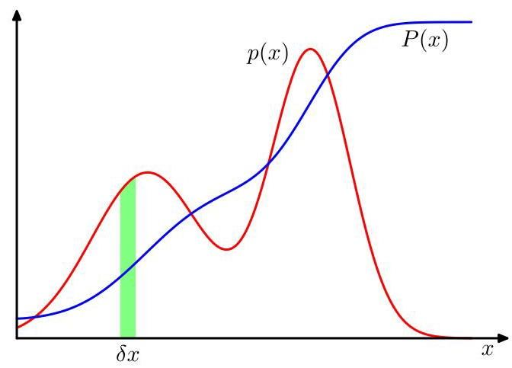

Figure 2.6 The concept of probability for discrete variables can be extended to that of a probability density over a continuous variable and is such that the probability of lying in the interval is given by for . The probability density can be expressed as the derivative of a cumulative distribution function .

图 2.6 离散变量的概率概念可以扩展到连续变量 上的概率密度 ，使得 落在区间 内的概率由 给出，其中 。概率密度可以表示为累积分布函数 的导数。

# 2.2. Probability Densities

# 2.2. 概率密度

As well as considering probabilities defined over discrete sets of values, we also wish to consider probabilities with respect to continuous variables. For instance, we might wish to predict what dose of drug to give to a patient. Since there will be uncertainty in this prediction, we want to quantify this uncertainty and again we can make use of probabilities. However, we cannot simply apply the concepts of probability discussed so far directly, since the probability of observing a specific value for a continuous variable, to infinite precision, will effectively be zero. Instead, we need to introduce the concept of a probability density. Here we will limit ourselves to a relatively informal discussion.

除了考虑在离散值集上定义的概率之外，我们还希望考虑关于连续变量的概率。例如，我们可能希望预测给患者使用的药物剂量。由于这种预测存在不确定性，我们希望量化这种不确定性，并且同样可以利用概率。然而，我们不能简单地直接应用到目前为止所讨论的概率概念，因为以无限精度观察连续变量的特定值的概率实际上将为零。相反，我们需要引入概率密度的概念。在这里，我们将仅限于进行相对非正式的讨论。

We define the probability density over a continuous variable to be such that the probability of falling in the interval is given by for . This is illustrated in Figure 2.6. The probability that will lie in an interval is then given by

我们定义连续变量 上的概率密度 ，使得 落在区间 内的概率由 给出，其中 。这在图 2.6 中进行了说明。那么 落在区间 内的概率由下式给出

Because probabilities are non-negative, and because the value of must lie somewhere on the real axis, the probability density must satisfy the two conditions

由于概率是非负的，并且由于 的值必定位于实轴上的某个位置，概率密度 必须满足两个条件

The probability that lies in the interval is given by the cumulative distribution function defined by

落在区间 内的概率由累积分布函数给出，其定义为

which satisfies , as shown in Figure 2.6.

如图 2.6 所示，它满足 。

If we have several continuous variables , denoted collectively by the vector , then we can define a joint probability density such that the probability of falling in an infinitesimal volume containing the point is given by . This multivariate probability density must satisfy

如果我们有几个连续变量 ，用向量 统一表示，那么我们可以定义一个联合概率密度 ，使得 落在包含点 的无穷小体积 内的概率由 给出。这个多元概率密度必须满足

in which the integral is taken over the whole of space. More generally, we can also consider joint probability distributions over a combination of discrete and continuous variables.

其中积分是在整个 空间上进行的。更一般地，我们还可以考虑离散变量和连续变量组合的联合概率分布。

The sum and product rules of probability, as well as Bayes’ theorem, also apply to probability densities as well as to combinations of discrete and continuous variables. If and are two real variables, then the sum and product rules take the form

概率的求和规则和乘积规则，以及贝叶斯定理，同样适用于概率密度以及离散变量和连续变量的组合。如果 和 是两个实变量，那么求和规则和乘积规则的形式为

Similarly, Bayes’ theorem can be written in the form

类似地，贝叶斯定理可以写成如下形式

where the denominator is given by

其中分母由下式给出

A formal justification of the sum and product rules for continuous variables requires a branch of mathematics called measure theory (Feller, 1966) and lies outside the scope of this book. Its validity can be seen informally, however, by dividing each real variable into intervals of width and considering the discrete probability distribution over these intervals. Taking the limit then turns sums into integrals and gives the desired result.

对连续变量的求和规则和乘积规则进行正式的证明需要用到数学中一个称为测度论的分支(Feller，1966)，这超出了本书的范围。然而，我们可以通过将每个实变量划分为宽度为 的区间，并考虑这些区间上的离散概率分布，来非正式地理解其有效性。取极限 时，求和就变成了积分，从而得到所需的结果。

# 2.2.1 Example distributions

# 2.2.1 示例分布

There are many forms of probability density that are in widespread use and that are important both in their own right and as building blocks for more complex probabilistic models. The simplest form would be one in which is a constant, independent of , but this cannot be normalized because the integral in (2.28) will be divergent. Distributions that cannot be normalized are called improper. We can, however, have the uniform distribution that is constant over a finite region, say , and zero elsewhere, in which case (2.28) implies

有许多形式的概率密度被广泛使用，它们本身就很重要，同时也是构建更复杂概率模型的基础。最简单的形式是 为常数，与 无关，但这无法进行归一化，因为 (2.28) 中的积分会发散。无法归一化的分布称为非正则分布。然而，我们可以有在有限区域(例如 )内为常数，在其他地方为零的均匀分布，在这种情况下，(2.28) 意味着

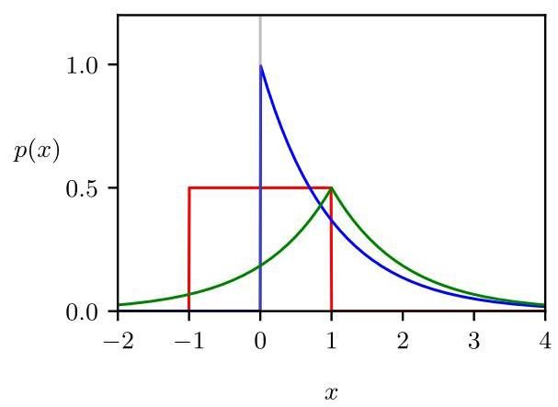

Figure 2.7 Plots of a uniform distribution over the range , shown in red, the exponential distribution with , shown in blue, and a Laplace distribution with and , shown in green.

图 2.7 绘制了在区间 上的均匀分布(红色)、参数为 的指数分布(蓝色)以及参数为 和 的拉普拉斯分布(绿色)。

Another simple form of density is the exponential distribution given by

另一种简单的密度形式是由下式给出的指数分布

A variant of the exponential distribution, known as the Laplace distribution, allows the peak to be moved to a location and is given by

指数分布的一种变体，即拉普拉斯分布，允许将峰值移动到位置 ，其表达式为

The constant, exponential, and Laplace distributions are illustrated in Figure 2.7.

常数分布、指数分布和拉普拉斯分布如图 2.7 所示。

Another important distribution is the Dirac delta function, which is written

另一个重要的分布是狄拉克δ函数，其表示为

This is defined to be zero everywhere except at and to have the property of integrating to unity according to (2.28). Informally, we can think of this as an infinitely narrow and infinitely tall spike located at with the property of having unit area. Finally, if we have a finite set of observations of given by then we can use the delta function to construct the empirical distribution given by

除了在 处，该函数在其他地方都被定义为零，并且根据 (2.28) 式，它具有积分结果为 1 的性质。通俗地说，我们可以将其看作是位于 处的一个无限窄且无限高的尖峰，其面积为 1。最后，如果我们有一组关于 的有限观测值 ，那么我们可以使用狄拉克δ函数来构造如下的经验分布

which consists of a Dirac delta function centred on each of the data points. The probability density defined by (2.37) integrates to one as required.

该分布由以每个数据点为中心的狄拉克δ函数组成。由 (2.37) 式定义的概率密度函数的积分结果符合要求，为 1。

Exercise 2.6

练习 2.6

# 2.2.2 Expectations and covariances

# 2.2.2 期望和协方差

One of the most important operations involving probabilities is that of finding weighted averages of functions. The weighted average of some function under a probability distribution is called the expectation of and will be denoted by . For a discrete distribution, it is given by summing over all possible values

涉及概率的最重要运算之一是求函数的加权平均值。在概率分布 下，某个函数 的加权平均值称为 的期望，用 表示。对于离散分布，它可以通过对 的所有可能取值求和得到

of in the form

其形式为

where the average is weighted by the relative probabilities of the different values of . For continuous variables, expectations are expressed in terms of an integration with respect to the corresponding probability density:

其中平均值由 不同值的相对概率加权得到。对于连续变量，期望用相对于相应概率密度的积分来表示:

In either case, if we are given a finite number of points drawn from the probability distribution or probability density, then the expectation can be approximated as a finite sum over these points:

在这两种情况下，如果我们得到从概率分布或概率密度中抽取的有限个点 ，那么期望可以近似为这些点上的有限和:

Exercise 2.7

练习 2.7

The approximation in (2.40) becomes exact in the limit .

在极限 下，(2.40) 中的近似变得精确。

Sometimes we will be considering expectations of functions of several variables, in which case we can use a subscript to indicate which variable is being averaged over, so that for instance

有时我们会考虑多个变量的函数的期望，在这种情况下，我们可以使用下标来表示对哪个变量求平均，例如

denotes the average of the function with respect to the distribution of . Note that will be a function of .

表示函数 相对于 的分布的平均值。注意 将是 的函数。

We can also consider a conditional expectation with respect to a conditional distribution, so that

我们还可以考虑关于条件分布的条件期望，即

which is also a function of . For continuous variables, the conditional expectation

这也是 的一个函数。对于连续变量，条件期望

takes the form

具有如下形式

The variance of is defined by

的方差定义为

and provides a measure of how much varies around its mean value . Expanding out the square, we see that the variance can also be written in terms of the expectations of and :

它衡量了 相对于其均值 的变化程度。将平方项展开，我们可以看到方差也可以用 和 的期望来表示:

Exercise 2.8

练习 2.8

In particular, we can consider the variance of the variable itself, which is given by

特别地，我们可以考虑变量 本身的方差，其表达式为

For two random variables and , the covariance measures the extent to which the two variables vary together and is defined by

对于两个随机变量 和 ，协方差衡量了这两个变量一起变化的程度，其定义为

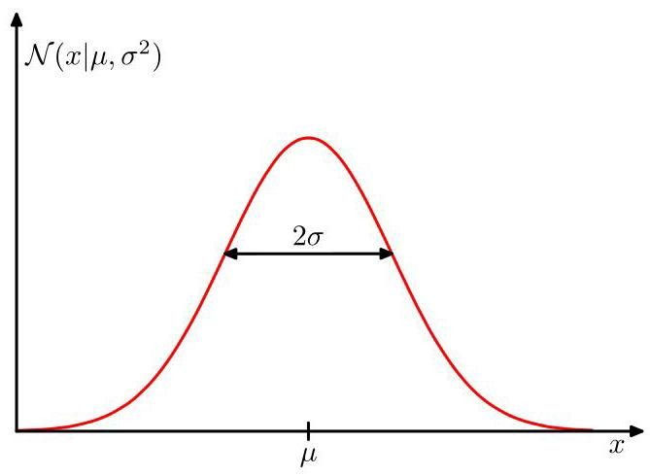

Figure 2.8 Plot of a Gaussian distribution for a single continuous variable showing the mean and the standard deviation .

图 2.8 展示了单个连续变量 的高斯分布曲线，其中标注了均值 和标准差 。

Exercise 2.9

练习 2.9

If and are independent, then their covariance equals zero.

如果 和 相互独立，那么它们的协方差等于零。

For two vectors and , their covariance is a matrix given by

对于两个向量 和 ，它们的协方差是一个矩阵，表达式为

If we consider the covariance of the components of a vector with each other, then we use a slightly simpler notation .

如果我们考虑向量 各分量之间的协方差，那么我们会使用一个稍简单的符号 。

# 2.3.The Gaussian Distribution

# 2.3. 高斯分布

One of the most important probability distributions for continuous variables is called the normal or Gaussian distribution, and we will make extensive use of this distribution throughout the rest of the book. For a single real-valued variable , the Gaussian distribution is defined by

对于连续变量而言，最重要的概率分布之一是正态分布或高斯分布，在本书的其余部分我们将广泛使用这种分布。对于单个实值变量 ，高斯分布定义为

which represents a probability density over governed by two parameters: , called the mean, and , called the variance. The square root of the variance, given by , is called the standard deviation, and the reciprocal of the variance, written as , is called the precision. We will see the motivation for this terminology shortly. Figure 2.8 shows a plot of the Gaussian distribution. Although the form of the Gaussian distribution might seem arbitrary, we will see later that it arises naturally from the concept of maximum entropy and from the perspective of the central limit theorem.

它表示 上的一个概率密度，由两个参数控制: 称为均值， 称为方差。方差的平方根 称为标准差，方差的倒数 称为精度。我们很快会看到采用这些术语的原因。图 2.8 展示了高斯分布的图像。尽管高斯分布的形式看起来可能有些随意，但我们稍后会看到，它自然地源于最大熵的概念以及中心极限定理的视角。

Section 2.5.4

2.5.4 节

Section 3.2

3.2 节

From (2.49) we see that the Gaussian distribution satisfies

从 (2.49) 式我们可以看出，高斯分布满足

Also, it is straightforward to show that the Gaussian is normalized, so that

此外，很容易证明高斯分布是归一化的，即

Exercise 2.12

练习 2.12

Thus, (2.49) satisfies the two requirements for a valid probability density.

因此，(2.49) 式满足有效概率密度的两个要求。

# 2.3.1 Mean and variance

# 2.3.1 均值和方差

We can readily find expectations of functions of under the Gaussian distribution. In particular, the average value of is given by

我们可以很容易地求出在高斯分布下 的函数的期望。特别地， 的平均值由下式给出

Exercise 2.13

练习 2.13

Because the parameter represents the average value of under the distribution, it is referred to as the mean. The integral in (2.52) is known as the first-order moment of the distribution because it is the expectation of raised to the power one. We can similarly evaluate the second-order moment given by

由于参数 表示 在该分布下的平均值，因此它被称为均值。(2.52) 中的积分被称为该分布的一阶矩，因为它是 的一次方的期望。我们可以类似地计算由下式给出的二阶矩

From (2.52) and (2.53), it follows that the variance of is given by

由 (2.52) 和 (2.53) 可知， 的方差由下式给出

and hence is referred to as the variance parameter. The maximum of a distribution is known as its mode. For a Gaussian, the mode coincides with the mean.

因此 被称为方差参数。分布的最大值被称为众数。对于高斯分布，众数与均值重合。

Exercise 2.14

练习 2.14

# 2.3.2 Likelihood function

# 2.3.2 似然函数

Suppose that we have a data set of observations represented as a row vector , representing observations of the scalar variable . Note that we are using the typeface to distinguish this from a single observation of a - dimensional vector-valued variable, which we represent by a column vector . We will suppose that the observations are drawn independently from a Gaussian distribution whose mean and variance are unknown, and we would like to determine these parameters from the data set. The problem of estimating a distribution, given a finite set of observations, is known as density estimation. It should be emphasized that the problem of density estimation is fundamentally ill-posed, because there are infinitely many probability distributions that could have given rise to the observed finite data set. Indeed, any distribution that is nonzero at each of the data points is a potential candidate. Here we constrain the space of distributions to be Gaussians, which leads to a well-defined solution.

假设我们有一个观测数据集，用行向量 表示，它代表对标量变量 的 次观测。请注意，我们使用字体 来将其与 维向量值变量的单次观测区分开来，后者我们用列向量 表示。我们假设这些观测是从一个高斯分布中独立抽取的，该分布的均值 和方差 未知，并且我们希望从数据集中确定这些参数。给定一组有限的观测值来估计一个分布的问题，被称为密度估计。需要强调的是，密度估计问题本质上是不适定的，因为有无数种概率分布可能产生所观测到的有限数据集。实际上，任何在每个数据点 处都不为零的分布 都是潜在的候选分布。在这里，我们将分布的空间限制为高斯分布，这会得到一个定义明确的解。

Data points that are drawn independently from the same distribution are said to be independent and identically distributed, which is often abbreviated to i.i.d. or IID. We have seen that the joint probability of two independent events is given by the product of the marginal probabilities for each event separately. Because our data set is i.i.d., we can therefore write the probability of the data set, given and , in the form

从同一分布中独立抽取的数据点被称为独立同分布，通常缩写为 i.i.d. 或 IID。我们已经知道，两个独立事件的联合概率由每个事件的边缘概率的乘积给出。因为我们的数据集 是独立同分布的，所以给定 和 时，我们可以将数据集的概率写成如下形式

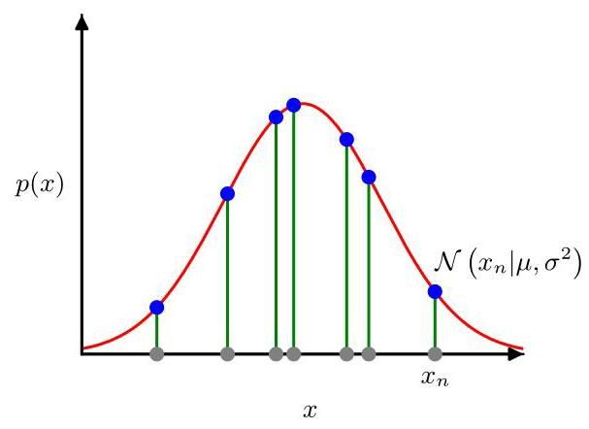

Figure 2.9 Illustration of the likelihood function for the Gaussian distribution shown by the red curve. Here the grey points denote a data set of values , and the likelihood function (2.55) is given by the product of the corresponding values of denoted by the blue points. Maximizing the likelihood involves adjusting the mean and variance of the Gaussian so as to maximize this product.

图 2.9 红色曲线展示了高斯分布的似然函数。这里灰色点表示值为 的数据集，似然函数 (2.55) 由蓝色点表示的 的对应值的乘积给出。最大化似然涉及调整高斯分布的均值和方差，以使这个乘积最大化。

When viewed as a function of and , this is called the likelihood function for the Gaussian and is interpreted diagrammatically in Figure 2.9.

当将其视为 和 的函数时，这被称为高斯分布的似然函数，如图 2.9 所示进行图解解释。

One common approach for determining the parameters in a probability distribution using an observed data set, known as maximum likelihood, is to find the parameter values that maximize the likelihood function. This might appear to be a strange criterion because, from our foregoing discussion of probability theory, it would seem more natural to maximize the probability of the parameters given the data, not the probability of the data given the parameters. In fact, these two criteria are related.

一种使用观测数据集确定概率分布中参数的常见方法，称为最大似然法，是找到使似然函数最大化的参数值。这可能看起来是一个奇怪的准则，因为从我们前面关于概率论的讨论来看，最大化给定数据下参数的概率，而不是给定参数下数据的概率，似乎更自然。实际上，这两个准则是相关的。

Section 2.6.2

第 2.6.2 节

To start with, however, we will determine values for the unknown parameters and in the Gaussian by maximizing the likelihood function (2.55). In practice, it is more convenient to maximize the log of the likelihood function. Because the logarithm is a monotonically increasing function of its argument, maximizing the of a function is equivalent to maximizing the function itself. Taking the not only simplifies the subsequent mathematical analysis, but it also helps numerically because the product of a large number of small probabilities can easily underflow the numerical precision of the computer, and this is resolved by computing the sum of the log probabilities instead. From (2.49) and (2.55), the log likelihood function can be written in the form

然而，首先我们将通过最大化似然函数 (2.55) 来确定高斯分布中未知参数 和 的值。在实践中，最大化似然函数的对数更为方便。因为对数是其自变量的单调递增函数，所以最大化一个函数的 等价于最大化该函数本身。取 不仅简化了后续的数学分析，而且在数值计算上也有帮助，因为大量小概率的乘积很容易导致计算机数值精度下溢，而通过计算对数概率的和可以解决这个问题。由 (2.49) 和 (2.55)，对数似然函数可以写成如下形式

Maximizing (2.56) with respect to , we obtain the maximum likelihood solution given by

关于 最大化 (2.56)，我们得到由下式给出的最大似然解

which is the sample mean, i.e., the mean of the observed values . Similarly, maximizing (2.56) with respect to , we obtain the maximum likelihood solution for the variance in the form

这就是样本均值，即观测值 的均值。类似地，关于 最大化 (2.56)，我们得到方差的最大似然解，形式如下

Exercise 2.15

练习 2.15

which is the sample variance measured with respect to the sample mean . Note that we are performing a joint maximization of (2.56) with respect to and , but for a Gaussian distribution, the solution for decouples from that for so that we can first evaluate (2.57) and then subsequently use this result to evaluate (2.58).

这是相对于样本均值 测量的样本方差。注意，我们正在对 (2.56) 关于 和 进行联合最大化，但对于高斯分布， 的解与 的解是分离的，因此我们可以先计算 (2.57)，然后再用这个结果计算 (2.58)。

# 2.3.3 Bias of maximum likelihood

# 2.3.3 最大似然估计的偏差

The technique of maximum likelihood is widely used in deep learning and forms the foundation for most machine learning algorithms. However, it has some limitations, which we can illustrate using a univariate Gaussian.

最大似然技术在深度学习中被广泛使用，并且是大多数机器学习算法的基础。然而，它有一些局限性，我们可以用单变量高斯分布来说明这些局限性。

We first note that the maximum likelihood solutions and are functions of the data set values . Suppose that each of these values has been generated independently from a Gaussian distribution whose true parameters are and . Now consider the expectations of and with respect to these data set values. It is straightforward to show that

我们首先注意到，最大似然解 和 是数据集值 的函数。假设这些值中的每一个都是从一个真实参数为 和 的高斯分布中独立生成的。现在考虑 和 关于这些数据集值的期望。很容易证明

Exercise 2.16

练习 2.16

We see that, when averaged over data sets of a given size, the maximum likelihood solution for the mean will equal the true mean. However, the maximum likelihood estimate of the variance will underestimate the true variance by a factor . This is an example of a phenomenon called bias in which the estimator of a random quantity is systematically different from the true value. The intuition behind this result is given by Figure 2.10.

我们看到，当对给定大小的数据集求平均时，均值的最大似然解将等于真实均值。然而，方差的最大似然估计将低估真实方差，低估因子为 。这是一种称为偏差的现象的例子，在这种现象中，随机量的估计值与真实值存在系统性差异。图 2.10 给出了这个结果背后的直观解释。

Note that bias arises because the variance is measured relative to the maximum likelihood estimate of the mean, which itself is tuned to the data. Suppose instead we had access to the true mean and we used this to determine the variance using

请注意，偏差的产生是因为方差是相对于均值的最大似然估计来测量的，而均值的最大似然估计本身是根据数据进行调整的。假设我们可以获得真实均值 ，并使用它来通过以下方式确定方差

the estimator

估计量

Exercise 2.17 Then we find that

练习 2.17 然后我们发现

which is unbiased. Of course, we do not have access to the true mean but only to the observed data values. From the result (2.60) it follows that for a Gaussian distribution, the following estimate for the variance parameter is unbiased:

这是无偏的。当然，我们无法获取真实均值，只能获取观测到的数据值。由结果 (2.60) 可知，对于高斯分布，方差参数的以下估计是无偏的:

Correcting for the bias of maximum likelihood in complex models such as neural networks is not so easy, however.

然而，在诸如神经网络等复杂模型中校正最大似然估计的偏差并非易事。

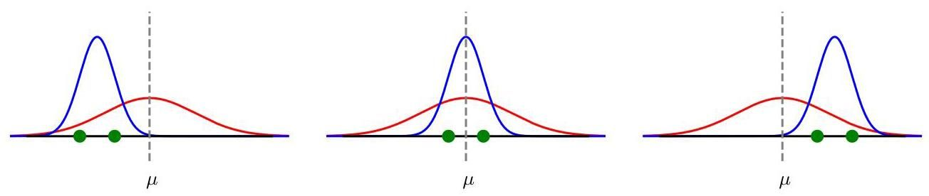

Figure 2.10 Illustration of how bias arises when using maximum likelihood to determine the mean and variance of a Gaussian. The red curves show the true Gaussian distribution from which data is generated, and the three blue curves show the Gaussian distributions obtained by fitting to three data sets, each consisting of two data points shown in green, using the maximum likelihood results (2.57) and (2.58). Averaged across the three data sets, the mean is correct, but the variance is systematically underestimated because it is measured relative to the sample mean and not relative to the true mean.

图 2.10 展示了使用最大似然法确定高斯分布的均值和方差时偏差是如何产生的。红色曲线表示生成数据的真实高斯分布，三条蓝色曲线表示通过对三个数据集进行拟合得到的高斯分布，每个数据集由两个绿色显示的数据点组成，使用的是最大似然结果 (2.57) 和 (2.58)。对这三个数据集求平均后，均值是正确的，但方差被系统性地低估了，因为它是相对于样本均值而非真实均值来度量的。

Note that the bias of the maximum likelihood solution becomes less significant as the number of data points increases. In the limit the maximum likelihood solution for the variance equals the true variance of the distribution that generated the data. In the case of the Gaussian, for anything other than small , this bias will not prove to be a serious problem. However, throughout this book we will be interested in complex models with many parameters, for which the bias problems associated with maximum likelihood will be much more severe. In fact, the issue of bias in maximum likelihood is closely related to the problem of over-fitting.

请注意，随着数据点数量 的增加，最大似然解的偏差变得不那么显著。在极限情况 下，方差的最大似然解等于生成数据的分布的真实方差。对于高斯分布而言，除了数据点数量 较小时，这种偏差不会成为严重问题。然而，在本书中，我们将关注具有许多参数的复杂模型，对于这些模型，与最大似然估计相关的偏差问题会严重得多。实际上，最大似然估计中的偏差问题与过拟合问题密切相关。

Section 2.6.3

第 2.6.3 节

# 2.3.4 Linear regression

# 2.3.4 线性回归

We have seen how the problem of linear regression can be expressed in terms of error minimization. Here we return to this example and view it from a probabilistic perspective, thereby gaining some insights into error functions and regularization.

我们已经了解了如何用误差最小化来表述线性回归问题。在这里，我们回到这个例子，从概率的角度来看待它，从而对误差函数和正则化有一些深入的理解。

Section 1.2

第1.2节

The goal in the regression problem is to be able to make predictions for the target variable given some new value of the input variable by using a set of training data comprising input values and their corresponding target values . We can express our uncertainty over the value of the target variable using a probability distribution. For this purpose, we will assume that, given the value of , the corresponding value of has a Gaussian distribution with a mean equal to the value of the polynomial curve given by (1.1), where are the polynomial coefficients, and a variance . Thus, we have

回归问题的目标是，利用一组由 个输入值 及其对应的目标值 组成的训练数据，针对输入变量 的某个新值，对目标变量 进行预测。我们可以使用概率分布来表示对目标变量值的不确定性。为此，我们假设，给定 的值，对应的 的值服从高斯分布，其均值等于由(1.1)式给出的多项式曲线的值 ，其中 是多项式系数，方差为 。因此，我们有

This is illustrated schematically in Figure 2.11.

这在图2.11中进行了示意性说明。

We now use the training data to determine the values of the unknown parameters and by maximum likelihood. If the data is assumed to be drawn

现在，我们使用训练数据 通过最大似然法来确定未知参数 和 的值。如果假设数据是从……中抽取的

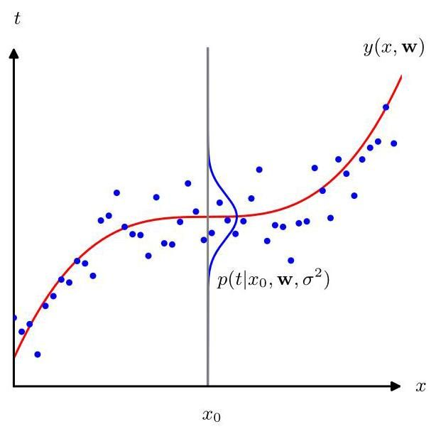

Figure 2.11 Schematic illustration of a Gaussian conditional distribution for given , defined by (2.64), in which the mean is given by the polynomial function , and the variance is given by the parameter .

图 2.11 给定 时 的高斯条件分布的示意图，由式 (2.64) 定义，其中均值由多项式函数 给出，方差由参数 给出。

independently from the distribution (2.64), then the likelihood function is given by

独立于分布 (2.64)，则似然函数由下式给出

As we did for the simple Gaussian distribution earlier, it is convenient to maximize the logarithm of the likelihood function. Substituting for the Gaussian distribution, given by (2.49), we obtain the log likelihood function in the form

正如我们之前对简单高斯分布所做的那样，最大化似然函数的对数是很方便的。将式 (2.49) 给出的高斯分布代入，我们得到如下形式的对数似然函数

Consider first the evaluation of the maximum likelihood solution for the polynomial coefficients, which will be denoted by . These are determined by maximizing (2.66) with respect to . For this purpose, we can omit the last two terms on the right-hand side of (2.66) because they do not depend on w. Also, note that scaling the log likelihood by a positive constant coefficient does not alter the location of the maximum with respect to , and so we can replace the coefficient with . Finally, instead of maximizing the log likelihood, we can equivalently minimize the negative log likelihood. We therefore see that maximizing the likelihood is equivalent, so far as determining is concerned, to minimizing the sum-of-squares error function defined by

首先考虑对多项式系数的最大似然解进行评估，用 表示。这些系数是通过相对于 最大化式 (2.66) 来确定的。为此，我们可以省略式 (2.66) 右侧的最后两项，因为它们不依赖于 w。此外，请注意，用一个正的常数系数对对数似然进行缩放不会改变相对于 的最大值位置，因此我们可以用 替换系数 。最后，我们可以等效地最小化负对数似然而不是最大化对数似然。因此，就确定 而言，我们看到最大化似然等效于最小化由下式定义的平方和误差函数

Thus, the sum-of-squares error function has arisen as a consequence of maximizing the likelihood under the assumption of a Gaussian noise distribution.

因此，平方和误差函数是在高斯噪声分布假设下最大化似然的结果。

We can also use maximum likelihood to determine the variance parameter . Maximizing (2.66) with respect to gives

我们还可以使用最大似然法来确定方差参数 。相对于 最大化式 (2.66) 可得

Exercise 2.18

练习 2.18

Note that we can first determine the parameter vector governing the mean, and subsequently use this to find the variance as was the case for the simple Gaussian distribution.

注意，我们可以先确定控制均值的参数向量 ，然后像简单高斯分布那样，用它来求方差 。

Having determined the parameters and , we can now make predictions for new values of . Because we now have a probabilistic model, these are expressed in terms of the predictive distribution that gives the probability distribution over , rather than simply a point estimate, and is obtained by substituting the maximum likelihood parameters into (2.64) to give

确定了参数 和 之后，我们现在可以对 的新值进行预测。由于我们现在有了一个概率模型，这些预测用预测分布来表示，该分布给出了 上的概率分布，而不仅仅是一个点估计。通过将最大似然参数代入 (2.64) 式得到

# 2.4. Transformation of Densities

# 2.4. 密度的变换

We turn now to a discussion of how a probability density transforms under a nonlinear change of variable. This property will play a crucial role when we discuss a class of generative models called normalizing flows. It also highlights that a probability density has a different behaviour than a simple function under such transformations.

现在我们来讨论概率密度在变量的非线性变换下是如何变化的。当我们讨论一类称为归一化流的生成模型时，这个性质将起到关键作用。它还凸显了在这种变换下，概率密度的行为与简单函数不同。

Chapter 18

第 18 章

Consider a single variable and suppose we make a change of variables , then a function becomes a new function defined by

考虑一个单变量 ，并假设我们进行变量变换 ，那么一个函数 就变成了一个由下式定义的新函数

Now consider a probability density , and again change variables using , giving rise to a density with respect to the new variable , where the suffixes denote that and are different densities. Observations falling in the range will, for small values of , be transformed into the range , where , and . Hence, if we take the limit , we obtain

现在考虑一个概率密度 ，再次使用 进行变量变换，得到一个关于新变量 的密度 ，其中下标表示 和 是不同的密度。对于小的 值，落在区间 内的观测值将被变换到区间 内，其中 ，且 。因此，如果我们取极限 ，我们得到

Here the modulus arises because the derivative could be negative, whereas the density is scaled by the ratio of lengths, which is always positive.

这里的模 出现是因为导数 可能为负，而密度是按长度比进行缩放的，长度比总是正的。

This procedure for transforming densities can be very powerful. Any density can be obtained from a fixed density that is everywhere non-zero by making a nonlinear change of variable in which is a monotonic function so that .

这种变换密度的方法可能非常强大。任何密度 都可以通过对一个处处非零的固定密度 进行非线性变量变换 得到，其中 是一个单调函数，使得 。

Exercise 2.19

练习 2.19

One consequence of the transformation property (2.71) is that the concept of the maximum of a probability density is dependent on the choice of variable. Suppose has a mode (i.e., a maximum) at so that . The corresponding mode of will occur for a value obtained by differentiating both sides of (2.70) with respect to :

变换性质 (2.71) 的一个结果是，概率密度最大值的概念依赖于变量的选择。假设 在 处有一个众数(即最大值)，使得 。 的相应众数将出现在通过对 (2.70) 两边关于 求导得到的值 处:

Assuming at the mode, then . However, we know that , and so we see that the locations of the mode expressed in terms of each of the variables and are related by , as one would expect. Thus, finding a mode with respect to the variable is equivalent to first transforming to the variable , then finding a mode with respect to , and then transforming back to .

假设在众数处有 ，那么 。然而，我们知道 ，因此可以看到，用变量 和 表示的众数位置由 相关联，这是符合预期的。因此，找到关于变量 的众数等价于先转换到变量 ，然后找到关于 的众数，再转换回 。

Now consider the behaviour of a probability density under the change of variables , where the density with respect to the new variable is and is given by (2.71). To deal with the modulus in (2.71) we can write where . Then (2.71) can be written as

现在考虑概率密度 在变量变换 下的行为，其中关于新变量的密度为 ，由式 (2.71) 给出。为了处理式 (2.71) 中的模，我们可以写成 ，其中 。那么式 (2.71) 可以写成

where we have used . Differentiating both sides with respect to then gives

这里我们使用了 。然后对两边关于 求导可得

Due to the presence of the second term on the right-hand side of (2.73), the relationship no longer holds. Thus, the value of obtained by maximizing will not be the value obtained by transforming to then maximizing with respect to and then transforming back to . This causes modes of densities to be dependent on the choice of variables. However, for a linear transformation, the second term on the right-hand side of (2.73) vanishes, and so in this case the location of the maximum transforms according to .

由于式 (2.73) 右侧第二项的存在，关系 不再成立。因此，通过最大化 得到的 值将不是先转换到 ，然后关于 最大化，再转换回 所得到的值。这导致密度的众数依赖于变量的选择。然而，对于线性变换，式 (2.73) 右侧的第二项消失，因此在这种情况下，最大值的位置根据 进行变换。

This effect can be illustrated with a simple example, as shown in Figure 2.12. We begin by considering a Gaussian distribution over shown by the red curve in Figure 2.12. Next we draw a sample of points from this distribution and plot a histogram of their values, which as expected agrees with the distribution . Now consider a nonlinear change of variables from to given by

如图 2.12 所示，这个效应可以用一个简单的例子来说明。我们首先考虑在 上的高斯分布 ，如图 2.12 中的红色曲线所示。接下来，我们从这个分布中抽取 个点的样本，并绘制它们值的直方图，正如预期的那样，该直方图与分布 一致。现在考虑从 到 的非线性变量变换，由下式给出

The inverse of this function is given by

这个函数的反函数由下式给出

which is a logistic sigmoid function and is shown in Figure 2.12 by the blue curve.

这是一个逻辑 sigmoid 函数，在图 2.12 中用蓝色曲线表示。

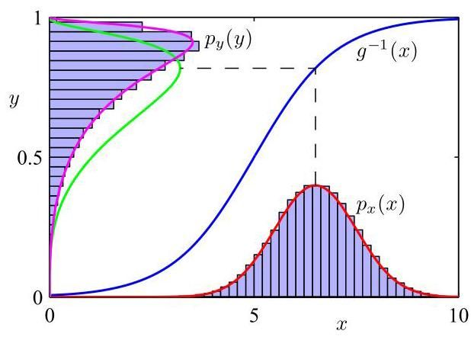

Figure 2.12 Example of the transformation of the mode of a density under a nonlinear change of variables, illustrating the different behaviour compared to a simple function.

图 2.12 展示了在变量进行非线性变换时，密度模式的转换示例，说明了与简单函数相比的不同行为。

If we simply transform as a function of we obtain the green curve shown in Figure 2.12, and we see that the mode of the density is transformed via the sigmoid function to the mode of this curve. However, the density over transforms instead according to (2.71) and is shown by the magenta curve on the left side of the diagram. Note that this has its mode shifted relative to the mode of the green curve.

如果我们简单地将 作为 的函数进行变换，我们会得到图 2.12 中所示的绿色曲线 ，并且我们看到密度 的模式通过 sigmoid 函数变换为该曲线的模式。然而， 上的密度则根据 (2.71) 进行变换，并在图的左侧用洋红色曲线表示。请注意，其模式相对于绿色曲线的模式发生了偏移。

To confirm this result, we take our sample of 50,000 values of , evaluate the corresponding values of using (2.75), and then plot a histogram of their values. We see that this histogram matches the magenta curve in Figure 2.12 and not the green curve.

为了证实这一结果，我们选取 50,000 个 的值作为样本，使用 (2.75) 计算相应的 的值，然后绘制它们值的直方图。我们发现这个直方图与图 2.12 中的洋红色曲线相符，而不是绿色曲线。

# 2.4.1 Multivariate distributions

# 2.4.1 多元分布

We can extend the result (2.71) to densities defined over multiple variables. Consider a density over a -dimensional variable , and suppose we transform to a new variable where . Here we will limit ourselves to the case where and have the same dimensionality. The transformed density is then given by the generalization of (2.71) in the form

我们可以将结果 (2.71) 扩展到定义在多个变量上的密度。考虑一个关于 维变量 的密度 ，并假设我们变换到一个新变量 ，其中 。在这里，我们将自己限制在 和 具有相同维度的情况。然后，变换后的密度由 (2.71) 的推广形式给出

where is the Jacobian matrix whose elements are given by the partial derivatives , so that

其中 是雅可比矩阵，其元素由偏导数 给出，因此

Intuitively, we can view the change of variables as expanding some regions of space and contracting others, with an infinitesimal region around a point being transformed to a region around the point . The absolute value of the determinant of the Jacobian represents the ratio of these volumes and is the same factor that arises when changing variables within an integral. The formula (2.77) follows from the fact that the probability mass in region is the same as the probability mass in . Once again, we take the modulus to ensure that the density is nonnegative.

直观地说，我们可以将变量变换视为对空间的某些区域进行扩展，而对其他区域进行收缩，围绕点 的无穷小区域 被变换为围绕点 的区域 。雅可比行列式的绝对值表示这些体积的比率，并且与在积分中进行变量变换时出现的因子相同。公式 (2.77) 源于区域 中的概率质量与 中的概率质量相同这一事实。我们再次取模以确保密度是非负的。

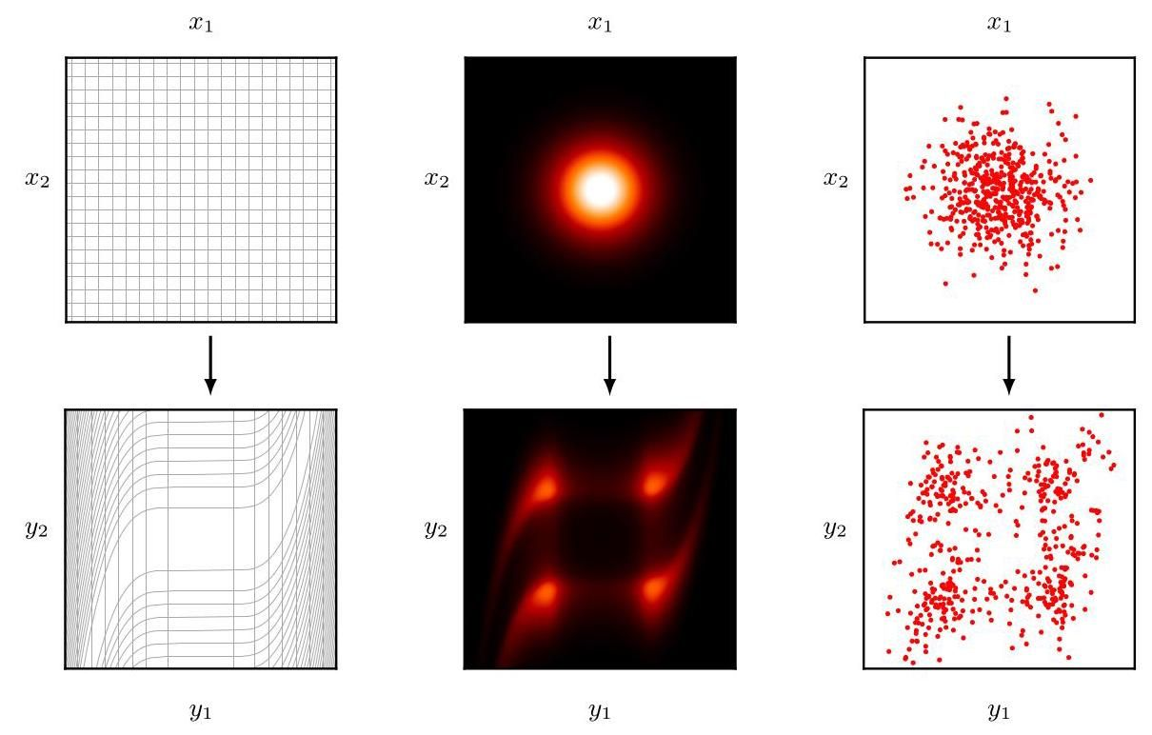

Figure 2.13 Illustration of the effect of a change of variables on a probability distribution in two dimensions. The left column shows the transforming of the variables whereas the middle and right columns show the corresponding effects on a Gaussian distribution and on samples from that distribution, respectively.

图 2.13 展示了二维概率分布中变量变换的效果。左列显示了变量的变换，而中间列和右列分别显示了对高斯分布及其样本的相应影响。

We can illustrate this by applying a change of variables to a Gaussian distribution in two dimensions, as shown in the top row in Figure 2.13. Here the transformation

我们可以通过对二维高斯分布应用变量变换来说明这一点，如图 2.13 顶行所示。这里的变换

Exercise 2.20 from to is given by

练习 2.20 从 到 的变换由下式给出

Also shown on the bottom row are samples from a Gaussian distribution in -space along with the corresponding transformed samples in -space.

底行还展示了 空间中高斯分布的样本以及 空间中相应的变换样本。

# 2.5. Information Theory

# 2.5. 信息论

Probability theory forms the basis for another important framework called information theory, which quantifies the information present in a data set and which plays an important role in machine learning. Here we give a brief introduction to some of the key elements of information theory that we will need later in the book, including the important concept of entropy in its various forms. For a more comprehensive introduction to information theory, with connections to machine learning, see MacKay (2003).

概率论构成了另一个重要框架——信息论的基础。信息论对数据集中存在的信息进行量化，并且在机器学习中发挥着重要作用。在这里，我们简要介绍信息论的一些关键要素，这些要素在本书后面的内容中会用到，包括各种形式的重要概念——熵。关于信息论与机器学习的联系的更全面介绍，请参阅 MacKay (2003)。

# 2.5.1 Entropy

# 2.5.1 熵

We begin by considering a discrete random variable and we ask how much information is received when we observe a specific value for this variable. The amount of information can be viewed as the ’degree of surprise’ on learning the value of . If we are told that a highly improbable event has just occurred, we will have received more information than if we were told that some very likely event has just occurred, and if we knew that the event was certain to happen, we would receive no information. Our measure of information content will therefore depend on the probability distribution , and so we look for a quantity that is a monotonic function of the probability and that expresses the information content. The form of can be found by noting that if we have two events and that are unrelated, then the information gained from observing both of them should be the sum of the information gained from each of them separately, so that . Two unrelated events are statistically independent and so . From these two relationships, it is easily shown that must be given by the logarithm of and so we have

我们首先考虑一个离散随机变量 ，并询问当我们观察到该变量的一个特定值时，我们接收到了多少信息。信息的数量可以看作是得知 的值时的“惊讶程度”。如果我们被告知一个极不可能发生的事件刚刚发生，那么我们接收到的信息比被告知一个非常可能发生的事件刚刚发生时要多；如果我们知道某个事件肯定会发生，那么我们就不会接收到任何信息。因此，我们对信息内容的度量将取决于概率分布 ，所以我们要寻找一个量 ，它是概率 的单调函数，并能表达信息内容。通过注意到如果我们有两个不相关的事件 和 ，那么观察到这两个事件所获得的信息应该是分别观察每个事件所获得的信息之和，即 。两个不相关的事件在统计上是独立的，所以 。从这两个关系中，很容易证明 必须由 的对数给出，因此我们有

Exercise 2.21

练习 2.21

where the negative sign ensures that information is positive or zero. Note that low probability events correspond to high information content. The choice of base for the logarithm is arbitrary, and for the moment we will adopt the convention prevalent in information theory of using logarithms to the base of 2 . In this case, as we will see shortly, the units of are bits (’binary digits’).

其中负号确保信息为正或零。请注意，低概率事件 对应着高信息内容。对数的底数选择是任意的，目前我们将采用信息论中普遍使用的以 2 为底的对数约定。在这种情况下，正如我们很快会看到的， 的单位是比特(“二进制数字”)。

Now suppose that a sender wishes to transmit the value of a random variable to a receiver. The average amount of information that they transmit in the process is obtained by taking the expectation of (2.80) with respect to the distribution and is given by

现在假设发送方希望将一个随机变量的值传输给接收方。他们在此过程中传输的平均信息量是通过对 (2.80) 关于分布 取期望得到的，其表达式为

This important quantity is called the entropy of the random variable . Note that and so we will take whenever we encounter a value for such that .

这个重要的量被称为随机变量 的熵。注意到 ，因此每当我们遇到 的值使得 时，我们将取 。

So far, we have given a rather heuristic motivation for the definition of information (2.80) and the corresponding entropy (2.81). We now show that these definitions indeed possess useful properties. Consider a random variable having eight possible states, each of which is equally likely. To communicate the value of to a receiver, we would need to transmit a message of length 3 bits. Notice that the entropy of this variable is given by

到目前为止，我们对信息的定义 (2.80) 以及相应的熵的定义 (2.81) 给出了一种较为启发式的动机。现在我们证明这些定义确实具有有用的性质。考虑一个具有八个可能状态的随机变量 ，每个状态的可能性相等。为了将 的值传达给接收方，我们需要传输一个长度为 3 比特的消息。注意到这个变量的熵为

Now consider an example (Cover and Thomas, 1991) of a variable having eight possible states for which the respective probabilities are given by . The entropy in this case is given by

现在考虑一个例子(Cover 和 Thomas，1991)，一个变量具有八个可能的状态 ，其各自的概率由 给出。在这种情况下，熵为

We see that the nonuniform distribution has a smaller entropy than the uniform one, and we will gain some insight into this shortly when we discuss the interpretation of entropy in terms of disorder. For the moment, let us consider how we would transmit the identity of the variable’s state to a receiver. We could do this, as before, using a 3-bit number. However, we can take advantage of the nonuniform distribution by using shorter codes for the more probable events, at the expense of longer codes for the less probable events, in the hope of getting a shorter average code length. This can be done by representing the states using, for instance, the following set of code strings: 0, 10, 110, 1110, 111100, 111101, 111110, and 111111. The average length of the code that has to be transmitted is then

我们看到，非均匀分布的熵比均匀分布的熵小。当我们从无序性的角度讨论熵的解释时，很快就会对这一点有更深入的理解。目前，让我们考虑如何将变量的状态标识传输给接收方。和之前一样，我们可以使用一个 3 比特的数字来完成。然而，我们可以利用非均匀分布的特点，为更可能发生的事件使用更短的编码，而为不太可能发生的事件使用更长的编码，以期获得更短的平均编码长度。例如，可以使用以下一组编码字符串来表示状态 :0、10、110、1110、111100、111101、111110 和 111111。那么需要传输的编码的平均长度为

average code length bits,

平均编码长度 比特

which again is the same as the entropy of the random variable. Note that shorter code strings cannot be used because it must be possible to disambiguate a concatenation of such strings into its component parts. For instance, 11001110 decodes uniquely into the state sequence . This relation between entropy and shortest coding length is a general one. The noiseless coding theorem (Shannon, 1948) states that the entropy is a lower bound on the number of bits needed to transmit the state of a random variable.

这再次与随机变量的熵相同。请注意，不能使用更短的代码字符串，因为必须能够将这样的字符串的串联明确地拆分为其组成部分。例如，11001110 能唯一地解码为状态序列 。熵与最短编码长度之间的这种关系是一种普遍关系。无噪声编码定理(Shannon，1948)指出，熵是传输随机变量状态所需比特数的下限。

From now on, we will switch to the use of natural logarithms in defining entropy, as this will provide a more convenient link with ideas elsewhere in this book. In this case, the entropy is measured in units of nats (from ’natural logarithm’) instead of bits, which differ simply by a factor of .

从现在起，我们将在定义熵时改用自然对数，因为这将与本书其他地方的概念建立更便捷的联系。在这种情况下，熵的单位是奈特(来自“自然对数”)而非比特，二者仅相差一个因子 。

# 2.5.2 Physics perspective

# 2.5.2 物理学视角

We have introduced the concept of entropy in terms of the average amount of information needed to specify the state of a random variable. In fact, the concept of entropy has much earlier origins in physics where it was introduced in the context of equilibrium thermodynamics and later given a deeper interpretation as a measure of disorder through developments in statistical mechanics. We can understand this alternative view of entropy by considering a set of identical objects that are to be divided amongst a set of bins, such that there are objects in the th bin. Consider the number of different ways of allocating the objects to the bins. There are ways to choose the first object, ways to choose the second object, and so on, leading to a total of ! ways to allocate all objects to the bins, where ! (pronounced ’ factorial’) denotes the product . However, we do not wish to distinguish between rearrangements of objects within each bin. In the th bin there are ! ways of reordering the objects, and so the total number of ways of allocating the objects to the bins is given by

我们从指定随机变量状态所需的平均信息量的角度引入了熵的概念。实际上，熵的概念在物理学中的起源要早得多，它最初是在平衡热力学的背景下引入的，后来通过统计力学的发展被赋予了更深刻的解释，即作为无序程度的度量。我们可以通过考虑一组 个相同的物体来理解熵的这种另类观点，这些物体要被分配到一组箱子中，使得第 个箱子中有 个物体。考虑将物体分配到箱子中的不同方式的数量。选择第一个物体有 种方法，选择第二个物体有 种方法，依此类推，将所有 个物体分配到箱子中的总方法数为 ! 种，其中 !(读作“ 的阶乘”)表示乘积 。然而，我们不希望区分每个箱子内物体的重新排列。在第 个箱子中，有 ! 种重新排列物体的方法，因此将 个物体分配到箱子中的总方法数为

which is called the multiplicity. The entropy is then defined as the logarithm of the multiplicity scaled by a constant factor so that

这被称为多重性。然后，熵被定义为多重性的对数乘以一个常数因子 ，即

We now consider the limit , in which the fractions are held fixed, and apply Stirling’s approximation:

现在我们考虑极限 ，其中分数 保持不变，并应用斯特林近似:

which gives

由此可得

where we have used . Here is the probability of an object being assigned to the th bin. In physics terminology, the specific allocation of objects into bins is called a microstate, and the overall distribution of occupation numbers, expressed through the ratios , is called a macrostate. The multiplicity , which expresses the number of microstates in a given macrostate, is also known as the weight of the macrostate.

其中我们使用了 。这里 是一个对象被分配到第 个容器的概率。用物理学的术语来说，将对象具体分配到各个容器的方式称为微观态，而通过比率 表示的占据数的总体分布称为宏观态。表示给定宏观态中微观态数量的多重性 ，也被称为该宏观态的权重。

We can interpret the bins as the states of a discrete random variable , where . The entropy of the random variable is then

我们可以将这些容器解释为离散随机变量 的状态 ，其中 。那么随机变量 的熵为

Distributions that are sharply peaked around a few values will have a relatively low entropy, whereas those that are spread more evenly across many values will have higher entropy, as illustrated in Figure 2.14.

如图 2.14 所示，在少数几个值附近有尖锐峰值的分布 的熵相对较低，而那些更均匀地分布在多个值上的分布的熵则较高。

Because , the entropy is non-negative, and it will equal its minimum value of 0 when one of the and all other . The maximum entropy configuration can be found by maximizing using a Lagrange multiplier to enforce the normalization constraint on the probabilities. Thus, we maximize

因为 ，所以熵是非负的，并且当其中一个 且所有其他 时，熵将等于其最小值 0。可以通过使用拉格朗日乘数法来最大化 并同时满足概率的归一化约束条件，从而找到最大熵配置。因此，我们最大化

from which we find that all of the are equal and are given by where is the total number of states . The corresponding value of the entropy is then . This result can also be derived from Jensen’s inequality (to be discussed shortly). To verify that the stationary point is indeed a maximum, we can evaluate the second derivative of the entropy, which gives

由此我们发现所有的 都相等，且由 给出，其中 是状态 的总数。那么熵的相应值为 。这个结果也可以从 Jensen 不等式(稍后讨论)推导得出。为了验证该驻点确实是最大值，我们可以计算熵的二阶导数，结果为

Appendix

附录

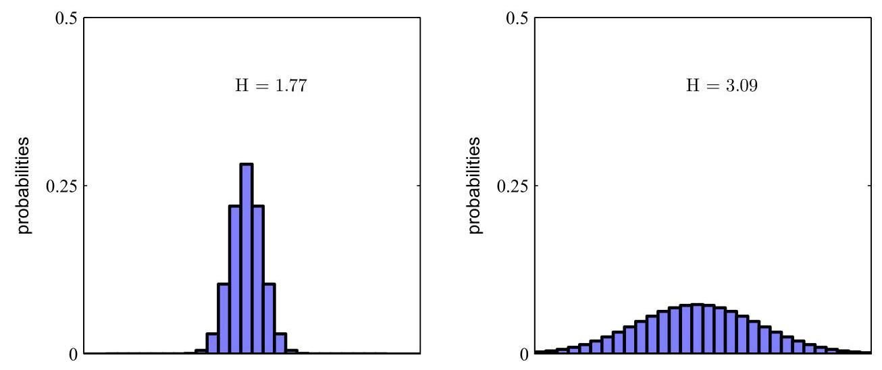

Figure 2.14 Histograms of two probability distributions over 30 bins illustrating the higher value of the entropy for the broader distribution. The largest entropy would arise from a uniform distribution which would give .

图 2.14 两个概率分布在 30 个区间上的直方图，展示了更宽泛分布的熵 值更高。最大熵将来自均匀分布，其值为 。

Exercise 2.22

练习 2.22

Exercise 2.23

练习 2.23

where are the elements of the identity matrix. We see that these values are all negative and, hence, the stationary point is indeed a maximum.

其中 是单位矩阵的元素。我们看到这些值都是负的，因此，该驻点确实是一个最大值点。

# 2.5.3 Differential entropy

# 2.5.3 微分熵

We can extend the definition of entropy to include distributions over continuous variables as follows. First divide into bins of width . Then, assuming that is continuous, the mean value theorem (Weisstein,1999) tells us that, for each such bin, there must exist a value in the range such that

我们可以将熵的定义扩展到包含连续变量 上的分布 ，具体如下。首先，将 划分为宽度为 的区间。然后，假设 是连续的，中值定理(Weisstein，1999)告诉我们，对于每个这样的区间，在范围 内必定存在一个值 ，使得

We can now quantize the continuous variable by assigning any value to the value whenever falls in the th bin. The probability of observing the value is then . This gives a discrete distribution for which the entropy takes the form

现在，我们可以对连续变量 进行量化，每当 落在第 个区间时，就将其赋值为 。那么，观测到值 的概率就是 。这就得到了一个离散分布，其熵的形式为

where we have used , which follows from (2.89) and (2.25). We now omit the second term on the right-hand side of (2.90), since it is independent of , and then consider the limit . The first term on the right-hand side of (2.90) will approach the integral of in this limit so that

这里我们使用了 ，它由式(2.89)和式(2.25)得出。现在，我们忽略式(2.90)右侧的第二项 ，因为它与 无关，然后考虑极限 。在这个极限下，式(2.90)右侧的第一项将趋近于 的积分，使得

where the quantity on the right-hand side is called the differential entropy. We see that the discrete and continuous forms of the entropy differ by a quantity , which diverges in the limit . This reflects that specifying a continuous variable very precisely requires a large number of bits. For a density defined over multiple continuous variables, denoted collectively by the vector , the differential entropy is given by

其中，右侧的量被称为微分熵。我们看到，熵的离散形式和连续形式相差一个量 ，该量在极限 下趋于无穷。这反映出，要非常精确地指定一个连续变量需要大量的比特。对于定义在多个连续变量上的概率密度(用向量 统一表示)，微分熵由下式给出

# 2.5.4 Maximum entropy

# 2.5.4 最大熵

We saw for discrete distributions that the maximum entropy configuration corresponds to a uniform distribution of probabilities across the possible states of the variable. Let us now consider the corresponding result for a continuous variable. If this maximum is to be well defined, it will be necessary to constrain the first and second moments of and to preserve the normalization constraint. We therefore maximize the differential entropy with the three constraints:

我们已经知道，对于离散分布，最大熵配置对应于变量所有可能状态上的均匀概率分布。现在，让我们考虑连续变量的相应结果。为了使这个最大值有明确定义，有必要对 的一阶矩和二阶矩进行约束，并保留归一化约束。因此，我们在以下三个约束条件下最大化微分熵:

Appendix

附录

The constrained maximization can be performed using Lagrange multipliers so that we maximize the following functional with respect to :

可以使用拉格朗日乘数法进行约束最大化，从而使我们关于 最大化以下泛函:

Using the calculus of variations, we set the derivative of this functional to zero giving

使用变分法，我们将该泛函的导数设为零，得到

Appendix B

附录 B

The Lagrange multipliers can be found by back-substitution of this result into the three constraint equations, leading finally to the result:

通过将此结果回代到三个约束方程中，可以求出拉格朗日乘数，最终得到结果:

Exercise 2.24

练习 2.24

and so the distribution that maximizes the differential entropy is the Gaussian. Note that we did not constrain the distribution to be non-negative when we maximized the entropy. However, because the resulting distribution is indeed non-negative, we see with hindsight that such a constraint is not necessary.

因此，使微分熵最大化的分布是高斯分布。请注意，在最大化熵时，我们并未对分布进行非负约束。然而，由于得到的分布实际上是非负的，事后看来，这样的约束并非必要。

Exercise 2.25

练习 2.25

If we evaluate the differential entropy of the Gaussian, we obtain

如果我们计算高斯分布的微分熵，我们会得到

Thus, we see again that the entropy increases as the distribution becomes broader, i.e., as increases. This result also shows that the differential entropy, unlike the discrete entropy, can be negative, because in (2.99) for .

因此，我们再次看到，随着分布变宽，即随着 增大，熵也会增加。这个结果还表明，与离散熵不同，微分熵可以为负，因为对于 ，(2.99) 式中的 。

# 2.5.5 Kullback-Leibler divergence

# 2.5.5 库尔贝克 - 莱布勒散度

So far in this section, we have introduced a number of concepts from information theory, including the key notion of entropy. We now start to relate these ideas to machine learning. Consider some unknown distribution , and suppose that we have modelled this using an approximating distribution . If we use to construct a coding scheme for transmitting values of to a receiver, then the average additional amount of information (in nats) required to specify the value of (assuming we choose an efficient coding scheme) as a result of using instead of the true distribution is given by

到目前为止，在本节中，我们已经介绍了信息论中的一些概念，包括熵这一关键概念。现在我们开始将这些概念与机器学习联系起来。考虑某个未知分布 ，并假设我们使用一个近似分布 对其进行建模。如果我们使用 来构建一个编码方案，用于向接收方传输 的值，那么由于使用 而非真实分布 来指定 的值(假设我们选择了一个高效的编码方案)所需的平均额外信息量(以奈特为单位)由下式给出

This is known as the relative entropy or Kullback-Leibler divergence, or KL divergence (Kullback and Leibler,1951), between the distributions and . Note that it is not a symmetrical quantity, that is to say .

这被称为分布 和 之间的相对熵或 Kullback-Leibler 散度，简称 KL 散度(Kullback 和 Leibler，1951)。需要注意的是，它不是一个对称量，也就是说 。

We now show that the Kullback–Leibler divergence satisfies with equality if, and only if, . To do this we first introduce the concept of convex functions. A function is said to be convex if it has the property that every chord lies on or above the function, as shown in Figure 2.15.

现在我们证明，当且仅当 时，Kullback-Leibler 散度满足 且等号成立。为此，我们首先引入凸函数的概念。如果函数 具有每条弦都位于函数之上或与函数重合的性质，则称该函数为凸函数，如图 2.15 所示。

Any value of in the interval from to can be written in the form where . The corresponding point on the chord

区间 到 内的任意 值都可以写成 的形式，其中 。弦上对应的点

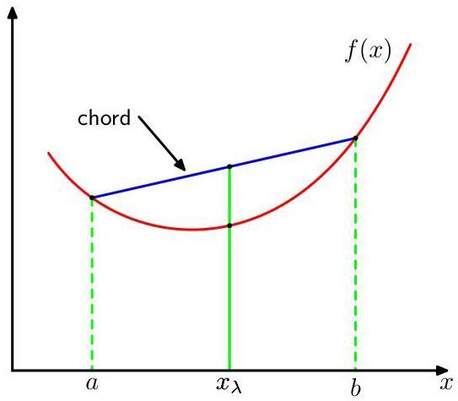

Figure 2.15 A convex function is one for which every chord (shown in blue) lies on or above the function (shown in red).

图 2.15 凸函数 的每条弦(蓝色所示)都位于函数(红色所示)之上或与函数重合。

is given by , and the corresponding value of the function is . Convexity then implies

由 给出，函数的对应值为 。那么凸性意味着

This is equivalent to the requirement that the second derivative of the function be everywhere positive. Examples of convex functions are (for ) and . A function is called strictly convex if the equality is satisfied only for and . If a function has the opposite property, namely that every chord lies on or below the function, it is called concave, with a corresponding definition for strictly concave. If a function is convex, then will be concave.

这等价于要求函数的二阶导数处处为正。凸函数的例子有 (对于 )和 。如果仅当 和 时等号成立，则称该函数为严格凸函数。如果一个函数具有相反的性质，即每条弦都位于函数之下或与函数重合，则称该函数为凹函数，严格凹函数也有相应的定义。如果函数 是凸函数，那么 将是凹函数。

Exercise 2.32

练习 2.32

Exercise 2.33

练习 2.33

Using the technique of proof by induction, we can show from (2.101) that a convex function satisfies

使用归纳证明的技巧，我们可以从 (2.101) 式证明凸函数 满足

where and , for any set of points . The result (2.102) is known as Jensen’s inequality. If we interpret the as the probability distribution over a discrete variable taking the values , then (2.102) can be written

其中 且 ，对于任意一组点 均成立。结果 (2.102) 式被称为詹森不等式。如果我们将 解释为离散变量 取值为 时的概率分布，那么 (2.102) 式可以写成

where denotes the expectation. For continuous variables, Jensen’s inequality

其中 表示期望。对于连续变量，詹森不等式

takes the form

具有如下形式

We can apply Jensen’s inequality in the form (2.104) to the Kullback-Leibler divergence (2.100) to give

我们可以将形式为 (2.104) 的詹森不等式应用于库尔贝克 - 莱布勒散度 (2.100)，得到

where we have used is a convex function, together with the normalization condition . In fact, is a strictly convex function, so the equality will hold if, and only if, for all . Thus, we can interpret the Kullback-Leibler divergence as a measure of the dissimilarity of the two distributions and .

其中我们使用了 是一个凸函数，以及归一化条件 。事实上， 是一个严格凸函数，因此等式成立的充要条件是，对于所有的 都有 。因此，我们可以将库尔贝克 - 莱布勒散度解释为两个分布 和 之间差异的度量。

We see that there is an intimate relationship between data compression and density estimation (i.e., the problem of modelling an unknown probability distribution) because the most efficient compression is achieved when we know the true distribution. If we use a distribution that is different from the true one, then we must necessarily have a less efficient coding, and on average the additional information that must be transmitted is (at least) equal to the Kullback-Leibler divergence between the two distributions.

我们发现数据压缩和密度估计(即对未知概率分布进行建模的问题)之间存在着密切的关系，因为当我们知道真实分布时，就能实现最有效的压缩。如果我们使用的分布与真实分布不同，那么编码效率必然会降低，并且平均而言，必须传输的额外信息(至少)等于这两个分布之间的库尔贝克 - 莱布勒散度。

Suppose that data is being generated from an unknown distribution that we wish to model. We can try to approximate this distribution using some parametric distribution , governed by a set of adjustable parameters . One way to determine is to minimize the Kullback-Leibler divergence between and with respect to . We cannot do this directly because we do not know . Suppose, however, that we have observed a finite set of training points , for , drawn from . Then the expectation with respect to can be approximated by a finite sum over these points, using (2.40), so that

假设数据是由一个我们希望对其进行建模的未知分布 生成的。我们可以尝试使用某个由一组可调节参数 控制的参数化分布 来近似这个分布。确定 的一种方法是相对于 最小化 和 之间的库尔贝克 - 莱布勒散度。我们不能直接这样做，因为我们不知道 。然而，假设我们已经观察到了从 中抽取的有限训练点集 ，其中 。然后，使用 (2.40)，相对于 的期望可以通过对这些点的有限求和来近似，从而得到

The second term on the right-hand side of (2.106) is independent of , and the first term is the negative log likelihood function for under the distribution evaluated using the training set. Thus, we see that minimizing this Kullback-Leibler divergence is equivalent to maximizing the log likelihood function.

(2.106) 式右侧的第二项与 无关，而第一项是在使用训练集评估的分布 下 的负对数似然函数。因此，我们看到最小化这个库尔贝克 - 莱布勒散度等价于最大化对数似然函数。

Exercise 2.34

练习 2.34

# 2.5.6 Conditional entropy

# 2.5.6 条件熵

Now consider the joint distribution between two sets of variables and given by from which we draw pairs of values of and . If a value of is already known, then the additional information needed to specify the corresponding value of is given by . Thus the average additional information needed to specify can be written as

现在考虑两组变量 和 之间的联合分布，由 给出，我们从中抽取 和 的值对。如果 的一个值已经已知，那么指定 相应值所需的额外信息由 给出。因此，指定 所需的平均额外信息可以写成

which is called the conditional entropy of given . It is easily seen, using the product rule, that the conditional entropy satisfies the relation:

这被称为在给定 的条件下 的条件熵。利用乘积法则，很容易看出条件熵满足以下关系:

Exercise 2.35

练习 2.35

where is the differential entropy of and is the differential entropy of the marginal distribution . Thus, the information needed to describe and is given by the sum of the information needed to describe alone plus the additional information required to specify given .

其中 是 的微分熵， 是边缘分布 的微分熵。因此，描述 和 所需的信息由描述 单独所需的信息加上在给定 的条件下指定 所需的额外信息之和给出。

# 2.5.7 Mutual information

# 2.5.7 互信息

When two variables and are independent, their joint distribution will factorize into the product of their marginals . If the variables are not independent, we can gain some idea of whether they are ’close’ to being independent by considering the Kullback-Leibler divergence between the joint distribution and the product of the marginals, given by

当两个变量 和 相互独立时，它们的联合分布将分解为各自边缘分布的乘积 。如果这些变量不独立，我们可以通过考虑联合分布与边缘分布乘积之间的 Kullback-Leibler 散度来了解它们是否“接近”独立，该散度由下式给出

which is called the mutual information between the variables and . From the properties of the Kullback-Leibler divergence, we see that with equality if, and only if, and are independent. Using the sum and product rules of probability, we see that the mutual information is related to the conditional entropy through

这被称为变量 和 之间的互信息。根据 Kullback-Leibler 散度的性质，我们可知 ，当且仅当 和 相互独立时等号成立。利用概率的求和规则和乘积规则，我们可以发现互信息与条件熵之间存在如下关系

Exercise 2.38

练习 2.38

Thus, the mutual information represents the reduction in the uncertainty about by virtue of being told the value of (or vice versa). From a Bayesian perspective, we can view as the prior distribution for and as the posterior distribution after we have observed new data y. The mutual information therefore represents the reduction in uncertainty about as a consequence of the new observation .

因此，互信息表示由于得知 的值(反之亦然)而使关于 的不确定性的减少量。从贝叶斯的角度来看，我们可以将 视为 的先验分布，将 视为在观察到新数据 y 后的后验分布。因此，互信息表示由于新的观察 而使关于 的不确定性的减少量。

# 2.6. Bayesian Probabilities

# 2.6. 贝叶斯概率

When we considered the bent coin in Figure 2.2, we introduced the concept of probability in terms of the frequencies of random, repeatable events, such as the probability of the coin landing concave side up. We will refer to this as the classical or frequentist interpretation of probability. We also introduced the more general Bayesian view, in which probabilities provide a quantification of uncertainty. In this case, our uncertainty is whether the concave side of the coin is heads or tails.

当我们考虑图 2.2 中的弯曲硬币时，我们从随机、可重复事件的频率角度引入了概率的概念，例如硬币凹面朝上的概率。我们将这种概率解释称为经典或频率主义解释。我们还引入了更一般的贝叶斯观点，在该观点中，概率用于量化不确定性。在这种情况下，我们的不确定性在于硬币的凹面是正面还是反面。

The use of probability to represent uncertainty is not an ad hoc choice but is inevitable if we are to respect common sense while making rational and coherent inferences. For example, Cox (1946) showed that if numerical values are used to represent degrees of belief, then a simple set of axioms encoding common sense properties of such beliefs leads uniquely to a set of rules for manipulating degrees of belief that are equivalent to the sum and product rules of probability. It is therefore natural to refer to these quantities as (Bayesian) probabilities.

使用概率来表示不确定性并非临时的选择，而是如果我们要在进行合理且连贯的推断时遵循常识，这就是不可避免的。例如，Cox(1946)表明，如果使用数值来表示置信度，那么一组简单的编码此类置信度常识属性的公理将唯一地导出一组处理置信度的规则，这些规则等同于概率的求和与乘积规则。因此，自然地将这些量称为(贝叶斯)概率。

For the bent coin we assumed, in the absence of further information, that the probability of the concave side of the coin being heads is 0.5 . Now suppose we are told the results of flipping the coin a few times. Intuitively, it seems that this should provide us with some information as to whether the concave side is heads. For instance, suppose we see many more flips that land tails than land heads. Given that the coin is more likely to land concave side up, this provides evidence to suggest that the concave side is more likely to be tails. In fact, this intuition is correct, and furthermore, we can quantify this using the rules of probability. Bayes’ theorem now acquires a new significance, because it allows us to convert the prior probability for the concave side being heads into a posterior probability by incorporating the data provided by the coin flips. Moreover, this process is iterative, meaning the posterior probability becomes the prior for incorporating data from further coin flips.

对于弯曲的硬币，在没有更多信息的情况下，我们假设硬币凹面朝上为正面的概率是 0.5。现在假设我们得知了抛硬币几次的结果。直观上，这似乎应该为我们提供一些关于凹面是否为正面的信息。例如，假设我们看到硬币反面朝上的次数远多于正面朝上的次数。鉴于硬币更有可能凹面朝上，这表明凹面更有可能是反面。事实上，这种直觉是正确的，而且，我们可以使用概率规则对其进行量化。贝叶斯定理现在有了新的意义，因为它允许我们通过纳入抛硬币提供的数据，将凹面为正面的先验概率转换为后验概率。此外，这个过程是迭代的，这意味着后验概率会成为纳入更多抛硬币数据的先验概率。

Exercise 2.40

练习 2.40

One aspect of the Bayesian viewpoint is that the inclusion of prior knowledge arises naturally. Suppose, for instance, that a fair-looking coin is tossed three times and lands heads each time. The maximum likelihood estimate of the probability of landing heads would give 1, implying that all future tosses will land heads! By contrast, a Bayesian approach with any reasonable prior will lead to a less extreme conclusion.

贝叶斯观点的一个方面是，纳入先验知识是自然产生的。例如，假设一枚看起来均匀的硬币被抛了三次，每次都正面朝上。正面朝上概率的最大似然估计将得出 1，这意味着未来所有的抛掷都将正面朝上！相比之下，任何具有合理先验的贝叶斯方法都会得出不那么极端的结论。

Section 3.1.2

第 3.1.2 节

# 2.6.1 Model parameters

# 2.6.1 模型参数

The Bayesian perspective provides valuable insights into several aspects of machine learning, and we can illustrate these using the sine curve regression example. Here we denote the training data set by . We have already seen in the context of linear regression that the parameters can be chosen using maximum likelihood, in which is set to the value that maximizes the likelihood function . This corresponds to choosing the value of for which the probability of the observed data set is maximized. In the machine learning literature, the negative log of the likelihood function is called an error function. Because the negative logarithm is a monotonically decreasing function, maximizing the likelihood is equivalent to minimizing the error. This leads to a specific choice of parameter values, denoted , which are then used to make predictions for new data.

贝叶斯视角为机器学习的多个方面提供了有价值的见解，我们可以使用正弦曲线回归示例来说明这些见解。在这里，我们用 表示训练数据集。我们已经在线性回归的背景下看到，可以使用最大似然法选择参数，其中将 设置为使似然函数 最大化的值。这对应于选择 的值，使得观测到的数据集的概率最大化。在机器学习文献中，似然函数的负对数被称为误差函数。由于负对数是单调递减函数，最大化似然等价于最小化误差。这导致了参数值的特定选择，记为 ，然后使用这些参数值对新数据进行预测。

Section 1.2

第 1.2 节

We have seen that different choices of training data set, for example containing different numbers of data points, give rise to different solutions for . From a Bayesian perspective, we can also use the machinery of probability theory to describe this uncertainty in the model parameters. We can capture our assumptions about , before observing the data, in the form of a prior probability distribution . The effect of the observed data is expressed through the likelihood function , and Bayes’ theorem now takes the form

我们已经看到，不同的训练数据集选择，例如包含不同数量的数据点，会导致 的不同解。从贝叶斯的角度来看，我们还可以使用概率论的方法来描述模型参数中的这种不确定性。在观测数据之前，我们可以以先验概率分布 的形式来表达我们对 的假设。观测数据 的影响通过似然函数 来表达，现在贝叶斯定理采用以下形式

which allows us to evaluate the uncertainty in after we have observed in the form of the posterior probability .

这使我们能够以后验概率 的形式评估在观测到 之后 的不确定性。

It is important to emphasize that the quantity is called the likelihood function when it is viewed as a function of the parameter vector , and it expresses how probable the observed data set is for different values of . Note that the likelihood is not a probability distribution over , and its integral with respect to w does not (necessarily) equal one.

重要的是要强调，当将量 视为参数向量 的函数时，它被称为似然函数，它表示对于 的不同值，观测到的数据集的可能性有多大。请注意，似然 不是关于 的概率分布，并且它关于 w 的积分(不一定)等于 1。

Given this definition of likelihood, we can state Bayes’ theorem in words:

根据似然的这个定义，我们可以用文字表述贝叶斯定理:

where all of these quantities are viewed as functions of . The denominator in (2.111) is the normalization constant, which ensures that the posterior distribution on the left-hand side is a valid probability density and integrates to one. Indeed, by integrating both sides of (2.111) with respect to , we can express the denominator in Bayes’ theorem in terms of the prior distribution and the likelihood function:

其中所有这些量都被视为 的函数。(2.111) 式中的分母是归一化常数，它确保左侧的后验分布是一个有效的概率密度，并且积分结果为 1。实际上，通过对 (2.111) 式两边关于 进行积分，我们可以用先验分布和似然函数来表示贝叶斯定理中的分母:

In both the Bayesian and frequentist paradigms, the likelihood function plays a central role. However, the manner in which it is used is fundamentally different in the two approaches. In a frequentist setting, is considered to be a fixed parameter, whose value is determined by some form of ’estimator’, and error bars on this estimate are determined (conceptually, at least) by considering the distribution of possible data sets . By contrast, from the Bayesian viewpoint there is only a single data set (namely the one that is actually observed), and the uncertainty in the parameters is expressed through a probability distribution over .

在贝叶斯和频率主义这两种范式中，似然函数 都起着核心作用。然而，在这两种方法中，它的使用方式有着根本的不同。在频率主义的设定中， 被认为是一个固定的参数，其值由某种形式的“估计器”确定，并且(至少在概念上)通过考虑可能的数据集 的分布来确定该估计的误差范围。相比之下，从贝叶斯的观点来看，只有一个数据集 (即实际观测到的那个)，并且参数的不确定性通过 上的概率分布来表示。

# 2.6.2 Regularization

# 2.6.2 正则化

We can use this Bayesian perspective to gain insight into the technique of regularization that was used in the sine curve regression example to reduce over-fitting. Instead of choosing the model parameters by maximizing the likelihood function with respect to , we can maximize the posterior probability (2.111). This technique is called the maximum a posteriori estimate, or simply MAP estimate. Equivalently, we can minimize the negative log of the posterior probability. Taking negative logs of both sides of (2.111), we have

我们可以利用这种贝叶斯观点来深入理解正则化技术，该技术曾在正弦曲线回归示例中用于减少过拟合。我们不是通过关于 最大化似然函数来选择模型参数，而是可以最大化后验概率 (2.111)。这种技术称为最大后验估计，或简称为 MAP 估计。等价地，我们可以最小化后验概率的负对数。对 (2.111) 式两边取负对数，我们得到

Section 1.2.5

第 1.2.5 节

The first term on the right-hand side of (2.114) is the usual log likelihood. The third term can be omitted since it does not depend on . The second term takes the form of a function of , which is added to the log likelihood, and we can recognize this as a form of regularization. To make this more explicit, suppose we choose the prior distribution to be the product of independent zero-mean Gaussian distributions for each of the elements of such that each has the same variance so that

(2.114) 式右侧的第一项是通常的对数似然。第三项可以省略，因为它不依赖于 。第二项是 的函数形式，它被加到对数似然上，我们可以将其识别为一种正则化形式。为了更明确地说明这一点，假设我们选择先验分布 为 的每个元素的独立零均值高斯分布的乘积，使得每个元素具有相同的方差 ，即

Substituting into (2.114), we obtain

代入 (2.114)，我们得到

If we consider the particular case of the linear regression model whose log likelihood is given by (2.66), then we find that maximizing the posterior distribution is equivalent to minimizing the function

如果我们考虑线性回归模型的特定情况，其对数似然由 (2.66) 给出，那么我们会发现最大化后验分布等价于最小化该函数

Exercise 2.41

练习 2.41

We see that this takes the form of the regularized sum-of-squares error function encountered earlier in the form (1.4).

我们看到，这采用了之前以形式 (1.4) 遇到的正则化平方和误差函数的形式。

# 2.6.3 Bayesian machine learning

# 2.6.3 贝叶斯机器学习

The Bayesian perspective has allowed us to motivate the use of regularization and to derive a specific form for the regularization term. However, the use of Bayes’ theorem alone does not constitute a truly Bayesian treatment of machine learning since it is still finding a single solution for and does not therefore take account of uncertainty in the value of . Suppose we have a training data set and our goal is to predict some target variable given a new input value . We are therefore interested in the distribution of given both and . From the sum and product rules of probability, we have

贝叶斯观点使我们能够推动正则化的使用并推导出正则化项的特定形式。然而，仅使用贝叶斯定理并不构成对机器学习的真正贝叶斯处理，因为它仍然是为 找到单一解，因此没有考虑 值的不确定性。假设我们有一个训练数据集 ，我们的目标是在给定新输入值 的情况下预测某个目标变量 。因此，我们感兴趣的是在给定 和 的情况下 的分布。根据概率的求和与乘积规则，我们有

We see that the prediction is obtained by taking a weighted average over all possible values of in which the weighting function is given by the posterior probability distribution . The key difference that distinguishes Bayesian methods is this integration over the space of parameters. By contrast, conventional frequentist methods use point estimates for parameters obtained by optimizing a loss function such as a regularized sum-of-squares.

我们看到，预测是通过对 的所有可能值取加权平均 得到的，其中加权函数由后验概率分布 给出。贝叶斯方法的关键区别在于对参数空间进行这种积分。相比之下，传统的频率论方法使用通过优化损失函数(如正则化平方和)得到的参数点估计。

This fully Bayesian treatment of machine learning offers some powerful insights. For example, the problem of over-fitting, encountered earlier in the context of polynomial regression, is an example of a pathology arising from the use of maximum likelihood, and does not arise when we marginalize over parameters using the Bayesian approach. Similarly, we may have multiple potential models that we could use to solve a given problem, such as polynomials of different orders in the regression example. A maximum likelihood approach simply picks the model that gives the highest probability of the data, but this favours ever more complex models, leading to over-fitting. A fully Bayesian treatment involves averaging over all possible models, with the contribution of each model weighted by its posterior probability. Moreover, this probability is typically highest for models of intermediate complexity. Very simple models (such as polynomials of low order) have low probability as they are unable to fit the data well, whereas very complex models (such as polynomials of very high order) also have low probability because the Bayesian integration over parameters automatically and elegantly penalizes complexity. For a comprehensive overview of Bayesian methods applied to machine learning, including neural networks, see Bishop (2006).

这种对机器学习的完全贝叶斯处理提供了一些有力的见解。例如，我们在多项式回归中早些时候遇到的过拟合问题，就是使用最大似然法产生的一种病态情况的例子，而当我们使用贝叶斯方法对参数进行边缘化时，这种问题就不会出现。同样，我们可能有多个潜在的模型可以用来解决给定的问题，比如回归示例中不同阶数的多项式。最大似然法只是选择能使数据出现概率最高的模型，但这会倾向于选择越来越复杂的模型，从而导致过拟合。完全贝叶斯处理涉及对所有可能的模型进行平均，每个模型的贡献由其后验概率加权。此外，对于中等复杂度的模型，这个概率通常是最高的。非常简单的模型(如低阶多项式)概率较低，因为它们无法很好地拟合数据，而非常复杂的模型(如非常高阶的多项式)概率也较低，因为贝叶斯对参数的积分会自动且巧妙地对复杂度进行惩罚。有关应用于机器学习(包括神经网络)的贝叶斯方法的全面概述，请参阅 Bishop (2006)。

Section 1.2

第 1.2 节

Section 9.6

第 9.6 节

Unfortunately, there is a major drawback with the Bayesian framework, and this is apparent in (2.118), which involves integrating over the space of parameters. Modern deep learning models can have millions or billions of parameters and even simple approximations to such integrals are typically infeasible. In fact, given a

不幸的是，贝叶斯框架有一个主要缺点，这在 (2.118) 中很明显，它涉及对参数空间进行积分。现代深度学习模型可能有数百万甚至数十亿个参数，即使是对这种积分进行简单的近似通常也是不可行的。事实上，在给定

limited compute budget and an ample source of training data, it will often be better to apply maximum likelihood techniques, generally augmented with one or more forms of regularization, to a large neural network rather than apply a Bayesian treatment to a much smaller model.

有限的计算预算和充足的训练数据的情况下，通常最好将最大似然技术(通常辅以一种或多种形式的正则化)应用于大型神经网络，而不是对小得多的模型进行贝叶斯处理。

Exercises

练习

2.1 (★) In the cancer screening example, we used a prior probability of cancer of 1) = 0.01 . In reality, the prevalence of cancer is generally very much lower. Consider a situation in which , and recompute the probability of having cancer given a positive test . Intuitively, the result can appear surprising to many people since the test seems to have high accuracy and yet a positive test still leads to a low probability of having cancer.

2.1 (★) 在癌症筛查示例中，我们使用的癌症先验概率为 1) = 0.01。实际上，癌症的患病率通常要低得多。考虑一种情况，其中 ，并重新计算在检测结果为阳性的情况下患癌症的概率 。直观地说，这个结果可能会让很多人感到惊讶，因为该检测似乎具有很高的准确性，但检测结果为阳性时患癌症的概率仍然很低。

2.2 Deterministic numbers satisfy the property of transitivity, so that if and then it follows that . When we go to random numbers, however, this property need no longer apply. Figure 2.16 shows a set of four cubical dice that have been arranged in a cyclic order. Show that each of the four dice has a 2/3 probability of rolling a higher number than the previous die in the cycle. Such dice are known as non-transitive dice, and the specific examples shown here are called Efron dice.

2.2 确定性数字满足传递性，因此如果 且 ，那么可以推出 。然而，当涉及到随机数字时，这个性质不再适用。图 2.16 展示了一组按循环顺序排列的四个立方体骰子。证明这四个骰子中的每一个都有 2/3 的概率掷出比循环中前一个骰子更高的数字。这种骰子被称为非传递性骰子，这里展示的具体示例被称为 Efron 骰子。

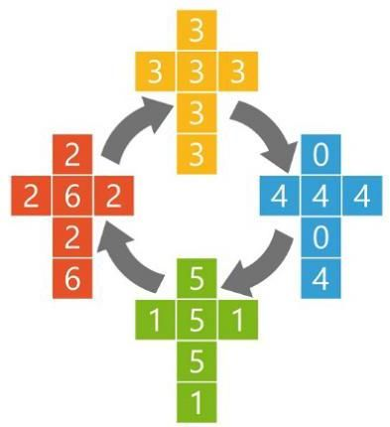

Figure 2.16 An example of non-transitive cubical dice, in which each die has been ’flattened’ to reveal the numbers on each of the faces. The dice have been arranged in a cycle, such that each die has a 2/3 probability of rolling a higher number than the previous die in the cycle.

图 2.16 非传递性立方体骰子的一个示例，其中每个骰子都被“压扁”以显示每个面上的数字。这些骰子按循环排列，使得每个骰子都有 2/3 的概率掷出比循环中前一个骰子更高的数字。

2.3 (⋆) Consider a variable given by the sum of two independent random variables where and . Show that the distribution is given by

2.3 (⋆) 考虑一个变量 ，它由两个独立随机变量的和给出 ，其中 且 。证明分布 由下式给出

This is known as the convolution of and .

这被称为 和 的卷积。

2.4 Verify that the uniform distribution (2.33) is correctly normalized, and find expressions for its mean and variance.

2.4 验证均匀分布 (2.33) 已正确归一化，并求出其均值和方差的表达式。

2.5 (★★) Verify that the exponential distribution (2.34) and the Laplace distribution (2.35) are correctly normalized.

2.5 (★★) 验证指数分布 (2.34) 和拉普拉斯分布 (2.35) 已正确归一化。

2.6 (*) Using the properties of the Dirac delta function, show that the empirical density (2.37) is correctly normalized.

2.6 (*) 利用狄拉克δ函数的性质，证明经验密度 (2.37) 已正确归一化。

2.7 (*) By making use of the empirical density (2.37), show that the expectation given by (2.39) can be approximated by a sum over a finite set of samples drawn from the density in the form (2.40).

2.7 (*) 利用经验密度 (2.37)，证明由 (2.39) 给出的期望可以近似为从形式为 (2.40) 的密度中抽取的有限样本集的求和。

2.8 (*) Using the definition (2.44), show that satisfies (2.45).

2.8 (*) 利用定义 (2.44)，证明 满足 (2.45)。

2.9 (*) Show that if two variables and are independent, then their covariance is zero.

2.9 (*) 证明如果两个变量 和 相互独立，则它们的协方差为零。

2.10 (*) Suppose that the two variables and are statistically independent. Show that the mean and variance of their sum satisfies

2.10 (*) 假设两个变量 和 在统计上是独立的。证明它们之和的均值和方差满足

2.11 (*) Consider two variables and with joint distribution . Prove the following two results:

2.11 (*) 考虑两个变量 和 ，其联合分布为 。证明以下两个结果:

Here denotes the expectation of under the conditional distribution , with a similar notation for the conditional variance.

这里 表示在条件分布 下 的期望，条件方差的表示方法类似。

In this exercise, we prove the normalization condition (2.51) for the univariate Gaussian. To do this consider, the integral

在本练习中，我们证明单变量高斯分布的归一化条件 (2.51)。为此，考虑积分

which we can evaluate by first writing its square in the form

我们可以先将其平方写成如下形式来计算

Now make the transformation from Cartesian coordinates to polar coordinates and then substitute . Show that, by performing the integrals over and and then taking the square root of both sides, we obtain

现在从笛卡尔坐标 变换到极坐标 ，然后代入 。证明通过对 和 进行积分，然后对两边取平方根，我们得到

Finally, use this result to show that the Gaussian distribution is normalized.

最后，利用这个结果证明高斯分布 是归一化的。

2.13 By using a change of variables, verify that the univariate Gaussian distribution given by (2.49) satisfies (2.52). Next, by differentiating both sides of the normaliza-

2.13 通过变量替换，验证由式 (2.49) 给出的单变量高斯分布满足式 (2.52)。接下来，对归一化

tion condition

条件

with respect to , verify that the Gaussian satisfies (2.53). Finally, show that (2.54) holds.

关于 求导，验证高斯分布满足式 (2.53)。最后，证明式 (2.54) 成立。

2.14 (⋆) Show that the mode (i.e., the maximum) of the Gaussian distribution (2.49) is given by .

2.14 (⋆) 证明高斯分布 (2.49) 的众数(即最大值)由 给出。

2.15 (*) By setting the derivatives of the log likelihood function (2.56) with respect to and equal to zero, verify the results (2.57) and (2.58).

2.15 (*) 通过令对数似然函数 (2.56) 关于 和 的导数等于零，验证结果 (2.57) 和 (2.58)。

2.16 Using the results (2.52) and (2.53), show that

2.16 利用结果 (2.52) 和 (2.53)，证明

where and denote data points sampled from a Gaussian distribution with mean and variance and satisfies if and otherwise. Hence prove the results (2.59) and (2.60).

其中 和 表示从均值为 、方差为 的高斯分布中采样的数据点，并且如果 ，则 满足 ，否则满足 。因此，证明结果 (2.59) 和 (2.60)。

Using the definition (2.61), prove the result (2.62) which shows that the expectation of the variance estimator for a Gaussian distribution based on the true mean is given by the true variance .

利用定义 (2.61)，证明结果 (2.62)，该结果表明基于真实均值的高斯分布方差估计量的期望由真实方差 给出。

2.18 (*) Show that maximizing (2.66) with respect to gives the result (2.68).

2.18 (*) 证明关于 最大化 (2.66) 可得到结果 (2.68)。

2.19 Use the transformation property (2.71) of a probability density under a change of variable to show that any density can be obtained from a fixed density that is everywhere non-zero by making a nonlinear change of variable in which is a monotonic function so that . Write down the differential equation satisfied by and draw a diagram illustrating the transformation of the density.

2.19 利用变量变换下概率密度的变换性质 (2.71)，证明任何密度 都可以通过对一个处处非零的固定密度 进行非线性变量变换 得到，其中 是一个单调函数，使得 。写出 满足的微分方程，并绘制一个图来说明密度的变换。

2.20 ( ) Evaluate the elements of the Jacobian matrix for the transformation defined by (2.78) and (2.79).

2.20 ( ) 计算由 (2.78) 和 (2.79) 定义的变换的雅可比矩阵的元素。

2.21 In Section 2.5, we introduced the idea of entropy as the information gained on observing the value of a random variable having distribution . We saw that, for independent variables and for which , the entropy functions are additive, so that . In this exercise, we derive the relation between and in the form of a function . First show that and, hence, by induction that where is a positive integer. Hence, show that where is also a positive integer. This implies that where is a positive rational number and, hence, by continuity when it is a positive real number. Finally, show that this implies must take the form .

2.21 在 2.5 节中，我们引入了熵 的概念，它是观察具有分布 的随机变量 的值所获得的信息。我们看到，对于独立变量 和 ，当 时，熵函数是可加的，即 。在本题中，我们以函数 的形式推导 和 之间的关系。首先证明 ，进而通过归纳法证明 ，其中 是正整数。因此，证明 ，其中 也是正整数。这意味着 ，其中 是正有理数，进而通过连续性可知当它是正实数时也成立。最后，证明这意味着 必须取 的形式。

2.22 (★) Use a Lagrange multiplier to show that maximization of the entropy (2.86) for a discrete variable gives a distribution in which all of the probabilities are equal and that the corresponding value of the entropy is then .

2.22 (★) 使用拉格朗日乘数法证明，对于离散变量，使熵(2.86)最大化会得到一个所有概率 都相等的分布，此时熵的对应值为 。

2.23 ( ) Consider an -state discrete random variable , and use Jensen’s inequality in the form (2.102) to show that the entropy of its distribution satisfies .

2.23 ( ) 考虑一个 状态的离散随机变量 ，并使用形式为(2.102)的 Jensen 不等式证明其分布 的熵满足 。

2.24 Use the calculus of variations to show that the stationary point of the functional (2.96) is given by (2.97). Then use the constraints (2.93), (2.94), and (2.95) to eliminate the Lagrange multipliers and, hence, show that the maximum entropy solution is given by the Gaussian (2.98).

2.24 使用变分法证明泛函(2.96)的驻点由(2.97)给出。然后使用约束条件(2.93)、(2.94)和(2.95)消除拉格朗日乘数，从而证明最大熵解由高斯分布(2.98)给出。

2.25 (★) Use the results (2.94) and (2.95) to show that the entropy of the univariate Gaussian (2.98) is given by (2.99).

2.25 (★) 使用结果(2.94)和(2.95)证明单变量高斯分布(2.98)的熵由(2.99)给出。

Suppose that is some fixed distribution and that we wish to approximate it using a Gaussian distribution . By writing down the form of the Kullback-Leibler divergence for a Gaussian and then differentiating, show that minimization of with respect to and leads to the result that is given by the expectation of under and that is given by the covariance.

假设 是某个固定的分布，我们希望用高斯分布 来近似它。通过写出高斯分布 的 Kullback - Leibler 散度 的形式，然后求导，证明关于 和 最小化 会得到如下结果: 由 在 下的期望给出， 由协方差给出。

2.27 Evaluate the Kullback-Leibler divergence (2.100) between the two Gaussians and .

2.27 计算两个高斯分布 和 之间的 Kullback-Leibler 散度 (2.100)。

The alpha family of divergences is defined by

α 族散度的定义为

where is a continuous parameter. Show that the Kullback-Leibler divergence corresponds to . This can be done by writing and then taking . Similarly, show that corresponds to .

其中 是一个连续参数。证明 Kullback-Leibler 散度 对应于 。这可以通过写出 然后取 来完成。类似地，证明 对应于 。

2.29 Consider two variables and having joint distribution . Show that the differential entropy of this pair of variables satisfies

2.29 考虑两个具有联合分布 的变量 和 。证明这对变量的微分熵满足

with equality if, and only if, and are statistically independent.

当且仅当 和 统计独立时，等号成立。

2.30 (*) Consider a vector of continuous variables with distribution and corresponding entropy . Suppose that we make a non-singular linear transformation of to obtain a new variable . Show that the corresponding entropy is given by where denotes the determinant of .

2.30 (*) 考虑一个具有分布 和相应熵 的连续变量向量 。假设我们对 进行非奇异线性变换以获得一个新变量 。证明相应的熵由 给出，其中 表示 的行列式。

2.31 Suppose that the conditional entropy between two discrete random variables and is zero. Show that, for all values of such that , the variable must be a function of . In other words, for each there is only one value of such that .

2.31 假设两个离散随机变量 和 之间的条件熵 为零。证明:对于所有满足 的 值，变量 必定是 的函数。换句话说，对于每个 ，只有一个 值满足 。

2.32 (★) A strictly convex function is defined as one for which every chord lies above the function. Show that this is equivalent to the condition that the second derivative of the function is positive.

2.32 (★) 严格凸函数的定义是其每条弦都位于函数上方。证明这等价于函数的二阶导数为正这一条件。

2.33 (★★) Using proof by induction, show that the inequality (2.101) for convex functions implies the result (2.102).

2.33 (★★) 使用归纳法证明，凸函数的不等式 (2.101) 蕴含结果 (2.102)。

2.34 (★) Show that, up to an additive constant, the Kullback-Leibler divergence (2.100) between the empirical distribution (2.37) and a model distribution is equal to the negative log likelihood function.

2.34 (★) 证明:在一个加法常数的范围内，经验分布 (2.37) 与模型分布 之间的 Kullback - Leibler 散度 (2.100) 等于负对数似然函数。

2.35 ( ) Using the definition (2.107) together with the product rule of probability, prove the result (2.108).

2.35 ( ) 结合定义 (2.107) 和概率的乘积法则，证明结果 (2.108)。

2.36 Consider two binary variables and having the joint distribution given by

2.36 考虑两个二元变量 和 ，其联合分布由下式给出

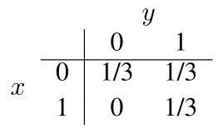

Evaluate the following quantities:

计算以下量:

(a) (c) (e)

(a) (c) (e)

(b) (d) (f) .

(b) (d) (f) 。

Draw a Venn diagram to show the relationship between these various quantities.

绘制一个维恩图来展示这些不同量之间的关系。

2.37 (*) By applying Jensen’s inequality (2.102) with , show that the arithmetic mean of a set of real numbers is never less than their geometrical mean.

2.37 (*) 通过应用 时的詹森不等式(2.102)，证明一组实数的算术平均值永远不小于它们的几何平均值。

2.38 ( ) Using the sum and product rules of probability, show that the mutual information satisfies the relation (2.110).

2.38 ( ) 利用概率的求和与乘积规则，证明互信息 满足关系式(2.110)。

2.39 Suppose that two variables and are independent so that . Show that the covariance matrix between these variables is diagonal. This shows that independence is a sufficient condition for two variables to be uncorrelated. Now consider two variables and where is symmetrically distributed around 0 and . Write down the conditional distribution and observe that this is dependent on , thus showing that the two variables are not independent. Now show that the covariance matrix between these two variables is again diagonal. To do this, use the relation to show that the off-diagonal terms are zero. This counterexample shows that zero correlation is not a sufficient condition for independence.

2.39 假设两个变量 和 相互独立，使得 。证明这些变量之间的协方差矩阵是对角矩阵。这表明独立性是两个变量不相关的充分条件。现在考虑两个变量 和 ，其中 关于 0 对称分布，且 。写出条件分布 ，并注意到它依赖于 ，从而表明这两个变量不是相互独立的。现在证明这两个变量之间的协方差矩阵仍然是对角矩阵。为此，使用关系 证明非对角元素为零。这个反例表明零相关性不是独立性的充分条件。

2.40 (*) Consider the bent coin in Figure 2.2. Assume that the prior probability that the convex side is heads is 0.1 . Now suppose the coin is flipped 10 times and we are told that eight of the flips landed heads up and two of the flips landed tails up. Use Bayes’ theorem to evaluate the posterior probability that the concave side is heads. Calculate the probability that the next flip will land heads up.

2.40 (*) 考虑图 2.2 中的弯硬币。假设凸面为正面的先验概率是 0.1。现在假设硬币被抛掷 10 次，并且我们得知其中 8 次正面朝上，2 次反面朝上。使用贝叶斯定理评估凹面为正面的后验概率。计算下一次抛掷正面朝上的概率。

2.41 (★) By substituting (2.115) into (2.114) and making use of the result (2.66) for the log likelihood of the linear regression model, derive the result (2.117) for the regularized error function.

2.41 (★) 将 (2.115) 代入 (2.114) ，并利用线性回归模型对数似然的结果 (2.66) ，推导出正则化误差函数的结果 (2.117) 。

Deep Learning

深度学习

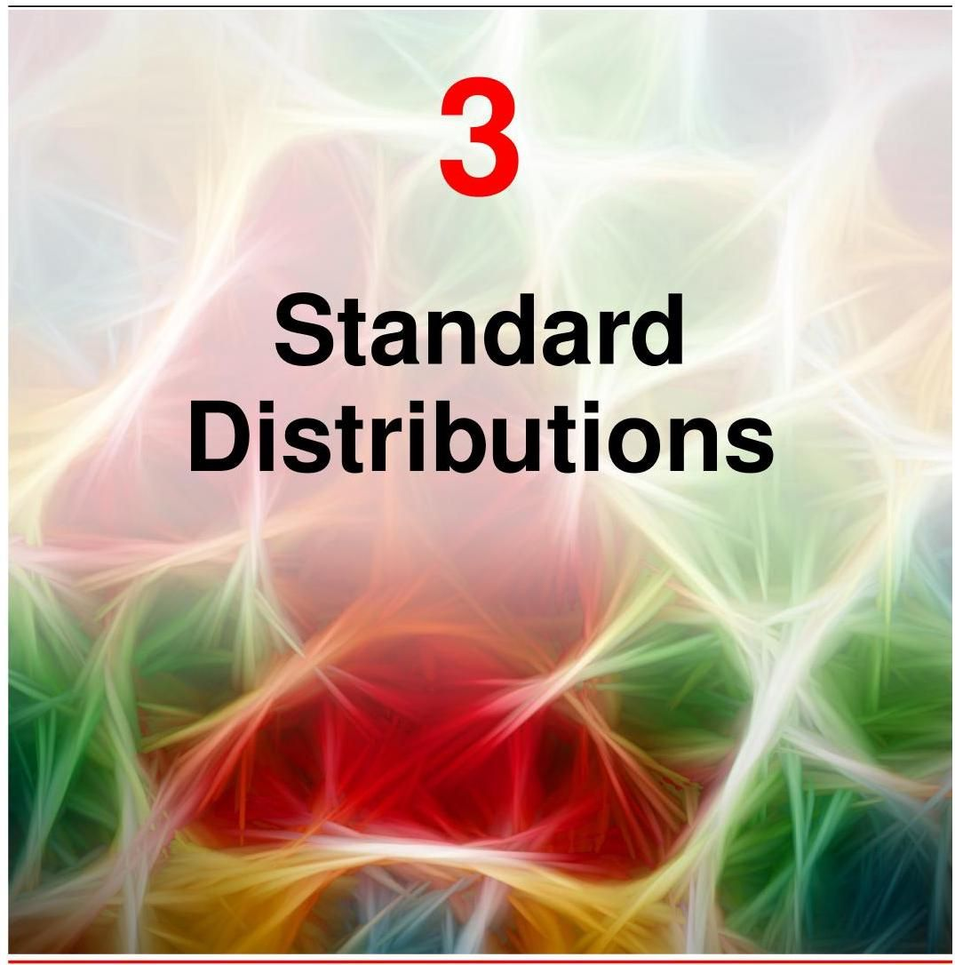

In this chapter we discuss some specific examples of probability distributions and their properties. As well as being of interest in their own right, these distributions can form building blocks for more complex models and will be used extensively throughout the book.

在本章中，我们将讨论一些具体的概率分布示例及其性质。这些分布本身就很有趣，同时它们也可以作为构建更复杂模型的基石，并将在整本书中被广泛使用。

One role for the distributions discussed in this chapter is to model the probability distribution of a random variable , given a finite set of observations. This problem is known as density estimation. It should be emphasized that the problem of density estimation is fundamentally ill-posed, because there are infinitely many probability distributions that could have given rise to the observed finite data set. Indeed, any distribution that is non-zero at each of the data points is a potential candidate. The issue of choosing an appropriate distribution relates to the problem of model selection, which has already been encountered in the context of polynomial curve fitting and which is a central issue in machine learning.

本章讨论的分布的一个作用是，在给定有限观测集 的情况下，对随机变量 的概率分布 进行建模。这个问题被称为密度估计。需要强调的是，密度估计问题本质上是不适定的，因为有无数种概率分布可能产生观测到的有限数据集。实际上，任何在每个数据点 处都不为零的分布 都是潜在的候选分布。选择合适分布的问题与模型选择问题相关，这在多项式曲线拟合的背景下已经遇到过，并且是机器学习中的一个核心问题。

Section 1.2

第1.2节

We begin by considering distributions for discrete variables before exploring the Gaussian distribution for continuous variables. These are specific examples of parametric distributions, so called because they are governed by a relatively small number of adjustable parameters, such as the mean and variance of a Gaussian. To apply such models to the problem of density estimation, we need a procedure for determining suitable values for the parameters, given an observed data set, and our main focus will be on maximizing the likelihood function. In this chapter, we will assume that the data observations are independent and identically distributed (i.i.d.), whereas in future chapters we will explore more complex scenarios involving structured data where this assumption no longer holds.

我们首先考虑离散变量的分布，然后再探讨连续变量的高斯分布。这些都是参数分布的具体例子，之所以这样称呼，是因为它们由相对较少的可调整参数控制，例如高斯分布的均值和方差。为了将此类模型应用于密度估计问题，我们需要一种在给定观测数据集的情况下确定参数合适值的方法，而我们的主要关注点将是最大化似然函数。在本章中，我们将假设数据观测是独立同分布(i.i.d.)的，而在后续章节中，我们将探讨涉及结构化数据的更复杂场景，在这些场景中，这一假设不再成立。

One limitation of the parametric approach is that it assumes a specific functional form for the distribution, which may turn out to be inappropriate for a particular application. An alternative approach is given by nonparametric density estimation methods in which the form of the distribution typically depends on the size of the data set. Such models still contain parameters, but these control the model complexity rather than the form of the distribution. We end this chapter by briefly considering three nonparametric methods based respectively on histograms, nearest neighbours, and kernels. A major limitation of nonparametric techniques such as these is that they involve storing all the training data. In other words, the number of parameters grows with the size of the data set, so that the method become very inefficient for large data sets. Deep learning combines the efficiency of parametric models with the generality of nonparametric methods by considering flexible distributions based on neural networks having a large, but fixed, number of parameters.

参数方法的一个局限性在于，它假设分布具有特定的函数形式，而这对于特定应用可能并不合适。另一种方法是非参数密度估计方法，其中分布的形式通常取决于数据集的大小。此类模型仍然包含参数，但这些参数控制的是模型复杂度，而非分布的形式。本章结尾，我们将简要介绍三种分别基于直方图、最近邻和核函数的非参数方法。诸如此类非参数技术的一个主要局限性在于，它们需要存储所有的训练数据。换句话说，参数数量会随着数据集的大小而增加，因此对于大型数据集，这些方法的效率会变得非常低。深度学习通过考虑基于具有大量但固定数量参数的神经网络的灵活分布，将参数模型的效率与非参数方法的通用性相结合。

# 3.1. Discrete Variables

# 3.1. 离散变量

We begin by considering simple distributions for discrete variables, starting with binary variables and then moving on to multi-state variables.

我们首先考虑离散变量的简单分布，从二元变量开始，然后再讨论多状态变量。

# 3.1.1 Bernoulli distribution

# 3.1.1 伯努利分布

Consider a single binary random variable . For example, might describe the outcome of flipping a coin, with representing ’heads’ and representing ’tails’. If this were a damaged coin, such as the one shown in Figure 2.2, the probability of landing heads is not necessarily the same as that of landing tails. The probability of will be denoted by the parameter so that

考虑一个单一的二元随机变量 。例如， 可能描述抛硬币的结果，其中 表示 “正面”， 表示 “反面”。如果这是一枚有缺陷的硬币，如图 2.2 所示，那么硬币正面朝上的概率不一定与反面朝上的概率相同。 的概率将用参数 表示，即

where , from which it follows that . The probability distribution over can therefore be written in the form

其中 ，由此可得 。因此， 的概率分布可以写成如下形式

Exercise 3.1

练习 3.1

which is known as the Bernoulli distribution. It is easily verified that this distribution is normalized and that it has mean and variance given by

这就是所谓的伯努利分布。很容易验证，这个分布是归一化的，并且其均值和方差分别为

Now suppose we have a data set of observed values of . We can construct the likelihood function, which is a function of , on the assumption that the observations are drawn independently from , so that

现在假设我们有一个数据集 ，它是 的观测值。我们可以构建似然函数，它是 的函数，假设这些观测值是从 中独立抽取的，即

We can estimate a value for by maximizing the likelihood function or equivalently by maximizing the logarithm of the likelihood, since the log is a monotonic function. The log likelihood function of the Bernoulli distribution is given by

我们可以通过最大化似然函数，或者等价地，通过最大化似然函数的对数来估计 的值，因为对数是一个单调函数。伯努利分布的对数似然函数为

At this point, note that the log likelihood function depends on the observations only through their sum . This sum provides an example of a sufficient statistic for the data under this distribution. If we set the derivative of with respect to equal to zero, we obtain the maximum likelihood estimator:

此时，请注意对数似然函数仅通过它们的和 依赖于 观测值 。这个和为该分布下数据的充分统计量提供了一个示例。如果我们令 关于 的导数等于零，我们就得到了最大似然估计量:

Section 3.4

3.4 节

which is also known as the sample mean. Denoting the number of observations of (heads) within this data set by , we can write (3.7) in the form

这也被称为样本均值。用 表示该数据集中 (正面)的观测次数，我们可以将 (3.7) 写成如下形式

so that the probability of landing heads is given, in this maximum likelihood framework, by the fraction of observations of heads in the data set.

因此，在这个最大似然框架下，硬币正面朝上的概率由数据集中正面观测次数的比例给出。

# 3.1.2 Binomial distribution

# 3.1.2 二项分布

We can also work out the distribution for the binary variable of the number of observations of , given that the data set has size . This is called the binomial distribution, and from (3.5) we see that it is proportional to . To obtain the normalization coefficient, note that out of coin flips, we have to add up all of the possible ways of obtaining heads, so that the binomial distribution

我们还可以计算出给定数据集大小为 时， 的观测次数 这个二元变量 的分布。这被称为二项分布，从 (3.5) 我们可以看出它与 成比例。为了得到归一化系数，请注意在 次抛硬币中，我们必须将得到 次正面的所有可能方式相加，这样就得到了二项分布

can be written as

可以写成

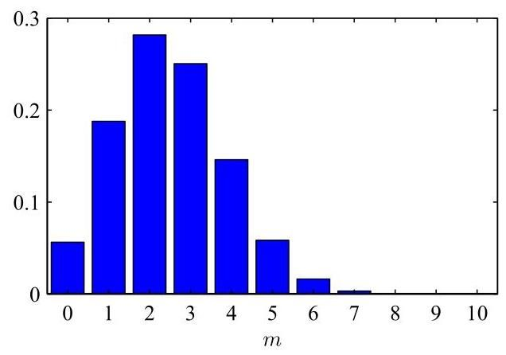

Figure 3.1 Histogram plot of the binomial distribution (3.9) as a function of for and .

图 3.1 二项分布 (3.9) 作为 的函数的直方图，其中 和 。

where

其中

is the number of ways of choosing objects out of a total of identical objects without replacement. Figure 3.1 shows a plot of the binomial distribution for and .

是从总共 个相同对象中不重复地选取 个对象的方式数。图 3.1 展示了 和 时二项分布的图形。

Exercise 3.3

练习 3.3

The mean and variance of the binomial distribution can be found by using the results that, for independent events, the mean of the sum is the sum of the means and the variance of the sum is the sum of the variances. Because and because for each observation the mean and variance are given by (3.3) and (3.4), respectively, we have

二项分布的均值和方差可以通过以下结果来计算:对于独立事件，和的均值等于均值的和，和的方差等于方差的和。因为 ，并且对于每次观测，均值和方差分别由 (3.3) 和 (3.4) 给出，所以我们有

Exercise 2.10

练习 2.10

Exercise 3.4

练习 3.4

These results can also be proved directly by using calculus.

这些结果也可以直接用微积分来证明。

# 3.1.3 Multinomial distribution

# 3.1.3 多项分布

Binary variables can be used to describe quantities that can take one of two possible values. Often, however, we encounter discrete variables that can take on one of possible mutually exclusive states. Although there are various alternative ways to express such variables, we will see shortly that a particularly convenient representation is the 1-of- scheme, sometimes called ’one-hot encoding’, in which the variable is represented by a -dimensional vector in which one of the elements equals 1 and all remaining elements equal 0 . So, for instance, if we have a variable that can take states and a particular observation of the variable happens to correspond to the state where , then will be represented by

二元变量可用于描述只能取两个可能值之一的量。然而，我们经常会遇到可以取 个可能的互斥状态之一的离散变量。虽然有多种不同的方式来表示这类变量，但我们很快会看到，一种特别方便的表示方法是 “ 中取 1” 方案，有时也称为 “独热编码”，其中变量由一个 维向量 表示，该向量中的一个元素 等于 1，其余所有元素都等于 0。例如，如果我们有一个可以取 个状态的变量，并且该变量的一个特定观测值恰好对应于 的状态，那么 将表示为

Note that such vectors satisfy . If we denote the probability of by the parameter , then the distribution of is given by

注意，这样的向量满足 。如果我们用参数 表示 的概率，那么 的分布由下式给出

where , and the parameters are constrained to satisfy and , because they represent probabilities. The distribution (3.14) can be regarded as a generalization of the Bernoulli distribution to more than two outcomes. It is easily seen that the distribution is normalized:

其中 ，并且参数 被约束以满足 和 ，因为它们表示概率。分布 (3.14) 可以被视为伯努利分布向多于两个结果的推广。很容易看出该分布是归一化的:

and that

并且

Now consider a data set of independent observations . The corresponding likelihood function takes the form

现在考虑一个包含 个独立观测值 的数据集 。相应的似然函数形式如下

where we see that the likelihood function depends on the data points only through the quantities:

我们可以看到，似然函数仅通过 个量依赖于 个数据点:

which represent the number of observations of . These are called the sufficient statistics for this distribution. Note that the variables are subject to the constraint

它们表示 的观测数量。这些被称为该分布的充分统计量。注意，变量 受以下约束

Section 3.4

第 3.4 节

To find the maximum likelihood solution for , we need to maximize with respect to taking account of the constraint (3.15) that the must sum to one. This can be achieved using a Lagrange multiplier and maximizing

为了找到 的最大似然解，我们需要在考虑约束条件 (3.15)(即 之和必须为 1)的情况下，关于 最大化 。这可以通过使用拉格朗日乘数 并最大化来实现

Appendix

附录

Setting the derivative of (3.20) with respect to to zero, we obtain

将 (3.20) 关于 的导数设为零，我们得到

We can solve for the Lagrange multiplier by substituting (3.21) into the constraint to give . Thus, we obtain the maximum likelihood solution for

我们可以通过将 (3.21) 代入约束条件 来求解拉格朗日乘数 ，得到 。因此，我们得到了

in the form

的形式为

which is the fraction of the observations for which .

这是 观测值中满足 的比例。

We can also consider the joint distribution of the quantities , conditioned on the parameter vector and on the total number of observations. From (3.17), this takes the form

我们还可以考虑量 的联合分布，该分布以参数向量 和观测总数 为条件。由式 (3.17) 可知，其形式为

which is known as the multinomial distribution. The normalization coefficient is the number of ways of partitioning objects into groups of size and is given by

这就是所谓的多项分布。归一化系数是将 个对象划分为大小为 的 个组的方式数，由下式给出

Note that two-state quantities can be represented either as binary variables and modelled using the binomial distribution (3.9) or as 1-of-2 variables and modelled using the distribution (3.14) with .

请注意，二态量既可以表示为二元变量，并使用二项分布 (3.9) 进行建模，也可以表示为 2 选 1 变量，并在 的情况下使用分布 (3.14) 进行建模。

# 3.2.The Multivariate Gaussian

# 3.2. 多元高斯分布

The Gaussian, also known as the normal distribution, is a widely used model for the distribution of continuous variables. We have already seen that for of a single

高斯分布，也称为正态分布，是一种广泛用于连续变量分布的模型。我们已经知道，对于单个

Section 2.3 variable , the Gaussian distribution can be written in the form

第 2.3 节 变量 ，高斯分布可以写成如下形式

where is the mean and is the variance. For a -dimensional vector , the multivariate Gaussian distribution takes the form

其中 是均值， 是方差。对于一个 维向量 ，多元高斯分布具有以下形式

where is the -dimensional mean vector, is the covariance matrix, and denotes the determinant of .

其中 是 维均值向量， 是 协方差矩阵， 表示 的行列式。

The Gaussian distribution arises in many different contexts and can be motivated from a variety of different perspectives. For example, we have already seen that for a single real variable, the distribution that maximizes the entropy is the Gaussian.

高斯分布出现在许多不同的情境中，并且可以从多种不同的视角来理解。例如，我们已经看到，对于单个实变量，使熵最大化的分布是高斯分布。

Section 2.5

第 2.5 节

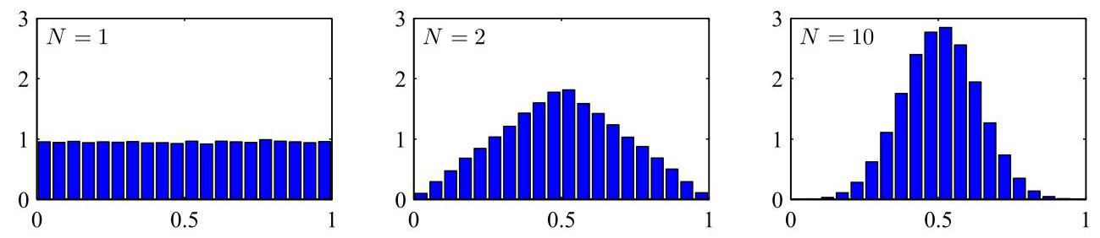

Figure 3.2 Histogram plots of the mean of uniformly distributed numbers for various values of . We observe that as increases, the distribution tends towards a Gaussian.

图 3.2 不同 值下 个均匀分布数字的均值的直方图。我们观察到，随着 的增加，分布趋向于高斯分布。

Exercise 3.8 This property applies also to the multivariate Gaussian.

练习 3.8 这个性质也适用于多元高斯分布。

Another situation in which the Gaussian distribution arises is when we consider the sum of multiple random variables. The central limit theorem tells us that, subject to certain mild conditions, the sum of a set of random variables, which is of course itself a random variable, has a distribution that becomes increasingly Gaussian as the number of terms in the sum increases (Walker, 1969). We can illustrate this by considering variables each of which has a uniform distribution over the interval and then considering the distribution of the mean . For large , this distribution tends to a Gaussian, as illustrated in Figure 3.2. In practice, the convergence to a Gaussian as increases can be very rapid. One consequence of this result is that the binomial distribution (3.9), which is a distribution over defined by the sum of observations of the random binary variable , will tend to a Gaussian as (see Figure 3.1 for ).

高斯分布出现的另一种情况是当我们考虑多个随机变量的和时。中心极限定理告诉我们，在某些温和条件下，一组随机变量的和(它本身当然也是一个随机变量)的分布随着求和项数的增加越来越接近高斯分布(Walker，1969)。我们可以通过考虑 个变量 来说明这一点，每个变量在区间 上服从均匀分布，然后考虑均值 的分布。对于较大的 ，这个分布趋向于高斯分布，如图 3.2 所示。实际上，随着 的增加，向高斯分布的收敛可能非常迅速。这一结果的一个推论是，二项分布(3.9)，它是由随机二元变量 的 次观测之和定义的关于 的分布，当 时将趋向于高斯分布(对于 ，见图 3.1)。

The Gaussian distribution has many important analytical properties, and we will consider several of these in detail. As a result, this section will be rather more technically involved than some of the earlier sections and will require familiarity with various matrix identities.

高斯分布有许多重要的分析性质，我们将详细讨论其中的几个。因此，本节将比前面的一些章节在技术上更复杂，并且需要熟悉各种矩阵恒等式。

Appendix A

附录 A

# 3.2.1 Geometry of the Gaussian

# 3.2.1 高斯分布的几何性质

We begin by considering the geometrical form of the Gaussian distribution. The functional dependence of the Gaussian on is through the quadratic form

我们首先考虑高斯分布的几何形式。高斯分布对 的函数依赖是通过二次型实现的

which appears in the exponent. The quantity is called the Mahalanobis distance from to . It reduces to the Euclidean distance when is the identity matrix. The Gaussian distribution is constant on surfaces in -space for which this quadratic form is constant.

它出现在指数中。量 被称为从 到 的马氏距离。当 是单位矩阵时，它简化为欧几里得距离。在 空间中，对于二次型为常数的曲面，高斯分布是常数。

First, note that the matrix can be taken to be symmetric, without loss of generality, because any antisymmetric component would disappear from the exponent. Now consider the eigenvector equation for the covariance matrix

首先，注意到不失一般性，矩阵 可以被视为对称矩阵，因为任何反对称分量都会从指数中消失。现在考虑协方差矩阵的特征向量方程

Exercise 3.11

练习 3.11

where . Because is a real, symmetric matrix, its eigenvalues will be real, and its eigenvectors can be chosen to form an orthonormal set, so that

其中 。因为 是一个实对称矩阵，其特征值将是实数，并且可以选择其特征向量构成一个标准正交基，使得

Exercise 3.12

练习 3.12

where is the element of the identity matrix and satisfies

其中 是单位矩阵的 元素，并且满足

The covariance matrix can be expressed as an expansion in terms of its eigenvectors in the form

协方差矩阵 可以用其特征向量展开的形式表示为

Exercise 3.13

练习 3.13

and similarly the inverse covariance matrix can be expressed as

类似地，逆协方差矩阵 可以表示为

Substituting (3.32) into (3.27), the quadratic form becomes

将 (3.32) 代入 (3.27)，二次型变为

where we have defined

其中我们定义了

We can interpret as a new coordinate system defined by the orthonormal vectors that are shifted and rotated with respect to the original coordinates. Forming the vector , we have

我们可以将 解释为一个由正交归一向量 定义的新坐标系，该坐标系相对于原始的 坐标进行了平移和旋转。构造向量 ，我们有

where is a matrix whose rows are given by . From (3.29) it follows that is an orthogonal matrix, i.e., it satisfies , where is the identity matrix.

其中 是一个矩阵，其行由 给出。由 (3.29) 可知， 是一个正交矩阵，即它满足 ，其中 是单位矩阵。

Appendix A

附录 A

The quadratic form, and hence the Gaussian density, is constant on surfaces for which (3.33) is constant. If all the eigenvalues are positive, then these surfaces represent ellipsoids, with their centres at and their axes oriented along , and with scaling factors in the directions of the axes given by , as illustrated in Figure 3.3.

二次型，进而高斯密度，在 (3.33) 为常数的曲面上是恒定的。如果所有特征值 都是正的，那么这些曲面表示椭球体，其中心位于 ，轴沿着 方向，并且轴方向的缩放因子由 给出，如图 3.3 所示。

For the Gaussian distribution to be well defined, it is necessary for all the eigenvalues of the covariance matrix to be strictly positive, otherwise the distribution cannot be properly normalized. A matrix whose eigenvalues are strictly positive is said to be positive definite. When we discuss latent variable models, we will encounter Gaussian distributions for which one or more of the eigenvalues are zero, in which case the distribution is singular and is confined to a subspace of lower dimensionality. If all the eigenvalues are non-negative, then the covariance matrix is said to be positive semidefinite.

为了使高斯分布有良好的定义，协方差矩阵的所有特征值 必须严格为正，否则该分布无法正确归一化。特征值严格为正的矩阵称为正定矩阵。当我们讨论潜在变量模型时，会遇到一个或多个特征值为零的高斯分布，在这种情况下，分布是奇异的，并且局限于一个低维子空间。如果所有特征值都是非负的，那么协方差矩阵称为半正定矩阵。

Chapter 16

第 16 章

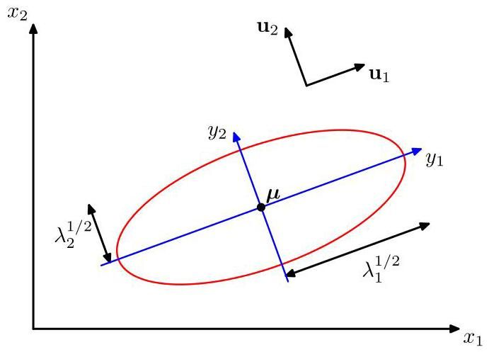

Figure 3.3 The red curve shows the elliptical surface of constant probability density for a Gaussian in a two-dimensional space on which the density is of its value at . The axes of the ellipse are defined by the eigenvectors of the covariance matrix, with corresponding eigenvalues .

图 3.3 红色曲线展示了二维空间 中高斯分布的恒定概率密度椭圆曲面，在该曲面上的密度是其在 处值的 倍。椭圆的轴由协方差矩阵的特征向量 定义，对应的特征值为 。

Now consider the form of the Gaussian distribution in the new coordinate system defined by the . In going from the to the coordinate system, we have a Jacobian matrix with elements given by

现在考虑由 定义的新坐标系中高斯分布的形式。从 坐标系转换到 坐标系时，我们有一个雅可比矩阵 ，其元素由下式给出

where are the elements of the matrix . Using the orthonormality property of the matrix , we see that the square of the determinant of the Jacobian matrix is

其中 是矩阵 的元素。利用矩阵 的正交归一性，我们可以看到雅可比矩阵行列式的平方为

and, hence, . Also, the determinant of the covariance matrix can be written as the product of its eigenvalues, and hence

因此， 。此外，协方差矩阵的行列式 可以写成其特征值的乘积，因此

Thus, in the coordinate system, the Gaussian distribution takes the form

因此，在 坐标系中，高斯分布具有以下形式

which is the product of independent univariate Gaussian distributions. The eigenvectors therefore define a new set of shifted and rotated coordinates with respect to which the joint probability distribution factorizes into a product of independent distributions. The integral of the distribution in the coordinate system is then

这是 个独立的单变量高斯分布的乘积。因此，特征向量定义了一组新的平移和旋转后的坐标，相对于这些坐标，联合概率分布可以分解为独立分布的乘积。在 坐标系中，该分布的积分为

where we have used the result (2.51) for the normalization of the univariate Gaussian. This confirms that the multivariate Gaussian (3.26) is indeed normalized.

这里我们使用了单变量高斯分布归一化的结果 (2.51)。这证实了多元高斯分布 (3.26) 确实是归一化的。

# 3.2.2 Moments

# 3.2.2 矩

We now look at the moments of the Gaussian distribution and thereby provide an interpretation of the parameters and . The expectation of under the Gaussian distribution is given by

现在我们来研究高斯分布的矩，从而对参数 和 给出一种解释。在高斯分布下 的期望由下式给出

where we have changed variables using . Note that the exponent is an even function of the components of , and because the integrals over these are taken over the range , the term in in the factor will vanish by symmetry. Thus,

这里我们使用 进行了变量替换。注意，指数是 各分量的偶函数，并且由于对这些分量的积分范围是 ，因子 中涉及 的项将由于对称性而消失。因此，

and so we refer to as the mean of the Gaussian distribution.

所以我们将 称为高斯分布的均值。

We now consider second-order moments of the Gaussian. In the univariate case, we considered the second-order moment given by . For the multivariate Gaussian, there are second-order moments given by , which we can group together to form the matrix . This matrix can be written as

现在我们考虑高斯分布的二阶矩。在单变量情况下，我们考虑由 给出的二阶矩。对于多变量高斯分布，有 个由 给出的二阶矩，我们可以将它们组合在一起形成矩阵 。这个矩阵可以写成

where again we have changed variables using . Note that the cross-terms involving and will again vanish by symmetry. The term is constant and can be taken outside the integral, which itself is unity because the Gaussian distribution is normalized. Consider the term involving . Again, we can make use of the eigenvector expansion of the covariance matrix given by (3.28), together with the completeness of the set of eigenvectors, to write

这里我们再次使用 进行了变量替换。注意，涉及 和 的交叉项将再次由于对称性而消失。项 是常数，可以提到积分外面，由于高斯分布是归一化的，积分本身的值为 1。考虑涉及 的项。同样，我们可以利用由 (3.28) 给出的协方差矩阵的特征向量展开，再结合特征向量集的完备性，写成

where , which gives

其中 ，由此可得

where we have made use of the eigenvector equation (3.28), together with the fact that the integral on the middle line vanishes by symmetry unless . In the final line we have made use of the results (2.53) and (3.38), together with (3.31). Thus, we have

在此我们利用了特征向量方程 (3.28)，以及中间一行的积分由于对称性而消失的事实，除非 。在最后一行，我们利用了结果 (2.53) 和 (3.38)，以及 (3.31)。因此，我们得到

When defining the variance for a single random variable, we subtracted the mean before taking the second moment. Similarly, in the multivariate case it is again convenient to subtract off the mean, giving rise to the covariance of a random vector

在定义单个随机变量的方差时，我们在取二阶矩之前减去了均值。类似地，在多变量的情况下，减去均值仍然很方便，从而引出了随机向量的协方差

defined by

定义为

For the specific case of a Gaussian distribution, we can make use of , together with the result (3.46), to give

对于高斯分布的特定情况，我们可以利用 以及结果 (3.46)，得到

Because the parameter matrix governs the covariance of under the Gaussian distribution, it is called the covariance matrix.

由于参数矩阵 控制着高斯分布下 的协方差，因此它被称为协方差矩阵。

# 3.2.3 Limitations

# 3.2.3 局限性

Although the Gaussian distribution (3.26) is often used as a simple density model, it suffers from some significant limitations. Consider the number of free parameters in the distribution. A general symmetric covariance matrix will have independent parameters, and there are another independent parameters in , giving parameters in total. For large , the total number of parameters therefore grows quadratically with , and the computational task of manipulating and inverting the large matrices can become prohibitive. One way to address this problem is to use restricted forms of the covariance matrix. If we consider covariance matrices that are diagonal, so that , we then have a total of independent parameters in the density model. The corresponding contours of constant density are given by axis-aligned ellipsoids. We could further restrict the covariance matrix to be proportional to the identity matrix, , known as an isotropic covariance, giving independent parameters in the model together with spherical surfaces of constant density. The three possibilities of general, diagonal, and isotropic covariance matrices are illustrated in Figure 3.4. Unfortunately, whereas such approaches limit the number of degrees of freedom in the distribution and make inversion of the covariance matrix a much faster operation, they also greatly restrict the form of the probability density and limit its ability to capture interesting correlations in the data.

尽管高斯分布(3.26)常被用作简单的密度模型，但它存在一些显著的局限性。考虑该分布中的自由参数数量。一个一般的对称协方差矩阵 将有 个独立参数，并且在 中还有另外 个独立参数，总共给出 个参数。对于较大的 ，参数总数因此随 呈二次增长，处理和求逆大型矩阵的计算任务可能变得难以承受。解决这个问题的一种方法是使用协方差矩阵的受限形式。如果我们考虑对角协方差矩阵，使得 ，那么我们在密度模型中总共有 个独立参数。相应的等密度轮廓由与坐标轴对齐的椭球体给出。我们可以进一步将协方差矩阵限制为与单位矩阵成比例，即 ，称为各向同性协方差，在模型中给出 个独立参数以及等密度的球面。一般、对角和各向同性协方差矩阵的三种可能性如图 3.4 所示。不幸的是，虽然这些方法限制了分布中的自由度数量，并使协方差矩阵的求逆操作快得多，但它们也极大地限制了概率密度的形式，并限制了其捕捉数据中有趣相关性的能力。

Exercise 3.15

练习 3.15

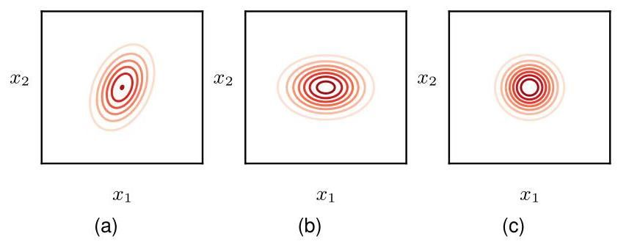

Figure 3.4 Contours of constant probability density for a Gaussian distribution in two dimensions in which the covariance matrix is (a) of general form, (b) diagonal, in which case the elliptical contours are aligned with the coordinate axes, and (c) proportional to the identity matrix, in which case the contours are concentric circles.

图 3.4 二维高斯分布的等概率密度轮廓，其中协方差矩阵为(a)一般形式，(b)对角形式，在这种情况下椭圆轮廓与坐标轴对齐，以及(c)与单位矩阵成比例，在这种情况下轮廓为同心圆。

A further limitation of the Gaussian distribution is that it is intrinsically unimodal (i.e., has a single maximum) and so is unable to provide a good approximation to multimodal distributions. Thus, the Gaussian distribution can be both too flexible, in the sense of having too many parameters, and too limited in the range of distributions that it can adequately represent. We will see later that the introduction of latent variables, also called hidden variables or unobserved variables, allows both of these problems to be addressed. In particular, a rich family of multimodal distributions is obtained by introducing discrete latent variables leading to mixtures of Gaussians. Similarly, the introduction of continuous latent variables leads to models in which the number of free parameters can be controlled independently of the dimensionality of the data space while still allowing the model to capture the dominant correlations in the data set.

高斯分布的另一个局限性是它本质上是单峰的(即只有一个最大值)，因此无法很好地近似多峰分布。因此，高斯分布可能既过于灵活(从参数过多的意义上来说)，又在其能够充分表示的分布范围上过于受限。我们稍后将看到，引入潜在变量(也称为隐藏变量或未观测变量)可以解决这两个问题。特别是，通过引入离散潜在变量得到了一个丰富的多峰分布族，从而产生了高斯混合模型。类似地，引入连续潜在变量会得到这样的模型，其中自由参数的数量可以独立于数据空间的维度 进行控制，同时仍然允许模型捕捉数据集中的主要相关性。

Section 3.2.9

第 3.2.9 节

Chapter 16

第 16 章

# 3.2.4 Conditional distribution

# 3.2.4 条件分布

An important property of a multivariate Gaussian distribution is that if two sets of variables are jointly Gaussian, then the conditional distribution of one set conditioned on the other is again Gaussian. Similarly, the marginal distribution of either set is also Gaussian.

多元高斯分布的一个重要性质是，如果两组变量是联合高斯分布，那么一组变量在另一组变量条件下的条件分布仍然是高斯分布。同样，任一组变量的边缘分布也是高斯分布。

First, consider the case of conditional distributions. Suppose that is a - dimensional vector with Gaussian distribution and that we partition into two disjoint subsets and . Without loss of generality, we can take to form the first components of , with comprising the remaining components, so that

首先，考虑条件分布的情况。假设 是一个服从高斯分布 的 维向量，并且我们将 划分为两个不相交的子集 和 。不失一般性，我们可以取 构成 的前 个分量， 包含其余的 个分量，使得

We also define corresponding partitions of the mean vector given by

我们还定义均值向量 的相应划分如下

and of the covariance matrix given by

以及协方差矩阵 的相应划分如下

Note that the symmetry of the covariance matrix implies that and are symmetric and that .

注意，协方差矩阵的对称性 意味着 和 是对称的，并且 。

In many situations, it will be convenient to work with the inverse of the covariance matrix:

在许多情况下，使用协方差矩阵的逆矩阵会很方便:

which is known as the precision matrix. In fact, we will see that some properties of Gaussian distributions are most naturally expressed in terms of the covariance, whereas others take a simpler form when viewed in terms of the precision. We therefore also introduce the partitioned form of the precision matrix:

它被称为精度矩阵。事实上，我们将看到，高斯分布的一些性质用协方差来表达最为自然，而另一些性质用精度来表达则形式更简单。因此，我们也引入精度矩阵的分块形式:

corresponding to the partitioning (3.49) of the vector . Because the inverse of a symmetric matrix is also symmetric, we see that and are symmetric and that . It should be stressed at this point that, for instance, is not simply given by the inverse of . In fact, we will shortly examine the relation between the inverse of a partitioned matrix and the inverses of its partitions.

对应于向量 的分块 (3.49)。由于对称矩阵的逆矩阵也是对称的，我们可以看到 和 是对称的，并且 。此时需要强调的是，例如， 并非简单地由 的逆矩阵给出。事实上，我们很快将研究分块矩阵的逆矩阵与其各分块的逆矩阵之间的关系。

Exercise 3.16

练习 3.16

We begin by finding an expression for the conditional distribution . From the product rule of probability, we see that this conditional distribution can be evaluated from the joint distribution simply by fixing to the observed value and normalizing the resulting expression to obtain a valid probability distribution over . Instead of performing this normalization explicitly, we can obtain the solution more efficiently by considering the quadratic form in the exponent of the Gaussian distribution given by (3.27) and then reinstating the normalization coefficient at the end of the calculation. If we make use of the partitioning (3.49), (3.50), and (3.53), we obtain

我们首先来推导条件分布 的表达式。根据概率的乘积规则，我们知道可以通过将联合分布 中的 固定为观测值，并对得到的表达式进行归一化处理，从而得到关于 的有效概率分布，以此来计算这个条件分布。我们无需显式地进行归一化操作，而是可以通过考虑由 (3.27) 给出的高斯分布指数中的二次型，然后在计算结束时恢复归一化系数，从而更高效地得到解。如果我们利用分块 (3.49)、(3.50) 和 (3.53)，就可以得到

We see that as a function of , this is again a quadratic form, and hence, the corresponding conditional distribution will be Gaussian. Because this distribution is completely characterized by its mean and its covariance, our goal will be to identify expressions for the mean and covariance of by inspection of (3.54).

我们看到，作为 的函数，这又是一个二次型，因此，相应的条件分布 将是高斯分布。由于这个分布完全由其均值和协方差来表征，我们的目标将是通过观察 (3.54) 来确定 的均值和协方差的表达式。

This is an example of a rather common operation associated with Gaussian distributions, sometimes called ’completing the square’, in which we are given a quadratic form defining the exponent terms in a Gaussian distribution and we need to determine the corresponding mean and covariance. Such problems can be solved straightforwardly by noting that the exponent in a general Gaussian distribution can be written as

这是一个与高斯分布相关的相当常见的运算示例，有时称为“配方法”。在这个示例中，我们得到一个定义高斯分布中指数项的二次型，并且需要确定相应的均值和协方差。通过注意到一般高斯分布 中的指数可以写成如下形式，这类问题可以直接得到解决

where ’const’ denotes terms that are independent of , We have also made use of the symmetry of . Thus, if we take our general quadratic form and express it in the form given by the right-hand side of (3.55), then we can immediately equate the matrix of coefficients entering the second-order term in to the inverse covariance matrix and the coefficient of the linear term in to , from which we can obtain .

其中 ’const’ 表示与 无关的项。我们还利用了 的对称性。因此，如果我们取一般的二次型并将其表示为 (3.55) 式右侧的形式，那么我们可以立即将 中二阶项的系数矩阵等同于逆协方差矩阵 ，并将 中线性项的系数等同于 ，由此我们可以得到 。

Now let us apply this procedure to the conditional Gaussian distribution for which the quadratic form in the exponent is given by (3.54). We will denote the mean and covariance of this distribution by and , respectively. Consider the functional dependence of (3.54) on in which is regarded as a constant. If we pick out all terms that are second order in , we have

现在让我们将这个过程应用于条件高斯分布 ，其指数中的二次型由 (3.54) 式给出。我们分别用 和 表示这个分布的均值和协方差。考虑 (3.54) 式对 的函数依赖关系，其中 被视为常数。如果我们挑出 的所有二阶项，我们得到

from which we can immediately conclude that the covariance (inverse precision) of is given by

由此我们可以立即得出 的协方差(逆精度)由下式给出

Now consider all the terms in (3.54) that are linear in :

现在考虑 (3.54) 式中所有关于 的线性项:

where we have used . From our discussion of the general form (3.55), the coefficient of in this expression must equal and, hence,

其中我们使用了 。根据我们对一般形式 (3.55) 的讨论，这个表达式中 的系数必须等于 ，因此，

where we have made use of (3.57).

这里我们利用了式(3.57)。

The results (3.57) and (3.59) are expressed in terms of the partitioned precision matrix of the original joint distribution . We can also express these results in terms of the corresponding partitioned covariance matrix. To do this, we make use of the following identity for the inverse of a partitioned matrix:

结果(3.57)和(3.59)是用原始联合分布 的分块精度矩阵表示的。我们也可以用相应的分块协方差矩阵来表示这些结果。为此，我们利用分块矩阵求逆的以下恒等式:

Exercise 3.18

练习3.18

where we have defined

这里我们定义了

The quantity is known as the Schur complement of the matrix on the left-hand side of (3.60) with respect to the submatrix D. Using the definition

量 被称为式(3.60)左边矩阵关于子矩阵 D 的舒尔补。利用该定义

and making use of (3.60), we have

并利用式(3.60)，我们得到

From these we obtain the following expressions for the mean and covariance of the conditional distribution :

由此，我们得到条件分布 的均值和协方差的以下表达式:

Comparing (3.57) and (3.66), we see that the conditional distribution takes a simpler form when expressed in terms of the partitioned precision matrix than when it is expressed in terms of the partitioned covariance matrix. Note that the mean of the conditional distribution , given by (3.65), is a linear function of and that the covariance, given by (3.66), is independent of . This represents an example of a linear-Gaussian model.

比较 (3.57) 和 (3.66)，我们发现，用分块精度矩阵表示时，条件分布 的形式比分块协方差矩阵表示时更简单。注意，由 (3.65) 给出的条件分布 的均值是 的线性函数，而由 (3.66) 给出的协方差与 无关。这是线性高斯模型的一个例子。

Section 11.1.4

第 11.1.4 节

# 3.2.5 Marginal distribution

# 3.2.5 边缘分布

We have seen that if a joint distribution is Gaussian, then the conditional distribution will again be Gaussian. Now we turn to a discussion of the marginal distribution given by

我们已经知道，如果联合分布 是高斯分布，那么条件分布 也将是高斯分布。现在我们来讨论由下式给出的边缘分布

which, as we will see, is also Gaussian. Once again, our strategy for calculating this distribution will be to focus on the quadratic form in the exponent of the joint distribution and thereby to identify the mean and covariance of the marginal distribution .

正如我们将看到的，它也是高斯分布。同样，我们计算这个分布的策略将是关注联合分布指数中的二次型，从而确定边缘分布 的均值和协方差。

The quadratic form for the joint distribution can be expressed, using the partitioned precision matrix, in the form (3.54). Our goal is to integrate out , which is most easily achieved by first considering the terms involving and then completing the square to facilitate the integration. Picking out just those terms that involve , we have

使用分块精度矩阵，联合分布的二次型可以表示为式 (3.54) 的形式。我们的目标是对 进行积分，最简便的方法是先考虑涉及 的项，然后通过配方法来简化积分。仅选取那些涉及 的项，我们得到

where we have defined

其中我们定义了

We see that the dependence on has been cast into the standard quadratic form of a Gaussian distribution corresponding to the first term on the right-hand side of (3.68) plus a term that does not depend on (but that does depend on ). Thus, when we take the exponential of this quadratic form, we see that the integration over required by (3.67) will take the form

我们看到，对 的依赖已被转化为高斯分布的标准二次型，对应于式 (3.68) 右侧的第一项，再加上一个不依赖于 (但依赖于 )的项。因此，当我们对这个二次型取指数时，我们会发现式 (3.67) 所要求的对 的积分将具有如下形式

This integration is easily performed by noting that it is the integral over an unnormalized Gaussian, and so the result will be the reciprocal of the normalization coefficient. We know from the form of the normalized Gaussian given by (3.26) that this coefficient is independent of the mean and depends only on the determinant of the covariance matrix. Thus, by completing the square with respect to , we can integrate out so that the only term remaining from the contributions on the left-hand side of (3.68) that depends on is the last term on the right-hand side of (3.68) in which is given by (3.69). Combining this term with the remaining terms from (3.54) that depend on , we obtain

注意到这是对一个未归一化的高斯分布进行积分，因此这个积分很容易计算，结果将是归一化系数的倒数。从式 (3.26) 给出的归一化高斯分布的形式我们知道，这个系数与均值无关，仅取决于协方差矩阵的行列式。因此，通过对 进行配方法，我们可以对 进行积分，使得式 (3.68) 左侧的贡献中仅剩下依赖于 的项，即式 (3.68) 右侧的最后一项，其中 由式 (3.69) 给出。将这项与式 (3.54) 中剩下的依赖于 的项相结合，我们得到

where ’const’ denotes quantities independent of . Again, by comparison with (3.55), we see that the covariance of the marginal distribution is given by

其中 “const” 表示与 无关的量。再次与式 (3.55) 进行比较，我们看到边缘分布 的协方差由下式给出

Similarly, the mean is given by

类似地，均值由下式给出

where we have used (3.72). The covariance (3.72) is expressed in terms of the partitioned precision matrix given by (3.53). We can rewrite this in terms of the corresponding partitioning of the covariance matrix given by (3.51), as we did for the conditional distribution. These partitioned matrices are related by

这里我们使用了式(3.72)。协方差(3.72)是用式(3.53)给出的分块精度矩阵来表示的。我们可以像处理条件分布那样，用式(3.51)给出的协方差矩阵的相应分块来重写它。这些分块矩阵之间的关系为

Making use of (3.60), we then have

利用式(3.60)，我们可以得到

Thus, we obtain the intuitively satisfying result that the marginal distribution has mean and covariance given by

因此，我们得到一个直观上令人满意的结果，即边缘分布 的均值和协方差为

We see that for a marginal distribution, the mean and covariance are most simply expressed in terms of the partitioned covariance matrix, in contrast to the conditional distribution for which the partitioned precision matrix gives rise to simpler expressions.

我们看到，对于边缘分布，均值和协方差用分块协方差矩阵表示最为简单，这与条件分布形成对比，对于条件分布，分块精度矩阵会得到更简单的表达式。

Our results for the marginal and conditional distributions of a partitioned Gaussian can be summarized as follows. Given a joint Gaussian distribution with and the following partitions

我们关于分块高斯分布的边缘分布和条件分布的结果可以总结如下。给定一个联合高斯分布 ，其中 以及以下分块

then the conditional distribution is given by

那么条件分布为

and the marginal distribution is given by

并且边缘分布由下式给出

We illustrate the idea of conditional and marginal distributions associated with a multivariate Gaussian using an example involving two variables in Figure 3.5.

我们在图 3.5 中通过一个涉及两个变量的例子来说明与多元高斯分布相关的条件分布和边缘分布的概念。

# 3.2.6 Bayes’ theorem

# 3.2.6 贝叶斯定理

In Sections 3.2.4 and 3.2.5 we considered a Gaussian in which we partitioned the vector into two subvectors and then found expressions for the conditional distribution and the marginal distribution . We noted that the mean of the conditional distribution was a linear function of . Here we will suppose that we are given a Gaussian marginal distribution and a Gaussian conditional distribution in which has a mean that is a linear function of and a covariance that is independent of . This is an example of a linear-Gaussian model (Roweis and Ghahramani, 1999). We wish to find the marginal distribution and the conditional distribution . This is a structure that arises in several types of generative model and it will prove convenient to derive the general results here.

在 3.2.4 节和 3.2.5 节中，我们考虑了一个高斯分布 ，其中我们将向量 划分为两个子向量 ，然后得到了条件分布 和边缘分布 的表达式。我们注意到条件分布 的均值是 的线性函数。在这里，我们假设给定一个高斯边缘分布 和一个高斯条件分布 ，其中 的均值是 的线性函数，协方差与 无关。这是线性高斯模型的一个例子(Roweis 和 Ghahramani，1999)。我们希望找到边缘分布 和条件分布 。这种结构出现在几种类型的生成模型中，在这里推导一般结果将被证明是方便的。

Section 11.1.4

11.1.4 节

Chapter 16

第 16 章

We will take the marginal and conditional distributions to be

我们将把边缘分布和条件分布设为

where , and are parameters governing the means, and and are precision matrices. If has dimensionality and has dimensionality , then the matrix has size .

其中 和 是控制均值的参数， 和 是精度矩阵。如果 的维数为 ， 的维数为 ，那么矩阵 的大小为 。

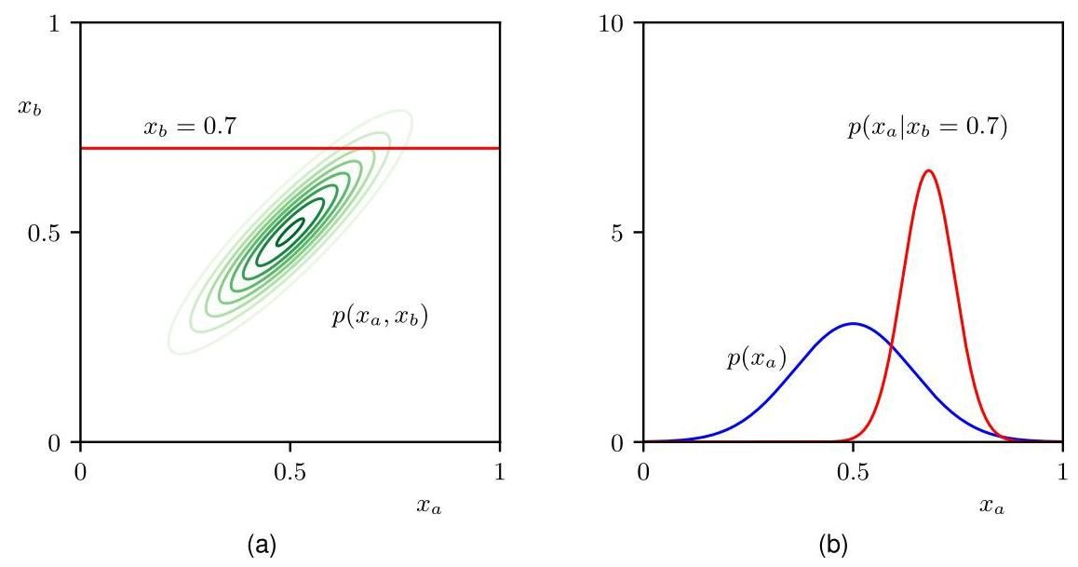

Figure 3.5 (a) Contours of a Gaussian distribution over two variables. (b) The marginal distribution (blue curve) and the conditional distribution for (red curve).

图 3.5 (a) 两个变量上的高斯分布 的等高线。(b) 边缘分布 (蓝色曲线)和给定 时的条件分布 (红色曲线)。

First we find an expression for the joint distribution over and . To do this, we

首先，我们要找到 和 的联合分布的表达式。为此，我们

define

定义

and then consider the log of the joint distribution:

然后考虑联合分布的对数:

where ’const’ denotes terms independent of and . As before, we see that this is a quadratic function of the components of , and hence, is Gaussian distribution. To find the precision of this Gaussian, we consider the second-order terms in (3.86), which can be written as

其中 ’const’ 表示与 和 无关的项。和之前一样，我们看到这是 各分量的二次函数，因此， 是高斯分布。为了求出这个高斯分布的精度，我们考虑 (3.86) 中的二阶项，它可以写成

and so the Gaussian distribution over has precision (inverse covariance) matrix

因此，关于 的高斯分布具有精度(协方差的逆)矩阵

given by

由下式给出

The covariance matrix is found by taking the inverse of the precision, which can be done using the matrix inversion formula (3.60) to give

通过求精度矩阵的逆来得到协方差矩阵，这可以使用矩阵求逆公式 (3.60) 来完成，结果为

Exercise 3.23

练习 3.23

Similarly, we can find the mean of the Gaussian distribution over by identifying the linear terms in (3.86), which are given by

类似地，我们可以通过确定 (3.86) 中的线性项来求出关于 的高斯分布的均值，这些线性项由下式给出

Using our earlier result (3.55) obtained by completing the square over the quadratic form of a multivariate Gaussian, we find that the mean of is given by

利用我们之前通过对多元高斯分布的二次型进行配方法得到的结果 (3.55)，我们发现 的均值由下式给出

Exercise 3.24

练习 3.24

Making use of (3.89), we then obtain

利用 (3.89)，我们随后得到

Next we find an expression for the marginal distribution in which we have marginalized over . Recall that the marginal distribution over a subset of the components of a Gaussian random vector takes a particularly simple form when expressed in terms of the partitioned covariance matrix. Specifically, its mean and covariance are given by (3.76) and (3.77), respectively. Making use of (3.89) and (3.92), we see that the mean and covariance of the marginal distribution are given by

接下来，我们要找到边缘分布 的表达式，其中我们对 进行了边缘化处理。回顾一下，当用分块协方差矩阵表示时，高斯随机向量的部分分量的边缘分布具有特别简单的形式。具体来说，其均值和协方差分别由 (3.76) 和 (3.77) 给出。利用 (3.89) 和 (3.92)，我们可以看到边缘分布 的均值和协方差由下式给出

Section 3.2

第 3.2 节

A special case of this result is when , in which case the marginal distribution reduces to the convolution of two Gaussians, for which we see that the mean of the convolution is the sum of the means of the two Gaussians and the covariance of the convolution is the sum of their covariances.

这个结果的一个特殊情况是当 时，在这种情况下，边缘分布简化为两个高斯分布的卷积，我们可以看到卷积的均值是两个高斯分布均值之和，卷积的协方差是它们协方差之和。

Finally, we seek an expression for the conditional . Recall that the results for the conditional distribution are most easily expressed in terms of the partitioned precision matrix, using (3.57) and (3.59). Applying these results to (3.89) and (3.92), we see that the conditional distribution has mean and covariance given by

最后，我们寻求条件 的表达式。回想一下，条件分布的结果使用 (3.57) 和 (3.59) 以分块精度矩阵的形式最容易表达。将这些结果应用于 (3.89) 和 (3.92)，我们发现条件分布 的均值和协方差由下式给出

Section 3.2

3.2 节

The evaluation of this conditional distribution can be seen as an example of Bayes’ theorem, in which we interpret as a prior distribution over . If the variable is observed, then the conditional distribution represents the corresponding posterior distribution over . Having found the marginal and conditional distributions, we have effectively expressed the joint distribution in the form .

对这个条件分布的评估可以看作是贝叶斯定理的一个例子，其中我们将 解释为 上的先验分布。如果变量 被观测到，那么条件分布 表示 上相应的后验分布。在找到了边缘分布和条件分布之后，我们实际上已经将联合分布 表示为 的形式。

These results can be summarized as follows. Given a marginal Gaussian distribution for and a conditional Gaussian distribution for given in the form

这些结果可以总结如下。给定 的边缘高斯分布以及 给定时 的条件高斯分布，形式为

then the marginal distribution of and the conditional distribution of given are given by

那么 的边缘分布以及 给定时 的条件分布由下式给出

where

其中

# 3.2.7 Maximum likelihood

# 3.2.7 最大似然

Given a data set in which the observations are assumed to be drawn independently from a multivariate Gaussian distribution, we can estimate the parameters of the distribution by maximum likelihood. The log likelihood function is given by

给定一个数据集 ，其中的观测值 假定是从多元高斯分布中独立抽取的，我们可以通过最大似然法来估计该分布的参数。对数似然函数由下式给出

By simple rearrangement, we see that the likelihood function depends on the data set only through the two quantities

通过简单的重新排列，我们发现似然函数仅通过两个量依赖于数据集

These are known as the sufficient statistics for the Gaussian distribution. Using (A.19), the derivative of the log likelihood with respect to is given by

这些被称为高斯分布的充分统计量。利用 (A.19)，对数似然关于 的导数由下式给出

Appendix A

附录 A

and setting this derivative to zero, we obtain the solution for the maximum likelihood

令该导数为零，我们得到最大似然解

estimate of the mean:

均值估计:

which is the mean of the observed set of data points. The maximization of (3.102) with respect to is rather more involved. The simplest approach is to ignore the symmetry constraint and show that the resulting solution is symmetric as required. Alternative derivations of this result, which impose the symmetry and positive definiteness constraints explicitly, can be found in Magnus and Neudecker (1999). The result is as expected and takes the form

这是观测到的数据点集的均值。关于 对 (3.102) 进行最大化的过程要复杂得多。最简单的方法是忽略对称性约束，并证明得到的解满足所需的对称性。Magnus 和 Neudecker (1999) 中可以找到对该结果的其他推导方法，这些方法明确施加了对称性和正定性约束。结果如预期所示，形式为

Exercise 3.28

练习 3.28

which involves because this is the result of a joint maximization with respect to and . Note that the solution (3.105) for does not depend on , and so we can first evaluate and then use this to evaluate .

其中涉及 ，因为这是关于 和 进行联合最大化的结果。注意， 的解 (3.105) 不依赖于 ，因此我们可以先计算 ，然后用它来计算 。

If we evaluate the expectations of the maximum likelihood solutions under the true distribution, we obtain the following results

如果我们在真实分布下计算最大似然解的期望，我们会得到以下结果

Exercise 3.29

练习 3.29

We see that the expectation of the maximum likelihood estimate for the mean is equal to the true mean. However, the maximum likelihood estimate for the covariance has an expectation that is less than the true value, and hence, it is biased. We can correct this bias by defining a different estimator given by

我们发现，均值的最大似然估计的期望等于真实均值。然而，协方差的最大似然估计的期望小于真实值，因此它是有偏的。我们可以通过定义一个不同的估计量 来纠正这种偏差，该估计量由下式给出

Clearly from (3.106) and (3.108), the expectation of is equal to .

显然，从 (3.106) 和 (3.108) 可知， 的期望等于 。

# 3.2.8 Sequential estimation

# 3.2.8 序贯估计

Our discussion of the maximum likelihood solution represents a batch method in which the entire training data set is considered at once. An alternative is to use sequential methods, which allow data points to be processed one at a time and then discarded. These are important for online applications and for large data when the batch processing of all data points at once is infeasible.

我们对最大似然解的讨论代表了一种批量方法，在这种方法中，会一次性考虑整个训练数据集。另一种选择是使用序贯方法，该方法允许逐个处理数据点，然后将其丢弃。对于在线应用以及当一次性对所有数据点进行批量处理不可行的大数据情况，这些方法非常重要。

Consider the result (3.105) for the maximum likelihood estimator of the mean , which we will denote by when it is based on observations. If we dissect out the contribution from the final data point , we obtain

考虑均值 的最大似然估计的结果 (3.105)，当它基于 个观测值时，我们将其记为 。如果我们分离出最后一个数据点 的贡献，我们可以得到

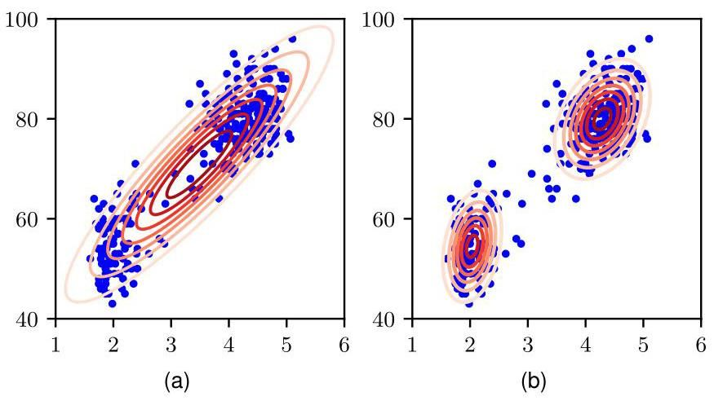

Figure 3.6 Plots of the Old Faithful data in which the red curves are contours of constant probability density. (a) A single Gaussian distribution which has been fitted to the data using maximum likelihood. Note that this distribution fails to capture the two clumps in the data and indeed places much of its probability mass in the central region between the clumps where the data are relatively sparse. (b) The distribution given by a linear combination of two Gaus-sians, also fitted by maximum likelihood, which gives a better representation of the data.

图 3.6 是老忠实间歇泉数据的绘图，其中红色曲线是等概率密度轮廓线。(a) 一个使用最大似然法拟合数据的单高斯分布。注意，这个分布未能捕捉到数据中的两个簇，实际上它将大部分概率质量置于簇之间的数据相对稀疏的中心区域。(b) 由两个高斯分布的线性组合给出的分布，同样使用最大似然法进行拟合，它能更好地表示数据。

This result has a nice interpretation, as follows. After observing data points, we estimate by . We now observe data point , and we obtain our revised estimate by moving the old estimate a small amount, proportional to , in the direction of the ’error signal’ . Note that, as increases, so the contributions from successive data points get smaller.

这个结果有一个很好的解释，如下所述。在观察到 个数据点后，我们用 来估计 。现在我们观察到数据点 ，并通过将旧的估计值向 “误差信号” 的方向移动一小段距离(与 成比例)来得到修正后的估计值 。注意，随着 的增加，连续数据点的贡献会变小。

# 3.2.9 Mixtures of Gaussians

# 3.2.9 高斯混合模型

Although the Gaussian distribution has some important analytical properties, it suffers from significant limitations when used to model modelling real data sets. Consider the example shown in Figure 3.6(a). This is known as the ’Old Faithful’ data set, and comprises 272 measurements of the eruption of the Old Faithful geyser in Yellowstone National Park in the USA. Each measurement gives the duration of the eruption in minutes (horizontal axis) and the time in minutes to the next eruption (vertical axis). We see that the data set forms two dominant clumps, and that a simple Gaussian distribution is unable to capture this structure.

尽管高斯分布具有一些重要的分析性质，但在用于对实际数据集进行建模时，它存在显著的局限性。考虑图 3.6(a) 所示的示例。这就是所谓的 “老忠实泉” 数据集，它包含了对美国黄石国家公园老忠实间歇泉喷发的 272 次测量数据。每次测量给出了喷发持续的分钟数(横轴)以及到下一次喷发的间隔分钟数(纵轴)。我们可以看到，该数据集形成了两个主要的簇，而简单的高斯分布无法捕捉到这种结构。

We might expect that a superposition of two Gaussian distributions would be able to do a much better job of representing the structure in this data set, and indeed

我们可能期望两个高斯分布的叠加能够更好地表示这个数据集中的结构，实际上

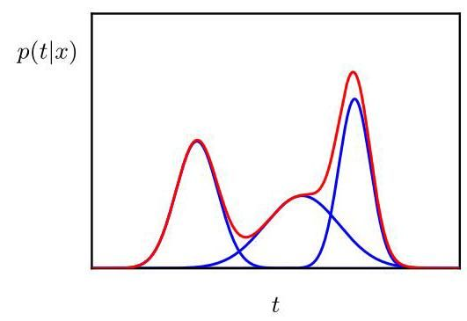

Figure 3.7 Example of a Gaussian mixture distribution in one dimension showing three Gaussians (each scaled by a coefficient) in blue and their sum in red.

图 3.7 一维高斯混合分布的示例，蓝色表示三个高斯分布(每个都乘以一个系数)，红色表示它们的总和。

this proves to be the case, as can be seen from Figure 3.6(b). Such superpositions, formed by taking linear combinations of more basic distributions such as Gaussians, can be formulated as probabilistic models known as mixture distributions. In this section we will consider Gaussians to illustrate the framework of mixture models. More generally, mixture models can comprise linear combinations of other distributions, for example mixtures of Bernoulli distributions for binary variables. In Figure 3.7 we see that a linear combination of Gaussians can give rise to very complex densities. By using a sufficient number of Gaussians and by adjusting their means and covari-ances as well as the coefficients in the linear combination, almost any continuous distribution can be approximated to arbitrary accuracy.

从图 3.6(b) 可以看出，情况确实如此。通过对更基本的分布(如高斯分布)进行线性组合而形成的这种叠加，可以被表述为称为混合分布的概率模型。在本节中，我们将以高斯分布为例来说明混合模型的框架。更一般地，混合模型可以包含其他分布的线性组合，例如用于二元变量的伯努利分布混合。在图 3.7 中，我们可以看到高斯分布的线性组合可以产生非常复杂的密度。通过使用足够数量的高斯分布，并调整它们的均值、协方差以及线性组合中的系数，几乎任何连续分布都可以以任意精度进行近似。

Chapter 15

第 15 章

We therefore consider a superposition of Gaussian densities of the form

因此，我们考虑形式为 的高斯密度的叠加

which is called a mixture of Gaussians. Each Gaussian density is called a component of the mixture and has its own mean and covariance . Contour and surface plots for a Gaussian mixture in two dimensions having three components are shown in Figure 3.8.

这被称为高斯混合模型。每个高斯密度 都被称为混合模型的一个分量，并且有其自身的均值 和协方差 。具有三个分量的二维高斯混合模型的等高线图和曲面图如图 3.8 所示。

The parameters in (3.111) are called mixing coefficients. If we integrate both sides of (3.111) with respect to , and note that both and the individual Gaussian components are normalized, we obtain

式 (3.111) 中的参数 被称为混合系数。如果我们对式 (3.111) 两边关于 进行积分，并注意到 和各个高斯分量都是归一化的，我们可以得到

Also, given that , a sufficient condition for the requirement 0 is that for all . Combining this with the condition (3.112), we obtain

此外，已知 ，对于要求 > 0 的一个充分条件是对于所有的 都有 。将此与条件 (3.112) 相结合，我们可以得到

We can therefore see that the mixing coefficients satisfy the requirements to be probabilities, and we will show that this probabilistic interpretation of mixture distributions is very powerful.

因此，我们可以看到混合系数满足作为概率的要求，并且我们将证明混合分布的这种概率解释非常有用。

Chapter 15

第15章

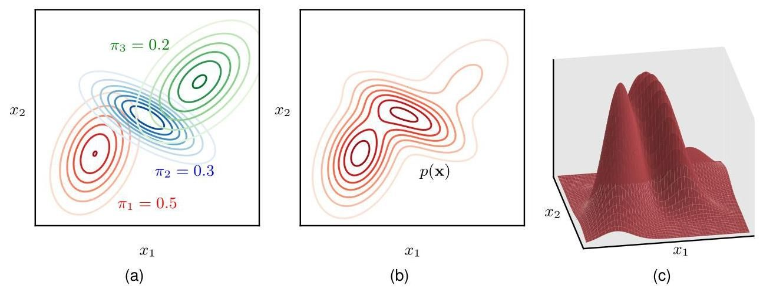

Figure 3.8 Illustration of a mixture of three Gaussians in a two-dimensional space. (a) Contours of constant density for each of the mixture components, in which the three components are denoted red, blue, and green, and the values of the mixing coefficients are shown below each component. (b) Contours of the marginal probability density of the mixture distribution. (c) A surface plot of the distribution .

图3.8 二维空间中三个高斯分布混合的示意图。(a) 每个混合分量的等密度轮廓，其中三个分量分别用红色、蓝色和绿色表示，每个分量下方显示了混合系数的值。(b) 混合分布的边缘概率密度 的轮廓。(c) 分布 的曲面图。

From the sum and product rules of probability, the marginal density can be writ-

根据概率的求和规则和乘积规则，边缘密度可以写为

ten as

如下形式

which is equivalent to (3.111) in which we can view as the prior probability of picking the th component, and the density as the probability of conditioned on . As we will see in later chapters, an important role is played by the corresponding posterior probabilities , which are also known as responsibilities. From Bayes’ theorem, these are given by

这等价于式(3.111)，其中我们可以将 视为选择第 个分量的先验概率，将密度 视为在给定 的条件下 的概率。正如我们将在后面的章节中看到的，相应的后验概率 起着重要的作用，它们也被称为责任。根据贝叶斯定理，这些后验概率由下式给出

The form of the Gaussian mixture distribution is governed by the parameters , , and , where we have used the notation , and . One way to set the values of these parameters is to use maximum likelihood. From (3.111), the log of the likelihood function is given by

高斯混合分布的形式由参数 、 和 决定，这里我们使用了符号 和 。设置这些参数值的一种方法是使用最大似然法。由式(3.111)可知，似然函数的对数为

where . We immediately see that the situation is now much more complex than with a single Gaussian, due to the summation over inside the logarithm. As a result, the maximum likelihood solution for the parameters no longer has a closed-form analytical solution. One approach for maximizing the likelihood function is to use iterative numerical optimization techniques. Alternatively, we can employ a powerful framework called expectation maximization, which has wide applicability to a variety of different deep generative models.

其中 。我们立即可以看出，由于对数内部对 进行求和，现在的情况比单个高斯分布要复杂得多。因此，参数的最大似然解不再有封闭形式的解析解。最大化似然函数的一种方法是使用迭代数值优化技术。或者，我们可以采用一种强大的框架，称为期望最大化，它广泛适用于各种不同的深度生成模型。

Chapter 15

第15章

# 3.3. Periodic Variables

# 3.3. 周期变量

Although Gaussian distributions are of great practical significance, both in their own right and as building blocks for more complex probabilistic models, there are situations in which they are inappropriate as density models for continuous variables. One important case, which arises in practical applications, is that of periodic variables.

尽管高斯分布本身以及作为更复杂概率模型的构建块都具有重要的实际意义，但在某些情况下，它们并不适合作为连续变量的密度模型。在实际应用中出现的一个重要情况是周期变量。

An example of a periodic variable is the wind direction at a particular geographical location. We might, for instance, measure the wind direction at multiple locations and wish to summarize this data using a parametric distribution. Another example is calendar time, where we may be interested in modelling quantities that are believed to be periodic over 24 hours or over an annual cycle. Such quantities can conveniently be represented using an angular (polar) coordinate .

周期变量的一个例子是特定地理位置的风向。例如，我们可能会在多个位置测量风向，并希望使用参数分布来总结这些数据。另一个例子是日历时间，我们可能对建模那些被认为在24小时或一年周期内具有周期性的量感兴趣。这些量可以方便地用角度(极坐标) 来表示。

We might be tempted to treat periodic variables by choosing some direction as the origin and then applying a conventional distribution such as the Gaussian. Such an approach, however, would give results that were strongly dependent on the arbitrary choice of origin. Suppose, for instance, that we have two observations at and , and we model them using a standard univariate Gaussian distribution. If we place the origin at , then the sample mean of this data set will be with standard deviation , whereas if we place the origin at , then the mean will be and the standard deviation will be . We clearly need to develop a special approach for periodic variables.

我们可能会想通过选择某个方向作为原点，然后应用诸如高斯分布这样的常规分布来处理周期变量。然而，这样的方法会得到强烈依赖于原点任意选择的结果。例如，假设我们在 和 处有两个观测值，并使用标准的单变量高斯分布对它们进行建模。如果我们将原点放在 处，那么这个数据集的样本均值将是 ，标准差是 ；而如果我们将原点放在 处，那么均值将是 ，标准差将是 。显然，我们需要为周期变量开发一种特殊的方法。

# 3.3.1 Von Mises distribution

# 3.3.1 冯·米塞斯分布

Let us consider the problem of evaluating the mean of a set of observations of a periodic variable where is measured in radians. We have already seen that the simple average will be strongly coordinate dependent. To find an invariant measure of the mean, note that the observations can be viewed as points on the unit circle and can therefore be described instead by two-dimensional unit vectors where for , as illustrated in Figure 3.9. We can average the vectors instead to give

让我们考虑评估一个周期变量 的一组观测值 的均值的问题，其中 以弧度为单位进行测量。我们已经知道，简单平均值 将强烈依赖于坐标。为了找到均值的一个不变度量，注意到这些观测值可以被视为单位圆上的点，因此可以用二维单位向量 来描述，其中对于 有 ，如图 3.9 所示。我们可以改为对向量 求平均，得到

and then find the corresponding angle of this average. Clearly, this definition will ensure that the location of the mean is independent of the origin of the angular coordinate. Note that will typically lie inside the unit circle. The Cartesian coordinates

然后找到这个平均值对应的角度 。显然，这个定义将确保均值的位置与角度坐标的原点无关。注意， 通常会位于单位圆内部。笛卡尔坐标

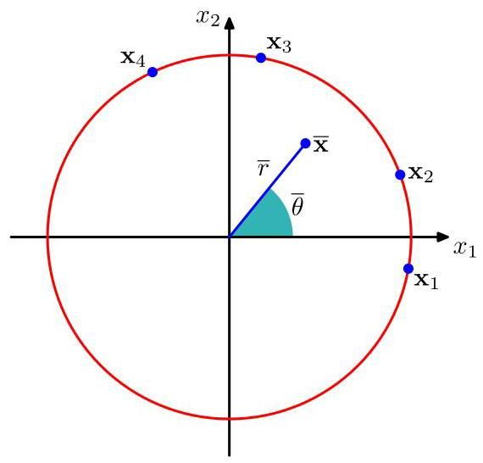

Figure 3.9 Illustration of the representation of values of a periodic variable as two-dimensional vectors living on the unit circle. Also shown is the average of those vectors.

图 3.9 周期变量的值 表示为位于单位圆上的二维向量 的图示。同时还展示了这些向量的平均值 。

of the observations are given by , and we can write the Cartesian coordinates of the sample mean in the form . Substituting into (3.117) and equating the and components then gives

观测值的笛卡尔坐标由 给出，我们可以将样本均值的笛卡尔坐标写成 的形式。代入 (3.117) 式并使 和 分量相等，然后得到

Taking the ratio, and using the identity , we can solve for to

取比值，并利用恒等式 ，我们可以求解 以

give

给予

Shortly, we will see how this result arises naturally as a maximum likelihood estimator.

很快，我们将看到这个结果是如何自然地作为最大似然估计量出现的。

First, we need to define a periodic generalization of the Gaussian called the von Mises distribution. Here we will limit our attention to univariate distributions, although analogous periodic distributions can also be found over hyperspheres of arbitrary dimension (Mardia and Jupp, 2000).

首先，我们需要定义高斯分布的一种周期性推广，称为冯·米塞斯分布。在这里，我们将注意力限制在单变量分布上，尽管在任意维度的超球面上也可以找到类似的周期性分布(Mardia 和 Jupp，2000)。

By convention, we will consider distributions that have period . Any probability density defined over must not only be non-negative and integrate to one, but it must also be periodic. Thus, must satisfy the three conditions:

按照惯例，我们将考虑周期为 的分布 。任何在 上定义的概率密度 不仅必须是非负的且积分值为 1，而且还必须是周期性的。因此， 必须满足三个条件:

From (3.122), it follows that for any integer .

由 (3.122) 可知，对于任意整数 ，有 。

We can easily obtain a Gaussian-like distribution that satisfies these three properties as follows. Consider a Gaussian distribution over two variables having mean and a covariance matrix where is the identity matrix, so that

我们可以很容易地得到一个满足这三个性质的类似高斯分布，如下所示。考虑两个变量 的高斯分布，其均值为 ，协方差矩阵为 ，其中 是 单位矩阵，使得

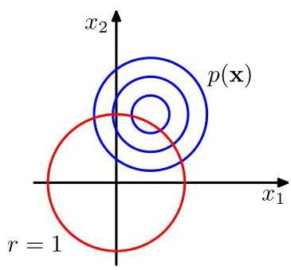

Figure 3.10 The von Mises distribution can be derived by considering a two-dimensional Gaussian of the form (3.123), whose density contours are shown in blue, and conditioning on the unit circle shown in red.

图 3.10 冯·米塞斯分布可以通过考虑形式为 (3.123) 的二维高斯分布推导得出，其密度轮廓用蓝色表示，并以红色所示的单位圆为条件。

The contours of constant are circles, as illustrated in Figure 3.10.

常数 的轮廓是圆形，如图 3.10 所示。

Now suppose we consider the value of this distribution along a circle of fixed radius. Then by construction, this distribution will be periodic, although it will not be normalized. We can determine the form of this distribution by transforming from Cartesian coordinates to polar coordinates so that

现在假设我们考虑这个分布在固定半径的圆上的值。那么根据构造，这个分布将是周期性的，尽管它不会被归一化。我们可以通过从笛卡尔坐标 转换到极坐标 来确定这个分布的形式，使得

We also map the mean into polar coordinates by writing

我们还通过写作将均值 映射到极坐标中

Next we substitute these transformations into the two-dimensional Gaussian distribution (3.123), and then condition on the unit circle , noting that we are interested only in the dependence on . Focusing on the exponent in the Gaussian distribution we have

接下来，我们将这些变换代入二维高斯分布 (3.123) 中，然后以单位圆 为条件，注意我们只关注对 的依赖。关注高斯分布中的指数部分，我们有

where ’const’ denotes terms independent of . We have made use of the following trigonometrical identities:

其中 “const” 表示与 无关的项。我们使用了以下三角恒等式:

If we now define , we obtain our final expression for the distribution of along the unit circle in the form

如果我们现在定义 ，我们将得到 沿单位圆 分布的最终表达式，其形式为

which is called the von Mises distribution or the circular normal. Here the parameter corresponds to the mean of the distribution, whereas , which is known as the concentration parameter, is analogous to the inverse variance (i.e. the precision) for the Gaussian. The normalization coefficient in (3.129) is expressed in terms of , which is the zeroth-order modified Bessel function of the first kind (Abramowitz and Stegun, 1965) and is defined by

这被称为冯·米塞斯分布或圆形正态分布。这里的参数 对应于分布的均值，而 被称为集中度参数，类似于高斯分布的逆方差(即精度)。(3.129) 中的归一化系数用 表示，它是第一类零阶修正贝塞尔函数(Abramowitz 和 Stegun，1965)，定义为

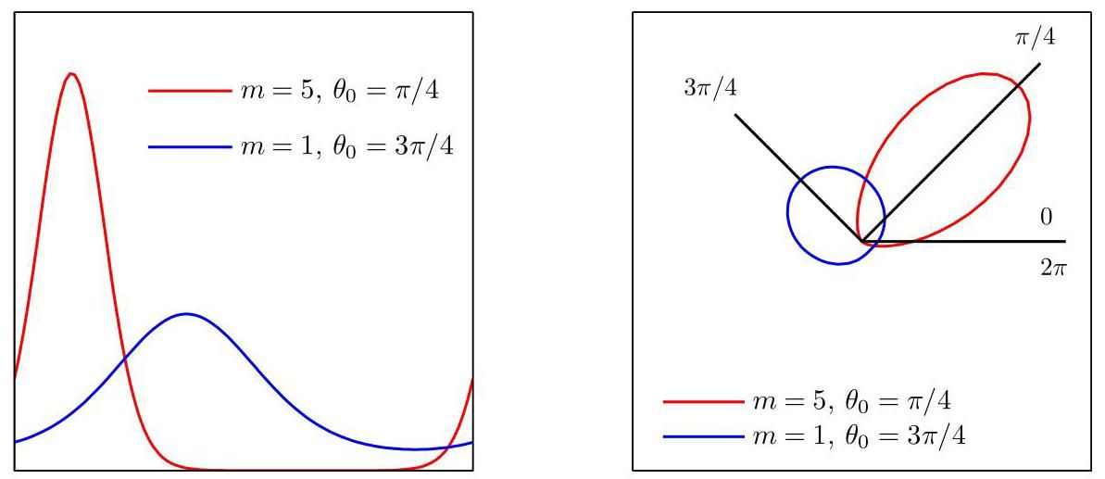

Figure 3.11 The von Mises distribution plotted for two different parameter values, shown as a Cartesian plot on the left and as the corresponding polar plot on the right.

图 3.11 绘制了两种不同参数值下的冯·米塞斯分布，左侧为直角坐标图，右侧为相应的极坐标图。

Exercise 3.31

练习 3.31

For large , the distribution becomes approximately Gaussian. The von Mises distribution is plotted in Figure 3.11, and the function is plotted in Figure 3.12.

对于较大的 ，该分布近似为高斯分布。图 3.11 绘制了冯·米塞斯分布，图 3.12 绘制了函数 。

Now consider the maximum likelihood estimators for the parameters and for the von Mises distribution. The log likelihood function is given by

现在考虑冯·米塞斯分布参数 和 的最大似然估计。对数似然函数由下式给出

Setting the derivative with respect to equal to zero gives

令关于 的导数等于零，可得

To solve for , we make use of the trigonometric identity

为求解 ，我们利用三角恒等式

Exercise 3.32 from which we obtain

习题 3.32，由此我们得到

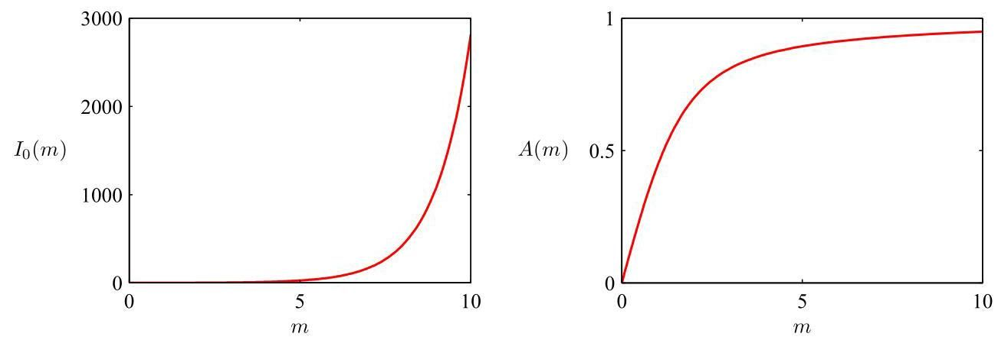

Figure 3.12 Plot of the Bessel function defined by (3.130), together with the function defined by (3.136).

图 3.12 由 (3.130) 定义的贝塞尔函数 以及由 (3.136) 定义的函数 的图像。

which we recognize as the result (3.119) obtained earlier for the mean of the observations viewed in a two-dimensional Cartesian space.

我们认识到这就是之前在二维笛卡尔空间中观察值的均值所得到的结果 (3.119)。

Similarly, maximizing (3.131) with respect to and making use of (Abramowitz and Stegun,1965), we have

类似地，关于 最大化 (3.131) 并利用 (Abramowitz 和 Stegun，1965)，我们有

where we have substituted for the maximum likelihood solution for (recalling that we are performing a joint optimization over and ), and we have defined

其中我们代入了 的最大似然解(回想一下，我们正在对 和 进行联合优化)，并且我们定义了

The function is plotted in Figure 3.12. Making use of the trigonometric identity (3.128), we can write (3.135) in the form

函数 绘制在图 3.12 中。利用三角恒等式 (3.128)，我们可以将 (3.135) 写成如下形式

The right-hand side of (3.137) is easily evaluated, and the function can be inverted numerically. One limitation of the von Mises distribution is that it is unimodal. By forming mixtures of von Mises distributions, we obtain a flexible framework for modelling periodic variables that can handle multimodality.

(3.137) 的右侧很容易计算，并且函数 可以通过数值方法求逆。冯·米塞斯分布的一个局限性是它是单峰的。通过构建冯·米塞斯分布的混合模型，我们得到了一个灵活的框架，用于对可以处理多峰性的周期变量进行建模。

For completeness, we mention briefly some alternative techniques for constructing periodic distributions. The simplest approach is to use a histogram of observations in which the angular coordinate is divided into fixed bins. This has the virtue of

为了完整性，我们简要提及一些构建周期分布的替代技术。最简单的方法是使用观测值的直方图，其中角度坐标被划分为固定的区间。这具有

simplicity and flexibility but also suffers from significant limitations, as we will see when we discuss histogram methods in more detail later. Another approach starts, like the von Mises distribution, from a Gaussian distribution over a Euclidean space but now marginalizes onto the unit circle rather than conditioning (Mardia and Jupp, 2000). However, this leads to more complex forms of distribution and will not be discussed further. Finally, any valid distribution over the real axis (such as a Gaussian) can be turned into a periodic distribution by mapping successive intervals of width onto the periodic variable , which corresponds to ’wrapping’ the real axis around the unit circle. Again, the resulting distribution is more complex to handle than the von Mises distribution.

简单性和灵活性的优点，但也存在显著的局限性，正如我们稍后更详细讨论直方图方法时将看到的那样。另一种方法与冯·米塞斯分布类似，从欧几里得空间上的高斯分布开始，但现在是对单位圆进行边缘化而不是条件化(Mardia 和 Jupp，2000)。然而，这会导致更复杂的分布形式，我们将不再进一步讨论。最后，任何实轴上的有效分布(如高斯分布)都可以通过将宽度为 的连续区间映射到周期变量 上转换为周期分布，这对应于将实轴“缠绕”在单位圆上。同样，得到的分布比冯·米塞斯分布更难处理。

Section 3.5

第 3.5 节

# 3.4.The Exponential Family

# 3.4. 指数族

The probability distributions that we have studied so far in this chapter (with the exception of mixture models) are specific examples of a broad class of distributions called the exponential family (Duda and Hart, 1973; Bernardo and Smith, 1994). Members of the exponential family have many important properties in common, and it is illuminating to discuss these properties in some generality.

我们在本章中到目前为止所研究的概率分布(混合模型除外)是一类广泛分布的具体示例，这类分布被称为指数族(Duda 和 Hart，1973 年；Bernardo 和 Smith，1994 年)。指数族的成员有许多重要的共同属性，一般性地讨论这些属性很有启发性。

The exponential family of distributions over , given parameters , is defined to be the set of distributions of the form

给定参数 ，关于 的指数族分布被定义为具有以下形式的分布集合

where may be scalar or vector and may be discrete or continuous. Here are called the natural parameters of the distribution, and is some function of . The function can be interpreted as the coefficient that ensures that the distribution is normalized, and therefore, it satisfies

其中 可以是标量或向量，并且可以是离散的或连续的。这里 被称为分布的自然参数， 是 的某个函数。函数 可以被解释为确保分布归一化的系数，因此，它满足

where the integration is replaced by summation if is a discrete variable.

如果 是离散变量，则积分替换为求和。

We begin by taking some examples of the distributions introduced earlier in the chapter and showing that they are indeed members of the exponential family. Consider first the Bernoulli distribution:

我们首先来看本章前面介绍的一些分布示例，并证明它们确实是指数族的成员。首先考虑伯努利分布:

Expressing the right-hand side as the exponential of the logarithm, we have

将右侧表示为对数的指数形式，我们得到

Comparison with (3.138) allows us to identify

与 (3.138) 进行比较，我们可以确定

which we can solve for to give , where

我们可以对 求解，得到 ，其中

is called the logistic sigmoid function. Thus, we can write the Bernoulli distribution using the standard representation (3.138) in the form

这被称为逻辑 sigmoid 函数。因此，我们可以使用标准表示 (3.138) 将伯努利分布写成如下形式

where we have used , which is easily proved from (3.143). Comparison with (3.138) shows that

这里我们使用了 ，这可以从 (3.143) 轻松证明。与 (3.138) 比较可知

Next consider the multinomial distribution which, for a single observation ,

接下来考虑多项分布，对于单个观测值 ，

takes the form

采用……形式

where . Again, we can write this in the standard representation (3.138) so that

其中 。同样，我们可以将其写成标准表示形式 (3.138)，使得

where , and we have defined . Again, comparing with (3.138) we have

其中 ，并且我们定义了 。同样，与 (3.138) 比较，我们有

Note that the parameters are not independent because the parameters are subject to the constraint

注意，参数 不是相互独立的，因为参数 受到约束条件的限制

so that, given any of the parameters , the value of the remaining parameter is fixed. In some circumstances, it will be convenient to remove this constraint by expressing the distribution in terms of only parameters. This can be achieved by using the relationship (3.153) to eliminate by expressing it in terms of the remaining where , thereby leaving parameters. Note that these remaining parameters are still subject to the constraints

因此，给定参数 中的任意 个参数，其余参数的值就固定了。在某些情况下，通过仅用 个参数来表示分布，消除这个约束会很方便。这可以通过使用关系 (3.153) 来实现，即根据其余的 (其中 )来表示 ，从而消除 ，留下 个参数。注意，这些剩余的参数仍然受到约束条件的限制

Making use of the constraint (3.153), the multinomial distribution in this representation then becomes

利用约束条件 (3.153)，这种表示形式下的多项分布就变为

We now identify

我们现在确定

which we can solve for by first summing both sides over and then rearranging and back-substituting to give

我们可以通过以下步骤求解 :首先对 两边求和，然后重新整理并回代，得到

This is called the softmax function or the normalized exponential. In this representation, the multinomial distribution therefore takes the form

这被称为 softmax 函数或归一化指数函数。因此，在这种表示中，多项分布采用以下形式

This is the standard form of the exponential family, with parameter vector in which

这是指数族的标准形式，参数向量为 ，其中

Finally, let us consider the Gaussian distribution. For the univariate Gaussian, we have

最后，让我们考虑高斯分布。对于单变量高斯分布，我们有

which, after some simple rearranging, can be cast in the standard exponential family form (3.138) with

经过一些简单的整理后，它可以写成标准指数族形式 (3.138)，其中

Exercise 3.35

练习 3.35

Finally, we shall sometimes make use of a restricted form of (3.138) in which we choose . However, this can be somewhat generalized by noting that if is a normalized density then

最后，我们有时会使用 (3.138) 的一种受限形式，其中我们选择 。然而，通过注意到如果 是一个归一化密度，那么

is also a normalized density, where is a scale parameter. Combining these, we arrive at a restricted set of exponential family class-conditional densities of the form

也是一个归一化密度，其中 是一个尺度参数。将这些结合起来，我们得到了一类形式受限的指数族类条件密度

Note that we are allowing each class to have its own parameter vector but we are assuming that the classes share the same scale parameter .

注意，我们允许每个类别有其自己的参数向量 ，但我们假设这些类别共享相同的尺度参数 。

# 3.4.1 Sufficient statistics

# 3.4.1 充分统计量

Let us now consider the problem of estimating the parameter vector in the general exponential family distribution (3.138) using the technique of maximum likelihood. Taking the gradient of both sides of (3.139) with respect to , we have

现在让我们考虑使用最大似然技术来估计一般指数族分布 (3.138) 中的参数向量 的问题。对 (3.139) 两边关于 取梯度，我们得到

Rearranging and making use again of (3.139) then gives

重新整理并再次利用 (3.139) 式，可得

We therefore obtain the result

因此，我们得到如下结果

Note that the covariance of can be expressed in terms of the second derivatives of , and similarly for higher-order moments. Thus, provided we can normalize a distribution from the exponential family, we can always find its moments by simple differentiation.

注意， 的协方差可以用 的二阶导数来表示，高阶矩的情况类似。因此，只要我们能对指数族分布进行归一化，就总能通过简单的求导得到它的矩。

Exercise 3.36

练习 3.36

Now consider a set of independent identically distributed data denoted by , for which the likelihood function is given by

现在考虑一组独立同分布的数据，用 表示，其似然函数为

Setting the gradient of with respect to to zero, we get the following condition to be satisfied by the maximum likelihood estimator :

令 关于 的梯度为零，我们得到最大似然估计量 需满足以下条件:

which can in principle be solved to obtain . We see that the solution for the maximum likelihood estimator depends on the data only through , which is therefore called the sufficient statistic of the distribution (3.138). We do not need to store the entire data set itself but only the value of the sufficient statistic. For the Bernoulli distribution, for example, the function is given just by and so we need only keep the sum of the data points , whereas for the Gaussian , and so we should keep both the sum of and the sum of .

原则上可以求解该式以得到 。我们看到，最大似然估计量的解仅通过 依赖于数据，因此 被称为分布 (3.138) 的充分统计量。我们不需要存储整个数据集本身，而只需要存储充分统计量的值。例如，对于伯努利分布，函数 由 给出，因此我们只需要保留数据点 的总和；而对于高斯分布 ，因此我们应该同时保留 的总和以及 的总和。

If we consider the limit , then the right-hand side of (3.174) becomes , and so by comparing with (3.172) we see that in this limit, will equal the true value .

如果我们考虑极限 ，那么 (3.174) 式的右侧变为 ，因此通过与 (3.172) 式比较，我们发现在这个极限下， 将等于真实值 。

# 3.5. Nonparametric Methods

# 3.5. 非参数方法

Throughout this chapter, we have focused on the use of probability distributions having specific functional forms governed by a small number of parameters whose values are to be determined from a data set. This is called the parametric approach to density modelling. An important limitation of this approach is that the chosen density might be a poor model of the distribution that generates the data, which can result in poor predictive performance. For instance, if the process that generates the data is multimodal, then this aspect of the distribution can never be captured by a Gaussian, which is necessarily unimodal. In this final section, we consider some nonparametric approaches to density estimation that make few assumptions about the form of the distribution.

在本章中，我们一直专注于使用具有特定函数形式的概率分布，这些分布由少量参数控制，其值需要从数据集中确定。这被称为密度建模的参数化方法。这种方法的一个重要局限性在于，所选择的密度可能无法很好地拟合生成数据的分布，从而导致较差的预测性能。例如，如果生成数据的过程是多峰的，那么高斯分布(必然是单峰的)永远无法捕捉到分布的这一特征。在最后这一节中，我们将考虑一些非参数密度估计方法，这些方法对分布的形式所做的假设较少。

# 3.5.1 Histograms

# 3.5.1 直方图

Let us start with a discussion of histogram methods for density estimation, which we have already encountered in the context of marginal and conditional distributions in Figure 2.5 and in the context of the central limit theorem in Figure 3.2. Here we explore the properties of histogram density models in more detail, focusing on cases with a single continuous variable . Standard histograms simply partition into distinct bins of width and then count the number of observations of falling

让我们从讨论用于密度估计的直方图方法开始，我们已经在图 2.5 中关于边缘分布和条件分布的内容以及图 3.2 中关于中心极限定理的内容中遇到过这种方法。在这里，我们将更详细地探讨直方图密度模型的性质，重点关注具有单个连续变量 的情况。标准直方图只是将 划分为宽度为 的不同区间，然后统计落入

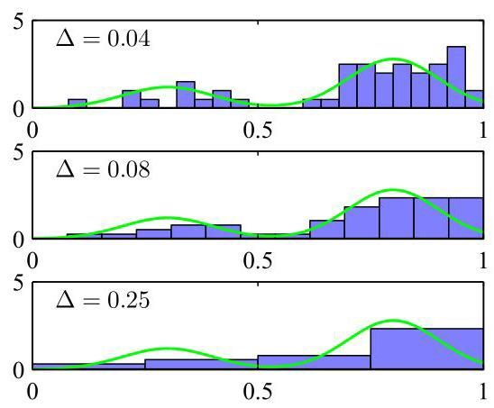

Figure 3.13 An illustration of the histogram approach to density estimation, in which a data set of 50 data points is generated from the distribution shown by the green curve. Histogram density estimates, based on (3.175) with a common bin width , are shown for various values of .

图 3.13 展示了使用直方图方法进行密度估计的示例，其中 50 个数据点的数据集是从绿色曲线所示的分布中生成的。图中展示了基于公式 (3.175)、使用不同的公共区间宽度 得到的直方图密度估计。

in bin . To turn this count into a normalized probability density, we simply divide by the total number of observations and by the width of the bins to obtain probability values for each bin:

在区间 内。为了将这个计数转换为归一化的概率密度，我们只需将其除以观测值的总数 以及区间的宽度 ，从而得到每个区间的概率值:

for which it is easily seen that . This gives a model for the density that is constant over the width of each bin. Often the bins are chosen to have the same width .

对于该式，很容易看出 。这给出了一个密度 的模型，该模型在每个区间的宽度上是恒定的。通常，区间会被选择为具有相同的宽度 。

In Figure 3.13, we show an example of histogram density estimation. Here the data is drawn from the distribution corresponding to the green curve, which is formed from a mixture of two Gaussians. Also shown are three examples of histogram density estimates corresponding to three different choices for the bin width . We see that when is very small (top figure), the resulting density model is very spiky, with a lot of structure that is not present in the underlying distribution that generated the data set. Conversely, if is too large (bottom figure) then the result is a model that is too smooth and consequently fails to capture the bimodal property of the green curve. The best results are obtained for some intermediate value of (middle figure). In principle, a histogram density model is also dependent on the choice of edge location for the bins, though this is typically much less significant than the bin width .

在图 3.13 中，我们展示了一个直方图密度估计的示例。这里的数据是从对应于绿色曲线的分布中抽取的，该曲线由两个高斯分布混合而成。图中还展示了对应于区间宽度 的三种不同选择的直方图密度估计示例。我们看到，当 非常小时(上图)，得到的密度模型非常尖锐，具有很多在生成数据集的底层分布中不存在的结构。相反，如果 太大(下图)，则结果是一个过于平滑的模型，因此无法捕捉到绿色曲线的双峰特性。对于 的某个中间值(中图)，可以得到最佳结果。原则上，直方图密度模型也依赖于区间边缘位置的选择，不过这通常远不如区间宽度 重要。

Note that the histogram method has the property (unlike the methods to be discussed shortly) that, once the histogram has been computed, the data set itself can be discarded, which can be advantageous if the data set is large. Also, the histogram approach is easily applied if the data points arrive sequentially.

请注意，直方图方法具有这样的特性(与稍后要讨论的方法不同):一旦计算出直方图，数据集本身就可以被丢弃，如果数据集很大，这可能是一个优势。此外，如果数据点是依次到达的，直方图方法也很容易应用。

In practice, the histogram technique can be useful for obtaining a quick visualization of data in one or two dimensions but is unsuited to most density estimation applications. One obvious problem is that the estimated density has discontinuities that are due to the bin edges rather than any property of the underlying distribution that generated the data. A major limitation of the histogram approach is its scaling with dimensionality. If we divide each variable in a -dimensional space into bins, then the total number of bins will be . This exponential scaling with is an example of the curse of dimensionality. In a space of high dimensionality, the quantity of data needed to provide meaningful estimates of the local probability density would be prohibitive.

在实践中，直方图技术可用于快速可视化一维或二维数据，但不适合大多数密度估计应用。一个明显的问题是，估计的密度存在不连续性，这是由于区间边缘造成的，而不是生成数据的底层分布的任何特性。直方图方法的一个主要局限性是其随维度的缩放问题。如果我们将 维空间中的每个变量划分为 个区间，那么区间的总数将是 。这种随 的指数缩放是维度灾难的一个例子。在高维空间中，为了对局部概率密度提供有意义的估计所需的数据量将是巨大的。

Section 6.1.1

6.1.1 节

The histogram approach to density estimation does, however, teach us two important lessons. First, to estimate the probability density at a particular location, we should consider the data points that lie within some local neighbourhood of that point. Note that the concept of locality requires that we assume some form of distance measure, and here we have been assuming Euclidean distance. For histograms, this neighbourhood property was defined by the bins, and there is a natural ’smoothing’ parameter describing the spatial extent of the local region, in this case the bin width. Second, to obtain good results, the value of the smoothing parameter should be neither too large nor too small. This is reminiscent of the choice of model complexity in polynomial regression where the degree of the polynomial, or alternatively the value of the regularization parameter, was optimal for some intermediate value, neither too large nor too small. Armed with these insights, we turn now to a discussion of two widely used nonparametric techniques for density estimation, kernel estimators and nearest neighbours, which have better scaling with dimensionality than the simple histogram model.

然而，直方图方法用于密度估计给我们上了重要的两课。首先，为了估计特定位置的概率密度，我们应该考虑位于该点某个局部邻域内的数据点。请注意，局部性的概念要求我们假设某种形式的距离度量，在这里我们一直假设使用欧几里得距离。对于直方图，这种邻域属性由区间定义，并且有一个自然的“平滑”参数来描述局部区域的空间范围，在这种情况下就是区间宽度。其次，为了获得良好的结果，平滑参数的值既不应太大也不应太小。这让人想起多项式回归中模型复杂度的选择，其中多项式的次数 ，或者正则化参数的值 ，在某个中间值时是最优的，既不过大也不过小。有了这些见解，我们现在转向讨论两种广泛使用的非参数密度估计技术，核估计器和最近邻方法，它们在维度上的扩展性比简单的直方图模型更好。

Chapter 1

第 1 章

# 3.5.2 Kernel densities

# 3.5.2 核密度

Let us suppose that observations are being drawn from some unknown probability density in some -dimensional space, which we will take to be Euclidean, and we wish to estimate the value of . From our earlier discussion of locality, let us consider some small region containing . The probability mass associated with this region is given by

让我们假设观测值是从某个 维空间中的某个未知概率密度 中抽取的，我们将该空间视为欧几里得空间，并且我们希望估计 的值。根据我们之前对局部性的讨论，让我们考虑包含 的某个小区域 。与该区域相关的概率质量由下式给出

Now suppose that we have collected a data set comprising observations drawn from . Because each data point has a probability of falling within , the total number of points that lie inside will be distributed according to the binomial

现在假设我们已经收集了一个数据集，其中包含从 中抽取的 个观测值。因为每个数据点落入 的概率为 ，所以位于 内的点的总数 将服从二项分布

Section 3.1.2

第3.1.2节

distribution:

分布:

Using (3.11), we see that the mean fraction of points falling inside the region is , and similarly using (3.12), we see that the variance around this mean is . For large , this distribution will be sharply peaked around the mean and so

使用(3.11)，我们发现落在该区域内的点的平均比例为 ，同样，使用(3.12)，我们发现围绕该平均值的方差为 。对于较大的 ，这种分布将在平均值附近出现尖锐的峰值，因此

If, however, we also assume that the region is sufficiently small so that the probability density is roughly constant over the region, then we have

然而，如果我们还假设区域 足够小，使得概率密度 在该区域内大致恒定，那么我们有

where is the volume of . Combining (3.178) and (3.179), we obtain our density

其中 是 的体积。结合(3.178)和(3.179)，我们得到密度

estimate in the form

估计形式为

Note that the validity of (3.180) depends on two contradictory assumptions, namely that the region is sufficiently small that the density is approximately constant over the region and yet sufficiently large (in relation to the value of that density) that the number of points falling inside the region is sufficient for the binomial distribution to be sharply peaked.

请注意，(3.180) 的有效性依赖于两个相互矛盾的假设，即区域 足够小，使得该区域内的密度近似恒定，但又足够大(相对于该密度值而言)，使得落在该区域内的点的数量 足以让二项分布呈现尖锐的峰值。

We can exploit the result (3.180) in two different ways. Either we can fix and determine the value of from the data, which gives rise to the -nearest-neighbour technique discussed shortly, or we can fix and determine from the data, giving rise to the kernel approach. It can be shown that both the -nearest-neighbour density estimator and the kernel density estimator converge to the true probability density in the limit provided that shrinks with and that grows with , at an appropriate rate (Duda and Hart,1973).

我们可以通过两种不同的方式利用结果 (3.180)。要么我们固定 并从数据中确定 的值，这就产生了稍后要讨论的 -最近邻技术；要么我们固定 并从数据中确定 ，这就产生了核方法。可以证明，只要 随 缩小，并且 随 以适当的速率增长(Duda 和 Hart，1973)， -最近邻密度估计器和核密度估计器在极限 下都会收敛到真实的概率密度。

We begin by discussing the kernel method in detail. To start with we take the region to be a small hypercube centred on the point at which we wish to determine the probability density. To count the number of points falling within this region, it is convenient to define the following function:

我们首先详细讨论核方法。首先，我们将区域 取为一个以点 为中心的小超立方体，我们希望在该点确定概率密度。为了计算落在该区域内的点的数量 ，方便起见，我们定义以下函数:

which represents a unit cube centred on the origin. The function is an example of a kernel function, and in this context, it is also called a Parzen window. From (3.181), the quantity will be 1 if the data point lies inside a cube of side centred on , and zero otherwise. The total number of data points lying inside this cube will therefore be

它表示一个以原点为中心的单位立方体。函数 是核函数的一个例子，在这种情况下，它也被称为 Parzen 窗。根据 (3.181)，如果数据点 位于以 为中心、边长为 的立方体内，则量 为 1，否则为 0。因此，位于这个立方体内的数据点的总数将是

Substituting this expression into (3.180) then gives the following result for the estimated density at :

然后将这个表达式代入 (3.180)，就得到了在 处估计密度的以下结果:

where we have used for the volume of a hypercube of side in dimensions. Using the symmetry of the function , we can now reinterpret this equation, not as a single cube centred on but as the sum over cubes centred on the data points .

其中我们用 表示 维中边长为 的超立方体的体积。利用函数 的对称性，我们现在可以重新解释这个方程，不是将其看作是以 为中心的单个立方体，而是看作是以 个数据点 为中心的 个立方体的总和。

As it stands, the kernel density estimator (3.183) will suffer from one of the same problems that the histogram method suffered from, namely the presence of artificial discontinuities, in this case at the boundaries of the cubes. We can obtain a smoother density model if we choose a smoother kernel function, and a common choice is the Gaussian, which gives rise to the following kernel density model:

就目前情况而言，核密度估计器(3.183)会遇到与直方图方法相同的问题之一，即存在人为的不连续性，在这种情况下是在立方体的边界处。如果我们选择一个更平滑的核函数，就可以得到一个更平滑的密度模型，常见的选择是高斯核函数，这就产生了以下核密度模型:

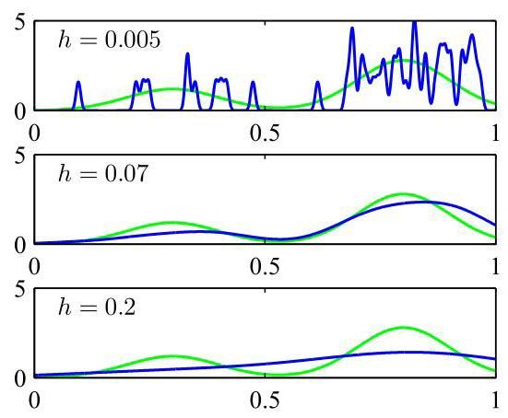

Figure 3.14 Illustration of the kernel density model (3.184) applied to the same data set used to demonstrate the histogram approach in Figure 3.13. We see that acts as a smoothing parameter and that if it is set too small (top panel), the result is a very noisy density model, whereas if it is set too large (bottom panel), then the bimodal nature of the underlying distribution from which the data is generated (shown by the green curve) is washed out. The best density model is obtained for some intermediate value of (middle panel).

图3.14展示了将核密度模型(3.184)应用于与图3.13中用于演示直方图方法相同的数据集的情况。我们看到 起到了平滑参数的作用，如果将其设置得太小(上图)，结果会是一个噪声很大的密度模型；而如果将其设置得太大(下图)，则生成数据的底层分布的双峰性质(由绿色曲线表示)就会被抹平。对于 的某个中间值(中图)，可以得到最佳的密度模型。

where represents the standard deviation of the Gaussian components. Thus, our density model is obtained by placing a Gaussian over each data point, adding up the contributions over the whole data set, and then dividing by so that the density is correctly normalized. In Figure 3.14, we apply the model (3.184) to the data set used earlier to demonstrate the histogram technique. We see that, as expected, the parameter plays the role of a smoothing parameter, and there is a trade-off between sensitivity to noise at small and over-smoothing at large . Again, the optimization of is a problem in model complexity, analogous to the choice of bin width in histogram density estimation or the degree of the polynomial used in curve fitting.

其中 表示高斯分量的标准差。因此，我们的密度模型是通过在每个数据点上放置一个高斯分布，将整个数据集上的贡献相加，然后除以 以使密度得到正确归一化而得到的。在图3.14中，我们将模型(3.184)应用于前面用于演示直方图技术的数据集。正如预期的那样，我们看到参数 起到了平滑参数的作用，并且在 较小时对噪声的敏感性和 较大时的过度平滑之间存在权衡。同样， 的优化是一个模型复杂度问题，类似于直方图密度估计中箱宽度的选择或曲线拟合中所用多项式的次数的选择。

We can choose any other kernel function in (3.183) subject to the conditions

我们可以在(3.183)中选择任何其他满足以下条件的核函数

which ensure that the resulting probability distribution is non-negative everywhere and integrates to one. The class of density model given by (3.183) is called a kernel density estimator or Parzen estimator. It has a great merit that there is no computation involved in the ’training’ phase because this simply requires the training set to be stored. However, this is also one of its great weaknesses because the computational cost of evaluating the density grows linearly with the size of the data set.

这些条件确保得到的概率分布在任何地方都是非负的，并且积分结果为1。由(3.183)给出的这类密度模型称为核密度估计器或帕曾估计器。它有一个很大的优点，即在“训练”阶段不需要进行计算，因为这只需要存储训练集。然而，这也是它的一个很大的缺点，因为评估密度的计算成本会随着数据集的大小线性增长。

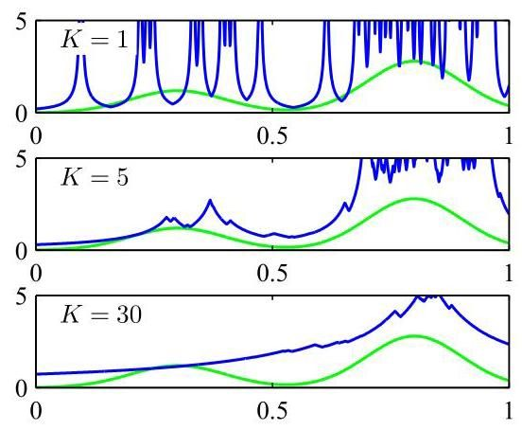

Figure 3.15 Illustration of -nearest-neighbour density estimation using the same data set as in Figures 3.14 and 3.13. We see that the parameter governs the degree of smoothing, so that a small value of leads to a very noisy density model (top panel), whereas a large value (bottom panel) smooths out the bimodal nature of the true distribution (shown by the green curve) from which the data set was generated.

图3.15展示了使用与图3.14和图3.13中相同的数据集进行 -最近邻密度估计的情况。我们看到参数 控制着平滑程度，因此 的值较小时会导致一个噪声很大的密度模型(上图)，而 的值较大时(下图)会抹平生成数据集的真实分布的双峰性质(由绿色曲线表示)。

# 3.5.3 Nearest-neighbours

# 3.5.3 最近邻

One of the difficulties with the kernel approach to density estimation is that the parameter governing the kernel width is fixed for all kernels. In regions of high data density, a large value of may lead to over-smoothing and a washing out of structure that might otherwise be extracted from the data. However, reducing may lead to noisy estimates elsewhere in the data space where the density is smaller. Thus, the optimal choice for may be dependent on the location within the data space. This issue is addressed by nearest-neighbour methods for density estimation.

核方法进行密度估计的困难之一在于，控制核宽度的参数 对于所有核都是固定的。在数据密度高的区域， 的较大值可能导致过度平滑，从而抹去原本可以从数据中提取的结构信息。然而，减小 可能会在数据空间中密度较小的其他地方导致估计结果出现噪声。因此， 的最优选择可能取决于数据空间中的位置。最近邻方法用于密度估计可以解决这个问题。

We therefore return to our general result (3.180) for local density estimation, and instead of fixing and determining the value of from the data, we consider a fixed value of and use the data to find an appropriate value for . To do this, we consider a small sphere centred on the point at which we wish to estimate the density , and we allow the radius of the sphere to grow until it contains precisely data points. The estimate of the density is then given by (3.180) with set to the volume of the resulting sphere. This technique is known as nearest neighbours and is illustrated in Figure 3.15 for various choices of the parameter using the same data set as used in Figures 3.13 and 3.14. We see that the value of now governs the degree of smoothing and that again there is an optimum choice for that is neither too large nor too small. Note that the model produced by nearest neighbours is not a true density model because the integral over all space diverges.

因此，我们回到局部密度估计的一般结果 (3.180)，不再固定 并从数据中确定 的值，而是考虑固定 的值，并利用数据为 找到合适的值。为此，我们考虑一个以点 为中心的小球体，我们希望在该点估计密度 ，并让球体的半径不断增大，直到它恰好包含 个数据点。然后，将 设置为所得球体的体积，通过 (3.180) 式给出密度 的估计值。这种技术称为 最近邻，图 3.15 展示了使用与图 3.13 和 3.14 相同的数据集，对参数 进行不同选择时的情况。我们看到， 的值现在控制着平滑程度，并且同样存在一个既不太大也不太小的 最优选择。请注意， 最近邻产生的模型不是一个真正的密度模型，因为在整个空间上的积分是发散的。

Exercise 3.38

练习 3.38

We close this chapter by showing how the -nearest-neighbour technique for density estimation can be extended to the problem of classification. To do this, we apply the -nearest-neighbour density estimation technique to each class separately and then make use of Bayes’ theorem. Let us suppose that we have a data set comprising points in class with points in total, so that . If we wish to classify a new point , we draw a sphere centred on containing precisely points irrespective of their class. Suppose this sphere has volume and contains points from class . Then (3.180) provides an estimate of the density associated

在本章结尾，我们将展示如何将用于密度估计的 -最近邻技术扩展到分类问题。为此，我们分别对每个类别应用 -最近邻密度估计技术，然后利用贝叶斯定理。假设我们有一个数据集，其中类别 包含 个点，总共有 个点，即 。如果我们希望对一个新点 进行分类，我们以 为中心绘制一个球体，使其恰好包含 个点，而不考虑这些点所属的类别。假设这个球体的体积为 ，并且包含来自类别 的 个点。那么 (3.180) 式提供了与之相关的密度估计

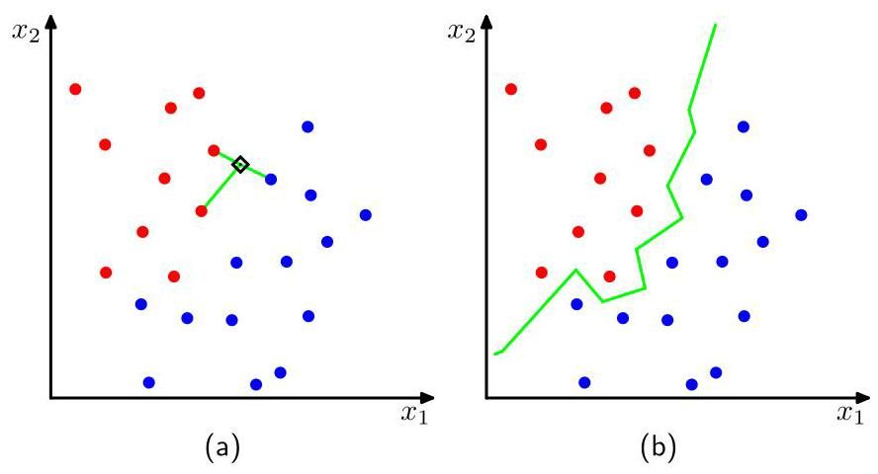

Figure 3.16 (a) In the -nearest-neighbour classifier, a new point, shown by the black diamond, is classified according to the majority class membership of the closest training data points, in this case 3. (b) In the nearest-neighbour approach to classification, the resulting decision boundary is composed of hyperplanes that form perpendicular bisectors of pairs of points from different classes.

图 3.16 (a) 在 -最近邻分类器中，一个新点(用黑色菱形表示)根据 个最近训练数据点的多数类别成员身份进行分类，在这种情况下 = 3。(b) 在最近邻 分类方法中，得到的决策边界由超平面组成，这些超平面是不同类别点对的垂直平分线。

with each class:

对于每个类别:

Similarly, the unconditional density is given by

类似地，无条件密度由下式给出

and the class priors are given by

并且类别先验由下式给出

We can now combine (3.187), (3.188), and (3.189) using Bayes’ theorem to obtain the posterior probability of class membership:

现在，我们可以使用贝叶斯定理将 (3.187)、(3.188) 和 (3.189) 结合起来，以获得类别归属的后验概率:

We can minimize the probability of misclassification by assigning the test point to the class having the largest posterior probability, corresponding to the largest value of . Thus, to classify a new point, we identify the nearest points from the training data set and then assign the new point to the class having the largest number of representatives amongst this set. Ties can be broken at random. The particular case of is called the nearest-neighbour rule, because a test point is simply assigned to the same class as the nearest point from the training set. These concepts are illustrated in Figure 3.16.

我们可以通过将测试点 分配给后验概率最大的类别来最小化分类错误的概率，该类别对应于 的最大值。因此，为了对一个新点进行分类，我们从训练数据集中找出 个最近的点，然后将新点分配给在这个集合中代表数量最多的类别。若出现平局，可以随机打破。 的特殊情况称为最近邻规则，因为测试点简单地被分配到与训练集中最近点相同的类别。这些概念如图 3.16 所示。

An interesting property of the nearest-neighbour classifier is that, in the limit , the error rate is never more than twice the minimum achievable error rate of an optimal classifier, i.e., one that uses the true class distributions (Cover and Hart, 1967) .

最近邻 分类器的一个有趣性质是，在极限 情况下，错误率永远不会超过最优分类器(即使用真实类别分布的分类器)所能达到的最小错误率的两倍(Cover 和 Hart，1967)。

As discussed so far, both the -nearest-neighbour method and the kernel density estimator require the entire training data set to be stored, leading to expensive computation if the data set is large. This effect can be offset, at the expense of some additional one-off computation, by constructing tree-based search structures to allow (approximate) near neighbours to be found efficiently without doing an exhaustive search of the data set. Nevertheless, these nonparametric methods are still severely limited. On the other hand, we have seen that simple parametric models are very restricted in terms of the forms of distribution that they can represent. We therefore need to find density models that are very flexible and yet for which the complexity of the models can be controlled independently of the size of the training set, and this can be achieved using deep neural networks. Exercises

到目前为止，我们已经讨论过， -最近邻方法和核密度估计器都需要存储整个训练数据集。如果数据集很大，这将导致计算成本高昂。通过构建基于树的搜索结构，在不进行数据集的穷举搜索的情况下高效地找到(近似)近邻，可以抵消这种影响，但这需要额外的一次性计算。然而，这些非参数方法仍然受到严重限制。另一方面，我们已经看到，简单的参数模型在它们能够表示的分布形式方面非常受限。因此，我们需要找到非常灵活的密度模型，并且这些模型的复杂度可以独立于训练集的大小进行控制，而这可以通过使用深度神经网络来实现。练习

3.1 (★) Verify that the Bernoulli distribution (3.2) satisfies the following properties:

3.1 (★) 验证伯努利分布(3.2)满足以下性质:

Show that the entropy of a Bernoulli-distributed random binary variable is given by

证明服从伯努利分布的随机二元变量 的熵 由下式给出

3.2 The form of the Bernoulli distribution given by (3.2) is not symmetric between the two values of . In some situations, it will be more convenient to use an equivalent formulation for which , in which case the distribution can be written

3.2 由(3.2)给出的伯努利分布形式在 的两个值之间并不对称。在某些情况下，使用一个等价的公式会更方便，其中 ，此时分布可以写成

where . Show that the distribution (3.195) is normalized, and evaluate its mean, variance, and entropy.

其中 。证明分布(3.195)是归一化的，并计算其均值、方差和熵。

3.3 In this exercise, we prove that the binomial distribution (3.9) is normalized. First, use the definition (3.10) of the number of combinations of identical objects chosen from a total of to show that

3.3 在这个练习中，我们证明二项分布(3.9)是归一化的。首先，使用从总共 个相同对象中选择 个的组合数的定义(3.10)来证明

Use this result to prove by induction the following result:

使用这个结果通过归纳法证明以下结果:

which is known as the binomial theorem and which is valid for all real values of . Finally, show that the binomial distribution is normalized, so that

这被称为二项式定理，并且对于 的所有实数值都成立。最后，证明二项分布是归一化的，使得

which can be done by first pulling a factor out of the summation and then making use of the binomial theorem.

这可以通过先从求和中提出一个因子 ，然后利用二项式定理来完成。

3.4 Show that the mean of the binomial distribution is given by (3.11). To do this, differentiate both sides of the normalization condition (3.198) with respect to and then rearrange to obtain an expression for the mean of . Similarly, by differentiating (3.198) twice with respect to and making use of the result (3.11) for the mean of the binomial distribution, prove the result (3.12) for the variance of the binomial.

3.4 证明二项分布的均值由 (3.11) 给出。为此，对归一化条件 (3.198) 两边关于 求导，然后重新整理以得到 均值的表达式。类似地，通过对 (3.198) 关于 求二阶导数，并利用二项分布均值的结果 (3.11)，证明二项分布方差的结果 (3.12)。

3.5 (*) Show that the mode of the multivariate Gaussian (3.26) is given by .

3.5 (*) 证明多元高斯分布 (3.26) 的众数由 给出。

3.6 Suppose that has a Gaussian distribution with mean and covariance . Show that the linearly transformed variable is also Gaussian, and find its mean and covariance.

3.6 假设 具有均值为 、协方差为 的高斯分布。证明线性变换后的变量 也是高斯分布，并求出其均值和协方差。

3.7 Show that the Kullback-Leibler divergence between two Gaussian distributions and is given by

3.7 证明两个高斯分布 和 之间的 Kullback-Leibler 散度由下式给出

where denotes the trace of a matrix, and is the dimensionality of .

其中 表示矩阵的迹， 是 的维数。

3.8 This exercise demonstrates that the multivariate distribution with maximum entropy, for a given covariance, is a Gaussian. The entropy of a distribution is given by

3.8 本练习证明，对于给定的协方差，具有最大熵的多元分布是高斯分布。分布 的熵由下式给出

We wish to maximize over all distributions subject to the constraints that is normalized and that it has a specific mean and covariance, so that

我们希望在所有分布 上最大化 ，同时满足 是归一化的，并且它具有特定的均值和协方差，即

By performing a variational maximization of (3.200) and using Lagrange multipliers to enforce the constraints (3.201), (3.202), and (3.203), show that the maximum likelihood distribution is given by the Gaussian (3.26).

通过对 (3.200) 进行变分最大化，并使用拉格朗日乘子来施加约束条件 (3.201)、(3.202) 和 (3.203)，证明最大似然分布由高斯分布 (3.26) 给出。

3.9 Show that the entropy of the multivariate Gaussian is given by

3.9 证明多元高斯分布 的熵由下式给出

where is the dimensionality of .

其中 是 的维度。

3.10 Consider two random variables and having Gaussian distributions with means and and precisions and , respectively. Derive an expression for the differential entropy of the variable . To do this, first find the distribution of by using the relation

3.10 考虑两个随机变量 和 ，它们分别服从均值为 和 、精度为 和 的高斯分布。推导变量 的微分熵表达式。为此，首先利用该关系找到 的分布

and completing the square in the exponent. Then observe that this represents the convolution of two Gaussian distributions, which itself will be Gaussian, and finally make use of the result (2.99) for the entropy of the univariate Gaussian.

并对指数项进行配平方。然后注意到这表示两个高斯分布的卷积，其本身也是高斯分布，最后利用单变量高斯分布熵的结果 (2.99)。

3.11 (★) Consider the multivariate Gaussian distribution given by (3.26). By writing the precision matrix (inverse covariance matrix) as the sum of a symmetric and an antisymmetric matrix, show that the antisymmetric term does not appear in the exponent of the Gaussian, and hence, that the precision matrix may be taken to be symmetric without loss of generality. Because the inverse of a symmetric matrix is also symmetric (see Exercise 3.16), it follows that the covariance matrix may also be chosen to be symmetric without loss of generality.

3.11 (★) 考虑由 (3.26) 给出的多元高斯分布。通过将精度矩阵(协方差矩阵的逆)写为对称矩阵和反对称矩阵之和，证明反对称项不出现在高斯分布的指数中，因此，不失一般性，可以认为精度矩阵是对称的。由于对称矩阵的逆也是对称的(见练习 3.16)，因此，不失一般性，也可以选择协方差矩阵为对称矩阵。

3.12 Consider a real, symmetric matrix whose eigenvalue equation is given by (3.28). By taking the complex conjugate of this equation, subtracting the original equation, and then forming the inner product with eigenvector , show that the eigenvalues are real. Similarly, use the symmetry property of to show that two eigenvectors and will be orthogonal provided . Finally, show that, without loss of generality, the set of eigenvectors can be chosen to be orthonormal, so that they satisfy (3.29), even if some of the eigenvalues are zero.

3.12 考虑一个实对称矩阵 ，其特征值方程由 (3.28) 给出。对该方程取复共轭，减去原方程，然后与特征向量 形成内积，证明特征值 是实数。类似地，利用 的对称性证明，若 ，则两个特征向量 和 是正交的。最后，证明不失一般性，即使某些特征值为零，特征向量组也可以选择为标准正交的，从而满足 (3.29)。

3.13 Show that a real, symmetric matrix having the eigenvector equation (3.28) can be expressed as an expansion in the eigenvectors, with coefficients given by the eigenvalues, of the form (3.31). Similarly, show that the inverse matrix has a representation of the form (3.32).

3.13 证明具有特征向量方程 (3.28) 的实对称矩阵 可以表示为特征向量的展开式，其系数由特征值给出，形式为 (3.31)。类似地，证明逆矩阵 具有形式为 (3.32) 的表示。

3.14 A positive definite matrix can be defined as one for which the quadratic form

3.14 正定矩阵 可以定义为:对于该矩阵，二次型

is positive for any real value of the vector a. Show that a necessary and sufficient condition for to be positive definite is that all the eigenvalues of , defined by (3.28), are positive.

对于向量 a 的任何实数值都是正的。证明 为正定矩阵的充要条件是，由 (3.28) 定义的 的所有特征值 都是正的。

3.15 (⋆) Show that a real, symmetric matrix of size has independent parameters.

3.15 (⋆) 证明一个大小为 的实对称矩阵有 个独立参数。

3.16 Show that the inverse of a symmetric matrix is itself symmetric.

3.16 证明对称矩阵的逆矩阵本身也是对称的。

By diagonalizing the coordinate system using the eigenvector expansion (3.31), show that the volume contained within the hyperellipsoid corresponding to a constant Mahalanobis distance is given by

通过使用特征向量展开 (3.31) 对坐标系进行对角化，证明与恒定马氏距离 对应的超椭球体内包含的体积由下式给出

where is the volume of the unit sphere in dimensions, and the Mahalanobis distance is defined by (3.27).

其中 是 维单位球体的体积，马氏距离由 (3.27) 定义。

3.18 Prove the identity (3.60) by multiplying both sides by the matrix

3.18 通过将等式两边乘以矩阵来证明恒等式 (3.60)。

and making use of the definition (3.61).

并利用定义 (3.61)。

3.19 In Sections 3.2.4 and 3.2.5, we considered the conditional and marginal distributions for a multivariate Gaussian. More generally, we can consider a partitioning of the components of into three groups , and , with a corresponding partitioning of the mean vector and of the covariance matrix in the form

3.19 在 3.2.4 节和 3.2.5 节中，我们考虑了多元高斯分布的条件分布和边缘分布。更一般地，我们可以将 的分量划分为三组 、 ，并且将均值向量 和协方差矩阵 相应地划分为如下形式

By making use of the results of Section 3.2, find an expression for the conditional distribution in which has been marginalized out.

利用 3.2 节的结果，求出 被边缘化后的条件分布 的表达式。

3.20 A very useful result from linear algebra is the Woodbury matrix inversion formula given by

3.20 线性代数中一个非常有用的结果是伍德伯里矩阵求逆公式，其表达式为

By multiplying both sides by , prove the correctness of this result.

通过将等式两边乘以 来证明该结果的正确性。

3.21 Let and be two independent random vectors, so that . Show that the mean of their sum is given by the sum of the means of each of the variables separately. Similarly, show that the covariance matrix of is given by the sum of the covariance matrices of and .

3.21 设 和 为两个独立的随机向量，使得 。证明它们的和 的均值等于各个变量均值之和。类似地，证明 的协方差矩阵等于 和 的协方差矩阵之和。

3.22 Consider a joint distribution over the variable

3.22 考虑变量上的联合分布

whose mean and covariance are given by (3.92) and (3.89), respectively. By making use of the results (3.76) and (3.77), show that the marginal distribution is given by (3.83). Similarly, by making use of the results (3.65) and (3.66), show that the conditional distribution is given by (3.84).

其均值和协方差分别由 (3.92) 和 (3.89) 给出。利用结果 (3.76) 和 (3.77)，证明边缘分布 由 (3.83) 给出。类似地，利用结果 (3.65) 和 (3.66)，证明条件分布 由 (3.84) 给出。

3.23 Using the partitioned matrix inversion formula (3.60), show that the inverse of the precision matrix (3.88) is given by the covariance matrix (3.89).

3.23 利用分块矩阵求逆公式 (3.60)，证明精度矩阵 (3.88) 的逆由协方差矩阵 (3.89) 给出。

By starting from (3.91) and making use of the result (3.89), verify the result (3.92).

从 (3.91) 出发并利用结果 (3.89)，验证结果 (3.92)。

3.25 Consider two multi-dimensional random vectors and having Gaussian distributions and , respectively, together with their sum . By considering the linear-Gaussian model comprising the product of the marginal distribution and the conditional distribution and making use of the results (3.93) and (3.94), show that the marginal distribution of is given by

3.25 考虑两个多维随机向量 和 ，它们分别具有高斯分布 和 ，以及它们的和 。通过考虑包含边缘分布 和条件分布 乘积的线性高斯模型，并利用结果 (3.93) 和 (3.94)，证明 的边缘分布由

3.26 This exercise and the next provide practice at manipulating the quadratic forms that arise in linear-Gaussian models, and they also serve as an independent check of results derived in the main text. Consider a joint distribution defined by the marginal and conditional distributions given by (3.83) and (3.84). By examining the quadratic form in the exponent of the joint distribution and using the technique of ’completing the square’ discussed in Section 3.2, find expressions for the mean and covariance of the marginal distribution in which the variable has been integrated out. To do this, make use of the Woodbury matrix inversion formula (3.210). Verify that these results agree with (3.93) and (3.94).

3.26 本题及下一题旨在让你练习处理线性高斯模型中出现的二次型，同时也可独立验证正文中推导的结果。考虑由式(3.83)和(3.84)给出的边缘分布和条件分布所定义的联合分布 。通过考察联合分布指数中的二次型，并运用 3.2 节讨论的“配方法”，求出边缘分布 的均值和协方差的表达式，其中变量 已被积分掉。为此，需使用伍德伯里矩阵求逆公式(3.210)。验证这些结果是否与式(3.93)和(3.94)一致。

3.27 Consider the same joint distribution as in Exercise 3.26, but now use the technique of completing the square to find expressions for the mean and covariance of the conditional distribution . Again, verify that these agree with the corresponding expressions (3.95) and (3.96).

3.27 考虑与练习 3.26 相同的联合分布，但现在使用配方法来求条件分布 的均值和协方差的表达式。同样，验证这些结果是否与相应的表达式(3.95)和(3.96)一致。

3.28 To find the maximum likelihood solution for the covariance matrix of a multivariate Gaussian, we need to maximize the log likelihood function (3.102) with respect to , noting that the covariance matrix must be symmetric and positive definite. Here we proceed by ignoring these constraints and doing a straightforward maximization. Using the results (A.21), (A.26), and (A.28) from Appendix A, show that the covariance matrix that maximizes the log likelihood function (3.102) is given by the sample covariance (3.106). We note that the final result is necessarily symmetric and positive definite (provided the sample covariance is non-singular).

3.28 为了找到多元高斯分布协方差矩阵的最大似然解，我们需要关于 最大化对数似然函数(3.102)，同时要注意协方差矩阵必须是对称且正定的。这里我们先忽略这些约束条件，直接进行最大化操作。利用附录 A 中的结果(A.21)、(A.26)和(A.28)，证明使对数似然函数(3.102)最大化的协方差矩阵 由样本协方差(3.106)给出。我们注意到最终结果必然是对称且正定的(前提是样本协方差矩阵非奇异)。

Use the result (3.42) to prove (3.46). Now, using the results (3.42) and (3.46), show that

利用结果(3.42)证明(3.46)。现在，利用结果(3.42)和(3.46)，证明

where denotes a data point sampled from a Gaussian distribution with mean and covariance , and denotes the element of the identity matrix. Hence, prove the result (3.108).

其中 表示从均值为 、协方差为 的高斯分布中采样得到的数据点， 表示单位矩阵的第 个元素。因此，证明结果(3.108)。

3.30 (*) The various trigonometric identities used in the discussion of periodic variables in this chapter can be proven easily from the relation

3.30 (*) 本章中讨论周期变量时使用的各种三角恒等式可以很容易地从以下关系中得到证明

in which is the square root of minus one. By considering the identity

其中 是 -1 的平方根。通过考虑恒等式

prove the result (3.127). Similarly, using the identity

证明结果 (3.127)。类似地，使用恒等式

where denotes the real part, prove (3.128). Finally, by using , where denotes the imaginary part, prove the result (3.133).

其中 表示实部，证明 (3.128)。最后，通过使用 ，其中 表示虚部，证明结果 (3.133)。

For large , the von Mises distribution (3.129) becomes sharply peaked around the mode . By defining and taking the Taylor expansion of the cosine function given by

对于较大的 ，冯·米塞斯分布 (3.129) 在众数 附近变得尖锐。通过定义 并对余弦函数进行泰勒展开，其表达式为

show that as , the von Mises distribution tends to a Gaussian.

证明当 时，冯·米塞斯分布趋近于高斯分布。

3.32 (⋆) Using the trigonometric identity (3.133), show that solution of (3.132) for is given by (3.134).

3.32 (⋆) 使用三角恒等式 (3.133)，证明 (3.132) 关于 的解由 (3.134) 给出。

3.33 (*) By computing the first and second derivatives of the von Mises distribution (3.129), and using for , show that the maximum of the distribution occurs when and that the minimum occurs when .

3.33 (*) 通过计算冯·米塞斯分布(3.129)的一阶和二阶导数，并对 使用 ，证明该分布的最大值出现在 时，最小值出现在 时。

3.34 (⋆) By making use of the result (3.118) together with (3.134) and the trigonometric identity (3.128), show that the maximum likelihood solution for the concentration of the von Mises distribution satisfies where is the radius of the mean of the observations viewed as unit vectors in the two-dimensional Euclidean plane, as illustrated in Figure 3.9.

3.34 (⋆) 利用结果(3.118)以及(3.134)和三角恒等式(3.128)，证明冯·米塞斯分布浓度的最大似然解 满足 ，其中 是将观测值视为二维欧几里得平面中的单位向量时的均值半径，如图 3.9 所示。

3.35 Verify that the multivariate Gaussian distribution can be cast in exponential family form (3.138), and derive expressions for , and analogous to (3.164) to (3.167).

3.35 验证多元高斯分布可以表示为指数族形式(3.138)，并推导与(3.164)至(3.167)类似的 和 的表达式。

3.36 (*) The result (3.172) showed that the negative gradient of for the exponential family is given by the expectation of . By taking the second derivatives of (3.139), show that

3.36 (*) 结果(3.172)表明，指数族的 的负梯度由 的期望给出。通过对(3.139)求二阶导数，证明

3.37 Consider a histogram-like density model in which the space is divided into fixed regions for which the density takes the constant value over the th region. The volume of region is denoted . Suppose we have a set of observations of such that of these observations fall in region . Using a Lagrange multiplier to enforce the normalization constraint on the density, derive an expression for the maximum likelihood estimator for the .

3.37 考虑一个类似直方图的密度模型，其中空间 被划分为固定区域，在第 个区域上，密度 取常数值 。区域 的体积记为 。假设我们有一组 个 的观测值，使得其中 个观测值落在区域 中。使用拉格朗日乘数来强制密度的归一化约束，推导 的最大似然估计量的表达式。

3.38 (⋆) Show that the -nearest-neighbour density model defines an improper distribution whose integral over all space is divergent.

3.38 (⋆) 证明 -最近邻密度模型定义了一个非正则分布，其在整个空间上的积分是发散的。

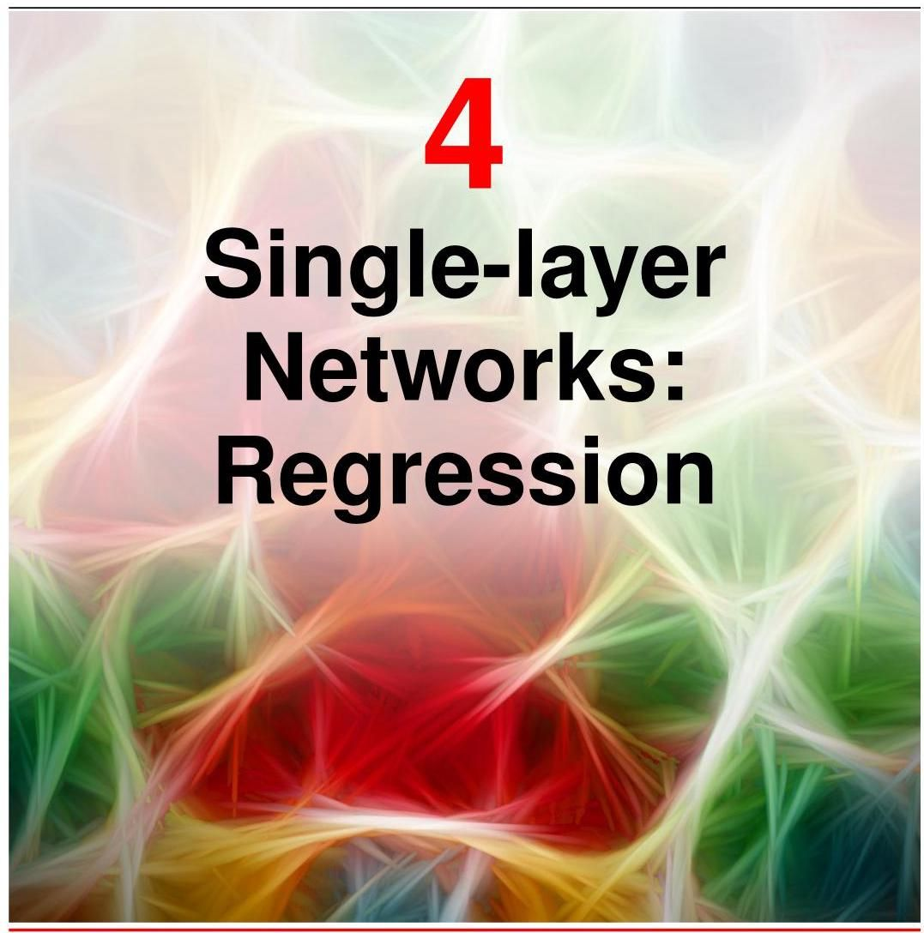

In this chapter we discuss some of the basic ideas behind neural networks using the framework of linear regression, which we encountered briefly in the context of polynomial curve fitting. We will see that a linear regression model corresponds to a simple form of neural network having a single layer of learnable parameters. Although single-layer networks have very limited practical applicability, they have simple analytical properties and provide an excellent framework for introducing many of the core concepts that will lay a foundation for our discussion of deep neural networks in later chapters.

在本章中，我们将使用线性回归的框架来讨论神经网络背后的一些基本概念，我们在多项式曲线拟合的背景下曾简要提及过线性回归。我们将看到，线性回归模型对应于一种具有单层可学习参数的简单神经网络形式。尽管单层网络的实际应用非常有限，但它们具有简单的分析特性，并为引入许多核心概念提供了一个极好的框架，这些概念将为我们在后续章节中讨论深度神经网络奠定基础。

Section 1.2

1.2 节

# 4.1. Linear Regression

# 4.1. 线性回归

The goal of regression is to predict the value of one or more continuous target variables given the value of a -dimensional vector of input variables. Typically we are given a training data set comprising observations , where , together with corresponding target values , and the goal is to predict the value of for a new value of . To do this, we formulate a function whose values for new inputs constitute the predictions for the corresponding values of , and where w represents a vector of parameters that can be learned from the training data.

回归的目标是在给定 维输入变量向量 的值的情况下，预测一个或多个连续目标变量 的值。通常，我们会得到一个包含 个观测值 的训练数据集，其中 ，以及相应的目标值 ，目标是为 的新值预测 的值。为此，我们构建一个函数 ，其对于新输入 的值构成了相应 值的预测，其中 w 表示一个可以从训练数据中学习的参数向量。

The simplest model for regression is one that involves a linear combination of the input variables:

最简单的回归模型是涉及输入变量线性组合的模型:

where . The term linear regression sometimes refers specifically to this form of model. The key property of this model is that it is a linear function of the parameters . It is also, however, a linear function of the input variables , and this imposes significant limitations on the model.

其中 。术语“线性回归”有时专门指这种形式的模型。该模型的关键特性是它是参数 的线性函数。然而，它也是输入变量 的线性函数，这给模型带来了显著的局限性。

# 4.1.1 Basis functions

# 4.1.1 基函数

We can extend the class of models defined by (4.1) by considering linear combinations of fixed nonlinear functions of the input variables, of the form

我们可以通过考虑输入变量的固定非线性函数的线性组合来扩展由 (4.1) 定义的模型类别，其形式为

where are known as basis functions. By denoting the maximum value of the index by , the total number of parameters in this model will be .

其中 被称为基函数。通过用 表示索引 的最大值，该模型中的参数总数将为 。

The parameter allows for any fixed offset in the data and is sometimes called a bias parameter (not to be confused with bias in a statistical sense). It is often convenient to define an additional dummy basis function whose value is fixed at so that (4.2) becomes

参数 允许数据中有任何固定偏移，有时被称为偏置参数(不要与统计意义上的偏差相混淆)。通常方便定义一个额外的虚拟基函数 ，其值固定为 ，这样 (4.2) 就变为

Section 4.3

4.3 节

where and . We can represent the model (4.3) using a neural network diagram, as shown in Figure 4.1.

其中 且 。我们可以使用神经网络图来表示模型 (4.3)，如图 4.1 所示。

By using nonlinear basis functions, we allow the function to be a nonlinear function of the input vector . Functions of the form (4.2) are called linear models, however, because they are linear in . It is this linearity in the parameters that will greatly simplify the analysis of this class of models. However, it also leads to some significant limitations.

通过使用非线性基函数，我们允许函数 成为输入向量 的非线性函数。然而，形如 (4.2) 的函数被称为线性模型，因为它们关于 是线性的。正是参数的这种线性将极大地简化对这类模型的分析。不过，这也导致了一些显著的局限性。

Section 6.1

第 6.1 节

Figure 4.1 The linear regression model (4.3) can be expressed as a simple neural network diagram involving a single layer of parameters. Here each basis function is represented by an input node, with the solid node representing the ’bias’ basis function , and the function is represented by an output node. Each of the parameters is shown by a line connecting the corresponding basis function to the output.

图 4.1 线性回归模型 (4.3) 可以表示为一个涉及单层参数的简单神经网络图。这里，每个基函数 由一个输入节点表示，实心节点表示 “偏置” 基函数 ，函数 由一个输出节点表示。每个参数 由一条将相应基函数连接到输出的线表示。

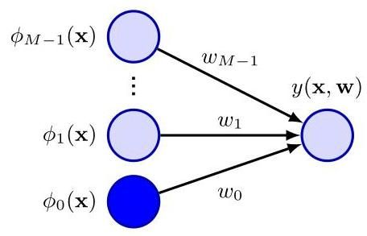

Before the advent of deep learning it was common practice in machine learning to use some form of fixed pre-processing of the input variables , also known as feature extraction, expressed in terms of a set of basis functions . The goal was to choose a sufficiently powerful set of basis functions that the resulting learning task could be solved using a simple network model. Unfortunately, it is very difficult to hand-craft suitable basis functions for anything but the simplest applications. Deep learning avoids this problem by learning the required nonlinear transformations of the data from the data set itself.

在深度学习出现之前，机器学习中常见的做法是对输入变量 进行某种形式的固定预处理，也称为特征提取，用一组基函数 来表示。目标是选择一组足够强大的基函数，以便可以使用简单的网络模型解决由此产生的学习任务。不幸的是，除了最简单的应用之外，手工设计合适的基函数非常困难。深度学习通过从数据集本身学习所需的数据非线性变换来避免这个问题。

We have already encountered an example of a regression problem when we discussed curve fitting using polynomials. The polynomial function (1.1) can be expressed in the form (4.3) if we consider a single input variable and if we choose basis functions defined by . There are many other possible choices for the basis functions, for example

在讨论使用多项式进行曲线拟合时，我们已经遇到过一个回归问题的例子。如果我们考虑单个输入变量 并选择由 定义的基函数，多项式函数 (1.1) 可以表示为 (4.3) 的形式。基函数还有许多其他可能的选择，例如

Chapter 1

第 1 章

where the govern the locations of the basis functions in input space, and the parameter governs their spatial scale. These are usually referred to as ’Gaussian’ basis functions, although it should be noted that they are not required to have a probabilistic interpretation. In particular the normalization coefficient is unimportant because these basis functions will be multiplied by learnable parameters .

其中 控制着基函数在输入空间中的位置，参数 控制着它们的空间尺度。这些通常被称为 “高斯” 基函数，尽管应该注意的是，它们不需要有概率解释。特别是归一化系数并不重要，因为这些基函数将与可学习参数 相乘。

Another possibility is the sigmoidal basis function of the form

另一种可能性是形式如下的 S 形基函数

where is the logistic sigmoid function defined by

其中 是由下式定义的逻辑 S 形函数

Equivalently, we can use the tanh function because this is related to the logistic sigmoid by , and so a general linear combination of logistic sigmoid functions is equivalent to a general linear combination of tanh functions in the sense that they can represent the same class of input-output functions. These various choices of basis function are illustrated in Figure 4.2.

同样，我们可以使用双曲正切函数，因为它与逻辑 S 形函数的关系为 ，因此，逻辑 S 形函数的一般线性组合在能够表示相同类别的输入 - 输出函数的意义上等同于双曲正切函数的一般线性组合。这些不同的基函数选择如图 4.2 所示。

Exercise 4.3

练习 4.3

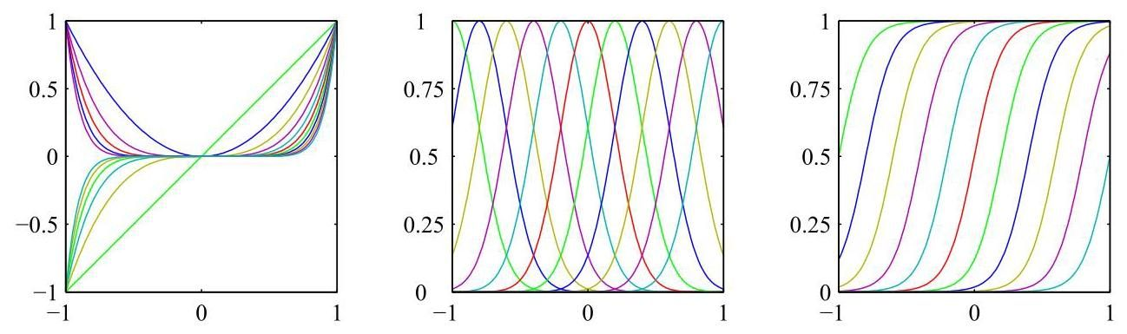

Figure 4.2 Examples of basis functions, showing polynomials on the left, Gaussians of the form (4.4) in the centre, and sigmoidal basis functions of the form (4.5) on the right.

图 4.2 基函数示例，左侧为多项式，中间为形式 (4.4) 的高斯函数，右侧为形式 (4.5) 的 S 形基函数。

Yet another possible choice of basis function is the Fourier basis, which leads to an expansion in sinusoidal functions. Each basis function represents a specific frequency and has infinite spatial extent. By contrast, basis functions that are localized to finite regions of input space necessarily comprise a spectrum of different spatial frequencies. In signal processing applications, it is often of interest to consider basis functions that are localized in both space and frequency, leading to a class of functions known as wavelets (Ogden, 1997; Mallat, 1999; Vidakovic, 1999). These are also defined to be mutually orthogonal, to simplify their application. Wavelets are most applicable when the input values live on a regular lattice, such as the successive time points in a temporal sequence or the pixels in an image.

另一种可能的基函数选择是傅里叶基，它会导致用正弦函数进行展开。每个基函数代表一个特定的频率，并且具有无限的空间范围。相比之下，局限于输入空间有限区域的基函数必然包含不同空间频率的频谱。在信号处理应用中，通常会考虑在空间和频率上都具有局部性的基函数，这就引出了一类被称为小波的函数(Ogden，1997；Mallat，1999；Vidakovic，1999)。为了简化应用，这些小波函数也被定义为相互正交的。当输入值位于规则网格上时，小波最为适用，例如时间序列中的连续时间点或图像中的像素。

Most of the discussion in this chapter, however, is independent of the choice of basis function set, and so we will not specify the particular form of the basis functions, except for numerical illustration. Furthermore, to keep the notation simple, we will focus on the case of a single target variable , although we will briefly outline the modifications needed to deal with multiple target variables.

然而，本章的大部分讨论与基函数集的选择无关，因此除了数值示例外，我们不会指定基函数的具体形式。此外，为了使符号表示简单，我们将重点关注单个目标变量 的情况，尽管我们会简要概述处理多个目标变量所需的修改。

Section 4.1.7

4.1.7 节

# 4.1.2 Likelihood function

# 4.1.2 似然函数

We solved the problem of fitting a polynomial function to data by minimizing a sum-of-squares error function, and we also showed that this error function could be motivated as the maximum likelihood solution under an assumed Gaussian noise model. We now return to this discussion and consider the least-squares approach, and its relation to maximum likelihood, in more detail.

我们通过最小化平方和误差函数解决了将多项式函数拟合到数据的问题，并且我们还表明，在假设的高斯噪声模型下，这个误差函数可以作为最大似然解得到。现在我们回到这个讨论，更详细地考虑最小二乘法及其与最大似然法的关系。

Section 1.2

1.2 节

As before, we assume that the target variable is given by a deterministic function with additive Gaussian noise so that

和之前一样，我们假设目标变量 由一个确定性函数 加上高斯噪声给出，即

where is a zero-mean Gaussian random variable with variance . Thus, we can write

其中 是一个均值为零、方差为 的高斯随机变量。因此，我们可以写成

Now consider a data set of inputs with corresponding target values . We group the target variables into a column vector that we denote by where the typeface is chosen to distinguish it from a single observation of a multivariate target, which would be denoted . Making the assumption that these data points are drawn independently from the distribution (4.8), we obtain an expression for the likelihood function, which is a function of the adjustable parameters and :

现在考虑一个输入 的数据集，其对应的目标值为 。我们将目标变量 组合成一个列向量，记为 ，这里选择这种字体是为了将其与多元目标的单个观测值区分开来，后者记为 。假设这些数据点是从分布 (4.8) 中独立抽取的，我们得到似然函数的表达式，它是可调参数 和 的函数:

where we have used (4.3). Taking the logarithm of the likelihood function and making use of the standard form (2.49) for the univariate Gaussian, we have

这里我们使用了 (4.3)。对似然函数取对数，并利用单变量高斯分布的标准形式 (2.49)，我们得到

where the sum-of-squares error function is defined by

其中平方和误差函数定义为

The first two terms in (4.10) can be treated as constants when determining because they are independent of . Therefore, as we saw previously, maximizing the likelihood function under a Gaussian noise distribution is equivalent to minimizing the sum-of-squares error function (4.11).

在确定 时，(4.10) 中的前两项可以视为常数，因为它们与 无关。因此，正如我们之前所见，在高斯噪声分布下最大化似然函数等价于最小化平方和误差函数 (4.11)。

Section 2.3.4

第2.3.4节

# 4.1.3 Maximum likelihood

# 4.1.3 最大似然

Having written down the likelihood function, we can use maximum likelihood to determine and . Consider first the maximization with respect to . The gradient of the log likelihood function (4.10) with respect to takes the form

写下似然函数后，我们可以使用最大似然法来确定 和 。首先考虑关于 的最大化问题。对数似然函数(4.10)关于 的梯度具有如下形式

Setting this gradient to zero gives

令该梯度为零，可得

Solving for we obtain

求解 ，我们得到

which are known as the normal equations for the least-squares problem. Here is an matrix, called the design matrix, whose elements are given by ,

这就是最小二乘问题的正规方程。这里 是一个 矩阵，称为设计矩阵，其元素由 给出

so that

以便；所以

The quantity

该量

is known as the Moore-Penrose pseudo-inverse of the matrix (Rao and Mitra, 1971; Golub and Van Loan, 1996). It can be regarded as a generalization of the notion of a matrix inverse to non-square matrices. Indeed, if is square and invertible, then using the property we see that .

被称为矩阵 的摩尔 - 彭罗斯广义逆(Rao 和 Mitra，1971 年；Golub 和 Van Loan，1996 年)。它可以被视为矩阵逆的概念向非方阵的推广。实际上，如果 是方阵且可逆，那么利用性质 我们可以得到 。

At this point, we can gain some insight into the role of the bias parameter . If we make the bias parameter explicit, then the error function (4.11) becomes

此时，我们可以深入了解偏置参数 的作用。如果我们明确写出偏置参数，那么误差函数(4.11)变为

Setting the derivative with respect to equal to zero and solving for , we obtain

令关于 的导数等于零并求解 ，我们得到

where we have defined

其中我们定义了

Thus, the bias compensates for the difference between the averages (over the training set) of the target values and the weighted sum of the averages of the basis function values.

因此，偏置 补偿了目标值的平均值(在训练集上)与基函数值的平均值的加权和之间的差异。

We can also maximize the log likelihood function (4.10) with respect to the variance , giving

我们还可以相对于方差 最大化对数似然函数 (4.10)，得到

and so we see that the maximum likelihood value of the variance parameter is given by the residual variance of the target values around the regression function.

因此我们看到，方差参数的最大似然值由目标值围绕回归函数的残差方差给出。

gure 4.3 Geometrical interpretation of the least-squares solution in an -dimensional space whose axes are the values of . The least-squares regression function is obtained by finding the orthogonal projection of the data vector onto the subspace spanned by the basis functions in which each basis function is viewed as a vector of length with elements .

图 4.3 在一个 维空间中最小二乘解的几何解释，该空间的坐标轴是 的值。最小二乘回归函数是通过将数据向量 正交投影到由基函数 张成的子空间中得到的，其中每个基函数被视为一个长度为 、元素为 的向量 。

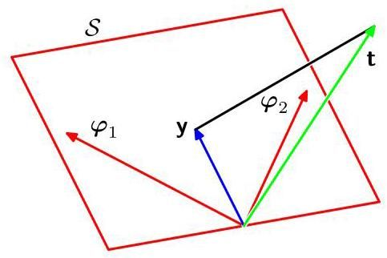

# 4.1.4 Geometry of least squares

# 4.1.4 最小二乘法的几何意义

At this point, it is instructive to consider the geometrical interpretation of the least-squares solution. To do this, we consider an -dimensional space whose axes are given by the , so that is a vector in this space. Each basis function , evaluated at the data points, can also be represented as a vector in the same space, denoted by , as illustrated in Figure 4.3. Note that corresponds to the th column of , whereas corresponds to the transpose of the th row of . If the number of basis functions is smaller than the number of data points, then the vectors will span a linear subspace of dimensionality . We define to be an -dimensional vector whose th element is given by , where . Because is an arbitrary linear combination of the vectors , it can live anywhere in the -dimensional subspace. The sum-of-squares error (4.11) is then equal (up to a factor of ) to the squared Euclidean distance between and . Thus, the least-squares solution for corresponds to that choice of that lies in subspace and is closest to . Intuitively, from Figure 4.3, we anticipate that this solution corresponds to the orthogonal projection of onto the subspace . This is indeed the case, as can easily be verified by noting that the solution for is given by and then confirming that this takes the form of an orthogonal projection.

此时，考虑最小二乘解的几何解释是很有启发性的。为此，我们考虑一个 维空间，其坐标轴由 给出，使得 是这个空间中的一个向量。每个基函数 在 个数据点上的取值也可以表示为同一空间中的一个向量，记为 ，如图 4.3 所示。注意， 对应于 的第 列，而 对应于 的第 行的转置。如果基函数的数量 小于数据点的数量 ，那么 个向量 将张成一个维数为 的线性子空间 。我们将 定义为一个 维向量，其第 个元素由 给出，其中 。因为 是向量 的任意线性组合，所以它可以位于 维子空间中的任何位置。平方和误差 (4.11) (相差一个因子 )等于 和 之间的欧几里得距离的平方。因此， 的最小二乘解对应于 的这样一种选择，它位于子空间 中且最接近 。直观地，从图 4.3 我们可以预期这个解对应于 在子空间 上的正交投影。事实确实如此，这可以通过注意到 的解由 给出，然后确认它具有正交投影的形式来轻松验证。

Exercise 4.4

练习 4.4

In practice, a direct solution of the normal equations can lead to numerical difficulties when is close to singular. In particular, when two or more of the basis vectors are co-linear, or nearly so, the resulting parameter values can have large magnitudes. Such near degeneracies will not be uncommon when dealing with real data sets. The resulting numerical difficulties can be addressed using the technique of singular value decomposition, or SVD (Deisenroth, Faisal, and Ong, 2020). Note that the addition of a regularization term ensures that the matrix is non-singular, even in the presence of degeneracies.

在实践中，当 接近奇异时，直接求解正规方程可能会导致数值计算困难。特别是，当两个或更多基向量 共线或近乎共线时，得到的参数值可能会有很大的量级。在处理实际数据集时，这种近乎退化的情况并不罕见。可以使用奇异值分解(SVD)技术来解决由此产生的数值计算困难(Deisenroth、Faisal 和 Ong，2020)。请注意，添加正则化项可确保矩阵非奇异，即使存在退化情况也是如此。

# 4.1.5 Sequential learning

# 4.1.5 顺序学习

The maximum likelihood solution (4.14) involves processing the entire training set in one go and is known as a batch method. This can become computationally costly for large data sets. If the data set is sufficiently large, it may be worthwhile to use sequential algorithms, also known as online algorithms, in which the data points are considered one at a time and the model parameters updated after each such presentation. Sequential learning is also appropriate for real-time applications in which the data observations arrive in a continuous stream and predictions must be made before all the data points are seen.

最大似然解(4.14)需要一次性处理整个训练集，这种方法被称为批量方法。对于大型数据集，这种方法的计算成本可能会很高。如果数据集足够大，使用顺序算法(也称为在线算法)可能是值得的。在顺序算法中，数据点是逐个处理的，并且在每次处理后更新模型参数。顺序学习也适用于实时应用，在这些应用中，数据观测值是连续到来的，并且必须在看到所有数据点之前做出预测。

We can obtain a sequential learning algorithm by applying the technique of stochastic gradient descent, also known as sequential gradient descent, as follows. If the error function comprises a sum over data points , then after presentation of data point , the stochastic gradient descent algorithm updates the parameter

我们可以通过应用随机梯度下降技术(也称为顺序梯度下降)来获得顺序学习算法，具体如下。如果误差函数是对数据点 的求和，那么在呈现数据点 之后，随机梯度下降算法会更新参数

Chapter 7

第 7 章

vector using

向量 使用

where denotes the iteration number, and is a suitably chosen learning rate parameter. The value of is initialized to some starting vector . For the sum-of-squares error function (4.11), this gives

其中 表示迭代次数， 是一个适当选择的学习率参数。 的值被初始化为某个起始向量 。对于平方和误差函数 (4.11)，这给出

where . This is known as the least-mean-squares or the LMS algorithm.

其中 。这被称为最小均方或 LMS 算法。

# 4.1.6 Regularized least squares

# 4.1.6 正则化最小二乘法

Section 1.2

第 1.2 节

We have previously introduced the idea of adding a regularization term to an error function to control over-fitting, so that the total error function to be minimized takes the form

我们之前已经介绍了在误差函数中添加正则化项以控制过拟合的思想，这样待最小化的总误差函数具有如下形式

where is the regularization coefficient that controls the relative importance of the data-dependent error and the regularization term . One of the simplest forms of regularizer is given by the sum of the squares of the weight vector

其中 是正则化系数，用于控制与数据相关的误差 和正则化项 的相对重要性。最简单的正则化器形式之一是权重向量元素的平方和

elements:

元素:

If we also consider the sum-of-squares error function given by

如果我们还考虑由下式给出的平方和误差函数

then the total error function becomes

那么总误差函数变为

In statistics, this regularizer provides an example of a parameter shrinkage method because it shrinks parameter values towards zero. It has the advantage that the error function remains a quadratic function of , and so its exact minimizer can be found in closed form. Specifically, setting the gradient of (4.26) with respect to to zero and solving for as before, we obtain

在统计学中，这种正则化器是参数收缩方法的一个例子，因为它会将参数值向零收缩。它的优点是误差函数仍然是 的二次函数，因此可以以封闭形式找到其精确的极小值点。具体来说，像之前一样，将 (4.26) 关于 的梯度设为零并求解 ，我们得到

Exercise 4.6

练习 4.6

This represents a simple extension of the least-squares solution (4.14).

这代表了最小二乘解 (4.14) 的一个简单扩展。

Figure 4.4 Representation of a linear regression model as a neural network having a single layer of connections. Each basis function is represented by a node, with the solid node representing the ’bias’ basis function . Likewise each output is represented by a node. The links between the nodes represent the corresponding weight and bias parameters.

图 4.4 将线性回归模型表示为具有单层连接的神经网络。每个基函数由一个节点表示，实心节点表示 “偏置” 基函数 。同样，每个输出 也由一个节点表示。节点之间的链接表示相应的权重和偏置参数。

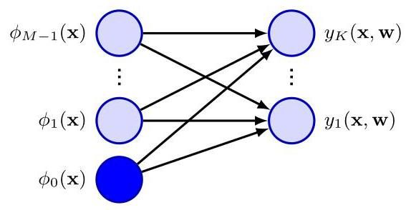

# 4.1.7 Multiple outputs

# 4.1.7 多输出

So far, we have considered situations with a single target variable . In some applications, we may wish to predict target variables, which we denote collectively by the target vector . This could be done by introducing a different set of basis functions for each component of , leading to multiple, independent regression problems. However, a more common approach is to use the same set of basis functions to model all of the components the target vector so that

到目前为止，我们考虑的是具有单个目标变量 的情况。在某些应用中，我们可能希望预测 个目标变量，我们将它们统一用目标向量 表示。这可以通过为 的每个分量引入一组不同的基函数来实现，从而产生多个独立的回归问题。然而，更常见的方法是使用同一组基函数来对目标向量的所有分量进行建模，使得

where is a -dimensional column vector, is an matrix of parameters, and is an -dimensional column vector with elements with as before. Again, this can be represented as a neural network having a single layer of parameters, as shown in Figure 4.4.

其中 是一个 维列向量， 是一个 参数矩阵， 是一个 维列向量，其元素为 ，其中 与之前相同。同样，这可以表示为一个具有单层参数的神经网络，如图 4.4 所示。

Suppose we take the conditional distribution of the target vector to be an isotropic Gaussian of the form

假设我们将目标向量的条件分布设为如下形式的各向同性高斯分布

If we have a set of observations , we can combine these into a matrix of size such that the th row is given by . Similarly, we can combine the input vectors into a matrix . The log likelihood function is then given by

如果我们有一组观测值 ，我们可以将这些观测值组合成一个大小为 的矩阵 ，使得第 行由 给出。类似地，我们可以将输入向量 组合成一个矩阵 。那么对数似然函数由下式给出

As before, we can maximize this function with respect to , giving

和之前一样，我们可以关于 最大化这个函数，得到

where we have combined the input feature vectors into a matrix . If we examine this result for each target variable , we have

其中我们将输入特征向量 组合成了一个矩阵 。如果我们针对每个目标变量 考察这个结果，我们有

where is an -dimensional column vector with components for . Thus, the solution to the regression problem decouples between the different target variables, and we need compute only a single pseudo-inverse matrix , which is shared by all the vectors .

其中 是一个 维列向量，其分量 对应于 。因此，回归问题的解在不同的目标变量之间是解耦的，并且我们只需要计算一个单一的伪逆矩阵 ，它由所有向量 共享。

The extension to general Gaussian noise distributions having arbitrary covariance matrices is straightforward. Again, this leads to a decoupling into independent regression problems. This result is unsurprising because the parameters define only the mean of the Gaussian noise distribution, and we know that the maximum likelihood solution for the mean of a multivariate Gaussian is independent of the covariance. From now on, we will therefore consider a single target variable for simplicity.

将其扩展到具有任意协方差矩阵的一般高斯噪声分布是很直接的。同样，这会导致解耦为 个独立的回归问题。这个结果并不令人惊讶，因为参数 仅定义了高斯噪声分布的均值，并且我们知道多元高斯分布均值的最大似然解与协方差无关。因此，为了简单起见，从现在起我们将考虑单个目标变量 。

Exercise 4.7

练习 4.7

Section 3.2.7

3.2.7 节

# 4.2. Decision theory

# 4.2. 决策理论

We have formulated the regression task as one of modelling a conditional probability distribution , and we have chosen a specific form for the conditional probability, namely a Gaussian (4.8) with an -dependent mean governed by parameters and with variance given by the parameter . Both and can be learned from data using maximum likelihood. The result is a predictive distribution given by

我们已将回归任务表述为对条件概率分布 进行建模的任务之一，并且我们为条件概率选择了一种特定形式，即高斯分布 (4.8)，其均值 依赖于 且由参数 控制，方差由参数 给出。 和 都可以使用最大似然法从数据中学习得到。结果得到一个由下式给出的预测分布

The predictive distribution expresses our uncertainty over the value of for some new input . However, for many practical applications we need to predict a specific value for rather than returning an entire distribution, particularly where we must take a specific action. For example, if our goal is to determine the optimal level of radiation to use for treating a tumour and our model predicts a probability distribution over radiation dose, then we must use that distribution to decide the specific dose to be administered. Our task therefore breaks down into two stages. In the first stage, called the inference stage, we use the training data to determine a predictive distribution . In the second stage, known as the decision stage, we use this predictive distribution to determine a specific value , which will be dependent on the input vector , that is optimal according to some criterion. We can do this by minimizing a loss function that depends on both the predictive distribution and on .

预测分布表达了我们对于某个新输入 对应的 值的不确定性。然而，对于许多实际应用，我们需要预测 的一个特定值，而不是给出整个分布，特别是在我们必须采取特定行动的情况下。例如，如果我们的目标是确定治疗肿瘤的最佳辐射水平，并且我们的模型预测了辐射剂量的概率分布，那么我们必须使用该分布来决定要施用的特定剂量。因此，我们的任务分为两个阶段。在第一阶段，称为推理阶段，我们使用训练数据来确定预测分布 。在第二阶段，称为决策阶段，我们使用这个预测分布来确定一个特定值 ，它将依赖于输入向量 ，并且根据某个准则是最优的。我们可以通过最小化一个依赖于预测分布 和 的损失函数来实现这一点。

Intuitively we might choose the mean of the conditional distribution, so that we would use . In some cases this intuition will be correct, but in other situations it can give very poor results. It is therefore useful to formalize this so that we can understand when it applies and under what assumptions, and the framework for doing this is called decision theory.

直观上，我们可能会选择条件分布的均值，这样我们会使用 。在某些情况下，这种直觉是正确的，但在其他情况下，它可能会给出非常糟糕的结果。因此，将其形式化是很有用的，这样我们就能理解它何时适用以及在什么假设下适用，而实现这一点的框架称为决策理论。

Suppose that we choose a value for our prediction when the true value is . In doing so, we incur some form of penalty or cost. This is determined by a loss, which we denote . Of course, we do not know the true value of , so instead of minimizing itself, we minimize the average, or expected, loss which is

假设当真实值为 时，我们为预测选择了一个值 。这样做时，我们会产生某种形式的惩罚或成本。这由一个损失决定，我们将其记为 。当然，我们不知道 的真实值，所以我们不是最小化 本身，而是最小化平均损失，即期望损失，它是

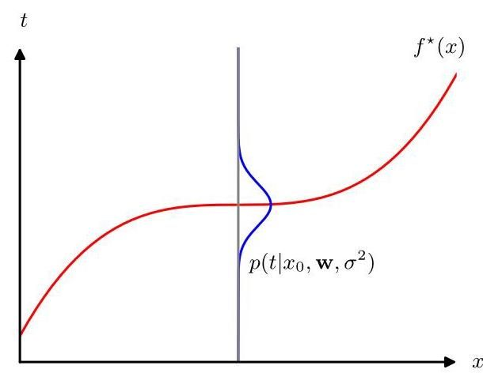

Figure 4.5 The regression function , which minimizes the expected squared loss, is given by the mean of the conditional distribution .

图 4.5 回归函数 使期望平方损失最小化，它由条件分布 的均值给出。

given by

由……给出

where we are averaging over the distribution of both input and target variables, weighted by their joint distribution . A common choice of loss function in regression problems is the squared loss given by . In this case, the expected loss can be written

这里我们对输入变量和目标变量的分布进行平均，并以它们的联合分布 为权重。回归问题中常用的损失函数是由 给出的平方损失。在这种情况下，期望损失可以写成

It is important not to confuse the squared-loss function with the sum-of-squares error function introduced earlier. The error function is used to set the parameters during training in order to determine the conditional probability distribution , whereas the loss function governs how the conditional distribution is used to arrive at a predictive function specifying a prediction for each value of .

重要的是不要将平方损失函数与前面介绍的平方和误差函数混淆。误差函数用于在训练期间设置参数，以确定条件概率分布 ，而损失函数则决定了如何使用条件分布来得到一个预测函数 ，该函数为 的每个值指定一个预测。

Our goal is to choose so as to minimize . If we assume a completely flexible function , we can do this formally using the calculus of variations to give

我们的目标是选择 以使 最小化。如果我们假设一个完全灵活的函数 ，我们可以正式地使用变分法来得到

Appendix B

附录 B

Solving for and using the sum and product rules of probability, we obtain

求解 并使用概率的求和与乘积规则，我们得到

which is the conditional average of conditioned on and is known as the regression function. This result is illustrated in Figure 4.5. It can readily be extended to multiple target variables represented by the vector , in which case the optimal solution is the conditional average . For a Gaussian conditional distribution of the form (4.8), the conditional mean will be simply

这是 在 条件下的条件均值，被称为回归函数。这一结果如图 4.5 所示。它可以很容易地扩展到由向量 表示的多个目标变量的情况，此时最优解是条件均值 。对于形式为 (4.8) 的高斯条件分布，条件均值将简单地为

Exercise 4.8

练习 4.8

The use of calculus of variations to derive (4.37) implies that we are optimizing over all possible functions . Although any parametric model that we can implement in practice is limited in the range of functions that it can represent, the framework of deep neural networks, discussed extensively in later chapters, provides a highly flexible class of functions that, for many practical purposes, can approximate any desired function to high accuracy.

使用变分法推导 (4.37) 意味着我们正在对所有可能的函数 进行优化。尽管我们在实践中能够实现的任何参数模型在其所能表示的函数范围上是有限的，但在后续章节中会详细讨论的深度神经网络框架提供了一类高度灵活的函数，对于许多实际应用而言，这些函数可以高精度地逼近任何所需的函数。

We can derive this result in a slightly different way, which will also shed light on the nature of the regression problem. Armed with the knowledge that the optimal solution is the conditional expectation, we can expand the square term as follows

我们可以用一种稍有不同的方式推导这个结果，这也将有助于我们理解回归问题的本质。已知最优解是条件期望，我们可以将平方项展开如下

where, to keep the notation uncluttered, we use to denote . Substituting into the loss function (4.35) and performing the integral over , we see that the cross-term vanishes and we obtain an expression for the loss function in the form

为了使符号简洁，我们用 表示 。将其代入损失函数 (4.35) 并对 进行积分，我们发现交叉项消失了，从而得到损失函数的表达式为

The function we seek to determine appears only in the first term, which will be minimized when is equal to , in which case this term will vanish. This is simply the result that we derived previously, and shows that the optimal least-squares predictor is given by the conditional mean. The second term is the variance of the distribution of , averaged over , and represents the intrinsic variability of the target data and can be regarded as noise. Because it is independent of , it represents the irreducible minimum value of the loss function.

我们试图确定的函数 仅出现在第一项中，当 等于 时，该项将取最小值，此时该项将消失。这正是我们之前推导得出的结果，表明最优最小二乘预测器由条件均值给出。第二项是 分布的方差，对 求平均，它代表了目标数据的内在变异性，可以看作是噪声。由于它与 无关，因此它代表了损失函数的不可约最小值。

The squared loss is not the only possible choice of loss function for regression. Here we consider briefly one simple generalization of the squared loss, called the Minkowski loss, whose expectation is given by

平方损失并不是回归中损失函数的唯一可能选择。在这里，我们简要考虑平方损失的一种简单推广，称为闵可夫斯基损失，其期望由下式给出

which reduces to the expected squared loss for . The function is plotted against for various values of in Figure 4.6. The minimum of is given by the conditional mean for , the conditional median for , and the conditional mode for .

对于 ，它简化为期望平方损失。图 4.6 展示了对于不同的 值，函数 随 的变化情况。 的最小值在 时由条件均值给出，在 时由条件中位数给出，在 时由条件众数给出。

Exercise 4.12

练习 4.12

Note that the Gaussian noise assumption implies that the conditional distribution of given is unimodal, which may be inappropriate for some applications. In this case a squared loss can lead to very poor results and we need to develop more sophisticated approaches. For example, we can extend this model by using mixtures

请注意，高斯噪声假设意味着给定 时 的条件分布是单峰的，这在某些应用中可能并不合适。在这种情况下，平方损失可能会导致非常糟糕的结果，我们需要开发更复杂的方法。例如，我们可以通过使用混合模型来扩展这个模型

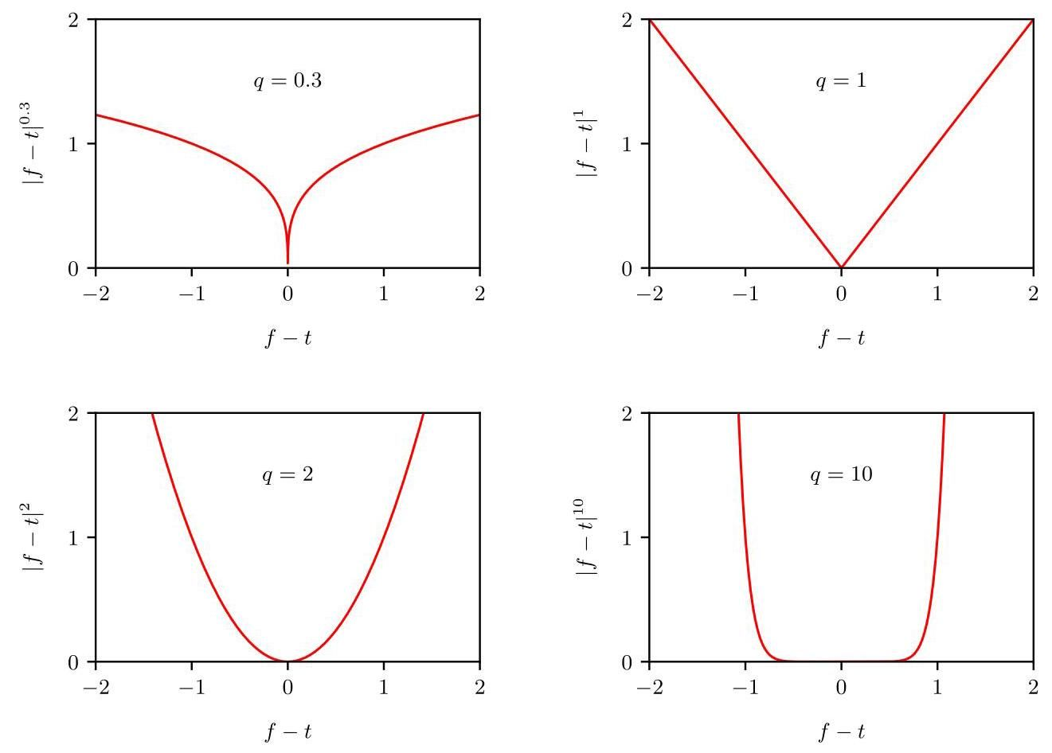

Figure 4.6 Plots of the quantity for various values of .

图 4.6 展示了对于不同的 值，量 的变化情况。

Section 6.5 of Gaussians to give multimodal conditional distributions, which often arise in the solution of inverse problems. Our focus in this section has been on decision theory for regression problems, and in the next chapter we shall develop analogous concepts

高斯分布的第 6.5 节给出了多模态条件分布，这种分布常在逆问题的求解中出现。本节我们关注的是回归问题的决策理论，在下一章我们将发展类似的概念

Section 5.2 for classification tasks.

第 5.2 节用于分类任务。

# 4.3.The Bias-Variance Trade-off

# 4.3. 偏差 - 方差权衡

So far in our discussion of linear models for regression, we have assumed that the

到目前为止，在我们对回归线性模型的讨论中，我们一直假设

Section 1.2 form and number of basis functions are both given. We have also seen that the use of maximum likelihood can lead to severe over-fitting if complex models are trained using data sets of limited size. However, limiting the number of basis functions to avoid over-fitting has the side effect of limiting the flexibility of the model to capture interesting and important trends in the data. Although a regularization term can control over-fitting for models with many parameters, this raises the question of how to determine a suitable value for the regularization coefficient . Seeking the solution that minimizes the regularized error function with respect to both the weight vector and the regularization coefficient is clearly not the right approach, since this leads to the unregularized solution with .

第 1.2 节基函数的形式和数量都是给定的。我们还看到，如果使用有限大小的数据集训练复杂模型，使用最大似然法可能会导致严重的过拟合。然而，限制基函数的数量以避免过拟合会产生限制模型捕捉数据中有趣且重要趋势的灵活性的副作用。虽然正则化项可以控制具有许多参数的模型的过拟合，但这就引出了如何确定正则化系数 的合适值的问题。寻求关于权重向量 和正则化系数 使正则化误差函数最小化的解显然不是正确的方法，因为这会导致 的无正则化解。

It is instructive to consider a frequentist viewpoint of the model complexity issue, known as the bias-variance trade-off. Although we will introduce this concept in the context of linear basis function models, where it is easy to illustrate the ideas using simple examples, the discussion has very general applicability. Note, however, that over-fitting is really an unfortunate property of maximum likelihood and does not arise when we marginalize over parameters in a Bayesian setting (Bishop, 2006).

从频率主义的观点来考虑模型复杂度问题是很有启发性的，这被称为偏差 - 方差权衡。虽然我们将在线性基函数模型的背景下引入这个概念，在这种情况下使用简单的例子很容易说明这些想法，但这个讨论具有非常广泛的适用性。然而，需要注意的是，过拟合实际上是最大似然法的一个不幸特性，在贝叶斯框架下对参数进行边缘化时不会出现这种情况(Bishop，2006)。

Section 4.2

4.2 节

When we discussed decision theory for regression problems, we considered various loss functions, each of which leads to a corresponding optimal prediction once we are given the conditional distribution . A popular choice is the squared-loss function, for which the optimal prediction is given by the conditional expectation, which we denote by and is given by

当我们讨论回归问题的决策理论时，我们考虑了各种损失函数，一旦给定条件分布 ，每一种损失函数都会产生相应的最优预测。一个常用的选择是平方损失函数，其最优预测由条件期望给出，我们用 表示，其表达式为

We have also seen that the expected squared loss can be written in the form

我们还看到，期望平方损失可以写成如下形式

Recall that the second term, which is independent of , arises from the intrinsic noise on the data and represents the minimum achievable value of the expected loss. The first term depends on our choice for the function , and we will seek a solution for that makes this term a minimum. Because it is non-negative, the smallest value that we can hope to achieve for this term is zero. If we had an unlimited supply of data (and unlimited computational resources), we could in principle find the regression function to any desired degree of accuracy, and this would represent the optimal choice for . However, in practice we have a data set containing only a finite number of data points, and consequently, we cannot know the regression function exactly.

回顾一下，第二项与 无关，它源于数据的固有噪声，代表了期望损失的最小可实现值。第一项取决于我们对函数 的选择，我们将寻求 的一个解，使该项最小。由于该项是非负的，我们希望该项达到的最小值是零。如果我们有无限的数据供应(以及无限的计算资源)，原则上我们可以以任意期望的精度找到回归函数 ，这将代表 的最优选择。然而，在实践中，我们有一个数据集 ，它只包含有限数量 的数据点，因此，我们无法精确知道回归函数 。

If we were to model using a function governed by a parameter vector , then from a Bayesian perspective, the uncertainty in our model would be expressed through a posterior distribution over . A frequentist treatment, however, involves making a point estimate of based on the data set and tries instead to interpret the uncertainty of this estimate through the following thought experiment. Suppose we had a large number of data sets each of size and each drawn independently from the distribution . For any given data set , we can run our learning algorithm and obtain a prediction function . Different data sets from the ensemble will give different functions and consequently different values of the squared loss. The performance of a particular learning algorithm is then assessed by taking the average over this ensemble of data sets.

如果我们使用一个由参数向量 控制的函数来对 进行建模，那么从贝叶斯的角度来看，我们模型中的不确定性将通过 上的后验分布来表达。然而，频率主义的处理方法是基于数据集 对 进行点估计，并试图通过以下思想实验来解释这个估计的不确定性。假设我们有大量的数据集，每个数据集的大小为 ，并且每个数据集都是独立地从分布 中抽取的。对于任何给定的数据集 ，我们可以运行我们的学习算法并得到一个预测函数 。集合中的不同数据集将给出不同的函数，从而得到不同的平方损失值。然后通过对这个数据集集合取平均值来评估特定学习算法的性能。

Consider the integrand of the first term in (4.42), which for a particular data set takes the form

考虑 (4.42) 中第一项的被积函数，对于特定的数据集 ，它具有如下形式

Because this quantity will be dependent on the particular data set , we take its average over the ensemble of data sets. If we add and subtract the quantity inside the braces, and then expand, we obtain

由于该量将取决于特定的数据集 ，我们对数据集的总体取其平均值。如果我们在大括号内加上和减去量 ，然后展开，我们得到

We now take the expectation of this expression with respect to and note that the final term will vanish, giving

现在我们对这个表达式关于 取期望，并注意到最后一项将消失，得到

We see that the expected squared difference between and the regression function can be expressed as the sum of two terms. The first term, called the squared bias, represents the extent to which the average prediction over all data sets differs from the desired regression function. The second term, called the variance, measures the extent to which the solutions for individual data sets vary around their average, and hence, this measures the extent to which the function is sensitive to the particular choice of data set. We will provide some intuition to support these definitions shortly when we consider a simple example.

我们看到， 与回归函数 之间的期望平方差可以表示为两项之和。第一项称为偏差平方，它表示所有数据集的平均预测与所需回归函数的差异程度。第二项称为方差，它衡量各个数据集的解围绕其平均值的变化程度，因此，它衡量函数 对特定数据集选择的敏感程度。当我们考虑一个简单的例子时，我们很快会给出一些直观的解释来支持这些定义。

So far, we have considered a single input value . If we substitute this expansion back into (4.42), we obtain the following decomposition of the expected squared loss:

到目前为止，我们考虑了单个输入值 。如果我们将这个展开式代回到 (4.42) 中，我们得到期望平方损失的如下分解:

where

其中

and the bias and variance terms now refer to integrated quantities.

并且偏差和方差项现在指的是积分量。

Our goal is to minimize the expected loss, which we have decomposed into the sum of a (squared) bias, a variance, and a constant noise term. As we will see, there is a trade-off between bias and variance, with very flexible models having low bias and high variance, and relatively rigid models having high bias and low variance. The model with the optimal predictive capability is the one that leads to the best balance between bias and variance. This is illustrated by considering the sinusoidal data set introduced earlier. Here we independently generate 100 data sets, each containing data points, from the sinusoidal curve . The data sets are indexed by , where . For each data set , we fit a model with Gaussian basis functions along with a constant ’bias’ basis function to give a total of 25 parameters. By minimizing the regularized error function (4.26), we obtain a prediction function , as shown in Figure 4.7.

我们的目标是最小化期望损失，我们已将其分解为(平方)偏差、方差和一个常数噪声项之和。正如我们将看到的，偏差和方差之间存在权衡关系，非常灵活的模型具有低偏差和高方差，而相对僵化的模型具有高偏差和低方差。具有最优预测能力的模型是能在偏差和方差之间实现最佳平衡的模型。通过考虑前面介绍的正弦数据集可以说明这一点。在这里，我们从正弦曲线 中独立生成 100 个数据集，每个数据集包含 个数据点。数据集由 索引，其中 。对于每个数据集 ，我们使用 个高斯基函数以及一个常数 “偏差” 基函数来拟合一个模型，总共得到 25 个参数。通过最小化正则化误差函数 (4.26)，我们得到一个预测函数 ，如图 4.7 所示。

Section 1.2

第 1.2 节

The top row corresponds to a large value of the regularization coefficient that gives low variance (because the red curves in the left plot look similar) but high bias (because the two curves in the right plot are very different). Conversely on the bottom row, for which is small, there is large variance (shown by the high variability between the red curves in the left plot) but low bias (shown by the good fit between the average model fit and the original sinusoidal function). Note that the result of averaging many solutions for the complex model with is a very good fit to the regression function, which suggests that averaging may be a beneficial procedure. Indeed, a weighted averaging of multiple solutions lies at the heart of a Bayesian approach, although the averaging is with respect to the posterior distribution of parameters, not with respect to multiple data sets.

顶行对应于正则化系数 的较大值，这会产生低方差(因为左图中的红色曲线看起来相似)但高偏差(因为右图中的两条曲线非常不同)。相反，在底行， 较小，存在大的方差(由左图中红色曲线之间的高变异性显示)但低偏差(由平均模型拟合与原始正弦函数之间的良好拟合显示)。请注意，对具有 的复杂模型的许多解进行平均的结果与回归函数拟合得非常好，这表明平均可能是一个有益的过程。实际上，多个解的加权平均是贝叶斯方法的核心，尽管这里的平均是相对于参数的后验分布，而不是相对于多个数据集。

We can also examine the bias-variance trade-off quantitatively for this example. The average prediction is estimated from

我们还可以针对这个例子定量地研究偏差 - 方差权衡。平均预测通过以下方式估计

and the integrated squared bias and integrated variance are then given by

然后，积分平方偏差和积分方差由下式给出

where the integral over , weighted by the distribution , is approximated by a finite sum over data points drawn from that distribution. These quantities, along with their sum, are plotted as a function of in Figure 4.8. We see that small values of allow the model to become finely tuned to the noise on each individual data set leading to large variance. Conversely, a large value of pulls the weight parameters towards zero leading to large bias.

其中，对 的积分，由分布 加权，通过对从该分布中抽取的数据点进行有限求和来近似。这些量及其总和在图 4.8 中绘制为 的函数。我们看到， 的较小值允许模型对每个单独数据集上的噪声进行精细调整，从而导致大的方差。相反， 的较大值会将权重参数拉向零，从而导致大的偏差。

Note that the bias-variance decomposition is of limited practical value because it is based on averages with respect to ensembles of data sets, whereas in practice we have only the single observed data set. If we had a large number of independent training sets of a given size, we would be better off combining them into a single larger training set, which of course would reduce the level of over-fitting for a given model complexity. Nevertheless, the bias-variance decomposition often provides useful insights into the model complexity issue, and although we have introduced it in this chapter from the perspective of regression problems, the underlying intuition has broad applicability. Exercises

请注意，偏差 - 方差分解的实际价值有限，因为它基于数据集集合的平均值，而在实践中我们只有单个观测数据集。如果我们有大量给定大小的独立训练集，我们最好将它们合并成一个更大的训练集，这当然会降低给定模型复杂度下的过拟合程度。尽管如此，偏差 - 方差分解通常能为模型复杂度问题提供有用的见解，并且虽然我们在本章从回归问题的角度引入了它，但潜在的直觉具有广泛的适用性。练习

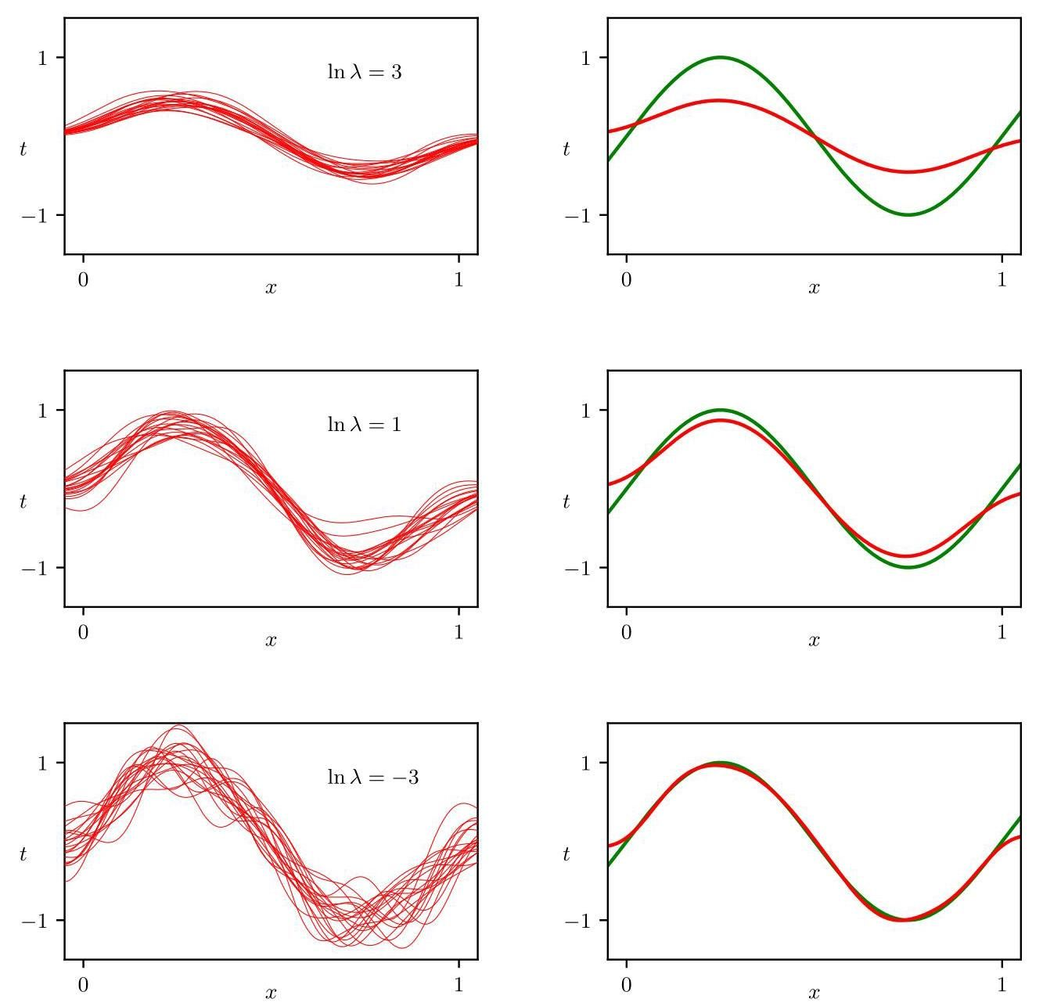

Figure 4.7 Illustration of the dependence of bias and variance on model complexity governed by a regularization parameter , using the sinusoidal data from Chapter 1. There are data sets, each having data points, and there are 24 Gaussian basis functions in the model so that the total number of parameters is including the bias parameter. The left column shows the result of fitting the model to the data sets for various values of (for clarity, only 20 of the 100 fits are shown). The right column shows the corresponding average of the 100 fits (red) along with the sinusoidal function from which the data sets were generated (green).

图 4.7 使用第 1 章中的正弦数据，说明了由正则化参数 控制的偏差和方差对模型复杂度的依赖性。有 个数据集，每个数据集有 个数据点，并且模型中有 24 个高斯基函数，因此包括偏差参数在内的参数总数为 。左列显示了针对不同 值将模型拟合到数据集的结果(为清晰起见，仅显示了 100 次拟合中的 20 次)。右列显示了 100 次拟合的相应平均值(红色)以及生成数据集的正弦函数(绿色)。

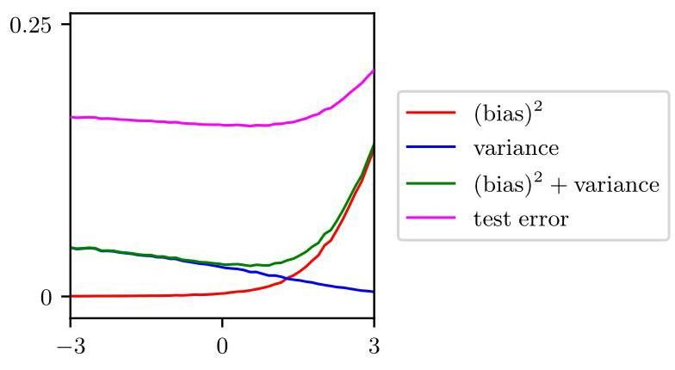

Figure 4.8 Plot of squared bias and variance, together with their sum, corresponding to the results shown in Figure 4.7. Also shown is the average test set error for a test data set size of 1,000 points. The minimum value of variance occurs around , which is close to the value that gives the minimum error on the test data.

图 4.8 绘制了平方偏差和方差及其总和，对应于图 4.7 所示的结果。还显示了测试数据集大小为 1000 个点时的平均测试集误差。 方差的最小值出现在 附近，这接近在测试数据上给出最小误差的值。

4.1 (★) Consider the sum-of-squares error function given by (1.2) in which the function is given by the polynomial (1.1). Show that the coefficients that minimize this error function are given by the solution to the following set of linear equations:

4.1 (★) 考虑由式 (1.2) 给出的平方和误差函数，其中函数 由多项式 (1.1) 给出。证明使该误差函数最小化的系数 由以下一组线性方程的解给出:

where

其中

Here a suffix or denotes the index of a component, whereas denotes raised to the power of .

这里下标 或 表示分量的索引，而 表示 的 次幂。

Write down the set of coupled linear equations, analogous to (4.53), satisfied by the coefficients that minimize the regularized sum-of-squares error function given by (1.4).

写出与 (4.53) 类似的一组耦合线性方程，这些方程由使 (1.4) 给出的正则化平方和误差函数最小化的系数 满足。

4.3 (*) Show that the tanh function defined by

4.3 (*) 证明由下式定义的双曲正切函数

and the logistic sigmoid function defined by (4.6) are related by

与由 (4.6) 定义的逻辑 sigmoid 函数之间存在如下关系

Hence, show that a general linear combination of logistic sigmoid functions of the

因此，证明形如

form

的逻辑 sigmoid 函数的一般线性组合

is equivalent to a linear combination of tanh functions of the form

等价于形如的双曲正切函数的线性组合

and find expressions to relate the new parameters to the original parameters .

并找出将新参数 与原始参数 相关联的表达式。

4.4 Show that the matrix

4.4 证明矩阵

takes any vector and projects it onto the space spanned by the columns of . Use this result to show that the least-squares solution (4.14) corresponds to an orthogonal projection of the vector onto the manifold , as shown in Figure 4.3.

将任意向量 投影到由 的列所张成的空间上。利用这一结果证明最小二乘解(4.14)对应于向量 到流形 上的正交投影，如图 4.3 所示。

4.5 (*) Consider a data set in which each data point is associated with a weighting factor , so that the sum-of-squares error function becomes

4.5 (*) 考虑一个数据集，其中每个数据点 都与一个权重因子 相关联，使得平方和误差函数变为

Find an expression for the solution that minimizes this error function. Give two alternative interpretations of the weighted sum-of-squares error function in terms of (i) data-dependent noise variance and (ii) replicated data points.

找出使该误差函数最小化的解 的表达式。从(i)与数据相关的噪声方差和(ii)重复的数据点这两个方面，对加权平方和误差函数给出两种不同的解释。

4.6 By setting the gradient of (4.26) with respect to to zero, show that the exact minimum of the regularized sum-of-squares error function for linear regression is given by (4.27).

4.6 通过将(4.26)关于 的梯度设为零，证明线性回归的正则化平方和误差函数的精确最小值由(4.27)给出。

4.7 Consider a linear basis function regression model for a multivariate target variable having a Gaussian distribution of the form

4.7 考虑一个针对多元目标变量 的线性基函数回归模型，该目标变量具有如下形式的高斯分布

where

其中

together with a training data set comprising input basis vectors and corresponding target vectors , with . Show that the maximum likelihood solution for the parameter matrix has the property that each column is given by an expression of the form (4.14), which was the solution for an isotropic noise distribution. Note that this is independent of the covariance matrix . Show that the maximum likelihood solution for is given by

同时考虑一个训练数据集，它包含输入基向量 和相应的目标向量 ，且 。证明参数矩阵 的最大似然解 具有这样的性质:每一列都由形如 (4.14) 的表达式给出，而 (4.14) 是各向同性噪声分布的解。注意，这与协方差矩阵 无关。证明 的最大似然解由下式给出

4.8 (★) Consider the generalization of the squared-loss function (4.35) for a single target variable to multiple target variables described by the vector given by

4.8 (★) 考虑将单个目标变量 的平方损失函数 (4.35) 推广到由向量 描述的多个目标变量，其形式如下

Using the calculus of variations, show that the function for which this expected loss is minimized is given by

使用变分法，证明使该期望损失最小化的函数 由下式给出

4.9 (*) By expansion of the square in (4.64), derive a result analogous to (4.39) and, hence, show that the function that minimizes the expected squared loss for a vector of target variables is again given by the conditional expectation of in the form (4.65).

4.9 (*) 通过展开 (4.64) 中的平方项，推导出与 (4.39) 类似的结果，从而证明使目标变量向量 的期望平方损失最小化的函数 再次由 的条件期望以 (4.65) 的形式给出。

4.10 (★★) Rederive the result (4.65) by first expanding (4.64) analogous to (4.39).

4.10 (★★) 首先类似于 (4.39) 式展开 (4.64) 式，重新推导结果 (4.65)。

4.11 The following distribution

4.11 以下分布

is a generalization of the univariate Gaussian distribution. Here is the gamma function defined by

是单变量高斯分布的推广。这里 是由下式定义的伽马函数

Show that this distribution is normalized so that

证明该分布是归一化的，使得

and that it reduces to the Gaussian when . Consider a regression model in which the target variable is given by and is a random noise variable drawn from the distribution (4.66). Show that the log likelihood function over and , for an observed data set of input vectors and corresponding target variables , is given by

并且当 时它简化为高斯分布。考虑一个回归模型，其中目标变量由 给出， 是从分布 (4.66) 中抽取的随机噪声变量。证明对于观测到的输入向量 和相应目标变量 的数据集，关于 和 的对数似然函数由下式给出

where ’const’ denotes terms independent of both and . Note that, as a function of , this is the error function considered in Section 4.2.

其中 ’const’ 表示与 和 都无关的项。注意，作为 的函数，这是第 4.2 节中考虑的 误差函数。

Consider the expected loss for regression problems under the loss function given by (4.40). Write down the condition that must satisfy to minimize . Show that, for , this solution represents the conditional median, i.e., the function such that the probability mass for is the same as for . Also show that the minimum expected loss for is given by the conditional mode, i.e., by the function being equal to the value of that maximizes for each .

考虑在由 (4.40) 给出的 损失函数下回归问题的期望损失。写出 必须满足的条件，以使 最小化。证明，对于 ，此解表示条件中位数，即函数 使得 的概率质量与 的概率质量相同。同时证明， 的最小期望 损失由条件众数给出，即对于每个 ，函数 等于使 最大化的 的值。

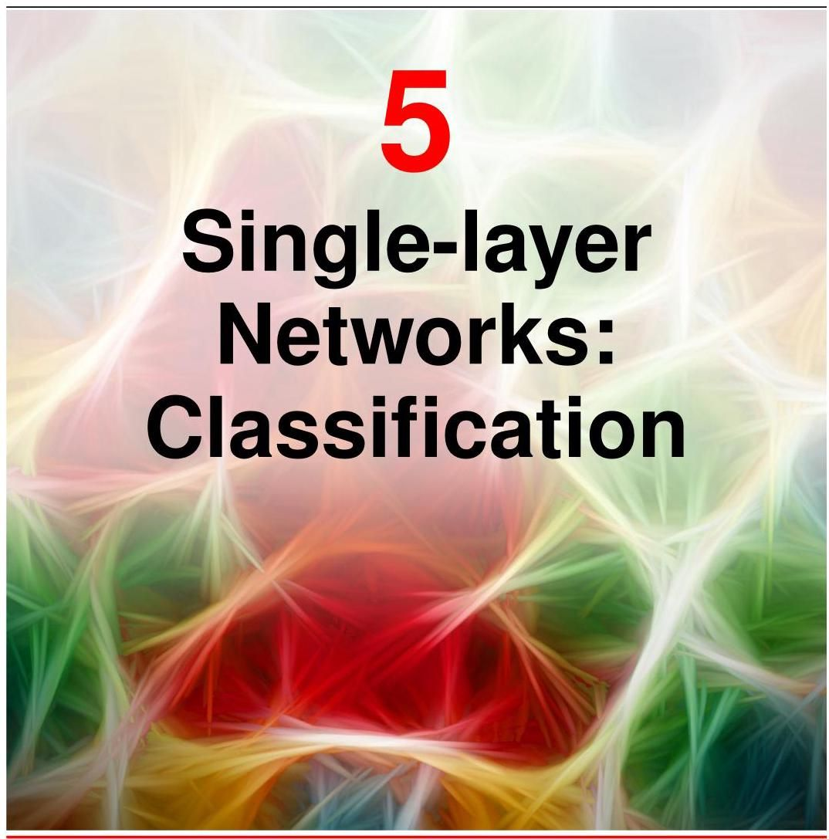

In the previous chapter, we explored a class of regression models in which the output variables were linear functions of the model parameters and which can therefore be expressed as simple neural networks having a single layer of weight and bias parameters. We turn now to a discussion of classification problems, and in this chapter, we will focus on an analogous class of models that again can be expressed as single-layer neural networks. These will allow us to introduce many of the key concepts of classification before dealing with more general deep neural networks in later chapters.

在上一章中，我们探讨了一类回归模型，其中输出变量是模型参数的线性函数，因此可以表示为具有单层权重和偏置参数的简单神经网络。现在我们转向分类问题的讨论，在本章中，我们将重点关注一类类似的模型，它们同样可以表示为单层神经网络。在后续章节处理更一般的深度神经网络之前，这些模型将使我们能够引入许多分类的关键概念。

The goal in classification is to take an input vector and assign it to one of discrete classes where . In the most common scenario, the classes are taken to be disjoint, so that each input is assigned to one and only one class. The input space is thereby divided into decision regions whose boundaries are called decision boundaries or decision surfaces. In this chapter, we consider linear models for classification, by which we mean that the decision surfaces are linear functions of the input vector and, hence, are defined by -dimensional hyperplanes within the -dimensional input space. Data sets whose classes can be separated exactly by linear decision surfaces are said to be linearly separable. Linear classification models can be applied to data sets that are not linearly separable, although not all inputs will be correctly classified.

分类的目标是获取一个输入向量 并将其分配到 个离散类别 中的一个，其中 。在最常见的情况下，这些类别是不相交的，因此每个输入被分配到且仅分配到一个类别。由此，输入空间被划分为决策区域，其边界称为决策边界或决策面。在本章中，我们考虑用于分类的线性模型，这意味着决策面是输入向量 的线性函数，因此在 维输入空间中由 维超平面定义。其类别可以由线性决策面完全分离的数据集被称为线性可分的。线性分类模型可以应用于线性不可分的数据集，尽管并非所有输入都能被正确分类。

We can broadly identify three distinct approaches to solving classification problems. The simplest involves constructing a discriminant function that directly assigns each vector to a specific class. A more powerful approach, however, models the conditional probability distributions in an inference stage and subsequently uses these distributions to make optimal decisions. Separating inference and decision brings numerous benefits. There are two different approaches to determining the conditional probabilities . One technique is to model them directly, for example by representing them as parametric models and then optimizing the parameters using a training set. This will be called a discriminative probabilistic model. Alternatively, we can model the class-conditional densities , together with the prior probabilities for the classes, and then compute the required posterior probabilities using Bayes’ theorem:

我们大致可以确定三种不同的解决分类问题的方法。最简单的方法是构建一个判别函数，直接将每个向量 分配到一个特定的类别。然而，一种更强大的方法是在推理阶段对条件概率分布 进行建模，然后使用这些分布做出最优决策。将推理和决策分开带来了许多好处。有两种不同的方法来确定条件概率 。一种技术是直接对它们进行建模，例如将它们表示为参数模型，然后使用训练集优化参数。这将被称为判别式概率模型。或者，我们可以对类条件密度 以及类的先验概率 进行建模，然后使用贝叶斯定理计算所需的后验概率:

Section 5.2.4

第 5.2.4 节

This will be called a generative probabilistic model because it offers the opportunity to generate samples from each of the class-conditional densities . In this chapter, we will discuss examples of all three approaches: discriminant functions, generative probabilistic models, and discriminative probabilistic models.

这将被称为生成式概率模型，因为它提供了从每个类条件密度 生成样本的机会。在本章中，我们将讨论所有三种方法的示例:判别函数、生成式概率模型和判别式概率模型。

# 5.1. Discriminant Functions

# 5.1. 判别函数

A discriminant is a function that takes an input vector and assigns it to one of classes, denoted . In this chapter, we will restrict attention to linear discriminants, namely those for which the decision surfaces are hyperplanes. To simplify the discussion, we consider first two classes and then investigate the extension to classes.

判别函数是一种将输入向量 分配到 个类别之一的函数，用 表示。在本章中，我们将重点关注线性判别函数，即决策面为超平面的那些函数。为了简化讨论，我们首先考虑两类问题，然后研究扩展到 类的情况。

# 5.1.1 Two classes

# 5.1.1 两类问题

The simplest representation of a linear discriminant function is obtained by taking a linear function of the input vector so that

线性判别函数的最简单表示是通过对输入向量取线性函数得到的，即

where is called a weight vector, and is a bias (not to be confused with bias in the statistical sense). An input vector is assigned to class if and to class otherwise. The corresponding decision boundary is therefore defined by the relation , which corresponds to a -dimensional hyperplane within

其中 称为权重向量， 是偏置(不要与统计意义上的偏差混淆)。如果 ，则输入向量 被分配到类别 ；否则，被分配到类别 。因此，相应的决策边界由关系 定义，它对应于一个 维超平面

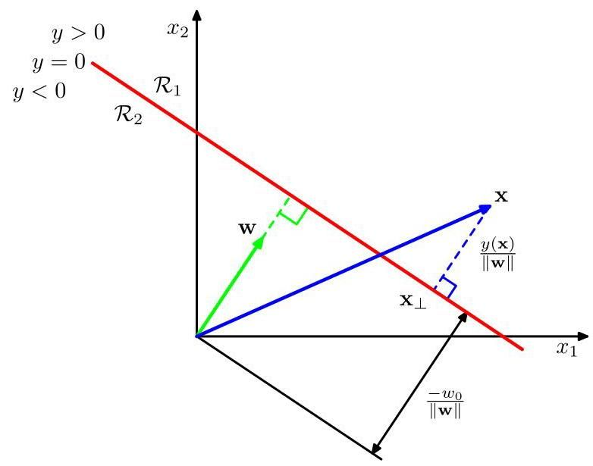

Figure 5.1 Illustration of the geometry of a linear discriminant function in two dimensions. The decision surface, shown in red, is perpendicular to , and its displacement from the origin is controlled by the bias parameter . Also, the signed orthogonal distance of a general point from the decision surface is given by .

图 5.1 二维线性判别函数的几何图示。红色显示的决策面与 垂直，其与原点的位移由偏置参数 控制。此外，一般点 到决策面的带符号正交距离由 给出。

the -dimensional input space. Consider two points and both of which lie on the decision surface. Because , we have and hence the vector is orthogonal to every vector lying within the decision surface, and so determines the orientation of the decision surface. Similarly, if is a point on the decision surface, then , and so the normal distance from the origin to the decision surface is given by

维输入空间。考虑两个点 和 ，它们都位于决策面上。因为 ，我们有 ，因此向量 与位于决策面内的每个向量都正交，所以 决定了决策面的方向。类似地，如果 是决策面上的一个点，那么 ，因此从原点到决策面的法向距离由下式给出

We therefore see that the bias parameter determines the location of the decision surface. These properties are illustrated for the case of in Figure 5.1.

因此，我们看到偏置参数 决定了决策面的位置。图 5.1 展示了 情况下的这些性质。

Furthermore, note that the value of gives a signed measure of the perpendicular distance of the point from the decision surface. To see this, consider an arbitrary point and let be its orthogonal projection onto the decision surface,

此外，请注意， 的值给出了点 到决策面的垂直距离 的带符号度量。为了说明这一点，考虑任意一点 ，并设 是它在决策面上的正交投影

so that

因此

Multiplying both sides of this result by and adding , and making use of and , we have

将这个结果的两边都乘以 并加上 ，并利用 和 ，我们得到

This result is illustrated in Figure 5.1.

图 5.1 展示了这个结果。

Section 4.1.1

第4.1.1节

As with linear regression models, it is sometimes convenient to use a more compact notation in which we introduce an additional dummy ’input’ value and then define and so that

与线性回归模型一样，有时使用更紧凑的符号表示会更方便，在这种表示中，我们引入一个额外的虚拟 “输入” 值 ，然后定义 和 ，使得

In this case, the decision surfaces are -dimensional hyperplanes passing through the origin of the -dimensional expanded input space.

在这种情况下，决策面是 维超平面，它们穿过 维扩展输入空间的原点。

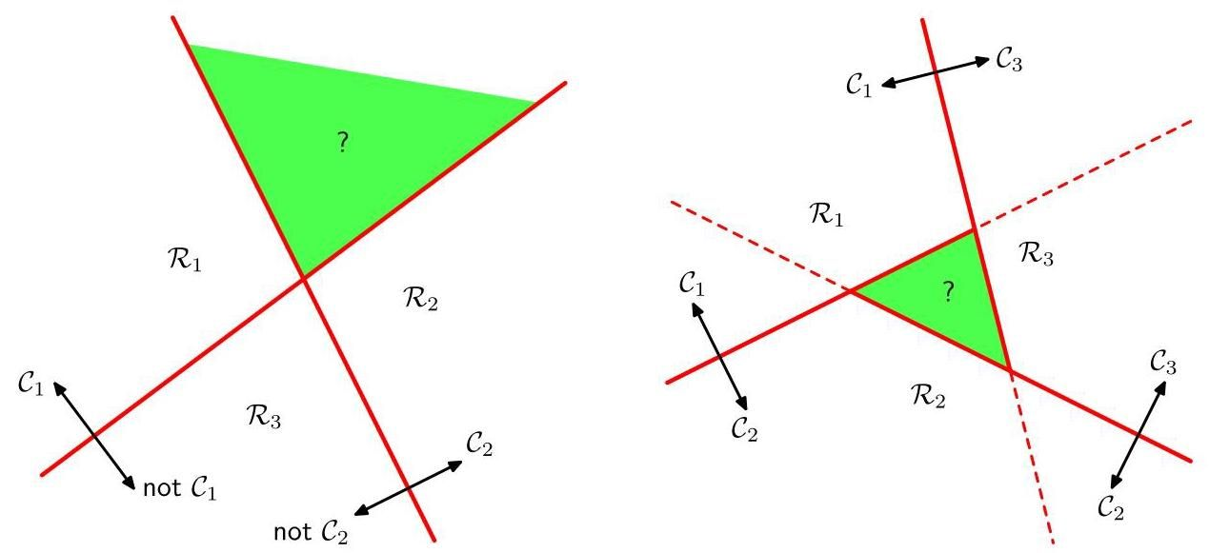

Figure 5.2 Attempting to construct a -class discriminant from a set of two-class discriminant functions leads to ambiguous regions, as shown in green. On the left is an example with two discriminant functions designed to distinguish points in class from points not in class . On the right is an example involving three discriminant functions each of which is used to separate a pair of classes and .

图5.2 尝试从一组二分类判别函数构建一个 分类判别器会导致模糊区域，如图中绿色部分所示。左侧是一个使用两个判别函数的示例，这些函数用于区分属于类别 的点和不属于类别 的点。右侧是一个涉及三个判别函数的示例，每个判别函数用于分离一对类别 和 。

# 5.1.2 Multiple classes

# 5.1.2 多类别

Now consider the extension of linear discriminant functions to classes. We might be tempted to build a -class discriminant by combining a number of two-class discriminant functions. However, this leads to some serious difficulties (Duda and Hart, 1973), as we now show.

现在考虑将线性判别函数扩展到 个类别。我们可能会尝试通过组合多个二分类判别函数来构建一个 分类判别器。然而，正如我们现在要展示的，这会导致一些严重的问题(Duda 和 Hart，1973)。

Consider a model with classifiers, each of which solves a two-class problem of separating points in a particular class from points not in that class. This is known as a one-versus-the-rest classifier. The left-hand example in Figure 5.2 shows an example involving three classes where this approach leads to regions of input space that are ambiguously classified.

考虑一个包含 个分类器的模型，每个分类器都用于解决一个二分类问题，即把属于特定类别 的点与不属于该类别的点区分开来。这被称为一对其余分类器。图 5.2 左侧的示例展示了一个涉及三个类别的例子，在这个例子中，这种方法会导致输入空间中出现分类模糊的区域。

An alternative is to introduce binary discriminant functions, one for every possible pair of classes. This is known as a one-versus-one classifier. Each point is then classified according to a majority vote amongst the discriminant functions. However, this too runs into the problem of ambiguous regions, as illustrated in the right-hand diagram of Figure 5.2.

另一种方法是引入 个二元判别函数，每个可能的类别对对应一个。这被称为一对一分类器。然后根据判别函数的多数投票结果对每个点进行分类。然而，如图 5.2 右侧的图所示，这种方法也会遇到分类模糊区域的问题。

We can avoid these difficulties by considering a single -class discriminant comprising linear functions of the form

我们可以通过考虑一个单一的 类判别器来避免这些困难，该判别器由形式如下的 个线性函数组成

and then assigning a point to class if for all . The decision boundary between class and class is therefore given by and

然后，如果对于所有的 都有 ，则将点 分配到类别 。因此，类别 和类别 之间的决策边界由 和给出

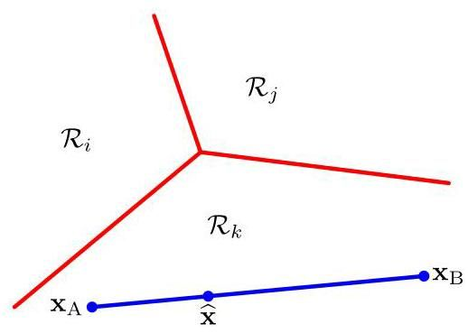

Figure 5.3 Illustration of the decision regions for a multi-class linear discriminant, with the decision boundaries shown in red. If two points and both lie inside the same decision region , then any point that lies on the line connecting these two points must also lie in , and hence, the decision region must be singly connected and convex.

图 5.3 展示了多类线性判别器的决策区域，决策边界用红色表示。如果两个点 和 都位于同一个决策区域 内，那么连接这两个点的直线上的任何点 也必定位于 内，因此，决策区域必须是单连通且凸的。

hence corresponds to a -dimensional hyperplane defined by

因此对应于一个由定义的 维超平面

This has the same form as the decision boundary for the two-class case discussed in Section 5.1.1, and so analogous geometrical properties apply.

这与 5.1.1 节中讨论的两类情况的决策边界具有相同的形式，因此类似的几何性质也适用。

The decision regions of such a discriminant are always singly connected and convex. To see this, consider two points and both of which lie inside decision region , as illustrated in Figure 5.3. Any point that lies on the line connecting and can be expressed in the form

这种判别式的决策区域总是单连通且凸的。为了说明这一点，考虑两个点 和 ，它们都位于决策区域 内，如图 5.3 所示。连接 和 的直线上的任何点 都可以表示为以下形式

where . From the linearity of the discriminant functions, it follows that

其中 。根据判别函数的线性性质，可以得出

Because both and lie inside , it follows that and that , for all , and hence , and so also lies inside . Thus, is singly connected and convex.

因为 和 都位于 内，所以对于所有的 ，有 且 ，因此 ，所以 也位于 内。因此， 是单连通且凸的。

Note that for two classes, we can either employ the formalism discussed here, based on two discriminant functions and , or else use the simpler but essentially equivalent formulation based on a single discriminant function .

请注意，对于两类问题，我们既可以采用这里讨论的基于两个判别函数 和 的形式，也可以使用基于单个判别函数 的更简单但本质上等价的公式。

Section 5.1.1

5.1.1 节

# 5.1.3 1-of- coding

# 5.1.3 1-of- 编码

For regression problems, the target variable was simply the vector of real numbers whose values we wish to predict. In classification, there are various ways of using target values to represent class labels. For two-class problems, the most convenient is the binary representation in which there is a single target variable such that represents class and represents class . We can interpret the value of as the probability that the class is , with the probability values taking only the extreme values of 0 and 1 . For classes, it is convenient to use a of coding scheme, also known as the one-hot encoding scheme, in which is a vector of length such that if the class is , then all elements of are zero except element , which takes the value 1 . For instance, if we have classes, then a data point from class 2 would be given the target vector

对于回归问题，目标变量 只是一个实数向量，其值是我们希望预测的。在分类问题中，有多种使用目标值来表示类别标签的方法。对于两类问题，最方便的是二进制表示法，其中有一个单一的目标变量 ，使得 表示类别 ， 表示类别 。我们可以将 的值解释为类别为 的概率，概率值仅取 0 和 1 这两个极值。对于 个类别，使用 of 编码方案(也称为独热编码方案)很方便，其中 是一个长度为 的向量，使得如果类别是 ，那么 的所有元素 都为零，除了元素 ，其值为 1。例如，如果我们有 个类别，那么来自类别 2 的一个数据点将被赋予目标向量

Again, we can interpret the value of as the probability that the class is in which the probabilities take only the values 0 and 1 .

同样，我们可以将 的值解释为类别为 的概率，其中概率仅取 0 和 1 这两个值。

# 5.1.4 Least squares for classification

# 5.1.4 分类的最小二乘法

With linear regression models, the minimization of a sum-of-squares error function leads to a simple closed-form solution for the parameter values. It is therefore tempting to see if we can apply the same least-squares formalism to classification problems. Consider a general classification problem with classes and a 1-of- binary coding scheme for the target vector . One justification for using least squares in such a context is that it approximates the conditional expectation of the target values given the input vector. For a binary coding scheme, this conditional expectation is given by the vector of posterior class probabilities. Unfortunately, these probabilities are typically approximated rather poorly, and indeed the approximations can have values outside the range . However, it is instructional to explore these simple models and to understand how these limitations arise.

对于线性回归模型，最小化平方和误差函数会得到参数值的简单闭式解。因此，我们很想看看是否可以将同样的最小二乘法形式应用于分类问题。考虑一个具有 个类别的一般分类问题，以及目标向量 的 1-of- 二进制编码方案。在这种情况下使用最小二乘法的一个理由是，它近似于给定输入向量时目标值的条件期望 。对于二进制编码方案，这个条件期望由后验类别概率向量给出。不幸的是，这些概率通常近似得很差，实际上，这些近似值可能会超出范围 。然而，探索这些简单模型并理解这些局限性是如何产生的是有指导意义的。

Section 4.1.3

第 4.1.3 节

Exercise 5.1

练习 5.1

Each class is described by its own linear model so that

每个类别 都由其自身的线性模型描述，使得

where . We can conveniently group these together using vector nota-

其中 。我们可以方便地使用向量表示法将这些组合在一起，使得

tion so that

其中

where is a matrix whose th column comprises the -dimensional vector and is the corresponding augmented input vector with a dummy input . A new input is then assigned to the class for which the output is largest.

其中 是一个矩阵，其第 列由 维向量 组成， 是对应的增广输入向量 ，带有一个虚拟输入 。然后，将新输入 分配给输出 最大的类别。

We now determine the parameter matrix by minimizing a sum-of-squares error function. Consider a training data set where , and define a matrix whose th row is the vector , together with a matrix whose th row is . The sum-of-squares error function can then be written as

现在，我们通过最小化平方和误差函数来确定参数矩阵 。考虑一个训练数据集 ，其中 ，并定义一个矩阵 ，其第 行是向量 ，以及一个矩阵 ，其第 行是 。然后，平方和误差函数可以写成

Setting the derivative with respect to to zero and rearranging, we obtain the solution for in the form

将关于 的导数设为零并重新整理，我们得到 的解的形式为

Section 4.1.3

第 4.1.3 节

where is the pseudo-inverse of the matrix . We then obtain the discriminant

其中 是矩阵 的伪逆。然后我们得到判别式

function in the form

函数的形式为

An interesting property of least-squares solutions with multiple target variables is that if every target vector in the training set satisfies some linear constraint

具有多个目标变量的最小二乘解的一个有趣性质是，如果训练集中的每个目标向量都满足某个线性约束

for some constants and , then the model prediction for any value of will satisfy the same constraint so that

对于某些常数 和 ，那么对于 的任何值，模型预测都将满足相同的约束，使得

Exercise 5.3

练习 5.3

Thus, if we use a 1-of- coding scheme for classes, then the predictions made by the model will have the property that the elements of will sum to 1 for any value of . However, this summation constraint alone is not sufficient to allow the model outputs to be interpreted as probabilities because they are not constrained to lie within the interval .

因此，如果我们对 个类别使用 1-of- 编码方案，那么模型做出的预测将具有这样的性质:对于 的任何值， 的元素之和都为 1。然而，仅这个求和约束不足以使模型输出被解释为概率，因为它们不受限于区间 内。

The least-squares approach gives an exact closed-form solution for the discriminant function parameters. However, even as a discriminant function (where we use it to make decisions directly and dispense with any probabilistic interpretation), it suffers from some severe problems. We have seen that the sum-of-squares error function can be viewed as the negative log likelihood under the assumption of a Gaussian noise distribution. If the true distribution of the data is markedly different from being Gaussian, then least squares can give poor results. In particular, least squares is very sensitive to the presence of outliers, which are data points located a long way from the bulk of the data. This is illustrated in Figure 5.4. Here we see that the additional data points in the right-hand figure produce a significant change in the location of the decision boundary, even though these points would be correctly classified by the original decision boundary in the left-hand figure. The sum-of-squares error function gives too much weight to data points that are a long way from the decision boundary, even though they are correctly classified. Outliers can arise due to rare events or may simply be due to mistakes in the data set. Techniques that are sensitive to a very few data points are said to lack robustness. For comparison, Figure 5.4 also shows results from a technique called logistic regression, which is more robust to outliers.

最小二乘法为判别函数参数提供了精确的闭式解。然而，即使作为判别函数(我们直接用它来做决策，而不进行任何概率解释)，它也存在一些严重的问题。我们已经看到，在高斯噪声分布的假设下，平方和误差函数可以看作是负对数似然。如果数据的真实分布与高斯分布显著不同，那么最小二乘法可能会得到较差的结果。特别是，最小二乘法对离群值的存在非常敏感，离群值是指那些远离大部分数据的数据点。图 5.4 说明了这一点。在这里我们看到，右图中额外的数据点导致决策边界的位置发生了显著变化，尽管这些点在左图的原始决策边界下会被正确分类。平方和误差函数对远离决策边界的数据点赋予了过大的权重，即使它们被正确分类。离群值可能是由于罕见事件引起的，也可能仅仅是由于数据集中的错误造成的。对极少数数据点敏感的技术被认为缺乏鲁棒性。作为对比，图 5.4 还展示了一种称为逻辑回归的技术的结果，该技术对离群值更具鲁棒性。

Section 2.3.4

第 2.3.4 节

Section 5.4.3

第 5.4.3 节

The failure of least squares should not surprise us when we recall that it corresponds to maximum likelihood under the assumption of a Gaussian conditional distribution, whereas binary target vectors clearly have a distribution that is far from Gaussian. By adopting more appropriate probabilistic models, we can obtain classification techniques with much better properties than least squares, and which can also be generalized to give flexible nonlinear neural network models, as we will see in later chapters.

当我们回忆起最小二乘法对应于在高斯条件分布假设下的最大似然而二元目标向量显然具有远非高斯的分布时，最小二乘法的失败就不足为奇了。通过采用更合适的概率模型，我们可以获得比最小二乘法具有更好性质的分类技术，并且正如我们将在后面的章节中看到的，这些技术还可以推广到灵活的非线性神经网络模型。

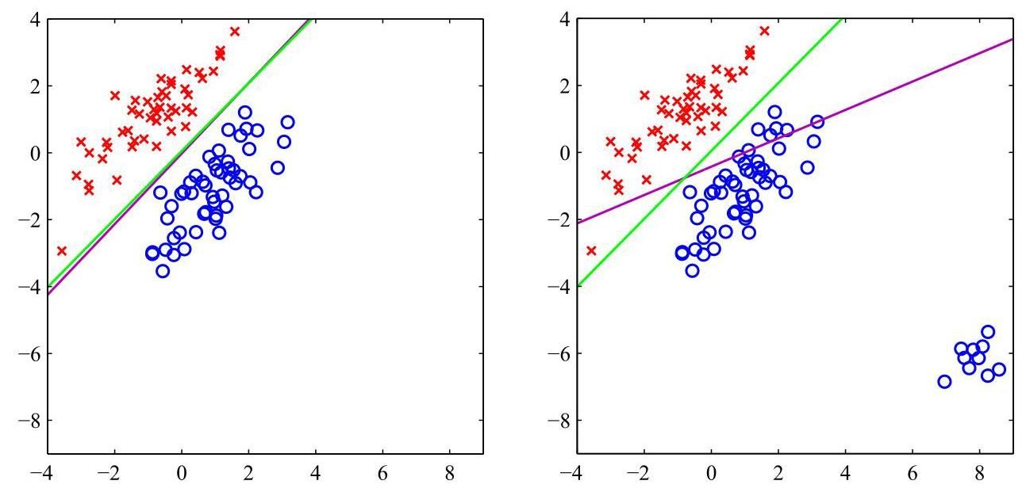

Figure 5.4 The left-hand plot shows data from two classes, denoted by red crosses and blue circles, together with the decision boundaries found by least squares (magenta curve) and by a logistic regression model (green curve). The right-hand plot shows the corresponding results obtained when extra data points are added at the bottom right of the diagram, showing that least squares is highly sensitive to outliers, unlike logistic regression.

图 5.4 左图展示了来自两类数据，分别用红色十字和蓝色圆圈表示，以及通过最小二乘法(品红色曲线)和逻辑回归模型(绿色曲线)找到的决策边界。右图展示了在图的右下角添加额外数据点后得到的相应结果，表明最小二乘法对离群值非常敏感，而逻辑回归则不然。

# 5.2. Decision Theory

# 5.2. 决策理论

When we discussed linear regression we saw how the process of making predictions in machine learning can be broken down into the two stages of inference and de-

在讨论线性回归时，我们了解到机器学习中的预测过程可以分解为推断和决策两个阶段。

Section 4.2 cision. We now explore this perspective in much greater depth specifically in the context of classifiers.

第 4.2 节 现在，我们将在分类器的背景下更深入地探讨这一观点。

Suppose we have an input vector together with a corresponding vector of target variables, and our goal is to predict given a new value for . For regression problems, will comprise continuous variables and in general will be a vector as we may wish to predict several related quantities. For classification problems, will represent class labels. Again, will in general be a vector if we have more than two classes. The joint probability distribution provides a complete summary of the uncertainty associated with these variables. Determining from a set of training data is an example of inference and is typically a very difficult problem whose solution forms the subject of much of this book. In a practical application, however, we must often make a specific prediction for the value of or more generally take a specific action based on our understanding of the values is likely to take, and this aspect is the subject of decision theory.

假设我们有一个输入向量 以及对应的目标变量向量 ，我们的目标是在给定 的新值时预测 。对于回归问题， 包含连续变量，并且通常是一个向量，因为我们可能希望预测多个相关的量。对于分类问题， 表示类别标签。同样，如果我们有两个以上的类别， 通常也会是一个向量。联合概率分布 完整概括了与这些变量相关的不确定性。从一组训练数据中确定 是推断的一个例子，通常是一个非常困难的问题，本书的大部分内容都围绕其解决方案展开。然而，在实际应用中，我们通常必须对 的值做出具体预测，或者更一般地，根据我们对 可能取值的理解采取具体行动，这方面就是决策理论的主题。

Consider, for example, our earlier medical diagnosis problem in which we have taken an image of a skin lesion on a patient, and we wish to determine whether the patient has cancer. In this case, the input vector is the set of pixel intensities in the image, and the output variable will represent the absence of cancer, which we denote by the class , or the presence of cancer, which we denote by the class . We might, for instance, choose to be a binary variable such that corresponds to class and corresponds to class . We will see later that this choice of label values is particularly convenient when working with probabilities. The general inference problem then involves determining the joint distribution , or equivalently , which gives us the most complete probabilistic description of the variables. Although this can be a very useful and informative quantity, ultimately, we must decide either to give treatment to the patient or not, and we would like this choice to be optimal according to some appropriate criterion (Duda and Hart, 1973). This is the decision step, and the aim of decision theory is that it should tell us how to make optimal decisions given the appropriate probabilities. We will see that the decision stage is generally very simple, even trivial, once we have solved the inference problem. Here we give an introduction to the key ideas of decision theory as required for the rest of the book. Further background, as well as more detailed accounts, can be found in Berger (1985) and Bather (2000).

例如，考虑我们之前的医学诊断问题，在这个问题中，我们对患者的皮肤病变进行了成像，并且希望确定患者是否患有癌症。在这种情况下，输入向量 是图像中的像素强度集合，输出变量 表示是否患有癌症，我们用类别 表示无癌症，用类别 表示有癌症。例如，我们可以选择 为一个二进制变量，使得 对应类别 ， 对应类别 。我们稍后会看到，在处理概率时，这种标签值的选择特别方便。那么，一般的推断问题就涉及确定联合分布 ，或者等价地确定 ，这为我们提供了变量的最完整概率描述。尽管这可能是一个非常有用且信息丰富的量，但最终，我们必须决定是否对患者进行治疗，并且我们希望这个选择根据某个合适的标准是最优的(Duda 和 Hart，1973)。这就是决策步骤，决策理论的目的是告诉我们在给定适当概率的情况下如何做出最优决策。我们将看到，一旦解决了推断问题，决策阶段通常非常简单，甚至微不足道。在这里，我们介绍决策理论的关键思想，这是本书其余部分所必需的。更多背景信息以及更详细的内容可以在 Berger(1985)和 Bather(2000)中找到。

Before giving a more detailed analysis, let us first consider informally how we might expect probabilities to play a role in making decisions. When we obtain the skin image for a new patient, our goal is to decide which of the two classes to assign the image to. We are therefore interested in the probabilities of the two classes, given the image, which are given by . Using Bayes’ theorem, these probabilities can be expressed in the form

在进行更详细的分析之前，让我们先非正式地考虑一下，我们期望概率在决策过程中如何发挥作用。当我们获取了一位新患者的皮肤图像 时，我们的目标是决定将该图像归入两个类别中的哪一类。因此，我们关注的是在给定图像的情况下，这两个类别的概率，这些概率由 给出。利用贝叶斯定理，这些概率可以表示为如下形式

Note that any of the quantities appearing in Bayes’ theorem can be obtained from the joint distribution by either marginalizing or conditioning with respect to the appropriate variables. We can now interpret as the prior probability for the class and as the corresponding posterior probability. Thus, represents the probability that a person has cancer, before the image is taken. Similarly, is the posterior probability, revised using Bayes’ theorem in light of the information contained in the image. If our aim is to minimize the chance of assigning to the wrong class, then intuitively we would choose the class having the higher posterior probability. We now show that this intuition is correct, and we also discuss more general criteria for making decisions.

请注意，贝叶斯定理中出现的任何量都可以通过对联合分布 关于适当的变量进行边缘化或条件化来得到。现在，我们可以将 解释为类别 的先验概率，将 解释为相应的后验概率。因此， 表示在拍摄图像之前一个人患癌症的概率。类似地， 是后验概率，它是根据图像中包含的信息，利用贝叶斯定理修正得到的。如果我们的目标是最小化将 归入错误类别的可能性，那么直观上我们会选择后验概率较高的类别。现在我们证明这种直觉是正确的，并且我们还将讨论更一般的决策准则。

# 5.2.1 Misclassification rate

# 5.2.1 误分类率

Suppose that our goal is simply to make as few misclassifications as possible. We need a rule that assigns each value of to one of the available classes. Such a rule will divide the input space into regions called decision regions, one for each class, such that all points in are assigned to class . The boundaries between decision regions are called decision boundaries or decision surfaces. Note that each decision region need not be contiguous but could comprise some number of disjoint regions. To find the optimal decision rule, consider first the case of two classes, as in the cancer problem, for instance. A mistake occurs when an input vector belonging to class is assigned to class or vice versa. The probability of this occurring is given by

假设我们的目标仅仅是尽可能减少误分类的情况。我们需要一个规则，将 的每个值分配到可用的类别之一。这样的规则会将输入空间划分为区域 ，称为决策区域，每个类别对应一个决策区域，使得 中的所有点都被分配到类别 。决策区域之间的边界称为决策边界或决策面。请注意，每个决策区域不一定是连续的，它可能由若干个不相交的区域组成。为了找到最优的决策规则，首先考虑两类的情况，例如癌症问题。当属于类别 的输入向量被分配到类别 或者反之，就会发生错误。这种情况发生的概率由下式给出

We are free to choose the decision rule that assigns each point to one of the two classes. Clearly, to minimize (mistake) we should arrange that each is assigned to whichever class has the smaller value of the integrand in (5.20). Thus, if for a given value of , then we should assign that to class . From the product rule of probability, we have . Because the factor is common to both terms, we can restate this result as saying that the minimum probability of making a mistake is obtained if each value of is assigned to the class for which the posterior probability is largest. This result is illustrated for two classes and a single input variable in Figure 5.5.

我们可以自由选择将每个点 分配到两个类别之一的决策规则。显然，为了最小化 (错误)，我们应该将每个 分配到使式 (5.20) 中被积函数值较小的类别。因此，如果对于给定的 值有 ，那么我们应该将该 分配到类别 。根据概率的乘积规则，我们有 。由于因子 是两项共有的，我们可以将这个结果重新表述为:如果将每个 值分配到后验概率 最大的类别，那么犯错误的概率最小。对于两个类别和单个输入变量 的情况，这个结果如图 5.5 所示。

For the more general case of classes, it is slightly easier to maximize the probability of being correct, which is given by

对于更一般的 类情况，最大化正确分类的概率会稍微容易一些，正确分类的概率由下式给出

which is maximized when the regions are chosen such that each is assigned to the class for which is largest. Again, using the product rule , and noting that the factor of is common to all terms, we see that each should be assigned to the class having the largest posterior probability .

当选择区域 使得每个 都被分配给 最大的类别时，该式达到最大值。再次使用乘积法则 ，并注意到 这一因子对所有项都是相同的，我们可以看到，每个 都应该被分配给后验概率 最大的类别。

# 5.2.2 Expected loss

# 5.2.2 期望损失

For many applications, our objective will be more complex than simply minimizing the number of misclassifications. Let us consider again the medical diagnosis problem. We note that, if a patient who does not have cancer is incorrectly diagnosed as having cancer, the consequences may be that they experience some distress plus there is the need for further investigations. Conversely, if a patient with cancer is diagnosed as healthy, the result may be premature death due to lack of treatment. Thus, the consequences of these two types of mistake can be dramatically different. It would clearly be better to make fewer mistakes of the second kind, even if this was at the expense of making more mistakes of the first kind.

在许多应用中，我们的目标比单纯最小化错误分类的数量要复杂得多。让我们再次考虑医学诊断问题。我们注意到，如果一个没有患癌症的患者被错误地诊断为患有癌症，其后果可能是他们会经历一些痛苦，并且需要进行进一步的检查。相反，如果一个患有癌症的患者被诊断为健康，结果可能是由于缺乏治疗而过早死亡。因此，这两种类型错误的后果可能会有很大的不同。显然，减少第二种类型的错误会更好，即使这意味着要增加第一种类型的错误。

We can formalize such issues through the introduction of a loss function, also called a cost function, which is a single, overall measure of loss incurred in taking any of the available decisions or actions. Our goal is then to minimize the total loss incurred. Note that some authors consider instead a utility function, whose value

我们可以通过引入损失函数(也称为成本函数)来将这些问题形式化，损失函数是对采取任何可用决策或行动所产生损失的单一总体度量。我们的目标是最小化所产生的总损失。请注意，一些作者考虑的是效用函数，其值

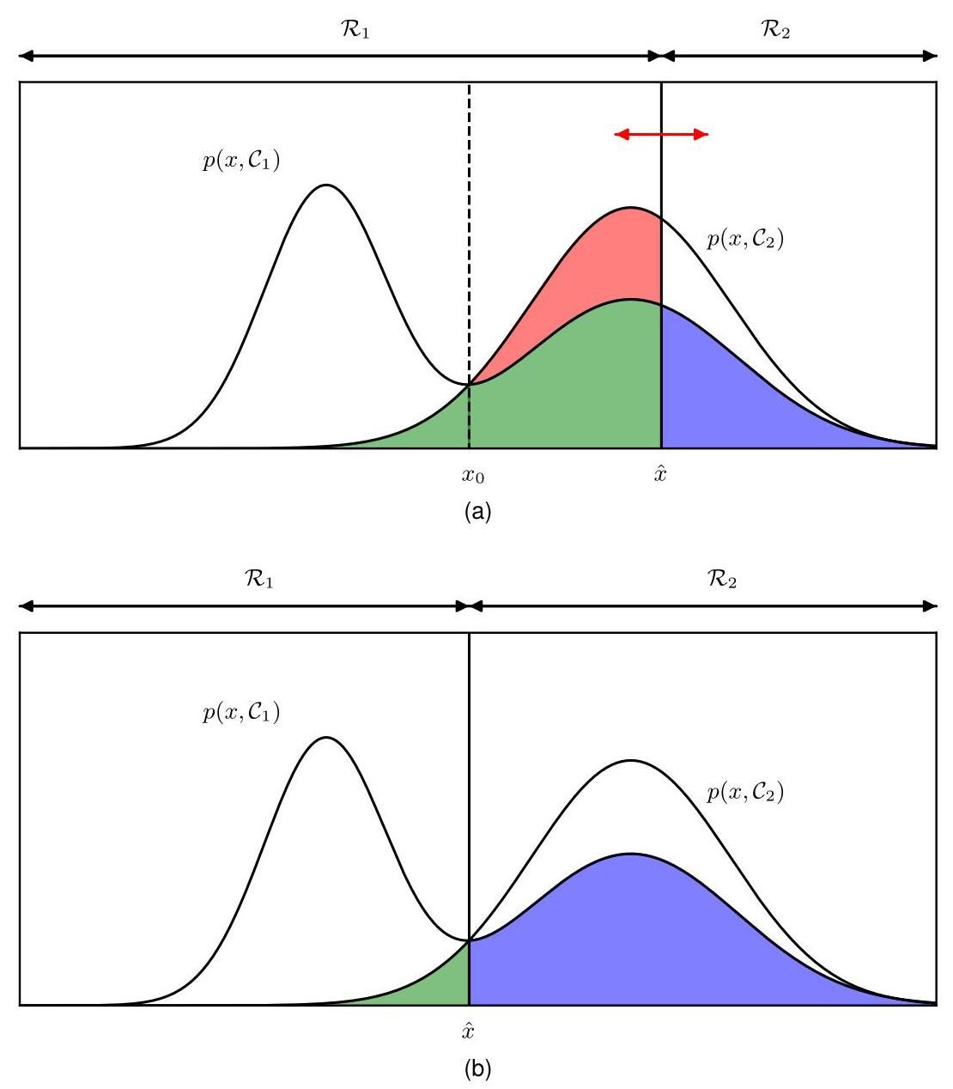

Figure 5.5 Schematic illustration of the joint probabilities for each of two classes plotted against , together with the decision boundary . Values of are classified as class and hence belong to decision region , whereas points are classified as and belong to . Errors arise from the blue, green, and red regions, so that for , the errors are due to points from class being misclassified as (represented by the sum of the red and green regions). Conversely for points in the region , the errors are due to points from class being misclassified as (represented by the blue region). By varying the location of the decision boundary, as indicated by the red double-headed arrow in (a), the combined areas of the blue and green regions remains constant, whereas the size of the red region varies. The optimal choice for is where the curves for and cross, as shown in (b) and corresponding to , because in this case the red region disappears. This is equivalent to the minimum misclassification rate decision rule, which assigns each value of to the class having the higher posterior probability .

图 5.5 两个类别各自的联合概率 相对于 的示意图，以及决策边界 。 的值被分类为类别 ，因此属于决策区域 ，而点 被分类为 ，属于 。误差来自蓝色、绿色和红色区域，因此对于 ，误差是由于类别 的点被错误分类为 (由红色和绿色区域的总和表示)。相反，对于区域 中的点，误差是由于类别 的点被错误分类为 (由蓝色区域表示)。通过改变决策边界的位置 ，如 (a) 中的红色双头箭头所示，蓝色和绿色区域的组合面积保持不变，而红色区域的大小会发生变化。 的最优选择是 和 的曲线相交的位置，如 (b) 所示，对应于 ，因为在这种情况下红色区域消失了。这等价于最小错误分类率决策规则，该规则将 的每个值分配给后验概率 更高的类别。

Figure 5.6 An example of a loss matrix with elements for the cancer treatment problem. The rows correspond to the true class, whereas the columns correspond to the assignment of class made by our decision criterion. they aim to maximize. These are equivalent concepts if we take the utility to be simply the negative of the loss. Throughout this text we will use the loss function convention. Suppose that, for a new value of , the true class is and that we assign to class (where may or may not be equal to ). In so doing, we incur some level of loss that we denote by , which we can view as the element of a loss matrix. For instance, in our cancer example, we might have a loss matrix of the form shown in Figure 5.6. This particular loss matrix says that there is no loss incurred if the correct decision is made, there is a loss of 1 if a healthy patient is diagnosed as having cancer, whereas there is a loss of 100 if a patient having cancer is diagnosed as healthy.

图 5.6 癌症治疗问题的损失矩阵示例，其元素为 。行对应真实类别，而列对应我们的决策准则所做出的类别分配。它们旨在最大化。如果我们简单地将效用视为损失的负值，那么这些概念是等价的。在本文中，我们将采用损失函数的约定。假设对于 的一个新值，真实类别是 ，并且我们将 分配到类别 (其中 可能等于也可能不等于 )。这样做时，我们会产生一定程度的损失，我们用 表示，我们可以将其视为损失矩阵的 元素。例如，在我们的癌症示例中，我们可能有一个如图 5.6 所示形式的损失矩阵。这个特定的损失矩阵表明，如果做出正确的决策，则不会产生损失；如果将健康患者诊断为患有癌症，则损失为 1；而如果将患有癌症的患者诊断为健康，则损失为 100。

|  |  |  |
| --- | --- | --- |
|  | normal | cancer |
| normal |  |  |
| cancer | 100 |  |
|  | 正常 | 癌症 |
| 正常 |  |  |
| 癌症 | 100 |  |

The optimal solution is the one that minimizes the loss function. However, the loss function depends on the true class, which is unknown. For a given input vector , our uncertainty in the true class is expressed through the joint probability distribution , and so we seek instead to minimize the average loss, where the average is computed with respect to this distribution and is given by

最优解是使损失函数最小化的解。然而，损失函数依赖于真实类别，而真实类别是未知的。对于给定的输入向量 ，我们对真实类别的不确定性通过联合概率分布 来表示，因此我们转而寻求最小化平均损失，其中平均值是相对于该分布计算的，由下式给出

Each can be assigned independently to one of the decision regions . Our goal is to choose the regions to minimize the expected loss (5.22), which implies that for each , we should minimize . As before, we can use the product rule to eliminate the common factor of . Thus, the decision rule that minimizes the expected loss assigns each new to the class for which the quantity

每个 可以独立地分配到一个决策区域 中。我们的目标是选择区域 以使期望损失 (5.22) 最小化，这意味着对于每个 ，我们应该最小化 。和之前一样，我们可以使用乘积规则 来消除 这个公因子。因此，使期望损失最小化的决策规则将每个新的 分配到使下式取值最小的类别 中

is a minimum. Once we have chosen values for the loss matrix elements , this is clearly trivial to do.

是最小值。一旦我们为损失矩阵元素 选择了值，这显然很容易做到。

# 5.2.3 The reject option

# 5.2.3 拒绝选项

We have seen that classification errors arise from the regions of input space where the largest of the posterior probabilities is significantly less than unity or equivalently where the joint distributions have comparable values. These are the regions where we are relatively uncertain about class membership. In some applications, it will be appropriate to avoid making decisions on the difficult cases in anticipation of obtaining a lower error rate on those examples for which a classification decision is made. This is known as the reject option. For example, in our hypothetical cancer screening example, it may be appropriate to use an automatic system to classify those images for which there is little doubt as to the correct class, while requesting a biopsy to classify the more ambiguous cases. We can achieve this by introducing a threshold and rejecting those inputs for which the largest of the posterior probabilities is less than or equal to . This is illustrated for two classes and a single continuous input variable in Figure 5.7. Note that setting will ensure that all examples are rejected, whereas if there are classes, then setting will ensure that no examples are rejected. Thus, the fraction of examples that are rejected is controlled by the value of .

我们已经看到，分类错误源于输入空间中后验概率 的最大值明显小于 1 的区域，或者等价地，联合分布 具有相近值的区域。这些是我们对类别归属相对不确定的区域。在某些应用中，为了在做出分类决策的那些示例上获得更低的错误率，避免对困难情况做出决策是合适的。这被称为拒绝选项。例如，在我们假设的癌症筛查示例中，使用自动系统对那些正确类别几乎没有疑问的图像进行分类，同时要求进行活检以对更模糊的情况进行分类，可能是合适的。我们可以通过引入一个阈值 并拒绝那些后验概率 的最大值小于或等于 的输入 来实现这一点。对于两个类别和一个连续输入变量 ，这在图 5.7 中进行了说明。请注意，设置 将确保所有示例都被拒绝，而如果有 个类别，那么设置 将确保没有示例被拒绝。因此，被拒绝的示例比例由 的值控制。

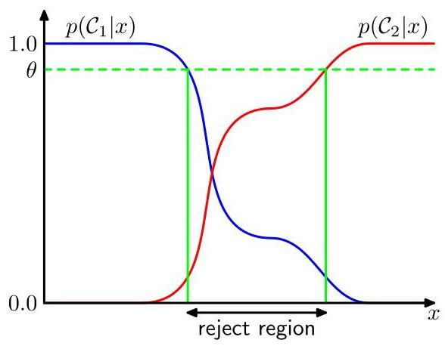

Figure 5.7 Illustration of the reject option. Inputs such that the larger of the two posterior probabilities is less than or equal to some threshold will be rejected.

图 5.7 拒绝选项的说明。输入 中两个后验概率中较大者小于或等于某个阈值 的将被拒绝。

We can easily extend the reject criterion to minimize the expected loss, when a loss matrix is given, by taking account of the loss incurred when a reject decision is made.

当给定一个损失矩阵时，我们可以通过考虑做出拒绝决策时产生的损失，轻松扩展拒绝准则以最小化预期损失。

Exercise 5.10

练习 5.10

# 5.2.4 Inference and decision

# 5.2.4 推理与决策

We have broken the classification problem down into two separate stages, the inference stage in which we use training data to learn a model for and the subsequent decision stage in which we use these posterior probabilities to make optimal class assignments. An alternative possibility would be to solve both problems together and simply learn a function that maps inputs directly into decisions. Such a function is called a discriminant function.

我们已将分类问题分解为两个独立的阶段:推理阶段，在该阶段我们使用训练数据学习 的模型；以及后续的决策阶段，在该阶段我们使用这些后验概率进行最优的类别分配。另一种可能是将这两个问题一起解决，直接学习一个将输入 直接映射到决策的函数。这样的函数称为判别函数。

In fact, we can identify three distinct approaches to solving decision problems, all of which have been used in practical applications. These are, in decreasing order of complexity, as follows:

事实上，我们可以确定三种不同的解决决策问题的方法，所有这些方法都已在实际应用中使用。按照复杂度从高到低的顺序，它们如下:

(a) First, solve the inference problem of determining the class-conditional densities for each class individually. Separately infer the prior class probabilities . Then use Bayes’ theorem in the form

(a) 首先，分别解决确定每个类别 的类条件密度 的推理问题。单独推断先验类别概率 。然后使用以下形式的贝叶斯定理

to find the posterior class probabilities . As usual, the denominator in

以找到后验类别概率 。和往常一样，

Bayes’ theorem can be found in terms of the quantities in the numerator, using

贝叶斯定理中的分母可以根据分子中的量来确定，使用

Equivalently, we can model the joint distribution directly and then normalize to obtain the posterior probabilities. Having found the posterior probabilities, we use decision theory to determine the class membership for each new input . Approaches that explicitly or implicitly model the distribution of inputs as well as outputs are known as generative models, because by sampling from them, it is possible to generate synthetic data points in the input space.

等价地，我们可以直接对联合分布 进行建模，然后进行归一化以获得后验概率。在找到后验概率后，我们使用决策理论来确定每个新输入 的类别归属。显式或隐式地对输入和输出的分布进行建模的方法被称为生成模型，因为通过对它们进行采样，可以在输入空间中生成合成数据点。

(b) First, solve the inference problem of determining the posterior class probabilities , and then subsequently use decision theory to assign each new to one of the classes. Approaches that model the posterior probabilities directly are called discriminative models.

(b) 首先，解决确定后验类别概率 的推理问题，然后随后使用决策理论将每个新的 分配到其中一个类别。直接对后验概率进行建模的方法称为判别模型。

(c) Find a function , called a discriminant function, that maps each input directly onto a class label. For instance, for two-class problems, might be binary valued and such that represents class and represents class . In this case, probabilities play no role.

(c) 找到一个称为判别函数的函数 ，它将每个输入 直接映射到一个类别标签。例如，对于两类问题， 可能是二元值的，并且使得 表示类别 ， 表示类别 。在这种情况下，概率不起作用。

Let us consider the relative merits of these three alternatives. Approach (a) is the most demanding because it involves finding the joint distribution over both and . For many applications, will have high dimensionality, and consequently, we may need a large training set to be able to determine the class-conditional densities to reasonable accuracy. Note that the class priors can often be estimated simply from the fractions of the training set data points in each of the classes. One advantage of approach (a), however, is that it also allows the marginal density of data to be determined from (5.25). This can be useful for detecting new data points that have low probability under the model and for which the predictions may be of low accuracy, which is known as outlier detection or novelty detection (Bishop, 1994; Tarassenko, 1995).

让我们考虑这三种选择的相对优点。方法 (a) 要求最高，因为它涉及找到 和 上的联合分布。对于许多应用， 将具有高维度，因此，我们可能需要一个大的训练集才能以合理的精度确定类别条件密度。请注意，类别先验 通常可以简单地从训练集中每个类别的数据点比例来估计。然而，方法 (a) 的一个优点是，它还允许从 (5.25) 确定数据的边缘密度 。这对于检测在模型下概率较低且预测可能精度较低的新数据点很有用，这被称为异常值检测或新奇性检测(Bishop，1994；Tarassenko，1995)。

However, if we wish only to make classification decisions, then it can be wasteful of computational resources and excessively demanding of data to find the joint distribution when in fact we really need only the posterior probabilities , which can be obtained directly through approach (b). Indeed, the class-conditional densities may contain a significant amount of structure that has little effect on the posterior probabilities, as illustrated in Figure 5.8. There has been much interest in exploring the relative merits of generative and discriminative approaches to machine learning and in finding ways to combine them (Jebara, 2004; Lasserre, Bishop, and Minka, 2006).

然而，如果我们仅希望做出分类决策，那么在实际上我们真正只需要后验概率 的情况下，寻找联合分布 可能会浪费计算资源，并且对数据的要求过高，而后验概率可以通过方法 (b) 直接获得。实际上，类条件密度可能包含大量对后验概率影响很小的结构，如图 5.8 所示。人们对探索机器学习中生成式和判别式方法的相对优点以及寻找将它们结合起来的方法非常感兴趣(Jebara，2004；Lasserre、Bishop 和 Minka，2006)。

An even simpler approach is (c) in which we use the training data to find a discriminant function that maps each directly onto a class label, thereby combining the inference and decision stages into a single learning problem. In the example of Figure 5.8, this would correspond to finding the value of shown by the vertical green line, because this is the decision boundary giving the minimum probability of misclassification.

一种更简单的方法是 (c)，在这种方法中，我们使用训练数据来找到一个判别函数 ，该函数将每个 直接映射到一个类别标签，从而将推理和决策阶段合并为一个单一的学习问题。在图 5.8 的示例中，这将对应于找到垂直绿线所示的 的值，因为这是给出最小误分类概率的决策边界。

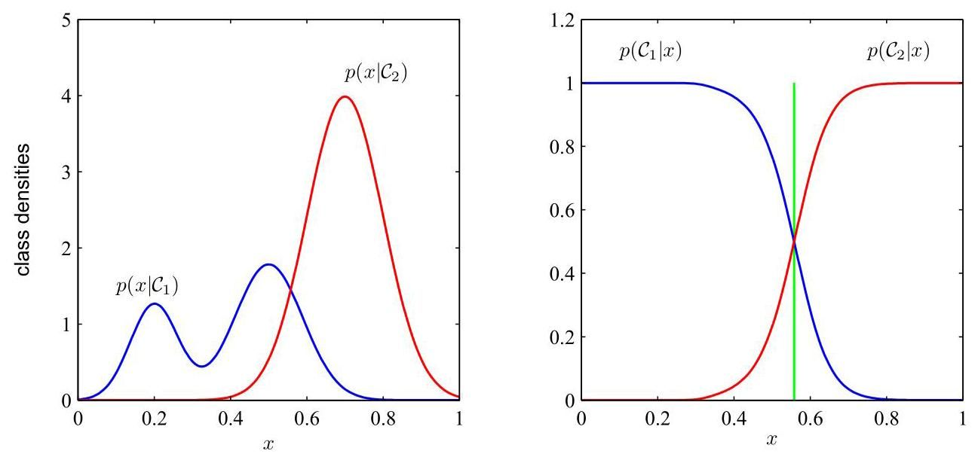

Figure 5.8 Example of the class-conditional densities for two classes having a single input variable (left plot) together with the corresponding posterior probabilities (right plot). Note that the left-hand mode of the class-conditional density , shown in blue on the left plot, has no effect on the posterior probabilities. The vertical green line in the right plot shows the decision boundary in that gives the minimum misclassification rate, assuming the prior class probabilities, and , are equal.

图 5.8 展示了具有单个输入变量 的两个类别的类条件密度示例(左图)以及相应的后验概率(右图)。请注意，左图中蓝色显示的类条件密度 的左侧模式对后验概率没有影响。右图中的垂直绿线显示了 中给出最小误分类率的决策边界，假设先验类概率 和 相等。

With option (c), however, we no longer have access to the posterior probabilities . There are many powerful reasons for wanting to compute the posterior probabilities, even if we subsequently use them to make decisions. These include:

然而，采用选项 (c) 时，我们将无法再获得后验概率 。即使我们随后使用后验概率来做出决策，也有很多强有力的理由需要计算它们。这些理由包括:

Minimizing risk. Consider a problem in which the elements of the loss matrix are subjected to revision from time to time (such as might occur in a financial application). If we know the posterior probabilities, we can trivially revise the minimum risk decision criterion by modifying (5.23) appropriately. If we have only a discriminant function, then any change to the loss matrix would require that we return to the training data and solve the inference problem afresh.

最小化风险。考虑一个损失矩阵的元素会不时进行修订的问题(例如在金融应用中可能会出现这种情况)。如果我们知道后验概率，我们可以通过适当修改 (5.23) 轻松地修订最小风险决策准则。如果我们只有一个判别函数，那么损失矩阵的任何变化都需要我们重新回到训练数据并重新解决推理问题。

Reject option. Posterior probabilities allow us to determine a rejection criterion that will minimize the misclassification rate, or more generally the expected loss, for a given fraction of rejected data points.

拒绝选项。后验概率使我们能够确定一个拒绝准则，对于给定比例的被拒绝数据点，该准则将使误分类率最小化，或者更一般地说，使预期损失最小化。

Section 2.1.1

第 2.1.1 节

Compensating for class priors. Consider our cancer screening example again, and suppose that we have collected a large number of images from the general population for use as training data, which we use to build an automated screening system. Because cancer is rare amongst the general population, we might find that, say, only 1 in every 1,000 examples corresponds to the presence of cancer.

补偿类别先验。我们再次考虑癌症筛查的例子，假设我们从普通人群中收集了大量图像作为训练数据，并用这些数据构建了一个自动筛查系统。由于癌症在普通人群中较为罕见，我们可能会发现，每 1000 个样本中只有 1 个对应着癌症的存在。

If we used such a data set to train an adaptive model, we could run into severe difficulties due to the small proportion of those in the cancer class. For instance, a classifier that assigned every point to the normal class would achieve 99.9% accuracy, and it may be difficult to avoid this trivial solution. Also, even a large data set will contain very few examples of skin images corresponding to cancer, and so the learning algorithm will not be exposed to a broad range of examples of such images and hence is not likely to generalize well. A balanced data set with equal numbers of examples from each of the classes would allow us to find a more accurate model. However, we then have to compensate for the effects of our modifications to the training data. Suppose we have used such a modified data set and found models for the posterior probabilities. From Bayes’ theorem (5.24), we see that the posterior probabilities are proportional to the prior probabilities, which we can interpret as the fractions of points in each class. We can therefore simply take the posterior probabilities obtained from our artificially balanced data set, divide by the class fractions in that data set, and then multiply by the class fractions in the population to which we wish to apply the model. Finally, we need to normalize to ensure that the new posterior probabilities sum to one. Note that this procedure cannot be applied if we have learned a discriminant function directly instead of determining posterior probabilities.

如果我们使用这样的数据集来训练一个自适应模型，由于癌症类别样本的比例较小，我们可能会遇到严重的困难。例如，一个将每个样本都归为正常类别的分类器将达到 99.9% 的准确率，并且可能很难避免这种简单的解决方案。此外，即使是一个大型数据集，其中与癌症对应的皮肤图像样本也会非常少，因此学习算法无法接触到广泛的此类图像样本，从而不太可能具有良好的泛化能力。一个包含每个类别数量相等样本的平衡数据集将使我们能够找到更准确的模型。然而，我们随后必须补偿对训练数据进行修改所产生的影响。假设我们使用了这样一个修改后的数据集，并找到了后验概率的模型。根据贝叶斯定理(5.24)，我们知道后验概率与先验概率成正比，我们可以将先验概率解释为每个类别中样本的比例。因此，我们可以简单地将从人工平衡数据集中获得的后验概率除以该数据集中的类别比例，然后乘以我们希望应用该模型的总体中的类别比例。最后，我们需要进行归一化处理，以确保新的后验概率之和为 1。请注意，如果我们直接学习了一个判别函数而不是确定后验概率，那么这个过程就不能应用。

Combining models. For complex applications, we may wish to break the problem into a number of smaller sub-problems each of which can be tackled by a separate module. For example, in our hypothetical medical diagnosis problem, we may have information available from, say, blood tests as well as skin images. Rather than combine all of this heterogeneous information into one huge input space, it may be more effective to build one system to interpret the images and a different one to interpret the blood data. If each of the two models gives posterior probabilities for the classes, then we can combine the outputs systematically using the rules of probability. One simple way to do this is to assume that, for each class separately, the distributions of inputs for the images, denoted by , and the blood data, denoted by , are independent, so that

组合模型。对于复杂的应用，我们可能希望将问题分解为多个较小的子问题，每个子问题可以由一个单独的模块来处理。例如，在我们假设的医学诊断问题中，我们可能有来自血液检测和皮肤图像等方面的信息。与其将所有这些异构信息合并到一个巨大的输入空间中，构建一个系统来解释图像，另一个系统来解释血液数据可能会更有效。如果这两个模型都给出了类别的后验概率，那么我们可以使用概率规则系统地组合这些输出。一种简单的方法是假设，对于每个类别分别而言，图像输入的分布(用 表示)和血液数据输入的分布(用 表示)是相互独立的，因此

Section 11.2

第 11.2 节

This is an example of a conditional independence property, because the independence holds when the distribution is conditioned on the class . The posterior probability, given both the image and blood data, is then given by

这是条件独立性属性的一个例子，因为当分布以类别 为条件时，独立性成立。给定图像和血液数据的后验概率则由下式给出

Thus, we need the class prior probabilities , which we can easily estimate from the fractions of data points in each class, and then we need to normalize

因此，我们需要类先验概率 ，我们可以很容易地从每个类中的数据点比例来估计这些概率，然后我们需要进行归一化处理

Figure 5.9 The confusion matrix for the cancer treatment problem, in which the rows correspond to the true class and the columns correspond to the assignment of class made by our decision criterion. The elements of the matrix show the numbers of true negatives, false positives, false negatives, and true positives. the resulting posterior probabilities so they sum to one. The particular condi-

图 5.9 癌症治疗问题的混淆矩阵，其中行对应真实类别，列对应我们的决策准则所做出的类别分配。矩阵元素显示了真阴性、假阳性、假阴性和真阳性的数量。由此得到的后验概率需要进行归一化，使其总和为 1。特定的条件 -

|  |  |  |
| --- | --- | --- |
|  | normal | cancer |
| normal |  |  |
| cancer |  | ) |
|  | 正常 | 癌症 |
| 正常 |  |  |
| 癌症 |  | ) |

# Section 11.2.3

# 第 11.2.3 节

tional independence assumption (5.26) is an example of a naive Bayes model. Note that the joint marginal distribution will typically not factorize under this model. We will see in later chapters how to construct models for combining data that do not require the conditional independence assumption (5.26). A further advantage of using models that output probabilities rather than decisions is that they can easily be made differentiable with respect to any adjustable parameters (such as the weight coefficients in the polynomial regression example), which allows them to be composed and trained jointly

条件独立性假设 (5.26) 是朴素贝叶斯模型的一个例子。请注意，在这个模型下，联合边缘分布 通常不会因式分解。我们将在后面的章节中看到如何构建用于组合数据的模型，这些模型不需要条件独立性假设 (5.26)。使用输出概率而非决策的模型的另一个优点是，它们可以很容易地关于任何可调参数(如多项式回归示例中的权重系数)求导，这使得它们可以组合并联合训练

# Chapter 7

# 第 7 章

using gradient-based optimization methods.

使用基于梯度的优化方法。

# 5.2.5 Classifier accuracy

# 5.2.5 分类器准确率

The simplest measure of performance for a classifier is the fraction of test set points that are correctly classified. However, we have seen that different types of error can have different consequences, as expressed through the loss matrix, and often we therefore do not simply wish to minimize the number of misclassifications. By changing the location of the decision boundary, we can make trade-offs between different kinds of error, for example with the goal of minimizing an expected loss. Because this is such an important concept, we will introduce some definitions and terminology so that the performance of a classifier can be better characterized.

分类器最简单的性能度量是测试集中被正确分类的点的比例。然而，我们已经看到，不同类型的错误可能会产生不同的后果，如通过损失矩阵所表达的那样，因此我们通常不只是希望最小化错误分类的数量。通过改变决策边界的位置，我们可以在不同类型的错误之间进行权衡，例如以最小化预期损失为目标。由于这是一个非常重要的概念，我们将引入一些定义和术语，以便更好地表征分类器的性能。

Section 2.1.1

第 2.1.1 节

We will consider again our cancer screening example. For each person tested, there is a ’true label’ of whether they have cancer or not, and there is also the prediction made by the classifier. If, for a particular person, the classifier predicts cancer and this is in fact the true label, then the prediction is called a true positive. However, if the person does not have cancer it is a false positive. Likewise, if the classifier predicts that a person does not have cancer and this is correct, then the prediction is called a true negative, otherwise it is a false negative. The false positives are also known as type 1 errors whereas the false negatives are called type 2 errors. If is the total number of people taking the test, then is the number of true positives, is the number of false positives, is the number of true negatives, and is the number of false negatives, where

我们将再次考虑癌症筛查的例子。对于每个接受检测的人，都有一个关于他们是否患有癌症的“真实标签”，同时也有分类器做出的预测。如果对于某个特定的人，分类器预测其患有癌症，而这实际上就是真实标签，那么这个预测就被称为真阳性。然而，如果这个人实际上没有患癌症，那么这个预测就是假阳性。同样地，如果分类器预测一个人没有患癌症，并且这是正确的，那么这个预测就被称为真阴性，否则就是假阴性。假阳性也被称为第一类错误，而假阴性则被称为第二类错误。如果 是参加测试的总人数，那么 是真阳性的人数， 是假阳性的人数， 是真阴性的人数， 是假阴性的人数，其中

This can be represented as a confusion matrix as shown in Figure 5.9. Accuracy, measured by the fraction of correct classifications, is then given by

这可以用如图 5.9 所示的混淆矩阵来表示。准确率通过正确分类的比例来衡量，其计算公式为

We can see that accuracy can be misleading if there are strongly imbalanced classes. In our cancer screening example, for instance, where only 1 person in 1,000 has cancer, a naive classifier that simply decides that nobody has cancer will achieve 99.9% accuracy and yet is completely useless.

我们可以看到，如果类别存在严重的不平衡，准确率可能会产生误导。例如，在我们的癌症筛查例子中，每 1000 人中只有 1 人患有癌症，一个简单地判定所有人都没有患癌症的简单分类器将达到 99.9% 的准确率，但实际上却毫无用处。

Several other quantities can be defined in terms of these numbers, of which the most commonly encountered are

根据这些数字还可以定义其他几个量，其中最常见的有

In our cancer screening example, precision represents an estimate of the probability that a person who has a positive test does indeed have cancer, whereas recall is an estimate of the probability that a person who has cancer is correctly detected by the test. The false positive rate is an estimate of the probability that a person who is normal will be classified as having cancer, whereas the false discovery rate represents the fraction of those testing positive who do not in fact have cancer.

在我们的癌症筛查例子中，精确率表示检测结果为阳性的人确实患有癌症的概率估计，而召回率表示患有癌症的人被检测正确发现的概率估计。假阳性率表示正常的人被分类为患有癌症的概率估计，而假发现率表示检测结果为阳性但实际上没有患癌症的人的比例。

By altering the location of the decision boundary, we can change the trade-offs between the two kinds of errors. To understand this trade-off, we revisit Figure 5.5, but now we label the various regions as shown in Figure 5.10. We can relate the labelled regions to the various true and false rates as follows:

通过改变决策边界的位置，我们可以改变两种错误之间的权衡。为了理解这种权衡，我们回顾图 5.5，但现在我们如图 5.10 所示对各个区域进行标注。我们可以将标注的区域与各种真率和假率关联如下:

where we are implicitly considering the limit so that we can relate number of observations to probabilities.

这里我们隐含地考虑极限 ，以便我们可以将观测数量与概率关联起来。

# 5.2.6 ROC curve

# 5.2.6 受试者工作特征(ROC)曲线

A probabilistic classifier will output a posterior probability, which can be converted to a decision by setting a threshold. As the value of the threshold is varied, we can reduce type 1 errors at the expense of increasing type 2 errors, or vice versa. To better understand this trade-off, it is useful to plot the receiver operating characteristic or ROC curve (Fawcett, 2006), a name that originates from procedures to measure the performance of radar receivers. This is a graph of true positive rate versus false positive rate, as shown in Figure 5.11.

概率分类器将输出后验概率，通过设置阈值可以将其转换为决策。随着阈值的变化，我们可以以增加第二类错误为代价来减少第一类错误，反之亦然。为了更好地理解这种权衡，绘制受试者工作特征(ROC)曲线(Fawcett，2006)是很有用的，这个名称源于测量雷达接收器性能的程序。这是一个真阳性率与假阳性率的关系图，如图 5.11 所示。

As the decision boundary in Figure 5.10 is moved from to , the ROC curve is traced out and can then be generated by plotting the cumulative fraction of correct detection of cancer on the -axis versus the cumulative fraction of incorrect detection on the -axis. Note that a specific confusion matrix represents one point along the ROC curve. The best possible classifier would be represented by a point at the top left corner of the ROC diagram. The bottom left corner represents a simple classifier that assigns every point to the normal class and therefore has no true positives but also no false positives. Similarly, the top right corner represents a classifier that assigns everything to the cancer class and therefore has no false negatives but also no true negatives. In Figure 5.11, the classifiers represented by the blue curve are better than those of the red curve for any choice of, say, false positive rate. It is also possible, however, for such curves to cross over, in which case the choice of which is better will depend on the choice of operating point.

如图 5.10 中的决策边界从 移动到 时，ROC 曲线就会被描绘出来，然后可以通过在 轴上绘制癌症正确检测的累积比例与在 轴上绘制错误检测的累积比例来生成。请注意，一个特定的混淆矩阵代表 ROC 曲线上的一个点。最佳的分类器将由 ROC 图左上角的一个点表示。左下角代表一个简单的分类器，它将每个点都分配到正常类别，因此没有真阳性，但也没有假阳性。类似地，右上角代表一个分类器，它将所有点都分配到癌症类别，因此没有假阴性，但也没有真阴性。在图 5.11 中，对于任何假阳性率的选择，蓝色曲线所代表的分类器都比红色曲线所代表的分类器更好。然而，这些曲线也可能会交叉，在这种情况下，哪个更好的选择将取决于工作点的选择。

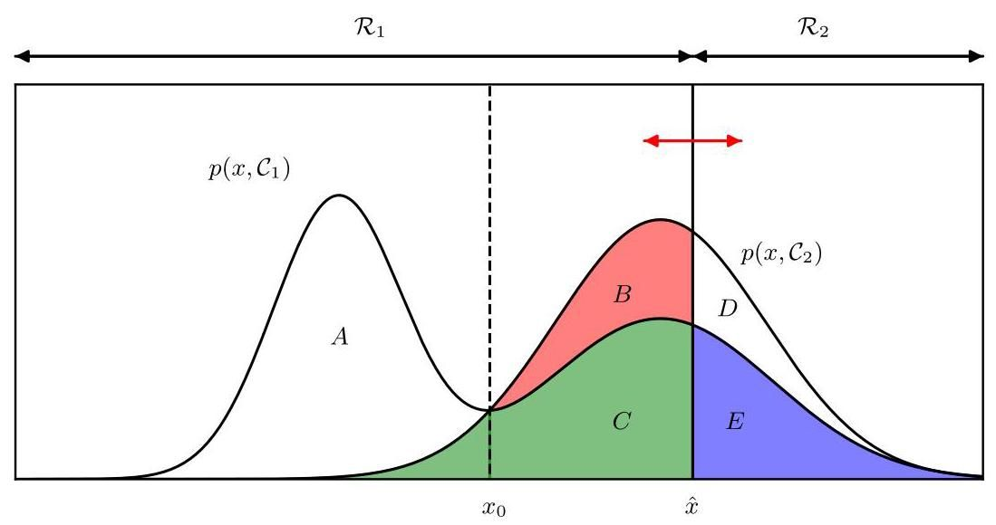

Figure 5.10 As in Figure 5.5, with the various regions labelled. In the cancer classification problem, region is assigned to the normal class whereas region is assigned to the cancer class.

图 5.10 与图 5.5 相同，对各个区域进行了标注。在癌症分类问题中，区域 被分配到正常类别，而区域 被分配到癌症类别。

As a baseline, we can consider a random classifier that simply assigns each data point to cancer with probability and to normal with probability . As we vary the value of it will trace out an ROC curve given by a diagonal straight line, as shown in Figure 5.11. Any classifier below the diagonal line performs worse than random guessing.

作为基线，我们可以考虑一个随机分类器，它简单地以概率 将每个数据点分配为癌症，以概率 分配为正常。当我们改变 的值时，它将描绘出一条由对角直线表示的受试者工作特征(ROC)曲线，如图 5.11 所示。任何位于对角线下的分类器的表现都比随机猜测差。

Sometimes it is useful to have a single number that characterises the whole ROC curve. One approach is to measure the area under the curve (AUC). A value of 0.5 for the AUC represents random guessing whereas a value of 1.0 represents a perfect classifier.

有时，用一个单一的数字来表征整个 ROC 曲线是很有用的。一种方法是测量曲线下面积(AUC)。AUC 值为 0.5 表示随机猜测，而值为 1.0 表示完美的分类器。

Another measure is the -score, which is the geometric mean of precision and

另一种度量是 分数，它是精确率和

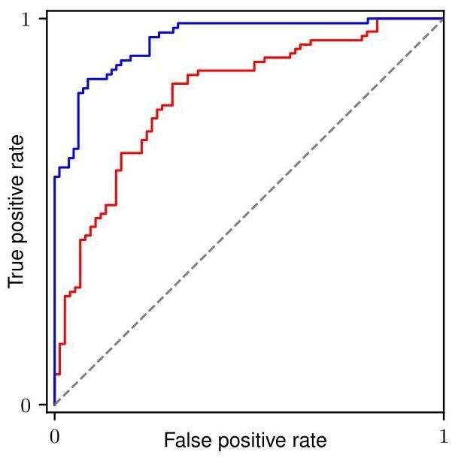

Figure 5.11 The receiver operator characteristic (ROC) curve is a plot of true positive rate against false positive rate, and it characterizes the trade-off between type 1 and type 2 errors in a classification problem. The upper blue curve represents a better classifier than the lower red curve. Here the dashed curve represents the performance of a simple random classifier.

图 5.11 受试者工作特征(ROC)曲线是真阳性率与假阳性率的关系图，它描述了分类问题中第一类错误和第二类错误之间的权衡。上方的蓝色曲线表示比下方的红色曲线更好的分类器。这里的虚线曲线表示简单随机分类器的性能。

recall, and is therefore defined by

召回率的几何平均值，因此定义为

Of course, we can also combine the confusion matrix in Figure 5.9 with the loss matrix in Figure 5.6 to compute the expected loss by multiplying the elements pointwise and summing the resulting products.

当然，我们也可以将图 5.9 中的混淆矩阵与图 5.6 中的损失矩阵相结合，通过逐点相乘元素并对所得乘积求和来计算预期损失。

Although the ROC curve can be extended to more than two classes, it rapidly becomes cumbersome as the number of classes increases.

尽管受试者工作特征(ROC)曲线可以扩展到两个以上的类别，但随着类别数量的增加，它会迅速变得繁琐。

# 5.3. Generative Classifiers

# 5.3. 生成式分类器

We turn next to a probabilistic view of classification and show how models with linear decision boundaries arise from simple assumptions about the distribution of the data. We have already discussed the distinction between the discriminative and the generative approaches to classification. Here we will adopt a generative approach in which we model the class-conditional densities as well as the class priors and then use these to compute posterior probabilities through Bayes’ theorem.

接下来，我们将从概率的角度看待分类问题，并展示具有线性决策边界的模型是如何从关于数据分布的简单假设中产生的。我们已经讨论了分类的判别式方法和生成式方法之间的区别。在这里，我们将采用生成式方法，在这种方法中，我们对类条件密度 以及类先验 进行建模，然后使用贝叶斯定理来计算后验概率 。

Section 5.2.4

5.2.4 节

First, consider problems having two classes. The posterior probability for class

首先，考虑具有两个类别的问题。类别的后验概率

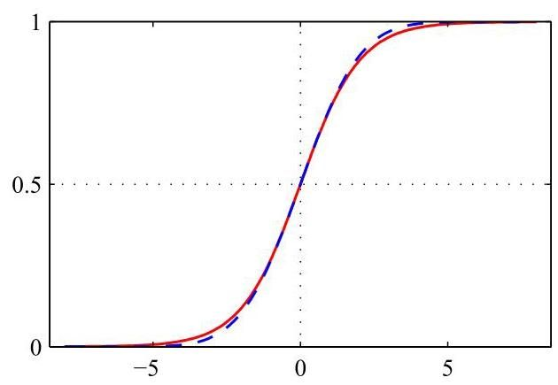

Figure 5.12 Plot of the logistic sigmoid function defined by (5.42), shown in red, together with the scaled probit function , for , shown in dashed blue, where is defined by (5.86). The scaling factor is chosen so that the derivatives of the two curves are equal for .

图 5.12 由 (5.42) 定义的逻辑 sigmoid 函数 的绘图(红色显示)，以及缩放后的概率单位函数 (对于 ，蓝色虚线显示)，其中 由 (5.86) 定义。选择缩放因子 使得两条曲线在 处的导数相等。

can be written as

可以写成

where we have defined

其中我们定义了

and is the logistic sigmoid function defined by

并且 是由下式定义的逻辑 S 型函数

which is plotted in Figure 5.12. The term ’sigmoid’ means S-shaped. This type of function is sometimes also called a ’squashing function’ because it maps the whole real axis into a finite interval. The logistic sigmoid has been encountered already in earlier chapters and plays an important role in many classification algorithms. It satisfies the following symmetry property:

该函数如图 5.12 所示。术语“sigmoid”表示 S 形。这种类型的函数有时也被称为“压缩函数”，因为它将整个实轴映射到一个有限区间。逻辑 S 型函数在前面的章节中已经出现过，并且在许多分类算法中起着重要作用。它满足以下对称性质:

as is easily verified. The inverse of the logistic sigmoid is given by

这很容易验证。逻辑 S 型函数的反函数由下式给出

and is known as the logit function. It represents the log of the ratio of probabilities for the two classes, also known as the odds.

并被称为对数几率函数。它表示两类概率 之比的对数，也称为 几率。

Note that in (5.40), we have simply rewritten the posterior probabilities in an equivalent form, and so the appearance of the logistic sigmoid may seem artificial.

请注意，在 (5.40) 中，我们只是将后验概率重写为等价形式，因此逻辑 sigmoid 函数的出现可能看起来有些牵强。

However, it will have significance provided has a constrained functional form. We will shortly consider situations in which is a linear function of , in which case the posterior probability is governed by a generalized linear model.

然而，如果 具有受限的函数形式，它将具有重要意义。我们很快会考虑 是 的线性函数的情况，在这种情况下，后验概率由广义线性模型控制。

If there are classes, we have

如果有 个类别，我们有

which is known as the normalized exponential and can be regarded as a multi-class generalization of the logistic sigmoid. Here the quantities are defined by

这被称为归一化指数函数，可以看作是逻辑 sigmoid 函数在多类别情况下的推广。这里的量 定义为

The normalized exponential is also known as the softmax function, as it represents a smoothed version of the ’max’ function because, if for all , then , and .

归一化指数函数也被称为 softmax 函数，因为它表示 “max” 函数的平滑版本，因为如果对于所有 都有 ，那么 ，并且 。

We now investigate the consequences of choosing specific forms for the class-conditional densities, looking first at continuous input variables and then discussing briefly discrete inputs.

我们现在研究为类别条件密度选择特定形式的后果，首先考虑连续输入变量 ，然后简要讨论离散输入。

# 5.3.1 Continuous inputs

# 5.3.1 连续输入

Let us assume that the class-conditional densities are Gaussian. We will then explore the resulting form for the posterior probabilities. To start with, we will assume that all classes share the same covariance matrix . Thus, the density for class is given by

让我们假设类条件密度是高斯分布的。然后我们将探讨后验概率的最终形式。首先，我们将假设所有类共享相同的协方差矩阵 。因此，类 的密度由下式给出

First, suppose that we have two classes. From (5.40) and (5.41), we have

首先，假设我们有两个类。根据 (5.40) 和 (5.41)，我们有

where we have defined

其中我们定义了

We see that the quadratic terms in from the exponents of the Gaussian densities have cancelled (due to the assumption of common covariance matrices), leading to a linear function of in the argument of the logistic sigmoid. This result is illustrated for a two-dimensional input space in Figure 5.13. The resulting decision boundaries correspond to surfaces along which the posterior probabilities are constant and so will be given by linear functions of , and therefore the decision boundaries are linear in input space. The prior probabilities enter only through the bias parameter , so that changes in the priors have the effect of making parallel shifts of the decision boundary and more generally of the parallel contours of constant posterior probability.

我们看到，高斯密度指数中关于 的二次项已经抵消(由于假设协方差矩阵相同)，导致逻辑 sigmoid 函数的自变量是 的线性函数。对于二维输入空间 ，这个结果如图 5.13 所示。由此产生的决策边界对应于后验概率 为常数的曲面，因此将由 的线性函数给出，所以决策边界在输入空间中是线性的。先验概率 仅通过偏置参数 进入，因此先验的变化会使决策边界以及更一般的后验概率恒定的平行轮廓发生平行移动。

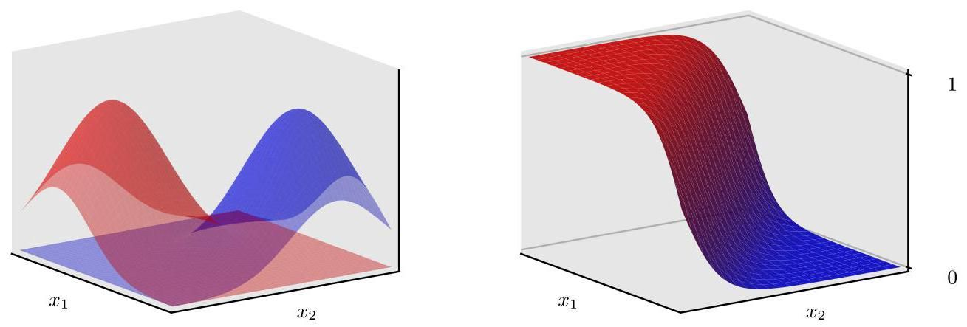

Figure 5.13 The left-hand plot shows the class-conditional densities for two classes, denoted red and blue. On the right is the corresponding posterior probability , which is given by a logistic sigmoid of a linear function of . The surface in the right-hand plot is coloured using a proportion of red ink given by and a proportion of blue ink given by .

图 5.13 左图显示了两个类(分别用红色和蓝色表示)的类条件密度。右图是相应的后验概率 ，它由 的线性函数的逻辑 sigmoid 函数给出。右图中的曲面使用比例为 的红色墨水和比例为 的蓝色墨水进行着色。

For the general case of classes, the posterior probabilities are given by (5.45) where, from (5.46) and (5.47), we have

对于 类的一般情况，后验概率由式 (5.45) 给出，其中，根据式 (5.46) 和式 (5.47)，我们有

in which we have defined

其中我们定义了

We see that the are again linear functions of as a consequence of the cancellation of the quadratic terms due to the shared covariances. The resulting decision boundaries, corresponding to the minimum misclassification rate, will occur when two of the posterior probabilities (the two largest) are equal, and so will be defined by linear functions of . Thus, we again have a generalized linear model.

我们看到，由于共享协方差导致二次项相消， 再次是 的线性函数。对应于最小误分类率的决策边界将在两个后验概率(两个最大的)相等时出现，因此将由 的线性函数定义。因此，我们再次得到一个广义线性模型。

If we relax the assumption of a shared covariance matrix and allow each class-conditional density to have its own covariance matrix , then the earlier cancellations will no longer occur, and we will obtain quadratic functions of , giving rise to a quadratic discriminant. The linear and quadratic decision boundaries are illustrated in Figure 5.14.

如果我们放宽共享协方差矩阵的假设，允许每个类条件密度 有其自己的协方差矩阵 ，那么前面的相消情况将不再发生，我们将得到 的二次函数，从而产生二次判别式。线性和二次决策边界如图 5.14 所示。

# 5.3.2 Maximum likelihood solution

# 5.3.2 最大似然解

Once we have specified a parametric functional form for the class-conditional densities , we can then determine the values of the parameters, together with the prior class probabilities , using maximum likelihood. This requires a data set comprising observations of along with their corresponding class labels.

一旦我们为类条件密度 指定了一个参数化的函数形式，我们就可以使用最大似然法来确定参数的值，以及先验类概率 。这需要一个数据集，其中包含 的观测值及其对应的类标签。

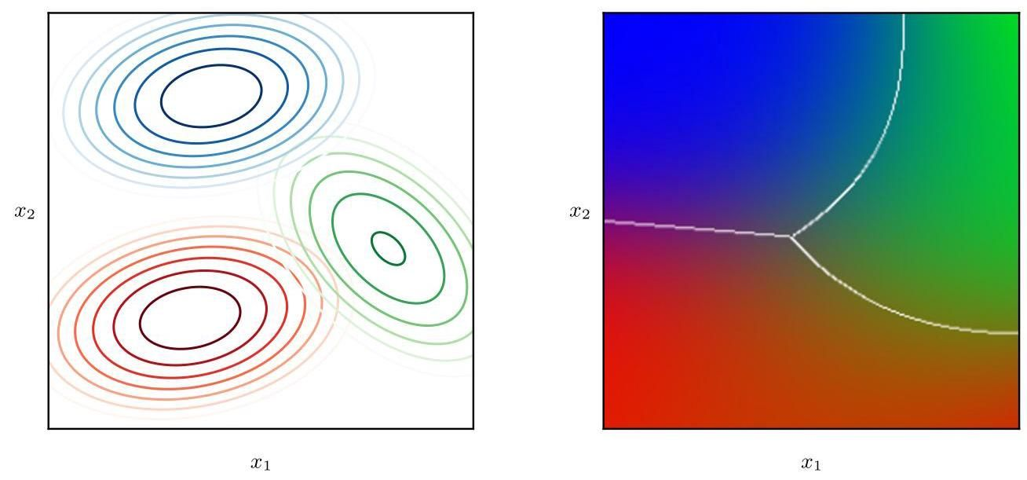

Figure 5.14 The left-hand plot shows the class-conditional densities for three classes each having a Gaussian distribution, coloured red, green, and blue, in which the red and blue classes have the same covariance matrix. The right-hand plot shows the corresponding posterior probabilities, in which each point on the image is coloured using proportions of red, blue, and green ink corresponding to the posterior probabilities for the respective three classes. The decision boundaries are also shown. Notice that the boundary between the red and blue classes, which have the same covariance matrix, is linear, whereas those between the other pairs of classes are quadratic.

图 5.14 左侧的图展示了三个类别的类条件密度，每个类别都具有高斯分布，分别用红色、绿色和蓝色表示，其中红色和蓝色类别具有相同的协方差矩阵。右侧的图展示了相应的后验概率，图像上的每个点都根据三个类别各自的后验概率，按比例使用红色、蓝色和绿色墨水着色。同时也显示了决策边界。注意，具有相同协方差矩阵的红色和蓝色类别之间的边界是线性的，而其他类别对之间的边界是二次的。

First, suppose we have two classes, each having a Gaussian class-conditional density with a shared covariance matrix, and suppose we have a data set where . Here denotes class and denotes class . We denote the prior class probability , so that . For a data point from class , we have and hence

首先，假设我们有两个类别，每个类别都具有一个共享协方差矩阵的高斯类条件密度，并且假设我们有一个数据集 ，其中 。这里 表示类别 ， 表示类别 。我们用 表示先验类别概率，因此 。对于来自类别 的一个数据点 ，我们有 ，因此

Similarly for class , we have and hence

类似地，对于类别 ，我们有 ，因此

Thus, the likelihood function is given by

因此，似然函数由下式给出

where . As usual, it is convenient to maximize the of the likelihood function. Consider first the maximization with respect to . The terms in the log likelihood function that depend on are

其中 。和往常一样，最大化似然函数的 会更方便。首先考虑关于 的最大化。对数似然函数中依赖于 的项为

Setting the derivative with respect to equal to zero and rearranging, we obtain

令关于 的导数等于零并重新整理，我们得到

where denotes the total number of data points in class , and denotes the total number of data points in class . Thus, the maximum likelihood estimate for is simply the fraction of points in class as expected. This result is easily generalized to the multi-class case where again the maximum likelihood estimate of the prior probability associated with class is given by the fraction of the training set points assigned to that class.

其中 表示类别 中数据点的总数， 表示类别 中数据点的总数。因此，正如预期的那样， 的最大似然估计仅仅是类别 中点的比例。这个结果很容易推广到多类别情况，在多类别情况下，与类别 相关的先验概率的最大似然估计同样由分配给该类别的训练集点的比例给出。

Exercise 5.13

练习 5.13

Now consider the maximization with respect to . Again, we can pick out of the log likelihood function those terms that depend on :

现在考虑关于 的最大化问题。同样，我们可以从对数似然函数中挑出那些依赖于 的项:

Setting the derivative with respect to to zero and rearranging, we obtain

令关于 的导数为零并重新整理，我们得到

which is simply the mean of all the input vectors assigned to class . By a similar argument, the corresponding result for is given by

这仅仅是分配给类别 的所有输入向量 的均值。通过类似的论证， 的相应结果由下式给出

which again is the mean of all the input vectors assigned to class .

这同样是分配给类别 的所有输入向量 的均值。

Finally, consider the maximum likelihood solution for the shared covariance matrix . Picking out the terms in the log likelihood function that depend on , we have

最后，考虑共享协方差矩阵 的最大似然解。从对数似然函数中挑出依赖于 的项，我们得到

where we have defined

其中我们定义了

Using the standard result for the maximum likelihood solution for a Gaussian distribution, we see that , which represents a weighted average of the covariance matrices associated with each of the two classes separately.

利用高斯分布最大似然解的标准结果，我们发现 表示分别与两个类别相关联的协方差矩阵的加权平均值。

This result is easily extended to the -class problem to obtain the corresponding maximum likelihood solutions for the parameters in which each class-conditional density is Gaussian with a shared covariance matrix. Note that the approach of fitting Gaussian distributions to the classes is not robust to outliers, because the maximum likelihood estimation of a Gaussian is not robust.

这个结果可以很容易地扩展到 类问题，以获得参数的相应最大似然解，其中每个类条件密度都是具有共享协方差矩阵的高斯分布。请注意，将高斯分布拟合到各个类别的方法对异常值不具有鲁棒性，因为高斯分布的最大似然估计不具有鲁棒性。

Exercise 5.14

练习 5.14

Section 5.1.4

第 5.1.4 节

# 5.3.3 Discrete features

# 5.3.3 离散特征

Let us now consider discrete feature values . For simplicity, we begin by looking at binary feature values and discuss the extension to more general discrete features shortly. If there are inputs, then a general distribution would correspond to a table of numbers for each class and have independent variables (due to the summation constraint). Because this grows exponentially with the number of features, we can seek a more restricted representation. Here we will

现在让我们考虑离散特征值 。为简单起见，我们先从二元特征值 开始讨论，稍后再探讨如何扩展到更一般的离散特征。如果有 个输入，那么对于每个类别，一个一般的分布将对应一个包含 个数字的表格，并且有 个独立变量(由于求和约束)。由于这会随着特征数量呈指数增长，我们可以寻求一种更受限的表示方法。在这里，我们将

# Section 11.2.3

# 第 11.2.3 节

make the naive Bayes assumption in which the feature values are treated as independent and conditioned on the class . Thus, we have class-conditional distributions

采用朴素贝叶斯假设，即特征值被视为相互独立且以类别 为条件。因此，我们有类别条件分布

of the form

形式为

which contain independent parameters for each class. Substituting into (5.46) then gives

其中每个类别包含 个独立参数。将其代入 (5.46) 式可得

which again are linear functions of the input values . For classes, we can alternatively consider the logistic sigmoid formulation given by (5.40). Analogous results are obtained for discrete variables that take states.

它们同样是输入值 的线性函数。对于 个类别，我们可以考虑由式 (5.40) 给出的逻辑 sigmoid 公式。对于具有 个状态的离散变量，也能得到类似的结果。

Exercise 5.16

练习 5.16

# 5.3.4 Exponential family

# 5.3.4 指数族

As we have seen, for both Gaussian distributed and discrete inputs, the posterior class probabilities are given by generalized linear models with logistic sigmoid

正如我们所见，对于高斯分布和离散输入，后验类别概率由具有逻辑 sigmoid 的广义线性模型给出

2 classes) or softmax ( classes) activation functions. These are particular cases of a more general result obtained by assuming that the class-conditional densities are members of the subset of the exponential family of distributions given

(2 个类别)或 softmax( 个类别)激活函数。这些是更一般结果的特殊情况，该一般结果是通过假设类别条件密度 是给定指数族分布子集的成员得到的

Section 3.4

第 3.4 节

by

由；通过

Here the scaling parameter is shared across all the classes.

在这里，缩放参数 在所有类别中共享。

For the two-class problem, we substitute this expression for the class-conditional densities into (5.41) and we see that the posterior class probability is again given by a logistic sigmoid acting on a linear function , which is given by

对于两类问题，我们将这个类条件密度的表达式代入 (5.41)，可以看到后验类概率再次由作用于线性函数 的逻辑 sigmoid 函数给出，该线性函数由下式给出

Similarly, for the -class problem, we substitute the class-conditional density expression into (5.46) to give

类似地，对于 类问题，我们将类条件密度表达式代入 (5.46) 得到

and so again is a linear function of .

因此，它再次是 的线性函数。

# 5.4. Discriminative Classifiers

# 5.4. 判别式分类器

For the two-class classification problem, we have seen that the posterior probability of class can be written as a logistic sigmoid acting on a linear function of , for a wide choice of class-conditional distributions from the exponential family. Similarly, for the multi-class case, the posterior probability of class is given by a softmax transformation of linear functions of . For specific choices of the class-conditional densities , we have used maximum likelihood to determine the parameters of the densities as well as the class priors and then used Bayes’ theorem to find the posterior class probabilities. This represents an example of generative modelling, because we could take such a model and generate synthetic data by drawing values of from the marginal distribution or from any of the class-conditional densities .

对于二分类问题，我们已经知道，对于指数族中广泛选择的类条件分布 ，类别 的后验概率可以写成一个作用于 的线性函数的逻辑 sigmoid 函数。类似地，对于多分类情况，类别 的后验概率由 的线性函数的 softmax 变换给出。对于类条件密度 的特定选择，我们使用最大似然法来确定密度的参数以及类别先验 ，然后使用贝叶斯定理来计算后验类别概率。这是生成式建模的一个例子，因为我们可以采用这样的模型，通过从边缘分布 或任何类条件密度 中抽取 的值来生成合成数据。

However, an alternative approach is to use the functional form of the generalized linear model explicitly and to determine its parameters directly by using maximum likelihood. In this direct approach, we maximize a likelihood function defined through the conditional distribution , which represents a form of discriminative probabilistic modelling. One advantage of the discriminative approach is that there will typically be fewer learnable parameters to be determined, as we will see shortly. It may also lead to improved predictive performance, particularly when the assumed forms for the class-conditional densities represent a poor approximation to the true distributions.

然而，另一种方法是明确使用广义线性模型的函数形式，并直接使用最大似然法来确定其参数。在这种直接方法中，我们最大化通过条件分布 定义的似然函数，这代表了一种判别式概率建模形式。判别式方法的一个优点是，通常需要确定的可学习参数会更少，我们很快就会看到这一点。它还可能提高预测性能，特别是当假设的类条件密度形式与真实分布相差较大时。

# 5.4.1 Activation functions

# 5.4.1 激活函数

Chapter 4

第 4 章

In linear regression, the model prediction is given by a linear function of the parameters

在线性回归中，模型预测 由参数的线性函数给出

which gives a continuous-valued output in the range . For classification problems, however, we wish to predict discrete class labels, or more generally posterior probabilities that lie in the range . To achieve this, we consider a generalization of this model in which we transform the linear function of and using a nonlinear function so that

这会产生一个取值范围为 的连续值输出。然而，对于分类问题，我们希望预测离散的类别标签，或者更一般地，预测取值范围为 的后验概率。为了实现这一点，我们考虑对该模型进行推广，在其中我们使用非线性函数 对 和 的线性函数进行变换，使得

In the machine learning literature, is known as an activation function, whereas its inverse is called a link function in the statistics literature. The decision surfaces correspond to constant, so that constant, and hence the decision surfaces are linear functions of , even if the function is nonlinear. For this reason, the class of models described by (5.70) are called generalized linear models (McCullagh and Nelder, 1989). However, in contrast to the models used for regression, they are no longer linear in the parameters due to the nonlinear function . This will lead to more complex analytical and computational properties than for linear regression models. Nevertheless, these models are still relatively simple compared to the much more flexible nonlinear models that will be studied in subsequent chapters.

在机器学习文献中， 被称为激活函数，而其反函数在统计学文献中被称为链接函数。决策面对应于 为常数，因此 为常数，所以即使函数 是非线性的，决策面也是 的线性函数。出于这个原因，由 (5.70) 描述的模型类被称为广义线性模型(McCullagh 和 Nelder，1989)。然而，与用于回归的模型相比，由于非线性函数 ，它们在参数上不再是线性的。这将导致比线性回归模型更复杂的分析和计算特性。尽管如此，与后续章节将研究的更灵活的非线性模型相比，这些模型仍然相对简单。

# 5.4.2 Fixed basis functions

# 5.4.2 固定基函数

So far in this chapter, we have considered classification models that work directly with the original input vector . However, all the algorithms are equally applicable if we first make a fixed nonlinear transformation of the inputs using a vector of basis functions . The resulting decision boundaries will be linear in the feature space , and these correspond to nonlinear decision boundaries in the original space, as illustrated in Figure 5.15. Classes that are linearly separable in the feature space need not be linearly separable in the original observation space .

到目前为止，在本章中，我们考虑了直接处理原始输入向量 的分类模型。然而，如果我们首先使用基函数向量 对输入进行固定的非线性变换，那么所有算法同样适用。由此产生的决策边界在特征空间 中将是线性的，并且这些对应于原始 空间中的非线性决策边界，如图 5.15 所示。在特征空间 中线性可分的类别在原始观测空间 中不一定是线性可分的。

Note that as in our discussion of linear models for regression, one of the basis functions is typically set to a constant, say , so that the corresponding parameter plays the role of a bias.

请注意，正如我们在讨论回归的线性模型时一样，其中一个基函数通常被设置为常数，例如 ，以便相应的参数 起到偏置的作用。

For many problems of practical interest, there is significant overlap in -space between the class-conditional densities . This corresponds to posterior probabilities , which, for at least some values of , are not 0 or 1 . In such cases, the optimal solution is obtained by modelling the posterior probabilities accurately and then applying standard decision theory. Note that nonlinear transformations cannot remove such a class overlap, although they can increase the level of overlap or create an overlap where none existed in the original observation space. However, suitable choices of nonlinearity can make the process of modelling the posterior probabilities easier. However, such fixed basis function models have important limitations, and these will be resolved in later chapters by allowing the basis functions themselves to adapt to the data.

对于许多实际感兴趣的问题，类别条件密度 在 空间中存在显著的重叠。这对应于后验概率 ，对于至少某些 的值，这些后验概率不为 0 或 1。在这种情况下，通过准确地对后验概率进行建模，然后应用标准决策理论，可以得到最优解。请注意，非线性变换 不能消除这种类别重叠，尽管它们可以增加重叠程度或在原始观测空间中不存在重叠的地方产生重叠。然而，合适的非线性选择可以使对后验概率进行建模的过程更容易。然而，这种固定基函数模型有重要的局限性，这些局限性将在后续章节中通过允许基函数本身适应数据来解决。

Section 5.2

第 5.2 节

Section 6.1

6.1 节

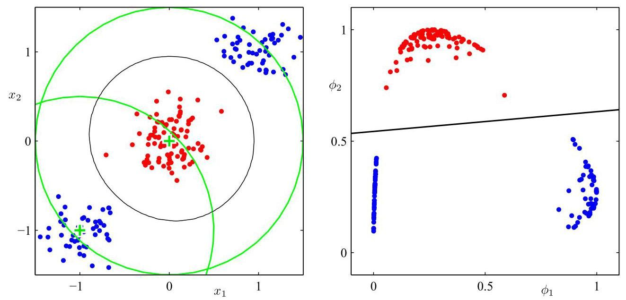

Figure 5.15 Illustration of the role of nonlinear basis functions in linear classification models. The left-hand plot shows the original input space together with data points from two classes labelled red and blue. Two ’Gaussian’ basis functions and are defined in this space with centres shown by the green crosses and with contours shown by the green circles. The right-hand plot shows the corresponding feature space together with the linear decision boundary obtained given by a logistic regression model of the form discussed in Section 5.4.3. This corresponds to a nonlinear decision boundary in the original input space, shown by the black curve in the left-hand plot.

图 5.15 线性分类模型中非线性基函数作用的图示。左图展示了原始输入空间 以及来自两类(分别标记为红色和蓝色)的数据点。在这个空间中定义了两个 “高斯” 基函数 和 ，其中心由绿色十字表示，等高线由绿色圆圈表示。右图展示了相应的特征空间 以及通过 5.4.3 节讨论的形式的逻辑回归模型得到的线性决策边界。这对应于原始输入空间中的非线性决策边界，如左图中的黑色曲线所示。

# 5.4.3 Logistic regression

# 5.4.3 逻辑回归

We first consider the problem of two-class classification. In our discussion of generative approaches in Section 5.3, we saw that under rather general assumptions, the posterior probability of class can be written as a logistic sigmoid acting on a linear function of the feature vector so that

我们首先考虑两类分类问题。在 5.3 节对生成式方法的讨论中，我们看到在相当一般的假设下，类别 的后验概率可以写成作用于特征向量 的线性函数的逻辑 S 型函数，即

with . Here is the logistic sigmoid function defined by (5.42). In the terminology of statistics, this model is known as logistic regression, although it should be emphasized that this is a model for classification rather than for continuous variable.

其中 。这里 是由 (5.42) 定义的逻辑 S 型函数。在统计学的术语中，这个模型被称为逻辑回归，不过需要强调的是，这是一个用于分类的模型，而不是用于连续变量的模型。

For an -dimensional feature space , this model has adjustable parameters. By contrast, if we had fitted Gaussian class-conditional densities using maximum likelihood, we would have used parameters for the means and parameters for the (shared) covariance matrix. Together with the class prior , this gives a total of parameters, which grows quadratically with , in contrast to the linear dependence on of the number of parameters in logistic regression. For large values of , there is a clear advantage in working with the logistic regression model directly.

对于一个 维的特征空间 ，这个模型有 个可调参数。相比之下，如果我们使用最大似然法拟合高斯类条件密度，我们将使用 个参数来表示均值，使用 个参数来表示(共享的)协方差矩阵。再加上类别先验 ，这总共给出了 个参数，其数量随 呈二次增长，这与逻辑回归中参数数量对 的线性依赖形成对比。对于较大的 值，直接使用逻辑回归模型有明显的优势。

We now use maximum likelihood to determine the parameters of the logistic regression model. To do this, we will make use of the derivative of the logistic sigmoid function, which can conveniently be expressed in terms of the sigmoid function

我们现在使用最大似然法来确定逻辑回归模型的参数。为此，我们将利用逻辑 sigmoid 函数的导数，它可以方便地用 sigmoid 函数表示

Exercise 5.18

练习 5.18

itself:

其本身:

For a data set , where and , with , the likelihood function can be written

对于一个数据集 ，其中 且 ，且 ，似然函数可以写成

where and . As usual, we can define an error function by taking the negative logarithm of the likelihood, which gives the cross-entropy error function:

其中 和 。和往常一样，我们可以通过取似然函数的负对数来定义一个误差函数，这就得到了交叉熵误差函数:

where and . Taking the gradient of the error function with respect to , we obtain

其中 和 。对误差函数关于 求梯度，我们得到

Exercise 5.19

练习 5.19

where we have made use of (5.72). We see that the factor involving the derivative of the logistic sigmoid has cancelled, leading to a simplified form for the gradient of the log likelihood. In particular, the contribution to the gradient from data point is given by the ’error’ between the target value and the prediction of the model times the basis function vector . Furthermore, comparison with (4.12) shows that this takes precisely the same form as the gradient of the sum-of-squares error function for the linear regression model.

在此我们利用了式(5.72)。我们发现，涉及逻辑 sigmoid 函数导数的因子被消去了，从而使得对数似然函数的梯度形式得到简化。特别地，数据点 对梯度的贡献由目标值与模型预测值之间的 “误差” 乘以基函数向量 给出。此外，与式(4.12)对比可知，这与线性回归模型的平方和误差函数的梯度形式完全相同。

Section 4.1.3

第 4.1.3 节

The maximum likelihood solution corresponds to . However, from (5.75) we see that this no longer corresponds to a set of linear equations, due to the nonlinearity in , and so this equation does not have a closed-form solution. One approach to finding a maximum likelihood solution would be to use stochastic gradient descent, in which is the th term on the right-hand side of (5.75). Stochastic gradient descent will be the principal approach to training the highly nonlinear neural networks discussed in later chapters. However, the maximum likelihood equation is only ’slightly’ nonlinear, and in fact the error function (5.74), in which the model is defined by (5.71), is a convex function of the parameters, which allows the error function to be minimized using a simple algorithm called iterative reweighted least squares or IRLS (Bishop, 2006). However, this does not easily generalize to more complex models such as deep neural networks.

最大似然解对应于 。然而，从式(5.75)我们可以看出，由于 中的非线性，这不再对应于一组线性方程，因此该方程没有闭式解。一种寻找最大似然解的方法是使用随机梯度下降法，其中 是式(5.75)右侧的第 项。随机梯度下降法将是训练后续章节中讨论的高度非线性神经网络的主要方法。然而，最大似然方程只是 “略微” 非线性的，实际上，由式(5.71)定义模型的误差函数(5.74)是参数的凸函数，这使得可以使用一种称为迭代重加权最小二乘法(IRLS)的简单算法来最小化误差函数(Bishop, 2006)。然而，这并不容易推广到更复杂的模型，如深度神经网络。

Chapter 7

第 7 章

Note that maximum likelihood can exhibit severe over-fitting for data sets that are linearly separable. This arises because the maximum likelihood solution occurs when the hyperplane corresponding to , equivalent to , separates the two classes and the magnitude of goes to infinity. In this case, the logistic sigmoid function becomes infinitely steep in feature space, corresponding to a Heaviside step function, so that every training point from each class is assigned a posterior probability . Furthermore, there is typically a continuum of such solutions because any separating hyperplane will give rise to the same posterior probabilities at the training data points. Maximum likelihood provides no way to favour one such solution over another, and which solution is found in practice will depend on the choice of optimization algorithm and on the parameter initialization. Note that the problem will arise even if the number of data points is large compared with the number of parameters in the model, so long as the training data set is linearly separable. The singularity can be avoided by adding a regularization term to the error function.

请注意，对于线性可分的数据集，最大似然法可能会出现严重的过拟合问题。这是因为当对应于 (等价于 )的超平面将两类数据分开，并且 的模趋于无穷大时，会出现最大似然解。在这种情况下，逻辑 sigmoid 函数在特征空间中变得无限陡峭，对应于一个 Heaviside 阶跃函数，因此每个类 中的每个训练点都被赋予一个后验概率 。此外，通常存在这样的解的连续统，因为任何分隔超平面都会在训练数据点处产生相同的后验概率。最大似然法没有办法偏好其中一个解而不是另一个解，并且在实践中找到的解将取决于优化算法的选择和参数的初始化。请注意，即使数据点的数量相对于模型中的参数数量很大，只要训练数据集是线性可分的，这个问题就会出现。可以通过在误差函数中添加正则化项来避免这种奇异性。

Exercise 5.20

练习 5.20

Chapter 9

第 9 章

# 5.4.4 Multi-class logistic regression

# 5.4.4 多类逻辑回归

Section 5.3

第 5.3 节

In our discussion of generative models for multi-class classification, we have seen that, for a large class of distributions from the exponential family, the posterior probabilities are given by a softmax transformation of linear functions of the feature

在我们对多类分类生成模型的讨论中，我们已经看到，对于指数族中的一大类分布，后验概率由特征的线性函数的 softmax 变换给出

variables, so that

变量，使得

where the pre-activations are given by

其中预激活值 由下式给出

There we used maximum likelihood to determine separately the class-conditional densities and the class priors and then found the corresponding posterior probabilities using Bayes’ theorem, thereby implicitly determining the parameters . Here we consider the use of maximum likelihood to determine the parameters of this model directly. To do this, we will require the derivatives of with respect to all the pre-activations . These are given by

在那里，我们使用最大似然法分别确定类条件密度和类先验概率，然后使用贝叶斯定理找到相应的后验概率，从而隐式地确定参数 。在这里，我们考虑直接使用最大似然法来确定该模型的参数 。为此，我们需要 关于所有预激活值 的导数。这些导数由下式给出

Exercise 5.21

练习 5.21

where are the elements of the identity matrix.

其中 是单位矩阵的元素。

Next we write down the likelihood function. This is most easily done using the 1-of- coding scheme in which the target vector for a feature vector belonging to class is a binary vector with all elements zero except for element , which equals one. The likelihood function is then given by

接下来，我们写下似然函数。使用 1-of- 编码方案来完成这一点最为容易，在该方案中，属于类别 的特征向量 对应的目标向量 是一个二进制向量，除了元素 等于 1 之外，所有元素都为 0。那么似然函数由下式给出

Figure 5.16 Representation of a multi-class linear classification model as a neural network having a single layer of connections. Each basis function is represented by a node, with the solid node representing the ’bias’ basis function , whereas each output is also represented by a node. The links between the nodes represent the corresponding weight and bias parameters.

图 5.16 将多类线性分类模型表示为具有单层连接的神经网络。每个基函数由一个节点表示，实心节点表示 “偏置” 基函数 ，而每个输出 也由一个节点表示。节点之间的链接表示相应的权重和偏置参数。

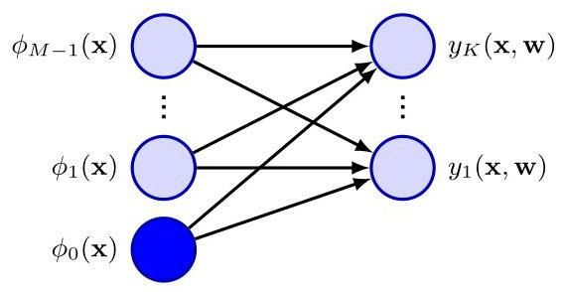

where , and is an matrix of target variables with elements . Taking the negative logarithm then gives

其中 ，并且 是一个包含元素 的目标变量的 矩阵。取负对数后可得

which is known as the cross-entropy error function for the multi-class classification problem.

这就是多分类问题的交叉熵误差函数。

We now take the gradient of the error function with respect to one of the parameter vectors . Making use of the result (5.78) for the derivatives of the softmax function, we obtain

现在，我们对误差函数关于其中一个参数向量 求梯度。利用 softmax 函数导数的结果 (5.78)，我们得到

Exercise 5.22

练习 5.22

where we have made use of . Again, we could optimize the parameters through stochastic gradient descent.

这里我们使用了 。同样，我们可以通过随机梯度下降来优化参数。

Chapter 7

第 7 章

Once again, we see the same form arising for the gradient as was found for the sum-of-squares error function with the linear model and for the cross-entropy error with the logistic regression model, namely the product of the error times the basis function activation . These are examples of a more general result that we will explore later.

再一次，我们看到梯度呈现出与线性模型的平方和误差函数以及逻辑回归模型的交叉熵误差相同的形式，即误差 乘以基函数激活值 的乘积。这些是我们稍后将探讨的更一般结果的示例。

Section 5.4.6

第 5.4.6 节

Linear classification models can be represented as single-layer neural networks as shown in Figure 5.16. If we consider the derivative of the error function with respect to a weight , which links basis function to output unit , we have from (5.81)

线性分类模型可以表示为单层神经网络，如图 5.16 所示。如果我们考虑误差函数关于权重 的导数，该权重将基函数 与输出单元 相连，那么根据式 (5.81) 我们有

Comparing this with Figure 5.16, we see that, for each data point this gradient takes the form of the output of the basis function at the input end of the weight link with the ’error’ at the output end.

将此与图 5.16 进行比较，我们发现，对于每个数据点 ，该梯度的形式为权重链接输入端基函数的输出乘以输出端的 “误差” 。

Figure 5.17 Schematic example of a probability density shown by the blue curve, given in this example by a mixture of two Gaussians, along with its cumulative distribution function , shown by the red curve. Note that the value of the blue curve at any point, such as that indicated by the vertical green line, corresponds to the slope of the red curve at the same point. Conversely, the value of the red curve at this point corresponds to the area under the blue curve indicated by the shaded green region. In the stochastic threshold model, the class label takes the value if the value of exceeds a threshold, otherwise it takes the value . This is equivalent to an activation function given by the cumulative distribution function .

图 5.17 概率密度 的示意图示例，蓝色曲线表示该概率密度，在本示例中由两个高斯分布的混合给出，以及其累积分布函数 ，由红色曲线表示。请注意，蓝色曲线在任何点(如垂直绿线所示的点)的值对应于红色曲线在同一点的斜率。相反，红色曲线在该点的值对应于蓝色曲线下由绿色阴影区域表示的面积。在随机阈值模型中，如果 的值超过阈值，则类别标签取值为 ，否则取值为 。这等效于由累积分布函数 给出的激活函数。

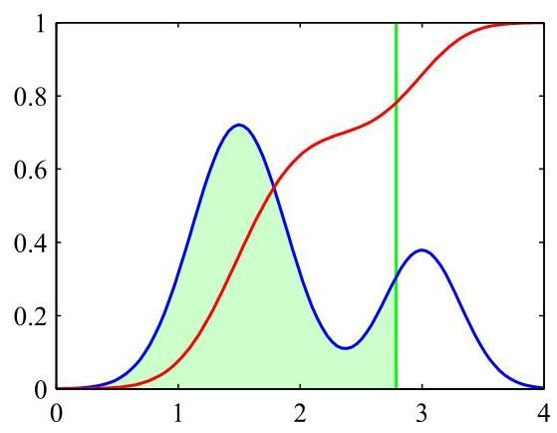

# 5.4.5 Probit regression

# 5.4.5 概率单位回归

We have seen that, for a broad range of class-conditional distributions described by the exponential family, the resulting posterior class probabilities are given by a logistic (or softmax) transformation acting on a linear function of the feature variables. However, not all choices of class-conditional density give rise to such a simple form for the posterior probabilities, which suggests that it might be worth exploring other types of discriminative probabilistic model. Consider the two-class case, again remaining within the framework of generalized linear models, so that

我们已经看到，对于由指数族描述的广泛的类条件分布，得到的后验类概率由作用于特征变量的线性函数的逻辑(或 softmax)变换给出。然而，并非所有类条件密度的选择都会产生如此简单形式的后验概率，这表明探索其他类型的判别式概率模型可能是值得的。考虑两类情况，仍然在广义线性模型的框架内，因此

where , and is the activation function.

其中 ，并且 是激活函数。

One way to motivate an alternative choice for the link function is to consider a noisy threshold model, as follows. For each input , we evaluate and then we set the target value according to

为链接函数选择另一种替代方案的一种方法是考虑一个有噪声的阈值模型，如下所示。对于每个输入 ，我们计算 ，然后根据以下规则设置目标值

If the value of is drawn from a probability density , then the corresponding activation function will be given by the cumulative distribution function

如果 的值是从概率密度 中抽取的，那么相应的激活函数将由累积分布函数给出

as illustrated in Figure 5.17.

如图 5.17 所示。

As a specific example, suppose that the density is given by a zero-mean, unit-variance Gaussian. The corresponding cumulative distribution function is given by

作为一个具体的例子，假设密度 由零均值、单位方差的高斯分布给出。相应的累积分布函数由下式给出

which is known as the probit function. It has a sigmoidal shape and is compared with the logistic sigmoid function in Figure 5.12. Note that the use of a Gaussian distribution with general mean and variances does not change the model because this is equivalent to a re-scaling of the linear coefficients w. Many numerical packages can evaluate a closely related function defined by

这被称为概率单位函数。它呈 S 形，并在图 5.12 中与逻辑 S 形函数进行了比较。请注意，使用具有一般均值和方差的高斯分布并不会改变模型，因为这相当于对线性系数 w 进行重新缩放。许多数值计算软件包可以计算由下式定义的密切相关的函数

and known as the erf function or error function (not to be confused with the error function of a machine learning model). It is related to the probit function by

它被称为误差函数(不要与机器学习模型的误差函数混淆)。它与概率单位函数的关系为

Exercise 5.23

练习 5.23

The generalized linear model based on a probit activation function is known as probit regression. We can determine the parameters of this model using maximum likelihood by a straightforward extension of the ideas discussed earlier. In practice, the results found using probit regression tend to be like those of logistic regression.

基于概率单位激活函数的广义线性模型被称为概率单位回归。我们可以通过直接扩展前面讨论的思想，使用最大似然法来确定该模型的参数。在实践中，使用概率单位回归得到的结果往往与逻辑回归的结果相似。

One issue that can occur in practical applications is that of outliers, which can arise for instance through errors in measuring the input vector or through mislabelling of the target value . Because such points can lie a long way to the wrong side of the ideal decision boundary, they can seriously distort the classifier. The logistic and probit regression models behave differently in this respect because the tails of the logistic sigmoid decay asymptotically like for , whereas for the probit activation function, they decay like , and so the probit model can be significantly more sensitive to outliers.

实际应用中可能出现的一个问题是离群值问题，例如，这可能是由于测量输入向量 时出现误差，或者对目标值 进行错误标记而产生的。由于这些点可能远离理想决策边界的错误一侧，它们会严重扭曲分类器。逻辑回归和概率单位回归模型在这方面的表现不同，因为逻辑 S 形函数的尾部在 时渐近地像 一样衰减，而对于概率单位激活函数，它们像 一样衰减，因此概率单位模型对离群值可能会更加敏感。

# 5.4.6 Canonical link functions

# 5.4.6 规范链接函数

For the linear regression model with a Gaussian noise distribution, the error function, corresponding to the negative log likelihood, is given by (4.11). If we take the derivative with respect to the parameter vector of the contribution to the error function from a data point , this takes the form of the ’error’ times the feature vector , where . Similarly, for the combination of the logistic-sigmoid activation function and the cross-entropy error function (5.74) and for the softmax activation function with the multi-class cross-entropy error function (5.80), we again obtain this same simple form. We now show that this is a general result of assuming a conditional distribution for the target variable from the exponential family along with a corresponding choice for the activation function known as the canonical link function.

对于具有高斯噪声分布的线性回归模型，对应于负对数似然的误差函数由式(4.11)给出。如果我们对数据点 对误差函数的贡献关于参数向量 求导，其形式为 “误差” 乘以特征向量 ，其中 。类似地，对于逻辑 - S 型激活函数与交叉熵误差函数的组合(式(5.74))，以及对于使用多类交叉熵误差函数的 softmax 激活函数(式(5.80))，我们再次得到相同的简单形式。现在我们证明，假设目标变量的条件分布来自指数族，并相应地选择被称为典范连接函数的激活函数，这是一个普遍的结果。

We again make use of the restricted form (3.169) of exponential family distributions. Note that here we are applying the assumption of exponential family distribution to the target variable , in contrast to Section 5.3.4 where we applied it to the input vector . We therefore consider conditional distributions of the target variable

我们再次使用指数族分布的受限形式(式(3.169))。注意，这里我们将指数族分布的假设应用于目标变量 ，这与第 5.3.4 节不同，在第 5.3.4 节中我们将其应用于输入向量 。因此，我们考虑目标变量的条件分布

of the form

形式为

Using the same line of argument as led to the derivation of the result (3.172), we see that the conditional mean of , which we denote by , is given by

使用与推导结果(式(3.172))相同的论证思路，我们看到 的条件均值(我们用 表示)由下式给出

Thus, and must related, and we denote this relation through .

因此， 和 必定相关，我们通过 来表示这种关系。

Following Nelder and Wedderburn (1972), we define a generalized linear model to be one for which is a nonlinear function of a linear combination of the input (or feature) variables so that

遵循 Nelder 和 Wedderburn(1972)的方法，我们将广义线性模型定义为这样一种模型，其中 是输入(或特征)变量的线性组合的非线性函数，使得

where is known as the activation function in the machine learning literature, and is known as the link function in statistics.

其中 在机器学习文献中被称为激活函数，而 在统计学中被称为链接函数。

Now consider the log likelihood function for this model, which, as a function of , is given by

现在考虑该模型的对数似然函数，它作为 的函数，由下式给出

where we are assuming that all observations share a common scale parameter (which corresponds to the noise variance for a Gaussian distribution, for instance) and so is independent of . The derivative of the log likelihood with respect to the model parameters is then given by

这里我们假设所有观测值共享一个共同的尺度参数(例如，这对应于高斯分布的噪声方差)，因此 与 无关。那么对数似然关于模型参数 的导数由下式给出

where , and we have used together with the result (5.90) for . We now see that there is a considerable simplification if we choose a particular form for the link function given by

其中 ，并且我们使用了 以及 的结果 (5.90)。现在我们看到，如果我们为链接函数 选择如下特定形式，会有相当大的简化

which gives and hence . Also, because , we have and hence . In this case, the gradient of the error function reduces to

这给出 ，因此 。此外，因为 ，我们有 ，因此 。在这种情况下，误差函数的梯度简化为

We have seen that there is a natural pairing between the choice of error function and the choice of output-unit activation function. Although we have derived this result in the context of single-layer network models, the same considerations apply to deep neural networks discussed in later chapters.

我们已经看到，误差函数的选择和输出单元激活函数的选择之间存在自然的配对关系。尽管我们是在单层网络模型的背景下推导出这个结果的，但同样的考虑也适用于后续章节中讨论的深度神经网络。

Exercises

练习

5.1 Consider a classification problem with classes and a target vector that uses a 1-of- binary coding scheme. Show that the conditional expectation is given by the posterior probability .

5.1 考虑一个具有 个类别的分类问题，以及一个使用 1-of- 二进制编码方案的目标向量 。证明条件期望 由后验概率 给出。

5.2 Given a set of data points , we can define the convex hull to be the set of all points given by

5.2 给定一组数据点 ，我们可以将凸包定义为所有由下式给出的点 的集合

where and . Consider a second set of points together with their corresponding convex hull. By definition, the two sets of points will be linearly separable if there exists a vector and a scalar such that for all and for all . Show that if their convex hulls intersect, the two sets of points cannot be linearly separable, and conversely that if they are linearly separable, their convex hulls do not intersect.

其中 且 。考虑第二组点 及其对应的凸包。根据定义，如果存在一个向量 和一个标量 ，使得对于所有 有 ，并且对于所有 有 ，那么这两组点将是线性可分的。证明如果它们的凸包相交，那么这两组点不能线性可分；反之，如果它们是线性可分的，那么它们的凸包不相交。

5.3 Consider the minimization of a sum-of-squares error function (5.14), and suppose that all the target vectors in the training set satisfy a linear constraint

5.3 考虑最小化一个平方和误差函数(5.14)，并假设训练集中的所有目标向量都满足一个线性约束

where corresponds to the th row of the matrix in (5.14). Show that as a consequence of this constraint, the elements of the model prediction given by the least-squares solution (5.16) also satisfy this constraint, so that

其中 对应于(5.14)中矩阵 的第 行。证明由于这个约束，由最小二乘解(5.16)给出的模型预测 的元素也满足这个约束，即

To do so, assume that one of the basis functions so that the corresponding parameter plays the role of a bias.

为此，假设其中一个基函数为 ，使得相应的参数 起到偏置的作用。

5.4 Extend the result of Exercise 5.3 to show that if multiple linear constraints are satisfied simultaneously by the target vectors, then the same constraints will also be satisfied by the least-squares prediction of a linear model.

5.4 扩展练习 5.3 的结果，以证明如果目标向量同时满足多个线性约束，那么线性模型的最小二乘预测也将满足相同的约束。

5.5 (*) Use the definition (5.38), along with (5.30) and (5.31) to derive the result (5.39) for the F-score.

5.5 (*) 使用定义 (5.38) 以及 (5.30) 和 (5.31) 推导 F 分数的结果 (5.39)。

5.6 Consider two non-negative numbers and , and show that, if , then . Use this result to show that, if the decision regions of a two-class classification problem are chosen to minimize the probability of misclassification, this probability will satisfy

5.6 考虑两个非负数 和 ，并证明如果 ，那么 。利用这个结果证明，如果选择两类分类问题的决策区域以最小化误分类概率，那么这个概率将满足

5.7 (*) Given a loss matrix with elements , the expected risk is minimized if, for each , we choose the class that minimizes (5.23). Verify that, when the loss matrix is given by , where are the elements of the identity matrix, this reduces to the criterion of choosing the class having the largest posterior probability. What is the interpretation of this form of loss matrix?

5.7 (*) 给定一个元素为 的损失矩阵，如果对于每个 ，我们选择使 (5.23) 最小化的类别，则期望风险最小化。验证当损失矩阵由 给出时，其中 是单位矩阵的元素，这将简化为选择具有最大后验概率的类别的准则。这种形式的损失矩阵有什么解释？

5.8 Derive the criterion for minimizing the expected loss when there is a general loss matrix and general prior probabilities for the classes.

5.8 推导当存在一般损失矩阵和类别一般先验概率时，最小化期望损失的准则。

5.9 Consider the average of the posterior probabilities over a set of data points in

5.9 考虑在一组 数据点上后验概率的平均值，形式为

the form

形式

By taking the limit , show that this quantity approaches the prior class probability .

通过取极限 ，证明该量趋近于先验类别概率 。

5.10 Consider a classification problem in which the loss incurred when an input vector from class is classified as belonging to class is given by the loss matrix and for which the loss incurred in selecting the reject option is . Find the decision criterion that will give the minimum expected loss. Verify that this reduces to the reject criterion discussed in Section 5.2.3 when the loss matrix is given by . What is the relationship between and the rejection threshold ?

5.10 考虑一个分类问题，其中当来自类别 的输入向量被分类为属于类别 时所产生的损失由损失矩阵 给出，并且选择拒绝选项所产生的损失为 。找出能使期望损失最小的决策准则。验证当损失矩阵由 给出时，该准则可简化为 5.2.3 节中讨论的拒绝准则。 与拒绝阈值 之间有什么关系？

5.11 (*) Show that the logistic sigmoid function (5.42) satisfies the property and that its inverse is given by .

5.11 (*) 证明逻辑 sigmoid 函数 (5.42) 满足性质 ，并且其反函数由 给出。

5.12 (*) Using (5.40) and (5.41), derive the result (5.48) for the posterior class probability in the two-class generative model with Gaussian densities, and verify the results (5.49) and (5.50) for the parameters and .

5.12 (*) 利用 (5.40) 和 (5.41) ，推导具有高斯密度的两类生成模型中后验类别概率的结果 (5.48) ，并验证参数 和 的结果 (5.49) 和 (5.50) 。

5.13 (*) Consider a generative classification model for classes defined by prior class probabilities and general class-conditional densities where is the input feature vector. Suppose we are given a training data set where , and is a binary target vector of length that uses the 1 -of- coding scheme, so that it has components if data point is from class . Assuming that the data points are drawn independently from this model, show that the maximum-likelihood solution for the prior probabilities is given by

5.13 (*) 考虑一个针对 个类别的生成式分类模型，该模型由先验类别概率 和一般的类别条件密度 定义，其中 是输入特征向量。假设我们有一个训练数据集 ，其中 ，并且 是一个长度为 的二进制目标向量，采用 1 -of- 编码方案，因此如果数据点 来自类别 ，则其分量为 。假设数据点是从该模型中独立抽取的，证明先验概率的最大似然解为

where is the number of data points assigned to class .

其中 是分配给类别 的数据点数量。

5.14 Consider the classification model of Exercise 5.13 and now suppose that the class-conditional densities are given by Gaussian distributions with a shared covariance matrix, so that

5.14 考虑练习 5.13 中的分类模型，现在假设类别条件密度由具有共享协方差矩阵的高斯分布给出，即

Show that the maximum likelihood solution for the mean of the Gaussian distribution for class is given by

证明类别 的高斯分布均值的最大似然解为

which represents the mean of those feature vectors assigned to class . Similarly, show that the maximum likelihood solution for the shared covariance matrix is given by

这表示分配给类别 的那些特征向量的均值。类似地，证明共享协方差矩阵的最大似然解为

where

其中

Thus, is given by a weighted average of the covariances of the data associated with each class, in which the weighting coefficients are given by the prior probabilities of the classes.

因此， 由与每个类别相关的数据的协方差的加权平均值给出，其中加权系数由类别的先验概率给出。

Derive the maximum likelihood solution for the parameters of the probabilistic naive Bayes classifier with discrete binary features described in Section 5.3.3.

推导第 5.3.3 节中描述的具有离散二元特征的概率朴素贝叶斯分类器的参数 的最大似然解。

5.16 Consider a classification problem with classes for which the feature vector has components each of which can take discrete states. Let the values of the components be represented by a 1-of- binary coding scheme. Further suppose that, conditioned on the class , the components of are independent, so that the class-conditional density factorizes with respect to the feature vector components. Show that the quantities given by (5.46), which appear in the argument to the softmax function describing the posterior class probabilities, are linear functions of the components of . Note that this represents an example of a naive Bayes model.

5.16 考虑一个具有 个类别的分类问题，对于该问题，特征向量 有 个分量，每个分量可以取 个离散状态。让这些分量的值由 1-of- 二进制编码方案表示。进一步假设，在类别 的条件下， 的 个分量是独立的，因此类条件密度相对于特征向量分量进行因式分解。证明由 (5.46) 给出的量 (出现在描述后验类别概率的 softmax 函数的自变量中)是 分量的线性函数。注意，这代表了一个朴素贝叶斯模型的例子。

Section 11.2.3

第 11.2.3 节

5.17 Derive the maximum likelihood solution for the parameters of the probabilistic naive Bayes classifier described in Exercise 5.16.

5.17 推导练习 5.16 中描述的概率朴素贝叶斯分类器的参数的最大似然解。

5.18 Verify the relation (5.72) for the derivative of the logistic sigmoid function defined by (5.42).

5.18 验证由 (5.42) 定义的逻辑 sigmoid 函数的导数的关系式 (5.72)。

5.19 (*) By making use of the result (5.72) for the derivative of the logistic sigmoid, show that the derivative of the error function (5.74) for the logistic regression model is given by (5.75).

5.19 (*) 利用逻辑 sigmoid 函数导数的结果 (5.72)，证明逻辑回归模型误差函数 (5.74) 的导数由 (5.75) 给出。

5.20 Show that for a linearly separable data set, the maximum likelihood solution for the logistic regression model is obtained by finding a vector whose decision boundary separates the classes and then taking the magnitude of to infinity.

5.20 证明对于线性可分的数据集，逻辑回归模型的最大似然解可通过以下方式获得:找到一个向量 ，其决策边界 能分离各类，然后将 的模取为无穷大。

5.21 (*) Show that the derivatives of the softmax activation function (5.76), where the are defined by (5.77), are given by (5.78).

5.21 (*) 证明 softmax 激活函数 (5.76) 的导数(其中 由 (5.77) 定义)由 (5.78) 给出。

5.22 (★) Using the result (5.78) for the derivatives of the softmax activation function, show that the gradients of the cross-entropy error (5.80) are given by (5.81).

5.22 (★) 利用 softmax 激活函数导数的结果 (5.78)，证明交叉熵误差 (5.80) 的梯度由 (5.81) 给出。

5.23 Show that the probit function (5.86) and the erf function (5.87) are related by (5.88).

5.23 证明概率单位函数 (5.86) 和误差函数 (5.87) 之间的关系由 (5.88) 给出。

Suppose we wish to approximate the logistic sigmoid defined by (5.42) by a scaled probit function , where is defined by (5.86). Show that if is chosen so that the derivatives of the two functions are equal at , then .

假设我们希望用一个缩放后的概率单位函数 来近似由 (5.42) 定义的逻辑 sigmoid 函数 ，其中 由 (5.86) 定义。证明如果选择 使得这两个函数的导数在 处相等，那么 。

Deep Learning

深度学习

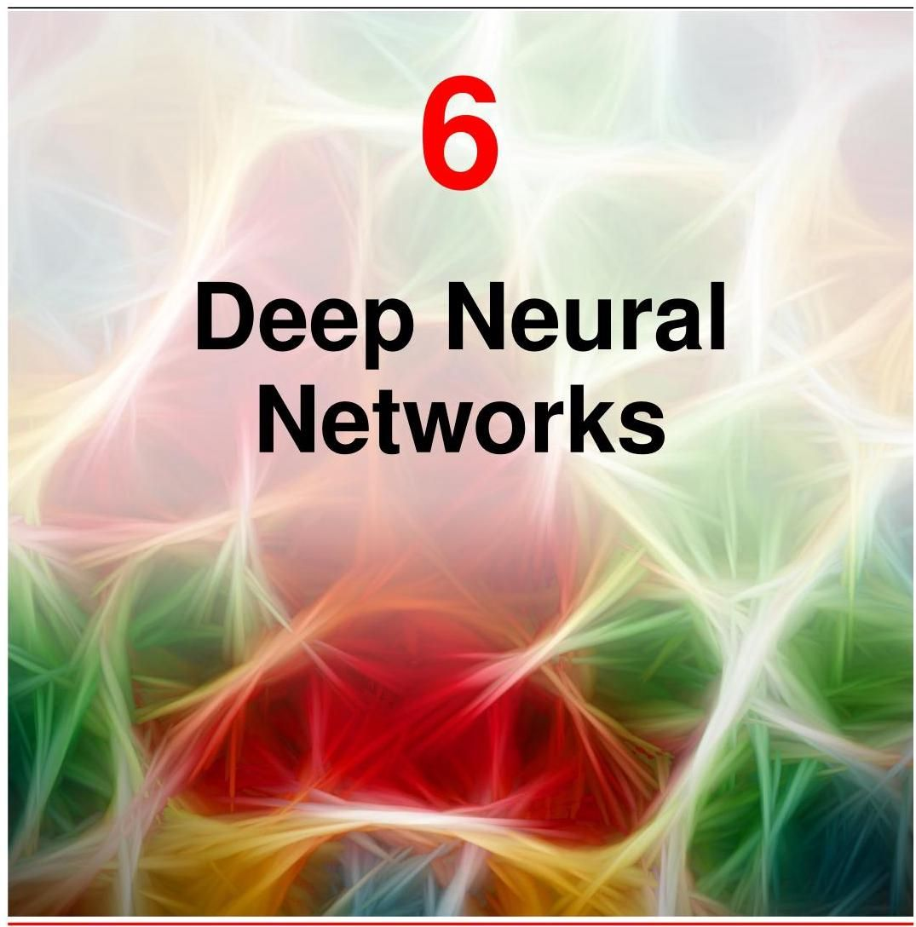

In recent years, neural networks have emerged as, by far, the most important machine learning technology for practical applications, and we therefore devote a large fraction of this book to studying them. Previous chapters have already laid many of the foundations we will need. In particular, we have seen that linear regression models that comprise linear combinations of fixed nonlinear basis functions can be

近年来，神经网络已成为目前实际应用中最重要的机器学习技术，因此我们在本书中用了很大篇幅来研究它们。前面的章节已经为我们奠定了许多所需的基础。特别是，我们已经看到，由固定非线性基函数的线性组合构成的线性回归模型可以

# Chapter 4

# 第4章

expressed as neural networks having a single layer of weight and bias parameters. Likewise, classification models based on linear combinations of basis functions can

表示为具有单层权重和偏置参数的神经网络。同样，基于基函数线性组合的分类模型也可以

# Chapter 5

# 第5章

also be viewed as single-layer neural networks. These allowed us to introduce several important concepts before we embark on a discussion of more complex multilayered networks in this chapter.

看作是单层神经网络。在本章开始讨论更复杂的多层网络之前，这些内容使我们能够引入几个重要的概念。

Given a sufficient number of suitably chosen basis functions, such linear models can approximate any given nonlinear transformation from inputs to outputs to any desired accuracy and might therefore appear to be sufficient to tackle any practical application. However, these models have some severe limitations, and so we will begin our discussion of neural networks by exploring these limitations and understanding why it is necessary to use basis functions that are themselves learned from data. This leads naturally to a discussion of neural networks having more than one layer of learnable parameters. These are known as feed-forward networks or multilayer perceptrons. We will also discuss the benefits of having many such layers of processing, leading to the key concept of deep neural networks that now dominate the field of machine learning.

给定足够数量且经过适当选择的基函数，此类线性模型可以以任意期望的精度逼近从输入到输出的任何给定非线性变换，因此似乎足以应对任何实际应用。然而，这些模型存在一些严重的局限性，因此我们将从探讨这些局限性并理解为何有必要使用从数据本身学习得到的基函数开始，来讨论神经网络。这自然会引出对具有多层可学习参数的神经网络的讨论。这些网络被称为前馈网络或多层感知机。我们还将讨论拥有多层处理的益处，从而引出如今在机器学习领域占据主导地位的深度神经网络这一关键概念。

Section 6.3.6

第 6.3.6 节

# 6.1. Limitations of Fixed Basis Functions

# 6.1. 固定基函数的局限性

Chapter 5

第 5 章

Linear basis function models for classification are based on linear combinations of basis functions and take the form

用于分类的线性基函数模型基于基函数 的线性组合，其形式为

where is a nonlinear output activation function. Linear models for regression take the same form but with replaced by the identity. These models allow for an arbitrary set of nonlinear basis functions , and because of the generality of these basis functions, such models can in principle provide a solution to any regression or classification problem. This is true in a trivial sense in that if one of the basis functions corresponds to the desired input-to-output transformation, then the learnable linear layer simply has to copy the value of this basis function to the output of the model.

其中 是非线性输出激活函数。用于回归的线性模型形式相同，但 被恒等函数取代。这些模型允许使用任意一组非线性基函数 ，并且由于这些基函数的通用性，原则上此类模型可以为任何回归或分类问题提供解决方案。从简单的意义上来说，如果其中一个基函数对应于所需的输入 - 输出变换，那么可学习的线性层只需将该基函数的值复制到模型的输出即可。

Chapter 4

第4章

More generally, we would expect that a sufficiently large and rich set of basis functions would allow any desired function to be approximated to arbitrary accuracy. It would seem therefore that such linear models constitute a general purpose framework for solving problems in machine learning. Unfortunately, there are some significant shortcomings with linear models, which arise from the assumption that the basis functions are fixed and independent of the training data. To understand these limitations, we start by looking at the behaviour of linear models as the number of input variables is increased.

更一般地，我们期望一组足够大且丰富的基函数能够以任意精度逼近任何所需的函数。因此，这样的线性模型似乎构成了解决机器学习问题的通用框架。不幸的是，线性模型存在一些显著的缺点，这些缺点源于基函数 是固定的且与训练数据无关的假设。为了理解这些局限性，我们首先考察随着输入变量数量的增加，线性模型的行为。

# 6.1.1 The curse of dimensionality

# 6.1.1 维数灾难

Consider a simple regression model for a single input variable given by a polynomial of order in the form

考虑一个针对单个输入变量的简单回归模型，其形式为 阶多项式

Section 1.2

第1.2节

and let us see what happens if we increase the number of inputs. If we have input variables , then a general polynomial with coefficients up to order 3 would take the form

让我们看看如果增加输入数量会发生什么。如果我们有 个输入变量 ，那么一个系数最高为3阶的一般多项式将采用以下形式

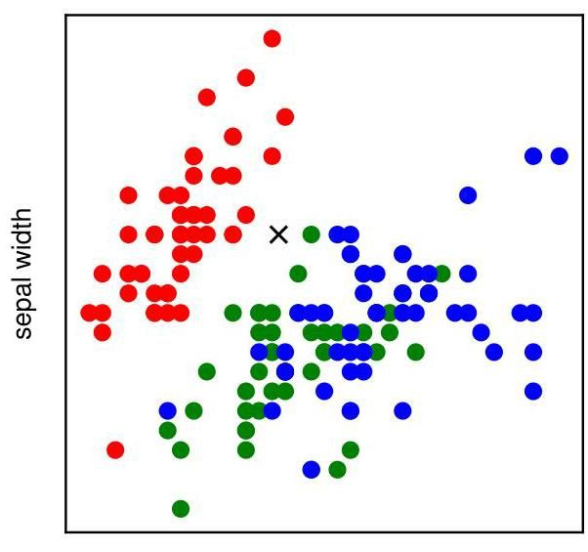

Figure 6.1 Plot of the Iris data in which red, green, and blue points denote three species of iris flower and the axes represent measurements of the length and width of the sepal, respectively. Our goal is to classify a new test point such as the one denoted by . sepal length

图 6.1 鸢尾花数据图，其中红色、绿色和蓝色点分别表示三种鸢尾花，坐标轴分别代表萼片长度和宽度的测量值。我们的目标是对一个新的测试点进行分类，例如由 表示的点。萼片长度

As increases, the growth in the number of independent coefficients is , whereas for a polynomial of order , the growth in the number of coefficients is (Bishop,2006). We see that in spaces of higher dimensionality, polynomials can rapidly become unwieldy and of little practical utility.

随着 的增加，独立系数数量的增长为 ，而对于阶数为 的多项式，系数数量的增长为 (Bishop，2006)。我们发现，在高维空间中，多项式会迅速变得难以处理且实际用途不大。

The severe difficulties that can arise in spaces of many dimensions is sometimes called the curse of dimensionality (Bellman, 1961). It is not limited to polynomial regression but is in fact quite general. Consider the use of linear models for solving classification problems. Figure 6.1 shows a plot of data from the Iris data set comprising 50 observations taken from each of three species of iris flowers. Each observation has four variables representing measurements of the sepal length, sepal width, petal length, and petal width. For this illustration, we consider only the sepal length and sepal width variables. Given these 150 observations as training data, our goal is to classify a new test point, such as the one denoted by the cross in Figure 6.1, by assigning it to one of the three species. We observe that the cross is close to several red points, and so we might suppose that it belongs to the red class. However, there are also some green points nearby, so we might think that it could instead belong to the green class. It seems less likely that it belongs to the blue class. The intuition here is that the identity of the cross should be determined more strongly by nearby points from the training set and less strongly by more distant points, and this intuition turns out to be reasonable.

在高维空间中可能出现的严重困难有时被称为维数灾难(Bellman，1961)。它不仅限于多项式回归，实际上非常普遍。考虑使用线性模型解决分类问题。图 6.1 展示了鸢尾花数据集的数据图，该数据集包含从三种鸢尾花中每种选取的 50 个观测值。每个观测值有四个变量，分别代表萼片长度、萼片宽度、花瓣长度和花瓣宽度的测量值。为了说明这一点，我们仅考虑萼片长度和萼片宽度这两个变量。以这 150 个观测值作为训练数据，我们的目标是对一个新的测试点进行分类，例如图 6.1 中用十字表示的点，将其分配到三种鸢尾花中的某一种。我们观察到十字靠近几个红色点，因此我们可能会认为它属于红色类别。然而，附近也有一些绿色点，所以我们可能会认为它可能属于绿色类别。它属于蓝色类别的可能性似乎较小。这里的直觉是，十字的类别应该更多地由训练集中的近邻点决定，而较少地由较远的点决定，事实证明这种直觉是合理的。

One very simple way of converting this intuition into a learning algorithm would be to divide the input space into regular cells, as indicated in Figure 6.2. When we are given a test point and we wish to predict its class, we first decide which cell it belongs to, and then we find all the training data points that fall in the same cell. The identity of the test point is predicted to be the same as the class having the largest number of training points in the same cell as the test point (with ties being broken at random). We can view this as a basis function model in which there is a basis function for each grid cell, which simply returns zero if lies outside the grid cell, and otherwise returns the majority class of the training data points that fall inside the cell. The output of the model is then given by the sum of the outputs of all the basis functions.

将这种直觉转化为学习算法的一种非常简单的方法是将输入空间划分为规则的单元格，如图 6.2 所示。当给定一个测试点并希望预测其类别时，我们首先确定它属于哪个单元格，然后找到所有落在同一单元格中的训练数据点。预测测试点的类别与该单元格中训练点数量最多的类别相同(若出现平局则随机选择)。我们可以将其视为一个基函数模型，其中每个网格单元格都有一个基函数 ，如果 位于网格单元格之外，则该基函数返回零，否则返回落在该单元格内的训练数据点的多数类别。然后，模型的输出由所有基函数的输出之和给出。

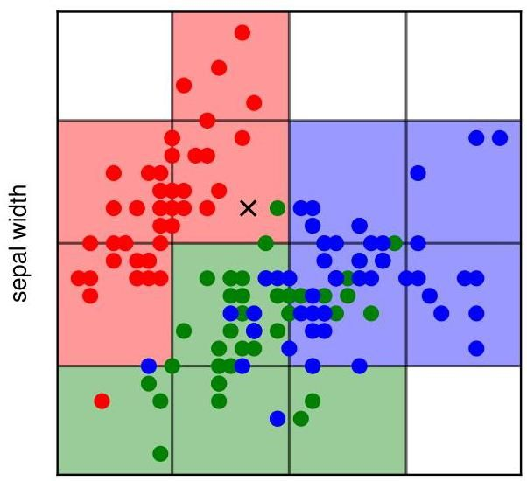

Figure 6.2 Illustration of a simple approach for solving classification problems in which the input space is divided into cells and any new test point is assigned to the class that has the most representatives in the same cell as the test point. As we shall see shortly, this simplistic approach has some severe shortcomings. sepal length

图 6.2 展示了一种解决分类问题的简单方法，其中输入空间被划分为单元格，任何新的测试点都被分配到与该测试点所在单元格中代表数量最多的类别。正如我们很快将看到的，这种简单的方法存在一些严重的缺点。萼片长度

There are numerous problems with this naive approach, but one of the most severe becomes apparent when we consider its extension to problems having larger numbers of input variables, corresponding to input spaces of higher dimensionality. The origin of the problem is illustrated in Figure 6.3, which shows that, if we divide a region of a space into regular cells, then the number of such cells grows exponentially with the dimensionality of the space. The challenge with an exponentially large number of cells is that we would need an exponentially large quantity of training data to ensure that the cells are not empty. We have already seen in Figure 6.2 that some cells contain no training points. Hence, a test point in such cells cannot be classified. Clearly, we have no hope of applying such a technique in a space of more than a few variables. The difficulties with both the polynomial regression example and the Iris data classification example arise because the basis functions were chosen independently of the problem being solved. We will need to be more sophisticated in our choice of basis functions if we are to circumvent the curse of dimensionality.

这种简单的方法存在许多问题，但当我们考虑将其扩展到具有更多输入变量(对应于更高维输入空间)的问题时，最严重的问题之一就会显现出来。问题的根源如图 6.3 所示，该图表明，如果我们将空间区域划分为规则的单元格，那么这些单元格的数量会随着空间维度的增加呈指数级增长。单元格数量呈指数级增长带来的挑战是，我们需要数量呈指数级增长的训练数据来确保单元格不为空。我们在图 6.2 中已经看到，一些单元格中没有训练点。因此，这些单元格中的测试点无法被分类。显然，我们不可能在具有多个变量的空间中应用这种技术。多项式回归示例和鸢尾花数据分类示例中出现的困难，是因为基函数的选择与要解决的问题无关。如果我们要克服维数灾难，就需要更巧妙地选择基函数。

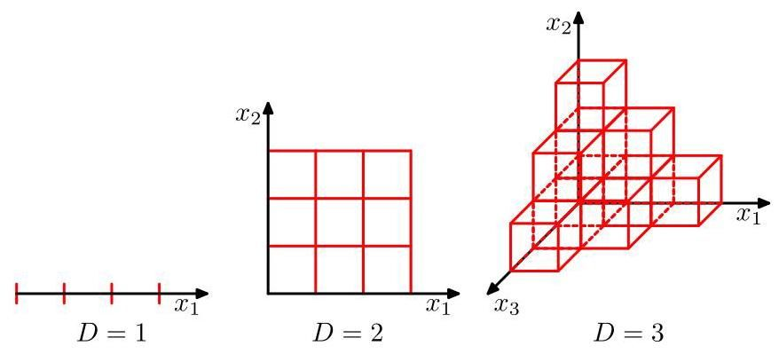

Figure 6.3 Illustration of the curse of dimensionality, showing how the number of regions of a regular grid grows exponentially with the dimensionality of the space. For clarity, only a subset of the cubical regions are shown for .

图 6.3 维数灾难的图示，展示了规则网格的区域数量如何随空间维数 呈指数增长。为清晰起见，对于 仅显示了立方体区域的一个子集。

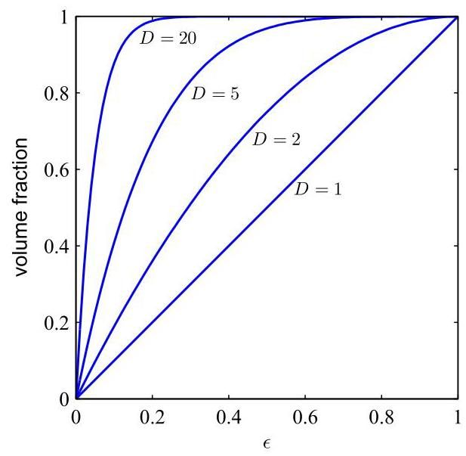

Figure 6.4 Plot of the fraction of the volume of a hypersphere of radius lying in the range to for various values of the dimensionality .

图 6.4 对于不同的维数 ，半径为 的超球体位于范围 到 内的体积分数图。

Section 6.1.4

第 6.1.4 节

# 6.1.2 High-dimensional spaces

# 6.1.2 高维空间

First, however, we will look more closely at the properties of spaces with higher dimensionality where our geometrical intuitions, formed through a life spent in a space of three dimensions, can fail badly. As a simple example, consider a hypersphere of radius in a space of dimensions, and ask what is the fraction of the volume of the hypersphere that lies between radius and . We can evaluate this fraction by noting that the volume of a hypersphere of radius in dimensions must scale as , and so we write

然而，首先我们将更仔细地研究高维空间的性质，在这些空间中，我们在三维空间中形成的几何直觉可能会严重失效。作为一个简单的例子，考虑在 维空间中半径为 的超球体，并询问该超球体位于半径 和 之间的体积分数是多少。我们可以通过注意到在 维空间中半径为 的超球体的体积 必须与 成比例来计算这个分数，因此我们可以写成

Exercise 6.1

练习 6.1

where the constant depends only on . Thus, the required fraction is given by

其中常数 仅依赖于 。因此，所需的比例由下式给出

which is plotted as a function of for various values of in Figure 6.4. We see that, for large , this fraction tends to 1 even for small values of . Thus, we arrive at the remarkable result that, in spaces of high dimensionality, most of the volume of a hypersphere is concentrated in a thin shell near the surface!

图 6.4 针对 的不同取值，绘制了该比例随 变化的函数曲线。我们看到，对于较大的 ，即使 取值较小，该比例也趋近于 1。因此，我们得到了一个显著的结果:在高维空间中，超球体的大部分体积集中在靠近表面的薄壳内！

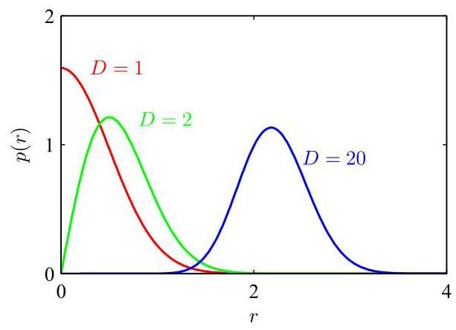

Figure 6.5 Plot of the probability density with respect to radius of a Gaussian distribution for various values of the dimensionality . In a high-dimensional space, most of the probability mass of a Gaussian is located within a thin shell at a specific radius.

图 6.5 针对不同的维度 ，绘制了高斯分布相对于半径 的概率密度曲线。在高维空间中，高斯分布的大部分概率质量位于特定半径处的薄壳内。

As a further example of direct relevance to machine learning, consider the behaviour of a Gaussian distribution in a high-dimensional space. If we transform from Cartesian to polar coordinates and then integrate out the directional variables, we obtain an expression for the density as a function of radius from the origin. Thus, is the probability mass inside a thin shell of thickness located at radius . This distribution is plotted, for various values of , in Figure 6.5, and we see that for large , the probability mass of the Gaussian is concentrated in a thin shell at a specific radius.

作为与机器学习直接相关的另一个例子，考虑高维空间中高斯分布的行为。如果我们从笛卡尔坐标转换为极坐标，然后对方向变量进行积分，我们可以得到密度 作为到原点半径 的函数表达式。因此， 是位于半径 处、厚度为 的薄壳内的概率质量。图 6.5 针对 的不同取值绘制了该分布曲线，我们看到，对于较大的 ，高斯分布的概率质量集中在特定半径处的薄壳内。

Exercise 6.3

练习 6.3

In this book, we make extensive use of illustrative examples involving one or two variables, because this makes it particularly easy to visualize these spaces graphically. The reader should be warned, however, that not all intuitions developed in spaces of low dimensionality will generalize to situations involving many dimensions.

在本书中，我们广泛使用涉及一个或两个变量的示例进行说明，因为这样可以特别容易地以图形方式直观呈现这些空间。然而，读者应该注意，并非所有在低维空间中形成的直觉都能推广到涉及多个维度的情况。

Finally, although we have talked about the curse of dimensionality, there can also be advantages to working in high-dimensional spaces. Consider the situation shown in Figure 6.6. We see that this data set, in which each data point consists of a pair of values , is linearly separable, but when only the value of is observed, the classes have a strong overlap. The classification problem is therefore much easier in the higher-dimensional space.

最后，尽管我们已经讨论了维数灾难，但在高维空间中工作也可能存在优势。考虑图 6.6 所示的情况。我们看到这个数据集，其中每个数据点由一对值 组成，是线性可分的，但当仅观察 的值时，类别之间存在强烈的重叠。因此，在高维空间中分类问题要容易得多。

# 6.1.3 Data manifolds

# 6.1.3 数据流形

With both the polynomial regression model and the grid-based classifier in Figure 6.2, we saw that the number of basis functions grows rapidly with dimensionality, making such methods impractical for applications involving even a few dozen variables, never mind the millions of inputs that often arise with, say, image processing. The problem is that the basis functions are fixed ahead of time and do not depend on the data, or indeed even on the specific problem being solved. We need to find a way to create basis functions that are tuned to the particular application.

在图 6.2 中的多项式回归模型和基于网格的分类器中，我们看到基函数的数量随维数迅速增长，这使得此类方法对于涉及即使只有几十个变量的应用也不切实际，更不用说在图像处理等应用中经常出现的数百万个输入了。问题在于基函数是预先固定的，不依赖于数据，甚至不依赖于正在解决的具体问题。我们需要找到一种方法来创建适合特定应用的基函数。

Although the curse of dimensionality certainly raises important issues for machine learning applications, it does not prevent us from finding effective techniques applicable to high-dimensional spaces. One reason for this is that real data will generally be confined to a region of the data space having lower effective dimensionality. Consider the images shown in Figure 6.7. Each image is a point in a high-dimensional space whose dimensionality is determined by the number of pixels. Because the objects can occur at different vertical and horizontal positions within the image and in different orientations, there are three degrees of freedom of variability between images, and a set of images will, to a first approximation, live on a three-dimensional manifold embedded within the high-dimensional space. Due to the complex relationships between the object position or orientation and the pixel intensities, this manifold will be highly nonlinear.

尽管维数灾难确实给机器学习应用带来了重要问题，但它并不妨碍我们找到适用于高维空间的有效技术。其中一个原因是，实际数据通常会局限于数据空间中有效维数较低的区域。考虑图 6.7 所示的图像。每个图像都是高维空间中的一个点，其维数由像素数量决定。由于物体可以在图像内以不同的垂直和水平位置以及不同的方向出现，图像之间存在三个自由度的变化，并且一组图像在一阶近似下将位于嵌入在高维空间中的三维流形上。由于物体位置或方向与像素强度之间的复杂关系，这个流形将是高度非线性的。

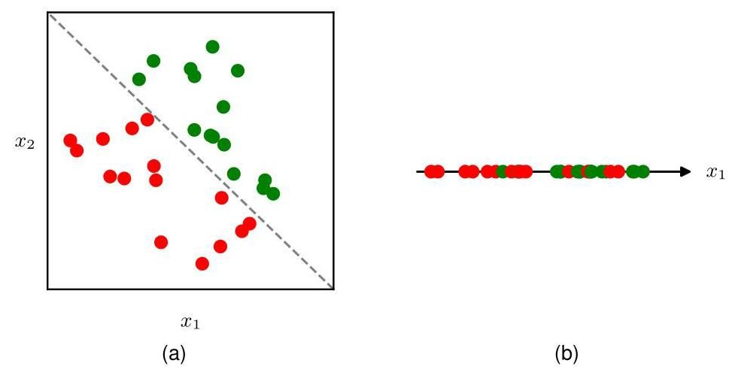

Figure 6.6 Illustration of a data set in two dimensions in which data points from the two classes depicted using green and red circles can be separated by a linear decision surface, as seen in (a). If, however, only the variable is measured then the classes are no longer separable, as seen in (b).

图 6.6 二维 数据集的图示，其中用绿色和红色圆圈表示的两个类别的数据点可以通过线性决策面分离，如图 (a) 所示。然而，如果仅测量变量 ，则类别不再可分，如图 (b) 所示。

In fact, the number of pixels is really an artefact of the image generation process since they represent measurements of a continuous world. Capturing the same image at a higher resolution increases the dimensionality of the data space without changing the fact that the images still live on a three-dimensional manifold. If we can associate localized basis functions with the data manifold, rather than with the entire high-dimensional data space, we might expect that the number of required basis functions would grow exponentially with the dimensionality of the manifold rather than with the dimensionality of the data space. Since the manifold will typically have a much lower dimensionality than the data space, this represents a huge improvement. Effectively, neural networks learn a set of basis functions that are adapted to data manifolds. Moreover, for a particular application, not all directions within the manifold may be significant. For example, if we wish to determine only the orientation, and not the position, of the object in Figure 6.7, then there is only one relevant degree of freedom on the manifold and not three. Neural networks are also able to learn which directions on the manifold are relevant to predicting the desired outputs.

实际上，像素数量实际上是图像生成过程的产物，因为它们代表对连续世界的测量。以更高的分辨率捕获同一图像会增加数据空间的维数 ，但不会改变图像仍然位于三维流形上这一事实。如果我们可以将局部基函数与数据流形相关联，而不是与整个高维数据空间相关联，我们可能期望所需基函数的数量将随流形的维数呈指数增长，而不是随数据空间的维数增长。由于流形的维数通常远低于数据空间的维数，这代表了巨大的改进。实际上，神经网络学习了一组适应数据流形的基函数。此外，对于特定应用，流形内并非所有方向都可能是重要的。例如，如果我们只想确定图 6.7 中物体的方向，而不是位置，那么流形上只有一个相关的自由度，而不是三个。神经网络还能够学习流形上哪些方向与预测所需输出相关。

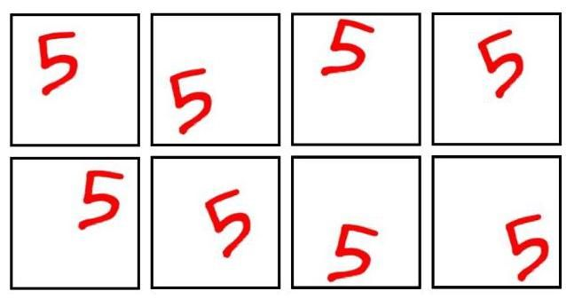

Figure 6.7 Examples of images of a handwritten digit that differ in the location of the digit within the images as well as in their orientation. This data lives on a nonlinear three-dimensional manifold within the high-dimensional image space.

图 6.7 手写数字图像的示例，这些图像中数字的位置以及方向各不相同。这些数据位于高维图像空间中的一个非线性三维流形上。

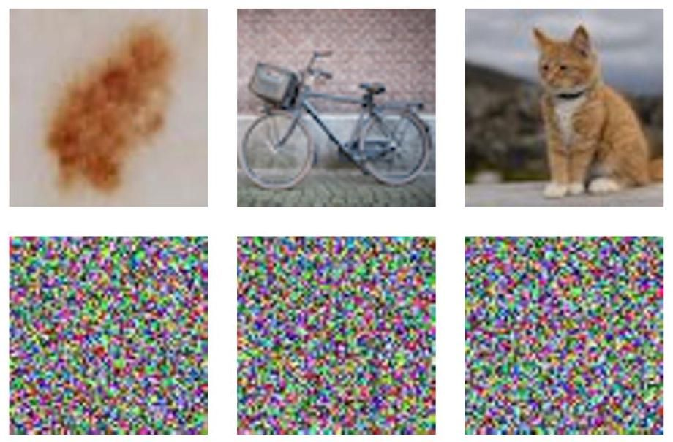

Figure 6.8 The top row shows examples of natural images of size pixels, whereas the bottom row shows randomly generated images of the same size obtained by drawing pixel values from a uniform probability distribution over the possible pixel colours.

图 6.8 顶行展示了尺寸为 像素的自然图像示例，而底行展示了通过从可能像素颜色的均匀概率分布中抽取像素值得到的相同尺寸的随机生成图像。

Another way to see that real data is confined to low-dimensional manifolds is to consider the task of generating random images. In Figure 6.8 we see examples of natural images along with examples of synthetic images of the same resolution generated by sampling each of the red, green, and blue intensities at each pixel independently at random from a uniform distribution. We see that none of the synthetic images look at all like natural images. The reason is that these random images lack the very strong correlations between pixels that natural images exhibit. For example, two adjacent pixels in a natural image have a much higher probability of having the same, or very similar, colour, than would two adjacent images in the random examples. Each of the images in Figure 6.8 corresponds to a point in a high-dimensional space, yet natural images cover only a tiny fraction of this space.

另一种理解真实数据局限于低维流形的方法是考虑生成随机图像的任务。在图 6.8 中，我们看到了自然图像的示例，以及通过从均匀分布中独立随机采样每个像素的红、绿、蓝强度生成的相同分辨率的合成图像示例。我们发现，没有一个合成图像看起来像自然图像。原因是这些随机图像缺乏自然图像所呈现的像素之间非常强的相关性。例如，自然图像中两个相邻像素具有相同或非常相似颜色的概率，比随机示例中两个相邻像素的概率要高得多。图 6.8 中的每个图像都对应于高维空间中的一个点，但自然图像只覆盖了这个空间的一小部分。

# 6.1.4 Data-dependent basis functions

# 6.1.4 依赖数据的基函数

We have seen that simple basis functions that are chosen independently of the problem being solved can run into significant limitations, particularly in spaces of high dimensionality. If we want to use basis functions in such situations, then one approach would be to use expert knowledge to hand-craft the basis functions in a way that is specific to each application. For many years, this was the mainstream approach in machine learning. Basis functions, often called features, would be determined by a combination of domain knowledge and trial-and-error. However, this approach met with limited success and was superseded by data-driven approaches in which basis functions are learned from the training data. Domain knowledge still plays a role in modern machine learning, but at a more qualitative level in designing network architectures where it can capture appropriate inductive bias, as we will see in later chapters.

我们已经看到，独立于待解决问题选择的简单基函数可能会遇到显著的局限性，特别是在高维空间中。如果我们想在这种情况下使用基函数，那么一种方法是利用专家知识，以针对每个应用的特定方式手工设计基函数。多年来，这一直是机器学习中的主流方法。基函数，通常称为特征，将由领域知识和反复试验的组合来确定。然而，这种方法取得的成功有限，并被数据驱动的方法所取代，在数据驱动的方法中，基函数是从训练数据中学习得到的。领域知识在现代机器学习中仍然发挥着作用，但在设计网络架构时处于更定性的层面，在这个层面上它可以捕捉适当的归纳偏置，我们将在后面的章节中看到。

Section 9.1

第 9.1 节

Since data in a high-dimensional space may be confined to a low-dimensional manifold, we do not need basis functions that densely fill the whole input space, but instead we can use basis functions that are themselves associated with the data manifold. One way to do this is to have one basis function associated with each data point in the training set, which ensures that the basis functions are automatically adapted to the underlying data manifold. An example of such a model is that of radial basis functions (Broomhead and Lowe, 1988), which have the property that each basis function depends only on the radial distance (typically Euclidean) from a central vector. If the basis centres are chosen to be the input data values then there is one basis function for each data point, which will therefore capture the whole of the data manifold. A typical choice for a radial basis function is

由于高维空间中的数据可能局限于低维流形，我们不需要能密集填充整个输入空间的基函数，而是可以使用与数据流形本身相关联的基函数。实现这一点的一种方法是为训练集中的每个数据点关联一个基函数，这确保了基函数能自动适应底层的数据流形。这种模型的一个例子是径向基函数(Broomhead 和 Lowe，1988)，其特性是每个基函数仅取决于与中心向量的径向距离(通常是欧几里得距离)。如果选择输入数据值 作为基中心，那么每个数据点都有一个基函数 ，因此可以捕捉整个数据流形。径向基函数的一个典型选择是

where is a parameter controlling the width of the basis function. Although it can be quick to set up such a model, a major problem with this technique is that it becomes computationally unwieldy for large data sets. Moreover, the model needs careful regularization to avoid severe over-fitting.

其中 是控制基函数宽度的参数。尽管建立这样的模型可能很快，但这种技术的一个主要问题是，对于大型数据集，其计算变得难以处理。此外，该模型需要仔细的正则化以避免严重的过拟合。

A related approach, called a support vector machine or SVM (Vapnik, 1995; Schölkopf and Smola, 2002; Bishop, 2006), addresses this by again defining basis functions that are centred on each of the training data points and then selecting a subset of these automatically during training. As a result, the effective number of basis functions in the resulting models is generally much smaller than the number of training points, although it is often still relatively large and typically increases with the size of the training set. Support vector machines also do not produce probabilistic outputs, and they do not naturally generalize to more than two classes. Methods such as radial basis functions and support vector machines have been superseded by deep neural networks, which are much better at exploiting very large data sets efficiently. Moreover, as we will see later, neural networks are able to learn deep hierarchical representations, which are crucial to achieving high prediction accuracy in more complex applications.

一种相关的方法，称为支持向量机(SVM)(Vapnik，1995；Schölkopf 和 Smola，2002；Bishop，2006)，通过再次定义以每个训练数据点为中心的基函数，然后在训练期间自动选择这些基函数的一个子集来解决这个问题。结果，所得模型中基函数的有效数量通常远小于训练点的数量，尽管它通常仍然相对较大，并且通常会随着训练集的大小而增加。支持向量机也不产生概率输出，并且它们不能自然地推广到两个以上的类别。诸如径向基函数和支持向量机之类的方法已被深度神经网络所取代，深度神经网络在有效利用非常大的数据集方面要好得多。此外，正如我们稍后将看到的，神经网络能够学习深度层次表示，这对于在更复杂的应用中实现高预测精度至关重要。

# 6.2. Multilayer Networks

# 6.2. 多层网络

In the previous section, we saw that to apply linear models of the form (6.1) to problems involving large-scale data sets and high-dimensional spaces, we need to find a set of basis functions that is tuned to the problem being solved. The key idea behind neural networks is to choose basis functions that themselves have learnable parameters and then allow these parameters to be adjusted, along with the coefficients , during training. We then optimize the whole model by minimizing an error function using gradient-based optimization methods, such as stochastic gradient descent, where the error function is defined jointly across all the parameters in the model.

在上一节中，我们看到要将形式为(6.1)的线性模型应用于涉及大规模数据集和高维空间的问题，我们需要找到一组针对所解决问题进行调整的基函数。神经网络背后的关键思想是选择本身具有可学习参数的基函数 ，然后允许在训练期间调整这些参数以及系数 。然后，我们使用基于梯度的优化方法(如随机梯度下降)最小化误差函数来优化整个模型，其中误差函数是在模型中的所有参数上联合定义的。

Chapter 7

第 7 章

There are, of course, many ways to construct parametric nonlinear basis functions. One key requirement is that they must be differentiable functions of their learnable parameters so that we can apply gradient-based optimization. The most successful choice has been to use basis functions that follow the same form as (6.1), so that each basis function is itself a nonlinear function of a linear combination of the inputs, where the coefficients in the linear combination are learnable parameters. Note that this construction can clearly be extended recursively to give a hierarchical model with many layers, which forms the basis for deep neural networks.

当然，有许多方法可以构造参数化非线性基函数。一个关键要求是，它们必须是其可学习参数的可微函数，以便我们可以应用基于梯度的优化方法。最成功的选择是使用与 (6.1) 形式相同的基函数，这样每个基函数本身就是输入的线性组合的非线性函数，其中线性组合的系数是可学习参数。请注意，这种构造显然可以递归扩展，以得到一个具有多层的分层模型，这构成了深度神经网络的基础。

Section 6.3

第 6.3 节

Consider a basic neural network model having two layers of learnable parameters. First, we construct linear combinations of the input variables in

考虑一个具有两层可学习参数的基本神经网络模型。首先，我们构造输入变量 的 个线性组合

the form

形式为

where , and the superscript (1) indicates that the corresponding parameters are in the first ’layer’ of the network. We will refer to the parameters as weights and the parameters as biases, while the quantities are called pre-activations. Each of the quantities is then transformed using a differentiable, nonlinear activation function to give

其中 ，上标 (1) 表示相应的参数位于网络的第一个 “层” 中。我们将参数 称为权重，将参数 称为偏置，而量 称为预激活值。然后，使用可微的非线性激活函数 对每个量 进行变换，得到

Chapter 4

第 4 章

which represent the outputs of the basis functions in (6.1). In the context of neural networks, these basis functions are called hidden units. We will explore various choices for the nonlinear function shortly, but here we note that provided the derivative can be evaluated, then the overall network function will be differentiable. Following (6.1), these values are again linearly combined to give

它们表示 (6.1) 中基函数的输出。在神经网络的背景下，这些基函数被称为隐藏单元。我们很快会探讨非线性函数 的各种选择，但这里我们注意到，只要导数 可以计算，那么整个网络函数就是可微的。根据 (6.1)，这些值再次进行线性组合得到

where , and is the total number of outputs. This transformation corresponds to the second layer of the network, and again the are bias parameters. Finally, the are transformed using an appropriate output-unit activation

其中 ，并且 是输出的总数。这种变换对应于网络的第二层，同样， 是偏置参数。最后， 使用适当的输出单元激活

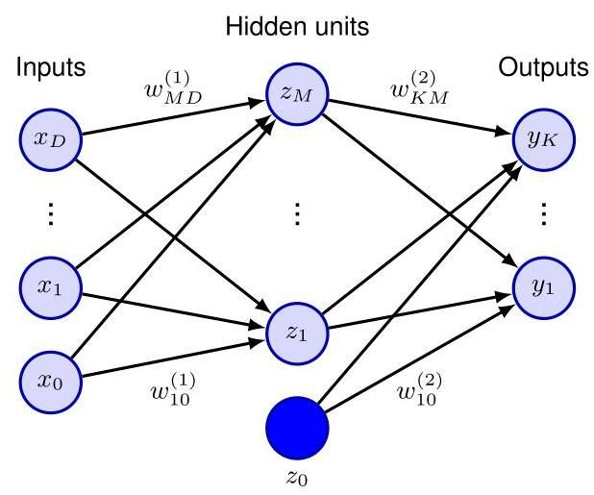

Figure 6.9 Network diagram for a two-layer neural network. The input, hidden, and output variables are represented by nodes, and the weight parameters are represented by links between the nodes. The bias parameters are denoted by links coming from additional input and hidden variables and which are themselves denoted by solid nodes. Arrows denote the direction of information flow through the network during forward propagation.

图 6.9 两层神经网络的网络图。输入、隐藏和输出变量由节点表示，权重参数由节点之间的链接表示。偏置参数由来自额外输入和隐藏变量 和 的链接表示，这些变量本身由实心节点表示。箭头表示前向传播期间信息在网络中流动的方向。

function to give a set of network outputs . A two-layer neural network can be represented in diagram form as shown in Figure 6.9.

函数 以得到一组网络输出 。两层神经网络可以用如图 6.9 所示的图表形式表示。

# 6.2.1 Parameter matrices

# 6.2.1 参数矩阵

Section 4.1.1

第 4.1.1 节

As we discussed in the context of linear regression models, the bias parameters in (6.7) can be absorbed into the set of weight parameters by defining an additional input variable whose value is clamped at , so that (6.7) takes the form

正如我们在线性回归模型的背景下所讨论的，通过定义一个额外的输入变量 并将其值固定为 ，可以将 (6.7) 中的偏置参数并入权重参数集合中，从而使 (6.7) 具有以下形式

We can similarly absorb the second-layer biases into the second-layer weights, so that the overall network function becomes

类似地，我们可以将第二层的偏置并入第二层的权重中，这样整个网络函数就变为

Another notation that will prove convenient at various points in the book is to represent the inputs as a column vector and then to gather the weight and bias parameters in (6.11) into matrices to give

本书中在多处会证明很方便的另一种表示方法是，将输入表示为列向量 ，然后将 (6.11) 中的权重和偏置参数合并成矩阵，得到

where and are evaluated on each vector element separately.

其中 和 分别对每个向量元素进行计算。

# 6.2.2 Universal approximation

# 6.2.2 通用逼近

The capability of a two-layer network to model a broad range of functions is illustrated in Figure 6.10. This figure also shows how individual hidden units work collaboratively to approximate the final function. The role of hidden units in a simple classification problem is illustrated in Figure 6.11.

两层网络对广泛函数进行建模的能力如图 6.10 所示。该图还展示了各个隐藏单元如何协同工作以逼近最终函数。图 6.11 展示了隐藏单元在简单分类问题中的作用。

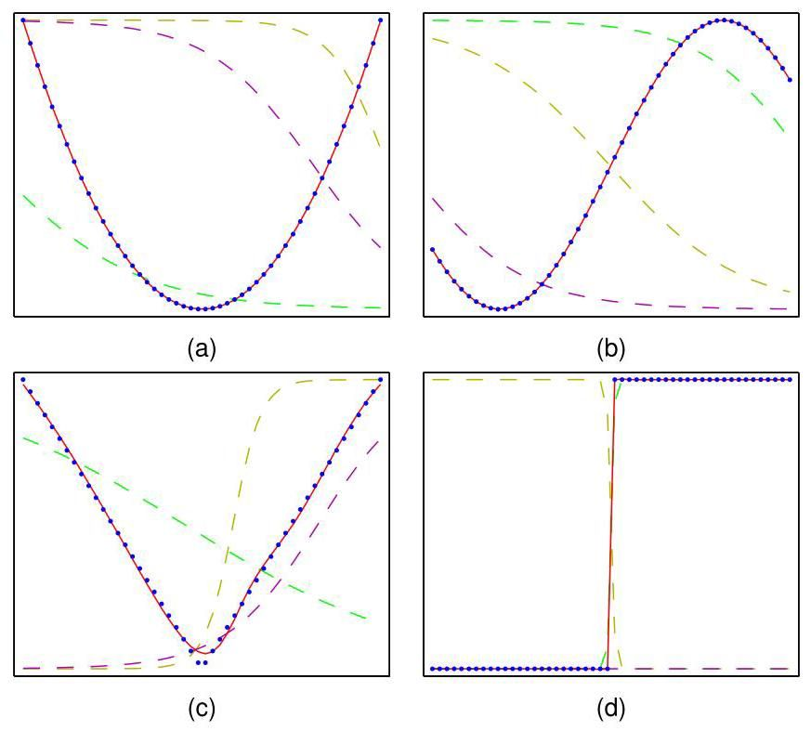

Figure 6.10 Illustration of the capability of a two-layer neural network to approximate four different functions: (a) ,(b) ,(c), , and (d) where is the Heaviside step function. In each case, data points, shown as blue dots, have been sampled uniformly in over the interval and the corresponding values of evaluated. These data points are then used to train a two-layer network having three hidden units with tanh activation functions and linear output units. The resulting network functions are shown by the red curves, and the outputs of the three hidden units are shown by the three dashed curves.

图 6.10 展示了两层神经网络逼近四种不同函数的能力:(a) ，(b) ，(c) ，以及 (d) ，其中 是海维赛德阶跃函数。在每种情况下， 个数据点(以蓝色圆点表示)已在区间 上的 中均匀采样，并计算了 的相应值。然后使用这些数据点来训练一个具有三个隐藏单元(采用双曲正切激活函数)和线性输出单元的两层网络。得到的网络函数由红色曲线表示，三个隐藏单元的输出由三条虚线曲线表示。

The approximation properties of two-layer feed-forward networks were widely studied in the 1980s, with various theorems showing that, for a wide range of activation functions, such networks can approximate any function defined over a continuous subset of to arbitrary accuracy (Funahashi,1989; Cybenko,1989; Hornik, Stinchcombe, and White, 1989; Leshno et al., 1993). A similar result holds for functions from any finite-dimensional discrete space to any another. Neural networks are therefore said to be universal approximators.

两层前馈网络的逼近特性在 20 世纪 80 年代得到了广泛研究，各种定理表明，对于广泛的激活函数，此类网络可以以任意精度逼近在 的连续子集上定义的任何函数(Funahashi，1989；Cybenko，1989；Hornik、Stinchcombe 和 White，1989；Leshno 等人，1993)。对于从任何有限维离散空间到任何其他空间的函数，也有类似的结果。因此，神经网络被称为通用逼近器。

Although such theorems are reassuring, they tell us only that there exists a network that can represent the required function. In some cases, they may require networks that have an exponentially large number of hidden units. Moreover, they say nothing about whether such a network can be found by a learning algorithm. Furthermore, we will see later that the no free lunch theorem says that we can never find a truly universal machine learning algorithm. Finally, although networks having two layers of weights are universal approximators, in a practical application, there can be huge benefits in considering networks having many more than two layers that can learn hierarchical internal representations. All these points support the drive towards deep learning.

尽管这些定理让人放心，但它们只告诉我们存在一个可以表示所需函数的网络。在某些情况下，可能需要具有指数级大量隐藏单元的网络。此外，它们没有说明是否可以通过学习算法找到这样的网络。此外，我们稍后会看到，没有免费午餐定理表明我们永远无法找到真正通用的机器学习算法。最后，尽管具有两层权重的网络是通用逼近器，但在实际应用中，考虑具有两层以上的网络可能会有巨大的好处，因为这些网络可以学习分层的内部表示。所有这些观点都推动了深度学习的发展。

Section 9.1.2

第 9.1.2 节

# 6.2.3 Hidden unit activation functions

# 6.2.3 隐藏单元激活函数

We have seen that the activation functions for the output units are determined by the kind of distribution being modelled. For the hidden units, however, the only requirement is that they need to be differentiable, which leaves a wide range of pos-

我们已经看到，输出单元的激活函数由所建模的分布类型决定。然而，对于隐藏单元，唯一的要求是它们需要是可微的，这留下了广泛的……

Figure 6.11 Example of the solution of a simple two-class classification problem involving synthetic data using a neural network having two inputs, two hidden units with tanh activation functions, and a single output having a logistic-sigmoid activation function. The dashed blue lines show the contours for each of the hidden units, and the red line shows the 0.5 decision surface for the network. For comparison, the green lines denote the optimal decision boundary computed from the distributions used to generate the data. sibilities. In most cases, all the hidden units in a network will be given the same activation function, although in principle there is no reason why different choices could not be applied in different parts of the network.

图 6.11 一个使用神经网络解决简单两类分类问题的示例，该问题涉及合成数据。神经网络有两个输入、两个使用双曲正切激活函数的隐藏单元和一个使用逻辑 S 型激活函数的输出。蓝色虚线显示了每个隐藏单元的 等高线，红色线显示了网络的 0.5 决策面。为作比较，绿色线表示根据用于生成数据的分布计算出的最优决策边界。可能性。在大多数情况下，网络中的所有隐藏单元将被赋予相同的激活函数，尽管原则上没有理由不能在网络的不同部分应用不同的选择。

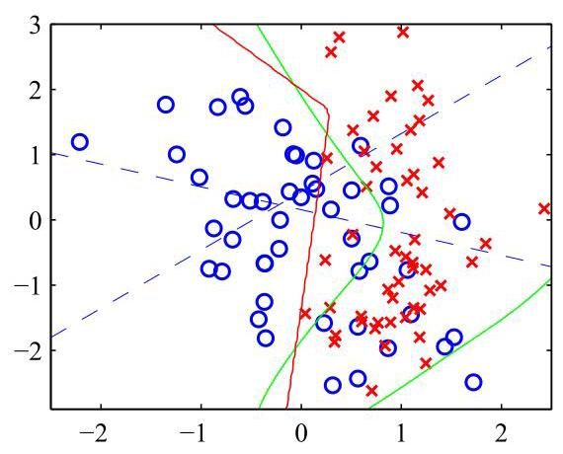

The simplest option for a hidden unit activation function is the identity function, which means that all the hidden units become linear. However, for any such network, we can always find an equivalent network without hidden units. This follows from the fact that the composition of successive linear transformations is itself a linear transformation, and so its representational capability is no greater than that of a single linear layer. However, if the number of hidden units is smaller than either the number of input or output units, then the transformations that such a network can generate are not the most general possible linear transformation from inputs to outputs because information is lost in the dimensionality reduction at the hidden units. Consider a network with inputs, hidden units, and outputs, and where all activation functions are linear. Such a network has parameters, whereas a linear transformation of inputs directly to outputs would have parameters. If is small relative to or , or both, this leads to a two-layer linear network having fewer parameters than the direct linear mapping, corresponding to a rank-deficient transformation. Such ’bottleneck’ networks of linear units corresponds to a standard data analysis technique called principal component analysis. In general, however, there is limited interest in using multilayer networks of linear units since the overall function computed by such a network is still linear.

隐藏单元激活函数最简单的选择是恒等函数，这意味着所有隐藏单元都变为线性的。然而，对于任何这样的网络，我们总能找到一个没有隐藏单元的等效网络。这是因为连续线性变换的组合本身就是一个线性变换，因此其表示能力并不比单个线性层更强。然而，如果隐藏单元的数量小于输入单元或输出单元的数量，那么这样的网络所能生成的变换并不是从输入到输出的最一般的线性变换，因为在隐藏单元的降维过程中信息会丢失。考虑一个有 个输入、 个隐藏单元和 个输出的网络，并且所有激活函数都是线性的。这样的网络有 个参数，而将输入直接线性变换到输出则有 个参数。如果 相对于 或 或两者都较小，这会导致一个两层线性网络的参数比直接线性映射的参数少，对应于一个秩亏变换。这种线性单元的“瓶颈”网络对应于一种称为主成分分析的标准数据分析技术。然而，一般来说，使用线性单元的多层网络的意义有限，因为这样的网络所计算的整体函数仍然是线性的。

Chapter 16

第 16 章

A simple, nonlinear differentiable function is the logistic sigmoid given by

一个简单的非线性可微函数是由下式给出的逻辑 S 型函数

which is plotted in Figure 5.12. This was widely used in the early years of work on multilayer neural networks and was partly inspired by studies of the properties of

它绘制在图 5.12 中。在多层神经网络研究的早期，该函数被广泛使用，部分灵感来自于对……特性的研究

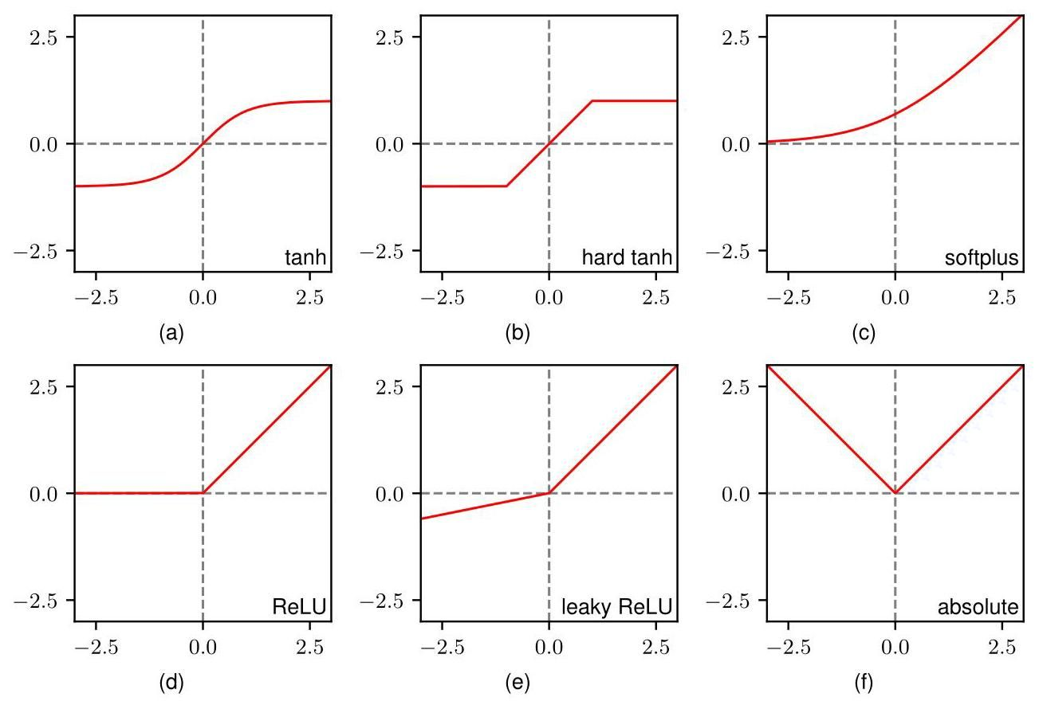

Figure 6.12 A variety of nonlinear activation functions.

图 6.12 各种非线性激活函数。

biological neurons. A closely related function is tanh, which is defined by

生物神经元。一个密切相关的函数是双曲正切函数(tanh)，其定义为

which is plotted in Figure 6.12(a). This function differs from the logistic sigmoid by a linear transformation of its input and its output values, and so for any network with logistic-sigmoid hidden-unit activation functions, there is an equivalent network

该函数如图 6.12(a) 所示。此函数与逻辑 sigmoid 函数的区别在于其输入和输出值的线性变换，因此对于任何具有逻辑 sigmoid 隐藏单元激活函数的网络，都存在一个等效的网络

# Exercise 6.4

# 练习 6.4

with tanh activation functions. However, when training a network, these are not necessarily equivalent because for gradient-based optimization, the network weights and biases need to be initialized, and so if the activation functions are changed, then the initialization scheme must be adjusted accordingly. A ’hard’ version of the tanh function (Collobert, 2004) is given by

使用双曲正切(tanh)激活函数。然而，在训练网络时，它们不一定等效，因为对于基于梯度的优化，需要初始化网络权重和偏置，所以如果改变激活函数，则必须相应地调整初始化方案。双曲正切(tanh)函数的一个“硬”版本(Collobert，2004)定义为

and is plotted in Figure 6.12(b).

并如图 6.12(b) 所示。

A major drawback of both the logistic sigmoid and the tanh activation functions is that the gradients go to zero exponentially when the inputs have either large positive or large negative values. We will discuss this ’vanishing gradients’ issue later, but for the moment, we note that it will generally be better to use activation functions with non-zero gradients, at least when the input takes a large positive value. One such choice is the softplus activation function given by

逻辑 sigmoid 函数和双曲正切(tanh)激活函数的一个主要缺点是，当输入具有较大的正值或较大的负值时，梯度会呈指数级趋近于零。我们稍后将讨论这个“梯度消失”问题，但目前，我们注意到，至少当输入取较大正值时，使用具有非零梯度的激活函数通常会更好。一个这样的选择是由以下公式给出的软加(softplus)激活函数

Section 7.4.2

第7.4.2节

Exercise 6.7

练习6.7

which is plotted in Figure 6.12(c). For , we have , and so the gradient remains non-zero even when the input to the activation function is large and positive, thereby helping to alleviate the vanishing gradients problem.

其绘制于图6.12(c)中。对于 ，我们有 ，因此即使激活函数的输入很大且为正时，梯度仍然不为零，从而有助于缓解梯度消失问题。

An even simpler choice of activation function is the rectified linear unit or ReLU, which is defined by

一种更简单的激活函数选择是修正线性单元(ReLU)，其定义为

and which is plotted in Figure 6.12(d). Empirically, this is one of the best-performing activation functions, and it is in widespread use. Note that strictly speaking, the derivative of the ReLU function is not defined when , but in practice this can be safely ignored. The softplus function (6.16) can be viewed as a smoothed version of the ReLU and is therefore also sometimes called soft ReLU.

其绘制于图6.12(d)中。根据经验，这是性能最佳的激活函数之一，并且被广泛使用。请注意，严格来说，当 时，ReLU函数的导数未定义，但在实践中可以安全地忽略这一点。软加函数(6.16)可以看作是ReLU的平滑版本，因此有时也称为软ReLU。

Exercise 6.5

练习6.5

Although the ReLU has a non-zero gradient for positive input values, this is not the case for negative inputs, which can mean that some hidden units receive no ’error signal’ during training. A modification of ReLU that seeks to avoid this issue is called a leaky and is defined by

尽管 ReLU 对于正输入值具有非零梯度，但对于负输入并非如此，这可能意味着某些隐藏单元在训练期间不会接收到“误差信号”。为避免此问题而对 ReLU 进行的一种修改称为带泄漏的 ，其定义为

where . This function is plotted in Figure 6.12(e). Unlike ReLU, this has a nonzero gradient for input values , which ensures that there is a signal to drive training. A variant of this activation function uses , in which case , which is plotted in Figure 6.12(f). Another variant allows each hidden unit to have its own value , which can be learned during network training by evaluating gradients with respect to the along with the gradients with respect to the weights and biases.

其中 。该函数如图 6.12(e) 所示。与 ReLU 不同，对于输入值 ，它具有非零梯度，这确保了存在驱动训练的信号。此激活函数的一个变体使用 ，在这种情况下 ，如图 6.12(f) 所示。另一个变体允许每个隐藏单元有其自己的值 ，该值可以在网络训练期间通过评估关于 的梯度以及关于权重和偏置的梯度来学习。

The introduction of ReLU gave a big improvement in training efficiency over previous sigmoidal activation functions (Krizhevsky, Sutskever, and Hinton, 2012). As well as allowing deeper networks to be trained efficiently, it is much less sensitive to the random initialization of the weights. It is also well suited to a low-precision implementation, such as 8-bit fixed versus 64-bit floating point, and it is computationally cheap to evaluate. Many practical applications simply use ReLU units as the default unless the goal is explicitly to explore the effects of different choices of activation function.

ReLU 的引入相对于之前的 S 形激活函数在训练效率上有了很大的提升(Krizhevsky、Sutskever 和 Hinton，2012 年)。它不仅允许高效地训练更深的网络，而且对权重的随机初始化不太敏感。它也非常适合低精度实现，例如 8 位定点与 64 位浮点，并且计算成本较低。许多实际应用只是简单地将 ReLU 单元作为默认选择，除非目标明确是探索不同激活函数选择的效果。

# 6.2.4 Weight-space symmetries

# 6.2.4 权重空间对称性

One property of feed-forward networks is that multiple distinct choices for the weight vector can all give rise to the same mapping function from inputs to outputs (Chen, Lu, and Hecht-Nielsen, 1993). Consider a two-layer network of the form shown in Figure 6.9 with hidden units having tanh activation functions and full connectivity in both layers. If we change the sign of all the weights and the bias feeding into a particular hidden unit, then, for a given input data point, the sign of the pre-activation of the hidden unit will be reversed, and therefore so too will the activation, because tanh is an odd function, so that . This transformation can be exactly compensated for by changing the sign of all the weights leading out of that hidden unit. Thus, by changing the signs of a particular group of weights (and a bias), the input-output mapping function represented by the network is unchanged, and so we have found two different weight vectors that give rise to the same mapping function. For hidden units, there will be such ’sign-flip’ symmetries, and thus, any given weight vector will be one of a set equivalent weight vectors .

前馈网络的一个特性是，权重向量 的多个不同选择都可以产生从输入到输出的相同映射函数(Chen、Lu 和 Hecht - Nielsen，1993 年)。考虑图 6.9 所示形式的两层网络，其中 个隐藏单元具有双曲正切激活函数，并且两层均为全连接。如果我们改变输入到某个特定隐藏单元的所有权重和偏置的符号，那么对于给定的输入数据点，该隐藏单元的预激活值的符号将反转，因此激活值也会反转，因为双曲正切是奇函数，即 。通过改变从该隐藏单元输出的所有权重的符号，可以完全补偿这种变换。因此，通过改变特定一组权重(和一个偏置)的符号，网络所表示的输入 - 输出映射函数保持不变，这样我们就找到了两个不同的权重向量，它们产生相同的映射函数。对于 个隐藏单元，将有 个这样的“符号翻转”对称性，因此，任何给定的权重向量将是一组 个等效权重向量中的一个。

Similarly, imagine that we interchange the values of all of the weights (and the bias) leading both into and out of a particular hidden unit with the corresponding values of the weights (and bias) associated with a different hidden unit. Again, this clearly leaves the network input-output mapping function unchanged, but it corresponds to a different choice of weight vector. For hidden units, any given weight vector will belong to a set of ! equivalent weight vectors associated with this interchange symmetry, corresponding to the ! different orderings of the hidden units. The network will therefore have an overall weight-space symmetry factor of . For networks with more than two layers of weights, the total level of symmetry will be given by the product of such factors, one for each layer of hidden units.

类似地，假设我们将输入和输出到某个特定隐藏单元的所有权重(和偏置)的值与另一个不同隐藏单元对应的权重(和偏置)的值进行交换。同样，这显然会使网络的输入 - 输出映射函数保持不变，但它对应于权重向量的不同选择。对于 个隐藏单元，任何给定的权重向量将属于与这种交换对称性相关的一组 ! 个等效权重向量，对应于隐藏单元的 ! 种不同排序。因此，网络将具有 的总体权重空间对称因子。对于具有两层以上权重的网络，总对称水平将由这些因子的乘积给出，每个隐藏单元层对应一个因子。

It turns out that these factors account for all the symmetries in weight space (except for possible accidental symmetries due to specific choices for the weight values). Furthermore, the existence of these symmetries is not a particular property of the tanh function but applies to a wide range of activation functions (Kurková and Kainen, 1994). In general, these symmetries in weight space are of little practical consequence, since network training aims to find a specific setting for the parameters, and the existence of other, equivalent, settings is of little consequence. However, weight-space symmetries do play a role when Bayesian methods are used to evaluate the probability distribution over networks of different sizes (Bishop, 2006).

事实证明，这些因素解释了权重空间中的所有对称性(除了由于权重值的特定选择可能产生的偶然对称性)。此外，这些对称性的存在并非双曲正切函数的特殊性质，而是适用于广泛的激活函数(Kurková 和 Kainen，1994)。一般来说，权重空间中的这些对称性在实际应用中影响不大，因为网络训练旨在为参数找到特定的设置，而其他等效设置的存在影响甚微。然而，当使用贝叶斯方法评估不同规模网络的概率分布时，权重空间对称性确实会发挥作用(Bishop，2006)。

# 6.3. Deep Networks

# 6.3. 深度网络

We have motivated the development of neural networks by making the basis functions of a linear regression or classification model themselves be governed by learnable parameters, giving rise to the two-layer network model shown in Figure 6.9. For many years, this was the most widely used architecture, primarily because it proved difficult to train networks with more than two layers effectively. However, extending neural networks to have more than two layers, known as deep neural networks, brings many advantages as we will discuss shortly, and recent advances in techniques for training neural networks are effective for networks with many layers.

我们通过使线性回归或分类模型的基函数本身由可学习的参数控制，推动了神经网络的发展，从而产生了图 6.9 所示的两层网络模型。多年来，这是应用最广泛的架构，主要是因为事实证明，有效训练两层以上的网络很困难。然而，将神经网络扩展到两层以上(即深度神经网络)会带来许多优势，我们将很快讨论这些优势，并且最近在神经网络训练技术方面的进展对多层网络很有效。

Chapter 7

第 7 章

We can easily extend the two-layer network architecture (6.12) to any finite number of layers, in which layer computes the following function:

我们可以轻松地将两层网络架构(6.12)扩展到任意有限数量 的层，其中第 层计算以下函数:

where denotes the activation function associated with layer , and denotes the corresponding matrix of weight and bias parameters. Also, represents the input vector and represents the output vector.

其中 表示与第 层相关联的激活函数， 表示相应的权重和偏置参数矩阵。此外， 表示输入向量， 表示输出向量。

Note that there has been some confusion in the literature regarding the terminology for counting the number of layers in such networks. Thus, the network in Figure 6.9 is sometimes described as a three-layer network (which counts the number of layers of units and treats the inputs as units) or sometimes as a single-hidden-layer network (which counts the number of layers of hidden units). We recommend a terminology in which Figure 6.9 is called a two-layer network, because it is the number of layers of learnable weights that is important for determining the network properties.

请注意，文献中在对这类网络的层数进行计数的术语方面存在一些混淆。因此，图 6.9 中的网络有时被描述为三层网络(这种计数方式统计单元层的数量，并将输入视为单元)，有时又被描述为单隐藏层网络(这种计数方式统计隐藏单元层的数量)。我们建议采用一种术语，将图 6.9 中的网络称为两层网络，因为对于确定网络属性而言，可学习权重的层数才是重要的。

We have seen that a network of the form shown in Figure 6.9, having two layers of learnable parameters, has universal approximation capabilities. However, networks with more than two layers can sometimes represent a given function with far fewer parameters than a two-layer network. Montúfar et al. (2014) show that the network function divides the input space into a number of regions that is exponential in the depth of the network, but which is only polynomial in the width of the hidden layers. To represent the same function using a two-layer network would require an exponential number of hidden units.

我们已经看到，图 6.9 所示形式的网络具有两层可学习参数，具备通用逼近能力。然而，层数超过两层的网络有时可以用比两层网络少得多的参数来表示给定的函数。Montúfar 等人(2014)表明，网络函数将输入空间划分为多个区域，区域数量与网络深度呈指数关系，但与隐藏层宽度仅呈多项式关系。若要使用两层网络来表示相同的函数，则需要指数数量的隐藏单元。

# 6.3.1 Hierarchical representations

# 6.3.1 分层表示

Although this is an interesting result, a more compelling reason to explore deep neural networks is that the network architecture encodes a particular form of inductive bias, namely that the outputs are related to the input space through a hierarchical representation. A good example is the task of recognizing objects in images. The relationship between the pixels of an image and a high-level concept such as ’cat’ is highly complex and nonlinear, and would be an extremely challenging problem for a two-layer network. However, a deep neural network can learn to detect low-level features, such as edges, in the early layers, and can then combine these in subsequent layers to make higher-level features such as eyes or whiskers, which in turn can be combined in later layers to detect the presence of a cat. This can be viewed as a compositional inductive bias, in which higher-level objects, such as a cat, are composed of lower-level objects, such as eyes, which in turn have yet lower-level elements such as edges. We can also think of this in reverse by considering the process of generating an image starting with low-level features such as edges, then combining these to form simple shapes such as circles, and then combining those in turn to form higher-level objects such as cats. At each stage there are many ways to combine different components, giving an exponential gain in the number of possibilities with increasing depth.

尽管这是一个有趣的结果，但探索深度神经网络更有说服力的原因是，网络架构编码了一种特定形式的归纳偏置，即输出通过分层表示与输入空间相关联。一个很好的例子是图像中的物体识别任务。图像像素与诸如“猫”这样的高级概念之间的关系是高度复杂且非线性的，对于两层网络来说，这将是一个极具挑战性的问题。然而，深度神经网络可以在早期层学习检测低级特征，如边缘，然后在后续层将这些特征组合起来形成更高级的特征，如眼睛或胡须，进而在更后面的层中组合这些高级特征以检测猫的存在。这可以被视为一种组合式归纳偏置，其中像猫这样的高级物体由像眼睛这样的低级物体组成，而眼睛又由像边缘这样更低级的元素组成。我们也可以反过来思考，考虑从边缘这样的低级特征开始生成图像的过程，然后将这些特征组合成圆形等简单形状，再将这些简单形状组合成猫等高级物体。在每个阶段，都有许多种组合不同组件的方式，随着网络深度的增加，可能性的数量呈指数级增长。

Chapter 10

第 10 章

# 6.3.2 Distributed representations

# 6.3.2 分布式表示

Neural networks can take advantage of another form of compositionality called a distributed representation. Conceptually, each unit in a hidden layer can be thought of as representing a ’feature’ at that level of the network, with a high value of the activation indicating that the corresponding feature is present and a low value indicating its absence. With units in a given layer, such a network can represent different features. However, the network could potentially learn a different representation in which combinations of hidden units represent features, thereby potentially allowing a hidden layer with units to represent different features, growing exponentially with the number of units. Consider, for example, a network designed to process images of faces. Each particular face image may or may not have glasses, it may or may not have a hat, and it may or may not have a beard, leading to eight different combinations. Although this could be represented by eight units each of which ’turns on’ when it detects the corresponding combination, it could also be represented more compactly by just three units, one for each attribute. These can be present independently of each other (although statistically their presence is likely to be correlated to some degree). Later, we will explore in detail the kinds of internal representations that deep learning networks discover for themselves during training.

神经网络可以利用另一种称为分布式表示的组合性形式。从概念上讲，隐藏层中的每个单元都可以被视为在网络的该层表示一个“特征”，激活值高表示相应特征存在，激活值低表示相应特征不存在。在给定层中有 个单元的情况下，这样的网络可以表示 个不同的特征。然而，网络有可能学习到一种不同的表示，其中隐藏单元的组合表示特征，从而有可能使具有 个单元的隐藏层能够表示 个不同的特征，特征数量随单元数量呈指数增长。例如，考虑一个旨在处理人脸图像的网络。每张特定的人脸图像可能有也可能没有眼镜，可能有也可能没有帽子，可能有也可能没有胡须，这就产生了八种不同的组合。虽然这可以用八个单元来表示，每个单元在检测到相应组合时“开启”，但也可以更紧凑地用三个单元来表示，每个属性对应一个单元。这些属性可以相互独立存在(尽管从统计上看，它们的存在可能在一定程度上相关)。稍后，我们将详细探讨深度学习网络在训练过程中自行发现的各种内部表示。

Chapter 10

第 10 章

# 6.3.3 Representation learning

# 6.3.3 表示学习

We can view the successive layers of a deep neural network as performing transformations of the data, that make it easier to solve the desired task or tasks. For example, a neural network that successfully learns to classify skin lesions as benign or malignant must have learned to transform the original image data into a new space, represented by the outputs of the final layer of hidden units, such that the final layer of the network can distinguish the two classes. This final layer can be viewed as a simple linear classifier, and so in the representation of the last hidden layer, the two classes must be well separated by a linear surface. This ability to discover a nonlinear transformation of the data that makes subsequent tasks easier to solve is called representation learning (Bengio, Courville, and Vincent, 2012). The learned representation, sometimes called the embedding space, is given by the outputs of one of the hidden layers of the network, so that any input vector, either from the training set or from some new data set, can be transformed into this representation by forward propagation through the network.

我们可以将深度神经网络的连续层视为对数据进行变换，从而使解决所需任务变得更容易。例如，一个成功学会将皮肤病变分类为良性或恶性的神经网络，必定已经学会将原始图像数据转换到一个新的空间，这个空间由隐藏单元最后一层的输出表示，这样网络的最后一层就可以区分这两类。这最后一层可以被视为一个简单的线性分类器，因此在最后一个隐藏层的表示中，这两类必须能被一个线性表面很好地分开。发现一种能使后续任务更易于解决的数据非线性变换的能力被称为表示学习(Bengio、Courville 和 Vincent，2012)。学习到的表示，有时也称为嵌入空间，由网络的某个隐藏层的输出给出，这样，任何输入向量，无论是来自训练集还是来自某个新数据集，都可以通过网络的前向传播转换为这种表示。

Section 1.1.1

1.1.1 节

Representation learning is especially powerful because it allows us to exploit unlabelled data. Often it is easy to collect a large quantity of unlabelled data, but acquiring the associated labels may be more difficult. For example, a video camera on a vehicle can gather large numbers of images of urban scenes as the vehicle is driven around a city, but taking those images and identifying relevant objects, such as pedestrians and road signs, would require expensive and time-consuming human labelling.

表示学习特别强大，因为它使我们能够利用未标记的数据。通常，收集大量未标记的数据很容易，但获取相关的标签可能更困难。例如，车辆上的摄像机在车辆行驶于城市中时可以收集大量城市场景的图像，但要对这些图像进行处理并识别相关对象，如行人和路标，则需要昂贵且耗时的人工标注。

Learning from unlabelled data is called unsupervised learning, and many different algorithms have been developed to do this. For example, a neural network can be trained to take images as input and to create the same images as the output. To make this into a non-trivial task, the network may use hidden layers with fewer units than the number of pixels in the image, thereby forcing the network to learn some kind of compression of the images. Only unlabelled data is needed because each image in the training set acts as both the input vector and the target vector. Such networks are known as autoencoders. The goal is that this type of training will force the network to discover some internal representation for the data that is useful for solving other tasks, such as image classification.

从无标签数据中学习被称为无监督学习，并且已经开发出许多不同的算法来实现这一点。例如，可以训练一个神经网络以图像作为输入，并生成相同的图像作为输出。为了使这成为一个非平凡的任务，网络可能会使用隐藏层，其单元数量少于图像中的像素数量，从而迫使网络学习某种图像压缩方法。只需要无标签数据，因为训练集中的每个图像既充当输入向量，又充当目标向量。这种网络被称为自编码器。目标是，这种类型的训练将迫使网络发现数据的某种内部表示，这种表示对于解决其他任务(如图像分类)是有用的。

Section 19.1

第19.1节

Historically, unsupervised learning played an important role in enabling the first deep networks (apart from convolutional networks) to be successfully trained. Each layer of the network was first pre-trained using unsupervised learning and then the entire network was trained further using gradient-based supervised training. It was later discovered that the pre-training phase could be omitted and a deep network could be trained from scratch purely using supervised learning given appropriate conditions.

从历史上看，无监督学习在使第一批深度网络(除卷积网络外)能够成功训练方面发挥了重要作用。网络的每一层首先使用无监督学习进行预训练，然后使用基于梯度的监督训练对整个网络进行进一步训练。后来发现，在适当的条件下，可以省略预训练阶段，并且可以纯粹使用监督学习从头开始训练深度网络。

However, pre-training and representation learning remain central to deep learning in other contexts. The most notable example of pre-training is in natural language processing in which transformer models are trained on large quantities of text and are able to learn highly sophisticated internal representations of language that facilitates an impressive range of capabilities at human level and beyond.

然而，在其他情况下，预训练和表示学习仍然是深度学习的核心。预训练最显著的例子是自然语言处理，其中transformer模型在大量文本上进行训练，并且能够学习高度复杂的语言内部表示，这有助于实现一系列令人印象深刻的、达到人类水平甚至超越人类水平的能力。

Chapter 12

第12章

# 6.3.4 Transfer learning

# 6.3.4 迁移学习

The internal representation learned for one particular task might also be useful for related tasks. For example, a network trained on a large labelled data set of everyday objects can learn how to transform an image representation into one that is much better suited for classifying objects. Then, the final classification layer of the network can be retrained using a smaller labelled data set of skin lesion images to create a lesion classifier. This is an example of transfer learning (Hospedales et al., 2021), which allows higher accuracy to be achieved than if only the lesion image data were used for training, because the network can exploit commonalities shared by natural images in general. Transfer learning is illustrated in Figure 6.13.

为某一特定任务学习到的内部表示可能对相关任务也有用。例如，在一个包含大量日常物体标注数据集上训练的网络可以学习如何将图像表示转换为更适合物体分类的表示。然后，可以使用一个较小的皮肤病变图像标注数据集对网络的最终分类层进行重新训练，以创建一个病变分类器。这是迁移学习的一个例子(Hospedales 等人，2021)，与仅使用病变图像数据进行训练相比，迁移学习可以实现更高的准确率，因为网络可以利用自然图像通常共有的共性。迁移学习如图 6.13 所示。

Section 1.1.1

第 1.1.1 节

In general, transfer learning can be used to improve performance on some task A, for which training data is in short supply, by using data from a related task B, for which data is more plentiful. The two tasks should have the same kind of inputs, and there should be some commonality between the tasks so that low-level features, or internal representations, learned from task B will be useful for task A. When we look at convolutional networks we will see that many image processing tasks require similar low-level features corresponding to the early layers of a deep neural network, whereas later layers are more specialized to a particular task, making such networks well suited to transfer learning applications.

一般来说，迁移学习可用于通过使用来自相关任务 B 的数据来提高某些任务 A 的性能，其中任务 A 的训练数据供应不足，而任务 B 的数据更为丰富。这两个任务应该具有相同类型的输入，并且任务之间应该存在一些共性，以便从任务 B 中学到的低级特征或内部表示对任务 A 有用。当我们研究卷积网络时，会发现许多图像处理任务需要与深度神经网络早期层相对应的相似低级特征，而后期层则更专门针对特定任务，这使得此类网络非常适合迁移学习应用。

Chapter 10

第 10 章

When data for task A is very scarce, we might simply re-train the final layer of the network. In contrast, if there are more data points, it is feasible to retrain several layers. The process of learning parameters using one task that are then applied to one or more other tasks is called pre-training. Note that for the new task, instead of applying stochastic gradient descent to the whole network, it is much more efficient to send the new training data once through the fixed pre-trained network so as to evaluate the training inputs in the new representation. Iterative gradient-based optimization can then be applied just to the smaller network consisting of the final layers. As well as using a pre-trained network as a fixed pre-processor for a different task, it is also possible to apply fine-tuning in which the whole network is adapted to the data for task A. This is generally done with a very small learning rate for a limited number of iterations to ensure that the network does not over-fit to the relatively small data set available for the new task.

当任务 A 的数据非常稀缺时，我们可以简单地重新训练网络的最终层。相反，如果有更多的数据点，则可以重新训练多个层。使用一个任务学习参数，然后将这些参数应用于一个或多个其他任务的过程称为预训练。请注意，对于新任务，与对整个网络应用随机梯度下降相比，将新的训练数据一次性通过固定的预训练网络，以便在新表示中评估训练输入要高效得多。然后可以仅对由最终层组成的较小网络应用基于迭代梯度的优化。除了将预训练网络用作不同任务的固定预处理器之外，还可以进行微调，即让整个网络适应任务 A 的数据。这通常以非常小的学习率进行有限次数的迭代，以确保网络不会对新任务可用的相对较小的数据集过拟合。

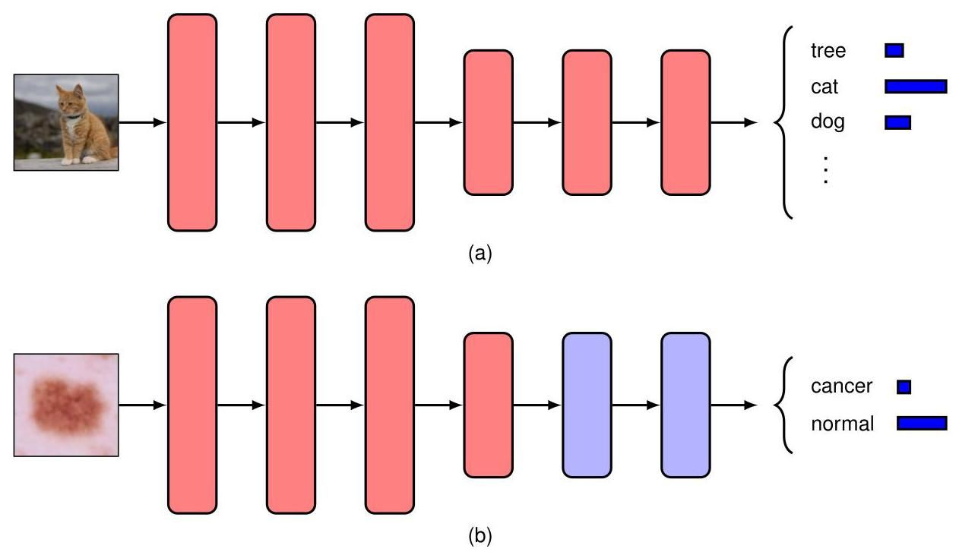

Figure 6.13 Schematic illustration of transfer learning. (a) A network is first trained on a task with abundant data, such as object classification of natural images. (b) The early layers of the network (shown in red) are copied from the first task and the final few layers of the network (shown in blue) are then retrained on a new task such as skin lesion classification for which training data is more scarce.

图 6.13 迁移学习的示意图。(a) 首先在一个数据丰富的任务(如自然图像的物体分类)上训练一个网络。(b) 从第一个任务中复制网络的早期层(以红色显示)，然后在一个新任务(如皮肤病变分类，其训练数据更为稀缺)上重新训练网络的最后几层(以蓝色显示)。

A related approach is multitask learning (Caruana, 1997) in which a network jointly learns more than one related task at the same time. For example, we might wish to construct a spam email filter that allows different users to have different classifiers tuned to their particular preferences. The training data may comprise examples of spam email and non-spam email for many different users, but the number of examples for any one user may be quite limited, and therefore training a separate classifier for each user would give poor results. Instead, we can combine the data sets to train a single larger network that might, for example, share early layers but have separate learnable parameters for the different users in later layers. Sharing data across tasks allows the network to exploit commonalities amongst the tasks, thereby improving the accuracy for all users. With a large number of training examples, a deeper network with more parameters can be used, again leading to improved performance.

一种相关的方法是多任务学习(Caruana，1997)，在这种方法中，一个网络可以同时联合学习多个相关任务。例如，我们可能希望构建一个垃圾邮件过滤器，允许不同用户拥有根据其特定偏好调整的不同分类器。训练数据可能包含许多不同用户的垃圾邮件和非垃圾邮件示例，但任何一个用户的示例数量可能相当有限，因此为每个用户训练一个单独的分类器可能会得到较差的结果。相反，我们可以合并数据集来训练一个更大的单一网络，例如，该网络可以共享早期层，但在后期层为不同用户设置单独的可学习参数。跨任务共享数据可以让网络利用任务之间的共性，从而提高所有用户的准确性。如果有大量的训练示例，可以使用具有更多参数的更深层次的网络，这同样会提高性能。

Learning across multiple tasks can be extended to meta-learning, which is also called learning to learn. Whereas multitask learning aims to make predictions for a fixed set of tasks, the aim of meta-learning is to make predictions for future tasks that were not seen during training. This can be done by not only learning a shared internal representation across tasks but also by learning the learning algorithm itself (Hospedales et al., 2021). Meta-learning can be used to facilitate generalization of, for example, a classification model to new classes when there are very few labelled examples of the new classes. This is referred to as few-shot learning. When only a single labelled example is used it is called one-shot learning.

跨多个任务的学习可以扩展到元学习，也称为学会学习。多任务学习旨在对一组固定的任务进行预测，而元学习的目标是对训练期间未见过的未来任务进行预测。这不仅可以通过学习跨任务的共享内部表示来实现，还可以通过学习学习算法本身来实现(Hospedales 等人，2021)。元学习可用于促进分类模型等在新类别只有极少标注示例时向新类别的泛化。这被称为少样本学习。当只使用一个标注示例时，称为单样本学习。

# 6.3.5 Contrastive learning

# 6.3.5 对比学习

One of the most common and powerful representation learning methods is contrastive learning (Gutmann and Hyvärinen, 2010; Oord, Li, and Vinyals, 2018; Chen, Kornblith, et al., 2020). The idea is to learn a representation such that certain pairs of inputs, referred to as positive pairs, are close in the embedding space, and other pairs of inputs, called negative pairs, are far apart. The intuition is that if we choose our positive pairs in such a way that they are semantically similar and choose negative pairs that are semantically dissimilar, then we will learn a representation space in which similar inputs are close, making downstream tasks, such as classification, much easier. As with other forms of representation learning, the outputs of the trained network are typically not used directly, and instead the activations at some earlier layer are used to form the embedding space. Contrastive learning is unlike most other machine learning tasks, in that the error function for a given input is defined only with respect to other inputs, instead of having a per-input label or target output.

最常见且强大的表示学习方法之一是对比学习(Gutmann 和 Hyvärinen，2010；Oord、Li 和 Vinyals，2018；Chen、Kornblith 等人，2020)。其思想是学习一种表示，使得某些输入对(称为正样本对)在嵌入空间中彼此接近，而其他输入对(称为负样本对)彼此远离。直观地说，如果我们选择语义相似的正样本对和语义不同的负样本对，那么我们将学习到一个表示空间，在这个空间中相似的输入彼此接近，这会使分类等下游任务变得容易得多。与其他形式的表示学习一样，训练好的网络的输出通常不直接使用，而是使用某个早期层的激活来形成嵌入空间。对比学习与大多数其他机器学习任务不同，因为给定输入的误差函数仅相对于其他输入来定义，而不是有每个输入的标签或目标输出。

Suppose we have a given data point called the anchor, for which we have specified another data point that together with makes up a positive pair. We must also specify a set of data points each of which makes up a negative pair with . We now need a loss function that will reward close proximity between the representations of and while encouraging a large distance between each pair . One example of such a function, and the most commonly used loss function for contrastive learning, is called the InfoNCE loss (Gutmann and Hyvärinen, 2010; Oord, Li, and Vinyals, 2018), where NCE denotes ’noise contrastive estimation’. Suppose we have a neural network function that maps points from the input space to a representation space, governed by learnable parameters . This representation is normalized so that . Then, for a data point , the InfoNCE loss is defined by

假设我们有一个给定的数据点 称为锚点，我们为其指定了另一个数据点 ，它与 构成一个正样本对。我们还必须指定一组数据点 ，其中每个数据点都与 构成一个负样本对。现在我们需要一个损失函数，该函数将奖励 和 的表示之间的接近程度，同时鼓励每对 之间有较大的距离。这样的一个函数示例，也是对比学习中最常用的损失函数，称为 InfoNCE 损失(Gutmann 和 Hyvärinen，2010；Oord、Li 和 Vinyals，2018)，其中 NCE 表示“噪声对比估计”。假设我们有一个神经网络函数 ，它将输入空间 中的点映射到一个表示空间，该空间由可学习参数 控制。这个表示被归一化，使得 。那么，对于一个数据点 ，InfoNCE 损失定义为

We can see that in this function, the cosine similarity between the representation of the anchor and the representation of the positive example provides our measure of how close the positive pair examples are in the learned space, and the same measure is used to assess how close the anchor is to the negative examples. Note that the function resembles a classification cross-entropy error function in which the cosine similarity of the positive pair gives the logit for the label class and the cosine similarities for the negative pairs give the logits for the incorrect classes. Also note that the negative pairs are crucial as without them the embedding would simply learn the degenerate solution of mapping every point to the same representation.

我们可以看到，在这个函数中，锚点的表示 与正例的表示 之间的余弦相似度 为我们衡量正例对在学习空间中的接近程度提供了度量，并且使用相同的度量来评估锚点与负例的接近程度。请注意，该函数类似于分类交叉熵误差函数，其中正例对的余弦相似度给出了标签类别的对数几率，而负例对的余弦相似度给出了错误类别的对数几率。还要注意，负例对至关重要，因为如果没有它们，嵌入将简单地学习将每个点映射到相同表示的退化解。

A particular contrastive learning algorithm is defined predominantly by how the positive and negative pairs are chosen, which is how we use our prior knowledge to specify what a good representation should be. For example, consider the problem of learning representations of images. Here, a common choice is to create positive pairs by corrupting the input images in ways that should preserve the semantic information of the image while greatly altering the image in the pixel space (Wu et al., 2018; He et al., 2019; Chen, Kornblith, et al., 2020). Corruptions are closely related to data augmentations, and examples include rotation, translation, and colour shifts. Other images from the data set can then be used to create the negative pairs. This approach to contrastive learning is known as instance discrimination.

特定的对比学习算法主要由正例对和负例对的选择方式定义，这就是我们如何利用先验知识来指定良好表示应该是什么样的。例如，考虑学习图像表示的问题。在这里，一种常见的选择是通过以保留图像语义信息同时在像素空间中大幅改变图像的方式损坏输入图像来创建正例对(Wu 等人，2018 年；He 等人，2019 年；Chen、Kornblith 等人，2020 年)。损坏与数据增强密切相关，示例包括旋转、平移和颜色变换。然后可以使用数据集中的其他图像来创建负例对。这种对比学习方法被称为实例判别。

Section 9.1.3

第 9.1.3 节

If, however, we have access to class labels, then we can use images of the same class as positive pairs and images of different classes as negative pairs. This relaxes the reliance on specifying the augmentations that the representation should be invariant to and also avoids treating two semantically similar images as a negative pair. This is referred to as supervised contrastive learning (Khosla et al., 2020) because of the reliance on the class labels, and it can often yield better results than simply learning the representation using cross-entropy classification.

然而，如果我们可以获取类别标签，那么我们可以将同一类别的图像用作正例对，将不同类别的图像用作负例对。这减少了对指定表示应保持不变的增强方式的依赖，并且还避免了将两个语义相似的图像视为负例对。由于依赖于类别标签，这被称为有监督的对比学习(Khosla 等人，2020 年)，并且它通常比仅使用交叉熵分类来学习表示能产生更好的结果。

The members of positive and negative pairs do not necessarily have to come from the same data modality. In contrastive-language image pretraining, or CLIP (Radford et al., 2021), a positive pair consists of an image and its corresponding text caption, and two separate functions, one for each modality, are used to map the inputs to the same representation space. Negative pairs are then mismatched images and captions. This is often referred to as weakly supervised, as it relies on captioned images, which are often easier to obtain by scraping data from the internet than by manually labelling images with their classes. The loss function in this case is given by

正例对和负例对的成员不一定必须来自相同的数据模态。在对比语言 - 图像预训练(CLIP)(Radford 等人，2021 年)中，正例对由一幅图像及其对应的文本描述组成，并且使用两个单独的函数(每个模态一个)将输入映射到相同的表示空间。然后负例对是不匹配的图像和描述。这通常被称为弱监督，因为它依赖于带描述的图像，与手动为图像标注类别相比，通过从互联网上抓取数据通常更容易获得这些图像。在这种情况下，损失函数由下式给出

where and represent a positive pair in which is an image and is its corresponding text caption, represents the mapping from images to the representation space, and is the mapping from text input to the representation space. We also require a set of other images from the data set, for which we can assume the text caption is inappropriate, and a set of text captions that are similarly mismatched to the input image . The two terms in the loss function ensure that (a) the representation of the image is close to its text caption representation relative to other image representations and (b) the text caption representation is close to the representation of the image it describes relative to other representations of text captions. Although CLIP uses text and image pairs, any data set with paired modalities can be used to learn representations. A comparison of the different contrastive learning methods we have discussed is shown in Figure 6.14.

其中 和 表示一个正例对，其中 是一幅图像， 是其对应的文本描述， 表示从图像到表示空间的映射， 是从文本输入到表示空间的映射。我们还需要数据集中的另一组图像 ，我们可以假设文本描述 不适合这些图像，以及一组与输入图像 同样不匹配的文本描述 。损失函数中的两项确保:(a) 相对于其他图像表示，图像的表示与其文本描述的表示接近；(b) 相对于其他文本描述的表示，文本描述的表示与其所描述的图像的表示接近。尽管 CLIP 使用文本和图像对，但任何具有配对模态的数据集都可用于学习表示。我们讨论过的不同对比学习方法的比较如图 6.14 所示。

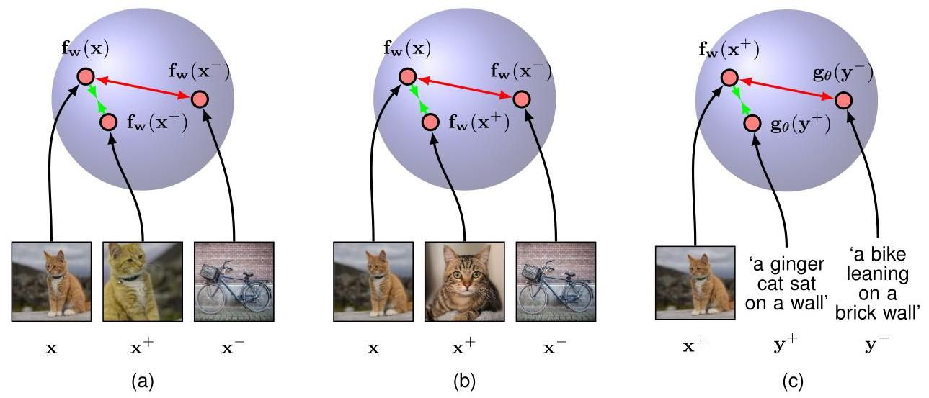

Figure 6.14 Illustration of three different contrastive learning paradigms. (a) The instance discrimination approach, where the positive pair is made up of the anchor and an augmented version of the same image. These are mapped to points in a normalized space that can be thought of as a unit hypersphere. The coloured arrows show that the loss encourages the representations of the positive pair to be closer together but pushes negative pairs further apart. (b) Supervised contrastive learning in which the positive pair consists of two different images from the same class. (c) The CLIP model in which the positive pair is made up of an image and an associated text snippet.

图 6.14 三种不同对比学习范式的图示。(a) 实例判别方法，其中正样本对由锚点和同一图像的增强版本组成。这些被映射到归一化空间中的点，可以将其视为单位超球面。彩色箭头表明，损失函数促使正样本对的表示更接近，而使负样本对的表示更远离。(b) 有监督对比学习，其中正样本对由同一类别的两幅不同图像组成。(c) CLIP 模型，其中正样本对由一幅图像和相关的文本片段组成。

# 6.3.6 General network architectures

# 6.3.6 通用网络架构

So far, we have explored neural network architectures that are organized into a sequence of fully-connected layers. However, because there is a direct correspondence between a network diagram and its mathematical function, we can develop more general network mappings by considering more complex network diagrams. These must be restricted to a feed-forward architecture, in other words to one having no closed directed cycles, to ensure that the outputs are deterministic functions of the inputs. This is illustrated with a simple example in Figure 6.15. Each (hidden or output) unit in such a network computes a function given by

到目前为止，我们已经探讨了由一系列全连接层组成的神经网络架构。然而，由于网络示意图与其数学函数之间存在直接对应关系，我们可以通过考虑更复杂的网络示意图来开发更通用的网络映射。这些网络必须限制为前馈架构，换句话说，不能有封闭的有向循环，以确保输出是输入的确定性函数。图 6.15 用一个简单的例子说明了这一点。在这样的网络中，每个(隐藏或输出)单元计算一个由下式给出的函数

where denotes the set of ancestors of node , in other words the set of units that send connections to unit , and denotes the associated bias parameter. For a given set of values applied to the inputs of the network, successive application of (6.22) allows the activations of all units in the network to be evaluated including those of the output units.

其中 表示节点 的祖先集合，换句话说，是向单元 发送连接的单元集合， 表示相关的偏置参数。对于应用于网络输入的给定一组值，通过连续应用式 (6.22)，可以计算网络中所有单元(包括输出单元)的激活值。

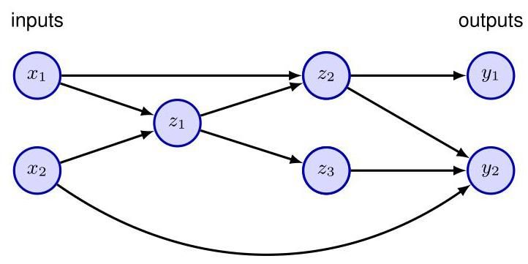

Figure 6.15 Example of a neural network having a general feed-forward topology. Note that each hidden and output unit has an associated bias parameter (omitted for clarity).

图 6.15 具有通用前馈拓扑结构的神经网络示例。请注意，每个隐藏单元和输出单元都有一个相关的偏置参数(为清晰起见省略)。

# 6.3.7 Tensors

# 6.3.7 张量

We see that linear algebra plays a central role in neural networks, with quantities such as data sets, activations, and network parameters represented as scalars, vectors, and matrices. However, we also encounter variables of higher dimensionality. Consider, for example, a data set of colour images each of which is pixels high and pixels wide. Each pixel is indexed by its row and column within the image and has red, green, and blue values. We have one such value for each image in the data set, and so we can represent a particular intensity value by a four-dimensional array with elements where and index the row and column within the image, indexes the red, green, and blue intensities, and indexes the particular image within the data set. These higher-dimensional arrays are called tensors and include scalars, vectors, and matrices as special cases. We will see many examples of such tensors when we discuss more sophisticated neural network architectures later in the book. Massively parallel processors such as GPUs are especially well suited to processing tensors.

我们发现线性代数在神经网络中起着核心作用，诸如数据集、激活值和网络参数等数量被表示为标量、向量和矩阵。然而，我们也会遇到更高维度的变量。例如，考虑一个包含 张彩色图像的数据集，每张图像的高度为 像素，宽度为 像素。每个像素通过其在图像中的行和列进行索引，并且具有红、绿、蓝三个值。数据集中的每张图像都有这样一组值，因此我们可以用一个四维数组 来表示特定的强度值，其元素为 ，其中 和 对图像内的行和列进行索引， 对红、绿、蓝强度进行索引， 对数据集中的特定图像进行索引。这些高维数组被称为张量，标量、向量和矩阵是其特殊情况。在本书后面讨论更复杂的神经网络架构时，我们将看到许多这样的张量示例。像 GPU 这样的大规模并行处理器特别适合处理张量。

# 6.4. Error Functions

# 6.4. 误差函数

Chapter 4 Chapter 5

第 4 章 第 5 章

In earlier chapters, we explored linear models for regression and classification, and in the process we derived suitable forms for the error functions along with corresponding choices for the output-unit activation function. The same considerations for choosing an error function apply for multilayer neural networks, and so for convenience, we will summarize the key points here.

在前面的章节中，我们探讨了用于回归和分类的线性模型，并且在此过程中，我们推导出了误差函数的合适形式以及输出单元激活函数的相应选择。选择误差函数的相同考虑因素也适用于多层神经网络，因此为了方便起见，我们将在此总结要点。

# 6.4.1 Regression

# 6.4.1 回归

We start by discussing regression problems, and for the moment we consider a single target variable that can take any real value. Following the discussion of regression in single-layer networks, we assume that has a Gaussian distribution with an -dependent mean, which is given by the output of the neural network, so that

我们从讨论回归问题开始，目前我们考虑一个可以取任意实数值的单一目标变量 。遵循单层网络中回归的讨论，我们假设 具有一个依赖于 的均值的高斯分布，该均值由神经网络的输出给出，即

where is the variance of the Gaussian noise. Of course this is a somewhat restrictive assumption, and in some applications we will need to extend this approach to allow for more general distributions. For the conditional distribution given by (6.23), it is sufficient to take the output-unit activation function to be the identity, because such a network can approximate any continuous function from to . Given a data set of i.i.d. observations , along with corresponding target values , we can construct the corresponding likelihood function:

其中 是高斯噪声的方差。当然，这是一个有些限制性的假设，在某些应用中，我们需要扩展这种方法以允许更一般的分布。对于由 (6.23) 给出的条件分布，将输出单元的激活函数设为恒等函数就足够了，因为这样的网络可以近似从 到 的任何连续函数。给定一个包含 个独立同分布观测值 的数据集，以及相应的目标值 ，我们可以构建相应的似然函数:

Section 2.3.4

第 2.3.4 节

Section 6.5

第 6.5 节

Note that in the machine learning literature, it is usual to consider the minimization of an error function rather than the maximization of the likelihood, and so here we will follow this convention. Taking the negative logarithm of the likelihood function (6.24), we obtain the error function

请注意，在机器学习文献中，通常考虑的是最小化误差函数，而不是最大化似然函数，因此这里我们将遵循这一惯例。对似然函数 (6.24) 取负对数，我们得到误差函数

which can be used to learn the parameters and . Consider first the determination of . Maximizing the likelihood function is equivalent to minimizing the sum-of-squares error function given by

该误差函数可用于学习参数 和 。首先考虑确定 。最大化似然函数等价于最小化由下式给出的平方和误差函数

where we have discarded additive and multiplicative constants. The value of found by minimizing will be denoted . Note that this will typically not correspond to the global maximum of the likelihood function because the nonlinearity of the network function causes the error to be non-convex, and so finding the global optimum is generally infeasible. Moreover, regularization terms may be added to the error function and other modifications may be made to the training process, so that the resulting solution for the network parameters may differ significantly from the maximum likelihood solution.

这里我们舍弃了加法和乘法常数。通过最小化 得到的 的值将记为 。请注意，这通常并不对应于似然函数的全局最大值，因为网络函数 的非线性导致误差 是非凸的，因此找到全局最优解通常是不可行的。此外，可能会在误差函数中添加正则化项，并且可能会对训练过程进行其他修改，从而使得网络参数的最终解可能与最大似然解有显著差异。

Chapter 9

第 9 章

Having found , the value of can be found by minimizing the error function (6.25) to give

在找到 之后，可以通过最小化误差函数 (6.25) 来得到 的值，结果为

Exercise 6.8

练习 6.8

Note that this can be evaluated once the iterative optimization required to find is completed.

注意，一旦完成找到 所需的迭代优化，就可以计算这个值。

If we have multiple target variables, and we assume that they are independent, conditional on and , with shared noise variance , then the conditional distribution of the target values is given by

如果我们有多个目标变量，并且假设它们在给定 和 的条件下是独立的，且具有共享的噪声方差 ，那么目标值的条件分布由下式给出

Following the same argument as for a single target variable, we see that maximizing the likelihood function with respect to the weights is equivalent to minimizing the sum-of-squares error function:

按照与单个目标变量相同的论证，我们可以看到，关于权重最大化似然函数等价于最小化平方和误差函数:

Exercise 6.9

练习 6.9

The noise variance is then given by

噪声方差则由下式给出

where is the dimensionality of the target variable. The assumption of conditional independence of the target variables can be dropped at the expense of a slightly more complex optimization problem.

其中 是目标变量的维度。可以放弃目标变量条件独立的假设，但代价是优化问题会稍微复杂一些。

Exercise 6.10

练习 6.10

Recall that there is a natural pairing of the error function (given by the negative log likelihood) and the output-unit activation function. In regression, we can view the network as having an output activation function that is the identity, so that . The corresponding sum-of-squares error function then has the property

回顾一下，误差函数(由负对数似然给出)和输出单元激活函数之间存在一种自然的配对关系。在回归中，我们可以将网络视为具有一个恒等输出激活函数，使得 。相应的平方和误差函数则具有以下性质

Section 5.4.6

第 5.4.6 节

# 6.4.2 Binary classification

# 6.4.2 二分类

Now consider binary classification in which we have a single target variable such that denotes class and denotes class . Following the discussion of canonical link functions, we consider a network having a single output whose activation function is a logistic sigmoid (6.13) so that . We can interpret as the conditional probability , with given by . The conditional distribution of targets given inputs is then a Bernoulli distribution of the form

现在考虑二元分类问题，其中我们有一个单一的目标变量 ，使得 表示类别 ， 表示类别 。根据对典范链接函数的讨论，我们考虑一个具有单一输出的网络，其激活函数是逻辑 sigmoid 函数 (6.13)，使得 。我们可以将 解释为条件概率 ，其中 由 给出。那么，给定输入时目标的条件分布就是如下形式的伯努利分布

Section 5.4.6

第 5.4.6 节

If we consider a training set of independent observations, then the error function, which is given by the negative log likelihood, is then a cross-entropy error of the

如果我们考虑一个由独立观测值组成的训练集，那么由负对数似然给出的误差函数就是一个如下形式的交叉熵误差

form

形式

where denotes . Simard, Steinkraus, and Platt (2003) found that using the cross-entropy error function instead of the sum-of-squares for a classification problem leads to faster training as well as improved generalization.

其中 表示 。Simard、Steinkraus 和 Platt (2003) 发现，在分类问题中使用交叉熵误差函数而非平方和误差函数可以加快训练速度并提高泛化能力。

Note that there is no analogue of the noise variance in (6.32) because the target values are assumed to be correctly labelled. However, the model is easily extended to allow for labelling errors by introducing a probability that the target value has been flipped to the wrong value (Opper and Winther,2000). Here may be set in advance, or it may be treated as a hyperparameter whose value is inferred from the data.

请注意，(6.32) 中没有与噪声方差 类似的项，因为假设目标值的标签是正确的。然而，通过引入一个概率 ，即目标值 被错误标记的概率，该模型可以很容易地扩展以考虑标记误差 (Opper 和 Winther，2000)。这里 可以预先设定，也可以将其视为一个超参数，其值从数据中推断得出。

Exercise 6.11

练习 6.11

If we have separate binary classifications to perform, then we can use a network having outputs each of which has a logistic-sigmoid activation function. Associated with each output is a binary class label , where . If we assume that the class labels are independent, given the input vector, then the conditional distribution of the targets is

如果我们要进行 个独立的二分类任务，那么我们可以使用一个具有 个输出的网络，每个输出都有一个逻辑 sigmoid 激活函数。与每个输出相关联的是一个二分类标签 ，其中 。如果我们假设在给定输入向量的情况下，这些类别标签是相互独立的，那么目标的条件分布为

Taking the negative logarithm of the corresponding likelihood function then gives the following error function:

对相应的似然函数取负对数，就得到了以下误差函数:

Exercise 6.13

练习 6.13

where denotes . Again, the derivative of the error function with respect to the pre-activation for a particular output unit takes the form (6.31), just as in the regression case.

其中 表示 。同样，误差函数关于特定输出单元的预激活的导数形式为 (6.31)，这与回归情况相同。

Exercise 6.14

练习 6.14

# 6.4.3 multiclass classification

# 6.4.3 多类分类

Finally, we consider the standard multiclass classification problem in which each input is assigned to one of mutually exclusive classes. The binary target variables have a 1-of- coding scheme indicating the class, and the network outputs are interpreted as , leading to the error function (5.80), which we reproduce here:

最后，我们考虑标准的多类分类问题，其中每个输入被分配到 个互斥类别之一。二元目标变量 采用 1-of- 编码方案来指示类别，网络输出被解释为 ，从而得到误差函数 (5.80)，我们在此重现如下:

Section 5.1.3

第 5.1.3 节

The output-unit activation function, which corresponds to the canonical link, is given by the softmax function:

与规范链接相对应的输出单元激活函数由 softmax 函数给出:

Section 5.4.4

第 5.4.4 节

which satisfies and . Note that the are unchanged if a constant is added to all of the , causing the error function to be constant for some directions in weight space. This degeneracy is removed if an appropriate regularization term is added to the error function. Once again, the derivative of the error function with respect to the pre-activation for a particular output unit takes the familiar form (6.31).

它满足 和 。请注意，如果给所有的 都加上一个常数， 不会改变，这会导致误差函数在权重空间的某些方向上为常数。如果在误差函数中添加适当的正则化项，这种退化现象就会消除。同样，误差函数关于特定输出单元的预激活的导数采用熟悉的形式 (6.31)。

Chapter 9

第 9 章

Exercise 6.15

练习 6.15

In summary, there is a natural choice of both output-unit activation function and matching error function according to the type of problem being solved. For regression, we use linear outputs and a sum-of-squares error, for multiple independent binary classifications, we use logistic sigmoid outputs and a cross-entropy error function, and for multi-class classification, we use softmax outputs with the corresponding multi-class cross-entropy error function. For classification problems involving two classes, we can use a single logistic sigmoid output, or alternatively, we can use a network with two outputs having a softmax output activation function.

总之，根据所解决问题的类型，输出单元激活函数和匹配误差函数都有自然的选择。对于回归问题，我们使用线性输出和平方和误差；对于多个独立的二分类问题，我们使用逻辑 sigmoid 输出和交叉熵误差函数；对于多分类问题，我们使用 softmax 输出和相应的多类交叉熵误差函数。对于涉及两类的分类问题，我们可以使用单个逻辑 sigmoid 输出，或者也可以使用具有两个输出且采用 softmax 输出激活函数的网络。

This procedure is quite general, and by considering other forms of conditional distribution, we can derive the associated error functions as the corresponding negative log likelihood. We will see an example of this in the next section when we consider multimodal network outputs.

这个过程相当通用，通过考虑其他形式的条件分布，我们可以将相关的误差函数推导为相应的负对数似然。在下一节中，当我们考虑多模态网络输出时，将看到一个这样的例子。

# 6.5. Mixture Density Networks

# 6.5. 混合密度网络

So far in this chapter we have discussed neural networks whose outputs represent simple probability distributions comprising either a Gaussian for continuous variables or a binary distribution for discrete variables. We close the chapter by showing how a neural network can represent more general conditional probabilities by treating the outputs of the network as the parameters of a more complex distribution, in this case a Gaussian mixture model. This is known as a mixture density network, and we will see how to define the associated error function and the corresponding output-unit activation functions.

到目前为止，在本章中我们讨论了输出表示简单概率分布的神经网络，这些分布对于连续变量是高斯分布，对于离散变量是二项分布。在本章结尾，我们将展示如何通过将网络的输出视为更复杂分布(在这种情况下是高斯混合模型)的参数，使神经网络能够表示更一般的条件概率。这被称为混合密度网络，我们将了解如何定义相关的误差函数和相应的输出单元激活函数。

# 6.5.1 Robot kinematics example

# 6.5.1 机器人运动学示例

The goal of supervised learning is to model a conditional distribution , which for many simple regression problems is chosen to be Gaussian. However, practical machine learning problems can often have significantly non-Gaussian distributions. These can arise, for example, with inverse problems in which the distribution can be multimodal, in which case the Gaussian assumption can lead to very poor predictions.

监督学习的目标是对条件分布 进行建模，对于许多简单的回归问题，该分布通常选择为高斯分布。然而，实际的机器学习问题往往具有明显的非高斯分布。例如，在逆问题中可能会出现这种情况，其中分布可能是多峰的，在这种情况下，高斯假设可能会导致非常糟糕的预测。

As a simple illustration of an inverse problem, consider the kinematics of a robot arm, as illustrated in Figure 6.16. The forward problem involves finding the end effector position given the joint angles and has a unique solution. However, in practice we wish to move the end effector of the robot to a specific position, and to do this we must set appropriate joint angles. We therefore need to solve the inverse problem, which has two solutions, as seen in Figure 6.16.

作为逆问题的一个简单示例，考虑如图 6.16 所示的机器人手臂的运动学。正向问题是在给定关节角度的情况下确定末端执行器的位置，并且有唯一解。然而，在实际应用中，我们希望将机器人的末端执行器移动到特定位置，为此我们必须设置合适的关节角度。因此，我们需要解决逆问题，如图 6.16 所示，该问题有两个解。

Exercise 6.16

练习 6.16

Forward problems often correspond to causality in a physical system and generally have a unique solution. For instance, a specific pattern of symptoms in the human body may be caused by the presence of a particular disease. In machine learning, however, we typically have to solve an inverse problem, such as trying to predict the presence of a disease given a set of symptoms. If the forward problem involves a many-to-one mapping, then the inverse problem will have multiple solutions. For instance, several different diseases may result in the same symptoms.

正向问题通常对应于物理系统中的因果关系，并且一般有唯一解。例如，人体中特定的症状模式可能是由某种特定疾病引起的。然而，在机器学习中，我们通常需要解决逆问题，例如根据一组症状来预测某种疾病的存在。如果正向问题涉及多对一的映射，那么逆问题将有多个解。例如，几种不同的疾病可能导致相同的症状。

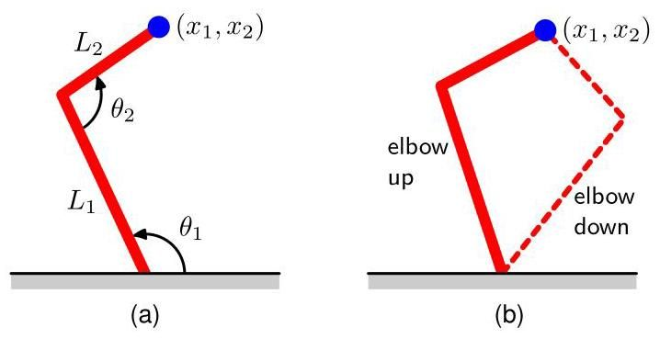

Figure 6.16 (a) A two-link robot arm, in which the Cartesian coordinates of the end effector are determined uniquely by the two joint angles and and the (fixed) lengths and of the arms. This is known as the forward kinematics of the arm. (b) In practice, we have to find the joint angles that will give rise to a desired end effector position. This inverse kinematics has two solutions corresponding to ’elbow up’ and ’elbow down’.

图 6.16 (a) 一个双连杆机器人手臂，其中末端执行器的笛卡尔坐标 由两个关节角度 和 以及手臂的(固定)长度 和 唯一确定。这被称为手臂的正向运动学。(b) 在实际应用中，我们必须找到能够使末端执行器达到期望位置的关节角度。这种逆向运动学有两个解，分别对应于“肘部向上”和“肘部向下”。

In the robotics example, the kinematics is defined by geometrical equations, and the multimodality is readily apparent. However, in many machine learning problems the presence of multimodality, particularly in problems involving spaces of high dimensionality, can be less obvious. For tutorial purposes, however, we will consider a simple toy problem for which we can easily visualize the multimodality. The data for this problem is generated by sampling a variable uniformly over the interval , to give a set of values , and the corresponding target values are obtained by computing the function and then adding uniform noise over the interval . The inverse problem is then obtained by keeping the same data points but exchanging the roles of and . Figure 6.17 shows the data sets for the forward and inverse problems, along with the results of fitting two-layer neural networks having six hidden units and a single linear output unit by minimizing a sum-of-squares error function. Least squares corresponds to maximum likelihood under a Gaussian assumption. We see that this leads to a good model for the forward problem but a very poor model for the highly non-Gaussian inverse problem.

在机器人学的例子中，运动学由几何方程定义，并且多模态性显而易见。然而，在许多机器学习问题中，尤其是涉及高维空间的问题，多模态性的存在可能不太明显。不过，出于教学目的，我们将考虑一个简单的示例问题，对于该问题我们可以轻松可视化其多模态性。此问题的数据是通过在区间 上对变量 进行均匀采样生成的，得到一组值 ，相应的目标值 是通过计算函数 然后在区间 上添加均匀噪声得到的。然后，通过保留相同的数据点但交换 和 的角色来得到逆问题。图 6.17 展示了正问题和逆问题的数据集，以及通过最小化平方误差和函数来拟合具有六个隐藏单元和一个线性输出单元的两层神经网络的结果。在高斯假设下，最小二乘法对应于最大似然法。我们看到，这为正问题得到了一个很好的模型，但对于高度非高斯的逆问题却是一个非常差的模型。

# 6.5.2 Conditional mixture distributions

# 6.5.2 条件混合分布

We therefore seek a general framework for modelling conditional probability distributions. This can be achieved by using a mixture model for in which both the mixing coefficients as well as the component densities are flexible functions of the input vector , giving rise to a mixture density network. For any given value of , the mixture model provides a general formalism for modelling an arbitrary conditional density function . Provided we consider a sufficiently flexible network, we then have a framework for approximating arbitrary conditional distributions.

因此，我们寻求一个用于对条件概率分布进行建模的通用框架。这可以通过对 使用混合模型来实现，其中混合系数以及分量密度都是输入向量 的灵活函数，从而产生一个混合密度网络。对于 的任何给定值，混合模型为对任意条件密度函数 进行建模提供了一个通用形式。只要我们考虑一个足够灵活的网络，我们就有了一个用于近似任意条件分布的框架。

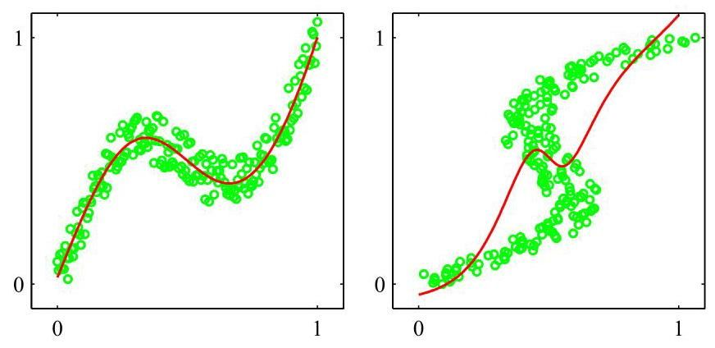

Figure 6.17 On the left is the data set for a simple forward problem in which the red curve shows the result of fitting a two-layer neural network by minimizing the sum-of-squares error function. The corresponding inverse problem, shown on the right, is obtained by exchanging the roles of and . Here the same network, again trained by minimizing the sum-of-squares error function, gives a poor fit to the data due to the multimodality of the data set.

图 6.17 左侧是一个简单正问题的数据集，其中红色曲线显示了通过最小化平方误差和函数来拟合两层神经网络的结果。右侧显示的相应逆问题是通过交换 和 的角色得到的。在这里，同样的网络再次通过最小化平方误差和函数进行训练，但由于数据集的多模态性，对数据的拟合效果很差。

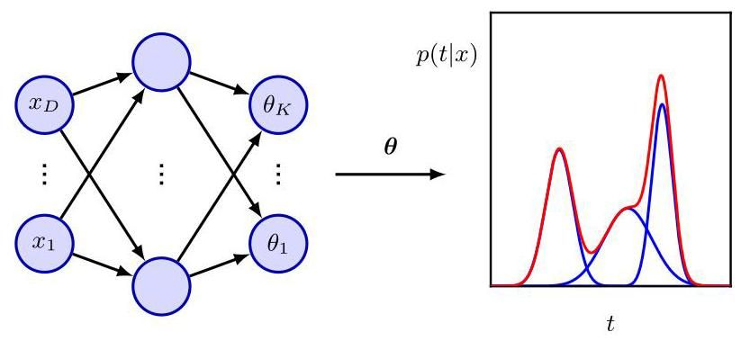

Figure 6.18 The mixture density network can represent general conditional probability densities by considering a parametric mixture model for the distribution of whose parameters are determined by the outputs of a neural network that takes as its input vector.

图 6.18 混合密度网络可以通过考虑 分布的参数化混合模型来表示一般的条件概率密度 ，该模型的参数由以 作为输入向量的神经网络的输出确定。

Here we will develop the model explicitly for Gaussian components, so that

在这里，我们将明确地为高斯分量开发该模型，使得

This is an example of a heteroscedastic model in which the noise variance on the data is a function of the input vector . Instead of Gaussians, we can use other distributions for the components, such as Bernoulli distributions if the target variables are binary rather than continuous. We have also specialized to the case of isotropic covariances for the components, although the mixture density network can readily be extended to allow for general covariance matrices by representing the covariances using a Cholesky factorization (Williams, 1996). Even with isotropic components, the conditional distribution does not assume factorization with respect to the components of (in contrast to the standard sum-of-squares regression model) as a consequence of the mixture distribution.

这是一个异方差模型的示例，其中数据的噪声方差是输入向量 的函数。除了高斯分布，我们还可以为各分量使用其他分布，例如，如果目标变量是离散的而非连续的，则可以使用伯努利分布。我们还专门研究了各分量具有各向同性协方差的情况，尽管混合密度网络可以很容易地扩展到允许使用一般协方差矩阵，方法是使用乔列斯基分解来表示协方差(Williams，1996)。即使各分量是各向同性的，由于混合分布的原因，条件分布 也不假设相对于 的各分量进行因式分解(这与标准的平方和回归模型不同)。

We now take the various parameters of the mixture model, namely the mixing coefficients , the means , and the variances , to be governed by the outputs of a neural network that takes as its input. The structure of this mixture density network is illustrated in Figure 6.18. The mixture density network is closely related to the mixture-of-experts model (Jacobs et al., 1991). The principal difference is that a mixture of experts has independent parameters for each component model in the mixture, whereas in a mixture density network, the same function is used to predict the parameters of all the component densities as well as the mixing coefficients, and so the nonlinear hidden units are shared amongst the input-dependent functions.

现在，我们假设混合模型的各种参数，即混合系数 、均值 和方差 ，由一个以 为输入的神经网络的输出决定。这个混合密度网络的结构如图 6.18 所示。混合密度网络与专家混合模型密切相关(Jacobs 等人，1991)。主要区别在于，专家混合模型中每个分量模型都有独立的参数，而在混合密度网络中，使用相同的函数来预测所有分量密度的参数以及混合系数，因此非线性隐藏单元在依赖于输入的函数之间共享。

The neural network in Figure 6.18 can, for example, be a two-layer network having sigmoidal (tanh) hidden units. If there are components in the mixture model (6.38), and if has components, then the network will have output-unit pre-activations denoted by that determine the mixing coefficients outputs denoted by that determine the Gaussian standard deviations , and outputs denoted by that determine the components of the Gaussian means . The total number of network outputs is given by , unlike the usual outputs for a network that simply predicts the conditional means of the target variables.

例如，图 6.18 中的神经网络可以是一个具有 S 形(tanh)隐藏单元的两层网络。如果混合模型(6.38)中有 个分量，并且 有 个分量，那么该网络将有 个输出单元预激活值，用 表示，它们决定了混合系数； 个输出，用 表示，它们决定了高斯标准差 ；以及 个输出，用 表示，它们决定了高斯均值 的分量 。网络输出的总数由 给出，这与简单预测目标变量条件均值的网络通常的 个输出不同。

The mixing coefficients must satisfy the constraints

混合系数必须满足以下约束条件

which can be achieved using a set of softmax outputs:

这可以通过一组 softmax 输出来实现:

Similarly, the variances must satisfy and so can be represented in terms of the exponentials of the corresponding network pre-activations using

类似地，方差必须满足 ，因此可以使用相应网络预激活值的指数来表示

Finally, because the means have real components, they can be represented directly by the network outputs:

最后，由于均值 具有实分量，它们可以直接由网络输出表示:

in which the output-unit activation functions are given by the identity .

其中，输出单元的激活函数由恒等函数 给出。

The learnable parameters of the mixture density network comprise the vector of weights and biases in the neural network, which can be set by maximum likelihood or equivalently by minimizing an error function defined to be the negative logarithm of the likelihood. For independent data, this error function takes the form

混合密度网络的可学习参数包括神经网络中的权重和偏置向量 ，这些参数可以通过最大似然法来设置，或者等效地通过最小化一个定义为似然函数负对数的误差函数来设置。对于独立数据，这个误差函数具有如下形式

where we have made the dependencies on explicit.

这里我们明确表示出了对 的依赖关系。

# 6.5.3 Gradient optimization

# 6.5.3 梯度优化

To minimize the error function, we need to calculate the derivatives of the error with respect to the components of . We will see later how to compute these derivatives automatically. It is instructive, however, to derive suitable expressions for the derivatives of the error with respect to the output-unit pre-activations explicitly as this highlights the probabilistic interpretation of these quantities. Because the error function (6.43) is composed of a sum of terms, one for each training data point, we can consider the derivatives for a particular input vector with associated target vector . The derivatives of the total error are obtained by summing over all data points, or the individual gradients for each data point can be used directly in gradient-based optimization algorithms.

为了最小化误差函数，我们需要计算误差 关于 各分量的导数。我们稍后将看到如何自动计算这些导数。然而，显式地推导出误差关于输出单元预激活值的导数的合适表达式是很有启发性的，因为这凸显了这些量的概率解释。由于误差函数(6.43)是由一系列项组成的，每个训练数据点对应一项，我们可以考虑针对特定输入向量 及其关联的目标向量 的导数。总误差 的导数可以通过对所有数据点求和得到，或者每个数据点的单个梯度可以直接用于基于梯度的优化算法中。

Chapter 8

第 8 章

Chapter 7

第 7 章

It is convenient to introduce the following variables:

引入以下变量很方便:

where denotes . These quantities have a natural interpretation as posterior probabilities for the components of the mixture in which the mixing coefficients are viewed as -dependent prior probabilities.

其中 表示 。这些量可以自然地解释为混合成分的后验概率，其中混合系数 被视为依赖于 的先验概率。

Exercise 6.17

练习 6.17

The derivatives of the error function with respect to the network output pre-activations governing the mixing coefficients are given by

误差函数关于控制混合系数的网络输出预激活的导数由下式给出

Exercise 6.18

练习 6.18

Similarly, the derivatives with respect to the output pre-activations controlling the component means are given by

类似地，关于控制分量均值的输出预激活的导数由下式给出

Exercise 6.19

练习 6.19

Finally, the derivatives with respect to the output pre-activations controlling the component variances are given by

最后，关于控制分量方差的输出预激活的导数由下式给出

Exercise 6.20

练习 6.20

# 6.5.4 Predictive distribution

# 6.5.4 预测分布

We illustrate the use of a mixture density network by returning to the toy example of an inverse problem shown in Figure 6.17. Plots of the mixing coefficients , the means , and the conditional density contours corresponding to , are shown in Figure 6.19. The outputs of the neural network, and hence the parameters in the mixture model, are necessarily continuous single-valued functions of the input variables. However, we see from Figure 6.19(c) that the model is able to produce a conditional density that is unimodal for some values of and trimodal for other values by modulating the amplitudes of the mixing components .

我们通过回到图 6.17 所示的反问题的玩具示例来说明混合密度网络的使用。图 6.19 展示了混合系数 、均值 以及对应于 的条件密度轮廓图。神经网络的输出，也就是混合模型中的参数，必然是输入变量的连续单值函数。然而，从图 6.19(c) 中我们可以看到，该模型能够通过调节混合分量 的幅度，针对 的某些值生成单峰条件密度，针对其他值生成三峰条件密度。

Once a mixture density network has been trained, it can predict the conditional density function of the target data for any given value of the input vector. This conditional density represents a complete description of the generator of the data, so far as the problem of predicting the value of the output vector is concerned. From this density function, we can calculate more specific quantities that may be of interest in different applications. One of the simplest of these is the mean, corresponding to the conditional average of the target data, and is given by

一旦混合密度网络训练完成，它就可以针对输入向量的任何给定值预测目标数据的条件密度函数。就预测输出向量的值这一问题而言，这个条件密度代表了数据生成器的完整描述。从这个密度函数中，我们可以计算出在不同应用中可能感兴趣的更具体的量。其中最简单的一个量是均值，它对应于目标数据的条件平均值，其表达式为

Figure 6.19 (a) Plot of the mixing coefficients as a function of for the three mixture components in a mixture density network trained on the data shown in Figure 6.17. The model has three Gaussian components and uses a two-layer neural network with five tanh sigmoidal units in the hidden layer and nine outputs (corresponding to the three means and three variances of the Gaussian components and the three mixing coefficients). At both small and large values of , where the conditional probability density of the target data is unimodal, only one of the Gaussian components has a high value for its prior probability, whereas at intermediate values of , where the conditional density is trimodal, the three mixing coefficients have comparable values. (b) Plots of the means using the same colour coding as for the mixing coefficients. (c) Plot of the contours of the corresponding conditional probability density of the target data for the same mixture density network. (d) Plot of the approximate conditional mode, shown by the red points, of the conditional density. where we have used (6.38). Because a standard network trained by least squares approximates the conditional mean, we see that a mixture density network can reproduce the conventional least-squares result as a special case. Of course, as we have already noted, for a multimodal distribution the conditional mean is of limited value.

图 6.19 (a) 展示了在图 6.17 所示数据上训练的混合密度网络中，三个混合分量的混合系数 随 变化的曲线。该模型有三个高斯分量，使用一个两层神经网络，隐藏层有五个双曲正切 S 型单元，九个输出(对应于高斯分量的三个均值、三个方差以及三个混合系数)。在 的小值和大值处，目标数据的条件概率密度是单峰的，只有一个高斯分量的先验概率具有较高的值；而在 的中间值处，条件密度是三峰的，三个混合系数的值相近。(b) 展示了均值 的曲线，颜色编码与混合系数的相同。(c) 展示了同一混合密度网络下目标数据的相应条件概率密度的轮廓图。(d) 展示了条件密度的近似条件众数，用红点表示。这里我们使用了 (6.38)。因为通过最小二乘法训练的标准网络近似于条件均值，所以我们看到混合密度网络可以将传统的最小二乘结果作为一种特殊情况重现。当然，正如我们已经指出的，对于多峰分布，条件均值的价值是有限的。

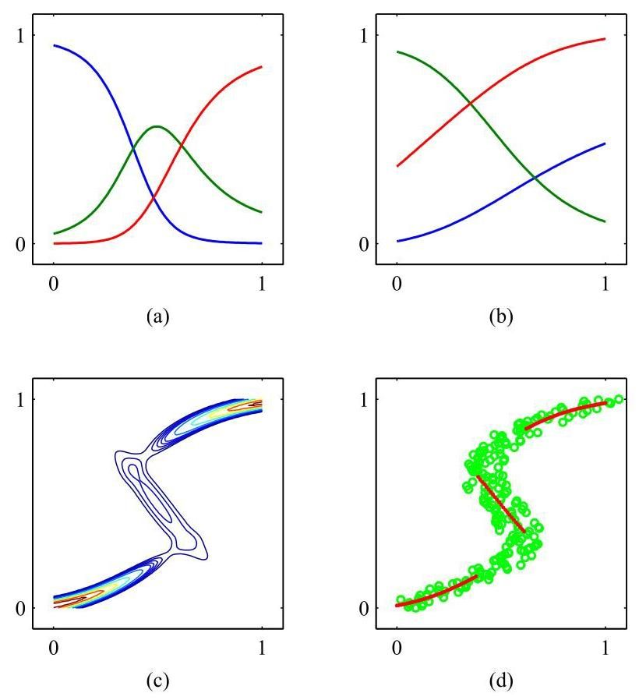

We can similarly evaluate the variance of the density function about the conditional average, to give

我们可以类似地评估密度函数关于条件平均值的方差，结果为

Exercise 6.21

练习 6.21

where we have used (6.38) and (6.48). This is more general than the corresponding least-squares result because the variance is a function of .

这里我们使用了 (6.38) 和 (6.48)。这比相应的最小二乘结果更具一般性，因为方差是 的函数。

We have seen that for multimodal distributions, the conditional mean can give a poor representation of the data. For instance, in controlling the simple robot arm shown in Figure 6.16, we need to pick one of the two possible joint angle settings to achieve the desired end-effector location, but the average of the two solutions is not itself a solution. In such cases, the conditional mode may be of more value. Because the conditional mode for the mixture density network does not have a simple analytical solution, a numerical iteration is required. A simple alternative is to take the mean of the most probable component (i.e., the one with the largest mixing coefficient) at each value of . This is shown for the toy data set in Figure 6.19(d).

我们已经看到，对于多峰分布，条件均值可能无法很好地表示数据。例如，在控制图 6.16 所示的简单机器人手臂时，我们需要从两种可能的关节角度设置中选择一种，以实现所需的末端执行器位置，但这两种解决方案的平均值本身并不是一个解决方案。在这种情况下，条件众数可能更有价值。由于混合密度网络的条件众数没有简单的解析解，因此需要进行数值迭代。一种简单的替代方法是在 的每个值处取最可能的分量(即具有最大混合系数的分量)的均值。图 6.19(d) 展示了针对玩具数据集的这种情况。

Exercises

练习

6.1 Use the result (2.126) to derive an expression for the surface area and the volume of a hypersphere of unit radius in dimensions. To do this, consider the following result, which is obtained by transforming from Cartesian to polar

6.1 利用结果 (2.126) 推导 维单位半径超球体的表面积 和体积 的表达式。为此，考虑以下通过从笛卡尔坐标转换为极坐标得到的结果

coordinates:

坐标:

Using the gamma function, defined by

使用由以下式子定义的伽马函数

together with (2.126), evaluate both sides of this equation, and hence show that

结合 (2.126)，计算该方程的两边，从而证明

Next, by integrating with respect to the radius from 0 to 1, show that the volume of the unit hypersphere in dimensions is given by

接下来，通过对半径从 0 到 1 进行积分，证明 维单位超球体的体积由下式给出

Finally, use the results and to show that (6.53) and (6.54) reduce to the usual expressions for and .

最后，利用结果 和 证明 (6.53) 和 (6.54) 可简化为 和 的常用表达式。

6.2 Consider a hypersphere of radius in dimensions together with the concentric hypercube of side , so that the hypersphere touches the hypercube at the centres of each of its sides. By using the results of Exercise 6.1, show that the ratio of the volume of the hypersphere to the volume of the cube is given by

6.2 考虑一个 维中半径为 的超球体，以及与之同心、边长为 的超立方体，使得超球体在超立方体各边的中心处与之相切。利用练习 6.1 的结果，证明超球体体积与立方体体积之比由下式给出

Now make use of Stirling’s formula in the form

现在使用如下形式的斯特林公式

which is valid for , to show that, as , the ratio (6.55) goes to zero. Show also that the distance from the centre of the hypercube to one of the corners divided by the perpendicular distance to one of the sides is , which therefore goes to as . From these results, we see that, in a space of high dimensionality, most of the volume of a cube is concentrated in the large number of corners, which themselves become very long ’spikes’!

该公式在 时成立，证明当 时，比率 (6.55) 趋于零。同时证明超立方体中心到一个角的距离除以到一条边的垂直距离为 ，因此当 时，该值趋于 。从这些结果我们可以看出，在高维空间中，立方体的大部分体积集中在大量的角上，而这些角本身变成了很长的“尖刺”！

6.3 In this exercise, we explore the behaviour of the Gaussian distribution in high-dimensional spaces. Consider a Gaussian distribution in dimensions given by

6.3 在这个练习中，我们探讨高维空间中高斯分布的行为。考虑一个由下式给出的 维高斯分布

We wish to find the density as a function of the radius in polar coordinates in which the direction variables have been integrated out. To do this, show that the integral of the probability density over a thin shell of radius and thickness , where , is given by where

我们希望找到极坐标下密度随半径变化的函数，其中方向变量已被积分掉。为此，证明概率密度在半径为 、厚度为 (其中 )的薄壳上的积分由 给出，其中

where is the surface area of a unit hypersphere in dimensions. Show that the function has a single stationary point located, for large , at . By considering where , show that for large ,

其中 是 维单位超球面的表面积。证明对于大的 ，函数 在 处有一个驻点。通过考虑 (其中 )，证明对于大的 ，

which shows that is a maximum of the radial probability density and also that decays exponentially away from its maximum at with length scale . We have already seen that for large , and so we see that most of the probability mass is concentrated in a thin shell at large radius. Finally, show that the probability density is larger at the origin than at the radius by a factor of . We therefore see that most of the probability mass in a high-dimensional Gaussian distribution is located at a different radius from the region of high probability density.

这表明 是径向概率密度的最大值，并且 从其在 处的最大值以长度尺度 呈指数衰减。我们已经看到，对于大的 有 ，因此我们看到大部分概率质量集中在大半径处的一个薄壳中。最后，证明概率密度 在原点处比在半径 处大 倍。因此，我们看到高维高斯分布中的大部分概率质量位于与高概率密度区域不同的半径处。

6.4 Consider a two-layer network function of the form (6.11) in which the hidden-unit nonlinear activation functions are given by logistic sigmoid functions of the form

6.4 考虑形式为 (6.11) 的两层网络函数，其中隐藏单元的非线性激活函数 由形式如下的逻辑 sigmoid 函数给出

Show that there exists an equivalent network, which computes exactly the same function, but with hidden-unit activation functions given by where the tanh function is defined by (6.14). Hint: first find the relation between and , and then show that the parameters of the two networks differ by linear transformations.

证明存在一个等效网络，它能精确计算相同的函数，但隐藏单元的激活函数由 给出，其中双曲正切函数由 (6.14) 定义。提示:首先找出 和 之间的关系，然后证明这两个网络的参数相差一个线性变换。

6.5 The swish activation function (Ramachandran, Zoph, and Le,2017) is defined by

6.5 Swish 激活函数(Ramachandran、Zoph 和 Le，2017)定义为

where is the logistic-sigmoid activation function defined by (6.13). When used in a neural network, can be treated as a learnable parameter. Either sketch or plot using software graphs of the swish activation function as well as its first derivative for , and . Show that when , the swish function becomes the ReLU function.

其中 是由 (6.13) 定义的逻辑 S 型激活函数。当在神经网络中使用时， 可以被视为一个可学习的参数。使用软件绘制或手绘 和 时 Swish 激活函数及其一阶导数的图形。证明当 时，Swish 函数变为 ReLU 函数。

6.6 We saw in (5.72) that the derivative of the logistic-sigmoid activation function can be expressed in terms of the function value itself. Derive the corresponding result for the tanh activation function defined by (6.14).

6.6 我们在 (5.72) 中看到，逻辑 S 型激活函数的导数可以用函数值本身来表示。推导由 (6.14) 定义的双曲正切激活函数的相应结果。

Show that the softplus activation function given by (6.16) satisfies the properties:

证明由 (6.16) 给出的 Softplus 激活函数 满足以下性质:

where is the logistic-sigmoid activation function given by (6.13).

其中 是由 (6.13) 给出的逻辑 S 型激活函数。

6.8 (*) Show that minimization of the error function (6.25) with respect to the variance gives the result (6.27).

6.8 (*) 证明关于方差 最小化误差函数 (6.25) 可得到结果 (6.27)。

6.9 (*) Show that maximizing the likelihood function under the conditional distribution (6.28) for a multioutput neural network is equivalent to minimizing the sum-of-squares error function (6.29). Also, show that the noise variance that minimizes this error function is given by (6.30).

6.9 (*) 证明在多输出神经网络的条件分布 (6.28) 下最大化似然函数等价于最小化平方和误差函数 (6.29)。此外，证明使该误差函数最小化的噪声方差由 (6.30) 给出。

6.10 Consider a regression problem involving multiple target variables in which it is assumed that the distribution of the targets, conditioned on the input vector , is a Gaussian of the form

6.10 考虑一个涉及多个目标变量的回归问题，其中假设在输入向量 的条件下，目标的分布是如下形式的高斯分布

where is the output of a neural network with input vector and weight vector , and is the covariance of the assumed Gaussian noise on the targets. Given a set of independent observations of and , write down the error function that must be minimized to find the maximum likelihood solution for , if we assume that is fixed and known. Now assume that is also to be determined from the data, and write down an expression for the maximum likelihood solution for . Note that the optimizations of and are now coupled, in contrast to the case of independent target variables discussed in Section 6.4.1.

其中 是输入向量为 、权重向量为 的神经网络的输出， 是假设的目标上高斯噪声的协方差。给定 和 的一组独立观测值，如果我们假设 是固定且已知的，写出为找到 的最大似然解必须最小化的误差函数。现在假设 也需要从数据中确定，写出 的最大似然解的表达式。注意，与 6.4.1 节中讨论的独立目标变量的情况不同，现在 和 的优化是耦合的。

6.11 Consider a binary classification problem in which the target values are , with a network output that represents , and suppose that there is a probability that the class label on a training data point has been incorrectly set. Assuming i.i.d. data, write down the error function corresponding to the negative likelihood. Verify that the error function (6.33) is obtained when . Note that this error function makes the model robust to incorrectly labelled data, in contrast to the usual cross-entropy error function.

6.11 考虑一个二分类问题，其中目标值为 ，网络输出为 ，表示 ，并且假设训练数据点的类别标签被错误设置的概率为 。假设数据是独立同分布的，写出对应于负 似然的误差函数。验证当 时可得到误差函数 (6.33)。注意，与通常的交叉熵误差函数不同，这个误差函数使模型对标签错误的数据具有鲁棒性。

The error function (6.33) for binary classification problems was derived for a network having a logistic-sigmoid output activation function, so that 1, and data having target values . Derive the corresponding error function if we consider a network having an output and target values for class and for class . What would be the appropriate choice of output-unit activation function?

二分类问题的误差函数 (6.33) 是针对具有逻辑 sigmoid 输出激活函数的网络推导出来的，使得 1，且数据的目标值为 。如果我们考虑一个输出为 且类别 的目标值为 、类别 的目标值为 的网络，推导相应的误差函数。输出单元激活函数的合适选择是什么？

6.13 ( ) Show that maximizing the likelihood for a multi-class neural network model in which the network outputs have the interpretation is equivalent to minimizing the cross-entropy error function (6.36).

6.13 ( ) 证明对于一个多类别神经网络模型，最大化似然(其中网络输出具有解释 )等价于最小化交叉熵误差函数 (6.36)。

6.14 (*) Show that the derivative of the error function (6.33) with respect to the pre-activation for an output unit having a logistic-sigmoid activation function , where is given by (6.13), satisfies (6.31).

6.14 (*) 证明对于具有逻辑 sigmoid 激活函数 的输出单元，误差函数 (6.33) 关于预激活 的导数(其中 由 (6.13) 给出)满足 (6.31)。

6.15 Show that the derivative of the error function (6.36) with respect to the pre-activation for output units having a softmax activation function (6.37) satisfies (6.31).

6.15 证明对于具有 softmax 激活函数 (6.37) 的输出单元，误差函数 (6.36) 关于预激活 的导数满足 (6.31)。

6.16 Write down a pair of equations that express the Cartesian coordinates for the robot arm shown in Figure 6.16 in terms of the joint angles and and the lengths and of the links. Assume the origin of the coordinate system is given by the attachment point of the lower arm. These equations define the forward kinematics of the robot arm.

6.16 写出一对方程，用关节角度 和 以及连杆长度 和 来表示图 6.16 所示机器人手臂的笛卡尔坐标 。假设坐标系的原点由下臂的连接点给出。这些方程定义了机器人手臂的正向运动学。

Show that the variable defined by (6.44) can be viewed as the posterior probabilities for the components of the mixture distribution (6.38) in which the mixing coefficients are viewed as -dependent prior probabilities .

证明由 (6.44) 定义的变量 可以看作是混合分布 (6.38) 各分量的后验概率 ，其中混合系数 被视为依赖于 的先验概率 。

6.18 Derive the result (6.45) for the derivative of the error function with respect to the network output pre-activations controlling the mixing coefficients in the mixture density network.

6.18 推导混合密度网络中误差函数关于控制混合系数的网络输出预激活的导数结果 (6.45)。

Derive the result (6.46) for the derivative of the error function with respect to the network output pre-activations controlling the component means in the mixture density network.

推导混合密度网络中误差函数关于控制分量均值的网络输出预激活的导数结果 (6.46)。

6.20 Derive the result (6.47) for the derivative of the error function with respect to the network output pre-activations controlling the component variances in the mixture density network.

6.20 推导混合密度网络中误差函数关于控制分量方差的网络输出预激活的导数结果 (6.47)。

6.21 Verify the results (6.48) and (6.50) for the conditional mean and variance of the mixture density network model.

6.21 验证混合密度网络模型的条件均值和方差的结果 (6.48) 和 (6.50)。

Deep Learning

深度学习

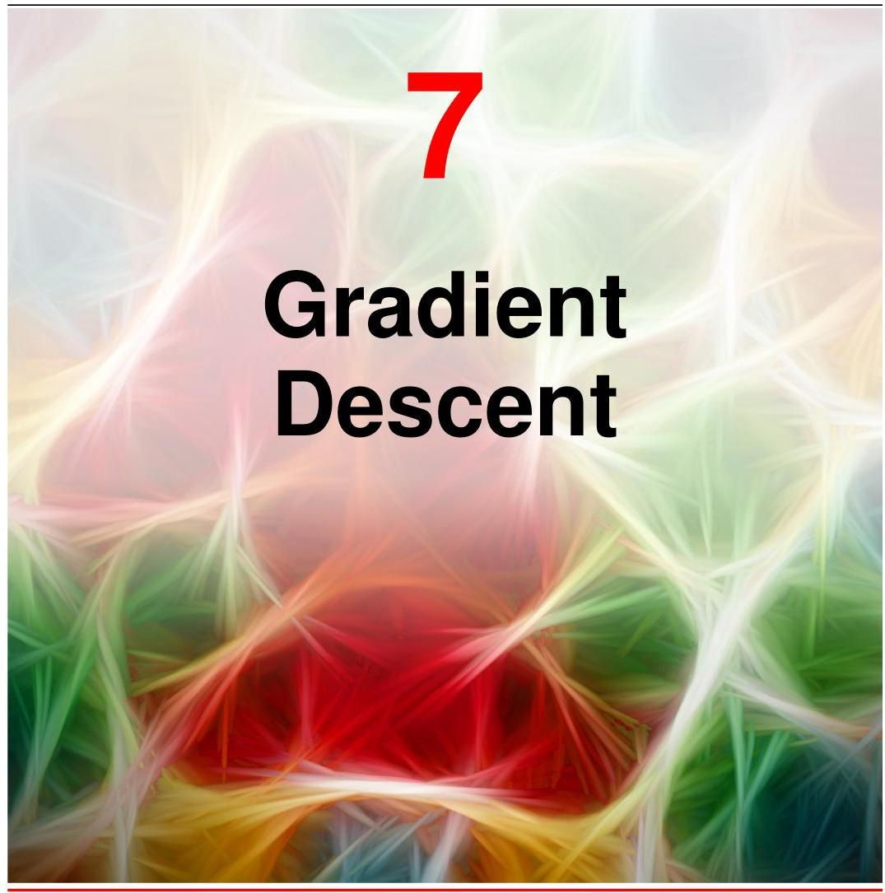

In the previous chapter we saw that neural networks are a very broad and flexible class of functions and are able in principle to approximate any desired function to arbitrarily high accuracy given a sufficiently large number of hidden units. Moreover, we saw that deep neural networks can encode inductive biases corresponding to hierarchical representations, which prove valuable in a wide range of practical applications. We now turn to the task of finding a suitable setting for the network parameters (weights and biases), based on a set of training data.

在上一章中，我们了解到神经网络是一类非常广泛且灵活的函数，并且原则上，在给定足够多的隐藏单元的情况下，能够以任意高的精度逼近任何所需的函数。此外，我们还看到深度神经网络可以编码与分层表示相对应的归纳偏置，这在广泛的实际应用中被证明是有价值的。现在，我们将基于一组训练数据，着手为网络参数(权重和偏置)寻找合适的设置。

As with the regression and classification models discussed in earlier chapters, we choose the model parameters by optimizing an error function. We have seen how to define a suitable error function for a particular application by using maximum likelihood. Although in principle the error function could be minimized numerically through a series of direct error function evaluations, this turns out to be very inefficient. Instead, we turn to another core concept that is used in deep learning, which is that optimizing the error function can be done much more efficiently by making use of gradient information, in other words by evaluating the derivatives of the error function with respect to the network parameters. This is why we took care to ensure that the function represented by the neural network is differentiable by design. Likewise, the error function itself also needs to be differentiable.

与前面章节中讨论的回归和分类模型一样，我们通过优化误差函数来选择模型参数。我们已经了解了如何通过最大似然法为特定应用定义合适的误差函数。虽然原则上可以通过一系列直接的误差函数评估来数值最小化误差函数，但事实证明这非常低效。相反，我们转向深度学习中使用的另一个核心概念，即利用梯度信息，换句话说，通过评估误差函数相对于网络参数的导数，可以更高效地优化误差函数。这就是为什么我们要确保神经网络所表示的函数在设计上是可微的。同样，误差函数本身也需要是可微的。

Section 6.4

第 6.4 节

The required derivatives of the error function with respect to each of the parameters in the network can be evaluated efficiently using a technique called back-propagation, which involves successive computations that flow backwards through the network in a way that is analogous to the forward flow of function computations during the evaluation of the network outputs.

误差函数相对于网络中每个参数的所需导数可以使用一种称为反向传播的技术来高效计算，该技术涉及一系列连续的计算，这些计算以类似于网络输出评估期间函数计算的前向流动的方式在网络中反向流动。

Chapter 8

第 8 章

Although the likelihood is used to define an error function, the goal when optimizing the error function in a neural network is to achieve good generalization on test data. In classical statistics, maximum likelihood is used to fit a parametric model to a finite data set, in which the number of data points typically far exceeds the number of parameters in the model. The optimal solution has the maximum value of the likelihood function, and the values found for the fitted parameters are of direct interest. By contrast, modern deep learning works with very rich models containing huge numbers of learnable parameters, and the goal is never simply exact optimization. Instead, the properties and behaviour of the learning algorithm itself, along with various methods for regularization, are important in determining how well the solution generalizes to new data.

尽管似然性用于定义误差函数，但在神经网络中优化误差函数时，目标是在测试数据上实现良好的泛化能力。在经典统计学中，最大似然法用于将参数模型拟合到有限数据集，其中数据点的数量通常远超过模型中的参数数量。最优解具有似然函数的最大值，并且所找到的拟合参数值是直接关注的对象。相比之下，现代深度学习使用包含大量可学习参数的非常丰富的模型，其目标绝不仅仅是精确优化。相反，学习算法本身的特性和行为，以及各种正则化方法，对于确定解对新数据的泛化能力至关重要。

Section 9.3.2

第 9.3.2 节

Chapter 9

第 9 章

# 7.1. Error Surfaces

# 7.1. 误差曲面

Our goal during training is to find values for the weights and biases in the neural network that will allow it to make effective predictions. For convenience we will group these parameters into a single vector , and we will optimize by using a chosen error function . At this point, it is useful to have a geometrical picture of the error function, which we can view as a surface sitting over ’weight space’, as shown in Figure 7.1.

我们在训练期间的目标是找到神经网络中权重和偏置的值，使其能够进行有效的预测。为方便起见，我们将这些参数组合成一个单一向量 ，并使用选定的误差函数 来优化 。此时，对误差函数有一个几何图像是很有用的，我们可以将其视为位于“权重空间”上方的一个曲面，如图 7.1 所示。

First note that if we make a small step in weight space from to then the change in the error function is given by

首先注意到，如果我们在权重空间中从 进行一个小的步长到 ，那么误差函数的变化由下式给出

where the vector points in the direction of the greatest rate of increase of the error function. Provided the error is a smooth, continuous function of , its smallest value will occur at a point in weight space such that the gradient of the error function vanishes, so that

其中向量 指向误差函数增长最快的方向。假设误差 是 的一个平滑、连续的函数，其最小值将出现在权重空间中的某一点，使得误差函数的梯度为零，即

as otherwise we could make a small step in the direction of and thereby further reduce the error. Points at which the gradient vanishes are called stationary points and may be further classified into minima, maxima, and saddle points.

否则，我们可以沿着 的方向进行一个小的步长，从而进一步减小误差。梯度为零的点称为驻点，并且可以进一步分为最小值点、最大值点和鞍点。

Section 7.1.1

7.1.1 节

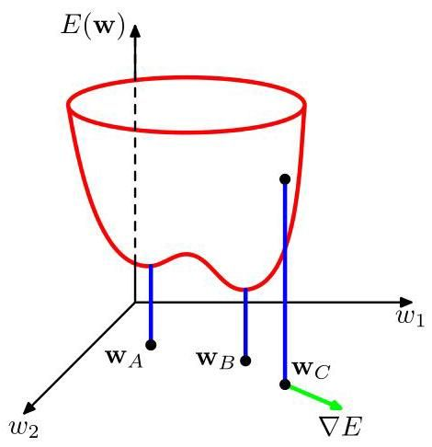

Figure 7.1 ure 7.1 Geometrical view of the error function as a surface sitting over weight space. Point is a local minimum and is the global minimum, so that . At any point , the local gradient of the error surface is given by the vector .

图 7.1 图 7.1 将误差函数 视为位于权重空间上方的一个曲面的几何视图。点 是一个局部最小值点， 是全局最小值点，因此 。在任意点 ，误差曲面的局部梯度由向量 给出。

We will aim to find a vector such that takes its smallest value. However, the error function typically has a highly nonlinear dependence on the weights and bias parameters, and so there will be many points in weight space at which the gradient vanishes (or is numerically very small). Indeed, for any point that is a local minimum, there will generally be other points in weight space that are equivalent minima. For instance, in a two-layer network of the kind shown in Figure 6.9, with hidden units, each point in weight space is a member of a family of equivalent points.

我们的目标是找到一个向量 ，使得 取到其最小值。然而，误差函数通常高度非线性地依赖于权重和偏置参数，因此在权重空间中会有许多点的梯度为零(或者在数值上非常小)。实际上，对于任意一个局部最小值点 ，在权重空间中通常会有其他等价的最小值点。例如，在图 6.9 所示的那种两层网络中，有 个隐藏单元，权重空间中的每个点都是一个包含 个等价点的族的成员。

Section 6.2.4

第 6.2.4 节

Furthermore, there may be multiple non-equivalent stationary points and in particular multiple non-equivalent minima. A minimum that corresponds to the smallest value of the error function across the whole of w-space is said to be a global minimum. Any other minima corresponding to higher values of the error function are said to be local minima. The error surfaces for deep neural networks can be very complex, and it was thought that gradient-based methods might become trapped in poor local minima. In practice, this seems not to be the case, and large networks can reach solutions with similar performance under a variety of initial conditions.

此外，可能存在多个不等价的驻点，特别是多个不等价的极小值点。在整个权重空间中对应误差函数最小值的极小值点被称为全局极小值点。其他对应误差函数较高值的极小值点被称为局部极小值点。深度神经网络的误差曲面可能非常复杂，人们曾认为基于梯度的方法可能会陷入较差的局部极小值点。但在实践中，情况似乎并非如此，大型网络在各种初始条件下都能达到性能相近的解。

Section 9.3.2

第 9.3.2 节

# 7.1.1 Local quadratic approximation

# 7.1.1 局部二次近似

Insight into the optimization problem and into the various techniques for solving it can be obtained by considering a local quadratic approximation to the error function. The Taylor expansion of around some point in weight space is given by

通过考虑误差函数的局部二次近似，可以深入了解优化问题以及解决该问题的各种技术。 在权重空间中某点 附近的泰勒展开式为

where cubic and higher terms have been omitted. Here is defined to be the gradient of evaluated at

其中三次及更高次项已被省略。这里 定义为 在 处的梯度

The Hessian is defined to be the corresponding matrix of second derivatives

海森矩阵被定义为二阶导数对应的矩阵

If there is a total of weights and biases in the network, then and have length and has dimensionality . From (7.3), the corresponding local approximation to the gradient is given by

如果网络中总共有 个权重和偏置，那么 和 的长度为 ， 的维度为 。由式 (7.3) 可知，梯度的相应局部近似由下式给出

For points that are sufficiently close to , these expressions will give reasonable approximations for the error and its gradient.

对于足够接近 的点 ，这些表达式将为误差及其梯度提供合理的近似。

Consider the particular case of a local quadratic approximation around a point that is a minimum of the error function. In this case there is no linear term, because at , and (7.3) becomes

考虑误差函数在某点 处取最小值时的局部二次近似的特殊情况。在这种情况下，没有线性项，因为在 处 ，式 (7.3) 变为

where the Hessian is evaluated at . To interpret this geometrically, consider the eigenvalue equation for the Hessian matrix:

其中海森矩阵 在 处求值。为了从几何角度解释这一点，考虑海森矩阵的特征值方程:

Appendix A

附录 A

where the eigenvectors form a complete orthonormal set so that

其中特征向量 构成一个完备的正交归一集合，使得

We now expand as a linear combination of the eigenvectors in the form

现在我们将 展开为特征向量的线性组合，形式如下

This can be regarded as a transformation of the coordinate system in which the origin is translated to the point and the axes are rotated to align with the eigenvectors through the orthogonal matrix whose columns are . By substituting (7.10) into (7.7) and using (7.8) and (7.9), the error function can be written in the

这可以看作是坐标系的一种变换，在该变换中，原点平移到点 ，并且坐标轴通过其列向量为 的正交矩阵旋转以与特征向量对齐。将 (7.10) 代入 (7.7) 并使用 (7.8) 和 (7.9)，误差函数可以写成

Appendix A

附录 A

Exercise 7.1

练习 7.1

form

形式

Suppose we set all for and then vary , corresponding to moving away from in the direction of . We see from (7.11) that the error function will increase if the corresponding eigenvalue is positive and will decrease if it is negative. If all eigenvalues are positive then corresponds to a local minimum of the error function, whereas if they are all negative then corresponds to a local maximum. If we have a mix of positive and negative eigenvalues then represents a saddle point.

假设我们对 设置所有 ，然后改变 ，这对应于将 沿 的方向从 移开。从 (7.11) 我们可以看出，如果相应的特征值 为正，则误差函数将增大；如果为负，则误差函数将减小。如果所有特征值均为正，则 对应于误差函数的一个局部最小值；而如果所有特征值均为负，则 对应于一个局部最大值。如果特征值有正有负，则 表示一个鞍点。

A matrix is said to be positive definite if, and only if,

当且仅当矩阵 满足以下条件时，称其为正定矩阵:

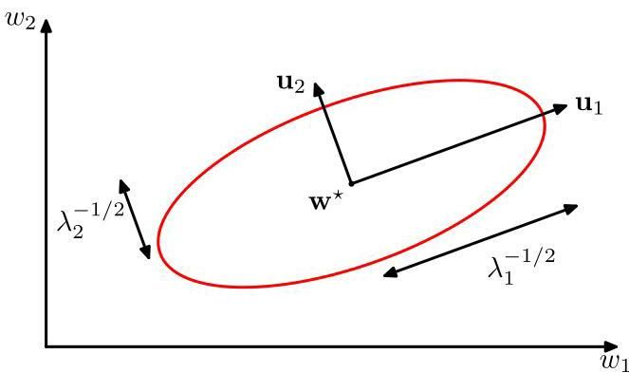

Figure 7.2 In the neighbourhood of a minimum , the error function can be approximated by a quadratic. Contours of constant error are then ellipses whose axes are aligned with the eigenvectors of the Hessian matrix, with lengths that are inversely proportional to the square roots of the corresponding eigenvectors .

图 7.2 在最小值 的邻域内，误差函数可以用一个二次函数来近似。此时，误差恒定的等高线为椭圆，其轴与海森矩阵的特征向量 对齐，长度与相应特征值 的平方根成反比。

Because the eigenvectors form a complete set, an arbitrary vector can be

由于特征向量 构成一个完备集，任意向量 可以

written in the form

写成如下形式

From (7.8) and (7.9), we then have

由 (7.8) 和 (7.9)，我们有

Exercise 7.2

练习 7.2

and so will be positive definite if, and only if, all its eigenvalues are positive. Thus, a necessary and sufficient condition for to be a local minimum is that the gradient of the error function should vanish at and the Hessian matrix evaluated at should be positive definite. In the new coordinate system, whose basis vectors are given by the eigenvectors , the contours of constant are axis-aligned Exercise 7.6 ellipses centred on the origin, as illustrated in Figure 7.2.

因此， 为正定矩阵的充要条件是其所有特征值均为正。因此， 为局部极小值的充要条件是误差函数的梯度在 处消失，并且在 处计算得到的黑塞矩阵应为正定矩阵。在以特征向量 为基向量的新坐标系中，常数 的等值线是以原点为中心、轴对齐的椭圆(练习 7.6)，如图 7.2 所示。

Exercise 7.3

练习 7.3

# 7.2. Gradient Descent Optimization

# 7.2. 梯度下降优化

There is little hope of finding an analytical solution to the equation for an error function as complex as one defined by a neural network, and so we resort to iterative numerical procedures. The optimization of continuous nonlinear functions is a widely studied problem, and there exists an extensive literature on how to solve it efficiently. Most techniques involve choosing some initial value for the weight vector and then moving through weight space in a succession of steps of the form

对于像神经网络所定义的那样复杂的误差函数，要找到方程 的解析解几乎是不可能的，因此我们采用迭代数值方法。连续非线性函数的优化是一个被广泛研究的问题，并且有大量关于如何有效解决该问题的文献。大多数技术都涉及为权重向量选择某个初始值 ，然后在权重空间中以一系列形式为的步骤进行移动

where labels the iteration step. Different algorithms involve different choices for the weight vector update .

其中 标记迭代步骤。不同的算法涉及对权重向量更新 的不同选择。

Because of the complex shape of the error surface for all but the simplest neural networks, the solution found will depend, among other things, on the particular choice of initial parameter values . To find a sufficiently good solution, it may be necessary to run a gradient-based algorithm multiple times, each time using a different randomly chosen starting point, and comparing the resulting performance on an independent validation set.

除了最简单的神经网络之外，由于所有神经网络的误差曲面形状复杂，找到的解在很大程度上取决于初始参数值 的具体选择。为了找到一个足够好的解，可能需要多次运行基于梯度的算法，每次使用不同的随机选择的起始点，并在独立的验证集上比较所得的性能。

# 7.2.1 Use of gradient information

# 7.2.1 梯度信息的使用

The gradient of an error function for a deep neural network can be evaluated efficiently using the technique of error backpropagation, and applying this gradient information can lead to significant improvements in the speed of network training. We can see why this is so, as follows.

可以使用误差反向传播技术有效地计算深度神经网络误差函数的梯度，应用此梯度信息可以显著提高网络训练的速度。我们可以通过以下内容了解其原因。

Chapter 8

第 8 章

In the quadratic approximation to the error function given by (7.3), the error surface is specified by the quantities and , which contain a total of independent elements (because the matrix is symmetric), where is the dimensionality of (i.e., the total number of learnable parameters in the network). The location of the minimum of this quadratic approximation therefore depends on parameters, and we should not expect to be able to locate the minimum until we have gathered independent pieces of information. If we do not make use of gradient information, we would expect to have to perform function evaluations, each of which would require steps. Thus, the computational effort needed to find the minimum using such an approach would be .

在由式 (7.3) 给出的误差函数的二次近似中，误差曲面由量 和 确定，它们总共包含 个独立元素(因为矩阵 是对称的)，其中 是 的维数(即网络中可学习参数的总数)。因此，这个二次近似的最小值位置取决于 个参数，在收集到 条独立信息之前，我们不应期望能够找到最小值。如果不利用梯度信息，我们预计需要进行 次函数评估，每次评估都需要 步。因此，使用这种方法找到最小值所需的计算量将是 。

Exercise 7.7

练习 7.7

Now compare this with an algorithm that makes use of the gradient information. Because is a vector of length , each evaluation of brings pieces of information, and so we might hope to find the minimum of the function in gradient evaluations. As we shall see, by using error backpropagation, each such evaluation takes only steps and so the minimum can now be found in steps. Although the quadratic approximation only holds in the neighbourhood of a minimum, the efficiency gains are generic. For this reason, the use of gradient information forms the basis of all practical algorithms for training neural networks.

现在将其与利用梯度信息的算法进行比较。由于 是一个长度为 的向量，每次对 的计算都会带来 条信息，因此我们可能希望通过 次梯度计算找到函数的最小值。正如我们将看到的，通过使用误差反向传播，每次这样的计算只需要 步，因此现在可以在 步内找到最小值。尽管二次近似仅在最小值附近成立，但效率提升是普遍的。出于这个原因，利用梯度信息构成了所有训练神经网络实用算法的基础。

Chapter 8

第 8 章

# 7.2.2 Batch gradient descent

# 7.2.2 批量梯度下降

The simplest approach to using gradient information is to choose the weight update in (7.15) such that there is a small step in the direction of the negative gradient, so that

使用梯度信息的最简单方法是选择 (7.15) 中的权重更新方式，使得在负梯度方向上进行一个小步长的更新，即

where the parameter is known as the learning rate. After each such update, the gradient is re-evaluated for the new weight vector and the process repeated. At each step, the weight vector is moved in the direction of the greatest rate of decrease of the error function, and so this approach is known as gradient descent or steepest descent. Note that the error function is defined with respect to a training set, and so to evaluate , each step requires that the entire training set be processed. Techniques that use the whole data set at once are called batch methods.

其中参数 被称为学习率。每次进行这样的更新后，会针对新的权重向量 重新计算梯度，并重复该过程。在每一步中，权重向量都会朝着误差函数下降最快的方向移动，因此这种方法被称为梯度下降或最速下降。请注意，误差函数是相对于训练集定义的，因此为了计算 ，每一步都需要处理整个训练集。一次性使用整个数据集的技术称为批量方法。

# 7.2.3 Stochastic gradient descent

# 7.2.3 随机梯度下降

Deep learning methods benefit greatly from very large data sets. However, batch methods can become extremely inefficient if there are many data points in the training set because each error function or gradient evaluation requires the entire data set

深度学习方法从非常大的数据集中受益匪浅。然而，如果训练集中有许多数据点，批量方法可能会变得极其低效，因为每次误差函数或梯度评估都需要整个数据集

Algorithm 7.1: Stochastic gradient descent

算法 7.1:随机梯度下降

Input: Training set of data points indexed by

输入:由 索引的数据点训练集

Error function per data point

每个数据点的误差函数

Learning rate parameter

学习率参数

Initial weight vector

初始权重向量

Output: Final weight vector

输出:最终权重向量

repeat

// update weight vector

// iterate over data

until convergence

return

to be processed. To find a more efficient approach, note that error functions based on maximum likelihood for a set of independent observations comprise a sum of terms, one for each data point:

待处理。为了找到更有效的方法，请注意，基于一组独立观测值的最大似然的误差函数由各项之和组成，每个数据点对应一项:

The most widely used training algorithms for large data sets are based on a sequential version of gradient descent known as stochastic gradient descent (Bottou, 2010), or SGD, which updates the weight vector based on one data point at a time, so that

对于大型数据集，最广泛使用的训练算法基于梯度下降的一种顺序版本，即随机梯度下降(Bottou，2010)，简称 SGD。该算法每次基于一个数据点更新权重向量，因此

This update is repeated by cycling through the data. A complete pass through the whole training set is known as a training epoch. This technique is also known as online gradient descent, especially if the data arises from a continuous stream of new data points. Stochastic gradient descent is summarized in Algorithm 7.1.

通过遍历数据重复进行此更新。完整遍历整个训练集一次称为一个训练轮次。这种技术也称为在线梯度下降，特别是当数据来自连续的新数据点流时。随机梯度下降总结在算法 7.1 中。

A further advantage of stochastic gradient descent, compared to batch gradient descent, is that it handles redundancy in the data much more efficiently. To see this, consider an extreme example in which we take a data set and double its size by duplicating every data point. Note that this simply multiplies the error function by a factor of 2 and so is equivalent to using the original error function, if the value of the learning rate is adjusted to compensate. Batch methods will require double the computational effort to evaluate the batch error function gradient, whereas stochastic gradient descent will be unaffected. Another property of stochastic gradient descent is the possibility of escaping from local minima, since a stationary point with respect to the error function for the whole data set will generally not be a stationary point for each data point individually.

与批量梯度下降相比，随机梯度下降的另一个优点是它能更有效地处理数据中的冗余。为了说明这一点，考虑一个极端的例子，我们取一个数据集，通过复制每个数据点将其大小翻倍。请注意，如果调整学习率的值进行补偿，这只是将误差函数乘以 2，因此等同于使用原始误差函数。批量方法在评估批量误差函数梯度时需要两倍的计算量，而随机梯度下降则不受影响。随机梯度下降的另一个特性是有可能逃离局部最小值，因为相对于整个数据集的误差函数的驻点通常对于每个单独的数据点来说并不是驻点。

# 7.2.4 Mini-batches

# 7.2.4 小批量

A downside of stochastic gradient descent is that the gradient of the error function computed from a single data point provides a very noisy estimate of the gradient of the error function computed on the full data set. We can consider an intermediate approach in which a small subset of data points, called a mini-batch, is used to evaluate the gradient at each iteration. In determining the optimum size for the mini-batch, note that the error in computing the mean from samples is given by where is the standard deviation of the distribution generating the data. This indicates that there are diminishing returns in estimating the true gradient from increasing the batch size. If we increase the size of the mini-batch by a factor of 100 then the error only reduces by a factor of 10 . Another consideration in choosing the mini-batch size is the desire to make efficient use of the hardware architecture on which the code is running. For example, on some hardware platforms, mini-batch sizes that are powers of 2 (for example, 64, 128, 256, ...) work well.

随机梯度下降的一个缺点是，从单个数据点计算出的误差函数梯度，对在整个数据集上计算出的误差函数梯度的估计非常不准确。我们可以考虑一种折中的方法，即使用一小部分数据点(称为小批量)来在每次迭代中评估梯度。在确定小批量的最佳大小时，请注意，从 个样本计算均值的误差由 给出，其中 是生成数据的分布的标准差。这表明，通过增加批量大小来估计真实梯度的收益是递减的。如果我们将小批量的大小增加 100 倍，那么误差仅会减少 10 倍。选择小批量大小的另一个考虑因素是要有效利用运行代码的硬件架构。例如，在某些硬件平台上，2 的幂次方大小的小批量(例如 64、128、256 等)效果很好。

Exercise 7.8

练习 7.8

One important consideration when using mini-batches is that the constituent data points should be chosen randomly from the data set, since in raw data sets there may be correlations between successive data points arising from the way the data was collected (for example, if the data points have been ordered alphabetically or by date). This is often handled by randomly shuffling the entire data set and then subsequently drawing mini-batches as successive blocks of data. The data set can also be reshuffled between iterations through the data set, so that each mini-batch is unlikely to have been used before, which can help escape local minima. The variant of stochastic gradient descent with mini-batches is summarized in Algorithm 7.2. Note that the learning algorithm is often still called ’stochastic gradient descent’ even when mini-batches are used.

使用小批量时的一个重要考虑因素是，组成小批量的数据点应该从数据集中随机选择，因为在原始数据集中，由于数据的收集方式(例如，如果数据点是按字母顺序或日期排序的)，连续的数据点之间可能存在相关性。这通常通过随机打乱整个数据集，然后将小批量作为连续的数据块来处理。在遍历数据集的迭代过程中，也可以重新打乱数据集，这样每个小批量不太可能之前被使用过，这有助于跳出局部最小值。使用小批量的随机梯度下降变体总结在算法 7.2 中。请注意，即使使用了小批量，学习算法通常仍被称为“随机梯度下降”。

# 7.2.5 Parameter initialization

# 7.2.5 参数初始化

Iterative algorithms such as gradient descent require that we choose some initial setting for the parameters being learned. The specific initialization can have a significant effect on how long it takes to reach a solution and on the generalization performance of the resulting trained network. Unfortunately, there is relatively little theory to guide the initialization strategy.

诸如梯度下降之类的迭代算法要求我们为要学习的参数选择一些初始设置。具体的初始化方式会对达到解决方案所需的时间以及最终训练好的网络的泛化性能产生重大影响。不幸的是，指导初始化策略的理论相对较少。

One key consideration, however, is symmetry breaking. Consider a set of hidden units or output units that take the same inputs. If the parameters were all initialized with the same value, for example if they were all set to zero, the parameters of these units would all be updated in unison and the units would each compute the same function and hence be redundant. This problem can be addressed by initializing parameters randomly from some distribution to break symmetry. If computational resources permit, the network might be trained multiple times starting from different random initializations and the results compared on held-out data.

然而，一个关键的考虑因素是打破对称性。考虑一组接收相同输入的隐藏单元或输出单元。如果所有参数都初始化为相同的值，例如都设置为零，那么这些单元的参数将同时更新，并且每个单元将计算相同的函数，因此是冗余的。这个问题可以通过从某个分布中随机初始化参数来打破对称性来解决。如果计算资源允许，可以从不同的随机初始化开始多次训练网络，并在保留数据上比较结果。

The distribution used to initialize the weights is typically either a uniform distribution in the range or a zero-mean Gaussian of the form . The choice of the value of is important, and various heuristics to select it have been proposed. One widely used approach is called He initialization (He et al., 2015b). Consider a

用于初始化权重的分布通常是范围在 内的均匀分布，或者是形式为 的零均值高斯分布。 值的选择很重要，人们已经提出了各种启发式方法来选择它。一种广泛使用的方法称为 He 初始化(He 等人，2015b)。考虑一个

# Algorithm 7.2: Mini-batch stochastic gradient descent

# 算法 7.2:小批量随机梯度下降

Input: Training set of data points indexed by

输入:由 索引的数据点训练集

Batch size

批量大小

Error function per mini-batch

每个小批量的误差函数

Learning rate parameter

学习率参数

Initial weight vector

初始权重向量

Output: Final weight vector

输出:最终权重向量

repeat

weight vector update

if then

shuffle data

end if

until convergence

return

network in which layer evaluates the following transformations

其中第 层网络执行以下变换

where is the number of units that send connections to unit , and the ReLU activation function is given by (6.17). Suppose we initialize the weights using a Gaussian , and suppose that the outputs of the units in layer have variance . Then we can easily show that

其中 是向单元 发送连接的单元数量，ReLU 激活函数由式 (6.17) 给出。假设我们使用高斯分布 初始化权重，并且假设第 层单元的输出 的方差为 。那么我们可以很容易地证明

Exercise 7.9

练习 7.9

where the factor of arises from the ReLU activation function. Ideally we want to ensure that the variance of the pre-activations neither decays to zero nor grows significantly as we propagate from one layer to the next. If we therefore require that the units at layer also have variance then we arrive at the following choice for the standard deviation of the Gaussian used to initialize the weights that feed into a

其中因子 来自 ReLU 激活函数。理想情况下，我们希望确保在从一层传播到下一层时，预激活值的方差既不会衰减到零，也不会显著增长。因此，如果我们要求第 层的单元也具有方差 ，那么我们可以得到用于初始化输入到某一层的权重的高斯分布的标准差的以下选择

Figure 7.3 Schematic illustration of fixed-step gradient descent for an error function that has substantially different curvatures along different directions. The error surface has the form of a long valley, as depicted by the ellipses. Note that, for most points in weight space, the local negative gradient vector does not point towards the minimum of the error function. Successive steps of gradient descent can therefore oscillate across the valley, leading to very slow progress along the valley towards the minimum. The vectors and are the eigenvectors of the Hessian matrix.

图 7.3 展示了一个误差函数在不同方向上曲率显著不同时，固定步长梯度下降法的示意图。误差曲面 呈长谷状，如椭圆所示。请注意，在权重空间的大多数点上，局部负梯度向量 并不指向误差函数的最小值。因此，梯度下降的连续步骤可能会在山谷间振荡，导致沿山谷向最小值的进展非常缓慢。向量 和 是海森矩阵的特征向量。

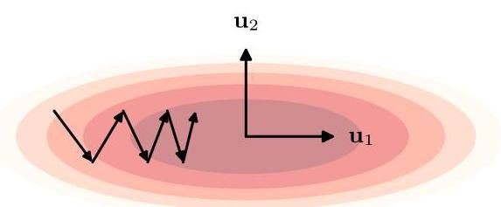

unit with inputs:

具有 个输入的单元:

It is also possible to treat the scale of the initialization distribution as a hyper-parameter and to explore different values across multiple training runs. The bias parameters are typically set to small positive values to ensure that most pre-activations are initially active during learning. This is particularly helpful with ReLU units, where we want the pre-activations to be positive so that there is a non-zero gradient to drive learning.

也可以将初始化分布的尺度 视为一个超参数，并在多次训练运行中探索不同的值。偏置参数通常设置为较小的正值，以确保在学习过程开始时，大多数预激活值处于激活状态。这对于 ReLU 单元尤其有用，因为我们希望预激活值为正，以便有非零梯度来驱动学习。

Another important class of techniques for initializing the parameters of a neural network is by using the values that result from training the network on a different task or by exploiting various forms of unsupervised training. These techniques fall into the broad class of transfer learning techniques.

另一类重要的神经网络参数初始化技术是使用在不同任务上训练网络得到的值，或者利用各种形式的无监督训练。这些技术属于广义的迁移学习技术范畴。

Section 6.3.4

第 6.3.4 节

# 7.3. Convergence

# 7.3. 收敛性

When applying gradient descent in practice, we need to choose a value for the learning rate parameter . Consider the simple error surface depicted in Figure 7.3 for a hypothetical two-dimensional weight space in which the curvature of varies significantly with direction, creating a ’valley’. At most points on the error surface, the local gradient vector for batch gradient descent, which is perpendicular to the local contour, does not point directly towards the minimum. Intuitively we might expect that increasing the value of should lead to bigger steps through weight space and hence faster convergence. However, the successive steps oscillate back and forth across the valley, and if we increase too much, those oscillations will become divergent. Because must be kept sufficiently small to avoid divergent oscillations across the valley, progress along the valley is very slow. Gradient descent then takes many small steps to reach the minimum and is a very inefficient procedure.

在实际应用梯度下降法时，我们需要为学习率参数 选择一个值。考虑图 7.3 中描绘的一个假设的二维权重空间的简单误差曲面，其中 的曲率随方向显著变化，形成了一个“山谷”。在误差曲面上的大多数点，批量梯度下降的局部梯度向量(它垂直于局部等高线)并不直接指向最小值。直观上，我们可能期望增加 的值会导致在权重空间中迈出更大的步长，从而实现更快的收敛。然而，连续的步长会在山谷间来回振荡，如果我们过度增加 ，这些振荡将会发散。由于必须将 保持得足够小以避免在山谷间出现发散振荡，因此沿着山谷的进展非常缓慢。梯度下降法随后需要采取许多小步才能达到最小值，这是一个非常低效的过程。

We can gain deeper insight into the nature of this problem by considering the quadratic approximation to the error function in the neighbourhood of the minimum. From (7.7), (7.8), and (7.10), the gradient of the error function in this approximation

通过考虑在最小值附近对误差函数进行二次逼近，我们可以更深入地了解这个问题的本质。从式 (7.7)、式 (7.8) 和式 (7.10) 可知，在这个逼近中误差函数的梯度

Section 7.1.1

7.1.1 节

can be written as

可以写成

Again using (7.10) we can express the change in the weight vector in terms of corresponding changes in the coefficients :

再次使用式 (7.10)，我们可以用系数 的相应变化来表示权重向量的变化:

Combining (7.24) with (7.25) and the gradient descent formula (7.16) and using the orthonormality relation (7.9) for the eigenvectors of the Hessian, we obtain the following expression for the change in at each step of the gradient descent algorithm:

将式 (7.24) 与式 (7.25) 以及梯度下降公式 (7.16) 相结合，并利用 Hessian 矩阵特征向量的正交归一关系 (7.9)，我们得到了梯度下降算法每一步中 变化的以下表达式:

Exercise 7.10 from which it follows that

习题 7.10，由此可得

where ’old’ and ’new’ denote values before and after a weight update. Using the orthonormality relation (7.9) for the eigenvectors together with (7.10), we have

其中“旧”和“新”分别表示权重更新前后的值。结合特征向量的正交归一关系 (7.9) 和 (7.10)，我们有

and so can be interpreted as the distance to the minimum along the direction . From (7.27) we see that these distances evolve independently such that, at each step, the distance along the direction of is multiplied by a factor . After a total of steps we have

因此 可以解释为沿方向 到最小值的距离。从 (7.27) 我们可以看出，这些距离是独立演化的，使得在每一步中，沿 方向的距离都乘以一个因子 。经过总共 步后，我们有

It follows that, provided , the limit leads to , which from (7.28) shows that and so the weight vector has reached the minimum of the error.

由此可知，假设 ，极限 会导致 ，从 (7.28) 可以看出这意味着 ，因此权重向量已达到误差的最小值。

Note that (7.29) demonstrates that gradient descent leads to linear convergence in the neighbourhood of a minimum. Also, convergence to the stationary point requires that all the be positive, which in turn implies that the stationary point is indeed a minimum. By making larger we can make the factor smaller and hence improve the speed of convergence. There is a limit to how large can be made, however. We can permit to go negative (which gives oscillating values of ), but we must ensure that otherwise the values will diverge. This limits the value of to where is the largest of the eigenvalues. The rate of convergence, however, is dominated by the smallest eigenvalue, so with set to its largest permitted value, the convergence along the direction corresponding to the smallest eigenvalue (the long axis of the ellipse in Figure 7.3)

注意，(7.29) 表明梯度下降在最小值附近会导致线性收敛。此外，收敛到驻点要求所有的 都为正，这反过来意味着该驻点确实是一个最小值。通过增大 ，我们可以使因子 变小，从而提高收敛速度。然而， 的增大是有限度的。我们可以允许 为负(这会导致 的值振荡)，但我们必须确保 ，否则 的值将发散。这将 的值限制在 ，其中 是最大的特征值。然而，收敛速度由最小的特征值主导，因此当 设置为其最大允许值时，沿对应于最小特征值方向(图 7.3 中椭圆的长轴)的收敛

will be governed by

将由

where is the smallest eigenvalue. If the ratio (whose reciprocal is known as the condition number of the Hessian) is very small, corresponding to highly elongated elliptical error contours as in Figure 7.3, then progress towards the minimum will be extremely slow.

其中 是最小特征值。如果比率 (其倒数被称为海森矩阵的条件数)非常小，对应于如图 7.3 所示的高度拉长的椭圆误差轮廓，那么向最小值的进展将极其缓慢。

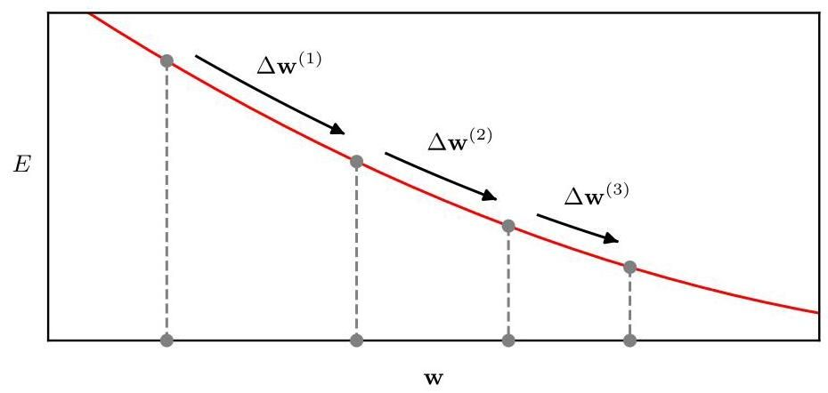

Figure 7.4 With a fixed learning rate parameter, gradient descent down a surface with low curvature leads to successively smaller steps corresponding to linear convergence. In such a situation, the effect of a momentum term is like an increase in the effective learning rate parameter.

图 7.4 使用固定的学习率参数时，在低曲率表面上进行梯度下降会导致步长逐渐变小，对应于线性收敛。在这种情况下，动量项的作用就像是有效学习率参数的增加。

# 7.3.1 Momentum

# 7.3.1 动量

One simple technique for dealing with the problem of widely differing eigenvalues is to add a momentum term to the gradient descent formula. This effectively adds inertia to the motion through weight space and smooths out the oscillations depicted in Figure 7.3. The modified gradient descent formula is given by

处理特征值差异较大问题的一种简单技术是在梯度下降公式中添加一个动量项。这实际上为权重空间中的运动增加了惯性，并消除了图 7.3 中所示的振荡。修改后的梯度下降公式为

where is called the momentum parameter. The weight vector is then updated using (7.15).

其中 称为动量参数。然后使用 (7.15) 更新权重向量。

To understand the effect of the momentum term, consider first the motion through a region of weight space for which the error surface has relatively low curvature, as indicated in Figure 7.4. If we make the approximation that the gradient is unchanging, then we can apply (7.31) iteratively to a long series of weight updates, and then sum the resulting arithmetic series to give

为了理解动量项的影响，首先考虑在权重空间的一个区域中的运动，该区域的误差表面曲率相对较低，如图 7.4 所示。如果我们近似认为梯度是不变的，那么我们可以对一系列长时间的权重更新迭代应用 (7.31)，然后对得到的算术级数求和，得到

and we see that the result of the momentum term is to increase the effective learning rate from to .

并且我们看到，动量项的作用是将有效学习率从 提高到 。

By contrast, in a region of high curvature in which gradient descent is oscillatory, as indicated in Figure 7.5, successive contributions from the momentum term will tend to cancel and the effective learning rate will be close to . Thus, the momentum term can lead to faster convergence towards the minimum without causing divergent oscillations. A schematic illustration of the effect of a momentum term is shown in Figure 7.6.

相比之下，在高曲率区域中，梯度下降会产生振荡，如图 7.5 所示，动量项的连续贡献往往会相互抵消，有效学习率将接近 。因此，动量项可以在不引起发散振荡的情况下，使收敛速度更快地趋向最小值。图 7.6 展示了动量项作用的示意图。

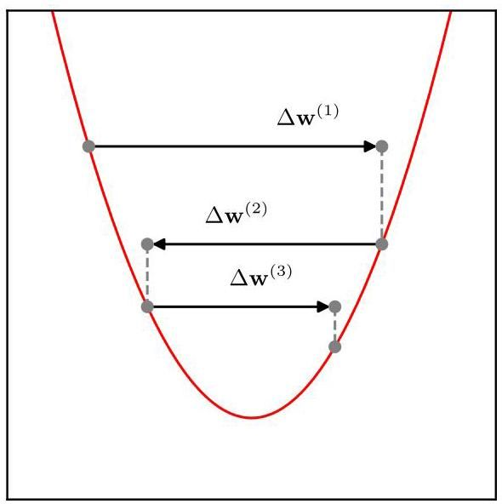

Figure 7.5 For a situation in which successive steps of gradient descent are oscillatory, a momentum term has little influence on the effective value of the learning rate parameter.

图 7.5 在梯度下降的连续步骤产生振荡的情况下，动量项对学习率参数的有效值影响很小。

Although the inclusion of momentum can lead to an improvement in the performance of gradient descent, it also introduces a second parameter whose value needs to be chosen, in addition to that of the learning rate parameter . From (7.33) we see that should be in the range . A typical value used in practice is . Stochastic gradient descent with momentum is summarized in Algorithm 7.3.

尽管引入动量可以提高梯度下降的性能，但除了学习率参数 之外，它还引入了第二个参数 ，其值需要进行选择。从式 (7.33) 中我们可以看出， 的取值范围应该是 。实际中常用的典型值是 。带有动量的随机梯度下降总结在算法 7.3 中。

The convergence can be further accelerated using a modified version of momentum called Nesterov momentum (Nesterov, 2004; Sutskever et al., 2013). In conventional stochastic gradient descent with momentum, we first compute the gradient at the current location then take a step that is amplified by adding momentum from the previous step. With the Nesterov method, we change the order of these and first compute a step based on the previous momentum, then calculate the gradient at this

使用一种称为 Nesterov 动量的改进版动量(Nesterov，2004；Sutskever 等人，2013)可以进一步加速收敛。在传统的带有动量的随机梯度下降中，我们首先在当前位置计算梯度，然后通过添加前一步的动量来放大步长。而在 Nesterov 方法中，我们改变了这些步骤的顺序，首先根据前一步的动量计算一个步长，然后在这个位置计算梯度。

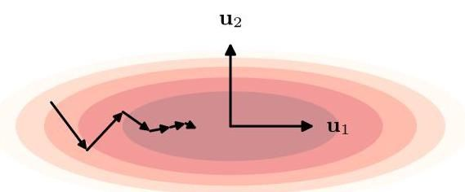

Figure 7.6 Illustration of the effect of adding a momentum term to the gradient descent algorithm, showing the more rapid progress along the valley of the error function, compared with the unmodified gradient descent shown in Figure 7.3.

图 7.6 展示了在梯度下降算法中添加动量项的效果，与图 7.3 中未修改的梯度下降相比，显示出沿着误差函数谷值的收敛速度更快。

Algorithm 7.3: Stochastic gradient descent with momentum

算法 7.3:带动量的随机梯度下降法

Input: Training set of data points indexed by

输入:由 索引的数据点训练集

Batch size

批量大小

Error function per mini-batch

每个小批量的误差函数

Learning rate parameter

学习率参数

Momentum parameter

动量参数

Initial weight vector

初始权重向量

Output: Final weight vector

输出:最终权重向量

repeat

calculate update term

weight vector update

if then

shuffle data

end if

until convergence

return

new location to find the update, so that

寻找更新的新位置，以便

For batch gradient descent, Nesterov momentum can improve the rate of convergence, although for stochastic gradient descent it can be less effective.

对于批量梯度下降，Nesterov 动量可以提高收敛速度，尽管对于随机梯度下降，其效果可能较差。

# 7.3.2 Learning rate schedule

# 7.3.2 学习率调度

In the stochastic gradient descent learning algorithm (7.18), we need to specify a value for the learning rate parameter . If is very small then learning will proceed slowly. However, if is increased too much it can lead to instability. Although some oscillation can be tolerated, it should not be divergent. In practice, the best results are obtained by using a larger value for at the start of training and then reducing the learning rate over time, so that the value of becomes a function of the step index :

在随机梯度下降学习算法(7.18)中，我们需要为学习率参数 指定一个值。如果 非常小，那么学习过程将进展缓慢。然而，如果 增加过多，可能会导致不稳定。虽然可以容忍一些振荡，但不应出现发散情况。在实践中，通过在训练开始时为 使用较大的值，然后随着时间降低学习率，从而使 的值成为步长索引 的函数，可以获得最佳结果:

Section 7.3.1

第 7.3.1 节

Examples of learning rate schedules include linear, power law, and exponential decay:

学习率调度的示例包括线性衰减、幂律衰减和指数衰减:

where in (7.36) the value of reduces linearly over steps, after which its value is held constant at . Good values for the hyperparameters , and must be found empirically. It can be very helpful in practice to monitor the learning curve showing how the error function evolves during the gradient descent iteration to ensure that it is decreasing at a suitable rate.

其中在 (7.36) 中， 的值在 步内线性减小，之后其值保持在 不变。必须通过经验找到超参数 和 的合适值。在实践中，监测显示误差函数在梯度下降迭代过程中如何变化的学习曲线非常有帮助，以确保它以合适的速率下降。

# 7.3.3 RMSProp and Adam

# 7.3.3 RMSProp 和 Adam

We saw that the optimal learning rate depends on the local curvature of the error surface, and moreover that this curvature can vary according to the direction in parameter space. This motivates several algorithms that use different learning rates for each parameter in the network. The values of these learning rates are adjusted automatically during training. Here we review some of the most widely used examples. Note, however, that this intuition really applies only if the principal curvature directions are aligned with the axes in weight space, corresponding to a locally diagonal Hessian matrix, which is unlikely to be the case in practice. Nevertheless, these types of algorithms can be effective and are widely used.

我们看到，最优学习率取决于误差曲面的局部曲率，而且该曲率会根据参数空间中的方向而变化。这促使人们提出了几种为网络中的每个参数使用不同学习率的算法。这些学习率的值在训练过程中会自动调整。在这里，我们回顾一些最广泛使用的示例。然而，需要注意的是，这种直觉实际上仅适用于主曲率方向与权重空间中的坐标轴对齐的情况，即对应于局部对角的 Hessian 矩阵，而在实践中这种情况不太可能发生。尽管如此，这些类型的算法仍然可能有效，并且被广泛使用。

Section 7.3

第 7.3 节

The key idea behind AdaGrad, short for ’adaptive gradient’, is to reduce each learning rate parameter over time by using the accumulated sum of squares of all the derivatives calculated for that parameter (Duchi, Hazan, and Singer, 2011). Thus, parameters associated with high curvature are reduced most rapidly. Specifically,

AdaGrad 是 “自适应梯度(adaptive gradient)” 的缩写，其核心思想是随着时间的推移，通过使用为该参数计算的所有导数的累积平方和来降低每个学习率参数(Duchi、Hazan 和 Singer，2011 年)。因此，与高曲率相关的参数会被最迅速地降低。具体而言，

where is the learning rate parameter, and is a small constant, say , that ensures numerical stability in the event that is close to zero. The algorithm is initialized with . Here is the error function for a particular mini-batch, and the update (7.40) is standard stochastic gradient descent but with a modified learning rate that is specific to each parameter.

其中 是学习率参数， 是一个小常数，例如 ，用于在 接近零时确保数值稳定性。该算法以 初始化。这里 是特定小批量的误差函数，更新公式(7.40)是标准的随机梯度下降法，但学习率针对每个参数进行了修改。

One problem with AdaGrad is that it accumulates the squared gradients from the very start of training, and so the associated weight updates can become very small, which can slow down training too much in the later phases. The idea behind the RMSProp algorithm, which is short for ’root mean square propagation’, is to replace the sum of squared gradients of AdaGrad with an exponentially weighted average

AdaGrad 的一个问题是，它从训练一开始就累积梯度的平方，因此相关的权重更新可能会变得非常小，这可能会在训练后期过度减慢训练速度。RMSProp 算法是 “均方根传播(root mean square propagation)” 的缩写，其思想是用指数加权平均值代替 AdaGrad 中的梯度平方和

(Hinton, 2012), giving

(Hinton，2012 年)，得到

where and a typical value is .

其中 ，典型值为 。

If we combine RMSProp with momentum, we obtain the Adam optimization method (Kingma and Ba, 2014) where the name is derived from ‘adaptive moments’. Adam stores the momentum for each parameter separately using update equations that consist of exponentially weighted moving averages for both the gradients and the squared gradients in the form

如果我们将 RMSProp 与动量法相结合，就得到了 Adam 优化方法(Kingma 和 Ba，2014 年)，其名称源自 “自适应矩(adaptive moments)”。Adam 使用更新方程分别存储每个参数的动量，这些方程对梯度和梯度的平方采用指数加权移动平均的形式

Here the factors and correct for a bias introduced by initializing and to zero. Note that the bias goes to zero as becomes large, since , and so in practice this bias correction is sometimes omitted. Typical values for the weighting parameters are and . Adam is the most widely adopted learning algorithm in deep learning and is summarized in Algorithm 7.4.

这里，因子 和 用于校正因将 和 初始化为零而引入的偏差。请注意，当 变得很大时，偏差趋近于零，因为 ，所以在实践中有时会省略这种偏差校正。加权参数的典型值为 和 。Adam 是深度学习中应用最广泛的学习算法，总结在算法 7.4 中。

Exercise 7.12

练习 7.12

# 7.4. Normalization

# 7.4. 归一化

Normalization of the variables computed during the forward pass through a neural network removes the need for the network to deal with extremely large or extremely small values. Although in principle the weights and biases in a neural network can adapt to whatever values the input and hidden variables take, in practice normalization can be crucial for ensuring effective training. Here we consider three kinds of normalization according to whether we are normalizing across the input data, across mini-batches, or across layers.

在神经网络前向传播过程中对计算得到的变量进行归一化处理，可避免网络处理极大或极小的值。虽然原则上神经网络中的权重和偏差可以适应输入和隐藏变量的任何取值，但在实践中，归一化对于确保有效训练至关重要。这里，我们根据是对输入数据、小批量数据还是各层进行归一化，考虑三种归一化方式。

# Algorithm 7.4: Adam optimization

# 算法 7.4:Adam 优化算法

Input: Training set of data points indexed by

输入:由 索引的数据点训练集

Batch size

批量大小

Error function per mini-batch

每个小批量的误差函数

Learning rate parameter

学习率参数

Decay parameters and

衰减参数 和

Stabilization parameter

稳定参数

Output: Final weight vector

输出:最终权重向量

repeat

Choose a mini-batch at random from

evaluate gradient vector

// element-wise multiply

// bias correction

// bias correction

// element-wise operations

weight vector update

if then

shuffle data

end if

until convergence

return

# 7.4.1 Data normalization

# 7.4.1 数据归一化

Sometimes we encounter data sets in which different input variables span very different ranges. For example, in health data, a patient’s height might be measured in meters, such as , whereas their blood platelet count might be measured in platelets per microliter, such as 300,000 platelets per . Such variations can make gradient descent training much more challenging. Consider a single-layer regression network with two weights in which the two corresponding input variables have very different ranges. Changes in the value of one of the weights produce much larger changes in the output, and hence in the error function, than would similar changes in the other weight. This corresponds to an error surface with very different curvatures along different axes as illustrated in Figure 7.3.

有时我们会遇到不同输入变量的取值范围差异很大的数据集。例如，在健康数据中，患者的身高可能以米为单位进行测量，如 ，而他们的血小板计数可能以每微升的血小板数量为单位进行测量，如每 有 300,000 个血小板。这种差异会使梯度下降训练变得更具挑战性。考虑一个具有两个权重的单层回归网络，其中两个对应的输入变量的取值范围差异很大。一个权重值的变化对输出产生的变化，进而对误差函数产生的变化，比另一个权重的类似变化要大得多。这对应于一个误差曲面，其沿不同轴的曲率差异很大，如图 7.3 所示。

For continuous input variables, it can therefore be very beneficial to re-scale the input values so that they span similar ranges. This is easily done by first evaluating the mean and variance of each input:

因此，对于连续输入变量，重新缩放输入值使其取值范围相近可能非常有益。这可以通过首先计算每个输入的均值和方差来轻松实现:

which is a calculation that is performed once, before any training is started. The input values are then re-scaled using

这是在开始任何训练之前进行一次的计算。然后使用以下方法重新缩放输入值

Exercise 7.14

练习 7.14

so that the re-scaled values have zero mean and unit variance. Note that the same values of and must be used to pre-process any development, validation, or test data to ensure that all inputs are scaled in the same way. Input data normalization is illustrated in Figure 7.7.

这样重新缩放后的值 的均值为零，方差为 1。请注意，必须使用相同的 和 值对任何开发、验证或测试数据进行预处理，以确保所有输入都以相同的方式进行缩放。输入数据归一化如图 7.7 所示。

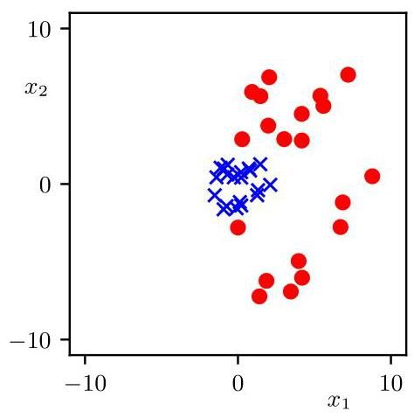

Figure 7.7 Illustration of the effect of input data normalization. The red circles show the original data points for a data set with two variables. The blue crosses show the data set after normalization such that each variable now has zero mean and unit variance across the data set.

图 7.7 输入数据归一化效果的图示。红色圆圈表示具有两个变量的数据集的原始数据点。蓝色十字表示归一化后的数据集，使得每个变量在整个数据集中的均值为零且方差为 1。

# 7.4.2 Batch normalization

# 7.4.2 批量归一化

We have seen the importance of normalizing the input data, and we can apply similar reasoning to the variables in each hidden layer of a deep network. If there is wide variation in the range of activation values in a particular hidden layer, then normalizing those values to have zero mean and unit variance should make the learning problem easier for the next layer. However, unlike normalization of the input values, which can be done once prior to the start of training, normalization of the hidden-unit values will need to be repeated during training every time the weight values are updated. This is called batch normalization (Ioffe and Szegedy, 2015).

我们已经看到了对输入数据进行归一化的重要性，并且我们可以将类似的推理应用于深度网络每个隐藏层中的变量。如果特定隐藏层中的激活值范围存在很大差异，那么将这些值归一化为均值为零且方差为 1 应该会使下一层的学习问题变得更容易。然而，与可以在训练开始前一次性完成的输入值归一化不同，隐藏单元值的归一化需要在训练期间每次更新权重值时重复进行。这被称为批量归一化(Ioffe 和 Szegedy，2015)。

A further motivation for batch normalization arises from the phenomena of vanishing gradients and exploding gradients, which occur when we try to train very deep neural networks. From the chain rule of calculus, the gradient of an error function with respect to a parameter in the first layer of the network is given by

批量归一化的另一个动机来自梯度消失和梯度爆炸现象，当我们尝试训练非常深的神经网络时会出现这些现象。根据微积分的链式法则，误差函数 相对于网络第一层中某个参数的梯度由下式给出

Section 8.1.5

第 8.1.5 节

where denotes the activation of node in layer , and each of the partial derivatives on the right-hand side of (7.51) represents the elements of the Jacobian matrix for that layer. The product of a large number of such terms will tend towards 0 if most of them have a magnitude and will tend towards if most of them have a magnitude . Consequently, as the depth of a network increases, error function gradients can tend to become either very large or very small. Batch normalization largely resolves this issue.

其中 表示层 中节点 的激活值，并且 (7.51) 式右侧的每个偏导数表示该层雅可比矩阵的元素。如果大多数项的幅度为 ，那么大量此类项的乘积将趋于 0；如果大多数项的幅度为 ，则乘积将趋于 。因此，随着网络深度的增加，误差函数的梯度可能会变得非常大或非常小。批量归一化在很大程度上解决了这个问题。

Section 8.1.5

第 8.1.5 节

To see how batch normalization is defined, consider a specific layer within a multi-layer network. Each hidden unit in that layer computes a nonlinear function of its input pre-activation , and so we have a choice of whether to normalize the pre-activation values or the activation values . In practice, either approach may be used, and here we illustrate the procedure by normalizing the pre-activations. Because weight values are updated after each mini-batch of examples, we apply the normalization to each mini-batch. Specifically, for a mini-batch of size , we define

为了了解批量归一化是如何定义的，考虑多层网络中的一个特定层。该层中的每个隐藏单元都会计算其输入预激活值 的非线性函数，因此我们可以选择对预激活值 还是激活值 进行归一化。在实践中，可以使用任何一种方法，这里我们通过对预激活值进行归一化来说明该过程。由于权重值会在每个小批量样本之后更新，因此我们对每个小批量应用归一化。具体来说，对于大小为 的小批量，我们定义

where the summations over are taken over the elements of the mini-batch. Here is a small constant, introduced to avoid numerical issues in situations where is small.

其中对 的求和是在小批量的元素上进行的。这里 是一个小常数，用于避免在 较小时出现数值问题。

By normalizing the pre-activations in a given layer of the network, we reduce the number of degrees of freedom in the parameters of that layer and hence we reduce its representational capability. We can compensate for this by re-scaling the pre-activations of the batch to have mean and standard deviation using

通过对网络给定层的预激活值进行归一化，我们减少了该层参数的自由度，从而降低了其表示能力。我们可以通过使用以下方法将小批量的预激活值重新缩放为均值为 、标准差为 来弥补这一点

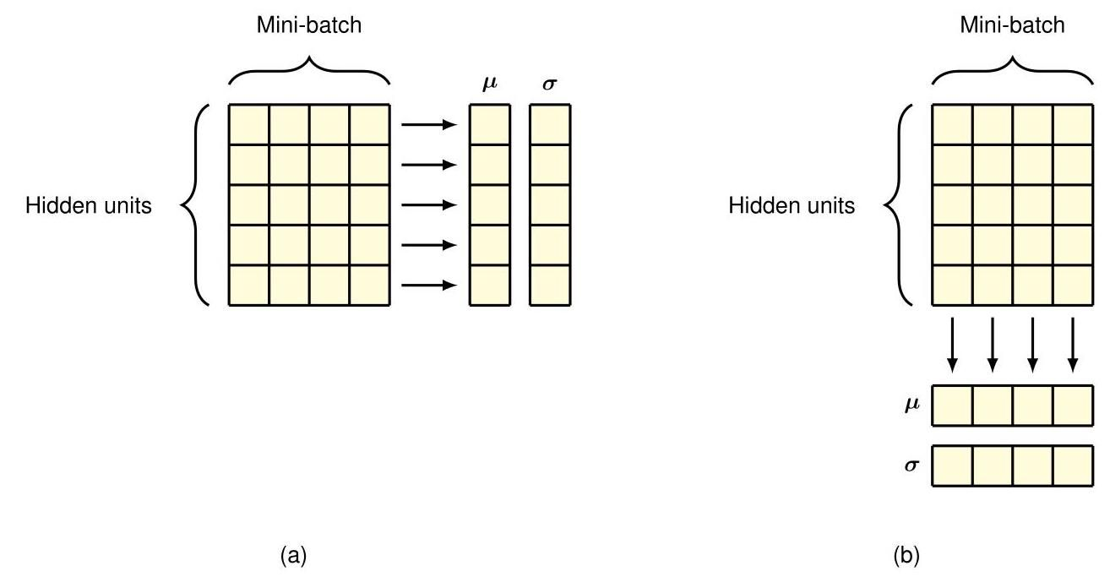

Figure 7.8 Illustration of batch normalization and layer normalization in a neural network. In batch normalization, shown in (a), the mean and variance are computed across the mini-batch separately for each hidden unit. In layer normalization, shown in (b), the mean and variance are computed across the hidden units separately for each data point.

图 7.8 神经网络中批量归一化和层归一化的示意图。在 (a) 所示的批量归一化中，每个隐藏单元分别在小批量上计算均值和方差。在 (b) 所示的层归一化中，每个数据点分别在隐藏单元上计算均值和方差。

where and are adaptive parameters that are learned by gradient descent jointly with the weights and biases of the network. These learnable parameters represent a key difference compared to input data normalization.

其中 和 是自适应参数，它们与网络的权重和偏置一起通过梯度下降法学习。与输入数据归一化相比，这些可学习参数是一个关键区别。

Section 7.4.1

第7.4.1节

It might appear that the transformation (7.55) has simply undone the effect of the batch normalization since the mean and variance can now adapt to arbitrary values again. However, the crucial difference is in the way the parameters evolve during training. For the original network, the mean and variance across a mini-batch are determined by a complex function of all the weights and biases in the layer, whereas in the representation given by (7.55), they are determined directly by independent parameters and , which turn out to be much easier to learn during gradient descent.

似乎变换 (7.55) 只是抵消了批量归一化的效果，因为均值和方差现在又可以适应任意值了。然而，关键的区别在于参数在训练过程中的演变方式。对于原始网络，小批量数据的均值和方差由该层中所有权重和偏置的复杂函数决定，而在 (7.55) 给出的表示中，它们直接由独立参数 和 决定，事实证明在梯度下降过程中学习这些参数要容易得多。

Equations (7.52) - (7.55) describe a transformation of the variables that is differentiable with respect to the learnable parameters and . This can be viewed as an additional layer in the neural network, and so each standard hidden layer can be followed by a batch normalization layer. The structure of the batch-normalization process is illustrated in Figure 7.8.

方程 (7.52) - (7.55) 描述了一个关于可学习参数 和 可微的变量变换。这可以看作是神经网络中的一个附加层，因此每个标准隐藏层之后都可以跟一个批量归一化层。批量归一化过程的结构如图7.8所示。

Once the network is trained and we want to make predictions on new data, we no longer have the training mini-batches available, and we cannot determine a mean and variance from just one data example. To solve this, we could in principle evaluate and for each layer across the whole training set after we have made the final update to the weights and biases. However, this would involve processing the whole data set just to evaluate these quantities and is therefore usually too expensive. Instead, we compute moving averages throughout the training phase:

一旦网络训练完成，我们想对新数据进行预测时，就不再有训练小批量数据可用了，而且仅从一个数据示例中无法确定均值和方差。为了解决这个问题，原则上，在对权重和偏置进行最终更新后，我们可以在整个训练集上为每一层计算 和 。然而，这将涉及处理整个数据集来计算这些量，因此通常代价太高。相反，我们在整个训练阶段计算移动平均值:

where . These moving averages play no role during training but are used to process new data points during the inference phase.

其中 。这些移动平均值在训练过程中不起作用，但在推理阶段用于处理新的数据点。

Although batch normalization is very effective in practice, there is uncertainty as to why it works so well. Batch normalization was originally motivated by noting that updates to weights in earlier layers of the network change the distribution of values seen by later layers, a phenomenon called internal covariate shift. However, later studies (Santurkar et al., 2018) suggest that covariate shift is not a significant factor and that the improved training results from an improvement in the smoothness of the error function landscape.

虽然批量归一化在实践中非常有效，但对于它为何如此有效还存在不确定性。批量归一化最初的动机是注意到网络早期层中权重的更新会改变后期层所看到的值的分布，这种现象称为内部协变量偏移。然而，后来的研究(Santurkar 等人，2018)表明，协变量偏移并不是一个重要因素，训练效果的改善源于误差函数曲面平滑性的提高。

# 7.4.3 Layer normalization

# 7.4.3 层归一化

With batch normalization, if the batch size is too small then the estimates of the mean and variance become too noisy. Also, for very large training sets, the mini-batches may be split across different GPUs, making global normalization across the mini-batch inefficient. An alternative to normalizing across examples within a mini-batch for each hidden unit separately is to normalize across the hidden-unit values for each data point separately. This is known as layer normalization (Ba, Kiros, and Hinton, 2016). It was introduced in the context of recurrent neural networks where the distributions change after each time step making batch normalization infeasible. However, it is useful in other architectures such as transformer networks.

对于批量归一化，如果批量大小过小，那么均值和方差的估计会变得过于嘈杂。此外，对于非常大的训练集，小批量可能会分布在不同的 GPU 上，这使得跨小批量的全局归一化效率低下。对于每个隐藏单元，不采用在小批量内跨样本进行归一化，而是对每个数据点的隐藏单元值分别进行归一化，这就是层归一化(Ba、Kiros 和 Hinton，2016)。它是在循环神经网络的背景下提出的，在这种网络中，每个时间步之后分布都会发生变化，使得批量归一化不可行。然而，它在其他架构(如变压器网络)中也很有用。

Section 12.2.5

第 12.2.5 节

Chapter 12

第 12 章

By analogy with batch normalization, we therefore make the following transformation:

因此，通过与批量归一化进行类比，我们进行以下变换:

where the sums are taken over all hidden units in the layer. As with batch normalization, additional learnable mean and standard deviation parameters are introduced for each hidden unit separately in the form (7.55). Note that the same normalization function can be employed during training and during inference, and

其中，求和 是对该层中的所有隐藏单元进行的。与批量归一化一样，以式(7.55)的形式为每个隐藏单元分别引入额外的可学习均值和标准差参数。请注意，在训练和推理过程中可以使用相同的归一化函数，并且

so there is no need to store moving averages. Layer normalization is compared with batch normalization in Figure 7.8.

因此，无需存储移动平均值。图 7.8 对层归一化和批量归一化进行了比较。

Exercises

练习

By substituting (7.10) into (7.7) and using (7.8) and (7.9), show that the error function (7.7) can be written in the form (7.11).

通过将 (7.10) 代入 (7.7) 并使用 (7.8) 和 (7.9)，证明误差函数 (7.7) 可以写成 (7.11) 的形式。

7.2 (*) Consider a Hessian matrix with eigenvector equation (7.8). By setting the vector in (7.14) equal to each of the eigenvectors in turn, show that is positive definite if, and only if, all its eigenvalues are positive.

7.2 (*) 考虑一个具有特征向量方程 (7.8) 的黑塞矩阵 。通过依次将 (7.14) 中的向量 设为每个特征向量 ，证明 是正定的，当且仅当它的所有特征值都是正的。

7.3 By considering the local Taylor expansion (7.7) of an error function about a stationary point , show that the necessary and sufficient condition for the stationary point to be a local minimum of the error function is that the Hessian matrix , defined by (7.5) with , is positive definite.

7.3 通过考虑误差函数在驻点 附近的局部泰勒展开式 (7.7)，证明驻点是误差函数局部最小值的充要条件是由 (7.5) 定义的黑塞矩阵 (其中 )是正定的。

7.4 Consider a linear regression model with a single input variable and a single output variable of the form

7.4 考虑一个具有单个输入变量 和单个输出变量 的线性回归模型，其形式为

together with a sum-of-squares error function given by

以及由下式给出的平方和误差函数

Derive expressions for the elements of the Hessian matrix given by the second derivatives of the error function with respect to the weight parameter and bias parameter . Show that the trace and the determinant of this Hessian are both positive. Since the trace represents the sum of the eigenvalue and the determinant corresponds to the product of the eigenvalues, then both eigenvalues are positive and hence the stationary point of the error function is a minimum.

推导 海森矩阵元素的表达式，该矩阵由误差函数关于权重参数 和偏置参数 的二阶导数给出。证明此海森矩阵的迹和行列式均为正。由于迹表示特征值之和，行列式对应特征值之积，那么两个特征值均为正，因此误差函数的驻点是极小值点。

Appendix A

附录 A

7.5 Consider a single-layer classification model with a single input variable and a single output variable of the form

7.5 考虑一个单层分类模型，其具有单个输入变量 和单个输出变量 ，形式如下

where is the logistic sigmoid function defined by (5.42) together with a cross-entropy error function given by

其中 是由 (5.42) 定义的逻辑 sigmoid 函数，以及由下式给出的交叉熵误差函数

Derive expressions for the elements of the Hessian matrix given by the second derivatives of the error function with respect to the weight parameter and bias parameter . Show that the trace and the determinant of this Hessian are both positive. Since the trace represents the sum of the eigenvalue and the determinant corresponds to the product of the eigenvalues, then both eigenvalues are positive and hence the stationary point of the error function is a minimum.

推导 海森矩阵元素的表达式，该矩阵由误差函数关于权重参数 和偏置参数 的二阶导数给出。证明此海森矩阵的迹和行列式均为正。由于迹表示特征值之和，行列式对应特征值之积，那么两个特征值均为正，因此误差函数的驻点是极小值点。

Appendix A

附录 A

7.6 Consider a quadratic error function defined by (7.7) in which the Hessian matrix has an eigenvalue equation given by (7.8). Show that the contours of constant error are ellipses whose axes are aligned with the eigenvectors with lengths that are inversely proportional to the square roots of the corresponding eigenvalues .

7.6 考虑由式 (7.7) 定义的二次误差函数，其中黑塞矩阵 具有由式 (7.8) 给出的特征值方程。证明恒定误差的等高线是椭圆，其轴与特征向量 对齐，长度与相应特征值 的平方根成反比。

7.7 (*) Show that, as a consequence of the symmetry of the Hessian matrix , the number of independent elements in the quadratic error function (7.3) is given by .

7.7 (*) 证明由于黑塞矩阵 的对称性，二次误差函数 (7.3) 中独立元素的数量由 给出。

7.8 Consider a set of values drawn from a distribution with mean and variance , and define the sample mean to be

7.8 考虑一组从均值为 、方差为 的分布中抽取的值 ，并将样本均值定义为

Show that the expectation of the squared error with respect to the distribution from which the data is drawn is given by . This shows that the RMS error in the sample mean is given by , which decreases relatively slowly as the sample size increases.

证明相对于抽取数据的分布，平方误差 的期望由 给出。这表明样本均值的均方根误差由 给出，随着样本大小 的增加，该误差相对缓慢地减小。

7.9 (★★) Consider a layered network that computes the functions (7.19) and (7.20) in layer . Suppose we initialize the weights using a Gaussian , and suppose that the outputs of the units in layer have variance . By using the form of the ReLU activation function, show that the mean and variance of the outputs in layer are given by (7.21) and (7.22), respectively. Hence, show that if we want the units in layer also to have pre-activations with variance then the value of should be given by (7.23).

7.9 (★★) 考虑一个分层网络，该网络在第 层计算函数 (7.19) 和 (7.20)。假设我们使用高斯分布 初始化权重，并且假设第 层单元的输出 的方差为 。通过使用 ReLU 激活函数的形式，证明第 层输出的均值和方差分别由式 (7.21) 和 (7.22) 给出。因此，证明如果我们希望第 层的单元也具有方差为 的预激活值，那么 的值应由式 (7.23) 给出。

By making use of (7.7),(7.8), and (7.10), derive the results (7.24) and (7.25), which express the gradient vector and a general weight update, as expansions in the eigenvectors of the Hessian matrix. Use these results, together with the eigenvector orthonormality relation (7.9) and the batch gradient descent formula (7.16), to derive the result (7.26) for the batch gradient descent update expressed in terms of the coefficients .

利用式 (7.7)、(7.8) 和 (7.10)，推导结果 (7.24) 和 (7.25)，它们将梯度向量和一般的权重更新表示为海森矩阵特征向量的展开式。利用这些结果，结合特征向量的正交归一关系 (7.9) 和批量梯度下降公式 (7.16)，推导以系数 表示的批量梯度下降更新结果 (7.26)。

7.11 (*) Consider a smoothly varying error surface with low curvature such that the gradient varies only slowly with position. Show that, for small values of the learning rate and momentum parameters, the Nesterov momentum gradient update defined by (7.34) is equivalent to the standard gradient descent with momentum defined by (7.31).

7.11 (*) 考虑一个曲率较小的平滑变化误差曲面，使得梯度随位置的变化非常缓慢。证明对于较小的学习率和动量参数值，由式 (7.34) 定义的 Nesterov 动量梯度更新等价于由式 (7.31) 定义的标准带动量梯度下降。

Consider a sequence of values of some variable , and suppose we compute an exponentially weighted moving average using the formula

考虑某个变量 的一系列值 ，并假设我们使用以下公式计算指数加权移动平均值

where . By making use of the following result for the sum of a finite geometric series

其中 。利用有限几何级数求和的以下结果

show that if the sequence of averages is initialized using , then the estimators are biased and that the bias can be corrected using

证明如果平均值序列使用 初始化，则估计量存在偏差，并且可以使用以下方法校正偏差

7.13 In gradient descent, the weight vector is updated by taking a step in weight space in the direction of the negative gradient governed by a learning rate parameter . Suppose instead that we choose a direction in weight space along which we minimize the error function, given the current weight vector . This involves

7.13 在梯度下降中，权重向量 通过在权重空间中沿着由学习率参数 控制的负梯度方向迈出一步来更新。相反，假设我们在权重空间中选择一个方向 ，在给定当前权重向量 的情况下，沿着该方向最小化误差函数。这涉及

minimizing the quantity

最小化该量

as a function of to give a value corresponding to a new weight vector . Show that the gradient of at is orthogonal to the vector . This is known as a ’line search’ method and it forms the basis for a variety of numerical optimization algorithms (Bishop, 1995b).

作为 的函数，得到一个对应于新权重向量 的值 。证明 在 处的梯度与向量 正交。这被称为“线搜索”方法，它构成了各种数值优化算法的基础(Bishop，1995b)。

7.14 (*) Show that the renormalized input variables defined by (7.50), where is defined by (7.48) and is defined by (7.49), have zero mean and unit variance.

7.14 (*) 证明由 (7.50) 定义的重新归一化的输入变量(其中 由 (7.48) 定义， 由 (7.49) 定义)具有零均值和单位方差。

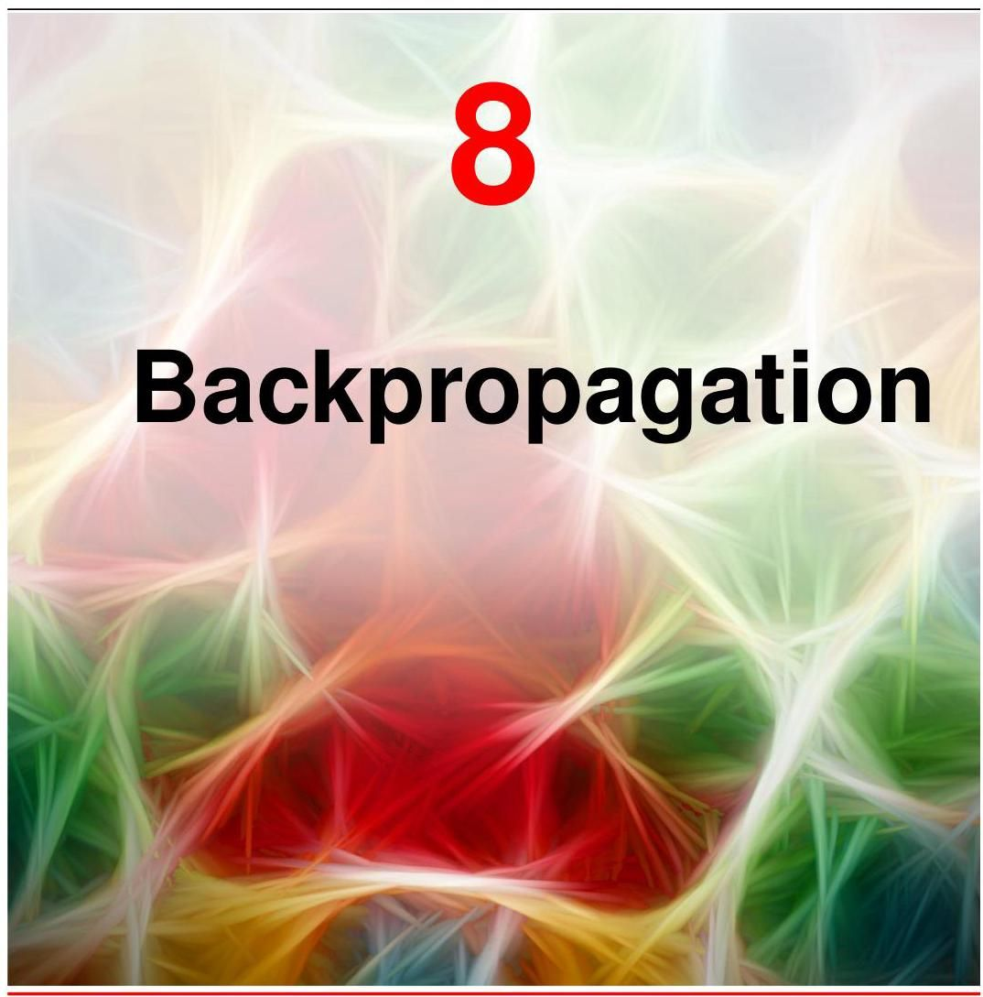

Our goal in this chapter is to find an efficient technique for evaluating the gradient of an error function for a feed-forward neural network. We will see that this can be achieved using a local message-passing scheme in which information is sent backwards through the network and is known as error backpropagation, or sometimes simply as backprop.

本章的目标是找到一种有效的技术来计算前馈神经网络的误差函数 的梯度。我们将看到，这可以通过一种局部消息传递方案来实现，在该方案中，信息通过网络反向传播，这被称为误差反向传播，有时也简称为反向传播。

Historically, the backpropagation equations would have been derived by hand and then implemented in software alongside the forward propagation equations, with both steps taking time and being prone to mistakes. Modern neural network software environments, however, allow virtually any derivatives of interest to be calculated efficiently with only minimal effort beyond that of coding up the original network function. This idea, called automatic differentiation, plays a key role in modern deep learning. However, it is valuable to understand how the calculations are performed so that we are not relying on ’black box’ software solutions. In this chapter we therefore explain the key concepts of backpropagation, and explore the framework of automatic differentiation in detail.

从历史上看，反向传播方程需要手动推导，然后与前向传播方程一起在软件中实现，这两个步骤都很耗时且容易出错。然而，现代神经网络软件环境几乎可以高效地计算任何感兴趣的导数，只需在编写原始网络函数的基础上付出极少的额外努力。这种被称为自动微分的思想在现代深度学习中起着关键作用。然而，理解这些计算是如何进行的很有价值，这样我们就不会依赖于“黑箱”软件解决方案。因此，在本章中，我们将解释反向传播的关键概念，并详细探讨自动微分的框架。

Section 8.2

第 8.2 节

Note that the term ’backpropagation’ is used in the neural computing literature in a variety of different ways. For instance, a feed-forward architecture may be called a backpropagation network. Also the term ’backpropagation’ is sometimes used to describe the end-to-end training procedure for a neural network including the gradient descent parameter updates. In this book we will use ’backpropagation’ specifically to describe the computational procedure used in the numerical evaluation of derivatives such as the gradient of the error function with respect to the weights and biases of a network. This procedure can also be applied to the evaluation of other important derivatives such as the Jacobian and Hessian matrices. 8.1. Evaluation of Gradients

请注意，术语“反向传播”在神经计算文献中有多种不同的用法。例如，前馈架构可能被称为反向传播网络。此外，术语“反向传播”有时用于描述神经网络的端到端训练过程，包括梯度下降参数更新。在本书中，我们将专门使用“反向传播”来描述用于数值计算导数的计算过程，例如误差函数相对于网络权重和偏置的梯度。此过程也可应用于其他重要导数的计算，如雅可比矩阵和海森矩阵。8.1. 梯度计算

We now derive the backpropagation algorithm for a general network having arbitrary feed-forward topology, arbitrary differentiable nonlinear activation functions, and a broad class of error function. The resulting formulae will then be illustrated using a simple layered network structure having a single layer of sigmoidal hidden units together with a sum-of-squares error.

我们现在推导适用于具有任意前馈拓扑结构、任意可微非线性激活函数和广泛类别的误差函数的通用网络的反向传播算法。然后，我们将使用一个简单的分层网络结构来说明所得公式，该结构具有一层 S 型隐藏单元和一个平方和误差函数。

Many error functions of practical interest, for instance those defined by maximum likelihood for a set of i.i.d. data, comprise a sum of terms, one for each data point in the training set, so that

许多实际中感兴趣的误差函数，例如由一组独立同分布数据的最大似然定义的误差函数，由一系列项的和组成，训练集中的每个数据点对应一项，因此

Here we will consider the problem of evaluating for one such term in the error function. This may be used directly for stochastic gradient descent, or the results could be accumulated over a set of training data points for batch or mini-batch methods.

在这里，我们将考虑计算误差函数中一个这样的项的 的问题。这可以直接用于随机梯度下降，或者可以将结果在一组训练数据点上累加，用于批量或小批量方法。

# 8.1.1 Single-layer networks

# 8.1.1 单层网络

Consider first a simple linear model in which the outputs are linear combinations of the input variables so that

首先考虑一个简单的线性模型，其中输出 是输入变量 的线性组合，即

together with a sum-of-squares error function that, for a particular input data point , takes the form

再加上一个平方和误差函数，对于特定的输入数据点 ，其形式为

where , and is the associated target value. The gradient of this error function with respect to a weight is given by

其中 ，并且 是相关的目标值。该误差函数关于权重 的梯度由下式给出

This can be interpreted as a ’local’ computation involving the product of an ’error signal’ associated with the output end of the link and the variable associated with the input end of the link. In Section 5.4.3, we saw how a similar formula arises with the logistic-sigmoid activation function together with the cross-entropy error function and similarly for the softmax activation function together with its matching multivariate cross-entropy error function. We will now see how this simple result extends to the more complex setting of multilayer feed-forward networks.

这可以解释为一种“局部”计算，涉及与链接 输出端相关的“误差信号” 与和链接输入端相关的变量 的乘积。在 5.4.3 节中，我们看到了类似的公式是如何在逻辑 - S 型激活函数与交叉熵误差函数结合时出现的，以及在 softmax 激活函数与其匹配的多元交叉熵误差函数结合时同样出现的情况。现在我们将看到这个简单的结果如何扩展到更复杂的多层前馈网络设置中。

# 8.1.2 General feed-forward networks

# 8.1.2 一般前馈网络

In general, a feed-forward network consists of a set of units each of which computes a weighted sum of its inputs:

一般来说，前馈网络由一组单元组成，每个单元计算其输入的加权和:

where is either the activation of another unit or an input unit that sends a connection to unit , and is the weight associated with that connection. Biases can be included in this sum by introducing an extra unit, or input, with activation fixed at +1, and so we do not need to deal with biases explicitly. The sum in (8.5), known as a pre-activation, is transformed by a nonlinear activation function to give the activation of unit in the form

其中 要么是另一个单元的激活值，要么是向单元 发送连接的输入单元，并且 是与该连接相关的权重。通过引入一个激活值固定为 +1 的额外单元或输入，可以将偏置包含在这个和中，因此我们不需要明确处理偏置。式 (8.5) 中的和，称为预激活，通过非线性激活函数 进行变换，以如下形式给出单元 的激活值

Section 6.2

6.2 节

Note that one or more of the variables in the sum in (8.5) could be an input, and similarly, the unit in (8.6) could be an output.

请注意，(8.5) 式求和中的一个或多个变量 可能是输入，类似地，(8.6) 式中的单元 可能是输出。

For each data point in the training set, we will suppose that we have supplied the corresponding input vector to the network and calculated the activations of all the hidden and output units in the network by successive application of (8.5) and (8.6). This process is called forward propagation because it can be regarded as a forward flow of information through the network.

对于训练集中的每个数据点，我们假设已经将相应的输入向量提供给网络，并通过连续应用 (8.5) 式和 (8.6) 式计算出了网络中所有隐藏单元和输出单元的激活值。这个过程称为前向传播，因为它可以被视为信息在网络中的正向流动。

Now consider the evaluation of the derivative of with respect to a weight . The outputs of the various units will depend on the particular input data point . However, to keep the notation uncluttered, we will omit the subscript from the network variables. First note that depends on the weight only via the summed input to unit . We can therefore apply the chain rule for partial derivatives to give

现在考虑计算 关于权重 的导数。各个单元的输出将取决于特定的输入数据点 。然而，为了使符号简洁，我们将省略网络变量中的下标 。首先注意到， 仅通过单元 的求和输入 依赖于权重 。因此，我们可以应用偏导数的链式法则得到

We now introduce a useful notation:

我们现在引入一个有用的符号:

where the ’s are often referred to as errors for reasons we will see shortly. Using (8.5), we can write

其中 通常被称为误差，原因我们很快就会看到。使用 (8.5) 式，我们可以写成

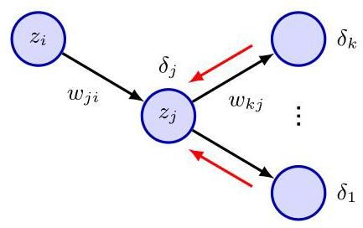

Figure 8.1 Illustration of the calculation of for hidden unit by backpropagation of the ’s from those units to which unit sends connections. The black arrows denote the direction of information flow during forward propagation, and the red arrows indicate the backward propagation of error information.

图 8.1 通过将来自单元 所连接的那些单元 的 进行反向传播来计算隐藏单元 的 的示意图。黑色箭头表示前向传播期间信息流的方向，红色箭头表示误差信息的反向传播。

Substituting (8.8) and (8.9) into (8.7), we then obtain

将 (8.8) 和 (8.9) 代入 (8.7)，我们得到

Equation (8.10) tells us that the required derivative is obtained simply by multiplying the value of for the unit at the output end of the weight by the value of for the unit at the input end of the weight (where for a bias). Note that this takes the same form as that found for the simple linear model in (8.4). Thus, to evaluate the derivatives, we need calculate only the value of for each hidden and output unit in the network and then apply (8.10).

方程 (8.10) 告诉我们，所需的导数可以通过将权重输出端单元的 值乘以权重输入端单元的 值(对于偏置为 )来简单地获得。注意，这与 (8.4) 中简单线性模型的形式相同。因此，为了计算导数，我们只需要计算网络中每个隐藏单元和输出单元的 值，然后应用 (8.10)。

As we have seen already, for the output units, we have

正如我们已经看到的，对于输出单元，我们有

Section 5.4.6

第 5.4.6 节

provided we are using the canonical link as the output-unit activation function. To evaluate the ’s for hidden units, we again make use of the chain rule for partial

前提是我们使用规范链接作为输出单元的激活函数。为了计算隐藏单元的 ，我们再次使用偏导数的链式法则

derivatives:

导数:

where the sum runs over all units to which unit sends connections. The arrangement of units and weights is illustrated in Figure 8.1. Note that the units labelled include other hidden units and/or output units. In writing down (8.12), we are making use of the fact that variations in give rise to variations in the error function only through variations in the variables .

其中求和是对单元 发送连接的所有单元 进行的。单元和权重的排列如图 8.1 所示。请注意，标记为 的单元包括其他隐藏单元和/或输出单元。在写下公式 (8.12) 时，我们利用了这样一个事实，即 的变化仅通过变量 的变化引起误差函数的变化。

If we now substitute the definition of given by (8.8) into (8.12) and make use of (8.5) and (8.6), we obtain the following backpropagation formula:

如果我们现在将公式 (8.8) 给出的 的定义代入公式 (8.12) 并利用公式 (8.5) 和 (8.6)，我们得到以下反向传播公式:

Exercise 8.1

练习 8.1

which tells us that the value of for a particular hidden unit can be obtained by propagating the ’s backwards from units higher up in the network, as illustrated

这告诉我们，特定隐藏单元的 值可以通过从网络中更高层的单元反向传播 来获得，如图所示

# Algorithm 8.1: Backpropagation

# 算法 8.1:反向传播

Input: Input vector

输入:输入向量

Network parameters

网络参数

Error function for input

输入 的误差函数

Activation function

激活函数

Output: Error function derivatives

输出:误差函数导数

// Forward propagation

for all hidden and output units do

includes inputs

// activation function

end for

// Error evaluation

for all output units do

compute errors

end for

// Backward propagation, in reverse order

for all hidden units do

// recursive backward evaluation

evaluate derivatives

end for

return

in Figure 8.1. Note that the summation in (8.13) is taken over the first index on (corresponding to backward propagation of information through the network), whereas in the forward propagation equation (8.5), it is taken over the second index. Because we already know the values of the ’s for the output units, it follows that by recursively applying (8.13), we can evaluate the ’s for all the hidden units in a feed-forward network, regardless of its topology. The backpropagation procedure is summarized in Algorithm 8.1.

如图 8.1 所示。请注意，(8.13) 中的求和是对 的第一个索引进行的(对应于信息通过网络的反向传播)，而在正向传播方程 (8.5) 中，求和是对第二个索引进行的。因为我们已经知道输出单元的 值，所以通过递归应用 (8.13)，我们可以计算前馈网络中所有隐藏单元的 值，而不管其拓扑结构如何。反向传播过程总结在算法 8.1 中。

Exercise 8.2

练习 8.2

For batch methods, the derivative of the total error can then be obtained by repeating the above steps for each data point in the training set and then summing over all data points in the batch or mini-batch:

对于批量方法，总误差 的导数可以通过对训练集中的每个数据点重复上述步骤，然后对批量或小批量中的所有数据点求和来获得:

In the above derivation we have implicitly assumed that each hidden or output unit in the network has the same activation function . However, the derivation is easily generalized to allow different units to have individual activation functions, simply by keeping track of which form of goes with which unit.

在上述推导中，我们隐含地假设网络中的每个隐藏单元或输出单元都具有相同的激活函数 。然而，通过跟踪哪个单元使用哪种形式的 ，该推导可以很容易地推广到允许不同单元具有各自的激活函数的情况。

# 8.1.3 A simple example

# 8.1.3 一个简单的例子

The above derivation of the backpropagation procedure allowed for general forms for the error function, the activation functions, and the network topology. To illustrate the application of this algorithm, we consider a two-layer network of the form illustrated in Figure 6.9, together with a sum-of-squares error. The output units have linear activation functions, so that , and the hidden units have sigmoidal activation functions given by

上述反向传播过程的推导允许误差函数、激活函数和网络拓扑采用一般形式。为了说明该算法的应用，我们考虑图 6.9 所示形式的两层网络，以及平方和误差。输出单元具有线性激活函数，即 ，而隐藏单元具有由下式给出的 S 型激活函数

where is defined by (6.14). A useful feature of this function is that its derivative can be expressed in a particularly simple form:

其中 由式 (6.14) 定义。该函数的一个有用特性是其导数可以用一种特别简单的形式表示:

We also consider a sum-of-squares error function, so that for data point the error is given by

我们还考虑一个平方和误差函数，因此对于数据点 ，误差由下式给出

where is the activation of output unit , and is the corresponding target value for a particular input vector .

其中 是输出单元 的激活值， 是特定输入向量 对应的目标值。

For each data point in the training set in turn, we first perform a forward propagation using

对于训练集中的每个数据点，我们首先依次使用以下方法进行前向传播

where is the dimensionality of the input vector and is the total number of hidden units. Also we have used to allow bias parameters to be included in the weights. Next we compute the ’s for each output unit using

其中 是输入向量 的维度， 是隐藏单元的总数。此外，我们使用 来允许将偏置参数包含在权重中。接下来，我们使用以下方法计算每个输出单元的 。

Then, we backpropagate these errors to obtain ’s for the hidden units using

然后，我们反向传播这些误差，使用以下方法获得隐藏单元的 。

which follows from (8.13) and (8.16). Finally, the derivatives with respect to the first-layer and second-layer weights are given by

这是由 (8.13) 和 (8.16) 推导得出的。最后，关于第一层和第二层权重的导数由下式给出

# 8.1.4 Numerical differentiation

# 8.1.4 数值微分

One of the most important aspects of backpropagation is its computational efficiency. To understand this, let us examine how the number of compute operations required to evaluate the derivatives of the error function scales with the total number of weights and biases in the network.

反向传播最重要的方面之一是其计算效率。为了理解这一点，让我们研究评估误差函数导数所需的计算操作数量如何随网络中权重和偏置的总数 而变化。

A single evaluation of the error function (for a given input data point) would require operations, for sufficiently large . This follows because, except for a network with very sparse connections, the number of weights is typically much greater than the number of units, and so the bulk of the computational effort in forward propagation arises from evaluation of the sums in (8.5), with the evaluation of the activation functions representing a small overhead. Each term in the sum in (8.5) requires one multiplication and one addition, leading to an overall computational cost that is .

对于足够大的 ，单次评估误差函数(针对给定的输入数据点)需要 次操作。这是因为，除了连接非常稀疏的网络外，权重的数量通常远大于单元的数量，因此前向传播中的大部分计算工作来自于对 (8.5) 式中求和的评估，而激活函数的评估只占很小的开销。(8.5) 式中求和的每一项都需要一次乘法和一次加法，导致总体计算成本为 。

An alternative approach to backpropagation for computing the derivatives of the error function is to use finite differences. This can be done by perturbing each weight in turn and approximating the derivatives by using the expression

计算误差函数导数的另一种替代反向传播的方法是使用有限差分。这可以通过依次扰动每个权重并使用以下表达式来近似导数来实现

where . In a software simulation, the accuracy of the approximation to the derivatives can be improved by making smaller, until numerical round-off problems arise. The accuracy of the finite differences method can be improved significantly by using symmetrical central differences of the form

其中 。在软件模拟中，可以通过减小 来提高导数近似的精度，直到出现数值舍入问题。通过使用以下形式的对称中心差分，可以显著提高有限差分方法的精度

Exercise 8.3

练习 8.3

In this case, the corrections cancel, as can be verified by a Taylor expansion of the right-hand side of (8.25), and so the residual corrections are . Note, however, that the number of computational steps is roughly doubled compared with (8.24). Figure 8.2 shows a plot of the error between a numerical evaluation of a gradient using both finite differences (8.24) and central differences (8.25) versus the analytical result, as a function of the value of the step size .

在这种情况下， 修正项相互抵消，这可以通过对 (8.25) 式右侧进行泰勒展开来验证，因此剩余的修正项为 。然而，需要注意的是，与 (8.24) 式相比，计算步骤的数量大约增加了一倍。图 8.2 展示了使用有限差分法 (8.24) 和中心差分法 (8.25) 对梯度进行数值计算的结果与解析结果之间的误差随步长 变化的曲线。

The main problem with numerical differentiation is that the highly desirable scaling has been lost. Each forward propagation requires steps, and there are weights in the network each of which must be perturbed individually, so that the overall computational cost is .

数值微分的主要问题在于，非常理想的 缩放特性丢失了。每次前向传播需要 步，并且网络中有 个权重，每个权重都必须单独进行扰动，因此总的计算成本为 。

However, numerical differentiation can play a useful role in practice, because a comparison of the derivatives calculated from a direct implementation of back-propagation, or from automatic differentiation, with those obtained using central differences provides a powerful check on the correctness of the software.

然而，数值微分在实践中可以发挥有用的作用，因为将直接实现反向传播或自动微分计算得到的导数与使用中心差分法得到的导数进行比较，可以有力地检验软件的正确性。

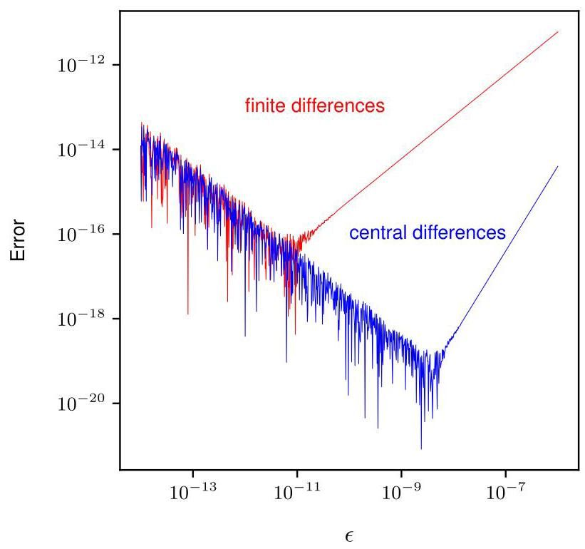

Figure 8.2 The red curve shows a plot of the error between the numerical evaluation of a gradient using finite differences (8.24) and the analytical result, as a function of . As decreases, the plot initially shows a linear decrease in error, and this represents a power law behaviour since the axes are logarithmic. The slope of this line is 1 which shows that this error behaves like . At some point the evaluated gradient reaches the limit of numerical round-off and further reduction in leads to a noisy line, which again follows a power law but where the error now increases with decreasing . The blue curve shows the corresponding result for central differences (8.25). We see a much smaller error compared to finite differences, and the slope of the line is 2 which shows that the error is .

图 8.2 红色曲线展示了使用有限差分法 (8.24) 对梯度进行数值计算的结果与解析结果之间的误差随 变化的曲线。随着 的减小，曲线最初显示误差呈线性减小，由于坐标轴是对数坐标，这代表了幂律行为。这条线的斜率为 1，表明该误差的行为类似于 。在某一点上，计算得到的梯度达到了数值舍入的极限，进一步减小 会导致曲线变得嘈杂，同样遵循幂律，但此时误差随着 的减小而增大。蓝色曲线展示了中心差分法 (8.25) 的相应结果。我们看到与有限差分法相比，误差要小得多，并且这条线的斜率为 2，表明误差为 。

# 8.1.5 The Jacobian matrix

# 8.1.5 雅可比矩阵

We have seen how the derivatives of an error function with respect to the weights can be obtained by propagating errors backwards through the network. Backprop-agation can also be used to calculate other derivatives. Here we consider the evaluation of the Jacobian matrix, whose elements are given by the derivatives of the network outputs with respect to the inputs:

我们已经了解了如何通过在网络中反向传播误差来获得误差函数关于权重的导数。反向传播也可用于计算其他导数。这里我们考虑雅可比矩阵的计算，其元素由网络输出关于输入的导数给出:

where each such derivative is evaluated with all other inputs held fixed. Jacobian matrices play a useful role in systems built from a number of distinct modules, as illustrated in Figure 8.3. Each module can comprise a fixed or learnable function, which can be linear or nonlinear, so long as it is differentiable.

其中每个这样的导数都是在所有其他输入保持固定的情况下计算的。雅可比矩阵在由多个不同模块构建的系统中起着重要作用，如图 8.3 所示。每个模块可以包含一个固定或可学习的函数，该函数可以是线性的也可以是非线性的，只要它是可微的即可。

Suppose we wish to minimize an error function with respect to the parameter in Figure 8.3. The derivative of the error function is given by

假设我们希望相对于图 8.3 中的参数 最小化误差函数 。误差函数的导数由下式给出

in which the Jacobian matrix for the red module in Figure 8.3 appears as the middle term on the right-hand side.

其中图 8.3 中红色模块的雅可比矩阵出现在等式右侧的中间项。

Because the Jacobian matrix provides a measure of the local sensitivity of the outputs to changes in each of the input variables, it also allows any known errors

由于雅可比矩阵提供了输出对每个输入变量变化的局部敏感度的度量，它还允许任何已知的误差

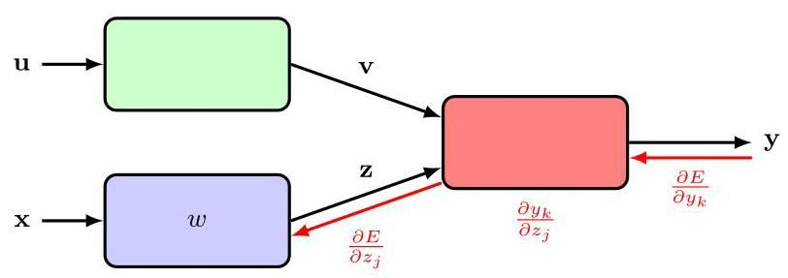

Figure 8.3 Illustration of a modular deep learning architecture in which the Jacobian matrix can be used to back-propagate error signals from the outputs through to earlier modules in the system.

图 8.3 模块化深度学习架构的示意图，其中雅可比矩阵可用于将误差信号从输出反向传播到系统中较早的模块。

associated with the inputs to be propagated through the trained network to estimate their contribution to the errors at the outputs, through the relation

与输入相关联的误差可以通过训练好的网络进行传播，以通过以下关系估计它们对输出误差的贡献

which assumes that the are small. In general, the network mapping represented by a trained neural network will be nonlinear, and so the elements of the Jacobian matrix will not be constants but will depend on the particular input vector used. Thus, (8.28) is valid only for small perturbations of the inputs, and the Jacobian itself must be re-evaluated for each new input vector.

该式假设 很小。一般来说，经过训练的神经网络所表示的网络映射将是非线性的，因此雅可比矩阵的元素不是常数，而是取决于所使用的特定输入向量。因此，(8.28) 仅对输入的小扰动有效，并且对于每个新的输入向量，都必须重新计算雅可比矩阵本身。

The Jacobian matrix can be evaluated using a backpropagation procedure that is like the one derived earlier for evaluating the derivatives of an error function with respect to the weights. We start by writing the element in the form

可以使用一种反向传播过程来计算雅可比矩阵，该过程类似于前面推导的用于计算误差函数关于权重的导数的过程。我们首先将元素 写成如下形式

where we have made use of (8.5). The sum in (8.29) runs over all units to which the input unit sends connections (for example, over all units in the first hidden layer in the layered topology considered earlier). We now write down a recursive backpropagation formula for the derivatives :

这里我们使用了 (8.5)。(8.29) 中的求和是对输入单元 发送连接的所有单元 进行的(例如，对前面考虑的分层拓扑中的第一个隐藏层中的所有单元进行求和)。现在我们为导数 写出一个递归的反向传播公式:

where the sum runs over all units to which unit sends connections (corresponding to the first index of ). Again, we have made use of (8.5) and (8.6). This back-propagation starts at the output units, for which the required derivatives can be found directly from the functional form of the output-unit activation function. For linear

其中求和是对单元 发送连接的所有单元 进行的(对应于 的第一个索引)。同样，我们使用了 (8.5) 和 (8.6)。这种反向传播从输出单元开始，对于输出单元，所需的导数可以直接从输出单元激活函数的函数形式中找到。对于线性

output units, we have

输出单元，我们有

where are the elements of the identity matrix and are defined by

其中 是单位矩阵的元素，定义为

Section 3.4

3.4 节

If we have individual logistic sigmoid activation functions at each output unit, then

如果我们在每个输出单元使用单独的逻辑 S 型激活函数，那么

Section 3.4

3.4 节

whereas for softmax outputs, we have

而对于 softmax 输出，我们有

We can summarize the procedure for calculating the Jacobian matrix as follows. Apply the input vector corresponding to the point in input space at which the Jacobian matrix is to be evaluated, and forward propagate in the usual way to obtain the states of all the hidden and output units in the network. Next, for each row of the Jacobian matrix, corresponding to the output unit , backpropagate using the recursive relation (8.30), starting with (8.31), (8.33) or (8.34), for all the hidden units in the network. Finally, use (8.29) for the backpropagation to the inputs. The Jacobian can also be evaluated using an alternative forward propagation formalism, which can be derived in an analogous way to the backpropagation approach given here.

我们可以将计算雅可比矩阵的过程总结如下。应用与输入空间中要计算雅可比矩阵的点相对应的输入向量，并以通常的方式进行前向传播，以获得网络中所有隐藏单元和输出单元的状态。接下来，对于雅可比矩阵的每一行 ，对应于输出单元 ，使用递归关系 (8.30) 进行反向传播，从 (8.31)、(8.33) 或 (8.34) 开始，对网络中的所有隐藏单元进行操作。最后，使用 (8.29) 进行反向传播到输入。雅可比矩阵也可以使用另一种前向传播形式来计算，这种形式可以通过与这里给出的反向传播方法类似的方式推导出来。

Exercise 8.5

练习 8.5

Again, the implementation of such algorithms can be checked using numerical differentiation in the form

同样，可以使用以下形式的数值微分来检查此类算法的实现

which involves forward propagation passes for a network having inputs and therefore requires steps in total.

这涉及对具有 个输入的网络进行 次前向传播，因此总共需要 步。

# 8.1.6 The Hessian matrix

# 8.1.6 海森矩阵

We have shown how backpropagation can be used to obtain the first derivatives of an error function with respect to the weights in the network. Backpropagation can also be used to evaluate the second derivatives of the error, which are given by

我们已经展示了如何使用反向传播来获得误差函数相对于网络中权重的一阶导数。反向传播还可用于计算误差的二阶导数，其表达式为

It is often convenient to consider all the weight and bias parameters as elements of a single vector, denoted , in which case the second derivatives form the elements of the Hessian matrix :

通常，将所有权重和偏置参数视为单个向量 的元素 会很方便，在这种情况下，二阶导数构成海森矩阵 的元素 :

where and is the total number of weights and biases. The Hessian matrix arises in several nonlinear optimization algorithms used for training neural networks based on considerations of the second-order properties of the error surface (Bishop, 2006). It also plays a role in some Bayesian treatments of neural networks (MacKay, 1992; Bishop, 2006) and has been used to reduce the precision of the weights in large language models to lessen their memory footprint (Shen et al., 2019).

其中 和 分别是权重和偏置的总数。基于对误差曲面二阶性质的考虑，海森矩阵出现在几种用于训练神经网络的非线性优化算法中(Bishop，2006)。它在神经网络的一些贝叶斯处理方法中也发挥着作用(MacKay，1992；Bishop，2006)，并且已被用于降低大语言模型中权重的精度以减少其内存占用(Shen 等人，2019)。

An important consideration for many applications of the Hessian is the efficiency with which it can be evaluated. If there are parameters (weights and biases) in the network, then the Hessian matrix has dimensions and so the computational effort needed to evaluate the Hessian will scale like for each point in the data set. Extension of the backpropagation procedure (Bishop, 1992) allows the Hessian matrix to be evaluated efficiently with a scaling that is indeed . Sometimes, we do not need the Hessian matrix explicitly but only the product of the Hessian with some vector , and this product can be calculated efficiently in steps using an extension of backpropagation (Møller,1993; Pearlmutter, 1994).

对于黑塞矩阵(Hessian)的许多应用来说，一个重要的考虑因素是其计算效率。如果网络中有 个参数(权重和偏置)，那么黑塞矩阵的维度为 ，因此对于数据集中的每个点，计算黑塞矩阵所需的计算量将按 规模增长。反向传播过程的扩展(Bishop，1992)使得能够以 的规模高效地计算黑塞矩阵。有时，我们不需要显式地得到黑塞矩阵，而只需要黑塞矩阵与某个向量 的乘积 ，并且可以使用反向传播的扩展在 步内高效地计算这个乘积(Møller，1993；Pearlmutter，1994)。

Exercise 8.6

练习 8.6

Since neural networks may contain millions or even billions of parameters, evaluating, or even just storing, the full Hessian matrix for many models is infeasible. Evaluating the inverse of the Hessian is even more demanding as this has computational scaling. Consequently there is interest in finding effective approximations to the full Hessian.

由于神经网络可能包含数百万甚至数十亿个参数，因此对于许多模型来说，计算甚至仅仅存储完整的黑塞矩阵都是不可行的。计算黑塞矩阵的逆则要求更高，因为这具有 的计算规模。因此，人们对寻找完整黑塞矩阵的有效近似方法很感兴趣。

One approximation involves simply evaluating only the diagonal elements of the Hessian and implicitly setting the off-diagonal elements to zero. This requires storage and allows the inverse to be evaluated in steps but still requires computation (Ricotti, Ragazzini, and Martinelli,1988), although with further approximation this can be reduced to steps (Becker and LeCun,1989; LeCun, Denker, and Solla, 1990). In practice, however, the Hessian generally has significant off-diagonal terms, and so this approximation must be treated with care.

一种近似方法是仅计算黑塞矩阵的对角元素，并隐式地将非对角元素设为零。这需要 的存储空间，并且可以在 步内计算其逆，但仍然需要 的计算量(Ricotti，Ragazzini 和 Martinelli，1988)，尽管通过进一步近似可以将其减少到 步(Becker 和 LeCun，1989；LeCun，Denker 和 Solla，1990)。然而，在实践中，黑塞矩阵通常具有显著的非对角项，因此必须谨慎对待这种近似。

A more convincing approach, known as the outer product approximation, is obtained as follows. Consider a regression application using a sum-of-squares error

一种更有说服力的方法，称为外积近似，如下所述。考虑一个使用平方误差和的回归应用

function of the form

形式的函数

where we have considered a single output to keep the notation simple (the extension to several outputs is straightforward). We can then write the Hessian matrix in the

为了简化符号，我们考虑了单个输出(扩展到多个输出很直接)。然后我们可以将黑塞矩阵写成

Exercise 8.8

练习 8.8

form

形式

where denotes the gradient with respect to . If the network has been trained on the data set and its outputs are very close to the target values , then the final term in (8.39) will be small and can be neglected. More generally, however, it may be appropriate to neglect this term based on the following argument. Recall from Section 4.2 that the optimal function that minimizes a sum-of-squares loss is the conditional average of the target data. The quantity is then a random variable with zero mean. If we assume that its value is uncorrelated with the value of the second derivative term on the right-hand side of (8.39), then the whole term will average to zero in the summation over .

其中 表示关于 的梯度。如果网络在数据集上进行了训练，并且其输出 非常接近目标值 ，那么 (8.39) 中的最后一项将很小，可以忽略不计。然而，更一般地，基于以下论点忽略这一项可能是合适的。回顾第 4.2 节，最小化平方和损失的最优函数是目标数据的条件均值。那么量 是一个均值为零的随机变量。如果我们假设其值与 (8.39) 右侧二阶导数项的值不相关，那么在对 求和时，整个项的平均值将为零。

Exercise 8.9

练习 8.9

By neglecting the second term in (8.39), we arrive at the Levenberg-Marquardt approximation, also known as the outer product approximation because the Hessian matrix is built up from a sum of outer products of vectors, given by

通过忽略 (8.39) 中的第二项，我们得到了列文伯格 - 马夸尔特近似，也称为外积近似，因为黑塞矩阵是由向量外积的和构成的，如下所示

Evaluating the outer product approximation for the Hessian is straightforward as it involves only first derivatives of the error function, which can be evaluated efficiently in steps using standard backpropagation. The elements of the matrix can then be found in steps by simple multiplication. It is important to emphasize that this approximation is likely to be valid only for a network that has been trained appropriately, and that for a general network mapping, the second derivative terms on the right-hand side of (8.39) will typically not be negligible.

评估 Hessian 矩阵的外积近似很直接，因为它只涉及误差函数的一阶导数，使用标准的反向传播算法可以在 步内高效地计算这些导数。然后，通过简单的乘法运算，可以在 步内求出矩阵的元素。需要强调的是，这种近似可能仅对经过适当训练的网络有效，对于一般的网络映射，(8.39) 式右侧的二阶导数项通常不可忽略。

For a cross-entropy error function for a network with logistic-sigmoid output-unit activation functions, the corresponding approximation is given by

对于具有逻辑 sigmoid 输出单元激活函数的网络的交叉熵误差函数，相应的近似由下式给出

Exercise 8.10

练习 8.10

An analogous result can be obtained for multi-class networks having softmax output-unit activation functions. The outer product approximation can also be used to develop an efficient sequential procedure for approximating the inverse of a Hessian (Hassibi and Stork, 1993).

对于具有 softmax 输出单元激活函数的多类网络，可以得到类似的结果。外积近似还可用于开发一种高效的顺序过程，用于近似 Hessian 矩阵的逆(Hassibi 和 Stork，1993)。

Exercise 8.11 Exercise 8.12

练习 8.11 练习 8.12

# 8.2. Automatic Differentiation

# 8.2. 自动微分

We have seen the importance of using gradient information to train neural networks efficiently. There are essentially four ways in which the gradient of a neural network error function can be evaluated.

我们已经看到了利用梯度信息来高效训练神经网络的重要性。本质上，有四种方法可以评估神经网络误差函数的梯度。

Section 7.2.1

第7.2.1节

The first approach, which formed the mainstay of neural networks for many years, is to derive the backpropagation equations by hand and then to implement them explicitly in software. If this is done carefully it results in efficient code that gives precise results that are accurate to numerical precision. However, the process of deriving the equations as well as the process of coding them both take time and are prone to errors. It also results in some redundancy in the code because the forward propagation equations are coded separately from the backpropagation equations. As these often involve duplicated calculations, then if the model is altered, both the forward and backward implementations need to be changed in unison. This effort can easily become a limitation on how quickly and effectively different architectures can be explored empirically.

第一种方法多年来一直是神经网络的主要方法，即手动推导反向传播方程，然后在软件中明确实现这些方程。如果操作仔细，这种方法会生成高效的代码，得到精确到数值精度的准确结果。然而，推导方程的过程以及编写代码的过程都很耗时，而且容易出错。这还会导致代码中存在一些冗余，因为前向传播方程和反向传播方程是分开编写的。由于这些方程通常涉及重复计算，因此如果模型发生改变，前向和反向实现都需要同步更改。这种工作量很容易限制我们凭经验探索不同架构的速度和效率。

A second approach is to evaluate the gradients numerically using finite differences. This requires only a software implementation of the forward propagation equations. One problem with numerical differentiation is that it has limited computational accuracy, although this is unlikely to be an issue for network training as we may be using stochastic gradient descent in which each evaluation is only a very noisy estimate of the local gradient. The main drawback of this approach is that it scales poorly with the size of the network. However, the technique is useful for debugging other approaches, because the gradients are evaluated using only the forward propagation code and so can be used to confirm the correctness of backpropagation or other code used to evaluate gradients.

第二种方法是使用有限差分法数值计算梯度。这只需要在软件中实现前向传播方程。数值微分的一个问题是其计算精度有限，不过对于网络训练来说，这可能不是问题，因为我们可能使用随机梯度下降法，每次计算只是对局部梯度的一个非常嘈杂的估计。这种方法的主要缺点是，随着网络规模的增大，其扩展性较差。然而，这种技术对于调试其他方法很有用，因为梯度仅通过前向传播代码计算，因此可以用来确认反向传播或其他用于计算梯度的代码的正确性。

Section 8.1.4

第8.1.4节

A third approach is called symbolic differentiation and makes use of specialist software to automate the analytical manipulations that are done by hand in the first approach. This process is an example of computer algebra or symbolic computation and involves the automatic application of the rules of calculus, such as the chain rule, in a completely mechanistic process. The resulting expressions are then implemented in standard software. An obvious advantage of this approach is that it avoids human error in the manual derivation of the backpropagation equations. Moreover, the gradients are again calculated to machine precision, and the poor scaling seen with numerical differentiation is avoided. The major downside of symbolic differentiation, however, is that the resulting expressions for derivatives can become exponentially longer than the original function, with correspondingly long evaluation times. Consider a function given by the product of and . The function and its derivative are given by

第三种方法称为符号微分，它利用专业软件来自动完成第一种方法中手动进行的分析操作。这个过程是计算机代数或符号计算的一个例子，涉及以完全机械的方式自动应用微积分规则，如链式法则。然后将得到的表达式在标准软件中实现。这种方法的一个明显优点是，它避免了手动推导反向传播方程时可能出现的人为错误。此外，梯度再次以机器精度进行计算，并且避免了数值微分中出现的扩展性差的问题。然而，符号微分的主要缺点是，得到的导数表达式可能比原始函数长得多，计算时间也相应变长。考虑一个由 和 的乘积给出的函数 。该函数及其导数如下所示

We see that there is redundant computation in that and must be evaluated both for the calculation of and for . If the factors and themselves involve factors, then we end up with a nested duplication of expressions, which rapidly grow in complexity. This problem is called expression swell.

我们发现，在计算 和 时都必须对 和 进行求值，这存在冗余计算。如果因子 和 本身还包含其他因子，那么最终会出现表达式的嵌套重复，其复杂度会迅速增加。这个问题被称为表达式膨胀。

As a further illustration, consider a function that is structured like two layers of a neural network (Grosse,2018) with a single input , a hidden unit with activation , and an output in which

为进一步说明，考虑一个结构类似于两层神经网络(Grosse，2018)的函数，该函数有一个输入 、一个具有激活函数 的隐藏单元和一个输出 ，其中

where is the soft ReLU:

其中 是软 ReLU 函数:

The overall function is therefore given by

因此，整个函数可表示为

and the derivative of the network output with respect to , evaluated symbolically, is given by

网络输出关于 的导数，通过符号计算可得

Exercise 8.13

练习 8.13

As well as being significantly more complex than the original function, we also see redundant computation where expressions such as occur in several places.

除了比原始函数明显更复杂之外，我们还看到了冗余计算，像 这样的表达式会在多个地方出现。

A further major drawback with symbolic differentiation is that it requires that the expression to be differentiated is expressed in closed form. It therefore excludes important control flow operations such as loops, recursions, conditional execution, and procedure calls, which are valuable constructs that we might wish to use when defining the network function.

符号微分的另一个主要缺点是，它要求被微分的表达式以封闭形式表示。因此，它排除了重要的控制流操作，如循环、递归、条件执行和过程调用，而这些都是我们在定义网络函数时可能希望使用的有价值的结构。

We therefore turn to the fourth technique for evaluating derivatives in neural networks called automatic differentiation, also known as ’autodiff’ or ’algorithmic differentiation’ (Baydin et al., 2018). Unlike symbolic differentiation, the goal of automatic differentiation is not to find a mathematical expression for the derivatives but to have the computer automatically generate the code that implements the gradient calculations given only the code for the forward propagation equations. It is accurate to machine precision, just as with symbolic differentiation, but is more efficient because it is able to exploit intermediate variables used in the definition of the forward propagation equations and thereby avoid redundant evaluations. It is important to note that not only can automatic differentiation handle conventional closed-form mathematical expressions but it can also deal with flow control elements such as branches, loops, recursion, and procedure calls, and is therefore significantly more powerful than symbolic differentiation. Automatic differentiation is a well-established field with broad applicability that was developed largely outside of the machine learning community. Modern deep learning is a largely empirical process, involving evaluating and comparing different architectures, and automatic differentiation therefore plays a key role in enabling this experimentation to be done accurately and efficiently.

因此，我们转向神经网络中评估导数的第四种技术，即自动微分，也称为 “自动求导” 或 “算法微分”(Baydin 等人，2018 年)。与符号微分不同，自动微分的目标不是为导数找到一个数学表达式，而是让计算机仅根据前向传播方程的代码自动生成实现梯度计算的代码。和符号微分一样，它能达到机器精度的准确性，但效率更高，因为它能够利用前向传播方程定义中使用的中间变量，从而避免冗余计算。重要的是要注意，自动微分不仅可以处理传统的封闭形式的数学表达式，还可以处理诸如分支、循环、递归和过程调用等流控制元素，因此比符号微分强大得多。自动微分是一个成熟的领域，具有广泛的适用性，它的发展在很大程度上独立于机器学习社区。现代深度学习在很大程度上是一个实证过程，涉及评估和比较不同的架构，因此自动微分在使这种实验能够准确高效地进行方面起着关键作用。

The key idea of automatic differentiation is to take the code that evaluates a function, for example the forward propagation equations that evaluate the error function for a neural network, and augment the code with additional variables whose values are accumulated during code execution to obtain the required derivatives. There are two principal forms of automatic differentiation, known as forward mode and reverse mode. We start by looking at forward mode, which is conceptually somewhat simpler.

自动微分的关键思想是获取评估函数的代码，例如评估神经网络误差函数的前向传播方程，并为代码添加额外的变量，这些变量的值在代码执行过程中累积，以获得所需的导数。自动微分有两种主要形式，即前向模式和反向模式。我们先来看前向模式，它在概念上稍微简单一些。

# 8.2.1 Forward-mode automatic differentiation

# 8.2.1 前向模式自动微分

In forward-mode automatic differentiation, we augment each intermediate variable , known as a ’primal’ variable, involved in the evaluation of a function, such as the error function of a neural network, with an additional variable representing the value of some derivative of that variable, which we can denote , known as a ’tangent’ variable. The tangent variables and their associated code are generated automatically by the software environment. Instead of simply doing forward propagation to compute , the code now propagates tuples so that variables and derivatives are evaluated in parallel. The original function is generally defined in terms of elementary operators consisting of arithmetic operations and negation as well as transcendental functions such as exponential, logarithm, and trigonometric functions, all of which have simple formulae for their derivatives. Using these derivatives in combination with the chain rule of calculus allows the code used to evaluate gradients to be constructed automatically.

在前向模式自动微分中，我们为参与函数评估(如神经网络的误差函数)的每个中间变量 (称为 “原” 变量)添加一个额外的变量，该变量表示该变量的某个导数的值，我们可以将其表示为 ，称为 “切” 变量。切变量及其相关代码由软件环境自动生成。现在代码不再只是进行前向传播来计算 ，而是传播元组 ，以便并行评估变量和导数。原始函数通常是根据基本运算符定义的，这些运算符包括算术运算和取反，以及诸如指数、对数和三角函数等超越函数，所有这些函数的导数都有简单的公式。结合使用这些导数和微积分的链式法则，可以自动构建用于评估梯度的代码。

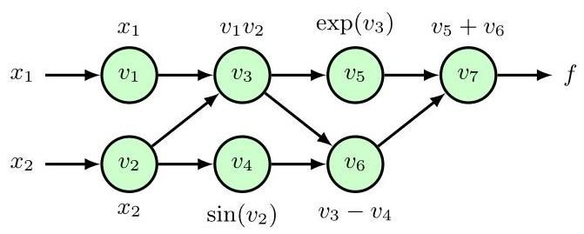

Figure 8.4 Evaluation trace diagram showing the steps involved in the numerical evaluation of the function (8.49) using the primal equations (8.50) to (8.56).

图 8.4 评估跟踪图，展示了使用原始方程 (8.50) 至 (8.56) 对函数 (8.49) 进行数值评估所涉及的步骤。

As an example, consider the following function, which has two input variables:

作为示例，考虑以下具有两个输入变量的函数:

When implemented in software, the code consists of a sequence of operations that can be expressed as an evaluation trace of the underlying elementary operations. This trace can be visualized in the form of a graph, as shown in Figure 8.4. Here we have defined the following primal variables

当以软件形式实现时，代码由一系列操作组成，这些操作可以表示为底层基本操作的评估跟踪。如图 8.4 所示，此跟踪可以图形形式可视化。这里我们定义了以下原始变量

Now suppose we wish to evaluate the derivative . We define the tangent variables by . Expressions for evaluating these can be constructed automatically using the chain rule of calculus:

现在假设我们希望评估导数 。我们通过 定义切变量。可以使用微积分的链式法则自动构建评估这些变量的表达式:

where denotes the set of parents of the node in the evaluation trace diagram, that is the set of variables with arrows pointing to node . For example, in Figure 8.4 the parents of node are nodes and . Applying (8.57) to the evaluation trace .

其中 表示评估跟踪图中节点 的父节点集合，即指向节点 的变量集合。例如，在图 8.4 中，节点 的父节点是节点 和 。将 (8.57) 应用于评估跟踪 。

Figure 8.5 Extension of the example shown in Figure 8.4 to a function with two outputs and

图 8.5 将图 8.4 所示示例扩展到具有两个输出 和的函数

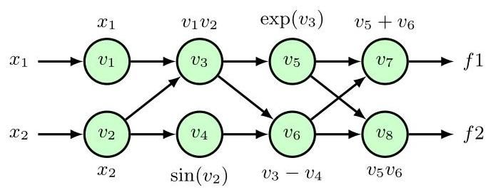

equations (8.50) to (8.56), we obtain the following evaluation trace equations for the tangent variables

由方程 (8.50) 至 (8.56)，我们得到以下关于切变量的求值跟踪方程

We can summarize automatic differentiation for this example as follows. We first write code to implement the evaluation of the primal variables, given by (8.50) to (8.56). The associated equations and corresponding code for evaluating the tangent variables (8.58) to (8.64) are generated automatically. To evaluate the derivative , we input specific values of and and the code then executes the primal and tangent equations, numerically evaluating the tuples in sequence until we obtain , which is the required derivative.

我们可以将此示例的自动微分总结如下。首先，我们编写代码来实现对由 (8.50) 至 (8.56) 给出的原变量的求值。用于计算切变量的相关方程 (8.58) 至 (8.64) 及其对应代码会自动生成。为了计算导数 ，我们输入 和 的特定值，然后代码执行原方程和切方程，按顺序对元组 进行数值计算，直到得到 ，即所需的导数。

Exercise 8.17

练习 8.17

Now consider an example with two outputs and where is defined by (8.49) and

现在考虑一个有两个输出 和 的示例，其中 由 (8.49) 定义，

as illustrated by the evaluation trace diagram in Figure 8.5. We see that this involves only a small extension to the evaluation equations for the primal and tangent variables, and so both and can be evaluated together in a single forward pass. The downside, however, is that if we wish to evaluate derivatives with respect to a different input variable then we have to run a separate forward pass. In general, if we have a function with inputs and outputs then a single pass of forward-mode automatic differentiation produces a single column of the

如图 8.5 中的求值跟踪图所示。我们发现，这仅涉及对原变量和切变量求值方程的小扩展，因此 和 可以在一次前向传播中一起计算。然而，缺点是，如果我们希望计算关于不同输入变量 的导数，那么我们必须运行一次单独的前向传播。一般来说，如果我们有一个具有 个输入和 个输出的函数，那么前向模式自动微分的一次传播会生成 的单列

Jacobian matrix:

雅可比矩阵:

To compute column of the Jacobian, we need to initialize the forward pass of the tangent equations by setting and for . We can write this in vector form as where is the th unit vector. To compute the full Jacobian matrix we need forward-mode passes. However, if we wish to evaluate the product of the Jacobian with a vector :

为了计算雅可比矩阵的第 列，我们需要通过为 设置 和 来初始化正切方程的前向传播。我们可以将其写成向量形式 ，其中 是第 个单位向量。为了计算完整的雅可比矩阵，我们需要进行 次前向模式传播。然而，如果我们希望计算雅可比矩阵与向量 的乘积:

Exercise 8.18

练习 8.18

then this can be done in single forward pass by setting .

那么可以通过设置 在单次前向传播中完成。

We see that forward-mode automatic differentiation can evaluate the full Jacobian matrix of derivatives using forward passes. This is very efficient for networks with a few inputs and many outputs, such that . However, we often operate in a regime where we often have just one function, namely the error function used for training, and large numbers of variables that we want to differentiate with respect to, comprising the weights and biases in the network, of which there may be millions or billions. In such situations, forward-mode automatic differentiation is extremely inefficient. We therefore turn to an alternative version of automatic differentiation based on the a backwards flow of derivative data through the evaluation trace graph.

我们看到，前向模式自动微分可以使用 次前向传播来计算完整的导数雅可比矩阵 。对于输入较少而输出较多(即 )的网络来说，这非常高效。然而，我们通常处于这样一种情况:我们通常只有一个函数，即用于训练的误差函数，并且有大量我们想要对其求导的变量，这些变量包括网络中的权重和偏置，可能有数百万或数十亿个。在这种情况下，前向模式自动微分的效率极低。因此，我们转向基于导数数据通过求值跟踪图的反向流动的另一种自动微分版本。

# 8.2.2 Reverse-mode automatic differentiation

# 8.2.2 反向模式自动微分

We can think of reverse-mode automatic differentiation as a generalization of the error backpropagation procedure. As with forward mode, we augment each intermediate variable with additional variables, in this case called adjoint variables, denoted . Consider again a situation with a single output function for which the adjoint variables are defined by

我们可以将反向模式自动微分视为误差反向传播过程的推广。与前向模式一样，我们为每个中间变量 增加额外的变量，在这种情况下称为伴随变量，用 表示。再次考虑只有一个输出函数 的情况，其伴随变量定义为

These can be evaluated sequentially starting with the output and working backwards by using the chain rule of calculus:

这些可以从输出开始，通过使用微积分的链式法则依次反向计算来进行评估:

Here denotes the children of node in the evaluation trace graph, in other words the set of nodes that have arrows pointing into them from node . The successive evaluation of the adjoint variables represents a flow of information backwards through the graph, as we saw previously.

这里 表示评估跟踪图中节点 的子节点，换句话说，就是那些有箭头从节点 指向它们的节点集合。如我们之前所见，伴随变量的连续评估表示信息在图中反向流动。

Figure 8.1

图 8.1

If we again consider the specific example function given by (8.50) to (8.56), we obtain the following evaluation equations for the evaluation of the adjoint variables

如果我们再次考虑由 (8.50) 到 (8.56) 给出的具体示例函数，我们可以得到以下用于评估伴随变量的计算方程

Exercise 8.16

练习 8.16

Note that these start at the output and then flow backwards through the graph to the inputs. Even with multiple inputs, only a single backward pass is required to evaluate the derivatives. For a neural network error function, the derivatives of with respect to the weight and biases are obtained as the corresponding adjoint variables. However, if we now have more than one output then we need to run a separate backward pass for each output variable.

请注意，这些计算从输出开始，然后通过图反向流向输入。即使有多个输入，也只需要一次反向传播就可以计算导数。对于神经网络误差函数， 关于权重和偏置的导数可以作为相应的伴随变量得到。然而，如果现在有多个输出，那么对于每个输出变量都需要单独进行一次反向传播。

Figure 8.5

图 8.5

Reverse mode is often more memory intensive than forward mode because all of the intermediate primal variables must be stored so that they will be available as needed when evaluating the adjoint variables during the backward pass. By contrast, with forward mode, the primal and tangent variables are computed together during the forward pass, and therefore variables can be discarded once they have been used. It is therefore also generally easier to implement forward mode compared to reverse mode.

反向模式通常比正向模式更耗费内存，因为必须存储所有中间原变量，以便在反向传播过程中计算伴随变量时根据需要使用。相比之下，在正向模式中，原变量和切变量在正向传播过程中一起计算，因此变量一旦使用就可以丢弃。因此，与反向模式相比，正向模式通常也更容易实现。

For both forward-mode and reverse-mode automatic differentiation, a single pass through the network is guaranteed to take no more than 6 times the computational cost of a single function evaluation. In practice, the overhead is typically closer to a factor of 2 or 3 (Griewank and Walther, 2008). Hybrids of forward and reverse modes are also of interest. One situation in which this arises is in the evaluation of the product of a Hessian matrix with a vector, which can be calculated without explicit evaluation of the full Hessian (Pearlmutter, 1994). Here we can use reverse mode to calculate the gradient of code, which itself has been generated by the forward model. We start from a vector and a point at which the Hessian-vector product is to be evaluated. By setting and using forward mode, we obtain the directional derivative . This is then differentiated using reverse mode to obtain . If is the number of parameters in the neural network then this evaluation has complexity even though the Hessian is of size . The Hessian itself can also be evaluated explicitly using automatic differentiation but this has complexity.

对于正向模式和反向模式的自动微分，保证通过网络的单次传播所花费的计算成本不超过单次函数评估的 6 倍。在实践中，开销通常接近 2 倍或 3 倍(Griewank 和 Walther，2008)。正向和反向模式的混合模式也很受关注。出现这种情况的一种情形是计算海森矩阵与向量的乘积，此时可以在不显式计算完整海森矩阵的情况下进行计算(Pearlmutter，1994)。在这里，我们可以使用反向模式来计算由正向模型生成的代码的梯度。我们从一个向量 和一个要计算海森 - 向量乘积的点 开始。通过设置 并使用正向模式，我们得到方向导数 。然后使用反向模式对其进行微分以得到 。如果 是神经网络中的参数数量，那么即使海森矩阵的大小为 ，这种计算的复杂度也为 。也可以使用自动微分显式地计算海森矩阵本身，但这具有 的复杂度。

Exercises By making use of (8.5),(8.6),(8.8), and (8.12), verify the backpropagation formula (8.13) for evaluating the derivatives of an error function.

练习 利用 (8.5)、(8.6)、(8.8) 和 (8.12)，验证用于计算误差函数导数的反向传播公式 (8.13)。

Consider a network that consists of layers and rewrite the backpropagation formula (8.13) in matrix notation by starting with the forward propagation equation (6.19). Note that the result involves multiplication by the transposes of the matrices.

考虑一个由多层组成的网络，从正向传播方程 (6.19) 开始，用矩阵表示法重写反向传播公式 (8.13)。注意，结果涉及矩阵的转置相乘。

8.3 (⋆) By using a Taylor expansion, verify that the terms that are cancel on the right-hand side of (8.25).

8.3 (⋆) 通过使用泰勒展开式，验证 (8.25) 右侧 项相互抵消。

8.4 Consider a two-layer network of the form shown in Figure 6.9 with the addition of extra parameters corresponding to skip-layer connections that go directly from the inputs to the outputs. By extending the discussion of Section 8.1.3, write down the equations for the derivatives of the error function with respect to these additional parameters.

8.4 考虑一个如图 6.9 所示形式的两层网络，并增加对应于从输入直接连接到输出的跨层连接的额外参数。通过扩展 8.1.3 节的讨论，写出误差函数关于这些额外参数的导数方程。

8.5 In Section 8.1.5, we derived a procedure for evaluating the Jacobian matrix of a neural network using a backpropagation procedure. Derive an alternative formalism for finding the Jacobian based on forward propagation equations.

8.5 在 8.1.5 节中，我们推导了一种使用反向传播过程来计算神经网络雅可比矩阵的方法。基于前向传播方程推导一种求雅可比矩阵的替代形式。

8.6 Consider a two-layer neural network, and define the quantities

8.6 考虑一个两层神经网络，并定义以下量

Derive expressions for the elements of the Hessian matrix expressed in terms of and for elements in which (i) both weights are in the second layer,(ii) both weights are in the first layer, and (iii) one weight is in each layer.

推导海森矩阵元素的表达式，用 和 表示，其中 (i) 两个权重都在第二层，(ii) 两个权重都在第一层，(iii) 每个层各有一个权重。

8.7 Extend the results of Exercise 8.6 for the exact Hessian of a two-layer network to include skip-layer connections that go directly from inputs to outputs.

8.7 将练习 8.6 中两层网络精确海森矩阵的结果扩展到包含从输入直接到输出的跨层连接的情况。

8.8 The outer product approximation to the Hessian matrix for a neural network using a sum-of-squares error function is given by (8.40). Extend this result for multiple outputs.

8.8 使用平方和误差函数的神经网络海森矩阵的外积近似由式 (8.40) 给出。将此结果扩展到多输出的情况。

8.9 Consider a squared-loss function of the form

8.9 考虑如下形式的平方损失函数

where is a parametric function such as a neural network. The result (4.37) shows that the function that minimizes this error is given by the conditional expectation of given . Use this result to show that the second derivative of with respect to two elements and of the vector , is given by

其中 是一个参数化函数，如神经网络。结果 (4.37) 表明，使该误差最小化的函数 由给定 时 的条件期望给出。利用这一结果证明， 关于向量 的两个元素 和 的二阶导数为

Note that, for a finite sample from , we obtain (8.40).

注意，对于来自 的有限样本，我们得到 (8.40)。

8.10 Derive the expression (8.41) for the outer product approximation of a Hessian matrix for a network having a single output with a logistic-sigmoid output-unit activation function and a cross-entropy error function, corresponding to the result (8.40) for the sum-of-squares error function.

8.10 推导具有单个输出、逻辑 - S 型输出单元激活函数和交叉熵误差函数的网络的海森矩阵外积近似表达式 (8.41)，该表达式对应于平方和误差函数的结果 (8.40)。

8.11 Derive an expression for the outer product approximation of a Hessian matrix for a network having outputs with a softmax output-unit activation function and a cross-entropy error function, corresponding to the result (8.40) for the sum-of-squares error function.

8.11 推导具有 个输出、softmax 输出单元激活函数和交叉熵误差函数的网络的海森矩阵外积近似表达式，该表达式对应于平方和误差函数的结果 (8.40)。

Consider the matrix identity

考虑矩阵恒等式

which is simply a special case of the Woodbury identity (A.7). By applying (8.80) to the outer product approximation (8.40) for a Hessian matrix, derive a formula that allows the inverse of the Hessian matrix to be computed by making one pass through the training data and updating the inverse Hessian with each data point. Note that the algorithm can initialized using where is a small constant, and that the results are not particularly sensitive to the precise value of .

这只是伍德伯里恒等式(A.7)的一个特例。通过将(8.80)应用于海森矩阵的外积近似(8.40)，推导出一个公式，该公式允许通过对训练数据进行一次遍历，并在每个数据点更新海森矩阵的逆矩阵来计算海森矩阵的逆。注意，该算法可以使用 进行初始化，其中 是一个小常数，并且结果对 的精确值不是特别敏感。

Verify that the derivative of (8.47) is given by (8.48).

验证(8.47)的导数由(8.48)给出。

The logistic map is a function defined by the iterative relation with . Write down the evaluation trace equations for , and , and then write down expressions for the corresponding derivatives , and . Do not simplify the expressions but instead simply note how the complexity of the formulae for the derivatives grows much more rapidly than the expressions for the functions themselves.

逻辑映射是由迭代关系 定义的函数，其中 。写出 和 的求值跟踪方程，然后写出相应导数 和 的表达式。不要简化这些表达式，而是简单地注意导数公式的复杂度比函数本身的表达式增长得快得多。

Starting from the evaluation trace equations (8.50) to (8.56) for the example function (8.49), use (8.57) to derive the forward-mode tangent variable evaluation equations (8.58) to (8.64).

从示例函数(8.49)的求值跟踪方程(8.50)到(8.56)开始，使用(8.57)推导出前向模式切变量求值方程(8.58)到(8.64)。

Starting from the evaluation trace equations (8.50) to (8.56) for the example function (8.49), and referring to Figure 8.4, use (8.69) to derive the reverse-mode adjoint variable evaluation equations (8.70) to (8.76).

从示例函数(8.49)的求值跟踪方程(8.50)到(8.56)开始，并参考图 8.4，使用(8.69)推导出反向模式伴随变量求值方程(8.70)到(8.76)。

8.17 Consider the example function (8.49). Write down an expression for and evaluate this function for and . Now use the evaluation trace equations (8.50) to (8.56) to evaluate the variables to and then use the evaluation trace equations of forward-mode automatic differentiation to evaluate the tangent variables to and to confirm that the resulting value of agrees with that found directly. Similarly, use the evaluation trace equations of reverse-mode automatic differentiation (8.70) to (8.76) to evaluate the adjoint variables to and again confirm that the resulting value of agrees with that found directly.

8.17 考虑示例函数(8.49)。写出 的表达式，并针对 和 计算该函数的值。现在使用求值跟踪方程(8.50)到(8.56)计算变量 到 的值，然后使用前向模式自动微分的求值跟踪方程计算切变量 到 的值，并确认 的计算结果与直接计算的结果一致。类似地，使用反向模式自动微分的求值跟踪方程(8.70)到(8.76)计算伴随变量 到 的值，并再次确认 的计算结果与直接计算的结果一致。

By expressing an arbitrary vector as a linear combination of the unit vectors , where , show that the product of the Jacobian of a function with in the form (8.67) can be evaluated using a single pass of forward-mode automatic differentiation by setting .

通过将任意向量 表示为单位向量 的线性组合，其中 ，证明通过设置 ，可以使用单次前向模式自动微分来计算函数的雅可比矩阵与 (形式如 (8.67))的乘积。

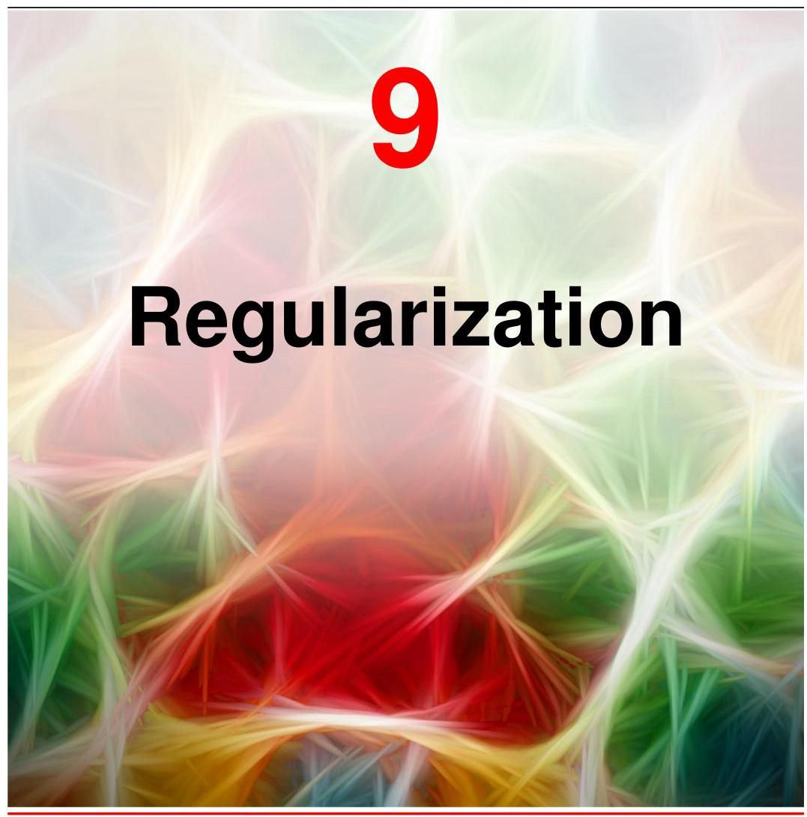

We introduced the concept of regularization when discussing polynomial curve fitting as a way to reduce over-fitting by discouraging the parameters of the model from taking values with a large magnitude. This involved adding a simple penalty term to the error function to give a regularized error function in the form

我们在讨论多项式曲线拟合时引入了正则化的概念，作为一种通过抑制模型参数取大值来减少过拟合的方法。这涉及在误差函数中添加一个简单的惩罚项，以得到如下形式的正则化误差函数

Section 1.2

第 1.2 节

where is the vector of model parameters, is the unregularized error function, and the regularization hyperparameter controls the strength of the regularization effect. An improvement in predictive accuracy with such a regularizer can be understood in terms of the bias-variance trade-off through the reduction in the variance of the solution at the expense of some increase in bias. In this chapter we will explore regularization in depth and will discuss several different approaches to regularization. We will also look more broadly at the important role of bias in achieving good generalization from finite training data sets.

其中 是模型参数向量， 是未正则化的误差函数，正则化超参数 控制正则化效果的强度。使用这样的正则化器提高预测精度可以从偏差 - 方差权衡的角度来理解，即通过牺牲一定的偏差增加来减少解的方差。在本章中，我们将深入探讨正则化，并讨论几种不同的正则化方法。我们还将更广泛地探讨偏差在从有限训练数据集中实现良好泛化方面的重要作用。

Section 4.3

第 4.3 节

In a practical application, it is very unlikely that the process that generates the data will correspond precisely to a particular neural network architecture, and so any given neural network will only ever represent an approximation to the true data generator. Larger networks can provide closer approximations, but this comes at the risk of over-fitting. In practice, we find that the best generalization results are almost always obtained by using a larger network combined with some form of regularization. In this chapter we explore several alternative regularization techniques including early stopping, model averaging, dropout, data augmentation, and parameter sharing. Multiple forms of regularization can be used together if desired. For example, error function regularization of the form (9.1) is often used alongside dropout.

在实际应用中，生成数据的过程几乎不可能精确对应于特定的神经网络架构，因此任何给定的神经网络都只是对真实数据生成器的一种近似。更大的网络可以提供更接近的近似，但这存在过拟合的风险。在实践中，我们发现几乎总是通过使用更大的网络并结合某种形式的正则化来获得最佳的泛化结果。在本章中，我们将探讨几种替代的正则化技术，包括提前停止、模型平均、随机失活、数据增强和参数共享。如果需要，可以同时使用多种形式的正则化。例如，形式为 (9.1) 的误差函数正则化通常与随机失活一起使用。

# 9.1. Inductive Bias

# 9.1. 归纳偏置

When we compared the predictive error of polynomials of various orders for the sinusoidal synthetic data problem, we saw that the smallest generalization error was achieved using a polynomial of intermediate complexity, being neither too simple nor too flexible. A similar result was found when we used a regularization term of the form (9.1) to control model complexity, as an intermediate value of the regularization coefficient gave the best predictions for new input values. Insight into this result came from the bias-variance decomposition, where we saw that an appropriate level of bias in the model was important to allow generalization from finite data sets. Simple models with high bias are unable to capture the variation in the underlying data generation process, whereas highly flexible models with low bias are prone to over-fitting leading to poor generalization. As the size of the data set grows, we can afford to use more flexible models having less bias without incurring excessive variance, thereby leading to improved generalization. Note that in a practical setting, our choice of model might also be influenced by factors such as memory usage or speed of execution. Here we ignore such ancillary considerations and focus on the core goal of achieving good predictive performance, in other words good generalization.

当我们比较不同阶多项式对正弦合成数据问题的预测误差时，我们发现使用中等复杂度的多项式(既不过于简单也不过于灵活)可实现最小的泛化误差。当我们使用形式为 (9.1) 的正则化项来控制模型复杂度时，也得到了类似的结果，因为正则化系数 取中间值时对新输入值的预测效果最佳。对这一结果的深入理解来自偏差 - 方差分解，我们发现模型中适当水平的偏差对于从有限数据集进行泛化非常重要。具有高偏差的简单模型无法捕捉底层数据生成过程中的变化，而具有低偏差的高度灵活模型则容易过拟合，导致泛化能力差。随着数据集规模的增大，我们可以使用偏差更小、更灵活的模型，而不会产生过大的方差，从而提高泛化能力。请注意，在实际应用中，我们对模型的选择可能还会受到内存使用或执行速度等因素的影响。在这里，我们忽略这些次要因素，专注于实现良好预测性能这一核心目标，换句话说，就是良好的泛化能力。

Section 1.2.4

第 1.2.4 节

Section 1.2.5

第 1.2.5 节

Section 4.3

第 4.3 节

# 9.1.1 Inverse problems

# 9.1.1 逆问题

This issue of model choice lies at the heart of machine learning and can be traced to the fact that most machine learning tasks are examples of inverse problems. Given a conditional distribution along with a finite set of input points , it is straightforward, at least in principle, to sample corresponding values from that distribution. In machine learning, however, we have to solve the inverse of this problem, namely to infer an entire distribution given only a finite number of samples. This is intrinsically ill-posed, as there are infinitely many distributions which could potentially have been responsible for generating the observed training data. In fact any distribution that has a non-zero probability density at the observed target values is a candidate.

模型选择这一问题是机器学习的核心，可追溯到大多数机器学习任务都是逆问题的实例这一事实。给定一个条件分布 以及一组有限的输入点 ，至少原则上，从该分布中采样相应的值 是直接明了的。然而，在机器学习中，我们必须解决这个问题的逆问题，即仅根据有限数量的样本推断出整个分布。这本质上是不适定的，因为有无数种分布可能是生成所观察到的训练数据的原因。事实上，任何在观察到的目标值处具有非零概率密度的分布都是候选分布。

For machine learning to be useful, however, we need to make predictions for new values of , and therefore we need a way to choose a specific distribution from amongst the infinitely many possibilities. The preference for one choice over others is called inductive bias, or prior knowledge, and plays a central role in machine learning. Prior knowledge may come from background information that helps constrain the space of solutions. For many applications, small changes in the input values should lead to small changes in the output values, and so we should bias our solutions towards those with smoothly varying functions. Regularization terms of the form (9.1) encourage the model weights to have a smaller magnitude and hence introduce a bias towards functions that vary more slowly with changes in the inputs. Likewise, when detecting objects in images, we can introduce prior knowledge that the identity of an object is generally independent of its location within the image. This is known as translation invariance, and incorporating this into our solution can greatly simplify the task of building a system with good generalization. However, care must be taken not to incorporate biases or constraints that are inconsistent with the underlying process that generates the data. For example, assuming that the relationship between outputs and inputs is linear when in fact there are significant nonlinearities can lead to a system that produces inaccurate answers.

然而，为了使机器学习有用，我们需要对 的新值进行预测，因此我们需要一种方法从无数种可能性中选择一个特定的分布。对一种选择优于其他选择的偏好称为归纳偏置或先验知识，它在机器学习中起着核心作用。先验知识可能来自有助于限制解空间的背景信息。对于许多应用来说，输入值的微小变化应该导致输出值的微小变化，因此我们应该使我们的解偏向于那些具有平滑变化函数的解。形式为 (9.1) 的正则化项鼓励模型权重具有较小的幅度，从而引入对随输入变化更缓慢的函数的偏置。同样，在图像中检测物体时，我们可以引入先验知识，即物体的身份通常与其在图像中的位置无关。这被称为平移不变性，将其纳入我们的解中可以大大简化构建具有良好泛化能力的系统的任务。然而，必须注意不要纳入与生成数据的底层过程不一致的偏置或约束。例如，当实际上存在显著的非线性时，假设输出和输入之间的关系是线性的，可能会导致系统产生不准确的答案。

Chapter 10 Section 6.3.4

第 10 章 第 6.3.4 节

Techniques such as transfer learning and multi-task learning can also be viewed from the perspective of regularization. When training data for a particular task is limited, additional data from a different, but related, task can be used to help determine the learnable parameters in a neural network. The assumption of similarity between the tasks represents a more sophisticated form of inductive bias compared to simple regularization, and this explains the improved performance resulting from the use of the additional data.

诸如迁移学习和多任务学习等技术也可以从正则化的角度来看待。当特定任务的训练数据有限时，可以使用来自不同但相关任务的额外数据来帮助确定神经网络中的可学习参数。与简单的正则化相比，任务之间相似性的假设代表了一种更复杂的归纳偏置形式，这解释了使用额外数据所带来的性能提升。

# 9.1.2 No free lunch theorem

# 9.1.2 没有免费午餐定理

The core focus of this book is on the important class of machine learning models called deep neural networks. These are highly flexible models and have revolutionized many fields including computer vision, speech recognition, and natural language processing. In fact, they have become the framework of choice for the great majority of machine learning applications. It might appear, therefore, that they represent a ’universal’ learning algorithm able to solve all tasks. However, even very flexible neural networks contain important inductive biases. For example, convolutional neural networks encode specific forms of inductive bias, including translation equivariance, that are especially useful in applications involving images.

本书的核心重点是一类重要的机器学习模型，即深度神经网络。这些是高度灵活的模型，已经彻底改变了许多领域，包括计算机视觉、语音识别和自然语言处理。事实上，它们已经成为绝大多数机器学习应用的首选框架。因此，它们似乎代表了一种能够解决所有任务的“通用”学习算法。然而，即使是非常灵活的神经网络也包含重要的归纳偏置。例如，卷积神经网络编码了特定形式的归纳偏置，包括平移等变性，这在涉及图像的应用中特别有用。

Chapter 10

第10章

The no free lunch theorem (Wolpert, 1996), named from the expression ’There’s no such thing as a free lunch,’ states that every learning algorithm is as good as any other when averaged over all possible problems. If a particular model or algorithm is better than average on some problems, it must be worse than average on others. However, this is a rather theoretical notion as the space of possible problems here includes relationships between input and output that would be very uncharacteristic of any plausible practical application. For example, we have already noted that most examples of practical interest exhibit some degree of smoothness, in which small changes in the input values are associated, for the most part, with small changes in the target values. Models such as neural networks, and indeed most widely used machine learning techniques, exhibit this form of inductive bias, and therefore to some degree, they have broad applicability.

没有免费午餐定理(Wolpert，1996)，得名于 “天下没有免费的午餐” 这一表述，该定理指出，当对所有可能的问题求平均时，每个学习算法的效果都和其他算法一样。如果某个特定的模型或算法在某些问题上表现优于平均水平，那么它在其他问题上必然表现逊于平均水平。然而，这是一个相当理论化的概念，因为这里可能问题的空间包括了输入和输出之间的关系，而这些关系在任何合理的实际应用中都是非常不典型的。例如，我们已经注意到，大多数实际感兴趣的例子都表现出一定程度的平滑性，即输入值的小变化在很大程度上与目标值的小变化相关。像神经网络这样的模型，实际上大多数广泛使用的机器学习技术，都表现出这种形式的归纳偏置，因此在一定程度上，它们具有广泛的适用性。

Although the no free lunch theorem is somewhat theoretical, it does highlight the central importance of bias in determining the performance of a machine learning algorithm. It is not possible to learn ’purely from data’ in the absence of any bias. In practice, bias may be implicit. For example, every neural network has a finite number of parameters, which therefore limits the functions that it can represent. However, bias may also be encoded explicitly as a reflection of prior knowledge relating to the specific type of problem being solved.

尽管没有免费午餐定理有些理论化，但它确实凸显了偏置在确定机器学习算法性能方面的核心重要性。在没有任何偏置的情况下，不可能 “纯粹从数据中学习”。在实践中，偏置可能是隐含的。例如，每个神经网络都有有限数量的参数，因此限制了它所能表示的函数。然而，偏置也可以作为与正在解决的特定类型问题相关的先验知识的反映而被明确编码。

In trying to find general-purpose learning algorithms, we are really seeking inductive biases that are appropriate to the broad classes of applications that will be encountered in practice. For any given application, however, better results can be obtained if it is possible to incorporate stronger inductive biases that are specific to that application. The perspective of model-based machine learning (Winn et al., 2023) advocates making all the assumptions in machine learning models explicit so that the appropriate choices can be made for inductive biases.

在试图寻找通用学习算法时，我们实际上是在寻找适合实际中会遇到的广泛应用类别的归纳偏置。然而，对于任何给定的应用，如果能够纳入针对该应用的更强的归纳偏置，则可以获得更好的结果。基于模型的机器学习观点(Winn 等人，2023)主张将机器学习模型中的所有假设明确化，以便为归纳偏置做出适当的选择。

We have seen that inductive bias can be incorporated through the form of distribution, for example by specifying that the output is a linear function of a fixed set of specific basis functions. It can also be incorporated through the addition of a regularization term to the error function used during training. Yet another way to control the complexity of a neural network is through the training process itself. We will see that deep neural networks can give good generalization even when the number of adjustable parameters exceeds the number of training data points, provided the training process is set up correctly. Part of the skill in applying deep learning to real-world problems is in the careful design of inductive bias and the incorporation of prior knowledge.

我们已经看到，归纳偏置可以通过分布的形式来纳入，例如通过指定输出是一组固定的特定基函数的线性函数。它也可以通过在训练期间使用的误差函数中添加正则化项来纳入。控制神经网络复杂度的另一种方法是通过训练过程本身。我们将看到，即使可调整参数的数量超过训练数据点的数量，只要训练过程设置正确，深度神经网络也能给出良好的泛化能力。将深度学习应用于实际问题的部分技巧在于精心设计归纳偏置和纳入先验知识。

Chapter 7

第7章

# 9.1.3 Symmetry and invariance

# 9.1.3 对称性与不变性

In many applications of machine learning, the predictions should be unchanged, or invariant, under one or more transformations of the input variables. For example, when classifying an object in two-dimensional images, such as a cat or dog, a particular object should be assigned the same classification irrespective of its position within the image. This is known as translation invariance. Likewise changes to the size of the object within the image should also leave its classification unchanged. This is called scale invariance. Exploiting such symmetries to create inductive biases can greatly improve the performance of machine learning models and forms the subject of geometric deep learning (Bronstein et al., 2021).

在机器学习的许多应用中，输入变量经过一次或多次变换后，预测结果应保持不变，即具有不变性。例如，在对二维图像中的物体(如猫或狗)进行分类时，无论物体在图像中的位置如何，都应赋予其相同的分类。这被称为平移不变性。同样，图像中物体大小的变化也不应改变其分类。这被称为尺度不变性。利用这些对称性来创建归纳偏置可以极大地提高机器学习模型的性能，这也是几何深度学习的研究主题(Bronstein 等人，2021)。

Transformations, such as a translation or scaling, that leave particular properties unchanged, represent symmetries. The set of all transformations corresponding to a particular symmetry form a mathematical structure called a group. A group consists of a set of elements together with a binary operation for composing pairs of elements together, which we denote using the notation . The following four axioms hold for a group:

诸如平移或缩放等能使特定属性保持不变的变换体现了对称性。与特定对称性相对应的所有变换构成了一种称为群的数学结构。群由一组元素 以及一个用于组合元素对的二元运算组成，我们用符号 表示该运算。群满足以下四个公理:

1. Closed: For any two elements in the set, must also be in the set.

1. 封闭性:对于集合中的任意两个元素 ， 也必须在该集合中。

2. Associative: For any three elements in the set, .

2. 结合律:对于集合中的任意三个元素 ，有 。

3. Identity: There exists an element of the set, called the identity, with the property: for every element in the set.

3. 单位元:集合中存在一个元素 ，称为单位元，具有以下性质:对于集合中的每个元素 ，都有 。

4. Inverse: For each element in the set, there exists another element in the set, which we denote by , called the inverse, which has the property:

4. 逆元:对于集合中的每个元素 ，集合中都存在另一个元素，我们用 表示，称为逆元，它具有以下性质:

Simple examples of groups include the set of rotations of a square through multiples of or the set of continuous translations of an object in a two-dimensional plane.

群的简单例子包括正方形绕 的倍数旋转的集合，或二维平面中物体的连续平移集合。

Exercise 9.1

练习 9.1

In principle, invariance of the predictions made by a neural network to transformations of the input space could be learned from data, without any special modifications to the network or the training procedure. In practice, however, this can prove to be extremely challenging because such transformations can produce substantial changes in the raw data. For example, relatively small translations of an object within an image, even by a few pixels, can cause pixel values to change significantly. Furthermore, multiple invariances must often hold at the same time, for example invariance to translations in two dimensions as well as scaling, rotation, changes of intensity, changes of colour balance, and many others. There are exponentially many possible combinations of such transformations, making the size of the required training set needed to learn all of these invariances prohibitive.

原则上，神经网络对输入空间变换的预测不变性可以从数据中学习到，而无需对网络或训练过程进行任何特殊修改。然而，在实践中，这可能极具挑战性，因为此类变换会使原始数据产生重大变化。例如，图像中物体相对较小的平移，即使只有几个像素，也可能导致像素值显著改变。此外，通常必须同时满足多种不变性，例如二维平移不变性以及缩放、旋转、强度变化、色彩平衡变化等等。这些变换的可能组合数量呈指数级增长，使得学习所有这些不变性所需的训练集规模大得令人望而却步。

We therefore seek more efficient approaches for encouraging an adaptive model to exhibit the required invariances. These can broadly be divided into four categories:

因此，我们寻求更有效的方法来促使自适应模型展现所需的不变性。这些方法大致可分为四类:

1. Pre-processing. Invariances are built into a pre-processing stage by computing features of the data that are invariant under the required transformations. Any subsequent regression or classification system that uses such features as inputs will necessarily also respect these invariances.

1. 预处理。通过计算在所需变换下保持不变的数据特征，将不变性融入预处理阶段。任何后续使用这些特征作为输入的回归或分类系统必然也会遵循这些不变性。

2. Regularized error function. A regularization term is added to the error function to penalize changes in the model output when the input is subject to one of the invariant transformations.

2. 正则化误差函数。在误差函数中添加一个正则化项，以对输入进行某种不变变换时模型输出的变化进行惩罚。

3. Data augmentation. The training set is expanded using replicas of the training data points, transformed according to the desired invariances and carrying the same output target values as the untransformed examples.

3. 数据增强。使用训练数据点的副本扩展训练集，这些副本根据所需的不变性进行变换，并与未变换的示例具有相同的输出目标值。

4. Network architecture. The invariance properties are built into the structure of a neural network through an appropriate choice of network architecture.

4. 网络架构。通过适当选择网络架构，将不变性属性构建到神经网络的结构中。

One challenge with approach 1 is to design features that exhibit the required invariances without also discarding information that can be useful for determining the network outputs. We have already seen that fixed, hand-crafted features have limited capabilities and have been superseded by learned representations obtained using deep neural networks.

方法 1 的一个挑战是设计出既能表现出所需不变性，又不会丢弃对确定网络输出有用信息的特征。我们已经看到，固定的手工特征能力有限，并且已被使用深度神经网络获得的学习表示所取代。

Chapter 6

第 6 章

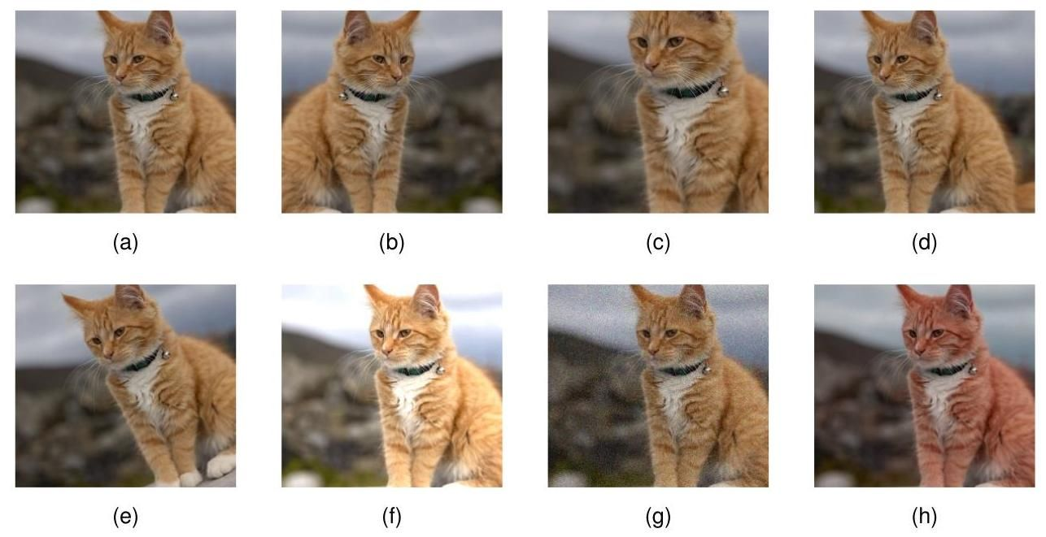

Figure 9.1 Illustration of data set augmentation, showing (a) the original image, (b) horizontal inversion, (c) scaling, (d) translation, (e) rotation, (f) brightness and contrast change, (g) additive noise, and (h) colour shift.

图 9.1 数据集增强示例，展示了 (a) 原始图像，(b) 水平翻转，(c) 缩放，(d) 平移，(e) 旋转，(f) 亮度和对比度变化，(g) 加性噪声，以及 (h) 颜色偏移。

An example of approach 2 is the technique of tangent propagation (Simard et al., 1992) in which a regularisation term is added to the error function during training. This term directly penalizes changes in the output resulting from changes in the input variables that correspond to one of the invariant transformations. A limitation of this technique, in addition to the extra complexity of training, is can only cope with small transformations (e.g., translations by less than a pixel).

方法 2 的一个例子是切线传播技术(Simard 等人，1992)，在该技术中，训练期间会在误差函数中添加一个正则化项。该项直接惩罚因输入变量变化而导致的输出变化，这些输入变量的变化对应于一种不变变换。除了训练的额外复杂性之外，该技术的一个局限性是它只能处理小的变换(例如，小于一个像素的平移)。

Approach 3 is known as data set augmentation. It is often relatively easy to implement and can prove to be very effective in practice. It is often applied in the context of image analysis as it straightforward to create the transformed training data. Figure 9.1 shows examples of such transformations applied to an image of a cat. For medical images of soft tissue, data augmentation could also include continuous ‘rubber sheet’ deformations (Ronneberger, Fischer, and Brox, 2015).

方法 3 被称为数据集增强。它通常相对容易实现，并且在实践中可以证明非常有效。它经常应用于图像分析领域，因为创建经过变换的训练数据很直接。图 9.1 展示了对一张猫的图像应用此类变换的示例。对于软组织的医学图像，数据增强还可以包括连续的“橡胶片”变形(Ronneberger、Fischer 和 Brox，2015)。

For sequential training algorithms, such as stochastic gradient descent, the data set can be augmented by transforming each input data point before it is presented to the model so that, if the data points are being recycled, a different transformation (drawn from an appropriate distribution) is applied each time. For batch methods, a similar effect can be achieved by replicating each data point a number of times and transforming each copy independently.

对于顺序训练算法，如随机梯度下降，可以在将每个输入数据点呈现给模型之前对其进行变换来增强数据集，这样，如果数据点被循环使用，每次都会应用不同的变换(从适当的分布中抽取)。对于批量方法，可以通过多次复制每个数据点并独立地对每个副本进行变换来实现类似的效果。

We can analyse the effect of using augmented data by considering transformations that represent small changes to the original examples and then making a Taylor expansion of the error function in powers of the magnitude of the transformation (Bishop, 1995c; Leen, 1995; Bishop, 2006). This leads to a regularized error function in which the regularizer penalizes the gradient of the network output with respect to the input variables projected onto the direction of transformation. This is related to the technique of tangent propagation discussed above. A special case arises when the transformation of the input variables consists simply of the addition of random noise, in which case the regularizer penalizes the derivatives of the network outputs with respect to the inputs. Again, this is intuitively reasonable, since we are encouraging the network outputs to remain unchanged despite the addition of noise to the input variables.

我们可以通过考虑表示对原始示例进行小变化的变换，然后对误差函数按变换幅度的幂次进行泰勒展开来分析使用增强数据的效果(Bishop，1995c；Leen，1995；Bishop，2006)。这会得到一个正则化的误差函数，其中正则化项惩罚网络输出相对于投影到变换方向上的输入变量的梯度。这与上面讨论的切线传播技术有关。当输入变量的变换仅仅是添加随机噪声时，会出现一种特殊情况，在这种情况下，正则化项惩罚网络输出相对于输入的导数。同样，这在直觉上是合理的，因为我们鼓励网络输出在输入变量添加噪声的情况下保持不变。

Exercise 9.2

练习 9.2

Finally, approach 4, in which we build invariances into the structure of the network, has proven to be very powerful and effective and leads to other key benefits. We will discuss this approach at length in the context of convolutional neural networks for computer vision.

最后，方法 4 是将不变性构建到网络结构中，事实证明这种方法非常强大且有效，并带来其他关键益处。我们将在用于计算机视觉的卷积神经网络的背景下详细讨论这种方法。

Chapter 10

第 10 章

# 9.1.4 Equivariance

# 9.1.4 等变性

An important generalization of invariance is called equivariance in which the output of the network, instead of remaining constant when the input is transformed, is itself transformed in a specific way. For example, consider a network that takes an image as input and returns a segmentation of that image in which each pixel is classified as belonging either to a foreground object or to the background. In this case, if the location of the object within the image is translated, we want the corresponding segmentation of the object to be similarly translated. Suppose we denote the image by , and the operation of the segmentation network by , then for a translation operation we have

不变性的一个重要推广称为等变性，在等变性中，当输入被变换时，网络的输出不是保持不变，而是以特定方式进行自身变换。例如，考虑一个以图像为输入并返回该图像分割结果的网络，其中每个像素被分类为属于前景对象或背景。在这种情况下，如果图像内对象的位置发生平移，我们希望对象的相应分割也进行类似的平移。假设我们用 表示图像，用 表示分割网络的操作，那么对于平移操作 ，我们有

which says that the segmentation of the translated image is given by the translation of the segmentation of the original image. This is illustrated in Figure 9.2

这表明平移后图像的分割结果由原始图像分割结果的平移给出。如图 9.2 所示

More generally, equivariance can hold if the transformation applied to the output is different to that applied to the input:

更一般地，如果应用于输出的变换与应用于输入的变换不同，等变性仍然可以成立:

For example, if the segmented image has a lower resolution than the original image, then if is a translation in the original image space, represents the corresponding translation in the lower-dimensional segmentation space. Similarly, if is an operator that measures the orientation of an object within an image, and represents a rotation (which is a complex nonlinear transformation of all of the pixel values in the image) then will increment or decrement the scalar orientation value generated by .

例如，如果分割后的图像分辨率低于原始图像，那么如果 是原始图像空间中的平移， 表示低维分割空间中的相应平移。类似地，如果 是一个测量图像内对象方向的算子，并且 表示旋转(这是图像中所有像素值的复杂非线性变换)，那么 将增加或减少由 生成的标量方向值。

We also see that invariance is a special case of equivariance in which the output transformation is simply the identity. For example, if is a neural network that classifies an object within an image and is a translation operator then

我们还发现，不变性是等变性的一种特殊情况，在这种情况下，输出变换仅仅是恒等变换。例如，如果 是一个对图像中的物体进行分类的神经网络， 是一个平移算子，那么

which says that the class of the object does not depend on its position within the image.

这表明物体的类别不依赖于其在图像中的位置。

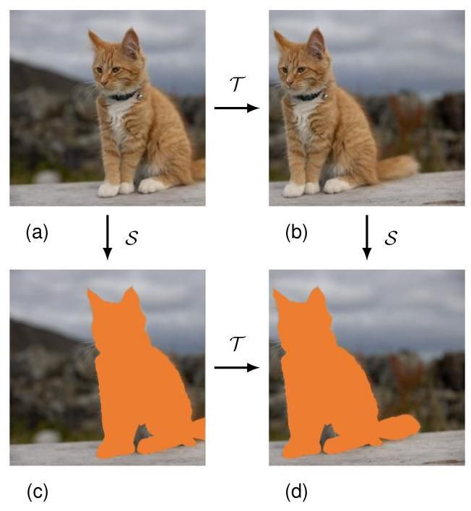

Figure 9.2 Illustration of equivariance, corresponding to (9.2). If an image (a) is first translated to give (b) and then segmented to give (d), the result is the same as if the image is first segmented to give (c) and then translated to give (d).

图 9.2 等变性的图示，对应于公式 (9.2)。如果先对图像 (a) 进行平移得到 (b)，然后进行分割得到 (d)，其结果与先对图像进行分割得到 (c)，再进行平移得到 (d) 相同。

# 9.2. Weight Decay

# 9.2. 权重衰减

# Section 1.2.5

# 第 1.2.5 节

We introduced regularization in the context of linear regression to control model complexity, as an alternative to limiting the number of parameters in the model. The simplest regularizer comprises the sum of the squares of the model parameters to give a regularized error function of the form (9.1), which penalizes parameter values with large magnitude. The effective model complexity is then determined by the choice of the regularization coefficient .

我们在线性回归的背景下引入了正则化，以控制模型复杂度，作为限制模型中参数数量的一种替代方法。最简单的正则化项是模型参数的平方和，从而得到形式为 (9.1) 的正则化误差函数，该函数会对绝对值较大的参数值进行惩罚。然后，有效模型复杂度由正则化系数 的选择决定。

We have also seen that this additive regularization term can be interpreted as the negative logarithm of a zero-mean Gaussian prior distribution over the weight vector . This provides a probabilistic perspective on the inclusion of prior knowledge into the model training process. Unfortunately, this prior is expressed over the model parameters, whereas any domain knowledge we might possess regarding the problem to be solved is more likely to be expressed in terms of the network function from inputs to outputs. The relationship between the parameters and the network function is, however, extremely complex, and therefore only very limited kinds of prior knowledge can easily be expressed directly as priors over model parameters.

我们还看到，这个加法正则化项可以被解释为权重向量 上零均值高斯先验分布的负对数。这为将先验知识纳入模型训练过程提供了一个概率视角。不幸的是，这个先验是在模型参数上表达的，而我们可能拥有的关于待解决问题的任何领域知识更有可能以从输入到输出的网络函数来表达。然而，参数和网络函数之间的关系极其复杂，因此只有非常有限类型的先验知识可以轻松地直接表示为模型参数上的先验。

Section 2.6.2

2.6.2 节

The sum-of-squares regularizer in (9.1) is known in the machine learning literature as weight decay because in sequential learning algorithms, it encourages weight values to decay towards zero, unless supported by the data. One advantage of this kind of regularizer is that it is trivial to evaluate its derivatives for use in gradient descent training. Specifically for (9.1) the gradient is given by

在机器学习文献中，(9.1) 中的平方和正则化项被称为权重衰减，因为在顺序学习算法中，除非有数据支持，否则它会促使权重值向零衰减。这种正则化项的一个优点是，很容易计算其导数以用于梯度下降训练。具体来说，对于 (9.1)，梯度由下式给出

We see that the factor of in (9.1), which is often included by convention, disappears when we take the derivative.

我们看到，(9.1) 中通常按惯例包含的 因子在求导时消失了。

Exercise 9.3

练习 9.3

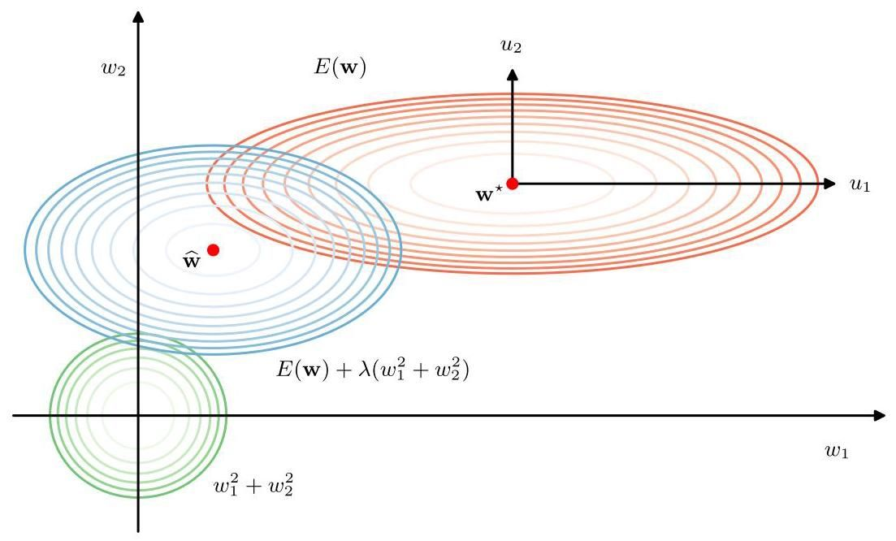

Figure 9.3 Contours of the error function (red), the regularization term (green), and a linear combination of the two (blue) for a quadratic error function and a sum-of-squares regularizer . Here the axes in parameter space have been rotated to align with the axes of the elliptical contour of the unregularized error function. For , the minimum error is indicated by . When , the minimum of the regularized error function is shifted towards the origin. This shift is greater in the direction of because the unregularized error is relatively insensitive to the parameter value, and less in direction where the error is more strongly dependent on the parameter value. The regularization term is effectively suppressing parameters that have only a small effect on the accuracy of the network predictions.

图 9.3 展示了二次误差函数和平方和正则化项 的误差函数(红色)、正则化项(绿色)以及两者的线性组合(蓝色)的等高线。这里，参数空间中的坐标轴已旋转，以与未正则化误差函数的椭圆等高线的轴对齐。对于 ，最小误差由 表示。当 时，正则化误差函数 的最小值向原点移动。在 方向上的移动更大，因为未正则化误差对参数值相对不敏感；而在 方向上的移动较小，因为误差对参数值的依赖性更强。正则化项有效地抑制了对网络预测准确性影响较小的参数。

The general effect of a quadratic regularizer can be seen by considering a two-dimensional parameter space along with an unregularized error function that is a quadratic function of (corresponding to a simple linear regression model with a sum-of-squares error function), as illustrated in Figure 9.3. The axes in parameter space have been rotated to align with the eigenvectors of the Hessian matrix, corresponding to the axes of the elliptical error function contours. We see that the effect of the regularization term is to shrink the magnitudes of the weight parameters. However, the effect is much larger for parameter because the unregularized error is much less sensitive to the value of compared to that of . Intuitively only the parameter is ’active’ because the output is relatively insensitive to , and hence the regularizer pushes close to zero. The effective number of parameters is the number that remain active after regularization, and this concept can be formalized either from a Bayesian or from a frequentist perspective (Bishop, 2006; Hastie, Tibshirani, and Friedman,2009). For , all the parameters are driven to zero and the effective number of parameters is then zero. As is reduced, the number of parameters increases until for it equals the total number of actual parameters in the model. We see that controlling model complexity by regularization has similarities to controlling model complexity by limiting the number of parameters.

通过考虑一个二维参数空间以及一个未正则化的误差函数 (它是 的二次函数，对应于一个带有平方和误差函数的简单线性回归模型)，可以看出二次正则化项的一般效果，如图 9.3 所示。参数空间中的坐标轴已旋转至与黑塞矩阵的特征向量对齐，这些特征向量对应于椭圆误差函数等高线的轴。我们发现，正则化项的作用是缩小权重参数的大小。然而，对于参数 ，这种作用要大得多，因为与 相比，未正则化的误差对 的值不太敏感。直观地说，只有参数 是“活跃的”，因为输出对 相对不敏感，因此正则化项将 推向接近零的值。有效参数的数量是正则化后仍然活跃的参数数量，这个概念可以从贝叶斯或频率主义的角度进行形式化(Bishop，2006；Hastie，Tibshirani 和 Friedman，2009)。对于 ，所有参数都被驱动为零，此时有效参数的数量为零。随着 的减小，参数的数量增加，直到对于 ，它等于模型中实际参数的总数。我们看到，通过正则化控制模型复杂度与通过限制参数数量控制模型复杂度有相似之处。

Section 4.1.2 Section 8.1.6

第 4.1.2 节 第 8.1.6 节

# 9.2.1 Consistent regularizers

# 9.2.1 一致正则化项

One of the limitations of simple weight decay in the form (9.1) is that it breaks certain desirable transformation properties of network mappings. To illustrate this, consider a multilayer perceptron network having two layers of weights and linear output units that performs a mapping from a set of input variables to a set of output variables . The activations of the hidden units in the first hidden layer

形式为 (9.1) 的简单权重衰减的局限性之一是，它破坏了网络映射的某些理想变换性质。为了说明这一点，考虑一个具有两层权重和线性输出单元的多层感知器网络，该网络执行从一组输入变量 到一组输出变量 的映射。第一个隐藏层中隐藏单元的激活

take the form

采用以下形式

whereas the activations of the output units are given by

而输出单元的激活由下式给出

Suppose we perform a linear transformation of the input data:

假设我们对输入数据进行线性变换:

Then we can arrange for the mapping performed by the network to be unchanged by making a corresponding linear transformation of the weights and biases from the inputs to the units in the hidden layer:

然后，我们可以通过对从输入到隐藏层单元的权重和偏置进行相应的线性变换，使网络执行的映射保持不变:

Exercise 9.4

练习 9.4

Similarly, a linear transformation of the output variables of the network of the form

类似地，对网络输出变量进行如下形式的线性变换

can be achieved transforming the second-layer weights and biases using

可以通过使用以下方法对第二层的权重和偏置进行变换来实现

If we train one network using the original data and one network using data for which the input and/or target variables have been transformed by one of the above linear transformations, then consistency requires that we should obtain equivalent networks that differ only by the linear transformation of the weights as given. Any regularizer should be consistent with this property, otherwise it would arbitrarily favour one solution over another, equivalent one. Clearly, simple weight decay (9.1), which treats all weights and biases on an equal footing, does not satisfy this property.

如果我们使用原始数据训练一个网络，使用经过上述线性变换之一对输入和/或目标变量进行变换后的数据训练另一个网络，那么一致性要求我们应该得到仅在权重的线性变换上有所不同的等效网络。任何正则化器都应该与这个性质一致，否则它会任意地偏向一个解而不是另一个等效的解。显然，简单的权重衰减(9.1)，它平等对待所有的权重和偏置，不满足这个性质。

We therefore look for a regularizer that is invariant under the linear transformations (9.9), (9.10), (9.12), and (9.13). These require that the regularizer should be invariant to re-scaling of the weights and to shifts of the biases. Such a regularizer is

因此，我们寻找一个在线性变换 (9.9)、(9.10)、(9.12) 和 (9.13) 下保持不变的正则化项。这些变换要求正则化项在权重的重新缩放和偏置的平移下保持不变。这样的正则化项是

given by

由……给出

where denotes the set of weights in the first layer, denotes the set of weights in the second layer, and biases are excluded from the summations. This regularizer will remain unchanged under the weight transformations provided the regularization parameters are re-scaled using and .

其中 表示第一层的权重集合， 表示第二层的权重集合，并且求和中不包含偏置。如果使用 和 对正则化参数进行重新缩放，那么这个正则化项在权重变换下将保持不变。

The regularizer (9.14) corresponds to a prior distribution over the parameters of the form:

正则化项 (9.14) 对应于参数的先验分布形式为:

Note that priors of this form are improper (they cannot be normalized) because the bias parameters are unconstrained. Using improper priors can lead to difficulties in selecting regularization coefficients and in model comparison within the Bayesian framework. It is therefore common to include separate priors for the biases (which then break the shift invariance) that have their own hyperparameters.

请注意，这种形式的先验是不合适的(它们无法归一化)，因为偏置参数是无约束的。使用不合适的先验会在选择正则化系数和在贝叶斯框架内进行模型比较时带来困难。因此，通常会为偏置包含单独的先验(这会破坏平移不变性)，这些先验有它们自己的超参数。

We can illustrate the effect of the resulting four hyperparameters by drawing samples from the prior and plotting the corresponding network functions, as shown in Figure 9.4. The priors are governed by four hyperparameters, , and , which represent the precisions of the Gaussian distributions of the first-layer biases, first-layer weights, second-layer biases, and second-layer weights, respectively. We see that the parameter governs the vertical scale of the functions (note the different vertical axis ranges on the top two diagrams), governs the horizontal scale of variations in the function values, and governs the horizontal range over which variations occur. The parameter , whose effect is not illustrated here, governs the range of the vertical offsets of the functions

我们可以通过从先验中抽取样本并绘制相应的网络函数来说明由此产生的四个超参数的影响，如图 9.4 所示。先验由四个超参数 和 控制，它们分别表示第一层偏置、第一层权重、第二层偏置和第二层权重的高斯分布的精度。我们看到，参数 控制函数的垂直尺度(注意上面两个图中不同的垂直轴范围)， 控制函数值变化的水平尺度， 控制变化发生的水平范围。参数 的影响在此未展示，它控制函数垂直偏移的范围

More generally, we can consider regularizers in which the weights are divided into any number of groups so that

更一般地，我们可以考虑这样的正则化项，其中权重被划分为任意数量的组 ，使得

where

其中

For example, we could use a different regularizer for each layer in a multilayer network.

例如，我们可以为多层网络中的每一层使用不同的正则化项。

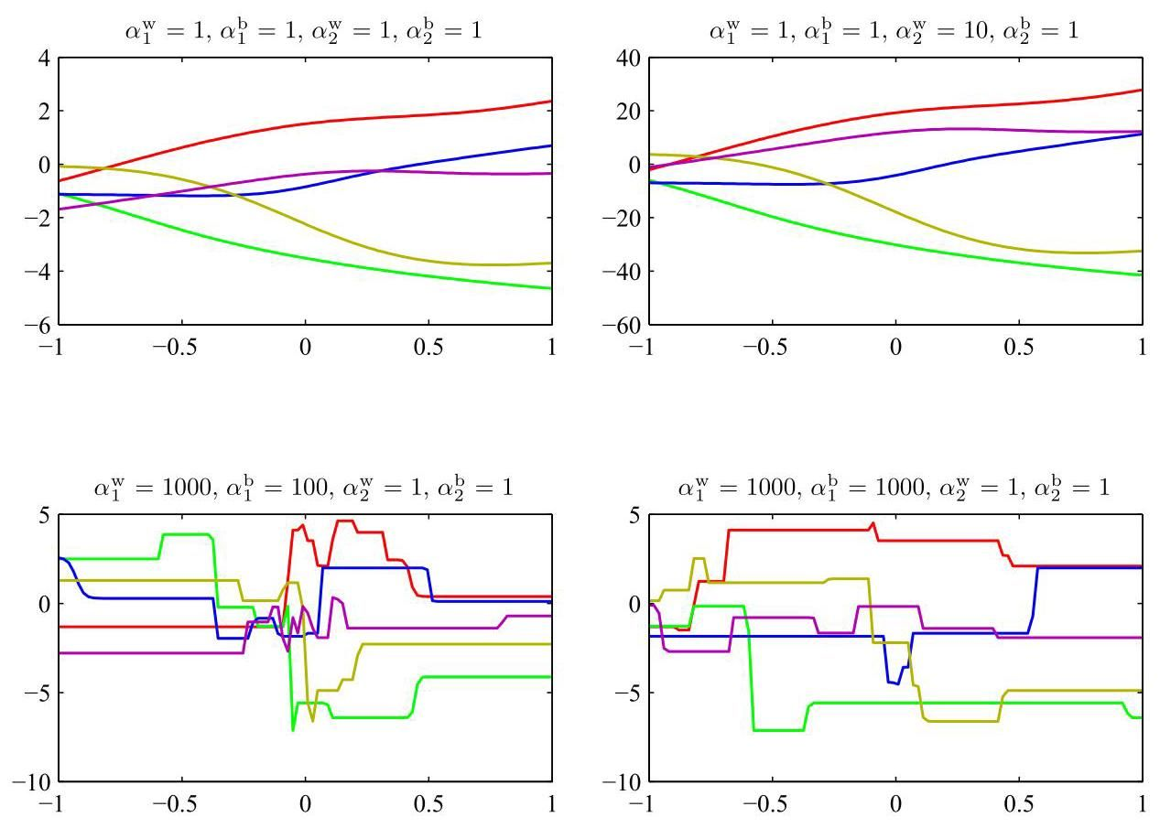

Figure 9.4 Illustration of the effect of the hyperparameters governing the prior distribution over weights and biases in a two-layer network having a single input, a single linear output, and 12 hidden units with tanh activation functions.

图 9.4 展示了超参数对两层网络中权重和偏置的先验分布的影响，该网络有一个输入、一个线性输出和 12 个具有双曲正切激活函数的隐藏单元。

# 9.2.2 Generalized weight decay

# 9.2.2 广义权重衰减

A generalization of the simple quadratic regularizer is sometimes used:

有时会使用简单二次正则化项的一种推广形式:

where corresponds to the quadratic regularizer in (9.1). Figure 9.5 shows contours of the regularization function for different values of .

其中 对应于 (9.1) 中的二次正则化项。图 9.5 展示了不同 值下正则化函数的等高线。

A regularizer of the form (9.18) with is known as a lasso in the statistics literature (Tibshirani, 1996). For quadratic error functions, it has the property that if is sufficiently large, some of the coefficients are driven to zero, leading to a sparse model in which the corresponding basis functions play no role. To see this,

形式为 (9.18) 且带有 的正则化项在统计学文献中被称为套索(Tibshirani，1996)。对于二次误差函数，若 足够大，某些系数 会变为零，从而得到一个稀疏模型，其中相应的基函数不起作用。为了理解这一点，

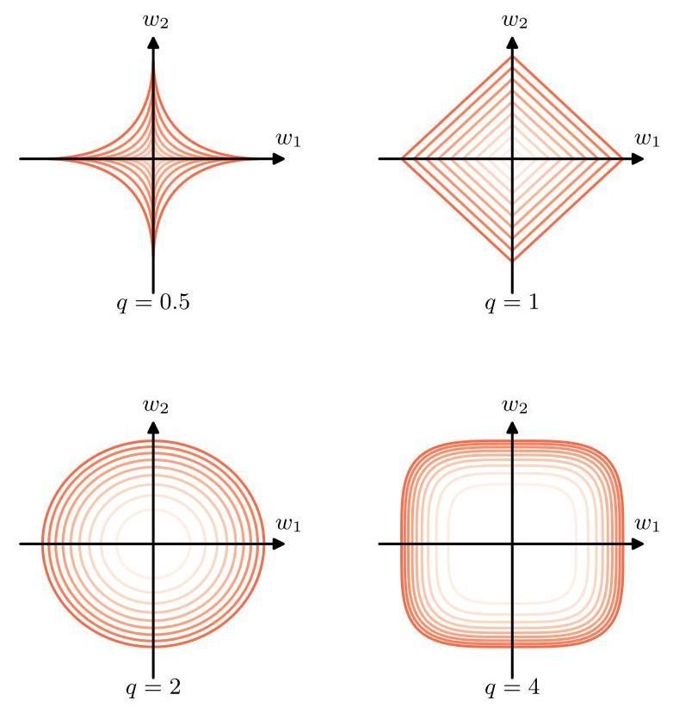

Figure 9.5 Contours of the regularization term in (9.18) for various values of the parameter .

图 9.5 展示了参数 取不同值时 (9.18) 中正则化项的等高线。

we first note that minimizing the regularized error function given by

我们首先注意到，最小化由下式给出的正则化误差函数

is equivalent to minimizing the unregularized error function subject to the

等价于在满足以下条件的情况下最小化未正则化的误差函数

Exercise 9.5

练习 9.5

constraint

约束

for an appropriate value of the parameter , where the two approaches can be related using Lagrange multipliers. The origin of the sparsity can be seen in Figure 9.6, which shows the minimum of the error function, subject to the constraint (9.20). As is increased, more parameters will be driven to zero. By comparison, a quadratic regularizer leaves both weight parameters with non-zero values.

对于参数 的适当值，其中这两种方法可以使用拉格朗日乘数法关联起来。稀疏性的来源可以在图 9.6 中看到，该图展示了误差函数在约束条件 (9.20) 下的最小值。随着 的增加，更多的参数将被驱动为零。相比之下，二次正则化器会使两个权重参数都具有非零值。

Appendix

附录

Regularization allows complex models to be trained on data sets of limited size without severe over-fitting, essentially by limiting the effective model complexity. However, the problem of determining the optimal model complexity is then shifted from one of finding the appropriate number of learnable parameters to one of determining a suitable value of the regularization coefficient . We will discuss the issue of model complexity in the next section.

正则化允许在有限大小的数据集上训练复杂模型而不会出现严重的过拟合，本质上是通过限制有效模型复杂度来实现的。然而，确定最优模型复杂度的问题随后从寻找合适数量的可学习参数转变为确定正则化系数 的合适值。我们将在下一节讨论模型复杂度的问题。

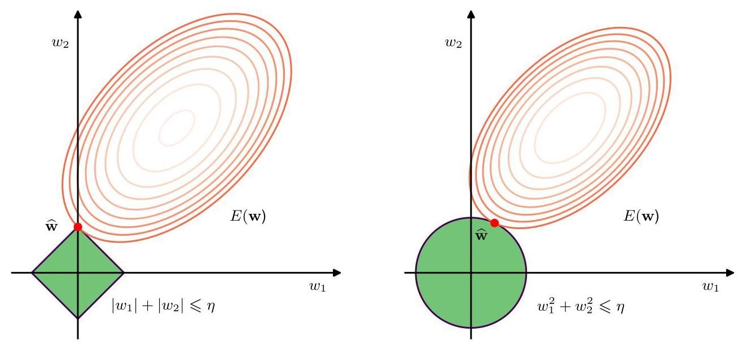

Figure 9.6 Plot of the contours of the unregularized error function (red) along with the constraint region (9.20) for the lasso regularizer on the left, and the quadratic regularizer on the right, in which the optimum value for the parameter vector is denoted by . The lasso gives a sparse solution in which , whereas the quadratic regularizer simply reduces to a smaller value.

图 9.6 左侧展示了未正则化误差函数(红色)的等高线以及套索正则化器 的约束区域 (9.20)，右侧展示了二次正则化器 的情况，其中参数向量 的最优值用 表示。套索方法给出了一个稀疏解，其中 ，而二次正则化器只是将 减小到一个较小的值。

# 9.3. Learning Curves

# 9.3. 学习曲线

We have already explored how the generalization performance of a model varies as we change the number of parameters in the model, the size of the data set, and the coefficient of a weight-decay regularization term. Each of these allows for a tradeoff between bias and variance to minimize the generalization error. Another factor that influences this trade-off is the learning process itself. During optimization of the error function through gradient descent, the training error typically decreases as the model parameters are updated, whereas the error for hold-out data may be non-monotonic. This behaviour can be visualized using learning curves, which plot performance measures such as training set and validation set error as a function of iteration number during an iterative learning process such as stochastic gradient descent. These curves provide insight into the progress of training and also offer a practical methodology for controlling the effective model complexity.

我们已经探讨了在改变模型参数数量、数据集大小以及权重衰减正则化项系数时，模型的泛化性能是如何变化的。这些因素中的每一个都允许在偏差和方差之间进行权衡，以最小化泛化误差。影响这种权衡的另一个因素是学习过程本身。在通过梯度下降优化误差函数的过程中，随着模型参数的更新，训练误差通常会减小，而保留数据的误差可能是非单调的。这种行为可以通过学习曲线直观地展示出来，学习曲线绘制了诸如训练集误差和验证集误差等性能指标，这些指标是随机梯度下降等迭代学习过程中迭代次数的函数。这些曲线有助于深入了解训练的进展情况，也为控制有效模型复杂度提供了一种实用的方法。

# 9.3.1 Early stopping

# 9.3.1 提前停止

An alternative to regularization as a way of controlling the effective complexity of a network is early stopping. The training of deep learning models involves an iterative reduction of the error function defined with respect to a set of training data. Although the error function evaluated using the training set often shows a broadly monotonic decrease as a function of the iteration number, the error measured with respect to held-out data, generally called a validation set, often shows a decrease at first, followed by an increase as the network starts to over-fit. Therefore, to obtain a network with good generalization performance, training should be stopped at the point of smallest error with respect to the validation data set, as indicated in Figure 9.7.

作为控制网络有效复杂度的一种方法，正则化的替代方案是提前停止。深度学习模型的训练涉及对根据一组训练数据定义的误差函数进行迭代减小。尽管使用训练集评估的误差函数通常会随着迭代次数大致单调递减，但相对于保留数据(通常称为验证集)测量的误差通常一开始会减小，然后随着网络开始过拟合而增加。因此，为了获得具有良好泛化性能的网络，应在验证数据集误差最小时停止训练，如图 9.7 所示。

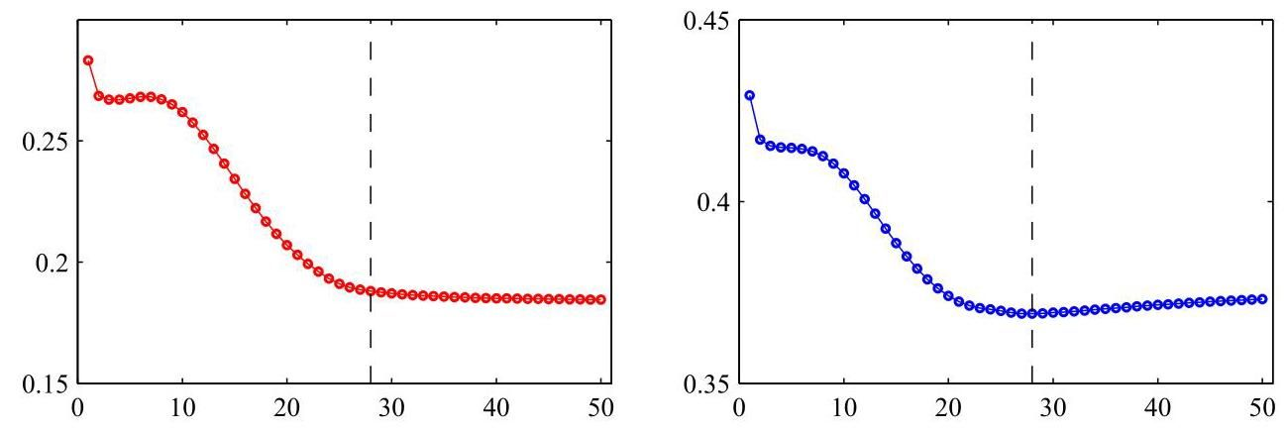

Figure 9.7 An illustration of the behaviour of training set error (left) and validation set error (right) during a typical training session, as a function of the iteration step, for the sinusoidal data set. To achieve the best generalization performance, the training should be stopped at the point shown by the vertical dashed lines, corresponding to the minimum of the validation set error.

图 9.7 展示了在典型训练过程中，正弦数据集的训练集误差(左)和验证集误差(右)随迭代步骤的变化情况。为了实现最佳泛化性能，应在垂直虚线所示的点停止训练，该点对应于验证集误差的最小值。

This behaviour of the learning curves is sometimes explained qualitatively in terms of the effective number of parameters in the network. This number starts out small and then grows during training, corresponding to a steady increase in the effective complexity of the model. Stopping training before a minimum of the training error has been reached is a way to limit the effective network complexity.

学习曲线的这种行为有时可以根据网络中有效参数的数量进行定性解释。这个数量在开始时较小，然后在训练过程中增加，这对应于模型有效复杂度的稳步增加。在达到训练误差的最小值之前停止训练是一种限制网络有效复杂度的方法。

We can verify this insight for a quadratic error function and show that early stopping should exhibit similar behaviour to regularization using a simple weight-decay term (Bishop, 1995a). This can be understood from Figure 9.8, in which the axes in weight space have been rotated to be parallel to the eigenvectors of the Hessian matrix. If, in the absence of weight decay, the weight vector starts at the origin and proceeds during training along a path that follows the local negative gradient vector, then the weight vector will move initially parallel to the axis through a point corresponding roughly to and then move towards the minimum of the error function . This follows from the shape of the error surface and the widely differing eigenvalues of the Hessian. Stopping at a point near is therefore similar to weight decay. The relationship between early stopping and weight decay can be made quantitative, thereby showing that the quantity (where is the iteration index and is the learning rate parameter) acts like the reciprocal of the regularization parameter . The effective number of parameters in the network therefore grows during training.

我们可以针对二次误差函数验证这一见解，并表明提前停止应表现出与使用简单权重衰减项的正则化类似的行为(Bishop，1995a)。从图 9.8 可以理解这一点，其中权重空间的坐标轴已旋转为与 Hessian 矩阵的特征向量平行。如果在没有权重衰减的情况下，权重向量从原点开始，并在训练过程中沿着局部负梯度向量的路径前进，那么权重向量最初将平行于 轴移动，经过大致对应于 的点，然后朝着误差函数 的最小值移动。这是由误差表面的形状以及 Hessian 矩阵差异很大的特征值决定的。因此，在接近 的点停止类似于权重衰减。可以对提前停止和权重衰减之间的关系进行量化，从而表明量 (其中 是迭代索引， 是学习率参数)的作用类似于正则化参数 的倒数。因此，网络中的有效参数数量在训练过程中会增加。

Section 7.1.1 Exercise 9.6

第 7.1.1 节 练习 9.6

Figure 9.8 A schematic illustration of why early stopping can give similar results to weight decay for a quadratic error function. The ellipses show contours of constant error, and denotes the maximum likelihood solution corresponding to the minimum of the unregularized error function. If the weight vector starts at the origin and moves according to the local negative gradient direction, then it will follow the path shown by the curve. By stopping training early, a weight vector is found that is qualitatively like that obtained with a simple weight-decay regularizer along with training to the minimum of the regularized error, as can be seen by comparing with Figure 9.3.

图 9.8 展示了对于二次误差函数，提前停止训练为何能得到与权重衰减类似的结果。椭圆表示恒定误差的等高线， 表示对应于未正则化误差函数最小值的最大似然解。如果权重向量从原点开始并根据局部负梯度方向移动，那么它将沿着曲线所示的路径移动。通过提前停止训练，可以找到一个权重向量 ，从定性上看，它与使用简单的权重衰减正则化器并训练到正则化误差最小值时得到的权重向量相似，这可以通过与图 9.3 进行比较看出。

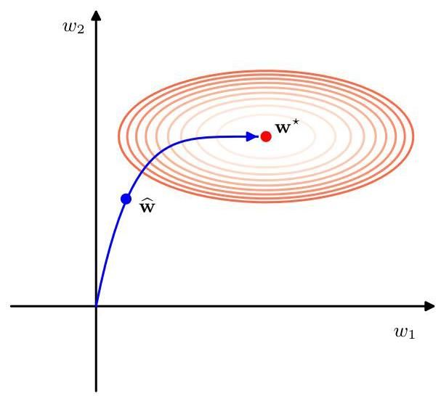

# 9.3.2 Double descent

# 9.3.2 双重下降

Section 4.3

第 4.3 节

The bias-variance trade-off provides insight into the generalization performance of a learnable model as the number of parameters in the model is varied. Models with too few parameters will have a high test set error due to the limited representational capacity (high bias), and as the number of parameters increases, the test error is expected to fall. However, as the number of parameters is increased further, the test error increases again due to over-fitting (high variance). This leads to the conventional belief, widespread in classical statistics, that the number of parameters in the model needs to be limited according to the size of the data set and that for a given training data set, very large models are expected to have poor performance.

偏差 - 方差权衡为我们理解可学习模型的泛化性能随模型参数数量的变化提供了视角。参数过少的模型由于表示能力有限(高偏差)，测试集误差会很高，并且随着参数数量的增加，测试误差预计会下降。然而，当参数数量进一步增加时，由于过拟合(高方差)，测试误差会再次上升。这导致了经典统计学中广泛存在的传统观点，即模型中的参数数量需要根据数据集的大小进行限制，并且对于给定的训练数据集，非常大的模型预计表现不佳。

Contrary to this expectation, however, modern deep neural networks can have excellent performance even when the number of parameters far exceeds that required to achieve a perfect fit to the training data (Zhang et al., 2016), and the general wisdom in the deep learning community is that bigger models are better. Although early stopping is sometimes used, models may also be trained to zero error and yet still have good performance on test data.

然而，与这种预期相反，现代深度神经网络即使在参数数量远远超过实现对训练数据完美拟合所需的数量时，也能有出色的表现(Zhang 等人，2016)，并且深度学习社区的普遍观点是模型越大越好。虽然有时会使用提前停止训练的方法，但模型也可以训练到误差为零，并且在测试数据上仍然表现良好。

These seemingly contradictory perspectives can be reconciled by examining learning curves and other plots of generalization performance versus model complexity, which reveal a more subtle phenomenon called double descent (Belkin et al., 2019). This is illustrated in Figure 9.9, which shows training set and test set errors versus model complexity, as determined by the number of learnable parameters, for a large neural network called ResNet18 (He et al., 2015a), which has 18 layers of parameters trained on an image classification task. The number of weights and biases in the network is varied by changing the ’width parameter’, which governs the number of hidden units in each layer. We see that the training error decreases monotonically with increasing complexity of the model, as expected. However, the test set error decreases at first then increases again and then finally decreases again. This reduction in test set error for very large models continues even after the training set error has reached zero.

通过研究学习曲线以及泛化性能与模型复杂度的其他关系图，可以调和这些看似矛盾的观点，这些图揭示了一种更为微妙的现象，称为双重下降(Belkin 等人，2019 年)。图 9.9 对此进行了说明，该图展示了一个名为 ResNet18 的大型神经网络(He 等人，2015a)在图像分类任务上训练时，训练集误差和测试集误差随模型复杂度的变化情况，模型复杂度由可学习参数的数量决定，该网络有 18 层参数。网络中权重和偏置的数量通过改变“宽度参数”来调整，该参数控制着每一层中隐藏单元的数量。正如预期的那样，我们看到训练误差随着模型复杂度的增加而单调递减。然而，测试集误差起初会下降，然后再次上升，最后又再次下降。即使训练集误差达到零之后，非常大的模型的测试集误差仍会继续降低。

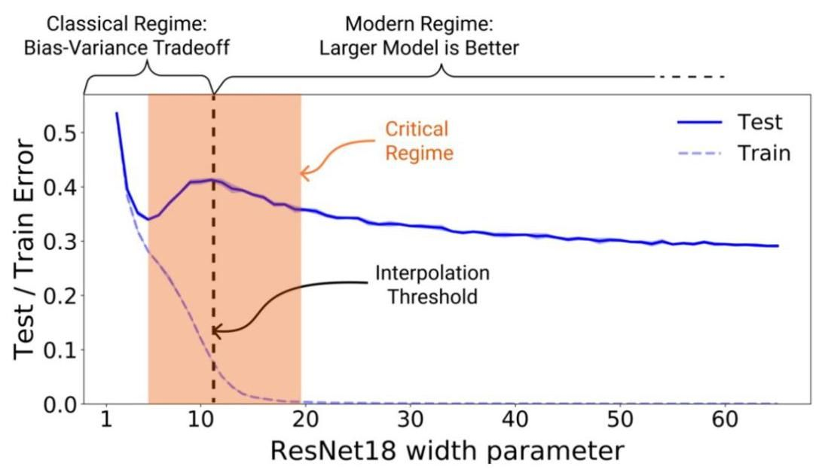

Figure 9.9 Plot of training set and test set errors for a large neural network model called ResNet18 trained on an image classification problem versus the complexity of a model. The horizontal axis represents a hyperparameter governing the number of hidden units and hence the overall number of weights and biases in the network. The vertical dashed line, labelled ’interpolation threshold’ indicates the level of model complexity at which the model is capable, in principle, of achieving zero error on the training set. [From Nakkiran et al. (2019) with permission.]

图 9.9 展示了在图像分类问题上训练的名为 ResNet18 的大型神经网络模型的训练集误差和测试集误差与模型复杂度的关系图。横轴表示一个超参数，该超参数控制着隐藏单元的数量，进而控制着网络中权重和偏置的总数。标有“插值阈值”的垂直虚线表示模型原则上能够在训练集上实现零误差时的模型复杂度水平。[经许可摘自 Nakkiran 等人(2019 年)。]

This surprising behaviour is more complex than we would expect from the usual bias-variance discussion of classical statistics and exhibits two different regimes of model fitting, as shown schematically in Figure 9.9, corresponding to the classical bias-variance trade-off for small to medium complexity, followed by a further reduction in test set error as we enter a regime of very large models. The transition between the two regimes occurs roughly when the number of parameters in the model is sufficiently large that the model is able to fit the training data exactly (Belkin et al., 2019). Nakkiran et al. (2019) define the effective model complexity to be the maximum size of training data set on which a model can achieve zero training error, and so double descent arises when the effective model complexity exceeds the number of data points in the training set.

这种令人惊讶的行为比我们从经典统计学中常见的偏差 - 方差讨论所预期的更为复杂，并且呈现出两种不同的模型拟合状态，如图 9.9 所示，对应于中小复杂度模型的经典偏差 - 方差权衡，随后当我们进入非常大的模型状态时，测试集误差会进一步降低。这两种状态之间的转变大致发生在模型中的参数数量足够大，使得模型能够精确拟合训练数据时(Belkin 等人，2019 年)。Nakkiran 等人(2019 年)将有效模型复杂度定义为模型能够在其上实现零训练误差的训练数据集的最大规模，因此当有效模型复杂度超过训练集中的数据点数量时，就会出现双重下降现象。

We see similar behaviour if we control model complexity using early stopping, as seen in Figure 9.10. Increasing the number of training epochs increases the effective model complexity, and for a sufficiently large model, double descent is again observed. For such models there are many possible solutions including those that over-fit to the data. It therefore seems to be a property of stochastic gradient descent that the implicit biases that it introduces lead to good generalization performance.

如果我们使用早停法来控制模型复杂度，也会看到类似的行为，如图 9.10 所示。增加训练轮数会增加有效模型复杂度，对于足够大的模型，会再次观察到双重下降现象。对于这样的模型，存在许多可能的解，包括那些对数据过拟合的解。因此，随机梯度下降似乎具有这样一种特性，即它引入的隐式偏差会带来良好的泛化性能。

Analogous results are also obtained when a regularization term in the error function is used to control complexity. Here the test set error of a large model trained to convergence shows double descent with respect to , the inverse regularization parameter, since high corresponds to low complexity (Yilmaz and Heckel, 2022).

当使用误差函数中的正则化项来控制复杂度时，也会得到类似的结果。在这里，训练至收敛的大型模型的测试集误差相对于 (正则化参数的倒数)呈现出双重下降现象，因为高 对应着低复杂度(Yilmaz 和 Heckel，2022 年)。

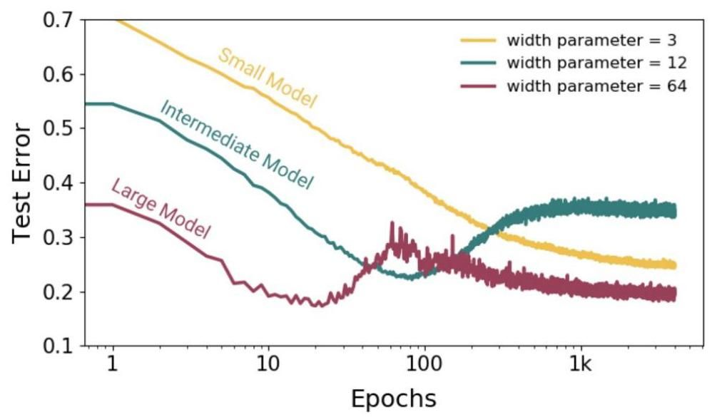

Figure 9.10 Plot of test set error versus number of epochs of gradient descent training for ResNet18 models of various sizes. The effective model complexity increases with the number of training epochs, and the double descent phenomenon is observed for a sufficiently large model. [From Nakkiran et al. (2019) with permission.]

图 9.10 展示了不同大小的 ResNet18 模型的测试集误差与梯度下降训练轮数的关系图。有效模型复杂度随着训练轮数的增加而增加，对于足够大的模型，可以观察到双重下降现象。[经许可摘自 Nakkiran 等人(2019 年)。]

One ironic consequence of double descent is that it possible to operate in a regime where increasing the size of the training data set could actually reduce performance, contrary to the conventional view that more data is always a good thing. For a model in the critical regime shown in Figure 9.9, an increase in the size of the training set can push the interpolation threshold to the right, leading to a higher test set error. This is confirmed in Figure 9.11, which shows the test set error for a transformer model as a function of the dimensionality of the input space, known as the embedding dimension. Increasing the embedding dimension increases the number of weights and biases in the model and hence increases the model complexity. We see that increasing the training set size from 4,000 to 18,000 data points leads to a curve that is overall much lower. However, for a range of embedding dimensions that correspond to models in the critical complexity regime, increasing the size of the data set can actually reduce generalization performance.

双重下降的一个具有讽刺意味的结果是，有可能处于这样一种状态:增加训练数据集的规模实际上可能会降低性能，这与传统观点(即更多的数据总是有益的)相悖。对于图 9.9 所示的临界状态下的模型，训练集规模的增加会将插值阈值向右推移，从而导致测试集误差增大。图 9.11 证实了这一点，该图展示了一个 transformer 模型的测试集误差与输入空间维度(即嵌入维度)的函数关系。增加嵌入维度会增加模型中权重和偏置的数量，从而增加模型的复杂度。我们可以看到，将训练集规模从 4000 个数据点增加到 18000 个数据点会使曲线整体大幅下降。然而，对于对应于临界复杂度状态下模型的一系列嵌入维度，增加数据集规模实际上可能会降低泛化性能。

Chapter 12

第 12 章

# 9.4. Parameter Sharing

# 9.4. 参数共享

Regularization terms, such as the regularizer , help to reduce over-fitting by encouraging weight values to be close to zero. Another way to reduce network complexity is to impose hard constraints on the weights by forming them into groups and requiring that all weights within each group share the same value, in which the shared value is learned from data. This is known as weight sharing or parameter sharing or parameter tying. It means that the number of degrees of freedom is smaller than the number of connections in the network. Usually this is introduced as a way to encode inductive bias into a network to express some known invariances. Evaluating the error function gradients for such networks can be done using a small modification to backpropagation although in practice this is handled implicitly through automatic differentiation. We will make extensive use of parameter sharing when we discuss convolutional neural networks. Parameter sharing is applicable, however, only to particular problems in which the form of the constraints can be specified in advance.

正则化项，如 正则化器 ，通过促使权重值接近零来帮助减少过拟合。另一种降低网络复杂度的方法是对权重施加硬约束，即将它们分组，并要求每个组内的所有权重共享相同的值，其中共享值是从数据中学习得到的。这被称为权重共享、参数共享或参数绑定。这意味着自由度的数量小于网络中连接的数量。通常，这是作为一种将归纳偏置编码到网络中以表达某些已知不变性的方法引入的。对于此类网络，误差函数梯度的计算可以通过对反向传播算法进行小的修改来完成，不过在实践中，这是通过自动微分隐式处理的。在讨论卷积神经网络时，我们将广泛使用参数共享。然而，参数共享仅适用于那些可以预先指定约束形式的特定问题。

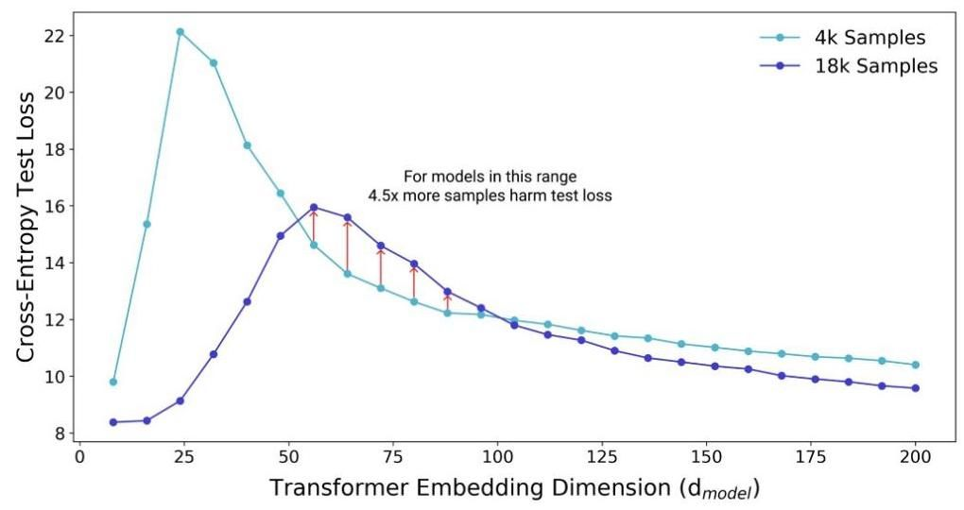

Figure 9.11 Plot of test set error for a large transformer model versus the embedding dimension, which controls the number of parameters in the model. Increasing the size of the training set from 4,000 to 18,000 samples generally leads to a lower test set error, but for some intermediate values of model complexity, there can be an increase in the error, as shown by the vertical red arrows. [From Nakkiran et al. (2019) with permission.]

图 9.11 大型 transformer 模型的测试集误差与嵌入维度的关系图，嵌入维度控制着模型中的参数数量。将训练集规模从 4000 个样本增加到 18000 个样本通常会导致测试集误差降低，但对于模型复杂度的某些中间值，误差可能会增加，如垂直红色箭头所示。[经许可改编自 Nakkiran 等人(2019)的研究。]

Exercise 9.7

练习 9.7

Chapter 10

第 10 章

# 9.4.1 Soft weight sharing

# 9.4.1 软权重共享

Instead of using a hard constraint that forces sets of model parameters to be equal, Nowlan and Hinton (1992) introduced a form of soft weight sharing in which a regularization term encourages groups of weights to have similar values. Furthermore, the division of weights into groups, the mean weight value for each group, and the spread of values within the groups are all determined as part of the learning process.

Nowlan 和 Hinton(1992 年)没有采用强制模型参数集相等的硬约束，而是引入了一种软权重共享形式，其中正则化项促使权重组具有相似的值。此外，权重分组、每组的平均权重值以及组内值的分布都是作为学习过程的一部分来确定的。

Recall that the simple-weight decay regularizer in (9.1) can be viewed as the negative log of a Gaussian prior distribution over the weights. This encourages all the weights to converge towards a single value of zero. We can instead encourage the weight values to form several groups, rather than just one group, by considering a probability distribution that is a mixture of Gaussians. The means and variances of the Gaussian components, as well as the mixing coefficients , will be considered as adjustable parameters to be determined as part of the learning process.

回顾一下，(9.1) 中的简单权重衰减正则化器可以看作是权重上高斯先验分布的负对数。这促使所有权重收敛到单个零值。相反，我们可以通过考虑一个高斯混合的概率分布，促使权重值形成多个组，而不仅仅是一个组。高斯分量的均值 和方差 以及混合系数 将被视为可调整参数，作为学习过程的一部分来确定。

Section 3.2.9

第 3.2.9 节

Thus, we have a probability density of the form

因此，我们得到了如下形式的概率密度

where is the number of components in the mixture. Taking the negative logarithm then leads to a regularization function of the form

其中 是混合成分的数量。取负对数后，会得到如下形式的正则化函数

The total error function is then given by

那么，总误差函数可表示为

where is the regularization coefficient.

其中 是正则化系数。

This error is minimized jointly with respect to the weights and with respect to the parameters of the mixture model. This can be done using gradient descent, which requires that we evaluate the derivatives of with respect to all the learnable parameters. To do this, it is convenient to regard the as prior probabilities for each component to have generated a weight value, and to introduce the corresponding posterior probabilities, which are given by Bayes’ theorem:

该误差会同时针对权重 和混合模型的参数 进行最小化。这可以通过梯度下降法来实现，这就要求我们计算 关于所有可学习参数的导数。为此，将 视为每个成分生成一个权重值的先验概率，并引入相应的后验概率会很方便，后验概率由贝叶斯定理给出:

Exercise 9.8

练习 9.8

The derivatives of the total error function with respect to the weights are then given by

那么，总误差函数关于权重的导数可表示为

Exercise 9.9

练习 9.9

The effect of the regularization term is therefore to pull each weight towards the centre of the th Gaussian, with a force proportional to the posterior probability of that Gaussian for the given weight. This is precisely the kind of effect that we are seeking.

因此，正则化项的作用是将每个权重拉向第 个高斯分布的中心，拉力与给定权重属于该高斯分布的后验概率成正比。这正是我们所期望的效果。

Derivatives of the error with respect to the centres of the Gaussians are also easily computed to give

误差关于高斯分布中心的导数也很容易计算得出

Exercise 9.10

练习 9.10

which has a simple intuitive interpretation, because it pushes towards an average of the weight values, weighted by the posterior probabilities that the respective weight parameters were generated by component .

这有一个简单直观的解释，因为它将 推向权重值的平均值，该平均值由各个权重参数由分量 生成的后验概率加权得到。

To ensure that the variances remain positive, we introduce new variables defined by

为确保方差 保持为正，我们引入由下式定义的新变量

and an unconstrained minimization is performed with respect to the . The associated derivatives are then given by

然后对 进行无约束最小化。相关的导数由下式给出

Exercise 9.11

练习 9.11

This process drives towards a weighted average of the squared deviations of the weights around the corresponding centre , where the weighting coefficients are again given by the posterior probability that each weight is generated by component .

这个过程驱使 趋向于权重围绕相应中心 的平方偏差的加权平均值，其中权重系数再次由每个权重由分量 生成的后验概率给出。

For the derivatives with respect to the mixing coefficients , we need to take account of the constraints

对于关于混合系数 的导数，我们需要考虑约束条件

which follow from the interpretation of the as prior probabilities. This can be done by expressing the mixing coefficients in terms of a set of auxiliary variables using the softmax function given by

这源于将 解释为先验概率。这可以通过使用由下式给出的 softmax 函数，用一组辅助变量 来表示混合系数来实现

The derivatives of the regularized error function with respect to the then take

正则化误差函数关于 的导数则为

Exercise 9.12

练习 9.12

the form

形式

We see that is therefore driven towards the average posterior probability for mixture component .

我们看到，因此 被驱动向混合分量 的平均后验概率。

A different application of soft weight sharing (Lasserre, Bishop, and Minka, 2006) introduces a principled approach that combines the unsupervised training of a generative model with the supervised training of a corresponding discriminative model. This is useful in situations where we have a significant amount of unlabelled data but where labelled data is in short supply. The generative model has the advantage that all of the data can be used to determine its parameters, whereas only the labelled examples directly inform the parameters of the discriminative model. However, a discriminative model can achieve better generalization when there is model mis-specification, in other words when the model does not exactly describe the true distribution that generates the data, as is typically the case. By introducing a soft tying of the parameters of the two models, we obtain a well-defined hybrid of generative and discriminative approaches that can be robust to model mis-specification while also benefiting from being trained on unlabelled data.

软权重共享的另一种应用(Lasserre、Bishop 和 Minka，2006 年)引入了一种原则性方法，该方法将生成模型的无监督训练与相应判别模型的有监督训练相结合。在我们有大量未标记数据但标记数据供应不足的情况下，这很有用。生成模型的优点是可以使用所有数据来确定其参数，而只有标记示例才能直接为判别模型的参数提供信息。然而，当存在模型误指定时，即当模型不能准确描述生成数据的真实分布时(通常就是这种情况)，判别模型可以实现更好的泛化。通过引入两个模型参数的软绑定，我们得到了一种明确定义的生成和判别方法的混合体，它可以对模型误指定具有鲁棒性，同时也能从对未标记数据的训练中受益。

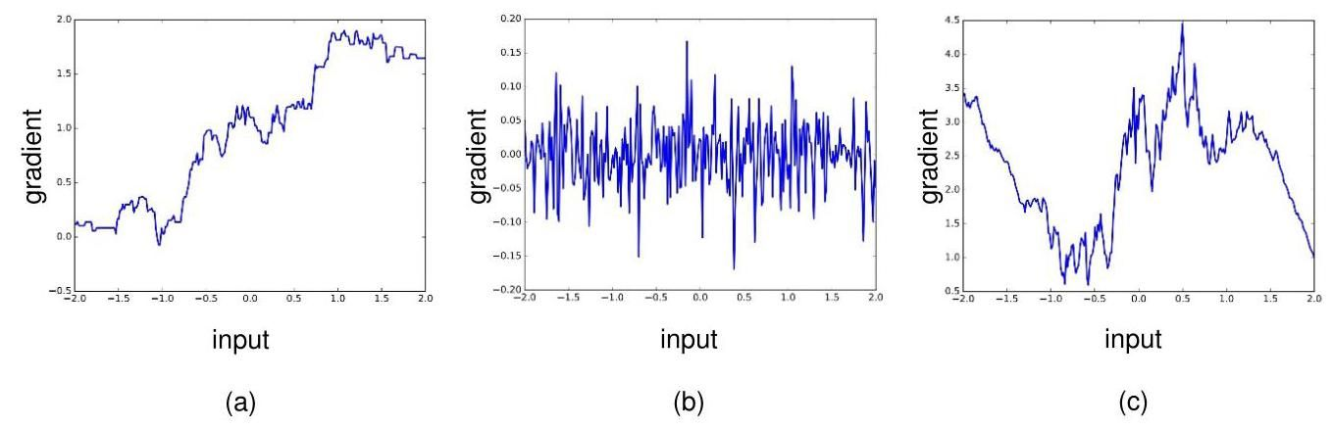

Figure 9.12 Plots of the Jacobian for networks with a single input and a single output, showing (a) a network with two layers of weights, (b) a network with 25 layers of weights, and (c) a network with 51 layers of weights together with residual connections. [From Balduzzi et al. (2017) with permission.]

图 9.12 单输入单输出网络的雅可比矩阵图，显示了 (a) 具有两层权重的网络，(b) 具有 25 层权重的网络，以及 (c) 具有 51 层权重并带有残差连接的网络。[经许可摘自 Balduzzi 等人(2017 年)。]

# 9.5. Residual Connections

# 9.5. 残差连接

The representational power of deep neural networks stems in large part from the use of multiple layers of processing, and it has been observed that increasing the number of layers in a network can increase generalization performance significantly. We have also seen how batch normalization, along with careful initialization of the weights and biases, can help address the problem of vanishing or exploding gradients in deep networks. However, even with batch normalization, it becomes increasingly difficult to train networks with a large number of layers.

深度神经网络的表征能力在很大程度上源于使用多层处理，并且已经观察到，增加网络中的层数可以显著提高泛化性能。我们还了解到批量归一化以及仔细初始化权重和偏置如何有助于解决深度网络中梯度消失或梯度爆炸的问题。然而，即使使用了批量归一化，训练具有大量层数的网络也变得越来越困难。

Section 7.4.2

7.4.2 节

Section 7.2.5

7.2.5 节

One explanation for this phenomenon is called shattered gradients (Balduzzi et al., 2017). We have seen that the representational capabilities of neural networks increase exponentially with depth. With ReLU activation functions, there is an exponential increase in the number of linear regions that the network can represent. However, a consequence of this is a proliferation of discontinuities in the gradient of the error function. This is illustrated for networks with a single input variable and a single output variable in Figure 9.12. Here the derivative of the output variable with respect to the input variable (the Jacobian of the network) is plotted as a function of the input variable. From the chain rule of calculus, these derivatives determine the gradients of the error function surface. We see that for deep networks, extremely small changes in the weight parameters in the early layers of the network can produce significant changes in the gradient. Iterative gradient-based optimization algorithms assume that the gradient varies smoothly across parameter space, and hence this ’shattered gradient’ effect can render training ineffective in very deep networks.

对这种现象的一种解释称为破碎梯度(Balduzzi 等人，2017 年)。我们已经看到，神经网络的表征能力随深度呈指数增长。使用 ReLU 激活函数时，网络能够表示的线性区域数量呈指数增加。然而，这会导致误差函数梯度中的不连续点大量增加。图 9.12 展示了具有单个输入变量和单个输出变量的网络的这种情况。这里绘制了输出变量相对于输入变量的导数(网络的雅可比矩阵)随输入变量的变化情况。根据微积分的链式法则，这些导数决定了误差函数曲面的梯度。我们看到，对于深度网络，网络早期层中权重参数的极小变化可能会导致梯度发生显著变化。基于迭代梯度的优化算法假设梯度在参数空间中平滑变化，因此这种“破碎梯度”效应会使非常深的网络的训练变得无效。

Section 6.3

6.3 节

An important modification to the architecture of neural networks that greatly assists in training very deep networks is that of residual connections (He et al., 2015a), which are a particular form of skip-layer connections. Consider a neural network

对神经网络架构的一项重要改进极大地有助于训练非常深的网络，即残差连接(He 等人，2015a)，它是一种特殊形式的跨层连接。考虑一个神经网络

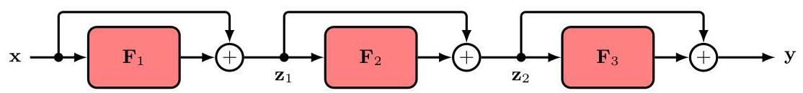

Figure 9.13 A residual network consisting of three residual blocks, corresponding to the sequence of transformations (9.35) to (9.37).

图 9.13 一个由三个残差块组成的残差网络，对应于变换序列 (9.35) 至 (9.37)。

that consists of a sequence of three layers of the form

它由三层形式的序列组成

Here the functions might simply consist of a linear transformation followed by a ReLU activation function or they might be more complex with multiple linear, activation function, and normalization layers. A residual connection consists simply of adding the input to each function back onto the output to give

这里的函数 可能仅由一个线性变换后接一个 ReLU 激活函数组成，或者它们可能更复杂，包含多个线性层、激活函数层和归一化层。残差连接简单地将每个函数的输入加回到输出上，得到

Each combination of a function and a residual connection, such as , is called a residual block. A residual network, also known as a ResNet, consists of multiple layers of such blocks in sequence. A modified network with residual connections is illustrated in Figure 9.13. A residual block can easily generate the identity transformation, if the parameters in the nonlinear function are small enough for the function outputs to become close to zero.

函数和残差连接的每一种组合，如 ，都被称为一个残差块。残差网络，也称为 ResNet，由多层这样的块依次组成。带有残差连接的改进网络如图 9.13 所示。如果非线性函数中的参数足够小，使得函数输出接近零，那么残差块可以很容易地生成恒等变换。

The term ’residual’ refers to the fact that in each block the function learns the residual between the identity map and the desired output, which we can see by rearranging the residual transformation:

“残差” 这一术语指的是在每个块中，函数学习恒等映射和期望输出之间的残差，我们可以通过重新排列残差变换来看到这一点:

The gradients in a network with residual connections are much less sensitive to input values compared to a standard deep network, as seen in Figure 9.12(c).

如图 9.12(c) 所示，与标准深度网络相比，带有残差连接的网络中的梯度对输入值的敏感性要低得多。

Li et al. (2017) developed a way to visualize error surfaces directly, which showed that the effect of the residual connections is to create smoother error function surfaces, as shown in Figure 9.14. It is usual to include batch normalization layers in a residual network, as together they significantly reduce the issue of vanishing and exploding gradients. He et al. (2015a) showed that including residual connections allows very deep networks, potentially having hundreds of layers, to be trained effectively.

Li 等人(2017 年)开发了一种直接可视化误差曲面的方法，该方法表明残差连接的作用是创建更平滑的误差函数曲面，如图 9.14 所示。通常会在残差网络中包含批量归一化层，因为它们一起能显著减少梯度消失和梯度爆炸的问题。He 等人(2015a)表明，包含残差连接可以使非常深的网络(可能有数百层)得到有效训练。

Further insight into the way residual connections encourage smooth error surfaces can be obtained if we combine (9.35), (9.36), and (9.37) to give a single overall equation for the whole network:

如果我们将(9.35)、(9.36)和(9.37)式结合起来，得到整个网络的一个整体方程，就可以进一步深入了解残差连接促进平滑误差曲面的方式:

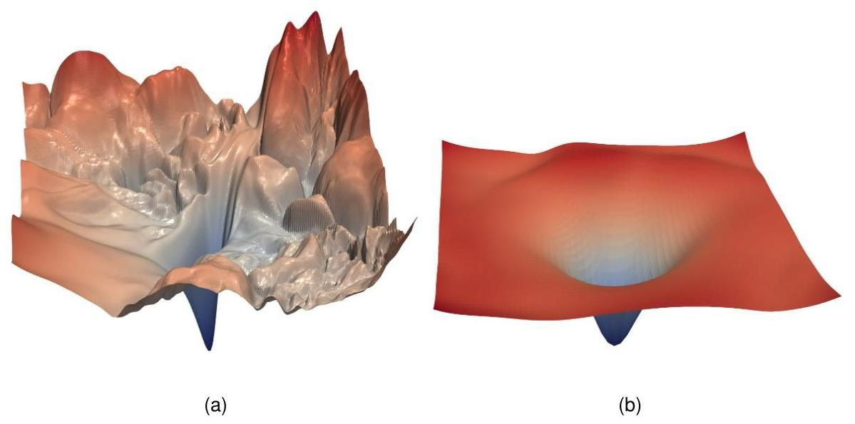

Figure 9.14 (a) A visualization of the error surface for a network with 56 layers. (b) The same network with the inclusion of residual connections, showing the smoothing effect that comes from the residual connections. [From Li et al. (2017) with permission.]

图 9.14 (a)一个 56 层网络的误差曲面可视化图。(b)包含残差连接的同一网络，展示了残差连接带来的平滑效果。[经许可摘自 Li 等人(2017 年)的研究。]

We can now substitute for the intermediate variables and to give an expression

现在我们可以代入中间变量 和 来得到一个表达式

Exercise 9.13 for the network output as a function of the input :

练习 9.13 网络输出作为输入 的函数:

This expanded form of the residual network is depicted in Figure 9.15. We see that the overall function consists of multiple networks acting in parallel and that these include networks with fewer layers. The network has the representational capability of a deep network, since it contains such a network as a special case. However, the error surface is moderated by a combination of shallow and deep sub-networks.

残差网络的这种扩展形式如图 9.15 所示。我们看到，整体函数由多个并行运行的网络组成，其中包括层数较少的网络。该网络具有深度网络的表示能力，因为它将这样的网络作为一种特殊情况包含在内。然而，误差曲面受到浅层和深层子网络组合的调节。

Note that the skip-layer connections defined by (9.40) require the input and all the intermediate variables to have the same dimensionality so that they can be added. We can change the dimensionality at some point in the network by including a non-square matrix of learnable parameters in the form

请注意，由 (9.40) 定义的跨层连接要求输入和所有中间变量具有相同的维度，以便它们可以相加。我们可以在网络的某些点通过包含一个形式为 的可学习参数的非方阵来改变维度

So far we have not been specific about the form of the learnable nonlinear functions . The simplest choice would be a standard neural network that alternates between layers consisting of a learnable linear transformation and a fixed nonlinear activation function such as ReLU. This opens two possibilities for placing the residual connections, as shown in Figure 9.16. In version (a) the quantities being added are always non-negative since they are given by the outputs of ReLU layers, and so to allow for both positive and negative values, version (b) is more commonly used.

到目前为止，我们尚未明确可学习非线性函数 的具体形式。最简单的选择是一个标准神经网络，它在由可学习线性变换组成的层和固定的非线性激活函数(如 ReLU)层之间交替。如图 9.16 所示，放置残差连接有两种可能。在版本 (a) 中，相加的量始终是非负的，因为它们由 ReLU 层的输出给出，因此为了允许正负值，版本 (b) 更常用。

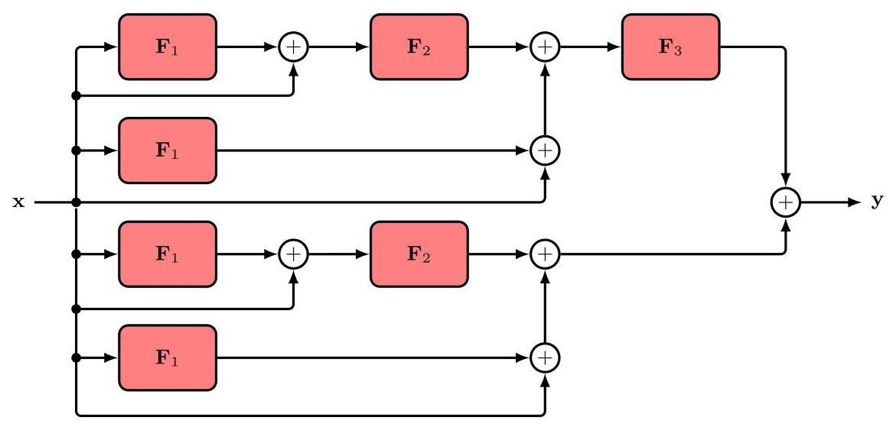

Figure 9.15 The same network as in Figure 9.13, shown here in expanded form.

图 9.15 与图 9.13 相同的网络，此处以展开形式展示。

# 9.6. Model Averaging

# 9.6. 模型平均

If we have several different models trained to solve the same problem then instead of trying to select the single best model, we can often improve generalization by averaging the predictions made by the individual models. Such combinations of models are sometimes called committees or ensembles. For models that produce probabilistic outputs, the predicted distribution is the average of the predictions from

如果我们有几个不同的模型经过训练来解决同一个问题，那么与其试图选择单个最佳模型，我们通常可以通过对各个模型的预测进行平均来提高泛化能力。这种模型组合有时被称为委员会或集成。对于产生概率输出的模型，预测分布是每个模型预测的平均值

each model:

每个模型:

where is the output of model and is the total number of models.

其中 是模型 的输出， 是模型的总数。

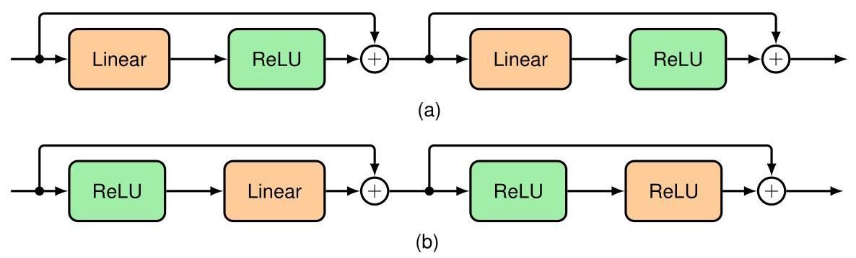

Figure 9.16 Two alternative ways to include residual network connections into a standard feed-forward network that alternates between learnable linear layers and nonlinear ReLU activation functions.

图 9.16 将残差网络连接纳入标准前馈网络的两种替代方法，该前馈网络在可学习的线性层和非线性 ReLU 激活函数之间交替。

This averaging process can be motivated by considering the trade-off between bias and variance. Recall from Figure 4.7 that when we trained multiple polynomials using the sinusoidal data and then averaged the resulting functions, the contribution arising from the variance term tended to cancel, leading to improved predictions.

可以通过考虑偏差和方差之间的权衡来解释这种平均过程。回顾图 4.7，当我们使用正弦数据训练多个多项式，然后对得到的函数进行平均时，方差项的贡献往往会相互抵消，从而提高预测效果。

Section 4.3

第 4.3 节

In practice, of course, we have only a single data set, and so we have to find a way to introduce variability between the different models within the committee. One approach is to use bootstrap data sets, in which multiple data sets are created as follows. Suppose our original data set consists of data points . We can create a new data set by drawing points at random from , with replacement, so that some points in may be replicated in , whereas other points in may be absent from . This process can be repeated times to generate data sets each of size and each obtained by sampling from the original data set . Each data set can then be used to train a model, and the predictions of the resulting models are averaged. This procedure is known as bootstrap aggregation or bagging (Breiman, 1996). An alternative approach to forming an ensemble is to use the original data set to train multiple different models having different architectures.

当然，在实践中，我们只有一个数据集，因此我们必须找到一种方法来引入委员会中不同模型之间的可变性。一种方法是使用自助数据集，其中多个数据集的创建方式如下。假设我们的原始数据集由 个数据点 组成。我们可以通过从 中有放回地随机抽取 个点来创建一个新的数据集 ，这样 中的一些点可能会在 中重复出现，而 中的其他点可能不会出现在 中。这个过程可以重复 次，以生成 个大小均为 的数据集，每个数据集都是通过从原始数据集 中采样得到的。然后，每个数据集都可以用于训练一个模型，并对得到的模型的预测结果进行平均。这个过程被称为自助聚合或装袋法(Breiman，1996)。另一种形成集成模型的方法是使用原始数据集来训练多个具有不同架构的不同模型。

We can analyse the benefits of ensemble predictions by considering a regression problem with an input vector and a single output variable . Suppose we have a set of trained models , and we form a committee prediction given by

我们可以通过考虑一个输入向量为 且单个输出变量为 的回归问题来分析集成预测的好处。假设我们有一组经过训练的模型 ，并且我们形成了一个由下式给出的委员会预测

If the true function that we are trying to predict is given by , then the output of each of the models can be written as the true value plus an error:

如果我们试图预测的真实函数由 给出，那么每个模型的输出可以写成真实值加上一个误差:

The average sum-of-squares error then takes the form

那么平均平方误差就具有如下形式

where denotes a frequentist expectation with respect to the distribution of the input vector . The average error made by the models acting individually is therefore

其中 表示关于输入向量 的分布的频率主义期望。因此，各个模型单独产生的平均误差为

Similarly, the expected error from the committee (9.43) is given by

类似地，委员会(9.43)的期望误差由下式给出

If we assume that the errors have zero mean and are uncorrelated, so that

如果我们假设误差的均值为零且不相关，即

Exercise 9.14

练习 9.14

then we obtain

然后我们得到

This apparently dramatic result suggests that the average error of a model can be reduced by a factor of simply by averaging versions of the model. Unfortunately, it depends on the key assumption that the errors due to the individual models are uncorrelated. In practice, the errors are typically highly correlated, and the reduction in the overall error is generally much smaller. It can, however, be shown that the expected committee error will not exceed the expected error of the constituent models, so that .

这个看似惊人的结果表明，只需对模型的 个版本取平均值，模型的平均误差就可以降低 倍。不幸的是，这依赖于一个关键假设，即各个模型产生的误差是不相关的。在实践中，误差通常是高度相关的，总体误差的降低幅度通常要小得多。然而，可以证明，委员会的预期误差不会超过组成模型的预期误差，因此 。

Exercise 9.15

练习 9.15

A somewhat different approach to model combination, known as boosting (Fre-und and Schapire, 1996), combines multiple ’base’ classifiers to produce a form of committee whose performance can be significantly better than that of any of the base classifiers. Boosting can give good results even if the base classifiers perform only slightly better than random. The principal difference between boosting and the committee methods, such as bagging as discussed above, is that the base classifiers are trained in sequence and each base classifier is trained using a weighted form of the data set in which the weighting coefficient associated with each data point depends on the performance of the previous classifiers. In particular, points that are misclassified by one of the base classifiers are given a greater weight when used to train the next classifier in the sequence. Once all the classifiers have been trained, their predictions are then combined through a weighted majority voting scheme.

一种稍有不同的模型组合方法称为提升法(Fre-und 和 Schapire，1996)，它将多个“基”分类器组合起来，形成一个委员会，其性能可能明显优于任何一个基分类器。即使基分类器的表现仅略好于随机猜测，提升法也能取得不错的效果。提升法与委员会方法(如上述的装袋法)的主要区别在于，基分类器是按顺序训练的，并且每个基分类器都是使用数据集的加权形式进行训练的，其中与每个数据点相关的加权系数取决于前一个分类器的性能。具体来说，被某个基分类器误分类的点在用于训练序列中的下一个分类器时会被赋予更大的权重。一旦所有分类器都训练完成，它们的预测结果就会通过加权多数投票方案进行组合。

In practice, the major drawback of all model combination methods is that multiple models have to be trained and then predictions have to be evaluated for all the models, thereby increasing the computational cost of both training and inference. How significant this depends on the specific application scenario.

在实践中，所有模型组合方法的主要缺点是必须训练多个模型，然后对所有模型的预测结果进行评估，从而增加了训练和推理的计算成本。这一影响的显著程度取决于具体的应用场景。

# 9.6.1 Dropout

# 9.6.1 随机失活

A widely used and very effective form of regularization known as dropout (Sri-vastava et al., 2014) can be viewed as an implicit way to perform approximate model averaging over exponentially many models without having to train multiple models individually. It has broad applicability and is computationally cheap. Dropout is one of the most effective forms of regularization and is widely used in applications.

一种被广泛使用且非常有效的正则化形式，即所谓的随机失活(Sri-vastava 等人，2014 年)，可以被视为一种隐式方法，用于对指数级数量的模型进行近似模型平均，而无需单独训练多个模型。它具有广泛的适用性，并且计算成本较低。随机失活是最有效的正则化形式之一，在应用中被广泛使用。

The central idea of dropout is to delete nodes from the network, including their connections, at random during training. Each time a data point is presented to the network, a new random choice is made for which nodes to omit. Figure 9.17 shows a simple network along with examples of pruned networks in which subsets of nodes have been omitted.

随机失活的核心思想是在训练期间随机从网络中删除节点及其连接。每次将一个数据点输入到网络时，都会重新随机选择要省略的节点。图 9.17 展示了一个简单的网络以及修剪后的网络示例，其中部分节点已被省略。

Dropout is applied to both hidden nodes and input nodes, but not outputs, and is equivalent to setting the output of a dropped node to zero. It can be implemented by defining a mask vector which multiplies the activation of the non-output node for data point , whose values are set to 1 with probability . A value of seems to work well for the hidden nodes, whereas for the inputs a value of is typically used.

随机失活应用于隐藏节点和输入节点，但不应用于输出节点，这相当于将被删除节点的输出设置为零。可以通过定义一个掩码向量 来实现，该向量将数据点 的非输出节点 的激活值相乘，其值以概率 设置为 1。对于隐藏节点， 的值似乎效果很好，而对于输入，通常使用 的值。

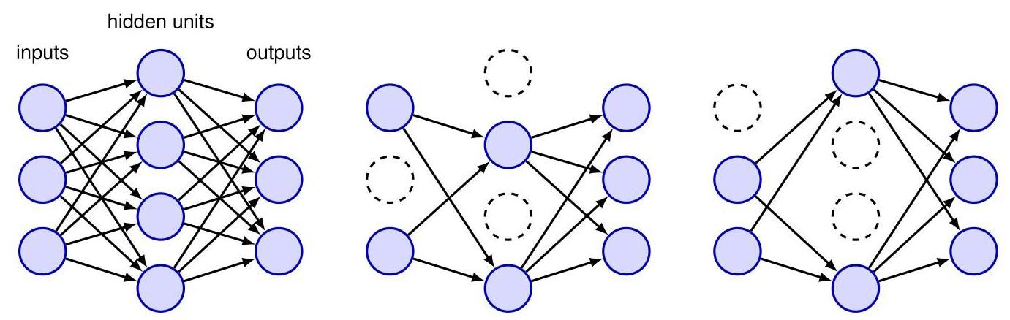

Figure 9.17 A neural network on the left along with two examples of pruned networks in which a random subset of nodes have been omitted.

图 9.17 左侧是一个神经网络，旁边是两个修剪后的网络示例，其中随机选择的部分节点已被省略。

During training, as each data point is presented to the network, a new mask is created, and the forward and backward propagation steps are applied on that pruned network to create error function gradients, which are then used to update the weights, for example by stochastic gradient descent. If the data points are grouped into mini-batches then the gradients are averaged over the data points in each mini-batch before applying the weight update. For a network with non-output nodes, there are pruned networks, and so only a small fraction of these networks will ever be considered during training. This differs from conventional ensemble methods in which each of the networks in the ensemble is independently trained to convergence. Another difference is that the exponentially many networks that are implicitly being trained with dropout are not independent but share their parameter values with the full network, and hence with each other. Note that training can take longer with dropout since the individual parameter updates are very noisy. Also, because the error function is intrinsically noisy, it is harder to confirm that the optimization algorithm is working correctly just by looking for a decreasing error function during training.

在训练期间，当每个数据点被输入到网络时，会创建一个新的掩码，并在修剪后的网络上应用前向和反向传播步骤以创建误差函数梯度，然后使用这些梯度来更新权重，例如通过随机梯度下降法。如果将数据点分组为小批量，则在应用权重更新之前，会对每个小批量中的数据点的梯度进行平均。对于具有 个非输出节点的网络，有 个修剪后的网络，因此在训练期间只会考虑这些网络中的一小部分。这与传统的集成方法不同，在传统集成方法中，集成中的每个网络都独立训练至收敛。另一个区别是，使用随机失活隐式训练的指数级数量的网络并非相互独立，而是与完整网络共享其参数值，因此彼此之间也共享参数值。请注意，使用随机失活进行训练可能需要更长时间，因为单个参数更新的噪声很大。此外，由于误差函数本质上是有噪声的，仅通过观察训练期间误差函数的下降情况来确认优化算法是否正常工作会更加困难。

Section 7.2.4

第 7.2.4 节

Once training is complete, predictions can in principle be made by applying the ensemble rule (9.42), which in this case takes the form

一旦训练完成，原则上可以通过应用集成规则 (9.42) 进行预测，在这种情况下，该规则的形式为

where the sum is over the exponentially large space of masks, and is the predictive distribution from the network with mask . Because this summation is intractable, it can be approximated by sampling a small number of masks, and in practice, as few as 10 or 20 masks can be sufficient to obtain good results. This procedure is known as Monte Carlo dropout.

其中求和是在指数级大的掩码空间上进行的，并且 是带有掩码 的网络的预测分布。由于这种求和难以处理，可以通过对少量掩码进行采样来近似，实际上，少至 10 或 20 个掩码就足以获得良好的结果。这个过程被称为蒙特卡罗随机失活。

An even simpler approach is to make predictions using the trained network with no nodes masked out, and to re-scale the weights in the network so that the expected input to each node is roughly the same during testing as it would be during training, compensating for the fact that in training a proportion of the nodes would be missing. Thus, if a node is present with probability during training, then during testing the output weights from that node would be multiplied by before using the network to make predictions.

一种更简单的方法是使用未对节点进行掩码的训练好的网络进行预测，并重新调整网络中的权重，使得每个节点在测试期间的期望输入与训练期间大致相同，以补偿训练期间部分节点缺失的情况。因此，如果在训练期间某个节点以概率 存在，那么在测试期间，在使用网络进行预测之前，该节点的输出权重将乘以 。

A different motivation for dropout comes from the Bayesian perspective. In a fully Bayesian treatment, we would make predictions by averaging over all possible network models, with each network weighted by its posterior probability. Computationally, this would be prohibitively expensive, both during training when evaluating the posterior probabilities and during testing when computing the weighted predictions. Dropout approximates this model averaging by giving an equal weight to each possible model.

随机失活的另一个动机来自贝叶斯观点。在完全贝叶斯处理中，我们将通过对所有可能的 网络模型进行平均来进行预测，每个网络都根据其后验概率进行加权。从计算角度来看，这将是非常昂贵的，无论是在训练期间评估后验概率，还是在测试期间计算加权预测时。随机失活通过对每个可能的模型赋予相等的权重来近似这种模型平均。

Section 2.6

第 2.6 节

Further intuition behind dropout comes from its role in reducing over-fitting. In a standard network, the parameters can become tuned to noise on individual data points, with hidden nodes becoming over-specialized. Each node adjusts its weights to minimize the error, given the outputs of other nodes, leading to co-adaptation of nodes in a way that might not generalize to new data. With dropout, each node cannot rely on the presence of other specific nodes and must instead make useful contributions in a broad range of contexts, thereby reducing co-adaptation and specialization. For a simple linear regression model trained using least squares, dropout regularization is equivalent to a modified form of quadratic regularization.

随机失活背后的进一步直觉来自其在减少过拟合方面的作用。在标准网络中，参数可能会针对单个数据点上的噪声进行调整，隐藏节点变得过度专业化。每个节点根据其他节点的输出调整其权重以最小化误差，从而导致节点之间的协同适应，这种方式可能无法推广到新数据。使用随机失活时，每个节点不能依赖于其他特定节点的存在，而必须在广泛的上下文中做出有用的贡献，从而减少协同适应和专业化。对于使用最小二乘法训练的简单线性回归模型，随机失活正则化等效于一种修改形式的二次正则化。

Exercise 9.18

练习 9.18

Exercises

练习

Section 9.1.3

第 9.1.3 节

9.1 (*) By considering each of the four group axioms in turn, show that the set of all possible rotations of a square through (positive or negative) multiples of , together with the binary operation of composing rotations, forms a group. Similarly, show that the set of all continuous translations of an object in a two-dimensional plane also forms a group.

9.1 (*) 依次考虑四个群公理中的每一个，证明正方形所有可能的绕 的(正或负)整数倍旋转的集合，连同旋转复合的二元运算，构成一个群。类似地，证明二维平面中物体的所有连续平移的集合也构成一个群。

9.2 Consider a linear model of the form

9.2 考虑以下形式的线性模型

together with a sum-of-squares error function of the form

以及以下形式的平方和误差函数

Now suppose that Gaussian noise with zero mean and variance is added independently to each of the input variables . By making use of and , show that minimizing averaged over the noise distribution is equivalent to minimizing the sum-of-squares error for noise-free input variables with the addition of a weight-decay regularization term, in which the bias parameter is omitted from the regularizer.

现在假设将均值为零、方差为 的高斯噪声 独立地添加到每个输入变量 中。利用 和 ，证明对噪声分布求平均后的 最小化等价于对无噪声输入变量的平方和误差进行最小化，并添加一个权重衰减正则化项，其中偏置参数 不包含在正则化项中。

9.3 Consider an error function that consists simply of the quadratic regularizer

9.3 考虑一个仅由二次正则化项组成的误差函数

together with the gradient descent update formula

以及梯度下降更新公式

By considering the limit of infinitesimal updates, write down a corresponding differential equation for the evolution of . Write down the solution of this equation starting from an initial value , and show that the elements of decay exponentially to zero.

通过考虑无穷小更新的极限，写出 演化的相应微分方程。写出从初始值 开始的该方程的解，并证明 的元素呈指数衰减至零。

9.4 (*) Verify that the network function defined by (9.6) and (9.7) is invariant under the transformation (9.8) applied to the inputs, provided the weights and biases are simultaneously transformed using (9.9) and (9.10). Similarly, show that the network outputs can be transformed according to (9.11) by applying the transformation (9.12) and (9.13) to the second-layer weights and biases.

9.4 (*) 验证由 (9.6) 和 (9.7) 定义的网络函数在对输入应用变换 (9.8) 时是不变的，前提是权重和偏置同时使用 (9.9) 和 (9.10) 进行变换。类似地，证明通过对第二层权重和偏置应用变换 (9.12) 和 (9.13)，网络输出可以根据 (9.11) 进行变换。

9.5 By using Lagrange multipliers, show that minimizing the regularized error function given by (9.19) is equivalent to minimizing the unregularized error function subject to the constraint (9.20). Discuss the relationship between the parameters and .

9.5 通过使用拉格朗日乘数法，证明最小化由 (9.19) 给出的正则化误差函数等价于在约束条件 (9.20) 下最小化未正则化的误差函数 。讨论参数 和 之间的关系。

9.6 Consider a quadratic error function of the form

9.6 考虑如下形式的二次误差函数

where represents the minimum, and the Hessian matrix is positive definite and constant. Suppose the initial weight vector is chosen to be at the origin and is updated using simple gradient descent:

其中 表示最小值，并且黑塞矩阵 是正定且恒定的。假设初始权重向量 被选择为原点处，并使用简单的梯度下降法进行更新:

where denotes the step number, and is the learning rate (which is assumed to be small). Show that, after steps, the components of the weight vector parallel to the eigenvectors of can be written

其中 表示步数， 是学习率(假设其很小)。证明在 步之后，权重向量中与 的特征向量平行的分量可以写成

where , and and and are the eigenvectors and eigenvalues of , respectively, defined by

其中 ，并且 、 和 分别是 的特征向量和特征值，定义为

Show that as , this gives as expected, provided . Now suppose that training is halted after a finite number of steps. Show that the components of the weight vector parallel to the eigenvectors of the Hessian satisfy

证明当 时，若 ，则如预期的那样得到 。现在假设训练在有限的 步之后停止。证明权重向量中与黑塞矩阵的特征向量平行的分量满足

This result shows that plays an analogous role to the regularization parameter in weight decay.

这个结果表明 与权重衰减中的正则化参数 起着类似的作用。

9.7 Consider a neural network in which multiple weights are constrained to have the same value. Discuss how the standard backpropagation algorithm must be modified to ensure that such constraints are satisfied when evaluating the derivatives of an error function with respect to the adjustable parameters in the network.

9.7 考虑一个神经网络，其中多个权重被约束为具有相同的值。讨论在评估误差函数相对于网络中可调参数的导数时，必须如何修改标准的反向传播算法以确保满足此类约束条件。

9.8 (*) Consider a mixture distribution defined by

9.8 (*) 考虑一个由下式定义的混合分布

in which can be viewed as prior probabilities for the corresponding Gaussian components. Using Bayes’ theorem, show that the corresponding posterior probabilities are given by (9.24).

其中 可以看作是相应高斯分量的先验概率 。使用贝叶斯定理，证明相应的后验概率 由式 (9.24) 给出。

9.9 (★★) Using (9.21), (9.22), (9.23), and (9.24) verify the result (9.25).

9.9 (★★) 使用式 (9.21)、(9.22)、(9.23) 和 (9.24) 验证结果 (9.25)。

9.10 (★★) Using (9.21), (9.22), (9.23), and (9.24) verify the result (9.26).

9.10 (★★) 使用式 (9.21)、(9.22)、(9.23) 和 (9.24) 验证结果 (9.26)。

9.11 (★★) Using (9.21), (9.22), (9.23), and (9.24) verify the result (9.28).

9.11 (★★) 使用式 (9.21)、(9.22)、(9.23) 和 (9.24) 验证结果 (9.28)。

9.12 Show that the derivatives of the mixing coefficients defined by (9.30) with respect to the auxiliary parameters are given by

9.12 证明由式 (9.30) 定义的混合系数 关于辅助参数 的导数为

Hence, by making use of the constraint for all , derive the result (9.31).

因此，利用对所有 都成立的约束条件 ，推导出结果 (9.31)。

9.13 (⋆) Verify that combining (9.35), (9.36), and (9.37) gives a single overall equation for the whole network in the form (9.40).

9.13 (⋆) 验证将式 (9.35)、(9.36) 和 (9.37) 相结合，可得到整个网络的一个单一的总体方程，其形式为 (9.40)。

The expected sum-of-squares error for a simple committee model can be defined by (9.46), and the expected error of the committee itself is given by (9.47). Assuming that the individual errors satisfy (9.48) and (9.49), derive the result (9.50).

简单委员会模型的期望平方和误差 可由式 (9.46) 定义，而委员会自身的期望误差由式 (9.47) 给出。假设各个误差满足式 (9.48) 和 (9.49)，推导出结果 (9.50)。

9.15 By making use of Jensen’s inequality (2.102) for the special case of the convex function , show that the average expected sum-of-squares error of the members of a simple committee model, given by (9.46), and the expected error of the committee itself, given by (9.47), satisfy

9.15 对于凸函数 的特殊情况，利用 Jensen 不等式 (2.102)，证明由式 (9.46) 给出的简单委员会模型成员的平均期望平方和误差 与由式 (9.47) 给出的委员会自身的期望误差 满足

9.16 By making use of Jensen’s in equality (2.102), show that the result (9.64) derived in the previous exercise holds for any error function , not just sum-of-squares, provided it is a convex function of .

9.16 利用 Jensen 不等式 (2.102)，证明上一练习中推导出的结果 (9.64) 对于任何误差函数 都成立，而不仅仅是平方和误差函数，只要它是 的凸函数。

9.17 Consider a committee in which we allow unequal weighting of the constituent models, so that

9.17 考虑一个委员会，其中我们允许对组成模型进行不等权重设置，使得

To ensure that the predictions remain within sensible limits, suppose that we require that they be bounded at each value of by the minimum and maximum values given by any of the members of the committee, so that

为确保预测值 保持在合理范围内，假设我们要求在 的每个值处，它们都由委员会中任何成员给出的最小值和最大值界定，使得

Show that a necessary and sufficient condition for this constraint is that the coefficients satisfy

证明此约束的充要条件是系数 满足

9.18 Here we explore the effect of dropout regularization on a simple linear regression model trained using least squares. Consider a model of the form

9.18 在此我们探讨丢弃正则化对使用最小二乘法训练的简单线性回归模型的影响。考虑形式为

along with a sum-of-squares error function given by

以及由下式给出的平方和误差函数

where the elements of the dropout matrix are chosen randomly from a Bernoulli distribution with parameter . We now take an expectation over the distribution of random dropout parameters. Show that

其中丢弃矩阵的元素 是从参数为 的伯努利分布中随机选取的。现在我们对随机丢弃参数的分布取期望。证明

Hence, show that the expected error function for this dropout model is given by

因此，证明此随机失活模型的期望误差函数由下式给出

Thus, we see that the expected error function corresponds to a sum-of-squares error with a quadratic regularizer in which the regularization coefficient is scaled separately for each input variable according to the data values seen by that input. Finally, write down a closed-form solution for the weight matrix that minimizes this regularized error function.

因此，我们看到期望误差函数对应于一个带有二次正则化项的平方和误差，其中正则化系数根据每个输入变量所看到的数据值分别进行缩放。最后，写出使这个正则化误差函数最小化的权重矩阵的闭式解。

Deep Learning

深度学习



The simplest machine learning models assume that the observed data values are unstructured, meaning that the elements of the data vectors are treated as if we do not know anything in advance about how the individual elements might relate to each other. If we were to make a random permutation of the ordering of these variables and apply this fixed permutation consistently on all training and test data, there would be no difference in the performance for the models considered so far.

最简单的机器学习模型假设观测到的数据值是无结构的，这意味着数据向量 的元素被处理成好像我们事先对各个元素之间可能的关系一无所知。如果我们对这些变量的顺序进行随机排列，并将这个固定的排列一致地应用于所有训练和测试数据，到目前为止所考虑的模型的性能不会有任何差异。

Many applications of machine learning, however, involve structured data in which there are additional relationships between input variables. For example, the words in natural language form a sequence, and if we were to model language as a generative autoregressive process then we would expect each word to depend more strongly on the immediately preceding words and less so on words much earlier in the sequence. Likewise, the pixels of an image have a well-defined spatial relation- 288 10. CONVOLUTIONAL NETWORKS ship to each other in which the input variables are arranged in a two-dimensional grid, and nearby pixels have highly correlated values.

然而，机器学习的许多应用涉及结构化数据，其中输入变量之间存在额外的关系。例如，自然语言中的单词形成一个序列，如果我们将语言建模为一个生成式自回归过程，那么我们会期望每个单词更多地依赖于紧接在前的单词，而较少依赖于序列中更早的单词。同样，图像的像素彼此之间有明确的空间关系，其中输入变量排列在二维网格中，相邻像素的值具有高度相关性。

Chapter 12

第 12 章

We have already seen that our knowledge of the structure of specific data modalities can be utilized through the addition of a regularization term to the error function in the training objective, through data augmentation, or through modifications to the model architecture. These approaches can help guide the model to respect certain properties such as invariance and equivariance with respect to transformations of the input data. In this chapter we will take a look at an architectural approach called a convolutional neural network (CNN), which we will see can be viewed as a sparsely connected multilayer network with parameter sharing, and designed to encode in-variances and equivariances specific to image data.

我们已经了解到，我们对特定数据模态结构的认识可以通过以下方式加以利用:在训练目标的误差函数中添加正则化项、进行数据增强，或者对模型架构进行修改。这些方法有助于引导模型遵循某些特性，例如输入数据变换下的不变性和等变性。在本章中，我们将探讨一种名为卷积神经网络(CNN)的架构方法。我们会发现，它可以被视为一个具有参数共享的稀疏连接多层网络，旨在对图像数据特有的不变性和等变性进行编码。

Section 9.1

9.1 节

Section 9.1.4

9.1.4 节

# 10.1. Computer Vision

# 10.1. 计算机视觉

The automatic analysis and interpretation of image data form the focus of the field of computer vision and represent a major application area for machine learning (Szeliski, 2022). Historically, computer vision was based largely on 3-dimensional projective geometry. Hand-crafted features were constructed and used as input to simple learning algorithms (Hartley and Zisserman, 2004). However, it was one of the first fields to be transformed by the deep learning revolution, predominantly thanks to the CNN architecture. Although the architecture was originally developed in the context of image analysis, it has also been applied in other domains such as the analysis of sequential data. Recently alternative architectures based on transformers have become competitive with convolutional networks in some applications.

图像数据的自动分析和解释是计算机视觉领域的核心，也是机器学习的一个主要应用领域(Szeliski，2022)。从历史上看，计算机视觉主要基于三维射影几何。人们构建手工特征，并将其作为简单学习算法的输入(Hartley 和 Zisserman，2004)。然而，它是最早受到深度学习革命影响的领域之一，这主要归功于 CNN 架构。尽管该架构最初是在图像分析的背景下开发的，但它也被应用于其他领域，如序列数据分析。最近，基于变压器(transformer)的替代架构在某些应用中已能与卷积网络相媲美。

Chapter 12

第 12 章

There are many applications for machine learning in computer vision, of which some of the most commonly encountered are the following:

机器学习在计算机视觉中有许多应用，其中一些最常见的应用如下:

Figure 1.1

图 1.1

1. Classification of images, for example classifying an image of a skin lesion as benign or malignant. This is sometimes called ’image recognition’.

1. 图像分类，例如将皮肤病变图像分类为良性或恶性。这有时被称为“图像识别”。

Figure 10.19

图 10.19

2. Detection of objects in an image and determining their locations within the image, for example detecting pedestrians from camera data collected by an autonomous vehicle.

2. 检测图像中的物体并确定它们在图像中的位置，例如从自动驾驶车辆收集的摄像头数据中检测行人。

Figure 10.26

图 10.26

3. Segmentation of images, in which each pixel is classified individually thereby dividing the image into regions sharing a common label. For example, a natural scene might be segmented into sky, grass, trees, and buildings, whereas a medical scan image could be segmented into cancerous tissue and normal tissue.

3. 图像分割，即对每个像素进行单独分类，从而将图像划分为具有共同标签的区域。例如，自然场景可能会被分割为天空、草地、树木和建筑物，而医学扫描图像则可以被分割为癌组织和正常组织。

Figure 12.27

图 12.27

4. Caption generation in which a textual description is generated automatically from an image.

4. 图像描述生成，即从图像中自动生成文本描述。

Figure 1.3

图 1.3

5. Synthesis of new images, for example generating images of human faces. Images can also be synthesized based on a text input describing the desired image content.

5. 新图像合成，例如生成人脸图像。也可以根据描述所需图像内容的文本输入来合成图像。

Figure 20.9

图 20.9

6. Inpainting in which a region of an image is replaced with synthesized pixels that are consistent with the rest of the image. This is used, for example, to remove unwanted objects during image editing.

6. 图像修复，即图像的某个区域被替换为与图像其余部分一致的合成像素。例如，这可用于在图像编辑过程中去除不需要的对象。

Figure 10.32

图 10.32

7. Style transfer in which an input image in one style, for example a photograph, is transformed into a corresponding image in a different style, for example an oil painting.

7. 风格迁移，即将一种风格的输入图像(例如照片)转换为另一种风格的对应图像(例如油画)。

Figure 20.8

图 20.8

8. Super-resolution in which the resolution of an image is improved by increasing the number of pixels and synthesizing associated high-frequency information.

8. 超分辨率，即通过增加像素数量并合成相关的高频信息来提高图像的分辨率。

9. Depth prediction in which one or more views are used to predict the distance of the scene from the camera at each pixel in a target image.

9. 深度预测，即使用一个或多个视图来预测目标图像中每个像素处场景与相机的距离。

10. Scene reconstruction in which one or more two-dimensional images of a scene are used to reconstruct a three-dimensional representation.

10. 场景重建，即利用场景的一幅或多幅二维图像来重建三维表示。

# 10.1.1 Image data

# 10.1.1 图像数据

An image comprises a rectangular array of pixels, in which each pixel has either a grey-scale intensity or more commonly a triplet of red, green, and blue channels each with its own intensity value. These intensities are non-negative numbers that also have some maximum value corresponding to the limits of the camera or other hardware device used to capture the image. For the most part, we will view the intensities as continuous variables, but in practice they are represented with finite precision, for example as 8-bit numbers represented as integers in the range . Some images, such as the magnetic resonance imaging (MRI) scans used in medical diagnosis, comprise three-dimensional grids of voxels. Similarly, videos comprise a sequence of two-dimensional images and therefore can also be viewed as three-dimensional structures in which successive frames are stacked through time.

一幅图像由一个矩形像素阵列组成，其中每个像素要么具有灰度强度，要么更常见的是具有红、绿、蓝三个通道，每个通道都有自己的强度值。这些强度是非负数字，并且还有一些对应于用于捕获图像的相机或其他硬件设备极限的最大值。在大多数情况下，我们将强度视为连续变量，但在实践中，它们以有限的精度表示，例如表示为范围在 内的整数的 8 位数字。一些图像，如医学诊断中使用的磁共振成像(MRI)扫描，由体素的三维网格组成。同样，视频由一系列二维图像组成，因此也可以看作是三维结构，其中连续的帧随时间堆叠。

Now consider the challenge of applying neural networks to image data to address some of the applications highlighted above. Images generally have a high dimensionality, with typical cameras capturing images comprising tens of megapix-els. Treating the image data as unstructured may therefore require a model with a vast number of parameters that would be infeasible to train. More significantly, such an approach fails to take account of the highly structured nature of image data, in which the relative positions of different pixels play a crucial role. We can see this because if we take the pixels of an image and randomly permute them, then the result no longer looks like a natural image. Similarly, if we generate a synthetic image by drawing random values for the pixel intensities independently for each pixel, there is essentially zero chance of generating something that looks like a natural image. Local correlations are important, and in a natural image there is a much higher probability that two nearby pixels will have similar colours and intensities compared to two pixels that are far apart. This represents powerful prior knowledge and can be used to encode strong inductive biases into a neural network, leading to models with far fewer parameters and with much better generalization accuracy.

现在考虑将神经网络应用于图像数据以解决上述一些应用的挑战。图像通常具有很高的维度，典型的相机捕获的图像包含数千万像素。因此，将图像数据视为无结构数据可能需要一个具有大量参数的模型，而训练这样的模型是不可行的。更重要的是，这种方法没有考虑到图像数据的高度结构化性质，在这种性质中，不同像素的相对位置起着至关重要的作用。我们可以看到这一点，因为如果我们获取图像的像素并随机排列它们，那么结果就不再像自然图像了。同样，如果我们通过为每个像素独立绘制随机的像素强度值来生成合成图像，那么生成看起来像自然图像的东西的可能性几乎为零。局部相关性很重要，在自然图像中，与相距较远的两个像素相比，两个相邻像素具有相似颜色和强度的概率要高得多。这代表了强大的先验知识，可以用于将强归纳偏置编码到神经网络中，从而得到参数少得多且泛化精度高得多的模型。

Figure 6.8

图 6.8

# 10.2. Convolutional Filters

# 10.2. 卷积滤波器

One motivation for the introduction of convolutional networks is that for image data, which is the modality for which CNNs were designed, a standard fully connected architecture would require vast numbers of parameters due to the high-dimensional nature of images. To see this, consider a colour image with pixels, each with three values corresponding to red, green, and blue intensities. If the first hidden layer of the network has, say,1,000 hidden units, then we already have weights in the first layer. Furthermore, such a network would have to learn any invariances and equivariances by example, which would require huge data sets. By designing an architecture that incorporates our inductive bias about the structure of images, we can reduce the data set requirements dramatically and also improve generalization with respect to symmetries in the image space.

引入卷积网络的一个动机是，对于图像数据(这是卷积神经网络设计所针对的模态)，由于图像具有高维特性，标准的全连接架构将需要大量的参数。为了说明这一点，考虑一个具有 个像素的彩色图像，每个像素有三个值，分别对应红、绿、蓝的强度。如果网络的第一个隐藏层有，比如说，1000 个隐藏单元，那么仅在第一层我们就有 个权重。此外，这样的网络必须通过示例来学习任何不变性和等变性，这将需要庞大的数据集。通过设计一种融入我们对图像结构的归纳偏置的架构，我们可以显著降低对数据集的要求，并且还能提高图像空间中关于对称性的泛化能力。

To exploit the two-dimensional structure of image data to create inductive biases, we can use four interrelated concepts: hierarchy, locality, equivariance, and invariance. Consider the task of detecting faces in images. There is a natural hierarchical structure because one image may contain several faces, and each face includes elements such as eyes, and each eye has structure such as an iris, which itself has structure such as edges. At the lowest level of the hierarchy, a node in a neural network could detect the presence of a feature such as an edge using information that is local to a small region of an image, and therefore it would only need to see a small subset of the image pixels. More complex structures further up the hierarchy can be detected by composing multiple features found at previous levels. A key point, however, is that although we want to build the general concept of hierarchy into the model, we want the details of the hierarchy, including the type of features extracted at each level, to be learned from data, not hand-coded. Hierarchical models fit naturally within the deep learning framework, which already allows very complex concepts to be extracted from raw data through a succession of, possibly very many, ’layers’ of processing, in which the whole system is trained end-to-end.

为了利用图像数据的二维结构来创建归纳偏置，我们可以使用四个相互关联的概念:层次结构、局部性、等变性和不变性。考虑在图像中检测人脸的任务。这里存在一种自然的层次结构，因为一幅图像可能包含多个人脸，每个人脸包含诸如眼睛等元素，每只眼睛又有诸如虹膜等结构，而虹膜本身又有诸如边缘等结构。在层次结构的最低层，神经网络中的一个节点可以使用图像小区域内的局部信息来检测诸如边缘等特征的存在，因此它只需要查看图像像素的一个小子集。层次结构中更复杂的结构可以通过组合前一层发现的多个特征来检测。然而，关键的一点是，虽然我们希望将层次结构的一般概念融入模型，但我们希望层次结构的细节，包括每一层提取的特征类型，都从数据中学习得到，而不是手动编码。层次模型自然地适用于深度学习框架，该框架已经允许通过一系列(可能非常多)的处理“层”从原始数据中提取非常复杂的概念，在这个过程中整个系统是端到端训练的。

# 10.2.1 Feature detectors

# 10.2.1 特征检测器

For simplicity we will initially restrict our attention to grey-scale images (i.e., ones having a single channel). Consider a single unit in the first layer of a neural network that takes as input just the pixel values from a small rectangular region, or patch, from the image, as illustrated in Figure 10.1(a). This patch is referred to as the receptive field of that unit, and it captures the notion of locality. We would like weight values associated with this unit to learn to detect some useful low-level feature. The output of this unit is given by the usual functional form comprising a weighted linear combination of the input values, which is subsequently transformed using a nonlinear activation function:

为了简单起见，我们最初将注意力限制在灰度图像(即只有一个通道的图像)上。考虑神经网络第一层中的一个单元，它仅将图像中一个小矩形区域(或小块)的像素值作为输入，如图 10.1(a) 所示。这个小块被称为该单元的感受野，它体现了局部性的概念。我们希望与该单元相关联的权重值能够学习检测一些有用的低级特征。该单元的输出由通常的函数形式给出，包括输入值的加权线性组合，随后使用非线性激活函数进行变换:

where is a vector of pixel values for the receptive field, and we have assumed a ReLU activation function. Because there is one weight associated with each input pixel, the weights themselves form a small two-dimensional grid known as a filter, sometimes also called a kernel, which itself can be visualized as an image. This is illustrated in Figure 10.1(b).

其中 是感受野的像素值向量，并且我们假设使用 ReLU 激活函数。因为每个输入像素都有一个相关联的权重，所以权重本身形成一个小的二维网格，称为滤波器，有时也称为核，它本身可以可视化为一幅图像。如图 10.1(b) 所示。

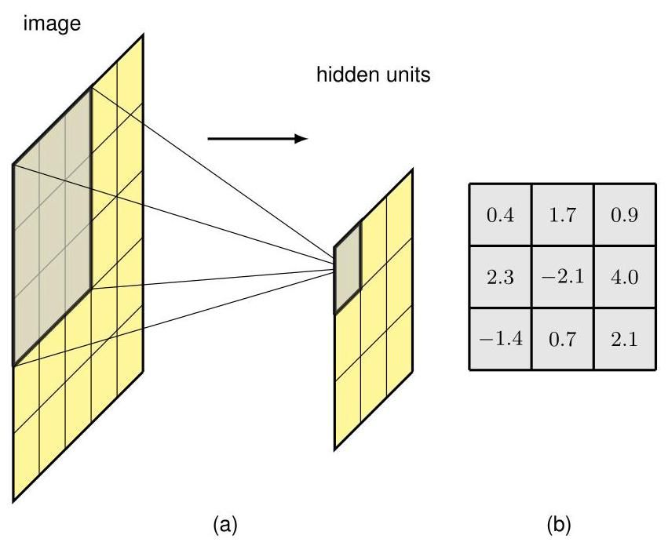

Figure 10.1 (a) Illustration of a receptive field, showing a unit in a hidden layer of a network that receives input from pixels in a patch of the image. Pixels in this patch form the receptive field for this unit. (b) The weight values associated with this hidden unit can be visualized as a small matrix, known as a kernel. There is also an additional bias parameter that is not shown here.

图 10.1 (a) 感受野的图示，展示了网络隐藏层中的一个单元，它从图像的一个 小块中的像素接收输入。这个小块中的像素构成了该单元的感受野。(b) 与这个隐藏单元相关联的权重值可以可视化为一个小的 矩阵，称为核。这里还有一个额外的偏置参数未显示。

Suppose that and in (10.1) are fixed and we ask for which value of the input image patch will this hidden unit give the largest output response. To answer this we need to constrain in some way, so let us suppose that its norm is fixed. Then the solution for that maximizes , and hence maximizes the response of the hidden unit, is of the form for some coefficient . This says that the maximum output response from this hidden unit occurs when it detects a patch of image that, up to an overall scaling, looks like the kernel image. Note that the ReLU generates a non-zero output only when exceeds a threshold of , and therefore the unit acts as a feature detector that signals when it finds a sufficiently good match to its kernel.

假设 (10.1) 中的 和 是固定的，我们要问对于输入图像块 的哪个值，这个隐藏单元会给出最大的输出响应。为了回答这个问题，我们需要以某种方式约束 ，所以让我们假设其范数 是固定的。那么，使 最大化，从而使隐藏单元的响应最大化的 的解具有 的形式，其中 为某个系数。这表明，当这个隐藏单元检测到一个图像块时，会出现最大输出响应，该图像块在整体缩放的情况下看起来像核图像。请注意，只有当 超过阈值 时，ReLU 才会产生非零输出，因此该单元充当一个特征检测器，当它找到与核足够匹配的特征时会发出信号。

Exercise 10.1

练习 10.1

# 10.2.2 Translation equivariance

# 10.2.2 平移不变性

Next note that if a small patch in a face image represents, for example, an eye at that location, then the same set of pixel values in a different part of the image must represent an eye at the new location. Our neural network needs to be able to generalize what it has learned in one location to all possible locations in the image, without needing to see examples in the training set of the corresponding feature at every possible location. To achieve this, we can simply replicate the same hidden-unit weight values at multiple locations across the image, as illustrated for a one-dimensional input space in Figure 10.2.

接下来注意，如果人脸图像中的一个小图像块表示该位置的一只眼睛，那么图像中不同部分的相同像素值集合必然表示新位置的一只眼睛。我们的神经网络需要能够将在一个位置学到的知识推广到图像中的所有可能位置，而无需在训练集中看到对应特征在每个可能位置的示例。为了实现这一点，我们可以简单地在图像的多个位置复制相同的隐藏单元权重值，如图 10.2 中一维输入空间的示例所示。

The units of the hidden layer form a feature map in which all the units share the same weights. Consequently if a local patch of an image produces a particular

隐藏层的单元形成一个特征图，其中所有单元共享相同的权重。因此，如果图像的一个局部图像块产生了一个特定的

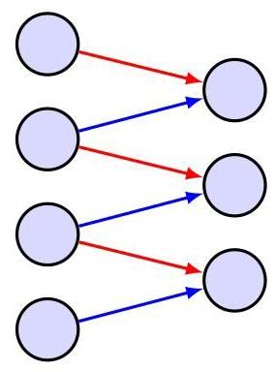

Figure 10.2 Illustration of convolution for a one-dimensional array of input values and a kernel of width 2 . The connections are sparse and are shared by the hidden units, as shown by the red and blue arrows in which links with the same colour have the same weight values. This network therefore has six connections but only two independent learnable parameters.

图 10.2 一维输入值数组和宽度为 2 的核的卷积示例。连接是稀疏的，并且由隐藏单元共享，如红色和蓝色箭头所示，相同颜色的链接具有相同的权重值。因此，这个网络有六个连接，但只有两个独立的可学习参数。

response in the unit connected to that patch, then the same set of pixel values at a different location will produce the same response in the corresponding translated location in the feature map. This is an example of equivariance. We see that the connections in this network are sparse in that most connections are absent. Also, the values of the weights are shared by all the hidden units, as indicated by the colours of the connections. This transformation is an example of a convolution.

在连接到该小块的单元中产生响应，那么在不同位置的相同像素值集合将在特征图中相应的平移位置产生相同的响应。这是等变性的一个例子。我们看到这个网络中的连接是稀疏的，因为大多数连接是不存在的。此外，如连接的颜色所示，所有权重值由所有隐藏单元共享。这种变换是卷积的一个例子。

Section 9.1.3

第 9.1.3 节

We can extend the idea of convolution to two-dimensional images as follows (Dumoulin and Visin,2016). For an image with pixel intensities , and a filter with pixel values , the feature map has activation values given by

我们可以按如下方式将卷积的概念扩展到二维图像(Dumoulin 和 Visin，2016)。对于具有像素强度 的图像 ，以及具有像素值 的滤波器 ，特征图 的激活值由下式给出

where we have omitted the nonlinear activation function for clarity. This again is an example of a convolution and is sometimes expressed as . Note that strictly speaking (10.2) is called a cross-correlation, which differs slightly from the conventional mathematical definition of convolution, but here we will follow common practice in the machine learning literature and refer to (10.2) as a convolution. The relationship (10.2) is illustrated in Figure 10.3 for a image and a filter. Importantly, when using batch normalization in a convolutional network, the same value of mean and variance must be used at every spatial location within a feature map when normalizing the states of the units to ensure that the statistics of the feature map are independent of location.

为了清晰起见，我们省略了非线性激活函数。这再次是卷积的一个例子，有时表示为 。请注意，严格来说，(10.2) 被称为互相关，它与传统的数学卷积定义略有不同，但在这里我们将遵循机器学习文献中的常见做法，将 (10.2) 称为卷积。对于 图像和 滤波器，关系 (10.2) 如图 10.3 所示。重要的是，在卷积网络中使用批量归一化时，在对单元状态进行归一化时，必须在特征图内的每个空间位置使用相同的均值和方差值，以确保特征图的统计特性与位置无关。

Exercise 10.4

练习 10.4

Section 7.4.2

第 7.4.2 节

As an example of the application of convolution, we consider the problem of detecting edges in images using a fixed, hand-crafted convolutional filter. Intuitively, we can think of a vertical edge as occurring when there is a significant local change in the intensity between pixels as we move horizontally across the image. We can measure this by convolving the image with a filter of the form

作为卷积应用的一个示例，我们考虑使用固定的手工卷积滤波器检测图像中边缘的问题。直观地说，当我们在图像上水平移动时，如果像素之间的强度发生显著的局部变化，我们可以认为出现了垂直边缘。我们可以通过将图像与形式为 的滤波器进行卷积来测量这种变化。

|  |  |  |
| --- | --- | --- |
| -1 | 0 | 1 |
| -1 | 0 | 1 |
| -1 | 0 | 1 |
| -1 | 0 | 1 |
| -1 | 0 | 1 |
| -1 | 0 | 1 |

(10.3)

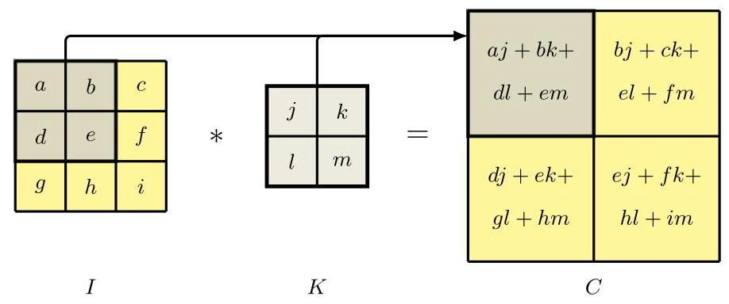

Figure 10.3 Example of a image convolved with a filter to give a resulting feature map.

图 10.3 一个 图像与一个 滤波器进行卷积以得到一个 特征图的示例。

Similarly we can detect horizontal edges by convolving with the transpose of this filter:

类似地，我们可以通过与该滤波器的转置进行卷积来检测水平边缘:

(10.4)

|  |  |  |
| --- | --- | --- |
| -1 | image | image |
| 0 | 0 | 0 |
| 1 | 1 | 1 |
| -1 | image | image |
| 0 | 0 | 0 |
| 1 | 1 | 1 |

Figure 10.4 shows the results of applying these two convolutional filters to a sample image. Note that in Figure 10.4(b) if a vertical edge corresponds to an increase in pixel intensity, the corresponding point on the feature map is positive (indicated by a light colour), whereas if the vertical edge corresponds to a decrease in pixel intensity, the corresponding point on the feature map is negative (indicated by a dark colour), with analogous properties for Figure 10.4(c) for horizontal edges.

图 10.4 展示了将这两个卷积滤波器应用于样本图像的结果。请注意，在图 10.4(b) 中，如果垂直边缘对应于像素强度的增加，则特征图上的对应点为正(用浅色表示)；而如果垂直边缘对应于像素强度的降低，则特征图上的对应点为负(用深色表示)。图 10.4(c) 中的水平边缘也具有类似的性质。

Comparing this convolutional structure with a standard fully connected network, we see several advantages: (i) the connections are sparse, leading to far fewer weights even with large images, (ii) the weight values are shared, greatly reducing the number of independent parameters and consequently reducing the required size of the training set needed to learn those parameters, and (iii) the same network can be applied to images of different sizes without the need for retraining. We will return to this final point later, but for the moment, simply note that changing the size of the input image simply changes the size of the feature map but does not change the number of weights, or the number of independent learnable parameters, in the model. One final observation regarding convolutional networks is that, by exploiting the massive parallelism of graphics processing units (GPUs) to achieve high computational throughput, convolutions can be implemented very efficiently.

将这种卷积结构与标准的全连接网络进行比较，我们可以看到几个优点:(i) 连接是稀疏的，即使对于大尺寸图像，权重数量也会少得多；(ii) 权重值是共享的，这大大减少了独立参数的数量，从而减少了学习这些参数所需的训练集大小；(iii) 同一网络可以应用于不同尺寸的图像，而无需重新训练。我们稍后会再讨论最后一点，但目前只需注意，改变输入图像的大小只会改变特征图的大小，而不会改变模型中的权重数量或独立可学习参数的数量。关于卷积网络的最后一个观察结果是，通过利用图形处理单元(GPU)的大规模并行性来实现高计算吞吐量，可以非常高效地实现卷积运算。

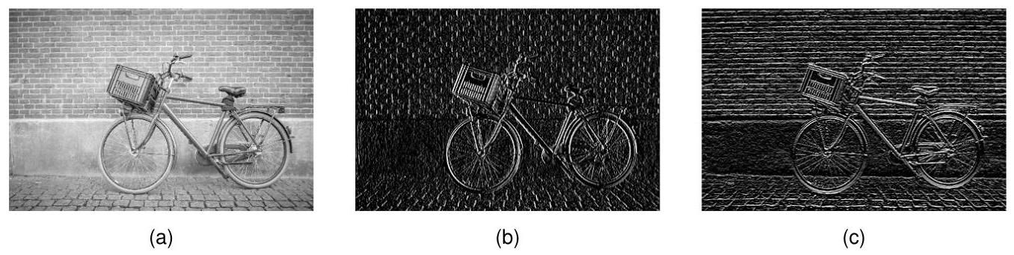

Figure 10.4 Illustration of edge detection using convolutional filters showing (a) the original image, (b) the result of convolving with the filter (10.3) that detects vertical edges, and (c) the result of convolving with the filter (10.4) that detects horizontal edges.

图 10.4 使用卷积滤波器进行边缘检测的示意图，展示了 (a) 原始图像，(b) 与检测垂直边缘的滤波器 (10.3) 卷积的结果，以及 (c) 与检测水平边缘的滤波器 (10.4) 卷积的结果。

Section 10.4.3

第 10.4.3 节

# 10.2.3 Padding

# 10.2.3 填充

We see from Figure 10.3 that the convolution map is smaller than the original image. If the image has dimensionality pixels and we convolve with a kernel of dimensionality (filters are typically chosen to be square) the resulting feature map has dimensionality . In some cases we want the feature map to have the same dimensions as the original image. This can be achieved by padding the original image with additional pixels around the outside, as illustrated in Figure 10.5. If we pad with P pixels then the output map has dimensionality . If there is no padding, so that , this is called a valid convolution. When the value of is chosen such that the output array has the same size as the input, corresponding to , this is called a same convolution, because the image and the feature map have the same dimensions. In computer vision, filters generally use odd values of , so that the padding can be symmetric on all sides of the image and that there is a well-defined central pixel associated with the location of the filter. Finally, we have to choose a suitable value for the intensities associated with the padding pixels. A typical choice is to set the padding values to zero, after first subtracting the mean from each image so that zero represents the average value of the pixel intensity. Padding can also be applied to feature maps for processing by subsequent convolutional layers.

从图 10.3 中我们可以看到，卷积映射比原始图像小。如果图像的维度为 像素，并且我们使用维度为 的核进行卷积(滤波器通常选择为正方形)，则得到的特征图的维度为 。在某些情况下，我们希望特征图的维度与原始图像相同。这可以通过在原始图像外部填充额外的像素来实现，如图 10.5 所示。如果我们填充 P 个像素，则输出映射的维度为 。如果不进行填充，即 ，这称为有效卷积。当选择 的值使得输出数组的大小与输入相同时，即 ，这称为相同卷积，因为图像和特征图具有相同的维度。在计算机视觉中，滤波器通常使用奇数的 ，这样填充可以在图像的所有边上对称，并且与滤波器的位置相关联的中心像素有明确的定义。最后，我们必须为与填充像素相关的强度选择合适的值。一个典型的选择是将填充值设置为零，首先从每个图像中减去均值，这样零就代表像素强度的平均值。填充也可以应用于特征图，以便后续的卷积层进行处理。

Exercise 10.6

练习 10.6

# 10.2.4 Strided convolutions

# 10.2.4 步幅卷积

In typical image processing applications, the images can have very large numbers of pixels, and since the kernels are often relatively small, so that , the convolutional feature map will be of a similar size to the original image and will be the same size if same padding is used. Sometimes we wish to use feature maps that are significantly smaller than the original image to provide flexibility in the design of convolutional network architectures. One way to achieve this is to use strided convolutions in which, instead of stepping the filter over the image one pixel at a time, it is moved in larger steps of size , called the stride. If we use the same stride horizontally and vertically, then the number of elements in the feature map will be

在典型的图像处理应用中，图像可能有大量像素，并且由于卷积核通常相对较小，使得 ，卷积特征图的大小将与原始图像相似，如果使用相同的填充方式，二者大小将相同。有时，我们希望使用比原始图像小得多的特征图，以便在卷积网络架构设计中提供灵活性。实现这一点的一种方法是使用步幅卷积，在这种卷积中，滤波器不是每次在图像上移动一个像素，而是以大小为 的更大步长移动，这个步长称为步幅。如果我们在水平和垂直方向上使用相同的步幅，那么特征图中的元素数量将是

Exercise 10.7

练习 10.7

where denotes the ’floor’ of , i.e., the largest integer that is less than or equal to . For large images and small filter sizes, the image map will be roughly a factor of smaller than the original image.

其中 表示 的 “向下取整”，即小于或等于 的最大整数。对于大尺寸图像和小尺寸滤波器，图像映射将比原始图像大约小 倍。

Figure 10.5 Illustration of a image that has been padded with additional pixels to create a image.

图 10.5 展示了一个 图像通过填充额外像素形成 图像的过程。

|  |  |  |  |  |  |
| --- | --- | --- | --- | --- | --- |
| 0 | 0 | 0 | 0 | 0 | 0 |
| 0 |  |  |  |  | 0 |
| 0 |  |  |  |  | 0 |
| 0 |  |  |  |  | 0 |
| 0 |  |  |  |  | 0 |
| 0 | 0 | 0 | 0 | 0 | 0 |
| 0 | 0 | 0 | 0 | 0 | 0 |
| 0 |  |  |  |  | 0 |
| 0 |  |  |  |  | 0 |
| 0 |  |  |  |  | 0 |
| 0 |  |  |  |  | 0 |
| 0 | 0 | 0 | 0 | 0 | 0 |

# 10.2.5 Multi-dimensional convolutions

# 10.2.5 多维卷积

So far we have considered convolutions over a single grey-scale image. For a colour image there will be three channels corresponding to the red, green, and blue colours. We can easily extend convolutions to cover multiple channels by extending the dimensionality of the filter. An image with pixels and channels will be described by a tensor of dimensionality . We can introduce a filter described by a tensor of dimensionality comprising a separate filter for each of the channels. Assuming no padding and a stride of 1, this again gives a feature map of size , as is illustrated in Figure 10.6.

到目前为止，我们只考虑了对单张灰度图像进行卷积。对于彩色图像，会有三个通道，分别对应红色、绿色和蓝色。我们可以通过扩展滤波器的维度，轻松地将卷积扩展到多个通道。具有 个像素和 个通道的图像将由一个维度为 的张量来描述。我们可以引入一个维度为 的张量来描述滤波器，该张量为 个通道中的每个通道包含一个单独的 滤波器。假设不进行填充且步长为 1，这同样会得到一个大小为 的特征图，如图 10.6 所示。

Section 6.3.7

6.3.7 节

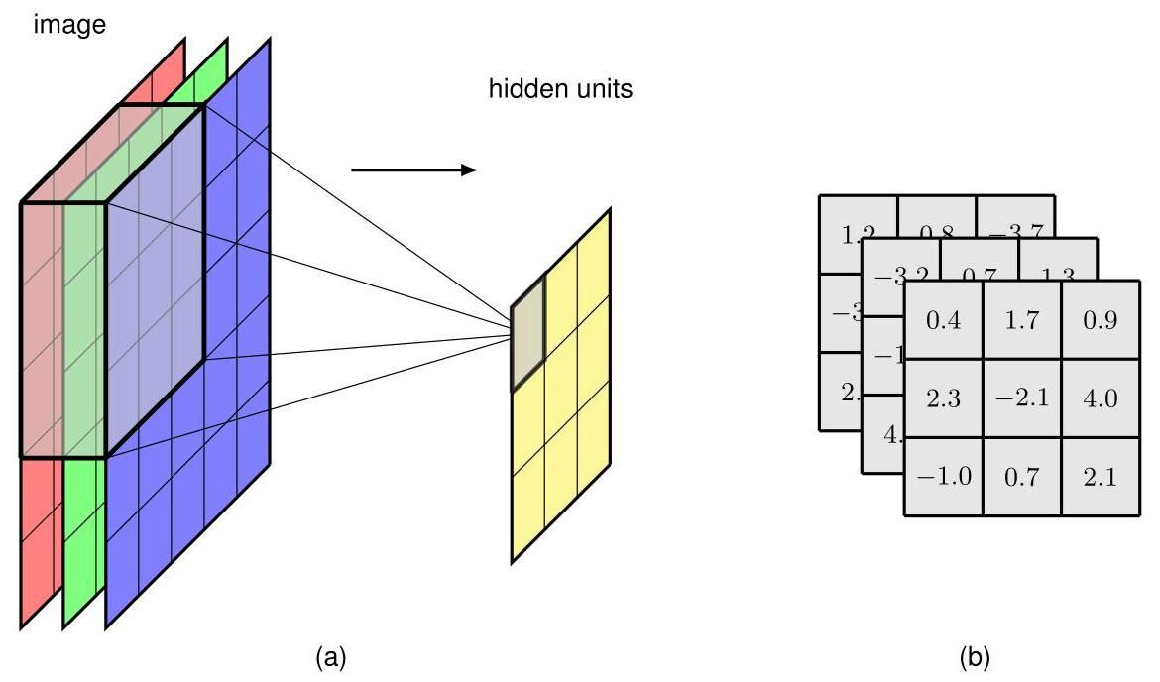

Figure 10.6 (a) Illustration of a multi-dimensional filter that takes input from across the R, G, and B channels. (b) The kernel here has 27 weights (plus a bias parameter not shown) and can be visualized as a tensor.

图 10.6 (a) 展示了一个从 R、G 和 B 通道获取输入的多维滤波器。(b) 这里的卷积核有 27 个权重(加上一个未显示的偏置参数)，可以可视化为一个 张量。

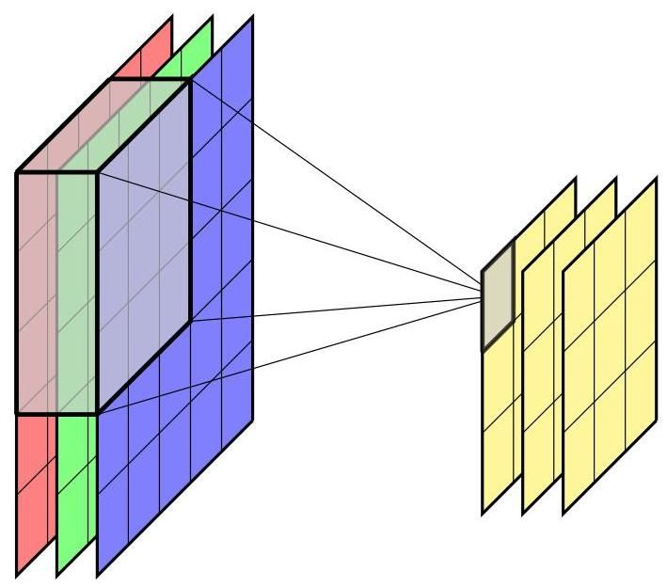

Figure 10.7 The multi-dimensional convolutional filter layer shown in Figure 10.6 can be extended to include multiple independent filter channels.

图 10.7 图 10.6 中所示的多维卷积滤波器层可以扩展为包含多个独立的滤波器通道。

We now make a further important extension to convolutions. Up to now we have created a single feature map in which all the points in the feature map share the same set of learnable parameters. For a filter of dimensionality , this will have weight parameters, irrespective of the size of the image. In addition there will be a bias parameter associated with this unit. Such a filter is analogous to a single hidden node in a fully connected network, and it can learn to detect only one kind of feature and is therefore very limited. To build more flexible models, we simply include multiple such filters, in which each filter has its own independent set of parameters giving rise to its own independent feature map, as illustrated in Figure 10.7. We will again refer to these separate feature maps as channels. The filter tensor now has dimensionality where is the number of input channels and is the number of output channels. Each output channel will have its own associated bias parameter, so the total number of parameters will be .

现在，我们对卷积进行进一步重要的扩展。到目前为止，我们创建了单个特征图，其中特征图中的所有点共享同一组可学习参数。对于维度为 的滤波器，无论图像大小如何，它都将有 个权重参数。此外，该单元还会有一个偏置参数。这样的滤波器类似于全连接网络中的单个隐藏节点，它只能学习检测一种特征，因此非常有限。为了构建更灵活的模型，我们只需包含多个这样的滤波器，其中每个滤波器都有自己独立的参数集，从而产生自己独立的特征图，如图 10.7 所示。我们再次将这些单独的特征图称为通道。现在，滤波器张量的维度为 ，其中 是输入通道的数量， 是输出通道的数量。每个输出通道都将有自己关联的偏置参数，因此参数总数将为 。

A useful concept in designing convolutional networks is the convolution (Lin, Chen, and Yan, 2013), which is simply a convolutional layer in which the filter size is a single pixel. The filters have weights, one for each input channel, plus a bias. One application for convolutions is simply to change the number of channels (typically to reduce the number of channels) without changing the size of the feature maps, by setting the number of output channels to be different to the number of input channels. It is therefore complementary to strided convolutions or pooling in that it reduces the number of channels rather than the dimensionality of the channels.

在设计卷积网络时，一个有用的概念是 卷积(Lin、Chen 和 Yan，2013 年)，它只是一个卷积层，其中滤波器大小为单个像素。滤波器有 个权重，每个输入通道对应一个，再加上一个偏置。 卷积的一个应用是，通过将输出通道数设置为与输入通道数不同，在不改变特征图大小的情况下简单地改变通道数(通常是减少通道数)。因此，它与步幅卷积或池化互补，因为它减少的是通道数，而不是通道的维度。

# 10.2.6 Pooling

# 10.2.6 池化

A convolutional layer encodes translation equivariance, whereby if a small patch of pixels, representing the receptive field of a hidden unit, is moved to a different location in the image, the associated outputs of the feature map will move to the corresponding location in the feature map. This is valuable for applications such as finding the location of an object within an image. For other applications, such as classifying an image, we want the output to be invariant to translations of the input. In all cases, however, we want the network to be able to learn hierarchical structure in which complex features at a particular level are built up from simpler features at the previous level. In many cases the spatial relationship between those simpler features will be important. For example, it is the relative positions of the eyes, nose, and mouth that help determine the presence of a face and not just the presence of these features in arbitrary locations within the image. However, small changes in the relative locations do not affect the classification, and we want to be invariant to such small translations of individual features. This can be achieved using pooling applied to the output of the convolutional layer.

卷积层编码了平移等变性，即如果代表隐藏单元感受野的一小片像素在图像中移动到不同位置，特征图的相关输出将移动到特征图中的相应位置。这对于诸如在图像中查找对象位置等应用很有价值。对于其他应用，如图像分类，我们希望输出对输入的平移具有不变性。然而，在所有情况下，我们都希望网络能够学习层次结构，其中特定层次的复杂特征由前一层次的简单特征构建而成。在许多情况下，这些简单特征之间的空间关系将很重要。例如，是眼睛、鼻子和嘴巴的相对位置有助于确定面部的存在，而不仅仅是这些特征在图像中任意位置的存在。然而，相对位置的微小变化并不影响分类，并且我们希望对单个特征的这种微小平移具有不变性。这可以通过对卷积层的输出应用池化来实现。

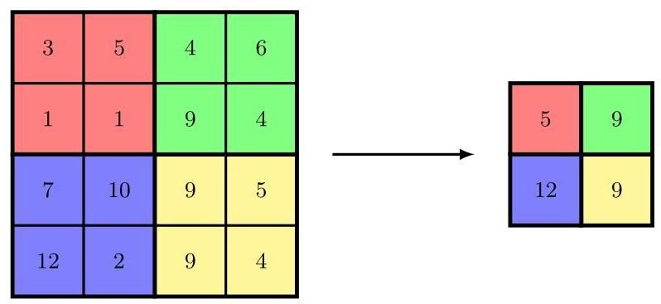

Figure 10.8 Illustration of max-pooling in which blocks of pixels in a feature map are combined using the ’max’ operator to generate a new feature map of smaller dimensionality.

图 10.8 最大池化的示意图，其中特征图中 像素的块使用“最大”运算符组合，以生成维度更小的新特征图。

Pooling has similarities to using a convolutional layer in that an array of units is arranged in a grid, with each unit taking input from a receptive field in the previous feature map layer. Again, there is a choice of filter size and of stride length. The difference, however, is that the output of a pooling unit is a simple, fixed function of its inputs, and so there are no learnable parameters in pooling. A common example of a pooling function is max-pooling (Zhou and Chellappa, 1988) in which each unit simply outputs the max function applied to the input values. This is illustrated with a simple example in Figure 10.8. Here the stride length is equal to the filter width, and so there is no overlap of the receptive fields.

池化与使用卷积层有相似之处，即单元数组排列成网格，每个单元从先前特征图层的感受野获取输入。同样，也需要选择滤波器大小和步长。然而，不同之处在于，池化单元的输出是其输入的简单固定函数，因此池化中没有可学习的参数。一个常见的池化函数示例是最大池化(Zhou 和 Chellappa，1988 年)，其中每个单元简单地输出应用于输入值的最大函数。图 10.8 用一个简单的例子说明了这一点。这里步长等于滤波器宽度，因此感受野没有重叠。

As well as building in some local translation invariance, pooling can also be used to reduce the dimensionality of the representation by down-sampling the feature map. Note that using strides greater than 1 in a convolutional layer also has the effect of down-sampling the feature maps.

除了引入一些局部平移不变性外，池化还可用于通过对特征图进行下采样来降低表示的维度。请注意，在卷积层中使用大于 1 的步长也有对特征图进行下采样的效果。

We can interpret the activation of a unit in a feature map as a measure of the strength of detection of a corresponding feature, so that the max-pooling preserves information on whether the feature is present and with what strength but discards some positional information. There are many other choices of pooling function, for example average pooling in which the pooling function computes the average of the values from the corresponding receptive field in the feature map. These all introduce some degree of local translation invariance.

我们可以将特征图中一个单元的激活解释为对相应特征检测强度的一种度量，这样最大池化就保留了关于该特征是否存在以及强度如何的信息，但丢弃了一些位置信息。池化函数还有许多其他选择，例如平均池化，在平均池化中，池化函数计算特征图中相应感受野内值的平均值。所有这些都引入了一定程度的局部平移不变性。

Pooling is usually applied to each channel of a feature map independently. For example, if we have a feature map with 8 channels, each of dimensionality , and we apply max-pooling with a receptive field of size and a stride of 2, the output of the pooling operation will be a tensor of dimensionality .

池化通常独立应用于特征图的每个通道。例如，如果我们有一个具有 8 个通道、每个通道维度为 的特征图，并且我们应用大小为 、步长为 2 的最大池化，那么池化操作的输出将是一个维度为 的张量。

We can also apply pooling across multiple channels of a feature map, which gives the network the potential to learn other invariances beyond simple translation invariance. For example, if several channels in a convolutional layer learn to detect the same feature but at different orientations, then max-pooling across those feature maps will be approximately invariant to rotations.

我们还可以跨特征图的多个通道应用池化，这使网络有潜力学习除简单平移不变性之外的其他不变性。例如，如果卷积层中的几个通道学会了检测相同的特征，但方向不同，那么对这些特征图进行最大池化将大致具有旋转不变性。

Pooling also allows a convolutional network to process images of varying sizes. Ultimately, the output, and generally some of the intermediate layers, of a convolutional network must have a fixed size. Variable-sized inputs can be accommodated by varying the stride length of the pooling according to the size of the image such that the number of pooled outputs remains constant.

池化还允许卷积网络处理不同大小的图像。最终，卷积网络的输出，通常还有一些中间层，必须具有固定的大小。可以根据图像的大小改变池化的步长，以使池化输出的数量保持恒定，从而适应不同大小的输入。

# 10.2.7 Multilayer convolutions

# 10.2.7 多层卷积

The convolutional network structure described so far is analogous to a single layer in a standard fully connected neural network. To allow the network to discover and represent hierarchical structure in the data, we now extend the architecture by considering multiple layers of the kind described above. Each convolutional layer is described by a filter tensor of dimensionality in which the number of independent weight and bias parameters is . Each such convolutional layer can optionally be followed by a pooling layer. We can now apply multiple such layers of convolution and pooling in succession, in which the output channels of a particular layer, analogous to the RGB channels of the input image, form the input channels of the next layer. Note that the number of channels in a feature map is sometimes called the ’depth’ of the feature map, but we prefer to reserve the term depth to mean the number of layers in a multilayer network.

到目前为止所描述的卷积网络结构类似于标准全连接神经网络中的单层。为了让网络能够发现并表示数据中的层次结构，我们现在通过考虑上述类型的多个层来扩展架构。每个卷积层由一个维度为 的滤波器张量描述，其中独立的权重和偏置参数的数量为 。每个这样的卷积层后面可以选择跟一个池化层。我们现在可以连续应用多个这样的卷积和池化层，其中特定层的 个输出通道，类似于输入图像的 RGB 通道，构成下一层的输入通道。请注意，特征图中的通道数有时被称为特征图的“深度”，但我们更愿意将“深度”这个术语保留为表示多层网络中的层数。

A key property that we built into the convolutional framework is that of locality, in which a given unit in a feature map takes information only from a small patch, the receptive field, in the previous layer. When we construct a deep neural network in which each layer is convolutional then the effective receptive field of a unit in later layers in the network becomes much larger than those in earlier layers, as seen in Figure 10.9.

我们构建到卷积框架中的一个关键特性是局部性，即特征图中的给定单元仅从先前层的一个小区域(感受野)获取信息。当我们构建一个每一层都是卷积层的深度神经网络时，网络中较后层单元的有效感受野会比早期层的感受野大得多，如图 10.9 所示。

In many applications, the output units of the network need to make predictions about the image as a whole, for example in a classification task, and so they need to combine information from across the whole of the input image. This is typically achieved by introducing one or two standard fully connected layers as the final stages of the network, in which each unit is connected to every unit in the previous layer. The number of parameters in such an architecture can be manageable because the final convolutional layer generally has much lower dimensionality than the input layer due to the intermediate pooling layers. Nevertheless, the final fully connected layers may contain the majority of the independent degrees of freedom in the network even if the number of (shared) connections in the network is larger in the convolutional layers.

在许多应用中，网络的输出单元需要对整个图像进行预测，例如在分类任务中，因此它们需要整合来自整个输入图像的信息。这通常是通过在网络的最后阶段引入一两个标准的全连接层来实现的，其中每个单元都与前一层的每个单元相连。由于中间的池化层，最终卷积层的维度通常比输入层低得多，因此这种架构中的参数数量是可控的。然而，即使网络中卷积层的(共享)连接数量更多，最终的全连接层可能仍包含网络中大部分的独立自由度。

A complete CNN therefore comprises multiple layers of convolutions interspersed with pooling operations, and often with conventional fully connected layers in the final stages of the network. There are many choices to be made in designing such an architecture including the number of layers, the number of channels in each layer, the filter sizes, the stride widths, and multiple other such hyperparameters. A wide variety of different architectures have been explored, although in practice it is difficult to make a systematic comparison of hyperparameter values using hold-out data due to the high computational cost of training each candidate configuration.

因此，一个完整的卷积神经网络(CNN)包括多层卷积层，中间穿插着池化操作，并且通常在网络的最后阶段包含传统的全连接层。在设计这样的架构时，有许多选择需要做出，包括层数、每层的通道数、滤波器大小、步幅宽度以及其他多个超参数。已经探索了各种各样的不同架构，尽管在实践中，由于训练每个候选配置的计算成本很高，很难使用保留数据对超参数值进行系统比较。

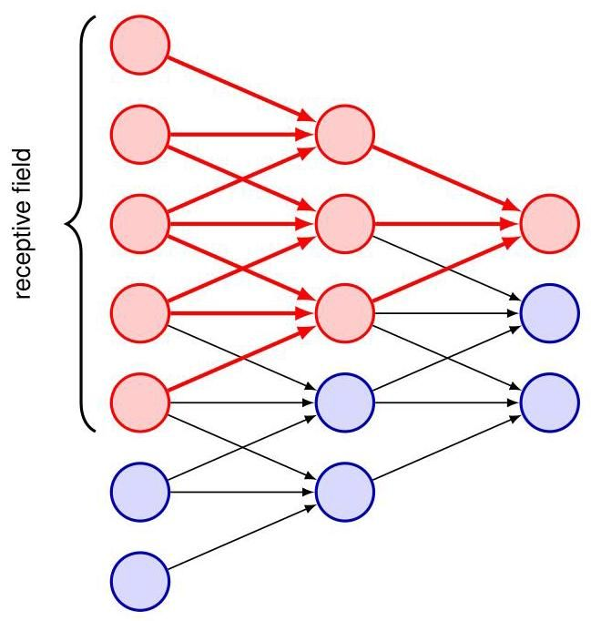

Figure 10.9 Illustration of how the effective receptive field grows with depth in a multilayer convolutional network. Here we see that the red unit at the top of the output layer takes inputs from a receptive field in the middle layer of units, each of which has a receptive field in the first layer of units. Thus, the activation of the red unit in the output layer depends on the outputs of 3 units in the middle layer and 5 units in the input layer.

图 10.9 说明了多层卷积网络中有效感受野如何随深度增加。在这里，我们看到输出层顶部的红色单元从中间层单元的感受野获取输入，而中间层的每个单元又在第一层单元中有一个感受野。因此，输出层中红色单元的激活取决于中间层的 3 个单元和输入层的 5 个单元的输出。

# 10.2.8 Example network architectures

# 10.2.8 示例网络架构

Convolutional networks were the first deep neural networks (i.e., ones with more than two learnable layers of parameters) to be successfully deployed in applications. An early example was LeNet, which was used to classify low-resolution monochrome images of handwritten digits (LeCun et al., 1989; LeCun et al., 1998). The development of more powerful convolutional networks was accelerated through the introduction of a large-scale benchmark data set called ImageNet (Deng et al., 2009) comprising some 14 million natural images each of which has been hand labelled into one of nearly 22,000 categories. This was a much larger data set than had been used previously, and the advances in the field driven by ImageNet served to emphasize the importance of large-scale data, alongside well-designed models having appropriate inductive biases, in building successful deep learning solutions.

卷积网络是最早成功应用于实际的深度神经网络(即具有两层以上可学习参数层的网络)。早期的一个例子是 LeNet，它用于对手写数字的低分辨率单色图像进行分类(LeCun 等人，1989 年；LeCun 等人，1998 年)。通过引入一个名为 ImageNet 的大规模基准数据集(Deng 等人，2009 年)，包含约 1400 万张自然图像，每张图像都被手动标记到近 22000 个类别之一，更强大的卷积网络的发展得到了加速。这是一个比以前使用的数据集大得多的数据集，由 ImageNet 推动的该领域的进展强调了大规模数据以及具有适当归纳偏置的精心设计的模型在构建成功的深度学习解决方案中的重要性。

A subset of images comprising 1,000 non-overlapping categories formed the basis for the annual ImageNet Large Scale Visual Recognition Challenge. Again, this was a much larger number of categories than the typically few dozen classes previously considered. Having so many categories made the problem much more challenging because, if the classes were distributed uniformly, random guessing would have an error rate of 99.9%. The data set has just over 1.28 million training images, 50,000 validation images, and 100,000 test images. The classifiers are designed to produce a ranked list of predicted output classes on test images, and results are reported in terms of top-1 and top-5 error rates, meaning an image is deemed to be correctly classified if the true class appears at the top of the list or if it is in one of the five highest-ranked class predictions. Early results with this data set achieved a top-5 error rate of around 25.5%. An important advance was made by the AlexNet convolutional network architecture (Krizhevsky, Sutskever, and Hinton, 2012), which won the 2012 competition and reduced the top-5 error rate to a new record of 15.3%. Key aspects of this model were the use of the ReLU activation function, the application of GPUs to train the network, and the use of dropout regularization. Subsequent years saw further advances, leading to error rates of around 3%, which is somewhat better than human-level performance for the same data, which is around 5% (Dodge and Karam, 2017). This can be attributed to the difficulty humans have in distinguishing subtly different classes (for example multiple varieties of mushrooms).

由 1000 个不重叠类别组成的图像子集构成了年度 ImageNet 大规模视觉识别挑战赛的基础。同样，这一类别数量比之前通常考虑的几十类要多得多。拥有如此多的类别使得问题更具挑战性，因为如果类别均匀分布，随机猜测的错误率将达到 99.9%。该数据集有略多于 128 万张训练图像、5 万张验证图像和 10 万张测试图像。分类器旨在生成测试图像预测输出类别的排名列表，结果以 top-1 和 top-5 错误率报告，这意味着如果真实类别出现在列表顶部，或者它在五个排名最高的类别预测中，那么该图像被认为分类正确。使用该数据集的早期结果实现了约 25.5%的 top-5 错误率。AlexNet 卷积网络架构(Krizhevsky、Sutskever 和 Hinton，2012 年)取得了重要进展，它赢得了 2012 年的竞赛，并将 top-5 错误率降至新纪录 15.3%。该模型的关键方面包括使用 ReLU 激活函数、应用 GPU 训练网络以及使用 dropout 正则化。随后几年取得了进一步进展，错误率降至约 3%，这比同一数据的人类水平表现(约 5%，Dodge 和 Karam，2017 年)略好。这可以归因于人类在区分细微不同类别(例如多种蘑菇品种)时存在困难。

Section 9.6.1

第 9.6.1 节

As an example of a typical convolutional network architecture, we look in detail at the VGG-16 model (Simonyan and Zisserman, 2014), where VGG stands for the Visual Geometry Group, who developed the model, and 16 refers to the number of learnable layers in the model. VGG-16 has some simple design principles leading to a relatively uniform architecture, shown in Figure 10.10, that minimizes the number of hyperparameter choices that need to be made. It takes an input image having pixels and three colour channels, followed by sets of convolutional layers interspersed with down-sampling. All convolutional layers have filters of size with a stride of 1, same padding, and a ReLU activation function, whereas the max-pooling operations all use stride 2 and filter size thereby down-sampling the number of units by a factor of 4 . The first learnable layer is a convolutional layer in which each unit takes input from a ’cube’ from the stack of input channels and so has 28 parameters including the bias. These parameters are shared across all units in the feature map for that channel. There are 64 such feature channels in the first layer, giving an output tensor of size . The second layer is also convolutional and again has 64 channels. This is followed by max-pooling giving feature maps of size . Layers 3 and 4 are again convolutional, of dimensionality , and each was chosen to have 128 channels. This increase in the number of channels offsets to some extent the down-sampling in the max-pooling layer to ensure that the number of variables in the representation at each layer does not decrease too rapidly through the network. Again, this is followed by a max-pooling operation to give a feature map size of . Next come three more convolutional layers each with 256 channels, thereby again doubling the number of channels in association with the down-sampling. This is followed by another max-pooling to give feature maps of size followed by three more convolutional layers each having 512 channels, followed by another max-pooling, which down-samples to feature maps of size . This is followed by three more convolutional layers, although the number of feature maps in these layers is kept at 512, followed by another max-pooling, which brings the size of the feature maps down to . Finally there are three more layers that are fully connected meaning that they are standard neural network layers with full connectivity and no sharing of parameters. The final max-pooling layer has 512 channels each of size giving 25,088 units in total. The first fully connected layer has 4,096 units, each of which is connected to each of the max-pooling units. This is followed by a second fully connected layer again with 4,096 units, and finally there is a third fully connected layer with 1,000 units so that the network can be applied to a classification problem involving 1,000 classes. All the learnable layers in the network have nonlinear ReLU activation functions, except for the output layer, which has a softmax activation function. In total there are roughly 138 million independently learnable parameters in VGG-16, the majority of which (nearly 103 million) are in the first fully connected layer,

作为典型卷积网络架构的一个示例，我们详细研究 VGG - 16 模型(Simonyan 和 Zisserman，2014)，其中 VGG 代表开发该模型的视觉几何组(Visual Geometry Group)，16 指的是模型中可学习层的数量。VGG - 16 有一些简单的设计原则，形成了相对统一的架构，如图 10.10 所示，这最大限度地减少了需要选择的超参数数量。它接收一个具有 像素和三个颜色通道的输入图像，随后是穿插着下采样的卷积层组。所有卷积层的滤波器大小为 ，步长为 1，采用相同填充，并使用 ReLU 激活函数，而最大池化操作都使用步长 2 和滤波器大小 ，从而将单元数量下采样为原来的四分之一。第一个可学习层是一个卷积层，其中每个单元从输入通道堆栈的一个 “立方体” 中获取输入，因此包括偏置在内有 28 个参数。这些参数在该通道的特征图中的所有单元之间共享。第一层中有 64 个这样的特征通道，输出张量的大小为 。第二层也是卷积层，同样有 64 个通道。随后是最大池化，得到大小为 的特征图。第 3 层和第 4 层同样是卷积层，维度为 ，并且每层都选择有 128 个通道。通道数量的增加在一定程度上抵消了最大池化层中的下采样，以确保网络中每层表示的变量数量不会下降得太快。同样，随后是一个最大池化操作，得到大小为 的特征图。接下来是另外三个卷积层，每层有 256 个通道，因此与下采样相关联，通道数量再次翻倍。随后是另一个最大池化，得到大小为 的特征图，接着是另外三个卷积层，每层有 512 个通道，随后是另一个最大池化，将特征图下采样到大小为 。接着是另外三个卷积层，不过这些层中的特征图数量保持在 512，随后是另一个最大池化，将特征图的大小降至 。最后还有三个全连接层，这意味着它们是具有完全连接且没有参数共享的标准神经网络层。最后的最大池化层有 512 个通道，每个通道的大小为 ，总共得到 25088 个单元。第一个全连接层有 4096 个单元，每个单元都与最大池化层的每个单元相连。接着是第二个全连接层，同样有 4096 个单元，最后是第三个全连接层，有 1000 个单元，这样网络就可以应用于涉及 1000 个类别的分类问题。网络中所有可学习层都具有非线性 ReLU 激活函数，除了输出层，它具有 softmax 激活函数。VGG - 16 中总共有大约 1.38 亿个独立可学习参数，其中大部分(近 1.03 亿个)在第一个全连接层。

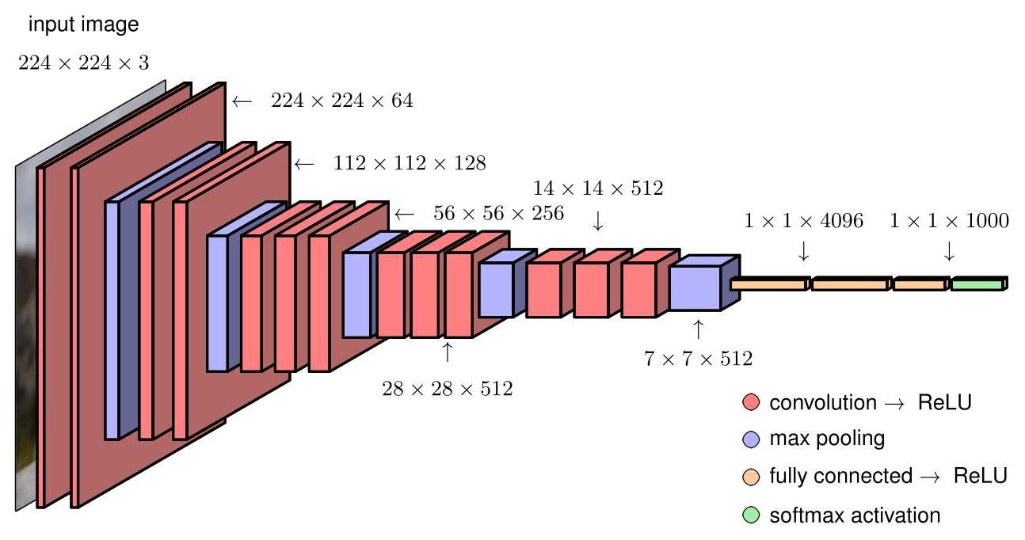

Figure 10.10 The architecture of a typical convolutional network, in this case a model called VGG-16.

图 10.10 典型卷积网络的架构，在这种情况下是一个名为 VGG - 16 的模型。

# Exercise 10.8

# 练习 10.8

whereas most of the connections are in the first convolutional layer.

而大多数连接在第一个卷积层。

Earlier CNNs typically had fewer convolutional layers, as they had larger receptive fields. For example, Alexnet (Krizhevsky, Sutskever, and Hinton, 2012) has receptive fields with a stride of 4 . We saw in Figure 10.9 that larger receptive fields can also be achieved implicitly by using multiple layers each having smaller receptive fields. The advantage of the latter approach is that it requires significantly fewer parameters, effectively imposing an inductive bias on the larger filters as they must be composed of convolutional sub-filters. Although this is a highly complex architecture, only the network function itself needs to be coded explicitly since the derivatives of the cost function can be evaluated using automatic differentiation and the cost function optimized using stochastic gradient descent.

早期的卷积神经网络(CNNs)通常卷积层较少，因为它们具有更大的感受野。例如，AlexNet(Krizhevsky、Sutskever 和 Hinton，2012 年)具有步长为 4 的 感受野。我们在图 10.9 中看到，通过使用多个具有较小感受野的层，也可以隐式地实现更大的感受野。后一种方法的优点是它所需的参数显著减少，实际上对较大的滤波器施加了归纳偏置，因为它们必须由卷积子滤波器组成。尽管这是一个高度复杂的架构，但由于可以使用自动微分来计算成本函数的导数，并使用随机梯度下降来优化成本函数，因此只需要显式地对网络函数本身进行编码。

Section 8.2

第 8.2 节

# 10.3. Visualizing Trained CNNs

# 10.3. 可视化训练好的卷积神经网络

We turn now to an exploration of the features learned by modern deep CNNs, and we will see some remarkable similarities to the properties of the mammalian visual cortex.

现在我们来探索现代深度卷积神经网络所学习到的特征，我们将看到它们与哺乳动物视觉皮层的特性有一些显著的相似之处。

# 10.3.1 Visual cortex

# 10.3.1 视觉皮层

Historically, much of the motivation for CNNs came from pioneering research in neuroscience, which gave insights into the nature of visual processing in mammals including humans. Electrical signals from the retina are transformed through a series of processing layers in the visual cortex, which is at the back of the brain, where the neurons are organized into two-dimensional sheets each of which forms a map of the two-dimensional visual field. In their pioneering work, Hubel and Wiesel (1959) measured the electrical responses of individual neurons in the visual cortex of cats while presenting visual stimuli to the cats’ eyes. They discovered that some neurons, called ’simple cells’, have a strong response to visual inputs with a simple edge oriented at a particular angle and located at a particular position within the visual field, whereas other stimuli generated relatively little response in those neurons. More detailed studies showed that the response of these simple cells can be modelled using Gabor filters, which are two-dimensional functions defined by

从历史上看，卷积神经网络的许多灵感来自神经科学领域的开创性研究，这些研究让我们深入了解了包括人类在内的哺乳动物的视觉处理本质。来自视网膜的电信号通过位于大脑后部的视觉皮层中的一系列处理层进行转换，在那里神经元被组织成二维层，每一层都形成了二维视野的映射。在他们的开创性工作中，Hubel 和 Wiesel(1959 年)在向猫的眼睛呈现视觉刺激时，测量了猫视觉皮层中单个神经元的电反应。他们发现，一些被称为“简单细胞”的神经元，对具有特定角度且位于视野内特定位置的简单边缘的视觉输入有强烈反应，而其他刺激在这些神经元中产生的反应相对较小。更详细的研究表明，这些简单细胞的反应可以用 Gabor 滤波器来建模，Gabor 滤波器是由以下公式定义的二维函数

where

哪里

Equations (10.7) and (10.8) represent a rotation of the coordinate system through an angle and therefore the term in (10.6) represents a sinusoidal spatial oscillation oriented in a direction defined by the polar angle , with frequency and phase angle . The exponential factor in (10.6) creates a decay envelope that localizes the filter in the neighbourhood of position and with decay rates governed by and . Example Gabor filters are shown in Figure 10.11.

方程 (10.7) 和 (10.8) 表示坐标系绕角度 旋转，因此 (10.6) 中的 项表示一个正弦空间振荡，其方向由极角 定义，频率为 ，相位角为 。(10.6) 中的指数因子创建了一个衰减包络，将滤波器定位在位置 的邻域内，衰减率由 和 控制。图 10.11 展示了示例 Gabor 滤波器。

Hubel and Wiesel also discovered the presence of ’complex cells’, which respond to more complex stimuli and which seem to be derived by combining and processing the output of simple cells. These responses exhibit some degree of invariance to small changes in the input such as shifts in location, analogous to the pooling units in a convolutional deep network. Deeper levels of the mammalian visual processing system have even more specific responses and even greater invariance to transformations of the visual input. Such cells have been termed ’grandmother cells’ because such a cell could notionally respond if, and only if, the visual input corresponds to a person’s grandmother, irrespective of location, scale, lighting, or other transformations of the scene. This work directly inspired an early form of deep neural network called the neocognitron (Fukushima, 1980), which was the forerunner of convolutional neural networks. The neocognitron had multiple layers of processing comprising local receptive fields with shared weights followed by local averaging or max-pooling to confer positional invariance. However, it lacked an end-to-end training procedure since it predated the development of backpropagation, relying instead on greedy layer-wise learning through an unsupervised clustering algorithm.

Hubel 和 Wiesel 还发现了“复杂细胞”的存在，这些细胞对更复杂的刺激做出反应，并且似乎是通过组合和处理简单细胞的输出而产生的。这些反应对输入的微小变化(如位置偏移)表现出一定程度的不变性，类似于卷积深度网络中的池化单元。哺乳动物视觉处理系统的更深层次具有更特定的反应，并且对视觉输入的变换具有更大的不变性。这类细胞被称为“祖母细胞”，因为从概念上讲，只有当视觉输入对应于一个人的祖母时，这样的细胞才会做出反应，而不考虑场景的位置、尺度、光照或其他变换。这项工作直接启发了一种早期形式的深度神经网络，称为神经认知机(Fukushima，1980)，它是卷积神经网络的先驱。神经认知机有多层处理，包括具有共享权重的局部感受野，随后进行局部平均或最大池化以赋予位置不变性。然而，它缺乏端到端的训练过程，因为它早于反向传播算法的发展，而是依赖于通过无监督聚类算法进行的贪婪逐层学习。

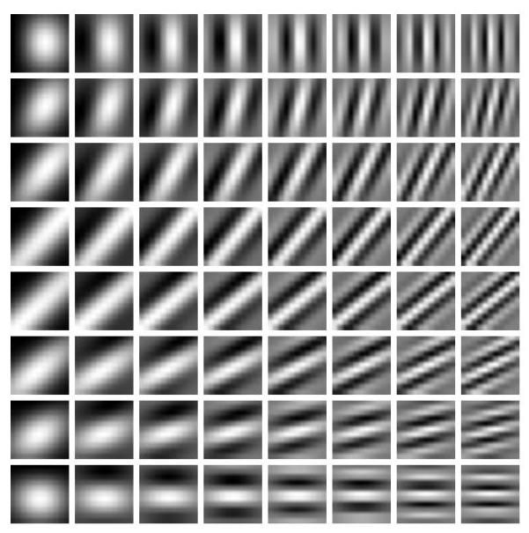

Figure 10.11 Examples of Gabor filters defined by (10.6). The orientation angle varies from 0 in the top row to in the bottom row, whereas the frequency varies from in the left column to in the right column.

图 10.11 由 (10.6) 定义的 Gabor 滤波器示例。方向角 从顶行的 0 变化到底行的 ，而频率从左列的 变化到右列的 。

# 10.3.2 Visualizing trained filters

# 10.3.2 可视化训练好的滤波器

Suppose we have a trained deep CNN and we wish to explore what the hidden units have learned to detect. For the filters in the first convolutional layer this is relatively straightforward, as they correspond to small patches in the original input image space, and so we can visualize the network weights associated with these filters directly as small images. The first convolutional layer computes inner products between the filters and the corresponding image patches, and so the unit will have a large activation when the inner product has a large magnitude.

假设我们有一个训练好的深度卷积神经网络(CNN)，并且我们希望探究隐藏单元学会检测的内容。对于第一个卷积层中的滤波器，这相对简单，因为它们对应于原始输入图像空间中的小补丁，因此我们可以直接将与这些滤波器相关的网络权重可视化为小图像。第一个卷积层计算滤波器与相应图像补丁之间的内积，因此当内积的幅度较大时，单元将具有较大的激活值。

Figure 10.12 shows some example filters from the first layer of a CNN trained on the ImageNet data set. We see a remarkable similarity between these filters and the Gabor filters of Figure 10.11. However, this does not imply that a convolutional neural network is a good model of how the brain works, because very similar results can be obtained from a wide variety of statistical methods (Hyvärinen, Hurri, and Hoyer, 2009). This is because these characteristic filters are a general property of the statistics of natural images and therefore prove useful for image understanding in both natural and artificial systems.

图 10.12 展示了在 ImageNet 数据集上训练的卷积神经网络(CNN)第一层的一些示例滤波器。我们发现这些滤波器与图 10.11 中的 Gabor 滤波器有显著的相似性。然而，这并不意味着卷积神经网络是大脑工作方式的良好模型，因为通过各种各样的统计方法都可以得到非常相似的结果(Hyvärinen、Hurri 和 Hoyer，2009 年)。这是因为这些特征滤波器是自然图像统计特性的普遍属性，因此在自然和人工系统的图像理解中都很有用。

Although we can visualize the filters in the first layer directly, the subsequent layers in the network are harder to interpret because their inputs are not patches of images but groups of filter responses. One approach, analogous to that used by Hubel and Wiesel, is to present a large number of image patches to the network and see which produce the highest activation value in any particular hidden unit. Figure 10.13 shows examples obtained using a network with five convolutional layers, followed by two fully connected layers, trained on 1.3 million ImageNet data points spanning 1,000 classes. We see a natural hierarchical structure, with the first layer responding to edges, the second layer responding to textures and simple shapes, layer 3 showing components of objects (such as wheels), and layer 5 showing entire objects.

虽然我们可以直接可视化第一层的滤波器，但网络中的后续层更难解释，因为它们的输入不是图像块，而是滤波器响应组。一种类似于 Hubel 和 Wiesel 所使用的方法是，向网络呈现大量的图像块，然后观察哪些图像块在任何特定的隐藏单元中产生最高的激活值。图 10.13 展示了使用一个具有五个卷积层，随后是两个全连接层的网络得到的示例，该网络在跨越 1000 个类别的 130 万个 ImageNet 数据点上进行了训练。我们看到了一种自然的层次结构，第一层对边缘做出响应，第二层对纹理和简单形状做出响应，第三层显示物体的组成部分(如轮子)，而第五层显示整个物体。

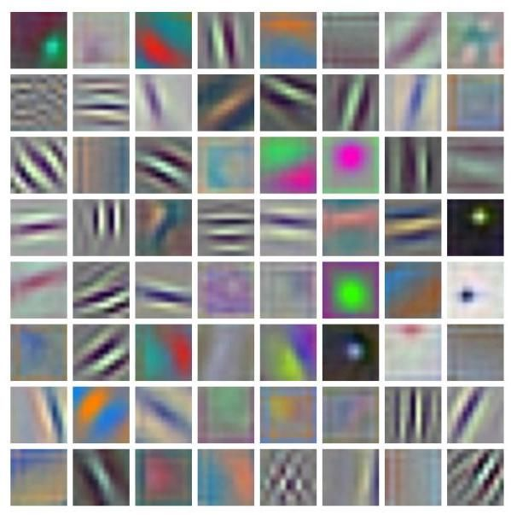

Figure 10.12 Examples of learned filters from the first layer of AlexNet. Note the remarkable similarity of many of the learned filters to the Gabor filters in Figure 10.11, which correspond to features detected by living neurons in the visual cortex of mammals.

图 10.12 AlexNet 第一层学习到的滤波器示例。注意，许多学习到的滤波器与图 10.11 中的 Gabor 滤波器有显著的相似性，后者对应于哺乳动物视觉皮层中活体神经元检测到的特征。

We can extend this technique to go beyond simply selecting image patches from the validation set and instead perform a numerical optimization over the input variables to maximize the activation of a particular unit (Zeiler and Fergus, 2013; Si-monyan, Vedaldi, and Zisserman, 2013; Yosinski et al., 2015). If we chose the unit to be one of the outputs then we can look for an image that is most representative of the corresponding class label. Because the output units generally have a softmax activation function, it is better to maximise the pre-activation value that feeds into the softmax rather than the class probability directly, as this ensures the optimization depends on only one class. For example, if we seek the image that produces the strongest response to the class ’dog’, then if we optimize the softmax output it could drive the image to be, say, less like a cat because of the denominator in the softmax. This approach is related to adversarial training. Unconstrained optimization of the output-unit activation, however, leads to individual pixel values being driven to infinity and also creates high-frequency structure that is difficult to interpret, and so some form of regularization is required to find solutions that are closer to natural images. Yosinski et al. (2015) used a regularization function comprising the sum of squares of the pixel values along with a procedure that alternates gradient-based updates to the image pixel values with a blurring operation to remove high-frequency structure and a clipping operation that sets to zero those pixel values that make only small contributions to the class label. Example results are shown in Figure 10.14.

我们可以扩展这种技术，不仅仅是从验证集中选择图像块，而是对输入变量进行数值优化，以最大化特定单元的激活值(Zeiler 和 Fergus，2013 年；Simonyan、Vedaldi 和 Zisserman，2013 年；Yosinski 等人，2015 年)。如果我们选择的单元是输出单元之一，那么我们可以寻找最能代表相应类别标签的图像。由于输出单元通常具有 softmax 激活函数，最好最大化输入到 softmax 的预激活值，而不是直接最大化类别概率，因为这样可以确保优化仅依赖于一个类别。例如，如果我们要寻找对“狗”类别产生最强响应的图像，那么如果我们优化 softmax 输出，由于 softmax 中的分母，可能会使图像变得不太像猫。这种方法与对抗训练有关。然而，对输出单元激活值进行无约束的优化会导致单个像素值趋于无穷大，并且会产生难以解释的高频结构，因此需要某种形式的正则化来找到更接近自然图像的解。Yosinski 等人(2015 年)使用了一个正则化函数，该函数由像素值的平方和组成，同时还采用了一种程序，该程序将基于梯度的图像像素值更新与模糊操作交替进行，以去除高频结构，并采用裁剪操作将那些对类别标签贡献很小的像素值设置为零。示例结果如图 10.14 所示。

Chapter 17

第 17 章

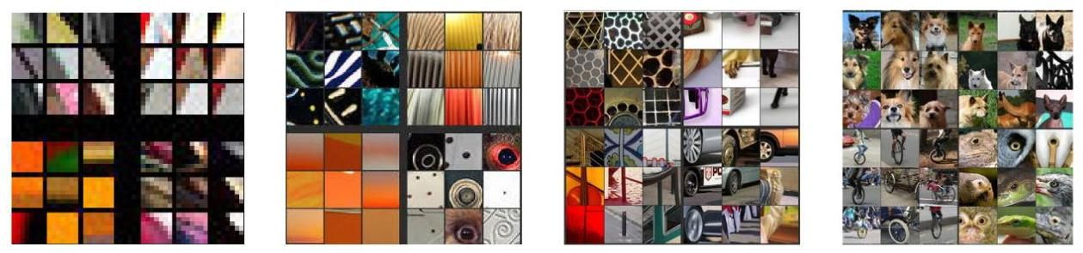

Figure 10.13 Examples of image patches (taken from a validation set) that produce the strongest activation in the hidden units in a network having five convolutional layers trained on ImageNet data. The top nine activations in each feature map are arranged as a 3 × 3 grid for four randomly chosen channels in each of the corresponding layers. We see a steady progression in complexity with depth, from simple edges in layer 1 to complete objects in layer 5. [From Zeiler and Fergus (2013) with permission.]

图 10.13 在 ImageNet 数据上训练的具有五个卷积层的网络中，在隐藏单元中产生最强激活的图像块示例(取自验证集)。每个特征图中的前九个激活值被排列成一个 3×3 的网格，对应于每个相应层中随机选择的四个通道。我们看到随着深度的增加，复杂度稳步提升，从第一层的简单边缘到第五层的完整物体。[经许可摘自 Zeiler 和 Fergus(2013 年)。]

# 10.3.3 Saliency maps

# 10.3.3 显著性图

Another way to gain insight into the features used by a convolutional network is through saliency maps, which aim to identify those regions of an image that are most significant in determining the class label. This is best done by investigating the final convolutional layer because this still retains spatial localization, which becomes lost in the subsequent fully connected layers, and yet it has the highest level of semantic representation. The Grad-CAM (gradient class activation mapping) method (Selvaraju et al., 2016) first computes, for a given input image, the derivatives of the output-unit pre-activation for a given class , before the softmax, with respect to the pre-activations of all the units in the final convolutional layer for channel . For each channel in that layer, the average of those derivatives is evaluated to give

深入了解卷积网络所使用特征的另一种方法是通过显著性图，其目的是识别图像中在确定类别标签时最重要的区域。最好通过研究最后一个卷积层来实现这一点，因为该层仍然保留了空间定位信息，而这些信息在后续的全连接层中会丢失，并且它具有最高级别的语义表示。Grad - CAM(梯度类激活映射)方法(Selvaraju 等人，2016)首先针对给定的输入图像，计算在 softmax 之前，给定类别 的输出单元预激活值 相对于通道 最后一个卷积层中所有单元的预激活值 的导数。对于该层中的每个通道，评估这些导数的平均值以得到

where and index the rows and columns of channel , and is the total number of units in that channel. These averages are then used to form a weighted sum of the

其中 和 表示通道 的行和列索引， 是该通道中单元的总数。然后使用这些平均值来形成一个加权和，形式为:

form:

形式:

in which is a matrix with elements . The resulting array has the same dimensionality as the final convolutional layer, for example for the VGG network shown in Figure 10.10, and can be superimposed on the original image in the form of a ’heat map’ as seen in Figure 10.15.

其中 是一个元素为 的矩阵。得到的数组与最后一个卷积层具有相同的维度，例如图 10.10 所示的 VGG 网络为 ，并且可以以“热图”的形式叠加在原始图像上，如图 10.15 所示。

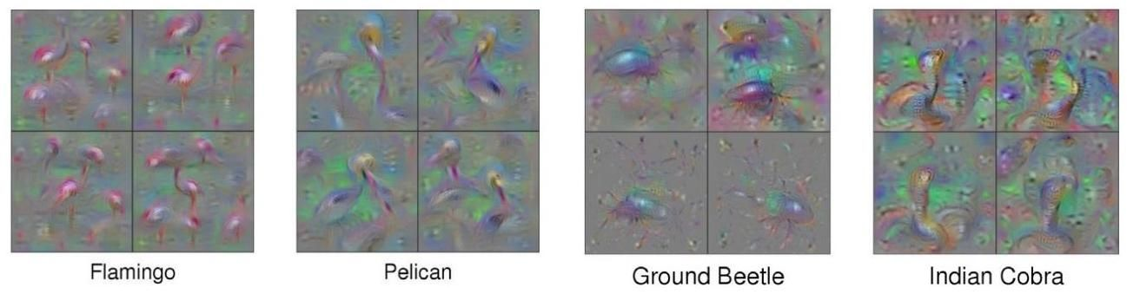

Figure 10.14 Examples of synthetic images generated by maximizing the class probability with respect to the image pixel channel values for a trained convolutional classifier. Four different solutions, obtained with different settings of the regularization parameters, are shown for each of four object classes. [From Yosinski et al. (2015) with permission.]

图 10.14 对于训练好的卷积分类器，通过相对于图像像素通道值最大化类别概率生成的合成图像示例。针对四个对象类别中的每一个，展示了通过不同正则化参数设置获得的四种不同解决方案。[经许可摘自 Yosinski 等人(2015)。]

# 10.3.4 Adversarial attacks

# 10.3.4 对抗攻击

Gradients with respect to changes in the input image pixel values can also be used to create adversarial attacks against convolutional networks (Szegedy et al., 2013). These attacks involve making very small modifications to an image, at a level that is imperceptible to a human, which cause the image to be misclassified by the neural network. One simple approach to creating adversarial images is called the fast gradient sign method (Goodfellow, Shlens, and Szegedy, 2014). This involves changing each pixel value in an image by a fixed amount with a sign determined by the gradient of an error function with respect to the pixel values. This gives a modified image defined by

关于输入图像像素值变化的梯度也可用于对卷积网络进行对抗攻击(Szegedy 等人，2013 年)。这些攻击包括对图像进行非常小的修改，这种修改程度人类难以察觉，但会导致神经网络对图像进行错误分类。创建对抗图像的一种简单方法称为快速梯度符号法(Goodfellow、Shlens 和 Szegedy，2014 年)。这涉及将图像 中的每个像素值改变一个固定量 ，其符号由误差函数 关于像素值的梯度确定。这给出了由下式定义的修改后的图像

Here is the true label of , and the error could, for example, be the negative log likelihood of . The required gradient can be computed efficiently using backpropagation. During conventional training of a neural network, the network parameters are adjusted to minimize this error, whereas the modification defined by (10.11) alters the image (while keeping the trained network parameters fixed) so as

这里 是 的真实标签，误差 例如可以是 的负对数似然。可以使用反向传播高效地计算所需的梯度。在神经网络的常规训练期间，调整网络参数以最小化此误差，而由 (10.11) 定义的修改会改变图像(同时保持训练好的网络参数固定)，从而

Chapter 8

第 8 章

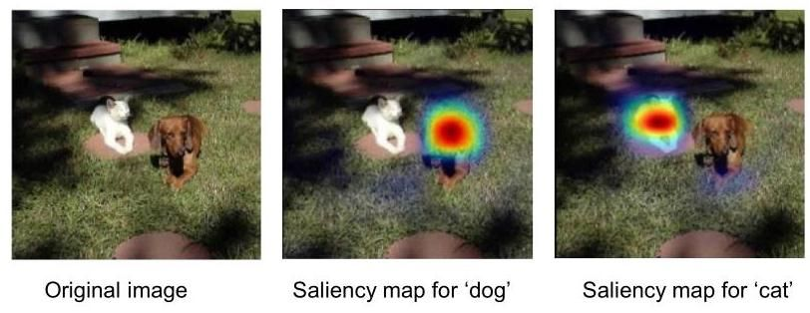

Figure 10.15 Saliency maps for the VGG-16 network with respect to the ’dog’ and ’cat’ categories. [From Sel-varaju et al. (2016) with permission.]

图 10.15 VGG - 16 网络关于“狗”和“猫”类别的显著性图。[经许可摘自 Sel - varaju 等人(2016 年)。]

Figure 10.16 Example of an adversarial attack against a trained convolutional network. The image on the left is classified as a panda with confidence . The addition of a small level of a random-looking perturbation (that itself is classified as a nematode with confidence 8.2%) results in the image on the right, which is classified as a gibbon with confidence 99.3%. [From Goodfellow, Shlens, and Szegedy (2014) with permission.] to increase the error. By keeping small, we ensure that the changes to the image are undetectable to the human eye. Remarkably, this can give images that are misclassified by the network with high confidence, as seen in the example in Figure 10.16.

图 10.16 对训练好的卷积网络进行对抗攻击的示例。左侧的图像被分类为熊猫，置信度为 。添加少量看似随机的扰动(该扰动本身被分类为线虫，置信度为 8.2%)后得到右侧的图像，该图像被分类为长臂猿，置信度为 99.3%。[经许可摘自 Goodfellow、Shlens 和 Szegedy(2014 年)。]以增加误差。通过保持 较小，我们确保图像的变化对人眼不可察觉。值得注意的是，这可以得到被网络高置信度错误分类的图像，如图 10.16 中的示例所示。

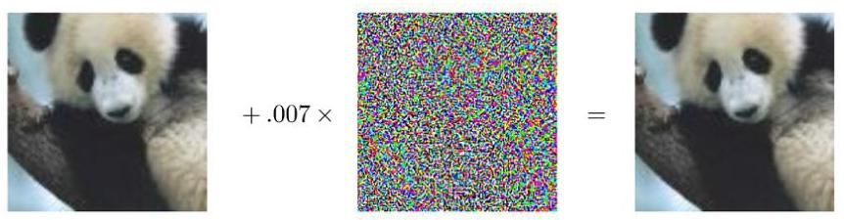

The ability to fool neural networks in this way raises potential security concerns as it creates opportunities for attacking trained classifiers. It might appear that this issue arises from over-fitting, in which a high-capacity model has adapted precisely to the specific image such that small changes in the input produce large changes in the predicted class probabilities. However, it turns out that an image that has been adapted to give a spurious output for a particular trained network can give similarly spurious outputs when fed to other networks (Goodfellow, Shlens, and Szegedy, 2014). Moreover, a similar adversarial result can be obtained with much less flexible linear models. It is even possible to create physical artefacts such that a regular, uncorrupted image of the artefact will give erroneous predictions when presented to a trained neural network, as seen in Figure 10.17. Although these basic kinds of adversarial attacks can be addressed by simple modifications to the network training process, more sophisticated approaches are harder to defeat. Understanding the implications of these results and mitigating their potential pitfalls remain open areas of research.

以这种方式欺骗神经网络的能力引发了潜在的安全担忧，因为它为攻击经过训练的分类器创造了机会。这个问题似乎源于过拟合，即高容量模型精确地适应了特定图像，以至于输入的微小变化会导致预测类别概率的巨大变化。然而，事实证明，针对特定训练网络进行调整以产生虚假输出的图像，在输入到其他网络时也会产生类似的虚假输出(Goodfellow、Shlens 和 Szegedy，2014)。此外，使用灵活性低得多的线性模型也可以获得类似的对抗性结果。甚至有可能创建物理制品，使得该制品的正常、未损坏图像在呈现给经过训练的神经网络时会给出错误的预测，如图 10.17 所示。尽管可以通过对网络训练过程进行简单修改来应对这些基本类型的对抗性攻击，但更复杂的方法则更难被击败。理解这些结果的影响并减轻其潜在风险仍然是有待研究的领域。

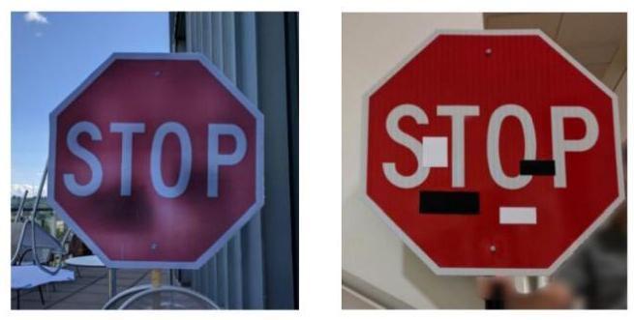

Figure 10.17 Two examples of physical stop signs that have been modified. Images of these objects are robustly classified as speed-limit signs by CNNs. [From Eykholt et al. (2018) with permission.]

图 10.17 两个经过修改的物理停车标志示例。卷积神经网络(CNNs)将这些物体的图像稳健地分类为 限速标志。[经许可改编自 Eykholt 等人(2018)。]

# 10.3.5 Synthetic images

# 10.3.5 合成图像

As a final example of image modification that provides additional insights into the operation of a trained convolutional network, we consider a technique called DeepDream (Mordvintsev, Olah, and Tyka, 2015). The goal is to generate a synthetic image with exaggerated characteristics. We do this by determining which nodes in a particular hidden layer of the network respond strongly to a particular image and then modifying the image to amplify those responses. For example, if we present an image of some clouds to a network trained on object recognition and a particular node detects a cat-like pattern at a particular region of the image, then we modify the image to be more ’cat like’ in that region. To do this, we apply an image to the input of the network and forward propagate through to some particular layer. We then set the backpropagation variables for that layer equal to the pre-activations of the nodes and run backpropagation to the input layer to get a gradient vector over the pixels of the image. Finally, we modify the image by taking a small step in the direction of the gradient vector. This procedure can be viewed as a gradient-based method for increasing the function

作为为深入了解经过训练的卷积网络的运行提供额外见解的图像修改的最后一个示例，我们考虑一种称为深度梦境(DeepDream)的技术(Mordvintsev、Olah 和 Tyka，2015)。其目标是生成具有夸张特征的合成图像。我们通过确定网络特定隐藏层中的哪些节点对特定图像有强烈响应，然后修改图像以放大这些响应来实现这一目标。例如，如果我们将一些云朵的图像输入到一个经过物体识别训练的网络中，并且某个特定节点在图像的特定区域检测到类似猫的图案，那么我们就修改该图像，使其在该区域更“像猫”。为此，我们将一幅图像输入到网络中，并向前传播到某个特定层。然后，我们将该层的反向传播 变量设置为节点的预激活值，并向输入层进行反向传播，以获得图像像素上的梯度向量。最后，我们沿着梯度向量的方向进行小步修改图像。这个过程可以看作是一种基于梯度的方法，用于增加函数

Section 8.1.2

第 8.1.2 节

Exercise 10.10

练习 10.10

where is the pre-activation of the unit in row and column of channel in the chosen layer when the input image is , and the sum is over all units and over all channels in that layer. To generate smooth-looking images, some regularization is applied in the form of spatial smoothing and pixel clipping. This process can then be repeated multiple times if stronger enhancements are desired. Examples of the resulting image are shown in Figure 10.18. It is interesting that even though convolutional networks are trained to discriminate between object classes, they seem able to capture at least some of the information needed to generate images from those classes.

其中 是当输入图像为 时，所选层中通道 的第 行和第 列的单元的预激活值，并且求和是对该层中的所有单元和所有通道进行的。为了生成外观平滑的图像，会以空间平滑和像素裁剪的形式应用一些正则化方法。如果需要更强的增强效果，这个过程可以重复多次。生成图像的示例如图 10.18 所示。有趣的是，尽管卷积网络是为区分对象类别而训练的，但它们似乎能够捕捉到至少一些从这些类别生成图像所需的信息。

This technique can be applied to a photograph, or we can start with inputs consisting of random noise to obtain an image generated entirely from the trained network. Although DeepDream provides some insights into the operation of the trained network, it has primarily been used to generate interesting looking images as a form of artwork.

这种技术可以应用于照片，或者我们可以从由随机噪声组成的输入开始，以获得完全从训练好的网络生成的图像。虽然 DeepDream 为训练好的网络的运行提供了一些见解，但它主要被用于生成具有艺术感的有趣图像。

# 10.4. Object Detection

# 10.4. 目标检测

We have motivated the design of CNNs primarily by the image classification problem, in which an entire image is assigned to a single class, for example ’cat’ or ’bicycle’. This is reasonable for data sets such as ImageNet where, by design, each image is dominated by a single object. However, there are many other applications for CNNs that are able to exploit the inbuilt inductive biases. More generally, the convolutional layers of a CNN trained on a large image data base for a particular task can learn internal representations that have broad applicability, and therefore a CNN can be fine-tuned for a wide range of specific tasks. We have already seen an example of a convolutional network trained on ImageNet data, which through transfer learning was able to achieve human-level performance on skin lesion classification.

我们主要通过图像分类问题来推动卷积神经网络(CNN)的设计，在图像分类问题中，整个图像被分配到一个单一的类别，例如“猫”或“自行车”。对于像 ImageNet 这样的数据集来说，这是合理的，因为从设计上看，每个图像主要由一个对象主导。然而，CNN 还有许多其他应用可以利用其内置的归纳偏置。更一般地说，在大型图像数据库上针对特定任务训练的 CNN 的卷积层可以学习具有广泛适用性的内部表示，因此 CNN 可以针对各种特定任务进行微调。我们已经看到了一个在 ImageNet 数据上训练的卷积网络的例子，通过迁移学习，它能够在皮肤病变分类上达到人类水平的性能。

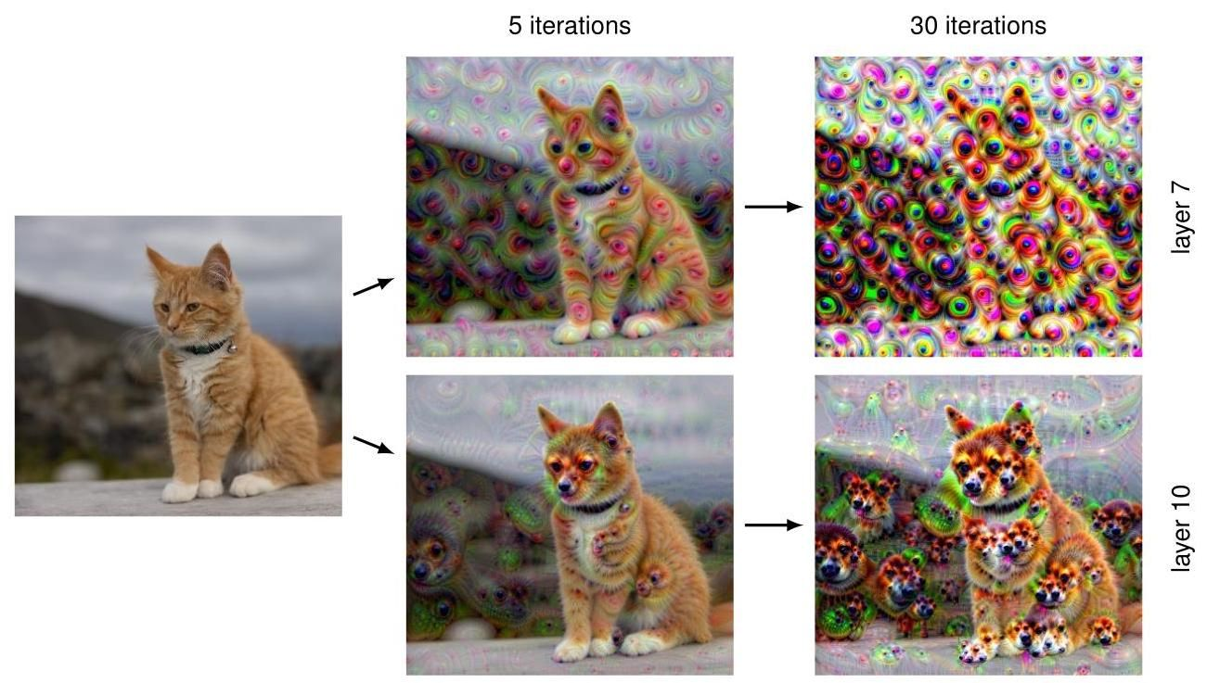

Figure 10.18 Examples of DeepDream applied to an image. The top row shows outputs when the algorithm is applied using the activations from the 7th convolutional layer of the VGG-16 network after five iterations and after 30 iterations. Similarly, the bottom row shows examples using the 10th layer, again after five iterations and after 30 iterations.

图 10.18 DeepDream 应用于图像的示例。顶行显示了在 VGG - 16 网络的第 7 个卷积层的激活值下，算法分别迭代 5 次和 30 次后的输出。同样，底行显示了使用第 10 层的示例，也是分别迭代 5 次和 30 次后的结果。

Section 6.3.4

6.3.4 节

Section 1.1.1

第 1.1.1 节

# 10.4.1 Bounding boxes

# 10.4.1 边界框

Many images have multiple objects belonging to one or more classes, and we may wish to detect the presence and class of each object. Moreover, in many applications of computer vision we also need to determine the locations within the image of any objects that are detected. For example, an autonomous vehicle that uses RGB cameras may need to detect the presence and location of pedestrians and also identify road signs, other vehicles, etc.

许多图像包含多个属于一个或多个类别的对象，我们可能希望检测每个对象的存在和类别。此外，在计算机视觉的许多应用中，我们还需要确定检测到的任何对象在图像中的位置。例如，使用 RGB 相机的自动驾驶车辆可能需要检测行人的存在和位置，还需要识别路标、其他车辆等。

Consider the problem of specifying the location of an object in an image. A widely used approach is to define a bounding box, which consists of a rectangle that fits closely to the boundary of the object, as illustrated in Figure 10.19. The bounding box can be defined by the coordinates of its centre along with its width and height in the form of a vector . Here the elements of can be specified in terms of pixels or as continuous numbers where, by convention, the top left of the image is given coordinates and the bottom right is given coordinates .

考虑在图像中指定对象位置的问题。一种广泛使用的方法是定义一个边界框，它由一个紧密贴合对象边界的矩形组成，如图 10.19 所示。边界框可以通过其中心坐标以及宽度和高度以向量 的形式来定义。这里 的元素可以用像素表示，也可以用连续数字表示，按照惯例，图像的左上角坐标为 ，右下角坐标为 。

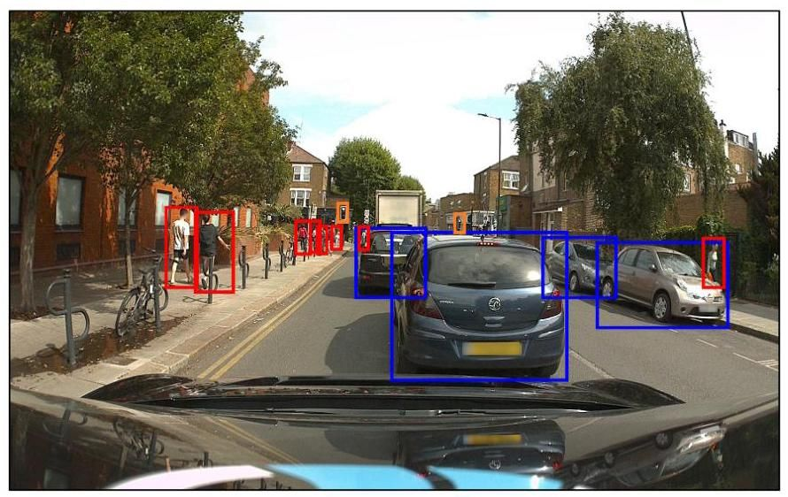

Figure 10.19 An image containing several objects from different classes in which the location of each object is labelled by a close-fitting rectangle known as a bounding box. Here blue boxes correspond to the class ’car’, red boxes to the class ’pedestrian’, and orange boxes to the class ’traffic light’. [Original image courtesy of Wayve Technologies Ltd.]

图 10.19 一幅包含来自不同类别的多个对象的图像，其中每个对象的位置都用一个紧密贴合的矩形(即边界框)标记。这里蓝色框对应“汽车”类别，红色框对应“行人”类别，橙色框对应“交通信号灯”类别。[原始图像由 Wayve Technologies Ltd. 提供。]

When images are assumed to contain one, and only one, object drawn from a predefined set of classes, a CNN will generally have output units whose

当假设图像包含且仅包含一个从预定义的 个类别集合中选取的对象时，卷积神经网络通常会有 个输出单元，其

# Section 5.3

# 5.3 节

activation functions are defined by the softmax function. An object can be localized by using an additional four outputs, with linear activation functions trained to predict the bounding box coordinates . Since these quantities are continuous, a sum-of-squares error function over the corresponding outputs may be appropriate. This is used for example by Redmon et al. (2015), who first divide the image into a grid. For each grid cell, they use a convolutional network to output the class and bounding box coordinates of any object associated with that grid cell, based on features taken from the whole image.

激活函数由 softmax 函数定义。可以使用额外的四个输出对对象进行定位，这些输出采用线性激活函数，经过训练以预测边界框坐标 。由于这些量是连续的，因此对相应输出使用平方和误差函数可能是合适的。例如，Redmon 等人(2015 年)就采用了这种方法，他们首先将图像划分为 网格。对于每个网格单元，他们使用卷积网络根据从整个图像中提取的特征，输出与该网格单元相关的任何对象的类别和边界框坐标。

# 10.4.2 Intersection-over-union

# 10.4.2 交并比

We need a meaningful way to measure the performance of a trained network that can predict bounding boxes. In image classification the output of the network is a probability distribution over class labels, and we can measure performance by looking at the log likelihood for the true class labels on a test set. For object localization, however, we need some way to measure the accuracy of a bounding box relative to some ground truth, where the latter could, for example, be obtained by human labelling. The extent to which the predicted and target boxes overlap can be used as the basis for such a measure, but the area of the overlap will depend on the size of the object within the image. Also a predicted bounding box should be be penalized for the region of the prediction that lies outside the ground truth bounding box. A better metric that addresses both of these issues is called intersection-over-union, or IoU, and is simply the ratio of the area of the intersection of the two bounding boxes

我们需要一种有意义的方法来衡量能够预测边界框的训练网络的性能。在图像分类中，网络的输出是类别标签上的概率分布，我们可以通过查看测试集上真实类别标签的对数似然来衡量性能。然而，对于对象定位，我们需要某种方法来衡量预测边界框相对于某个真实标注的准确性，后者例如可以通过人工标注获得。预测框和目标框的重叠程度可以作为这种衡量方法的基础，但重叠区域的面积将取决于图像中对象的大小。此外，预测边界框超出真实边界框的部分应该受到惩罚。一种能解决这两个问题的更好指标称为交并比(IoU)，它仅仅是两个边界框交集面积与并集面积的比值。

Figure 10.20 Illustration of the intersection-over-union metric for quantifying the accuracy of a bounding box prediction. If the predicted bounding box is shown by the blue rectangle and the ground truth by the red rectangle, then the intersection-over-union is defined as the ratio of the area of the intersection of the boxes, shown in green on the left, divided by the area of their union, shown in green on the right. to that of their union, as illustrated in Figure 10.20. Note that the IoU measure lies in the range 0 to 1 . Predictions can be labelled as correct if the IoU measure exceeds a threshold, which is typically set at 0.5 . Note that IoU is not generally used directly as a loss function for training as it is hard to optimize by gradient descent, and so training is typically performed using centred objects, and the IoU score is mainly used an evaluation metric.

图 10.20 用于量化边界框预测准确性的交并比指标示意图。如果预测边界框用蓝色矩形表示，真实边界框用红色矩形表示，那么交并比定义为两个框交集面积(左图中绿色部分)与它们并集面积(右图中绿色部分)的比值，如图 10.20 所示。请注意，IoU 指标的取值范围是 0 到 1。如果 IoU 指标超过某个阈值(通常设置为 0.5)，则预测可以被标记为正确。需要注意的是，IoU 通常不直接用作训练的损失函数，因为通过梯度下降法对其进行优化比较困难，因此训练通常使用居中对象进行，而 IoU 分数主要用作评估指标。

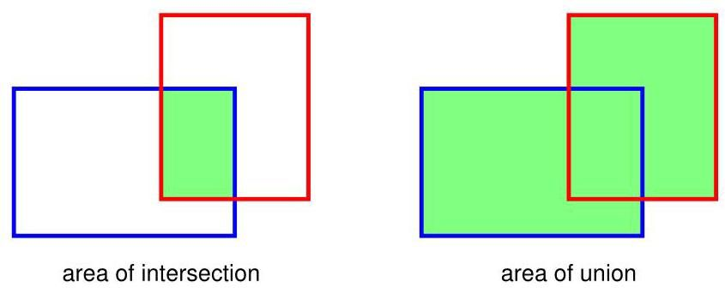

# 10.4.3 Sliding windows

# 10.4.3 滑动窗口

One approach to object detection and object localization starts by creating a training set consisting of tightly cropped examples of the object to be detected, as well as examples of similarly cropped sections of images that do not contain any object (the ’background’ class). This data set is used to train a classifier, such as a deep CNN, whose outputs represent the probability of there being an object of each particular class in the input window. The trained model is then used to detect objects in a new image by ’scanning’ an input window across the image and, for each location, taking the resulting subset of the image as input to the classifier. This is called a sliding window. When an object is detected with high probability, the associated window location then defines the corresponding bounding box.

一种目标检测和目标定位的方法是，首先创建一个训练集，该训练集由待检测目标的紧密裁剪示例以及不包含任何目标的图像裁剪区域示例(即“背景”类别)组成。这个数据集用于训练一个分类器，比如深度卷积神经网络(CNN)，其输出表示输入窗口中存在每个特定类别目标的概率。然后，通过在新图像上“扫描”输入窗口，并将每个位置对应的图像子集作为输入传递给分类器，使用训练好的模型在新图像中检测目标。这被称为滑动窗口。当以高概率检测到目标时，相关的窗口位置就定义了相应的边界框。

One obvious drawback of this approach is that it can be computationally very costly due to the large number of potential window positions in the image. Furthermore, the process may have to be repeated using windows of various scales to allow for different sizes of object within the image. A cost saving can be made by moving the input window in strides across the image, both horizontally and vertically, which are larger than one pixel. However, there is a trade-off between precision of location using a small stride and reducing the computational cost by using a larger stride. The computational cost of a sliding window approach may be reasonable for simple classifiers, but for deep neural networks potentially containing millions of parameters, the cost of a naive implementation can be prohibitive.

这种方法的一个明显缺点是，由于图像中潜在的窗口位置数量众多，计算成本可能非常高。此外，可能需要使用不同尺度的窗口重复该过程，以适应图像中不同大小的目标。通过在图像上以大于一个像素的步长水平和垂直移动输入窗口，可以节省计算成本。然而，使用小步长进行精确定位和使用大步长降低计算成本之间存在权衡。对于简单的分类器，滑动窗口方法的计算成本可能是合理的，但对于可能包含数百万个参数的深度神经网络，简单实现的成本可能高得令人望而却步。

Fortunately, the convolutional structure of the neural network allows for a dramatic improvement in efficiency (Sermanet et al., 2013). We note that a convolutional layer within such a network itself involves sliding a feature detector, with shared weights, across the input image in strides. Consequently, when a sliding window is used to generate multiple forward passes through a convolutional network there is substantial redundancy in the computation, as illustrated in Figure 10.21.

幸运的是，神经网络的卷积结构可以显著提高效率(Sermanet 等人，2013)。我们注意到，这种网络中的卷积层本身就涉及以一定步长在输入图像上滑动具有共享权重的特征检测器。因此，当使用滑动窗口在卷积网络中进行多次前向传播时，计算中存在大量冗余，如图 10.21 所示。

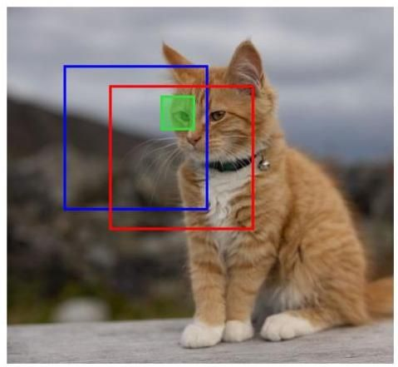

Figure 10.21 Illustration of replicated calculations when a CNN is used to process data from a sliding input window, in which the red and blue boxes show two overlapping locations for the input window. The green box represents one of the locations for the receptive field of a hidden unit in the first convolutional layer, and the evaluation of the corresponding hidden-unit activation is shared across the two window positions.

图 10.21 展示了使用卷积神经网络(CNN)处理滑动输入窗口数据时的重复计算情况，其中红色和蓝色框表示输入窗口的两个重叠位置。绿色框表示第一个卷积层中一个隐藏单元的感受野位置之一，并且相应隐藏单元激活值的计算在两个窗口位置之间是共享的。

Because the computational structure of sliding windows mirrors that of convolutions, it turns out to be remarkably simple to implement sliding windows efficiently in a convolutional network. Consider the simplified convolutional network in Figure 10.22, which consists of a convolutional layer followed by a max-pooling layer followed by a fully connected layer. For simplicity we have shown only a single channel in each layer, but the extension to multiple channels is straightforward. The input image to the network has size , the filters in the convolutional layer have size with stride 1, and the max-pooling layer has non-overlapping receptive fields of size with stride 1 . This is followed by a fully connected layer with a single output unit. Note that we can also view this final layer as another convolutional layer with a filter size that is , so that there is only a single position for the filter and hence a single output.

由于滑动窗口的计算结构与卷积的计算结构相似，因此在卷积网络中高效实现滑动窗口实际上非常简单。考虑图 10.22 中的简化卷积网络，它由一个卷积层、一个最大池化层和一个全连接层组成。为简单起见，我们在每层中只显示了一个通道，但扩展到多个通道很直接。网络的输入图像大小为 ，卷积层中的滤波器大小为 ，步长为 1，最大池化层具有大小为 、步长为 1 的非重叠感受野。随后是一个具有单个输出单元的全连接层。请注意，我们也可以将这个最后一层视为另一个滤波器大小为 的卷积层，这样滤波器就只有一个位置，因此只有一个输出。

Now suppose this network is trained on centred images of objects and then applied to a larger image of size , as shown in Figure 10.23 in which we simply enlarge the network by increasing the size of the convolutional and max-pooling layers. The convolution layer now has size and the pooling layer has size significant increase in efficiency compared to a naive repeated application of the full convolutional structure.

现在假设这个网络在目标居中的图像上进行训练，然后应用于大小为 的更大图像，如图 10.23 所示，我们通过增加卷积层和最大池化层的大小来扩展网络。现在卷积层的大小为 ，池化层的大小与简单重复应用完整卷积结构相比，效率有显著提高。

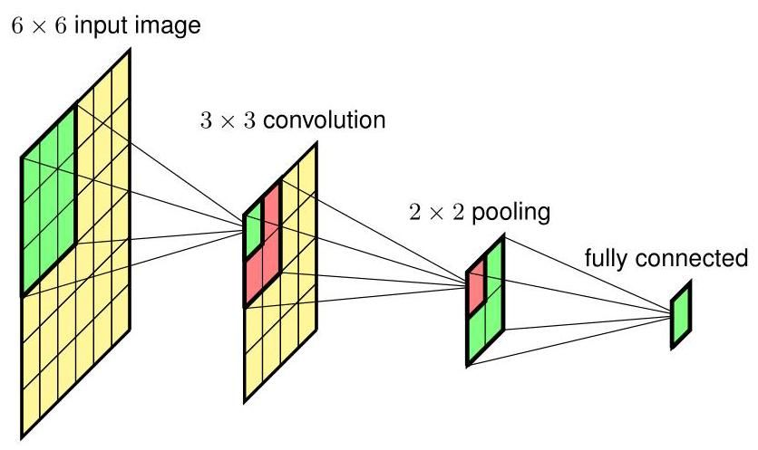

Figure 10.22 Example of a simple convolutional network having a single channel at each layer used to illustrate the concept of a sliding window for detecting objects in images.

图 10.22 一个简单卷积网络的示例，该网络每层只有一个通道，用于说明在图像中检测物体的滑动窗口概念。

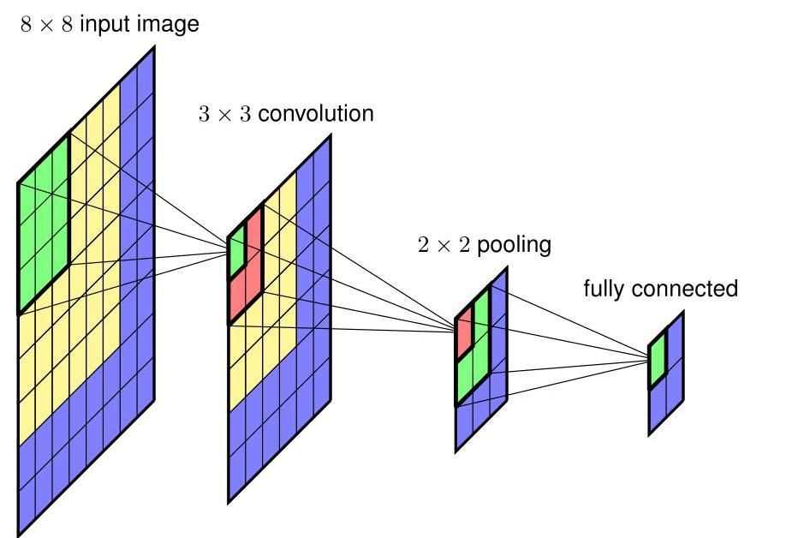

Figure 10.23 Application of the network shown in Figure 10.22 to a larger image in which the additional computation required corresponds to the blue regions.

图 10.23 将图 10.22 所示的网络应用于更大的图像，其中所需的额外计算对应于蓝色区域。

Exercise 10.12

练习 10.12

# 10.4.4 Detection across scales

# 10.4.4 跨尺度检测

As well as looking for objects in different positions in the image, we also need to look for objects at different scales and at different aspect ratios. For example, a tight bounding box drawn around a cat will have a different aspect ratio when the cat is sitting upright compared to when it is lying down. Instead of using multiple detectors with different sizes and shapes of input window, it is simpler but equivalent image space, as illustrated in Figure 10.24.

除了在图像的不同位置寻找物体外，我们还需要在不同尺度和不同纵横比下寻找物体。例如，当猫直立坐着时，围绕它绘制的紧密边界框与它躺下时的纵横比不同。与其使用多个具有不同大小和形状输入窗口的检测器，在图像空间中采用更简单但等效的方法，如图 10.24 所示。

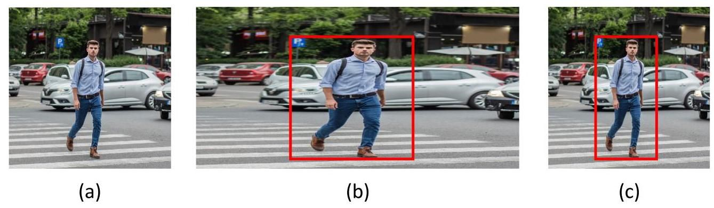

Figure 10.24 Illustration of the detection and localization of objects at multiple scales and aspect ratios using a fixed input window. The original image (a) is replicated multiple times and each copy is scaled in the horizontal and/or vertical directions, as illustrated for a horizontal scaling in (b). A fixed-sized window is then scanned over the scaled images. When an object is detected with high probability, as illustrated by the red box in (b), the corresponding window coordinates can be projected back into the original image space to determine the corresponding bounding box as shown in (c).

图 10.24 展示了如何使用固定输入窗口在多个尺度和纵横比下检测和定位物体。原始图像 (a) 被多次复制，并且每个副本在水平和/或垂直方向上进行缩放，如 (b) 中水平缩放所示。然后在缩放后的图像上扫描固定大小的窗口。当以高概率检测到物体时，如 (b) 中的红色框所示，相应的窗口坐标可以投影回原始图像空间，以确定如图 (c) 所示的相应边界框。

# 10.4.5 Non-max suppression

# 10.4.5 非极大值抑制

By scanning a trained convolutional network over an image, it is possible to detect multiple instances of the same class of object within the image as well as instances of objects from other classes. However, this also tends to produce multiple detections of the same object at similar locations, as illustrated in Figure 10.25. This can be addressed using non-max suppression, which, for each object class in turn, works as follows. It first runs the sliding window over the whole image and evaluates the probability of an object of that class being present at each location. Next it eliminates all the associated bounding boxes whose probability is below some threshold, say 0.7, giving a result of the kind illustrated in Figure 10.25. The box with the highest probability is considered to be a successful detection, and the corresponding bounding box is recorded as a prediction. Next, any other boxes whose IoU with the successful detection box exceeds some threshold, say 0.5, is discarded. This is intended to eliminate multiple nearby detections of the same object. Then of the remaining boxes, the one with the highest probability is declared to be another successful detection, and the elimination step is repeated. The process continues until all bounding boxes have either been discarded or declared as successful detections.

通过在图像上扫描训练好的卷积网络，可以检测到图像中同一类对象的多个实例以及其他类对象的实例。然而，这也往往会在相似位置产生同一对象的多次检测结果，如图 10.25 所示。这可以通过非极大值抑制来解决，该方法依次对每个对象类别按以下步骤操作。首先，它在整个图像上运行滑动窗口，并评估该类对象在每个位置出现的概率。接下来，它消除所有概率低于某个阈值(例如 0.7)的相关边界框，得到如图 10.25 所示的结果。概率最高的框被视为成功检测，相应的边界框被记录为预测结果。然后，任何与成功检测框的交并比(IoU)超过某个阈值(例如 0.5)的其他框都将被丢弃。这旨在消除同一对象在附近的多次检测结果。接着，在剩余的框中，概率最高的框被宣布为另一次成功检测，并重复消除步骤。这个过程会一直持续，直到所有边界框要么被丢弃，要么被宣布为成功检测。

# 10.4.6 Fast region CNNs

# 10.4.6 快速区域卷积神经网络

Another way to speed up object detection and localization is to note that a scanning window approach applies the full power of a deep convolutional network to all areas of the image, even though some areas may be unlikely to contain an object. Instead, we can apply some form of computationally cheaper technique, for example a segmentation algorithm, to identify parts of the image where there is a higher probability of finding an object, and then apply the full network only to these areas, leading to techniques such as fast region proposals with or fast

另一种加速对象检测和定位的方法是注意到扫描窗口方法会将深度卷积网络的全部能力应用于图像的所有区域，即使某些区域不太可能包含对象。相反，我们可以应用某种计算成本较低的技术，例如分割算法，来识别图像中更有可能找到对象的部分，然后仅将完整网络应用于这些区域，从而产生了诸如使用 的快速区域提议或快速 等技术。

Figure 10.25 (Girshick, 2015). It is also possible to use a region proposal convolutional network to identify the most promising regions, leading to faster R-CNN (Ren et al., 2015), which allows end-to-end training of both the region proposal network and the detection and localization network.

图 10.25(Girshick，2015)。也可以使用区域提议卷积网络来识别最有希望的区域，从而产生更快的 R-CNN(Ren 等人，2015)，该方法允许对区域提议网络以及检测和定位网络进行端到端训练。

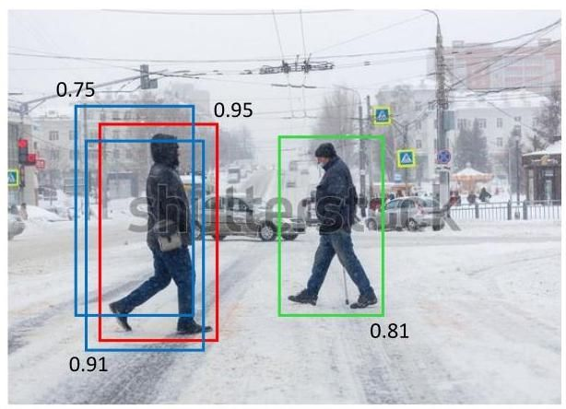

Schematic illustration of multiple detections of the same object at nearby locations, along with their associated probabilities. The red bounding box corresponds to the highest overall probability. Non-max suppression eliminates the other overlapping candidate bounding boxes shown in blue, while preserving the detection of another instance of the same object class shown by the bounding box in green.

同一对象在附近位置的多次检测的示意图，以及它们相关的概率。红色边界框对应于总体最高概率。非极大值抑制消除了其他蓝色显示的重叠候选边界框，同时保留了绿色边界框所示的同一对象类别的另一个实例的检测结果。

A disadvantage of the sliding window approach is that if we want a very precise localization the objects then we need to consider large numbers of finely spaced window positions, which becomes computationally costly. A more efficient approach is to combine sliding windows with the direct bounding box predictions that we discussed at the start of this section (Sermanet et al., 2013). In this case, the continuous outputs predict the position of the bounding box relative to the window position and therefore provide some fine-tuning to the predicted position.

滑动窗口方法的一个缺点是，如果我们想要非常精确地定位对象，那么我们需要考虑大量间隔精细的窗口位置，这在计算上成本很高。一种更有效的方法是将滑动窗口与我们在本节开头讨论的直接边界框预测相结合(Sermanet 等人，2013 年)。在这种情况下，连续输出预测边界框相对于窗口位置的位置，因此对预测位置进行了一些微调。

# 10.5. Image Segmentation

# 10.5. 图像分割

In an image classification problem, an entire image is assigned to a single class label. We have seen that more detailed information is provided if multiple objects are detected and their positions recorded using bounding boxes. An even more detailed analysis is obtained with semantic segmentation in which every pixel of an image is assigned to one of a predefined set of classes. This means that the output space will have the same dimensionality as the input image and can therefore be conveniently represented as an image with the same number of pixels. Although the input image will generally have three channels for , and , the output array will have channels, if there are classes, representing the probability for each class. If we associate a different (arbitrarily chosen) colour with each class, then the prediction of a segmentation network can be represented as an image in which each pixel is coloured according to the class having the highest probability, as illustrated in Figure 10.26.

在图像分类问题中，整个图像被分配到一个单一的类别标签。我们已经看到，如果检测到多个对象并使用边界框记录它们的位置，则会提供更详细的信息。通过语义分割可以获得更详细的分析，其中图像的每个像素都被分配到一组预定义的类别中。这意味着输出空间将与输入图像具有相同的维度，因此可以方便地表示为具有相同像素数的图像。尽管输入图像通常对于 和 有三个通道，但如果有 个类别，输出数组将有 个通道，表示每个类别的概率。如果我们为每个类别关联一种不同的(任意选择的)颜色，那么分割网络的预测可以表示为一幅图像，其中每个像素根据具有最高概率的类别进行着色，如图 10.26 所示。

Section 10.4

第 10.4 节

# 10.5.1 Convolutional segmentation

# 10.5.1 卷积分割

A simple way to approach a semantic segmentation problem would be to construct a convolutional network that takes as input a rectangular section of the image centred on a pixel and that has a single softmax output that classifies that pixel. By applying such a network to each pixel in turn, the entire image can be segmented (this would require edge padding around the image depending on the size of the input window). However, this approach would be extremely inefficient due to redun-

处理语义分割问题的一种简单方法是构建一个卷积网络，该网络以图像中以某个像素为中心的矩形区域作为输入，并具有一个单一的 softmax 输出，用于对该像素进行分类。通过依次将这样的网络应用于每个像素，可以对整个图像进行分割(根据输入窗口的大小，这可能需要在图像周围进行边缘填充)。然而，由于冗余，这种方法效率极低。

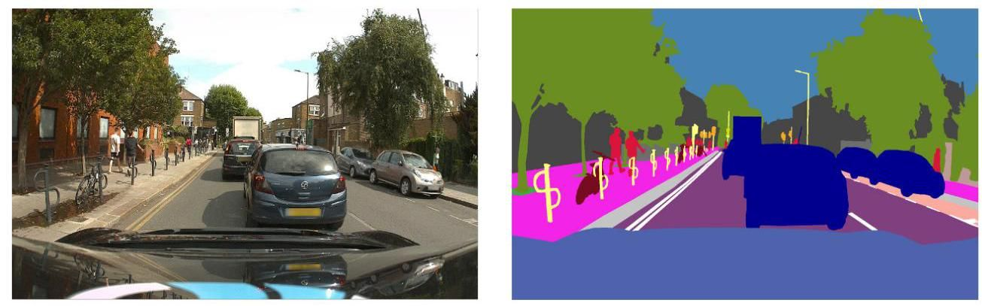

Figure 10.26 Example of an image and its corresponding semantic segmentation in which each pixel is coloured according to its class. For example, blue pixels correspond to the class ’car’, red pixels to the class ’pedestrian’, and orange pixels to the class ’traffic light’. [Courtesy of Wayve Technologies Ltd.]

图 10.26 一幅图像及其对应的语义分割示例，其中每个像素根据其类别进行着色。例如，蓝色像素对应于“汽车”类别，红色像素对应于“行人”类别，橙色像素对应于“交通信号灯”类别。[图片由 Wayve Technologies Ltd. 提供]

# Figure 10.21

# 图 10.21

dant calculations caused by overlapping patches. As we have seen, we can remove this inefficiency by grouping together the forward-pass calculations for different input locations into a single network, which results in a model in which the final fully connected layers are also convolutional. We could therefore create a CNN in which each layer has the same dimensionality as the input image, by having stride 1 at each layer with same padding and no pooling. Each output unit has a softmax activation function with weights that are shared across all outputs. Although this could work, such a network would still need many layers, with multiple channels in each layer, to learn the complex internal representations needed to achieve high accuracy, and overall this would be prohibitively costly for images of reasonable resolution.

由重叠补丁导致的冗余计算。正如我们所见，我们可以通过将不同输入位置的前向传播计算组合到单个网络中来消除这种低效性，这会得到一个最终全连接层也是卷积层的模型。因此，我们可以创建一个卷积神经网络(CNN)，其中每一层的维度都与输入图像相同，方法是在每一层使用步长为 1 且采用相同填充方式，并且不进行池化操作。每个输出单元都有一个 softmax 激活函数，其权重在所有输出之间共享。虽然这可能可行，但这样的网络仍然需要很多层，每层有多个通道，才能学习到实现高精度所需的复杂内部表示，而且总体而言，对于具有合理分辨率的图像来说，这将是成本过高的。

Figure 10.23

图 10.23

# 10.5.2 Up-sampling

# 10.5.2 上采样

As we have already seen, most convolutional networks use several levels of down-sampling so that as the number of channels increases, the size of the feature maps decreases, keeping the overall size and cost of the network tractable, while allowing the network to extract semantically meaningful high-order features from the image. We can use this concept to create a more efficient architecture for semantic segmentation by taking a standard deep convolutional network and adding additional learnable layers that take the low-dimensional internal representation and transform it back up to the original image resolution (Long, Shelhamer, and Darrell, 2014; Noh, Hong, and Han, 2015; Badrinarayanan, Kendall, and Cipolla, 2015), as illustrated in Figure 10.27.

正如我们已经看到的，大多数卷积网络使用多个级别的下采样，这样随着通道数量的增加，特征图的大小会减小，从而使网络的总体规模和成本可控，同时允许网络从图像中提取具有语义意义的高阶特征。我们可以利用这个概念为语义分割创建一个更高效的架构，方法是采用一个标准的深度卷积网络，并添加额外的可学习层，这些层将低维内部表示转换回原始图像分辨率(Long、Shelhamer 和 Darrell，2014 年；Noh、Hong 和 Han，2015 年；Badrinarayanan、Kendall 和 Cipolla，2015 年)，如图 10.27 所示。

To do this we need a way to reverse the down-sampling effects of strided convolutions and pooling operations. Consider first the up-sampling analogue of pooling, where the output layer has a larger number of units than the input layer, for example with each input unit corresponding to a block of output units. The question is then what values to use for the outputs. To find an up-sampling analogue of average pooling, we can simply copy over each input value into all the corresponding output units, as shown in Figure 10.28(a). We see that applying average pooling to the output of this operation regenerates the input.

为此，我们需要一种方法来逆转步幅卷积和池化操作的下采样效果。首先考虑池化的上采样类比，即输出层的单元数量比输入层多，例如每个输入单元对应一个 输出单元块。那么问题就变成了输出应该使用什么值。为了找到平均池化的上采样类比，我们可以简单地将每个输入值复制到所有对应的输出单元中，如图 10.28(a) 所示。我们发现对该操作的输出应用平均池化会重新生成输入。

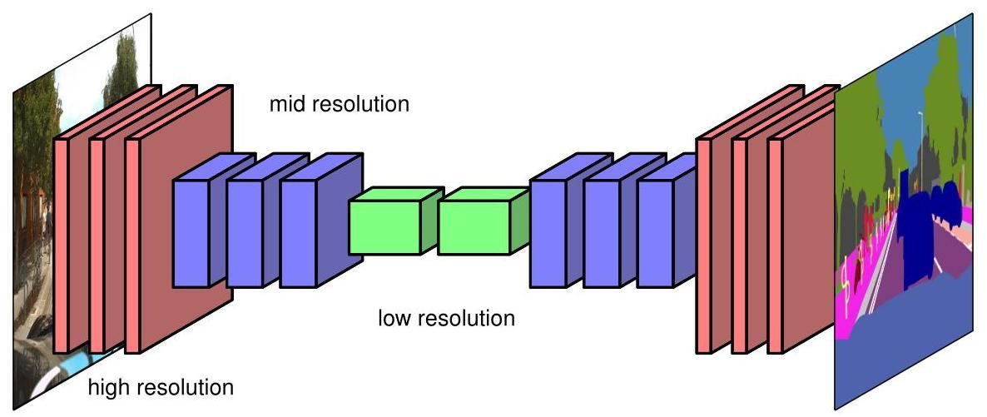

Figure 10.27 Illustration of a convolutional neural network used for semantic image segmentation, showing the reduction in the dimensionality of the feature maps through a series of strided convolutions and/or pooling operations, followed by a series of transpose convolutions and/or unpooling which increase the dimensionality back up to that of the original image.

图 10.27 展示了用于语义图像分割的卷积神经网络，显示了通过一系列步幅卷积和/或池化操作降低特征图的维度，随后通过一系列转置卷积和/或反池化操作将维度增加回原始图像的维度。

For max-pooling, we can consider the operation shown in Figure 10.28(b) in which each input value is copied into the first unit of the corresponding output block, and the remaining values in each block are set to zero. Again we see that applying a max-pooling operation to the output layer regenerates the input layer. This is sometimes called max-unpooling. Assigning the non-zero value to the first element of the output block seems arbitrary, and so a modified approach can be used that also preserves more of the spatial information from the down-sampling layers (Badrinarayanan, Kendall, and Cipolla, 2015). This is done by choosing a network architecture in which each max-pooling down-sampling layer has a corresponding up-sampling layer later in the network. Then during down-sampling, a record is kept of which element in each block had the maximum value, and then in the corresponding up-sampling layer, the non-zero element is chosen to have the same location, as illustrated for max-pooling in Figure 10.29.

对于最大池化，我们可以考虑图 10.28(b) 所示的操作，其中每个输入值被复制到相应输出块的第一个单元中，而每个块中的其余值被设置为零。同样，我们看到对输出层应用最大池化操作会重新生成输入层。这有时被称为最大反池化。将非零值分配给输出块的第一个元素似乎是随意的，因此可以使用一种改进的方法，该方法还能保留更多来自下采样层的空间信息(Badrinarayanan、Kendall 和 Cipolla，2015)。这可以通过选择一种网络架构来实现，在该架构中，每个最大池化下采样层在网络的后续部分都有一个对应的上采样层。然后在进行下采样时，会记录每个块中哪个元素具有最大值，然后在对应的上采样层中，选择非零元素位于相同的位置，如图 10.29 中 最大池化所示。

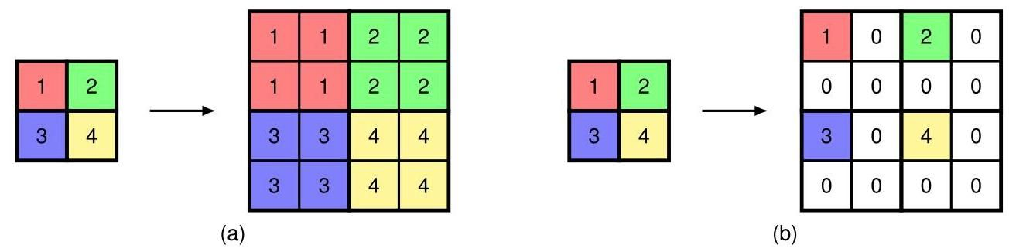

Figure 10.28 Illustration of unpooling operations showing (a) an analogue of average pooling and (b) an analogue of max-pooling.

图 10.28 展示了反池化操作，显示了 (a) 平均池化的类比和 (b) 最大池化的类比。

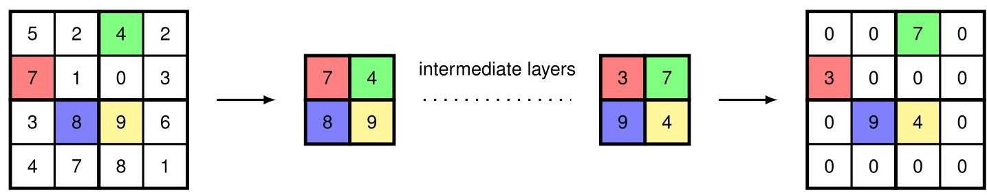

Figure 10.29 Some of the spatial information from a max-pooling layer, shown on the left, can be preserved by noting the location of the maximum value for each block in the input array, and then in the corresponding up-sampling layer, placing the non-zero entry at the corresponding location in the output array.

图 10.29 左侧所示的最大池化层的一些空间信息可以通过记录输入数组中每个 块的最大值位置来保留，然后在对应的上采样层中，将非零项放置在输出数组的相应位置。

# 10.5.3 Fully convolutional networks

# 10.5.3 全卷积网络

The up-sampling methods considered above are fixed functions, much like the average-pooling and max-pooling down-sampling operations. We can also use a learned up-sampling that is analogous to strided convolution for down-sampling. In strided convolution, each unit on the output map is connected via shared learnable weights to a small patch on the input map, and as we move one step through the output array, the filter is moved two or more steps across the input array, and hence the output array has lower dimensionality than the input array. For up-sampling, we use a filter that connects one pixel in the input array to a patch in the output array, and then chose the architecture so that as we move one step across the input array, we move two or more steps across the output array (Dumoulin and Visin, 2016). This is illustrated for filters, and an output stride of 2, in Figure 10.30. Note that there are output cells for which multiple filter positions overlap, and the corresponding output values can be found either by summing or by averaging the contributions from the individual filter positions.

上述考虑的上采样方法是固定函数，这与平均池化和最大池化下采样操作非常相似。我们还可以使用一种可学习的上采样方法，它类似于用于下采样的步幅卷积。在步幅卷积中，输出特征图上的每个单元通过共享的可学习权重连接到输入特征图上的一个小区域，并且当我们在输出数组中移动一步时，滤波器在输入数组中移动两步或更多步，因此输出数组的维度低于输入数组。对于上采样，我们使用一个滤波器将输入数组中的一个像素连接到输出数组中的一个区域，然后选择合适的架构，使得当我们在输入数组中移动一步时，在输出数组中移动两步或更多步(Dumoulin 和 Visin，2016)。图 10.30 展示了 滤波器和输出步幅为 2 的情况。请注意，存在多个滤波器位置重叠的输出单元，相应的输出值可以通过对各个滤波器位置的贡献求和或求平均来得到。

This up-sampling is called transpose convolution because, if the down-sampling convolution is expressed in matrix form, the corresponding up-sampling is given by the transpose matrix. It is also called ’fractionally strided convolution’ because the stride of a standard convolution is the ratio of the step size in the output layer to the step size in the input layer. In Figure 10.30, for example, this ratio is . Note that this is sometimes also referred to as ’deconvolution’, but it is better to avoid this term since deconvolution is widely used in mathematics to mean the inverse of the operation of convolution used in functional analysis, which is a different concept. If we have a network architecture with no pooling layers, so that the down-sampling and up-sampling are done purely using convolutions, then the architecture is known as a fully convolutional network (Long, Shelhamer, and Darrell, 2014). It can take an arbitrarily sized image and will output a segmentation map of the same size.

这种上采样被称为转置卷积，因为如果下采样卷积以矩阵形式表示，那么相应的上采样由转置矩阵给出。它也被称为“分数步幅卷积”，因为标准卷积的步幅是输出层步长与输入层步长的比值。例如，在图 10.30 中，这个比值是 。请注意，这有时也被称为“反卷积”，但最好避免使用这个术语，因为反卷积在数学中广泛用于表示泛函分析中卷积运算的逆运算，这是一个不同的概念。如果我们有一个没有池化层的网络架构，使得下采样和上采样完全使用卷积来完成，那么这种架构被称为全卷积网络(Long、Shelhamer 和 Darrell，2014)。它可以处理任意大小的图像，并输出相同大小的分割图。

Exercise 10.13

练习 10.13

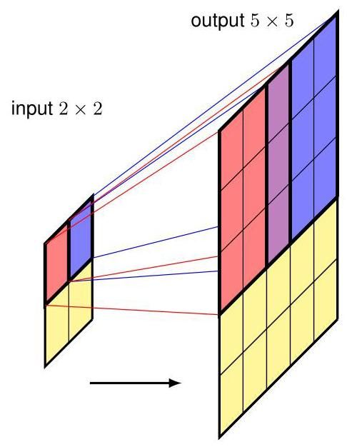

Figure 10.30 Illustration of transpose convolution for a 3 filter with an output stride of 2 . This can be thought of as the inverse operation to a convolution. The red output patch is given by multiplying the kernel by the activation of the red unit in the input layer, and similarly for the blue output patch. The activations of cells for which patches overlap are calculated by summing or averaging the contributions from the individual patches.

图 10.30 展示了输出步幅为 2 的 3 滤波器的转置卷积。这可以被视为 卷积的逆运算。红色输出区域是通过将卷积核与输入层中红色单元的激活值相乘得到的，蓝色输出区域同理。对于区域重叠的单元的激活值，通过对各个区域的贡献求和或求平均来计算。

# 10.5.4 The U-net architecture

# 10.5.4 U 型网络架构

We have seen that the down-sampling associated with strided convolutions and pooling allows the number of channels to be increased without the size of the network becoming prohibitive. This also has the effect of reducing the spatial resolution and hence discarding positional information as the signals flow through the network. Although this is fine for image classification, the loss of spatial information is a problem for semantic segmentation as we want to classify each pixel. One approach for addressing this is the -net architecture (Ronneberger, Fischer, and Brox,2015) illustrated in Figure 10.31, where the name comes from the U-shape of the diagram.

我们已经看到，与步幅卷积和池化相关的下采样允许在不使网络规模过大的情况下增加通道数。这也会降低空间分辨率，因此在信号流经网络时会丢弃位置信息。虽然这对于图像分类来说没问题，但对于语义分割而言，空间信息的丢失是一个问题，因为我们希望对每个像素进行分类。解决这个问题的一种方法是 网络架构(Ronneberger、Fischer 和 Brox，2015)，如图 10.31 所示，其名称来源于该图的 U 形。

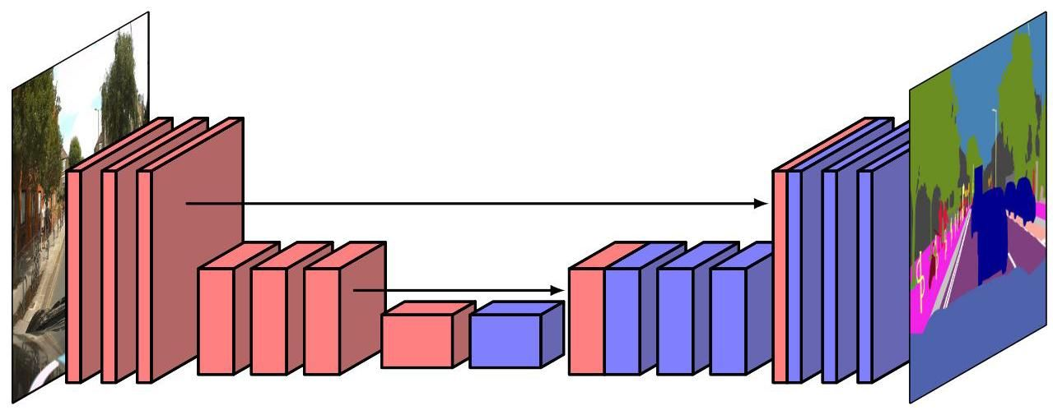

Figure 10.31 The U-net architecture has a symmetrical arrangement of down-sampling and up-sampling layers, and the output from each down-sampling layer is concatenated with the corresponding up-sampling layer.

图 10.31 U-net 架构具有下采样层和上采样层的对称排列，每个下采样层的输出与相应的上采样层拼接。

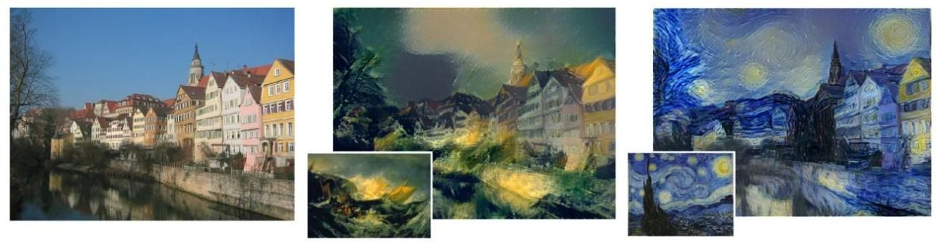

Figure 10.32 An example of neural style transfer showing a photograph of a canal scene (left) that has been rendered in the style of The Wreck of a Transport Ship by J. M. W. Turner (centre) and in the style of The Starry Night by Vincent van Gogh (right). In each case the image used to provide the style is shown in the inset. [From Gatys, Ecker, and Bethge (2015) with permission.]

图 10.32 神经风格迁移示例，展示了一幅运河场景的照片(左)，该照片已分别以 J. M. W. 透纳(J. M. W. Turner)的《运输船遇难》(The Wreck of a Transport Ship)风格(中)和文森特·梵高(Vincent van Gogh)的《星月夜》(The Starry Night)风格(右)进行渲染。在每种情况下，用于提供风格的图像都显示在插图中。[经许可改编自加蒂斯(Gatys)、埃克(Ecker)和贝格(Bethge)(2015 年)的研究。]

The core concept is that for each down-sampling layer there is a corresponding up-sampling layer, and the final set of channel activations at each down-sampling layer is concatenated with the corresponding first set of channels in the up-sampling layer, thereby giving those layers access to higher-resolution spatial information. Note that convolutions may be used in the final layer of a U-net to reduce the number of channels down to the number of classes, which is then followed by a softmax activation function.

核心概念是，对于每个下采样层，都有一个相应的上采样层，并且每个下采样层的最终通道激活集与上采样层中相应的第一组通道拼接，从而使这些层能够访问更高分辨率的空间信息。请注意， 卷积可用于 U-net 的最后一层，以将通道数量减少到类别数量，然后再应用 softmax 激活函数。

# 10.6. Style Transfer

# 10.6. 风格迁移

As we have seen, early layers in a deep convolutional network learn to detect simple features such as edges and textures whereas later layers learn to detect more complex

正如我们所见，深度卷积网络的早期层学习检测简单特征，如边缘和纹理，而后期层学习检测更复杂的

Section 10.3 entities such as objects. We can exploit this property to re-render an image in the style of a different image using a process called neural style transfer (Gatys, Ecker, and Bethge, 2015). This is illustrated in Figure 10.32.

第 10.3 节 实体，如物体。我们可以利用这一特性，通过一种称为神经风格迁移的过程(加蒂斯(Gatys)、埃克(Ecker)和贝格(Bethge)，2015 年)，以不同图像的风格重新渲染一幅图像。这在图 10.32 中得到了说明。

Our goal is to generate a synthetic image whose ’content’ is defined by an image and whose ’style’ is taken from some other image . This is achieved by defining an error function given by the sum of two terms, one of which encourages to have a similar content to whereas the other encourages to have a similar style to :

我们的目标是生成一幅合成图像 ，其 “内容” 由图像 定义，其 “风格” 取自另一幅图像 。这可以通过定义一个误差函数 来实现，该误差函数由两项之和构成，其中一项促使 与 具有相似的内容，而另一项则促使 与 具有相似的风格:

The concepts of content and style are defined implicitly by the functional forms of these two terms. We can then find by starting from a randomly initialized image and using gradient descent to minimize .

内容和风格的概念由这两项的函数形式隐式定义。然后，我们可以从一幅随机初始化的图像开始，使用梯度下降法来最小化 ，从而找到 。

To define , we can pick a particular convolutional layer in the network and measure the activations of the units in that layer when image is used as input and also when image is used as input. We can then encourage the corresponding pre-activations to be similar by using a sum-of-squares error function

为了定义 ，我们可以选择网络中的一个特定卷积层，并测量当图像 作为输入以及图像 作为输入时，该层中单元的激活值。然后，我们可以使用平方和误差函数来促使相应的预激活值相似

of the form

形式为

where denotes the pre-activation of the unit at position in channel of that layer when the input image is , and similarly for . The choice of which layer to use in defining the pre-activations will influence the final result, with earlier layers aiming to match low-level features like edges and later layers matching more complex structures or even entire objects.

其中 表示当输入图像为 时，该层通道 中位置 处单元的预激活值， 同理。在定义预激活值时选择使用哪一层会影响最终结果，较早的层旨在匹配边缘等低级特征，而较晚的层则匹配更复杂的结构甚至整个对象。

In defining , the intuition is that style is determined by the co-occurrence of features from different channels within a convolutional layer. For example, if the style image is such that vertical edges are generally associated with orange blobs, then we would like the same to be true for the generated image . However, although tries to match features in at the same locations as corresponding features in , for the style error we want to have characteristics that match those of but taken from any location, and so we take an average over locations in a feature map. Again, consider a particular convolutional layer. We can measure the extent to which a feature in channel co-occurs with the corresponding feature in channel for input image by forming the cross-correlation matrix

在定义 时，其直觉是风格由卷积层内不同通道的特征共现情况决定。例如，如果风格图像 中垂直边缘通常与橙色斑点相关联，那么我们希望生成的图像 也具有同样的情况。然而，尽管 试图在 中与 中相应特征相同的位置匹配特征，但对于风格误差 ，我们希望 具有与 相匹配的特征，但这些特征可以来自任何位置，因此我们对特征图中的位置取平均值。同样，考虑一个特定的卷积层。我们可以通过形成互相关矩阵来测量对于输入图像 ，通道 中的特征与通道 中相应特征的共现程度

where and are the dimensions of the feature maps in this particular convolutional layer, and the product will be large if both features are activated. If there are channels in this layer, then form the elements of a matrix, called the style matrix. We can measure the extent to which the two images and have the same style by comparing their style matrices using

其中 和 是该特定卷积层中特征图的维度，如果两个特征都被激活，则乘积 会很大。如果该层中有 个通道，那么 构成一个 矩阵的元素，称为风格矩阵。我们可以通过使用以下方法比较两幅图像 和 的风格矩阵来衡量它们具有相同风格的程度

Although we could again make use of a single layer, more pleasing results are obtained by using contributions from multiple layers in the form

虽然我们可以再次使用单层，但通过以某种形式利用多层的贡献可以获得更令人满意的结果

where denotes the convolutional layer. The coefficients determine the relative weighting between the different layers and also the weighting relative to the content error term. These weighting coefficients are adjusted empirically using subjective judgement.

其中 表示卷积层。系数 决定了不同层之间的相对权重，以及相对于内容误差项的权重。这些权重系数是通过主观判断凭经验调整的。

Exercises

练习

10.1 (*) Consider a fixed weight vector and show that the input vector that maximizes the scalar product , subject to the constraint that is constant, is given by

10.1 (*) 考虑一个固定的权重向量 ，并证明在 为常数的约束下，使标量积 最大化的输入向量 由下式给出

Appendix for some scalar . This can most easily be done using a Lagrange multiplier.

附录 对于某个标量 成立。这可以最容易地通过使用拉格朗日乘数来完成。

10.2 Consider a convolutional network layer with a one-dimensional input array and a one-dimensional feature map as shown in Figure 10.2, in which the input array has dimensionality 5 and the filters have width 3 with a stride of 1 . Show that this can be expressed as a special case of a fully connected layer by writing down the weight matrix in which missing connections are replaced by zeros and where shared parameters are indicated by using replicated entries. Ignore any bias parameters.

10.2 考虑一个卷积网络层，其输入为一维数组，特征图也为一维，如图 10.2 所示。其中，输入数组的维度为 5，滤波器的宽度为 3，步长为 1。通过写出权重矩阵(其中缺失的连接用零代替，共享参数用重复的条目表示)，证明这可以表示为全连接层的一种特殊情况。忽略任何偏置参数。

10.3 (*) Explicitly calculate the output of the following convolution of a input matrix with a filter:

10.3 (*) 明确计算以下 输入矩阵与 滤波器的卷积输出:

(10.18)

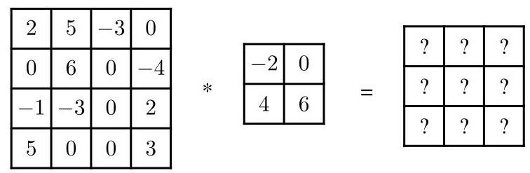

10.4 If an image has pixels and a filter has elements, write down the limits for the two summations in (10.2). In the mathematics literature, the operation (10.2) would be called a cross-correlation, whereas a convolution would be defined by

10.4 如果图像 有 个像素，滤波器 有 个元素，写出 (10.2) 中两个求和的范围。在数学文献中，运算 (10.2) 被称为互相关，而卷积的定义为

Write down the limits for the summations in (10.19). Show that (10.19) can be written in the equivalent ’flipped’ form

写出 (10.19) 中求和的范围。证明 (10.19) 可以写成等价的“翻转”形式

and again write down the limits for the summations.

并再次写出求和的范围。

10.5 ( ) In mathematics, a convolution for a continuous variable is defined by

10.5 ( ) 在数学中，连续变量 的卷积定义为

where is the kernel function. By considering a discrete approximation to the integral, explain the relationship to a convolutional layer, defined by (10.19), in a CNN.

其中 是核函数。通过考虑对积分进行离散近似，解释其与卷积神经网络(CNN)中由 (10.19) 定义的卷积层的关系。

10.6 Consider an image of size that is padded with an additional pixels on all sides and which is then convolved using a kernel of size where is an odd number. Show that if we choose , then the resulting feature map will have size and hence will be the same size as the original image.

10.6 考虑一个大小为 的图像，在其所有边上填充额外的 个像素，然后使用大小为 的核进行卷积，其中 是奇数。证明如果我们选择 ，那么得到的特征图将具有大小 ，因此将与原始图像大小相同。

10.7 (*) Show that if a kernel of size is convolved with an image of size with padding of depth and strides of length then the dimensionality of the resulting feature map is given by (10.5)

10.7 (*) 证明如果将大小为 的核与大小为 的图像进行卷积，填充深度为 ，步长为 ，那么得到的特征图的维度由 (10.5) 给出。

10.8 (★★) For each of the 16 layers in the VGG-16 CNN shown in Figure 10.10, evaluate (i) the number of weights (i.e., connections) including biases and (ii) the number of independently learnable parameters. Confirm that the total number of learnable parameters in the network is approximately 138 million.

10.8 (★★) 对于图 10.10 所示的 VGG - 16 CNN 中的 16 层，分别计算 (i) 包括偏置在内的权重(即连接)数量，以及 (ii) 可独立学习的参数数量。确认网络中可学习参数的总数约为 1.38 亿。

10.9 Consider a convolution of the form (10.2) and suppose that the kernel is separable so that

10.9 考虑形式为 (10.2) 的卷积，并假设核是可分离的，使得

for some functions and . Show that instead of performing a single two-dimensional convolution it is now possible to compute the same answer using two one-dimensional convolutions thereby resulting in a significant improvement in efficiency.

对于某些函数 和 。证明现在可以使用两次一维卷积来计算相同的结果，而不是执行一次二维卷积，从而显著提高效率。

10.10 The DeepDream update procedure involves setting the variables for backprop-agation equal to the pre-activations of the nodes in the chosen layer and then running backpropagation to the input layer to get a gradient vector over the pixels of the image. Show that this can be derived as a gradient optimization with respect to the pixels of an image applied to the function (10.12).

10.10 DeepDream 更新过程包括将用于反向传播的 变量设置为所选层中节点的预激活值，然后向输入层进行反向传播，以得到图像像素上的梯度向量。证明这可以推导为对应用于函数 (10.12) 的图像 像素进行的梯度优化。

10.11 When designing a neural network to detect objects from different classes in an image, we can use a 1-of- class label with one variable for each object class and one additional variable representing a ’background’ class, i.e., an input image region that does not contain an object belonging to any of the defined classes. The network will then output a vector of probabilities of length . Alternatively, we can use a single binary variable to denote the presence or absence of an object and then use a separate 1-of- vector to denote the specific object class. In this case, the network outputs a single probability representing the presence of an object and a separate set of probabilities over the class label. Write down the relationship between these two sets of probabilities.

10.11 在设计一个神经网络以检测图像中 不同类别的对象时，我们可以使用 1-of- 类标签，为每个对象类别设置一个变量，并额外设置一个变量表示 “背景” 类，即不包含任何已定义类别对象的输入图像区域。然后，网络将输出一个长度为 的概率向量。或者，我们可以使用一个单一的二进制变量来表示对象的存在与否，然后使用一个单独的 1-of- 向量来表示特定的对象类别。在这种情况下，网络输出一个表示对象存在的单一概率，以及一个关于类别标签的单独概率集。写出这两组概率之间的关系。

10.12 Calculate the number of computational steps required to make one forward pass through the convolutional network shown in Figure 10.22, ignoring biases and ignoring the evaluation of activation functions. Similarly, calculate the total number of computational steps for a single forward pass through the expanded network shown in Figure 10.23. Finally, evaluate ratio of nine repeated naive applications of the network in Figure 10.22 to an image compared to a single application of the network in Figure 10.23. This ratio indicates the improvement in efficiency from using a convolutional implementation of the sliding window technique.

10.12 计算通过图 10.22 所示的卷积网络进行一次前向传播所需的计算步骤数，忽略偏置项和激活函数的计算。同样，计算通过图 10.23 所示的扩展网络进行一次前向传播的总计算步骤数。最后，评估对 图像九次重复简单应用图 10.22 中的网络与一次应用图 10.23 中的网络的比率。该比率表明了使用滑动窗口技术的卷积实现所带来的效率提升。

10.13 In this exercise we use one-dimensional vectors to demonstrate why a convolutional up-sampling is sometimes called a transpose convolution. Consider a one-dimensional strided convolutional layer with an input having four units with activations , which is padded with zeros to give , and a filter with parameters . Write down the one-dimensional activation vector of the output layer assuming a stride of 2 . Express this output in the form of a matrix multiplied by the vector . Now consider an up-sampling convolution in which the input layer has activations with a filter having values and an output stride of 2 . Write down the six-dimensional output vector assuming that overlapping filter values are summed and that the activation function is just the identity. Show that this can be expressed as a matrix multiplication using the transpose matrix .

10.13 在本练习中，我们使用一维向量来演示为什么卷积上采样有时被称为转置卷积。考虑一个一维步幅卷积层，其输入有四个具有激活值 的单元，对其进行零填充得到 ，以及一个参数为 的滤波器。假设步幅为 2，写出输出层的一维激活向量。将此输出表示为矩阵 乘以向量 的形式。现在考虑一个上采样卷积，其中输入层的激活值为 ，滤波器的值为 ，输出步幅为 2。假设重叠的滤波器值相加，且激活函数为恒等函数，写出六维输出向量。证明这可以表示为使用转置矩阵 进行的矩阵乘法。

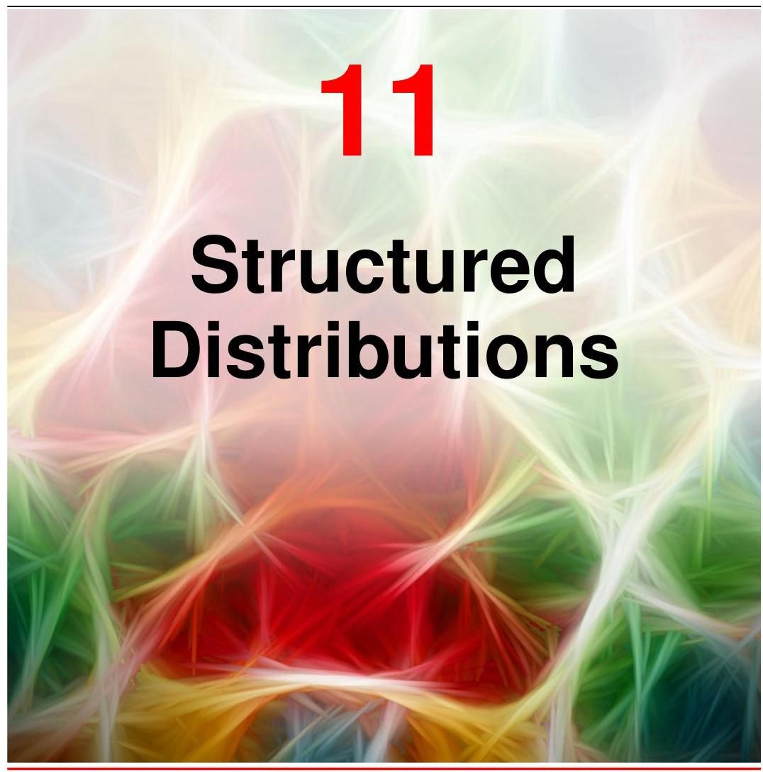

We have seen that probability forms one of the most important foundational concepts for deep learning. For example, a neural network used for binary classification is described by a conditional probability distribution of the form

我们已经看到，概率构成了深度学习最重要的基础概念之一。例如，用于二分类的神经网络由以下形式的条件概率分布描述

where represents a neural network function that takes a vector as input and is governed by a vector of learnable parameters. The corresponding cross-entropy likelihood forms the basis for defining an error function used to train the neural network. Although the network function might be extremely complex, the conditional distribution in (11.1) has a simple form. However, there are many important deep learning models that have a much richer probabilistic structure, such as large language models, normalizing flows, variational autoencoders, diffusion models, and many others. To describe and exploit this structure, we introduce a powerful

其中 表示一个神经网络函数，它以向量 作为输入，并由可学习参数向量 控制。相应的交叉熵似然构成了定义用于训练神经网络的误差函数的基础。尽管网络函数可能极其复杂，但 (11.1) 中的条件分布具有简单的形式。然而，有许多重要的深度学习模型具有更丰富的概率结构，如大型语言模型、归一化流、变分自编码器、扩散模型等等。为了描述和利用这种结构，我们引入了一种强大的

framework called probabilistic graphical models, or simply graphical models, which allows structured probability distributions to be expressed in graphical form. When combined with neural networks to define associated probability distributions, graphical models offer huge flexibility when creating sophisticated models that can be trained end to end using stochastic gradient descent in which gradients are evaluated efficiently using auto-differentiation. In this chapter, we will focus on the core concepts of graphical models needed for applications in deep learning, whereas a more comprehensive treatment of graphical models for machine learning can be found in Bishop (2006).

一种称为概率图模型(或简称为图模型)的框架，它允许以图形形式表示结构化概率分布。当与神经网络结合以定义相关的概率分布时，图模型在创建复杂模型时提供了极大的灵活性，这些模型可以使用随机梯度下降进行端到端训练，其中梯度可以通过自动微分高效地计算。在本章中，我们将重点介绍深度学习应用所需的图模型的核心概念，而关于机器学习中图模型的更全面处理可以在 Bishop (2006) 中找到。

# 11.1. Graphical Models

# 11.1. 图模型

Probability theory can be expressed in terms of two simple equations known as the sum rule and the product rule. All of the probabilistic manipulations discussed in this book, no matter how complex, amount to repeated application of these two equations. In principle, we could therefore formulate and use complex probabilistic models purely by using algebraic manipulation. However, we will find it advantageous to augment the analysis using diagrammatic representations of probability distributions, as these offer several useful properties:

概率论可以用两个简单的方程来表示，即求和规则和乘积规则。本书中讨论的所有概率操作，无论多么复杂，都相当于反复应用这两个方程。原则上，我们因此可以纯粹通过代数操作来构建和使用复杂的概率模型。然而，我们会发现使用概率分布的图形表示来增强分析是有利的，因为它们具有以下几个有用的特性:

Section 2.1

第 2.1 节

1. They provide a simple way to visualize the structure of a probabilistic model and can be used to design and motivate new models.

1. 它们提供了一种直观展示概率模型结构的简单方法，可用于设计和启发新的模型。

2. Insights into the properties of the model, including conditional independence properties, can be obtained by inspecting the graph.

2. 通过检查图形，可以深入了解模型的特性，包括条件独立性。

3. The complex computations required to perform inference and learning in sophisticated models can be expressed in terms of graphical operations, such as message-passing, in which the underlying mathematical operations are carried out implicitly.

3. 在复杂模型中进行推理和学习所需的复杂计算可以用图形操作来表示，例如消息传递，其中底层的数学运算被隐式执行。

Although such graphical models have nodes and edges much like neural network diagrams, their interpretation is specifically probabilistic and carries a richer semantics. To help avoid confusion, in this book we denote neural network diagrams in blue and probabilistic graphical models in red.

尽管此类图形模型与神经网络图一样有节点和边，但其解释具有特定的概率性，并且具有更丰富的语义。为避免混淆，在本书中，我们用蓝色表示神经网络图，用红色表示概率图形模型。

# 11.1.1 Directed graphs

# 11.1.1 有向图

A graph comprises nodes, also called vertices, connected by links, also known as edges. In a probabilistic graphical model, each node represents a random variable, and the links express probabilistic relationships between these variables. The graph then captures the way in which the joint distribution over all the random variables can be decomposed into a product of factors each depending only on a subset of the variables. In this chapter we will focus on graphical models in which the links of the graphs have a particular direction indicated by arrows. These are known as directed graphical models and are also called Bayesian networks or Bayes nets.

图由节点(也称为顶点)组成，节点之间通过链接(也称为边)相连。在概率图形模型中，每个节点代表一个随机变量，而链接表示这些变量之间的概率关系。然后，该图描述了所有随机变量的联合分布如何分解为仅依赖于部分变量的因子的乘积。在本章中，我们将重点关注图的链接具有由箭头指示的特定方向的图形模型。这些模型被称为有向图形模型，也称为贝叶斯网络。

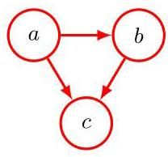

Figure 11.1 A directed graphical model representing the joint probability distribution over three variables , and , corresponding to the decomposition on the right-hand side of (11.3).

图 11.1 一个有向图形模型，它表示三个变量 和 的联合概率分布，对应于 (11.3) 式右侧的分解。

The other major class of graphical models are Markov random fields, also known as undirected graphical models, in which the links do not carry arrows and have no directional significance. Directed graphs are useful for expressing causal relationships between random variables, whereas undirected graphs are better suited to expressing soft constraints between random variables. Both directed and undirected graphs can be viewed as special cases of a representation called factor graphs. From now on we focus our attention on directed graphical models. Note, however, that undirected graphs, without the probabilistic interpretation, will also arise in our discussion of graph neural networks in which the nodes represent deterministic variables as in standard neural networks.

另一类主要的图形模型是马尔可夫随机场，也称为无向图形模型，其中的链接没有箭头，也没有方向意义。有向图可用于表示随机变量之间的因果关系，而无向图更适合表示随机变量之间的软约束。有向图和无向图都可以看作是一种称为因子图的表示的特殊情况。从现在起，我们将重点关注有向图形模型。不过要注意，在我们对图神经网络的讨论中，也会出现没有概率解释的无向图，其中的节点和标准神经网络一样，表示确定性变量。

Chapter 13

第13章

# 11.1.2 Factorization

# 11.1.2 因式分解

To motivate the use of directed graphs to describe probability distributions, consider first an arbitrary joint distribution over three variables , and . Note that at this stage, we do not need to specify anything further about these variables, such as whether they are discrete or continuous. Indeed, one of the powerful aspects of graphical models is that a specific graph can make probabilistic statements for a broad class of distributions. By application of the product rule of probability (2.9), we can write the joint distribution in the form

为了说明使用有向图来描述概率分布的动机，首先考虑三个变量 和 上的任意联合分布 。请注意，在这个阶段，我们不需要进一步指定这些变量的任何信息，比如它们是离散的还是连续的。实际上，图模型的一个强大之处在于，一个特定的图可以对广泛的一类分布做出概率陈述。通过应用概率的乘积规则(2.9)，我们可以将联合分布写成如下形式

A second application of the product rule, this time to the second term on the righthand side of (11.2), gives

再次应用乘积规则，这次应用于(11.2)式右边的第二项，得到

Note that this decomposition holds for any choice of the joint distribution. We now represent the right-hand side of (11.3) in terms of a simple graphical model as follows. First we introduce a node for each of the random variables , and and associate each node with the corresponding conditional distribution on the right-hand side of (11.3). Then, for each conditional distribution we add directed links (depicted as arrows) from the nodes corresponding to the variables on which the distribution is conditioned. Thus, for the factor , there will be links from nodes and to node , whereas for the factor , there will be no incoming links. The result is the graph shown in Figure 11.1. If there is a link going from node to node , then we say that node is the parent of node , and we say that node is the child of node . Note that we will not make any formal distinction between a node and the variable to which it corresponds but will simply use the same symbol to refer to both.

请注意，这种分解对于联合分布的任何选择都成立。现在，我们用一个简单的图模型来表示(11.3)式的右边，具体如下。首先，我们为每个随机变量 和 引入一个节点，并将每个节点与(11.3)式右边相应的条件分布关联起来。然后，对于每个条件分布，我们从对应于该分布所依赖变量的节点添加有向链接(用箭头表示)。因此，对于因子 ，会有从节点 和 到节点 的链接，而对于因子 ，则没有入向链接。结果就是图11.1所示的图。如果有一条从节点 到节点 的链接，那么我们称节点 是节点 的父节点，称节点 是节点 的子节点。请注意，我们不会对节点和它所对应的变量进行正式区分，而是简单地使用相同的符号来指代两者。

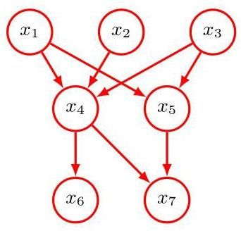

Figure 11.2 Example of a directed graph describing the joint distribution over variables . The corresponding decomposition of the joint distribution is given by (11.5).

图11.2 描述变量 上联合分布的有向图示例。联合分布的相应分解由(11.5)式给出。

An important point to note about (11.3) is that the left-hand side is symmetrical with respect to the three variables , and , whereas the right-hand side is not. In making the decomposition in (11.3), we have implicitly chosen a particular ordering, namely , and had we chosen a different ordering we would have obtained a different decomposition and hence a different graphical representation.

关于 (11.3) 需要注意的一个重要点是，左边关于三个变量 和 是对称的，而右边则不是。在进行 (11.3) 中的分解时，我们隐式地选择了一个特定的顺序，即 ，如果我们选择了不同的顺序，就会得到不同的分解，从而得到不同的图形表示。

For the moment let us extend the example of Figure 11.1 by considering the joint distribution over variables given by . By repeated application of the product rule of probability, this joint distribution can be written as a product of conditional distributions, one for each of the variables:

目前，让我们通过考虑由 给出的 个变量上的联合分布来扩展图 11.1 的示例。通过反复应用概率的乘积规则，这个联合分布可以写成条件分布的乘积，每个变量对应一个条件分布:

For a given choice of , we can again represent this as a directed graph having nodes, one for each conditional distribution on the right-hand side of (11.4), with each node having incoming links from all lower numbered nodes. We say that this graph is fully connected because there is a link between every pair of nodes.

对于给定的 的选择，我们可以再次将其表示为一个有 个节点的有向图，每个节点对应于 (11.4) 右边的一个条件分布，每个节点都有来自所有编号较低节点的入边。我们说这个图是完全连通的，因为每对节点之间都有一条边。

So far, we have worked with completely general joint distributions, and so their factorization, and associated representation as fully connected graphs, will be applicable to any choice of distribution. As we will see shortly, it is the absence of links in the graph that conveys interesting information about the properties of the class of distributions that the graph represents. Consider the graph shown in Figure 11.2. Note that it is not a fully connected graph because, for instance, there is no link from to or from to . We take this graph and extract the corresponding representation of the joint probability distribution written in terms of the product of a set of conditional distributions, one for each node in the graph. Each such conditional distribution will be conditioned only on the parents of the corresponding node in the graph. For instance, will be conditioned on and . The joint distribution of all seven variables is therefore given by

到目前为止，我们处理的是完全一般的联合分布，因此它们的因式分解以及作为完全连通图的相关表示将适用于任何分布的选择。正如我们很快将看到的，图中边的缺失传达了关于该图所表示的分布类的性质的有趣信息。考虑图 11.2 所示的图。注意它不是一个完全连通的图，例如，从 到 或从 到 没有边。我们取这个图并提取相应的联合概率分布的表示，该表示写成一组条件分布的乘积，图中的每个节点对应一个条件分布。每个这样的条件分布将仅以图中相应节点的父节点为条件。例如， 将以 和 为条件。因此，所有七个变量的联合分布由下式给出

The reader should take a moment to study carefully the correspondence between (11.5) and Figure 11.2.

读者应该花点时间仔细研究 (11.5) 和图 11.2 之间的对应关系。

We can now state in general terms the relationship between a given directed graph and the corresponding distribution over the variables. The joint distribution defined by a graph is given by the product, over all of the nodes of the graph, of a conditional distribution for each node conditioned on the variables corresponding to the parents of that node in the graph. Thus, for a graph with nodes, the joint distribution is given by

现在我们可以用一般术语陈述给定有向图和变量上相应分布之间的关系。由图定义的联合分布由图中所有节点上的条件分布的乘积给出，每个节点的条件分布以图中该节点的父节点对应的变量为条件。因此，对于一个有 个节点的图，联合分布由下式给出

where denotes the set of parents of . This key equation expresses the factorization properties of the joint distribution for a directed graphical model. Although we have considered each node to correspond to a single variable, we can equally well associate sets of variables and vector-valued or tensor-valued variables with the nodes of a graph. It is easy to show that the representation on the right-hand side of (11.6) is always correctly normalized provided the individual conditional distributions are normalized.

其中 表示 的父节点集合。这个关键方程表达了有向图模型联合分布的因式分解性质。尽管我们考虑每个节点对应一个单一变量，但我们同样可以将变量集合以及向量值或张量值变量与图的节点相关联。很容易证明，只要各个条件分布是归一化的，(11.6) 式右侧的表示总是能正确归一化。

Exercise 11.1

练习 11.1

The directed graphs that we are considering are subject to an important restriction, namely that there must be no directed cycles. In other words, there are no closed paths within the graph such that we can move from node to node along links following the direction of the arrows and end up back at the starting node. Such graphs are also called directed acyclic graphs, or DAGs. This is equivalent to the statement that there exists an ordering of the nodes such that there are no links that go from any node to any lower-numbered node.

我们所考虑的有向图受到一个重要限制，即不能有有向环。换句话说，图中不存在这样的封闭路径:我们可以沿着箭头方向从一个节点移动到另一个节点，最终回到起始节点。这样的图也称为有向无环图，简称 DAG。这等价于存在一种节点排序方式，使得不存在从任何节点指向编号更小节点的链接。

Exercise 11.2

练习 11.2

# 11.1.3 Discrete variables

# 11.1.3 离散变量

We have discussed the importance of probability distributions that are members of the exponential family, and we have seen that this family includes many well-known distributions as special cases. Although such distributions are relatively simple, they form useful building blocks for constructing more complex probability distributions, and the framework of graphical models is very useful in expressing the way in which these building blocks are linked together. There are two particular choices for the component distributions that are widely used, corresponding to discrete variables and to Gaussian variables. We begin by examining the discrete case.

我们已经讨论了指数族概率分布的重要性，并且看到这个族包含许多著名的分布作为特殊情况。尽管这类分布相对简单，但它们是构建更复杂概率分布的有用基础，而图模型框架在表达这些基础如何相互关联方面非常有用。对于组件分布，有两种广泛使用的特定选择，分别对应离散变量和高斯变量。我们首先研究离散情况。

Section 3.4

3.4 节

The probability distribution for a single discrete variable having possible states (using the 1-of- representation) is given by

单个离散变量 具有 个可能状态(使用 1-of- 表示法)的概率分布 由下式给出

and is governed by the parameters . Due to the constraint , only values for need to be specified to define the distribution.

并且由参数 控制。由于约束条件 ，只需指定 的 个值即可定义该分布。

Now suppose that we have two discrete variables, and , each of which has states, and we wish to model their joint distribution. We denote the probability of observing both and by the parameter , where denotes the

现在假设我们有两个离散变量 和 ，每个变量都有 个状态，并且我们希望对它们的联合分布进行建模。我们用参数 表示同时观察到 和 的概率，其中 表示

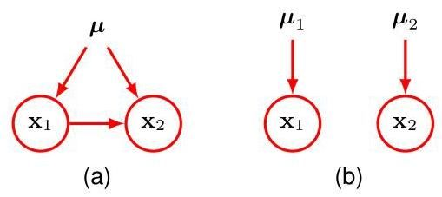

Figure 11.3 (a) This fully connected graph describes a general distribution over two -state discrete variables having a total of parameters. (b) By dropping the link between the nodes, the number of parameters is reduced to .

图 11.3 (a) 这个完全连接的图描述了两个 状态离散变量的一般分布，总共有 个参数。(b) 通过去掉节点之间的链接，参数数量减少到 个。

th component of , and similarly for . The joint distribution can be written

的第 个分量， 同理。联合分布可以写成

Because the parameters are subject to the constraint , this distribution is governed by parameters. It is easily seen that the total number of parameters that must be specified for an arbitrary joint distribution over variables is and therefore grows exponentially with the number of variables.

由于参数 受约束条件 的限制，此分布由 个参数决定。容易看出，对于 个变量的任意联合分布，必须指定的参数总数为 ，因此该总数随变量数量 呈指数增长。

Using the product rule, we can factor the joint distribution in the form , which corresponds to a two-node graph with a link going from the node to the node as shown in Figure 11.3(a). The marginal distribution is governed by parameters, as before. Similarly, the conditional distribution requires the specification of parameters for each of the possible values of . The total number of parameters that must be specified in the joint distribution is therefore as before.

利用乘积规则，我们可以将联合分布 分解为 的形式，这对应于一个两节点图，如图 11.3(a) 所示，有一条从 节点指向 节点的边。与之前一样，边缘分布 由 个参数决定。类似地，对于 的 个可能取值中的每一个，条件分布 都需要指定 个参数。因此，联合分布中必须指定的参数总数与之前一样为 。

Now suppose that the variables and are independent, corresponding to the graphical model shown in Figure 11.3(b). Each variable is then described by a separate discrete distribution, and the total number of parameters would be . For a distribution over independent discrete variables, each having states, the total number of parameters would be , which therefore grows linearly with the number of variables. From a graphical perspective, we have reduced the number of parameters by dropping links in the graph, at the expense of having a more restricted class of distributions.

现在假设变量 和 相互独立，对应于图 11.3(b) 所示的图形模型。那么每个变量都由一个单独的离散分布描述，参数总数为 。对于 个相互独立的离散变量，每个变量有 个状态，参数总数为 ，因此该总数随变量数量呈线性增长。从图形的角度来看，我们通过去掉图中的边减少了参数数量，但代价是分布类受到了更多限制。

More generally, if we have discrete variables , we can model the joint distribution using a directed graph with one variable for each node. The conditional distribution at each node is given by a set of non-negative parameters subject to the usual normalization constraint. If the graph is fully connected, then we have a completely general distribution having parameters, whereas if there are no links in the graph, the joint distribution factorizes into the product of the marginal distributions, and the total number of parameters is . Graphs having intermediate levels of connectivity allow for more general distributions than the fully factorized one while requiring fewer parameters than the general joint distribution. As an illustration, consider the chain of nodes shown in Figure 11.4. The marginal distribution requires parameters, whereas each of the conditional distributions , for , requires parameters. This gives a total parameter count of , which is quadratic in and which grows linearly (rather than exponentially) with the length of the chain.

更一般地，如果我们有 个离散变量 ，我们可以使用一个有向图来对联合分布进行建模，图中每个节点对应一个变量。每个节点处的条件分布由一组非负参数给出，这些参数受通常的归一化约束。如果图是完全连通的，那么我们得到一个完全一般的分布，其参数数量为 ；而如果图中没有边，联合分布可分解为边缘分布的乘积，参数总数为 。具有中间连通性水平的图所允许的分布比完全分解的分布更一般，同时所需的参数比一般联合分布更少。作为一个示例，考虑图 11.4 所示的节点链。边缘分布 需要 个参数，而对于 ， 个条件分布 中的每一个都需要 个参数。这使得参数总数为 ，该总数关于 是二次的，并且随链的长度 呈线性(而非指数)增长。

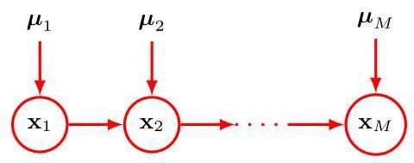

figure 11.4 This chain of discrete nodes, each having states, requires the specification of parameters, which grows linearly with the length of the chain. In contrast, a fully connected graph of nodes would have parameters, which grows exponentially with .

图 11.4 这条由 个离散节点组成的链，每个节点有 个状态，需要指定 个参数，这些参数的数量随链的长度 线性增长。相比之下，一个由 个节点组成的全连接图将有 个参数，其数量随 呈指数增长。

An alternative way to reduce the number of independent parameters in a model is by sharing parameters (also known as tying of parameters). For instance, in the chain example of Figure 11.4, we can arrange that all the conditional distributions , for , are governed by the same set of parameters, giving the model shown in Figure 11.5. Together with the parameters governing the distribution of , this gives a total of parameters that must be specified to define the joint distribution.

减少模型中独立参数数量的另一种方法是共享参数(也称为参数绑定)。例如，在图 11.4 的链示例中，我们可以安排所有条件分布 (对于 )都由同一组 个参数控制，从而得到图 11.5 所示的模型。再加上控制 分布的 个参数，总共需要指定 个参数来定义联合分布。

Another way of controlling the exponential growth of the number of parameters in models of discrete variables is to use parameterized representations for the conditional distributions instead of complete tables of conditional probability values. To illustrate this idea, consider the graph in Figure 11.6 in which all the nodes represent binary variables. Each of the parent variables is governed by a single parameter representing the probability , giving parameters in total for the parent nodes. The conditional distribution , however, would require parameters representing the probability for each of the possible settings of the parent variables. Thus, in general the number of parameters required to specify this conditional distribution will grow exponentially with . We can obtain a more parsimonious form for the conditional distribution by using a logistic sigmoid function acting on a linear combination of the parent variables, giving

控制离散变量模型中参数数量指数增长的另一种方法是使用参数化表示来表示条件分布，而不是使用完整的条件概率值表。为了说明这一概念，考虑图 11.6 中的图，其中所有节点都表示二元变量。每个父变量 由一个单一参数 控制，该参数表示概率 ，因此父节点总共需要 个参数。然而，条件分布 需要 个参数，这些参数表示父变量的 种可能设置中每一种的概率 。因此，一般来说，指定这个条件分布所需的参数数量将随 呈指数增长。我们可以通过对父变量的线性组合应用逻辑 sigmoid 函数来获得条件分布的更简洁形式，即

Section 3.4

第 3.4 节

where is the logistic sigmoid, is an -dimensional vector of parent states augmented with an additional variable whose value is clamped to 1, and is a vector of parameters. This is a more restricted form of conditional distribution than the general case but is now governed by a number of parameters that grows linearly with . In this sense, it is analogous to the choice of a restrictive form of covariance matrix (for example, a diagonal matrix) in a multivariate Gaussian distribution.

其中 是逻辑 sigmoid 函数， 是一个由父状态组成的 维向量，并增加了一个额外变量 ，其值固定为 1， 是一个由 个参数组成的向量。这是一种比一般情况更受限的条件分布形式，但现在由数量随 线性增长的参数控制。从这个意义上说，它类似于在多元高斯分布中选择一种受限形式的协方差矩阵(例如，对角矩阵)。

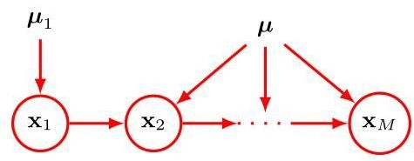

Figure 11.5 As in Figure 11.4 but with a single set of parameters shared amongst all the conditional distributions .

图 11.5 与图 11.4 类似，但所有条件分布 共享同一组参数 。

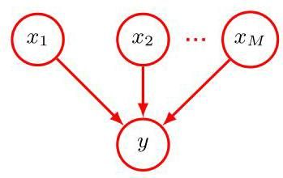

Figure 11.6 A graph comprising parents and a single child , used to illustrate the idea of parameterized conditional distributions for discrete variables.

图 11.6 一个包含 个父节点 和一个子节点 的图，用于说明离散变量的参数化条件分布的概念。

# 11.1.4 Gaussian variables

# 11.1.4 高斯变量

We now turn to graphical models in which the nodes represent continuous variables having Gaussian distributions. Each distribution is conditioned on the state of its parents in the graph. That dependence could take many forms, and here we focus on a specific choice in which the mean of each Gaussian is some linear function of the states of the Gaussian parent variables. This leads to a class of models called linear-Gaussian models, which include many cases of practical interest such as probabilistic principal component analysis, factor analysis, and linear dynamical systems (Roweis and Ghahramani, 1999).

现在我们转向节点表示具有高斯分布的连续变量的图形模型。每个分布都以图中其父节点的状态为条件。这种依赖关系可以有多种形式，这里我们关注一种特定的选择，其中每个高斯分布的均值是高斯父变量状态的某个线性函数。这引出了一类称为线性 - 高斯模型的模型，其中包括许多实际感兴趣的情况，如概率主成分分析、因子分析和线性动态系统(Roweis 和 Ghahramani，1999)。

Section 16.2

第 16.2 节

Consider an arbitrary directed acyclic graph over variables in which node represents a single continuous random variable having a Gaussian distribution. The mean of this distribution is taken to be a linear combination of the states of its parent nodes of node :

考虑一个关于 个变量的任意有向无环图，其中节点 表示一个具有高斯分布的单个连续随机变量 。该分布的均值被设为其节点 的父节点 状态的线性组合:

where and are parameters governing the mean and is the variance of the conditional distribution for . The log of the joint distribution is then the log of the product of these conditionals over all nodes in the graph and hence takes the form

其中 和 是控制均值的参数， 是 的条件分布的方差。那么联合分布的对数就是图中所有节点上这些条件分布乘积的对数，因此具有以下形式

where and ’const’ denotes terms independent of . We see that this is a quadratic function of the components of , and hence the joint distribution is a multivariate Gaussian.

其中 ，’const’ 表示与 无关的项。我们看到这是 各分量的二次函数，因此联合分布 是一个多元高斯分布。

We can find the mean and covariance of this joint distribution as follows. The mean of each variable is given by the recursion relation

我们可以按如下方式找到这个联合分布的均值和协方差。每个变量的均值由递归关系给出

and so we can find the components of by starting at the lowest numbered node and working recursively through the graph, where we assume that the nodes are numbered such that each node has a higher number than its parents. Similarly, the elements of the covariance matrix of the joint distribution satisfy a recursion relation of the form

因此，我们可以通过从编号最小的节点开始，并递归地遍历图来找到 的分量，这里我们假设节点的编号方式使得每个节点的编号都大于其父节点。类似地，联合分布的协方差矩阵的元素满足如下形式的递归关系

Exercise 11.6

练习 11.6

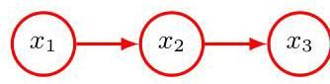

Exercise 11.7

练习 11.7

and so the covariance can similarly be evaluated recursively starting from the lowest numbered node.

因此，协方差同样可以从编号最小的节点开始递归计算。

We now consider two extreme cases of possible graph structures. First, suppose that there are no links in the graph, which therefore comprises isolated nodes. In this case, there are no parameters and so there are just parameters and parameters . From the recursion relations (11.12) and (11.13), we see that the mean of is given by and the covariance matrix is diagonal of the form . The joint distribution has a total of parameters and represents a set of independent univariate Gaussian distributions.

现在我们考虑两种极端的图结构情况。首先，假设图中没有边，因此该图由 个孤立节点组成。在这种情况下，没有参数 ，所以只有 个参数 和 个参数 。从递归关系 (11.12) 和 (11.13) 中，我们可以看到 的均值由 给出，协方差矩阵是形如 的对角矩阵。联合分布总共有 个参数，代表了一组 个独立的单变量高斯分布。

Now consider a fully connected graph in which each node has all lower numbered nodes as parents. In this case the total number of independent parameters and in the covariance matrix is corresponding to a general symmetric covariance.

现在考虑一个完全连通的图，其中每个节点都以所有编号更小的节点作为父节点。在这种情况下，协方差矩阵中独立参数 和 的总数为 ，对应于一个一般的对称协方差。

Exercise 11.8

练习 11.8

Graphs having some intermediate level of complexity correspond to joint Gaussian distributions with partially constrained covariance matrices. Consider for example the graph shown in Figure 11.7, which has a link missing between variables and . Using the recursion relations (11.12) and (11.13), we see that the mean and covariance of the joint distribution are given by

具有一定中间复杂程度的图对应于具有部分约束协方差矩阵的联合高斯分布。例如，考虑图 11.7 所示的图，其中变量 和 之间缺少一条边。使用递推关系 (11.12) 和 (11.13)，我们可以看到联合分布的均值和协方差由下式给出

Exercise 11.9

练习 11.9

We can readily extend the linear-Gaussian graphical model to a situation in which the nodes of the graph represent multivariate Gaussian variables. In this case, we can write the conditional distribution for node in the form

我们可以很容易地将线性 - 高斯图形模型扩展到图的节点表示多元高斯变量的情况。在这种情况下，我们可以将节点 的条件分布写成如下形式

where now is a matrix (which is non-square if and have different dimensionality). Again it is easy to verify that the joint distribution over all variables is Gaussian.

其中现在 是一个矩阵(如果 和 的维数不同，则该矩阵是非方阵)。同样，很容易验证所有变量的联合分布是高斯分布。

Exercise 11.10

练习 11.10

Figure 11.8 Directed graphical model representing the binary classifier model described by the joint distribution (11.17) showing only the stochastic variables and .

图 11.8 有向图模型，它表示由联合分布 (11.17) 描述的二元分类器模型，仅显示随机变量 和 。

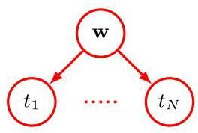

# 11.1.5 Binary classifier

# 11.1.5 二元分类器

We can illustrate the use of directed graphs to describe probability distributions using a two-class classifier model with Gaussian prior over the learnable parameters. We can write this in the form

我们可以使用一个对可学习参数具有高斯先验的两类分类器模型来说明如何使用有向图来描述概率分布。我们可以将其写成如下形式

Section 2.6.2

第 2.6.2 节

where is the vector of target values, is the data matrix with rows , and the distribution is given by (11.1). We also assume a Gaussian prior over the parameter vector given by

其中 是目标值向量， 是数据矩阵，其行向量为 ，分布 由 (11.1) 给出。我们还假设参数向量 具有高斯先验，其形式为

The stochastic variables in this model are and . In addition, this model contains the noise variance and the hyperparameter , both of which are parameters of the model rather than stochastic variables. If we consider for a moment only the stochastic variables, then the distribution given by (11.17) can be represented by the graphical model shown in Figure 11.8.

该模型中的随机变量是 和 。此外，该模型包含噪声方差 和超参数 ，它们都是模型的参数，而不是随机变量。如果我们暂时只考虑随机变量，那么由 (11.17) 给出的分布可以用图 11.8 所示的图形模型来表示。

When we start to deal with more complex models, it becomes inconvenient to have to write out multiple nodes of the form explicitly as in Figure 11.8. We therefore introduce a graphical notation that allows such multiple nodes to be expressed more compactly. We draw a single representative node and then surround this with a box, called a plate, labelled with to indicate that there are nodes of this kind. Rewriting the graph of Figure 11.8 in this way, we obtain the graph shown in Figure 11.9.

当我们开始处理更复杂的模型时，像图 11.8 那样明确写出多个形式为 的节点会变得很不方便。因此，我们引入一种图形表示法，它能更简洁地表示这类多个节点。我们绘制一个代表性节点 ，然后用一个框将其包围起来，这个框称为盘，标有 以表示有 个这类节点。以这种方式重写图 11.8 的图，我们得到图 11.9 所示的图。

# 11.1.6 Parameters and observations

# 11.1.6 参数和观测值

We will sometimes find it helpful to make the parameters of a model, as well as its stochastic variables, explicit in the graphical representation. To do this, we will adopt the convention that random variables are denoted by open circles and deterministic parameters are denoted by floating variables. If we take the graph of ple is shown explicitly. Figure 11.9 and include the deterministic parameters, we obtain the graph shown in Figure 11.10.

我们有时会发现，在图形表示中明确模型的参数以及随机变量会很有帮助。为此，我们采用如下约定:随机变量用空心圆表示，确定性参数用浮动变量表示。如果我们采用图 11.9 的图并包含确定性参数，就会得到图 11.10 所示的图，其中 被明确显示。

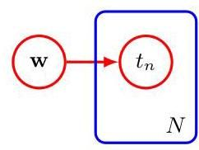

Figure 11.10 The same model as in Figure 11.9 but with the deterministic parameters shown explicitly by the floating variables.

图 11.10 与图 11.9 相同的模型，但确定性参数由浮动变量明确显示。

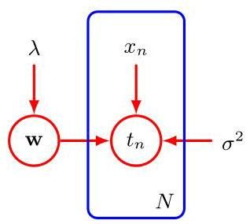

When we apply a graphical model to a problem in machine learning, we will typically set some of the random variables to specific observed values. For example, the stochastic variables in the linear regression model will be set equal to the specific values given in the training set. In a graphical model, we denote such - served variables by shading the corresponding nodes. Thus, the graph corresponding to Figure 11.10 in which the variables are observed is shown in Figure 11.11.

当我们将图形模型应用于机器学习问题时，通常会将一些随机变量设置为特定的观测值。例如，线性回归模型中的随机变量 将被设置为训练集中给出的特定值。在图形模型中，我们通过对相应节点进行着色来表示这类 观测变量。因此，对应于图 11.10 且变量 被观测到的图如图 11.11 所示。

Note that the value of is not observed, and so is an example of a latent variable, also known as a hidden variable. Such variables play a crucial role in many of the models discussed in this book. We therefore have three kinds of variables in a directed graphical model. First, there are unobserved (also called latent, or hidden) stochastic variables, which are denoted by open red circles. Second, when stochastic variables are observed, so that that they are set to specific values, they are denoted by red circles shaded with blue. Finally, non-stochastic parameters are denoted by floating variables, as seen in Figure 11.11.

请注意， 的值未被观测到，因此 是潜在变量(也称为隐藏变量)的一个例子。这类变量在本书讨论的许多模型中起着至关重要的作用。因此，在有向图形模型中有三种类型的变量。首先，有未观测到的(也称为潜在或隐藏)随机变量，用红色空心圆表示。其次，当随机变量被观测到时，即它们被设置为特定值时，用蓝色阴影的红色圆表示。最后，非随机参数用浮动变量表示，如图 11.11 所示。

Note that model parameters such as are generally of little direct interest in themselves, because our ultimate goal is to make predictions for new input values. Suppose we are given a new input value and we wish to find the corresponding probability distribution for conditioned on the observed data. The joint distribution of all the random variables in this model, conditioned on the deterministic parameters, is given by

请注意，像 这样的模型参数本身通常没有太大的直接意义，因为我们的最终目标是对新的输入值进行预测。假设我们得到一个新的输入值 ，并且我们希望找到在观测数据条件下 的相应概率分布。在确定性参数条件下，该模型中所有随机变量的联合分布由下式给出

and the corresponding graphical model is shown in Figure 11.12.

相应的图形模型如图 11.12 所示。

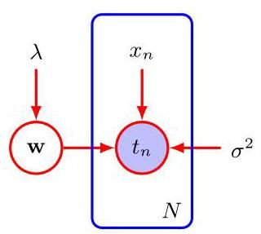

Figure 11.11 As in Figure 11.10 but with the nodes shaded to indicate that the corresponding random variables have been set to their observed values given by the training set.

图 11.11 与图 11.10 类似，但节点 被阴影覆盖，以表明相应的随机变量已被设置为训练集给出的观测值。

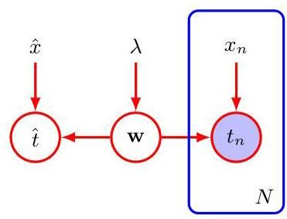

Figure 11.12 The classification model, corresponding to Figure 11.11, showing a new input value together with the corresponding model prediction .

图 11.12 对应于图 11.11 的分类模型，展示了一个新的输入值 以及相应的模型预测 。

The required predictive distribution for is then obtained from the sum rule of probability by integrating out the model parameters . This integration over parameters represents a fully Bayesian treatment, which is rarely used in practice, especially with deep neural networks. Instead, we approximate this integral by first finding the most probable value that maximizes the posterior distribution and then using just this single value to make predictions using .

然后，通过概率的求和规则，对模型参数 进行积分，得到 所需的预测分布。对参数的这种积分表示完全贝叶斯处理方法，在实践中很少使用，尤其是在深度神经网络中。相反，我们通过以下方式近似这个积分:首先找到使后验分布最大化的最可能值 ，然后仅使用这个单一值，通过 进行预测。

# 11.1.7 Bayes’ theorem

# 11.1.7 贝叶斯定理

When stochastic variables in a probabilistic model are set equal to observed values, the distributions over other unobserved stochastic variables change accordingly. The process of calculating these updated distributions is known as inference. We can illustrate this by considering the graphical interpretation of Bayes’ theorem. Suppose we decompose the joint distribution over two variables and into a product of factors in the form . This can be represented by the directed graph shown in Figure 11.13(a). Now suppose we observe the value of , as indicated by the shaded node in Figure 11.13(b). We can view the marginal distribution as a prior over the latent variable , and our goal is to infer the corresponding posterior. Using the sum and product rules of probability we can evaluate

当概率模型中的随机变量被设定为观测值时，其他未观测到的随机变量的分布会相应改变。计算这些更新后的分布的过程被称为推断。我们可以通过考虑贝叶斯定理的图形解释来说明这一点。假设我们将两个变量 和 上的联合分布 分解为 形式的因子乘积。这可以用图 11.13(a) 所示的有向图来表示。现在假设我们观测到了 的值，如图 11.13(b) 中阴影节点所示。我们可以将边缘分布 视为潜在变量 上的先验分布，我们的目标是推断相应的后验分布。使用概率的求和与乘积规则，我们可以计算

which can then be used in Bayes’ theorem to calculate

然后可以将其用于贝叶斯定理来计算

Thus, the joint distribution is now expressed in terms of and . From a graphical perspective, the joint distribution is represented by the graph shown in Figure 11.13(c), in which the direction of the arrow is reversed. This is the simplest example of an inference problem for a graphical model.

因此，联合分布现在用 和 来表示。从图形的角度来看，联合分布 由图 11.13(c) 所示的图表示，其中箭头的方向反转了。这是图形模型推断问题的最简单示例。

For complex graphical models that capture rich probabilistic structure, the process of calculating posterior distributions once some of the stochastic variables are observed can be complex and subtle. Conceptually, it simply involves the systematic application of the sum and product rules of probability, or equivalently Bayes’ theorem. In practice, however, managing these calculations efficiently can benefit greatly from an exploitation of the graphical structure. These calculations can be expressed

对于捕捉丰富概率结构的复杂图形模型，一旦观测到一些随机变量，计算后验分布的过程可能会复杂而微妙。从概念上讲，它仅仅涉及系统地应用概率的求和与乘积规则，或者等价地应用贝叶斯定理。然而，在实践中，有效管理这些计算可以极大地受益于对图形结构的利用。这些计算可以表示为

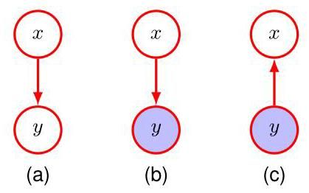

Figure 11.13 A graphical representation of Bayes’ theorem showing (a) a joint distribution over two variables and expressed in factorized form, (b) the case with set to an observed value, and (c) the resulting posterior distribution over , given by Bayes’ theorem.

图 11.13 贝叶斯定理的图形表示，展示了 (a) 以因式分解形式表示的两个变量 和 上的联合分布，(b) 被设定为观测值的情况，以及 (c) 由贝叶斯定理给出的 上的后验分布。

in terms of elegant calculations on the graph that involve sending local messages between nodes. Such methods give exact answers for tree-structured graphs and give approximate iterative algorithms for graphs with loops. Since we will not discuss these further here, see Bishop (2006) for a more comprehensive discussion in the context of machine learning.

通过在图上进行涉及节点之间传递局部消息的优雅计算。此类方法对于树状结构的图能给出精确答案，对于有环的图则给出近似迭代算法。由于我们在此不再进一步讨论这些内容，有关机器学习背景下的更全面讨论，请参阅 Bishop (2006)。

# 11.2. Conditional Independence

# 11.2. 条件独立性

An important concept for probability distributions over multiple variables is that of conditional independence (Dawid,1980). Consider three variables , and , and suppose that the conditional distribution of given and is such that it does not depend on the value of , so that

对于多个变量的概率分布而言，一个重要的概念是条件独立性(Dawid，1980)。考虑三个变量 、 ，假设给定 和 时 的条件分布不依赖于 的值，即

We say that is conditionally independent of given . This can be expressed in a slightly different way if we consider the joint distribution of and conditioned on , which we can write in the form

我们称给定 时， 与 条件独立。如果我们考虑给定 时 和 的联合分布，那么可以用另一种稍有不同的方式来表达，我们可以将其写成如下形式

where we have used the product rule of probability together with (11.22). We see that, conditioned on , the joint distribution of and factorizes into the product of the marginal distribution of and the marginal distribution of (again both conditioned on ). This says that the variables and are statistically independent, given . Note that our definition of conditional independence will require that (11.22), or equivalently (11.23), must hold for every possible value of , and not just for some values. We will sometimes use a shorthand notation for conditional independence (Dawid, 1979) in which

这里我们结合式(11.22)使用了概率的乘积规则。我们看到，在给定 的条件下， 和 的联合分布可以分解为 的边缘分布与 的边缘分布的乘积(同样，两者都以 为条件)。这表明，给定 时，变量 和 是统计独立的。请注意，我们对条件独立性的定义要求式(11.22)，或者等价地式(11.23)，必须对 的每一个可能值都成立，而不仅仅是某些值。我们有时会使用条件独立性的简写符号(Dawid，1979)，其中

denotes that is conditionally independent of given . Conditional independence properties play an important role in probabilistic models for machine learning because they simplify both the structure of a model and the computations needed to perform inference and learning under that model.

表示给定 时， 与 条件独立。条件独立性性质在机器学习的概率模型中起着重要作用，因为它们既简化了模型的结构，也简化了在该模型下进行推理和学习所需的计算。

Figure 11.14 The first of three examples of graphs over three variables , and used to discuss conditional independence properties of directed graphical models.

图 11.14 是关于三个变量 和 的图的三个示例中的第一个，用于讨论有向图模型的条件独立性性质。

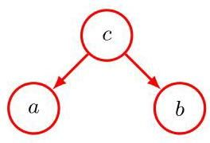

If we are given an expression for the joint distribution over a set of variables in terms of a product of conditional distributions (i.e., the mathematical representation underlying a directed graph), then we could in principle test whether any potential conditional independence property holds by repeated application of the sum and product rules of probability. In practice, such an approach would be very time-consuming. An important and elegant feature of graphical models is that conditional independence properties of the joint distribution can be read directly from the graph without having to perform any analytical manipulations. The general framework for achieving this is called d-separation, where the ’d’ stands for ’directed’ (Pearl, 1988). Here we will motivate the concept of d-separation and give a general statement of the d-separation criterion. A formal proof can be found in Lauritzen (1996).

如果我们得到了一组变量的联合分布表达式，该表达式是用条件分布的乘积形式表示的(即有向图所基于的数学表示)，那么原则上，我们可以通过反复应用概率的求和规则和乘积规则来检验任何潜在的条件独立性是否成立。在实践中，这种方法会非常耗时。图模型的一个重要且精妙的特点是，联合分布的条件独立性可以直接从图中读出，而无需进行任何分析性的操作。实现这一点的通用框架称为 d-分离，其中的“d”代表“有向”(Pearl，1988)。在这里，我们将引入 d-分离的概念，并给出 d-分离准则的一般表述。正式的证明可在 Lauritzen(1996)中找到。

# 11.2.1 Three example graphs

# 11.2.1 三个示例图

We begin our discussion of the conditional independence properties of directed graphs by considering three simple examples each involving graphs having just three nodes. Together, these will motivate and illustrate the key concepts of d-separation. The first of the three examples is shown in Figure 11.14, and the joint distribution corresponding to this graph is easily written down using the general result (11.6) to give

我们通过考虑三个简单的例子来开始讨论有向图的条件独立性，每个例子都涉及只有三个节点的图。这些例子将共同引出并阐释 d-分离的关键概念。这三个例子中的第一个如图 11.14 所示，使用一般结果(11.6)可以很容易地写出与此图对应的联合分布

If none of the variables are observed, then we can investigate whether and are independent by marginalizing both sides of (11.25) with respect to to give

如果没有变量被观测到，那么我们可以通过对(11.25)式两边关于 求边缘分布来研究 和 是否独立，从而得到

In general, this does not factorize into the product , and so

一般来说，这不能分解为乘积 ，因此

$$a \mathrel{\text{ \textbackslash bot \textbackslash not\{ } }} b \mid \varnothing \qquad \text{(11.27)}$$

where denotes the empty set, and the symbol means that the conditional independence property does not hold in general. Of course, it may hold for a particular distribution by virtue of the specific numerical values associated with the various conditional probabilities, but it does not follow in general from the structure of the graph.

其中 表示空集，符号 表示条件独立性一般情况下不成立。当然，对于特定的分布，由于与各种条件概率相关的具体数值，条件独立性可能成立，但一般来说，它并不由图的结构所决定。

Now suppose we condition on the variable , as represented by the graph of Figure 11.15. From (11.25), we can easily write down the conditional distribution of

现在假设我们以变量 为条件，如图 11.15 所示。根据 (11.25)，我们可以轻松写出

Figure 11.15 As in Figure 11.14 but where we have conditioned on the value of variable .

图 11.15 与图 11.14 类似，但这里我们以变量 的值为条件。

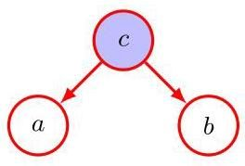

and , given , in the form

给定 时， 和 的条件分布，形式为

and so we obtain the conditional independence property

因此我们得到条件独立性质

We can provide a simple graphical interpretation of this result by considering the path from node to node via . The node is said to be tail-to-tail with respect to this path because the node is connected to the tails of the two arrows, and the presence of such a path connecting nodes and causes these nodes to be dependent. However, when we condition on node , as in Figure 11.15, the conditioned node ’blocks’ the path from to and causes and to become (conditionally) independent.

我们可以通过考虑从节点 经由 到节点 的路径，对这一结果给出一个简单的图形解释。对于这条路径，节点 被称为尾对尾节点，因为该节点与两条箭头的尾部相连，并且存在这样一条连接节点 和 的路径会导致这些节点相互依赖。然而，当我们以节点 为条件时，如图 11.15 所示，被条件化的节点 “阻断” 了从 到 的路径，并使 和 变得(条件)独立。

We can similarly consider the graph shown in Figure 11.16. The joint distribution corresponding to this graph is again obtained from our general formula (11.6) to give

我们可以类似地考虑图 11.16 所示的图。对应于该图的联合分布同样可以从我们的通用公式 (11.6) 得到，即

First, suppose that none of the variables are observed. Again, we can test to see if and are independent by marginalizing over to give

首先，假设没有一个变量是可观测的。同样，我们可以通过对 进行边缘化处理来检验 和 是否相互独立，得到

which in general does not factorize into , and so

一般情况下，它不能分解为 ，因此

$$a \mathrel{\text{ \textbackslash bot \textbackslash not\{ } }} b \mid \varnothing \qquad \text{(11.29)}$$

as before.

和之前一样。

Now suppose we condition on node , as shown in Figure 11.17. Using Bayes’

现在假设我们以节点 为条件，如图 11.17 所示。使用贝叶斯(Bayes)

Figure 11.16

图 11.16

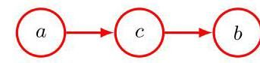

theorem together with (11.28), we obtain

定理与 (11.28) 式联立，我们得到

and so again we obtain the conditional independence property

因此，我们再次得到了条件独立性性质

As before, we can interpret these results graphically. The node is said to be head-to-tail with respect to the path from node to node . Such a path connects nodes and and renders them dependent. If we now observe , as in Figure 11.17, then this observation ’blocks’ the path from to and so we obtain the conditional independence property .

和之前一样，我们可以用图形来解释这些结果。节点 相对于从节点 到节点 的路径被称为头到尾连接。这样的路径连接了节点 和 ，并使它们相互依赖。如果我们现在观察到 ，如图 11.17 所示，那么这个观察结果 “阻断” 了从 到 的路径，因此我们得到了条件独立性性质 。

Finally, we consider the third of our three-node examples, shown by the graph in Figure 11.18. As we will see, this has a more subtle behaviour than the two previous graphs. The joint distribution can again be written down using our general result (11.6) to give

最后，我们考虑三节点示例中的第三个，如图 11.18 中的图所示。正如我们将看到的，这种情况的行为比前两个图更微妙。利用我们的一般结果 (11.6)，可以再次写出联合分布，得到

Consider first the case where none of the variables are observed. Marginalizing both sides of (11.30) over we obtain

首先考虑没有观察到任何变量的情况。对 (11.30) 式两边关于 进行边缘化，我们得到

and so and are independent with no variables observed, in contrast to the two previous examples. We can write this result as

因此，在没有观察到任何变量的情况下， 和 是相互独立的，这与前两个例子形成对比。我们可以将这个结果写成

Now suppose we condition on , as indicated in Figure 11.19. The conditional distribution of and is then given by

现在假设我们以 为条件，如图 11.19 所示。那么 和 的条件分布由下式给出

Figure 11.18 The last of our three examples of three-node graphs used to explore conditional independence properties in graphical models. This graph has rather different properties from the two previous examples.

图 11.18 我们用于探索图模型中条件独立性属性的三节点图的三个示例中的最后一个。此图与前两个示例具有相当不同的属性。

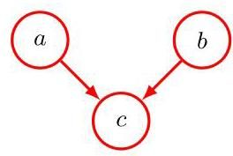

Figure 11.19 As in Figure 11.18 but conditioning on the value of node . In this graph, the act of conditioning induces a dependence between and . which in general does not factorize into the product , and so

图 11.19 与图 11.18 相同，但以节点 的值为条件。在此图中，以该值为条件的操作会在 和 之间引入一种依赖关系，这种依赖关系通常不能分解为乘积 ，因此

$$a \mathrel{\text{ \textbackslash bot \textbackslash not\{ } }} b \mid { } { } c.$$

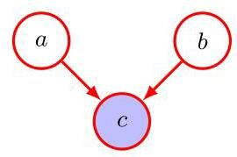

Thus, our third example has the opposite behaviour from the first two. Graphically, we say that node is head-to-head with respect to the path from to because it connects to the heads of the two arrows. The node is sometimes called a collider node. When node is unobserved, it ’blocks’ the path, and the variables and are independent. However, conditioning on ’unblocks’ the path and renders and dependent.

因此，我们的第三个示例与前两个示例的行为相反。从图形上看，我们说节点 相对于从 到 的路径是头对头的，因为它连接到两个箭头的头部。节点 有时被称为碰撞节点。当节点 未被观察到时，它“阻断”了路径，变量 和 是独立的。然而，以 为条件会“解除阻断”路径，并使 和 产生依赖关系。

There is one more subtlety associated with this third example that we need to consider. First we introduce some more terminology. We say that node is a descendant of node if there is a path from to in which each step of the path follows the directions of the arrows. Then it can be shown that a head-to-head path will become unblocked if either the node, or any of its descendants, is observed.

与这个第三个示例相关的还有一个更微妙的问题需要我们考虑。首先，我们引入一些更多的术语。如果从 到 存在一条路径，且路径的每一步都遵循箭头的方向，我们就说节点 是节点 的后代。然后可以证明，如果观察到该节点或其任何后代，头对头路径将被解除阻断。

Exercise 11.13

练习 11.13

In summary, a tail-to-tail node or a head-to-tail node leaves a path unblocked unless it is observed, in which case it blocks the path. By contrast, a head-to-head node blocks a path if it is unobserved, but once the node and/or at least one of its descendants is observed the path becomes unblocked.

总之，尾对尾节点或头对尾节点会使路径保持畅通，除非它被观察到，在这种情况下它会阻断路径。相比之下，头对头节点在未被观察到时会阻断路径，但一旦该节点和/或其至少一个后代被观察到，路径就会变得畅通。

# 11.2.2 Explaining away

# 11.2.2 解释消除

It is worth spending a moment to understand further the unusual behaviour of the graph in Figure 11.19. Consider a particular instance of such a graph corresponding to a problem with three binary random variables relating to the fuel system on a car, as shown in Figure 11.20. The variables are , which represents the state of a battery that is either charged or flat which represents the state of the fuel tank that is either full of fuel or empty , and , which is the state of an electric fuel gauge and which indicates that the fuel tank is either full or empty . The battery is either charged or flat, and independently, the fuel tank is either full or empty, with prior probabilities

值得花点时间进一步理解图 11.19 中图形的异常行为。考虑这样一个图形的特定实例，它对应于一个涉及汽车燃油系统的三个二元随机变量的问题，如图 11.20 所示。这些变量是 ，它表示电池的状态，要么已充电 要么没电 ； 表示燃油箱的状态，要么充满燃油 要么为空 ；以及 ，它是电子燃油表的状态，指示燃油箱要么满 要么空 。电池要么已充电要么没电，并且独立地，燃油箱要么满要么空，具有先验概率

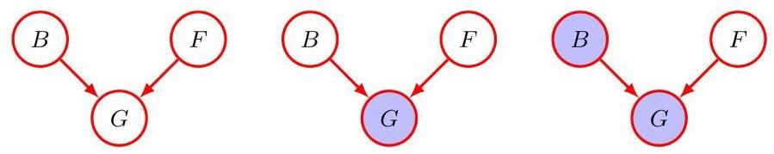

Figure 11.20 An example of a three-node graph used to illustrate ’explaining away’. The three nodes represent the state of the battery , the state of the fuel tank , and the reading on the electric fuel gauge . See the text for details.

图 11.20 用于说明“解释消除”的三节点图示例。三个节点分别表示电池的状态 、燃油箱的状态 以及电子燃油表的读数 。详情见正文。

Given the state of the fuel tank and the battery, the fuel gauge reads full with probabilities given by

给定燃油箱和电池的状态，燃油表显示满的概率由下式给出

so this is a rather unreliable fuel gauge! All remaining probabilities are determined by the requirement that probabilities sum to one, and so we have a complete specification of the probabilistic model.

所以这是一个相当不可靠的燃油表！所有其余的概率由概率之和为 1 的要求确定，因此我们有了概率模型的完整规范。

Before we observe any data, the prior probability of the fuel tank being empty is . Now suppose that we observe the fuel gauge and discover that it reads empty, i.e., , corresponding to the middle graph in Figure 11.20. We can use Bayes’ theorem to evaluate the posterior probability of the fuel tank being empty. First we evaluate the denominator for Bayes’ theorem:

在我们观察任何数据之前，燃油箱为空的先验概率是 。现在假设我们观察燃油表，发现它显示为空，即 ，对应于图 11.20 中的中间图形。我们可以使用贝叶斯定理来评估燃油箱为空的后验概率。首先，我们计算贝叶斯定理的分母:

and similarly we evaluate

同样地，我们进行评估

and using these results, we have

利用这些结果，我们得到

and so . Thus, observing that the gauge reads empty makes it more likely that the tank is indeed empty, as we would intuitively expect. Next suppose that we also check the state of the battery and find that it is flat, i.e., . We have now observed the states of both the fuel gauge and the battery, as shown by the right-hand graph in Figure 11.20. The posterior probability that the fuel tank is empty given the observations of both the fuel gauge and the battery state is then given by

因此 。这样，正如我们直观预期的那样，观察到燃油表显示为空会使油箱确实为空的可能性更大。接下来，假设我们还检查了电池的状态，发现电池没电了，即 。如图 11.20 右侧的图所示，我们现在已经观察到了燃油表和电池的状态。那么，在观察到燃油表和电池状态的情况下，油箱为空的后验概率由下式给出

where the prior probability has cancelled between the numerator and denominator. Thus, the probability that the tank is empty has decreased (from 0.257 to 0.111) as a result of the observation of the state of the battery. This accords with our intuition that finding that the battery is flat explains away the observation that the fuel gauge reads empty. We see that the state of the fuel tank and that of the battery have indeed become dependent on each other as a result of observing the reading on the fuel gauge. In fact, this would also be the case if, instead of observing the fuel gauge directly, we observed the state of some descendant of , for example a rather unreliable witness who reports seeing that the gauge was reading empty. Note that the probability is greater than the prior probability because the observation that the fuel gauge reads zero still provides some evidence in favour of an empty fuel tank.

其中，先验概率 在分子和分母中相互抵消。因此，由于观察到电池的状态，油箱为空的概率降低了(从 0.257 降至 0.111)。这符合我们的直觉，即发现电池没电可以解释燃油表显示为空的观察结果。我们看到，由于观察到燃油表的读数，油箱的状态和电池的状态实际上已经相互依赖。事实上，如果我们不是直接观察燃油表，而是观察 的某个后代的状态，例如一个相当不可靠的证人报告说看到燃油表显示为空，情况也是如此。请注意，概率 大于先验概率 ，因为观察到燃油表读数为零仍然为油箱为空提供了一些证据。

Figure 11.21 Illustration of d-separation. See the text for details.

图 11.21 d-分离的图示。详情见正文。

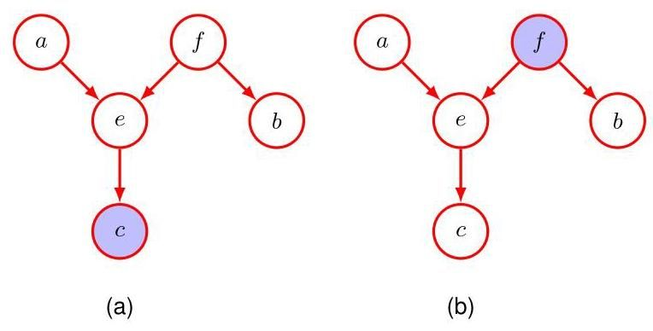

Exercise 11.14

练习 11.14

# 11.2.3 D-separation

# 11.2.3 D-分离

We now give a general statement of the d-separation property (Pearl, 1988) for directed graphs. Consider a general directed graph in which , and are arbitrary non-intersecting sets of nodes (whose union may be smaller than the complete set of nodes in the graph). We wish to ascertain whether a particular conditional independence statement is implied by a given directed acyclic graph. To do so, we consider all possible paths from any node in to any node in . Any such path is said to be blocked if it includes a node such that either

现在，我们给出有向图的 D-分离性质(Pearl，1988)的一般陈述。考虑一个一般的有向图，其中 和 是任意不相交的节点集合(它们的并集可能小于图中节点的完整集合)。我们希望确定给定的有向无环图是否蕴含特定的条件独立陈述 。为此，我们考虑从 中的任何节点到 中的任何节点的所有可能路径。如果这样的路径包含一个节点，满足以下任一条件，则称该路径被阻塞:

(a) the arrows on the path meet either head-to-tail or tail-to-tail at the node, and the node is in the set , or

(a) 路径上的箭头在该节点处是头对尾或尾对尾相遇，并且该节点在集合 中；或者

(b) the arrows meet head-to-head at the node and neither the node, nor any of its descendants is in the set .

(b) 箭头在该节点处头对头相遇，并且该节点及其任何后代都不在集合 中。

If all paths are blocked, then is said to be d-separated from by , and the joint distribution over all the variables in the graph will satisfy .

如果所有路径都被阻塞，则称 被 从 中 D-分离，并且图中所有变量的联合分布将满足 。

D-separation is illustrated in Figure 11.21. In graph (a), the path from to is not blocked by node because it is a tail-to-tail node for this path and is not observed, nor is it blocked by node because, although the latter is a head-to-head node, it has a descendant in the conditioning set. Thus, the conditional independence statement does not follow from this graph. In graph (b), the path from to is blocked by node because this is a tail-to-tail node that is observed, and so the conditional independence property will be satisfied by any distribution that factorizes according to this graph. Note that this path is also blocked by node because is a head-to-head node and neither it nor its descendant are in the conditioning set. In d-separation, parameters such as in Figure 11.12, which are indicated by floating variables, behave in the same way as observed nodes. However, there are no marginal distributions associated with such nodes, and consequently parameter nodes never themselves have parents and so all paths through these nodes will always be tail-to-tail and hence blocked. Consequently they play no role in d-separation.

D-分离在图 11.21 中进行了说明。在图 (a) 中，从 到 的路径没有被节点 阻塞，因为对于该路径而言，它是一个尾对尾节点且未被观测到；也没有被节点 阻塞，因为尽管后者是一个头对头节点，但它在条件集合中有一个后代 。因此，条件独立陈述 不能从这个图中得出。在图 (b) 中，从 到 的路径被节点 阻塞，因为这是一个被观测到的尾对尾节点，因此任何根据这个图进行因式分解的分布都将满足条件独立性质 。请注意，这条路径也被节点 阻塞，因为 是一个头对头节点，并且它及其后代都不在条件集合中。在 D-分离中，如图 11.12 中由浮动变量表示的参数(如 )，其行为与被观测节点相同。然而，这些节点没有相关的边缘分布，因此参数节点本身永远不会有父节点，所以通过这些节点的所有路径始终是尾对尾的，因此会被阻塞。因此，它们在 D-分离中不起作用。

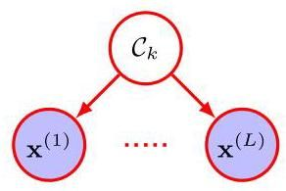

Figure 11.22 A graphical representation of the naive Bayes model for classification. Conditioned on the class label , the elements of the observed vector are assumed to be independent.

图 11.22 用于分类的朴素贝叶斯模型的图形表示。在类别标签 的条件下，观测向量 的元素被假定为相互独立。

Another example of conditional independence and d-separation is provided by i.i.d. (independent and identically distributed) data. Consider the binary classification model shown in Figure 11.12. Here the stochastic nodes correspond to , , and . We see that the node for is tail-to-tail with respect to the path from to any one of the nodes , and so we have the following conditional independence

条件独立性和 d-分离的另一个例子由独立同分布(i.i.d.)数据提供。考虑图 11.12 所示的二元分类模型。这里，随机节点对应于 、 和 。我们看到，节点 相对于从 到任何一个节点 的路径是尾对尾的，因此我们有以下条件独立性

Section 2.3.2

第 2.3.2 节

property:

性质:

Thus, conditioned on the network parameters , the predictive distribution for is independent of the training data . We can therefore first use the training data to determine the posterior distribution (or some approximation to the posterior distribution) over the coefficients and then we can discard the training data and use the posterior distribution for to make predictions of for new input observations .

因此，在网络参数 的条件下， 的预测分布与训练数据 无关。因此，我们可以首先使用训练数据来确定系数 的后验分布(或后验分布的某种近似)，然后我们可以丢弃训练数据，并使用 的后验分布对新的输入观测 进行 的预测。

# 11.2.4 Naive Bayes

# 11.2.4 朴素贝叶斯

A related graphical structure arises in an approach to classification called the naive Bayes model, in which we use conditional independence assumptions to simplify the model structure. Suppose our data consists of observations of a vector , and we wish to assign values of to one of classes. We can define a class-conditional density for each of the classes, along with prior class probabilities . The key assumption of the naive Bayes model is that, conditioned on the class , the distribution of the input variable factorizes into the product of two or more densities. Suppose we partition into elements . Naive Bayes then takes the form

一种相关的图形结构出现在一种称为朴素贝叶斯模型的分类方法中，在该方法中，我们使用条件独立性假设来简化模型结构。假设我们的数据由向量 的观测值组成，并且我们希望将 的值分配到 个类别之一。我们可以为每个类别定义一个类别条件密度 ，以及先验类别概率 。朴素贝叶斯模型的关键假设是，在给定类别 的条件下，输入变量的分布可以分解为两个或更多密度的乘积。假设我们将 划分为 个元素 。那么朴素贝叶斯模型具有如下形式

where it is assumed that (11.37) holds for each of the classes separately. The graphical representation of this model is shown in Figure 11.22. We see that an observation of would block the path between and for because such paths are tail-to-tail at the node , and so and are conditionally independent given . If, however, we marginalize out , the tail-to-tail path from to is no longer blocked, which tells us that in general the marginal density will not factorize with respect to the elements .

其中假设 (11.37) 分别对每个类别 都成立。该模型的图形表示如图 11.22 所示。我们看到，对于 ， 的一个观测值会阻断 和 之间的路径，因为这样的路径在节点 处是尾对尾的，因此在给定 的条件下， 和 是条件独立的。然而，如果我们对 进行边缘化，从 到 的尾对尾路径不再被阻断，这告诉我们，一般来说，边缘密度 不会相对于元素 进行分解。

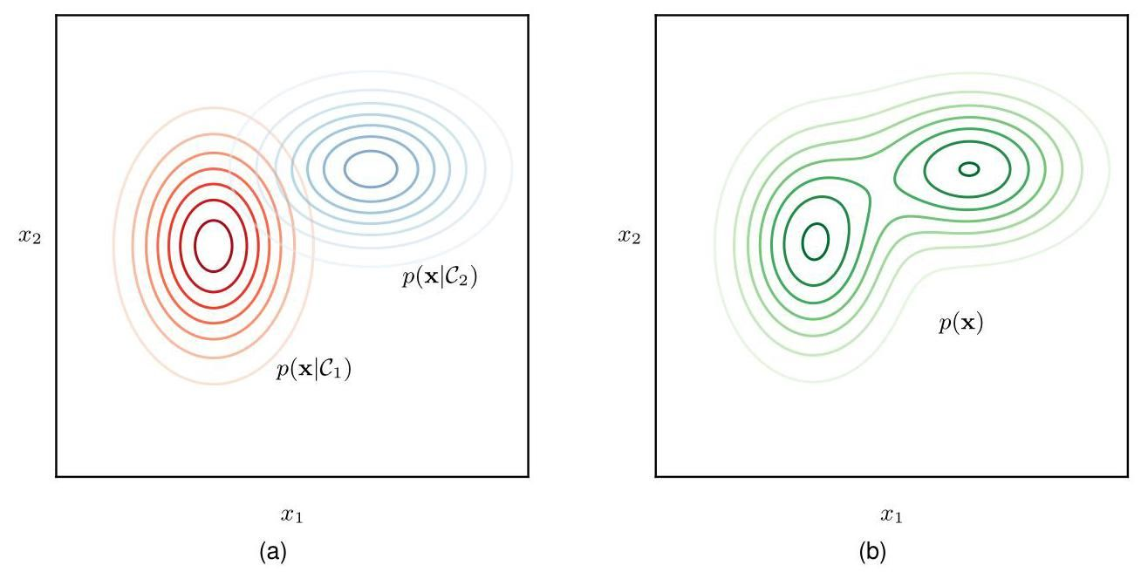

Figure 11.23 Illustration of a naive Bayes classifier for a two-dimensional data space, showing (a) the conditional distributions for each of the two classes and (b) the marginal distribution in which we have assumed equal class priors . Note that the conditional distributions factorize with respect to and , whereas the marginal distribution does not.

图 11.23 展示了二维数据空间中的朴素贝叶斯分类器，其中 (a) 显示了两个类别各自的条件分布 ，(b) 显示了边缘分布 ，我们假设两个类别的先验概率 相等。请注意，条件分布相对于 和 是可分解的，而边缘分布则不是。

If we are given a labelled training set, comprising observations together with their class labels, then we can fit the naive Bayes model to the training data using maximum likelihood by assuming that the data are drawn independently from the model. The solution is obtained by fitting the model for each class separately using the corresponding labelled data and then setting the class priors equal to the fraction of training data points in each class. The probability that a vector belongs to class is then given by Bayes’ theorem in the form

如果我们有一个带标签的训练集，它由观测值 及其类别标签组成，那么我们可以假设数据是从模型中独立抽取的，使用最大似然法将朴素贝叶斯模型拟合到训练数据上。通过使用相应的带标签数据分别对每个类别拟合模型，然后将类别先验 设置为每个类别中训练数据点的比例，即可得到解决方案。然后，向量 属于类别 的概率由贝叶斯定理给出，形式如下

Exercise 11.15

练习 11.15

where is given by (11.37), and can be evaluated using

其中 由 (11.37) 给出，并且 可以使用以下方法计算

The naive Bayes model is illustrated for a two-dimensional data space in Figure 11.23 in which . Here we assume that the conditional densities for each of the two classes are axis-aligned Gaussians, and hence that they each factorize with respect to and so that

图 11.23 展示了二维数据空间中的朴素贝叶斯模型，其中 。这里我们假设两个类别各自的条件密度 是轴对齐的高斯分布，因此它们各自关于 和 可分解，使得

However, the marginal density given by

然而，由下式给出的边缘密度

is now a mixture of Gaussians and does not factorize with respect to and . We have already encountered a simple application of the naive Bayes model in the context of fusing data from different sources, such as blood tests and skin images for medical diagnosis.

现在是高斯分布的混合，并且关于 和 不可分解。我们已经在融合不同来源数据(如用于医学诊断的血液检测和皮肤图像)的背景下遇到过朴素贝叶斯模型的一个简单应用。

Section 5.2.4

第 5.2.4 节

The naive Bayes assumption is helpful when the dimensionality of the input space is high, making density estimation in the full -dimensional space more challenging. It is also useful if the input vector contains both discrete and continuous variables, since each can be represented separately using appropriate models (e.g., Bernoulli distributions for binary observations or Gaussians for real-valued variables). The conditional independence assumption of this model is clearly a strong one that may lead to rather poor representations of the class-conditional densities. Nevertheless, even if this assumption is not precisely satisfied, the model may still give good classification performance in practice because the decision boundaries can be insensitive to some of the details in the class-conditional densities, as illustrated in Figure 5.8.

当输入空间的维度 较高时，朴素贝叶斯假设很有帮助，因为这使得在完整的 维空间中进行密度估计更具挑战性。如果输入向量同时包含离散变量和连续变量，该假设也很有用，因为可以使用合适的模型分别表示每个变量(例如，使用伯努利分布表示二元观测值，使用高斯分布表示实值变量)。该模型的条件独立假设显然很强，可能会导致对类别条件密度的表示相当糟糕。然而，即使这个假设不完全满足，该模型在实践中仍可能给出良好的分类性能，因为决策边界可能对类别条件密度中的某些细节不敏感，如图 5.8 所示。

# 11.2.5 Generative models

# 11.2.5 生成模型

Many applications of machine learning can be viewed as examples of inverse problems in which there is an underlying, often physical, process that generates data, and the goal is to learn now to invert this process. For example, an image of an object can be viewed as the output of a generative process in which the type of object is selected from some distribution of possible object classes. The position and orientation of the object are also chosen from some prior distributions, and then the resulting image is created. Given a large data set of images labelled with the type, position, and scale of the objects they contain, the goal is to train a machine learning model that can take new, unlabelled images and detect the presence of an object including its location within the image and its size. The machine learning solution therefore represents the inverse of the process that generated the data.

机器学习的许多应用可以看作是逆问题的例子，在这些逆问题中，存在一个潜在的、通常是物理的过程来生成数据，而目标是学习如何逆转这个过程。例如，一个物体的图像可以看作是一个生成过程的输出，在这个过程中，物体的类型是从可能的物体类别分布中选择的。物体的位置和方向也从一些先验分布中选择，然后生成最终的图像。给定一个包含物体类型、位置和大小标签的大型图像数据集，目标是训练一个机器学习模型，该模型可以接收新的、未标记的图像，并检测物体的存在，包括其在图像中的位置和大小。因此，机器学习解决方案代表了生成数据过程的逆过程。

One approach would be to train a deep neural network, such as a convolutional network, to take an image as input and to generate outputs that describe the object’s type, position, and scale. This approach therefore tries to solve the inverse problem directly and is an example of a discriminative model. It can achieve high accuracy provided ample examples of labelled images are available. In practice, unlabelled images are often plentiful, and much of the effort in obtaining a training set goes into proving the labels, which may be done by hand. Our simple discriminative model cannot directly make use of unlabelled images during training.

一种方法是训练一个深度神经网络，如卷积网络，以图像作为输入，并生成描述物体类型、位置和大小的输出。因此，这种方法试图直接解决逆问题，是判别模型的一个例子。如果有足够的标记图像示例，它可以实现高精度。在实践中，未标记的图像通常很多，而获取训练集的大部分工作都花在提供标签上，这可能需要手动完成。我们简单的判别模型在训练期间不能直接利用未标记的图像。

gure 11.24 A graphical model representing the process by which images of objects are created. The identity of an object (a discrete variable) and the position and orientation of that object (continuous variables) have independent prior probabilities. The image (an array of pixel intensities) has a probability distribution that is dependent on the identity of the object as well as on its position and orientation.

图11.24 一个表示物体图像创建过程的图形模型。物体的身份(一个离散变量)以及该物体的位置和方向(连续变量)具有独立的先验概率。图像(一个像素强度数组)具有一个概率分布，该分布取决于物体的身份以及其位置和方向。

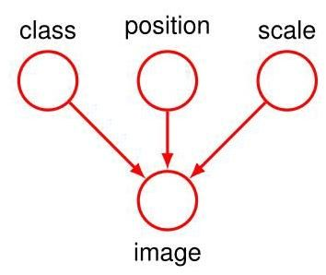

An alternative approach is to model the generative process and then subsequently to invert it computationally. In our image example, if we assume that the object’s class, position, and scale are all chosen independently, then we can represent the generative process using a directed graphical model as shown in Figure 11.24. Note that the directions of the arrows correspond to the sequence of generative steps, and so the model represents the causal process (Pearl, 1988) by which the observed data is generated. This is an example of a generative model because once it is trained, it can be used to generate synthetic images by first selecting values for object’s class, position, and scale from the learned prior distributions and then subsequently sampling an image from the learned conditional distribution. We will later see how diffusion models and other generative models can synthesize impressive high-resolution images based on a textual description of the desired content and style of the image.

另一种方法是对生成过程进行建模，然后在计算上对其进行逆转。在我们的图像示例中，如果我们假设物体的类别、位置和大小都是独立选择的，那么我们可以使用如图11.24所示的有向图形模型来表示生成过程。请注意，箭头的方向对应于生成步骤的顺序，因此该模型表示生成观测数据的因果过程(Pearl，1988)。这是生成模型的一个例子，因为一旦训练完成，它可以通过首先从学习到的先验分布中选择物体的类别、位置和大小的值，然后从学习到的条件分布中采样图像来生成合成图像。我们稍后将看到扩散模型和其他生成模型如何根据对图像所需内容和风格的文本描述合成令人印象深刻的高分辨率图像。

Chapter 20

第20章

The graph in Figure 11.24 assumes that, when no image is observed, the class, position, and scale variables are independent. This follows because every path between any two of these variables is head-to-head with respect to the image variable, which is unobserved. However, when we observe an image, those paths become unblocked, and the class, position, and scale variables are no longer independent. Intuitively this is reasonable because being told the identity of the object within the image provides us with very relevant information to assist us with determining its location.

图11.24中的图假设，当没有观察到图像时，类别、位置和大小变量是独立的。这是因为这些变量中任意两个之间的每条路径相对于未观察到的图像变量都是头对头的。然而，当我们观察到一幅图像时，这些路径就不再被阻塞，类别、位置和大小变量也不再独立。直观地说，这是合理的，因为被告知图像中物体的身份为我们提供了非常相关的信息，有助于我们确定其位置。

The hidden variables in a probabilistic model need not, however, have any explicit physical interpretation but may be introduced simply to allow a more complex joint distribution to be constructed from simpler components. For example, models such as normalizing flows, variational autoencoders, and diffusion models all use deep neural networks to create complex distributions in the data space by transforming hidden variables having a simple Gaussian distribution.

然而，概率模型中的隐藏变量不一定需要有任何明确的物理解释，引入它们可能仅仅是为了能够从更简单的组件构建出更复杂的联合分布。例如，诸如归一化流、变分自编码器和扩散模型等模型，都使用深度神经网络，通过对具有简单高斯分布的隐藏变量进行变换，在数据空间中创建复杂的分布。

# 11.2.6 Markov blanket

# 11.2.6 马尔可夫毯

A conditional independence property that is helpful when discussing more complex directed graphs is called the Markov blanket or Markov boundary. Consider a joint distribution represented by a directed graph having nodes, and consider the conditional distribution of a particular node with variables conditioned on all the remaining variables . Using the factorization property (11.6),

在讨论更复杂的有向图时，一个有用的条件独立性属性被称为马尔可夫毯或马尔可夫边界。考虑由一个具有 个节点的有向图表示的联合分布 ，并考虑一个特定节点的变量 在所有其余变量 条件下的条件分布。利用因式分解性质(11.6)

Figure 11.25 The Markov blanket of a node comprises the set of parents, children, and co-parents of the node. It has the property that the conditional distribution of , conditioned on all the remaining variables in the graph, is dependent only on the variables in the Markov blanket. we can express this conditional distribution in the form

图 11.25 节点 的马尔可夫毯由该节点的父节点、子节点和共同父节点组成。它具有这样的性质:在图中所有其余变量的条件下， 的条件分布仅依赖于马尔可夫毯中的变量。我们可以将这个条件分布表示为以下形式

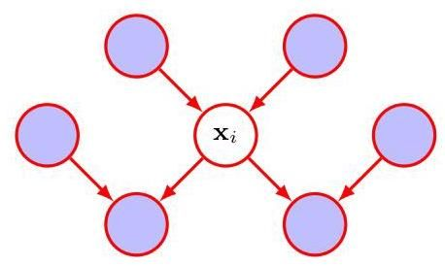

in which the integral is replaced by a summation for discrete variables. We now observe that any factor that does not have any functional dependence on can be taken outside the integral over and will therefore cancel between numerator and denominator. The only factors that remain will be the conditional distribution for node itself, together with the conditional distributions for any nodes such that node is in the conditioning set of , in other words for which is a parent of . The conditional will depend on the parents of node , whereas the conditionals will depend on the children of as well as on the co-parents, in other words variables corresponding to parents of node other than node . The set of nodes comprising the parents, the children, and the co-parents is called the Markov blanket and is illustrated in Figure 11.25.

其中，对于离散变量，积分被求和所取代。现在我们注意到，任何对 没有函数依赖关系的因子 都可以提到对 的积分外面，因此会在分子和分母之间相互抵消。剩下的唯一因子将是节点 本身的条件分布 ，以及任何节点 的条件分布，使得节点 位于 的条件集合中，换句话说， 是 的父节点。条件分布 将依赖于节点 的父节点，而条件分布 将依赖于 的子节点以及共同父节点，换句话说，对应于节点 的除节点 之外的父节点的变量。由父节点、子节点和共同父节点组成的节点集合被称为马尔可夫毯，如图 11.25 所示。

We can think of the Markov blanket of a node as being the minimal set of nodes that isolates from the rest of the graph. Note that it is not sufficient to include only the parents and children of node because explaining away means that observations of the child nodes will not block paths to the co-parents. We must therefore observe the co-parent nodes as well.

我们可以将节点 的马尔可夫毯看作是将 与图的其余部分隔离开来的最小节点集合。请注意，仅包含节点 的父节点和子节点是不够的，因为解释消除意味着对子节点的观测不会阻断通向共同父节点的路径。因此，我们还必须观测共同父节点。

# 11.2.7 Graphs as filters

# 11.2.7 作为过滤器的图

We have seen that a particular directed graph represents a specific decomposition of a joint probability distribution into a product of conditional probabilities, and it also expresses a set of conditional independence statements obtained through the d-separation criterion. The d-separation theorem is really an expression of the equivalence of these two properties. To make this clear, it is helpful to think of a directed graph as a filter. Suppose we consider a particular joint probability distribution over the variables corresponding to the (unobserved) nodes of the graph. The filter will allow this distribution to pass through if, and only if, it can be expressed in terms of the factorization (11.6) implied by the graph. If we present to the filter the set of all possible distributions over the set of variables , then the subset of distributions that are passed by the filter is denoted , for directed factorization. This is illustrated in Figure 11.26.

我们已经看到，一个特定的有向图表示将联合概率分布分解为条件概率乘积的特定形式，它还表达了一组通过 d-分离准则得到的条件独立陈述。d-分离定理实际上是这两个性质等价性的一种表述。为了更清楚地说明这一点，将有向图看作一个过滤器是很有帮助的。假设我们考虑一个关于变量 的特定联合概率分布 ，这些变量对应于图中(未观测到的)节点。当且仅当该分布可以用图所隐含的因式分解(11.6)来表示时，过滤器才会允许这个分布通过。如果我们将变量集 上的所有可能分布 提供给过滤器，那么通过过滤器的分布子集记为 ，表示有向因式分解。这在图 11.26 中有所说明。

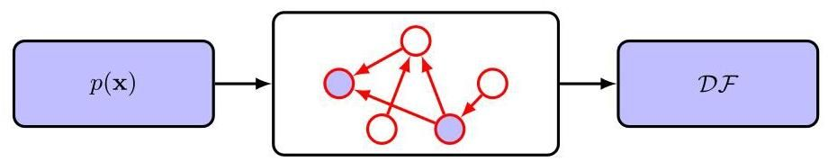

Figure 11.26 We can view a graphical model (in this case a directed graph) as a filter in which a probability distribution is allowed through the filter if, and only if, it satisfies the directed factorization property (11.6). The set of all possible probability distributions that pass through the filter is denoted . We can alternatively use the graph to filter distributions according to whether they respect all the conditional independence properties implied by the d-separation properties of the graph. The d-separation theorem says the same set of distributions will be allowed through this second kind of filter.

图 11.26 我们可以将一个图形模型(在这种情况下是有向图)看作一个过滤器，当且仅当概率分布 满足有向因式分解性质(11.6)时，它才会被允许通过过滤器。通过过滤器的所有可能概率分布 的集合记为 。我们也可以根据分布是否尊重图的 d-分离性质所隐含的所有条件独立性质，使用图来过滤分布。d-分离定理表明，同一组分布 将被允许通过第二种类型的过滤器。

Alternatively, we can use the graph as a different kind of filter by first listing all the conditional independence properties obtained by applying the d-separation criterion to the graph and then allowing a distribution to pass only if it satisfies all of these properties. If we present all possible distributions to this second kind of filter, then the d-separation theorem tells us that the set of distributions that will be allowed through is precisely the set .

或者，我们可以将图用作另一种类型的过滤器，方法是先列出通过对图应用 d-分离准则得到的所有条件独立性质，然后仅当一个分布满足所有这些性质时才允许它通过。如果我们将所有可能的分布 提供给这种第二种类型的过滤器，那么 d-分离定理告诉我们，被允许通过的分布集合恰好就是集合 。

It should be emphasized that the conditional independence properties obtained from d-separation apply to any probabilistic model described by that particular directed graph. This will be true, for instance, whether the variables are discrete or continuous or a combination of these. Again, we see that a particular graph describes a whole family of probability distributions.

应该强调的是，从 d-分离得到的条件独立性质适用于由该特定有向图描述的任何概率模型。例如，无论变量是离散的、连续的还是两者的组合，这都是成立的。我们再次看到，一个特定的图描述了一整个概率分布族。

At one extreme, we have a fully connected graph that exhibits no conditional independence properties at all and which can represent any possible joint probability distribution over the given variables. The set will contain all possible distributions . At the other extreme, we have a fully disconnected graph, i.e., one having no links at all. This corresponds to joint distributions that factorize into the product of the marginal distributions over the variables comprising the nodes of the graph. Note that for any given graph, the set of distributions will include any distributions that have additional independence properties beyond those described by the graph. For instance, a fully factorized distribution will always be passed through the filter implied by any graph over the corresponding set of variables.

在一个极端情况下，我们有一个完全连通的图，它根本不表现出任何条件独立性质，并且可以表示给定变量上的任何可能的联合概率分布。集合 将包含所有可能的分布 。在另一个极端情况下，我们有一个完全不连通的图，即一个根本没有边的图。这对应于可以分解为图中节点所包含变量的边缘分布乘积的联合分布。请注意，对于任何给定的图，分布集合 将包括任何具有超出图所描述的额外独立性质的分布。例如，一个完全因式分解的分布总是会通过由相应变量集上的任何图所隐含的过滤器。

# 11.3. Sequence Models

# 11.3. 序列模型

There are many important applications of machine learning in which the data consists of a sequence of values. For example, text comprises a sequence of words, whereas a protein comprises a sequence of amino acids. Many sequences are ordered by time, such as the audio signals from a microphone or daily rainfall measurements at a particular location. Sometimes the terminology of ’time’ as well as ’past’ and ’future’ are used when referring to other types of sequential data, not just temporal sequences. Applications involving sequences include speech recognition, automatic translation between languages, detecting genes in DNA, synthesizing music, writing computer code, holding a conversation with a modern search engine, and many others.

机器学习有许多重要的应用，其中的数据由一系列值组成。例如，文本由一系列单词组成，而蛋白质由一系列氨基酸组成。许多序列是按时间排序的，比如麦克风的音频信号或特定地点的每日降雨量测量值。有时，在提及其他类型的顺序数据时，不仅是时间序列，也会使用“时间”以及“过去”和“未来”等术语。涉及序列的应用包括语音识别、语言之间的自动翻译、检测 DNA 中的基因、合成音乐、编写计算机代码、与现代搜索引擎进行对话等等。

Figure 11.27 An illustration of a general autoregressive model of the form (11.42) with four nodes.

图 11.27 一个具有四个节点的形式为 (11.42) 的一般自回归模型的图示。

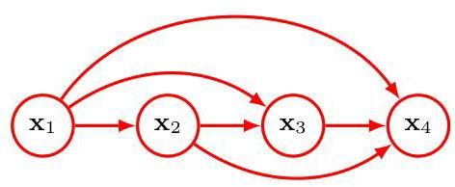

We will denote a data sequence by where each element of the sequence comprises a vector of values. Note that we might have several such sequences drawn independently from the same distribution, in which case the joint distribution over all the sequences factorizes into the product of the distributions over each sequence individually. From now on, we focus on modelling just one of those sequences.

我们将用 表示一个数据序列，其中序列的每个元素 都包含一个值向量。请注意，我们可能有几个这样的序列是从同一分布中独立抽取的，在这种情况下，所有序列的联合分布可以分解为每个序列分布的乘积。从现在起，我们专注于对其中一个序列进行建模。

We have already seen in (11.4) that by repeated application of the product rule of probability, a general distribution over variables can be written as the product of conditional distributions, and that the form of this decomposition depends on a specific of ordering for the variables. For vector-valued variables, and if we chose an ordering that corresponds to the order of the variables in the sequence, then we

我们在 (11.4) 中已经看到，通过重复应用概率的乘积规则， 个变量的一般分布可以写成条件分布的乘积，并且这种分解的形式取决于变量的特定排序。对于向量值变量，如果我们选择的排序与序列中变量的顺序相对应，那么我们

can write

可以写成

This corresponds to a directed graph in which each node receives a link from every previous node in the sequence, as illustrated using four variables in Figure 11.27. This is known as an autoregressive model.

这对应于一个有向图，其中序列中的每个节点都接收来自序列中每个先前节点的链接，如图 11.27 中使用四个变量所示。这被称为自回归模型。

This representation has complete generality and therefore from a modelling perspective adds no value since it encodes no assumptions. We can constrain the space of models by introducing conditional independence properties by removing links from the graph, or equivalently by removing variables from the conditioning set of the factors on the right-hand-side of (11.42).

这种表示具有完全的通用性，因此从建模的角度来看没有增加任何价值，因为它没有编码任何假设。我们可以通过从图中移除链接来引入条件独立性属性，或者等效地，从 (11.42) 右侧因子的条件集合中移除变量，从而限制模型的空间。

The strongest assumption would be to remove all conditioning variables, giving a joint distribution of the form

最强的假设是移除所有条件变量，得到如下形式的联合分布

which treats the variables as independent and therefore completely ignores the ordering information. This corresponds to a probabilistic graphical model without links, as shown in Figure 11.28.

这将变量视为独立的，因此完全忽略了顺序信息。这对应于一个没有链接的概率图模型，如图 11.28 所示。

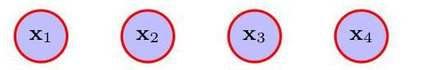

Figure 11.28 The simplest approach to modelling a sequence of observations .... is to treat them as independent, corresponding to a probabilistic graphical model without links.

图 11.28 对一系列观测值进行建模的最简单方法……是将它们视为独立的，对应于一个没有链接的概率图模型。

Interesting models that capture sequential properties while introducing modelling assumptions lie between these two extremes. One strong assumption would be to assume that each conditional distribution depends only on the immediately preceding variable in the sequence, giving a joint distribution of the form

在引入建模假设的同时捕捉序列属性的有趣模型介于这两个极端之间。一个较强的假设是假设每个条件分布仅依赖于序列中紧接在前的变量，得到如下形式的联合分布

Note that the first variable in the sequence is treated slightly differently since it has no conditioning variable. The functional form (11.44) is known as a Markov model, or Markov chain, and is represented by a graph consisting of a simple chain of nodes, as seen in Figure 11.29. Using d-separation, we see that the conditional distribution for observation , given all of the observations up to time , is given by

请注意，序列中的第一个变量处理方式略有不同，因为它没有条件变量。函数形式 (11.44) 被称为马尔可夫模型或马尔可夫链，由一个简单的节点链组成的图表示，如图 11.29 所示。使用 d-分离，我们可以看到，给定直到时间 的所有观测值，观测值 的条件分布为

Section 11.2.3

第 11.2.3 节

which is easily verified by direct evaluation starting from (11.44) and using the product rule of probability. Thus, if we use such a model to predict the next observation in a sequence, the distribution of predictions will depend only on the value of the immediately preceding observation and will be independent of all earlier observations.

从 (11.44) 开始直接计算并使用概率的乘积规则，可以很容易地验证这一点。因此，如果我们使用这样的模型来预测序列中的下一个观测值，预测的分布将仅取决于前一个观测值的值，并且与所有更早的观测值无关。

Exercise 11.16

练习 11.16

More specifically, (11.44) is known as a first-order Markov model because only one conditioning variable appears in each conditional distribution. We can extend the model by allowing each conditional distribution to depend on the two preceding variables, giving a second-order Markov model of the form

更具体地说，(11.44) 被称为一阶马尔可夫模型，因为每个条件分布中只出现一个条件变量。我们可以通过允许每个条件分布依赖于前两个变量来扩展该模型，得到形式如下的二阶马尔可夫模型

Note that the first two variables are treated differently as they have fewer than two conditioning variables. This model is shown as a directed graph in Figure 11.30.

请注意，前两个变量的处理方式不同，因为它们的条件变量少于两个。该模型的有向图如图 11.30 所示。

Exercise 11.17

练习 11.17

By using d-separation (or by direct evaluation using the rules of probability), we see that in the second-order Markov model, the conditional distribution of given all previous observations is independent of the observations . We can similarly consider extensions to an order Markov chain in which the conditional distribution for a particular variable depends on the previous variables. However, we have paid a price for this increased flexibility because the number of parameters in the model is now much larger. Suppose the observations are discrete variables having states. Then the conditional distribution in a first-order Markov chain will be specified by a set of parameters for each of the states of giving a total of parameters. Now suppose we extend the model to an order Markov chain, so that the joint distribution is built up from conditionals . If the variables are discrete and if the conditional distributions are represented by general conditional probability tables, then such a model will have parameters. Thus, the number of parameters grows exponentially with , which will generally render this approach impractical for larger values of .

通过使用 d-分离(或使用概率规则直接评估)，我们发现，在二阶马尔可夫模型中，给定所有先前观测值 时 的条件分布与观测值 无关。类似地，我们可以考虑将其扩展到 阶马尔可夫链，其中特定变量的条件分布取决于先前的 个变量。然而，我们为这种增加的灵活性付出了代价，因为模型中的参数数量现在要大得多。假设观测值是具有 个状态的离散变量。那么，在一阶马尔可夫链中，条件分布 将由一组 个参数指定，对于 的每个 个状态，总共给出 个参数。现在假设我们将模型扩展到 阶马尔可夫链，使得联合分布由条件分布 构建而成。如果变量是离散的，并且条件分布由一般的条件概率表表示，那么这样的模型将有 个参数。因此，参数数量随 呈指数增长，这通常会使这种方法在 值较大时不切实际。

Figure 11.29 A first-order Markov chain of observations in which the distribution of a particular observation is conditioned on the value of the previous observation .

图 11.29 观测值的一阶马尔可夫链，其中特定观测值 的分布以先前观测值 的值为条件。

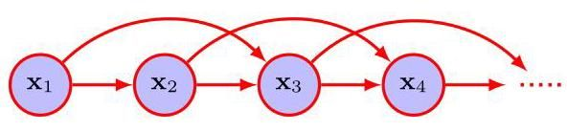

Figure 11.30 A second-order Markov chain in which the conditional distribution of a particular observation depends on the values of the two previous observations and .

图 11.30 二阶马尔可夫链，其中特定观测值 的条件分布取决于前两个观测值 和 的值。

# 11.3.1 Hidden variables

# 11.3.1 隐藏变量

Suppose we wish to build a model for sequences that is not limited by the Markov assumption to any order and yet can be specified using a limited number of free parameters. We can achieve this by introducing additional latent variables, thus permitting a rich class of models to be constructed out of simple components. For each observation , we introduce a corresponding latent variable (which may be of different type or dimensionality to the observed variable). We now assume that it is the latent variables that form a Markov chain, giving rise to the graphical structure known as a state-space model, which is shown in Figure 11.31. It satisfies the key conditional independence property that and are independent given , so that

假设我们希望为序列构建一个不受任何阶马尔可夫假设限制的模型，并且可以使用有限数量的自由参数来指定。我们可以通过引入额外的潜在变量来实现这一点，从而允许从简单组件构建出丰富的模型类别。对于每个观测值 ，我们引入一个相应的潜在变量 (其类型或维度可能与观测变量不同)。现在我们假设是潜在变量形成了一个马尔可夫链，从而产生了称为状态空间模型的图形结构，如图 11.31 所示。它满足关键的条件独立性属性，即给定 时， 和 是独立的，因此

The joint distribution for this model is given by

该模型的联合分布由下式给出

# Figure 11.31

# 图 11.31

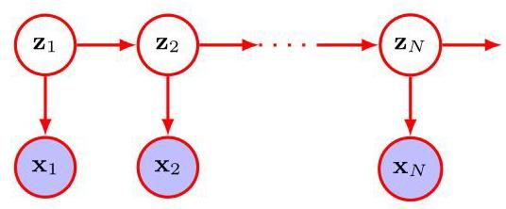

e 11.31 A state-space model expresses the joint probability distribution over a sequence of observed states in terms of a Markov chain of hidden states in the form (11.48).

图 11.31 一个状态空间模型以式 (11.48) 的形式，用隐藏状态 的马尔可夫链来表示一系列观测状态 上的联合概率分布。

Using the d-separation criterion, we see that in the state-space model there is always a path connecting any two observed variables and via the latent variables and that this path is never blocked. Thus, the predictive distribution for observation given all previous observations does not exhibit any conditional independence properties, and so our predictions for depend on all previous observations. The observed variables, therefore, do not satisfy the Markov property at any order.

使用 d-分离准则，我们发现在状态空间模型中，总是存在一条通过潜在变量连接任意两个观测变量 和 的路径，并且这条路径永远不会被阻断。因此，给定所有先前观测值的情况下，观测值 的预测分布 不表现出任何条件独立性质，所以我们对 的预测依赖于所有先前的观测值。因此，观测变量不满足任何阶的马尔可夫性质。

There are two important models for sequential data that are described by this graph. If the latent variables are discrete, then we obtain a hidden Markov model (Elliott, Aggoun, and Moore, 1995). Note that the observed variables in a hidden Markov model may be discrete or continuous, and a variety of different conditional distributions can be used to model them. If both the latent and the observed variables are Gaussian (with a linear-Gaussian dependence of the conditional distributions on their parents), then we obtain a linear dynamical system, also known as a Kalman filter (Zarchan and Musoff, 2005). Both hidden Markov models and Kalman filters are discussed at length, along with algorithms for training them, in Bishop (2006). Such models can be made considerably more flexible by replacing the simple discrete probability tables, or linear-Gaussian distributions, used to define with deep neural networks. Exercises

有两种重要的序列数据模型可以用这个图来描述。如果潜在变量是离散的，那么我们得到一个隐马尔可夫模型(Elliott、Aggoun 和 Moore，1995)。请注意，隐马尔可夫模型中的观测变量可以是离散的或连续的，并且可以使用各种不同的条件分布来对它们进行建模。如果潜在变量和观测变量都是高斯分布(条件分布对其父节点具有线性 - 高斯依赖关系)，那么我们得到一个线性动态系统，也称为卡尔曼滤波器(Zarchan 和 Musoff，2005)。Bishop(2006)详细讨论了隐马尔可夫模型和卡尔曼滤波器，以及训练它们的算法。通过用深度神经网络替换用于定义 的简单离散概率表或线性 - 高斯分布，可以使这些模型具有更大的灵活性。练习

11.1 (⋆) By marginalizing out the variables in order, show that the representation (11.6) for the joint distribution of a directed graph is correctly normalized, provided each of the conditional distributions is normalized.

11.1 (⋆) 通过按顺序对变量进行边缘化，证明如果每个条件分布都是归一化的，那么有向图联合分布的表示 (11.6) 是正确归一化的。

11.2 (*) Show that the property of there being no directed cycles in a directed graph follows from the statement that there exists an ordered numbering of the nodes such that for each node there are no links going to a lower-numbered node.

11.2 (*) 证明:若有向图的节点存在一种有序编号，使得每个节点都没有指向编号更小节点的边，那么该有向图不存在有向环。

11.3 Consider three binary variables having the joint distribution given in Table 11.1. Show by direct evaluation that this distribution has the property that and are marginally dependent, so that , but that they become independent when conditioned on , so that for both and .

11.3 考虑三个二元变量 ，其联合分布如表 11.1 所示。通过直接计算证明，该分布具有如下性质: 和 存在边际依赖关系，即 ，但在以 为条件时它们相互独立，即对于 和 都有 。

Table 11.1 The joint distribution over three binary variables.

表 11.1 三个二元变量的联合分布。

|  |  |  |  |  |
| --- | --- | --- | --- | --- |
|  |  |  |  |  |
|  | 0 | 0 | 0 | 0.192 |
|  | 0 | 0 | 1 | 0.144 |
|  | 0 | 1 | 0 | 0.048 |
|  | 0 | 1 | 1 | 0.216 |
|  | 1 | 0 | 0 | 0.192 |
|  | 1 | 0 | 1 | 0.064 |
|  | 1 | 1 | 0 | 0.048 |
|  | 1 | 1 | 1 | 0.096 |
|  |  |  |  |  |
|  | 0 | 0 | 0 | 0.192 |
|  | 0 | 0 | 1 | 0.144 |
|  | 0 | 1 | 0 | 0.048 |
|  | 0 | 1 | 1 | 0.216 |
|  | 1 | 0 | 0 | 0.192 |
|  | 1 | 0 | 1 | 0.064 |
|  | 1 | 1 | 0 | 0.048 |
|  | 1 | 1 | 1 | 0.096 |

11.4 Evaluate the distributions , and corresponding to the joint distribution given in Table 11.1. Hence, show by direct evaluation that . Draw the corresponding directed graph.

11.4 评估与表 11.1 中给出的联合分布相对应的分布 和 。因此，通过直接计算证明 。绘制相应的有向图。

11.5 For the model shown in Figure 11.6, we have seen that the number of parameters required to specify the conditional distribution , where , could be reduced from to by making use of the logistic sigmoid representation (11.8). An alternative representation (Pearl, 1988) is given by

11.5 对于图 11.6 所示的模型，我们已经看到，通过使用逻辑 sigmoid 表示(11.8)，指定条件分布 (其中 )所需的参数数量可以从 减少到 。另一种表示(Pearl，1988)如下所示

where the parameters represent the probabilities and is an additional parameter satisfying . The conditional distribution (11.49) is known as the noisy-OR. Show that this can be interpreted as a ’soft’ (probabilistic) form of the logical OR function (i.e., the function that gives whenever at least one of the . Discuss the interpretation of .

其中参数 表示概率 ，并且 是满足 的一个额外参数。条件分布(11.49)被称为噪声或(noisy - OR)。证明这可以被解释为逻辑或函数的“软”(概率性)形式(即，只要 中的至少一个为真，该函数就给出 )。讨论 的解释。

11.6 Starting from the definition (11.9) for the conditional distributions, derive the recursion relation (11.12) for the mean of the joint distribution for a linear-Gaussian model.

11.6 从条件分布的定义(11.9)出发，推导线性高斯模型联合分布均值的递推关系(11.12)。

11.7 Starting from the definition (11.9) for the conditional distributions, derive the recursion relation (11.13) for the covariance matrix of the joint distribution for a linear-Gaussian model.

11.7 从条件分布的定义(11.9)出发，推导线性高斯模型联合分布协方差矩阵的递推关系(11.13)。

11.8 Show that the number of parameters in the covariance matrix of a fully connected linear-Gaussian graphical model over variables defined by (11.9) is 1)/2.

11.8 证明由(11.9)定义的 个变量的全连接线性高斯图模型的协方差矩阵中的参数数量为 1)/2。

11.9 Using the recursion relations (11.12) and (11.13), show that the mean and covariance of the joint distribution for the graph shown in Figure 11.7 are given by (11.14) and (11.15), respectively.

11.9 利用递归关系 (11.12) 和 (11.13)，证明图 11.7 所示图的联合分布的均值和协方差分别由 (11.14) 和 (11.15) 给出。

11.10 Verify that the joint distribution over a set of vector-valued variables defined by a linear-Gaussian model in which each node corresponds to a distribution of the form (11.16) is itself a Gaussian.

11.10 验证由线性高斯模型定义的一组向量值变量的联合分布本身是高斯分布，其中每个节点对应于形式为 (11.16) 的分布。

11.11 Show that implies .

11.11 证明 蕴含 。

11.12 (*) Using the d-separation criterion, show that the conditional distribution for a node in a directed graph, conditioned on all the nodes in the Markov blanket, is independent of the remaining variables in the graph.

11.12 (*) 使用 d-分离准则，证明有向图中节点 在给定马尔可夫毯中所有节点的条件下，其条件分布与图中其余变量无关。

11.13 (★) Consider the directed graph shown in Figure 11.32 in which none of the variables is observed. Show that . Suppose we now observe the variable . Show that in general $a \mathrel{\text{ \textbackslash bot \textbackslash not\{ } }} b \mid d$ .

11.13 (★) 考虑图 11.32 所示的有向图，其中没有变量被观测到。证明 。假设我们现在观测到变量 。证明一般情况下 $a \mathrel{\text{ \textbackslash bot \textbackslash not\{ } }} b \mid d$ 。

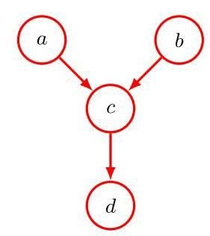

Figure 11.32 Example of a graphical model used to explore the conditional independence properties of the head-to-head path when a descendant of , namely the node , is observed.

图 11.32 一个图形模型的示例，用于探索当 的一个后代节点，即节点 被观测到时，头对头路径 的条件独立性性质。

11.14 (★★) Consider the example of the car fuel system shown in Figure 11.20, and suppose that instead of observing the state of the fuel gauge directly, the gauge is seen by the driver , who reports to us the reading on the gauge. This report says that the gauge shows either that the tank is full or that it is empty . Our driver is a bit unreliable, as expressed through the following probabilities:

11.14 (★★) 考虑图 11.20 所示的汽车燃油系统示例，假设我们不是直接观察燃油表的状态 ，而是由驾驶员 看到燃油表，并向我们报告燃油表的读数。该报告称，燃油表显示油箱要么是满的 ，要么是空的 。我们的驾驶员有点不可靠，这通过以下概率来表示:

Suppose that the driver tells us that the fuel gauge shows empty, in other words that we observe . Evaluate the probability that the tank is empty given only this observation. Similarly, evaluate the corresponding probability given also the observation that the battery is flat, and note that this second probability is lower. Discuss the intuition behind this result, and relate the result to Figure 11.32.

假设驾驶员告诉我们燃油表显示为空，换句话说，我们观察到 。仅根据这一观察结果，评估油箱为空的概率。同样，在还观察到电池没电的情况下，评估相应的概率，并注意到第二个概率较低。讨论这一结果背后的直觉，并将该结果与图 11.32 联系起来。

11.15 Suppose we train a naive Bayes model, with the assumption (11.37), using maximum likelihood. Assume that each of the class-conditional densities is governed by its own independent parameters . Show that the maximum likelihood solution involves fitting each of the class-conditional densities using the corresponding observed data vectors by maximizing the likelihood with respect to the corresponding class label data, and then setting the class priors to the fraction of training data points in each class.

11.15 假设我们使用最大似然法，在假设 (11.37) 的条件下训练一个朴素贝叶斯模型。假设每个类条件密度 都由其独立的参数 控制。证明最大似然解包括通过相对于相应的类标签数据最大化似然，使用相应的观测数据向量 拟合每个类条件密度，然后将类先验 设置为每个类中训练数据点的比例。

11.16 Consider the joint probability distribution (11.44) corresponding to the directed graph of Figure 11.29. Using the sum and product rules of probability, verify that this joint distribution satisfies the conditional independence property (11.45) for . Similarly, show that the second-order Markov model described by the joint distribution (11.46) satisfies the conditional independence property

11.16 考虑与图 11.29 的有向图相对应的联合概率分布 (11.44)。使用概率的求和规则和乘积规则，验证该联合分布对于 满足条件独立性质 (11.45)。同样，证明由联合分布 (11.46) 描述的二阶马尔可夫模型满足条件独立性质

for .

对于 。

11.17 (*) Use d-separation, as discussed in Section 11.2, to verify that the Markov model shown in Figure 11.29 having nodes in total satisfies the conditional independence properties (11.45) for . Similarly, show that a model described by the graph in Figure 11.30 in which there are nodes in total satisfies the conditional independence properties (11.52) for .

11.17 (*) 使用第 11.2 节中讨论的 d-分离方法，验证图 11.29 所示的总共具有 个节点的马尔可夫模型对于 满足条件独立性质 (11.45)。同样，证明图 11.30 所示的图所描述的、总共具有 个节点的模型对于 满足条件独立性质 (11.52)。

11.18 (★) Consider a second-order Markov process described by the graph in Figure 11.30. By combining adjacent pairs of variables, show that this can be expressed as a first-order Markov process over the new variables.

11.18 (★) 考虑由图 11.30 中的图所描述的二阶马尔可夫过程。通过合并相邻的变量对，证明这可以表示为关于新变量的一阶马尔可夫过程。

11.19 (*) By using d-separation, show that the distribution of the observed data for the state-space model represented by the directed graph in Figure 11.31 does not satisfy any conditional independence properties and hence does not exhibit the Markov property at any finite order.

11.19 (*) 通过使用 d-分离，证明图 11.31 中有向图所表示的状态空间模型的观测数据分布 不满足任何条件独立性质，因此在任何有限阶上都不呈现马尔可夫性质。

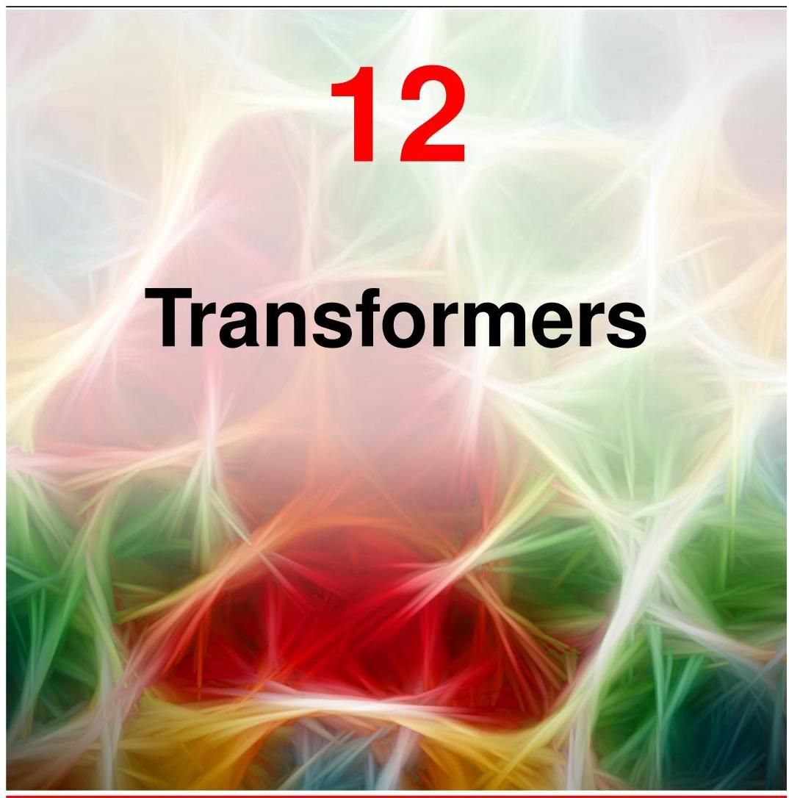

Transformers represent one of the most important developments in deep learning. They are based on a processing concept called attention, which allows a network to give different weights to different inputs, with weighting coefficients that themselves depend on the input values, thereby capturing powerful inductive biases related to sequential and other forms of data.

Transformer 是深度学习中最重要的发展之一。它们基于一种称为注意力的处理概念，该概念允许网络为不同的输入赋予不同的权重，其加权系数本身取决于输入值，从而捕捉与序列和其他形式的数据相关的强大归纳偏置。

These models are known as transformers because they transform a set of vectors in some representation space into a corresponding set of vectors, having the same dimensionality, in some new space. The goal of the transformation is that the new space will have a richer internal representation that is better suited to solving downstream tasks. Inputs to a transformer can take the form of unstructured sets of vectors, ordered sequences, or more general representations, giving transformers broad applicability.

这些模型被称为 Transformer，因为它们将某个表示空间中的一组向量转换为某个新空间中具有相同维度的对应向量集。这种转换的目标是使新空间具有更丰富的内部表示，更适合解决下游任务。Transformer 的输入可以采用无结构的向量集、有序序列或更通用的表示形式，这使得 Transformer 具有广泛的适用性。

Transformers were originally introduced in the context of natural language processing, or NLP (where a ’natural’ language is one such as English or Mandarin) and have greatly surpassed the previous state-of-the-art approaches based on recurrent neural networks (RNNs). Transformers have subsequently been found to achieve excellent results in many other domains. For example, vision transformers often outperform CNNs in image processing tasks, whereas multimodal transformers that combine multiple types of data, such as text, images, audio, and video, are amongst the most powerful deep learning models.

Transformer 最初是在自然语言处理(NLP)的背景下引入的(“自然”语言是指英语或普通话等语言)，并且已经大大超越了之前基于循环神经网络(RNN)的最先进方法。随后发现，Transformer 在许多其他领域也取得了优异的成果。例如，视觉 Transformer 在图像处理任务中通常优于卷积神经网络(CNN)，而结合了文本、图像、音频和视频等多种类型数据的多模态 Transformer 是最强大的深度学习模型之一。

One major advantage of transformers is that transfer learning is very effective, so that a transformer model can be trained on a large body of data and then the trained model can be applied to many downstream tasks using some form of fine-tuning. A large-scale model that can subsequently be adapted to solve multiple different tasks is known as a foundation model. Furthermore, transformers can be trained in a self-supervised way using unlabelled data, which is especially effective with language models since transformers can exploit vast quantities of text available from the internet and other sources. The scaling hypothesis asserts that simply by increasing the scale of the model, as measured by the number of learnable parameters, and training on a commensurately large data set, significant improvements in performance can be achieved, even with no architectural changes. Moreover, the transformer is especially well suited to massively parallel processing hardware such as graphical processing units, or GPUs, allowing exceptionally large neural network language models having of the order of a trillion parameters to be trained in reasonable time. Such models have extraordinary capabilities and show clear indications of emergent properties that have been described as the early signs of artificial general intelligence (Bubeck et al., 2023).

Transformer 的一个主要优点是迁移学习非常有效，因此可以在大量数据上训练一个 Transformer 模型，然后通过某种微调方式将训练好的模型应用于许多下游任务。一个随后可以适应解决多个不同任务的大规模模型被称为基础模型。此外，Transformer 可以使用未标记的数据以自监督的方式进行训练，这在语言模型中特别有效，因为 Transformer 可以利用从互联网和其他来源获得的大量文本。缩放假设断言，仅仅通过增加模型的规模(以可学习参数的数量来衡量)并在相应大的数据集上进行训练，即使不进行架构更改，也可以显著提高性能。此外，Transformer 特别适合图形处理单元(GPU)等大规模并行处理硬件，使得具有数万亿 参数的超大型神经网络语言模型能够在合理的时间内完成训练。这样的模型具有非凡的能力，并明确显示出涌现特性，这些特性被描述为通用人工智能的早期迹象(Bubeck 等人，2023)。

The architecture of a transformer can seem complex, or even daunting, to a newcomer as it involves multiple different components working together, in which the various design choices can seem arbitrary. In this chapter we therefore aim to give a comprehensive step-by-step introduction to all the key ideas behind transformers and to provide clear intuition to motivate the design of the various elements. We first describe the transformer architecture and then focus on natural language processing, before exploring other application domains.

对于新手来说，transformer 的架构可能看起来很复杂，甚至令人望而生畏，因为它涉及多个不同组件协同工作，其中各种设计选择似乎有些随意。因此，在本章中，我们旨在逐步全面介绍 transformer 背后的所有关键思想，并为各种元素的设计提供清晰的直观理解。我们首先描述 transformer 架构，然后专注于自然语言处理，最后探索其他应用领域。

# 12.1. Attention

# 12.1. 注意力机制

The fundamental concept that underpins a transformer is attention. This was originally developed as an enhancement to RNNs for machine translation (Bahdanau, Cho, and Bengio, 2014). However, Vaswani et al. (2017) later showed that significantly improved performance could be obtained by eliminating the recurrence structure and instead focusing exclusively on the attention mechanism. Today, transformers based on attention have completely superseded RNNs in almost all applications.

支撑 transformer 的基本概念是注意力机制。它最初是作为对循环神经网络(RNN)的改进而开发的，用于机器翻译(Bahdanau、Cho 和 Bengio，2014 年)。然而，Vaswani 等人(2017 年)后来表明，通过消除循环结构，转而专门关注注意力机制，可以显著提高性能。如今，基于注意力机制的 transformer 在几乎所有应用中已完全取代了 RNN。

Section 12.2.5

12.2.5 节

We will motivate the use of attention using natural language as an example, although it has much broader applicability. Consider the following two sentences: I swam across the river to get to the other bank. I walked across the road to get cash from the bank.

我们将以自然语言为例来说明注意力机制的用途，尽管它的应用范围要广泛得多。考虑以下两个句子:我游过了河，到达了对岸。我穿过马路，去银行取现金。

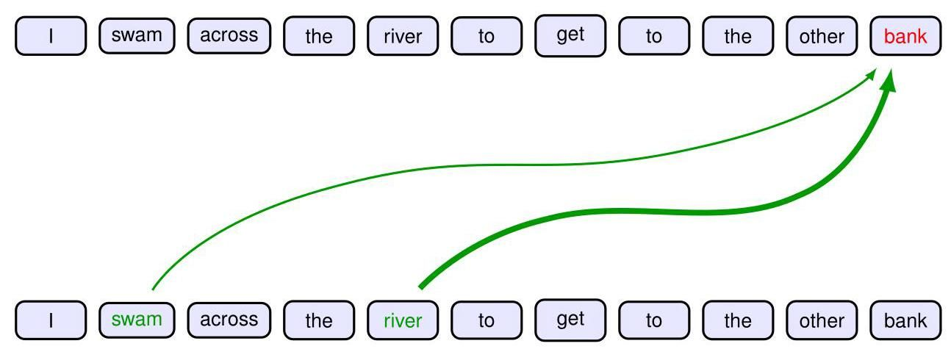

Figure 12.1 Schematic illustration of attention in which the interpretation of the word ’bank’ is influenced by the words ’river’ and ’swam’, with the thickness of each line being indicative of the strength of its influence.

图 12.1 注意力机制的示意图，其中“bank”一词的解释受“river”和“swam”这两个词的影响，每条线的粗细表示其影响的强度。

Here the word ’bank’ has different meanings in the two sentences. However, this can be detected only by looking at the context provided by other words in the sequence. We also see that some words are more important than others in determining the interpretation of ’bank’. In the first sentence, the words ’swam’ and ’river’ most strongly indicate that ’bank’ refers to the side of a river, whereas in the second sentence, the word ’cash’ is a strong indicator that ’bank’ refers to a financial institution. We see that to determine the appropriate interpretation of ’bank’, a neural network processing such a sentence should attend to, in other words rely more heavily on, specific words from the rest of the sequence. This concept of attention is illustrated in Figure 12.1.

在这里，“bank” 一词在这两个句子中有不同的含义。然而，只有通过查看序列中其他单词提供的上下文才能检测到这一点。我们还发现，在确定 “bank” 的释义时，有些单词比其他单词更重要。在第一个句子中，“swam” 和 “river” 这两个词最有力地表明 “bank” 指的是河岸；而在第二个句子中，“cash” 一词有力地表明 “bank” 指的是金融机构。我们看到，为了确定 “bank” 的恰当释义，处理这样一个句子的神经网络应该关注，换句话说，更依赖于序列中其他特定的单词。注意力这一概念如图 12.1 所示。

Moreover, we also see that the particular locations that should receive more attention depend on the input sequence itself: in the first sentence it is the second and fifth words that are important whereas in the second sentence it is the eighth word. In a standard neural network, different inputs will influence the output to different extents according to the values of the weights that multiply those inputs. Once the network is trained, however, those weights, and their associated inputs, are fixed. By contrast, attention uses weighting factors whose values depend on the specific input data. Figure 12.2 shows the attention weights from a section of a transformer network trained on natural language.

此外，我们还发现，应该给予更多关注的特定位置取决于输入序列本身:在第一个句子中，重要的是第二个和第五个单词，而在第二个句子中，重要的是第八个单词。在标准的神经网络中，不同的输入会根据与这些输入相乘的权重值以不同程度影响输出。然而，一旦网络训练完成，这些权重及其相关的输入就固定下来了。相比之下，注意力机制使用的加权因子的值取决于具体的输入数据。图 12.2 展示了在自然语言上训练的 transformer 网络某一部分的注意力权重。

When we discuss natural language processing, we will see how word embedding can be used to map words into vectors in an embedding space. These vectors can then be used as inputs for subsequent neural network processing. These embed-dings capture elementary semantic properties, for example by mapping words with similar meanings to nearby locations in the embedding space. One characteristic of such embeddings is that a given word always maps to the same embedding vector.

在讨论自然语言处理时，我们将了解如何使用词嵌入将单词映射到嵌入空间中的向量。然后，这些向量可以用作后续神经网络处理的输入。这些嵌入捕捉基本的语义属性，例如，通过将含义相似的单词映射到嵌入空间中的相邻位置。这种嵌入的一个特点是，给定的单词总是映射到相同的嵌入向量。

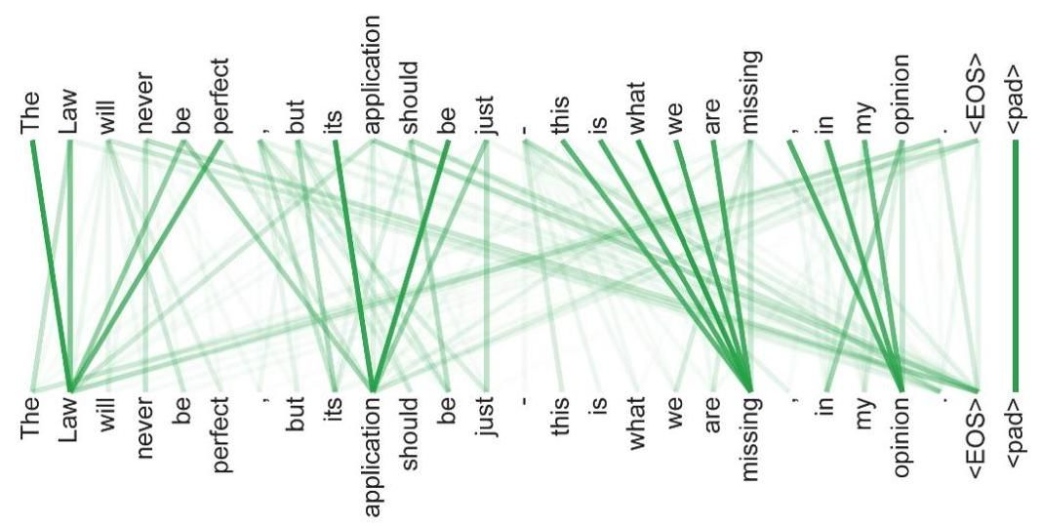

Figure 12.2 An example of learned attention weights. [From Vaswani et al. (2017) with permission.]

图 12.2 学习到的注意力权重示例。[经许可摘自 Vaswani 等人(2017 年)的研究。]

A transformer can be viewed as a richer form of embedding in which a given vector is mapped to a location that depends on the other vectors in the sequence. Thus, the vector representing ’bank’ in our example above could map to different places in a new embedding space for the two different sentences. For example, in the first sentence the transformed representation might put ’bank’ close to ’water’ in the embedding space, whereas in the second sentence the transformed representation might put it close to ’money’.

transformer 可以被视为一种更丰富的嵌入形式，其中给定的向量被映射到一个取决于序列中其他向量的位置。因此，在上述示例中，代表 “bank” 的向量在新的嵌入空间中对于两个不同的句子可能会映射到不同的位置。例如，在第一个句子中，经过变换的表示可能会将 “bank” 在嵌入空间中置于靠近 “water” 的位置，而在第二个句子中，经过变换的表示可能会将其置于靠近 “money” 的位置。

As an example of attention, consider the modelling of proteins. We can view a protein as a one-dimensional sequence of molecular units called amino acids. A protein can comprise potentially hundreds or thousands of such units, each of which is given by one of 22 possibilities. In a living cell, a protein folds up into a three-dimensional structure in which amino acids that are widely separated in the one-dimensional sequence can become physically close in three-dimensional space and thereby interact. Transformer models allows these distant amino acids to ’attend’ to each other thereby greatly improving the accuracy with which their 3-dimensional structure can be modelled (Vig et al., 2020).

以注意力机制在蛋白质建模中的应用为例。我们可以将蛋白质视为由称为氨基酸的分子单元组成的一维序列。一个蛋白质可能由数百或数千个这样的单元组成，每个单元有 22 种可能的类型。在活细胞中，蛋白质会折叠成三维结构，在这个结构中，一维序列中相距甚远的氨基酸在三维空间中可能会在物理上靠近并相互作用。Transformer 模型允许这些远距离的氨基酸相互 “关注”，从而大大提高了对其三维结构建模的准确性(Vig 等人，2020 年)。

Figure 1.2

图 1.2

# 12.1.1 Transformer processing

# 12.1.1 Transformer 处理

The input data to a transformer is a set of vectors of dimensionality , where . We refer to these data vectors as tokens, where a token might, for example, correspond to a word within a sentence, a patch within an image, or an amino acid within a protein. The elements of the tokens are called features. Later we will see how to construct these token vectors for natural language data and for images. A powerful property of transformers is that we do not have to design a new neural network architecture to handle a mix of different data types but instead can simply combine the data variables into a joint set of tokens.

Transformer 的输入数据是一组维度为 的向量 ，其中 。我们将这些数据向量称为标记，例如，一个标记可能对应于句子中的一个单词、图像中的一个图块或蛋白质中的一个氨基酸。标记的元素 称为特征。稍后我们将了解如何为自然语言数据和图像构建这些标记向量。Transformer 的一个强大特性是，我们不必设计新的神经网络架构来处理不同数据类型的混合，而是可以简单地将数据变量组合成一个联合标记集。

Before we can gain a clear understanding of the operation of a transformer, it is important to be precise about notation. We will follow the standard convention and combine the data vectors into a matrix of dimensions in which the th row comprises the token vector , and where labels the rows, as illustrated in Figure 12.3. Note that this matrix represents one set of input tokens, and that for most applications, we will require a data set containing many sets of tokens, such as independent passages of text where each word is represented as one token. The fundamental building block of a transformer is a function that takes a data matrix as input and creates a transformed matrix of the same dimensionality as the output. We can write this function in the form

在我们能够清楚理解 Transformer 的操作之前，精确使用符号表示非常重要。我们将遵循标准约定，将数据向量组合成一个维度为 的矩阵 ，其中第 行包含标记向量 ，并且 标记行，如图 12.3 所示。请注意，这个矩阵表示一组输入标记，并且对于大多数应用，我们需要一个包含许多组标记的数据集，例如独立的文本段落，其中每个单词都表示为一个标记。Transformer 的基本构建块是一个以数据矩阵为输入并创建与输入具有相同维度的变换矩阵 作为输出的函数。我们可以将这个函数写成如下形式

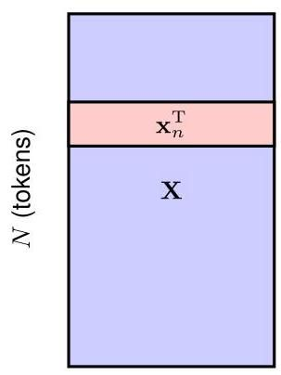

Figure 12.3 The structure of the data matrix , of dimension , in which row represents the transposed data vector . (features)

图 12.3 维度为 的数据矩阵 的结构，其中第 行表示转置后的数据向量 。 (特征)

We can then apply multiple transformer layers in succession to construct deep networks capable of learning rich internal representations. Each transformer layer contains its own weights and biases, which can be learned using gradient descent using an appropriate cost function, as we will discuss in detail later in the chapter.

然后，我们可以连续应用多个 Transformer 层来构建能够学习丰富内部表示的深度网络。每个 Transformer 层都有自己的权重和偏置，可以使用梯度下降法结合适当的代价函数来学习这些权重和偏置，我们将在本章后面详细讨论。

Section 12.3

第12.3节

A single transformer layer itself comprises two stages. The first stage, which implements the attention mechanism, mixes together the corresponding features from different token vectors across the columns of the data matrix, whereas the second stage then acts on each row independently and transforms the features within each token vector. We start by looking at the attention mechanism.

单个 transformer 层本身包含两个阶段。第一阶段实现注意力机制，它将数据矩阵各列中不同标记向量的相应特征混合在一起，而第二阶段则独立作用于每一行，并转换每个标记向量内的特征。我们首先来看看注意力机制。

# 12.1.2 Attention coefficients

# 12.1.2 注意力系数

Suppose that we have a set of input tokens in an embedding space and we want to map this to another set having the same number of tokens but in a new embedding space that captures a richer semantic structure. Consider a particular output vector . The value of should depend not just on the corresponding input vector but on all the vectors in the set. With attention, this dependence should be stronger for those inputs that are particularly important for determining the modified representation of . A simple way to achieve this is to define each output vector to be a linear combination of the input vectors

假设我们在一个嵌入空间中有一组输入标记 ，并且我们想将其映射到另一组 ，这组标记数量相同，但位于一个能捕捉更丰富语义结构的新嵌入空间中。考虑一个特定的输出向量 。 的值不仅应取决于相应的输入向量 ，还应取决于集合中的所有向量 。通过注意力机制，对于那些对确定 的修改表示特别重要的输入 ，这种依赖性应该更强。实现这一点的一种简单方法是将每个输出向量 定义为输入向量的线性组合

with weighting coefficients :

，其加权系数为 :

where are called attention weights. The coefficients should be close to zero for input tokens that have little influence on the output and largest for inputs that have most influence. We therefore constrain the coefficients to be non-negative to avoid situations in which one coefficient can become large and positive while another coefficient compensates by becoming large and negative. We also want to ensure that if an output pays more attention to a particular input, this will be at the expense of paying less attention to the other inputs, and so we constrain the coefficients to sum to unity. Thus, the weighting coefficients must satisfy the following two constraints:

其中 被称为注意力权重。对于对输出 影响很小的输入标记，这些系数应接近零，而对于影响最大的输入，系数应最大。因此，我们将系数限制为非负，以避免出现一个系数变得很大且为正，而另一个系数通过变得很大且为负来补偿的情况。我们还希望确保如果一个输出更多地关注某个特定输入，那么这将以减少对其他输入的关注为代价，因此我们将系数约束为总和为1。因此，加权系数必须满足以下两个约束条件:

Exercise 12.1

练习 12.1

Together these imply that each coefficient lies in the range and so the coefficients define a ’partition of unity’. For the special case , it follows that for , and therefore so that the input vector is unchanged by the transformation. More generally, the output is a blend of the input vectors with some inputs given more weight than others.

综合起来，这些意味着每个系数都位于范围 内，因此这些系数定义了一个 “单位分解”。对于特殊情况 ，可以得出对于 有 ，因此 ，使得输入向量在变换后保持不变。更一般地，输出 是输入向量的混合，其中一些输入比其他输入具有更大的权重。

Note that we have a different set of coefficients for each output vector , and the constraints (12.3) and (12.4) apply separately for each value of . These coefficients depend on the input data, and we will shortly see how to calculate them.

请注意，对于每个输出向量 ，我们都有一组不同的系数，并且约束条件 (12.3) 和 (12.4) 分别适用于 的每个值。这些系数 取决于输入数据，我们很快将看到如何计算它们。

# 12.1.3 Self-attention

# 12.1.3 自注意力机制

The next question is how to determine the coefficients . Before we discuss this in detail, it is useful to first introduce some terminology taken from the field of information retrieval. Consider the problem of choosing which movie to watch in an online movie streaming service. One approach would be to associate each movie with a list of attributes describing things such as the genre (comedy, action, etc.), the names of the leading actors, the length of the movie, and so on. The user could then search through a catalogue to find a movie that matches their preferences. We could automate this by encoding the attributes of each movie in a vector called the key. The corresponding movie file itself is called a value. Similarly, the user could then provide their own personal vector of values for the desired attributes, which we call the query. The movie service could then compare the query vector with all the key vectors to find the best match and send the corresponding movie to the user in the form of the value file. We can think of the user ’attending’ to the particular movie whose key most closely matches their query. This would be considered a form of hard attention in which a single value vector is returned. For the transformer, we generalize this to soft attention in which we use continuous variables to measure the degree of match between queries and keys and we then use these variables to weight the influence of the value vectors on the outputs. This will also ensure that the transformer function is differentiable and can therefore be trained by gradient descent.

接下来的问题是如何确定系数 。在详细讨论这个问题之前，首先引入一些来自信息检索领域的术语是很有用的。考虑在在线电影流媒体服务中选择观看哪部电影的问题。一种方法是将每部电影与一个属性列表相关联，这些属性描述了诸如类型(喜剧、动作等)、主演姓名、电影时长等等。然后用户可以在目录中搜索符合他们偏好的电影。我们可以通过将每部电影的属性编码到一个称为键的向量中来实现自动化。相应的电影文件本身称为值。类似地，用户可以提供他们自己对于所需属性的个人值向量，我们称之为查询。然后电影服务可以将查询向量与所有键向量进行比较，以找到最佳匹配，并以值文件的形式将相应的电影发送给用户。我们可以认为用户 “关注” 了其键与他们的查询最匹配的特定电影。这将被视为一种硬注意力机制，其中返回单个值向量。对于变压器模型，我们将其推广到软注意力机制，在这种机制中，我们使用连续变量来衡量查询和键之间的匹配程度，然后使用这些变量来权衡值向量对输出的影响。这也将确保变压器函数是可微的，因此可以通过梯度下降进行训练。

Following the analogy with information retrieval, we can view each of the input vectors as a value vector that will be used to create the output tokens. We also use the vector directly as the key vector for input token . That would be analogous to using the movie itself to summarize the characteristics of the movie. Finally, we can use as the query vector for output , which can then be compared to each of the key vectors. To see how much the token represented by should attend to the token represented by , we need to work out how similar these vectors are. One simple measure of similarity is to take their dot product . To impose the constraints (12.3) and (12.4), we can define the weighting coefficients by using the softmax function to transform the dot products:

按照与信息检索的类比，我们可以将每个输入向量 视为一个值向量，用于创建输出标记。我们还直接将向量 用作输入标记 的键向量。这类似于使用电影本身来总结电影的特征。最后，我们可以将 用作输出 的查询向量，然后可以将其与每个键向量进行比较。为了确定由 表示的标记应该在多大程度上关注由 表示的标记，我们需要计算这些向量的相似度。一种简单的相似度度量方法是取它们的点积 。为了施加约束条件 (12.3) 和 (12.4)，我们可以使用 softmax 函数来变换点积，从而定义加权系数 :

Section 5.3

第 5.3 节

Note that in this case there is no probabilistic interpretation of the softmax function and it is simply being used to normalize the attention weights appropriately.

请注意，在这种情况下，softmax 函数没有概率解释，它只是用于适当地归一化注意力权重。

So in summary, each input vector is transformed to a corresponding output vector by taking a linear combination of input vectors of the form (12.2) in which the weight applied to input vector is given by the softmax function (12.5) defined in terms of the dot product between the query for input and the key associated with input . Note that, if all the input vectors are orthogonal, then each output vector is simply equal to the corresponding input vector so that for .

综上所述，每个输入向量 通过对形式为 (12.2) 的输入向量进行线性组合转换为相应的输出向量 ，其中应用于输入向量 的权重 由 softmax 函数 (12.5) 给出，该函数根据输入 的查询 与输入 关联的键 之间的点积 定义。请注意，如果所有输入向量都是正交的，那么每个输出向量就简单地等于相应的输入向量，即对于 有 。

Exercise 12.3

练习 12.3

We can write (12.2) in matrix notation by using the data matrix , along with the analogous output matrix , whose rows are given by , so that

我们可以使用数据矩阵 以及类似的 输出矩阵 以矩阵表示法写出 (12.2)，其行由 给出，因此

where Softmax is an operator that takes the exponential of every element of a matrix and then normalizes each row independently to sum to one. From now on, we will focus on matrix notation for clarity.

其中 Softmax 是一个运算符，它对矩阵 的每个元素取指数，然后独立地对每一行进行归一化，使其总和为 1。从现在起，为了清晰起见，我们将专注于矩阵表示法。

This process is called self-attention because we are using the same sequence to determine the queries, keys, and values. We will encounter variants of this attention mechanism later in this chapter. Also, because the measure of similarity between query and key vectors is given by a dot product, this is known as dot-product self-attention.

这个过程被称为自注意力机制，因为我们使用相同的序列来确定查询、键和值。在本章后面，我们将遇到这种注意力机制的变体。此外，由于查询向量和键向量之间的相似度度量是通过点积给出的，因此这被称为点积自注意力机制。

# 12.1.4 Network parameters

# 12.1.4 网络参数

As it stands, the transformation from input vectors to output vectors is fixed and has no capacity to learn from data because it has no adjustable parameters. Furthermore, each of the feature values within a token vector plays an equal role in determining the attention coefficients, whereas we would like the network to have the flexibility to focus more on some features than others when determining token similarity. We can address both issues if we define modified feature vectors given by a linear transformation of the original vectors in the form

就目前而言，从输入向量 到输出向量 的变换是固定的，并且由于它没有可调整的参数，所以无法从数据中学习。此外，标记向量 中的每个特征值在确定注意力系数时都起着同等的作用，然而我们希望网络在确定标记相似度时能够灵活地更多地关注某些特征而不是其他特征。如果我们定义由原始向量的线性变换给出的修改后的特征向量，形式如下，就可以解决这两个问题

where is a matrix of learnable weight parameters, analogous to a ’layer’ in a standard neural network. This gives a modified transformation of the form

其中 是一个可学习权重参数的 矩阵，类似于标准神经网络中的一个 “层”。这给出了如下形式的修改后的变换

Although this has much more flexibility, it has the property that the matrix

虽然这具有更大的灵活性，但它具有矩阵

is symmetric, whereas we would like the attention mechanism to support significant asymmetry. For example, we might expect that ’chisel’ should be strongly associated with ’tool’ since every chisel is a tool, whereas ’tool’ should only be weakly associated with ’chisel’ because there are many other kinds of tools besides chisels. Although the softmax function means the resulting matrix of attention weights is not itself symmetric, we can create a much more flexible model by allowing the queries and the keys to have independent parameters. Furthermore, the form (12.8) uses the same parameter matrix to define both the value vectors and the attention coefficients, which again seems like an undesirable restriction.

是对称的性质，然而我们希望注意力机制能够支持显著的不对称性。例如，我们可能期望 “凿子” 应该与 “工具” 有很强的关联，因为每个凿子都是一种工具，而 “工具” 应该只与 “凿子” 有较弱的关联，因为除了凿子之外还有许多其他种类的工具。虽然 softmax 函数意味着得到的注意力权重矩阵本身不是对称的，但我们可以通过允许查询和键具有独立的参数来创建一个更加灵活的模型。此外，形式 (12.8) 使用相同的参数矩阵 来定义值向量和注意力系数，这似乎又是一个不理想的限制。

We can overcome these limitations by defining separate query, key, and value matrices each having their own independent linear transformations:

我们可以通过定义单独的查询、键和值矩阵来克服这些限制，每个矩阵都有其独立的线性变换:

where the weight matrices , and represent parameters that will be learned during the training of the final transformer architecture. Here the matrix has dimensionality where is the length of the key vector. The matrix must have the same dimensionality as so that we can form dot products between the query and key vectors. A typical choice is . Similarly, is a matrix of size , where governs the dimensionality of the output vectors. If we set , so that the output representation has the same dimensionality as the input, this will facilitate the inclusion of residual connections, which we discuss later. Also, multiple transformer layers can be stacked on top of each other if each layer has the same dimensionality. We can then generalize (12.6)

其中权重矩阵 和 表示将在最终 transformer 架构训练期间学习的参数。这里矩阵 的维度为 ，其中 是键向量的长度。矩阵 必须与 具有相同的维度 ，以便我们可以在查询向量和键向量之间形成点积。一个典型的选择是 。类似地， 是一个大小为 的矩阵，其中 控制输出向量的维度。如果我们设置 ，使得输出表示与输入具有相同的维度，这将有助于包含残差连接，我们将在后面讨论。此外，如果每层具有相同的维度，则可以将多个 transformer 层堆叠在一起。然后我们可以对 (12.6) 进行推广

Section 12.1.7

第 12.1.7 节

to give

得到

where has dimension , and the matrix has dimension . The calculation of the matrix is illustrated in Figure 12.4, whereas the evaluation of the matrix is illustrated in Figure 12.5.

其中 的维度为 ，矩阵 的维度为 。矩阵 的计算如图 12.4 所示，而矩阵 的计算如图 12.5 所示。

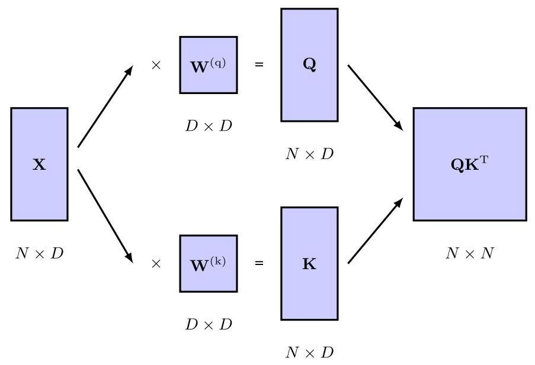

Figure 12.4 Illustration of the evaluation of the matrix , which determines the attention coefficients in a transformer. The input is separately transformed using (12.10) and (12.11) to give the query matrix and key matrix , respectively, which are then multiplied together.

图 12.4 矩阵 计算的图示，该矩阵决定了 transformer 中的注意力系数。输入 分别使用 (12.10) 和 (12.11) 进行变换，得到查询矩阵 和键矩阵 ，然后将它们相乘。

In practice we can also include bias parameters in these linear transformations. However, the bias parameters can be absorbed into the weight matrices, as we did with standard neural networks, by augmenting the data matrix with an additional column of 1’s and by augmenting the weight matrices with an additional row of parameters to represent the biases. From now on we will treat the bias parameters as implicit to avoid cluttering the notation.

在实践中，我们也可以在这些线性变换中包含偏置参数。然而，偏置参数可以被吸收到权重矩阵中，就像我们在标准神经网络中所做的那样，通过给数据矩阵 增加一列全为 1 的元素，并给权重矩阵增加一行参数来表示偏置。从现在起，为避免符号过于繁杂，我们将把偏置参数视为隐式的。

Section 6.2.1

6.2.1 节

Compared to a conventional neural network, the signal paths have multiplicative relations between activation values. Whereas standard networks multiply activations by fixed weights, here the activations are multiplied by the data-dependent attention coefficients. This means, for example, that if one of the attention coefficients is close to zero for a particular choice of input vector, the resulting signal path will ignore the corresponding incoming signal, which will therefore have no influence on the network outputs. By contrast, if a standard neural network learns to ignore a particular input or hidden-unit variable, it does so for all input vectors.

与传统神经网络相比，信号路径在激活值之间存在乘法关系。标准网络将激活值与固定权重相乘，而在这里，激活值与依赖于数据的注意力系数相乘。例如，这意味着如果对于特定的输入向量选择，某个注意力系数接近零，那么产生的信号路径将忽略相应的输入信号，因此该信号对网络输出没有影响。相比之下，如果标准神经网络学会忽略某个特定的输入或隐藏单元变量，那么它会对所有输入向量都这样做。

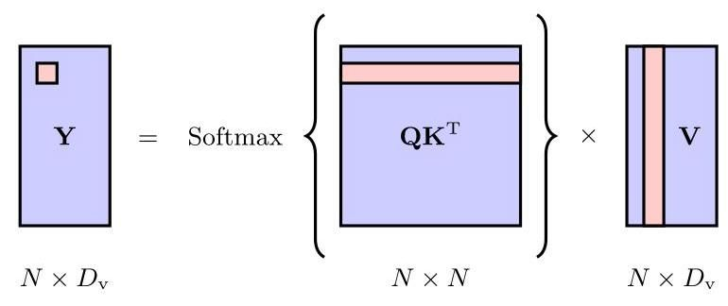

Figure 12.5 Illustration of the evaluation of the output from an attention layer given the query, key, and value matrices , , and , respectively. The entry at the position highlighted in the output matrix is obtained from the dot product of the highlighted row and column of the and matrices, respectively.

图 12.5 分别给定查询矩阵、键矩阵和值矩阵 、 和 时，注意力层输出评估的图示。输出矩阵 中高亮位置的元素分别由 矩阵的高亮行和 矩阵的高亮列的点积得到。

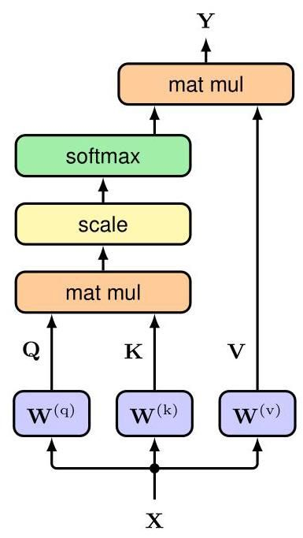

Figure 12.6 Information flow in a scaled dot-product self-attention neural network layer. Here ’mat mul’ denotes matrix multiplication, and ’scale’ refers to the normalization of the argument to the softmax using . This structure constitutes a single attention ’head’.

图 12.6 缩放点积自注意力神经网络层中的信息流。这里“mat mul”表示矩阵乘法，“scale”指使用 对 softmax 函数的参数进行归一化。这种结构构成一个单一的注意力“头”。

# 12.1.5 Scaled self-attention

# 12.1.5 缩放自注意力

There is one final refinement we can make to the self-attention layer. Recall that the gradients of the softmax function become exponentially small for inputs of high magnitude, just as happens with tanh or logistic-sigmoid activation functions. To help prevent this from happening, we can re-scale the product of the query and key vectors before applying the softmax function. To derive a suitable scaling, note that if the elements of the query and key vectors were all independent random numbers with zero mean and unit variance, then the variance of the dot product would be . We therefore normalize the argument to the softmax using the standard deviation given by the square root of , so that the output of the attention layer takes the

我们可以对自注意力层进行最后一项改进。回想一下，就像 tanh 或逻辑 S 型激活函数一样，对于大数值的输入，softmax 函数的梯度会呈指数级变小。为了防止这种情况发生，我们可以在应用 softmax 函数之前重新缩放查询向量和键向量的乘积。为了推导出合适的缩放因子，请注意，如果查询向量和键向量的元素都是均值为零、方差为 1 的独立随机数，那么点积的方差将是 。因此，我们使用 的平方根给出的标准差对 softmax 的参数进行归一化，以便注意力层的输出采用

Exercise 12.4

练习 12.4

form

形式

This is called scaled dot-product self-attention, and is the final form of our self-attention neural network layer. The structure of this layer is summarized in Figure 12.6 and in Algorithm 12.1.

这被称为缩放点积自注意力，是我们自注意力神经网络层的最终形式。该层的结构总结在图 12.6 和算法 12.1 中。

# 12.1.6 Multi-head attention

# 12.1.6 多头注意力

The attention layer described so far allows the output vectors to attend to data-dependent patterns of input vectors and is called an attention head. However, there

到目前为止所描述的注意力层允许输出向量关注输入向量的数据相关模式，这种层被称为注意力头。然而，存在

Algorithm 12.1: Scaled dot-product self-attention

算法 12.1:缩放点积自注意力机制

Input: Set of tokens

输入:标记集

Weight matrices and

权重矩阵 和

Output: Attention

输出:注意力

compute queries

计算查询

compute keys

计算键

compute values

计算值

return Attention might be multiple patterns of attention that are relevant at the same time. In natural language, for example, some patterns might be relevant to tense whereas others might be associated with vocabulary. Using a single attention head can lead to averaging over these effects. Instead we can use multiple attention heads in parallel. These consist of identically structured copies of the single head, with independent learnable parameters that govern the calculation of the query, key, and value matrices. This is analogous to using multiple different filters in each layer of a convolutional network.

返回注意力 可能是多个同时相关的注意力模式。例如，在自然语言中，一些模式可能与时态相关，而另一些模式可能与词汇相关。使用单个注意力头可能会导致对这些影响进行平均。相反，我们可以并行使用多个注意力头。这些注意力头由单个注意力头的相同结构副本组成，具有独立的可学习参数，用于控制查询、键和值矩阵的计算。这类似于在卷积网络的每一层中使用多个不同的滤波器。

Suppose we have heads indexed by of the form

假设我们有 个注意力头，其索引为 ，形式为

where Attention is given by (12.14), and we have defined separate query, key, and value matrices for each head using

其中注意力 由 (12.14) 给出，并且我们使用以下方式为每个注意力头定义了单独的查询、键和值矩阵

The heads are first concatenated into a single matrix, and the result is then linearly transformed using a matrix to give a combined output in the form

首先将这些注意力头连接成一个单一的矩阵，然后使用矩阵 对结果进行线性变换，以得到以下形式的组合输出

This is illustrated in Figure 12.7.

这在图 12.7 中进行了说明。

Each matrix has dimension , and so the concatenated matrix has dimension . This is transformed by the linear matrix of dimension to give the final output matrix of dimension , which is the same as the original input matrix . The elements of the matrix are learned during the training phase along with the query, key, and value matrices. Typically is

每个矩阵 的维度为 ，因此拼接后的矩阵维度为 。该矩阵通过维度为 的线性矩阵 进行变换，得到维度为 的最终输出矩阵 ，这与原始输入矩阵 的维度相同。矩阵 的元素在训练阶段与查询、键和值矩阵一起学习。通常 是

Figure 12.7 Network architecture for multihead attention. Each head comprises the structure shown in Figure 12.6, and has its own key, query, and value parameters. The outputs of the heads are concatenated and then linearly projected back to the input data dimensionality. chosen to be equal to so that the resulting concatenated matrix has dimension . Multi-head attention is summarized in Algorithm 12.2, and the information flow in a multi-head attention layer is illustrated in Figure 12.8.

图 12.7 多头注意力的网络架构。每个头都包含图 12.6 所示的结构，并且有自己的键、查询和值参数。各个头的输出被拼接起来，然后线性投影回输入数据的维度。通常选择使其等于 ，以便得到的拼接矩阵维度为 。多头注意力总结在算法 12.2 中，多头注意力层中的信息流如图 12.8 所示。

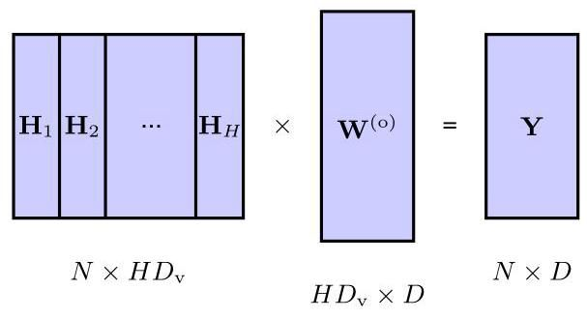

Note that the formulation of multi-head attention given above, which follows that used in the research literature, includes some redundancy in the successive multiplication of the matrix for each head and the output matrix . Removing this redundancy allows a multi-head self-attention layer to be written as a sum over contributions from each of the heads separately.

请注意，上述多头注意力的公式遵循研究文献中的用法，在每个头的 矩阵与输出矩阵 的连续乘法中存在一些冗余。消除这种冗余后，多头自注意力层可以写成每个头的贡献之和。

Exercise 12.5

练习 12.5

# 12.1.7 Transformer layers

# 12.1.7 变压器层

Multi-head self-attention forms the core architectural element in a transformer network. We know that neural networks benefit greatly from depth, and so we would like to stack multiple self-attention layers on top of each other. To improve training

多头自注意力构成了变压器网络的核心架构元素。我们知道神经网络从深度中受益匪浅，因此我们希望将多个自注意力层堆叠在一起。为了改进训练

# Algorithm 12.2: Multi-head attention

# 算法 12.2:多头注意力机制

Input: Set of tokens

输入:标记集

Query weight matrices

查询权重矩阵

Key weight matrices

键权重矩阵

Value weight matrices

值权重矩阵

Output weight matrix

输出权重矩阵

Output:

输出:

// compute self-attention for each head (Algorithm 12.1)

for do

end for

Concat // concatenate heads

return

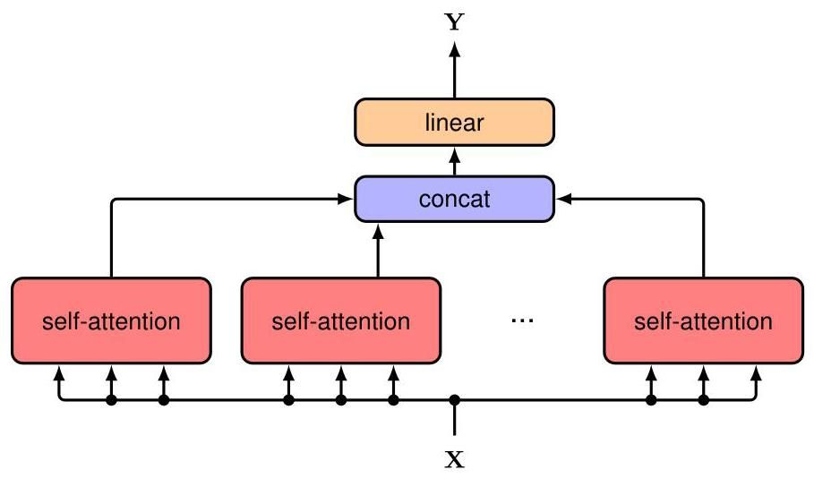

Figure 12.8 Information flow in a multi-head attention layer. The associated computation, given by Algorithm 12.2, is illustrated in Figure 12.7.

图 12.8 多头注意力层中的信息流。算法 12.2 给出的相关计算如图 12.7 所示。

Section 9.5

第 9.5 节

Section 7.4.3

第 7.4.3 节

efficiency, we can introduce residual connections that bypass the multi-head structure. To do this we require that the output dimensionality is the same as the input dimensionality, namely . This is then followed by layer normalization (Ba, Kiros, and Hinton, 2016), which improves training efficiency. The resulting transformation can be written as

为了提高效率，我们可以引入绕过多头结构的残差连接。为此，我们要求输出维度与输入维度相同，即 。然后进行层归一化(Ba、Kiros 和 Hinton，2016)，这可以提高训练效率。得到的变换可以写成

where is defined by (12.19). Sometimes the layer normalization is replaced by pre-norm in which the normalization layer is applied before the multi-head self-attention instead of after, as this can result in more effective optimization, in which case we have

其中 由式(12.19)定义。有时层归一化会被预归一化取代，即在多头自注意力之前应用归一化层，而不是之后，因为这样可以实现更有效的优化，在这种情况下我们有

In each case, again has the same dimensionality as the input matrix .

在每种情况下， 的维度 再次与输入矩阵 相同。

We have seen that the attention mechanism creates linear combinations of the value vectors, which are then linearly combined to produce the output vectors. Also, the values are linear functions of the input vectors, and so we see that the outputs of an attention layer are constrained to be linear combinations of the inputs. Nonlinearity does enter through the attention weights, and so the outputs will depend nonlinearly on the inputs via the softmax function, but the output vectors are still constrained to lie in the subspace spanned by the input vectors and this limits the expressive capabilities of the attention layer. We can enhance the flexibility of the transformer by post-processing the output of each layer using a standard nonlinear neural network with inputs and outputs, denoted MLP for ’multilayer per-ceptron’. For example, this might consist of a two-layer fully connected network with ReLU hidden units. This needs to be done in a way that preserves the ability of the transformer to process sequences of variable length. To achieve this, the same shared network is applied to each of the output vectors, corresponding to the rows of . Again, this neural network layer can be improved by using a residual connection. It also includes layer normalization so that the final output from the transformer layer has the form

我们已经看到，注意力机制会创建值向量的线性组合，然后将这些线性组合起来以产生输出向量。此外，这些值是输入向量的线性函数，因此我们可以看到，注意力层的输出被限制为输入的线性组合。非线性确实通过注意力权重引入，因此输出将通过 softmax 函数非线性地依赖于输入，但输出向量仍然被限制在输入向量所张成的子空间内，这限制了注意力层的表达能力。我们可以通过使用一个具有 个输入和 个输出的标准非线性神经网络对每一层的输出进行后处理来增强 transformer 的灵活性，记为 MLP ，即 “多层感知机”。例如，这可能由一个具有 ReLU 隐藏单元的两层全连接网络组成。这需要以一种保留 transformer 处理可变长度序列能力的方式来完成。为了实现这一点，将相同的共享网络应用于每个输出向量，对应于 的行。同样，这个神经网络层可以通过使用残差连接来改进。它还包括层归一化，以便 transformer 层的最终输出具有以下形式

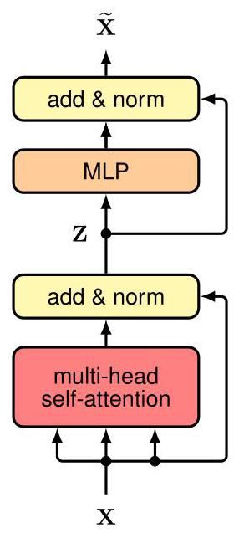

Figure 12.9 One layer of the transformer architecture that implements the transformation (12.1). Here ’MLP’ stands for multilayer perceptron, while ’add and norm’ denotes a residual connection followed by layer normalization.

图 12.9 实现变换 (12.1) 的 transformer 架构的一层。这里 “MLP” 代表多层感知机，而 “add and norm” 表示先进行残差连接，然后进行层归一化。

This leads to an overall architecture for a transformer layer shown in Figure 12.9 and summarized in Algorithm 12.3. Again, we can use a pre-norm instead, in which case the final output is given by

这导致了如图 12.9 所示并在算法 12.3 中总结的 transformer 层的整体架构。同样，我们也可以使用预归一化，在这种情况下，最终输出由下式给出

In a typical transformer there are multiple such layers stacked on top of each other. The layers generally have identical structures, although there is no sharing of weights and biases between different layers.

在一个典型的 transformer 中，有多个这样的层相互堆叠。这些层通常具有相同的结构，尽管不同层之间没有权重和偏置的共享。

# 12.1.8 Computational complexity

# 12.1.8 计算复杂度

The attention layer discussed so far takes a set of vectors each of length and maps them into another set of vectors having the same dimensionality. Thus, the inputs and outputs each have overall dimensionality . If we had used a standard fully connected neural network to map the input values to the output values, it would have independent parameters. Likewise the computational cost of evaluating one forward pass through such a network would also be .

到目前为止所讨论的注意力层接收一组长度均为 的 个向量，并将它们映射到另一组具有相同维度的 个向量。因此，输入和输出的总体维度均为 。如果我们使用标准的全连接神经网络将输入值映射到输出值，它将有 个独立参数。同样，评估通过这样一个网络的一次前向传播的计算成本也将是 。

In the attention layer, the matrices , and are shared across input tokens, and therefore the number of independent parameters is , assuming . Since there are input tokens, the number of computational steps

在注意力层中，矩阵 和 在输入标记之间共享，因此，假设 ，独立参数的数量为 。由于有 个输入标记，计算步骤的数量

Algorithm 12.3: Transformer layer

算法 12.3:Transformer 层

Input: Set of tokens

输入:标记集合

Multi-head self-attention layer parameters

多头自注意力层参数

Feed-forward network parameters

前馈网络参数

Output:

输出:

from Algorithm 12.2

来自算法 12.2 的

LayerNorm shared neural network

层归一化 共享神经网络

return in evaluating the dot products in a self-attention layer is . We can think of a self-attention layer as a sparse matrix in which parameters are shared between specific blocks of the matrix. The subsequent neural network layer, which has inputs and outputs, has a cost that is . Since it is shared across tokens, it has a complexity that is linear in , and therefore overall this layer has a cost that is . Depending on the relative sizes of and , either the transformer layer or the MLP layer may dominate the computational cost. Compared to a fully connected network, a transformer layer is computationally more efficient. Many variants of the transformer architecture have been proposed (Lin et al., 2021; Phuong and Hutter, 2022) including modifications aimed at improving efficiency (Tay et al., 2020).

在自注意力层中计算点积时返回 为 。我们可以将自注意力层视为一个稀疏矩阵，其中矩阵的特定块之间共享参数。后续的神经网络层有 个输入和 个输出，其成本为 。由于它在各个标记之间共享，其复杂度与 呈线性关系，因此该层的总成本为 。根据 和 的相对大小，变压器层或多层感知机层可能主导计算成本。与全连接网络相比，变压器层在计算上更高效。已经提出了许多变压器架构的变体(Lin 等人，2021；Phuong 和 Hutter，2022)，包括旨在提高效率的修改(Tay 等人，2020)。

Exercise 12.6

练习 12.6

# 12.1.9 Positional encoding

# 12.1.9 位置编码

In the transformer architecture, the matrices , and are shared across the input tokens, as is the subsequent neural network. As a consequence, the transformer has the property that permuting the order of the input tokens, i.e., the rows of , results in the same permutation of the rows of the output matrix . In other words a transformer is equivariant with respect to input permutations. The sharing of parameters in the network architecture facilitates the massively parallel processing of the transformer, and also allows the network to learn long-range dependencies just as effectively as short-range dependencies. However, the lack of dependence on token order becomes a major limitation when we consider sequential data, such as the words in a natural language, because the representation learned by a transformer will be independent of the input token ordering. The two sentences ’The food was bad, not good at all.’ and ’The food was good, not bad at all.’ contain the same tokens but they have very different meanings because of the different token ordering. Clearly token order is crucial for most sequential processing tasks including natural language processing, and so we need to find a way to inject token order information into the network.

在 transformer 架构中，矩阵 和 在输入标记之间共享，后续的神经网络也是如此。因此，transformer 具有这样的特性:对输入标记的顺序进行排列，即对 的行进行排列，会导致输出矩阵 的行产生相同的排列。换句话说，transformer 对于输入排列是等变的。网络架构中参数的共享促进了 transformer 的大规模并行处理，并且还使网络能够像学习短程依赖一样有效地学习长程依赖。然而，当我们考虑顺序数据(如自然语言中的单词)时，对标记顺序缺乏依赖就成为了一个主要限制，因为 transformer 学习到的表示将与输入标记的顺序无关。“The food was bad, not good at all.” 和 “The food was good, not bad at all.” 这两个句子包含相同的标记，但由于标记顺序不同，它们的含义截然不同。显然，标记顺序对于包括自然语言处理在内的大多数顺序处理任务至关重要，因此我们需要找到一种方法将标记顺序信息注入到网络中。

Exercise 12.7

练习 12.7

Section 10.2

第 10.2 节

Since we wish to retain the powerful properties of the attention layers that we have carefully constructed, we aim to encode the token order in the data itself instead of having to be represented in the network architecture. We will therefore construct a position encoding vector associated with each input position and then combine this with the associated input token embedding . One obvious way to combine these vectors would be to concatenate them, but this would increase the dimensionality of the input space and hence of all subsequent attention spaces, creating a significant increase in computational cost. Instead, we can simply add the position vectors onto the token vectors to give

由于我们希望保留精心构建的注意力层的强大特性，我们的目标是在数据本身中对标记顺序进行编码，而不是在网络架构中进行表示。因此，我们将构建一个与每个输入位置 相关联的位置编码向量 ，然后将其与相关的输入标记嵌入 相结合。一种明显的组合这些向量的方法是将它们连接起来，但这会增加输入空间的维度，进而增加所有后续注意力空间的维度，导致计算成本显著增加。相反，我们可以简单地将位置向量加到标记向量上，得到

This requires that the positional encoding vectors have the same dimensionality as the token-embedding vectors.

这要求位置编码向量与标记嵌入向量具有相同的维度。

At first it might seem that adding position information onto the token vector would corrupt the input vectors and make the task of the network much more difficult. However, some intuition as to why this can work well comes from noting that two randomly chosen uncorrelated vectors tend to be nearly orthogonal in spaces of high dimensionality, indicating that the network is able to process the token identity information and the position information relatively separately. Note also that, because of the residual connections across every layer, the position information does not get lost in going from one transformer layer to the next. Moreover, due to the linear processing layers in the transformer, a concatenated representation has similar properties to an additive one.

起初，似乎将位置信息添加到标记向量上会破坏输入向量，使网络的任务变得更加困难。然而，关于为什么这样做效果很好的一些直觉来自于这样一个事实:在高维空间中，两个随机选择的不相关向量往往几乎是正交的，这表明网络能够相对独立地处理标记身份信息和位置信息。还要注意，由于每一层都有残差连接，位置信息在从一个 transformer 层到下一个 transformer 层的过程中不会丢失。此外，由于 transformer 中的线性处理层，连接表示与加法表示具有相似的特性。

Exercise 12.8

练习 12.8

Exercise 12.9

练习 12.9

The next task is to construct the embedding vectors . A simple approach would be to associate an integer with each position. However, this has the problem that the magnitude of the value increases without bound and therefore may start to corrupt the embedding vector significantly. Also it may not generalize well to new input sequences that are longer than those used in training, since these will involve coding values that lie outside the range of those used in training. Alternatively we could assign a number in the range to each token in the sequence, which keeps the representation bounded. However, this representation is not unique for a given position as it depends on the overall sequence length.

接下来的任务是构建嵌入向量 。一种简单的方法是将整数 与每个位置相关联。然而，这存在一个问题，即值的大小会无限制地增加，因此可能会严重破坏嵌入向量。此外，对于比训练中使用的序列更长的新输入序列，它可能无法很好地泛化，因为这些序列将涉及超出训练中使用范围的编码值。或者，我们可以为序列中的每个标记分配一个范围在 内的数字，这可以使表示有界。然而，对于给定的位置，这种表示不是唯一的，因为它取决于整个序列的长度。

An ideal positional encoding should provide a unique representation for each position, it should be bounded, it should generalize to longer sequences, and it should have a consistent way to express the number of steps between any two input vectors irrespective of their absolute position because the relative position of tokens is often more important than the absolute position.

理想的位置编码应该为每个位置提供唯一的表示，它应该是有界的，应该能够泛化到更长的序列，并且应该有一种一致的方式来表达任意两个输入向量之间的步数，而不考虑它们的绝对位置，因为标记的相对位置通常比绝对位置更重要。

There are many approaches to positional encoding (Dufter, Schmitt, and Schütze, 2021). Here we describe a technique based on sinusoidal functions introduced by Vaswani et al. (2017). For a given position the associated position-encoding vector has components given by

有许多位置编码的方法(Dufter、Schmitt 和 Schütze，2021)。这里我们描述一种基于 Vaswani 等人(2017)引入的正弦函数的技术。对于给定的位置 ，相关的位置编码向量的分量 由下式给出

We see that the elements of the embedding vector are given by a series of sine and cosine functions of steadily increasing wavelength, as illustrated in Figure 12.10(a).

我们看到，嵌入向量 的元素由一系列波长不断增加的正弦和余弦函数给出，如图 12.10(a) 所示。

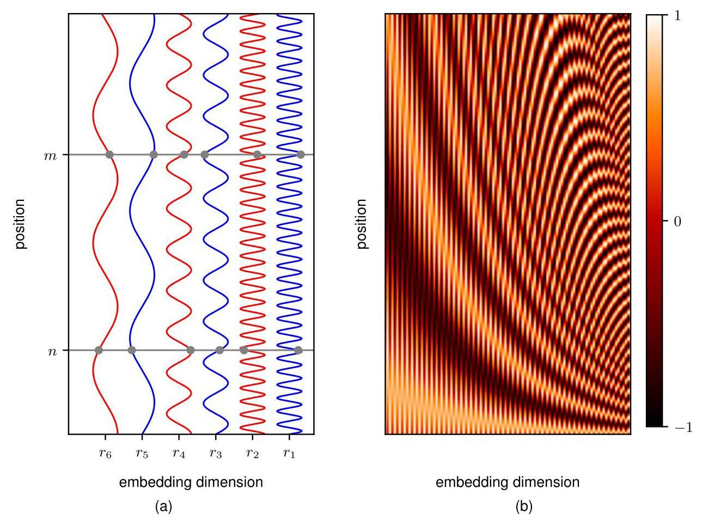

Figure 12.10 Illustrations of the functions defined by (12.25) and used to construct position-encoding vectors. (a) A plot in which the horizontal axis shows the different components of the embedding vector whereas the vertical axis shows the position in the sequence. The values of the vector elements for two positions and are shown by the intersections of the sine and cosine curves with the horizontal grey lines. (b) A heat map illustration of the position-encoding vectors defined by (12.25) for dimension with for the first positions.

图 12.10 由式(12.25)定义并用于构建位置编码向量的函数图示。(a) 一幅图，其中横轴表示嵌入向量 的不同分量，而纵轴表示序列中的位置。两个位置 和 的向量元素值由正弦和余弦曲线与水平灰线的交点表示。(b) 由式(12.25)定义的维度为 、 时前 个位置的位置编码向量的热力图图示。

This encoding has the property that the elements of the vector all lie in the range . It is reminiscent of the way binary numbers are represented, with the lowest order bit alternating with high frequency, and subsequent bits alternating with steadily decreasing frequencies:

这种编码具有向量 的所有元素都位于范围 内的性质。这让人联想到二进制数的表示方式，最低位以高频交替，后续位的交替频率逐渐降低:

|  |  |  |  |  |  |
| --- | --- | --- | --- | --- | --- |
|  | 1 | 0 | 0 | 0 | 1 |
|  | 2 | 0 | 0 | 1 | 0 |
|  | 3 | 0 | 0 | 1 | 1 |
|  | 4 | 0 | 1 | 0 | 0 |
|  | 5 | 0 | 1 | 0 | 1 |
|  | 6 | 0 | 1 | 1 | 0 |
|  | 7 | 0 | 1 | 1 | 1 |
|  | 8: | 1 | 0 | 0 | 0 |
|  | 9 | 1 | 0 | 0 | 1 |
|  | 1 | 0 | 0 | 0 | 1 |
|  | 2 | 0 | 0 | 1 | 0 |
|  | 3 | 0 | 0 | 1 | 1 |
|  | 4 | 0 | 1 | 0 | 0 |
|  | 5 | 0 | 1 | 0 | 1 |
|  | 6 | 0 | 1 | 1 | 0 |
|  | 7 | 0 | 1 | 1 | 1 |
|  | 8: | 1 | 0 | 0 | 0 |
|  | 9 | 1 | 0 | 0 | 1 |

For the encoding given by (12.25), however, the vector elements are continuous variables rather than binary. A plot of the position-encoding vectors is shown in Figure 12.10(b).

然而，对于由 (12.25) 给出的编码，向量元素是连续变量而非二进制变量。位置编码向量的图示如图 12.10(b) 所示。

One nice property of the sinusoidal representation given by (12.25) is that, for any fixed offset , the encoding at position can be represented as a linear combination of the encoding at position , in which the coefficients do not depend on the absolute position but only on the value of . The network should therefore be able to learn to attend to relative positions. Note that this property requires that the encoding makes use of both sine and cosine functions.

由 (12.25) 给出的正弦表示法有一个很好的性质，即对于任何固定的偏移量 ，位置 处的编码可以表示为位置 处编码的线性组合，其中系数不依赖于绝对位置，而仅依赖于 的值。因此，网络应该能够学会关注相对位置。请注意，此性质要求编码同时使用正弦和余弦函数。

Exercise 12.10

练习 12.10

Another popular approach to positional representation is to use learned position encodings. This is done by having a vector of weights at each token position that can be learned jointly with the rest of the model parameters during training, and avoids using hand-crafted representations. Because the parameters are not shared between the token positions, the tokens are no longer invariant under a permutation, which is the purpose of a positional encoding. However, this approach does not meet the criteria we mentioned earlier of generalizing to longer input sequences, as the encoding will be untrained for positional encodings not seen during training. Therefore, this approach is generally most suitable when the input length is relatively constant during both training and inference.

另一种流行的位置表示方法是使用学习得到的位置编码。这是通过在每个标记位置设置一个权重向量来实现的，该向量可以在训练期间与模型的其他参数一起学习，并且避免使用手工设计的表示法。由于参数在标记位置之间不共享，因此标记在排列下不再具有不变性，这正是位置编码的目的。然而，这种方法不满足我们之前提到的对更长输入序列进行泛化的标准，因为对于训练期间未见过的位置编码，该编码将未经训练。因此，这种方法通常最适用于训练和推理期间输入长度相对恒定的情况。

# 12.2. Natural Language

# 12.2. 自然语言

Now that we have studied the architecture of the transformer, we will explore how this can be used to process language data consisting of words, sentences, and paragraphs. Although this is the modality that transformers were originally developed to operate on, they have proved to be a very general class of models and have become the state-of-the-art for most input data types. Later in this chapter we will look at their use in other domains.

既然我们已经研究了 transformer 的架构，接下来我们将探讨如何使用它来处理由单词、句子和段落组成的语言数据。尽管这是 transformer 最初设计用于处理的模态，但事实证明它们是一类非常通用的模型，并且已成为大多数输入数据类型的最先进技术。在本章后面，我们将探讨它们在其他领域的应用。

Section 12.4

第12.4节

Many languages, including English, comprise a series of words separated by white space, along with punctuation symbols, and therefore represent an example of sequential data. For the moment we will focus on the words, and we will return to punctuation later.

包括英语在内的许多语言，由一系列用空格分隔的单词以及标点符号组成，因此是序列数据的一个例子。目前我们将专注于单词，稍后再讨论标点符号。

Section 11.3 Section 12.2.2

第11.3节 第12.2.2节

The first challenge is to convert the words into a numerical representation that is suitable for use as the input to a deep neural network. One simple approach is to define a fixed dictionary of words and then introduce vectors of length equal to the size of the dictionary along with a ’one hot’ representation for each word, in which the th word in the dictionary is encoded with a vector having a 1 in position and 0 in all other positions. For example if ’aardwolf’ is the third word in our dictionary then its vector representation would be .

第一个挑战是将单词转换为适合作为深度神经网络输入的数值表示。一种简单的方法是定义一个固定的单词词典，然后引入长度等于词典大小的向量，并为每个单词采用 “独热” 表示，其中词典中的第 个单词用一个在位置 处为 1、其他位置都为 0 的向量进行编码。例如，如果 “土狼” 是我们词典中的第三个单词，那么它的向量表示将是 。

An obvious problem with a one-hot representation is that a realistic dictionary might have several hundred thousand entries leading to vectors of very high dimensionality. Also, it does not capture any similarities or relationships that might exist between words. Both issues can be addressed by mapping the words into a lower-dimensional space through a process called word embedding in which each word is represented as a dense vector in a space of typically a few hundred dimensions.

独热表示的一个明显问题是，一个实际的词典可能有数十万个条目，这会导致向量的维度非常高。此外，它无法捕捉单词之间可能存在的任何相似性或关系。这两个问题都可以通过一个称为词嵌入的过程将单词映射到低维空间来解决，在这个过程中，每个单词都表示为一个通常几百维空间中的密集向量。

# 12.2.1 Word embedding

# 12.2.1 词嵌入

The embedding process can be defined by a matrix of size where is the dimensionality of the embedding space and is the dimensionality of the dictionary. For each one-hot encoded input vector we can then calculate the corresponding embedding vector using

嵌入过程可以由一个大小为 的矩阵 定义，其中 是嵌入空间的维度， 是字典的维度。对于每个独热编码的输入向量 ，我们可以使用以下方法计算相应的嵌入向量

Because has a one-hot encoding, the vector is simply given by the corresponding column of the matrix .

因为 是独热编码，向量 简单地由矩阵 的相应列给出。

We can learn the matrix from a corpus (i.e., a large data set) of text, and there are many approaches to doing this. Here we look at a popular technique called word2vec (Mikolov et al., 2013), which can be viewed as a simple two-layer neural network. A training set is constructed in which each sample is obtained by considering a ’window’ of adjacent words in the text, where a typical value might be . The samples are considered to be independent, and the error function is defined as the sum of the error functions for each sample. There are two variants of this approach. In continuous bag of words, the target variable for network training is the middle word, and the remaining context words form the inputs, so that the network is being trained to ’fill in the blank’. A closely related approach, called skip-grams, reverses the inputs and outputs, so that the centre word is presented as the input and the target values are the context words. These models are illustrated in Figure 12.11.

我们可以从一个文本语料库(即一个大型数据集)中学习矩阵 ，并且有许多方法可以做到这一点。这里我们来看一种流行的技术，称为 word2vec(Mikolov 等人，2013)，它可以被视为一个简单的两层神经网络。构建一个训练集，其中每个样本是通过考虑文本中 个相邻单词的“窗口”获得的，典型值可能是 。这些样本被认为是相互独立的，误差函数被定义为每个样本的误差函数之和。这种方法有两种变体。在连续词袋模型中，网络训练的目标变量是中间的单词，其余的上下文单词构成输入，因此网络被训练来“填空”。一种密切相关的方法，称为跳字模型，将输入和输出颠倒，因此中心单词作为输入呈现，目标值是上下文单词。这些模型如图 12.11 所示。

This training procedure can be viewed as a form of self-supervised learning since the data consists simply of a large corpus of unlabelled text from which many small windows of word sequences are drawn at random. Labels are obtained from the text itself by ’masking’ out those words whose values the network is trying to predict.

这种训练过程可以被视为一种自监督学习形式，因为数据仅仅由一个大型的未标记文本语料库组成，从中随机抽取许多小的单词序列窗口。标签是通过“屏蔽”那些网络试图预测其值的单词从文本本身获得的。

Once the model is trained, the embedding matrix is given by the transpose of the second-layer weight matrix for the continuous bag-of-words approach and by the first-layer weight matrix for skip-grams. Words that are semantically related are mapped to nearby positions in the embedding space. This is to be expected since related words are more likely to occur with similar context words compared to unrelated words. For example, the words ’city’ and ’capital’ might occur with higher frequency as context for target words such as ’Paris’ or ’London’ and less frequently as context for ’orange’ or ’polynomial’. The network can more easily predict the probability of the missing words if ’Paris’ and ’London’ are mapped to nearby embedding vectors.

一旦模型训练完成，对于连续词袋模型，嵌入矩阵 由第二层权重矩阵的转置给出；对于跳字模型，嵌入矩阵 由第一层权重矩阵给出。语义相关的单词被映射到嵌入空间中的相邻位置。这是可以预期的，因为与不相关的单词相比，相关的单词更有可能与相似的上下文单词一起出现。例如，“city”和“capital”作为“Paris”或“London”等目标单词的上下文出现的频率可能更高，而作为“orange”或“polynomial”的上下文出现的频率较低。如果“Paris”和“London”被映射到相邻的嵌入向量，网络可以更容易地预测缺失单词的概率。

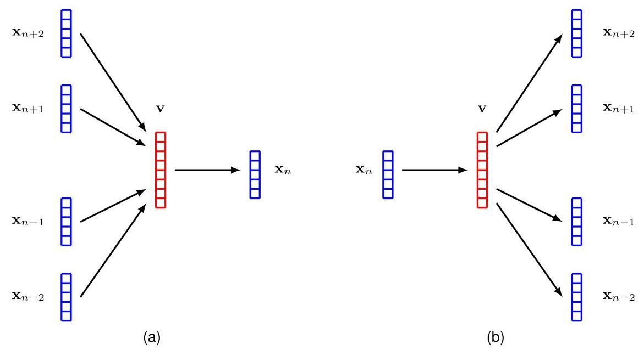

Figure 12.11 Two-layer neural networks used to learn word embeddings, where (a) shows the continuous bag-of-words approach, and (b) shows the skip-grams approach.

图 12.11 用于学习单词嵌入的两层神经网络，其中 (a) 显示了连续词袋模型，(b) 显示了跳字模型。

It turns out that the learned embedding space often has an even richer semantic structure than just the proximity of related words, and that this allows for simple vector arithmetic. For example, the concept that ’Paris is to France as Rome is to Italy’ can be expressed through operations on the embedding vectors. If we use (word) to denote the embedding vector for ’word’, then we find

事实证明，学习得到的嵌入空间通常具有比仅仅是相关单词的接近性更丰富的语义结构，并且这允许进行简单的向量运算。例如，“巴黎之于法国就如同罗马之于意大利”这一概念可以通过对嵌入向量进行运算来表达。如果我们用 (单词) 来表示 “单词” 的嵌入向量，那么我们会发现

Word embeddings were originally developed as natural language processing tools in their own right. Today, they are more likely to be used as pre-processing steps for deep neural networks. In this regard they can be viewed as the first layer in a deep neural network. They can be fixed using some standard pre-trained embedding matrix, or they can be treated as an adaptive layer that is learned as part of the overall end-to-end training of the system. In the latter case the embedding layer can be initialized either using random weight values or using a standard embedding matrix.

词嵌入最初本身就是作为自然语言处理工具而开发的。如今，它们更有可能被用作深度神经网络的预处理步骤。在这方面，它们可以被视为深度神经网络的第一层。可以使用一些标准的预训练嵌入矩阵来固定它们，或者可以将它们视为一个自适应层，作为系统整体端到端训练的一部分进行学习。在后一种情况下，嵌入层可以使用随机权重值进行初始化，也可以使用标准嵌入矩阵进行初始化。

Figure 12.12 An illustration of the process of tokenizing natural language by analogy with byte pair encoding. In this example, the most frequently occurring pair of characters is ’pe’, which occurs four times, and so these form a new token that replaces all the occurrences of ’pe’. Note that ’Pe’ is not included in this since uppercase ’ ’ and lower-case ’ ’ are distinct characters. Next the pair ’ck’ is added since this occurs three times. This is followed by tokens such as ’pi’, ’ed’, and ’per’, all of which occur twice, and so on. Peter Piper picked a peck of pickled peppers Peter Piper picked a peck of pickled peppers Peter Piper picked a peck of pickled peppers Peter Piper picked a peck of pickled peppers Peter Piper picked a peck of pickled peppers Peter Piper picked a peck of pickled peppers

图 12.12 通过与字节对编码类比来说明对自然语言进行分词的过程。在这个例子中，出现频率最高的字符对是 ’pe’，它出现了四次，因此这些字符形成了一个新的标记，替换了所有出现的 ’pe’。请注意，’Pe’ 不包括在内，因为大写的 ’ ’ 和小写的 ’ ’ 是不同的字符。接下来添加了字符对 ’ck’，因为它出现了三次。随后是诸如 ’pi’、’ed’ 和 ’per’ 等标记，它们都出现了两次，依此类推。Peter Piper picked a peck of pickled peppers Peter Piper picked a peck of pickled peppers Peter Piper picked a peck of pickled peppers Peter Piper picked a peck of pickled peppers Peter Piper picked a peck of pickled peppers Peter Piper picked a peck of pickled peppers

# 12.2.2 Tokenization

# 12.2.2 分词

One problem with using a fixed dictionary of words is that it cannot cope with words not in the dictionary or which are misspelled. It also does not take account of punctuation symbols or other character sequences such as computer code. An alternative approach that addresses these problems would be to work at the level of characters instead of using words, so that our dictionary comprises upper-case and lower-case letters, numbers, punctuation, and white-space symbols such as spaces and tabs. A disadvantage of this approach, however, is that it discards the semantically important word structure of language, and the subsequent neural network would have to learn to reassemble words from elementary characters. It would also require a much larger number of sequential steps for a given body of text, thereby increasing the computational cost of processing the sequence.

使用固定的单词词典存在一个问题，即它无法处理词典中没有的单词或拼写错误的单词。它也没有考虑标点符号或其他字符序列，如计算机代码。一种解决这些问题的替代方法是在字符级别进行处理，而不是使用单词，这样我们的词典就包括大写和小写字母、数字、标点符号以及空格和制表符等空白符号。然而，这种方法的一个缺点是它丢弃了语言中具有重要语义的单词结构，后续的神经网络必须学会从基本字符重新组合成单词。对于给定的文本主体，它还需要更多的顺序步骤，从而增加了处理序列的计算成本。

We can combine the benefits of character-level and word-level representations by using a pre-processing step that converts a string of words and punctuation symbols into a string of tokens, which are generally small groups of characters and might include common words in their entirety, along with fragments of longer words as well as individual characters that can be assembled into less common words (Schuster and Nakajima, 2012). This tokenization also allows the system to process other kinds of sequences such as computer code or even other modalities such as images. It also means that variations of the same word can have related representations. For example, ’cook’, ’cooks’, ’cooked’, ’cooking’, and ’cooker’ are all related and share the common element ’cook’, which itself could be represented as one of the tokens.

我们可以通过使用一个预处理步骤来结合字符级和单词级表示的优点，该步骤将一串单词和标点符号转换为一串标记，这些标记通常是小的字符组，可能包括完整的常见单词，以及较长单词的片段，还有可以组合成不太常见单词的单个字符(Schuster 和 Nakajima，2012)。这种分词还允许系统处理其他类型的序列，如计算机代码，甚至其他模态，如图像。这也意味着同一个单词的不同变体可以有相关的表示。例如，’cook’、’cooks’、’cooked’、’cooking’ 和 ’cooker’ 都是相关的，并且共享共同元素 ’cook’，它本身可以表示为其中一个标记。

Section 12.4.1

第 12.4.1 节

There are many approaches to tokenization. As an example, a technique called byte pair encoding that is used for data compression, can be adapted to text tokeniza-tion by merging characters instead of bytes (Sennrich, Haddow, and Birch, 2015). The process starts with the individual characters and iteratively merges them into longer strings. The list of tokens is first initialized with the list of individual characters. Then a body of text is searched for the most frequently occurring adjacent pairs of tokens and these are replaced with a new token. To ensure that words are not merged, a new token is not formed from two tokens if the second token starts with a white space. The process is repeated iteratively as illustrated in Figure 12.12.

分词有很多方法。例如，一种用于数据压缩的技术，称为字节对编码，可以通过合并字符而非字节来应用于文本分词(Sennrich、Haddow 和 Birch，2015)。该过程从单个字符开始，然后迭代地将它们合并成更长的字符串。词元列表首先用单个字符列表初始化。然后在文本主体中搜索最常出现的相邻词元对，并将这些对替换为一个新的词元。为确保单词不被合并，如果第二个词元以空格开头，则不会由两个词元形成一个新的词元。如图 12.12 所示，该过程会迭代重复。

Initially the number of tokens is equal to the number of characters, which is relatively small. As tokens are formed, the total number of tokens increases, and if this is continued long enough, the tokens will eventually correspond to the set of words in the text. The total number of tokens is generally fixed in advance, as a compromise between character-level and word-level representations. The algorithm is stopped when this number of tokens is reached.

最初，词元的数量等于字符的数量，这相对较少。随着词元的形成，词元的总数会增加，如果这个过程持续足够长的时间，最终词元将对应于文本中的单词集合。词元的总数通常会提前固定，作为字符级和单词级表示之间的一种折衷。当达到这个词元数量时，算法停止。

In practical applications of deep learning to natural language, the input text is typically first mapped into a tokenized representation. However, for the remainder of this chapter, we will use word-level representations as this makes it easier to illustrate and motivate key concepts.

在深度学习在自然语言中的实际应用中，输入文本通常首先被映射为分词后的表示。然而，在本章的其余部分，我们将使用单词级表示，因为这更容易说明和引出关键概念。

# 12.2.3 Bag of words

# 12.2.3 词袋模型

We now turn to the task of modelling the joint distribution of an ordered sequence of vectors, such as words (or tokens) in a natural language. The simplest approach is to assume that the words are drawn independently from the same distribution and hence that the joint distribution is fully factorized in the form

现在我们转向对有序向量序列(如自然语言中的单词(或词元))的联合分布 进行建模的任务。最简单的方法是假设这些单词是从相同的分布中独立抽取的，因此联合分布可以完全分解为以下形式

This can be expressed as a probabilistic graphical model in which the nodes are isolated with no interconnecting links.

这可以表示为一个概率图模型，其中节点相互孤立，没有互连的边。

Figure 11.28

图 11.28

The distribution is shared across the variables and can be represented, without loss of generality, as a simple table listing the probabilities of each of the possible states of (corresponding to the dictionary of words or tokens). The maximum likelihood solution for this model is obtained simply by setting each of these probabilities to the fraction of times that the word occurs in the training set. This is known as a bag-of-words model because it completely ignores the ordering of the words.

分布 在各个变量之间是共享的，并且不失一般性地，可以用一个简单的表格来表示，该表格列出了 的每个可能状态的概率(对应于单词或标记的字典)。对于这个模型，最大似然解可以通过将这些概率中的每一个都设置为该单词在训练集中出现的次数占比来简单地获得。这被称为词袋模型，因为它完全忽略了单词的顺序。

Exercise 12.11

练习 12.11

We can use the bag-of-words approach to construct a simple text classifier. This could be used for example in sentiment analysis in which a passage of text representing a restaurant review is to be classified as positive or negative. The naive Bayes classifier assumes that the words are independent within each class , but with a different distribution for each class, so that

我们可以使用词袋方法来构建一个简单的文本分类器。例如，这可以用于情感分析，在情感分析中，一段代表餐厅评价的文本要被分类为正面或负面。朴素贝叶斯分类器假设每个类别 中的单词是相互独立的，但每个类别的分布不同，因此

Given prior class probabilities , the posterior class probabilities for a new sequence are given by:

给定先验类别概率 ，新序列的后验类别概率由下式给出:

Both the class-conditional densities and the prior probabilities can be estimated using frequencies from the training data set. For a new sequence, the table entries are multiplied together to get the desired posterior probabilities. Note that if a word occurs in the test set that was not present in the training set then the corresponding probability estimate will be zero, and so these estimates are typically ’smoothed’ after training by reassigning a small level of probability uniformly across all entries to avoid zero values.

类条件密度 和先验概率 都可以使用训练数据集的频率来估计。对于一个新的序列，将表格中的各项相乘即可得到所需的后验概率。请注意，如果测试集中出现了训练集中未出现过的单词，那么相应的概率估计将为零，因此通常在训练后会对这些估计进行“平滑处理”，即对所有项均匀分配一个小概率值，以避免出现零值。

# 12.2.4 Autoregressive models

# 12.2.4 自回归模型

One obvious major limitation of the bag-of-words model is that it completely ignores word order. To address this we can take an autoregressive approach. Without loss of generality we can decompose the distribution over the sequence of words into a product of conditional distributions in the form

词袋模型的一个明显的主要局限性在于它完全忽略了单词的顺序。为了解决这个问题，我们可以采用自回归方法。不失一般性，我们可以将单词序列的分布分解为条件分布的乘积，形式如下

This can be represented as a probabilistic graphical model in which each node in the sequence receives a link from every previous node. We could represent each term on the right-hand side of (12.31) by a table whose entries are once again estimated using simple frequency counts from the training set. However, the size of these tables grows exponentially with the length of the sequence, and so this approach would become prohibitively expensive.

这可以用概率图模型来表示，其中序列中的每个节点都与之前的每个节点相连。我们可以用一个表格来表示 (12.31) 式右侧的每一项，表格中的项同样使用训练集的简单频率计数来估计。然而，这些表格的大小会随着序列长度呈指数级增长，因此这种方法的计算成本会高得令人望而却步。

Figure 11.27

图 11.27

Exercise 12.12

练习 12.12

We can simplify the model dramatically by assuming that each of the conditional distributions on the right-hand side of (12.31) is independent of all previous observations except the most recent words. For example, if then the joint distribution for a sequence of observations under this model is given by

我们可以通过假设 (12.31) 右侧的每个条件分布都独立于除 个最近的词之外的所有先前观察结果，来极大地简化模型。例如，如果 ，那么在该模型下 个观察结果序列的联合分布由下式给出

In the corresponding graphical model each node has links from the two previous nodes. Here we assume that the conditional distributions are shared across all variables. Again each of the distributions on the right-hand side of (12.32) can be represented as tables whose values are estimated from the statistics of triplets of successive words drawn from a training corpus.

在相应的图形模型中，每个节点都与前两个节点相连。这里我们假设条件分布 在所有变量中是共享的。同样，(12.32) 右侧的每个分布都可以表示为表格，其值是从训练语料库中抽取的连续词三元组的统计数据中估计出来的。

Figure 11.30

图 11.30

The case with is known as a bi-gram model because it depends on pairs of adjacent words. Similarly , which involves triplets of adjacent words, is called a tri-gram model, and in general these are called n-gram models.

的情况被称为二元语法模型，因为它依赖于相邻的词对。类似地， 涉及相邻的词三元组，被称为三元语法模型，一般来说，这些被称为 n - 元语法模型。

All the models discussed so far in this section can be run generatively to synthesize novel text. For example, if we provide the first and second words in a sequence, then we can sample from the tri-gram statistics to generate the third word, and then we can use the second and third words to sample the fourth word, and so on. The resulting text, however, will be incoherent because each word is predicted only on the basis of the two previous words. High-quality text models must take account of the long-range dependencies in language. On the other hand, we cannot simply increase the value of because the size of the probability tables grows exponentially in so that it is prohibitively expensive to go much beyond tri-gram models. However, the autoregressive representation will play a central role when we consider modern language models based not on probability tables but on deep neural networks configured as transformers.

本节到目前为止讨论的所有模型都可以以生成方式运行，以合成新的文本。例如，如果我们提供序列中的第一个和第二个词，那么我们可以从三元语法统计 中采样来生成第三个词，然后我们可以使用第二个和第三个词来采样第四个词，依此类推。然而，生成的文本将是不连贯的，因为每个词仅基于前两个词进行预测。高质量的文本模型必须考虑语言中的长距离依赖关系。另一方面，我们不能简单地增加 的值，因为概率表的大小会随着 呈指数增长，所以超出三元语法模型的代价会高得令人望而却步。然而，当我们考虑基于深度神经网络(配置为 transformer)而非概率表的现代语言模型时，自回归表示将发挥核心作用。

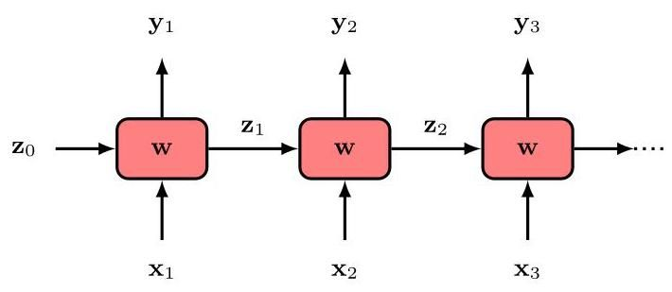

Figure 12.13 A general RNN with parameters . It takes a sequence as input and generates a sequence as output. Each of the boxes corresponds to a multilayer network with nonlinear hidden units.

图 12.13 一个具有参数 的通用循环神经网络(RNN)。它将序列 作为输入，并生成序列 作为输出。每个框对应一个具有非线性隐藏单元的多层网络。

One way to allow longer-range dependencies, while avoiding the exponential growth in the number of parameters of an -gram model, is to use a hidden Markov model whose graphical structure is shown in Figure 11.31. The number of learnable parameters is governed by the dimensionality of the latent variables whereas the distribution over a given observation depends, in principle, on all previous observations. However, the influence of more distant observations is still very limited since their effect must be carried through the chain of latent states which are themselves being updated by more recent observations.

一种在避免 元模型参数数量呈指数级增长的同时，允许更长距离依赖关系的方法是使用隐马尔可夫模型，其图形结构如图 11.31 所示。可学习参数的数量由潜在变量的维度决定，而给定观测值 的分布原则上取决于所有先前的观测值。然而，更遥远观测值的影响仍然非常有限，因为它们的影响必须通过潜在状态链传递，而这些潜在状态本身又会被更近的观测值更新。

Section 11.3.1

第 11.3.1 节

# 12.2.5 Recurrent neural networks

# 12.2.5 循环神经网络

Techniques such as -grams have very poor scaling with sequence length because they store completely general tables of conditional distributions. We can achieve much better scaling by using parameterized models based on neural networks. Suppose we simply apply a standard feed-forward neural network to sequences of words in natural language. One problem that arises is that the network has a fixed number of inputs and outputs, whereas we need to be able to handle sequences in the training and test sets that have variable length. Furthermore, if a word, or group of words, at a particular location in a sequence represents some concept then the same word, or group of words, at a different location is likely to represent the same concept at that new location. This is reminiscent of the equivariance property we encountered in processing image data. If we can construct a network architecture that is able to share parameters across the sequence then not only can we capture this equivariance property but we can greatly reduce the number of free parameters in the model as well as handle sequences having different lengths.

诸如 元模型之类的技术在处理序列长度时扩展性非常差，因为它们存储的是完全通用的条件分布表。我们可以通过使用基于神经网络的参数化模型来实现更好的扩展性。假设我们简单地将标准前馈神经网络应用于自然语言中的单词序列。出现的一个问题是，网络的输入和输出数量是固定的，而我们需要能够处理训练集和测试集中长度可变的序列。此外，如果序列中某个特定位置的一个单词或一组单词代表某个概念，那么在不同位置的相同单词或一组单词很可能在新位置代表相同的概念。这让人想起我们在处理图像数据时遇到的等变性属性。如果我们能够构建一个能够在序列中共享参数的网络架构，那么我们不仅可以捕捉到这种等变性属性，还可以大大减少模型中自由参数的数量，同时处理不同长度的序列。

Chapter 10

第 10 章

To address this we can borrow inspiration from the hidden Markov model and introduce an explicit hidden variable associated with each step in the sequence. The neural network takes as input both the current word and the current hidden state and produces an output word as well as the next state of the hidden variable. We can then chain together copies of this network, in which the weight values are shared across the copies. The resulting architecture is called a recurrent neural network (RNN) and is illustrated in Figure 12.13. Here the initial value of the hidden state may be initialized for example to some default value such as .

为了解决这个问题，我们可以从隐马尔可夫模型中汲取灵感，并引入与序列中每个步骤 相关联的显式隐藏变量 。神经网络将当前单词 和当前隐藏状态 作为输入，并产生一个输出单词 以及隐藏变量的下一个状态 。然后，我们可以将这个网络的副本连接在一起，其中权重值在副本之间共享。由此产生的架构称为循环神经网络(RNN)，如图 12.13 所示。这里，隐藏状态的初始值可以例如初始化为某个默认值，如 。

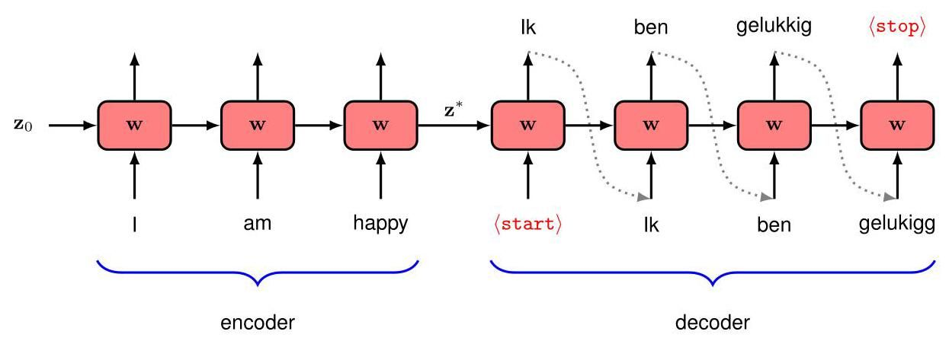

Figure 12.14 An example of a recurrent neural network used for language translation. See the text for details.

图 12.14 用于语言翻译的循环神经网络示例。详情见正文。

As an example of how an RNN might be used in practice, consider the specific task of translating sentences from English into Dutch. The sentences can have variable length, and each output sentence might have a different length from the corresponding input sentence. Furthermore, the network may need to see the whole of the input sentence before it can even start to generate the output sentence. We can address this using an RNN by feeding in the complete English sentence followed by a special input token, which we denote by ⟨start⟩, to trigger the start of translation. During training the network learns to associate (start) with the beginning of the output sentence. We also take each successively generated word and feed it into the input at the next time step, as shown in Figure 12.14. The network can be trained to generate a specific (stop) token to signify the completion of the translation. The first few stages of the network are used to absorb the input sequence, and the associated output vectors are simply ignored. This part of the network can be viewed as an ’encoder’ in which the entire input sentence has been compressed into the state of the hidden variable. The remaining network stages function as the ’decoder’, which generates the translated sentence as output one word at a time. Notice that each output word is fed as input to the next stage of the network, and so this approach has an autoregressive structure analogous to (12.31).

作为循环神经网络(RNN)在实际中应用方式的一个例子，考虑将英语句子翻译成荷兰语这一具体任务。句子的长度可以是可变的，并且每个输出句子的长度可能与相应的输入句子不同。此外，网络可能需要先查看整个输入句子，才能开始生成输出句子。我们可以使用 RNN 来解决这个问题，方法是先输入完整的英语句子，然后输入一个特殊的输入标记，我们用 ⟨start⟩ 表示，以触发翻译的开始。在训练过程中，网络学习将 ⟨start⟩ 与输出句子的开头关联起来。如图 12.14 所示，我们还会将依次生成的每个单词作为输入，在下一个时间步输入到网络中。可以对网络进行训练，使其生成一个特定的 ⟨stop⟩ 标记，以表示翻译完成。网络的前几个阶段用于吸收输入序列，而相关的输出向量则被简单地忽略。网络的这一部分可以看作是一个“编码器”，其中整个输入句子被压缩到隐藏变量的状态 中。网络的其余阶段起到“解码器”的作用，它一次输出一个单词，生成翻译后的句子。请注意，每个输出单词都作为输入被馈送到网络的下一阶段，因此这种方法具有类似于(12.31)的自回归结构。

# 12.2.6 Backpropagation through time

# 12.2.6 时间反向传播

RNNs can be trained by stochastic gradient descent using gradients calculated by backpropagation and evaluated through automatic differentiation, just as with regular neural networks. The error function consists of a sum over all output units of the error for each unit, in which each output unit has a softmax activation function along with an associated cross-entropy error function. During forward propagation, the activation values are propagated all the way from the first input in the sequence through to all the output nodes in the sequence, and error signals are then backprop-agated along the same paths. This process is called backpropagation through time and in principle is straightforward. However, in practice, for very long sequences, training can be difficult due to the problems of vanishing gradients or exploding gradients that arise with very deep network architectures.

与常规神经网络一样，循环神经网络(RNN)可以通过随机梯度下降进行训练，使用通过反向传播计算并通过自动微分评估的梯度。误差函数由每个输出单元的误差之和组成，其中每个输出单元都有一个 softmax 激活函数以及相关的交叉熵误差函数。在正向传播过程中，激活值从序列中的第一个输入一直传播到序列中的所有输出节点，然后误差信号沿着相同的路径反向传播。这个过程称为时间反向传播，原则上很简单。然而，在实践中，对于非常长的序列，由于非常深的网络架构会出现梯度消失或梯度爆炸的问题，训练可能会很困难。

Section 5.4.4

第 5.4.4 节

Section 7.4.2

第 7.4.2 节

Another problem with standard RNNs is that they deal poorly with long-range dependencies. This is especially problematic for natural language where such dependencies are widespread. In a long passage of text, a concept might be introduced that plays an important role in predicting words occurring much later in the text. In the architecture shown in Figure 12.14, the entire concept of the English sentence must be captured in the single hidden vector of fixed length, and this becomes increasingly problematic with longer sequences. This is known as the bottleneck problem because a sequence of arbitrary length has to be summarized in a single hidden vector of activations and the network can start to generate the output translation only once the full input sequence has been processed.

标准循环神经网络(RNN)的另一个问题是，它们在处理长距离依赖关系方面表现不佳。这对于自然语言来说尤其成问题，因为这种依赖关系在自然语言中广泛存在。在一段长文本中，可能会引入一个概念，这个概念在预测文本中稍后出现的单词时起着重要作用。在图 12.14 所示的架构中，英语句子的整个概念必须被捕捉到固定长度的单个隐藏向量 中，并且随着序列变长，这个问题会变得越来越严重。这被称为瓶颈问题，因为任意长度的序列必须被总结到单个激活的隐藏向量中，并且网络只有在处理完完整的输入序列后才能开始生成输出翻译。

One approach for addressing both the vanishing and exploding gradients problems and the limited long-range dependencies is to modify the architecture of the neural network to allow additional signal paths that bypass many of the processing steps within each stage of the network and hence allow information to be remembered over a larger number of time steps. Long short-term memory (LSTM) models (Hochreiter and Schmidhuber, 1997) and gated recurrent unit (GRU) models (Cho et al., 2014) are the most widely known examples. Although they improve performance compared to standard RNNs, they still have a limited ability to model long-range dependencies. Also, the additional complexity of each cell means that LSTMs are even slower to train than standard RNNs. Furthermore, all recurrent networks have signal paths that grow linearly with the number of steps in the sequence. Moreover, they do not support parallel computation within a single training example due to the sequential nature of the processing. In particular, this means that RNNs struggle to make efficient use of modern highly parallel hardware based on GPUs. These problems are addressed by replacing RNNs with transformers.

解决梯度消失和梯度爆炸问题以及有限的长距离依赖关系问题的一种方法是修改神经网络的架构，以允许额外的信号路径绕过网络每个阶段内的许多处理步骤，从而使信息能够在更多的时间步长内被记住。长短期记忆(LSTM)模型(Hochreiter 和 Schmidhuber，1997)和门控循环单元(GRU)模型(Cho 等人，2014)是最广为人知的例子。尽管与标准 RNN 相比，它们提高了性能，但它们在建模长距离依赖关系方面的能力仍然有限。此外，每个单元的额外复杂性意味着 LSTM 的训练速度甚至比标准 RNN 还要慢。此外，所有循环网络的信号路径都随着序列步数的增加而线性增长。而且，由于处理的顺序性，它们不支持在单个训练示例内进行并行计算。特别是，这意味着 RNN 难以有效利用基于 GPU 的现代高度并行硬件。通过用 Transformer 取代 RNN 可以解决这些问题。

# 12.3. Transformer Language Models

# 12.3. Transformer 语言模型

The transformer processing layer is a highly flexible component for building powerful neural network models with broad applicability. In this section we explore the application of transformers to natural language. This has given rise to the development of massive neural networks known as large language models (LLMs), which have proven to be exceptionally capable (Zhao et al., 2023).

Transformer 处理层是一个高度灵活的组件，用于构建具有广泛适用性的强大神经网络模型。在本节中，我们将探讨 Transformer 在自然语言处理中的应用。这催生了被称为大型语言模型(LLM)的大规模神经网络的发展，事实证明这些模型能力非凡(Zhao 等人，2023)。

Transformers can be applied to many different kinds of language processing task, and can be grouped into three categories according to the form of the input and output data. In a problem such as sentiment analysis, we take a sequence of words as input and provide a single variable representing the sentiment of the text, for example happy or sad, as output. Here a transformer is acting as an ’encoder’ of the sequence. Other problems might take a single vector as input and generate a word sequence as output, for example if we wish to generate a text caption given an input image. In such cases the transformer functions as a ’decoder’, generating a sequence as output. Finally, in sequence-to-sequence processing tasks, both the input and the output comprise a sequence of words, for example if our goal is to translate from one language to another. In this case, transformers are used in both encoder and decoder roles. We discuss each of these classes of language model in turn, using illustrative examples of model architectures.

Transformer 可以应用于许多不同类型的语言处理任务，并且可以根据输入和输出数据的形式分为三类。在诸如情感分析这样的问题中，我们将单词序列作为输入，并提供一个表示文本情感的单一变量作为输出，例如高兴或悲伤。在这里，Transformer 充当序列的“编码器”。其他问题可能将单个向量作为输入，并生成单词序列作为输出，例如如果我们希望根据输入图像生成文本描述。在这种情况下，Transformer 起到“解码器”的作用，生成序列作为输出。最后，在序列到序列的处理任务中，输入和输出都包含一个单词序列，例如如果我们的目标是将一种语言翻译成另一种语言。在这种情况下，Transformer 同时充当编码器和解码器的角色。我们将依次讨论这些类型的语言模型，并使用模型架构的示例进行说明。

# 12.3.1 Decoder transformers

# 12.3.1 解码器 Transformer

We start by considering decoder-only transformer models. These can be used as generative models that create output sequences of tokens. As an illustrative example, we will focus on a class of models called GPT which stands for generative pre-trained transformer (Radford et al., 2019; Brown et al., 2020; OpenAI, 2023). The goal is to use the transformer architecture to construct an autoregressive model of the form defined by (12.31) in which the conditional distributions are expressed using a transformer neural network that is learned from data.

我们首先考虑仅解码器的变压器模型。这些模型可用作生成模型，用于创建标记的输出序列。作为一个示例，我们将重点关注一类名为 GPT 的模型，它代表生成式预训练变压器(Radford 等人，2019 年；Brown 等人，2020 年；OpenAI，2023 年)。目标是使用变压器架构构建一个由 (12.31) 定义形式的自回归模型，其中条件分布 使用从数据中学习到的变压器神经网络来表示。

The model takes as input a sequence consisting of the first tokens, and its corresponding output represents the conditional distribution for token . If we draw a sample from this distribution then we have extended the sequence to tokens and this new sequence can be fed back through the model to give a distribution over token , and so on. The process can be repeated to generate sequences up to a maximum length determined by the number of inputs to the transformer. We will shortly discuss strategies for sampling from the conditional distributions, but for the moment we focus on how to construct and train the network.

该模型将由前 个标记组成的序列作为输入，其相应的输出表示标记 的条件分布。如果我们从这个分布中抽取一个样本，那么我们就将序列扩展到了 个标记，并且这个新序列可以反馈回模型，以得到关于标记 的分布，依此类推。这个过程可以重复进行，以生成长度最大由变压器输入数量决定的序列。我们将很快讨论从条件分布中采样的策略，但目前我们专注于如何构建和训练网络。

Section 12.3.2

第 12.3.2 节

The architecture of a GPT model consists of a stack of transformer layers that take a sequence of tokens, each of dimensionality , as input and produce a sequence of tokens, again of dimensionality , as output. Each output needs to represent a probability distribution over the dictionary of tokens at that time step, and this dictionary has dimensionality whereas the tokens have a dimensionality of . We therefore make a linear transformation of each output token using a matrix of dimensionality followed by a softmax activation

GPT 模型的架构由一系列变压器层组成，这些层将维度为 的标记序列 作为输入，并生成同样维度为 的标记序列 作为输出。每个输出需要表示该时间步标记字典上的概率分布，这个字典的维度为 ，而标记的维度为 。因此，我们使用维度为 的矩阵 对每个输出标记进行线性变换，然后进行 softmax 激活。

function in the form

形式如下的函数

where is a matrix whose th row is , and is a matrix whose th row is . Each softmax output unit has an associated cross-entropy error function. The architecture of the model is shown in Figure 12.15.

其中 是一个矩阵，其第 行是 ， 是一个矩阵，其第 行是 。每个 softmax 输出单元都有一个相关的交叉熵误差函数。该模型的架构如图 12.15 所示。

Section 5.4.4

第 5.4.4 节

The model can be trained using a large corpus of unlabelled natural language by taking a self-supervised approach. Each training sample consists of a sequence of tokens , which form the input to the network, along with an associated target value consisting of the next token in the sequence. The sequences are considered to be independent and identically distributed so that the error function used for training is the sum of the cross-entropy error values summed over the training set, grouped into appropriate mini-batches. Naively we could process each such training sample independently using a forward pass through the model. However, we can achieve much greater efficiency by processing an entire sequence at once so that each token acts both as a target value for the sequence of previous tokens and as an input value for subsequent tokens. For example, consider the word sequence

该模型可以通过采用自监督方法，使用大量未标记的自然语言语料库进行训练。每个训练样本由一个标记序列 组成，该序列构成网络的输入，同时还有一个相关的目标值 ，它由序列中的下一个标记组成。这些序列被认为是独立同分布的，因此用于训练的误差函数是训练集上交叉熵误差值的总和，并分组为适当的小批量。简单地说，我们可以通过模型的前向传播独立处理每个这样的训练样本。然而，我们可以通过一次性处理整个序列来实现更高的效率，这样每个标记既作为前一个标记序列的目标值，又作为后续标记的输入值。例如，考虑单词序列

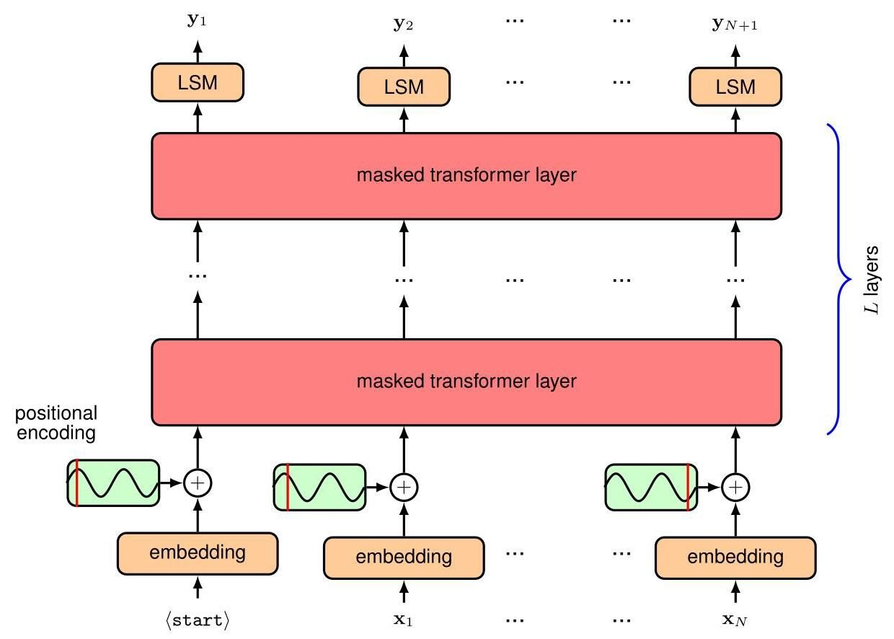

Figure 12.15 Architecture of a GPT decoder transformer network. Here ’LSM’ stands for linear-softmax and denotes a linear transformation whose learnable parameters are shared across the token positions, followed by a softmax activation function. Masking is explained in the text.

图 12.15 GPT 解码器变压器网络的架构。这里的“LSM”代表线性 - softmax，表示一种线性变换，其可学习参数在标记位置之间共享，随后是一个 softmax 激活函数。掩码在正文中有解释。

I swam across the river to get to the other bank.

我游过了河，到达了对岸。

We can use ‘I swam across’ as an input sequence with an associated target of ‘the’, and also use ’I swam across the’ as an input sequence with an associated target of ’river’, and so on. However, to process these in parallel we have to ensure that the network is not able to ’cheat’ by looking ahead in the sequence, otherwise it will simply learn to copy the next input directly to the output. If it did this, it would then be unable to generate new sequences since the subsequent token by definition is not available at test time. To address this problem we do two things. First, we shift the input sequence to the right by one step, so that input corresponds to output , with target , and an additional special token denoted start is prepended in the first position of the input sequence. Second, note that the tokens in a transformer are processed independently, except when they are used to compute the attention weights, when they interact in pairs through the dot product. We therefore introduce masked attention, sometimes called causal attention, into each of the attention layers, in which we set to zero all of the attention weights that correspond to a token attending to any later token in the sequence. This simply involves setting to zero all the corresponding elements of the attention matrix Attention defined by (12.14) and then normalizing the remaining elements so that each row once again sums to one. In practice, this can be achieved by setting the corresponding pre-activation values to so that the softmax evaluates to zero for the associated outputs and also takes care of the normalization across the non-zero outputs. The structure of the masked attention matrix is illustrated in Figure 12.16.

我们可以使用 “I swam across” 作为输入序列，其关联目标为 “the”，也可以使用 “I swam across the” 作为输入序列，其关联目标为 “river”，依此类推。然而，为了并行处理这些序列，我们必须确保网络不能通过查看序列中的后续内容来 “作弊”，否则它将只是简单地学会将下一个输入直接复制到输出。如果它这样做了，那么它将无法生成新的序列，因为根据定义，后续标记在测试时是不可用的。为了解决这个问题，我们采取了两个措施。首先，我们将输入序列向右移动一步，使得输入 对应输出 ，目标为 ，并且在输入序列的第一个位置添加一个额外的特殊标记 start 。其次，请注意，变压器中的标记是独立处理的，除非在计算注意力权重时，它们通过点积成对交互。因此，我们在每个注意力层中引入掩码注意力，有时也称为因果注意力，在这种注意力机制中，我们将对应于一个标记关注序列中任何后续标记的所有注意力权重都设置为零。这只需将由 (12.14) 定义的注意力矩阵 Attention 的所有相应元素设置为零，然后对其余元素进行归一化，使得每一行的和再次为 1。在实践中，这可以通过将相应的预激活值设置为 来实现，这样 softmax 对相关输出的计算结果为零，同时也处理了非零输出的归一化。掩码注意力矩阵的结构如图 12.16 所示。

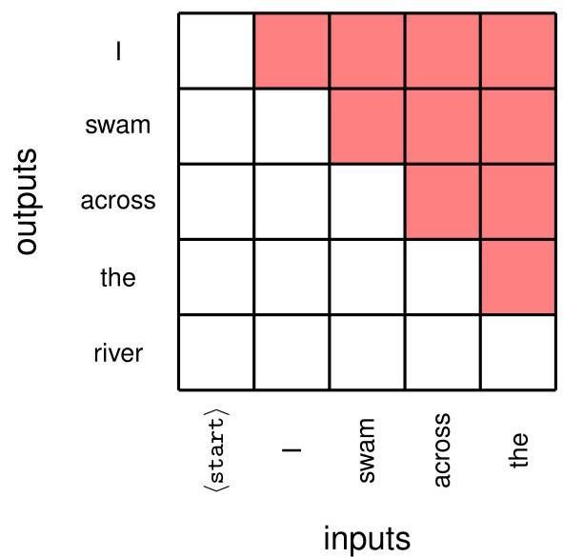

Figure 12.16 An illustration of the mask matrix for masked self-attention. Attention weights corresponding to the red elements are set to zero. Thus, in predicting the token ’across’, the output can depend only on the input tokens ’<start>’ ’l’ and ‘swam’.

图 12.16 掩码自注意力的掩码矩阵示例。对应于红色元素的注意力权重被设置为零。因此，在预测标记 “across” 时，输出只能依赖于输入标记 “<start>” “I” 和 “swam”。

In practice, we wish to make efficient use of the massive parallelism of GPUs, and hence multiple sequences may be stacked together into an input tensor for parallel processing in a single batch. However, this requires the sequences to be of the same length, whereas text sequences naturally have variable length. This can be addressed by introducing a specific token, which we denote by , that is used to fill unused positions to bring all sequences up to the same length so that they can be combined into a single tensor. An additional mask is then used in the attention weights to ensure that the output vectors do not pay attention to any inputs occupied by the token. Note that the form of this mask depends on the particular input sequence.

在实践中，我们希望有效利用 GPU 的大规模并行计算能力，因此可以将多个序列堆叠在一起，形成一个输入张量，以便在单个批次中进行并行处理。然而，这要求序列具有相同的长度，而文本序列的长度自然是可变的。这可以通过引入一个特定的标记来解决，我们用 表示该标记，它用于填充未使用的位置，使所有序列达到相同的长度，以便将它们组合成一个单一的张量。然后在注意力权重中使用一个额外的掩码，以确保输出向量不会关注 标记所占据的任何输入。请注意，此掩码的形式取决于特定的输入序列。

The output of the trained model is a probability distribution over the space of tokens, given by the softmax output activation function, which represents the probability of the next token given the current token sequence. Once this next word is chosen, the token sequence with the new token included can then be fed through the model again to generate the subsequent token in the sequence, and this process can be repeated indefinitely or until an end-of-sequence token is generated. This may appear to be quite inefficient since data must be fed through the whole model for each new generated token. However, note that due to the masked attention, the embedding learned for a particular token depends only on that token itself and on earlier tokens and hence does not change when a new, later token is generated. Consequently, much of the computation can be recycled when processing a new token.

训练好的模型的输出是一个在标记空间上的概率分布，由 softmax 输出激活函数给出，它表示在给定当前标记序列的情况下，下一个标记的概率。一旦选择了这个下一个单词，包含新标记的标记序列就可以再次输入模型，以生成序列中的后续标记，这个过程可以无限重复，或者直到生成一个序列结束标记为止。这似乎效率很低，因为对于每个新生成的标记，数据都必须通过整个模型。然而，请注意，由于使用了掩码注意力，为特定标记学习到的嵌入仅取决于该标记本身和之前的标记，因此在生成新的后续标记时不会改变。因此，在处理新标记时，大部分计算可以复用。

# 12.3.2 Sampling strategies

# 12.3.2 采样策略

We have seen that the output of a decoder transformer is a probability distribution over values for the next token in the sequence, from which a particular value for that token must be chosen to extend the sequence. There are several options for selecting the value of the token based on the computed probabilities (Holtzman et al., 2019). One obvious approach, called greedy search, is simply to select the token with the highest probability. This has the effect of making the model deterministic, in that a given input sequence always generates the same output sequence. Note that simply choosing the highest probability token at each stage is not the same as selecting the highest probability sequence of tokens. To find the most probable sequence, we would need to maximize the joint distribution over all tokens, which is given by

我们已经看到，解码器变压器的输出是序列中下一个标记值的概率分布，必须从中选择该标记的特定值来扩展序列。根据计算出的概率选择标记的值有几种方法(Holtzman 等人，2019)。一种明显的方法称为贪心搜索，即简单地选择概率最高的标记。这会使模型具有确定性，即给定的输入序列总是生成相同的输出序列。请注意，在每个阶段简单地选择概率最高的标记并不等同于选择概率最高的标记序列。为了找到最可能的序列，我们需要最大化所有标记上的联合分布，该联合分布由下式给出

Exercise 12.15

练习 12.15

If there are steps in the sequence and the number of token values in the dictionary is then the total number of sequences is , which grows exponentially with the length of the sequence, and hence finding the single most probable sequence is infeasible. By comparison, greedy search has , which is linear in the sequence length.

如果序列中有 步，字典中标记值的数量为 ，那么序列的总数为 ，它随序列长度呈指数增长，因此找到单个最可能的序列是不可行的。相比之下，贪心搜索的复杂度为 ，它与序列长度呈线性关系。

One technique that has the potential to generate higher probability sequences than greedy search is called beam search. Instead of choosing the single most probable token value at each step, we maintain a set of hypotheses, where is called the beam width, each consisting of a sequence of token values up to step . We then feed all these sequences through the network, and for each sequence we find the most probable token values, thereby creating possible hypotheses for the extended sequence. This list is then pruned by selecting the most probable hypotheses according to the total probability of the extended sequence. Thus, the beam search algorithm maintains alternative sequences and keeps track of their probabilities, finally selecting the most probable sequence amongst those considered. Because the probability of a sequence is obtained by multiplying the probabilities at each step of the sequence and since these probability are always less than or equal to one, a long sequence will generally have a lower probability than a short one, biasing the results towards short sequences. For this reason the sequence probabilities are generally normalized by the corresponding lengths of the sequence before making comparisons. Beam search has cost , which is again linear in the sequence length. However, the cost of generating a sequence is increased by a factor of , and so for very large language models, where the cost of inference can become significant, this makes beam search much less attractive.

有一种技术有可能生成比贪心搜索概率更高的序列，这种技术被称为束搜索。在每一步，我们不是选择单个最可能的标记值，而是维护一组 个假设，其中 被称为束宽，每个假设都由直到步骤 的标记值序列组成。然后，我们将所有这些序列输入网络，对于每个序列，我们找到 个最可能的标记值，从而为扩展序列创建 个可能的假设。然后，根据扩展序列的总概率选择最可能的 个假设，对这个列表进行修剪。因此，束搜索算法维护 个替代序列并跟踪它们的概率，最后从所考虑的序列中选择最可能的序列。由于序列的概率是通过将序列每一步的概率相乘得到的，并且这些概率总是小于或等于 1，因此长序列的概率通常比短序列低，这会使结果偏向于短序列。出于这个原因，在进行比较之前，通常会根据序列的相应长度对序列概率进行归一化。束搜索的成本为 ，这同样与序列长度呈线性关系。然而，生成序列的成本增加了 倍，因此对于非常大的语言模型，当推理成本变得很高时，这使得束搜索的吸引力大大降低。

One problem with approaches such as greedy search and beam search is that they limit the diversity of potential outputs and can even cause the generation process to become stuck in a loop, where the same sub-sequence of words is repeated over and over. As can be seen in Figure 12.17, human-generated text may have lower probability and hence be more surprising with respect to a given model than automatically generated text.

贪心搜索和束搜索等方法存在的一个问题是，它们限制了潜在输出的多样性，甚至可能导致生成过程陷入循环，即相同的单词子序列不断重复。如图 12.17 所示，与自动生成的文本相比，人类生成的文本在给定模型下的概率可能更低，因此更令人惊讶。

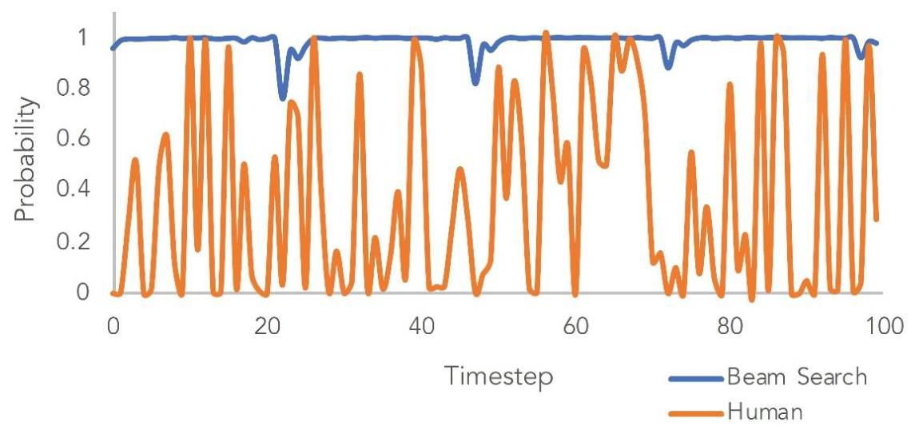

Figure 12.17 A comparison of the token probabilities from beam search and human text for a given trained transformer language model and a given initial input sequence, showing how the human sequence has much lower token probabilities. [From Holtzman et al. (2019) with permission.]

图 12.17 对于给定的经过训练的变压器语言模型和给定的初始输入序列，束搜索和人类文本的标记概率比较，显示了人类生成的序列的标记概率要低得多。[经许可摘自 Holtzman 等人(2019)。]

Instead of trying to find a sequence with the highest probability, we can instead generate successive tokens simply by sampling from the softmax distribution at each step. However, this can lead to sequences that are nonsensical. This arises from the typically very large size of the token dictionary, in which there is a long tail of many token states each of which has a very small probability but which in aggregate account for a significant fraction of the total probability mass. This leads to the problem in which there is a significant chance that the system will make a bad choice for the next token.

我们可以不尝试寻找概率最高的序列，而是简单地在每一步从 softmax 分布中采样来生成连续的标记。然而，这可能会导致生成无意义的序列。这是由于标记字典通常非常大，其中有许多标记状态构成的长尾，每个状态的概率都非常小，但它们的总概率却占了很大一部分。这就导致了一个问题，即系统很有可能为下一个标记做出错误的选择。

As a balance between these extremes, we can consider only the states having the top probabilities, for some choice of , and then sample from these according to their renormalized probabilities. A variant of this approach, called top- sampling or nucleus sampling, calculates the cumulative probability of the top outputs until a threshold is reached and then samples from this restricted set of token states.

作为这些极端情况之间的一种平衡，对于某个 的选择，我们可以只考虑具有前 个概率的状态，然后根据它们重新归一化后的概率从这些状态中采样。这种方法的一种变体，称为 top- 采样或核采样，会计算前几个输出的累积概率，直到达到一个阈值，然后从这个受限的标记状态集合中采样。

A ’softer’ version of top- sampling is to introduce a parameter called temperature into the definition of the softmax function (Hinton, Vinyals, and Dean, 2015) so that

top- 采样的一种“更柔和”的版本是在 softmax 函数的定义中引入一个称为温度的参数 (Hinton、Vinyals 和 Dean，2015)，使得

and then sample the next token from this modified distribution. When , the probability mass is concentrated on the most probable state, with all other states having zero probability, and hence this becomes greedy selection. For , we recover the unmodified softmax distribution, and as , the distribution becomes uniform across all states. By choosing a value in the range , the probability is concentrated towards the higher values.

然后从这个修改后的分布中采样下一个标记。当 时，概率质量集中在最可能的状态上，所有其他状态的概率为零，因此这就变成了贪心选择。对于 ，我们恢复未修改的 softmax 分布，并且当 时，分布在所有状态上变得均匀。通过在范围 中选择一个值，概率会向较高的值集中。

One challenge with sequence generation is that during the learning phase, the model is trained on a human-generated input sequence, whereas when it is running generatively, the input sequence is itself generated from the model. This means that the model can drift away from the distribution of sequences seen during training.

序列生成的一个挑战是，在学习阶段，模型是在人类生成的输入序列上进行训练的，而当它进行生成式运行时，输入序列本身是由模型生成的。这意味着模型可能会偏离训练期间所看到的序列分布。

# 12.3.3 Encoder transformers

# 12.3.3 编码器 Transformer

We next consider transformer language models based on encoders, which are models that take sequences as input and produce fixed-length vectors, such as class labels, as output. An example of such a model is BERT, which stands for bidirectional encoder representations from transformers (Devlin et al., 2018). The goal is to pre-train a language model using a large corpus of text and then to fine-tune the model using transfer learning for a broad range of downstream tasks each of which requires a smaller application-specific training data set. The architecture of an encoder transformer is illustrated in Figure 12.18. This approach is a straightforward application of the transformer layers discussed previously.

接下来，我们考虑基于编码器的 Transformer 语言模型，这类模型将序列作为输入，并产生固定长度的向量(如类别标签)作为输出。这种模型的一个例子是 BERT，它代表来自 Transformer 的双向编码器表示(Devlin 等人，2018 年)。目标是使用大量文本语料库对语言模型进行预训练，然后使用迁移学习对模型进行微调，以用于广泛的下游任务，每个任务都需要较小的特定应用训练数据集。编码器 Transformer 的架构如图 12.18 所示。这种方法是对前面讨论的 Transformer 层的直接应用。

Section 12.1.7

第 12.1.7 节

The first token of every input string is given by a special token ⟨class⟩, and the corresponding output of the model is ignored during pre-training. Its role will become apparent when we discuss fine-tuning. The model is pre-trained by presenting token sequences at the input. A randomly chosen subset of the tokens, say 15%, are replaced with a special token denoted mask . The model is trained to predict the missing tokens at the corresponding output nodes. This is analogous to the masking used in word2vec to learn word embeddings. For example, an input sequence might be

每个输入字符串的第一个标记由一个特殊标记 ⟨class⟩ 给出，并且在预训练期间忽略模型的相应输出。当我们讨论微调时，它的作用将变得明显。通过在输入处呈现标记序列对模型进行预训练。随机选择的一部分标记(例如 15%)被一个特殊标记 mask 替换。训练模型以在相应的输出节点处预测缺失的标记。这类似于 word2vec 中用于学习词嵌入的掩码。例如，一个输入序列可能是

Section 12.2.1

第12.2.1节

I ⟨mask⟩ across the river to get to the ⟨mask⟩ bank.

我 ⟨mask⟩ 过河到了 ⟨mask⟩ 岸。

and the network should predict ’swam’ at output node 2 and ’other’ at output node 10. In this case only two of the outputs contribute to the error function and the other outputs are ignored.

并且网络应该在输出节点2预测出 “swam”，在输出节点10预测出 “other”。在这种情况下，只有两个输出对误差函数有贡献，其他输出则被忽略。

The term ’bidirectional’ refers to the fact that the network sees words both before and after the masked word and can use both sources of information to make a prediction. As a consequence, unlike decoder models, there is no need to shift the inputs to the right by one place, and there is no need to mask the outputs of each layer from seeing input tokens occurring later in the sequence. Compared to the decoder model, an encoder is less efficient since only a fraction of the sequence tokens are used as training labels. Moreover, an encoder model is unable to generate sequences.

“双向” 这一术语指的是网络既能看到被掩码单词之前的单词，也能看到之后的单词，并能利用这两种信息源进行预测。因此，与解码器模型不同，不需要将输入向右移动一位，也不需要对每一层的输出进行掩码处理，以防止其看到序列中后续出现的输入标记。与解码器模型相比，编码器的效率较低，因为只有一部分序列标记被用作训练标签。此外，编码器模型无法生成序列。

The procedure of replacing randomly selected tokens with ⟨mask⟩ means the training set has a mismatch compared to subsequent fine-tuning sets in that the latter will not contain any \mathrm any \mathrm \The any problems this might cause, Devlin et al. (2018) modified the procedure slightly, so that of the 15% of randomly selected tokens, 80% are replaced with ⟨mask are replaced with a word selected at random from the vocabulary, and in 10% of the cases, the original words are retained at the input, but they still have to be correctly predicted at the output.

用 ⟨mask⟩ 替换随机选择的标记的过程意味着，与后续的微调集相比，训练集存在不匹配的情况，因为后者不会包含任何 \mathrm any \mathrm \The 为解决这可能导致的任何问题，Devlin 等人(2018)对该过程进行了轻微修改，使得在随机选择的15%的标记中，80%被替换为 ⟨mask 被替换为从词汇表中随机选择的一个单词，在10%的情况下，输入中保留原始单词，但在输出中仍需正确预测它们。

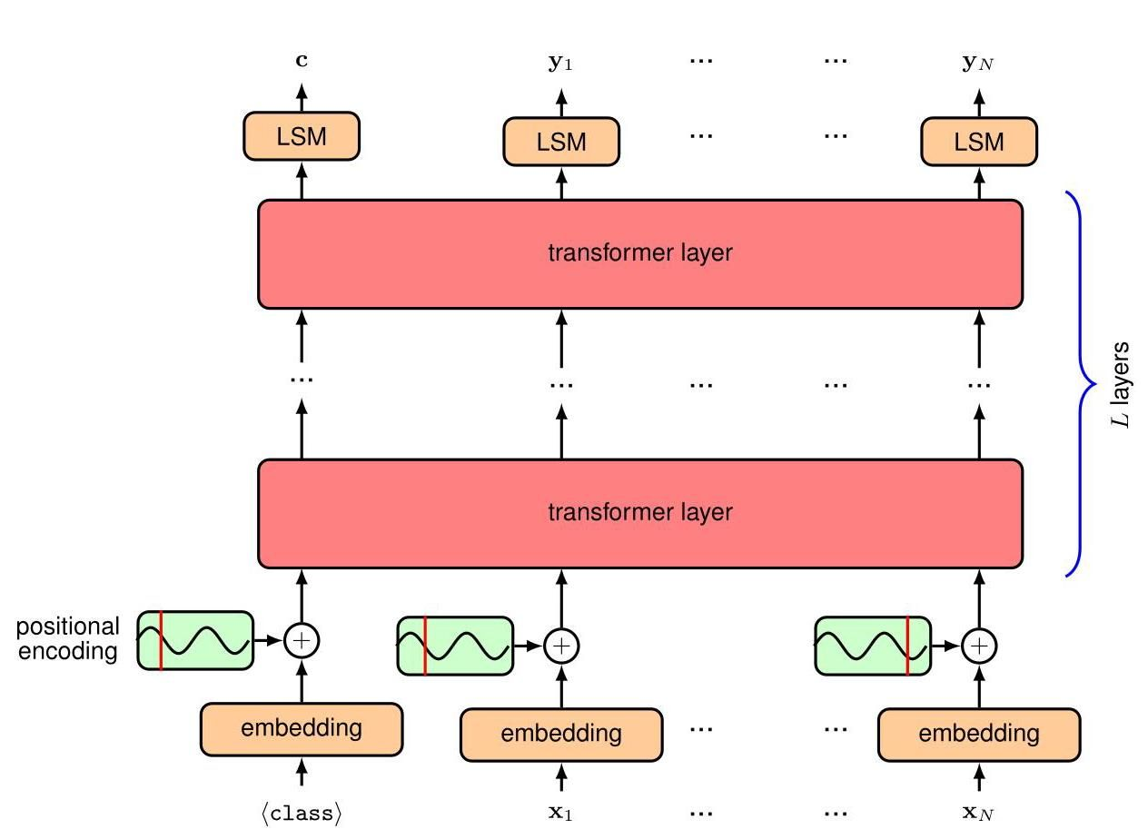

Figure 12.18 Architecture of an encoder transformer model. The boxes labelled ’LSM’ denote a linear transformation whose learnable parameters are shared across the token positions, followed by a softmax activation function. The main differences compared to the decoder model are that the input sequence is not shifted to the right, and the ’look ahead’ masking matrix is omitted and therefore, within each self-attention layer, every output token can attend to any of the input tokens.

图12.18 编码器Transformer模型的架构。标有 “LSM” 的框表示一个线性变换，其可学习参数在标记位置之间共享，随后是一个softmax激活函数。与解码器模型相比，主要区别在于输入序列不会向右移动，并且省略了 “前瞻” 掩码矩阵，因此，在每个自注意力层内，每个输出标记都可以关注任何输入标记。

Once the encoder model is trained it can then be fine-tuned for a variety of different tasks. To do this a new output layer is constructed whose form is specific to the task being solved. For a text classification task, only the first output position is used, which corresponds to the ⟨class⟩ token that always appears in the first position of the input sequence. If this output has dimension then a matrix of parameters of dimension , where is the number of classes, is appended to the first output node and this in turn feeds into a -dimensional softmax function or a vector of dimension followed by a logistic sigmoid for . The linear output transformation could alternatively be replaced with a more complex differentiable model such as an MLP. If the goal is to classify each token of the input string, for example to assign each token to a category (such as person, place, colour, etc) then the first output is ignored and the subsequent outputs have a shared linear-plus-softmax layer. During fine-tuning all model parameters including the new output matrix are learned by stochastic gradient descent using the log probability of the correct label. Alternatively the output of a pre-trained model might feed into a sophisticated generative deep learning model for applications such as text-to-image synthesis.

一旦编码器模型训练完成，就可以针对各种不同的任务进行微调。为此，需要构建一个新的输出层，其形式特定于要解决的任务。对于文本分类任务，仅使用第一个输出位置，该位置对应于始终出现在输入序列第一个位置的 ⟨class⟩ 标记。如果此输出的维度为 ，则将维度为 的参数矩阵(其中 是类别数)附加到第一个输出节点，然后将其输入到一个 维的 softmax 函数中，或者输入到一个维度为 的向量，随后是用于 的逻辑 sigmoid 函数。线性输出变换也可以用更复杂的可微模型(如多层感知器)替代。如果目标是对输入字符串的每个标记进行分类，例如将每个标记分配到一个类别(如人、地点、颜色等)，则忽略第一个输出，后续输出具有共享的线性加 softmax 层。在微调期间，包括新输出矩阵在内的所有模型参数都通过随机梯度下降法进行学习，使用正确标签的对数概率。或者，预训练模型的输出可以输入到一个复杂的生成式深度学习模型中，用于诸如文本到图像合成等应用。

Chapter 20

第 20 章

# 12.3.4 Sequence-to-sequence transformers

# 12.3.4 序列到序列的变压器模型

For completeness, we discuss briefly the third category of transformer model, which combines an encoder with a decoder, as discussed in the original transformer paper of Vaswani et al. (2017). Consider the task of translating an English sentence into a Dutch sentence. We can use a decoder model to generate the token sequence corresponding to the Dutch output, token by token, as discussed previously. The main difference is that this output needs to be conditioned on the entire input sequence corresponding to the English sentence. An encoder transformer can be used to map the input token sequence into a suitable internal representation, which we denote by . To incorporate into the generative process for the output sequence, we use a modified form of the attention mechanism called cross attention. This is the same as self-attention except that although the query vectors come from the sequence being generated, in this case the Dutch output sequence, the key and value vectors come from the sequence represented by , as illustrated in Figure 12.19. Returning to our analogy with a video streaming service, this would be like the user sending their query vector to a different streaming company who then compares it with their own set of key vectors to find the best match and then returns the associated value vector in the form of a movie.

为了完整性，我们简要讨论变压器模型的第三类，它将编码器与解码器结合起来，正如 Vaswani 等人(2017 年)在原始变压器论文中所讨论的那样。考虑将英语句子翻译成荷兰语句子的任务。我们可以使用解码器模型逐个标记地生成与荷兰语输出对应的标记序列，如前面所讨论的那样。主要区别在于，此输出需要以与英语句子对应的整个输入序列为条件。可以使用编码器变压器将输入标记序列映射到合适的内部表示，我们用 表示。为了将 纳入输出序列的生成过程，我们使用一种称为交叉注意力的注意力机制的修改形式。这与自注意力相同，只是尽管查询向量来自正在生成的序列(在这种情况下是荷兰语输出序列)，但键向量和值向量来自由 表示的序列，如图 12.19 所示。回到我们与视频流服务的类比，这就像用户将他们的查询向量发送给另一家流媒体公司，然后该公司将其与自己的键向量集进行比较以找到最佳匹配，然后以电影的形式返回相关的值向量。

Section 12.3.1

第 12.3.1 节

When we combine the encoder and decoder modules, we obtain the architecture of the model shown in Figure 12.20. The model can be trained using paired input and output sentences.

当我们将编码器和解码器模块组合在一起时，就得到了图 12.20 所示的模型架构。该模型可以使用成对的输入和输出句子进行训练。

# 12.3.5 Large language models

# 12.3.5 大型语言模型

The most important recent development in the field of machine learning has been the creation of very large transformer-based neural networks for natural language processing, known as large language models or LLMs. Here ’large’ refers to the number of weight and bias parameters in the network, which can number up to around one trillion at the time of writing. Such models are expensive to train, and the motivation for building them comes from their extraordinary capabilities.

机器学习领域近期最重要的进展是为自然语言处理创建了基于变压器(transformer)的超大型神经网络，即大型语言模型(LLMs)。这里的“大型”指的是网络中权重和偏置参数的数量，在撰写本文时，这一数量可达约一万亿 。训练此类模型成本高昂，构建它们的动力源于其卓越的能力。

In addition to the availability of large data sets, the training of ever larger models has been facilitated by the advent of massively parallel training hardware based on GPUs (graphics processing units) and similar processors tightly coupled in large clusters equipped fast interconnect and lots of onboard memory. The transformer architecture has played a key role in the development of these models because it is able to make very efficient use of such hardware. Very often, increasing the size of the training data set, along with a commensurate increase in the number of model parameters, leads to improvements in performance that outpace architectural improvements or other ways to incorporate more domain knowledge (Sutton, 2019; Kaplan et al., 2020). For example, the impressive increase in performance of the GPT series of models (Radford et al., 2019; Brown et al., 2020; OpenAI, 2023) through successive generations has come primarily from an increase in scale. These kinds

除了有大量数据集可用之外，基于 GPU(图形处理单元)的大规模并行训练硬件的出现也推动了更大模型的训练。这些 GPU 和类似处理器紧密耦合在配备快速互连和大量板载内存的大型集群中。变压器(transformer)架构在这些模型的发展中发挥了关键作用，因为它能够高效利用此类硬件。通常，增加训练数据集的规模，同时相应增加模型参数的数量，会带来性能提升，且这种提升超过架构改进或其他融入更多领域知识的方法(Sutton，2019；Kaplan 等人，2020)。例如，GPT 系列模型(Radford 等人，2019；Brown 等人，2020；OpenAI，2023)历代版本性能的显著提升主要源于规模的扩大。这些类型

|  |  |  |
| --- | --- | --- |
| Figure 12.19 | Schematic illustration of one cross- attention layer as used in the decoder section of a sequence-to-sequence trans- former. Here denotes the output from the encoder section. determines the key and value vectors for the cross- attention layer, whereas the query vec- tors are determined within the decoder section. |  |
| Figure 1.16 | of performance improvements have driven a new kind of Moore’s law in which the number of compute operations required to train a state-of-the-art machine learning model has grown exponentially since about 2012 with a doubling time of around 3.4 months. build a translation system, the training set would consist of matched pairs of sen- tences in two languages. A major limitation of supervised learning, however, is that the data typically has to be human-curated to provide labelled examples, and this severely limits the quantity of data available, thereby requiring heavy use of inductive biases such as feature engineering and architecture constraints to achieve reasonable performance. large data sets of text, along with potentially other token sequences such as computer | Early language models were trained using supervised learning. For example, to Large language models are trained instead by self-supervised learning on very |
| Section 12.3.1 | code. We have seen how a decoder transformer can be trained on token sequences in which each token acts as a labelled target example, with the preceding sequence as input, to learn a conditional probability distribution. This ’self-labelling’ hugely expands the quantity of training data available and therefore allows exploitation of deep neural networks having large numbers of parameters. |  |
| 图 12.19 | 序列到序列 transformer 解码器部分使用的一个交叉注意力层的示意图。这里 表示编码器部分的输出。 确定交叉注意力层的键向量和值向量，而查询向量在解码器部分内确定。 |  |
| 图 1.16 | 性能提升推动了一种新的摩尔定律，自 2012 年左右以来，训练一个最先进的机器学习模型所需的计算操作数量呈指数级增长，翻倍时间约为 3.4 个月。要构建一个翻译系统，训练集将由两种语言的匹配句子对组成。然而，监督学习的一个主要局限性是，数据通常必须由人工整理以提供带标签的示例，这严重限制了可用数据的数量，因此需要大量使用归纳偏置，如特征工程和架构约束，以实现合理的性能。大量的文本数据集，以及潜在的其他标记序列，如计算机 | 早期的语言模型是使用监督学习进行训练的。例如，大型语言模型则是通过对非常大的文本数据集以及潜在的其他标记序列(如计算机)进行自监督学习来训练的。 |
| 第 12.3.1 节 | 代码。我们已经了解了如何在标记序列上训练解码器 transformer，其中每个标记都作为一个带标签的目标示例，以前面的序列作为输入，以学习条件概率分布。这种“自标记”极大地扩展了可用训练数据的数量，因此可以利用具有大量参数的深度神经网络。 |  |

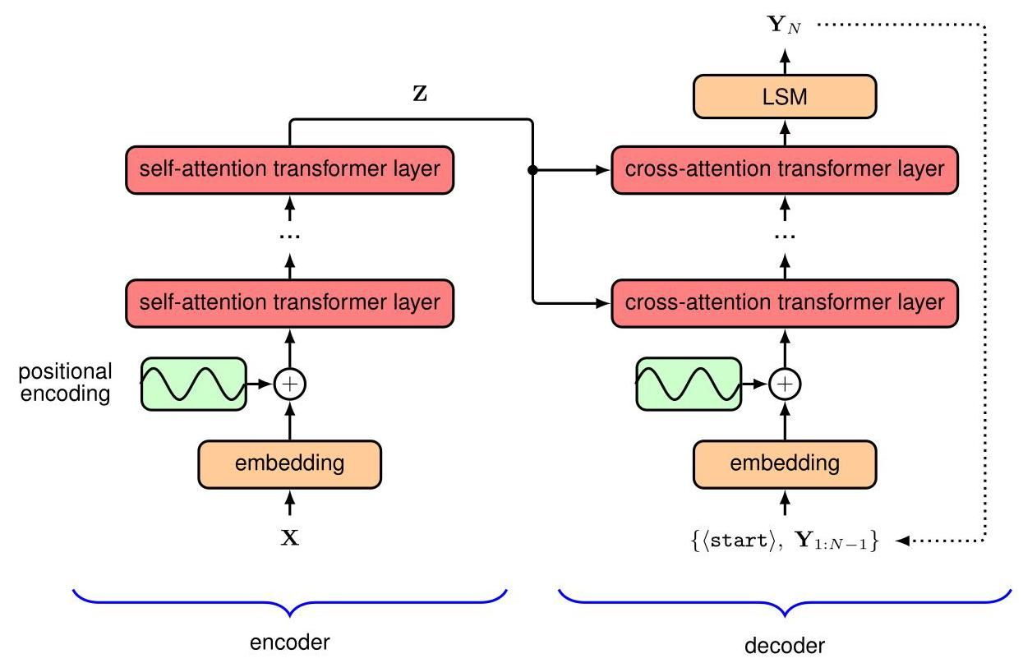

Figure 12.20 Schematic illustration of a sequence-to-sequence transformer. To keep the diagram uncluttered the input tokens are collectively shown as a single box, and likewise for the output tokens. Positional-encoding vectors are added to the input tokens for both the encoder and decoder sections. Each layer in the encoder corresponds to the structure shown in Figure 12.9, and each cross-attention layer is of the form shown in Figure 12.19.

图 12.20 序列到序列 transformer 的示意图。为使图表简洁，输入标记统一显示为一个框，输出标记同理。在编码器和解码器部分，位置编码向量会添加到输入标记中。编码器中的每一层对应图 12.9 所示的结构，每个交叉注意力层的形式如图 12.19 所示。

This use of self-supervised learning led to a paradigm shift in which a large model is first pre-trained using unlabelled data and then subsequently fine-tuned using supervised learning based on a much smaller set of labelled data. This is effectively a form of transfer learning, and the same pre-trained model can be used for multiple ’downstream’ applications. A model with broad capabilities that can be subsequently fine-tuned for specific tasks is called a foundation model (Bommasani et al., 2021).

这种自监督学习的应用引发了范式转变，即首先使用未标记数据对大型模型进行预训练，然后基于数量少得多的标记数据，使用监督学习对其进行微调。这实际上是一种迁移学习形式，同一个预训练模型可用于多个“下游”应用。具有广泛能力、可随后针对特定任务进行微调的模型称为基础模型(Bommasani 等人，2021 年)。

The fine-tuning can be done by adding extra layers to the outputs of the network or by replacing the last few layers with fresh parameters and then using the labelled data to train these final layers. During the fine-tuning stage, the weights and biases in the main model can either be left unchanged or be allowed to undergo small levels of adaptation. Typically the cost of the fine-tuning is small compared to that of pretraining.

微调可以通过在网络输出端添加额外层，或者用新参数替换最后几层，然后使用标记数据训练这些最终层来完成。在微调阶段，主模型中的权重和偏差可以保持不变，也可以进行小幅度调整。通常，微调的成本与预训练相比要小得多。

One very efficient approach to fine-tuning is called low-rank adaptation or LoRA (Hu et al., 2021). This approach is inspired by results which show that a trained over-parameterized model has a low intrinsic dimensionality with respect to fine-tuning, meaning that changes in the model parameters during fine-tuning lie on a manifold whose dimensionality is much smaller than the total number of learnable parameters in the model (Aghajanyan, Zettlemoyer, and Gupta, 2020). LoRa exploits this by freezing the weights of the original model and adding additional learnable weight matrices into each layer of the transformer in the form of low-rank products. Typically only attention-layer weights are modified, whereas MLP-layer weights are kept fixed. Consider a weight matrix having dimension , which might represent a query, key, or value matrix in which the matrices from multiple attention heads are treated together as a single matrix. We introduce a parallel set of weights defined by the product of two matrices and with dimensions and , respectively, as shown schematically in Figure 12.21. This layer then generates an output given by . The number of parameters in the additional weight matrix is compared to the parameters in the original weight matrix , and so if then the number of parameters that need to be adapted during fine-tuning is much smaller than the number in the original transformer. In practice, this can reduce the number of parameters that need to be trained by a factor of 10,000 . Once the fine-tuning is complete, the additional weights can be added to the original weight matrices to give a new weight matrix

一种非常有效的微调方法称为低秩自适应或 LoRA(Hu 等人，2021 年)。这种方法的灵感来源于一些研究结果，这些结果表明，经过训练的过参数化模型在微调方面具有较低的内在维度，这意味着在微调过程中模型参数的变化位于一个流形上，该流形的维度远小于模型中可学习参数的总数(Aghajanyan、Zettlemoyer 和 Gupta，2020 年)。LoRA 利用了这一点，它冻结原始模型的权重，并以低秩乘积的形式将额外的可学习权重矩阵添加到 transformer 的每一层中。通常只修改注意力层的权重，而多层感知机(MLP)层的权重保持不变。考虑一个维度为 的权重矩阵 ，它可能表示一个查询、键或值矩阵，其中来自多个注意力头的矩阵被视为一个单一矩阵。我们引入一组由两个矩阵 和 的乘积定义的并行权重，它们的维度分别为 和 ，如图 12.21 所示。然后，该层生成的输出由 给出。与原始权重矩阵 中的 个参数相比，额外权重矩阵 中的参数数量为 ，因此如果 ，那么在微调过程中需要调整的参数数量远小于原始 transformer 中的参数数量。实际上，这可以将需要训练的参数数量减少 10000 倍。一旦微调完成，额外的权重可以添加到原始权重矩阵中，以得到一个新的权重矩阵

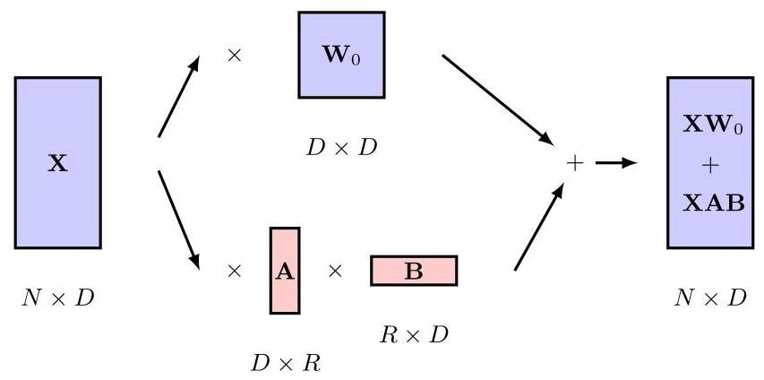

Figure 12.21 Schematic illustration low-rank adaptation showing a weight matrix from one of the attention layers in a pre-trained transformer. Additional weights given by matrices and B are adapted during fine-tuning and their product is then added to the original matrix for subsequent inference.

图 12.21 低秩自适应示意图，展示了预训练 transformer 中一个注意力层的权重矩阵 。由矩阵 和 B 给出的额外权重在微调过程中进行调整，然后将它们的乘积 添加到原始矩阵中，用于后续推理。

so that during inference there is no additional computational overhead compared to running the original model since the updated model has the same size as the original.

这样，在推理过程中，与运行原始模型相比不会有额外的计算开销，因为更新后的模型与原始模型大小相同。

As language models have become larger and more powerful, the need for fine-tuning has diminished, with generative language models now able to solve a broad range of tasks simply through text-based interaction. For example, if a text string

随着语言模型变得越来越大、越来越强大，微调的需求已经减少，如今生成式语言模型仅通过基于文本的交互就能解决广泛的任务。例如，如果给定一个文本字符串

English: the cat sat on the mat. French:

英语:The cat sat on the mat. 法语:

is given as the input sequence, an autoregressive language model can continue to generate subsequent tokens until a stop token is generated, in which the newly generated tokens represent the French translation. Note that the model was not trained specifically to do translation but has learned to do so as a result of being trained on a vast corpus of data that includes multiple languages.

作为输入序列，自回归语言模型可以继续生成后续标记，直到生成一个 停止 标记，此时新生成的标记代表法语翻译。请注意，该模型并非专门为进行翻译而训练，而是由于在包含多种语言的大量语料库上进行训练而学会了翻译。

A user can interact with such models using a natural language dialogue, making them very accessible to broad audiences. To improve the user experience and the quality of the generated outputs, techniques have been developed for fine-tuning large language models through human evaluation of generated output, using methods such as reinforcement learning through human feedback or RLHF (Christiano et al., 2017). Such techniques have helped to create large language models with impressively easy-to-use conversational interfaces, most notably the system from OpenAI called ChatGPT.

用户可以使用自然语言对话与这类模型进行交互，这使得它们易于被广大用户使用。为了改善用户体验和提高生成输出的质量，已经开发出了通过人工评估生成输出来微调大语言模型的技术，例如使用基于人类反馈的强化学习(RLHF)方法(Christiano 等人，2017 年)。这些技术有助于创建具有令人印象深刻的易用对话界面的大语言模型，其中最著名的是 OpenAI 开发的名为 ChatGPT 的系统。

The sequence of input tokens given by the user is called a prompt. For example, it might consist of the opening words of a story, which the model is required to complete. Or it might comprise a question, and the model should provide the answer. By using different prompts, the same trained neural network may be capable of solving a broad range of tasks such as generating computer code from a simple text request or writing rhyming poetry on demand. The performance of the model now depends on the form of the prompt, leading to a new field called prompt engineering (Liu et al., 2021), which aims to design a good form for a prompt that results in high-quality output for the downstream task. The behaviour of the model can also be modified by adapting the user’s prompt before feeding it into the language model by pre-pending an additional token sequence called a prefix prompt to the user prompt to modify the form of the output. For example, the pre-prompt might consist of instructions, expressed in standard English, to tell the network not to include offensive language in its output.

用户给出的输入标记序列称为提示。例如，它可能是一个故事的开头，模型需要完成这个故事。或者它可能是一个问题，模型应该给出答案。通过使用不同的提示，同一个经过训练的神经网络可能能够解决广泛的任务，例如根据简单的文本请求生成计算机代码或按需创作押韵诗歌。现在，模型的性能取决于提示的形式，这催生了一个名为提示工程的新领域(Liu 等人，2021 年)，该领域旨在为提示设计一种良好的形式，以便为下游任务生成高质量的输出。还可以通过在将用户提示输入语言模型之前对其进行调整来改变模型的行为，具体做法是在用户提示前添加一个额外的标记序列，称为前缀提示，以修改输出的形式。例如，前缀提示可能包含用标准英语表达的指令，告诉网络在其输出中不要包含冒犯性语言。

This allows the model to solve new tasks simply by providing some examples within the prompt, without needing to adapt the parameters of the model. This is an example of few-shot learning.

这使得模型只需在提示中提供一些示例，而无需调整模型的参数，就能解决新任务。这是少样本学习的一个例子。

Current state-of-the-art models such as GPT-4 have become so powerful that they are exhibiting remarkable properties which have been described as the first indications of artificial general intelligence (Bubeck et al., 2023) and are driving a new wave of technological innovation. Moreover, the capabilities of these models continue to improve at an impressive pace.

目前最先进的模型，如 GPT - 4，已经变得非常强大，它们展现出了非凡的特性，这些特性被描述为通用人工智能的初步迹象(Bubeck 等人，2023 年)，并推动了新一轮的技术创新。此外，这些模型的能力正以惊人的速度持续提升。

# 12.4. Multimodal Transformers

# 12.4. 多模态 Transformer

Although transformers were initially developed as an alternative to recurrent networks for processing sequential language data, they have become prevalent in nearly all areas of deep learning. They have proved to be general-purpose models, as they make very few assumptions about the input data, in contrast, for example, to convolutional networks, which make strong assumptions about equivariances and locality. Due to their generality, transformers have become the state-of-the-art for many different modalities, including text, image, video, point cloud, and audio data, and have been used for both discriminative and generative applications within each of these domains. The core architecture of the transformer layer has remained relatively constant, both over time and across applications. Therefore, the key innovations that enabled the use of transformers in areas other than natural language have largely focused on the representation and encoding of the inputs and outputs.

尽管 Transformer 最初是作为处理序列语言数据的循环网络的替代方案而开发的，但它们已在几乎所有深度学习领域中广泛应用。事实证明，它们是通用模型，因为与例如卷积网络相比，它们对输入数据的假设非常少，而卷积网络对等价性和局部性有很强的假设。由于其通用性，Transformer 已成为许多不同模态(包括文本、图像、视频、点云和音频数据)的最先进技术，并已用于这些领域中的判别式和生成式应用。随着时间的推移和跨应用场景，Transformer 层的核心架构相对保持不变。因此，使 Transformer 能够在自然语言之外的领域使用的关键创新主要集中在输入和输出的表示和编码上。

Chapter 10

第 10 章

One big advantage of a single architecture that is capable of processing many different kinds of data is that it makes multimodal computation relatively straightforward. In this context, multimodal refers to applications that combine two or more different types of of data, either in the inputs or outputs or both. For example, we may wish to generate an image from a text prompt or design a robot that can combine information from multiple sensors such as cameras, radar, and microphones. The important thing to note is that if we can tokenize the inputs and decode the output tokens, then it is likely that we can use a transformer.

能够处理多种不同类型数据的单一架构的一大优势在于，它使多模态计算相对简单。在这种情况下，多模态是指在输入或输出或两者中结合两种或更多不同类型数据的应用。例如，我们可能希望根据文本提示生成图像，或者设计一个能够整合来自多个传感器(如相机、雷达和麦克风)信息的机器人。需要注意的重要一点是，如果我们能够对输入进行分词并解码输出标记，那么我们很可能可以使用 Transformer。

# 12.4.1 Vision transformers

# 12.4.1 视觉 Transformer

Transformers have been applied with great success to computer vision and have achieved state-of-the-art performance on many tasks. The most common choice for discriminative tasks is a standard transformer encoder, and this approach in the vision domain is known as a vision transformer, or ViT (Dosovitskiy et al., 2020). When using a transformer, we need to decide how to convert an input image into tokens, and the simplest choice is to use each pixel as a token, following a linear projection. However, the memory required by a standard transformer implementation grows quadratically with the number of input tokens, and so this approach is generally infeasible. Instead, the most common approach to tokenization is to split the image into a set of patches of the same size. Suppose the images have dimension where and are the height and width of the image in pixels and is the number of channels (where typically for R, G, and B colours). Each image is split into non-overlapping patches of size (where is a common choice) and then ’flattened’ into a one-dimensional vector, which gives a representation where is the total number of patches for one image. The ViT architecture is shown in Figure 12.22.

Transformer 已成功应用于计算机视觉领域，并在许多任务中取得了最先进的性能。对于判别任务，最常见的选择是使用标准的 Transformer 编码器，这种在视觉领域的方法被称为视觉 Transformer，即 ViT(Dosovitskiy 等人，2020 年)。使用 Transformer 时，我们需要决定如何将输入图像转换为标记，最简单的选择是在进行线性投影后，将每个像素作为一个标记。然而，标准 Transformer 实现所需的内存会随着输入标记数量的增加而呈二次方增长，因此这种方法通常不可行。相反，最常见的标记化方法是将图像分割成一组大小相同的图像块。假设图像的维度为 ，其中 和 分别是图像的高度和宽度(以像素为单位)， 是通道数(通常对于 R、G、B 颜色， )。每个图像被分割成大小为 的不重叠图像块(通常选择 )，然后“展平”为一维向量，得到表示 ，其中 是一幅图像的图像块总数。ViT 架构如图 12.22 所示。

Another approach to tokenization is to feed the image through a small convolutional neural network (CNN). This can down-sample the image to give a manageable number of tokens each represented by one of the network outputs. For example a typical ResNet18 encoder architecture down-samples an image by a factor of 8 in both the height and width dimensions, giving 64 times fewer tokens than pixels.

另一种标记化方法是将图像输入一个小型卷积神经网络(CNN)。这可以对图像进行下采样，以得到数量可控的标记，每个标记由网络的一个输出表示。例如，典型的 ResNet18 编码器架构会在高度和宽度维度上都将图像下采样 8 倍，使得标记数量比像素数量少 64 倍。

Chapter 10

第 10 章

We also need a way to encode positional information in the tokens. It is possible to construct explicit positional embeddings that encode the two-dimensional positional information of the image patches, but in practice this does not generally improve performance, and so it is most common to just use learned positional em-beddings. In contrast to the transformers used for natural language, vision transformers generally take a fixed number of tokens as input, which avoids the problem of learned positional encodings not generalizing to inputs of a different size.

我们还需要一种方法来对标记中的位置信息进行编码。可以构建显式的位置嵌入来对图像块的二维位置信息进行编码，但实际上这通常不会提高性能，因此最常见的做法是使用学习得到的位置嵌入。与用于自然语言处理的 Transformer 不同，视觉 Transformer 通常接受固定数量的标记作为输入，这避免了学习得到的位置编码无法泛化到不同大小输入的问题。

A vision transformer has a very different architectural design compared to a CNN. Although strong inductive biases are baked into a CNN model, the only two-dimensional inductive bias in a vision transformer is due to the patches used to tokenize the input. A transformer therefore generally requires more training data than a comparable CNN as it has to learn the geometrical properties of images from scratch. However, because there are no strong assumptions about the structure of the inputs, transformers are often able to converge to a higher accuracy. This provides another illustration of the trade-off between inductive bias and the scale of the training data (Sutton, 2019).

与 CNN 相比，视觉 Transformer 的架构设计截然不同。虽然 CNN 模型中内置了强大的归纳偏置，但视觉 Transformer 中唯一的二维归纳偏置来自于用于对输入进行标记化的图像块。因此，与同等的 CNN 相比，Transformer 通常需要更多的训练数据，因为它必须从头开始学习图像的几何属性。然而，由于对输入结构没有强烈的假设，Transformer 通常能够收敛到更高的准确率。这再次说明了归纳偏置和训练数据规模之间的权衡(Sutton，2019 年)。

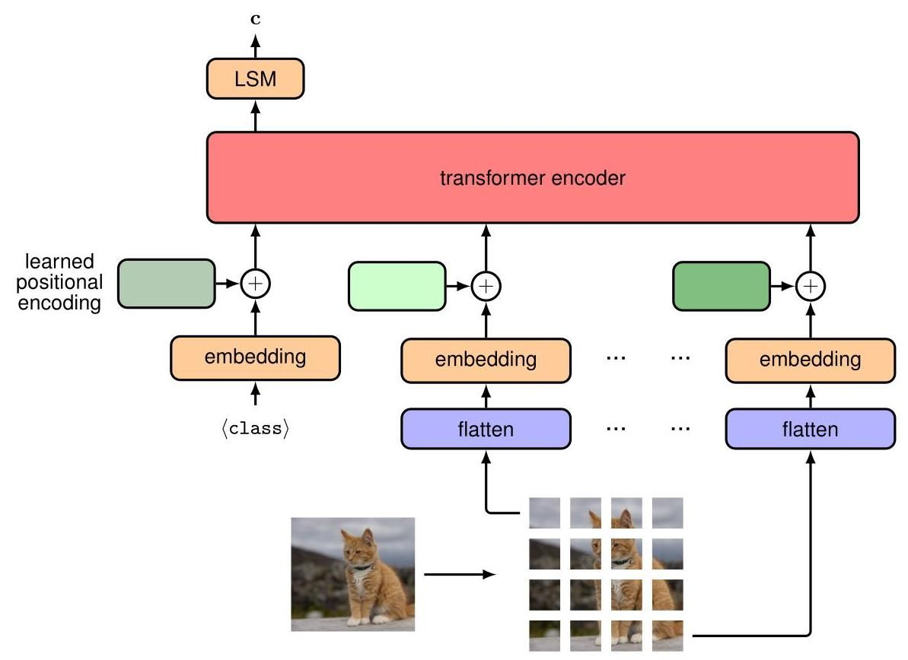

Figure 12.22 Illustration of the vision transformer architecture for a classification task. Here a learnable (class) token is included as an additional input, and the associated output is transformed by a linear layer with a softmax activation, denoted by LSM, to give the final class-vector output c.

图 12.22 分类任务中视觉 Transformer 架构的示意图。这里包含一个可学习的(类别)标记作为额外输入，相关输出通过一个带有 softmax 激活函数的线性层(用 LSM 表示)进行变换，以得到最终的类别向量输出 c。

# 12.4.2 Generative image transformers

# 12.4.2 生成式图像transformer

In the language domain, the most impressive results have come when transformers are used as an autoregressive generative model for synthesizing text. It is therefore natural to ask whether we can also use transformers to synthesize realistic images. Since natural language is inherently sequential, it fits neatly into the autoregressive framework, whereas images have no natural ordering of their pixels so that it is not as intuitive that decoding them autoregressively would be useful. However, any distribution can be decomposed into a product of conditionals, provided we first define some ordering of the variables. Thus, the joint distribution over ordered

在语言领域，当transformer被用作合成文本的自回归生成模型时，取得了最令人印象深刻的成果。因此，很自然会问我们是否也可以使用transformer来合成逼真的图像。由于自然语言本质上是顺序性的，它非常适合自回归框架，而图像的像素没有自然的顺序，因此以自回归方式解码它们是否有用并不那么直观。然而，任何分布都可以分解为条件概率的乘积，前提是我们首先定义变量的某种顺序。因此，有序变量上的联合分布

Section 11.1.2

第11.1.2节

Figure 12.23 Illustration of a raster scan that defines a specific linear ordering of the pixels in a two-dimensional image.

图12.23 定义二维图像中像素特定线性顺序的光栅扫描示意图。

|  |  |  |  |
| --- | --- | --- | --- |
|  |  |  |  |
|  |  |  |  |
|  |  |  |  |
|  |  |  |  |
|  |  |  |  |
|  |  |  |  |
|  |  |  |  |
|  |  |  |  |

variables can be written

变量 可以写成

This factorization is completely general and makes no restrictions on the form of the individual conditional distributions .

这种因式分解是完全通用的，对各个条件分布 的形式没有任何限制。

For an image we can choose to represent the th pixel as a three-dimensional vector of the RGB values. We now need to decide on an ordering for the pixels, and one widely used choice is called a raster scan as illustrated in Figure 12.23. A schematic illustration of an image being generated using an autoregressive model, based on a raster-scan ordering, is shown in Figure 12.24.

对于一幅图像，我们可以选择用 来表示第 个像素，将其表示为一个包含 RGB 值的三维向量。现在我们需要为像素确定一个顺序，一种广泛使用的选择称为光栅扫描，如图 12.23 所示。图 12.24 展示了基于光栅扫描顺序，使用自回归模型生成图像的示意图。

Note that the use of autoregressive generative models of images predates the introduction of transformers. For example, PixelCNN (Oord et al., 2016) and Pixel-RNN (Oord, Kalchbrenner, and Kavukcuoglu, 2016) used bespoke masked convolution layers that preserve the conditional independence defined for each pixel by the corresponding term on the right-hand side of 12.37.

请注意，图像自回归生成模型的使用早于变压器(transformer)的引入。例如，PixelCNN(Oord 等人，2016 年)和 Pixel - RNN(Oord、Kalchbrenner 和 Kavukcuoglu，2016 年)使用了定制的掩码卷积层，这些层保留了由式 12.37 右侧相应项为每个像素定义的条件独立性。

Representations of an image using continuous values can work well in discriminative tasks. However, much better results are obtained for image generation by using discrete representations. Continuous conditional distributions learned by maximum likelihood, such as Gaussians for which the negative log likelihood function is a sum-of-squares error function, tend to learn averages of the training data, leading to blurry images. Conversely, discrete distributions can handle multimodality with ease. For example, one of the conditional distributions in (12.37) might learn that a pixel could be either black or white, whereas a regression model might learn that the pixel should be grey.

使用连续值表示图像在判别任务中可能效果良好。然而，使用离散表示进行图像生成可获得更好的结果。通过最大似然法学习的连续条件分布，例如负对数似然函数为平方和误差函数的高斯分布，往往会学习训练数据的平均值，从而导致生成模糊的图像。相反，离散分布可以轻松处理多模态情况。例如，式(12.37)中的某个条件分布 可能会学习到一个像素可以是黑色或白色，而回归模型可能会学习到该像素应该是灰色。

Section 4.2

第 4.2 节

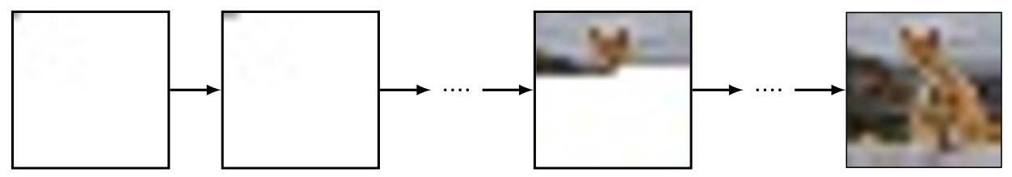

Figure 12.24 An illustration of how an image can be sampled from an autoregressive model. The first pixel is sampled from the marginal distribution , the second pixel from the conditional distribution , and so on in raster scan order until we have a complete image.

图 12.24 展示了如何从自回归模型中采样图像。第一个像素从边缘分布 中采样，第二个像素从条件分布 中采样，依光栅扫描顺序依次进行，直到得到完整的图像。

However, working with discrete spaces also brings its challenges. The R, G, and B values of image pixels are typically represented with at least 8 bits of precision, so that each pixel has possible values. Learning a conditional softmax distribution over a such a high-dimensional space is infeasible.

然而，处理离散空间也带来了挑战。图像像素的 R、G 和 B 值通常用至少 8 位精度表示，因此每个像素有 种可能的值。在如此高维的空间中学习条件 softmax 分布是不可行的。

One way to address the problem of the high dimensionality is to use the technique of vector quantization, which can be viewed as a form of data compression. Suppose we have a set of data vectors each of dimensionality , which might, for example, represent image pixels, and we then introduce a set of codebook vectors also of dimensionality , where typically . We now approximate each data vector by its nearest codebook vector according to some similarity metric, usually Euclidean distance, so that

解决高维问题的一种方法是使用向量量化技术，这可以看作是一种数据压缩形式。假设我们有一组数据向量 ，每个向量的维度为 ，例如，这些向量可能表示图像像素，然后我们引入一组 个码本向量 ，其维度同样为 ，通常 。现在，我们根据某种相似性度量(通常是欧几里得距离)，用每个数据向量最近的码本向量来近似它，即

Section 15.1.1

第 15.1.1 节

Since there are codebook vectors, we can represent each by a one-hot encoded -dimensional vector, and since we can choose the value of , we can control the trade-off between more accurate representation of the data, by using a larger value of , or greater compression, by using a smaller value of .

由于有 个码本向量，我们可以用一个独热编码的 维向量来表示每个 ，并且由于我们可以选择 的值，我们可以通过使用较大的 值来更精确地表示数据，或者通过使用较小的 值来实现更大程度的压缩，从而控制两者之间的权衡。

We can therefore take the original image pixels and map them into the lower-dimensional codebook space. An autoregressive transformer can then be trained to generate a sequence of codebook vectors, and this sequence can be mapped back into the original image space by replacing each codebook index with the corresponding -dimensional codebook vector .

因此，我们可以将原始图像像素映射到低维码本空间。然后可以训练一个自回归变压器来生成一系列码本向量，并且可以通过将每个码本索引 替换为相应的 维码本向量 ，将这个序列映射回原始图像空间。

Autoregressive transformers were first applied to images in ImageGPT (Chen, Radford, et al., 2020). Here each pixel is treated as one of a discrete set of three-dimensional colour codebook vectors, each corresponding to a cluster in a -means clustering of the colour space. A one-hot encoding therefore gives discrete tokens, analogous to language tokens, and allows the transformer to be trained in the same way as language models, with a next-token classification objective. This is a powerful objective for representation learning for subsequent fine-tuning, again in a similar way to language modelling.

自回归变压器模型首次被应用于图像领域是在 ImageGPT 中(Chen、Radford 等人，2020 年)。在这里，每个像素被视为一组离散的三维颜色码本向量之一，每个向量对应于颜色空间的 -均值聚类中的一个簇。因此，独热编码可以得到离散的标记，类似于语言标记，并允许以与语言模型相同的方式训练变压器模型，目标是进行下一个标记的分类。这是一个强大的目标，用于后续微调的表征学习，同样类似于语言建模。

Section 15.1

第 15.1 节

Section 6.3.3

第 6.3.3 节

Using the individual pixels as tokens directly, however, can lead to high computational cost since a forward pass is required per pixel, which means that both training and inference scale poorly with image resolution. Also, using individual pixels as inputs means that low-resolution images have to be used to give a reasonable context length when decoding the pixels later in the raster scan. As we saw with the ViT model, it is preferable to use patches of the image as tokens instead of pixels, as this can result in dramatically fewer tokens and therefore facilitates working with higher-resolution images. As before, we need to work with a discrete space of token values due to the potential multimodality of the conditional distributions. Again, this raises the challenge of dimensionality, which is now much more severe with patches than with individual pixels since the dimensionality is exponential with respect to the number of pixels in the patch. For example, even with just two possible pixel tokens, representing black and white, and patches of size , we would have a dictionary of patch tokens of size .

然而，直接将单个像素用作标记可能会导致较高的计算成本，因为每个像素都需要进行一次前向传播，这意味着训练和推理的效率会随着图像分辨率的提高而显著降低。此外，使用单个像素作为输入意味着在后续光栅扫描中解码像素时，必须使用低分辨率图像才能获得合理的上下文长度。正如我们在 ViT 模型中所看到的，最好使用图像块而不是像素作为标记，因为这样可以显著减少标记的数量，从而便于处理更高分辨率的图像。和之前一样，由于条件分布可能具有多模态性，我们需要处理标记值的离散空间。这再次带来了维度挑战，由于图像块的维度相对于块内像素数量呈指数增长，因此使用图像块时的维度挑战比使用单个像素时要严重得多。例如，即使只有两种可能的像素标记(代表黑色和白色)，以及大小为 的图像块，我们也会有一个大小为 的图像块标记字典。

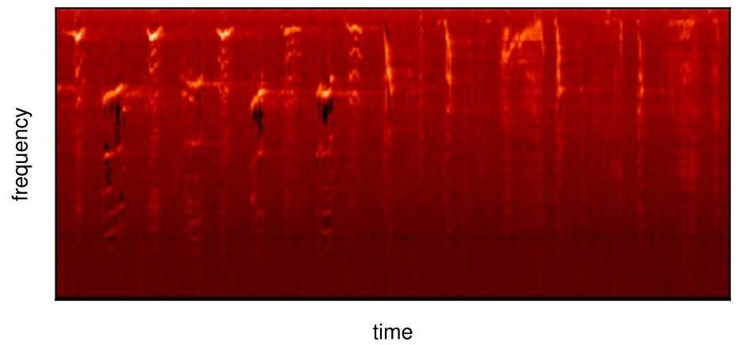

Figure 12.25 An example mel spectrogram of a humpback whale song. [Source data copyright ©2013- 2023, librosa development team.]

图 12.25 座头鲸歌声的梅尔频谱图示例。[源数据版权 ©2013 - 2023，librosa 开发团队。]

Once again we turn to vector quantization to address the challenge of dimensionality. The codebook vectors can be learned from a data set of image patches using simple clustering algorithms such as -means or with more sophisticated methods such as fully convolutional networks (Oord, Vinyals, and Kavukcuoglu, 2017; Esser, Rombach, and Ommer, 2020) or even vision transformers (Yu et al., 2021). One problem with learning to map each patch to a discrete set of codes and back again, is that vector quantization is a non-differentiable operation. Fortunately we can use a technique called straight-through gradient estimation (Bengio, Léonard, and Courville, 2013), which is a simple approximation that just copies the gradients through the non-differentiable function during backpropagation.

我们再次借助向量量化来应对维度挑战。可以使用简单的聚类算法(如 -均值算法)，或者更复杂的方法(如全卷积网络(Oord、Vinyals 和 Kavukcuoglu，2017 年；Esser、Rombach 和 Ommer，2020 年)，甚至视觉变压器模型(Yu 等人，2021 年))，从图像块数据集中学习码本向量。学习将每个图像块映射到一组离散代码并再映射回来存在一个问题，即向量量化是一种不可微操作。幸运的是，我们可以使用一种称为直通梯度估计的技术(Bengio、Léonard 和 Courville，2013 年)，这是一种简单的近似方法，在反向传播过程中直接将梯度复制通过不可微函数。

The use of autoregressive transformers to generate images can be extended to videos by treating a video as one long sequence of these vector-quantized tokens (Rakhimov et al., 2020; Yan et al., 2021; Hu et al., 2023).

通过将视频视为这些向量量化标记的一个长序列，自回归变压器在图像生成中的应用可以扩展到视频领域(Rakhimov 等人，2020 年；Yan 等人，2021 年；Hu 等人，2023 年)。

# 12.4.3 Audio data

# 12.4.3 音频数据

We next look at the application of transformers to audio data. Sound is generally stored as a waveform obtained by measuring the amplitude of the air pressure at regular time intervals. Although this waveform could be used directly as input to a deep learning model, in practice it is more effective to pre-process it into a mel spectrogram. This is a matrix whose columns represent time steps and whose rows correspond to frequencies. The frequency bands follow a standard convention that was chosen through subjective assessment to give equal perceptual differences between successive frequencies (the word ’mel’ comes from melody). An example of a mel spectrogram is shown in Figure 12.25.

接下来，我们将探讨变压器在音频数据方面的应用。声音通常以波形的形式存储，该波形是通过在规则的时间间隔测量气压振幅而获得的。虽然这种波形可以直接用作深度学习模型的输入，但在实践中，将其预处理成梅尔频谱图会更有效。这是一个矩阵，其列代表时间步长，而行对应于频率。频带遵循一种标准约定，该约定是通过主观评估选择的，以使连续频率之间具有相等的感知差异(“梅尔”一词来自旋律)。图 12.25 展示了一个梅尔频谱图的示例。

One application for transformers in the audio domain is classification in which segments of audio are assigned to one of a number of predefined categories. For example, the AudioSet data set (Gemmeke et al., 2017) is a widely used benchmark. It contains classes such as ’car’, ’animal’, and ’laughter’. Until the development of the transformer, the state-of-the-art approach for audio classification was based on mel spectrograms treated as images and used as the input to a convolutional neural network (CNN). However, although a CNN is good at understanding local relationships, one drawback is that it struggles with longer-range dependencies, which can be important in processing audio.

变压器在音频领域的一个应用是分类，即将音频片段分配到多个预定义类别中的某一个。例如，AudioSet 数据集(Gemmeke 等人，2017 年)是一个广泛使用的基准数据集。它包含诸如“汽车”、“动物”和“笑声”等类别。在变压器出现之前，音频分类的最先进方法是基于将梅尔频谱图视为图像，并将其用作卷积神经网络(CNN)的输入。然而，尽管 CNN 擅长理解局部关系，但它的一个缺点是难以处理长距离依赖关系，而这在音频处理中可能很重要。

Chapter 10

第 10 章

Just as transformers replaced RNNs as the state-of-the-art in natural language processing, they have also come to replace CNNs for tasks such as audio classification. For example, a transformer encoder model of identical structure to that used for both language and vision, as shown in Figure 12.18, can be used to predict the class of audio inputs (Gong, Chung, and Glass, 2021). Here the mel spectrogram is viewed as an image which is then tokenized. This is done by splitting the image into patches in a similar way to vision transformers, possibly with some overlap so as not to lose any important neighbourhood relations. Each patch is then flattened, meaning it is converted to a one-dimensional array, in this case of length 256 . A unique positional encoding is then added to each token, a specific ⟨class⟩ token is appended, and the tokens are then fed through the transformer encoder. The output token corresponding to the \class \input token from the last transformer layer can then be decoded using a linear layer followed by a softmax activation function, and the whole model can be trained end-to-end using a cross-entropy loss.

正如变压器在自然语言处理领域取代了循环神经网络(RNN)成为最先进的技术一样，它们也开始在音频分类等任务中取代卷积神经网络(CNN)。例如，如图 12.18 所示，一种与用于语言和视觉的结构相同的变压器编码器模型可用于预测音频输入的类别(Gong、Chung 和 Glass，2021 年)。在这里，梅尔频谱图被视为一幅图像，然后进行标记化处理。这是通过将图像分割成小块来完成的，类似于视觉变压器的做法，可能会有一些重叠，以免丢失任何重要的邻域关系。然后将每个小块展平，即将其转换为一维数组，在这种情况下长度为 256。接着为每个标记添加唯一的位置编码，附加一个特定的⟨类别⟩标记，然后将这些标记输入变压器编码器。最后一个变压器层中对应于 \类别 \输入标记的输出标记可以通过一个线性层，然后使用 softmax 激活函数进行解码，整个模型可以使用交叉熵损失进行端到端训练。

# 12.4.4 Text-to-speech

# 12.4.4 文本转语音

Classification is not the only task that deep learning, and more specifically the transformer architecture, has revolutionized in the audio domain. The success of transformers at synthesizing speech that imitates the voice of a given speaker is another demonstration of their versatility, and their application to this task is an informative case study in how to apply transformers in a new context.

分类并非深度学习，尤其是变压器(transformer)架构，在音频领域引发变革的唯一任务。变压器架构在合成模仿给定说话者声音的语音方面取得的成功，是其多功能性的又一体现，将其应用于这一任务是一个关于如何在新环境中应用变压器架构的有价值的案例研究。

Generating speech corresponding to a given passage of text is known as text-to-speech synthesis. A more traditional approach would be to collect recordings of speech from a given speaker and train a supervised regression model to predict the speech output, possibly in the form of a mel spectrogram, from corresponding transcribed text. During inference, the text for which we would like to synthesize speech is presented as input and the resulting mel spectrogram output can then be decoded back to an audio waveform since this is a fixed mapping.

生成与给定文本段落相对应的语音被称为文本转语音合成。一种更传统的方法是收集给定说话者的语音录音，并训练一个有监督的回归模型，以根据相应的转录文本预测语音输出，可能以梅尔频谱图的形式呈现。在推理过程中，我们想要合成语音的文本作为输入，由于这是一种固定映射，得到的梅尔频谱图输出随后可以解码回音频波形。

This approach has a few major drawbacks, however. First, if we predict speech at a low level, for example using sub-word components known as phonemes, a larger context is needed to make the resulting sentences sound fluid. However, if we predict longer segments, then the space of possible inputs grows significantly, and an infeasible amount of training data might be required to achieve good generalization. Second, this approach does not transfer knowledge across speakers, and so a lot of data will be required for each new speaker. Finally, the problem is really a generative modelling task, as there are multiple correct speech outputs for a given speaker and text pair, so regression may not be suitable since it tends to average over target values.

然而，这种方法存在一些主要缺点。首先，如果我们在较低层次上预测语音，例如使用被称为音素的子词成分，则需要更大的上下文才能使生成的句子听起来流畅。但是，如果我们预测更长的片段，那么可能的输入空间会显著增大，并且可能需要大量的训练数据才能实现良好的泛化。其次，这种方法无法在不同说话者之间传递知识，因此每个新说话者都需要大量的数据。最后，这个问题实际上是一个生成式建模任务，因为对于给定的说话者和文本对，存在多个正确的语音输出，所以回归可能不太合适，因为它倾向于对目标值进行平均。

Section 4.2

4.2 节

If instead we treat audio data in the same way as natural language and frame text-to-speech as a conditional language modelling task, then we should be able to train the model in much the same way as with text-based large language models. There are two main implementation details that need to be addressed. The first is how to tokenize the training data and decode the predictions, and the second is how to condition the model on the speaker’s voice.

相反，如果我们以处理自然语言的相同方式处理音频数据，并将文本转语音视为一个条件语言建模任务，那么我们应该能够以与基于文本的大型语言模型大致相同的方式训练模型。有两个主要的实现细节需要解决。第一个是如何对训练数据进行分词并解码预测结果，第二个是如何根据说话者的声音对模型进行条件设置。

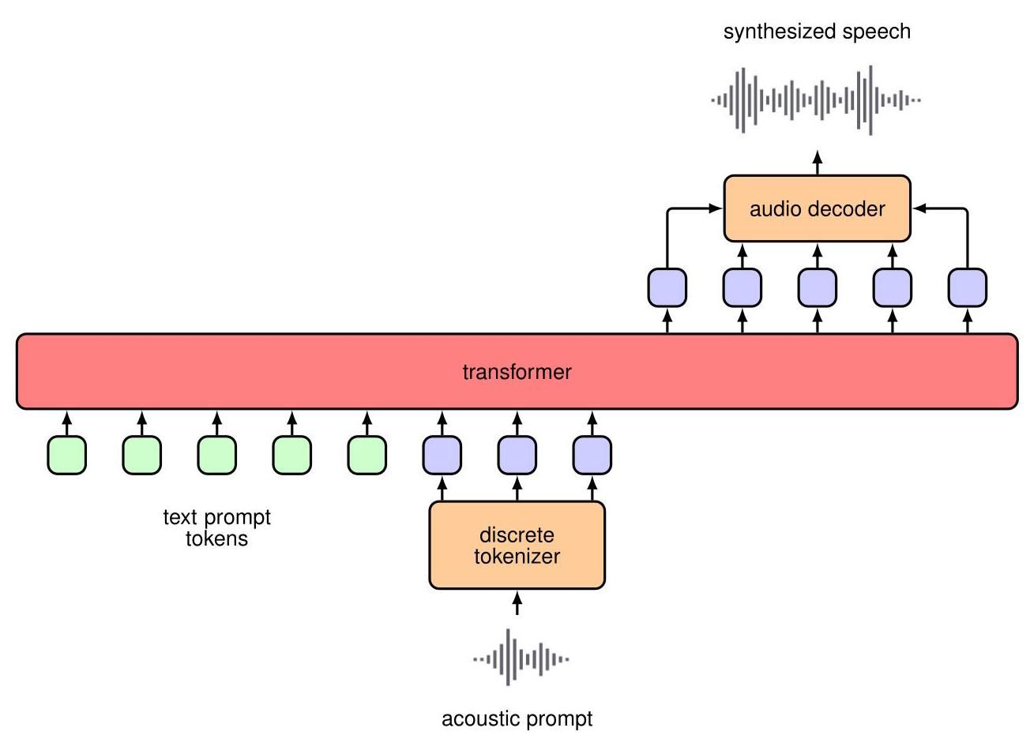

Figure 12.26 A diagram showing the high-level architecture of Vall-E. The input to the transformer model consists of standard text tokens, which prompt the model as to what words the synthesized speech should contain, together with acoustic prompt tokens that determine the speaker style and tone information. The sampled model output tokens are decoded back to speech with the learned decoder. For simplicity, the positional encodings and linear projections are not shown.

图 12.26 展示了 Vall - E 高层架构的示意图。变压器模型的输入包括标准文本标记，这些标记提示模型合成语音应包含哪些单词，以及声学提示标记，这些标记决定了说话者的风格和语调信息。采样得到的模型输出标记通过学习到的解码器解码回语音。为简单起见，位置编码和线性投影未显示。

One approach to text-to-speech synthesis that makes use of transformers and language modelling techniques is Vall-E (Wang et al., 2023). New text can be mapped into speech in the voice of a new speaker using only a few seconds of sample speech from that person. Speech data is converted into a sequence of discrete tokens from a learned dictionary or codebook obtained using vector quantization, and we can think of these tokens as analogous to the one-hot encoded tokens from the natural language domain. The input consists of text tokens from a passage of text whereas the target outputs for training consist of the corresponding speech tokens. Additional speech tokens from a short segment of unrelated speech from the same speaker are appended to the input text tokens, as illustrated in Figure 12.26. By including examples from many different speakers, the system can learn to read out a passage of text while imitating the voice represented by the additional speech input tokens. Once trained the system can be presented with new text, along with audio tokens from a brief segment of speech captured from a new speaker, and the resulting output tokens can be decoded, using the same codebook used during training, to create a speech waveform. This allows the system to synthesize speech corresponding to the input text in the voice of the new speaker.

一种利用变压器和语言建模技术进行文本到语音合成的方法是 Vall - E(Wang 等人，2023)。仅使用某人几秒钟的样本语音，就可以将新文本以该说话者的声音映射为语音。语音数据被转换为一系列离散标记，这些标记来自通过向量量化获得的学习字典或码本，我们可以将这些标记类比为自然语言领域中的独热编码标记。输入由一段文本中的文本标记组成，而训练的目标输出则由相应的语音标记组成。如图 12.26 所示，来自同一说话者的一段不相关语音的额外语音标记会附加到输入文本标记上。通过包含许多不同说话者的示例，系统可以学会在模仿额外语音输入标记所代表的声音的同时朗读一段文本。一旦训练完成，就可以向系统提供新文本以及从新说话者那里获取的一小段语音的音频标记，然后可以使用训练期间使用的同一码本对生成的输出标记进行解码，以创建语音波形。这使得系统能够以新说话者的声音合成与输入文本相对应的语音。

Section 12.4.2

第 12.4.2 节

# 12.4.5 Vision and language transformers

# 12.4.5 视觉与语言变压器

We have seen how to generate discrete tokens for text, audio, and images, and so it is a natural next step to ask if we can train a model with input tokens of one modality and output tokens of another, or whether we can have a combination of different modalities for either inputs or outputs or both. We will focus on the combination of text and vision data as this is the most widely studied example, but in principle the approaches discussed here could be applied to other combinations of input and output modalities.

我们已经了解了如何为文本、音频和图像生成离散标记，因此很自然地会问，我们是否可以用一种模态的输入标记训练模型并输出另一种模态的标记，或者是否可以在输入、输出或两者中结合不同的模态。我们将重点关注文本和视觉数据的结合，因为这是研究最广泛的示例，但原则上，这里讨论的方法可以应用于其他输入和输出模态的组合。

The first requirement is that we have a large data set for training. The LAION- 400M data set (Schuhmann et al., 2021) has greatly accelerated research in text-to-image generation and image-to-text captioning in much the same way that ImageNet was critical in the development of deep image classification models. Text-to-image generation is actually much like the unconditional image generation we have looked at so far, except that we also allow the model to take as input the text information to condition the generation process. This is straightforward when using transformers as we can simply provide the text tokens as additional input when decoding each image token.

第一个要求是我们有一个用于训练的大型数据集。LAION - 400M 数据集(Schuhmann 等人，2021)极大地加速了文本到图像生成和图像到文本字幕的研究，就像 ImageNet 在深度图像分类模型的发展中起到关键作用一样。文本到图像生成实际上与我们目前所研究的无条件图像生成非常相似，只是我们还允许模型将文本信息作为输入来对生成过程进行条件约束。在使用变压器时，这很简单，因为我们在解码每个图像标记时只需将文本标记作为额外输入提供即可。

This approach can also be viewed as treating the text-to-image problem as a sequence-to-sequence language modelling problem, such as machine translation, except that the target tokens are discrete image tokens rather than language tokens. It therefore makes sense to choose a full encoder-decoder transformer model, as shown in Figure 12.20, in which corresponds to the input text tokens and corresponds to the output image tokens. This is the approach taken in a model called Parti (Yu et al., 2022) in which the transformer is scaled to 20 billion parameters while showing consistent performance improvements with increasing model size.

这种方法也可以被视为将文本到图像的问题当作一个序列到序列的语言建模问题，比如机器翻译，只不过目标标记是离散的图像标记而非语言标记。因此，选择一个完整的编码器 - 解码器变压器模型是合理的，如图 12.20 所示，其中 对应输入的文本标记， 对应输出的图像标记。这是一个名为 Parti(Yu 等人，2022)的模型所采用的方法，在该模型中，变压器模型的参数规模扩展到了 200 亿，并且随着模型规模的增大，性能持续提升。

A lot of research has also been done on using pre-trained language models, and modifying or fine-tuning them so that they can also accept visual data as input (Alayrac et al., 2022; Li et al., 2022). These approaches largely use bespoke architectures, along with continuous-valued image tokens, and therefore are not natural fits for also generating visual data. Moreover, they cannot be used directly if we wish to include new modalities such as audio tokens. Although this is a step towards multimodality, we would ideally like to use both text and image tokens as both input and output. The simplest approach is to treat everything as a sequence of tokens as if this were natural language but with a dictionary that is the concatenation of a language token dictionary and the image token codebook. We can then treat any stream of audio and visual data as simply a sequence of tokens.

在使用预训练语言模型并对其进行修改或微调，使其也能接受视觉数据作为输入方面也开展了大量研究(Alayrac 等人，2022；Li 等人，2022)。这些方法大多使用定制架构以及连续值图像标记，因此并不适合用于生成视觉数据。此外，如果我们希望纳入新的模态，如音频标记，它们不能直接使用。尽管这是迈向多模态的一步，但我们理想情况下希望同时使用文本和图像标记作为输入和输出。最简单的方法是将所有内容都视为一个标记序列，就好像这是自然语言一样，但使用的字典是语言标记字典和图像标记码本的拼接。然后我们可以将任何音频和视觉数据流简单地视为一个标记序列。

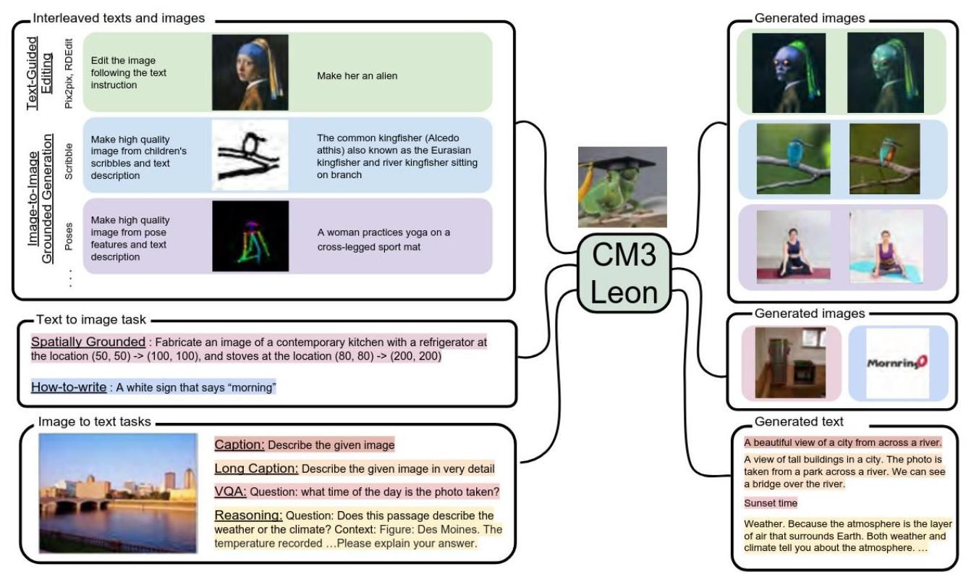

Figure 12.27 Examples of the CM3Leon model performing a variety of different tasks in the joint space of text and images. [From (Yu et al., 2023) with permission.]

图 12.27 CM3Leon 模型在文本和图像联合空间中执行各种不同任务的示例。[经许可摘自(Yu 等人，2023)。]

In CM3 (Aghajanyan et al., 2022) and CM3Leon (Yu et al., 2023), a variation of language modelling is used to train on HTML documents containing both image and text data taken from online sources. When this large quantity of training data was combined with a scalable architecture, the models became very powerful. Moreover, the multimodal nature of the training means that the models are very flexible. Such models are capable of completing many tasks that otherwise might require task-specific model architectures and training regimes, such as text-to-image generation, image-to-text captioning, image editing, text completion, and many more, including anything a regular language model is capable of. Examples of the CM3Leon model completing instances of a few different tasks are shown in Figure 12.27. Exercises

在 CM3(Aghajanyan 等人，2022)和 CM3Leon(Yu 等人，2023)中，采用了一种语言建模的变体，对包含从在线来源获取的图像和文本数据的 HTML 文档进行训练。当大量的训练数据与可扩展的架构相结合时，这些模型变得非常强大。此外，训练的多模态性质意味着这些模型非常灵活。这样的模型能够完成许多原本可能需要特定任务模型架构和训练机制的任务，如文本到图像生成、图像到文本字幕生成、图像编辑、文本补全等等，包括常规语言模型能够完成的任何任务。图 12.27 展示了 CM3Leon 模型完成几个不同任务实例的示例。练习

12.1 Consider a set of coefficients , for , with the properties that

12.1 考虑一组系数 ，其中 ，具有以下性质

By using a Lagrange multiplier show that the coefficients must also satisfy

通过使用拉格朗日乘数法证明这些系数还必须满足

Appendix C

附录 C

12.2 (*) Verify that the softmax function (12.5) satisfies the constraints (12.3) and (12.4) for any values of the vectors .

12.2 (*) 验证对于向量 的任意值，softmax 函数 (12.5) 满足约束条件 (12.3) 和 (12.4)。

12.3 ( ) Consider the input vectors in the simple transformation defined by (12.2), in which the weighting coefficients are defined by (12.5). Show that if all the input vectors are orthogonal, so that for , then the output vectors will simply be equal to the input vectors so that for .

12.3 ( ) 考虑由 (12.2) 定义的简单变换中的输入向量 ，其中加权系数 由 (12.5) 定义。证明如果所有输入向量都是正交的，即对于 有 ，那么输出向量将简单地等于输入向量，即对于 有 。

12.4 (*) Consider two independent random vectors and each of dimension and each being drawn from a Gaussian distribution with zero mean and unit variance . Show that the expected value of is given by .

12.4 (*) 考虑两个独立的随机向量 和 ，每个向量的维度为 ，并且每个向量都从均值为零、方差为 1 的高斯分布 中抽取。证明 的期望值由 给出。

12.5 Show that multi-head attention defined by (12.19) can be rewritten in the form

12.5 证明由 (12.19) 定义的多头注意力可以重写为以下形式

where is given by (12.15) and we have defined

其中 由 (12.15) 给出，并且我们定义了

Here we have partitioned the matrix horizontally into sub-matrices denoted each of dimension , corresponding to the vertical segments of the concatenated attention matrix. Since is typically smaller than , for example is a common choice, this combined matrix is rank deficient. Therefore, using a fully flexible matrix to replace would not be equivalent to the original formulation given in the text.

在这里，我们将矩阵 按行划分为子矩阵，记为 ，每个子矩阵的维度为 ，对应于拼接注意力矩阵的垂直段。由于 通常小于 ，例如 是常见的选择，因此这个组合矩阵是秩亏的。因此，使用一个完全灵活的矩阵来替换 并不等同于文本中给出的原始公式。

Figure 12.7

图 12.7

12.6 Express the self-attention function (12.14) as a fully connected network in the form of a matrix that maps the full input sequence of concatenated word vectors into an output vector of the same dimension. Note that such a matrix would have parameters. Show that the self-attention network corresponds to a sparse version of this matrix with parameter sharing. Draw a sketch showing the structure of this matrix, indicating which blocks of parameters are shared and which blocks have all elements equal to zero.

12.6 将自注意力函数 (12.14) 表示为一个全连接网络，形式为一个矩阵，该矩阵将拼接词向量的完整输入序列映射到相同维度的输出向量。请注意，这样的矩阵将有 个参数。证明自注意力网络对应于这个矩阵的一个具有参数共享的稀疏版本。绘制一个草图，展示这个矩阵的结构，指出哪些参数块是共享的，哪些参数块的所有元素都等于零。

12.7 (*) Show that if we omit the positional encoding of input vectors then the outputs of a multi-head attention layer defined by (12.19) are equivariant with respect to a reordering of the input sequence.

12.7 (*) 证明如果我们省略输入向量的位置编码，那么由 (12.19) 定义的多头注意力层的输出对于输入序列的重新排序是等变的。

12.8 Consider two -dimensional unit vectors and , satisfying and , drawn from a random distribution. Assume that the distribution is symmetrical around the origin, i.e., it depends only on the distance from the origin and not the direction. Show that for large values of the magnitude of the cosine of the angle between these vectors is close to zero and hence that these random vectors are nearly orthogonal in a high-dimensional space. To do this, consider an orthonormal basis set where and express and as expansions in this basis.

12.8 考虑两个 维单位向量 和 ，满足 和 ，它们来自一个随机分布。假设该分布关于原点对称，即它只取决于到原点的距离，而不取决于方向。证明对于较大的 值，这些向量之间夹角的余弦值接近零，因此这些随机向量在高维空间中几乎是正交的。为此，考虑一个正交基集 ，其中 ，并将 和 表示为在这个基下的展开式。

12.9 Consider a position encoding in which the input token vector is concatenated with a position-encoding vector e. Show that when this concatenated vector undergoes a general linear transformation by multiplication using a matrix, the result can be expressed as the sum of a linearly transformed input and a linearly transformed position vector.

12.9 考虑一种位置编码，其中输入令牌向量 与位置编码向量 e 拼接。证明当这个拼接向量通过与一个矩阵相乘进行一般线性变换时，结果可以表示为线性变换后的输入和线性变换后的位置向量之和。

12.10 Show that the positional encoding defined by (12.25) has the property that, for a fixed offset , the encoding at position can be represented as a linear combination of the encoding at position with coefficients that depend only on and not on . To do this make use of the following trigonometric identities:

12.10 证明由式 (12.25) 定义的位置编码具有如下性质:对于固定的偏移量 ，位置 处的编码可以表示为位置 处编码的线性组合，且组合系数仅依赖于 ，而不依赖于 。为此，请利用以下三角恒等式:

Show that if the encoding is based purely on sine functions, without cosine functions, then this property no longer holds.

证明如果编码仅基于正弦函数，而不包含余弦函数，那么该性质将不再成立。

12.11 (★) Consider the bag-of-words model (12.28) in which each of the component distributions is given by a general probability table that is shared across all words. Show that the maximum likelihood solution, given a training set of vectors, is given by a table whose entries are the fractions of times each word occurs in the training set.

12.11 (★) 考虑词袋模型 (12.28)，其中每个分量分布 由一个通用概率表给出，且该概率表在所有单词上共享。证明给定一个向量训练集，最大似然解由一个表格给出，该表格的每个条目是训练集中每个单词出现的频率。

12.12 Consider the autoregressive language model given by (12.31) and suppose that the terms on the right-hand side are represented by general probability tables. Show that the number of entries in these tables grows exponentially with the value of .

12.12 考虑由式 (12.31) 给出的自回归语言模型，并假设右侧的项 由通用概率表表示。证明这些表格中的条目数量随 的值呈指数增长。

12.13 (*) When using -grams it is usual to train the -gram and -gram models at the same time and then compute the conditional probability using the product rule of probability in the form

12.13 (*) 在使用 -元语法时，通常会同时训练 -元语法模型和 -元语法模型，然后使用如下形式的概率乘积规则来计算条件概率:

Explain why this is more convenient than storing the left-hand-side directly, and show that to obtain the correct probabilities the final token from each sequence must be omitted when evaluating .

解释为什么这比直接存储左侧的概率更方便，并证明为了得到正确的概率，在评估 时必须省略每个序列的最后一个标记。

12.14 Write down pseudo-code for the inference process in a trained RNN with an architecture of the form depicted in Figure 12.13.

12.14 为具有图 12.13 所示架构的训练好的循环神经网络(RNN)的推理过程编写伪代码。

12.15 Consider a sequence of two tokens and each of which can take the states or . The table below shows the joint probability distribution :

12.15 考虑由两个标记 和 组成的序列，每个标记可以取状态 或 。下表显示了联合概率分布 :

|  |  |  |
| --- | --- | --- |
|  |  |  |
|  | 0.0 | 0.4 |
|  | 0.1 | 0.25 |
|  |  |  |
|  | 0.0 | 0.4 |
|  | 0.1 | 0.25 |

We see that the most probable sequence is and that this has probability 0.4 . Using the sum and product rules of probability, write down the values of the marginal distribution and the conditional distribution . Show that if we first maximize to give a value and then subsequently maximize then we obtain a sequence that is different from the overall most probable sequence. Find the probability of the sequence.

我们看到最可能的序列是 ，其概率为 0.4。利用概率的求和与乘积规则，写出边缘分布 和条件分布 的值。证明如果我们先对 求最大值得到值 ，然后再对 求最大值，那么我们得到的序列与整体最可能的序列不同。求出该序列的概率。

12.16 The BERT-Large model (Devlin et al.,2018) has a maximum input length of 512 tokens, each of dimensionality and taken from a vocabulary of 30,000 . It has 24 transformer layers each with 16 self-attention heads with 64, and the MLP position-wise networks have two layers with 4,096 hidden nodes. Show that the total number of parameters in the BERT encoder transformer language model is approximately 340 million.

12.16 BERT - Large 模型(Devlin 等人，2018 年)的最大输入长度为 512 个词元，每个词元的维度为 ，且取自包含 30,000 个词的词汇表。它有 24 个 transformer 层，每层有 16 个自注意力头， 为 64，多层感知机(MLP)逐位置网络有两层，包含 4,096 个隐藏节点。证明 BERT 编码器 transformer 语言模型中的参数总数约为 3.4 亿。

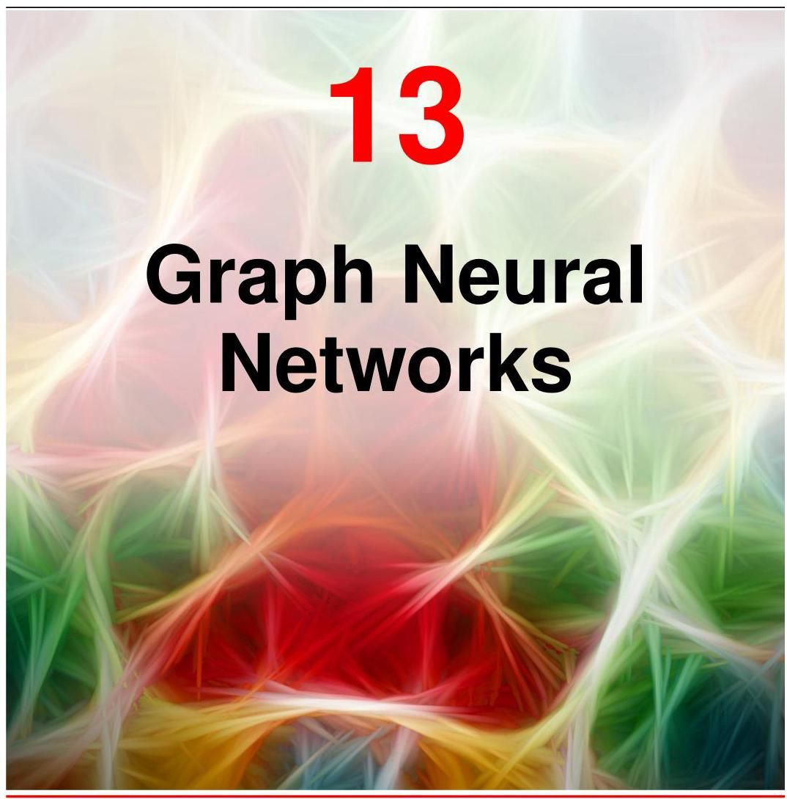

In previous chapters we have encountered structured data in the form of sequences and images, corresponding to one-dimensional and two-dimensional arrays of variables respectively. More generally, there are many types of structured data that are best described by a graph as illustrated in Figure 13.1. In general a graph consists of a set of objects, known as nodes, connected by edges. Both the nodes and the edges can have data associated with them. For example, in a molecule the nodes and edges are associated with discrete variables corresponding to the types of atom (carbon, nitrogen, hydrogen, etc.) and the types of bonds (single bond, double bond, etc.). For a rail network, each railway line might be associated with a continuous variable given by the average journey time between two cities. Here we are assuming that the edges are symmetrical, for example that the journey time from London to Cambridge is the same as the journey time from Cambridge to London. Such edges are depicted by undirected links between the nodes. For the worldwide web the edges are directed since if there is a hyperlink on page A that points to page B there is not necessarily a hyperlink on page B pointing back to page A.

在前面的章节中，我们遇到了以序列和图像形式存在的结构化数据，它们分别对应一维和二维的变量数组。更一般地，有许多类型的结构化数据最好用图来描述，如图 13.1 所示。一般来说，图由一组称为节点的对象组成，这些节点通过边相互连接。节点和边都可以关联数据。例如，在一个分子中，节点和边与离散变量相关联，这些变量对应于原子类型(碳、氮、氢等)和键的类型(单键、双键等)。对于铁路网络，每条铁路线可能与一个连续变量相关联，该变量由两个城市之间的平均旅行时间给出。这里我们假设边是对称的，例如从伦敦到剑桥的旅行时间与从剑桥到伦敦的旅行时间相同。这种边用节点之间的无向链接表示。对于万维网，边是有向的，因为如果页面 A 上有一个指向页面 B 的超链接，页面 B 上不一定有一个指向页面 A 的超链接。

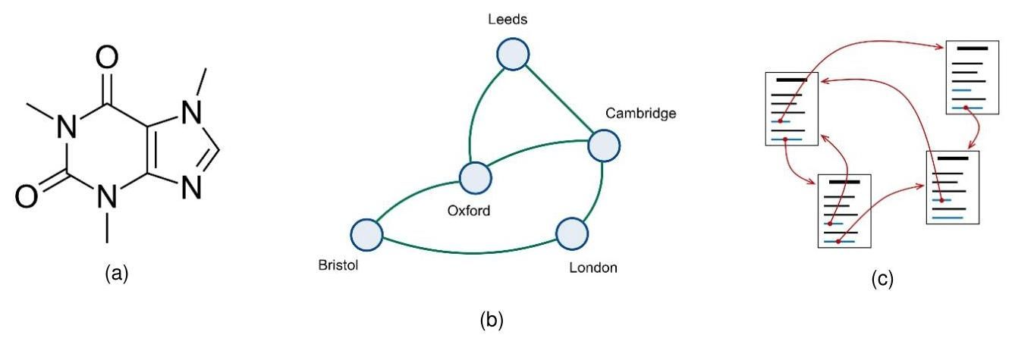

Figure 13.1 Three examples of graph-structured data: (a) the caffeine molecule consisting of atoms connected by chemical bonds, (b) a rail network consisting of cities connected by railway lines, and (c) the worldwide web consisting of pages connected by hyperlinks.

图 13.1 图结构数据的三个示例:(a) 由化学键连接的原子组成的咖啡因分子，(b) 由铁路线连接的城市组成的铁路网络，以及 (c) 由超链接连接的页面组成的万维网。

Other examples of graph-structured data include a protein interaction network, in which the nodes are proteins and the edges express how strongly pairs of proteins interact, an electrical circuit where the nodes are components and the edges are conductors, or a social network where the nodes are people and the edges are ’friendships’. More complex graphical structures are also possible, for example the knowledge graph inside a company comprises multiple different kinds of nodes such as people, documents, and meetings, along with multiple kinds of edges capturing different properties such as a person being present at a meeting or a document referencing another document.

图结构数据的其他示例包括蛋白质相互作用网络，其中节点是蛋白质，边表示蛋白质对之间的相互作用强度；电路，其中节点是组件，边是导体；或者社交网络，其中节点是人，边是“友谊”。更复杂的图形结构也是可能的，例如公司内部的知识图谱包含多种不同类型的节点，如人、文档和会议，以及多种类型的边，用于捕捉不同的属性，如某人出席会议或一个文档引用另一个文档。

In this chapter we explore how to apply deep learning to graph-structured data. We have already encountered an example of structured data when we discussed images, in which the individual elements of an image data vector correspond to pixels on a regular grid. An image is therefore a special instance of graph-structured data in which the nodes are the pixels and the edges describe which pixels are adjacent. Convolutional neural networks (CNNs) take this structure into account, incorporating prior knowledge of the relative positions of the pixels, together with the equiv-ariance of properties such as segmentation and the invariance of properties such as classification. We will use CNNs for images as a source of inspiration to construct more general approaches to deep learning for graphical data known as graph neural networks (Zhou et al., 2018; Wu et al., 2019; Hamilton, 2020; Veličković, 2023). We will see that a key consideration when applying deep learning to graph-structured data is to ensure either equivariance or invariance with respect to a reordering of the nodes in the graph.

在本章中，我们将探讨如何将深度学习应用于图结构数据。在讨论图像时，我们已经遇到了一个结构化数据的例子，其中图像数据向量 的各个元素对应于规则网格上的像素。因此，图像是图结构数据的一个特殊实例，其中节点是像素，边描述哪些像素相邻。卷积神经网络(CNNs)考虑了这种结构，结合了像素相对位置的先验知识，以及诸如分割等属性的等变性和诸如分类等属性的不变性。我们将以用于图像的 CNN 为灵感来源，构建更通用的用于图形数据的深度学习方法，即图神经网络(Zhou 等人，2018 年；Wu 等人，2019 年；Hamilton，2020 年；Veličković，2023 年)。我们将看到，将深度学习应用于图结构数据时的一个关键考虑因素是确保相对于图中节点的重新排序具有等变性或不变性。

Chapter 10

第 10 章

# 13.1. Machine Learning on Graphs

# 13.1. 图上的机器学习

There are many kinds of applications that we might wish to address using graph-structured data, and we can group these broadly according to whether the goal is to predict properties of nodes, of edges, or of the whole graph. An example of node prediction would be to classify documents according to their topic based on the hyperlinks and citations between the documents.

我们可能希望使用图结构数据来解决许多类型的应用问题，并且可以根据目标是预测节点、边还是整个图的属性，大致对这些应用进行分类。节点预测的一个例子是根据文档之间的超链接和引用，按照主题对文档进行分类。

Regarding edges we might, for example, know some of the interactions in a protein network and would like to predict the presence of any additional ones. Such tasks are called edge prediction or graph completion tasks. There are also tasks where the edges are known in advance and the goal is to discover clusters or ’communities’ within the graph.

对于边，例如，我们可能知道蛋白质网络中的一些相互作用，并希望预测是否存在其他相互作用。此类任务称为边预测或图补全任务。还有一些任务，其中边是预先已知的，目标是发现图中的聚类或“社区”。

Finally, we may wish to predict properties that relate to the graph as a whole. For example, we might wish to predict whether a particular molecule is soluble in water. Here instead of being given a single graph we will have a data set of different graphs, which we can view as being drawn from some common distribution, in other words we assume that the graphs themselves are independent and identically distributed. Such tasks can be considered as graph regression or graph classification tasks.

最后，我们可能希望预测与整个图相关的属性。例如，我们可能希望预测特定分子是否可溶于水。这里，我们得到的不是单个图，而是不同图的数据集，我们可以将其视为从某个共同分布中抽取的，换句话说，我们假设这些图本身是独立同分布的。此类任务可以被视为图回归或图分类任务。

For the molecule solubility classification example, we might be given a labelled training set of molecules, along with a test set of new molecules whose solubility needs to be predicted. This is a standard example of an inductive task of the kind we have seen many times in previous chapters. However, some graph prediction examples are transductive in which we are given the structure of the entire graph along with labels for some of the nodes and the goal is to predict the labels of the remaining nodes. An example would be a large social network in which our goal is to classify each node as either a real person or an automated bot. Here a small number of nodes might be manually labelled, but it would be prohibitive to investigate every node individually in a large and ever-changing social network. During training, we therefore have access to the whole graph along with labels for a subset of the nodes, and we wish to predict the labels for the remaining nodes. This can be viewed as a form of semi-supervised learning.

对于分子溶解性分类示例，我们可能会得到一个标记好的分子训练集，以及一个需要预测溶解性的新分子测试集。这是我们在前面章节中多次看到的归纳式任务的一个标准示例。然而，一些图预测示例是直推式的，在这种情况下，我们会得到整个图的结构以及部分节点的标签，目标是预测其余节点的标签。一个例子是大型社交网络，我们的目标是将每个节点分类为真实的人或自动化机器人。在这里，可能会手动标记少量节点，但在一个庞大且不断变化的社交网络中逐个调查每个节点是不现实的。因此，在训练过程中，我们可以访问整个图以及部分节点的标签，并希望预测其余节点的标签。这可以被视为一种半监督学习形式。

As well as solving prediction tasks directly, we can also use deep learning on graphs to discover useful internal representations that can subsequently facilitate a range of downstream tasks. This is known as graph representation learning. For example we could seek to build a foundation model for molecules by training a deep learning system on a large corpus of molecular structures. The goal is that once trained, such a foundation model can be fine-tuned to specific tasks by using a small, labelled data set.

除了直接解决预测任务外，我们还可以在图上使用深度学习来发现有用的内部表示，这些表示随后可以促进一系列下游任务。这被称为图表示学习。例如，我们可以通过在大量分子结构语料库上训练深度学习系统来构建分子的基础模型。目标是，一旦训练完成，就可以使用小的标记数据集对这样的基础模型进行微调以适应特定任务。

Graph neural networks define an embedding vector for each of the nodes, usually initialized with the observed node properties, which are then transformed through a series of learnable layers to create a learned representation. This is analogous to the way word embeddings, or tokens, are processed through a series of layers in the transformer to give a representation that better captures the meaning of the words in the context of the rest of the text. Graph neural networks can also use learned embeddings associated with the edges and with the graph as a whole.

图神经网络为每个节点定义一个嵌入向量，通常用观察到的节点属性进行初始化，然后通过一系列可学习的层进行变换，以创建一个学习到的表示。这类似于词嵌入或标记在transformer中通过一系列层进行处理，以得到一个能更好地捕捉文本其余部分上下文中单词含义的表示。图神经网络还可以使用与边以及整个图相关联的学习到的嵌入。

Chapter 12

第12章

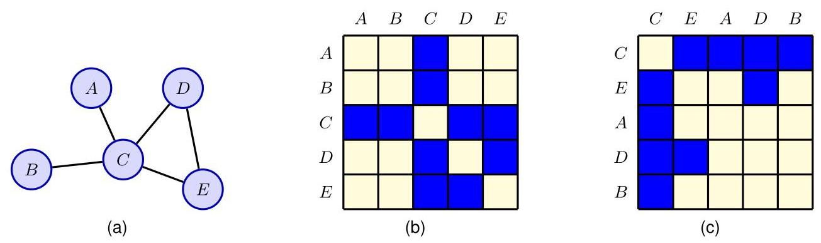

Figure 13.2 An example of an adjacency matrix showing (a) an example of a graph with five nodes, (b) the associated adjacency matrix for a particular choice of node order, and (c) the adjacency matrix corresponding to a different choice for the node order.

图13.2 邻接矩阵的一个示例，展示了 (a) 一个具有五个节点的图的示例，(b) 针对特定节点顺序选择的相关邻接矩阵，以及 (c) 对应于不同节点顺序选择的邻接矩阵。

# 13.1.1 Graph properties

# 13.1.1 图的属性

In this chapter we will focus on simple graphs where there is at most one edge between any pair of nodes, where the edges are undirected, and where there are no self-edges that connect a node to itself. This suffices to introduce the key concepts of graph neural networks, and it also encompasses a wide range of practical applications. These concepts can then be applied to more complex graphical structures.

在本章中，我们将重点关注简单图，其中任意一对节点之间最多有一条边，边是无向的，并且不存在将节点连接到自身的自环边。这足以引入图神经网络的关键概念，并且它还涵盖了广泛的实际应用。然后，这些概念可以应用于更复杂的图形结构。

We begin by introducing some notation associated with graphs and by defining some important properties. A graph consists of a set of nodes or vertices, denoted by , along with a set of edges or links, denoted by . We index the nodes by , and we write the edge from node to node as . If two nodes are linked by an edge they are called neighbours, and the set of all neighbours of node is denoted by .

我们首先介绍一些与图相关的符号，并定义一些重要的属性。图 由一组节点或顶点(用 表示)以及一组边或链接(用 表示)组成。我们用 对节点进行索引，并将从节点 到节点 的边记为 。如果两个节点由一条边相连，则称它们为邻居，节点 的所有邻居的集合用 表示。

In addition to the graph structure, we usually also have observed data associated with the nodes. For each node we can represent the corresponding node variables as a -dimensional column vector and we can group these into a data matrix of dimensionality in which row is given by . There may also be data variables associated with the edges in the graph, although to start with we will focus just on node variables.

除了图结构之外，我们通常还拥有与节点相关的观测数据。对于每个节点 ，我们可以将相应的节点变量表示为一个 维列向量 ，并将这些向量组合成一个维度为 的数据矩阵 ，其中第 行由 给出。图中的边也可能存在相关的数据变量，不过一开始我们将只关注节点变量。

Section 13.3.2

第 13.3.2 节

# 13.1.2 Adjacency matrix

# 13.1.2 邻接矩阵

A convenient way to specify the edges in a graph is to use an adjacency matrix denoted by . To define the adjacency matrix we first have to choose an ordering for the nodes. If there are nodes in the graph, we can index them using . The adjacency matrix has dimensions and contains a 1 in every location for which there is an edge going from node to node , with all other entries being 0 . For graphs with undirected edges, the adjacency matrix will be symmetric since the presence of an edge from node to node implies that there is also an edge from node to node , and therefore for all and . An example of an adjacency matrix is shown in Figure 13.2.

指定图中边的一种便捷方法是使用用 表示的邻接矩阵。为了定义邻接矩阵，我们首先必须为节点选择一个顺序。如果图中有 个节点，我们可以用 对它们进行索引。邻接矩阵的维度为 ，对于从节点 到节点 存在边的每个位置 ，矩阵中该位置的值为 1，其他所有元素的值为 0。对于具有无向边的图，邻接矩阵将是对称的，因为从节点 到节点 存在边意味着从节点 到节点 也存在边，因此对于所有的 和 有 。图 13.2 展示了一个邻接矩阵的示例。

Since the adjacency matrix defines the structure of a graph, we could consider using it directly as the input to a neural network. To do this we could ’flatten’ the matrix, for example by concatenating the columns into one long column vector. However, a major problem with this approach is that the adjacency matrix depends on the arbitrary choice of node ordering, as seen in Figure 13.2. Suppose for instance that we want to predict the solubility of a molecule. This clearly should not depend on the ordering assigned to the nodes when writing down an adjacency matrix. Because the number of permutations increases factorially with the number of nodes, it is impractical to try to learn permutation invariance by using large data sets or by data augmentation. Instead, we should treat this invariance property as an inductive bias when constructing a network architecture.

由于邻接矩阵定义了图的结构，我们可以考虑直接将其用作神经网络的输入。为此，我们可以将矩阵“展平”，例如将各列连接成一个长列向量。然而，这种方法的一个主要问题是邻接矩阵依赖于节点顺序的任意选择，如图 13.2 所示。例如，假设我们要预测一个分子的溶解度。显然，这不应依赖于在写下邻接矩阵时为节点分配的顺序。由于排列的数量随节点数量呈阶乘增长，试图通过使用大型数据集或数据增强来学习排列不变性是不切实际的。相反，我们应该在构建网络架构时将这种不变性属性视为一种归纳偏置。

# 13.1.3 Permutation equivariance

# 13.1.3 排列等变性

We can express node label permutation mathematically by introducing the concept of a permutation matrix , which has the same size as the adjacency matrix and which specifies a particular permutation of a node ordering. It contains a single 1 in each row and a single 1 in each column, with 0 in all the other elements, such that a 1 in position indicates that node will be relabelled as node after the permutation. Consider, for example, the permutation from corresponding to the two choices of node ordering in Figure 13.2. The corresponding permutation matrix takes the form

我们可以通过引入排列矩阵 的概念来数学地表达节点标签排列，该矩阵与邻接矩阵大小相同，并指定了节点排序的特定排列。它的每一行和每一列都只有一个 1，其他所有元素均为 0，使得位置 处的 1 表示节点 在排列后将被重新标记为节点 。例如，考虑对应于图 13.2 中两种节点排序选择的从 到 的排列。相应的排列矩阵形式如下

Exercise 13.1

练习 13.1

We can define the permutation matrix more formally as follows. First we introduce the standard unit vector , for . This is a column vector in which all elements are 0 except element , which equals 1 . In this notation the

我们可以更正式地将排列矩阵定义如下。首先，对于 ，我们引入标准单位向量 。这是一个列向量，除了元素 等于 1 之外，所有元素均为 0。用这种符号表示

identity matrix is given by

单位矩阵由下式给出

We can now introduce a permutation function that maps to . The associated permutation matrix is given by

现在我们可以引入一个排列函数 ，它将 映射到 。相关的排列矩阵由下式给出

When we reorder the labelling on the nodes of a graph, the effect on the corresponding node data matrix is to permute the rows according to , which can be achieved by pre-multiplication by to give

当我们对图的节点标签进行重新排序时，对相应的节点数据矩阵 的影响是根据 对行进行置换，这可以通过左乘 来实现，得到

Exercise 13.4

练习 13.4

For the adjacency matrix, both the rows and the columns become permuted. Again the rows can be permuted using pre-multiplication by whereas the columns are permuted using post-multiplication by , giving a new adjacency matrix:

对于邻接矩阵，行和列都会被置换。同样，行可以通过左乘 进行置换，而列可以通过右乘 进行置换，得到一个新的邻接矩阵:

Exercise 13.5

练习 13.5

When applying deep learning to graph-structured data, we will need to represent the graph structure in numerical form so that it can be fed into a neural network, which requires that we assign an ordering to the nodes. However, the specific ordering we choose is arbitrary and so it will be important to ensure that any global property of the graph does not depend on this ordering. In other words, the network predictions must be invariant to node label reordering, so that

当将深度学习应用于图结构数据时，我们需要以数值形式表示图结构，以便将其输入到神经网络中，这就要求我们为节点分配一个顺序。然而，我们选择的具体顺序是任意的，因此确保图的任何全局属性不依赖于这个顺序非常重要。换句话说，网络预测必须对节点标签重新排序保持不变，以便

where is the output of the network.

其中 是网络的输出。

We may also want to make predictions that relate to individual nodes. In this case, if we reorder the node labelling then the corresponding predictions should show the same reordering so that a given prediction is always associated with the same node irrespective of the choice of order. In other words, node predictions should be equivariant with respect to node label reordering. This can be expressed as

我们可能还希望做出与单个节点相关的预测。在这种情况下，如果我们对节点标签进行重新排序，那么相应的预测结果也应呈现相同的重新排序，这样无论选择何种顺序，给定的预测结果始终与同一个节点相关联。换句话说，节点预测应该相对于节点标签的重新排序具有等变性。这可以表示为

where is a vector of network outputs, with one element per node.

其中 是网络输出的向量，每个节点对应一个元素。

# 13.2. Neural Message-Passing

# 13.2. 神经消息传递

Ensuring invariance or equivariance under node label permutations is a key design consideration when we apply deep neural networks to graph-structured data. Another consideration is that we want to exploit the representational capabilities of deep neural networks and so we retain the concept of a ’layer’ as a computational transformation that can be applied repeatedly. If each layer of the network is equivariant under node reordering then multiple layers applied in succession will also exhibit equivariance, while allowing each layer of the network to be informed by the graph structure.

当我们将深度神经网络应用于图结构数据时，确保在节点标签排列下的不变性或等变性是关键的设计考量。另一个考量是，我们希望利用深度神经网络的表示能力，因此我们保留“层”的概念，将其作为一种可以重复应用的计算变换。如果网络的每一层在节点重新排序下都具有等变性，那么连续应用的多层也将表现出等变性，同时允许网络的每一层都能利用图结构的信息。

For networks whose outputs represent node-level predictions, the whole network will be equivariant as required. If the network is being used to predict a graph-level property then a final layer can be included that is invariant to permutations of its inputs. We also want to ensure that each layer is a highly flexible nonlinear function and is differentiable with respect to its parameters so that it can be trained by stochastic gradient descent using gradients obtained by automatic differentiation.

对于输出表示节点级预测的网络，整个网络将按要求具有等变性。如果网络用于预测图级属性，那么可以包含一个对其输入排列不变的最终层。我们还希望确保每一层都是高度灵活的非线性函数，并且相对于其参数是可微的，这样就可以使用通过自动微分获得的梯度，通过随机梯度下降对其进行训练。

Graphs come in various sizes. For example different molecules can have different numbers of atoms, so a fixed-length representation as used for standard neural networks is unsuitable. A further requirement is therefore that the network should be

图有各种不同的规模。例如，不同的分子可能具有不同数量的原子，因此标准神经网络所使用的固定长度表示是不合适的。因此，网络的另一个要求是

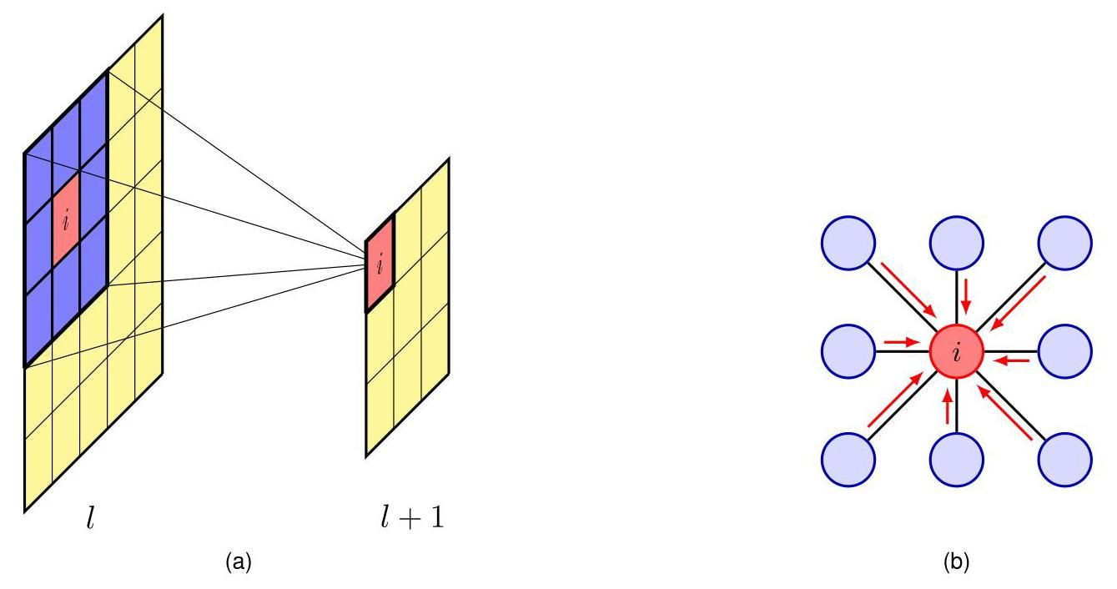

Figure 13.3 A convolutional filter for images can be represented as a graph-structured computation. (a) A filter computed by node in layer of a deep convolutional network is a function of the activation values in layer over a local patch of pixels. (b) The same computation structure expressed as a graph showing ‘messages’ flowing into node from its neighbours.

图 13.3 图像的卷积滤波器可以表示为图结构的计算。(a) 深度卷积网络第 层中节点 计算的滤波器是第 层中局部像素块上激活值的函数。(b) 相同的计算结构表示为一个图，显示“消息”从其邻居流入节点 。

Chapter 12 able to handle variable-length inputs, as we saw with transformer networks. Some graphs can be very large, for example a social network with many millions of participants, and so we also want to construct models that scale well. Not surprisingly, parameter sharing will play an important role, both to allow the invariance and equivariance properties to be built into the network architecture but also to facilitate scaling to large graphs.

第 12 章 正如我们在 transformer 网络中看到的，能够处理可变长度的输入。有些图可能非常大，例如拥有数百万参与者的社交网络，因此我们还希望构建能够良好扩展的模型。毫不奇怪，参数共享将发挥重要作用，既可以将不变性和等变性属性构建到网络架构中，也有助于扩展到大型图。

# 13.2.1 Convolutional filters

# 13.2.1 卷积滤波器

To develop a framework that meets all of these requirements, we can seek inspiration from image processing using convolutional neural networks. First note that an image can be viewed as a specific instance of graph-structured data, in which the nodes are the pixels and the edges represent pairs of pixels that are adjacent in the image, where adjacency includes nodes that are diagonally adjacent as well as those that are horizontally or vertically adjacent.

为了开发一个满足所有这些要求的框架，我们可以从使用卷积神经网络的图像处理中获取灵感。首先要注意的是，图像可以被视为图结构数据的一个特定实例，其中节点是像素，边表示图像中相邻的像素对，这里的相邻包括对角相邻以及水平或垂直相邻的节点。

Chapter 10

第 10 章

In a convolutional network, we make successive transformations of the image domain such that a pixel at a particular layer computes a function of states of pixels in the previous layer through a local function called a filter. Consider a convolutional layer using filters, as illustrated in Figure 13.3(a). The computation performed

在卷积网络中，我们对图像域进行连续变换，使得特定层的一个像素通过一个称为滤波器的局部函数计算前一层像素状态的函数。考虑一个使用 个滤波器的卷积层，如图 13.3(a) 所示。所执行的计算

Section 10.2

第10.2节

by a single filter at a single pixel in layer can be expressed as

在层 中单个像素处由单个滤波器进行的操作可以表示为

where is a differentiable nonlinear activation function such as ReLU, and the sum over is taken over all nine pixels in a small patch in layer . The same function is applied across multiple patches in the image, so that the weights and bias are shared across the patches (and therefore do not carry the index ).

其中 是一个可微的非线性激活函数，如 ReLU，并且对 的求和是在层 中一个小邻域的所有九个像素上进行的。相同的函数应用于图像中的多个邻域，因此权重 和偏置 在这些邻域中是共享的(因此不带有索引 )。

As it stands,(13.8) is not equivariant under reordering of the nodes in layer because the weight vector, with elements , is not invariant under permutation of its elements. However, we can achieve equivariance with some simple modifications as follows. We first view the filter as a graph, as shown in Figure 13.3(b), and separate out the contribution from node . The other eight 8 nodes are its neighbours . We then assume that a single weight parameter is shared across the neighbours so that

就目前而言，(13.8) 在层 中节点重新排序时不具有等变性，因为权重向量(其元素为 )在其元素的排列下不是不变的。然而，我们可以通过以下一些简单的修改来实现等变性。我们首先将滤波器视为一个图，如图 13.3(b) 所示，并分离出节点 的贡献。其他八个节点是其邻居 。然后我们假设单个权重参数 在邻居节点之间是共享的，使得

where node has its own weight parameter .

其中节点 有其自己的权重参数 。

We can interpret (13.9) as updating a local representation at node by gathering information from the neighbouring nodes by passing messages from the neighbouring nodes into node . In this case the messages are simply the activations of the other nodes. These messages are then combined with information from node , and the result is transformed using a nonlinear function. The information from the neighbouring nodes is aggregated through a simple summation in (13.9), and this is clearly invariant to any permutation of the labels associated with those nodes. Furthermore, the operation (13.9) is applied synchronously to every node in a graph, and so if the nodes are permuted then the resulting computations will be unchanged but their ordering will be likewise permuted, and hence, this calculation is equivariant under node reordering. Note that this depends on the parameters , and being shared across all nodes.

我们可以将 (13.9) 解释为通过将来自相邻节点的消息传递到节点 来收集相邻节点的信息，从而更新节点 处的局部表示 。在这种情况下，消息仅仅是其他节点的激活值。然后将这些消息与来自节点 的信息相结合，并使用非线性函数对结果进行变换。在 (13.9) 中，来自相邻节点的信息通过简单求和进行聚合，显然这对于与这些节点相关联的标签的任何排列都是不变的。此外，操作 (13.9) 同步应用于图中的每个节点，因此如果节点被重新排列，那么得到的计算结果将保持不变，但它们的顺序也会同样被重新排列，因此，这种计算在节点重新排序时具有等变性。请注意，这取决于参数 和 在所有节点之间是共享的。

# 13.2.2 Graph convolutional networks

# 13.2.2 图卷积网络

We now use the convolution example as a template to construct deep neural networks for graph-structured data. Our goal is to define a flexible, nonlinear transformation of the node embeddings that is differentiable with respect to a set of weight and bias parameters and which maps the variables in layer into corresponding variables in layer . For each node in the graph and for each layer in the network, we introduce a -dimensional column vector of node-embedding variables, where and .

现在，我们以卷积示例为模板，为图结构数据构建深度神经网络。我们的目标是定义节点嵌入的灵活非线性变换，该变换相对于一组权重和偏置参数是可微的，并将层 中的变量映射到层 中的相应变量。对于图中的每个节点 和网络中的每个层 ，我们引入节点嵌入变量的 维列向量 ，其中 且 。

We see that the transformation given by (13.9) first gathers and combines information from neighbouring nodes and then updates the node as a function of the

我们看到，由式 (13.9) 给出的变换首先收集并组合来自相邻节点的信息，然后根据这些信息更新节点

Algorithm 13.1: Simple message-passing neural network

算法 13.1:简单消息传递神经网络

Input: Undirected graph

输入:无向图

Initial node embeddings

初始节点嵌入

Aggregate function

聚合 函数

Update function

更新 函数

Output: Final node embeddings

输出:最终节点嵌入

// Iterative message-passing

for do

Aggregate

Update

end for

return

current embedding of the node and the incoming messages. We can therefore view each layer of processing as having two successive stages. The first is the aggregation stage in which, for each node , messages are passed to that node from its neighbours and combined to form a new vector in a way that is permutation invariant. This is followed by an update step in which the aggregated information from neighbouring nodes is combined with local information from the node itself and used to calculate a revised embedding vector for that node.

节点的当前嵌入和传入消息。因此，我们可以将每一层处理视为有两个连续的阶段。第一个是聚合阶段，在这个阶段中，对于每个节点 ，消息从其邻居节点传递到该节点，并以一种排列不变的方式组合成一个新的向量 。接下来是更新步骤，在这个步骤中，来自相邻节点的聚合信息与该节点自身的局部信息相结合，并用于计算该节点的修正嵌入向量。

Consider a specific node in the graph. We first aggregate the node vectors from all the neighbours of node :

考虑图中的一个特定节点 。我们首先聚合节点 所有邻居节点的节点向量:

The form of this aggregation function is very flexible if it is well defined for a variable number of neighbouring nodes and does not depend on the ordering of those nodes. It can potentially contain learnable parameters as long as it is a differentiable function with respect to those parameters to facilitate gradient descent training.

如果这个聚合函数对于可变数量的相邻节点有明确定义，并且不依赖于这些节点的顺序，那么它的形式是非常灵活的。只要它是关于这些参数的可微函数，以便于进行梯度下降训练，它就可能包含可学习的参数。

We then use another operation to update the embedding vector at node :

然后，我们使用另一个操作来更新节点 处的嵌入向量:

Again, this can be a differentiable function of a set of learnable parameters. Application of the Aggregate operation followed by the Update operation in parallel for every node in the graph represents one layer of the network. The node embeddings are typically initialized using observed node data so that . Note that each layer generally has its own independent parameters, although the parameters can also be shared across layers. This framework is called a message-passing neural network (Gilmer et al., 2017) and is summarized in Algorithm 13.1.

同样，这可以是一组可学习参数的可微函数。对图中的每个节点并行应用聚合操作，然后再应用更新操作，这代表网络的一层。节点嵌入通常使用观测到的节点数据进行初始化，使得 。请注意，尽管参数也可以在各层之间共享，但每层通常都有其独立的参数。这个框架被称为消息传递神经网络(Gilmer 等人，2017)，总结在算法 13.1 中。

# 13.2.3 Aggregation operators

# 13.2.3 聚合算子

There are many possible forms for the Aggregate function, but it must depend only on the set of inputs and not on their ordering. It must also be a differentiable function of any learnable parameters. The simplest such aggregation function, following from (13.9), is summation:

聚合函数有许多可能的形式，但它必须仅依赖于输入集，而不依赖于它们的顺序。它还必须是任何可学习参数的可微函数。根据式(13.9)，最简单的此类聚合函数是求和:

A simple summation is clearly independent of the ordering of the neighbouring nodes and is also well defined no matter how many nodes are in the neighbourhood set. Note that this has no learnable parameters.

简单的求和显然与相邻节点的顺序无关，并且无论邻域集中有多少节点，它都是明确定义的。请注意，这没有可学习的参数。

A summation gives a stronger influence over nodes that have many neighbours compared to those with few neighbours, and this can lead to numerical issues, particularly in applications such as social networks where the size of the neighbourhood set can vary by several orders of magnitude. A variation of this approach is to define the Aggregation operation to be the average of the neighbouring embedding vectors so that

与邻居较少的节点相比，求和对邻居较多的节点有更强的影响，这可能会导致数值问题，特别是在社交网络等应用中，邻域集的大小可能会相差几个数量级。这种方法的一种变体是将聚合操作定义为相邻嵌入向量的平均值，使得

where denotes the number of nodes in the neighbourhood set . However, this normalization also discards information about the network structure and is provably less powerful than a simple summation (Hamilton, 2020), and so the choice of whether to use it depends on the relative importance of node features compared to graph structure.

其中 表示邻域集 中的节点数量。然而，这种归一化方法也会丢弃有关网络结构的信息，并且经证明其能力不如简单求和(Hamilton，2020)，因此是否使用它取决于节点特征相对于图结构的相对重要性。

Another variation of this approach (Kipf and Welling, 2016) takes account of the number of neighbours for each of the neighbouring nodes:

这种方法的另一种变体(Kipf 和 Welling，2016)考虑了每个相邻节点的邻居数量:

Yet another possibility is to take the element-wise maximum (or minimum) of the neighbouring embedding vectors, which also satisfies the desired properties of being well defined for a variable number of neighbours and of being independent of their order.

另一种可能性是取相邻嵌入向量的逐元素最大值(或最小值)，这也满足对于可变数量的邻居有明确定义且与它们的顺序无关的期望属性。

Since each node in a given layer of the network is updated by aggregating information from its neighbours in the previous layer, this defines a receptive field analogous to the receptive fields of filters used in CNNs. As information is processed through successive layers, the updates to a given node depend on a steadily increasing fraction of other nodes in earlier layers until the effective receptive field potentially spans the whole graph as illustrated in Figure 13.4. However, large, sparse graphs may require an excessive number of layers before each output is influenced by every input. Some architectures therefore introduce an additional ’super-node’ that connects directly to every node in the original graph to ensure fast propagation of information.

由于网络给定层中的每个节点都是通过聚合上一层中其邻居的信息来更新的，这就定义了一个类似于卷积神经网络(CNN)中使用的滤波器的感受野。随着信息在连续的层中进行处理，对给定节点的更新依赖于早期层中其他节点的比例不断增加，直到有效感受野可能像图 13.4 所示那样覆盖整个图。然而，大型稀疏图可能需要过多的层才能使每个输出受到每个输入的影响。因此，一些架构引入了一个额外的“超级节点”，它直接连接到原始图中的每个节点，以确保信息的快速传播。

Chapter 10

第 10 章

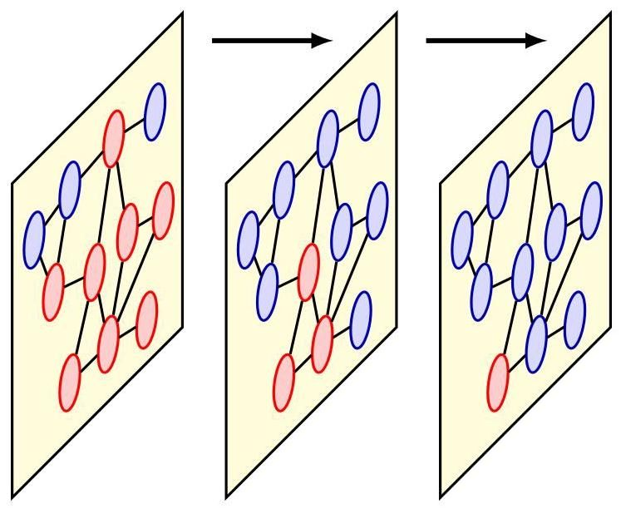

Figure 13.4 Schematic illustration of information flow through successive layers of a graph neural network. In the third layer a single node is highlighted in red. It receives information from its two neighbours in the previous layer and those in turn receive information from their neighbours in the first layer. As with convolutional neural networks for images, we see that the effective receptive field, corresponding to the number of nodes shown in red, grows with the number of processing layers.

图 13.4 图神经网络连续层中信息流的示意图。在第三层中，一个节点用红色突出显示。它从其上一层的两个邻居接收信息，而这些邻居又从第一层的邻居接收信息。与用于图像的卷积神经网络一样，我们看到有效感受野(对应于以红色显示的节点数量)随着处理层的数量而增大。

The aggregation operators discussed so far have no learnable parameters. We can introduce such parameters if we first transform each of the embedding vectors from neighbouring nodes using a multilayer neural network, denoted by , before combining their outputs, where MLP denotes ’multilayer perceptron’ and represents the parameters of the network. So long as the network has a structure and parameter values that are shared across nodes then this aggregation operator again be permutation invariant. We can also transform the combined vector with another neural network , with parameters , to give an overall aggregation operator:

到目前为止讨论的聚合算子没有可学习的参数。如果我们首先使用一个多层神经网络(用 表示)对来自相邻节点的每个嵌入向量进行变换，然后再组合它们的输出，就可以引入这样的参数，其中 MLP 表示 “多层感知机”， 表示网络的参数。只要网络具有在节点间共享的结构和参数值，那么这个聚合算子再次具有排列不变性。我们还可以使用另一个神经网络 (参数为 )对组合后的向量进行变换，从而得到一个整体的聚合算子:

in which and are shared across layer . Due to the flexibility of MLPs, the transformation defined by (13.15) represents a universal approximator for any permutation-invariant function that maps a set of embeddings to a single embedding (Zaheer et al., 2017). Note that the summation can be replaced by other invariant functions such as averages or an element-wise maximum or minimum.

其中 和 在层 中是共享的。由于多层感知机的灵活性，由 (13.15) 定义的变换表示了任何将一组嵌入映射到单个嵌入的排列不变函数的通用近似器(Zaheer 等人，2017)。请注意，求和可以用其他不变函数代替，如平均值或逐元素的最大值或最小值。

A special case of graph neural networks arises if we consider a graph having no edges, which corresponds simply to an unstructured set of nodes. In this case if we use (13.15) for each vector in the set, in which the summation is taken over all other vectors except , then we have a general framework for learning functions over unstructured sets of variables known as deep sets.

如果我们考虑一个没有边的图，就会出现图神经网络的一种特殊情况，这简单地对应于一个无结构的节点集合。在这种情况下，如果我们对集合中的每个向量 使用 (13.15)，其中求和是对除 之外的所有其他向量进行的，那么我们就有了一个用于学习无结构变量集合上的函数的通用框架，即所谓的深度集合。

# 13.2.4 Update operators

# 13.2.4 更新算子

Having chosen a suitable Aggregate operator, we similarly need to decide on the form of the Update operator. By analogy with (13.9) for the CNN, a simple form for this operator would be

在选择了合适的聚合算子之后，我们同样需要确定更新算子的形式。与卷积神经网络的 (13.9) 类似，这个算子的一种简单形式是

where is a nonlinear activation function such as ReLU applied element-wise to its vector argument, and where , and are the learnable weights and biases and is defined by the Aggregate operator (13.10).

其中 是一个非线性激活函数，如逐元素应用于其向量参数的 ReLU，并且 和 是可学习的权重和偏置， 由聚合算子 (13.10) 定义。

If we choose a simple summation (13.12) as the aggregation function and if we also share the same weight matrix between nodes and their neighbours so that , we obtain a particularly simple form of Update operator given by

如果我们选择简单求和(13.12)作为聚合函数，并且在节点及其邻居之间共享相同的权重矩阵，使得 ，我们可以得到一个特别简单的更新算子形式，如下所示

The message-passing algorithm is typically initialized by setting . Sometimes, however, we may want to have an internal representation vector for each node that has a higher, or lower, dimensionality than that of . Such a representation can be initialized by padding the node vectors with additional zeros (to achieve a higher dimensionality) or simply by transforming the node vectors using a learnable linear transformation to a space of the desired number of dimensions. An alternative form of initialization, particularly when there are no data variables associated with the nodes, is to use a one-hot vector that labels the degree of each node (i.e., the number of neighbours).

消息传递算法通常通过设置 来初始化。然而，有时我们可能希望每个节点的内部表示向量的维度高于或低于 的维度。这样的表示可以通过用额外的零填充节点向量 (以实现更高的维度)来初始化，或者简单地使用可学习的线性变换将节点向量转换到所需维度的空间。另一种初始化形式，特别是当节点没有关联的数据变量时，是使用一个独热向量来标记每个节点的度(即邻居的数量)。

Overall, we can represent a graph neural network as a sequence of layers that successively transform the node embeddings. If we group these embeddings into a matrix whose th row is the vector , which is initialized to the data matrix , then we can write the successive transformations in the form

总体而言，我们可以将图神经网络表示为一系列连续变换节点嵌入的层。如果我们将这些嵌入分组到一个矩阵 中，其第 行是向量 ，该向量初始化为数据矩阵 ，那么我们可以将连续变换写成如下形式

where is the adjacency matrix, and represents the complete set of weight and biases in layer of the network. Under a node reordering defined by a permutation matrix , the transformation of the node embeddings computed by layer is

其中 是邻接矩阵， 表示网络第 层中的所有权重和偏置。在由置换矩阵 定义的节点重新排序下，第 层计算的节点嵌入的变换是

equivariant:

等变的:

Exercise 13.7

练习 13.7

As a consequence, the complete network computes an equivariant transformation.

因此，整个网络计算的是一个等变变换。

# 13.2.5 Node classification

# 13.2.5 节点分类

A graph neural network can be viewed as a series of layers each of which transforms a set of node-embedding vectors into a new set of the same size and dimensionality. After the final convolutional layer of the network, we need to obtain predictions so that we can define a cost function for training and also for making predictions on new data using the trained network.

图神经网络可以看作是一系列层，每一层都将一组节点嵌入向量 转换为相同大小和维度的新集合 。在网络的最后一个卷积层之后，我们需要得到预测结果，以便为训练定义一个代价函数，也可以使用训练好的网络对新数据进行预测。

Consider first the task of classifying the nodes in a graph, which is one of the most common uses for graph neural networks. We can define an output layer, sometimes called a readout layer, which calculates a softmax function for each node corresponding to a classification over classes, of the form

首先考虑对图中的节点进行分类的任务，这是图神经网络最常见的用途之一。我们可以定义一个输出层，有时也称为读出层，它为每个节点计算一个对应于 个类别的分类的 softmax 函数，形式如下

where is a set of learnable weight vectors and . We can then define a loss function as the sum of the cross-entropy loss across all nodes and all

其中 是一组可学习的权重向量，且 。然后，我们可以将损失函数定义为所有节点和所有

classes:

类别的交叉熵损失之和:

where are target values with a one-hot encoding for each value of . Because the weight vectors are shared across the output nodes, the outputs are equivariant to permutation of the node ordering, and hence the loss function (13.21) is invariant. If the goal is to predict continuous values at the outputs then a simple linear transformation can be combined with a sum-of-squares error to define a suitable loss function.

其中 是针对 的每个值进行独热编码后的目标值。由于权重向量 在输出节点间共享，输出 对节点顺序的排列具有等变性，因此损失函数 (13.21) 具有不变性。如果目标是在输出端预测连续值，那么可以将简单的线性变换与平方和误差相结合来定义合适的损失函数。

The sum over in (13.21) is taken over the subset of the nodes denoted by and used for training. We can distinguish between three types of nodes as follows:

(13.21) 中对 的求和是在由 表示的节点子集上进行的，该子集用于训练。我们可以如下区分三种类型的节点:

1. The nodes are labelled and included in the message-passing operations of the graph neural network and are also used to compute the loss function used for training.

1. 节点 带有标签，参与图神经网络的消息传递操作，并且也用于计算训练所用的损失函数。

2. There is potentially also a transductive subset of nodes denoted by , which are unlabelled and which do not contribute to the evaluation of the loss function used for training. However, they still participate in the message-passing operations during both training and inference, and their labels may be predicted as part of the inference process.

2. 可能还存在一个由 表示的直推式子集节点，这些节点没有标签，并且对训练所用损失函数的评估没有贡献。然而，它们在训练和推理过程中仍然参与消息传递操作，并且它们的标签可以作为推理过程的一部分进行预测。

3. The remaining nodes, denoted , are a set of inductive nodes that are not used to compute the loss function, and neither these nodes nor their associated edges participate in message-passing during the training phase. However, they do participate in message-passing during the inference phase and their labels are predicted as the outcome of inference. If there are no transductive nodes, and hence the test nodes (and their associated edges) are not available during the training phase, then the training is generally referred to as inductive learning, which can be considered to be a form of supervised learning. However, if there are transductive nodes then it is called transductive learning, which may be viewed as a form of semi-supervised learning.

3. 其余由 表示的节点是一组归纳节点，这些节点不用于计算损失函数，并且在训练阶段，这些节点及其关联的边都不参与消息传递。然而，它们在推理阶段参与消息传递，并且它们的标签作为推理结果进行预测。如果没有直推节点，因此在训练阶段测试节点(及其关联的边)不可用，那么这种训练通常称为归纳学习，它可以被视为一种监督学习形式。然而，如果存在直推节点，那么它被称为直推学习，这可以被视为一种半监督学习形式。

# 13.2.6 Edge classification

# 13.2.6 边分类

In some applications we wish to make predictions about the edges of the graph rather than the nodes. A common form of edge classification task is edge completion in which the goal is to determine whether an edge should be present between two nodes. Given a set of node embeddings, the dot product between pairs of embeddings can be used to define a probability for the presence of an edge between nodes and by using the logistic sigmoid function:

在某些应用中，我们希望对图的边而不是节点进行预测。边分类任务的一种常见形式是边补全，其目标是确定两个节点之间是否应该存在一条边。给定一组节点嵌入，通过使用逻辑 sigmoid 函数，可以使用嵌入对之间的点积来定义节点 和 之间存在边的概率 :

An example application would be predicting whether two people in a social network have shared interests and therefore might wish to connect.

一个示例应用是预测社交网络中的两个人是否有共同兴趣，因此可能希望建立联系。

# 13.2.7 Graph classification

# 13.2.7 图分类

In some applications of graph neural networks, the goal is to predict the properties of new graphs given a training set of labelled graphs . This requires that we combine the final-layer embedding vectors in a way that does not depend on the arbitrary node ordering, thereby ensuring that the output predictions will be invariant to that ordering. The goal is somewhat like that of the Aggregate function except that all nodes in the graph are included, not just the neighbourhood sets of the individual nodes. The simplest approach is to take the sum of the node-embedding

在图神经网络的某些应用中，目标是根据标记图的训练集 预测新图的属性。这要求我们以一种不依赖于任意节点排序的方式组合最终层嵌入向量，从而确保输出预测对该排序具有不变性。这个目标有点类似于聚合函数的目标，只是图中的所有节点都被包含在内，而不仅仅是各个节点的邻域集。最简单的方法是对节点嵌入向量求和

vectors:

向量:

where the function may contain learnable parameters such as a linear transformation or a neural network. Other invariant aggregation functions can be used such as averages or element-wise minimum or maximum.

其中函数 可能包含可学习参数，如线性变换或神经网络。也可以使用其他不变聚合函数，如平均值或逐元素最小值或最大值。

A cross-entropy loss is typically used for classification problems, such as labelling a candidate drug molecule as toxic or safe, and a squared-error loss for regression problems, such as predicting the solubility of a candidate drug molecule. Graph-level predictions correspond to an inductive task since there must be separate sets of graphs for training and for inference.

交叉熵损失通常用于分类问题，例如将候选药物分子标记为有毒或安全；而平方误差损失用于回归问题，例如预测候选药物分子的溶解度。图级别的预测对应于归纳任务，因为训练和推理必须使用不同的图集合。

# 13.3. General Graph Networks

# 13.3. 通用图网络

There are many variations and extensions of the graph networks considered so far. Here we outline a few of the key concepts along with some practical considerations.

到目前为止，我们所考虑的图网络有许多变体和扩展。在这里，我们概述一些关键概念以及一些实际考虑因素。

# 13.3.1 Graph attention networks

# 13.3.1 图注意力网络

Section 12.1

第 12.1 节

The attention mechanism is very powerful when used as the basis of a transformer architecture. It can be used in the context of graph neural networks to construct an aggregation function that combines messages from neighbouring nodes. The incoming messages are weighted by attention coefficients to give

当注意力机制作为 transformer 架构的基础时，它非常强大。在图神经网络的背景下，它可用于构建一个聚合函数，该函数将来自相邻节点的消息进行组合。传入的消息通过注意力系数 进行加权，从而得到

where the attention coefficients satisfy

其中注意力系数满足

This is known as a graph attention network (Veličković et al., 2017) and can capture an inductive bias that says some neighbouring nodes will be more important than others in determining the best update in a way that depends on the data itself.

这被称为图注意力网络(Veličković 等人，2017 年)，它可以捕捉一种归纳偏置，即某些相邻节点在确定最佳更新时会比其他节点更重要，且这种方式取决于数据本身。

There are multiple ways to construct the attention coefficients, and these generally employ a softmax function. For example, we can use a bilinear form:

有多种方法可以构建注意力系数，这些方法通常采用 softmax 函数。例如，我们可以使用双线性形式:

where is a matrix of learnable parameters. A more general option is to use a neural network to combine the embedding vectors from the nodes at each end of the edge:

其中 是一个可学习参数的 矩阵。更通用的选择是使用神经网络来组合边两端节点的嵌入向量:

where the MLP has a single continuous output variable whose value is invariant if the input vectors are exchanged. Provided the MLP is shared across all the nodes in the network, this aggregation function will be equivariant under node reordering.

其中多层感知器(MLP)有一个连续的输出变量，如果交换输入向量，其值不变。如果多层感知器在网络中的所有节点间共享，那么这个聚合函数在节点重新排序时将具有等变性。

Exercise 13.8

练习 13.8

A graph attention network can be extended by introducing multiple attention heads in which distinct sets of attention weights are defined, for , in which each head is evaluated using one of the mechanisms described above and with its own independent parameters. These are then combined in the aggregation step using concatenation and linear projection. Note that, for a fully-connected network, a multi-head graph attention network becomes a standard transformer encoder.

图注意力网络可以通过引入多个注意力头来扩展，其中定义了 不同的注意力权重集合 ，例如 ，每个注意力头使用上述机制之一进行评估，并具有自己独立的参数。然后在聚合步骤中使用拼接和线性投影将它们组合起来。请注意，对于全连接网络，多头图注意力网络会变成标准的 transformer 编码器。

Section 12.1.6

第 12.1.6 节

Exercise 13.9

练习 13.9

# 13.3.2 Edge embeddings

# 13.3.2 边嵌入

The graph neural networks discussed above use embedding vectors that are associated with the nodes. We have seen that some networks also have data associated with the edges. Even when there are no observable values associated with the edges, we can still maintain and update edge-based hidden variables and these can contribute to the internal representations learned by the graph neural network.

上述讨论的图神经网络使用与节点相关联的嵌入向量。我们已经看到，一些网络还具有与边相关的数据。即使边没有可观测的值，我们仍然可以维护和更新基于边的隐藏变量，这些变量可以对图神经网络学习到的内部表示做出贡献。

In addition to the node embeddings given by , we therefore introduce edge embeddings . We can then define general message-passing equations in the form

因此，除了 给出的节点嵌入之外，我们还引入了边嵌入 。然后我们可以定义以下形式的通用消息传递方程

The learned edge embeddings from the final layer can be used directly to make predictions associated with the edges.

从最后一层学习到的边嵌入 可以直接用于进行与边相关的预测。

# 13.3.3 Graph embeddings

# 13.3.3 图嵌入

In addition to node and edge embeddings we can also maintain and update an embedding vector that relates to the graph as a whole. Bringing all these aspects together allows us to define a more general set of message-passing functions, and a richer set of learned representations, for graph-structured applications. Specifically, we can define general message-passing equations (Battaglia et al., 2018):

除了节点和边嵌入之外，我们还可以维护和更新一个与整个图相关的嵌入向量 。将所有这些方面结合起来，使我们能够为图结构应用定义一组更通用的消息传递函数，以及一组更丰富的学习表示。具体来说，我们可以定义通用的消息传递方程(Battaglia 等人，2018):

These update equations start in (13.32) by updating the edge embedding vectors based on the previous states of those vectors, on the node embeddings for the nodes connected by each edge, and on a graph-level embedding vector . These updated edge embeddings are then aggregated across every edge connected to each node using (13.33) to give a set of aggregated vectors. These in turn then contribute to the update of the node-embedding vector based on the current node-embedding vectors and on the graph-level embedding vector using (13.34). Finally, the graph-level embedding vector is updated using (13.35) based on information from all the nodes and all the edges in the graph along with the graph-level embedding from the previous layer. These message-passing updates are illustrated in Figure 13.5 and are summarized in Algorithm 13.2.

这些更新方程从(13.32)开始，基于边嵌入向量 的先前状态、每条边所连接节点的节点嵌入以及图级嵌入向量 来更新边嵌入向量。然后，使用(13.33)对连接到每个节点的所有边的这些更新后的边嵌入进行聚合，得到一组聚合向量。接着，基于当前的节点嵌入向量和图级嵌入向量，使用(13.34)，这些聚合向量又有助于更新节点嵌入向量 。最后，使用(13.35)，基于图中所有节点和所有边的信息以及上一层的图级嵌入，更新图级嵌入向量。这些消息传递更新如图 13.5 所示，并在算法 13.2 中进行了总结。

# 13.3.4 Over-smoothing

# 13.3.4 过平滑

One significant problem that can arise with some graph neural networks is called over-smoothing in which the node-embedding vectors tend to become very similar to each other after a number of iterations of message-passing, which effectively limits the depth of the network. One way to help alleviate this issue is to introduce residual connections. For example, we can modify the update operator (13.34):

一些图神经网络可能出现的一个重大问题称为过平滑，在这种情况下，经过多次消息传递迭代后，节点嵌入向量往往会变得彼此非常相似，这实际上限制了网络的深度。缓解这个问题的一种方法是引入残差连接。例如，我们可以修改更新算子(13.34):

Section 9.5

第9.5节

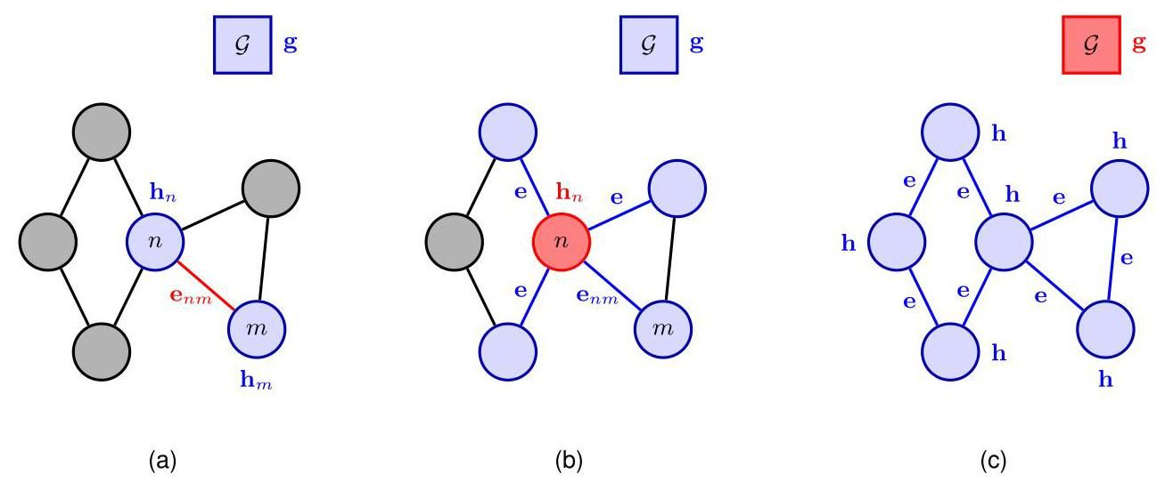

Figure 13.5 Illustration of the general graph message-passing updates defined by (13.32) to (13.35), showing (a) edge updates, (b) node updates, and (c) global graph updates. In each case the variable being updated is shown in red and the variables that contribute to that update are those shown in red and blue.

图13.5 由(13.32)至(13.35)定义的一般图消息传递更新的图示，展示了(a)边更新、(b)节点更新和(c)全局图更新。在每种情况下，正在更新的变量用红色显示，对该更新有贡献的变量用红色和蓝色显示。

Another approach for mitigating the effects of over-smoothing is to allow the output layer to take information from all previous layers of the network and not just the final convolutional layer. This can be done for example by concatenating the representations from previous layers:

减轻过平滑影响的另一种方法是允许输出层从网络的所有先前层获取信息，而不仅仅是最后一个卷积层。例如，可以通过连接先前层的表示来实现这一点:

where denotes the concatenation of vectors and . A variant of this would be to combine the vectors using max pooling instead of concatenation. In this case each element of the output vector is given by the max of all the corresponding elements of the embedding vectors from the previous layers.

其中 表示向量 和 的连接。这种方法的一个变体是使用最大池化而不是连接来组合向量。在这种情况下，输出向量的每个元素由先前层嵌入向量的所有对应元素的最大值给出。

# 13.3.5 Regularization

# 13.3.5 正则化

Chapter 9

第9章

Standard techniques for regularization can be used with graph neural networks, including the addition of penalty terms, such as the sum-of-squares of the parameter values, to the loss function. In addition, some regularization methods have been developed specifically for graph neural networks.

正则化的标准技术可用于图神经网络，包括在损失函数中添加惩罚项，如参数值的平方和。此外，还专门为图神经网络开发了一些正则化方法。

Graph neural networks already employ weight sharing to achieve permutation equivariance and invariance, but typically they have independent parameters in each layer. However, weights and biases can also be shared across layers to reduce the number of independent parameters.

图神经网络已经采用权重共享来实现排列等变性和不变性，但通常每层都有独立的参数。然而，也可以跨层共享权重和偏置，以减少独立参数的数量。

Dropout in the context of graph neural networks involves omitting random subsets of the graph nodes during training, with a fresh random subset chosen for each forward pass. This can likewise be applied to the edges in the graph in which randomly selected subsets of entries in the adjacency matrix are removed, or masked, during training. Algorithm 13.2: Graph neural network with node, edge, and graph embeddings

图神经网络中的随机失活是指在训练期间省略图节点的随机子集，每次前向传播都选择一个新的随机子集。同样，这也可以应用于图中的边，即在训练期间移除或屏蔽邻接矩阵中随机选择的条目子集。算法 13.2:具有节点、边和图嵌入的图神经网络

Input: Undirected graph

输入:无向图

Initial node embeddings

初始节点嵌入

Initial edge embeddings

初始边嵌入

Initial graph embedding

初始图嵌入

Output: Final node embeddings

输出:最终节点嵌入

Final edge embeddings

最终边嵌入

Final graph embedding

最终图嵌入

// Iterative message-passing

// 迭代消息传递

for do

对于 执行

end for

结束循环

return

返回

# 13.3.6 Geometric deep learning

# 13.3.6 几何深度学习

We have seen how permutation symmetry is a key consideration when designing deep learning models for graph-structured data. It acts as a form of inductive bias, dramatically reducing the data requirements while improving predictive performance. In applications of graph neural networks associated with spatial properties, such as graphics meshes, fluid flow simulations, or molecular structures, there are additional equivariance and invariance properties that can be built into the network architecture.

我们已经了解到，在为图结构数据设计深度学习模型时，排列对称性是一个关键考虑因素。它作为一种归纳偏置，在提高预测性能的同时，显著降低了数据需求。在与空间属性相关的图神经网络应用中，如图形网格、流体流动模拟或分子结构，网络架构中还可以融入额外的等变性和不变性属性。

Consider the task of predicting the properties of a molecule, for example when exploring the space of candidate drugs. The molecule can be represented as a list of atoms of given types (carbon, hydrogen, nitrogen, etc.) along with the spatial coordinates of each atom expressed as a three-dimensional column vector. We can introduce an associated embedding vector for each atom at each layer , denoted by , and these vectors can be initialized with the known atom coordinates. However, the values for the elements of these vectors depends on the arbitrary choice of coordinate system, whereas the properties of the molecule do not. For example, the solubility of the molecule is unchanged if it is rotated in space or translated to a new position relative to the origin of the coordinate system, or if the coordinate system itself is reflected to give the mirror image version of the molecule. The molecular properties should therefore be invariant under such transformations.

考虑预测分子性质的任务，例如在探索候选药物空间时。分子可以表示为给定类型(碳、氢、氮等)的原子列表，以及每个原子的空间坐标(表示为三维列向量)。我们可以为每一层 中的每个原子 引入一个关联的嵌入向量，用 表示，并且这些向量可以用已知的原子坐标进行初始化。然而，这些向量元素的值取决于坐标系的任意选择，而分子的性质则不然。例如，如果分子在空间中旋转、相对于坐标系原点平移到新位置，或者坐标系本身进行反射以得到分子的镜像版本，分子的溶解度不会改变。因此，分子性质在这些变换下应该是不变的。

By making careful choices of the functional forms for the update and aggregation operations (Satorras, Hoogeboom, and Welling, 2021), the new embeddings can be incorporated into the graph neural network update equations (13.29) to (13.31) to achieve the required symmetry properties:

通过谨慎选择更新和聚合操作的函数形式(Satorras、Hoogeboom 和 Welling，2021)，新的嵌入 可以纳入图神经网络的更新方程(13.29)至(13.31)中，以实现所需的对称性质:

Note that the quantity represents the squared distance between the coordinates and , and this does not depend on translations, rotations, or reflections. Also, the coordinates are updated through a linear combination of the relative differences . Here is a general scalar function of the edge embeddings and is represented by a neural network, and the coefficient is typically set equal to the reciprocal of the number of terms in the sum. It follows that under such transformations, the messages in (13.38), (13.40), and (13.41) are invariant and the coordinate embeddings given by (13.39) are equivariant.

请注意，量 表示坐标 和 之间距离的平方，并且这与平移、旋转或反射无关。此外，坐标 通过相对差值 的线性组合进行更新。这里 是边嵌入的一般标量函数，由神经网络表示，系数 通常设置为求和项数的倒数。由此可知，在这样的变换下，(13.38)、(13.40) 和 (13.41) 中的消息是不变的，而 (13.39) 给出的坐标嵌入是等变的。

Exercise 13.10

练习 13.10

We have seen many examples of symmetries in structured data, from translations of objects within images and the permutation of node orderings on graphs, to rotations and translations of molecules in three-dimensional space. Capturing these symmetries in the structure of a deep neural network is a powerful form of inductive bias and forms the basis of a rich field of research known as geometric deep learning (Bronstein et al., 2017; Bronstein et al., 2021).

我们已经看到了结构化数据中许多对称性的例子，从图像中物体的平移、图中节点顺序的排列，到三维空间中分子的旋转和平移。在深度神经网络的结构中捕捉这些对称性是一种强大的归纳偏置形式，也是被称为几何深度学习这一丰富研究领域的基础(Bronstein 等人，2017；Bronstein 等人，2021)。

Exercises

练习

13.1 (⋆) Show that the permutation corresponding to the two choices of node ordering in Figure 13.2 can be expressed in the form (13.5) with a permutation matrix given by (13.1).

13.1 (⋆) 证明图 13.2 中两种节点排序选择对应的排列 可以用 (13.5) 的形式表示，其中排列矩阵由 (13.1) 给出。

13.2 Show that the number of edges connected to each node of a graph is given by the corresponding diagonal element of the matrix where is the adjacency matrix.

13.2 证明图中每个节点连接的边的数量由矩阵 的相应对角元素给出，其中 是邻接矩阵。

13.3 (*) Draw the graph whose adjacency matrix is given by

13.3 (*) 绘制由以下邻接矩阵所表示的图

13.4 Show that the effect of pre-multiplying a data matrix using a permutation matrix defined by (13.3) is to create a new data matrix given by (13.4) whose rows are permuted according to the permutation function .

13.4 证明使用由 (13.3) 定义的置换矩阵 对数据矩阵 进行左乘的效果是创建一个由 (13.4) 给出的新数据矩阵 ，其行根据置换函数 进行了置换。

13.5 Show that the transformed adjacency matrix defined by (13.5), where is defined by (13.3), is such that both the rows and the columns are permuted according to the permutation function relative to the original adjacency matrix .

13.5 证明由 (13.5) 定义的变换后的邻接矩阵 (其中 由 (13.3) 定义)相对于原始邻接矩阵 ，其行和列都根据置换函数 进行了置换。

13.6 In this exercise we write the update equations (13.16) as graph-level equations using matrices. To keep the notation uncluttered, we omit the layer index . First, gather the node-embedding vectors into an matrix in which row is given by . Then show that the neighbourhood-aggregated vectors given by

13.6 在本练习中，我们使用矩阵将更新方程 (13.16) 写成图级别的方程。为了使符号简洁，我们省略层索引 。首先，将节点嵌入向量 收集到一个 矩阵 中，其中第 行由 给出。然后证明由以下给出的邻域聚合向量

can be written in matrix form as where is the matrix in which row is given by , and is the adjacency matrix. Finally, show that the argument to the nonlinear activation function in (13.16) can be written in matrix form as

可以写成矩阵形式 ，其中 是一个 矩阵，其第 行由 给出，并且 是邻接矩阵。最后，证明 (13.16) 中非线性激活函数的参数可以写成矩阵形式为

where is the -dimensional column vector in which all elements are 1 .

其中 是一个 维列向量，其所有元素均为 1。

By making use of the equivariance property (13.19) for layer of a deep graph convolutional network along with the permutation property (13.4) for the node variables, show that a complete deep graph convolutional network defined by (13.18) is also equivariant.

利用深度图卷积网络第 层的等变性性质 (13.19) 以及节点变量的置换性质 (13.4)，证明由 (13.18) 定义的完整深度图卷积网络也是等变的。

13.8 Explain why the aggregation function defined by (13.24), in which the attention weights are given by (13.28), is equivariant under a reordering of the nodes in the graph.

13.8 解释为什么由 (13.24) 定义的聚合函数(其中注意力权重由 (13.28) 给出)在图中节点重新排序时是等变的。

13.9 (⋆) Show that a graph attention network in which the graph is fully connected, so that there is an edge between every pair of nodes, is equivalent to a standard transformer architecture.

13.9 (⋆) 证明在图注意力网络中，如果图是完全连通的，即每对节点之间都有一条边，那么该图注意力网络等价于标准的 transformer 架构。

13.10 When a coordinate system is translated, the location of an object defined by that coordinate system is transformed using

13.10 当坐标系平移时，由该坐标系定义的对象的位置使用以下方式进行变换

where is a fixed vector describing the translation. Similarly, if the coordinate system is rotated and/or mirror reflected, the location vector of an object is transformed using

其中 是描述平移的固定向量。类似地，如果坐标系进行旋转和/或镜像反射，对象的位置向量使用以下方式进行变换

where is an orthogonal matrix whose inverse is given by its transpose so that

其中 是一个正交矩阵，其逆矩阵由其转置给出，使得

Using these properties, show that under translations, rotations, and reflections, the messages in (13.38), (13.40), and (13.41) are invariant, and that the coordinate em-beddings given by (13.39) are equivariant.

利用这些性质，证明在平移、旋转和反射变换下，式(13.38)、(13.40)和(13.41)中的信息是不变的，并且式(13.39)给出的坐标嵌入是等变的。

Deep Learning

深度学习

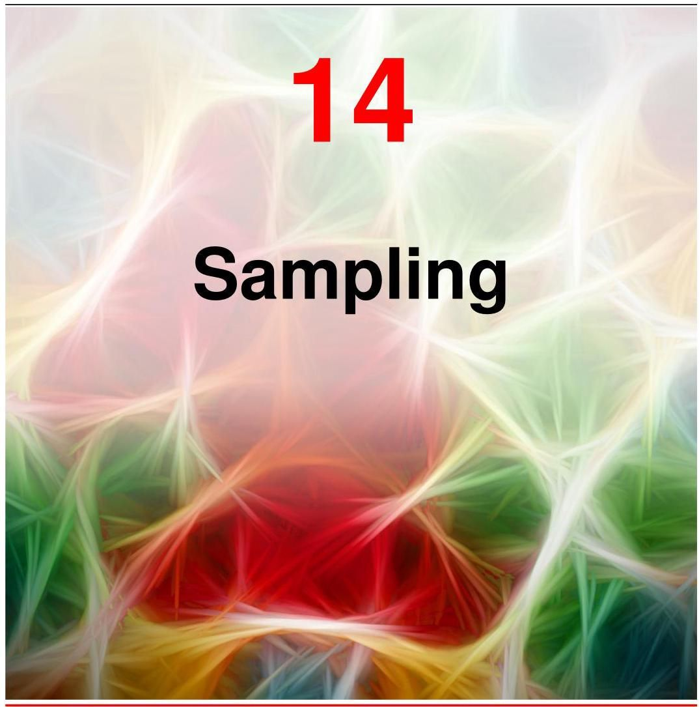

There are many situations in deep learning where we need to create synthetic examples of a variable from a probability distribution . Here might be a scalar and the distribution might be a univariate Gaussian, or might be a high-resolution image and might be a generative model defined by a deep neural network. The process of creating such examples is known as sampling, also known as Monte Carlo sampling. For many simple distributions there are numerical techniques that generate suitable samples directly, whereas for more complex distributions, including ones that are defined implicitly, we may need more sophisticated approaches. We adopt the convention of referring to each instantiated value as a sample, in contrast to the convention used in classical statistics whereby ’sample’ refers to a set of values.

在深度学习中，有许多情况需要我们从概率分布 中生成变量 的合成示例。这里， 可能是一个标量，分布可能是单变量高斯分布；或者 可能是高分辨率图像， 可能是由深度神经网络定义的生成模型。创建此类示例的过程称为采样，也称为蒙特卡罗采样。对于许多简单分布，有直接生成合适样本的数值技术；而对于更复杂的分布，包括隐式定义的分布，我们可能需要更复杂的方法。我们采用将每个实例化的值称为样本的约定，这与经典统计学中“样本”指一组值的约定不同。

In this chapter we focus on aspects of sampling that are most relevant to deep learning. Further information on Monte Carlo methods more generally can be found in Gilks, Richardson, and Spiegelhalter (1996) and Robert and Casella (1999).

在本章中，我们将重点关注与深度学习最相关的采样方面。关于蒙特卡罗方法的更多一般信息可以在 Gilks、Richardson 和 Spiegelhalter (1996) 以及 Robert 和 Casella (1999) 的著作中找到。

# 14.1. Basic Sampling Algorithms

# 14.1. 基本采样算法

In this section, we explore a variety of relatively simple strategies for generating random samples from a given distribution. Because the samples will be generated by a computer algorithm, they will in fact be pseudo-random, that is, they will be calculated using a deterministic algorithm but must nevertheless pass appropriate tests for randomness. Here we will assume that an algorithm has been provided that generates pseudo-random numbers distributed uniformly over , and indeed most software environments have such a facility built in.

在本节中，我们将探讨从给定分布生成随机样本的各种相对简单的策略。由于样本将由计算机算法生成，实际上它们将是伪随机的，即它们将使用确定性算法计算，但仍必须通过适当的随机性测试。这里我们假设已经提供了一种算法，该算法可以生成在 上均匀分布的伪随机数，实际上大多数软件环境都内置了这样的功能。

# 14.1.1 Expectations

# 14.1.1 期望

Although for some applications the samples themselves may be of direct interest, in other situations the goal is to evaluate expectations with respect to the distribution. Suppose we wish to find the expectation of a function with respect to a probability distribution . Here, the components of might comprise discrete or continuous variables or some combination of the two. For continuous variables the expectation is defined by

尽管对于某些应用而言，样本本身可能具有直接的研究价值，但在其他情况下，目标是评估关于分布的期望。假设我们希望找到函数 关于概率分布 的期望。这里， 的分量可能包含离散变量、连续变量或两者的某种组合。对于连续变量，期望定义为

where the integral is replaced by summation for discrete variables. This is illustrated schematically for a single continuous variable in Figure 14.1. We will suppose that such expectations are too complex to be evaluated exactly using analytical techniques.

对于离散变量，积分将被求和所取代。图 14.1 以示意图的形式展示了单个连续变量的情况。我们假设这些期望过于复杂，无法使用解析方法精确计算。

The general idea behind sampling methods is to obtain a set of samples (where ) drawn independently from the distribution . This allows the expectation (14.1) to be approximated by a finite sum:

抽样方法背后的总体思路是从分布 中独立抽取一组样本 (其中 )。这使得期望 (14.1) 可以用有限和来近似:

If the samples are drawn from the distribution , then and so the estimator has the correct mean. We can also write this in the form

如果样本 是从分布 中抽取的，那么 ，因此估计量 具有正确的均值。我们也可以将其写成如下形式

Exercise 14.1

练习 14.1

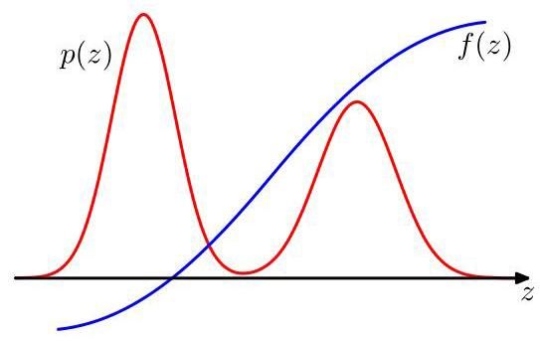

Figure 14.1 Schematic illustration of a function whose expectation is to be evaluated with respect to a distribution .

图 14.1 一个函数 的示意图，其期望需相对于分布 进行评估。

where the symbol denotes that the right-hand side is an unbiased estimator of the left-hand side, that is the two sides are equal when averaged over the noise distribution.

其中符号 表示右侧是左侧的无偏估计量，即当对噪声分布求平均时，两侧相等。

Exercise 14.2

练习 14.2

The variance of the estimator (14.2) is given by

估计量 (14.2) 的方差由下式给出

which is the variance of the function under the distribution . Note that the linear decrease of this variance with increasing does not depend on the dimensionality of , and that, in principle, high accuracy may be achievable with a relatively small number of samples . The problem, however, is that the samples might not be independent, and so the effective sample size might be much smaller than the apparent sample size. Also, referring back to Figure 14.1, note that if is small in regions where is large and vice versa, then the expectation may be dominated by regions of small probability, implying that relatively large sample sizes will be required to achieve sufficient accuracy.

这是函数 在分布 下的方差。注意，该方差随 的增加呈线性减小，这与 的维度无关，并且原则上，使用相对较少的样本 可能就能达到较高的精度。然而，问题在于样本 可能并非相互独立，因此有效样本量可能远小于表观样本量。此外，回顾图 14.1，注意如果在 较大的区域 较小，反之亦然，那么期望可能由小概率区域主导，这意味着需要相对较大的样本量才能达到足够的精度。

# 14.1.2 Standard distributions

# 14.1.2 标准分布

We now consider how to generate random numbers from simple nonuniform distributions, assuming that we already have available a source of uniformly distributed random numbers. Suppose that is uniformly distributed over the interval , and that we transform the values of using some function so that . The distribution of will be governed by

现在我们考虑如何从简单的非均匀分布中生成随机数，假设我们已经有了一个均匀分布随机数的来源。假设 在区间 上均匀分布，并且我们使用某个函数 对 的值进行变换，使得 。 的分布将由

Section 2.4

2.4 节

where, in this case, . Our goal is to choose the function such that the resulting values of have some specific desired distribution . Integrating (14.5)

其中，在这种情况下， 。我们的目标是选择函数 ，使得 的结果值具有某种特定的期望分布 。对 (14.5) 式进行积分

we obtain

我们得到

Exercise 14.3

练习 14.3

which is the indefinite integral of . Thus, , and so we have to transform the uniformly distributed random numbers using a function that is the inverse of the indefinite integral of the desired distribution. This is illustrated in Figure 14.2.

这是 的不定积分。因此， ，所以我们必须使用一个函数对均匀分布的随机数进行变换，该函数是期望分布的不定积分的反函数。这在图 14.2 中得到了说明。

Consider for example the exponential distribution

例如，考虑指数分布

where . In this case the lower limit of the integral in (14.6) is 0, and so . Thus, if we transform our uniformly distributed variable using , then will have an exponential distribution.

其中 。在这种情况下，(14.6) 中积分的下限为 0，因此 。因此，如果我们使用 对均匀分布的变量 进行变换，那么 将具有指数分布。

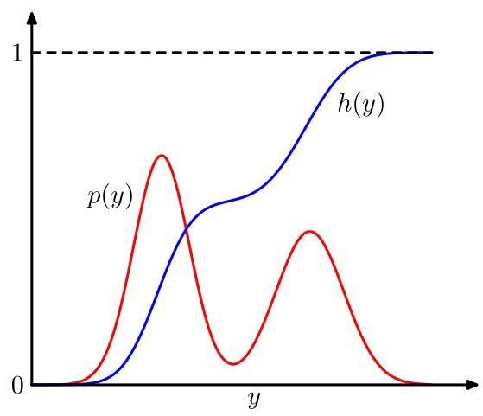

Figure 14.2 Geometrical interpretation of the transformation method for generating non-uniformly distributed random numbers. is the indefinite integral of the desired distribution . If a uniformly distributed random variable is transformed using , then will be distributed according to .

图 14.2 生成非均匀分布随机数的变换方法的几何解释。 是所需分布 的不定积分。如果使用 对均匀分布的随机变量 进行变换，那么 将按照 分布。

Another example of a distribution to which the transformation method can be applied is given by the Cauchy distribution

变换方法可以应用的另一个分布示例是柯西分布

In this case, the inverse of the indefinite integral can be expressed in terms of the tan function.

在这种情况下，不定积分的反函数可以用正切函数表示。

Exercise 14.4

练习 14.4

The generalization to multiple variables involves the Jacobian of the change of variables, so that

推广到多个变量时需要用到变量变换的雅可比矩阵，因此

Section 2.4

2.4 节

As a final example of the transformation technique, we consider the Box-Muller method for generating samples from a Gaussian distribution. First, suppose we generate pairs of uniformly distributed random numbers , which we can do by transforming a variable distributed uniformly over using . Next we discard each pair unless it satisfies . This leads to a uniform distribution of points inside the unit circle with , as illustrated in Figure 14.3. Then, for each pair we evaluate the quantities

作为变换技术的最后一个示例，我们考虑用于从高斯分布生成样本的 Box - Muller 方法。首先，假设我们生成均匀分布的随机数对 ，这可以通过使用 对在 上均匀分布的变量进行变换来实现。接下来，我们舍弃不满足 的每一对随机数。这会得到单位圆内点的均匀分布，其中 ，如图 14.3 所示。然后，对于每一对 ，我们计算这些量

Exercise 14.5

练习 14.5

where . Then the joint distribution of and is given by

其中 。那么 和 的联合分布由下式给出

and so and are independent and each has a Gaussian distribution with zero mean and unit variance.

因此 和 相互独立，且各自都服从均值为零、方差为 1 的高斯分布。

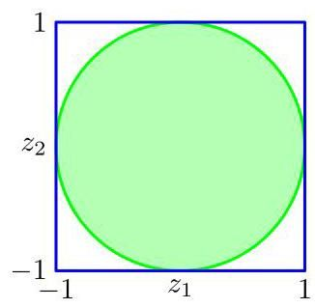

Figure 14.3 The Box-Muller method for generating Gaussian-distributed random numbers starts by generating samples from a uniform distribution inside the unit circle.

图 14.3 用于生成高斯分布随机数的 Box - Muller 方法首先从单位圆内的均匀分布中生成样本。

If has a Gaussian distribution with zero mean and unit variance, then will have a Gaussian distribution with mean and variance . To generate vector-valued variables having a multivariate Gaussian distribution with mean and covariance , we can make use of the Cholesky decomposition, which takes the form (Deisenroth, Faisal, and Ong,2020). Then, if is a random vector whose components are independent and Gaussian distributed with zero mean and unit variance, then will be Gaussian with mean and covariance .

如果 具有零均值和单位方差的高斯分布，那么 将具有均值为 且方差为 的高斯分布。为了生成具有均值为 和协方差为 的多元高斯分布的向量值变量，我们可以利用 Cholesky 分解，其形式为 (Deisenroth、Faisal 和 Ong，2020)。然后，如果 是一个随机向量，其分量是独立的且具有零均值和单位方差的高斯分布，那么 将是均值为 且协方差为 的高斯分布。

Exercise 14.6

练习 14.6

Clearly, the transformation technique depends for its success on the ability to calculate and then invert the indefinite integral of the required distribution. Such operations are feasible only for a limited number of simple distributions, and so we must turn to alternative approaches in search of a more general strategy. Here we consider two techniques called rejection sampling and importance sampling. Although mainly limited to univariate distributions and thus not directly applicable to complex problems in many dimensions, they do form important components in more general strategies.

显然，变换技术的成功依赖于计算并求所需分布的不定积分的逆的能力。这样的操作仅对有限数量的简单分布可行，因此我们必须寻求替代方法以找到更通用的策略。在这里，我们考虑两种称为拒绝采样和重要性采样的技术。虽然它们主要限于单变量分布，因此不能直接应用于高维复杂问题，但它们确实是更通用策略中的重要组成部分。

# 14.1.3 Rejection sampling

# 14.1.3 拒绝采样

The rejection sampling framework allows us to sample from relatively complex distributions, subject to certain constraints. We begin by considering univariate distributions and subsequently discuss the extension to multiple dimensions.

拒绝采样框架允许我们在一定约束条件下从相对复杂的分布中采样。我们首先考虑单变量分布，然后讨论向多维的扩展。

Suppose we wish to sample from a distribution that is not one of the simple, standard distributions considered so far and that sampling directly from is difficult. Furthermore suppose, as is often the case, that we are easily able to evaluate for any given value of , up to some normalizing constant , so that

假设我们希望从一个分布 中进行采样，该分布不是目前所考虑的简单标准分布之一，并且直接从 采样很困难。此外，通常情况下，假设我们能够轻松地针对 的任何给定值计算 ，直至某个归一化常数 ，使得

where can readily be evaluated, but is unknown.

其中 可以很容易地计算出来，但 是未知的。

To apply rejection sampling, we need some simpler distribution , sometimes called a proposal distribution, from which we can readily draw samples. We next introduce a constant whose value is chosen such that for all values of . The function is called the comparison function and is illustrated for a univariate distribution in Figure 14.4. Each step of the rejection sampler involves generating two random numbers. First, we generate a number from the distribution . Next, we generate a number from the uniform distribution over . This pair of random numbers has uniform distribution under the curve of the function . Finally, if then the sample is rejected, otherwise is retained. Thus, the pair is rejected if it lies in the grey shaded region in Figure 14.4. The remaining pairs then have uniform distribution under the curve of , and hence the corresponding values are distributed according to , as desired.

为了应用拒绝采样，我们需要一个更简单的分布 ，有时称为提议分布，我们可以很容易地从该分布中抽取样本。接下来，我们引入一个常数 ，其值的选择要使得对于 的所有值都有 。函数 称为比较函数，图 14.4 展示了单变量分布的情况。拒绝采样器的每一步都涉及生成两个随机数。首先，我们从分布 中生成一个数 。然后，我们从区间 上的均匀分布中生成一个数 。这对随机数在函数 的曲线下具有均匀分布。最后，如果 ，则拒绝该样本，否则保留 。因此，如果这对数位于图 14.4 的灰色阴影区域内，则被拒绝。剩下的数对在 的曲线下具有均匀分布，因此相应的 值按照所需的 分布。

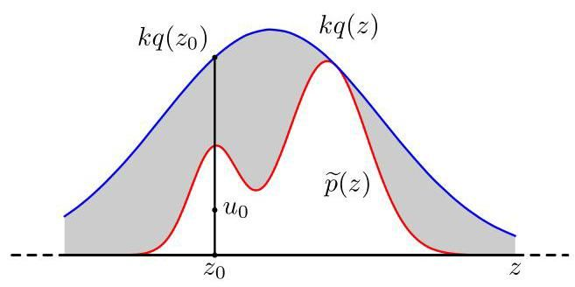

Figure 14.4 In the rejection sampling method, samples are drawn from a simple distribution and rejected if they fall in the grey area between the unnormalized distribution and the scaled distribution . The resulting samples are distributed according to , which is the normalized version of .

图 14.4 在拒绝采样方法中，从一个简单分布 中抽取样本，如果样本落在未归一化分布 和缩放后的分布 之间的灰色区域内，则将其拒绝。得到的样本按照 分布， 是 的归一化版本。

Exercise 14.7

练习 14.7

The original values of are generated from the distribution , and these samples are then accepted with probability , and so the probability that a sample will be accepted is given by

的原始值是从分布 中生成的，然后这些样本以概率 被接受，因此一个样本被接受的概率由下式给出

Thus, the fraction of points that are rejected by this method depends on the ratio of the area under the unnormalized distribution to the area under the curve . We therefore see that the constant should be as small as possible subject to the limitation that must be nowhere less than .

因此，该方法拒绝的点的比例取决于未归一化分布 下的面积与曲线 下的面积之比。因此，我们看到常数 应尽可能小，同时要满足 处处不小于 的限制。

As an illustration of the use of rejection sampling, consider the task of sampling from the gamma distribution

作为拒绝采样应用的一个示例，考虑从伽马分布中采样的任务

which, for , has a bell-shaped form, as shown in Figure 14.5. A suitable proposal distribution is therefore the Cauchy (14.8) because this too is bell-shaped and because we can use the transformation method, discussed earlier, to sample from it. We need to generalize the Cauchy slightly to ensure that it nowhere has a smaller value than the gamma distribution. This can be achieved by transforming a uniform random variable using , which gives random numbers distributed according to

对于 ，它呈钟形，如图 14.5 所示。因此，一个合适的提议分布是柯西分布 (14.8)，因为它也是钟形的，并且我们可以使用前面讨论过的变换方法从中采样。我们需要对柯西分布进行稍微的推广，以确保它在任何地方的值都不小于伽马分布。这可以通过使用 对均匀随机变量 进行变换来实现，这样得到的随机数将按照以下分布

Exercise 14.8

练习 14.8

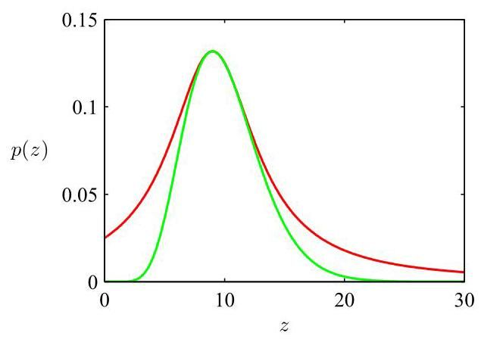

Figure 14.5 Plot showing the gamma distribution given by (14.15) as the green curve, with a scaled Cauchy proposal distribution shown by the red curve. Samples from the gamma distribution can be obtained by sampling from the Cauchy and then applying the rejection sampling criterion.

图 14.5 展示了由 (14.15) 给出的伽马分布(绿色曲线)，以及缩放后的柯西提议分布(红色曲线)。可以通过从柯西分布中采样，然后应用拒绝采样准则来获得伽马分布的样本。

The minimum reject rate is obtained by setting , and and choosing the constant to be as small as possible while still satisfying the requirement . The resulting comparison function is also illustrated in Figure 14.5.

通过设置 和 ，并选择常数 尽可能小，同时仍满足要求 ，可以得到最小拒绝率。由此得到的比较函数也在图 14.5 中进行了说明。

# 14.1.4 Adaptive rejection sampling

# 14.1.4 自适应拒绝采样

In many instances where we might wish to apply rejection sampling, it can be difficult to determine a suitable analytic form for the envelope distribution . An alternative approach is to construct the envelope function on the fly based on measured values of the distribution (Gilks and Wild,1992). Constructing an envelope function is particularly straightforward when is log concave, in other words when has derivatives that are non-increasing functions of . The construction of a suitable envelope function is illustrated graphically in Figure 14.6.

在许多我们可能希望应用拒绝采样的情况下，为包络分布 确定合适的解析形式可能很困难。一种替代方法是根据分布 的测量值动态构建包络函数(Gilks 和 Wild，1992 年)。当 是对数凹函数时，即当 关于 的导数是非增函数时，构建包络函数特别简单。图 14.6 以图形方式说明了合适包络函数的构建。

The function and its gradient are evaluated at some initial set of grid points, and the intersections of the resulting tangent lines are used to construct the envelope function. Next a sample value is drawn from the envelope distribution. This is straightforward because the log of the envelope distribution is a succession of linear functions, and hence the envelope distribution itself comprises a piecewise exponential distribution of the form

在一组初始网格点上计算函数 及其梯度，并使用所得切线的交点来构建包络函数。接下来，从包络分布中抽取一个样本值。这很简单，因为包络分布的对数是一系列线性函数，因此包络分布本身由以下形式的分段指数分布组成

Exercise 14.10

练习 14.10

Once a sample has been drawn, the usual rejection criterion can be applied. If the sample is accepted, then it will be a draw from the desired distribution. If, however, the sample is rejected, then it is incorporated into the set of grid points, a new tangent line is computed, and the envelope function is thereby refined. As the number of grid points increases, so the envelope function becomes a better approximation of the desired distribution and the probability of rejection decreases.

一旦抽取了一个样本，就可以应用通常的拒绝准则。如果样本被接受，那么它将是从所需分布中抽取的样本。然而，如果样本被拒绝，则将其纳入网格点集，计算一条新的切线，从而改进包络函数。随着网格点数量的增加，包络函数对所需分布 的近似效果越来越好，拒绝的概率也会降低。

There is a variant of the algorithm exists that avoids the evaluation of derivatives (Gilks, 1992). The adaptive rejection sampling framework can also be extended to distributions that are not log concave, simply by following each rejection sampling step with a Metropolis-Hastings step (to be discussed in Section 14.2.3), giving rise to adaptive rejection Metropolis sampling (Gilks, Best, and Tan, 1995).

存在一种无需计算导数的算法变体(Gilks，1992 年)。自适应拒绝采样框架也可以扩展到非对数凹的分布，只需在每次拒绝采样步骤之后进行一次 Metropolis - Hastings 步骤(将在 14.2.3 节讨论)，从而产生自适应拒绝 Metropolis 采样(Gilks、Best 和 Tan，1995 年)。

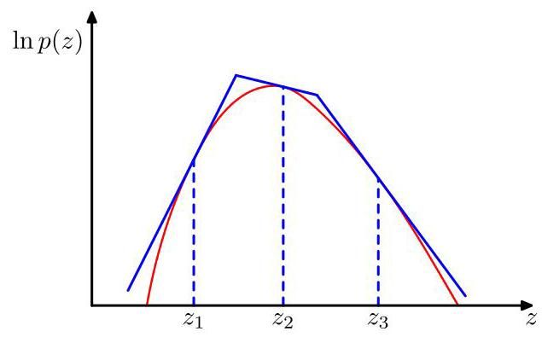

Figure 14.6 In rejection sampling, if a distribution is log concave then an envelope function can be constructed using the tangent lines computed at a set of grid points. If a sample point is rejected, it is added to the set of grid points and used to refine the envelope distribution.

图 14.6 在拒绝采样中，如果一个分布是对数凹的，那么可以使用在一组网格点处计算得到的切线来构造一个包络函数。如果一个采样点被拒绝，它会被添加到网格点集合中，并用于细化包络分布。

For rejection sampling to be of practical value, we require that the comparison function is close to the required distribution so that the rate of rejection is kept to a minimum. Now let us examine what happens when we try to use rejection sampling in spaces of high dimensionality. Consider, for illustration, a somewhat artificial problem in which we wish to sample from a zero-mean multivariate Gaussian distribution with covariance , where is the unit matrix, by rejection sampling from a proposal distribution that is itself a zero-mean Gaussian distribution having covariance . Clearly, we must have to ensure that there exists a such that . In -dimensions, the optimum value of is given by , as illustrated for in Figure 14.7. The acceptance rate will be the ratio of volumes under and , which, because both distributions are normalized, is just . Thus, the acceptance rate diminishes exponentially with dimensionality. Even if exceeds by just 1%, for the acceptance ratio will be approximately . In this illustrative example, the comparison function is close to the required distribution. For more practical examples, where the desired distribution may be multimodal and sharply peaked, it will be extremely difficult to find a good proposal distribution and comparison function. Furthermore, the exponential decrease of the acceptance rate with dimensionality is a generic feature of rejection sampling. Although rejection can be a useful technique in one or two dimensions, it is unsuited to problems of high dimensionality. It can, however, play a role as a subroutine in more sophisticated algorithms for sampling in high-dimensional spaces.

为了使拒绝采样具有实际价值，我们要求比较函数接近所需的分布，以便将拒绝率保持在最低水平。现在让我们来研究一下当我们尝试在高维空间中使用拒绝采样时会发生什么。为了说明问题，考虑一个有点人为设定的问题，在这个问题中，我们希望通过从一个提议分布(该提议分布本身是一个零均值高斯分布，协方差为 )进行拒绝采样，从一个零均值多元高斯分布(协方差为 ，其中 是单位矩阵)中采样。显然，我们必须有 ，以确保存在一个 使得 。在 维空间中， 的最优值由 给出，如图 14.7 中 的情况所示。接受率将是 和 下方的体积之比，由于这两个分布都是归一化的，所以接受率就是 。因此，接受率会随着维度的增加呈指数级下降。即使 仅比 大 1%，对于 ，接受率大约为 。在这个说明性的例子中，比较函数接近所需的分布。对于更实际的例子，其中所需的分布可能是多峰且尖峰的，找到一个好的提议分布和比较函数将极其困难。此外，接受率随维度呈指数级下降是拒绝采样的一个普遍特征。虽然拒绝采样在一维或二维情况下可能是一种有用的技术，但它不适合高维问题。然而，它可以作为一个子程序在更复杂的高维空间采样算法中发挥作用。

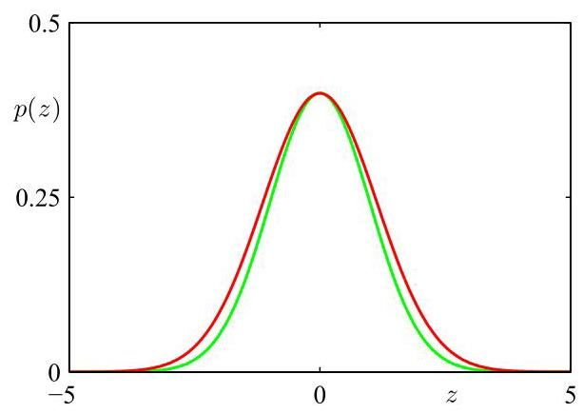

Figure 14.7 Illustrative example used to highlight a limitation of rejection sampling. Samples are drawn from a Gaussian distribution shown by the green curve, by using rejection sampling from a proposal distribution that is also Gaussian and whose scaled version is shown by the red curve.

图 14.7 用于突出拒绝采样局限性的说明性示例。通过从一个提议分布 (也是高斯分布，其缩放版本 由红色曲线表示)进行拒绝采样，从一个高斯分布 (由绿色曲线表示)中抽取样本。

# 14.1.5 Importance sampling

# 14.1.5 重要性采样

One reason for wishing to sample from complicated probability distributions is to evaluate expectations of the form (14.1). The technique of importance sampling provides a framework for approximating expectations directly but does not itself provide a mechanism for drawing samples from a distribution .

希望从复杂概率分布中采样的一个原因是评估形如 (14.1) 的期望。重要性采样技术提供了一个直接近似期望的框架，但它本身并不提供从分布 中抽取样本的机制。

The finite sum approximation to the expectation, given by (14.2), depends on being able to draw samples from the distribution . Suppose, however, that it is impractical to sample directly from but that we can evaluate easily for any given value of . One simplistic strategy for evaluating expectations would be to discretize -space into a uniform grid and to evaluate the integrand as a sum of the

由 (14.2) 给出的对期望的有限和近似依赖于能够从分布 中抽取样本。然而，假设直接从 中采样是不切实际的，但对于任何给定的 值，我们可以轻松地计算 。一种简单的评估期望的策略是将 空间离散化为一个均匀网格，并将被积函数计算为……

form

形式

An obvious problem with this approach is that the number of terms in the summation grows exponentially with the dimensionality of . Furthermore, as we have already noted, the kinds of probability distributions of interest will often have much of their mass confined to relatively small regions of -space and so uniform sampling will be very inefficient because in high-dimensional problems, only a very small proportion of the samples will make a significant contribution to the sum. We would really like to choose sample points from regions where is large or ideally where the product is large.

这种方法的一个明显问题是，求和项的数量会随着 的维度呈指数增长。此外，正如我们已经指出的，感兴趣的概率分布通常会将其大部分质量集中在 空间的相对较小区域，因此均匀采样效率会非常低，因为在高维问题中，只有极小比例的样本会对求和产生显著贡献。我们实际上希望从 较大的区域，或者理想情况下从乘积 较大的区域选择样本点。

As with rejection sampling, importance sampling is based a proposal distribution from which it is easy to draw samples, as illustrated in Figure 14.8. We can then express the expectation in the form of a finite sum over samples drawn from :

与拒绝采样一样，重要性采样基于一个提议分布 ，从该分布中容易抽取样本，如图 14.8 所示。然后，我们可以将期望表示为从 中抽取的样本 的有限和形式:

The quantities are known as importance weights, and they correct the bias introduced by sampling from the wrong distribution. Note that, unlike rejection sampling, all the samples generated are retained.

量 被称为重要性权重，它们纠正了从错误分布采样引入的偏差。请注意，与拒绝采样不同，生成的所有样本都会被保留。

Often the distribution can be evaluated only up to a normalization constant, so that where can be evaluated easily, whereas is unknown.

通常，分布 只能计算到一个归一化常数，因此 ，其中 可以轻松计算，而 是未知的。

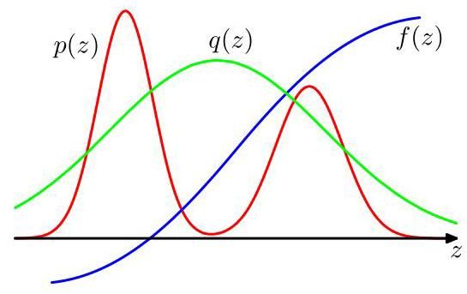

Figure 14.8 Importance sampling addresses the problem of evaluating the expectation of a function with respect to a distribution from which it is difficult to draw samples directly. Instead, samples are drawn from a simpler distribution , and the corresponding terms in the summation are weighted by the ratios .

图 14.8 重要性采样解决了评估函数 相对于分布 的期望的问题，直接从该分布中抽取样本很困难。相反，从更简单的分布 中抽取样本 ，并且求和中的相应项由比率 加权。

Similarly, we may wish to use an importance sampling distribution , which has the same property. We then have

同样地，我们可能希望使用具有相同性质的重要性采样分布 。然后我们有

where . We can use the same sample set to evaluate the ratio with the result

其中 。我们可以使用相同的样本集来计算比率 ，结果为

and hence the expectation in (14.20) is given by a weighted sum:

因此，(14.20) 中的期望由加权和给出:

where we have defined

其中我们定义了

Note that are non-negative numbers that sum to one.

注意， 是非负的数，且它们的和为 1。

As with rejection sampling, the success of importance sampling depends crucially on how well the sampling distribution matches the desired distribution . If, as is often the case, is strongly varying and has a significant proportion of its mass concentrated over relatively small regions of -space, then the set of importance weights may be dominated by a few weights having large values, with the remaining weights being relatively insignificant. Thus, the effective sample size can be much smaller than the apparent sample size . The problem is even more severe if none of the samples falls in the regions where is large. In that case, the apparent variances of and may be small even though the estimate of the expectation may be severely wrong. Hence, a major drawback of importance sampling is its potential to produce results that are arbitrarily in error and with no diagnostic indication. This also highlights a key requirement for the sampling distribution , namely that it should not be small or zero in regions where may be significant.

与拒绝采样一样，重要性采样的成功很大程度上取决于采样分布 与期望分布 的匹配程度。如果像通常情况那样， 变化剧烈，并且其大部分质量集中在 空间的相对较小区域，那么重要性权重集合 可能由少数几个较大的权重主导，其余权重相对较小。因此，有效样本量可能远小于表观样本量 。如果没有样本落在 较大的区域，问题会更加严重。在这种情况下，即使期望的估计可能严重错误， 和 的表观方差也可能很小。因此，重要性采样的一个主要缺点是它有可能产生任意误差的结果，且没有诊断指示。这也凸显了对采样分布 的一个关键要求，即它在 可能显著的区域不应很小或为零。

# 14.1.6 Sampling-importance-resampling

# 14.1.6 抽样 - 重要性 - 重抽样

The rejection sampling method discussed in Section 14.1.3 depends in part for its success on the determination of a suitable value for the constant . For many pairs of distributions and , it will be impractical to determine a suitable value for as any value that is sufficiently large to guarantee a bound on the desired distribution will lead to impractically small acceptance rates.

14.1.3 节中讨论的拒绝抽样方法的成功部分取决于确定常数 的合适值。对于许多分布对 和 而言，确定 的合适值是不切实际的，因为任何足够大以保证对所需分布有界的值都会导致极低的接受率，从而不具有实际可操作性。

As with rejection sampling, the sampling-importance-resampling approach also makes use of a sampling distribution but avoids having to determine the constant . There are two stages to the scheme. In the first stage, samples are drawn from . Then in the second stage, weights are constructed using (14.23). Finally, a second set of samples is drawn from the discrete distribution with probabilities given by the weights .

与拒绝抽样一样，抽样 - 重要性 - 重抽样方法也利用了一个抽样分布 ，但避免了确定常数 。该方案分为两个阶段。在第一阶段，从 中抽取 个样本 。然后在第二阶段，使用 (14.23) 式构造权重 。最后，从离散分布 中抽取第二组 个样本，其概率由权重 给出。

The resulting samples are only approximately distributed according to , but the distribution becomes correct in the limit . To see this, consider the univariate case, and note that the cumulative distribution of the resampled values is given by

最终得到的 个样本只是近似按照 分布，但在 的极限情况下，分布会变得准确。为了说明这一点，考虑单变量的情况，并注意到重抽样值的累积分布由下式给出

where otherwise). Taking the limit and assuming suitable regularity of the distributions, we can replace the sums by integrals weighted according to the original

其中 否则)。取极限 并假设分布具有适当的正则性，我们可以根据原始抽样分布 用积分来代替求和

sampling distribution :

抽样分布 :

which is the cumulative distribution function of . Again, we see that normalization of is not required.

这是 的累积分布函数。同样，我们看到不需要对 进行归一化。

For a finite value of and a given initial sample set, the resampled values will only approximately be drawn from the desired distribution. As with rejection sampling, the approximation improves as the sampling distribution gets closer to the desired distribution . When , the initial samples have the desired distribution and the weights , so that the resampled values also have the desired distribution.

对于 的有限值和给定的初始样本集，重采样的值将仅近似地从所需分布中抽取。与拒绝采样一样，随着采样分布 越来越接近所需分布 ，近似程度会提高。当 时，初始样本 具有所需分布，权重为 ，因此重采样的值也具有所需分布。

If moments with respect to the distribution are required, then they can be evaluated directly using the original samples together with the weights, because

如果需要关于分布 的矩，则可以使用原始样本和权重直接计算它们，因为

# 14.2. Markov Chain Monte Carlo

# 14.2. 马尔可夫链蒙特卡罗

In the previous section, we discussed the rejection sampling and importance sampling strategies for evaluating expectations of functions, and we saw that they suffer from severe limitations particularly in spaces of high dimensionality. We therefore turn in this section to a very general and powerful framework called Markov chain Monte Carlo, which allows sampling from a large class of distributions and which scales well with the dimensionality of the sample space. Markov chain Monte Carlo methods have their origins in physics (Metropolis and Ulam, 1949), and it was only towards the end of the 1980s that they started to have a significant impact in the field of statistics.

在上一节中，我们讨论了用于评估函数期望的拒绝采样和重要性采样策略，并且我们看到它们存在严重的局限性，特别是在高维空间中。因此，在本节中，我们转向一个非常通用且强大的框架，称为马尔可夫链蒙特卡罗，它允许从一大类分布中采样，并且随着样本空间的维度增加而表现良好。马尔可夫链蒙特卡罗方法起源于物理学(Metropolis 和 Ulam，1949 年)，直到 20 世纪 80 年代末，它们才开始在统计学领域产生重大影响。

As with rejection and importance sampling, we again sample from a proposal distribution. This time, however, we maintain a record of the current state , and the proposal distribution is conditioned on this current state, and so the sequence of samples forms a Markov chain. Again, if we write , we will assume that can readily be evaluated for any given value of , although the value of may be unknown. The proposal distribution is chosen to be sufficiently simple that it is straightforward to draw samples from it directly. At each cycle of the algorithm, we generate a candidate sample from the proposal distribution and then accept the sample according to an appropriate criterion.

与拒绝采样和重要性采样一样，我们再次从提议分布中采样。然而，这次我们记录当前状态 ，并且提议分布 以这个当前状态为条件，因此样本序列 形成一个马尔可夫链。同样，如果我们写成 ，我们将假设对于任何给定的 值，都可以轻松计算 ，尽管 的值可能未知。提议分布被选择得足够简单，以便可以直接从中抽取样本。在算法的每个循环中，我们从提议分布中生成一个候选样本 ，然后根据适当的标准接受该样本。

Section 14.2.2

第14.2.2节

# 14.2.1 The Metropolis algorithm

# 14.2.1 梅特罗波利斯算法

In the basic Metropolis algorithm (Metropolis et al., 1953), we assume that the proposal distribution is symmetric, that is for all values of and . The candidate sample is then accepted with probability

在基本的梅特罗波利斯算法(Metropolis 等人，1953)中，我们假设提议分布是对称的，即对于 和 的所有值都有 。然后，候选样本以一定概率被接受

This can be achieved by choosing a random number with uniform distribution over the unit interval and then accepting the sample if . Note that if the step from to causes an increase in the value of , then the candidate point is certain to be kept.

这可以通过在单位区间 上选择一个均匀分布的随机数 来实现，如果 则接受该样本。请注意，如果从 到 的步骤导致 的值增加，那么候选点肯定会被保留。

If the candidate sample is accepted, then , otherwise the candidate point is discarded, is set to , and another candidate sample is drawn from the distribution . This is in contrast to rejection sampling, where rejected samples are simply discarded. In the Metropolis algorithm, when a candidate point is rejected, the previous sample is included in the final list of samples, leading to multiple copies of samples. Of course, in a practical implementation, only a single copy of each retained sample would be kept, along with an integer weighting factor recording how many times that state appears. As we will see, if is positive for any values of and (this is a sufficient but not necessary condition), the distribution of tends to as . It should be emphasized, however, that the sequence is not a set of independent samples from because successive samples are highly correlated. If we wish to obtain independent samples, then we can discard most of the sequence and just retain every th sample. For sufficiently large, the retained samples will for all practical purposes be independent. The Metropolis algorithm in summarized in Algorithm 14.1. Figure 14.9 shows a simple illustrative example of sampling from a two-dimensional Gaussian distribution using the Metropolis algorithm in which the proposal distribution is an isotropic Gaussian.

如果候选样本被接受，则 ；否则，候选点 被丢弃， 被设置为 ，并从分布 中抽取另一个候选样本。这与拒绝采样不同，在拒绝采样中，被拒绝的样本只是被简单丢弃。在梅特罗波利斯算法中，当一个候选点被拒绝时，前一个样本会被包含在最终的样本列表中，从而导致样本有多个副本。当然，在实际实现中，每个保留的样本只会保留一个副本，同时会有一个整数权重因子记录该状态出现的次数。正如我们将看到的，如果对于 和 的任何值 都是正的(这是一个充分但非必要条件)，当 时， 的分布趋向于 。然而，应该强调的是，序列 不是来自 的一组独立样本，因为连续的样本是高度相关的。如果我们希望获得独立样本，那么我们可以丢弃大部分序列，只保留每隔 个样本。对于足够大的 ，出于所有实际目的，保留的样本将是独立的。梅特罗波利斯算法总结在算法 14.1 中。图 14.9 展示了一个使用梅特罗波利斯算法从二维高斯分布中采样的简单示例，其中提议分布是各向同性的高斯分布。

Further insight into the nature of Markov chain Monte Carlo algorithms can be gleaned by looking at the properties of a specific example, namely a simple random

通过研究一个具体示例(即一个简单的随机)的性质，可以进一步深入了解马尔可夫链蒙特卡罗算法的本质

Algorithm 14.1: Metropolis sampling

算法 14.1:Metropolis 采样

Input: Unnormalized distribution

输入:未归一化分布

Proposal distribution

提议分布

Initial state

初始状态

Number of iterations

迭代次数

Output:

输出:

// Iterative message-passing

for do

// Sample from proposal distribution

// Sample from uniform

if then

else

end if

end for

return

walk. Consider a state space consisting of the integers, with probabilities

行走。考虑一个由整数组成的状态空间 ，具有相应的概率

where denotes the state at step . If the initial state is , then by symmetry the expected state at time will also be zero , and similarly it is easily seen that . Thus, after steps, the random walk has travelled only a distance that on average is proportional to the square root of . This square root dependence is typical of random walk behaviour and shows that random walks are very inefficient in exploring the state space. As we will see, a central goal in designing Markov chain Monte Carlo methods is to avoid random walk behaviour.

其中 表示第 步的状态。如果初始状态为 ，那么根据对称性，在时间 时的期望状态也将为零 ，类似地，很容易看出 。因此，经过 步后，随机行走所经过的距离平均而言与 的平方根成正比。这种平方根依赖关系是随机行走行为的典型特征，表明随机行走在探索状态空间方面效率非常低。正如我们将看到的，设计马尔可夫链蒙特卡罗方法的一个核心目标是避免随机行走行为。

Exercise 14.11

练习 14.11

# 14.2.2 Markov chains

# 14.2.2 马尔可夫链

Before discussing Markov chain Monte Carlo methods in more detail, it is useful to study some general properties of Markov chains. In particular, we ask under what circumstances will a Markov chain converge to the desired distribution. A first-order

在更详细地讨论马尔可夫链蒙特卡罗方法之前，研究马尔可夫链的一些一般性质是很有用的。特别是，我们要问在什么情况下马尔可夫链会收敛到所需的分布。一阶

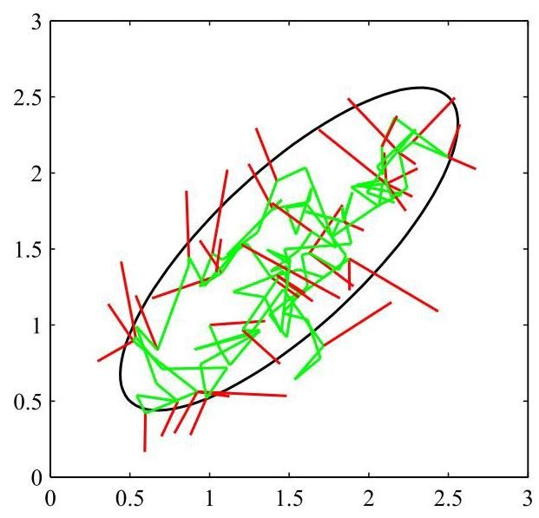

Figure 14.9 A simple illustration using the Metropolis algorithm to sample from a Gaussian distribution whose one standard-deviation contour is shown by the ellipse. The proposal distribution is an isotropic Gaussian distribution whose standard deviation is 0.2 . Steps that are accepted are shown as green lines, and rejected steps are shown in red. A total of 150 candidate samples are generated, of which 43 are rejected.

图 14.9 使用 Metropolis 算法从高斯分布中采样的简单示例，其一个标准差轮廓由椭圆表示。提议分布是一个各向同性的高斯分布，其标准差为 0.2。被接受的步骤用绿色线条表示，被拒绝的步骤用红色表示。总共生成了 150 个候选样本，其中 43 个被拒绝。

Markov chain is defined to be a series of random variables such that the following conditional independence property holds for :

马尔可夫链被定义为一系列随机变量 ，使得对于 以下条件独立性质成立:

Figure 11.29

图 11.29

which can be represented as a directed graphical model in the form of a chain. We can then specify the Markov chain by giving the probability distribution for the initial variable together with the conditional distributions for subsequent variables in the form of transition probabilities . A Markov chain is called homogeneous if the transition probabilities are the same for all .

这可以用链状的有向图模型来表示。然后，我们可以通过给出初始变量 的概率分布以及后续变量以转移概率 形式的条件分布来指定马尔可夫链。如果对于所有的 转移概率都相同，则称该马尔可夫链为齐次的。

The marginal probability for a particular variable can be expressed in terms of the marginal probability for the previous variable in the chain:

链中某个特定变量的边缘概率可以用链中前一个变量的边缘概率来表示:

where the integral is replaced by a summation for discrete variables. A distribution is said to be invariant, or stationary, with respect to a Markov chain if each step in the chain leaves that distribution invariant. Thus, for a homogeneous Markov chain with transition probabilities , the distribution is invariant if

对于离散变量，积分要替换为求和。如果马尔可夫链的每一步都使某个分布保持不变，则称该分布相对于该马尔可夫链是不变的，或平稳的。因此，对于具有转移概率 的齐次马尔可夫链，如果分布 满足以下条件，则它是不变的:

Note that a given Markov chain may have more than one invariant distribution. For instance, if the transition probabilities are given by the identity transformation, then any distribution will be invariant.

请注意，给定的马尔可夫链可能有多个不变分布。例如，如果转移概率由恒等变换给出，那么任何分布都是不变的。

A sufficient (but not necessary) condition for ensuring that the required distribution is invariant is to choose the transition probabilities to satisfy the property of detailed balance, defined by

确保所需分布 不变的一个充分(但非必要)条件是选择转移概率以满足细致平衡性质，其定义为

for the particular distribution . It is easily seen that a transition probability that satisfies detailed balance with respect to a particular distribution will leave that distribution invariant, because

对于特定分布 。很容易看出，相对于特定分布满足细致平衡的转移概率将使该分布保持不变，因为

A Markov chain that respects detailed balance is said to be reversible.

满足细致平衡的马尔可夫链被称为可逆的。

Our goal is to use Markov chains to sample from a given distribution. We can achieve this if we set up a Markov chain such that the desired distribution is invariant. However, we must also require that for , the distribution converges to the required invariant distribution , irrespective of the choice of initial distribution . This property is called ergodicity, and the invariant distribution is then called the equilibrium distribution. Clearly, an ergodic Markov chain can have only one equilibrium distribution. It can be shown that a homogeneous Markov chain will be ergodic, subject only to weak restrictions on the invariant distribution and the transition probabilities (Neal, 1993).

我们的目标是使用马尔可夫链从给定分布中采样。如果我们建立一个马尔可夫链，使得所需分布是不变的，就可以实现这一目标。然而，我们还必须要求对于 ，分布 收敛到所需的不变分布 ，而与初始分布 的选择无关。这个性质称为遍历性，此时不变分布称为平衡分布。显然，一个遍历的马尔可夫链只能有一个平衡分布。可以证明，一个齐次马尔可夫链将是遍历的，只需要对不变分布和转移概率施加较弱的限制(Neal，1993)。

In practice we often construct the transition probabilities from a set of ’base’ transitions . This can be achieved through a mixture distribution of the

在实践中，我们通常从一组“基本”转移 构建转移概率。这可以通过一个混合分布来实现

form

形式

for some set of mixing coefficients satisfying and . Alternatively, the base transitions may be combined through successive application, so that

对于满足 和 的某组混合系数 。或者，基本转移可以通过连续应用进行组合，使得

If a distribution is invariant with respect to each of the base transitions, then clearly it will also be invariant with respect to either of the given by (14.38) or (14.39). For the mixture (14.38), if each of the base transitions satisfies detailed balance, then the mixture transition will also satisfy detailed balance. This does not hold for the transition probability constructed using (14.39), although by symmetrizing the order of application of the base transitions, namely , detailed balance can be restored. A common example of the use of composite transition probabilities is where each base transition changes only a subset of the variables.

如果一个分布相对于每个基本转移是不变的，那么显然它对于由 (14.38) 或 (14.39) 给出的 也是不变的。对于混合 (14.38)，如果每个基本转移都满足细致平衡，那么混合转移 也将满足细致平衡。对于使用 (14.39) 构造的转移概率，这并不成立，尽管通过对基本转移的应用顺序进行对称化，即 ，可以恢复细致平衡。复合转移概率使用的一个常见例子是每个基本转移仅改变变量的一个子集。

# 14.2.3 The Metropolis-Hastings algorithm

# 14.2.3 梅特罗波利斯 - 黑斯廷斯算法

Earlier we introduced the basic Metropolis algorithm without actually demonstrating that it samples from the required distribution. Before giving a proof, we first discuss a generalization, known as the Metropolis-Hastings algorithm (Hastings, 1970), which applies when the proposal distribution is no longer a symmetric function of its arguments. In particular at step of the algorithm, in which the current state is , we draw a sample from the distribution and then accept it with probability where

早些时候，我们介绍了基本的梅特罗波利斯算法，但实际上并未证明它是从所需分布中采样的。在给出证明之前，我们首先讨论一种推广，即梅特罗波利斯 - 黑斯廷斯算法(黑斯廷斯，1970)，该算法适用于提议分布不再是其参数的对称函数的情况。具体来说，在算法的第 步，当前状态为 时，我们从分布 中抽取一个样本 ，然后以概率 接受它，其中

Here labels the members of the set of possible transitions being considered. Again, evaluating the acceptance criterion does not require knowledge of the normalizing constant in the probability distribution . For a symmetric proposal distribution, the Metropolis-Hastings criterion (14.40) reduces to the standard Metropolis criterion given by (14.27). Metropolis-Hastings sampling is summarized in Algorithm 14.2.

这里 标记了所考虑的可能转移集合的成员。同样，评估接受准则不需要知道概率分布 中的归一化常数 。对于对称的提议分布，梅特罗波利斯 - 黑斯廷斯准则 (14.40) 简化为 (14.27) 给出的标准梅特罗波利斯准则。梅特罗波利斯 - 黑斯廷斯采样总结在算法 14.2 中。

We can show that is an invariant distribution of the Markov chain defined by the Metropolis-Hastings algorithm by showing that detailed balance, defined by (14.34), is satisfied. Using (14.40) we have

我们可以通过证明由 (14.34) 定义的细致平衡得到满足，来表明 是由梅特罗波利斯 - 黑斯廷斯算法定义的马尔可夫链的一个不变分布。使用 (14.40)，我们有

as required.

根据要求。

The specific choice of proposal distribution can have a marked effect on the performance of the algorithm. For continuous state spaces, a common choice is a Gaussian centred on the current state, leading to an important trade-off in determining the variance parameter of this distribution. If the variance is small, then the proportion of accepted transitions will be high, but progress through the state space takes the form of a slow random walk leading to long correlation times. However, if the variance parameter is large, then the rejection rate will be high because, in the kind of complex problems we are considering, many of the proposed steps will be to states for which the probability is low. Consider a multivariate distribution having strong correlations between the components of , as illustrated in Figure 14.10. The scale of the proposal distribution should be as large as possible without incurring high rejection rates. This suggests that should be of the same order as the smallest length scale . The system then explores the distribution along the more extended direction by means of a random walk, and so the number of steps to arrive at a state that is more or less independent of the original state is of order . In fact in two dimensions, the increase in rejection rate as increases is offset by the larger step sizes of those transitions that are accepted, and more generally for a multivariate Gaussian, the number of steps required to obtain independent samples scales like

提议分布的具体选择会对算法的性能产生显著影响。对于连续状态空间，常见的选择是以当前状态为中心的高斯分布，这在确定该分布的方差参数时会产生一个重要的权衡。如果方差较小，那么被接受的转移比例会很高，但在状态空间中的进展会呈现为缓慢的随机游走，导致较长的相关时间。然而，如果方差参数较大，那么拒绝率会很高，因为在我们所考虑的这类复杂问题中，许多提议的步骤会指向概率 较低的状态。考虑一个在 的各分量之间具有强相关性的多元分布 ，如图 14.10 所示。提议分布的尺度 应尽可能大，同时避免产生高拒绝率。这表明 应与最小长度尺度 处于同一数量级。然后，系统通过随机游走沿着更扩展的方向探索分布，因此到达一个或多或少独立于原始状态的状态所需的步数约为 。实际上，在二维情况下，随着 的增加，拒绝率的上升会被那些被接受的转移的更大步长所抵消，更一般地，对于多元高斯分布，获得独立样本所需的步数的尺度类似于

Algorithm 14.2: Metropolis-Hastings sampling

算法 14.2:Metropolis - Hastings 采样

Input: Unnormalized distribution

输入:未归一化的分布

Proposal distributions

提议分布

Mapping from iteration index to distribution index

从迭代索引到分布索引的映射

Initial state

初始状态

Number of iterations

迭代次数

Output:

输出:

// Iterative message-passing

for do

// get distribution index for this iteration

sample from proposal distribution

// sample from uniform

if then

else

end if

end for

return

where is the second-smallest standard deviation (Neal,1993). These details aside, if the length scales over which the distributions vary are very different in different directions, then the Metropolis Hastings algorithm can have very slow convergence.

其中 是第二小的标准差(Neal，1993)。撇开这些细节不谈，如果分布在不同方向上变化的长度尺度差异很大，那么 Metropolis Hastings 算法的收敛速度可能会非常慢。

# 14.2.4 Gibbs sampling

# 14.2.4 吉布斯采样

Gibbs sampling (Geman and Geman, 1984) is a simple and widely applicable Markov chain Monte Carlo algorithm and can be seen as a special case of the Metropolis-Hastings algorithm. Consider the distribution from which we wish to sample, and suppose that we have chosen some initial state for the Markov chain. Each step of the Gibbs sampling procedure involves replacing the value of one of the variables by a value drawn from the distribution of that variable conditioned on the values of the remaining variables. Thus, we replace by a value drawn from the distribution , where denotes the th component of , and denotes but with omitted. This procedure is repeated either by cycling through the variables in some particular order or by choosing the

吉布斯采样(Geman 和 Geman，1984)是一种简单且广泛适用的马尔可夫链蒙特卡罗算法，可以看作是 Metropolis-Hastings 算法的一个特例。考虑我们希望从中采样的分布 ，并假设我们已经为马尔可夫链选择了某个初始状态。吉布斯采样过程的每一步都涉及用一个从该变量在其余变量取值条件下的分布中抽取的值来替换其中一个变量的值。因此，我们用从分布 中抽取的值替换 ，其中 表示 的第 个分量， 表示 但省略了 。这个过程可以通过按某种特定顺序遍历变量，或者通过选择

Figure 14.10 Schematic illustration of using an isotropic Gaussian proposal distribution (blue circle) to sample from a correlated multivariate Gaussian distribution (red ellipse) having very different standard deviations in different directions, using the Metropolis-Hastings algorithm. To keep the rejection rate low, the scale of the proposal distribution should be of the order of the smallest standard deviation , which leads to random walk behaviour in which the number of steps separating states that are approximately independent is of order where is the largest standard deviation. variable to be updated at each step at random from some distribution.

图 14.10 使用 Metropolis-Hastings 算法，采用各向同性高斯提议分布(蓝色圆圈)从一个在不同方向上标准差差异很大的相关多元高斯分布(红色椭圆)中采样的示意图。为了保持较低的拒绝率，提议分布的尺度 应与最小标准差 处于同一数量级，这会导致随机游走行为，其中近似独立的状态之间的步数约为 ，其中 是最大标准差。每个步骤要更新的变量是从某个分布中随机选取的。

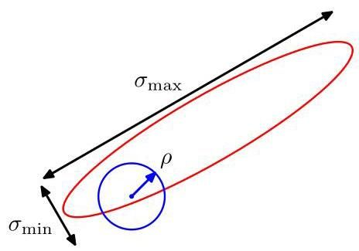

For example, suppose we have a distribution over three variables, and at step of the algorithm we have selected values , and . We first replace by a new value obtained by sampling from the conditional distri-

例如，假设我们有一个关于三个变量的分布 ，并且在算法的第 步，我们已经选择了值 和 。我们首先用一个从条件分布中采样得到的新值 替换 。

bution

分布

Next we replace by a value obtained by sampling from the conditional

接下来，我们用一个从条件分布中采样得到的值 替换 。

distribution

分布

so that the new value for is used straight away in subsequent sampling steps. Then we update with a sample drawn from

这样， 的新值会立即在后续的采样步骤中使用。然后，我们用一个从……中抽取的样本 更新 。

and so on, cycling through the three variables in turn. Gibbs sampling is summarized in Algorithm 14.3.

依此类推，依次循环遍历这三个变量。吉布斯采样总结在算法 14.3 中。

To show that this procedure samples from the required distribution, we first note that the distribution is an invariant of each of the Gibbs sampling steps individually and hence of the whole Markov chain. This follows since when we sample from , the marginal distribution is clearly invariant because the value of is unchanged. Also, each step by definition samples from the correct conditional distribution . Because these conditional and marginal distributions together specify the joint distribution, we see that the joint distribution is itself invariant.

为了证明该过程是从所需分布中采样的，我们首先注意到分布 是每个吉布斯采样步骤各自的不变量，因此也是整个马尔可夫链的不变量。这是因为当我们从 中采样时，边缘分布 显然是不变的，因为 的值没有改变。此外，根据定义，每个步骤都是从正确的条件分布 中采样的。由于这些条件分布和边缘分布共同确定了联合分布，我们可以看到联合分布本身是不变的。

The second requirement to be satisfied to ensure that the Gibbs sampling procedure samples from the correct distribution is that it is ergodic. A sufficient condition for ergodicity is that none of the conditional distributions are anywhere zero. If this is the case, then any point in -space can be reached from any other point in a finite number of steps involving one update of each of the component variables. If this requirement is not satisfied, so that some of the conditional distributions have zeros, then ergodicity, if it applies, must be proven explicitly.

为确保吉布斯采样过程从正确的分布中采样，需要满足的第二个要求是它具有遍历性。遍历性的一个充分条件是所有条件分布在任何地方都不为零。如果是这种情况，那么 空间中的任何一点都可以通过对每个分量变量进行一次更新的有限步骤从任何其他点到达。如果不满足这个要求，即某些条件分布存在零点，那么如果遍历性适用，则必须明确证明。

Algorithm 14.3: Gibbs sampling

算法 14.3:吉布斯采样

Input: Initial values

输入:初始值

Conditional distributions

条件分布

Number of iterations

迭代次数

Output: Final values

输出:最终值

for do

对于 执行

for do

对于 执行

end for

结束循环

end for

结束循环

return

返回

The distribution of initial states must also be specified to complete the algorithm, although samples drawn after many iterations will effectively become independent of this distribution. Of course, successive samples from the Markov chain will be highly correlated, and so to obtain samples that are nearly independent it will be necessary to sub-sample the sequence.

为了完善该算法，还必须指定初始状态的分布，尽管经过多次迭代后抽取的样本实际上将与该分布无关。当然，马尔可夫链的连续样本会高度相关，因此为了获得近乎独立的样本，有必要对序列进行子采样。

We can obtain the Gibbs sampling procedure as a particular instance of the Metropolis-Hastings algorithm as follows. Consider a Metropolis-Hastings sampling step involving the variable in which the remaining variables remain fixed, and for which the transition probability from to is given by . Note that because these components are unchanged by the sampling step. Also, . Thus, the factor that determines the acceptance probability in the Metropolis-Hastings (14.40) is given by

我们可以通过以下方式将吉布斯采样过程作为 Metropolis - Hastings 算法的一个特定实例来获得。考虑一个涉及变量 的 Metropolis - Hastings 采样步骤，其中其余变量 保持固定，并且从 到 的转移概率由 给出。注意， 因为这些分量在采样步骤中没有改变。此外， 。因此，决定 Metropolis - Hastings 算法(14.40)中接受概率的因子由下式给出

where we have used . Thus, the Metropolis-Hastings steps are always accepted.

这里我们使用了 。因此，Metropolis - Hastings 步骤总是被接受。

As with the Metropolis algorithm, we can gain some insight into the behaviour of Gibbs sampling by investigating its application to a Gaussian distribution. Consider a correlated Gaussian in two variables, as illustrated in Figure 14.11, having conditional distributions of width and marginal distributions of width . The typical step size is governed by the conditional distributions and will be of order . Because the state evolves according to a random walk, the number of steps needed to obtain independent samples from the distribution will be of order . Of course if the Gaussian distribution were uncorrelated, then the Gibbs sampling procedure would be optimally efficient. For this simple problem, we could rotate the coordinate system such that the new variables are uncorrelated. However, in practical applications it will generally be infeasible to find such transformations.

与 Metropolis 算法一样，我们可以通过研究吉布斯采样在高斯分布上的应用来深入了解其行为。考虑一个包含两个变量的相关高斯分布，如图 14.11 所示，其条件分布的宽度为 ，边缘分布的宽度为 。典型的步长由条件分布决定，量级为 。由于状态是根据随机游走演化的，从该分布中获得独立样本所需的步数量级为 。当然，如果高斯分布是不相关的，那么吉布斯采样过程将是最优高效的。对于这个简单的问题，我们可以旋转坐标系，使得新变量不相关。然而，在实际应用中，通常很难找到这样的变换。

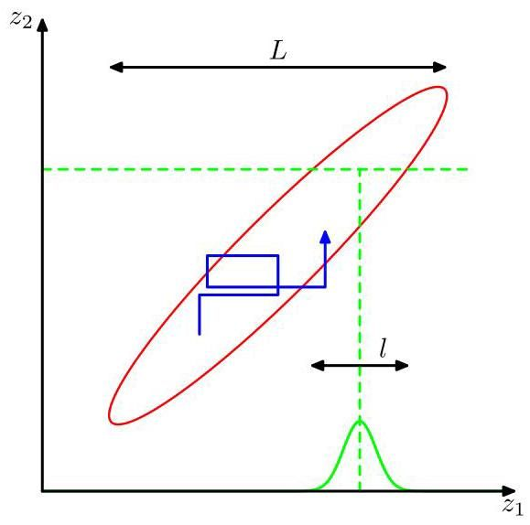

Figure 14.11 Illustration of Gibbs sampling by alternate updates of two variables whose distribution is a correlated Gaussian. The step size is governed by the standard deviation of the conditional distribution (green curve), and is , leading to slow progress in the direction of elongation of the joint distribution (red ellipse). The number of steps needed to obtain an independent sample from the distribution is .

图 14.11 展示了通过交替更新两个变量进行吉布斯采样的过程，这两个变量的分布是相关高斯分布。步长由条件分布的标准差(绿色曲线)决定，为 ，导致在联合分布(红色椭圆)的拉长方向上进展缓慢。从该分布中获得一个独立样本所需的步数为 。

One approach to reducing the random walk behaviour in Gibbs sampling is called over-relaxation (Adler, 1981). In its original form, it applies to problems for which the conditional distributions are Gaussian, which represents a more general class of distributions than the multivariate Gaussian because, for example, the non-Gaussian distribution has Gaussian conditional distributions. At each step of the Gibbs sampling algorithm, the conditional distribution for a particular component has some mean and some variance . In the over-relaxation framework, the value of is replaced with

减少吉布斯采样中随机游走行为的一种方法称为过松弛法(Adler，1981)。其原始形式适用于条件分布为高斯分布的问题，这代表了比多元高斯分布更广泛的一类分布，因为例如非高斯分布 具有高斯条件分布。在吉布斯采样算法的每一步中，特定分量 的条件分布具有某个均值 和某个方差 。在过松弛框架中， 的值被替换为

where is a Gaussian random variable with zero mean and unit variance, and is a parameter such that . For , the method is equivalent to standard Gibbs sampling, and for the step is biased to the opposite side of the mean. This step leaves the desired distribution invariant because if has mean and variance , then so too does . The effect of over-relaxation is to encourage directed motion through state space when the variables are highly correlated. The framework of ordered over-relaxation (Neal, 1999) generalizes this approach to non-Gaussian distributions.

其中 是均值为零、方差为 1 的高斯随机变量， 是一个参数，满足 。对于 ，该方法等同于标准的吉布斯采样，而对于 ，该步骤偏向于均值的另一侧。这一步骤使所需分布保持不变，因为如果 的均值为 且方差为 ，那么 也是如此。当过松弛变量高度相关时，过松弛的效果是鼓励在状态空间中进行有向运动。有序过松弛框架(Neal，1999)将这种方法推广到非高斯分布。

Exercise 14.14

练习 14.14

The practical applicability of Gibbs sampling depends on the ease with which samples can be drawn from the conditional distributions . For probability distributions specified using directed graphical models, the conditional distributions for individual nodes depend only on the variables in the corresponding Markov blanket, as illustrated in Figure 14.12. For directed graphs, a wide choice of conditional distributions for the individual nodes conditioned on their parents will lead to conditional distributions for Gibbs sampling that are log concave. The adaptive rejection sampling methods discussed in Section 14.1.4 therefore provide a framework for Monte Carlo sampling from directed graphs with broad applicability.

吉布斯采样的实际适用性取决于从条件分布 中抽取样本的难易程度。对于使用有向图模型指定的概率分布，单个节点的条件分布仅取决于相应马尔可夫毯中的变量，如图 14.12 所示。对于有向图，单个节点在其父节点条件下的多种条件分布选择将导致用于吉布斯采样的条件分布是对数凹的。因此，第 14.1.4 节中讨论的自适应拒绝采样方法为从具有广泛适用性的有向图进行蒙特卡罗采样提供了一个框架。

Figure 14.12 The Gibbs sampling method requires samples to be drawn from the conditional distribution of a variable conditioned on the remaining variables. For directed graphical models, this conditional distribution is a function of only the states of the nodes in the Markov blanket, shaded in blue, which comprises the parents, the children, and the co-parents.

图 14.12 吉布斯采样方法需要从变量 在其余变量条件下的条件分布中抽取样本。对于有向图模型，此条件分布仅是马尔可夫毯中节点状态的函数，马尔可夫毯用蓝色阴影表示，它由父节点、子节点和共同父节点组成。

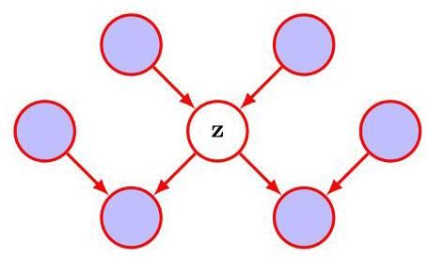

Because the basic Gibbs sampling technique considers one variable at a time, there are strong dependencies between successive samples. At the opposite extreme, if we could draw samples directly from the joint distribution (an operation that we are supposing is intractable), then successive samples would be independent. We can hope to improve on the simple Gibbs sampler by adopting an intermediate strategy in which we sample successively from groups of variables rather than individual variables. This is achieved in the blocking Gibbs sampling algorithm by choosing blocks of variables, not necessarily disjoint, and then sampling jointly from the variables in each block in turn, conditioned on the remaining variables (Jensen, Kong, and Kjaerulff, 1995).

由于基本的吉布斯采样技术一次考虑一个变量，因此连续样本之间存在很强的依赖性。在另一个极端情况下，如果我们可以直接从联合分布中抽取样本(我们假设这是难以处理的操作)，那么连续样本将是独立的。我们可以希望通过采用一种中间策略来改进简单的吉布斯采样器，在这种策略中，我们依次从变量组而不是单个变量中采样。这在分块吉布斯采样算法中通过选择变量块(不一定不相交)来实现，然后依次从每个块中的变量在其余变量条件下的联合分布中采样(Jensen、Kong 和 Kjaerulff，1995)。

# 14.2.5 Ancestral sampling

# 14.2.5 祖先采样

For many models, the joint distribution is conveniently specified in terms of a graphical model. For a directed graph with no observed variables, it is straightforward to sample from the joint distribution using the following ancestral sampling approach. The joint distribution is specified by

对于许多模型，联合分布 可以方便地用图模型来指定。对于没有观测变量的有向图，使用以下祖先采样方法从联合分布中采样是很直接的。联合分布由下式指定

where are the set of variables associated with node , and denotes the set of variables associated with the parents of node . To obtain a sample from the joint distribution, we make one pass through the set of variables in the order sampling from the conditional distributions . This is always possible because at each step, all the parent values will have been instantiated. After one pass through the graph, we will have obtained a sample from the joint distribution. This assumes that it is possible to sample from the individual conditional distributions at each node.

其中 是与节点 相关联的变量集， 表示与节点 的父节点相关联的变量集。为了从联合分布中获得一个样本，我们按照 的顺序对变量集进行一次遍历，从条件分布 中采样。这总是可行的，因为在每一步，所有父节点的值都已经被实例化。在对图进行一次遍历后，我们将从联合分布中获得一个样本。这假设可以从每个节点的单个条件分布中采样。

Now consider a directed graph in which some of the nodes, which comprise the evidence set , are instantiated with observed values. We can in principle extend the above procedure, at least for nodes representing discrete variables, to give the following logic sampling approach (Henrion, 1988), which can be seen as a special case of importance sampling. At each step, when a sampled value is obtained for a variable whose value is observed, the sampled value is compared to the observed value, and if they agree then the sample value is retained and the algorithm proceeds to the next variable in turn. However, if the sampled value and the observed value disagree, then the whole sample so far is discarded and the algorithm starts again with the first node in the graph. This algorithm samples correctly from the posterior distribution because it corresponds simply to drawing samples from the joint distribution of hidden variables and data variables and then discarding those samples that disagree with the observed data (with the slight saving of not continuing with the sampling from the joint distribution as soon as one contradictory value is observed). However, the overall probability of accepting a sample from the posterior decreases rapidly as the number of observed variables increases and as the number of states that those variables can take increases, and so this approach is rarely used in practice.

现在考虑一个有向图，其中一些节点(构成证据集 )被实例化为观测值。原则上，我们可以扩展上述过程，至少对于表示离散变量的节点，得到以下逻辑采样方法(Henrion，1988)，这可以看作是重要性采样的一个特例。在每一步，当为一个其值已被观测到的变量 获得一个采样值时，将采样值与观测值进行比较，如果它们一致，则保留采样值，算法依次处理下一个变量。然而，如果采样值和观测值不一致，则到目前为止的整个样本都被丢弃，算法从图中的第一个节点重新开始。该算法能正确地从后验分布中采样，因为它简单地对应于从隐藏变量和数据变量的联合分布中抽取样本，然后丢弃那些与观测数据不一致的样本(稍有节省的是，一旦观察到一个矛盾值，就不再继续从联合分布中采样)。然而，随着观测变量的数量增加以及这些变量可能取值的状态数量增加，接受后验样本的总体概率会迅速下降，因此这种方法在实践中很少使用。

Section 14.1.5

第 14.1.5 节

An improvement on this approach is called likelihood weighted sampling (Fung and Chang, 1990; Shachter and Peot, 1990). It is based on ancestral sampling combined with importance sampling. For each variable in turn, if that variable is in the evidence set, then it is just set to its instantiated value. If it is not in the evidence set, then it is sampled from the conditional distribution in which the conditioning variables are set to their currently sampled values. The weighting associated with the resulting sample is then given by

对这种方法的一种改进称为似然加权采样(Fung 和 Chang，1990；Shachter 和 Peot，1990)。它基于祖先采样与重要性采样相结合。依次对每个变量进行处理，如果该变量在证据集中，则将其设置为其实例化的值。如果它不在证据集中，则从条件分布 中采样，其中条件变量被设置为它们当前的采样值。然后，与所得样本 相关联的权重由下式给出

Exercise 14.15

练习 14.15

This method can be further extended using self-importance sampling (Shachter and Peot, 1990) in which the importance sampling distribution is continually updated to reflect the current estimated posterior distribution.

这种方法可以使用自重要性采样(Shachter 和 Peot，1990)进一步扩展，在该方法中，重要性采样分布会不断更新以反映当前估计的后验分布。

# 14.3. Langevin Sampling

# 14.3. 朗之万采样

The Metropolis-Hastings algorithm draws samples from a probability distribution by creating a Markov chain of candidate samples using a proposal distribution and then accepting or rejecting them using the criterion (14.40). This can be relatively inefficient since the proposal distribution is often a simple, fixed distribution that can generate updates in any direction in the data space, leading to a random walk.

Metropolis-Hastings 算法通过使用提议分布创建候选样本的马尔可夫链，然后使用准则(14.40)接受或拒绝这些样本，从而从概率分布中抽取样本。这可能相对低效，因为提议分布通常是一个简单的固定分布，它可以在数据空间的任何方向上生成更新，从而导致随机游走。

We have seen that when training neural networks, it is hugely advantageous to make use of the gradient of the log likelihood with respect to the learnable parameters of the model in order to maximize the likelihood function. By analogy, we can introduce Markov chain sampling algorithms that make use of the gradient of the probability density with respect to the data vector so as to take steps that preferentially move towards regions of higher probability. One such technique is called Hamiltonian Monte Carlo, also known as hybrid Monte Carlo. This again makes use of a Metropolis acceptance test (Duane et al., 1987; Bishop, 2006). Here we will focus on a different approach that is widely used in deep learning, called Langevin sampling. Although it avoids the use of an acceptance test, the algorithm has to be designed carefully to ensure that the resulting samples are unbiased. An important application of Langevin sampling arises in the context of machine learning models defined in terms of energy functions.

我们已经看到，在训练神经网络时，利用对数似然函数关于模型可学习参数的梯度来最大化似然函数具有巨大的优势。类似地，我们可以引入马尔可夫链采样算法，该算法利用概率密度关于数据向量的梯度，以便优先朝着概率更高的区域移动。一种这样的技术称为哈密顿蒙特卡罗，也称为混合蒙特卡罗。这同样使用了 Metropolis 接受测试(Duane 等人，1987；Bishop，2006)。在这里，我们将关注深度学习中广泛使用的另一种方法，称为朗之万采样。尽管它避免了使用接受测试，但必须仔细设计该算法以确保得到的样本是无偏的。朗之万采样的一个重要应用出现在根据能量函数定义的机器学习模型的背景下。

# 14.3.1 Energy-based models

# 14.3.1 基于能量的模型

Many generative models can be expressed as conditional probability distributions where is the data vector and represents a vector of learnable parameters. Such models can be trained by maximizing the corresponding likelihood function defined with respect to a training data set. However, to represent a valid probability distribution, the model must satisfy

许多生成模型可以表示为条件概率分布 ，其中 是数据向量， 表示可学习参数的向量。此类模型可以通过最大化相对于训练数据集定义的相应似然函数来进行训练。然而，为了表示一个有效的概率分布，模型必须满足

Ensuring that this requirement is met can significantly limit the allowable forms for the model. If we put aside the normalization constraint then we can consider a much broader class of models called energy-based models (LeCun et al., 2006). Suppose we have a function , called the energy function, which is a real-valued function of its arguments but which has no other constraints. The exponential is a non-negative quantity and can therefore be viewed as an unnormalized probability distribution over . Here the introduction of the minus sign in the exponent is simply a convention, and it means that higher values of energy correspond to lower values of probability. We can then define a normalized distribution

确保满足这一要求会显著限制模型的允许形式。如果我们抛开归一化约束，那么我们可以考虑一类更广泛的模型，称为基于能量的模型(LeCun 等人，2006 年)。假设我们有一个函数 ，称为能量函数，它是其自变量的实值函数，但没有其他约束。指数 是一个非负量，因此可以看作是关于 的未归一化概率分布。这里在指数中引入负号只是一种约定，它意味着能量值越高对应概率值越低。然后我们可以定义一个归一化分布

using

使用

Exercise 14.16

练习 14.16

where the normalizing constant , known as the partition function, is defined by

其中归一化常数 ，称为配分函数，定义为

The energy function is often modelled using a deep neural network with input vector and a scalar output , where represents the weights and biases in the network.

能量函数通常使用深度神经网络进行建模，该网络的输入向量为 ，标量输出为 ，其中 表示网络中的权重和偏置。

Note that the partition function depends on , which creates problems for training. For example, the log likelihood function for a data set of i.i.d. data has the form

请注意，配分函数依赖于 ，这给训练带来了问题。例如，对于独立同分布数据集 ，对数似然函数具有如下形式

Exercise 14.17

练习 14.17

To compute the gradient of with respect to , we need to know the form of . However, for many choices of the energy function , it will be impractical to evaluate the partition function in (14.51) because this involves integrating (or summing for discrete variables) over all the whole of -space. The term ’energy-based model’ is generally used for models where this integral is intractable. Note, however, that probabilistic models can be seen as special cases of energy-based models, and therefore many of the models discussed in this book can be viewed as energy-based models. The big advantage of energy-based models, therefore, is their flexibility in that they bypass the requirement for normalization. A corresponding disadvantage, however, is that since the normalizing constant is unknown, they can be more difficult to train.

为了计算 关于 的梯度，我们需要知道 的形式。然而，对于能量函数 的许多选择，计算 (14.51) 中的配分函数是不切实际的，因为这涉及对整个 空间进行积分(对于离散变量则是求和)。术语“基于能量的模型”通常用于指那些该积分难以处理的模型。不过要注意，概率模型可以看作是基于能量的模型的特殊情况，因此本书中讨论的许多模型都可以视为基于能量的模型。因此，基于能量的模型的一大优势在于其灵活性，即它们绕过了归一化的要求。然而，相应的一个缺点是，由于归一化常数未知，它们可能更难训练。

# 14.3.2 Maximizing the likelihood

# 14.3.2 最大化似然

Various approximation methods have been developed to train energy-based models without having to evaluate the partition function (Song and Kingma, 2021). Here we look at techniques based on Markov chain Monte Carlo. An alternative approach, called score matching, will be discussed in the context of diffusion models.

已经开发出了各种近似方法来训练基于能量的模型，而无需计算配分函数(Song 和 Kingma，2021)。这里我们将探讨基于马尔可夫链蒙特卡罗的技术。另一种称为得分匹配的方法将在扩散模型的背景下进行讨论。

Chapter 20

第 20 章

We have seen that for energy-based models, the likelihood function cannot be evaluated explicitly due to the unknown partition function . However, we can make use of Monte Carlo sampling methods to approximate the gradient of the log likelihood with respect to the model parameters. Once an energy-based model has been trained, by whatever means, we also need a way to draw samples from the model, and again we can make use of Monte Carlo methods.

我们已经看到，对于基于能量的模型，由于未知的配分函数 ，似然函数无法被显式计算。然而，我们可以利用蒙特卡罗采样方法来近似对数似然关于模型参数的梯度。一旦基于能量的模型通过任何方式训练完成，我们还需要一种从该模型中抽取样本的方法，同样，我们可以利用蒙特卡罗方法。

Using (14.50), the gradient, with respect to the model parameters, of the log likelihood function for an energy-based model can be written in the form

利用式(14.50)，基于能量的模型的对数似然函数关于模型参数的梯度可以写成如下形式

This is the likelihood function for a single data point , but in practice we want to maximize the likelihood defined over a training set of data points drawn from some unknown distribution . If we assume the data points are i.i.d., then we can consider the gradient of the expectation of the log likelihood with respect to , which is then given by

这是单个数据点 的似然函数，但在实践中，我们希望最大化在从某个未知分布 中抽取的训练数据集上定义的似然。如果我们假设数据点是独立同分布的，那么我们可以考虑对数似然关于 的期望的梯度，其由下式给出

where we have made use of the fact that the final term does not depend on and can therefore be taken outside the expectation. The partition function is assumed to be unknown, but we can make use of (14.51) and rearrange to obtain

这里我们利用了这样一个事实，即最后一项 不依赖于 ，因此可以提到期望外面。假设配分函数 是未知的，但我们可以利用式(14.51)并重新整理得到

Exercise 14.18

练习 14.18

The right-hand side of (14.55) corresponds to an expectation over the model distribution given by

式(14.55)的右侧对应于由下式给出的模型分布 上的期望

Exercise 14.18

练习 14.18

Combining (14.54), (14.55), and (14.56) we obtain

结合 (14.54)、(14.55) 和 (14.56)，我们得到

This result is illustrated in Figure 14.13, and has a nice interpretation, as follows. Our goal is to find values for the parameters that maximize the likelihood function, and therefore consider a small change to in the direction of the gradient . From (14.57) we see that expected value of this gradient can be expressed as two terms, having opposite signs. The first term on the right-hand side of (14.57) acts to decrease , and therefore to increase the probability density defined by the model, for points drawn from . The second term on the right-hand side of (14.57) acts to increase the value of , and therefore to decrease the probability density defined by the model, for data points drawn from the model itself. In regions where the model density exceeds the training data density, the net effect will be to increase the energy and therefore reduce the probability. Conversely, in regions where training data density exceeds the model density, the net effect will be to reduce the energy and therefore increase the probability density. Together these two terms move probability mass away from regions where there is a low density of training data and towards regions of high data density, as desired. The two terms will be equal in magnitude when the model distribution matches the data distribution, at which point the gradient on the left-hand-side of (14.57) will equal zero.

这一结果如图 14.13 所示，并且有如下很好的解释。我们的目标是找到参数 的值，使似然函数最大化，因此考虑 沿梯度 方向的一个小变化。从 (14.57) 我们看到，这个梯度的期望值可以表示为两项，符号相反。(14.57) 右侧的第一项会使 减小，从而增加模型定义的概率密度，对于从 中抽取的点 而言。(14.57) 右侧的第二项会使 的值增加，从而减小模型定义的概率密度，对于从模型本身抽取的数据点而言。在模型密度超过训练数据密度的区域，净效应将是增加能量，从而降低概率。相反，在训练数据密度超过模型密度的区域，净效应将是降低能量，从而增加概率密度。如我们所愿，这两项共同作用，将概率质量从训练数据密度低的区域移向数据密度高的区域。当模型分布与数据分布匹配时，这两项的大小将相等，此时 (14.57) 左侧的梯度将等于零。

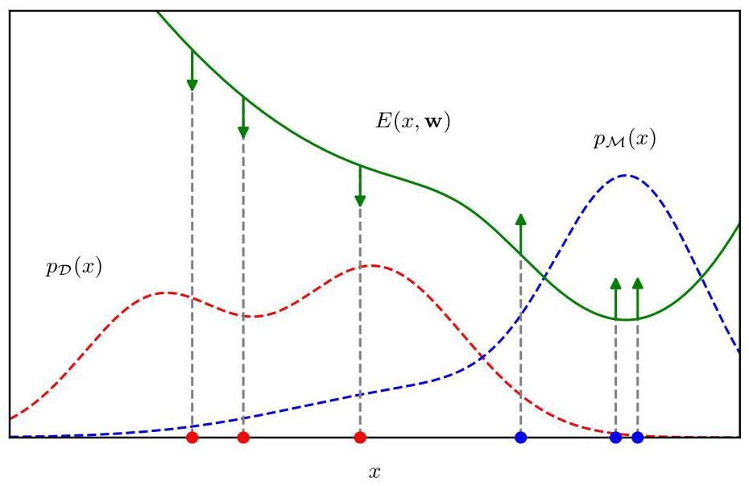

Figure 14.13 Illustration of the training of an energy-based model by maximizing the likelihood, showing the energy function in green along with the associated model distribution and the true data distribution . Increasing the expected log likelihood by using (14.57) pushes the energy function up at points corresponding to samples from the model (shown as blue dots) and pushes it down at points corresponding to samples from the data set (shown as red dots).

图 14.13 通过最大化似然对基于能量的模型进行训练的图示，绿色显示能量函数 以及相关的模型分布 和真实数据分布 。使用 (14.57) 增加期望对数似然，会使能量函数在对应于模型样本的点(显示为蓝色点)处上升，在对应于数据集样本的点(显示为红色点)处下降。

# 14.3.3 Langevin dynamics

# 14.3.3 朗之万动力学

When applying (14.57) as a practical training method, we need to approximate the two terms on the right-hand side. For any given value of , we can evaluate using automatic differentiation. For the first term in (14.57), we can use the training data set to estimate the expectation over :

当将 (14.57) 作为一种实际的训练方法应用时，我们需要对右侧的两项进行近似。对于 的任何给定值，我们可以使用自动微分来计算 。对于 (14.57) 中的第一项，我们可以使用训练数据集来估计关于 的期望:

The second term is more challenging because we need to draw samples from the model distribution defined by an energy function whose corresponding partition function is intractable. This can be done using Markov chain Monte Carlo methods. One popular approach is called stochastic gradient Langevin dynamics or simply Langevin sampling (Parisi, 1981; Welling and Teh, 2011). This term depends on the distribution only through the score function, which is defined to be the gradient of the log likelihood with respect to the data vector , and is given by

第二项更具挑战性，因为我们需要从由能量函数定义的模型分布中抽取样本，而该能量函数对应的配分函数难以处理。这可以使用马尔可夫链蒙特卡罗方法来完成。一种流行的方法称为随机梯度朗之万动力学，或简称为朗之万采样(Parisi，1981；Welling 和 Teh，2011)。这一项仅通过得分函数依赖于分布 ，得分函数被定义为对数似然关于数据向量 的梯度，其表达式为

It is worth emphasising that this gradient is taken with respect to the data point and is therefore not the usual gradient with respect to the learnable parameters . If we substitute (14.50) into (14.59) we obtain

值得强调的是，这个梯度是关于数据点 取的，因此不是通常关于可学习参数 的梯度。如果我们将 (14.50) 代入 (14.59)，我们得到

where we see that the partition function no longer appears at it is independent of .

在这里我们看到配分函数不再出现，因为它与 无关。

We start by drawing an initial value from a prior distribution, and then we iterate the following Markov chain steps:

我们首先从先验分布中抽取一个初始值 ，然后迭代以下马尔可夫链步骤:

where are independent samples from a zero-mean, unit-covariance Gaussian distribution, and the parameter controls the step size. Each iteration of the Langevin equation takes a step in the direction of the gradient of the log likelihood, and then adds Gaussian noise. It can be show that, in the limits of and , the value of is an independent sample from the distribution . Langevin sampling is summarized in Algorithm 14.4.

其中 是来自零均值、单位协方差高斯分布的独立样本，参数 控制步长。朗之万方程的每次迭代都沿着对数似然梯度的方向迈出一步，然后添加高斯噪声。可以证明，在 和 的极限情况下， 的值是来自分布 的独立样本。朗之万采样总结在算法 14.4 中。

We can repeat the process to generate a set of samples and then approximate the second term in (14.57) using

我们可以重复这个过程来生成一组样本 ，然后使用以下方法近似 (14.57) 中的第二项

Running long Markov chains to generate independent samples can be computationally expensive, and so we need to consider practical approximations. One approach is called contrastive divergence (Hinton, 2002). Here the samples used to evaluate (14.62) are obtained by running a Monte Carlo chain starting with one of the training data points . If the chain is run for a large number of steps, then the resulting value will be essentially an unbiased sample from the model distribution. Instead Hinton (2002) proposes running for only a few steps of Monte Carlo, perhaps even as few as one step, which is computationally much less costly. The resulting sample will be far from unbiased and will lie close to the data manifold. As a result, the effect of using gradient descent will be to shape the energy surface, and hence the probability density, only in the neighbourhood of the data manifold. This can prove effective for tasks such as discrimination but is expected to be less effective in learning a generative model.

运行长马尔可夫链来生成独立样本在计算上可能成本高昂，因此我们需要考虑实际的近似方法。一种方法称为对比散度(Hinton，2002)。这里，用于评估(14.62)的样本是通过从一个训练数据点 开始运行蒙特卡罗链获得的。如果链运行大量步骤，那么得到的值本质上将是模型分布的无偏样本。相反，Hinton(2002)建议仅运行几步蒙特卡罗，甚至可能少至一步，这在计算上成本要低得多。得到的样本远非无偏，并且将靠近数据流形。因此，使用梯度下降的效果将是仅在数据流形的邻域内塑造能量表面，进而塑造概率密度。这对于诸如判别等任务可能是有效的，但预计在学习生成模型方面效果较差。

Algorithm 14.4: Langevin sampling

算法 14.4:朗之万采样

Input: Initial value

输入:初始值

Probability density

概率密度

Learning rate parameter

学习率参数

Number of iterations

迭代次数

Output: Final value

输出:最终值

for do

end for

return // Final value

# Exercises

# 练习

14.1 (★) Show that defined by (14.2) is an unbiased estimator, in other words that the expectation of the right-hand side is equal to .

14.1 (★) 证明由 (14.2) 定义的 是一个无偏估计量，换句话说，等式右侧的期望等于 。

14.2 (*) Show that defined by (14.2) has variance given by (14.4).

14.2 (*) 证明由 (14.2) 定义的 的方差由 (14.4) 给出。

14.3 (⋆) Suppose that is a random variable with uniform distribution over and that we transform using where is given by (14.6). Show that has the distribution .

14.3 (⋆) 假设 是一个在 上服从均匀分布的随机变量，并且我们使用 对 进行变换，其中 由 (14.6) 给出。证明 服从分布 。

14.4 Given a random variable that is uniformly distributed over , find a transformation such that has a Cauchy distribution given by (14.8).

14.4 已知一个在 上服从均匀分布的随机变量 ，求一个变换 ，使得 服从由 (14.8) 给出的柯西分布。

14.5 Suppose that and are uniformly distributed over the unit circle, as shown in Figure 14.3, and that we make the change of variables given by (14.10) and (14.11). Show that will be distributed according to (14.12).

14.5 假设 和 在单位圆上均匀分布，如图 14.3 所示，并且我们进行由 (14.10) 和 (14.11) 给出的变量变换。证明 将按照 (14.12) 分布。

14.6 Let be a -dimensional random variable having a Gaussian distribution with zero mean and unit covariance matrix, and suppose that the positive definite symmetric matrix has the Cholesky decomposition , where is a lower-triangular matrix (i.e., one with zeros above the leading diagonal). Show that the variable has a Gaussian distribution with mean and covariance . This provides a technique for generating samples from a general multivariate Gaussian using samples from a univariate Gaussian having zero mean and unit variance.

14.6 设 是一个 维随机变量，具有零均值和单位协方差矩阵的高斯分布，并且假设正定对称矩阵 具有 Cholesky 分解 ，其中 是一个下三角矩阵(即主对角线以上元素为零的矩阵)。证明变量 具有均值为 且协方差为 的高斯分布。这提供了一种使用来自零均值和单位方差的单变量高斯分布的样本生成来自一般多元高斯分布样本的技术。

14.7 In this exercise, we show more carefully that rejection sampling does indeed draw samples from the desired distribution . Suppose the proposal distribution is . Show that the probability of a sample value being accepted is given by where is any unnormalized distribution that is proportional to , and the constant is set to the smallest value that ensures for all values of . Note that the probability of drawing a value is given by the probability of drawing that value from times the probability of accepting that value given that it has been drawn. Make use of this, along with the sum and product rules of probability, to write down the normalized form for the distribution over , and show that it equals .

14.7 在这个练习中，我们更仔细地证明拒绝采样确实从期望分布 中抽取样本。假设提议分布是 。证明样本值 被接受的概率由 给出，其中 是任何与 成比例的未归一化分布，并且常数 被设置为确保对于 的所有值都有 的最小值。注意，抽取值 的概率由从 中抽取该值的概率乘以在已经抽取该值的情况下接受该值的概率给出。利用这一点，以及概率的求和与乘积规则，写出 上分布的归一化形式，并证明它等于 。

14.8 Suppose that has a uniform distribution over the interval . Show that the variable has a Cauchy distribution given by (14.16).

14.8 假设 在区间 上具有均匀分布。证明变量 具有由 (14.16) 给出的柯西分布。

Determine expressions for the coefficients in the envelope distribution (14.17) for adaptive rejection sampling using the requirements of continuity and normalization.

使用连续性和归一化的要求，确定自适应拒绝采样的包络分布 (14.17) 中系数 的表达式。

14.10 By making use of the technique discussed in Section 14.1.2 for sampling from a single exponential distribution, devise an algorithm for sampling from the piecewise exponential distribution defined by (14.17).

14.10 利用第 14.1.2 节中讨论的从单个指数分布采样的技术，设计一种从由 (14.17) 定义的分段指数分布采样的算法。

14.11 (*) Show that the simple random walk over the integers defined by (14.28), (14.29), and (14.30) has the property that and hence by induction that .

14.11 (*) 证明由 (14.28)、(14.29) 和 (14.30) 定义的整数上的简单随机游走具有 的性质，因此通过归纳法可得 。

14.12 Show that the Gibbs sampling algorithm, discussed in Section 14.2.4, satisfies detailed balance as defined by (14.34).

14.12 证明在 14.2.4 节中讨论的吉布斯采样算法满足由 (14.34) 定义的细致平衡条件。

14.13 (*) Consider the distribution shown in Figure 14.14. Discuss whether the standard Gibbs sampling procedure for this distribution is ergodic and therefore whether it would sample correctly from this distribution

14.13 (*) 考虑图 14.14 所示的分布。讨论针对该分布的标准吉布斯采样过程是否具有遍历性，以及因此它是否能从该分布中正确采样。

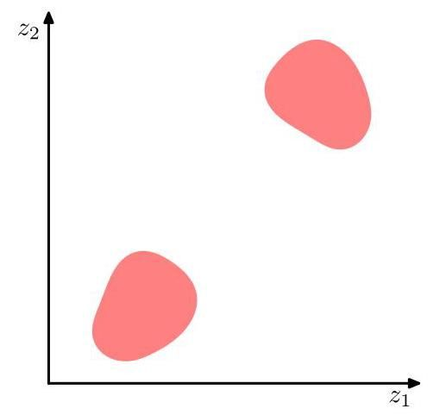

Figure 14.14 A probability distribution over two variables and that is uniform over the shaded regions and zero everywhere else.

图 14.14 两个变量 和 的概率分布，在阴影区域上是均匀的，在其他地方为零。

14.14 (*) Verify that the over-relaxation update (14.46), in which has mean and variance and where has zero mean and unit variance gives a value with mean and variance . 458 14. SAMPLING

14.14 (*) 验证过松弛更新 (14.46)，其中 的均值为 ，方差为 ，且 的均值为零，方差为 1，可得到一个均值为 ，方差为 的值 。458 14. 采样

14.15 (*) Show that in likelihood weighted sampling from a directed graph the importance sampling weights are given by (14.48).

14.15 (*) 证明在从有向图进行似然加权采样时，重要性采样权重由 (14.48) 给出。

14.16 Show that the distribution (14.50) is normalized with respect to provided satisfies (14.51).

14.16 证明:若 满足式 (14.51)，则分布 (14.50) 关于 是归一化的。

14.17 By making use of (14.50) show that the gradient of the log likelihood function for an energy-based model can be written in the form (14.52).

14.17 利用式 (14.50) 证明:基于能量的模型的对数似然函数的梯度可以写成式 (14.52) 的形式。

14.18 By making use of (14.54),(14.55), and (14.56), show that the gradient of the log likelihood function for an energy-based model can be written in the form (14.57).

14.18 利用式 (14.54)、(14.55) 和 (14.56) 证明:基于能量的模型的对数似然函数的梯度可以写成式 (14.57) 的形式。

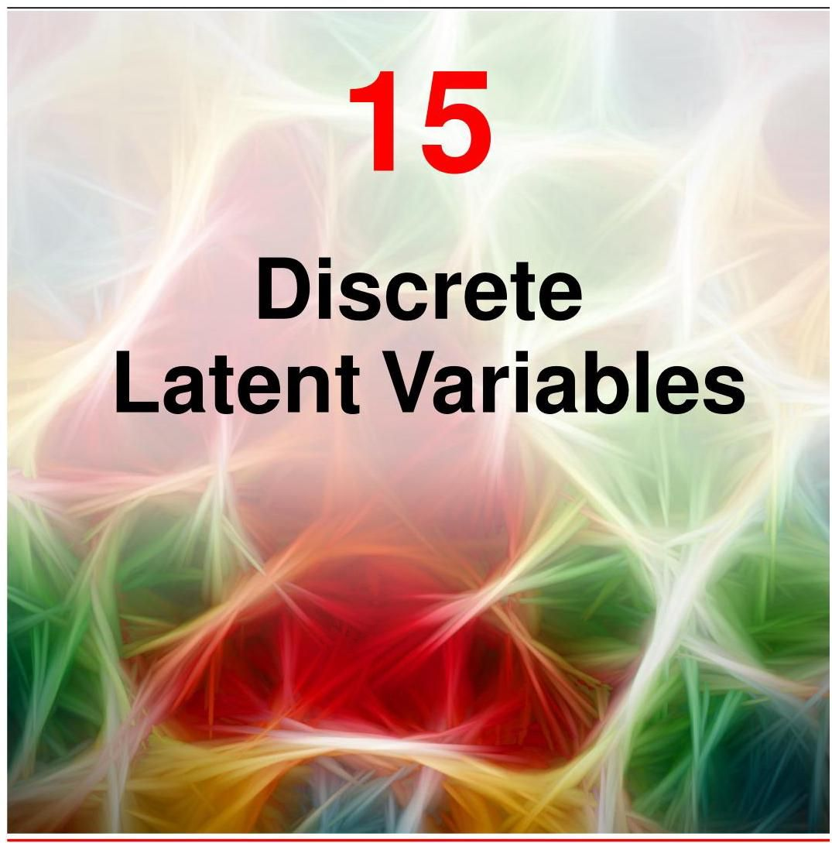

We have seen how complex distributions can be constructed by combining multiple simple distributions and how the resulting models can be described by directed graphs. In addition to the observed variables, which form part of the data set, such models often introduce additional hidden, or latent, variables. These might correspond to specific quantities involved in the data generation process, such as the unknown orientation of an object in three-dimensional space in the case of images, or they may be introduced simply as modelling constructs to allow much richer models to be created. If we define a joint distribution over observed and latent variables, the corresponding distribution of the observed variables alone is obtained by marginal-ization. This allows relatively complex marginal distributions over observed variables to be expressed in terms of more tractable joint distributions over the expanded space of observed and latent variables.

我们已经了解了如何通过组合多个简单分布来构建复杂分布，以及如何用有向图描述由此产生的模型。除了构成数据集一部分的观测变量之外，此类模型通常还会引入额外的隐藏变量或潜在变量。这些变量可能对应于数据生成过程中涉及的特定量，例如在图像的情况下，对应于三维空间中物体的未知方向；或者，引入这些变量仅仅是作为建模构造，以便创建更丰富的模型。如果我们定义观测变量和潜在变量的联合分布，那么仅观测变量的相应分布可以通过边缘化得到。这使得可以用观测变量和潜在变量扩展空间上更易处理的联合分布来表示观测变量上相对复杂的边缘分布。

Chapter 11

第 11 章

In this chapter, we will see that marginalizing over discrete latent variables gives rise to mixture distributions. Our focus will be on mixtures of Gaussians that provide a good illustration of mixture distributions and that are also widely used in machine learning. One simple application for mixture models is to discover clusters in data, and we begin our discussion by considering a technique for clustering called the -means algorithm, which corresponds to a particular non-probabilistic limit of Gaussian mixtures. Then we introduce the latent-variable view of mixture distributions in which the discrete latent variables can be interpreted as defining assignments of data points to specific components of the mixture.

在本章中，我们将看到对离散潜在变量进行边缘化会产生混合分布。我们将重点关注高斯混合模型，它很好地阐释了混合分布，并且在机器学习中也被广泛使用。混合模型的一个简单应用是发现数据中的聚类，我们首先讨论一种称为 -均值算法的聚类技术，它对应于高斯混合模型的一种特定非概率极限情况。然后，我们介绍混合分布的潜在变量视角，其中离散潜在变量可以解释为将数据点分配到混合模型的特定分量。

A general technique for finding maximum likelihood estimators in latent-variable models is the expectation-maximization (EM) algorithm. We first use the Gaussian mixture distribution to motivate the EM algorithm in an informal way, and then we give a more careful treatment based on the latent-variable viewpoint. Finally we provide a general perspective by introducing the evidence lower bound (ELBO), which will play an important role in generative models such as variational autoencoders and diffusion models.

在潜变量模型中寻找最大似然估计量的一种通用技术是期望最大化(EM)算法。我们首先使用高斯混合分布以一种非正式的方式引入 EM 算法，然后基于潜变量的观点进行更严谨的处理。最后，我们通过引入证据下界(ELBO)提供一个通用视角，它将在变分自编码器和扩散模型等生成模型中发挥重要作用。

# 15.1. -means Clustering

# 15.1. -均值聚类

We begin by considering the problem of identifying groups, or clusters, of data points in a multi-dimensional space. Suppose we have a data set consisting of observations of a -dimensional Euclidean variable . Our goal is to partition the data set into some number of clusters, where we will suppose for the moment that the value of is given. Intuitively, we might think of a cluster as comprising a group of data points whose inter-point distances are small compared with the distances to points outside the cluster. We can formalize this notion by first introducing a set of -dimensional vectors , where , in which is a ’prototype’ associated with the th cluster. As we will see shortly, we can think of the as representing the centres of the clusters. Our goal is then to find a set of cluster vectors , along with an assignment of data points to clusters, such that the sum of the squares of the distances of each data point to its closest cluster vector is a minimum.

我们首先考虑在多维空间中识别数据点的组或簇的问题。假设我们有一个数据集 ，它由对一个 维欧几里得变量 的 次观测组成。我们的目标是将数据集划分为 个簇，目前我们假设 的值是已知的。直观地说，我们可以将一个簇看作是一组数据点，这些数据点之间的距离相比于它们到簇外点的距离要小。我们可以通过首先引入一组 维向量 来形式化这个概念，其中 ，这里 是与第 个簇相关联的“原型”。正如我们很快会看到的，我们可以将 看作是簇的中心。然后我们的目标是找到一组簇向量 ，以及将数据点分配到簇的方案，使得每个数据点到其最近的簇向量 的距离的平方和最小。

It is convenient at this point to define some notation to describe the assignment of data points to clusters. For each data point , we introduce a corresponding set of binary indicator variables , where . These indicators describe which of the clusters the data point is assigned to, so that if data point is assigned to cluster then , and for . This is an example of the 1-of- coding scheme. We can then define an error function:

此时，定义一些符号来描述数据点到簇的分配是很方便的。对于每个数据点 ，我们引入一组相应的二进制指示变量 ，其中 。这些指示变量描述了数据点 被分配到 个簇中的哪一个，因此如果数据点 被分配到簇 ，那么 ，并且对于 有 。这是 1-of- 编码方案的一个例子。然后我们可以定义一个误差函数:

which represents the sum of the squares of the distances of each data point to its assigned vector . Our goal is to find values for the and the so as to minimize . We can do this through an iterative procedure in which each iteration involves two successive steps corresponding to successive optimizations with respect to the and the . First we choose some initial values for the . Then in the first step, we minimize with respect to the , keeping the fixed. In the second step, we minimize with respect to the , keeping fixed. This two-step optimization is then repeated until convergence. We will see that these two stages of updating and updating correspond, respectively, to the E (expectation) and M (maximization) steps of the EM algorithm, and to emphasize this, we will use the terms E step and M step in the context of the -means algorithm.

它表示每个数据点到其分配向量 的距离的平方和。我们的目标是找到 和 的值，以使 最小化。我们可以通过一个迭代过程来实现这一点，在这个过程中，每次迭代包括两个连续的步骤，分别对应于关于 和 的连续优化。首先，我们为 选择一些初始值。然后在第一步中，我们在固定 的情况下，关于 最小化 。在第二步中，我们在固定 的情况下，关于 最小化 。然后重复这个两步优化过程，直到收敛。我们将看到，更新 和更新 的这两个阶段分别对应于 EM 算法的 E(期望)步骤和 M(最大化)步骤，为了强调这一点，我们将在 -均值算法的上下文中使用 E 步骤和 M 步骤这两个术语。

Section 15.3

第 15.3 节

Consider first the determination of the with the held fixed (the E step). Because in (15.1) is a linear function of the , this optimization can be performed easily to give a closed-form solution. The terms involving different are independent, and so we can optimize for each separately by choosing to be 1 for whichever value of gives the minimum value of . In other words, we simply assign the th data point to the closest cluster centre. More formally, this can be expressed as

首先考虑在固定 的情况下确定 (E 步)。由于 (15.1) 中的 是 的线性函数，因此可以轻松进行此优化以得到封闭形式的解。涉及不同 的项是相互独立的，因此我们可以通过选择 为 1(对于使 取最小值的 的值)来分别对每个 进行优化。换句话说，我们只需将第 个数据点分配给最近的聚类中心。更正式地说，这可以表示为

Now consider the optimization of the with the held fixed (the M step). The objective function is a quadratic function of , and it can be minimized by setting its derivative with respect to to zero giving

现在考虑在固定 的情况下对 进行优化(M 步)。目标函数 是 的二次函数，通过将其关于 的导数设为零可以使其最小化，得到

which we can easily solve for to give

我们可以轻松求解 得到

The denominator in this expression is equal to the number of points assigned to cluster , and so this result has a simple interpretation, namely that is equal to the mean of all the data points assigned to cluster . For this reason, the procedure is known as the -means algorithm (Lloyd,1982). It is summarized in Algorithm 15.1. Because the assignments are discrete and each iteration will not lead to an increase in the error function, the -means algorithm is guaranteed to converge in a finite number of steps.

此表达式中的分母等于分配给聚类 的点数，因此这个结果有一个简单的解释，即 等于分配给聚类 的所有数据点 的均值。出于这个原因，该过程被称为 -均值算法(Lloyd，1982)。它总结在算法 15.1 中。由于分配 是离散的，并且每次迭代不会导致误差函数增加，因此 -均值算法保证在有限步数内收敛。

Exercise 15.1

练习 15.1

The two phases of reassigning data points to clusters and recomputing the cluster means are repeated in turn until there is no further change in the assignments (or until some maximum number of iterations is exceeded). However, this approach may converge to a local rather than a global minimum of . The convergence properties of the -means algorithm were studied by MacQueen (1967).

将数据点重新分配到聚类以及重新计算聚类均值这两个阶段依次重复，直到分配不再发生进一步变化(或者直到超过某个最大迭代次数)。然而，这种方法可能会收敛到 的局部最小值而非全局最小值。MacQueen(1967)研究了 -均值算法的收敛性质。

The -means algorithm is illustrated in Figure 15.1 using data derived from eruptions of the Old Faithful geyser in Yellowstone National Park. The data set consists of 272 data points, each of which gives the duration of an eruption on the Algorithm 15.1: -means algorithm

-均值算法如图 15.1 所示，该图使用了来自黄石国家公园老忠实间歇泉喷发的数据。数据集由 272 个数据点组成，每个数据点给出了一次喷发的持续时间(在算法 15.1: -均值算法的横轴上)以及到下一次喷发的时间(在纵轴上)。

Section 3.2.9

3.2.9 节

Input: Initial prototype vectors

输入:初始原型向量

Data set

数据集

Output: Final prototype vectors

输出:最终原型向量

Initially set all assignments to zero

repeat

// Update assignments

for do

end for

// Update prototype vectors

for do

end for

until Assignments unchanged

return

horizontal axis and the time to the next eruption on the vertical axis. Here we have made a linear re-scaling of the data, known as standardizing, such that each of the variables has zero mean and unit standard deviation.

这里我们对数据进行了线性重新缩放，即标准化，使得每个变量的均值为零，标准差为 1。

For this example, we have chosen and so the assignment of each data point to the nearest cluster centre is equivalent to a classification of the data points according to which side they lie of the perpendicular bisector of the two cluster centres. A plot of the cost function given by (15.1) for the Old Faithful example is shown in Figure 15.2. Note that we have deliberately chosen poor initial values for the cluster centres so that the algorithm takes several steps before convergence. In practice, a better initialization procedure would be to choose the cluster centres to be equal to a random subset of data points. Also note that the -means algorithm is often used to initialize the parameters in a Gaussian mixture model before applying the EM algorithm.

对于这个例子，我们选择了 ，因此将每个数据点分配到最近的聚类中心，等同于根据数据点位于两个聚类中心垂直平分线的哪一侧对其进行分类。图 15.2 展示了老忠实间歇泉例子中由式 (15.1) 给出的代价函数 的曲线图。请注意，我们故意为聚类中心选择了较差的初始值，以便算法在收敛前需要经过几个步骤。在实践中，更好的初始化方法是选择聚类中心 等于 个数据点的随机子集。还要注意， -均值算法通常用于在应用 EM 算法之前初始化高斯混合模型中的参数。

Section 15.2.2

第 15.2.2 节

So far, we have considered a batch version of -means in which the whole data set is used together to update the prototype vectors. We can also derive a sequential update in which, for each data point in turn, we update the nearest prototype using

到目前为止，我们考虑了 -均值的批量版本，其中整个数据集一起用于更新原型向量。我们还可以推导出一种顺序更新方法，即依次对每个数据点 ，使用以下方法更新最近的原型

Exercise 15.2

练习 15.2

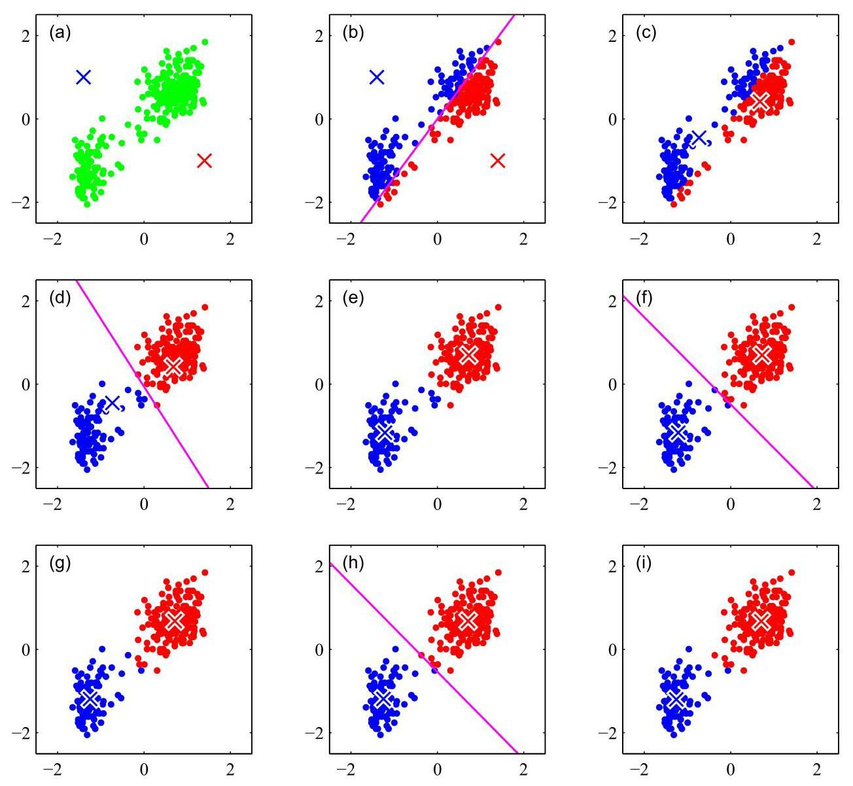

Figure 15.1 Illustration of the -means algorithm using the re-scaled Old Faithful data set. (a) Green points denote the data set in a two-dimensional Euclidean space. The initial choices for centres and are shown by the red and blue crosses, respectively. (b) In the initial E step, each data point is assigned either to the red cluster or to the blue cluster, according to which cluster centre is nearer. This is equivalent to classifying the points according to which side of the perpendicular bisector of the two cluster centres, shown by the magenta line, they lie. (c) In the subsequent step, each cluster centre is recomputed to be the mean of the points assigned to the corresponding cluster. (d)-(i) show successive and steps through to final convergence of the algorithm.

图 15.1 使用重新缩放后的老忠实间歇泉数据集对 -均值算法的说明。(a) 绿色点表示二维欧几里得空间中的数据集。中心 和 的初始选择分别用红色和蓝色十字表示。(b) 在初始的 E 步骤中，每个数据点根据哪个聚类中心更近被分配到红色聚类或蓝色聚类。这等同于根据数据点位于两个聚类中心垂直平分线(由品红色线表示)的哪一侧对其进行分类。(c) 在随后的 步骤中，重新计算每个聚类中心，使其成为分配到相应聚类的点的均值。(d)-(i) 展示了算法直到最终收敛的连续 和 步骤。

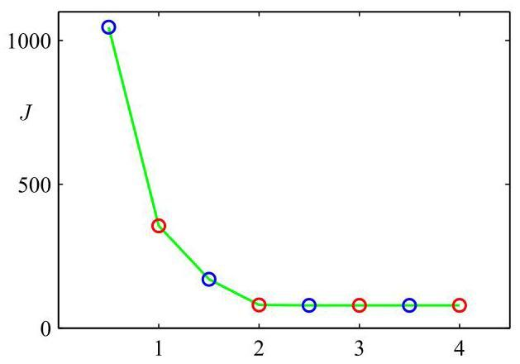

Figure 15.2 Plot of the cost function given by (15.1) after each E step (blue points) and M step (red points) of the - means algorithm for the example shown in Figure 15.1. The algorithm has converged after the third step, and the final EM cycle produces no changes in either the assignments or the prototype vectors.

图 15.2 对于图 15.1 所示的例子，在 -均值算法的每个 E 步骤(蓝色点)和 M 步骤(红色点)之后，由式 (15.1) 给出的代价函数 的曲线图。算法在第三次 步骤后收敛，最终的 EM 循环在分配或原型向量上都没有产生变化。

where is the number of data points that have so far been used to update . This allows each data point to be used once and then discarded before seeing the next data point.

其中 是到目前为止用于更新 的数据点数量。这使得每个数据点可以使用一次，然后在处理下一个数据点之前被丢弃。

One notable feature of the -means algorithm is that at each iteration, every data point is assigned to one, and only one, of the clusters. Although some data points will be much closer to a particular centre than to any other centre, there may be other data points that lie roughly midway between cluster centres. In the latter case, it is not clear that the hard assignment to the nearest cluster is the most appropriate. We will see that by adopting a probabilistic approach, we obtain ’soft’ assignments of data points to clusters in a way that reflects the level of uncertainty over the most appropriate assignment. This probabilistic formulation has numerous benefits.

-均值算法的一个显著特点是，在每次迭代中，每个数据点都被分配到一个且仅一个聚类中。尽管有些数据点可能比其他任何中心更接近某个特定中心 ，但也可能存在一些数据点大致位于聚类中心之间的中间位置。在后一种情况下，将其硬性分配到最近的聚类是否最合适并不明确。我们将看到，通过采用概率方法，我们可以以一种反映最合适分配的不确定性水平的方式，对数据点进行“软”分配到聚类中。这种概率公式有许多优点。

Section 15.2

第15.2节

# 15.1.1 Image segmentation

# 15.1.1 图像分割

As an illustration of the application of the -means algorithm, we consider the related problems of image segmentation and image compression. The goal of segmentation is to partition an image into regions such that each region has a reasonably homogeneous visual appearance or which corresponds to objects or parts of objects (Forsyth and Ponce, 2003). Each pixel in an image is a point in a three-dimensional space comprising the intensities of the red, blue, and green channels, and our segmentation algorithm simply treats each pixel in the image as a separate data point. Note that strictly this space is not Euclidean because the channel intensities are bounded by the interval . Nevertheless, we can apply the - means algorithm without difficulty. We illustrate the result of running -means to convergence, for any particular value of , by redrawing the image in which we replace each pixel vector with the intensity triplet given by the centre to which that pixel has been assigned. Results for various values of are shown in Figure 15.3. We see that for a given value of , the algorithm represents the image using a palette of only colours. It should be emphasized that this use of -means is not a particularly sophisticated approach to image segmentation, not least because it takes no account of the spatial proximity of different pixels. Image segmentation is in general extremely difficult and remains the subject of active research and is introduced here simply to illustrate the behaviour of the -means algorithm.

作为 -均值算法应用的一个示例，我们考虑图像分割和图像压缩的相关问题。分割的目标是将图像划分为多个区域，使得每个区域具有合理的均匀视觉外观，或者对应于物体或物体的部分(Forsyth 和 Ponce，2003)。图像中的每个像素都是一个三维空间中的点，该空间由红、蓝、绿通道的强度组成，我们的分割算法简单地将图像中的每个像素视为一个单独的数据点。请注意，严格来说，这个空间不是欧几里得空间，因为通道强度受区间 的限制。然而，我们可以毫无困难地应用 -均值算法。对于任何特定的 值，我们通过重新绘制图像来说明运行 -均值算法直至收敛的结果，在该图像中，我们用该像素被分配到的中心 给出的 强度三元组替换每个像素向量。图15.3展示了不同 值的结果。我们看到，对于给定的 值，该算法仅使用 种颜色的调色板来表示图像。应该强调的是，这种使用 -均值的方法并不是一种特别复杂的图像分割方法，尤其是因为它没有考虑不同像素的空间邻近性。一般来说，图像分割极其困难，仍然是活跃的研究课题，这里介绍它只是为了说明 -均值算法的行为。

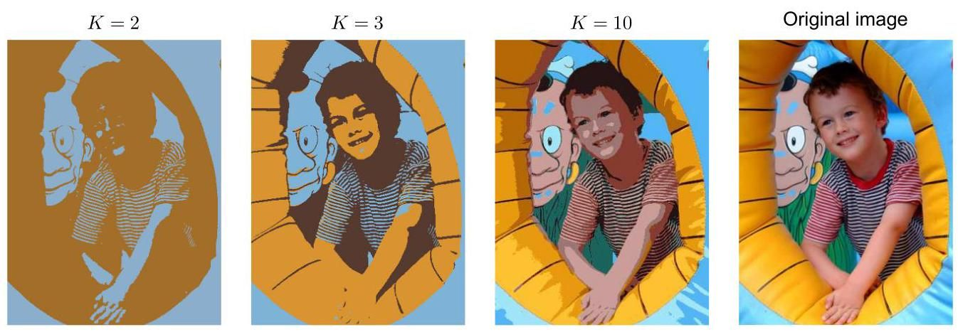

Figure 15.3 An example of the application of the -means clustering algorithm to image segmentation showing an initial image together with their -means segmentations obtained using various values of . This also illustrates the use of vector quantization for data compression, in which smaller values of give higher compression at the expense of poorer image quality.

图15.3 -均值聚类算法在图像分割中的应用示例，展示了初始图像以及使用不同 值获得的 -均值分割结果。这也说明了向量量化在数据压缩中的应用，其中较小的 值以较差的图像质量为代价实现了更高的压缩率。

We can also use a clustering algorithm to perform data compression. It is important to distinguish between lossless data compression, in which the goal is to be able to reconstruct the original data exactly from the compressed representation, and lossy data compression, in which we accept some errors in the reconstruction in return for higher levels of compression than can be achieved in the lossless case. We can apply the -means algorithm to the problem of lossy data compression as follows. For each of the data points, we store only the identity of the cluster to which it is assigned. We also store the values of the cluster centres , which typically requires significantly less data, provided we choose . Each data point is then approximated by its nearest centre . New data points can similarly be compressed by first finding the nearest and then storing the label instead of the original data vector. This framework is often called vector quantization, and the vectors are called codebook vectors.

我们还可以使用聚类算法来进行数据压缩。区分无损数据压缩和有损数据压缩很重要。在无损数据压缩中，目标是能够从压缩表示中精确地重构原始数据；而在有损数据压缩中，我们接受重构时存在一些误差，以换取比无损情况更高的压缩率。我们可以按如下方式将 -均值算法应用于有损数据压缩问题。对于 个数据点中的每一个，我们仅存储它被分配到的聚类的标识 。我们还存储 个聚类中心 的值，通常情况下，如果我们选择 ，这所需的数据量会显著减少。然后，每个数据点由其最近的中心 近似表示。新的数据点同样可以通过先找到最近的 ，然后存储标签 而非原始数据向量来进行压缩。这种框架通常被称为向量量化，向量 被称为码本向量。

The image segmentation problem discussed above also provides an illustration of the use of clustering for data compression. Suppose the original image has pixels comprising values, each of which is stored with 8 bits of precision. Directly transmitting the whole image would cost bits. Now suppose we first run -means on the image data, and then instead of transmitting the original pixel intensity vectors, we transmit the identity of the nearest vector . Because there are such vectors, this requires bits per pixel. We must also transmit the code book vectors , which requires bits, and so the total number of bits required to transmit the image is (rounding up to the nearest

上述讨论的图像分割问题也说明了聚类在数据压缩中的应用。假设原始图像有 个像素，每个像素包含 个值，每个值以 8 位精度存储。直接传输整个图像将需要 位。现在假设我们首先对图像数据运行 -均值算法，然后我们不传输原始像素强度向量，而是传输最近向量 的标识。因为有 个这样的向量，所以每个像素需要 位。我们还必须传输 个码本向量 ，这需要 位，因此传输图像所需的总位数为 (向上取整到最接近的

integer). The original image shown in Figure 15.3 has pixels and so requires bits to transmit directly. By comparison, the compressed images require 43,248 bits bits , and 173,040 bits , respectively, to transmit. These represent compression ratios compared to the original image of 4.2%, 8.3%, and 16.7%, respectively. We see that there is a trade-off between the degree of compression and image quality. Note that our aim in this example is to illustrate the -means algorithm. If we had been aiming to produce a good image compressor, then it would be more fruitful to consider small blocks of adjacent pixels, for instance , and thereby exploit the correlations that exist in natural images between nearby pixels.

整数)。图 15.3 中所示的原始图像有 个像素，因此直接传输需要 位。相比之下，压缩后的图像分别需要 43,248 位 位 和 173,040 位 来传输。与原始图像相比，这些分别代表了 4.2%、8.3% 和 16.7% 的压缩率。我们看到在压缩程度和图像质量之间存在权衡。请注意，此示例的目的是说明 -均值算法。如果我们的目标是制作一个优秀的图像压缩器，那么考虑相邻像素的小方块，例如 ，并利用自然图像中相邻像素之间存在的相关性会更有成效。

# 15.2. Mixtures of Gaussians

# 15.2. 高斯混合模型

We have previously motivated the Gaussian mixture model as a simple linear superposition of Gaussian components, aimed at providing a richer class of density models than a single Gaussian. We now turn to a formulation of Gaussian mixtures in terms of discrete latent variables. This will provide us with a deeper insight into this important distribution and will also serve to motivate the expectation-maximization algorithm.

我们之前将高斯混合模型作为高斯分量的简单线性叠加引入，目的是提供比单个高斯分布更丰富的密度模型类。现在我们从离散潜在变量的角度来阐述高斯混合模型。这将使我们更深入地理解这个重要的分布，同时也有助于引出期望最大化算法。

Section 3.2.9

3.2.9 节

Recall from (3.111) that the Gaussian mixture distribution can be written as a linear superposition of Gaussians in the form

回顾 (3.111) 可知，高斯混合分布可以写成高斯分布的线性叠加形式

Let us introduce a -dimensional binary random variable having a 1-of- representation in which one of the elements is equal to 1 and all other elements are equal to 0 . The values of therefore satisfy and , and we see that there are possible states for the vector according to which element is non-zero. We will define the joint distribution in terms of a marginal distribution and a conditional distribution . The marginal distribution over is specified in terms of the mixing coefficients , such that

让我们引入一个 维的二元随机变量 ，它采用 “1-of- ” 表示法，即其中一个元素等于 1，而其他所有元素都等于 0。因此， 的取值满足 和 ，并且我们看到向量 根据哪个元素非零有 种可能的状态。我们将根据边缘分布 和条件分布 来定义联合分布 。 上的边缘分布由混合系数 指定，使得

where the parameters must satisfy

其中参数 必须满足

together with

以及

Figure 15.4 Graphical representation of a mixture model, in which the joint distribution is expressed in the form .

图 15.4 混合模型的图形表示，其中联合分布表示为 的形式。

if they are to be valid probabilities. Because uses a 1-of- representation, we can also write this distribution in the form

如果它们要成为有效的概率。由于 采用 “1-of- ” 表示法，我们也可以将这个分布写成如下形式

Similarly, the conditional distribution of given a particular value for is a Gaussian:

类似地，给定 的特定值时 的条件分布是一个高斯分布:

which can also be written in the form

这也可以写成如下形式

The joint distribution is given by and is described by the graphical model in Figure 15.4. The marginal distribution of is then obtained by summing the joint distribution over all possible states of to give

联合分布由 给出，并由图 15.4 中的图形模型描述。然后，通过对 的所有可能状态上的联合分布求和，得到 的边缘分布为

Exercise 15.3

练习 15.3

where we have made use of (15.9) and (15.10). Thus, the marginal distribution of is a Gaussian mixture of the form (15.6). If we have several observations , then, because we have represented the marginal distribution in the form , it follows that for every observed data point there is a corresponding latent variable .

这里我们利用了式 (15.9) 和式 (15.10)。因此， 的边缘分布是形式为 (15.6) 的高斯混合分布。如果我们有多个观测值 ，那么，由于我们已经将边缘分布表示为 的形式，因此对于每个观测数据点 ，都有一个对应的隐变量 。

We have therefore found an equivalent formulation of the Gaussian mixture involving explicit latent variables. It might seem that we have not gained much by doing so. However, we are now able to work with the joint distribution instead of the marginal distribution , and this will lead to significant simplifications, most notably through the introduction of the EM algorithm.

因此，我们找到了一种涉及显式隐变量的高斯混合分布的等价表述。这样做似乎并没有带来太多好处。然而，我们现在可以处理联合分布 而不是边缘分布 ，这将带来显著的简化，最显著的是通过引入 EM 算法。

Another quantity that will play an important role is the conditional probability of given . We will use to denote , whose value can be found

另一个将发挥重要作用的量是给定 时 的条件概率。我们将使用 来表示 ，其值可以通过以下方法找到

using Bayes’ theorem:

使用贝叶斯定理:

We will view as the prior probability of , and the quantity as the corresponding posterior probability once we have observed . As we will see later, can also be viewed as the responsibility that component takes for ’explaining’ the observation .

我们将 视为 的先验概率，而一旦我们观察到 ，量 则为相应的后验概率。正如我们稍后将看到的， 也可以被视为分量 对 “解释” 观测值 所承担的责任。

Section 14.2.5

第 14.2.5 节

We can use ancestral sampling to generate random samples distributed according to the Gaussian mixture model. To do this, we first generate a value for , which we denote , from the marginal distribution and then generate a value for from the conditional distribution . We can depict samples from the joint distribution by plotting points at the corresponding values of and then colouring them according to the value of , in other words according to which Gaussian component was responsible for generating them, as shown in Figure 15.5(a). Similarly samples from the marginal distribution are obtained by taking the samples from the joint distribution and ignoring the values of . These are illustrated in Figure 15.5(b) by plotting the values without any coloured labels.

我们可以使用祖先采样来生成根据高斯混合模型分布的随机样本。为此，我们首先从边缘分布 中生成 的一个值，记为 ，然后从条件分布 中生成 的一个值。我们可以通过在 的相应值处绘制点，然后根据 的值对这些点进行着色，换句话说，根据哪个高斯分量生成了这些点，来描绘联合分布 的样本，如图 15.5(a) 所示。类似地，边缘分布 的样本可以通过从联合分布中获取样本并忽略 的值得到。在图 15.5(b) 中，通过绘制 的值而不使用任何彩色标签来说明这些样本。

We can also use this synthetic data set to illustrate the ’responsibilities’ by evaluating, for every data point, the posterior probability for each component in the mixture distribution from which this data set was generated. In particular, we can represent the value of the responsibilities associated with data point by plotting the corresponding point using proportions of red, blue, and green ink given by for , respectively, as shown in Figure 15.5(c). So, for instance, a data point for which will be coloured red, whereas one for which will be coloured with equal proportions of blue and green ink and so will appear cyan. This should be compared with Figure 15.5(a) in which the data points were labelled using the true identity of the component from which they were generated.

我们还可以使用这个合成数据集来说明 “责任”，方法是针对每个数据点，评估生成该数据集的混合分布中每个分量的后验概率。具体来说，我们可以通过使用由 分别为 给出的红色、蓝色和绿色墨水的比例来绘制相应的点，来表示与数据点 相关联的责任 的值，如图 15.5(c) 所示。例如，对于 的数据点将被染成红色，而对于 的数据点将用相等比例的蓝色和绿色墨水着色，因此将呈现青色。这应该与图 15.5(a) 进行比较，在图 15.5(a) 中，数据点使用生成它们的分量的真实标识进行标记。

# 15.2.1 Likelihood function

# 15.2.1 似然函数

Suppose we have a data set of observations , and we wish to model this data using a mixture of Gaussians. We can represent this data set as an matrix in which the th row is given by . From (15.6) the log of the likelihood function is given by

假设我们有一个观测数据集 ，并且我们希望使用高斯混合模型对这些数据进行建模。我们可以将这个数据集表示为一个 矩阵 ，其中第 行由 给出。根据式 (15.6)，似然函数的对数为

Maximizing this log likelihood function (15.13) is a more complex problem than for a single Gaussian. The difficulty arises from the presence of the summation over that appears inside the logarithm in (15.13), so that the logarithm function no longer acts directly on the Gaussian. If we set the derivatives of the log likelihood to zero, we will no longer obtain a closed-form solution, as we will see shortly.

最大化这个对数似然函数 (15.13) 比单个高斯分布的情况要复杂得多。困难源于式 (15.13) 中对数内部存在对 的求和，使得对数函数不再直接作用于高斯分布。如果我们令对数似然函数的导数为零，我们将无法得到一个封闭形式的解，我们很快就会看到这一点。

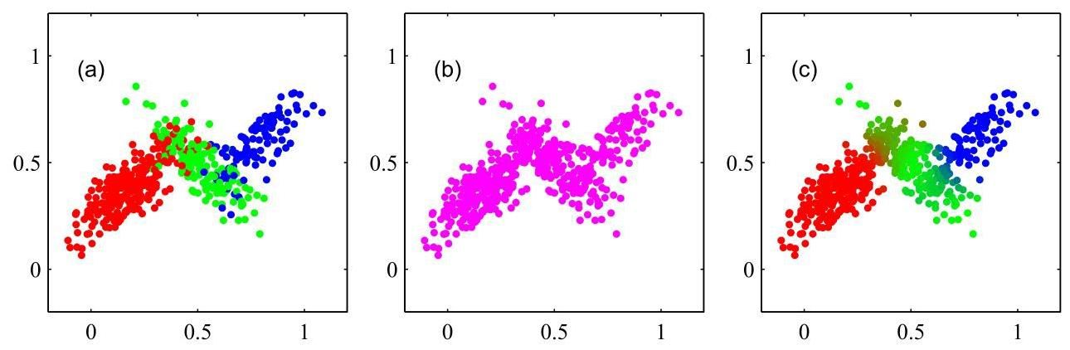

Figure 15.5 Example of 500 points drawn from the mixture of three Gaussians shown in Figure 3.8. (a) Samples from the joint distribution in which the three states of , corresponding to the three components of the mixture, are depicted in red, green, and blue, and (b) the corresponding samples from the marginal distribution , which is obtained by simply ignoring the values of and just plotting the values. The data set in (a) is said to be complete, whereas that in (b) is incomplete, as discussed further in Section 15.3. (c) The same samples in which the colours represent the value of the responsibilities associated with data point , obtained by plotting the corresponding point using proportions of red, blue, and green ink given by for , respectively.

图 15.5 从图 3.8 所示的三个高斯分布的混合中抽取 500 个点的示例。(a) 联合分布 的样本，其中 的三个状态(对应于混合模型的三个分量)分别用红色、绿色和蓝色表示；(b) 相应的边缘分布 的样本，这是通过简单地忽略 的值，仅绘制 的值得到的。如第 15.3 节进一步讨论的，(a) 中的数据集被称为完整数据集，而 (b) 中的数据集是不完整的。(c) 相同的样本，其中颜色表示与数据点 相关联的责任 的值，通过分别按照 ( )的比例使用红色、蓝色和绿色墨水绘制相应的点得到。

Before discussing how to maximize this function, it is worth emphasizing that there is a significant problem associated with the maximum likelihood framework when applied to Gaussian mixture models, due to the presence of singularities. For simplicity, consider a Gaussian mixture whose components have covariance matrices given by , where is the unit matrix, although the conclusions will hold for general covariance matrices. Suppose that one of the components of the mixture model, let us say the th component, has its mean exactly equal to one of the data points so that for some value of . This data point will then contribute a term in the likelihood function of the form

在讨论如何最大化这个函数之前，值得强调的是，当将最大似然框架应用于高斯混合模型时，由于存在奇点，会有一个重大问题。为简单起见，考虑一个高斯混合模型，其分量的协方差矩阵由 给出，其中 是单位矩阵，尽管这些结论对于一般的协方差矩阵也成立。假设混合模型的一个分量，比如说第 个分量，其均值 恰好等于某个数据点，即对于某个 的值有 。那么这个数据点将在似然函数中贡献一个形式如下的项

If we consider the limit , then we see that this term goes to infinity and so the log likelihood function will also go to infinity. Thus, the maximization of the log likelihood function is not a well posed-problem because such singularities will always be present and will occur whenever one of the Gaussian components ’collapses’ onto a specific data point. Recall that this problem did not arise with a single Gaussian distribution. To understand the difference, note that if a single Gaussian collapses onto a data point, it will contribute multiplicative factors to the

如果我们考虑极限 ，我们会发现这项趋于无穷大，因此对数似然函数也将趋于无穷大。因此，最大化对数似然函数不是一个适定问题，因为这样的奇点总是存在，并且只要某个高斯分量“坍缩”到一个特定的数据点上就会出现。回想一下，这个问题在单个高斯分布中不会出现。为了理解其中的差异，请注意，如果单个高斯分布坍缩到一个数据点上，它将对……贡献乘法因子

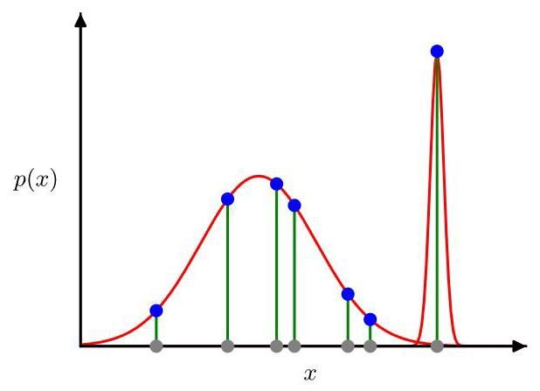

Figure 15.6 Illustration of how singularities in the likelihood function arise with mixtures of Gaussians. This should be compared with a single Gaussian shown in Figure 2.9 for which no singularities arise.

图 15.6 展示了高斯混合模型的似然函数中奇点是如何产生的。这应该与图 2.9 中所示的单个高斯分布进行比较，后者不会产生奇点。

likelihood function arising from the other data points, and these factors will go to zero exponentially fast, giving an overall likelihood that goes to zero rather than infinity. However, once we have (at least) two components in the mixture, one of the components can have a finite variance and therefore assign finite probability to all the data points while the other component can shrink onto one specific data point and thereby contribute an ever increasing additive value to the log likelihood. This is illustrated in Figure 15.6. These singularities provide an example of the over-fitting that can occur in a maximum likelihood approach. When applying maximum likelihood to Gaussian mixture models, we must take steps to avoid finding such pathological solutions and instead seek local maxima of the likelihood function that are well behaved. We can try to avoid the singularities by using suitable heuristics, for instance by detecting when a Gaussian component is collapsing and resetting its mean to a randomly chosen value while also resetting its covariance to some large value and then continuing with the optimization. The singularities can also be avoided by adding a regularization term to the log likelihood corresponding to a prior distribution over the parameters.

由其他数据点产生的似然函数，这些因子将以指数级速度趋近于零，从而使整体似然趋近于零而非无穷大。然而，一旦混合模型中有(至少)两个分量，其中一个分量可以具有有限的方差，因此可以为所有数据点分配有限的概率，而另一个分量可以收缩到一个特定的数据点上，从而为对数似然贡献一个不断增加的附加值。这在图 15.6 中得到了说明。这些奇点提供了一个最大似然方法中可能出现过拟合的例子。当将最大似然法应用于高斯混合模型时，我们必须采取措施避免找到这种病态解，而是寻找行为良好的似然函数的局部最大值。我们可以尝试使用合适的启发式方法来避免奇点，例如，当检测到一个高斯分量正在收缩时，将其均值重置为一个随机选择的值，同时将其协方差重置为某个较大的值，然后继续进行优化。通过在对数似然中添加一个对应于参数先验分布的正则化项，也可以避免奇点。

Section 15.4.3

第 15.4.3 节

A further issue in finding maximum likelihood solutions arises because for any given maximum likelihood solution, a -component mixture will have a total of ! equivalent solutions corresponding to the ! ways of assigning sets of parameters to components. In other words, for any given (non-degenerate) point in the space of parameter values, there will be a further additional points all of which give rise to exactly the same distribution. This problem is known as identifiability (Casella and Berger, 2002) and is an important issue when we wish to interpret the parameter values discovered by a model. Identifiability will also arise when we discuss models having continuous latent variables. However, when finding a good density model, it is irrelevant because any of the equivalent solutions is as good as any other.

寻找最大似然解时出现的另一个问题是，对于任何给定的最大似然解，一个 分量的混合模型将总共具有 ! 个等价解，对应于将 组参数分配给 个分量的 ! 种方式。换句话说，在参数值空间中的任何给定(非退化)点，将有另外 个额外的点，所有这些点都产生完全相同的分布。这个问题被称为可识别性问题(Casella 和 Berger，2002)，当我们希望解释模型发现的参数值时，这是一个重要的问题。当我们讨论具有连续潜在变量的模型时，也会出现可识别性问题。然而，在寻找一个好的密度模型时，这无关紧要，因为任何等价解都和其他解一样好。

Chapter 16

第 16 章

# 15.2.2 Maximum likelihood

# 15.2.2 最大似然

An elegant and powerful method for finding maximum likelihood solutions for models with latent variables is called the expectation-maximization algorithm or algorithm (Dempster, Laird, and Rubin, 1977; McLachlan and Krishnan, 1997). In this chapter we will give three different derivations of the EM algorithm, each more general than the previous. We begin here with a relatively informal treatment in the context of a Gaussian mixture model. We emphasize, however, that EM has broad applicability, and the underlying concepts will be encountered in the context of several different models in this book.

一种用于寻找含隐变量模型的最大似然解的优雅而强大的方法称为期望最大化算法或 算法(Dempster、Laird 和 Rubin，1977 年；McLachlan 和 Krishnan，1997 年)。在本章中，我们将给出 EM 算法的三种不同推导，每一种都比前一种更具一般性。我们从高斯混合模型的背景下进行相对非正式的处理开始。然而，我们强调 EM 具有广泛的适用性，并且在本书的几种不同模型的背景下都会遇到其底层概念。

We begin by writing down the conditions that must be satisfied at a maximum of the likelihood function. Setting the derivatives of in (15.13) with respect to the means of the Gaussian components to zero, we obtain

我们首先写下似然函数取最大值时必须满足的条件。将 (15.13) 式中 关于高斯分量的均值 的导数设为零，我们得到

where we have made use of the form (3.26) for the Gaussian distribution. Note that the posterior probabilities, or responsibilities, given by (15.12) appear naturally on the right-hand side. Multiplying by (which we assume to be nonsingular) and rearranging we obtain

这里我们使用了高斯分布的形式 (3.26)。注意，由 (15.12) 式给出的后验概率，即责任 自然地出现在等式右侧。将等式两边乘以 (我们假设它是非奇异的)并重新整理，我们得到

where we have defined

这里我们定义了

We can interpret as the effective number of points assigned to cluster . Note carefully the form of this solution. We see that the mean for the th Gaussian component is obtained by taking a weighted mean of all the points in the data set, in which the weighting factor for data point is given by the posterior probability that component was responsible for generating .

我们可以将 解释为分配给簇 的有效点数。仔细注意这个解的形式。我们看到第 个高斯分量的均值 是通过对数据集中的所有点取加权平均得到的，其中数据点 的权重因子由分量 生成 的后验概率 给出。

If we set the derivative of with respect to to zero and follow a similar line of reasoning by making use of the result for the maximum likelihood solution for the covariance matrix of a single Gaussian, we obtain

如果我们将 关于 的导数设为零，并利用单个高斯协方差矩阵的最大似然解的结果，按照类似的推理思路，我们得到

Section 3.2.7

3.2.7 节

which has the same form as the corresponding result for a single Gaussian fitted to the data set, but again with each data point weighted by the corresponding posterior probability and with the denominator given by the effective number of points associated with the corresponding component.

它与拟合到数据集的单个高斯分布的相应结果具有相同的形式，但同样每个数据点都由相应的后验概率加权，并且分母由与相应分量相关联的有效点数给出。

Finally, we maximize with respect to the mixing coefficients . Here we must take account of the constraint (15.8), which requires the mixing coefficients to sum to one. This can be achieved using a Lagrange multiplier and maximizing the following quantity:

最后，我们关于混合系数 最大化 。这里我们必须考虑约束条件 (15.8)，该条件要求混合系数之和为 1。这可以通过使用拉格朗日乘数 并最大化以下量来实现:

Appendix

附录

which gives

这给出

where again we see the appearance of the responsibilities. If we now multiply both sides by and sum over making use of the constraint (15.8), we find . Using this to eliminate and rearranging, we obtain

在这里我们再次看到了责任项的出现。如果我们现在将两边都乘以 并对 求和，利用约束条件 (15.8)，我们得到 。用这个结果消去 并重新整理，我们得到

so that the mixing coefficient for the th component is given by the average responsibility which that component takes for explaining the data points.

因此，第 个分量的混合系数由该分量解释数据点的平均责任给出。

Note that the results (15.16), (15.18), and (15.21) do not constitute a closed-form solution for the parameters of the mixture model because the responsibilities depend on those parameters in a complex way through (15.12). However, these results do suggest a simple iterative scheme for finding a solution to the maximum likelihood problem, which as we will see turns out to be an instance of the EM algorithm for the particular case of the Gaussian mixture model. We first choose some initial values for the means, covariances, and mixing coefficients. Then we alternate between the following two updates, which we will call the E step and the M step for reasons that will become apparent shortly. In the expectation step, or E step, we use the current values for the parameters to evaluate the posterior probabilities, or responsibilities, given by (15.12). We then use these probabilities in the maximization step, or M step, to re-estimate the means, covariances, and mixing coefficients using the results (15.16), (15.18), and (15.21). Note that in so doing, we first evaluate the new means using (15.16) and then use these new values to find the covariances using (15.18), in keeping with the corresponding result for a single Gaussian distribution. We will show that each update to the parameters resulting from an E step followed by an M step is guaranteed to increase the log likelihood function. In practice, the algorithm is deemed to have converged when the change in the log likelihood function, or alternatively in the parameters, falls below some threshold.

请注意，结果 (15.16)、(15.18) 和 (15.21) 并未构成混合模型参数的闭式解，因为责任 通过 (15.12) 以复杂的方式依赖于这些参数。然而，这些结果确实提出了一种简单的迭代方案来求解最大似然问题，正如我们将看到的，这是高斯混合模型特定情况下 EM 算法的一个实例。我们首先为均值、协方差和混合系数选择一些初始值。然后在以下两个更新步骤之间交替进行，我们将分别称它们为 E 步和 M 步，原因很快会变得明显。在期望步骤(即 E 步)中，我们使用参数的当前值来计算由 (15.12) 给出的后验概率，即责任。然后在最大化步骤(即 M 步)中，我们使用这些概率，根据结果 (15.16)、(15.18) 和 (15.21) 重新估计均值、协方差和混合系数。请注意，在这样做时，我们首先使用 (15.16) 计算新的均值，然后使用这些新值通过 (15.18) 计算协方差，这与单个高斯分布的相应结果一致。我们将证明，由 E 步后跟 M 步对参数进行的每次更新都保证会增加对数似然函数的值。在实践中，当对数似然函数的变化，或者参数的变化低于某个阈值时，就认为算法已经收敛。

Section 15.3

第 15.3 节

We illustrate the EM algorithm for a mixture of two Gaussians applied to the re-scaled Old Faithful data in Figure 15.7. Here a mixture of two Gaussians is used, with centres initialized using the same values as for the -means algorithm in Figure 15.1 and with covariance matrices initialized to be proportional to the unit matrix. Plot (a) shows the data points in green, together with the initial configuration of the mixture model in which the one standard-deviation contours for the two Gaussian components are shown as blue and red circles. Plot (b) shows the result of the initial E step, in which each data point is depicted using a proportion of blue ink equal to the posterior probability of having been generated from the blue component and a corresponding proportion of red ink given by the posterior probability of having been generated by the red component. Thus, points that have a roughly equal probability for belonging to either cluster appear purple. The situation after the first step is shown in plot (c), in which the mean of the blue Gaussian has moved to the mean of the data set, weighted by the probabilities of each data point belonging to the blue cluster. In other words it has moved to the centre of mass of the blue ink. Similarly, the covariance of the blue Gaussian is set equal to the covariance of the blue ink. Analogous results hold for the red component. Plots (d), (e), and (f) show the results after 2, 5, and 20 complete cycles of EM, respectively. In plot (f) the algorithm is close to convergence.

我们在图 15.7 中展示了将两个高斯分布的混合模型的 EM 算法应用于重新缩放后的老忠实间歇泉数据集的情况。这里使用了两个高斯分布的混合模型，其中心的初始值与图 15.1 中 -均值算法的初始值相同，协方差矩阵初始化为与单位矩阵成比例。图 (a) 以绿色显示了数据点，以及混合模型的初始配置，其中两个高斯分量的一个标准差轮廓分别用蓝色和红色圆圈表示。图 (b) 显示了初始 E 步的结果，其中每个数据点使用的蓝色墨水比例等于该点由蓝色分量生成的后验概率，相应的红色墨水比例等于该点由红色分量生成的后验概率。因此，大致具有相同概率属于任一聚类的点呈现为紫色。第一次 步之后的情况如图 (c) 所示，其中蓝色高斯分布的均值移动到了数据集的加权均值处，权重为每个数据点属于蓝色聚类的概率。换句话说，它移动到了蓝色墨水的质心位置。类似地，蓝色高斯分布的协方差被设置为等于蓝色墨水的协方差。红色分量也有类似的结果。图 (d)、(e) 和 (f) 分别显示了 EM 算法经过 2、5 和 20 个完整循环后的结果。在图 (f) 中，算法接近收敛。

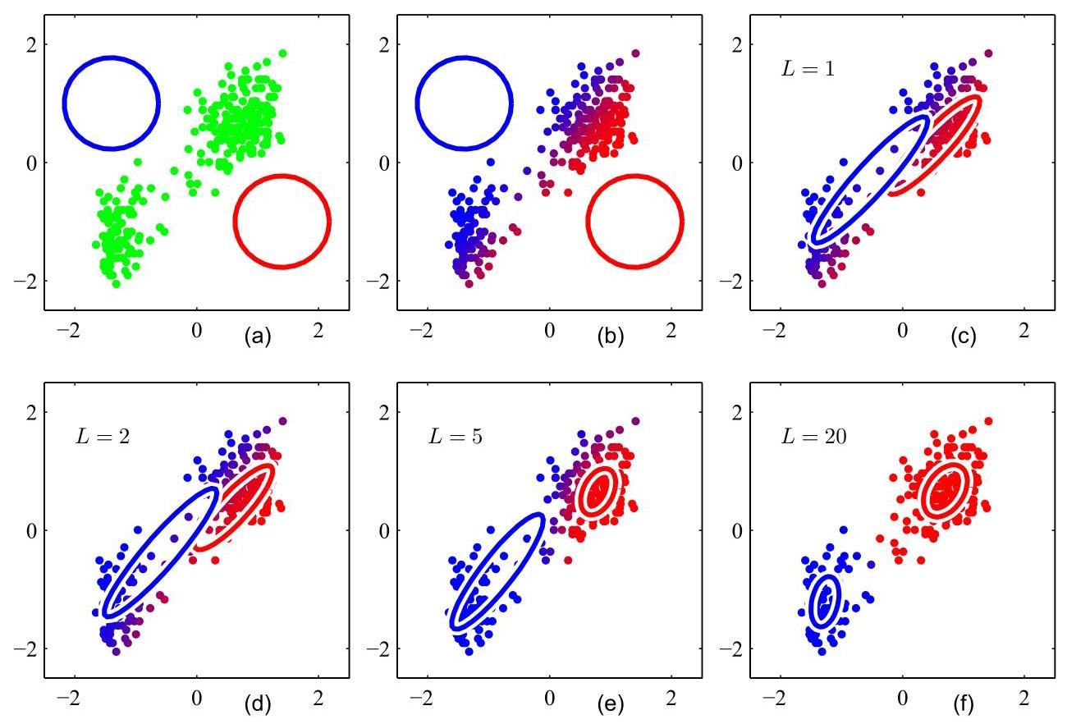

Figure 15.7 Application of the EM algorithm to the Old Faithful data set as used for the illustration of the -means algorithm in Figure 15.1. See the text for details.

图 15.7 EM 算法应用于老忠实间歇泉数据集，该数据集在图 15.1 中用于说明 -均值算法。详情见正文。

Note that the EM algorithm takes many more iterations to reach (approximate) convergence compared with the -means algorithm and that each cycle requires significantly more computation. It is therefore common to run the -means algorithm to find a suitable initialization for a Gaussian mixture model that is subsequently adapted using EM. The covariance matrices can conveniently be initialized to the sample covariances of the clusters found by the -means algorithm, and the mixing coefficients can be set to the fractions of data points assigned to the respective clusters. Techniques such as parameter regularization must be employed to avoid singularities of the likelihood function in which a Gaussian component collapses onto a particular data point. It should be emphasized that there will generally be multiple local maxima of the log likelihood function and that EM is not guaranteed to find the largest of these maxima. Because the EM algorithm for Gaussian mixtures plays such an important role, we summarize it in Algorithm 15.2.

请注意，与 -均值算法相比，EM 算法需要更多的迭代才能达到(近似)收敛，并且每个循环需要显著更多的计算量。因此，通常先运行 -均值算法来为高斯混合模型找到合适的初始值，然后再使用 EM 算法进行调整。协方差矩阵可以方便地初始化为 -均值算法找到的聚类的样本协方差，混合系数可以设置为分配给各个聚类的数据点的比例。必须采用参数正则化等技术来避免似然函数出现奇异性，即高斯分量坍缩到某个特定数据点的情况。应该强调的是，对数似然函数通常会有多个局部最大值，并且不能保证 EM 算法能找到其中最大的那个。由于高斯混合模型的 EM 算法起着如此重要的作用，我们在算法 15.2 中对其进行了总结。

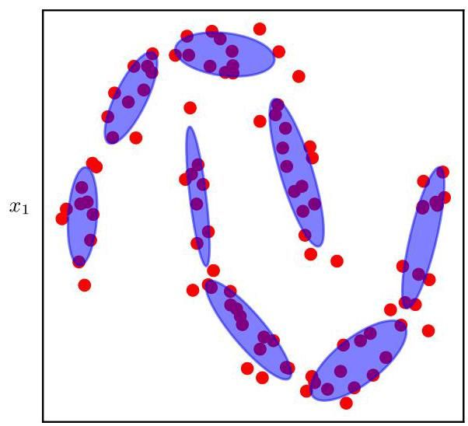

Figure 15.8 A Gaussian mixture model fitted to the ’two-moons’ data set, showing that a large number of mixture components may be required to give an accurate representation of a complex data distribution. Here the ellipses represent the contours of constant density for the corresponding mixture components. As we move to spaces of larger dimensionality, the number of components required to model a distribution accurately can become unacceptably large.

图 15.8 一个拟合到“双月”数据集的高斯混合模型，表明可能需要大量的混合成分才能准确表示复杂的数据分布。这里的椭圆表示相应混合成分的等密度轮廓。当我们进入更高维度的空间时，准确建模一个分布所需的成分数量可能会变得大得难以接受。

Mixture models are very flexible and can approximate complicated distributions to high accuracy given a sufficient number of components if the model parameters are chosen appropriately. In practice, however, the number of components can be extremely large, especially in spaces of high dimensionality. This problem is illustrated for the two-moons data set in Figure 15.8. Nevertheless, mixture models are useful in many applications. Also, an understanding of mixture models lays the foundations for models with continuous latent variables and for generative models based on deep neural networks, which have much better scaling to spaces of high dimensionality.

混合模型非常灵活，如果模型参数选择得当，在给定足够数量的成分时，它们可以高精度地近似复杂分布。然而，在实践中，成分的数量可能会非常大，特别是在高维空间中。图 15.8 中的双月数据集就说明了这个问题。尽管如此，混合模型在许多应用中仍然很有用。此外，对混合模型的理解为具有连续潜在变量的模型以及基于深度神经网络的生成模型奠定了基础，这些模型在高维空间中的扩展性要好得多。

Chapter 16

第 16 章

# 15.3. Expectation-Maximization Algorithm

# 15.3. 期望最大化算法

We turn now to a more general view of the EM algorithm in which we focus on the role of latent variables. As before we denote the set of all observed data points by , in which the th row represents . Similarly, the corresponding latent variables will be denoted by an matrix with rows . If we assume that the data points are drawn independently from the distribution, then we can express the Gaussian mixture model for this i.i.d. data set using the graphical representation shown in Figure 15.9. The set of all model parameters is denoted by , and so the log likelihood function

现在我们从更一般的角度来看期望最大化(EM)算法，重点关注潜在变量的作用。和之前一样，我们用 表示所有观测数据点的集合，其中第 行表示 。类似地，相应的潜在变量将用一个 矩阵 表示，其行是 。如果我们假设数据点是从分布中独立抽取的，那么我们可以使用图 15.9 所示的图形表示来表达这个独立同分布(i.i.d.)数据集的高斯混合模型。所有模型参数的集合用 表示，因此对数似然函数

Input: Initial model parameters

输入:初始模型参数

Data set

数据集

Output: Final model parameters

repeat

// E step

for do

for do

end for

end for

// M step

for do

end for

// Log likelihood

until convergence

return

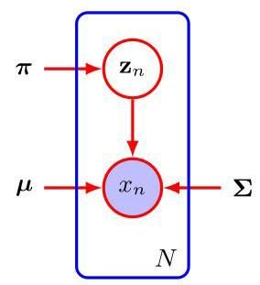

Figure 15.9 Graphical representation of a Gaussian mixture model for a set of i.i.d. data points , with corresponding latent points , where .

图 15.9 一组 独立同分布数据点 的高斯混合模型的图形表示，对应潜在点为 ，其中 。

is given by

由……给出

Chapter 16

第 16 章

Note that our discussion will apply equally well to continuous latent variables simply by replacing the sum over with an integral.

请注意，我们的讨论同样适用于连续潜在变量，只需将对 的求和替换为积分即可。

A key observation is that the summation over the latent variables appears inside the logarithm. Even if the joint distribution belongs to the exponential family, the marginal distribution typically does not as a result of this summation. The presence of the sum prevents the logarithm from acting directly on the joint distribution, resulting in complicated expressions for the maximum likelihood solution.

一个关键的观察结果是，对潜在变量的求和出现在对数内部。即使联合分布 属于指数族，由于这个求和，边缘分布 通常不属于指数族。求和的存在阻止了对数直接作用于联合分布，从而导致最大似然解的表达式复杂。

Now suppose that, for each observation in , we were told the corresponding value of the latent variable . We will call the complete data set, and we will refer to the actual observed data as incomplete, as illustrated in Figure 15.5. The likelihood function for the complete data set simply takes the form , and we will suppose that maximization of this complete-data log likelihood function is straightforward.

现在假设，对于 中的每个观测值，我们都知道潜在变量 的相应值。我们将 称为完整数据集，而将实际观测到的数据 称为不完整数据集，如图 15.5 所示。完整数据集的似然函数形式简单，为 ，并且我们假设最大化这个完整数据对数似然函数是直接可行的。

In practice, however, we are not given the complete data set but only the incomplete data . Our state of knowledge of the values of the latent variables in is given only by the posterior distribution . Because we cannot use the complete-data log likelihood, we consider instead its expected value under the posterior distribution of the latent variables, which corresponds (as we will see) to the E step of the EM algorithm. In the subsequent M step, we maximize this expectation. If the current estimate for the parameters is denoted by , then a pair of successive and steps gives rise to a revised estimate . The algorithm is initialized by choosing some starting value for the parameters . Although this use of the expectation may seem somewhat arbitrary, we will see the motivation for this choice when we give a deeper treatment of EM in Section 15.4.

然而，在实践中，我们并没有得到完整数据集 ，而只得到了不完整数据 。我们对 中潜在变量值的了解仅由后验分布 给出。由于我们不能使用完整数据对数似然，因此我们考虑它在潜在变量后验分布下的期望值，这(正如我们将看到的)对应于 EM 算法的 E 步。在随后的 M 步中，我们最大化这个期望值。如果参数的当前估计值用 表示，那么连续的一对 和 步会产生一个修订后的估计值 。该算法通过为参数 选择某个初始值来初始化。虽然这种对期望值的使用可能看起来有些随意，但当我们在第 15.4 节更深入地讨论 EM 算法时，我们将看到做出这种选择的动机。

In the step, we use the current parameter values to find the posterior distribution of the latent variables given by . We then use this posterior distribution to find the expectation of the complete-data log likelihood evaluated for some general parameter value . This expectation, denoted by , is given by

在 步中，我们使用当前参数值 来找到由 给出的潜在变量的后验分布。然后，我们使用这个后验分布来找到针对某个一般参数值 计算的完整数据对数似然的期望值。这个期望值用 表示，由下式给出

# Algorithm 15.3: General EM algorithm

# 算法 15.3:通用 EM 算法

Input: Joint distribution

输入:联合分布

Initial parameters

初始参数

Data set

数据集

Output: Final parameters

输出:最终参数

repeat

E step

M step

// Evaluate log likelihood

// Update the parameters

until convergence

return

In the M step, we determine the revised parameter estimate by maximizing this

在 M 步中，我们通过最大化此函数来确定修正后的参数估计

function:

函数:

Note that in the definition of , the logarithm acts directly on the joint distribution , and so the corresponding M-step maximization will, according to our assumption, be tractable. The general EM algorithm is summarized in Algorithm 15.3. It has the property, as we will show later, that each cycle of EM will increase the incomplete-data log likelihood (unless it is already at a local maximum).

请注意，在 的定义中，对数函数直接作用于联合分布 ，因此根据我们的假设，相应的 M 步最大化是可行的。通用 EM 算法总结在算法 15.3 中。正如我们稍后将展示的，它具有这样的性质:EM 的每个循环都会增加不完全数据的对数似然(除非它已经处于局部最大值)。

Section 15.4.1

第 15.4.1 节

The EM algorithm can also be used to find MAP (maximum posterior) solutions for models in which a prior is defined over the parameters. In this case the E step remains the same as in the maximum likelihood case, whereas in the step the quantity to be maximized is given by . Suitable choices for the prior will remove the singularities of the kind illustrated in Figure 15.6.

EM 算法还可用于为在参数上定义了先验 的模型寻找最大后验(MAP)解。在这种情况下，E 步与最大似然情况相同，而在 步中，要最大化的量由 给出。合适的先验选择将消除图 15.6 所示类型的奇异性。

Exercise 15.5

练习 15.5

Here we have considered the use of the EM algorithm to maximize a likelihood function when there are discrete latent variables. However, it can also be applied when the unobserved variables correspond to missing values in the data set. The distribution of the observed values is obtained by taking the joint distribution of all the variables and then marginalizing over the missing ones. EM can then be used to maximize the corresponding likelihood function. This will be a valid procedure if the data values are missing at random, meaning that the mechanism causing values to be missing does not depend on the unobserved values. In many situations this will not be the case, for instance if a sensor fails to return a value whenever the quantity it is measuring exceeds some threshold.

这里我们考虑了在存在离散隐变量时使用 EM 算法来最大化似然函数。然而，当未观测变量对应于数据集中的缺失值时，它也可以应用。观测值的分布是通过取所有变量的联合分布，然后对缺失变量进行边缘化得到的。然后可以使用 EM 算法来最大化相应的似然函数。如果数据值是随机缺失的，即导致值缺失的机制不依赖于未观测值，那么这将是一个有效的过程。在许多情况下并非如此，例如，如果传感器在其所测量的量超过某个阈值时无法返回值。

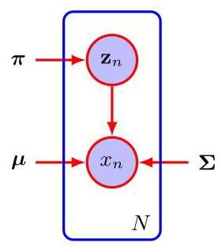

Figure 15.10 This shows the same graph as in Figure 15.9 except that we now suppose that the discrete variables are observed, as well as the data variables .

图 15.10 此图与图 15.9 相同，只是现在我们假设离散变量 以及数据变量 都是可观测的。

# 15.3.1 Gaussian mixtures

# 15.3.1 高斯混合模型

We now consider the application of this latent-variable view of EM to the specific case of a Gaussian mixture model. Recall that our goal is to maximize the log likelihood function (15.13), which is computed using the observed data set , and we saw that this was more difficult than with a single Gaussian distribution due to the summation over that occurs inside the logarithm. Suppose then that in addition to the observed data set , we were also given the values of the corresponding discrete variables . Recall that Figure 15.5(a) shows a complete data set (i.e., one that includes labels showing which component generated each data point) whereas Figure 15.5(b) shows the corresponding incomplete data set. A graphical model for the complete data is shown in Figure 15.10.

现在我们考虑将 EM 的这种隐变量观点应用于高斯混合模型的具体情况。回想一下，我们的目标是最大化对数似然函数(15.13)，该函数是使用观测数据集 计算的，并且我们发现这比单个高斯分布的情况更困难，因为对数内部存在对 的求和。假设除了观测数据集 之外，我们还得到了相应离散变量 的值。回想一下，图 15.5(a) 显示了一个完整的数据集(即包含显示每个数据点由哪个分量生成的标签的数据集)，而图 15.5(b) 显示了相应的不完整数据集。完整数据的图形模型如图 15.10 所示。

Now consider the problem of maximizing the likelihood for the complete data set . From (15.9) and (15.10), this likelihood function takes the form

现在考虑最大化完整数据集 的似然问题。由式(15.9)和式(15.10)可知，该似然函数具有如下形式

where denotes the th component of . Taking the logarithm, we obtain

其中 表示 的第 个分量。取对数后，我们得到

Comparison with the log likelihood function (15.13) for the incomplete data shows that the summation over and the logarithm have been interchanged. The logarithm now acts directly on the Gaussian distribution, which itself is a member of the exponential family. Not surprisingly, this leads to a much simpler solution to the maximum likelihood problem, as we now show. Consider first the maximization with respect to the means and covariances. Because is a -dimensional vector with all elements equal to 0 except for a single element having the value 1, the complete-data log likelihood function is simply a sum of independent contributions, one for each mixture component. Thus, the maximization with respect to a mean or a covariance is exactly as for a single Gaussian, except that it involves only the subset of data points that are ’assigned’ to that component. For the maximization with respect to the mixing coefficients, note that these are coupled for different values of by virtue of the summation constraint (15.8). Again, this can be enforced using a Lagrange multiplier as before, which leads to the result

将其与不完整数据的对数似然函数(15.13)进行比较，可以发现对 的求和与取对数的顺序互换了。现在对数直接作用于高斯分布，而高斯分布本身属于指数族。毫不奇怪，这将为最大似然问题带来更简单的解决方案，我们接下来将进行说明。首先考虑关于均值和协方差的最大化问题。由于 是一个 维向量，除了单个元素的值为 1 外，所有元素都等于 0，因此完整数据的对数似然函数只是 个独立贡献的总和，每个混合分量对应一个贡献。因此，关于均值或协方差的最大化问题与单个高斯分布的情况完全相同，只是它仅涉及“分配”给该分量的数据点子集。对于关于混合系数的最大化问题，请注意，由于求和约束(15.8)，这些系数对于 的不同值是相互耦合的。同样，这可以像之前一样使用拉格朗日乘数来实现，从而得到以下结果

so that the mixing coefficients are equal to the fractions of data points assigned to the corresponding components.

因此，混合系数等于分配给相应分量的数据点的比例。

Thus, we see that the complete-data log likelihood function can be maximized trivially in closed form. In practice, however, we do not have values for the latent variables. Therefore, as discussed earlier, we consider the expectation, with respect to the posterior distribution of the latent variables, of the complete-data log likelihood. Using (15.9) and (15.10) together with Bayes’ theorem, we see that this posterior distribution takes the form

因此，我们看到完整数据的对数似然函数可以以封闭形式轻松地最大化。然而，在实践中，我们没有潜在变量的值。因此，如前面所讨论的，我们考虑完整数据对数似然关于潜在变量后验分布的期望。结合式(15.9)和式(15.10)以及贝叶斯定理，我们发现这个后验分布具有如下形式

We see that this factorizes over so that under the posterior distribution, the are independent. This is easily verified by inspecting the directed graph in Figure 15.9 and making use of the d-separation criterion. The expected value of the indicator variable under this posterior distribution is then given by

我们看到，这个分布关于 进行了因式分解，因此在后验分布下， 是相互独立的。通过检查图 15.9 中的有向图并利用 d - 分离准则，可以很容易地验证这一点。那么，在这个后验分布下，指示变量 的期望值由下式给出

Exercise 15.6

练习 15.6

Section 11.2

第 11.2 节

which is just the responsibility of component for data point . The expected value of the complete-data log likelihood function is therefore given by

这正是组件 对数据点 的责任。因此，完整数据对数似然函数的期望值由下式给出

We can now proceed as follows. First we choose some initial values for the parameters , and , and we use these to evaluate the responsibilities (the E step). We then keep the responsibilities fixed and maximize (15.30) with respect to , and (the M step). This leads to closed-form solutions for , and given by (15.16),(15.18), and (15.21) as before. This is precisely the EM algorithm for Gaussian mixtures as derived earlier. We will gain more insight into the role of the expected complete-data log likelihood function when discuss the convergence of the EM algorithm in Section 15.4.

我们现在可以按如下步骤进行。首先，我们为参数 和 选择一些初始值，并使用这些值来计算责任(E 步)。然后，我们固定责任，并相对于 和 最大化 (15.30)(M 步)。这会像之前一样得到 和 的闭式解，由 (15.16)、(15.18) 和 (15.21) 给出。这正是前面推导的高斯混合模型的 EM 算法。当我们在第 15.4 节讨论 EM 算法的收敛性时，将对期望完整数据对数似然函数的作用有更深入的理解。

Exercise 15.9

练习 15.9

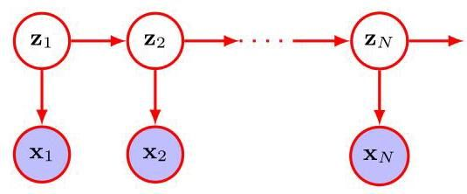

Figure 15.11 The probabilistic graphical model for sequential data corresponding to a hidden Markov model. The discrete latent variables are no longer independent but form a Markov chain.

图 15.11 对应于隐马尔可夫模型的序列数据的概率图模型。离散潜变量不再独立，而是形成一个马尔可夫链。

Throughout this chapter we assume that the data observations are i.i.d. For ordered observations that form a sequence, the mixture model can be extended by connecting the latent variables in a Markov chain to give a hidden Markov model whose graphical structure is shown in Figure 15.11. The EM algorithm can be extended to this more complex model in which the E step involves a sequential calculation in which messages are passed along the chain of latent variables (Bishop, 2006).

在本章中，我们假设数据观测值是独立同分布的。对于构成序列的有序观测值，可以通过将潜在变量连接成马尔可夫链来扩展混合模型，从而得到一个隐马尔可夫模型，其图形结构如图 15.11 所示。期望最大化(EM)算法可以扩展到这个更复杂的模型，其中 E 步涉及一个顺序计算，消息沿着潜在变量链传递(Bishop，2006)。

# 15.3.2 Relation to -means

# 15.3.2 与 -均值的关系

Comparison of the -means algorithm with the EM algorithm for Gaussian mixtures shows that there is a close similarity. Whereas the -means algorithm performs a hard assignment of data points to clusters in which each data point is associated uniquely with one cluster, the EM algorithm makes a soft assignment based on the posterior probabilities. In fact, we can derive the -means algorithm as a particular limit of EM for Gaussian mixtures as follows.

将 -均值算法与高斯混合模型的 EM 算法进行比较，可以发现它们有密切的相似性。 -均值算法对数据点进行硬分配，即每个数据点唯一地与一个聚类相关联，而 EM 算法则基于后验概率进行软分配。事实上，我们可以通过以下方式将 -均值算法推导为高斯混合模型 EM 算法的一个特殊极限情况。

Consider a Gaussian mixture model in which the covariance matrices of the mixture components are given by , where is a variance parameter that is shared by all the components, and is the identity matrix, so that

考虑一个高斯混合模型，其中混合成分的协方差矩阵由 给出，其中 是所有成分共享的方差参数， 是单位矩阵，即

We now consider the EM algorithm for a mixture of Gaussians of this form in which we treat as a fixed constant, instead of a parameter to be re-estimated. From (15.12) the posterior probabilities, or responsibilities, for a particular data point are given by

现在我们考虑针对这种形式的 个高斯分布混合的 EM 算法，在该算法中，我们将 视为一个固定常数，而不是一个需要重新估计的参数。根据式(15.12)，特定数据点 的后验概率(即权重)由下式给出

Consider the limit . The denominator consists of a sum of terms indexed by each of which goes to zero. The particular term for which is smallest, say , will go to zero most slowly and will then dominate this sum. Therefore, the responsibilities for the data point all go to zero except for term , for which the responsibility will go to unity. Note that this holds independently of the values of the so long as none of the is zero. Thus, in this limit, we obtain a hard assignment of data points to clusters, just as in the -means algorithm, so that where is defined by (15.2). Each data point is thereby assigned to the cluster having the closest mean. The EM re-estimation equation for the , given by (15.16), then reduces to the -means result (15.4). Note that the re-estimation formula for the mixing coefficients (15.21) simply resets the value of to be equal to the fraction of data points assigned to cluster , although these parameters no longer play an active role in the algorithm.

考虑极限 。分母是由以 为索引的项的和组成，每一项都趋近于零。其中 最小的那一项，设为 ，将最慢趋近于零，从而在这个和中占主导地位。因此，数据点 的权重 除了 项外都趋近于零，而 项的权重 将趋近于 1。请注意，只要所有的 都不为零，这一结论与 的取值无关。因此，在这个极限情况下，我们得到了数据点到聚类的硬分配，就像 -均值算法一样，即 ，其中 由式(15.2)定义。这样，每个数据点都被分配到均值最接近的聚类中。由式(15.16)给出的 的 EM 重新估计方程就简化为 -均值算法的结果(15.4)。请注意，混合系数的重新估计公式(15.21)只是将 的值重置为分配到聚类 的数据点的比例，尽管这些参数在算法中不再起积极作用。

Finally, in the limit , the expected complete-data log likelihood, given by (15.30), becomes

最后，在极限 情况下，由 (15.30) 给出的期望完全数据对数似然变为

Exercise 15.12

练习 15.12

Thus, we see that in this limit, maximizing the expected complete-data log likelihood is equivalent to minimizing the error measure for the -means algorithm given by (15.1). Note that the -means algorithm does not estimate the covariances of the clusters but only the cluster means.

因此，我们看到在这个极限下，最大化期望完全数据对数似然等价于最小化由 (15.1) 给出的 -均值算法的误差度量 。注意， -均值算法不估计聚类的协方差，而只估计聚类均值。

# 15.3.3 Mixtures of Bernoulli distributions

# 15.3.3 伯努利分布的混合

So far in this chapter, we have focused on distributions over continuous variables described by mixtures of Gaussians. As a further example of mixture modelling and to illustrate the EM algorithm in a different context, we now discuss mixtures of discrete binary variables described by Bernoulli distributions. This model is also known as latent class analysis (Lazarsfeld and Henry, 1968; McLachlan and Peel, 2000).

到目前为止，在本章中，我们主要关注由高斯混合模型描述的连续变量的分布。作为混合建模的另一个例子，并为了在不同的背景下说明 EM 算法，我们现在讨论由伯努利分布描述的离散二元变量的混合。这个模型也被称为潜在类别分析(Lazarsfeld 和 Henry，1968；McLachlan 和 Peel，2000)。

Consider a set of binary variables , where , each of which is governed by a Bernoulli distribution with parameter , so that

考虑一组 个二元变量 ，其中 ，每个变量都由一个参数为 的伯努利分布控制，使得

Section 3.1.1

第3.1.1节

where and . We see that the individual variables are independent, given . The mean and covariance of this distribution are easily seen to be

其中 和 。我们看到，给定 时，各个变量 是相互独立的。容易看出，该分布的均值和协方差为

Exercise 15.13

练习15.13

Now let us consider a finite mixture of these distributions given by

现在让我们考虑由下式给出的这些分布的有限混合

where , and

其中 ，并且

The mixing coefficients satisfy (15.7) and (15.8). The mean and covariance of this mixture distribution are given by

混合系数满足式(15.7)和式(15.8)。该混合分布的均值和协方差由下式给出

Exercise 15.14

练习 15.14

where . Because the covariance matrix is no longer diagonal, the mixture distribution can capture correlations between the variables, unlike a single Bernoulli distribution.

其中 。由于协方差矩阵 不再是对角矩阵，因此与单个伯努利分布不同，混合分布可以捕捉变量之间的相关性。

If we are given a data set then the log likelihood function for this model is given by

如果给定一个数据集 ，则该模型的对数似然函数为

Again we see the appearance of the summation inside the logarithm, so that the maximum likelihood solution no longer has closed form.

我们再次看到对数内部出现了求和项，因此最大似然解不再具有封闭形式。

We now derive the EM algorithm for maximizing the likelihood function for the mixture of Bernoulli distributions. To do this, we first introduce an explicit discrete latent variable associated with each instance of . As with the Gaussian mixture, has a 1-of- coding so that is a binary -dimensional vector having a single component equal to 1, with all other components equal to 0 . We can then write the conditional distribution of , given the latent variable, as

现在我们推导用于最大化伯努利分布混合的似然函数的 EM 算法。为此，我们首先引入一个与 的每个实例相关联的显式离散潜在变量 。与高斯混合模型一样， 采用 1-of- 编码，因此 是一个二进制 维向量，其中只有一个分量等于 1，所有其他分量都等于 0。然后，我们可以将给定潜在变量时 的条件分布写为

whereas the prior distribution for the latent variables is the same as for the mixture-of-Gaussians model, so that

而潜在变量的先验分布与高斯混合模型的相同，因此

If we form the product of and and then marginalize over , then we recover (15.37).

如果我们将 和 相乘，然后对 进行边缘化处理，那么我们就可以得到 (15.37)。

Exercise 15.16

练习 15.16

To derive the EM algorithm, we first write down the complete-data log likelihood function, which is given by

为了推导 EM 算法，我们首先写下完整数据对数似然函数，其表达式为

where and . Next we take the expectation of the complete-data log likelihood with respect to the posterior distribution of the latent variables to give

其中 和 。接下来，我们对完整数据对数似然关于潜在变量的后验分布取期望，得到

where is the posterior probability, or responsibility, of component given data point . In the step, these responsibilities are evaluated using Bayes’ theorem, which takes the form

其中 是给定数据点 时，分量 的后验概率，即责任。在 步骤中，使用贝叶斯定理计算这些责任，其形式为

If we consider the sum over in (15.45), we see that the responsibilities enter only through two terms, which can be written as

如果我们考虑 (15.45) 中对 的求和，我们会发现责任仅通过两项进入，这两项可以写成

where is the effective number of data points associated with component . In the M step, we maximize the expected complete-data log likelihood with respect to the parameters and . If we set the derivative of (15.45) with respect to equal to zero and rearrange the terms, we obtain

其中 是与分量 相关的数据点的有效数量。在 M 步中，我们关于参数 和 最大化期望的完全数据对数似然。如果我们将 (15.45) 关于 的导数设为零并重新整理各项，我们得到

Exercise 15.17

练习 15.17

We see that this sets the mean of component equal to a weighted mean of the data, with weighting coefficients given by the responsibilities that component takes for each of the data points. For the maximization with respect to , we need to introduce a Lagrange multiplier to enforce the constraint . Following analogous steps to those used for the mixture of Gaussians, we then obtain

我们看到这使得分量 的均值等于数据的加权均值，其加权系数由分量 对每个数据点承担的责任给出。为了关于 进行最大化，我们需要引入一个拉格朗日乘子来实施约束 。遵循与高斯混合模型类似的步骤，我们随后得到

which represents the intuitively reasonable result that the mixing coefficient for component is given by the effective fraction of points in the data set explained by that component.

这表示了一个直观上合理的结果，即分量 的混合系数由该分量所解释的数据集中点的有效比例给出。

Exercise 15.18

练习 15.18

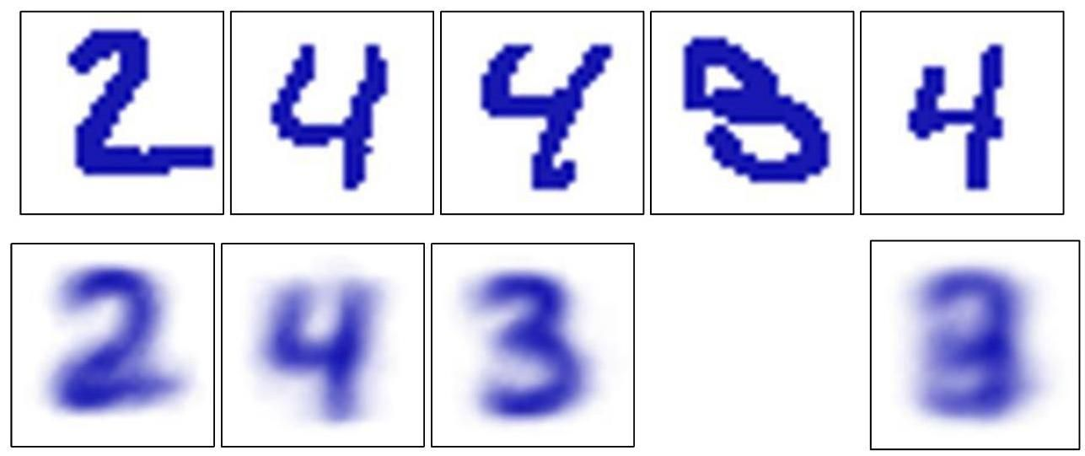

Figure 15.12 Illustration of the Bernoulli mixture model in which the top row shows examples from the digits data set after converting the pixel values from grey scale to binary using a threshold of 0.5 . On the bottom row the first three images show the parameters for each of the three components in the mixture model. As a comparison, we also fit the same data set using a single multivariate Bernoulli distribution, again using maximum likelihood. This amounts to simply averaging the counts in each pixel and is shown by the right-most image on the bottom row.

图 15.12 伯努利混合模型的图示，其中顶行显示了将像素值使用 0.5 的阈值从灰度转换为二值后，来自数字数据集的示例。底行的前三幅图像显示了混合模型中三个分量各自的参数 。作为比较，我们还使用单个多元伯努利分布对同一数据集进行拟合，同样使用最大似然法。这相当于简单地对每个像素的计数求平均，如底行最右侧的图像所示。

Note that in contrast to the mixture of Gaussians, there are no singularities in which the likelihood function goes to infinity. This can be seen by noting that the likelihood function is bounded above because . There exist solutions for which the likelihood function is zero, but these will not be found by EM provided it is not initialized to a pathological starting point, because the EM algorithm always increases the value of the likelihood function, until a local maximum

请注意，与高斯混合模型不同，不存在似然函数趋于无穷大的奇点。这可以通过注意到似然函数有上界来看出，因为 。存在似然函数为零的解，但只要 EM 算法不是从病态的起始点初始化，就不会找到这些解，因为 EM 算法总是会增加似然函数的值，直到达到局部最大值

Exercise 15.19

练习 15.19

# Section 15.3

# 第 15.3 节

is found.

被找到。

We illustrate the Bernoulli mixture model in Figure 15.12 by using it to model handwritten digits. Here the digit images have been turned into binary vectors by setting all elements whose values exceed 0.5 to 1 and setting the remaining elements to 0 . We now fit a data set of such digits, comprising the digits ‘2’,‘3’, and ’ 4’, with a mixture of Bernoulli distributions by running 10 iterations of the EM algorithm. The mixing coefficients were initialized to , and the parameters were set to random values chosen uniformly in the range and then normalized to satisfy the constraint that . We see that a mixture of three Bernoulli distributions is able to find the three clusters in the data set corresponding to the different digits. It is straightforward to extend the analysis of Bernoulli mixtures to the case of multinomial binary variables having states by making use of the discrete distribution (3.14).

我们在图 15.12 中通过使用伯努利混合模型对手写数字进行建模来说明该模型。这里，通过将所有值超过 0.5 的元素设置为 1，其余元素设置为 0，将数字图像转换为二进制向量。现在，我们使用 个伯努利分布的混合模型，对包含数字 “2”、“3” 和 “4” 的 个这样的数字数据集进行拟合，运行 EM 算法 10 次迭代。混合系数初始化为 ，参数 被设置为在范围 内均匀选择的随机值，然后进行归一化以满足约束条件 。我们看到，三个伯努利分布的混合模型能够在数据集中找到对应于不同数字的三个聚类。通过使用离散分布 (3.14)，可以很容易地将伯努利混合模型的分析扩展到具有 个状态的多项二进制变量的情况。

Exercise 15.20

练习 15.20

# 15.4. Evidence Lower Bound

# 15.4. 证据下界

We now present an even more general perspective on the EM algorithm by deriving a lower bound on the log likelihood function, which is known as the evidence lower bound or ELBO. It is sometimes called a variational lower bound. Here the term evidence refers to the (log) likelihood function, which is sometimes called the ’model evidence’ in a Bayesian setting as it allows different models to be compared without the use of hold-out data (Bishop, 2006). As an illustration of this bound, we use it to re-derive the EM algorithm for Gaussian mixtures from a third perspective. The ELBO will play an important role in several of the deep generative models discussed in later chapters. It also provides an example of a variational framework in which we introduce a distribution over the latent variables and then optimize with respect to this distribution using the calculus of variations.

我们现在通过推导对数似然函数的下界，从更一般的角度介绍 EM 算法，这个下界被称为证据下界(Evidence Lower Bound，ELBO)，有时也被称为变分下界。这里的“证据”一词指的是(对数)似然函数，在贝叶斯环境中，它有时被称为“模型证据”，因为它允许在不使用保留数据的情况下比较不同的模型(Bishop，2006)。作为这个下界的一个示例，我们用它从第三个角度重新推导高斯混合模型的 EM 算法。证据下界将在后面章节讨论的几个深度生成模型中发挥重要作用。它还提供了一个变分框架的例子，在这个框架中，我们引入一个关于隐变量的分布 ，然后使用变分法对这个分布进行优化。

Appendix B

附录 B

Consider a probabilistic model in which we collectively denote all the observed variables by and all the hidden variables by . The joint distribution is governed by a set of parameters denoted by . Our goal is to maximize the likelihood

考虑一个概率模型，在这个模型中，我们用 统一表示所有观测变量，用 表示所有隐藏变量。联合分布 由一组用 表示的参数控制。我们的目标是最大化似然

function:

函数:

Here we are assuming that is discrete, although the discussion is identical if comprises continuous variables or a combination of discrete and continuous variables, with summation replaced by integration as appropriate.

这里我们假设 是离散的，不过，如果 包含连续变量或离散变量与连续变量的组合，讨论过程是相同的，只需将求和适当地替换为积分。

We will suppose that direct optimization of is difficult, but that optimization of the complete-data likelihood function is significantly easier. Next we introduce a distribution defined over the latent variables, and we observe that, for any choice of , the following decomposition holds:

我们假设对 进行直接优化是困难的，但对完全数据似然函数 进行优化要容易得多。接下来，我们引入一个定义在潜在变量上的分布 ，并且我们注意到，对于 的任何选择，都有以下分解成立:

where we have defined

其中我们定义了

Appendix B

附录 B

Note that is a functional of the distribution and a function of the parameters . It is worth studying carefully the forms of the expressions (15.53) and (15.54), and in particular noting that they differ in sign and also that contains the joint distribution of and whereas contains the conditional distribution of given . To verify the decomposition (15.52), we first make use of the product rule of probability to give

注意， 是分布 的泛函，也是参数 的函数。仔细研究表达式 (15.53) 和 (15.54) 的形式是值得的，尤其要注意它们的符号不同，而且 包含 和 的联合分布，而 包含给定 时 的条件分布。为了验证分解式 (15.52)，我们首先利用概率的乘积法则得到

which we then substitute into the expression for . This gives rise to two terms, one of which cancels whereas the other gives the required log likelihood after noting that is a normalized distribution that sums to 1 .

然后我们将其代入 的表达式中。这产生了两项，其中一项与 抵消，而另一项在注意到 是一个归一化分布且总和为 1 后，得到所需的对数似然 。

Exercise 15.21

练习 15.21

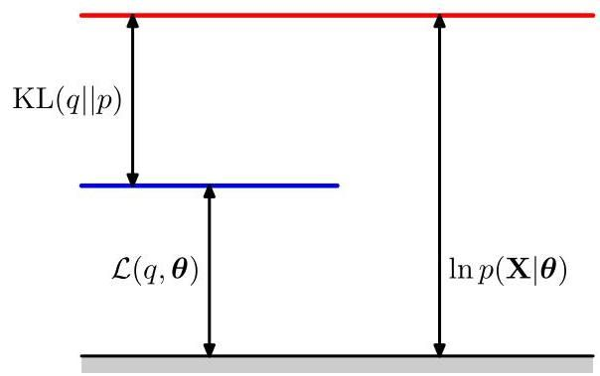

Figure 15.13 Illustration of the decomposition given by (15.52), which holds for any choice of distribution . Because the Kullback-Leibler divergence satisfies , we see that the quantity is a lower bound on the log likelihood function .

图 15.13 展示了由 (15.52) 给出的分解，该分解适用于任何分布 的选择。由于 Kullback-Leibler 散度满足 ，我们可以看到量 是对数似然函数 的下界。

From (15.54), we see that is the Kullback-Leibler divergence between and the posterior distribution . Recall that the Kullback-Leibler divergence satisfies , with equality if, and only if, . It therefore follows from (15.52) that , in other words that is a lower bound on . The decomposition (15.52) is illustrated in Figure 15.13.

从 (15.54) 可知， 是 与后验分布 之间的 Kullback-Leibler 散度。回顾 Kullback-Leibler 散度满足 ，当且仅当 时等号成立。因此，由 (15.52) 可得 ，换句话说， 是 的下界。分解式 (15.52) 如图 15.13 所示。

Section 2.5.7

第 2.5.7 节

# 15.4.1 EM revisited

# 15.4.1 重新审视 EM 算法

We can use the decomposition (15.52) to derive the EM algorithm and to demonstrate that it does indeed maximize the log likelihood. Suppose that the current value of the parameter vector is . In the E step, the lower bound is maximized with respect to while holding fixed. The solution to this maximization problem is easily seen by noting that the value of does not depend on and so the largest value of will occur when the Kullback-Leibler divergence vanishes, in other words when is equal to the posterior distribution . In this case, the lower bound will equal the log likelihood, as illustrated in Figure 15.14.

我们可以使用分解式 (15.52) 来推导 EM 算法，并证明它确实能最大化对数似然。假设参数向量的当前值为 。在 E 步中，在固定 的情况下，关于 最大化下界 。通过注意到 的值不依赖于 ，很容易看出这个最大化问题的解，因此当 Kullback-Leibler 散度为零时，即当 等于后验分布 时， 会取到最大值。在这种情况下，下界将等于对数似然，如图 15.14 所示。

In the subsequent M step, the distribution is held fixed and the lower bound

在随后的 M 步中，分布 保持固定，下界

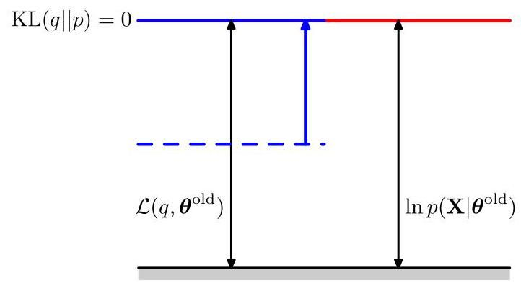

Figure 15.14 Illustration of the step of the EM algorithm. The distribution is set equal to the posterior distribution for the current parameter values , causing the lower bound to move up to the same value as the log likelihood function, with the KL divergence vanishing.

图 15.14 EM 算法 步骤的图示。将 分布设为当前参数值 下的后验分布，这使得下界上升到与对数似然函数相同的值，同时 KL 散度消失。

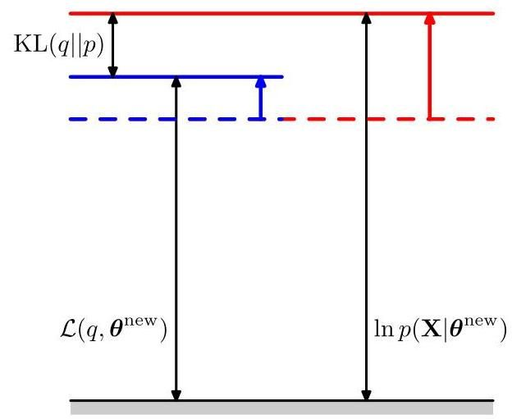

Figure 15.15 Illustration of the step of the EM algorithm. The distribution is held fixed and the lower bound is maximized with respect to the parameter vector to give a revised value . Because the Kullback-Leibler divergence is non-negative, this causes the log likelihood to increase by at least as much as the lower bound does.

图 15.15 EM 算法 步骤的图示。分布 保持固定，关于参数向量 最大化下界 以得到修正后的值 。由于 Kullback - Leibler 散度是非负的，这使得对数似然 的增加量至少与下界的增加量相同。

is maximized with respect to to give some new value . This will cause the lower bound to increase (unless it is already at a maximum), which will necessarily cause the corresponding log likelihood function to increase. Because the distribution is determined using the old parameter values rather than the new values and is held fixed during the step, it will not equal the new posterior distribution , and hence there will be a non-zero Kullback–Leibler divergence. The increase in the log likelihood function is therefore greater than the increase in the lower bound, as shown in Figure 15.15. If we substitute into (15.53), we see that, after the step, the lower bound takes the form

关于 最大化 以得到某个新值 。这将导致下界 增加(除非它已经处于最大值)，这必然会使相应的对数似然函数增加。因为分布 是使用旧的参数值而非新值确定的，并且在 步骤中保持固定，所以它将不等于新的后验分布 ，因此会存在非零的 Kullback - Leibler 散度。因此，如图 15.15 所示，对数似然函数的增加量大于下界的增加量。如果我们将 代入 (15.53)，我们会发现，在 步骤之后，下界具有以下形式

where the constant is simply the negative entropy of the distribution and is therefore independent of . Here we recognize as the expected complete-data log-likelihood defined by (15.23), and it is therefore the quantity that is being maximized in the M step, as we saw earlier distribution for mixtures of Gaussians. Note that the variable over which we are optimizing appears only inside the logarithm. If the joint distribution is a member of the exponential family or a product of such members, then we see that the logarithm will cancel the exponential and lead to an step that will be typically much simpler than the maximization of the corresponding incomplete-data log likelihood function .

其中常数仅仅是 分布的负熵，因此与 无关。在这里，我们将 识别为 (15.23) 定义的期望完全数据对数似然，因此，正如我们之前在高斯混合分布中看到的那样，它是在 M 步骤中被最大化的量。注意，我们正在优化的变量 仅出现在对数内部。如果联合分布 是指数族的成员或此类成员的乘积，那么我们会发现对数会抵消指数，并导致 步骤通常比相应的不完全数据对数似然函数 的最大化简单得多。

Section 15.3

第 15.3 节

The operation of the EM algorithm can also be viewed in the space of parameters, as illustrated schematically in Figure 15.16. Here the red curve depicts the (incomplete-data) log likelihood function whose value we wish to maximize. We start with some initial parameter value , and in the first step we evaluate the posterior distribution over latent variables, which gives rise to a lower bound whose value equals the log likelihood at , as shown by the blue curve. Note that the bound makes a tangential contact with the log likelihood at , so that both curves have the same gradient. This bound is a convex function having a unique maximum (for mixture components from the exponential family). In the M step, the bound is maximized giving the value , which gives a larger value of the likelihood than . The subsequent E step then constructs a bound that is tangential at as shown by the green curve.

EM 算法的操作也可以在参数空间中进行观察，如图 15.16 所示。这里，红色曲线描绘了(不完全数据)对数似然函数，我们希望最大化其值。我们从某个初始参数值 开始，在第一个 步骤中，我们评估潜在变量的后验分布，这会产生一个下界 ，其值等于在 处的对数似然，如蓝色曲线所示。注意，该下界在 处与对数似然相切，因此两条曲线具有相同的梯度。这个下界是一个凸函数，具有唯一的最大值(对于指数族的混合分量)。在 M 步骤中，最大化该下界得到值 ，它给出的 似然值比 更大。随后的 E 步骤则构建一个在 处相切的下界，如绿色曲线所示。

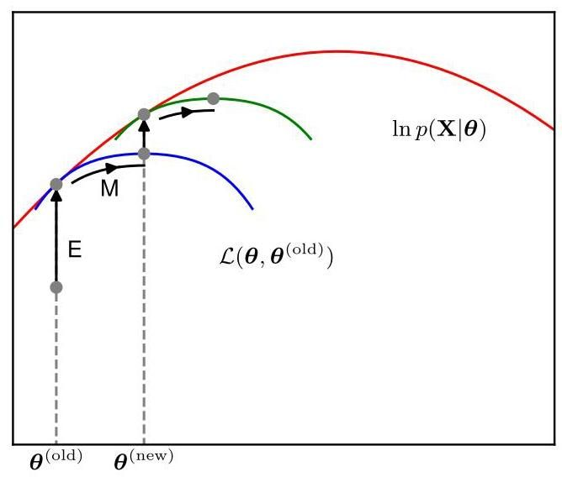

Figure 15.16 The EM algorithm involves alternately computing a lower bound on the log likelihood for the current parameter values and then maximizing this bound to obtain the new parameter values. See the text for a full discussion.

图 15.16 EM 算法包括交替计算当前参数值下对数似然的下界，然后最大化该下界以获得新的参数值。完整讨论见正文。

Exercise 15.22

练习 15.22

We have seen that both the and the steps of the EM algorithm increase the value of a well-defined bound on the log likelihood function and that the complete EM cycle will change the model parameters in such a way as to cause the log likelihood to increase (unless it is already at a maximum, in which case the parameters remain unchanged).

我们已经看到，EM 算法的 步骤和 步骤都会增加对数似然函数一个明确定义的下界的值，并且完整的 EM 循环会以一种使对数似然增加的方式改变模型参数(除非它已经处于最大值，在这种情况下参数保持不变)。

# 15.4.2 Independent and identically distributed data

# 15.4.2 独立同分布数据

For the particular case of an i.i.d. data set, will comprise data points whereas will comprise corresponding latent variables , where . From the independence assumption, we have , and by marginalizing over the we have . Using the sum and product rules, we see that the posterior probability that is evaluated in the E step takes the form

对于独立同分布数据集的特定情况， 将包含 个数据点 ，而 将包含 个相应的潜在变量 ，其中 。根据独立性假设，我们有 ，并且通过对 进行边缘化，我们有 。使用求和规则和乘积规则，我们可以看到在 E 步骤中评估的后验概率具有以下形式

and so the posterior distribution also factorizes with respect to . For a Gaussian mixture model, this simply says that the responsibility that each of the mixture components takes for a particular data point depends only on the value of and on the parameters of the mixture components, not on the values of the other data points.

因此，后验分布也会关于 进行因式分解。对于高斯混合模型，这仅仅表明每个混合成分对特定数据点 所承担的责任仅取决于 的值以及混合成分的参数 ，而不取决于其他数据点的值。

# 15.4.3 Parameter priors

# 15.4.3 参数先验

We can also use the EM algorithm to maximize the posterior distribution for models in which we have introduced a prior over the parameters. To see this, note that as a function of , we have and so

我们还可以使用 EM 算法来最大化模型的后验分布 ，在这些模型中，我们已经对参数引入了先验 。为了理解这一点，请注意，作为 的函数，我们有 ，因此

Making use of the decomposition (15.52), we have

利用分解式 (15.52)，我们得到

where is a constant. We can again optimize the right-hand side alternately with respect to and . The optimization with respect to gives rise to the same E-step equations as for the standard EM algorithm, because appears only in . The M-step equations are modified through the introduction of the prior term , which typically requires only a small modification to the standard maximum likelihood M-step equations. The additional term represents a form of regularization and has the effect of removing the singularities of the likelihood function for Gaussian mixture models.

其中 是一个常数。我们可以再次交替地关于 和 优化右侧。关于 的优化会得到与标准 EM 算法相同的 E 步方程，因为 仅出现在 中。M 步方程通过引入先验项 进行了修改，这通常只需要对标准的最大似然 M 步方程进行小的修改。额外的项代表了一种正则化形式，并且具有消除高斯混合模型似然函数奇异性的效果。

Chapter 9

第 9 章

# 15.4.4 Generalized EM

# 15.4.4 广义 EM 算法

The EM algorithm breaks down the potentially difficult problem of maximizing the likelihood function into two stages, the step and the step, each of which will often prove simpler to implement. Nevertheless, for complex models it may be the case that either the step or the step, or indeed both, remain intractable. This leads to two possible extensions of the EM algorithm, as follows.

EM 算法将最大化似然函数这一潜在的难题分解为两个阶段，即 步骤和 步骤，通常每个步骤实施起来会更简单。然而，对于复杂模型，可能会出现 步骤或 步骤，甚至两者都难以处理的情况。这就引出了 EM 算法的两种可能扩展，如下所述。

The generalized EM, or GEM, algorithm addresses the problem of an intractable M step. Instead of aiming to maximize with respect to , it seeks instead to change the parameters in such a way as to increase its value. Again, because is a lower bound on the log likelihood function, each complete EM cycle of the GEM algorithm is guaranteed to increase the value of the log likelihood (unless the parameters already correspond to a local maximum). One way to exploit the GEM approach would be to use gradient-based iterative optimization algorithms during the M step. Another form of GEM algorithm, known as the expectation conditional maximization algorithm, involves making several constrained optimizations within each M step (Meng and Rubin, 1993). For instance, the parameters might be partitioned into groups and the step broken down into multiple steps each of which involves optimizing one of the groups with the remainder held fixed.

广义 EM 算法，即 GEM 算法，解决了 M 步骤难以处理的问题。它不是旨在关于 最大化 ，而是寻求以一种能增加其值的方式改变参数。同样，由于 是对数似然函数的下界，GEM 算法的每个完整 EM 循环都保证会增加对数似然的值(除非参数已经对应于一个局部最大值)。利用 GEM 方法的一种方式是在 M 步骤中使用基于梯度的迭代优化算法。另一种形式的 GEM 算法，称为期望条件最大化算法，涉及在每个 M 步骤内进行多次约束优化(Meng 和 Rubin，1993)。例如，可以将参数划分为多个组，并将 步骤分解为多个步骤，每个步骤涉及在其余组固定的情况下优化其中一个组。

We can similarly generalize the step of the algorithm by performing a partial, rather than complete, optimization of with respect to (Neal and Hinton,1999). As we have seen, for any given value of there is a unique maximum of with respect to that corresponds to the posterior distribution and that for this choice of , the bound is equal to the log likelihood function . It follows that any algorithm that converges to the global maximum of will find a value of that is also a global maximum of the log likelihood . Provided is a continuous function of then, by continuity, any local maximum of will also be a local maximum of .

我们可以类似地对 算法的 步骤进行推广，即关于 对 进行部分而非完全的优化(Neal 和 Hinton，1999)。如我们所见，对于 的任何给定值，关于 存在 的唯一最大值，该最大值对应于后验分布 ，并且对于 的这种选择，界 等于对数似然函数 。由此可知，任何收敛到 全局最大值的算法都将找到一个 的值，该值也是对数似然 的全局最大值。假设 是 的连续函数，那么根据连续性， 的任何局部最大值也将是 的局部最大值。

# 15.4.5 Sequential EM

# 15.4.5 顺序 EM 算法

Consider independent data points with corresponding latent variables . The joint distribution factorizes over the data points, and this structure can be exploited in an incremental form of EM in which at each EM cycle, only one data point is processed at a time. In the E step, instead of recomputing the responsibilities for all the data points, we just re-evaluate the responsibilities for one data point. It might appear that the subsequent M step would require a computation involving the responsibilities for all the data points. However, if the mixture components are members of the exponential family, then the responsibilities enter only through simple sufficient statistics, and these can be updated efficiently. Consider, for instance, a Gaussian mixture, and suppose we perform an update for data point in which the corresponding old and new values of the responsibilities are denoted by and . In the M step, the required sufficient statistics can be updated incrementally. For instance, for the means, the sufficient statistics are defined by (15.16) and (15.17) from which we obtain

考虑 个独立的数据点 及其对应的潜在变量 。联合分布 可按数据点进行分解，这种结构可用于 EM 算法的增量形式，在每个 EM 循环中，每次仅处理一个数据点。在 E 步中，我们不是重新计算所有数据点的权重，而只是重新评估一个数据点的权重。乍一看，后续的 M 步似乎需要涉及所有数据点权重的计算。然而，如果混合成分属于指数族，那么权重仅通过简单的充分统计量进入，并且这些统计量可以有效地更新。例如，考虑一个高斯混合模型，并假设我们对数据点 进行更新，其中对应的权重的旧值和新值分别用 和 表示。在 M 步中，所需的充分统计量可以增量式更新。例如，对于均值，充分统计量由 (15.16) 和 (15.17) 定义，由此我们可以得到

Exercise 15.23

练习 15.23

together with

连同

The corresponding results for the covariances and the mixing coefficients are analogous.

协方差和混合系数的相应结果是类似的。

Thus, both the step and the step take a fixed time that is independent of the total number of data points. Because the parameters are revised after each data point, rather than waiting until after the whole data set is processed, this incremental version can converge faster than the batch version. Each E or M step in this incremental algorithm increases the value of , and as we have shown above, if the algorithm converges to a local (or global) maximum of , this will correspond to a local (or global) maximum of the log likelihood function .

因此， 步和 步都需要固定的时间，该时间与数据点的总数无关。由于参数是在每个数据点之后进行修订，而不是等到整个数据集处理完之后，这种增量版本的收敛速度可能比批量版本更快。此增量算法中的每个 E 步或 M 步都会增加 的值，并且正如我们上面所示，如果算法收敛到 的局部(或全局)最大值，这将对应于对数似然函数 的局部(或全局)最大值。

Exercises

练习

15.1 (*) Consider the -means algorithm discussed in Section 15.1. Show that as a consequence of there being a finite number of possible assignments for the set of discrete indicator variables and that for each such assignment there is a unique optimum for the , the -means algorithm must converge after a finite number of iterations.

15.1 (*) 考虑第 15.1 节中讨论的 -均值算法。证明由于离散指示变量集合 存在有限数量的可能赋值，并且对于每个这样的赋值， 都有唯一的最优解，因此 -均值算法必定会在有限次迭代后收敛。

15.2 In this exercise we derive the sequential form for the -means algorithm. At each step we consider a new data point , and only the prototype vector that is closest to is updated. Starting from the expression (15.4) for the prototype vectors in the batch setting, separate out the contribution from the final data point . By rearranging the formula, show that this update takes the form (15.5). Note that, since no approximation is made in this derivation, the resulting prototype vectors will have the property that they each equal the mean of all the data vectors that were assigned to them.

15.2 在本练习中，我们推导 -均值算法的顺序形式。在每一步，我们考虑一个新的数据点 ，并且仅更新最接近 的原型向量。从批量设置下原型向量的表达式 (15.4) 出发，分离出最后一个数据点 的贡献。通过重新整理公式，证明此更新采用形式 (15.5)。请注意，由于在这个推导过程中没有进行近似处理，因此得到的原型向量将具有这样的性质:它们各自等于所有分配给它们的数据向量的均值。

15.3 ( ) Consider a Gaussian mixture model in which the marginal distribution for the latent variable is given by (15.9) and the conditional distribution for the observed variable is given by (15.10). Show that the marginal distribution , obtained by summing over all possible values of , is a Gaussian mixture of the form (15.6).

15.3 ( ) 考虑一个高斯混合模型，其中隐变量的边缘分布 由式(15.9)给出，观测变量的条件分布 由式(15.10)给出。证明通过对 的所有可能值求和 得到的边缘分布 具有式(15.6)的高斯混合形式。

15.4 (*) Show that the number of equivalent parameter settings due to interchange symmetries in a mixture model with components is !.

15.4 (*) 证明在具有 个分量的混合模型中，由于交换对称性导致的等价参数设置的数量为 !。

15.5 Suppose we wish to use the EM algorithm to maximize the posterior distribution over parameters for a model containing latent variables, where is the observed data set. Show that the E step remains the same as in the maximum likelihood case, whereas in the step the quantity to be maximized is given by where is defined by (15.23).

15.5 假设我们希望使用 EM 算法来最大化包含隐变量的模型中参数 的后验分布，其中 是观测数据集。证明 E 步与最大似然情形下相同，而在 步中，需要最大化的量由 给出，其中 由式(15.23)定义。

15.6 (*) Consider the directed graph for a Gaussian mixture model shown in Figure 15.9. By making use of the d-separation criterion, show that the posterior distribution of the latent variables factorizes with respect to the different data points so that

15.6 (*) 考虑图 15.9 所示的高斯混合模型的有向图。利用 d-分离准则，证明隐变量的后验分布相对于不同的数据点是可分解的，使得

Section 11.2

第 11.2 节

15.7 Consider a special case of a Gaussian mixture model in which the covariance matrices of the components are all constrained to have a common value . Derive the EM equations for maximizing the likelihood function under such a model.

15.7 考虑高斯混合模型的一种特殊情况，其中各分量的协方差矩阵 都被约束为具有相同的值 。推导在这样一个模型下最大化似然函数的 EM 方程。

15.8 Verify that maximization of the complete-data log likelihood (15.26) for a Gaussian mixture model leads to the result that the means and covariances of each component are fitted independently to the corresponding group of data points and that the mixing coefficients are given by the fractions of points in each group.

15.8 验证对于高斯混合模型，最大化完全数据对数似然函数 (15.26) 会得到如下结果:每个分量的均值和协方差会独立地拟合到相应的数据点组，并且混合系数由每组中的点数比例给出。

15.9 Show that if we maximize (15.30) with respect to while keeping the responsibilities fixed, we obtain the closed-form solution given by (15.16).

15.9 证明如果在固定责任权重 的情况下，关于 最大化 (15.30)，我们会得到由 (15.16) 给出的闭式解。

15.10 Show that if we maximize (15.30) with respect to and while keeping the responsibilities fixed, we obtain the closed-form solutions given by (15.18) and (15.21).

15.10 证明如果在固定责任权重 的情况下，关于 和 最大化 (15.30)，我们会得到由 (15.18) 和 (15.21) 给出的闭式解。

15.11 Consider a density model given by a mixture distribution:

15.11 考虑一个由混合分布给出的密度模型:

and suppose that we partition the vector into two parts so that . Show that the conditional density is itself a mixture distribution, and find expressions for the mixing coefficients and for the component densities.

假设我们将向量 划分为两部分，使得 。证明条件密度 本身也是一个混合分布，并求出混合系数和分量密度的表达式。

15.12 (*) In Section 15.3.2, we obtained a relationship between means and EM for Gaussian mixtures by considering a mixture model in which all components have covariance . Show that in the limit , maximizing the expected complete-data log likelihood for this model, given by (15.30), is equivalent to minimizing the error measure for the -means algorithm given by (15.1).

15.12 (*) 在第 15.3.2 节中，我们通过考虑一个所有分量都具有协方差 的混合模型，得到了 均值算法和高斯混合模型的 EM 算法之间的关系。证明在极限 下，最大化该模型的期望完全数据对数似然函数(由 (15.30) 给出)等价于最小化 均值算法的误差度量 (由 (15.1) 给出)。

15.13 (★★) Verify the results (15.35) and (15.36) for the mean and covariance of the Bernoulli distribution.

15.13 (★★) 验证伯努利分布的均值和协方差的结果 (15.35) 和 (15.36)。

15.14 Consider a mixture distribution of the form

15.14 考虑以下形式的混合分布

where the elements of could be discrete or continuous or a combination of these. Denote the mean and covariance of by and , respectively. By making use of the results of Exercise 15.13, show that the mean and covariance of the mixture distribution are given by (15.39) and (15.40).

其中 的元素可以是离散的、连续的或两者的组合。分别用 和 表示 的均值和协方差。利用练习 15.13 的结果，证明混合分布的均值和协方差由 (15.39) 和 (15.40) 给出。

15.15 Using the re-estimation equations for the EM algorithm, show that a mixture of Bernoulli distributions, with its parameters set to values corresponding to a maximum of the likelihood function, has the property that

15.15 使用 EM 算法的重新估计方程，证明参数设置为对应似然函数最大值的伯努利分布混合具有以下性质

Hence, show that if the parameters of this model are initialized such that all components have the same mean for , then the EM algorithm will converge after one iteration, for any choice of the initial mixing coefficients, and that this solution has the property . Note that this represents a degenerate case of the mixture model in which all the components are identical, and in practice we try to avoid such solutions by using an appropriate initialization.

因此，证明如果该模型的参数初始化为所有分量对于 都具有相同的均值 ，那么对于初始混合系数的任何选择，EM 算法将在一次迭代后收敛，并且该解具有性质 。请注意，这代表了混合模型的一种退化情况，其中所有分量都是相同的，在实践中，我们通过使用适当的初始化来避免此类解。

15.16 Consider the joint distribution of latent and observed variables for the Bernoulli distribution obtained by forming the product of given by (15.42) and given by (15.43). Show that if we marginalize this joint distribution with respect to , then we obtain (15.37).

15.16 考虑通过将 (15.42) 给出的 与 (15.43) 给出的 相乘得到的伯努利分布的潜在变量和观测变量的联合分布。证明如果我们对该联合分布关于 进行边缘化，那么我们将得到 (15.37)。

15.17 (*) Show that if we maximize the expected complete-data log likelihood function (15.45) for a mixture of Bernoulli distributions with respect to , we obtain the M-step equation (15.49).

15.17 (*) 证明:如果我们针对 最大化伯努利分布混合的期望完全数据对数似然函数 (15.45)，我们将得到 M 步方程 (15.49)。

15.18 Show that if we maximize the expected complete-data log likelihood function (15.45) for a mixture of Bernoulli distributions with respect to the mixing coefficients , and use a Lagrange multiplier to enforce the summation constraint, we obtain the M-step equation (15.50).

15.18 证明:如果我们针对混合系数 最大化伯努利分布混合的期望完全数据对数似然函数 (15.45)，并使用拉格朗日乘数来实施求和约束，我们将得到 M 步方程 (15.50)。

15.19 (⋆) Show that as a consequence of the constraint for the discrete variable , the incomplete-data log likelihood function for a mixture of Bernoulli distributions is bounded above and hence that there are no singularities for which the likelihood goes to infinity.

15.19 (⋆) 证明:由于离散变量 存在约束 ，伯努利分布混合的不完全数据对数似然函数有上界，因此不存在似然趋于无穷大的奇点。

15.20 Consider a -dimensional variable each of whose components is itself a multinomial variable of degree so that is a binary vector with components where and , subject to the constraint that for all . Suppose that the distribution of these variables is described by a mixture of the discrete multinomial distributions so that

15.20 考虑一个 维变量 ，其每个分量 本身是一个阶为 的多项变量，使得 是一个二进制向量，其分量为 ，其中 且 ，并满足对于所有 都有 的约束条件。假设这些变量的分布由离散多项分布的混合来描述，使得

Section 3.1.3

第 3.1.3 节

where

其中

The parameters represent the probabilities and must satisfy together with the constraint for all values of and . Given an observed data set , where , derive the E-step and M-step equations of the EM algorithm for optimizing the mixing coefficients and the component parameters of this distribution by maximum likelihood.

参数 表示概率 ，并且对于 和 的所有值，必须满足 以及约束条件 。给定一个观测数据集 ，其中 ，通过最大似然法推导用于优化该分布的混合系数 和分量参数 的 EM 算法的 E 步和 M 步方程。

15.21 Verify the relation (15.52) in which and are defined by (15.53) and (15.54), respectively.

15.21 验证关系式 (15.52)，其中 和 分别由 (15.53) 和 (15.54) 定义。

15.22 Show that the lower bound given by (15.53), with , has the same gradient with respect to as the log likelihood function at the point .

15.22 证明由 (15.53) 给出的下界 ，在 的情况下，在点 处关于 的梯度与对数似然函数 的梯度相同。

15.23 Consider the incremental form of the EM algorithm for a mixture of Gaussians, in which the responsibilities are recomputed only for a specific data point . Starting from the M-step formulae (15.16) and (15.17), derive the results (15.60) and (15.61) for updating the component means.

15.23 考虑高斯混合模型的 EM 算法的增量形式，其中仅针对特定数据点 重新计算权重。从 M 步公式 (15.16) 和 (15.17) 出发，推导用于更新分量均值的结果 (15.60) 和 (15.61)。

15.24 Derive M-step formulae for updating the covariance matrices and mixing coefficients in a Gaussian mixture model when the responsibilities are updated incrementally, analogous to the result (15.60) for updating the means.

15.24 当权重进行增量更新时，推导用于更新高斯混合模型中协方差矩阵和混合系数的 M 步公式，类似于更新均值的结果 (15.60)。

Deep Learning

深度学习

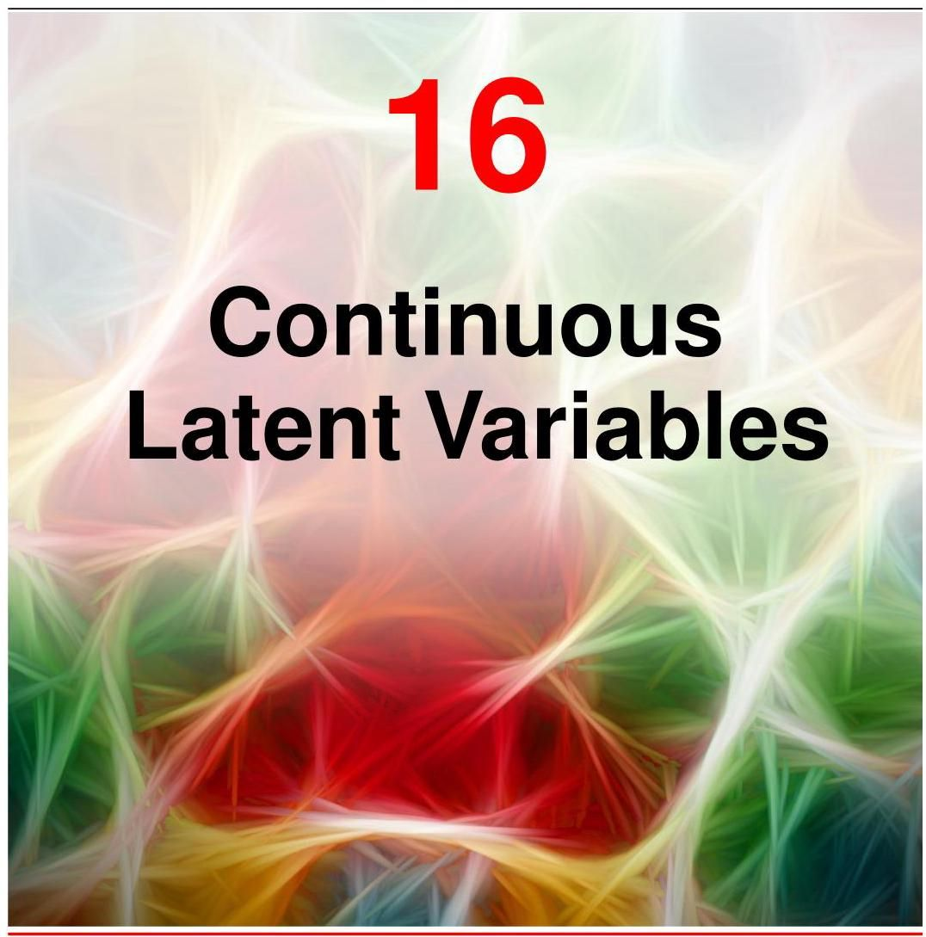

In the previous chapter we discussed probabilistic models having discrete latent variables, such as a mixture of Gaussians. We now explore models in which some, or all, of the latent variables are continuous. An important motivation for such models is that many data sets have the property that the data points lie close to a manifold of much lower dimensionality than that of the original data space. To see why this might arise, consider an artificial data set constructed by taking a handwritten digit from the MNIST data set (LeCun et al.,1998), represented by a pixel grey-level image, and embedding it in a larger image of size by padding with pixels having the value zero (corresponding to white pixels) in which the location and orientation of the digit are varied at random, as illustrated in Figure 16.1. Each of the resulting images is represented by a point in the -dimensional data space. However, across a data set of such images, there are only three degrees of freedom of variability, corresponding to vertical and horizontal translations and rotations. The data points will therefore live on a subspace of the data space whose intrinsic dimensionality is three. Note that the manifold will be nonlinear because, for instance, if we translate the digit past a particular pixel, that pixel value will go from zero (white) to one (black) and back to zero again, which is clearly a nonlinear function of the digit position. In this example, the translation and rotation parameters are latent variables because we observe only the image vectors and are not told which values of the translation or rotation variables were used to create them.

在上一章中，我们讨论了具有离散潜在变量的概率模型，例如高斯混合模型。现在，我们将探索其中部分或全部潜在变量为连续变量的模型。此类模型的一个重要动机是，许多数据集具有这样的特性:数据点位于一个维度远低于原始数据空间的流形附近。为了理解这种情况为何会出现，考虑一个人工数据集，它是通过从 MNIST 数据集(LeCun 等人，1998 年)中选取一个手写数字构建而成的。该手写数字由一个 像素的灰度图像表示，并通过用值为零(对应白色像素)的像素进行填充，将其嵌入到一个更大的 大小的图像中，其中数字的位置和方向是随机变化的，如图 16.1 所示。每个生成的图像都由 维数据空间中的一个点表示。然而，在这样的图像数据集中，只有三个自由度的可变性，分别对应于垂直和水平平移以及旋转。因此，数据点将位于数据空间的一个子空间中，该子空间的内在维度为三。请注意，该流形将是非线性的，因为例如，如果我们将数字平移经过某个特定像素，该像素的值将从零(白色)变为一(黑色)，然后再变回零，这显然是数字位置的非线性函数。在这个例子中，平移和旋转参数是潜在变量，因为我们仅观察到图像向量，而未被告知用于创建这些图像的平移或旋转变量的值。

Section 6.1.3

第 6.1.3 节

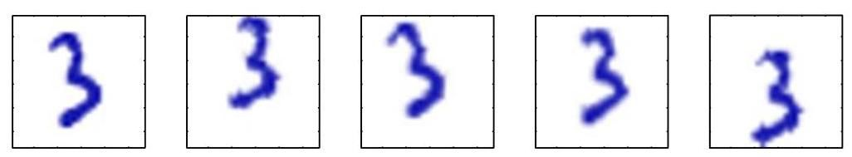

Figure 16.1 A synthetic data set obtained by taking an image of a handwritten digit and creating multiple copies in each of which the digit has undergone a random displacement and rotation within some larger image field. The resulting images each have pixels.

图 16.1 一个合成数据集，通过获取手写数字的图像并创建多个副本得到，每个副本中的数字在某个更大的图像区域内经历了随机位移和旋转。生成的图像每个都有 个像素。

For real data sets of handwritten digits, there will be further degrees of freedom arising from scaling and other variations due, for example, to the variability in an individual’s writing as well as the differences in writing styles between individuals. Nevertheless, the number of such degrees of freedom will be small compared to the dimensionality of the data set.

对于真实的手写数字数据集，由于缩放和其他变化，例如个人书写的可变性以及个体之间书写风格的差异，还会有更多的自由度。然而，与数据集的维度相比，这些自由度的数量将很小。

In practice, the data points will not be confined precisely to a smooth low-dimensional manifold, and we can interpret the departures of data points from the manifold as ’noise’. This leads naturally to a generative view of such models in which we first select a point within the manifold according to some latent-variable distribution and then generate an observed data point by adding noise drawn from some conditional distribution of the data variables given the latent variables.

在实践中，数据点不会精确地局限于一个平滑的低维流形，我们可以将数据点与流形的偏离解释为“噪声”。这自然地引出了此类模型的生成视角，在该视角中，我们首先根据某个潜在变量分布在流形内选择一个点，然后通过添加从给定潜在变量的数据变量的某个条件分布中抽取的噪声来生成一个观测数据点。

The simplest continuous latent-variable model assumes Gaussian distributions for both the latent and observed variables and makes use of a linear-Gaussian dependence of the observed variables on the state of the latent variables. This leads to a probabilistic formulation of the well-known technique of principal component analysis (PCA) as well as to a related model called factor analysis. In this chapter we will begin with a standard, non-probabilistic treatment of PCA, and then we show how PCA arises naturally as the maximum likelihood solution for a linear-Gaussian latent-variable model. This probabilistic reformulation brings many advantages, such as the use of EM for parameter estimation, principled extensions to mixtures of PCA models, and Bayesian formulations that allow the number of principal components to be determined automatically from the data (Bishop, 2006). This chapter also lays the foundations for nonlinear models having continuous latent variables including normalizing flows, variational autoencoders, and diffusion models.

最简单的连续潜在变量模型假设潜在变量和观测变量都服从高斯分布，并利用观测变量对潜在变量状态的线性高斯依赖关系。这导致了著名的主成分分析(PCA)技术的概率公式化，以及一个称为因子分析的相关模型。在本章中，我们将从 PCA 的标准非概率处理开始，然后展示 PCA 如何自然地作为线性高斯潜在变量模型的最大似然解出现。这种概率重新表述带来了许多优点，例如使用 EM 算法进行参数估计、对 PCA 模型混合的原则性扩展，以及允许从数据中自动确定主成分数量的贝叶斯公式化(Bishop，2006 年)。本章还为具有连续潜在变量的非线性模型奠定了基础，包括归一化流、变分自编码器和扩散模型。

Section 11.1.4 Section 16.1 Section 16.2

第 11.1.4 节 第 16.1 节 第 16.2 节

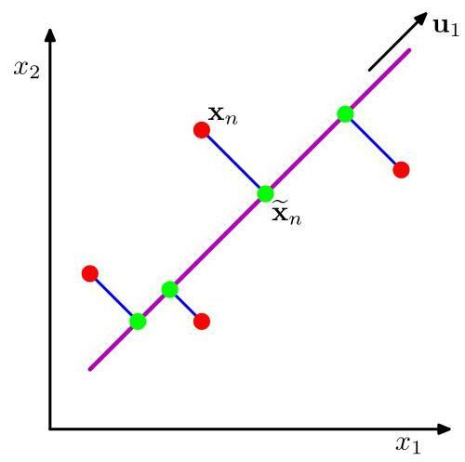

Figure 16.2 Principal component analysis seeks a space of lower dimensionality, known as the principal subspace and denoted by the magenta line, such that the orthogonal projection of the data points (red dots) onto this subspace maximizes the variance of the projected points (green dots). An alternative definition of PCA is based on minimizing the sum-of-squares of the projection errors, indicated by the blue lines.

图 16.2 主成分分析旨在寻找一个低维空间，即主子空间(由品红色线表示)，使得数据点(红点)在该子空间上的正交投影能使投影点(绿点)的方差最大化。主成分分析的另一种定义基于最小化投影误差的平方和，由蓝色线表示。

# 16.1. Principal Component Analysis

# 16.1. 主成分分析

Principal component analysis, or PCA, is widely used for applications such as dimensionality reduction, lossy data compression, feature extraction, and data visualization (Jolliffe, 2002). It is also known as the Kosambi-Karhunen-Loève transform.

主成分分析(PCA)广泛应用于降维、有损数据压缩、特征提取和数据可视化等领域(Jolliffe，2002)。它也被称为 Kosambi - Karhunen - Loève 变换。

Consider the orthogonal projection of a data set onto a lower-dimensional linear space, known as the principal subspace, as shown in Figure 16.2. PCA can be defined as the linear projection that maximizes the variance of the projected data (Hotelling, 1933). Equivalently, it can be defined as the linear projection that minimizes the average projection cost, defined as the mean squared distance between the data points and their projections (Pearson, 1901). We consider each of these definitions in turn.

考虑将数据集正交投影到一个低维线性空间(即主子空间)，如图 16.2 所示。主成分分析可以定义为使投影数据方差最大化的线性投影(Hotelling，1933)。等价地，它也可以定义为使平均投影成本最小化的线性投影，平均投影成本定义为数据点与其投影之间的均方距离(Pearson，1901)。我们将依次讨论这些定义。

# 16.1.1 Maximum variance formulation

# 16.1.1 最大方差公式

Consider a data set of observations where , and is a Euclidean variable with dimensionality . Our goal is to project the data onto a space having dimensionality while maximizing the variance of the projected data. For the moment, we will assume that the value of is given. Later in this chapter, we will consider techniques to determine an appropriate value of from the data.

考虑一个观测数据集 ，其中 ，且 是一个维度为 的欧几里得变量。我们的目标是将数据投影到一个维度为 的空间中，同时最大化投影数据的方差。目前，我们假设 的值是已知的。在本章后面，我们将考虑从数据中确定 合适值的技术。

To begin with, consider the projection onto a one-dimensional space . We can define the direction of this space using a -dimensional vector , which for convenience (and without loss of generality) we will choose to be a unit vector so that (note that we are interested only in the direction defined by , not in the magnitude of itself). Each data point is then projected onto a scalar value . The mean of the projected data is where is the sample set mean given by

首先，考虑投影到一维空间 。我们可以使用一个 维向量 来定义这个空间的方向，为了方便起见(且不失一般性)，我们选择它为单位向量，使得 (注意，我们只对 定义的方向感兴趣，而不是 本身的大小)。然后，每个数据点 被投影到一个标量值 上。投影数据的均值是 ，其中 是由下式给出的样本集均值

and the variance of the projected data is given by

投影数据的方差由下式给出

where is the data covariance matrix defined by

其中 是由下式定义的数据协方差矩阵

We now maximize the projected variance with respect to . Clearly, this has to be a constrained maximization to prevent . The appropriate constraint comes from the normalization condition . To enforce this constraint, we introduce a Lagrange multiplier that we will denote by , and then make an unconstrained maximization of

现在，我们关于 最大化投影方差 。显然，这必须是一个有约束的最大化问题，以防止 。合适的约束来自归一化条件 。为了实施这个约束，我们引入一个拉格朗日乘子，记为 ，然后对下式进行无约束最大化

Appendix

附录

By setting the derivative with respect to equal to zero, we see that this quantity will have a stationary point when

通过令关于 的导数等于零，我们可以看到，当满足以下条件时，该量将有一个驻点

which says that must be an eigenvector of . If we left-multiply by and make use of , we see that the variance is given by

这表明 必须是 的一个特征向量。如果我们在等式两边左乘 并利用 ，我们可以看到方差由下式给出

and so the variance will be a maximum when we set equal to the eigenvector having the largest eigenvalue . This eigenvector is known as the first principal component.

因此，当我们令 等于具有最大特征值 的特征向量时，方差将达到最大值。这个特征向量被称为第一主成分。

We can define additional principal components in an incremental fashion by choosing each new direction to be that which maximizes the projected variance amongst all possible directions orthogonal to those already considered. If we consider the general case of an -dimensional projection space, the optimal linear projection for which the variance of the projected data is maximized is now defined by the eigenvectors of the data covariance matrix corresponding to the largest eigenvalues . This is easily shown using proof by induction.

我们可以通过增量的方式定义额外的主成分，即选择每个新方向为在所有与已考虑方向正交的可能方向中使投影方差最大化的方向。如果我们考虑 维投影空间的一般情况，使投影数据方差最大化的最优线性投影现在由数据协方差矩阵 的 个特征向量 定义，这些特征向量对应于 个最大的特征值 。使用归纳法很容易证明这一点。

Exercise 16.1

练习 16.1

To summarize, PCA involves evaluating the mean and the covariance matrix of a data set and then finding the eigenvectors of corresponding to the largest eigenvalues. Algorithms for finding eigenvectors and eigenvalues, as well as additional theorems related to eigenvector decomposition, can be found in Golub and Van Loan (1996). Note that the computational cost of computing the full eigenvector decomposition for a matrix of size is . If we plan to project our data onto the first principal components, then we only need to find the first eigenvalues and eigenvectors. This can be done with more efficient techniques, such as the power method (Golub and Van Loan,1996), that scale like , or alternatively we can make use of the EM algorithm.

综上所述，主成分分析(PCA)包括计算数据集的均值 和协方差矩阵 ，然后找到 的对应于 个最大特征值的 个特征向量。寻找特征向量和特征值的算法以及与特征向量分解相关的其他定理可以在 Golub 和 Van Loan(1996)中找到。请注意，对大小为 的矩阵进行完整的特征向量分解的计算成本为 。如果我们计划将数据投影到前 个主成分上，那么我们只需要找到前 个特征值和特征向量。这可以通过更有效的技术来完成，例如幂法(Golub 和 Van Loan，1996)，其复杂度为 ，或者我们也可以使用期望最大化(EM)算法。

Section 16.3.2

第 16.3.2 节

# 16.1.2 Minimum-error formulation

# 16.1.2 最小误差公式

We now discuss an alternative formulation of PCA based on projection error minimization. To do this, we introduce a complete orthonormal set of -dimensional basis vectors where that satisfy

我们现在讨论基于投影误差最小化的主成分分析(PCA)的另一种公式。为此，我们引入一个完整的正交归一化的 维基向量集 ，其中 满足

Appendix A

附录 A

Because this basis is complete, each data point can be represented exactly by a linear combination of the basis vectors

由于这个基是完备的，每个数据点都可以由基向量的线性组合精确表示

where the coefficients will be different for different data points. This simply corresponds to a rotation of the coordinate system to a new system defined by the , and the original components are replaced by an equivalent set . Taking the inner product with , and making use of the orthonormality property, we obtain , and so without loss of generality we

其中系数 对于不同的数据点是不同的。这仅仅对应于将坐标系旋转到由 定义的新系统，并且原始的 分量 被等效的集合 所取代。与 取内积，并利用正交归一性，我们得到 ，因此不失一般性，我们

can write

可以书写

Our goal, however, is to approximate this data point using a representation involving a restricted number of variables corresponding to a projection onto a lower-dimensional subspace. The -dimensional linear subspace can be represented, without loss of generality, by the first of the basis vectors, and so we approximate each data point by

然而，我们的目标是使用一种表示来近似这个数据点，该表示涉及数量受限 的变量，这些变量对应于向低维子空间的投影。不失一般性， 维线性子空间可以由基向量中的前 个来表示，因此我们通过以下方式近似每个数据点

where the depend on the particular data point, whereas the are constants that are the same for all data points. We are free to choose the , the , and the so as to minimize the error introduced by the reduction in dimensionality. As our error measure, we will use the squared distance between the original data point and its approximation , averaged over the data set, so that our goal is to

其中 取决于特定的数据点，而 是对所有数据点都相同的常数。我们可以自由选择 、 和 ，以最小化因降维而引入的误差。作为误差度量，我们将使用原始数据点 与其近似值 之间的平方距离，并在数据集上取平均值，因此我们的目标是

minimize

最小化

Consider first the minimization with respect to the quantities . Substituting for , setting the derivative with respect to to zero, and making use of the orthonormality conditions, we obtain

首先考虑关于量 的最小化问题。代入 ，令关于 的导数为零，并利用正交归一性条件，我们得到

where . Similarly, setting the derivative of with respect to to zero and again making use of the orthonormality relations, gives

其中 。类似地，令 关于 的导数为零，并再次利用正交归一性关系，可得

where . If we substitute for and and make use of the general expansion (16.9), we obtain

其中 。如果我们代入 和 并利用一般展开式 (16.9)，我们得到

from which we see that the displacement vector from to lies in the space orthogonal to the principal subspace, because it is a linear combination of for , as illustrated in Figure 16.2. This is to be expected because the projected points must lie within the principal subspace, but we can move them freely within that subspace, and so the minimum error is given by the orthogonal projection.

由此我们可以看出，从 到 的位移向量位于与主子空间正交的空间中，因为它是 (对于 )的线性组合，如图 16.2 所示。这是可以预料到的，因为投影点 必须位于主子空间内，但我们可以在该子空间内自由移动它们，因此最小误差由正交投影给出。

We therefore obtain an expression for the error measure as a function purely of the in the form

因此，我们得到误差度量 仅作为 的函数的表达式，形式为

There remains the task of minimizing with respect to the , which must be a constrained minimization otherwise we will obtain the vacuous result . The constraints arise from the orthonormality conditions, and as we will see, the solution will be expressed in terms of the eigenvector expansion of the covariance matrix. Before considering a formal solution, let us try to obtain some intuition about the result by considering a two-dimensional data space and a one-dimensional principal subspace . We have to choose a direction so as to minimize , subject to the normalization constraint . Using a Lagrange multiplier to enforce the constraint, we consider the minimization of

剩下的任务是相对于 最小化 ，这必须是一个有约束的最小化问题，否则我们将得到无意义的结果 。约束条件来自正交归一性条件，正如我们将看到的，解将用协方差矩阵的特征向量展开来表示。在考虑正式解之前，让我们通过考虑二维数据空间 和一维主子空间 来尝试对结果有一些直观的认识。我们必须选择一个方向 以使 最小化，同时满足归一化约束 。使用拉格朗日乘子 来强制执行约束，我们考虑最小化

Setting the derivative with respect to to zero, we obtain so that is an eigenvector of with eigenvalue . Thus, any eigenvector will define a stationary point of the error measure. To find the value of at the minimum, we back-substitute the solution for into the error measure to give . We therefore obtain the minimum value of by choosing to be the eigenvector corresponding to the smaller of the two eigenvalues. Thus, we should choose the principal subspace to be aligned with the eigenvector having the larger eigenvalue. This result accords with our intuition that, to minimize the average squared projection distance, we should choose the principal component subspace so that it passes through the mean of the data points and is aligned with the directions of maximum variance. If the eigenvalues are equal, any choice of principal direction will give rise to the same value of .

令关于 的导数为零，我们得到 ，使得 是 的特征向量，特征值为 。因此，任何特征向量都将定义误差度量的一个驻点。为了找到最小值处 的值，我们将 的解代回误差度量中得到 。因此，我们通过选择 为对应于两个特征值中较小者的特征向量来获得 的最小值。因此，我们应该选择主子空间与具有较大特征值的特征向量对齐。这个结果符合我们的直觉，即为了最小化平均平方投影距离，我们应该选择主成分子空间使其通过数据点的均值并与最大方差方向对齐。如果特征值相等，任何主方向的选择都会导致 具有相同的值。

Exercise 16.2

练习 16.2

The general solution to the minimization of for arbitrary and arbitrary is obtained by choosing the to be eigenvectors of the covariance matrix given by

对于任意的 和任意的 ，通过选择 为协方差矩阵的特征向量，可以得到 最小化的一般解，该协方差矩阵由下式给出

where , and as usual the eigenvectors are chosen to be orthonormal. The corresponding value of the error measure is then given by

其中 ，并且和往常一样，特征向量 被选择为正交归一的。那么误差度量的相应值由下式给出

which is simply the sum of the eigenvalues of those eigenvectors that are orthogonal to the principal subspace. We therefore obtain the minimum value of by selecting these eigenvectors to be those having the smallest eigenvalues, and hence the eigenvectors defining the principal subspace are those corresponding to the largest eigenvalues.

这仅仅是那些与主子空间正交的特征向量的特征值之和。因此，我们通过选择这些特征向量为具有 最小特征值的特征向量来获得 的最小值，因此定义主子空间的特征向量是对应于 最大特征值的特征向量。

Although we have considered , the PCA analysis still holds if , in which case there is no dimensionality reduction but simply a rotation of the coordinate axes to align with the principal components.

尽管我们考虑了 ，但如果 ，主成分分析(PCA)仍然成立，在这种情况下，没有维度缩减，只是坐标轴的旋转以与主成分对齐。

Finally, note that there is a related linear dimensionality reduction technique called canonical correlation analysis (Hotelling, 1936; Bach and Jordan, 2002). Whereas PCA works with a single random variable, canonical correlation analysis considers two (or more) variables and tries to find a corresponding pair of linear subspaces that have high cross-correlation, so that each component within one of the subspaces is correlated with a single component from the other subspace. Its solution can be expressed in terms of a generalized eigenvector problem.

最后，请注意有一种相关的线性降维技术称为典型相关分析(Hotelling，1936；Bach 和 Jordan，2002)。主成分分析处理单个随机变量，而典型相关分析考虑两个(或更多)变量，并试图找到一对具有高互相关性的线性子空间，使得一个子空间内的每个分量都与另一个子空间中的单个分量相关。其解可以用广义特征向量问题来表示。

# 16.1.3 Data compression

# 16.1.3 数据压缩

One application for PCA is data compression, and we can illustrate this by considering a data set of images of handwritten digits. Because each eigenvector of the covariance matrix is a vector in the original -dimensional space, we can represent the eigenvectors as images of the same size as the data points. The mean image and the first four eigenvectors, along with their corresponding eigenvalues, are shown in Figure 16.3.

主成分分析(PCA)的一个应用是数据压缩，我们可以通过考虑一个手写数字图像数据集来说明这一点。由于协方差矩阵的每个特征向量都是原始 维空间中的向量，我们可以将这些特征向量表示为与数据点大小相同的图像。平均图像和前四个特征向量，以及它们对应的特征值，如图 16.3 所示。

A plot of the complete spectrum of eigenvalues, sorted into decreasing order, is shown in Figure 16.4(a). The error measure associated with choosing a particular value of is given by the sum of the eigenvalues from up to and is plotted for different values of in Figure 16.4(b).

按降序排列的完整特征值谱图如图 16.4(a) 所示。与选择特定的 值相关的误差度量 由从 到 的特征值之和给出，并在图 16.4(b) 中绘制了不同 值下的误差度量。

If we substitute (16.12) and (16.13) into (16.10), we can write the PCA approx-

如果我们将 (16.12) 和 (16.13) 代入 (16.10)，我们可以写出主成分分析的近似式

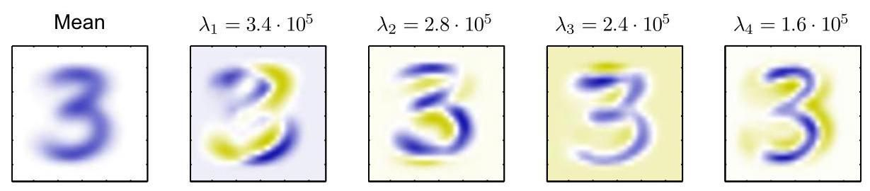

Figure 16.3 Illustration of PCA applied to a data set of 6,000 images of size 28×28, each comprising a handwritten image of the numeral ’3’, showing the mean vector along with the first four PCA eigenvectors , together with their corresponding eigenvalues.

图 16.3 展示了主成分分析应用于一个包含 6000 张 28×28 大小图像的数据集，每张图像都是手写数字 ’3’ 的图像，图中显示了均值向量 以及前四个主成分分析特征向量 ，还有它们对应的特征值。

imation to a data vector in the form

以如下形式对数据向量 进行近似

where we have made use of the relation

其中我们利用了如下关系

which follows from the completeness of the . This represents a compression of the data set, because for each data point we have replaced the -dimensional vector with an -dimensional vector having components . The smaller the value of , the greater the degree of compression. Examples of PCA reconstructions of data points for the digits data set are shown in Figure 16.5.

这是由 的完备性得出的。这代表了数据集的一种压缩，因为对于每个数据点，我们用一个具有分量 的 维向量替换了 维向量 。 的值越小，压缩程度就越大。图 16.5 展示了数字数据集的数据点的主成分分析(PCA)重构示例。

# 16.1.4 Data whitening

# 16.1.4 数据白化

Another application of PCA is to data pre-processing. In this case, the goal is not dimensionality reduction but rather the transformation of a data set to standardize certain of its properties. This can be important in allowing subsequent machine learning algorithms to be applied successfully to the data set. Typically, it is done when the original variables are measured in various different units or have significantly different variabilities. For instance in the Old Faithful data set, the time between eruptions is typically an order of magnitude greater than the duration of an eruption. When we applied the -means algorithm to this data set, we first made a separate linear re-scaling of the individual variables such that each variable had zero mean and unit variance. This is known as standardizing the data, and the covariance matrix for the standardized data has components

主成分分析(PCA)的另一个应用是数据预处理。在这种情况下，目标不是降维，而是对数据集进行变换以标准化其某些属性。这对于后续机器学习算法能否成功应用于该数据集可能很重要。通常，当原始变量以不同的单位进行测量或具有显著不同的变异性时，就会进行这种处理。例如，在老忠实间歇泉数据集中，喷发间隔时间通常比喷发持续时间大一个数量级。当我们将 -均值算法应用于这个数据集时，我们首先对各个变量分别进行线性重新缩放，使得每个变量的均值为零且方差为 1。这被称为数据标准化，标准化数据的协方差矩阵具有如下分量

Section 15.1

第 15.1 节

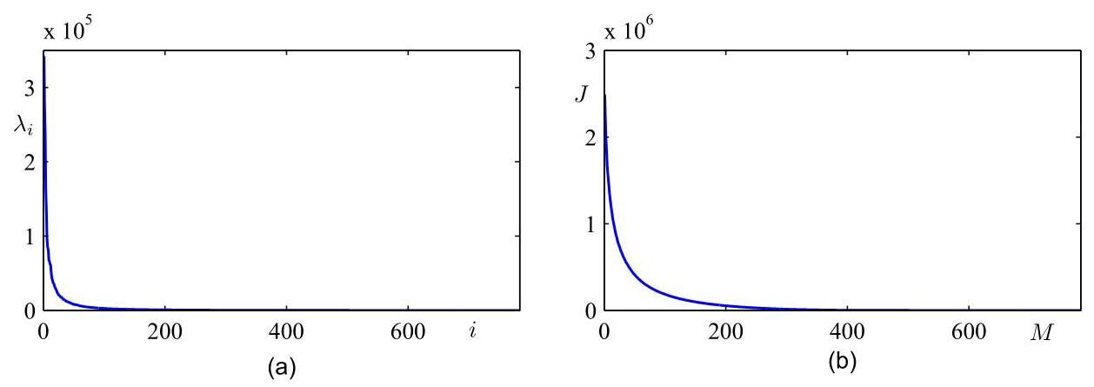

Figure 16.4 (a) Plot of the eigenvalue spectrum for the data set of handwritten digits used in Figure 16.3. (b) Plot of the sum of the discarded eigenvalues, which represents the sum-of-squares error introduced by projecting the data onto a principal component subspace of dimensionality .

图 16.4 (a) 图 16.3 中使用的手写数字数据集的特征值谱图。(b) 被舍弃的特征值之和的图，它表示将数据投影到维数为 的主成分子空间所引入的平方和误差 。

where is the standard deviation of . This is known as the correlation matrix of the original data and has the property that if two components and of the data are perfectly correlated, then , and if they are uncorrelated, then .

其中 是 的标准差。这被称为原始数据的相关矩阵，并且具有这样的性质:如果数据的两个分量 和 完全相关，则 ；如果它们不相关，则 。

However, using PCA we can make a more substantial normalization of the data to give it zero mean and unit covariance, so that different variables become decorre-lated. To do this, we first write the eigenvector equation (16.17) in the form

然而，使用主成分分析(PCA)，我们可以对数据进行更实质性的归一化处理，使其均值为零且协方差为单位矩阵，从而使不同变量之间去相关。为此，我们首先将特征向量方程(16.17)写成如下形式

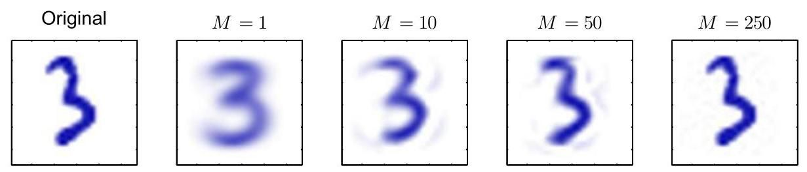

Figure 16.5 An example from the data set of handwritten digits together with its PCA reconstructions obtained by retaining principal components for various values of . As increases, the reconstruction becomes more accurate and would become perfect when .

图 16.5 手写数字数据集的一个示例，以及通过保留不同 值的主成分得到的 PCA 重构结果。随着 的增加，重构结果变得更加准确，当 时，重构将达到完美。

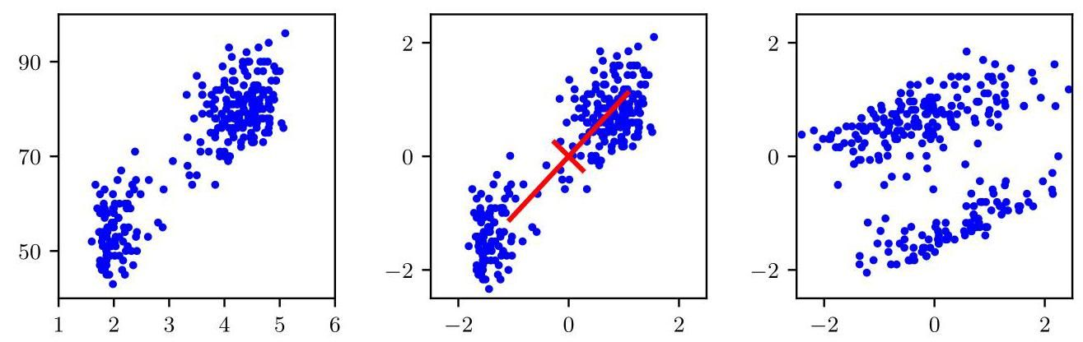

Figure 16.6 Illustration of the effects of linear pre-processing applied to the Old Faithful data set. The plot on the left shows the original data. The centre plot shows the result of standardizing the individual variables to zero mean and unit variance. Also shown are the principal axes of this normalized data set, plotted over the range . The plot on the right shows the result of whitening the data to give it zero mean and unit covariance.

图 16.6 展示了对老忠实间歇泉数据集应用线性预处理的效果。左侧的图显示了原始数据。中间的图显示了将各个变量标准化为均值为零、方差为单位 1 的结果。同时还展示了这个归一化数据集的主轴，绘制范围为 。右侧的图显示了对数据进行白化处理，使其均值为零且协方差为单位矩阵的结果。

where is a diagonal matrix with elements , and is a orthogonal matrix with columns given by . Then we define, for each data point , a transformed value given by

其中 是一个 对角矩阵，其元素为 ，而 是一个 正交矩阵，其列由 给出。然后，对于每个数据点 ，我们定义一个变换后的值为

where is the sample mean defined by (16.1). Clearly, the set has zero mean, and its covariance is given by the identity matrix because

其中 是由(16.1)定义的样本均值。显然，集合 的均值为零，并且其协方差由单位矩阵给出，因为

This operation is known as whitening or sphering the data and is illustrated for the Old Faithful data set in Figure 16.6.

此操作被称为数据白化或球化，图 16.6 展示了对老忠实间歇泉数据集进行该操作的情况。

Section 15.1

第15.1节

# 16.1.5 High-dimensional data

# 16.1.5 高维数据

In some applications of PCA, the number of data points is smaller than the dimensionality of the data space. For example, we might want to apply PCA to a data set of a few hundred images, each of which corresponds to a vector in a space of potentially several million dimensions (corresponding to three colour values for each of the pixels in the image). Note that in a -dimensional space, a set of points, where , defines a linear subspace whose dimensionality is at most , and so there is little point in applying PCA for values of that are greater than . Indeed, if we perform PCA we will find that at least of the eigenvalues are zero, corresponding to eigenvectors along whose directions the data set has zero variance. Furthermore, typical algorithms for finding the eigenvectors of a matrix have a computational cost that scales like , and so for applications such as the image example, a direct application of PCA will be computationally infeasible.

在主成分分析(PCA)的一些应用中，数据点的数量小于数据空间的维度。例如，我们可能想对几百张图像的数据集应用主成分分析，每张图像对应一个潜在的数百万维空间中的向量(对应图像中每个像素的三个颜色值)。请注意，在一个 维空间中，一组 个点(其中 )定义了一个线性子空间，其维度至多为 ，因此对于大于 的 值应用主成分分析意义不大。实际上，如果我们执行主成分分析，会发现至少有 个特征值为零，对应于数据集在其方向上方差为零的特征向量。此外，寻找 矩阵特征向量的典型算法的计算成本与 成正比，因此对于像图像示例这样的应用，直接应用主成分分析在计算上是不可行的。

We can resolve this problem as follows. First, let us define to be the - dimensional centred data matrix, whose th row is given by . The covariance matrix (16.3) can then be written as , and the corresponding eigenvector equation becomes

我们可以按如下方式解决这个问题。首先，让我们将 定义为 维的中心化数据矩阵，其第 行由 给出。然后，协方差矩阵(16.3)可以写成 ，相应的特征向量方程变为

Now pre-multiply both sides by to give

现在，将两边同时左乘 ，得到

If we now define , we obtain

如果我们现在定义 ，我们得到

which is an eigenvector equation for the matrix . We see that this has the same eigenvalues as the original covariance matrix (which itself has an additional eigenvalues of value zero). Thus, we can solve the eigenvector problem in spaces of lower dimensionality with computational cost instead of . To determine the eigenvectors, we multiply both sides of (16.28) by

这是 矩阵 的特征向量方程。我们看到，它与原始协方差矩阵具有相同的 特征值(原始协方差矩阵本身还有额外的 个值为零的特征值)。因此，我们可以在较低维度的空间中以计算成本 而非 来解决特征向量问题。为了确定特征向量，我们将 (16.28) 式两边同时乘以

to give

得到

from which we see that is an eigenvector of with eigenvalue . Note, however, that these eigenvectors are not necessarily normalized. To determine the appropriate normalization, we re-scale by a constant such that , which, assuming has been normalized to unit length, gives

由此我们可以看出， 是 的一个特征向量，其特征值为 。然而，需要注意的是，这些特征向量不一定是归一化的。为了确定合适的归一化方式，我们将 乘以一个常数，使得 。假设 已经被归一化为单位长度，则有

Exercise 16.3

练习 16.3

In summary, to apply this approach we first evaluate and then find its eigenvectors and eigenvalues and then compute the eigenvectors in the original data space using (16.30).

综上所述，要应用这种方法，我们首先计算 ，然后找出它的特征向量和特征值，最后使用 (16.30) 式计算原始数据空间中的特征向量。

# 16.2. Probabilistic Latent Variables

# 16.2. 概率潜在变量

We have seen in the previous section that PCA can be defined in terms of a linear projection of the data onto a subspace of lower dimensionality than the original data space. Each data point projects to a unique value of the quantities defined by (16.12), and we can view these quantities as deterministic latent variables. To introduce and motivate probabilistic continuous latent variables, we now show that PCA can also be expressed as the maximum likelihood solution of a probabilistic latent-variable model. This reformulation of PCA, known as probabilistic PCA, has several advantages compared with conventional PCA:

我们在上一节中看到，主成分分析(PCA)可以定义为将数据线性投影到一个比原始数据空间维度更低的子空间上。每个数据点投影到由 (16.12) 定义的量 的唯一值，我们可以将这些量视为确定性潜在变量。为了引入并激发对概率性连续潜在变量的讨论，我们现在表明，PCA 也可以表示为概率性潜在变量模型的最大似然解。这种对 PCA 的重新表述，即所谓的概率主成分分析(probabilistic PCA)，与传统的 PCA 相比有几个优点:

* A probabilistic PCA model represents a constrained form of a Gaussian distribution in which the number of free parameters can be restricted while still allowing the model to capture the dominant correlations in a data set.
* 概率主成分分析模型表示高斯分布的一种受限形式，其中自由参数的数量可以受到限制，同时仍允许模型捕捉数据集中的主要相关性。
* We can derive an EM algorithm for PCA that is computationally efficient in situations where only a few leading eigenvectors are required and that avoids having to evaluate the data covariance matrix as an intermediate step.
* 我们可以为 PCA 推导一个期望最大化(EM)算法，该算法在只需要少数前导特征向量的情况下计算效率高，并且避免了将计算数据协方差矩阵作为中间步骤。

Section 16.3.2

第 16.3.2 节

* The combination of a probabilistic model and EM allows us to deal with missing values in the data set.
* 概率模型和 EM 算法的结合使我们能够处理数据集中的缺失值。
* Mixtures of probabilistic PCA models can be formulated in a principled way and trained using the EM algorithm.
* 概率主成分分析模型的混合可以以一种有原则的方式构建，并使用 EM 算法进行训练。
* The existence of a likelihood function allows direct comparison with other probabilistic density models. By contrast, conventional PCA will assign a low reconstruction cost to data points that are close to the principal subspace even if they lie arbitrarily far from the training data.
* 似然函数的存在允许与其他概率密度模型进行直接比较。相比之下，传统的主成分分析(PCA)会给那些靠近主子空间的数据点分配较低的重构成本，即使它们与训练数据的距离任意远。
* Probabilistic PCA can be used to model class-conditional densities and hence be applied to classification problems.
* 概率主成分分析(Probabilistic PCA)可用于对类条件密度进行建模，因此可应用于分类问题。
* A probabilistic PCA model can be run generatively to provide samples from the distribution.
* 概率主成分分析模型可以以生成方式运行，以从分布中提供样本。
* Probabilistic PCA forms the basis for a Bayesian treatment of PCA in which the dimensionality of the principal subspace can be found automatically from the data (Bishop, 2006).
* 概率主成分分析为贝叶斯主成分分析处理方法奠定了基础，在该方法中，主子空间的维度可以从数据中自动确定(Bishop，2006)。

This formulation of PCA as a probabilistic model was proposed independently by Tipping and Bishop 1997; 1999 and by Roweis (1998). As we will see later, it is closely related to factor analysis (Basilevsky, 1994).

将主成分分析表述为概率模型这一方法由 Tipping 和 Bishop 分别于 1997 年、1999 年以及 Roweis(1998 年)独立提出。正如我们稍后将看到的，它与因子分析密切相关(Basilevsky，1994)。

# 16.2.1 Generative model

# 16.2.1 生成模型

Section 11.1.4

第 11.1.4 节

Probabilistic PCA is a simple example of the linear-Gaussian framework in which all the marginal and conditional distributions are Gaussian. We can formulate probabilistic PCA by first introducing an explicit -dimensional latent variable corresponding to the principal-component subspace. Next we define a Gaussian prior distribution over the latent variable, together with a Gaussian conditional distribution for the -dimensional observed variable conditioned on the value of the latent variable. Specifically, the prior distribution over is given by a zero-mean unit-covariance Gaussian:

概率主成分分析是线性高斯框架的一个简单示例，其中所有的边缘分布和条件分布都是高斯分布。我们可以通过首先引入一个明确的 维潜在变量 来构建概率主成分分析，该潜在变量对应于主成分子空间。接下来，我们定义潜在变量上的高斯先验分布 ，以及给定潜在变量值时 维观测变量 的高斯条件分布 。具体来说， 上的先验分布由零均值单位协方差高斯分布给出:

Similarly, the conditional distribution of the observed variable , conditioned on the value of the latent variable , is again Gaussian:

类似地，给定潜在变量 的值时，观测变量 的条件分布也是高斯分布:

in which the mean of is a general linear function of governed by the matrix and the -dimensional vector . Note that this factorizes with respect to the elements of . In other words this is an example of a naive Bayes model. As we will see shortly, the columns of span a linear subspace within the data space that corresponds to the principal subspace. The other parameter in this model is the scalar governing the variance of the conditional distribution. Note that there is no loss of generality in assuming a zero-mean unit-covariance Gaussian for the latent distribution because a more general Gaussian distribution would give rise to an equivalent probabilistic model.

其中 的均值是 的一般线性函数，由 矩阵 和 维向量 控制。请注意，这是关于 的元素进行因式分解的。换句话说，这是一个朴素贝叶斯模型的示例。正如我们很快将看到的， 的列张成了数据空间内的一个线性子空间，该子空间对应于主成分子空间。该模型中的另一个参数是标量 ，它控制着条件分布的方差。请注意，假设潜在分布 为零均值单位协方差高斯分布并不会损失一般性，因为更一般的高斯分布会产生一个等价的概率模型。

Section 11.2.3

第 11.2.3 节

Exercise 16.4

练习 16.4

We can view the probabilistic PCA model from a generative viewpoint in which a sampled value of the observed variable is obtained by first choosing a value for the latent variable and then sampling the observed variable conditioned on this latent value. Specifically, the -dimensional observed variable is defined by a linear transformation of the -dimensional latent variable plus additive Gaussian noise, so that

我们可以从生成的角度来看待概率主成分分析(PCA)模型，在该视角下，首先为潜在变量选择一个值，然后基于这个潜在值对观测变量进行采样，从而得到观测变量的一个采样值。具体来说， 维的观测变量 由 维的潜在变量 的线性变换加上加性高斯噪声定义，即

where is an -dimensional Gaussian latent variable, and is a -dimensional zero-mean Gaussian-distributed noise variable with covariance . This generative process is illustrated in Figure 16.7. Note that this framework is based on a mapping from latent space to data space, in contrast to the more conventional view of PCA discussed above. The reverse mapping, from data space to the latent space, will be obtained shortly using Bayes’ theorem.

其中 是一个 维的高斯潜在变量， 是一个 维的零均值高斯分布噪声变量，其协方差为 。这个生成过程如图 16.7 所示。请注意，与上述更传统的主成分分析观点相比，这个框架是基于从潜在空间到数据空间的映射。稍后我们将使用贝叶斯定理得到从数据空间到潜在空间的反向映射。

# 16.2.2 Likelihood function

# 16.2.2 似然函数

Suppose we wish to determine the values of the parameters , and using maximum likelihood. To write down the likelihood function, we need an expression for the marginal distribution of the observed variable. This is expressed, from the sum and product rules of probability, in the form

假设我们希望使用最大似然法来确定参数 和 的值。为了写出似然函数，我们需要一个关于观测变量的边缘分布 的表达式。根据概率的求和规则和乘积规则，这个表达式的形式为

Because this corresponds to a linear-Gaussian model, this marginal distribution is again Gaussian, and is given by

由于这对应于一个线性高斯模型，这个边缘分布仍然是高斯分布，其表达式为

Exercise 16.6

练习 16.6

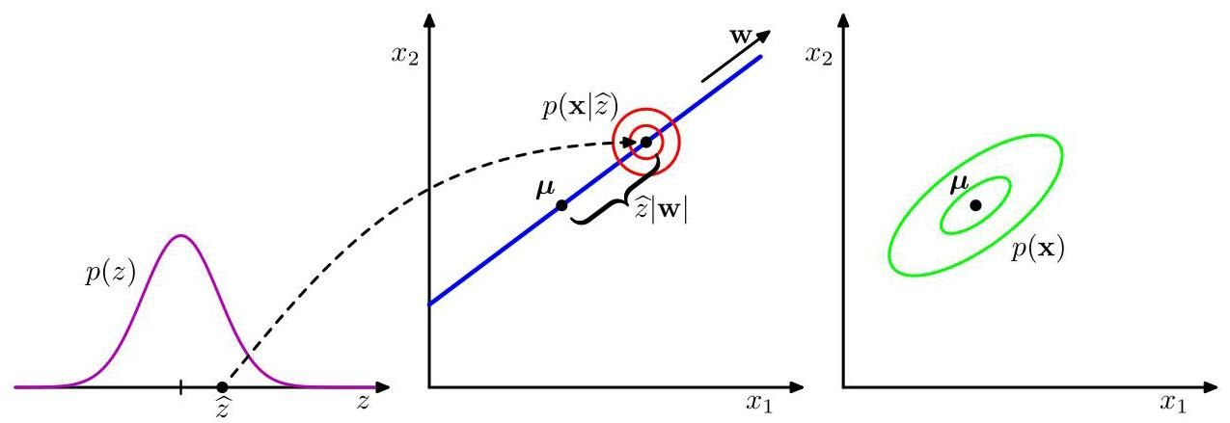

Figure 16.7 An illustration of the generative view of a probabilistic PCA model for a two-dimensional data space and a one-dimensional latent space. An observed data point is generated by first drawing a value for the latent variable from its prior distribution and then drawing a value for from an isotropic Gaussian distribution (illustrated by the red circles) having mean and covariance . The green ellipses show the density contours for the marginal distribution .

图 16.7 展示了二维数据空间和一维潜在空间的概率主成分分析(PCA)模型的生成视角。一个观测数据点 的生成过程如下:首先从潜在变量的先验分布 中抽取一个值 ，然后从均值为 、协方差为 的各向同性高斯分布(由红色圆圈表示)中抽取 的值。绿色椭圆表示边缘分布 的密度轮廓。

where the covariance matrix is defined by

其中 协方差矩阵 定义为

This result can also be derived more directly by noting that the predictive distribution will be Gaussian and then evaluating its mean and covariance using (16.33). This gives

通过注意到预测分布将是高斯分布，然后使用式(16.33)计算其均值和协方差，也可以更直接地推导出这个结果。这给出

where we have used the fact that and are independent random variables and hence are uncorrelated.

这里我们利用了 和 是独立随机变量，因此不相关这一事实。

Intuitively, we can think of the distribution as being defined by taking an isotropic Gaussian ’spray can’ and moving it across the principal subspace spraying Gaussian ink with density determined by and weighted by the prior distribution. The accumulated ink density gives rise to a ’pancake’ shaped distribution representing the marginal density .

直观地说，我们可以认为分布 的定义方式是:取一个各向同性的高斯“喷雾罐”，将其沿着主子空间移动，以 确定的密度并根据先验分布加权喷洒高斯墨水。累积的墨水密度产生了一个代表边缘密度 的“薄饼”形状的分布。

The predictive distribution is governed by the parameters , and . However, there is redundancy in this parameterization corresponding to rotations of the latent space coordinates. To see this, consider a matrix where is an orthogonal matrix. Using the orthogonality property , we see that the quantity that appears in the covariance matrix takes the form

预测分布 由参数 和 决定。然而，这种参数化方式在潜在空间坐标的旋转方面存在冗余。为了说明这一点，考虑一个矩阵 ，其中 是一个正交矩阵。利用正交性性质 ，我们可以看到出现在协方差矩阵 中的量 具有以下形式

and hence is independent of . Thus, there is a whole family of matrices all of which give rise to the same predictive distribution. This invariance can be understood in terms of rotations within the latent space. We will return to a discussion of the number of independent parameters in this model later.

因此与 无关。因此，存在一整个矩阵族 ，所有这些矩阵都产生相同的预测分布。这种不变性可以从潜在空间内的旋转角度来理解。我们稍后将回到对该模型中独立参数数量的讨论。

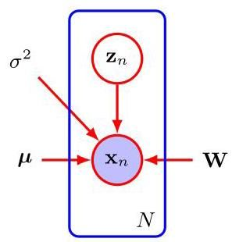

Figure 16.8 The probabilistic PCA model for a data set of observations of can be expressed as a directed graph in which each observation is associated with a value of the latent variable.

图 16.8 对于 的 个观测值的数据集，概率主成分分析模型可以表示为一个有向图，其中每个观测值 都与潜在变量的一个值 相关联。

When we evaluate the predictive distribution, we require , which involves the inversion of a matrix. The computation required to do this can be reduced by making use of the matrix inversion identity (A.7) to give

当我们评估预测分布时，我们需要 ，这涉及对一个 矩阵求逆。通过使用矩阵求逆恒等式(A.7)，可以减少执行此操作所需的计算量，得到

where the matrix is defined by

其中 矩阵 定义为

Because we invert rather than inverting directly, the cost of evaluating is reduced from to .

因为我们对 求逆而不是直接对 求逆，所以评估 的成本从 降低到 。

As well as the predictive distribution , we will also require the posterior distribution , which can again be written down directly using the result (3.100) for linear-Gaussian models to give

除了预测分布 ，我们还需要后验分布 ，再次使用线性高斯模型的结果(3.100)可以直接写出该后验分布，得到

Exercise 16.8

练习 16.8

Note that the posterior mean depends on , whereas the posterior covariance is independent of .

请注意，后验均值取决于 ，而后验协方差与 无关。

# 16.2.3 Maximum likelihood

# 16.2.3 最大似然法

We next consider the determination of the model parameters using maximum likelihood. Given a data set of observed data points, the probabilistic PCA model can be expressed as a directed graph, as shown in Figure 16.8. The corresponding log likelihood function is given, from (16.35), by

接下来，我们考虑使用最大似然法来确定模型参数。给定一组观测数据点 ，概率主成分分析(PCA)模型可以表示为一个有向图，如图 16.8 所示。根据式(16.35)，相应的对数似然函数为

Setting the derivative of the log likelihood with respect to equal to zero gives the expected result where is the data mean defined by (16.1). Because the log likelihood is a quadratic function of , this solution represents the unique maximum, as can be confirmed by computing second derivatives. Back-substituting, we can then write the log likelihood function in the form

令对数似然函数关于 的导数等于零，可得到预期结果 ，其中 是由式(16.1)定义的数据均值。由于对数似然函数是 的二次函数，通过计算二阶导数可以确认，该解代表唯一的最大值。回代后，我们可以将对数似然函数写成如下形式

Exercise 16.9

练习 16.9

where is the data covariance matrix defined by (16.3).

其中 是由 (16.3) 定义的数据协方差矩阵。

Maximization with respect to and is more complex but nonetheless has an exact closed-form solution. It was shown by Tipping and Bishop (1999) that all the stationary points of the log likelihood function can be written as

关于 和 的最大化问题更为复杂，但仍然有精确的闭式解。Tipping 和 Bishop(1999)证明，对数似然函数的所有驻点可以写成

where is a matrix whose columns are given by any subset (of size ) of the eigenvectors of the data covariance matrix . The diagonal matrix has elements given by the corresponding eigenvalues , and is an arbitrary orthogonal matrix.

其中 是一个 矩阵，其列由数据协方差矩阵 的特征向量的任意子集(大小为 )给出。 对角矩阵 的元素由相应的特征值 给出，并且 是任意的 正交矩阵。

Furthermore, Tipping and Bishop (1999) showed that the maximum of the likelihood function is obtained when the eigenvectors are chosen to be those whose eigenvalues are the largest (all other solutions being saddle points). A similar result was conjectured independently by Roweis (1998), although no proof was given. Again, we will assume that the eigenvectors have been arranged in order of decreasing values of the corresponding eigenvalues, so that the principal eigenvectors are . In this case, the columns of define the principal subspace of standard PCA. The corresponding maximum likelihood solution for is then given by

此外，Tipping 和 Bishop(1999)表明，当选择 个特征向量为其特征值是 个最大的特征向量时(所有其他解都是鞍点)，可以得到似然函数的最大值。Roweis(1998)独立地推测出了类似的结果，但没有给出证明。同样，我们将假设特征向量已按相应特征值的降序排列，使得 个主特征向量为 。在这种情况下， 的列定义了标准主成分分析(PCA)的主子空间。那么 的相应最大似然解由下式给出

so that is the average variance associated with the discarded dimensions.

因此， 是与被舍弃维度相关的平均方差。

Because is orthogonal, it can be interpreted as a rotation matrix in the - dimensional latent space. If we substitute the solution for into the expression for and make use of the orthogonality property , we see that is independent of . This simply says that the predictive density is unchanged by rotations in the latent space as discussed earlier. For the particular case , we see that the columns of are the principal component eigenvectors scaled by the variance parameters . The interpretation of these scaling factors is clear once we recognize that for a convolution of independent Gaussian distributions (in this case the latent space distribution and the noise model) the variances are additive. Thus, the variance in the direction of an eigenvector is composed of the sum of a contribution from the projection of the unit-variance latent space distribution into data space through the corresponding column of plus an isotropic contribution of variance , which is added in all directions by the noise model.

因为 是正交的，所以它可以被解释为 维潜在空间中的旋转矩阵。如果我们将 的解代入 的表达式中，并利用正交性性质 ，我们会发现 与 无关。这只是表明，如前面所讨论的，潜在空间中的旋转不会改变预测密度。对于特定情况 ，我们看到 的列是由方差参数 缩放后的主成分特征向量。一旦我们认识到对于独立高斯分布的卷积(在这种情况下是潜在空间分布和噪声模型)，方差是可加的，那么这些缩放因子的解释就很清楚了。因此，特征向量 方向上的方差 由两部分组成:一部分是单位方差潜在空间分布通过 的相应列投影到数据空间的贡献 ，另一部分是噪声模型在所有方向上添加的各向同性方差贡献 。

It is worth taking a moment to study the form of the covariance matrix given by (16.36). Consider the variance of the predictive distribution along some direction specified by the unit vector , where , which is given by . First suppose that is orthogonal to the principal subspace, in other words it is given by some linear combination of the discarded eigenvectors. Then and hence . Thus, the model predicts a noise variance orthogonal to the principal subspace, which from (16.47) is just the average of the discarded eigenvalues. Now suppose that where is one of the retained eigenvectors defining the principal subspace. Then . In other words, this model correctly captures the variance of the data along the principal axes and approximates the variance in all remaining directions with a single average value .

值得花点时间研究一下由 (16.36) 给出的协方差矩阵的形式。考虑预测分布沿由单位向量 指定的某个方向的方差，其中 ，该方差由 给出。首先假设 与主子空间正交，换句话说，它是由被舍弃的特征向量的某种线性组合给出的。那么 ，因此 。因此，该模型预测与主子空间正交的噪声方差，根据 (16.47)，这恰好是被舍弃的特征值的平均值。现在假设 ，其中 是定义主子空间的保留特征向量之一。那么 。换句话说，该模型正确地捕捉了数据沿主轴的方差，并使用单个平均值 来近似所有其余方向的方差。

One way to construct the maximum likelihood density model would simply be to find the eigenvectors and eigenvalues of the data covariance matrix and then to evaluate and using the results given above. In this case, we would choose for convenience. However, if the maximum likelihood solution is found by numerical optimization of the likelihood function, for instance using an algorithm such as conjugate gradients (Fletcher, 1987; Nocedal and Wright, 1999) or through the EM algorithm, then the resulting value of is essentially arbitrary. This implies that the columns of need not be orthogonal. If an orthogonal basis is required, the matrix can be post-processed appropriately (Golub and Van Loan,1996). Alternatively, the EM algorithm can be modified in such a way as to yield orthonormal principal directions, sorted in descending order of the corresponding eigenvalues, directly (Ahn and Oh, 2003).

构建最大似然密度模型的一种方法是简单地找出数据协方差矩阵的特征向量和特征值，然后使用上述结果计算 和 。在这种情况下，为了方便起见，我们会选择 。然而，如果通过对似然函数进行数值优化来找到最大似然解，例如使用共轭梯度算法(Fletcher，1987；Nocedal 和 Wright，1999)或通过 EM 算法，那么 的最终值本质上是任意的。这意味着 的列不一定是正交的。如果需要正交基，可以对矩阵 进行适当的后处理(Golub 和 Van Loan，1996)。或者，可以对 EM 算法进行修改，使其直接产生正交归一的主方向，并按相应特征值的降序排序(Ahn 和 Oh，2003)。

Section 16.3.2

第 16.3.2 节

The rotational invariance in latent space represents a form of statistical non-identifiability, analogous to that encountered for mixture models for discrete latent variables. Here there is a continuum of parameters, any value of which leads to the same predictive density, in contrast to the discrete non-identifiability associated with component relabelling in the mixture setting.

潜在空间中的旋转不变性代表了一种统计不可识别性，类似于离散潜在变量的混合模型所遇到的情况。这里存在一个连续的参数集，其中任何一个值都会导致相同的预测密度，这与混合模型中与组件重新标记相关的离散不可识别性形成对比。

If we consider , so that there is no reduction of dimensionality, then and . Making use of the orthogonality properties and , we see that the covariance of the marginal distribution for becomes

如果我们考虑 ，使得没有进行降维，那么 且 。利用正交性性质 和 ，我们可以看到 的边缘分布的协方差 变为

and so we obtain the standard maximum likelihood solution for an unconstrained Gaussian distribution in which the covariance matrix is given by the sample covariance.

因此，我们得到了无约束高斯分布的标准最大似然解，其中协方差矩阵由样本协方差给出。

Conventional PCA is generally formulated as a projection of points from the - dimensional data space onto an -dimensional linear subspace. Probabilistic PCA, however, is most naturally expressed as a mapping from the latent space into the data space via (16.33). For applications such as visualization and data compression, we can reverse this mapping using Bayes’ theorem. Any point in data space can then be summarized by its posterior mean and covariance in latent space. From (16.43) the mean is given by

传统主成分分析(PCA)通常被表述为将点从 维数据空间投影到 维线性子空间上。然而，概率主成分分析最自然的表达方式是通过 (16.33) 从潜在空间映射到数据空间。对于可视化和数据压缩等应用，我们可以使用贝叶斯定理反转这个映射。然后，数据空间中的任何点 都可以通过其在潜在空间中的后验均值和协方差来概括。根据 (16.43)，均值由下式给出

where is given by (16.42). This projects to a point in data space given by

其中 由 (16.42) 给出。这投影到数据空间中的一个点，该点由下式给出

Section 4.1.6

第 4.1.6 节

Note that this takes the same form as the equations for regularized linear regression and is a consequence of maximizing the likelihood function for a linear-Gaussian model. Similarly, from (16.43) the posterior covariance is given by and is independent of .

请注意，这与正则化线性回归的方程形式相同，这是线性高斯模型似然函数最大化的结果。类似地，根据 (16.43)，后验协方差由 给出，并且与 无关。

If we take the limit , then the posterior mean reduces to

如果我们取极限 ，那么后验均值简化为

which represents an orthogonal projection of the data point onto the latent space, and so we recover the standard PCA model. The posterior covariance in this limit is zero, however, and the density becomes singular. For , the latent projection is shifted towards the origin, relative to the orthogonal projection.

这表示数据点在潜在空间上的正交投影，因此我们恢复了标准的主成分分析模型。然而，在这个极限下，后验协方差为零，并且密度变得奇异。对于 ，相对于正交投影，潜在投影向原点移动。

Exercise 16.11

练习 16.11

Exercise 16.12

练习 16.12

Finally, note that an important role for the probabilistic PCA model is in defining a multivariate Gaussian distribution in which the number of degrees of freedom, in other words the number of independent parameters, can be controlled while still allowing the model to capture the dominant correlations in the data. Recall that a general Gaussian distribution has independent parameters in its covariance matrix (plus another parameters in its mean). Thus, the number of parameters scales quadratically with and can become excessive in spaces of high dimensionality. If we restrict the covariance matrix to be diagonal, then it has only independent parameters, and so the number of parameters now grows linearly with dimensionality. However, it now treats the variables as if they were independent and hence can no longer express any correlations between them. Probabilistic PCA provides an elegant compromise in which the most significant correlations can be captured while still ensuring that the total number of parameters grows only linearly with . We can see this by evaluating the number of degrees of freedom in the probabilistic PCA model as follows. The covariance matrix depends on the parameters , which has size , and , giving a total parameter count of . However, we have seen that there is some redundancy in this parameterization associated with rotations of the coordinate system in the latent space. The orthogonal matrix that expresses these rotations has size . In the first column of this matrix, there are independent parameters, because the column vector must be normalized to unit length. In the second column, there are independent parameters, because the column must be normalized and also must be orthogonal to the previous column, and so on. Summing this arithmetic series, we see that has a total of independent parameters. Thus, the number of degrees of freedom in the covariance matrix is given by

最后，请注意，概率主成分分析(PCA)模型的一个重要作用是定义一个多元高斯分布，在这个分布中，自由度的数量，换句话说，独立参数的数量，可以得到控制，同时仍允许模型捕捉数据中的主要相关性。回想一下，一般的高斯分布在其协方差矩阵中有 个独立参数(加上其均值中有另外 个参数)。因此，参数的数量与 呈二次方关系增长，在高维空间中可能会变得过多。如果我们将协方差矩阵限制为对角矩阵，那么它只有 个独立参数，因此参数的数量现在随维度线性增长。然而，它现在将变量视为相互独立的，因此无法再表达它们之间的任何相关性。概率主成分分析提供了一个巧妙的折衷方案，在这个方案中，可以捕捉 个最显著的相关性，同时仍确保参数的总数仅随 线性增长。我们可以通过如下评估概率主成分分析模型中的自由度数量来看到这一点。协方差矩阵 取决于参数 (其大小为 )和 ，总参数数量为 。然而，我们已经看到，这种参数化与潜在空间中坐标系的旋转相关，存在一些冗余。表示这些旋转的正交矩阵 的大小为 。在这个矩阵的第一列中，有 个独立参数，因为列向量必须归一化为单位长度。在第二列中，有 个独立参数，因为该列必须归一化，并且还必须与前一列正交，依此类推。对这个等差数列求和，我们看到 总共有 个独立参数。因此，协方差矩阵 中的自由度数量由下式给出

Section 3.2

第 3.2 节

The number of independent parameters in this model therefore only grows linearly with , for fixed . If we take , then we recover the standard result for a full covariance Gaussian. In this case, the variance along linearly independent directions is controlled by the columns of , and the variance along the remaining direction is given by . If , the model is equivalent to the isotropic covariance case.

因此，对于固定的 ，该模型中的独立参数数量仅随 线性增长。如果我们取 ，那么我们就得到了全协方差高斯分布的标准结果。在这种情况下，沿着 个线性独立方向的方差由 的列控制，而沿着其余方向的方差由 给出。如果 ，该模型等价于各向同性协方差的情况。

Exercise 16.14

练习 16.14

# 16.2.4 Factor analysis

# 16.2.4 因子分析

Factor analysis is a linear-Gaussian latent-variable model that is closely related to probabilistic PCA. Its definition differs from that of probabilistic PCA only in that the conditional distribution of the observed variable given the latent variable has a diagonal rather than an isotropic covariance so that

因子分析是一种线性高斯潜在变量模型，它与概率主成分分析密切相关。其定义与概率主成分分析的定义的不同之处仅在于，给定潜在变量 时，观测变量 的条件分布具有对角协方差矩阵，而非各向同性协方差矩阵，因此

where is a diagonal matrix. Note that the factor analysis model, in common with probabilistic PCA, assumes that the observed variables are independent, given the latent variable . In essence, a factor analysis model explains the observed covariance structure of the data by representing the independent variance associated with each coordinate in the matrix and capturing the covariance between variables in the matrix . In the factor analysis literature, the columns of , which capture the correlations between observed variables, are called factor loadings, and the diagonal elements of , which represent the independent noise variances for each of the variables, are called uniquenesses.

其中 是一个 对角矩阵。请注意，与概率主成分分析一样，因子分析模型假设给定潜在变量 时，观测变量 是相互独立的。本质上，因子分析模型通过表示与矩阵 中每个坐标相关的独立方差，并捕捉矩阵 中变量之间的协方差，来解释数据的观测协方差结构。在因子分析文献中，捕捉观测变量之间相关性的 的列被称为因子载荷，而表示每个变量的独立噪声方差的 的对角元素被称为独特性。

The origins of factor analysis are as old as those of PCA, and discussions of factor analysis can be found in the books by Everitt (1984), Bartholomew (1987), and Basilevsky (1994). Links between factor analysis and PCA were investigated by Lawley (1953) and Anderson (1963), who showed that at stationary points of the likelihood function, for a factor analysis model with , the columns of are scaled eigenvectors of the sample covariance matrix and is the average of the discarded eigenvalues. Later, Tipping and Bishop (1999) showed that the maximum of the log likelihood function occurs when the eigenvectors comprising are chosen to be the principal eigenvectors.

因子分析的起源与主成分分析一样古老，在 Everitt(1984)、Bartholomew(1987)和 Basilevsky(1994)的书中可以找到关于因子分析的讨论。Lawley(1953)和 Anderson(1963)研究了因子分析与主成分分析之间的联系，他们表明，对于具有 的因子分析模型，在似然函数的驻点处， 的列是样本协方差矩阵的缩放特征向量，而 是被舍弃特征值的平均值。后来，Tipping 和 Bishop(1999)表明，当构成 的特征向量被选为主要特征向量时，对数似然函数达到最大值。

Making use of (16.34), we see that the marginal distribution for the observed variable is given by where now

利用式(16.34)，我们可以看到观测变量的边缘分布由 给出，其中现在

Exercise 16.16

练习 16.16

As with probabilistic PCA, this model is invariant to rotations in the latent space.

与概率主成分分析一样，该模型在潜在空间的旋转下保持不变。

Historically, factor analysis has been the subject of controversy when attempts have been made to place an interpretation on the individual factors (the coordinates in -space), which has proven problematic due to the non-identifiability of factor analysis associated with rotations in this space. From our perspective, however, we shall view factor analysis as a form of latent-variable density model, in which the form of the latent space is of interest but not the particular choice of coordinates used to describe it. If we wish to remove the degeneracy associated with latent-space rotations, we must consider non-Gaussian latent-variable distributions, giving rise to independent component analysis models.

从历史上看，当人们试图对各个因子( 空间中的坐标)进行解释时，因子分析一直是争议的焦点。由于因子分析在该空间的旋转下具有不可识别性，这种解释已被证明存在问题。然而，从我们的角度来看，我们将把因子分析视为一种潜在变量密度模型，其中潜在空间的形式是我们关注的重点，但用于描述它的特定坐标选择并非关键。如果我们希望消除与潜在空间旋转相关的退化问题，就必须考虑非高斯潜在变量分布，从而产生独立成分分析模型。

Section 16.2.5

第 16.2.5 节

Another difference between probabilistic PCA and factor analysis is their behaviour under transformations of the data set. For PCA and probabilistic PCA, if we rotate the coordinate system in data space, then we obtain exactly the same fit to the data but with the matrix transformed by the corresponding rotation matrix. However, for factor analysis, the analogous property is that if we make a component-wise re-scaling of the data vectors, then this is absorbed into a corresponding re-scaling of the elements of .

概率主成分分析和因子分析之间的另一个区别在于它们在数据集变换下的表现。对于主成分分析和概率主成分分析，如果我们在数据空间中旋转坐标系，那么我们会得到与数据完全相同的拟合结果，但 矩阵会通过相应的旋转矩阵进行变换。然而，对于因子分析，类似的性质是，如果我们对数据向量进行逐分量的重新缩放，那么这会被吸收到 元素的相应重新缩放中。

Exercise 16.17

练习 16.17

# 16.2.5 Independent component analysis

# 16.2.5 独立成分分析

One generalization of the linear-Gaussian latent-variable model is to consider models in which the observed variables are related linearly to the latent variables, but for which the latent distribution is non-Gaussian. An important class of such models, known as independent component analysis, or ICA, arises when we consider a distribution over the latent variables that factorizes, so that

线性高斯潜变量模型的一种推广是考虑这样的模型，其中观测变量与潜变量呈线性关系，但潜变量的分布是非高斯的。当我们考虑一个可分解的潜变量分布时，就会产生一类重要的此类模型，即独立成分分析(ICA)，使得

To understand the role of such models, consider a situation in which two people are talking at the same time, and we record their voices using two microphones. If we ignore effects such as time delay and echoes, then the signals received by the microphones at any point in time will be given by linear combinations of the amplitudes of the two voices. The coefficients of this linear combination will be constant, and if we can infer their values from sample data, then we can invert the mixing process (assuming it is non-singular) and thereby obtain two clean signals each of which contains the voice of just one person. This is an example of a problem called blind source separation in which ’blind’ refers to the fact that we are given only the mixed data, and neither the original sources nor the mixing coefficients are observed (Cardoso, 1998).

为了理解这类模型的作用，考虑这样一种情况:两个人同时说话，我们使用两个麦克风记录他们的声音。如果忽略时间延迟和回声等影响，那么在任何时刻，麦克风接收到的信号将是两个人声音振幅的线性组合。这个线性组合的系数是恒定的，如果我们能从样本数据中推断出它们的值，那么我们就可以对混合过程进行逆运算(假设它是非奇异的)，从而得到两个纯净的信号，每个信号只包含一个人的声音。这是一个被称为盲源分离问题的例子，其中“盲”指的是我们只得到了混合数据，既没有观察到原始信号源，也没有观察到混合系数(Cardoso，1998)。

This type of problem is sometimes addressed using the following approach (MacKay, 2003) in which we ignore the temporal nature of the signals and treat the successive samples as i.i.d. We consider a generative model in which there are two latent variables corresponding to the unobserved speech signal amplitudes, and there are two observed variables given by the signal values at the microphones. The latent variables have a joint distribution that factorizes as above, and the observed variables are given by a linear combination of the latent variables. There is no need to include a noise distribution because the number of latent variables equals the number of observed variables, and therefore the marginal distribution of the observed variables will not in general be singular, so the observed variables are simply deterministic linear combinations of the latent variables. Given a data set of observations, the likelihood function for this model is a function of the coefficients in the linear combination. The log likelihood can be maximized using gradient-based optimization giving rise to a particular version of ICA.

这类问题有时可以使用以下方法解决(MacKay，2003)，在该方法中，我们忽略信号的时间特性，将连续的样本视为独立同分布的。我们考虑一个生成模型，其中有两个潜变量对应于未观察到的语音信号振幅，有两个观测变量由麦克风处的信号值给出。潜变量具有如上述那样可分解的联合分布，而观测变量是潜变量的线性组合。不需要包含噪声分布，因为潜变量的数量等于观测变量的数量，因此观测变量的边缘分布通常不会是奇异的，所以观测变量只是潜变量的确定性线性组合。给定一个观测数据集，该模型的似然函数是线性组合中系数的函数。可以使用基于梯度的优化方法来最大化对数似然，从而得到一种特定形式的独立成分分析。

The success of this approach requires that the latent variables have non-Gaussian distributions. To see this, recall that in probabilistic PCA (and in factor analysis) the latent-space distribution is given by a zero-mean isotropic Gaussian. The model therefore cannot distinguish between two different choices for the latent variables if these differ simply by a rotation in latent space. This can be verified directly by noting that the marginal density (16.35), and hence the likelihood function, is unchanged if we make the transformation where is an orthogonal matrix satisfying , because the matrix given by (16.36) is itself invariant. Extending the model to allow more general Gaussian latent distributions does not change this conclusion because, as we have seen, such a model is equivalent to the zero-mean isotropic Gaussian latent-variable model.

这种方法的成功要求潜变量具有非高斯分布。为了理解这一点，回顾一下，在概率主成分分析(以及因子分析)中，潜空间分布是由零均值各向同性高斯分布给出的。因此，如果潜变量的两种不同选择只是在潜空间中进行了旋转，那么该模型就无法区分它们。通过注意到如果我们进行变换 (其中 是一个满足 的正交矩阵)，边缘密度(16.35)以及似然函数都不会改变，就可以直接验证这一点，因为由(16.36)给出的矩阵 本身是不变的。将模型扩展到允许更一般的高斯潜分布并不会改变这个结论，因为正如我们所看到的，这样的模型等价于零均值各向同性高斯潜变量模型。

Another way to see why a Gaussian latent-variable distribution in a linear model is insufficient to find independent components is to note that the principal components represent a rotation of the coordinate system in data space so as to diagonalize the covariance matrix. The data distribution in the new coordinates is then uncorrelated. Although zero correlation is a necessary condition for independence it is not, however, sufficient. In practice, a common choice for the latent-variable distribution is given by

另一种理解为什么线性模型中的高斯潜变量分布不足以找到独立成分的方法是，要注意到主成分表示数据空间中坐标系的旋转，以便使协方差矩阵对角化。然后，新坐标系中的数据分布是不相关的。然而，零相关性虽然是独立性的必要条件，但并不充分。在实践中，潜变量分布的一个常见选择是

Exercise 2.39

练习 2.39

which has heavy tails compared to a Gaussian, reflecting the observation that many real-world distributions also exhibit this property.

与高斯分布相比，它具有重尾特性，这反映了许多现实世界的分布也具有此特性的观察结果。

The original ICA model (Bell and Sejnowski, 1995) was based on the optimization of an objective function defined by information maximization. One advantage of a probabilistic latent-variable formulation is that it helps to motivate and formulate generalizations of basic ICA. For instance, independent factor analysis (Attias, 1999) considers a model in which the number of latent and observed variables can differ, the observed variables are noisy, and the individual latent variables have flexible distributions modelled by mixtures of Gaussians. The log likelihood for this model is maximized using EM, and the reconstruction of the latent variables is approximated using a variational approach. Many other types of model have been considered, and there is now a huge literature on ICA and its applications (Jutten and Herault, 1991; Comon, Jutten, and Herault, 1991; Amari, Cichocki, and Yang, 1996; Pearlmutter and Parra, 1997; Hyvärinen and Oja, 1997; Hinton et al., 2001; Miskin and MacKay, 2001; Hojen-Sorensen, Winther, and Hansen, 2002; Choudrey and Roberts, 2003; Chan, Lee, and Sejnowski, 2003; Stone, 2004).

原始的独立成分分析(ICA)模型(Bell 和 Sejnowski，1995)基于通过信息最大化定义的目标函数的优化。概率潜在变量公式化的一个优点是，它有助于推动和构建基本 ICA 的推广形式。例如，独立因子分析(Attias，1999)考虑了一个模型，其中潜在变量和观测变量的数量可以不同，观测变量存在噪声，并且各个潜在变量具有由高斯混合模型建模的灵活分布。使用期望最大化(EM)算法来最大化该模型的对数似然，并使用变分方法近似重建潜在变量。已经考虑了许多其他类型的模型，现在有大量关于 ICA 及其应用的文献(Jutten 和 Herault，1991；Comon、Jutten 和 Herault，1991；Amari、Cichocki 和 Yang，1996；Pearlmutter 和 Parra，1997；Hyvärinen 和 Oja，1997；Hinton 等人，2001；Miskin 和 MacKay，2001；Hojen - Sorensen、Winther 和 Hansen，2002；Choudrey 和 Roberts，2003；Chan、Lee 和 Sejnowski，2003；Stone，2004)。

# 16.2.6 Kalman filters

# 16.2.6 卡尔曼滤波器

So far we have assumed that the data values are i.i.d. A common situation in which this assumption does not hold is when the data points form an ordered sequence. We have seen that a hidden Markov model can be viewed as an extension of the mixture models to allow for sequential correlations in the data. In a similar way, a continuous latent-variable model can be extended to handle sequential data by connecting the latent variables to form a Markov chain, as shown in the graphical model of Figure 16.9. This is known as a linear dynamical system or Kalman filter (Zarchan and Musoff, 2005). Note that this is the same graphical structure as a hidden Markov model. It is interesting to note that, historically, hidden Markov models and linear dynamical systems were developed independently. Once they are both expressed as graphical models, however, the deep relationship between them immediately becomes apparent. Kalman filters are widely used in many real-time tracking applications, for example to track aircraft using radar reflections.

到目前为止，我们一直假设数据值是独立同分布的。当数据点形成有序序列时，这种假设通常不成立。我们已经看到，隐马尔可夫模型可以看作是混合模型的扩展，以允许数据中的序列相关性。类似地，连续潜在变量模型可以通过将潜在变量连接成马尔可夫链来扩展以处理序列数据，如图 16.9 的图形模型所示。这被称为线性动态系统或卡尔曼滤波器(Zarchan 和 Musoff，2005)。请注意，这与隐马尔可夫模型具有相同的图形结构。有趣的是，从历史上看，隐马尔可夫模型和线性动态系统是独立发展的。然而，一旦它们都被表示为图形模型，它们之间的深层关系就立即变得明显。卡尔曼滤波器广泛应用于许多实时跟踪应用中，例如使用雷达反射来跟踪飞机。

Section 15.3.1 Section 15.3.1

第 15.3.1 节 第 15.3.1 节

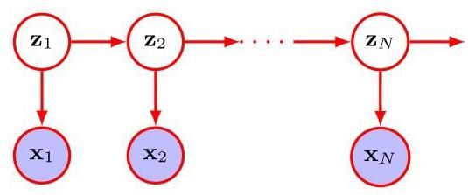

Figure 16.9 A probabilistic graphical model for sequential data, known as a linear dynamical system, or Kalman filter, in which the latent variables form a Markov chain.

图 16.9 用于序列数据的概率图形模型，称为线性动态系统或卡尔曼滤波器，其中潜在变量形成马尔可夫链。

In the simplest such model, the distributions in Figure 16.9 represent a linear-Gaussian latent-variable model for that particular observation, of the kind we have discussed previously for i.i.d. data. However, the latent variables are no longer treated as independent but now form a Markov chain in which the distribution of each latent variable is conditioned on the state of the previous latent variable in the chain. Again these can be chosen to be linear-Gaussian in which the distribution of is Gaussian with a mean given by a linear function of . Typically the parameters of all the distributions are shared, and likewise the parameters of the distributions are shared, so that the total number of parameters in the model is fixed, independently of the length of the sequence. These parameters can be learned from data by maximum likelihood with efficient algorithms that involve propagating messages around the graph (Bishop, 2006). For the rest of this chapter, however, we will focus on i.i.d. data.

在最简单的此类模型中，图 16.9 中的分布 代表针对该特定观测值的线性高斯潜变量模型，这是我们之前针对独立同分布(i.i.d.)数据所讨论过的那种模型。然而，潜变量 不再被视为相互独立，而是形成一个马尔可夫链，其中每个潜变量的分布 取决于链中前一个潜变量的状态。同样，这些分布可以选择为线性高斯分布，其中 的分布是高斯分布，其均值由 的线性函数给出。通常，所有分布 的参数是共享的，同样，分布 的参数也是共享的，因此模型中的参数总数是固定的，与序列的长度无关。这些参数可以通过涉及在图中传播消息的高效算法，利用最大似然法从数据中学习得到(Bishop，2006)。然而，在本章的其余部分，我们将专注于独立同分布(i.i.d.)数据。

# 16.3. Evidence Lower Bound

# 16.3. 证据下界

In our discussion of models with discrete latent variables, we derived the evidence

在我们对具有离散潜变量的模型的讨论中，我们推导出了证据

Section 15.4 lower bound (ELBO) on the marginal log likelihood and showed how this forms the basis for deriving the expectation-maximization (EM) algorithm including its generalizations such as variational inference. The same framework applies to continuous latent variables as well as to models that combine both discrete and continuous variables. Here we present a slightly different derivation of the ELBO, and we assume that the latent variables are continuous.

第 15.4 节 边缘对数似然的下界(ELBO)，并展示了它如何构成推导期望最大化(EM)算法(包括其诸如变分推断等推广形式)的基础。相同的框架同样适用于连续潜变量以及同时包含离散和连续变量的模型。在这里，我们给出 ELBO 的一种略有不同的推导，并且假设潜变量 是连续的。

Consider a model with an observed variable , a latent variable , and a learnable parameter vector . If we introduce an arbitrary distribution over the latent variable then we can write the log likelihood function as a sum of two terms in the form

考虑一个模型 ，它具有一个观测变量 、一个潜变量 和一个可学习的参数向量 。如果我们引入一个关于潜变量的任意分布 ，那么我们可以将对数似然函数 写成如下两项之和的形式

Exercise 16.18

练习 16.18

where we have defined

其中我们定义了

Since is a Kullback-Leibler divergence, it satisfies the property from which it follows that

由于 是一个 Kullback-Leibler 散度，它满足性质 ，由此可得

Section 2.5.5

第 2.5.5 节

and we therefore see that given by (16.58) forms a lower bound on the log likelihood, known as the evidence lower bound or ELBO. We see that takes the same form (15.53 ) as derived for the discrete case but with summations replaced by integrals.

因此我们看到，由 (16.58) 给出的 构成了对数似然的一个下界，称为证据下界或 ELBO。我们发现 与离散情形下推导得到的形式 (15.53) 相同，但求和被积分所取代。

We can maximize the log likelihood function using a two-stage iterative procedure called the expectation maximization algorithm, or EM algorithm, in which we alternately maximize with respect to (the E step) and (the M step). We first initialize the parameters . Then in the E step we keep fixed and we maximize the lower bound with respect to . This is easily done by noting that the highest value for the bound is obtained by minimizing the Kullback-Leibler divergence in (16.59) and hence is achieved when for which the Kullback-Leibler divergence is zero. In the M step, we keep this choice of fixed and maximize with respect to . Substituting for in (16.58) we obtain

我们可以使用一种称为期望最大化算法(或 EM 算法)的两阶段迭代过程来最大化对数似然函数。在该算法中，我们交替地关于 (E 步)和 (M 步)最大化 。我们首先初始化参数 。然后在 E 步中，我们固定 ，并关于 最大化下界。通过注意到通过最小化 (16.59) 中的 Kullback-Leibler 散度可以得到该下界的最大值，并且当 时可以实现这一点(此时 Kullback-Leibler 散度为零)，这很容易做到。在 M 步中，我们固定 的这个选择，并关于 最大化 。将 代入 (16.58) 中，我们得到

We now maximize this with respect to in the step while keeping fixed. Note that the second term on the right-hand side of (16.61) is independent of and so can be ignored during the M step. The first term on the right-hand side is the expectation of the complete data log likelihood where the expectation is taken with respect to the posterior distribution of computed using .

现在我们在 步中关于 最大化这个式子，同时固定 。注意 (16.61) 右侧的第二项与 无关，因此在 M 步中可以忽略。右侧的第一项是完全数据对数似然的期望，其中期望是关于使用 计算得到的 的后验分布取的。

Section 15.3

第 15.3 节

If we have a data set of i.i.d. observations then the likelihood func-

如果我们有一个独立同分布观测值的数据集 ，那么似然函

tion takes the form

数具有以下形式

where the data matrix comprises , and the parameters are shared across all data points. For each data point we introduce a corresponding latent variable with its associated distribution , and by following similar steps to those used to derive (16.58), we obtain the ELBO in the form

其中数据矩阵 由 组成，并且参数 在所有数据点之间共享。对于每个数据点，我们引入一个对应的潜在变量 及其相关分布 ，通过遵循与推导 (16.58) 类似的步骤，我们得到以下形式的证据下界

Exercise 16.19

练习 16.19

Section 19.2

第 19.2 节

When we discuss variational autoencoders, we will encounter a model for which an exact solution to the step is not feasible so instead a partial maximization is performed by modelling using a deep neural network and then using the ELBO to learn the parameters of the network.

当我们讨论变分自编码器时，会遇到一个模型，对于该模型， 步骤的精确解是不可行的，因此，我们通过使用深度神经网络对 进行建模，然后使用证据下界(ELBO)来学习网络的参数，从而进行部分最大化。

# 16.3.1 Expectation maximization

# 16.3.1 期望最大化

We can now use the EM algorithm, derived by iteratively maximizing the evidence lower bound, to learn the parameters of the probabilistic PCA model. This may seem rather pointless because we have already obtained an exact closed-form solution for the maximum likelihood parameter values. However, in spaces of high dimensionality, there may be computational advantages in using an iterative EM procedure rather than working directly with the sample covariance matrix. This EM procedure can also be extended to the factor analysis model, for which there is no closed-form solution. Finally, it allows missing data to be handled in a principled way.

现在，我们可以使用通过迭代最大化证据下界推导出来的期望最大化(EM)算法，来学习概率主成分分析(PCA)模型的参数。这可能看起来毫无意义，因为我们已经得到了最大似然参数值的精确闭式解。然而，在高维空间中，使用迭代的 EM 过程可能比直接处理样本协方差矩阵具有计算优势。这个 EM 过程还可以扩展到因子分析模型，该模型没有闭式解。最后，它允许以一种原则性的方式处理缺失数据。

Section 16.2.4

第 16.2.4 节

We can derive the EM algorithm for probabilistic PCA by following the general framework for EM. Thus, we write down the complete-data log likelihood and take its expectation with respect to the posterior distribution of the latent distribution evaluated using ’old’ parameter values. Maximization of this expected complete-data log likelihood then yields the ’new’ parameter values. Because the data points are assumed independent, the complete-data log likelihood function takes the form

我们可以通过遵循 EM 的一般框架来推导概率 PCA 的 EM 算法。因此，我们写下完整数据的对数似然，并对使用“旧”参数值评估的潜在分布的后验分布求其期望。然后，最大化这个期望的完整数据对数似然就得到了“新”的参数值。由于假设数据点是独立的，完整数据的对数似然函数具有以下形式

Section 15.3

第 15.3 节

where the th row of the matrix is given by . We already know that the exact maximum likelihood solution for is given by the sample mean defined by (16.1), and it is convenient to substitute for at this stage. Making use of the expressions (16.31) and (16.32) for the latent and conditional distributions, respectively, and taking the expectation with respect to the posterior distribution over the latent variables, we obtain

其中矩阵 的第 行由 给出。我们已经知道， 的精确最大似然解由样本均值 给出，其定义见 (16.1)，并且在这一阶段用它来替代 很方便。分别利用潜在分布和条件分布的表达式 (16.31) 和 (16.32)，并对潜在变量的后验分布取期望，我们得到

Note that this depends on the posterior distribution only through the sufficient statistics of the Gaussian. Thus, in the E step, we use the old parameter values to evaluate

注意，这仅通过高斯分布的充分统计量依赖于后验分布。因此，在 E 步中，我们使用旧的参数值来计算

which follow directly from the posterior distribution (16.43) together with the standard result . Here is defined by (16.42).

这些直接由后验分布 (16.43) 以及标准结果 得出。这里 由 (16.42) 定义。

In the M step, we maximize with respect to and , keeping the posterior statistics fixed. Maximization with respect to is straightforward. For the maximization with respect to , we make use of (A.24) to obtain the M-step equations:

在 M 步中，我们在固定后验统计量的情况下，对 和 进行最大化。关于 的最大化很直接。对于关于 的最大化，我们利用 (A.24) 得到 M 步方程:

Exercise 16.21

练习 16.21

The EM algorithm for probabilistic PCA proceeds by initializing the parameters and then alternately computing the sufficient statistics of the latent space posterior distribution using (16.66) and (16.67) in the E step and revising the parameter values using (16.68) and (16.69) in the M step.

概率主成分分析的 EM 算法通过初始化参数，然后在 E 步中交替使用 (16.66) 和 (16.67) 计算潜在空间后验分布的充分统计量，并在 M 步中使用 (16.68) 和 (16.69) 修改参数值来进行。

One of the benefits of the EM algorithm for PCA is its computational efficiency for large-scale applications (Roweis, 1998). Unlike conventional PCA based on an eigenvector decomposition of the sample covariance matrix, the EM approach is iterative and so might appear to be less attractive. However, each cycle of the EM algorithm can be computationally much more efficient than conventional PCA in spaces of high dimensionality. To see this, note that the eigendecomposition of the covariance matrix requires computation. Often we are interested only in the first eigenvectors and their corresponding eigenvalues, in which case we can use algorithms that are . However, evaluating the covariance matrix requires computations, where is the number of data points. Algorithms such as the snapshot method (Sirovich, 1987), which assume that the eigenvectors are linear combinations of the data vectors, avoid a direct evaluation of the covariance matrix but are and hence unsuited to large data sets. The EM algorithm described here also does not construct the covariance matrix explicitly. Instead, the most computationally demanding steps are those involving sums over the data set that are . For large , and , this can be a significant saving compared to and can offset the iterative nature of the EM algorithm.

主成分分析(PCA)的期望最大化(EM)算法的优点之一是它在大规模应用中的计算效率(Roweis，1998)。与基于样本协方差矩阵特征向量分解的传统主成分分析不同，期望最大化方法是迭代的，因此可能看起来吸引力较小。然而，在高维空间中，期望最大化算法的每个循环在计算上可能比传统主成分分析高效得多。要理解这一点，请注意协方差矩阵的特征分解需要 计算。通常，我们只对前 个特征向量及其对应的特征值感兴趣，在这种情况下，我们可以使用 的算法。然而，计算协方差矩阵需要 次计算，其中 是数据点的数量。像快照法(Sirovich，1987)这样的算法，假设特征向量是数据向量的线性组合，避免了直接计算协方差矩阵，但它们是 的，因此不适合处理大型数据集。这里描述的期望最大化算法也不会显式地构造协方差矩阵。相反，计算要求最高的步骤是涉及对数据集求和的步骤，这些步骤是 的。对于较大的 和 ，与 相比，这可以节省大量计算量，并可以弥补期望最大化算法的迭代性质带来的不足。

Note that this EM algorithm can be implemented in an online form in which each -dimensional data point is read in and processed and then discarded before the next data point is considered. To see this, note that the quantities evaluated in the E step (an -dimensional vector and an matrix) can be computed for each data point separately, and in the M step we need to accumulate sums over data points, which we can do incrementally. This approach can be advantageous if both and are large.

请注意，这个期望最大化算法可以以在线形式实现，其中每个 维数据点被读取、处理，然后在考虑下一个数据点之前被丢弃。要理解这一点，请注意在 E 步中计算的量(一个 维向量和一个 矩阵)可以针对每个数据点分别计算，而在 M 步中，我们需要对数据点进行求和，这可以逐步完成。如果 和 都很大，这种方法可能会很有优势。

Because we now have a fully probabilistic model for PCA, we can deal with missing data, provided that it is missing at random, in other words that the process that determines which values are missing does not depend on the values of any observed or unobserved variables. Such data sets can be handled by marginalizing over the distribution of the unobserved variables, and the resulting likelihood function can be maximized using the EM algorithm.

由于我们现在有了一个用于主成分分析的完全概率模型，只要数据是随机缺失的，也就是说，决定哪些值缺失的过程不依赖于任何观测或未观测变量的值，我们就可以处理缺失数据。可以通过对未观测变量的分布进行边缘化来处理这样的数据集，并且可以使用期望最大化算法来最大化得到的似然函数。

Exercise 16.22

练习 16.22

# 16.3.2 EM for PCA

# 16.3.2 主成分分析的期望最大化算法

Another elegant feature of the EM approach is that we can take the limit , corresponding to standard PCA, and still obtain a valid EM-like algorithm (Roweis, 1998). From (16.67), we see that the only quantity we need to compute in the E step is . Furthermore, the step is simplified because . To emphasize the simplicity of the algorithm, let us define to be a matrix of size whose th row is given by the vector and similarly define to be a matrix of size whose th column is given by the vector . The step (16.66) of the EM algorithm for PCA then becomes

期望最大化方法的另一个精妙之处在于，我们可以取极限 ，这对应于标准的主成分分析，并且仍然可以得到一个有效的类期望最大化算法(Roweis，1998)。从(16.67)式中，我们可以看到在 E 步中我们唯一需要计算的量是 。此外， 步被简化了，因为 。为了强调该算法的简单性，让我们定义 为一个大小为 的矩阵，其第 行由向量 给出，类似地，定义 为一个大小为 的矩阵，其第 列由向量 给出。那么主成分分析的期望最大化算法的 步(16.66)就变成了

and the M step (16.68) takes the form

并且 M 步(16.68)采用如下形式

Again these can be implemented in an online form. These equations have a simple interpretation as follows. From our earlier discussion, we see that the step involves an orthogonal projection of the data points onto the current estimate for the principal subspace. Correspondingly, the step represents a re-estimation of the principal subspace to minimize the reconstruction error in which the projections are fixed.

同样，这些可以以在线形式实现。这些方程有如下简单的解释。从我们之前的讨论中，我们看到 步涉及将数据点正交投影到主子空间的当前估计上。相应地， 步表示对主子空间的重新估计，以最小化投影固定时的重构误差。

Exercise 16.23

练习 16.23

We can give a simple physical analogy for this EM algorithm, which is easily visualized for and . Consider a collection of data points in two dimensions, and let the one-dimensional principal subspace be represented by a solid rod. Now attach each data point to the rod via a spring obeying Hooke’s law (force is proportional to the length of the spring and therefore stored energy is proportional to the square of the spring’s length). In the E step, we keep the rod fixed and allow the attachment points to slide up and down the rod so as to minimize the energy. This causes each attachment point (independently) to position itself at the orthogonal projection of the corresponding data point onto the rod. In the M step, we keep the attachment points fixed and then release the rod and allow it to move to the minimum energy position. The E step and M step are then repeated until a suitable convergence criterion is satisfied, as is illustrated in Figure 16.10.

我们可以为这个 EM 算法给出一个简单的物理类比，对于 和 很容易可视化。考虑二维空间中的一组数据点，让一维主子空间由一根实心杆表示。现在通过一个遵循胡克定律的弹簧(力与弹簧的长度成正比，因此储存的能量与弹簧长度的平方成正比)将每个数据点连接到杆上。在 E 步中，我们固定杆，让连接点在杆上上下滑动以最小化能量。这使得每个连接点(独立地)将自身定位在相应数据点在杆上的正交投影处。在 M 步中，我们固定连接点，然后松开杆，让它移动到能量最小的位置。然后重复 E 步和 M 步，直到满足合适的收敛准则，如图 16.10 所示。

# 16.3.3 EM for factor analysis

# 16.3.3 用于因子分析的 EM 算法

Section 16.2.4

第 16.2.4 节

We can determine the parameters , and in a factor analysis model by maximum likelihood. The solution for is again given by the sample mean. However, unlike probabilistic PCA, there is no longer a closed-form maximum likelihood solution for , which must therefore be found iteratively. Because factor analysis is a latent-variable model, this can be done using an EM algorithm (Rubin and Thayer, 1982) that is analogous to the one used for probabilistic PCA. Specifically, the E-step equations are given by

我们可以通过最大似然法确定因子分析模型中的参数 和 。 的解再次由样本均值给出。然而，与概率主成分分析不同， 不再有封闭形式的最大似然解，因此必须通过迭代来找到。由于因子分析是一种潜在变量模型，这可以使用一种类似于概率主成分分析中使用的 EM 算法(Rubin 和 Thayer，1982)来完成。具体来说，E 步方程为

Exercise 16.24

练习 16.24

where we have defined

其中我们定义了

Note that this is expressed in a form that involves inversion of matrices of size rather than (except for the diagonal matrix whose inverse is trivial to compute in steps), which is convenient because often . Similarly, the M-step equations take the form

请注意，这是以一种涉及对大小为 的矩阵求逆的形式表示的，而不是对 的矩阵求逆(除了 对角矩阵 ，其逆在 步内很容易计算)，这很方便，因为通常 。类似地，M 步方程采用以下形式

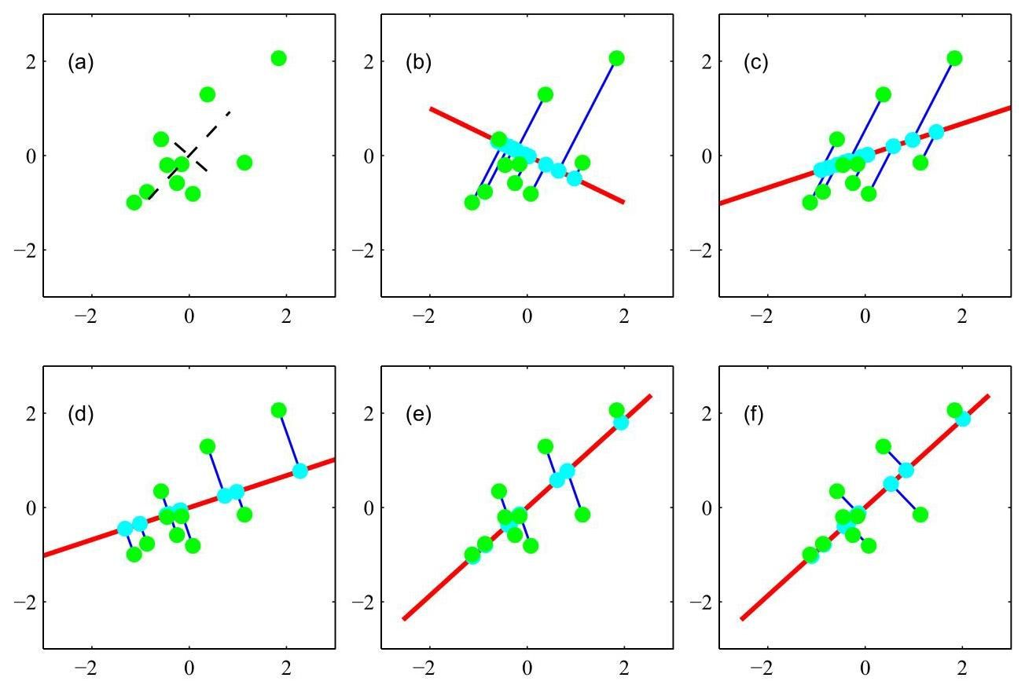

Figure 16.10 Synthetic data illustrating the EM algorithm for PCA defined by (16.70) and (16.71). (a) A set of data points shown in green, together with the true principal components (shown as eigenvectors scaled by the square roots of the eigenvalues). (b) Initial configuration of the principal subspace defined by , shown in red, together with the projections of the latent points into the data space, given by , shown in cyan. (c) After one M step, W has been updated with held fixed. (d) After the successive E step, the values of have been updated, giving orthogonal projections, with held fixed. (e) After the second step. (f) The converged solution.

图 16.10 展示了由 (16.70) 和 (16.71) 定义的主成分分析的 EM 算法的合成数据。(a) 一组绿色显示的数据点，以及真实的主成分(显示为按特征值的平方根缩放的特征向量)。(b) 由 定义的主子空间的初始配置，以红色显示，以及潜在点 在数据空间中的投影，由 给出，以青色显示。(c) 经过一次 M 步后，W 在 固定的情况下进行了更新。(d) 经过连续的 E 步后， 的值在 固定的情况下进行了更新，得到了正交投影。(e) 经过第二次 步后。(f) 收敛的解。

Exercise 16.25

练习 16.25

where the diag operator sets all the non-diagonal elements of a matrix to zero.

其中 diag 运算符将矩阵的所有非对角元素置为零。

# 16.4. Nonlinear Latent Variable Models

# 16.4. 非线性潜变量模型

So far in this chapter we have focused on latent variable models based on linear transformations from the latent space to the data space. It is natural to ask whether we can use the flexibility of deep neural networks to represent more complex transformations, while exploiting the learning ability of deep networks to allow the resulting distribution to be fitted to a data set. Consider a simple distribution over a vector variable , for example a Gaussian of the form

到目前为止，在本章中我们主要关注基于从潜空间到数据空间的线性变换的潜变量模型。很自然地，我们会问是否可以利用深度神经网络的灵活性来表示更复杂的变换，同时利用深度网络的学习能力使得到的分布能够拟合数据集。考虑一个向量变量 上的简单分布，例如形式如下的高斯分布

Now suppose we transform using a function given by a deep neural network, where represents the weights and biases. The combination of the distribution over together with the neural network defines a distribution over . Sampling from such a model is straightforward because we can generate samples from and then transform each of them using the neural network function to give corresponding samples of . This is an efficient process since it does not involve iteration.

现在假设我们使用一个由深度神经网络给出的函数 对 进行变换，其中 表示权重和偏置。 上的分布与神经网络的组合定义了 上的一个分布。从这样的模型中采样很直接，因为我们可以从 生成样本，然后使用神经网络函数对每个样本进行变换，从而得到 的相应样本。这是一个高效的过程，因为它不涉及迭代。

To learn from data, consider how to evaluate the likelihood function . The distribution of is given by the change of variables formula for densities:

为了从数据中学习 ，考虑如何评估似然函数 。 的分布由密度的变量变换公式给出:

Section 2.4

第 2.4 节

where is the Jacobian matrix of partial derivatives whose elements are given by

其中 是偏导数的雅可比矩阵，其元素由下式给出

To evaluate the distribution on the right-hand side of (16.78) for a given data vector and to evaluate the Jacobian matrix in (16.79) for that same value of , we need the inverse of the neural network function. For most neural networks this inverse will not be well defined. For example, the network may represent a many-to-one function in which multiple different input values map to the same output value, in which case the change of variable formula does not give a well-defined density. Moreover, if the dimensionality of the latent space is different from that of the data space then the transformation will not be invertible.

为了针对给定的数据向量 计算 (16.78) 式右侧的分布 ，并针对该 值计算 (16.79) 式中的雅可比矩阵，我们需要神经网络函数的逆 。对于大多数神经网络而言，这种逆可能没有明确定义。例如，网络可能表示一个多对一的函数，其中多个不同的输入值映射到相同的输出值，在这种情况下，变量变换公式无法给出明确定义的密度。此外，如果潜在空间的维度与数据空间的维度不同，那么该变换将不可逆。

One approach is to restrict our attention to functions that are invertible, which requires that and have the same dimensionality. We will explore this approach in more detail when we introduce the technique of normalizing flows.

一种方法是将我们的注意力限制在可逆函数 上，这要求 和 具有相同的维度。在介绍归一化流技术时，我们将更详细地探讨这种方法。

Chapter 18

第 18 章

# 16.4.1 Nonlinear manifolds

# 16.4.1 非线性流形

Requiring that the latent and data spaces have the same number of dimensions is a significant limitation. Consider the situation in which has dimensionality and has dimensionality , where . In this case the distribution over is confined to a manifold, or subspace, of dimensionality , as illustrated in Figure 16.11. Low-dimensional manifolds arise in many machine learning applications, for example when modelling the distribution of natural images. Nonlinear latent-variable models can be very useful in modelling such data because they express the strong inductive bias that the data does not ’fill’ the data space but is confined to a manifold, although the shape and dimensionality of this manifold are typically not known in advance.

要求潜在空间和数据空间具有相同的维度是一个显著的限制。考虑这样一种情况， 的维度为 ， 的维度为 ，其中 。在这种情况下， 上的分布被限制在一个维度为 的流形或子空间中，如图 16.11 所示。低维流形出现在许多机器学习应用中，例如在对自然图像的分布进行建模时。非线性潜在变量模型在对这类数据进行建模时非常有用，因为它们表达了一种强烈的归纳偏置，即数据并非“填满”数据空间，而是被限制在一个流形上，尽管这个流形的形状和维度通常事先未知。

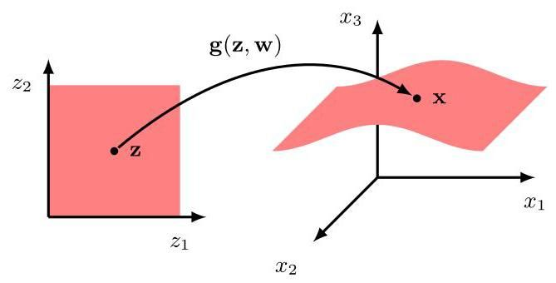

Figure 16.11 Illustration of a mapping from a two-dimensional latent space to a three-dimensional data space using a nonlinear function represented by a neural network with parameter vector .

图 16.11 展示了使用一个由参数向量为 的神经网络表示的非线性函数 ，将二维潜在空间 映射到三维数据空间 的情况。

Section 6.1.4

第 6.1.4 节

However, one problem with this framework is that it assigns zero probability density to any data vector that does not lie exactly on the manifold, which is a problem for gradient-based learning since the likelihood function will be zero at each of the data points and constant for small changes in , for any realistic data set. To address this, we follow the approach used previously with regression and classification problems and define a conditional distribution across the entire data space, whose parameters are given by the output of the neural network. If, for example, comprises a vector of continuous variables then we can choose the conditional distribution to be a Gaussian:

然而，这个框架存在一个问题，即它会给任何不完全位于流形上的数据向量赋予零概率密度。对于基于梯度的学习来说，这是个问题，因为对于任何实际的数据集，似然函数在每个数据点处都将为零，并且在 有小的变化时保持恒定。为了解决这个问题，我们采用之前处理回归和分类问题时使用的方法，在整个数据空间上定义一个条件分布，其参数由神经网络的输出给出。例如，如果 包含一个连续变量向量，那么我们可以选择条件分布为高斯分布:

in which the neural network has linear output-unit activation functions, and . The generative model is specified by the latent distribution over together with the conditional distribution over , and can be represented by the simple graphical model shown in Figure 16.12.

其中，神经网络 具有线性输出单元激活函数，且 。生成模型由 上的潜在分布以及 上的条件分布指定，并且可以由图 16.12 所示的简单图形模型表示。

Note that it is straightforward, and computationally efficient, to draw independent samples from this distribution. We first draw a sample from the Gaussian distribution (16.77) using standard methods. Next, we use this value as input to the neural network, giving an output value . Finally, we draw a sample from a Gaussian distribution with mean and covariance , as defined by (16.80). This three-step process can then be repeated to generate multiple independent samples.

请注意，从这个分布中抽取独立样本既简单又计算高效。我们首先使用标准方法从高斯分布 (16.77) 中抽取一个样本。接下来，我们将这个值作为输入传递给神经网络，得到一个输出值 。最后，我们从均值为 、协方差为 的高斯分布中抽取一个样本，如 (16.80) 所定义。然后可以重复这个三步过程来生成多个独立样本。

Section 14.1.2

第 14.1.2 节

The combination of a latent-variable distribution and a conditional distri-

潜在变量分布 与条件分布的组合

Figure 16.12 Graphical model representing the distribution given by (16.77) and (16.80), which together define a joint distribution . bution defines a marginal distribution over the data space given by

图 16.12 表示由式 (16.77) 和 (16.80) 给出的分布的图形模型，它们共同定义了一个联合分布 。分布 定义了数据空间上的边缘分布，由下式给出

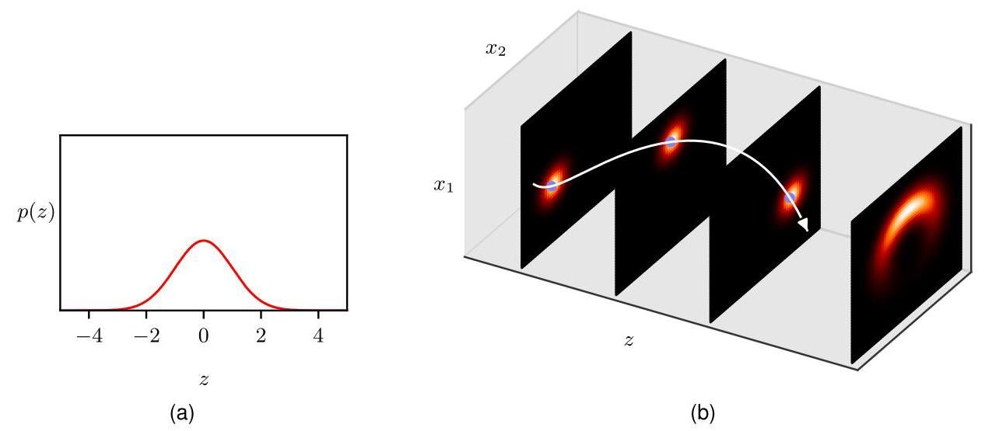

Figure 16.13 Illustration of a nonlinear latent-variable model for a one-dimensional latent space and a two-dimensional data space. (a) The prior distribution in latent space is given by a zero-mean unit-variance Gaussian distribution. (b) The three left-most plots show examples of the Gaussian conditional distribution for different values of , whereas the right-most plot shows the marginal distribution . The nonlinear function , which defines the mean of the conditional distribution, is given by , and, therefore, traces out a circle in data space. The standard deviation of the conditional distribution is given by . [Based on Prince (2020) with permission.]

图 16.13 展示了一个用于一维潜在空间和二维数据空间的非线性潜在变量模型。(a) 潜在空间中的先验分布由零均值单位方差的高斯分布给出。(b) 最左边的三个图展示了对于不同 值的高斯条件分布 的示例，而最右边的图展示了边缘分布 。定义条件分布均值的非线性函数 由 给出，因此在数据空间中描绘出一个圆。条件分布的标准差由 给出。[经许可改编自 Prince (2020)。]

We illustrate this using a simple example involving a one-dimensional latent space and a two-dimensional data space in Figure 16.13.

我们在图 16.13 中使用一个涉及一维潜在空间和二维数据空间的简单示例来说明这一点。

# 16.4.2 Likelihood function

# 16.4.2 似然函数

We have seen that it is easy to draw samples from this nonlinear latent-variable model. Now suppose we wish to fit the model to an observed data set by maximizing the likelihood function. The likelihood is obtained from the product and sum rules of probability by integrating over :

我们已经看到，从这个非线性潜在变量模型中抽取样本很容易。现在假设我们希望通过最大化似然函数来将模型拟合到一个观测数据集上。似然是通过对 进行积分，利用概率的乘积规则和求和规则得到的:

Although both distributions inside the integral are Gaussian, the integral is analytically intractable due to the highly nonlinear function defined by the neural network.

尽管积分内的两个分布均为高斯分布，但由于神经网络定义的高度非线性函数 ，该积分在解析上难以处理。

Figure 16.14 Three example images of handwritten digits, illustrating why sampling from the latent space to evaluate the likelihood function requires large numbers of samples. (a) shows the original image, (b) shows a corrupted image with part of the stroke removed, and (c) shows the original image shifted by half a pixel down and half a pixel to the right. Image (b) is closer to (a) in terms of likelihood, even though image (c) is much closer to (a) in appearance. [From Doersch (2016) with permission.]

图 16.14 手写数字的三个示例图像，说明了为什么从潜在空间采样以评估似然函数需要大量样本。(a) 显示原始图像，(b) 显示去除部分笔画的损坏图像，(c) 显示原始图像向下和向右各移动半个像素后的图像。就似然性而言，图像 (b) 更接近 (a)，尽管图像 (c) 在外观上与 (a) 更接近。[经许可摘自 Doersch (2016)。]

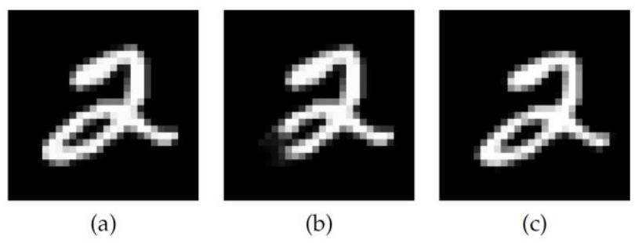

One approach for evaluating the likelihood function would be to draw samples from the latent space distribution and use these to approximate (16.82) by

评估似然函数的一种方法是从潜在空间分布中抽取样本，并使用这些样本来通过以下方式近似 (16.82)

where . This expresses the distribution over as a mixture of Gaussians with fixed mixing coefficients given by , and in the limit of an infinite number of samples, this gives the true likelihood function. However, the value of needed for effective training will typically be far too high to be practical. To see why, consider the three images of handwritten digits shown in Figure 16.14, and suppose that image (a) represents the vector for which we wish to evaluate the likelihood function. If a trained model generated image (b), we would consider this a poor model as this image is not a good representation of a digit ’ 2 ’, and so this should be assigned a much lower likelihood. Conversely, image (c), which was obtained by shifting the digit in (a) down and to the right by half a pixel, is a good example of a digit ’2’ and should therefore have a high likelihood. Since the distribution (16.80) is Gaussian, the likelihood function is proportional to the exponential of the negative squared distance between the output of the network and the data vector . However, the squared distance between (a) and (b) is 0.0387 whereas the squared distance between (a) and (c) is 0.2693 . So if the variance parameter is set to a sufficiently small value that image (b) has low likelihood, then image (c) will have an even lower likelihood. Even if the model is good at generating digits, we would have to consider extremely large numbers of samples for before seeing a digit that is sufficiently close to (a). We therefore seek more sophisticated techniques for training nonlinear latent variable models that can be used in practical applications. Before outlining such methods, we first discuss briefly some considerations regarding discrete data spaces.

其中 。这将 上的分布表示为具有由 给出的固定混合系数的高斯混合分布，并且在样本数量趋于无穷大的极限情况下，这给出了真实的似然函数。然而，有效训练所需的 值通常过高，不切实际。为了理解原因，考虑图 16.14 中显示的手写数字的三个图像，并假设图像 (a) 表示我们希望评估似然函数的向量 。如果一个训练好的模型生成了图像 (b)，我们会认为这是一个糟糕的模型，因为这个图像不能很好地表示数字 ’2’，因此应该赋予它低得多的似然性。相反，图像 (c) 是通过将 (a) 中的数字向下和向右移动半个像素得到的，它是数字 ’2’ 的一个很好的示例，因此应该具有高似然性。由于分布 (16.80) 是高斯分布，似然函数与网络输出和数据向量 之间负平方距离的指数成正比。然而，(a) 和 (b) 之间的平方距离为 0.0387，而 (a) 和 (c) 之间的平方距离为 0.2693。因此，如果将方差参数 设置为足够小的值，使得图像 (b) 具有低似然性，那么图像 (c) 的似然性将更低。即使模型擅长生成数字，在看到与 (a) 足够接近的数字之前，我们也必须考虑 的极大量样本。因此，我们寻求更复杂的技术来训练可用于实际应用的非线性潜在变量模型。在概述这些方法之前，我们首先简要讨论一些关于离散数据空间的考虑因素。

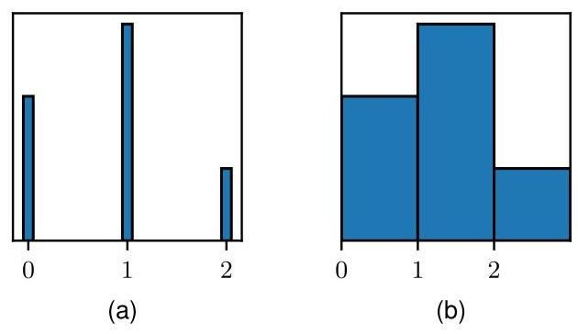

Figure 16.15 Schematic illustration of de-quantization, showing (a) a discrete distribution over a single variable and (b) an associated dequantized continuous distribution.

图 16.15 去量化的示意图，显示 (a) 单个变量上的离散分布和 (b) 相关的去量化连续分布。

# 16.4.3 Discrete data

# 16.4.3 离散数据

If the observed data set comprises independent binary variables then we can use a conditional distribution of the form

如果观测数据集包含独立的二元变量，那么我们可以使用以下形式的条件分布

where represents the activation of output unit , the activation function is given by the logistic sigmoid, and is the pre-activation for output unit . Similarly, for one-hot encoded categorical variables, we can use a multinomial distribution:

其中 表示输出单元 的激活值，激活函数 由逻辑 sigmoid 函数给出， 是输出单元 的预激活值。类似地，对于独热编码的分类变量，我们可以使用多项分布:

where

其中

is the softmax activation function. We can also consider combinations of discrete and continuous variables by forming the product of the associated conditional distributions.

是 softmax 激活函数。我们还可以通过形成相关条件分布的乘积来考虑离散变量和连续变量的组合。

In practice, continuous variables are represented with discrete values, for example in images, the red, green, and blue channel intensities might be expressed using 8-bit numbers representing the values . This can cause problems when we employ highly flexible models based on deep neural networks, as the likelihood function can go to zero if the density collapses onto one or more of the discrete values. The problem can be resolved using a technique called dequantization, which involves adding noise to the variables, typically drawn from a uniform distribution over the region between successive discrete values, as shown in Figure 16.15. A training set is dequantized by replacing each observed value with a sample drawn randomly from the associated continuous distribution associated with that discrete value, and this makes it less likely that the model will discover a pathological solution.

在实践中，连续变量用离散值表示，例如在图像中，红色、绿色和蓝色通道的强度可能使用 8 位数字表示，这些数字代表值 。当我们采用基于深度神经网络的高度灵活的模型时，这可能会导致问题，因为如果密度收敛到一个或多个离散值上，似然函数可能会变为零。这个问题可以使用一种称为去量化的技术来解决，该技术涉及向变量添加噪声，通常是从连续离散值之间的区域上的均匀分布中抽取的，如图 16.15 所示。通过用从与该离散值相关联的连续分布中随机抽取的样本替换每个观测值来对训练集进行去量化，这使得模型不太可能找到病态解。

# 16.4.4 Four approaches to generative modelling

# 16.4.4 生成式建模的四种方法

We have seen that nonlinear latent-variable models based on deep neural networks offer a highly flexible framework for building generative models. Due to the universality of the neural network transformation, such models are capable, in principle, of approximating essentially any desired distribution to high accuracy. Moreover, such models offer the potential, once trained, to generate samples from the distribution in using an efficient, non-iterative process. However, we have also identified some challenges associated with training such models that force us to develop more sophisticated techniques than those needed for linear models. Many such methods have been proposed, each having their own strengths and limitations. These can be broadly grouped into four approaches, as follows.

我们已经看到，基于深度神经网络的非线性潜变量模型为构建生成模型提供了一个高度灵活的框架。由于神经网络变换的通用性，原则上，此类模型能够以高精度逼近任何所需的分布。此外，一旦经过训练，此类模型有潜力通过高效的非迭代过程从分布中生成样本。然而，我们也发现了训练此类模型所面临的一些挑战，这迫使我们开发比线性模型所需技术更复杂的方法。已经提出了许多这样的方法，每种方法都有其自身的优势和局限性。这些方法大致可以分为以下四种途径。

Chapter 17

第17章

With generative adversarial networks, or GANs, we relax the requirement for the network mapping to be invertible, thereby allowing the latent space to have a lower dimensionality than the data space. We also abandon the concept of a likelihood function and instead introduce a second neural network whose function is to provide a training signal for the generative network. Due to the absence of a well-defined likelihood function, the training procedure may be brittle, but once trained it is straightforward to generate samples from the model, and the results can be of high quality.

通过生成对抗网络(GANs)，我们放宽了网络映射必须可逆的要求，从而允许潜在空间的维度低于数据空间的维度。我们还摒弃了似然函数的概念，转而引入第二个神经网络，其功能是为生成网络提供训练信号。由于没有明确定义的似然函数，训练过程可能不稳定，但一旦训练完成，就可以直接从模型中生成样本，并且结果可能具有较高的质量。

Chapter 19

第19章

The framework of variational autoencoders, or VAEs, also uses a second neural network whose role is to approximate the posterior distribution over the latent variables, thereby allowing an approximation to the likelihood function to be evaluated. Training is more robust than with GANs, and sampling from the trained model is straightforward, although it can be harder to obtain the highest quality results.

变分自编码器(VAEs)框架也使用第二个神经网络，其作用是逼近潜变量上的后验分布，从而可以对似然函数进行近似评估。与生成对抗网络相比，训练过程更加稳健，并且从训练好的模型中采样很直接，尽管可能更难获得最高质量的结果。

Chapter 18

第18章

In normalizing flows, we set the dimensionality of the latent space to be equal to that of the data space and then modify the generative neural network so that it becomes invertible. The requirement that the network is invertible restricts its functional form but it allows the likelihood function to be evaluated without approximation and it also allows for efficient sampling.

在归一化流中，我们将潜在空间的维度设置为与数据空间的维度相等，然后修改生成神经网络，使其具有可逆性。网络具有可逆性这一要求限制了其函数形式，但它允许精确计算似然函数，并且还能实现高效采样。

Chapter 20

第20章

Finally, diffusion models use a network that learns to transform a sample from the prior distribution into a sample from the data distribution through a sequence of denoising steps. This leads to state-of-the-art performance in many applications, although the cost of sampling can be high due to the multiple denoising passes through the network.

最后，扩散模型使用一个网络，该网络学习通过一系列去噪步骤将来自先验分布的样本转换为来自数据分布的样本。这在许多应用中带来了最先进的性能，尽管由于需要多次通过网络进行去噪，采样成本可能较高。

We explore these approaches in detail in the final four chapters of this book.

我们将在本书的最后四章详细探讨这些方法。

# Exercises

# 练习

16.1 In this exercise, we use proof by induction to show that the linear projection onto an -dimensional subspace that maximizes the variance of the projected data is defined by the eigenvectors of the data covariance matrix , given by (16.3), corresponding to the largest eigenvalues. In Section 16.1, this result was proven for . Now suppose the result holds for some general value of and show that it consequently holds for dimensionality . To do this, first set the derivative of the variance of the projected data with respect to a vector defining the new direction in data space equal to zero. This should be done subject to the constraints that are orthogonal to the existing vectors , and also that it is normalized to unit length. Use Lagrange multipliers to enforce these constraints. Then make use of the orthonormality properties of the vectors to show that the new vector is an eigenvector of . Finally, show that the variance is maximized if the eigenvector is chosen to be the one corresponding to eigenvalue where the eigenvalues have been ordered in decreasing value.

16.1 在本练习中，我们使用归纳法证明，将投影数据方差最大化的到 维子空间的线性投影由数据协方差矩阵 的 个特征向量定义，如式(16.3)所示，这些特征向量对应于 个最大的特征值。在第16.1节中，已针对 证明了该结果。现在假设该结果对于 的某个一般值成立，并证明它因此对于维度 也成立。为此，首先将投影数据的方差关于定义数据空间中新方向的向量 的导数设为零。这应该在 与现有向量 正交且其被归一化为单位长度的约束条件下进行。使用拉格朗日乘数法来施加这些约束。然后利用向量 的正交归一性性质证明新向量 是 的一个特征向量。最后，证明如果选择对应于特征值 的特征向量(特征值已按降序排列)，则方差将达到最大值。

Appendix

附录

16.2 Show that the minimum value of the PCA error measure given by (16.15) with respect to the , subject to the orthonormality constraints (16.7), is obtained when the are eigenvectors of the data covariance matrix . To do this, introduce a matrix of Lagrange multipliers, one for each constraint, so that the modified error measure, in matrix notation reads

16.2 证明在正交归一化约束条件 (16.7) 下，关于 的主成分分析(PCA)误差度量 (由式 (16.15) 给出)的最小值，是在 为数据协方差矩阵 的特征向量时取得。为此，引入一个拉格朗日乘子矩阵 ，每个约束对应一个拉格朗日乘子，使得用矩阵表示的修正误差度量为

where is a matrix of dimension whose columns are given by . Now minimize with respect to and show that the solution satisfies . Clearly, one possible solution is that the columns of are eigenvectors of , in which case is a diagonal matrix containing the corresponding eigenvalues. To obtain the general solution, show that can be assumed to be a symmetric matrix, and by using its eigenvector expansion, show that the general solution to gives the same value for as the specific solution in which the columns of are the eigenvectors of . Because these solutions are all equivalent, it is convenient to choose the eigenvector solution.

其中 是一个维度为 的矩阵，其列由 给出。现在关于 最小化 ，并证明该解满足 。显然，一个可能的解是 的列是 的特征向量，在这种情况下， 是一个包含相应特征值的对角矩阵。为了得到通解，证明可以假设 是一个对称矩阵，并通过使用其特征向量展开式，证明 的通解与 的列是 的特征向量这一特解给出的 值相同。由于这些解都是等价的，因此选择特征向量解会很方便。

16.3 ( ) Verify that the eigenvectors defined by (16.30) are normalized to unit length, assuming that the eigenvectors have unit length.

16.3 ( ) 假设特征向量 的长度为单位长度，验证由式 (16.30) 定义的特征向量已归一化为单位长度。

16.4 (★) Suppose we replace the zero-mean, unit-covariance latent space distribution (16.31) in the probabilistic PCA model by a general Gaussian distribution of the form . By redefining the parameters of the model, show that this leads to an identical model for the marginal distribution over the observed variables for any valid choice of and .

16.4 (★) 假设我们将概率主成分分析模型中的零均值、单位协方差潜在空间分布 (16.31) 替换为形式为 的一般高斯分布。通过重新定义模型的参数，证明对于 和 的任何有效选择，这会导致观测变量的边缘分布 具有相同的模型。

16.5 Let be a -dimensional random variable having a Gaussian distribution given by , and consider the -dimensional random variable given by where is an matrix. Show that also has a Gaussian distribution, and find expressions for its mean and covariance. Discuss the form of this Gaussian distribution for , for , and for .

16.5 设 是一个 维随机变量，其服从由 给出的高斯分布，并考虑由 给出的 维随机变量，其中 是一个 矩阵。证明 也服从高斯分布，并求出其均值和协方差的表达式。讨论当 、 和 时该高斯分布的形式。

16.6 By making use of the results (2.122) and (2.123) for the mean and covariance of a general distribution, derive the result (16.35) for the marginal distribution in the probabilistic PCA model.

16.6 利用一般分布的均值和协方差的结果 (2.122) 和 (2.123)，推导概率主成分分析 (PCA) 模型中边缘分布 的结果 (16.35)。

16.7 ( ) Draw a directed probabilistic graph for the probabilistic PCA model described in Section 16.2 in which the components of the observed variable are shown explicitly as separate nodes. Hence, verify that the probabilistic PCA model has the same independence structure as the naive Bayes model discussed in Section 11.2.3.

16.7 ( ) 为第 16.2 节中描述的概率主成分分析模型绘制一个有向概率图，其中观测变量 的各个分量明确显示为单独的节点。因此，验证概率主成分分析模型是否具有与第 11.2.3 节中讨论的朴素贝叶斯模型相同的独立性结构。

16.8 By making use of the result (3.100), show that the posterior distribution for the probabilistic PCA model is given by (16.43).

16.8 利用结果 (3.100)，证明概率主成分分析模型的后验分布 由 (16.43) 给出。

16.9 (*) Verify that maximizing the log likelihood (16.44) for the probabilistic PCA model with respect to the parameter gives the result where is the mean of the data vectors.

16.9 (*) 验证关于参数 最大化概率主成分分析模型的对数似然函数 (16.44) 可得到结果 ，其中 是数据向量的均值。

16.10 By evaluating the second derivatives of the log likelihood function (16.44) for the probabilistic PCA model with respect to the parameter , show that the stationary point represents the unique maximum.

16.10 通过计算概率主成分分析模型的对数似然函数 (16.44) 关于参数 的二阶导数，证明驻点 代表唯一的最大值。

16.11 Show that in the limit , the posterior mean for the probabilistic PCA model becomes an orthogonal projection onto the principal subspace, as in conventional PCA.

16.11 证明在极限 情况下，概率主成分分析模型的后验均值变为到主子空间上的正交投影，就像传统主成分分析那样。

16.12 For show that the posterior mean in the probabilistic PCA model is shifted towards the origin relative to the orthogonal projection.

16.12 对于 ，证明概率主成分分析(PCA)模型中的后验均值相对于正交投影向原点偏移。

16.13 Show that the optimal reconstruction of a data point under probabilistic PCA, according to the least-squares projection cost of conventional PCA, is given by

16.13 证明在概率主成分分析下，根据传统主成分分析的最小二乘投影代价，数据点的最优重构由下式给出

16.14 (*) The number of independent parameters in the covariance matrix for a probabilistic PCA model with an -dimensional latent space and a -dimensional data space is given by (16.52). Verify that for , the number of independent parameters is the same as in a general covariance Gaussian, whereas for it is the same as for a Gaussian with an isotropic covariance.

16.14 (*) 对于具有 维潜在空间和 维数据空间的概率主成分分析模型，其协方差矩阵中的独立参数数量由式(16.52)给出。验证对于 ，独立参数的数量与一般协方差高斯分布中的相同，而对于 ，它与具有各向同性协方差的高斯分布中的相同。

16.15 Derive an expression for the number of independent parameters in the factor analysis model described in Section 16.2.4.

16.15 推导第 16.2.4 节中描述的因子分析模型中独立参数数量的表达式。

16.16 Show that the factor analysis model described in Section 16.2.4 is invariant under rotations of the latent space coordinates.

16.16 证明第 16.2.4 节中描述的因子分析模型在潜在空间坐标旋转下是不变的。

16.17 Consider a linear-Gaussian latent-variable model having a latent space distribution and a conditional distribution for the observed variable where is an arbitrary symmetric positive-definite noise covariance matrix. Now suppose that we make a non-singular linear transformation of the data variables , where is a matrix. If , and represent the maximum likelihood solution corresponding to the original un-transformed data, show that , and represent the corresponding maximum likelihood solution for the transformed data set. Finally, show that the form of the model is preserved in two cases: (i) is a diagonal matrix and is a diagonal matrix. This corresponds to factor analysis. The transformed remains diagonal, and hence factor analysis is covariant under component-wise re-scaling of the data variables; (ii) is orthogonal and is proportional to the unit matrix so that . This corresponds to probabilistic PCA. The transformed matrix remains proportional to the unit matrix, and hence probabilistic PCA is covariant under a rotation of the axes of the data space, as is the case for conventional PCA.

16.17 考虑一个线性高斯潜在变量模型，其潜在空间分布为 ，观测变量的条件分布为 ，其中 是任意对称正定噪声协方差矩阵。现在假设我们对数据变量进行非奇异线性变换 ，其中 是一个 矩阵。如果 、 表示对应于原始未变换数据的最大似然解，证明 、 表示对应于变换后数据集的最大似然解。最后，证明模型的形式在两种情况下保持不变:(i) 是对角矩阵且 是对角矩阵。这对应于因子分析。变换后的 仍然是对角矩阵，因此因子分析在数据变量的逐分量重新缩放下是协变的；(ii) 是正交矩阵且 与单位矩阵成比例，即 。这对应于概率主成分分析。变换后的 矩阵仍然与单位矩阵成比例，因此概率主成分分析在数据空间坐标轴旋转下是协变的，这与传统主成分分析的情况相同。

16.18 Verify that the log likelihood function for a model with continuous latent variables can be written as the sum of two terms in the form (16.57) in which the terms are defined by (16.58) and (16.59). This can be done by using the product rule of probability in the form

16.18 验证具有连续潜在变量的模型的对数似然函数可以写成形式为 (16.57) 的两项之和，其中这些项由 (16.58) 和 (16.59) 定义。这可以通过使用如下形式的概率乘积规则来完成

and then substituting for in (16.58).

然后将 代入 (16.58)。

16.19 ( ) Show that, for a set of i.i.d. data, the evidence lower bound (ELBO) takes the form (16.63).

16.19 ( ) 证明，对于一组独立同分布的数据，证据下界 (ELBO) 具有形式 (16.63)。

16.20 Draw a directed probabilistic graphical model representing a discrete mixture of probabilistic PCA models in which each PCA model has its own values of , , and . Now draw a modified graph in which these parameter values are shared between the components of the mixture.

16.20 绘制一个有向概率图模型，该模型表示概率主成分分析 (PCA) 模型的离散混合，其中每个 PCA 模型都有自己的 、 和 值。现在绘制一个修改后的图，其中这些参数值在混合的各个成分之间共享。

16.21 Derive the M-step equations (16.68) and (16.69) for the probabilistic PCA model by maximizing the expected complete-data log likelihood function given by (16.65).

16.21 通过最大化由 (16.65) 给出的期望完全数据对数似然函数，推导概率主成分分析 (PCA) 模型的 M 步方程 (16.68) 和 (16.69)。

16.22 One benefit of a probabilistic formulation of principal component analysis is that it can be applied to a data set in which some of the values are missing, provided they are missing at random. Derive the EM algorithm for maximizing the likelihood function for the probabilistic PCA model in this situation. Note that the , as well as the missing data values that are components of the vectors , are now latent variables. Show that in the special case in which all the data values are observed, this reduces to the EM algorithm for probabilistic PCA derived in Section 16.3.2.

16.22 主成分分析的概率公式化的一个好处是，它可以应用于某些值缺失的数据集，前提是这些值是随机缺失的。推导在这种情况下最大化概率主成分分析 (PCA) 模型似然函数的 EM 算法。注意， 以及作为向量 分量的缺失数据值现在都是潜在变量。证明在所有数据值都被观测到的特殊情况下，这会简化为第 16.3.2 节中推导的概率主成分分析的 EM 算法。

Let be a matrix whose columns define a linear subspace of dimensionality embedded within a data space of dimensionality , and let be a -dimensional vector. Given a data set where , we can approximate the data points using a linear mapping from a set of -dimensional vectors , so that is approximated by . The associated sum-of-squares reconstruction cost is given by

设 为一个 矩阵，其列定义了一个嵌入在维度为 的数据空间中的维度为 的线性子空间，并设 为一个 维向量。给定一个数据集 ，其中 ，我们可以使用从一组 维向量 进行的线性映射来近似数据点，使得 由 近似。相关的平方和重建成本由下式给出

First show that minimizing with respect to leads to an analogous expression with and replaced by zero-mean variables and , respectively, where and denote sample means. Then show that minimizing with respect to , where is kept fixed, gives rise to the PCA E step (16.70), and that minimizing with respect to , where is kept fixed, gives rise to the PCA M step (16.71).

首先证明，关于 最小化 会得到一个类似的表达式，其中 和 分别被零均值变量 和 取代，其中 和 表示样本均值。然后证明，在 保持固定的情况下，关于 最小化 会得到主成分分析(PCA)的 E 步(16.70)，而在 保持固定的情况下，关于 最小化 会得到主成分分析的 M 步(16.71)。

16.24 Derive the formulae (16.72) and (16.73) for the E step of the EM algorithm for factor analysis. Note that from the result of Exercise 16.26, the parameter can be replaced by the sample mean .

16.24 推导因子分析的期望最大化(EM)算法 E 步的公式(16.72)和(16.73)。注意，根据练习 16.26 的结果，参数 可以用样本均值 代替。

16.25 Write down an expression for the expected complete-data log likelihood function for the factor analysis model, and hence derive the corresponding M-step equations (16.75) and (16.76).

16.25 写出因子分析模型的期望完全数据对数似然函数的表达式，并由此推导相应的 M 步方程(16.75)和(16.76)。

16.26 By considering second derivatives, show that the only stationary point of the log likelihood function for the factor analysis model discussed in Section 16.2.4 with respect to the parameter is given by the sample mean defined by (16.1). Furthermore, show that this stationary point is a maximum.

16.26 通过考虑二阶导数，证明在第 16.2.4 节中讨论的因子分析模型的对数似然函数关于参数 的唯一驻点由(16.1)定义的样本均值给出。此外，证明这个驻点是一个最大值点。

Deep Learning

深度学习



Generative models use machine learning algorithms to learn a distribution from a set of training data and then generate new examples from that distribution. For example, a generative model might be trained on images of animals and then used to generate new images of animals. We can think of such a generative model in terms of a distribution in which is a vector in the data space, and represent the learnable parameters of the model. In many cases we are interested in conditional generative models of the form where represents a vector of conditioning variables. In the case of our generative model for animal images, we may wish to specify that a generated image should be of a particular animal, such as a cat or a dog, specified by the value of .

生成模型使用机器学习算法从一组训练数据中学习分布，然后从该分布中生成新的样本。例如，一个生成模型可能在动物图像上进行训练，然后用于生成新的动物图像。我们可以从分布 的角度来考虑这样一个生成模型，其中 是数据空间中的一个向量， 表示模型的可学习参数。在许多情况下，我们对形式为 的条件生成模型感兴趣，其中 表示一个条件变量向量。在我们的动物图像生成模型的例子中，我们可能希望指定生成的图像应该是特定的动物，比如猫或狗，由 的值来指定。

For real-world applications such as image generation, the distributions are extremely complex, and consequently the introduction of deep learning has dramatically improved the performance of generative models. We have already encountered an important class of deep generative models when we discussed autoregressive large language models based on transformers. We have also outlined four important classes of generative model based on nonlinear latent variable models, and in this chapter we discuss the first of these, called generative adversarial networks. The other three approaches will be discussed in subsequent chapters.

对于图像生成等现实世界的应用，分布极其复杂，因此深度学习的引入极大地提高了生成模型的性能。在讨论基于 transformer 的自回归大型语言模型时，我们已经遇到了一类重要的深度生成模型。我们还概述了基于非线性潜在变量模型的四类重要的生成模型，在本章中，我们将讨论其中的第一类，称为生成对抗网络。其他三种方法将在后续章节中讨论。

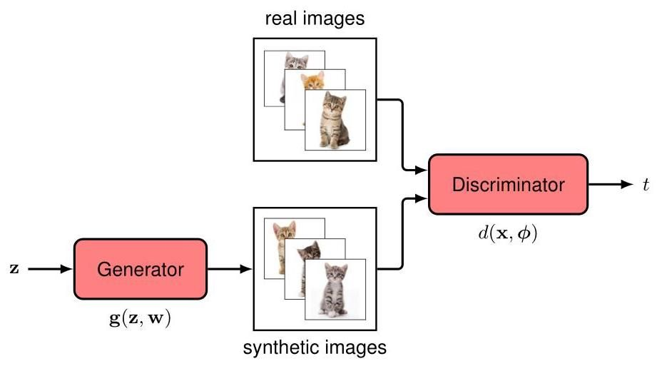

Figure 17.1 Schematic illustration of a GAN in which a discriminator neural network is trained to distinguish between real samples from the training set, in this case images of kittens, and synthetic samples produced by the generator network . The generator aims to maximize the error of the discriminator network by producing realistic images, whereas the discriminator network tries to minimize the same error by becoming better at distinguishing real from synthetic examples.

图 17.1 生成对抗网络(GAN)的示意图，其中判别器神经网络 经过训练，用于区分训练集中的真实样本(在这种情况下是小猫的图像)和生成器网络 生成的合成样本。生成器的目标是通过生成逼真的图像来最大化判别器网络的误差，而判别器网络则试图通过更好地区分真实样本和合成样本来最小化相同的误差。

Chapter 12 Section 16.4.4

第 12 章 第 16.4.4 节

# 17.1. Adversarial Training

# 17.1. 对抗训练

Consider a generative model based on a nonlinear transformation from a latent space to a data space . We introduce a latent distribution , which might take the form of a simple Gaussian

考虑一个基于从潜在空间 到数据空间 的非线性变换的生成模型。我们引入一个潜在分布 ，它可能是一个简单的高斯分布

along with with a nonlinear transformation defined by a deep neural network with learnable parameters known as the generator. Together these implicitly define a distribution over , and our goal is to fit this distribution to a data set of training examples where . However, we cannot determine w by optimizing the likelihood function because this cannot, in general, be evaluated in closed form. The key idea of generative adversarial networks, or GANs, (Goodfellow et al., 2014; Ruthotto and Haber, 2021) is to introduce a second discriminator network, which is trained jointly with the generator network and which provides a training signal to update the weights of the generator. This is illustrated in Figure 17.1.

以及由一个具有可学习参数 的深度神经网络定义的非线性变换 ，该深度神经网络被称为生成器。它们共同隐式地定义了一个关于 的分布，我们的目标是使这个分布拟合训练示例数据集 ，其中 。然而，我们不能通过优化似然函数来确定 w，因为一般来说，这个似然函数无法以封闭形式进行评估。生成对抗网络(Generative Adversarial Networks，简称 GANs)的关键思想(Goodfellow 等人，2014 年；Ruthotto 和 Haber，2021 年)是引入第二个判别器网络，它与生成器网络联合训练，并提供一个训练信号来更新生成器的权重。这在图 17.1 中进行了说明。

The goal of the discriminator network is to distinguish between real examples from the data set and synthetic, or ’fake’, examples produced by the generator network, and it is trained by minimizing a conventional classification error function. Conversely, the goal of the generator network is to maximize this error by synthesizing examples from the same distribution as the training set. The generator and discriminator networks are therefore working against each other, hence the term ’adversarial’. This is an example of a zero-sum game in which any gain by one network represents a loss to the other. It allows the discriminator network to provide a training signal, which can be used to train the generator network, and this turns the unsupervised density modelling problem into a form of supervised learning.

判别器网络的目标是区分来自数据集的真实示例和生成器网络生成的合成(即“假”)示例，并且通过最小化传统的分类误差函数来对其进行训练。相反，生成器网络的目标是通过合成与训练集具有相同分布的示例来最大化这个误差。因此，生成器网络和判别器网络是相互对抗的，这就是“对抗”这个术语的由来。这是一个零和博弈的例子，其中一个网络的任何收益都代表另一个网络的损失。它使判别器网络能够提供一个训练信号，该信号可用于训练生成器网络，从而将无监督密度建模问题转化为一种有监督学习的形式。

# 17.1.1 Loss function

# 17.1.1 损失函数

To make this precise, we define a binary target variable given by

为了精确描述这一点，我们定义一个由下式给出的二元目标变量

The discriminator network has a single output unit with a logistic-sigmoid activation function, whose output represents the probability that a data vector is real:

判别器网络有一个带有逻辑 - sigmoid 激活函数的单个输出单元，其输出表示数据向量 为真实数据的概率:

We train the discriminator network using the standard cross-entropy error function, which takes the form

我们使用标准的交叉熵误差函数来训练判别器网络，该函数的形式为

where is the output of the discriminator network for input vector , and we have normalized by the total number of data points. The training set comprises both real data examples denoted and synthetic examples given by the output of the generator network where is a random sample from the latent space distribution . Since for real examples and for synthetic examples, we can write the error function (17.5) in the form

其中 是鉴别器网络对于输入向量 的输出，并且我们已经通过数据点的总数进行了归一化。训练集包括标记为 的真实数据示例和由生成器网络 的输出给出的合成示例，其中 是来自潜在空间分布 的随机样本。由于真实示例的 和合成示例的 ，我们可以将误差函数 (17.5) 写成如下形式

Section 1.2.4

第 1.2.4 节

where typically the number of real data points is equal to the number of synthetic data points. This combination of generator and discriminator networks can be trained end-to-end using stochastic gradient descent with gradients evaluated using backpropagation. However, the unusual aspect is the adversarial training whereby the error is minimized with respect to but maximized with respect to w.

其中通常真实数据点的数量 等于合成数据点的数量 。生成器网络和鉴别器网络的这种组合可以使用随机梯度下降进行端到端训练，梯度通过反向传播进行评估。然而，不同寻常的方面是对抗训练，即误差相对于 最小化，但相对于 w 最大化。

Chapter 7

第 7 章

This maximization can be done using standard gradient-based methods with the sign of the gradient reversed, so that the parameter updates become

这种最大化可以使用基于标准梯度的方法来完成，只需反转梯度的符号，这样参数更新就变为

where denotes the error defined for data point or more generally for a mini-batch of data points. Note that the two terms in (17.7) and (17.8) have different signs since the discriminator is trained to decrease the error rate whereas the generator is trained to increase it. In practice, training alternates between updating the parameters of the generative network and updating those of the discriminative network, in each case taking just one gradient descent step using a mini-batch, after which a new set of synthetic samples is generated. If the generator succeeds in finding a perfect solution, then the discriminator network will be unable to tell the difference between the real and synthetic data and hence will always produce an output of 0.5 . Once the GAN is trained, the discriminator network is discarded and the generator network can be used to synthesize new examples in the data space by sampling from the latent space and propagating those samples through the trained generator network. We can show that for generative and discriminative networks having unlimited flexibility, a fully optimized GAN will have a generative distribution that matches the data distribution exactly. Some impressive examples of synthetic face images generated by a GAN are shown in Figure 1.3.

其中 表示为数据点 定义的误差，或者更一般地表示为一个小批量数据点的误差。请注意，(17.7) 和 (17.8) 中的两项具有不同的符号，因为鉴别器被训练来降低错误率，而生成器被训练来提高它。在实践中，训练在更新生成网络的参数和更新鉴别网络的参数之间交替进行，在每种情况下都使用一个小批量进行一次梯度下降步骤，之后生成一组新的合成样本。如果生成器成功找到一个完美的解决方案，那么鉴别器网络将无法区分真实数据和合成数据，因此将始终产生 0.5 的输出。一旦生成对抗网络 (GAN) 训练完成，鉴别器网络将被丢弃，生成器网络可以通过从潜在空间采样并将这些样本通过训练好的生成器网络进行传播，在数据空间中合成新的示例。我们可以证明，对于具有无限灵活性的生成网络和鉴别网络，一个完全优化的 GAN 将具有与数据分布完全匹配的生成分布。图 1.3 展示了由 GAN 生成的一些令人印象深刻的合成人脸图像示例。

Exercise 17.1

练习 17.1

The GAN model discussed so far generates samples from the unconditional distribution . For example, it could generate synthetic images of dogs if it is trained on dog images. We can also create conditional GANs (Mirza and Osindero, 2014), which sample from a conditional distribution in which the conditioning vector c might, for example, represent different species of dog. To do this, both the generator and the discriminator network take as an additional input, and labelled examples of images, comprising pairs , are used for training. Once the GAN has been trained, images from a desired class can be generated by setting to the corresponding class vector. Compared to training separate GANs for each class, this has the advantage that shared internal representations can be learned jointly across all classes, thereby making more efficient use of the data.

到目前为止讨论的生成对抗网络(GAN)模型从无条件分布 中生成样本。例如，如果在狗的图像上进行训练，它可以生成狗的合成图像。我们还可以创建条件生成对抗网络(Mirza 和 Osindero，2014)，它从条件分布 中采样，其中条件向量 c 例如可以表示不同品种的狗。为此，生成器网络和判别器网络都将 作为额外输入，并且包含成对 的带标签图像示例用于训练。一旦生成对抗网络训练完成，通过将 设置为相应的类别向量，就可以生成所需类别的图像。与为每个类别分别训练生成对抗网络相比，这样做的优点是可以跨所有类别联合学习共享的内部表示，从而更有效地利用数据。

# 17.1.2 GAN training in practice

# 17.1.2 实践中的生成对抗网络训练

Although GANs can produce high quality results, they are not easy to train successfully due to the adversarial learning. Also, unlike standard error function minimization, there is no metric of progress because the objective can go up as well as down during training.

虽然生成对抗网络可以产生高质量的结果，但由于对抗学习，它们并不容易成功训练。此外，与标准的误差函数最小化不同，没有进度指标，因为在训练过程中目标函数的值可能上升也可能下降。

Exercise 17.2

练习 17.2

One challenge that can arise is called mode collapse, in which the generator network weights adapt during training such that all latent-variable samples are mapped to a subset of possible valid outputs. In extreme cases the output can correspond to just one, or a small number, of the output values . The discriminator then assigns the value 0.5 to these instances, and training ceases. For example, a GAN trained on handwritten digits might learn to generate only examples of the digit ’ 3 ’, and while the discriminator is unable to distinguish these from genuine examples of the digit ‘3’, it fails to recognize that the generator is not generating the full range of digits.

可能出现的一个挑战称为模式崩溃，在这种情况下，生成器网络的权重在训练过程中进行调整，使得所有潜在变量样本 都被映射到可能的有效输出的一个子集。在极端情况下，输出可能只对应于一个或少数几个输出值 。然后判别器会给这些实例分配 0.5 的值，训练就会停止。例如，在手写数字上训练的生成对抗网络可能学会只生成数字 ’3’ 的示例，虽然判别器无法将这些与真实的数字 ’3’ 示例区分开来，但它无法识别出生成器并没有生成完整范围的数字。

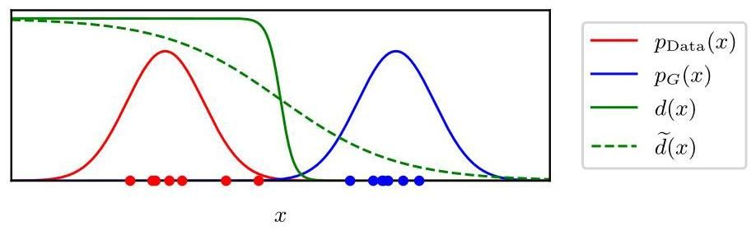

Figure 17.2 Conceptual illustration of why it can be difficult to train GANs, showing a simple one-dimensional data space with the fixed, but unknown, data distribution and the initial generative distribution . The optimal discriminator function has virtually zero gradient in the vicinity of either the training or synthetic data points, making learning very slow. A smoothed version of the discriminator function can lead to faster learning.

图 17.2 展示了训练生成对抗网络(GANs)为何困难的概念图，图中呈现了一个简单的一维数据空间 ，其中包含固定但未知的数据分布 和初始生成分布 。最优判别器函数 在训练数据点或合成数据点附近的梯度几乎为零，这使得学习过程非常缓慢。判别器函数的平滑版本 可以加快学习速度。

Insight into the difficulty of training GANs can be obtained by considering Figure 17.2, which shows a simple oneß-dimensional data space with samples drawn from the fixed, but unknown, data distribution . Also shown is the initial generative distribution together with samples drawn from this distribution. Because the data and generative distributions are so different, the optimal discriminator function is easy to learn and has a very steep fall-off with virtually zero gradient in the vicinity of either the real or synthetic samples. Consider the second term in the GAN error function (17.6). Because is equal to zero across the region spanned by the generated samples, small changes in the parameters of the generative network produce very little change in the output of the discriminator and so the gradients are small and learning proceeds slowly.

通过观察图 17.2 可以深入了解训练生成对抗网络(GANs)的难度，该图展示了一个简单的一维数据空间 ，其中的样本 来自固定但未知的数据分布 。图中还展示了初始生成分布 以及从该分布中抽取的样本。由于数据分布和生成分布差异很大，最优判别器函数 很容易学习，并且在真实样本或合成样本附近有非常陡峭的下降，梯度几乎为零。考虑生成对抗网络误差函数(17.6)中的第二项。因为在生成样本所跨越的区域内 等于零，生成网络参数 的微小变化对判别器的输出影响很小，所以梯度很小，学习过程进展缓慢。

This can be addressed by using a smoothed version of the discriminator function, illustrated in Figure 17.2, thereby providing a stronger gradient to drive the training of the generator network. The least-squares GAN (Mao et al., 2016) achieves smoothing by modifying the discriminator to produce a real-valued output rather than a probability in the range and by replacing the cross-entropy error function with a sum-of-squares error function. Alternatively, the technique of instance noise (Sønderby et al., 2016) adds Gaussian noise to both the real data and the synthetic samples, again leading to a smoother discriminator function.

可以通过使用判别器函数的平滑版本 来解决这个问题，如图 17.2 所示，从而为驱动生成器网络的训练提供更强的梯度。最小二乘生成对抗网络(Mao 等人，2016)通过修改判别器使其产生实值输出而非范围在 内的概率，并将交叉熵误差函数替换为平方和误差函数来实现平滑。另外，实例噪声技术(Sønderby 等人，2016)会向真实数据和合成样本中添加高斯噪声，同样会使判别器函数更加平滑。

Numerous other modifications to the GAN error function and training procedure have been proposed to improve training (Mescheder, Geiger, and Nowozin, 2018). One change that is often used is to replace the generative network term in the original error function

为了改进训练过程，人们已经提出了许多对生成对抗网络误差函数和训练过程的其他修改方法(Mescheder、Geiger 和 Nowozin，2018)。一种常用的修改方法是替换原始误差函数中的生成网络项

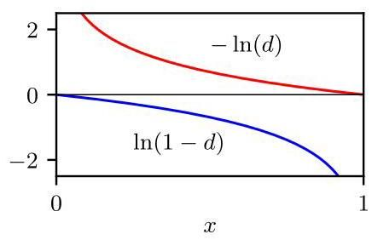

Figure 17.3 Plots of and showing the very different behaviour of the gradients close to and .

图 17.3 绘制了 和 ，展示了在 和 附近梯度的截然不同的行为。

with the modified form

使用修改后的形式

Although the first form minimizes the probability that the image is fake, the second version maximizes the probability that the image is real. The different properties of these two forms can be understood from Figure 17.3. When the generative distribution is very different from the true data distribution , the quantity is close to zero, and hence the first form has a very small gradient, whereas the second form has a large gradient, leading to faster training.

虽然第一种形式将图像为假的概率最小化，但第二种形式将图像为真的概率最大化。这两种形式的不同特性可以从图 17.3 中理解。当生成分布 与真实数据分布 差异很大时，量 接近零，因此第一种形式的梯度非常小，而第二种形式的梯度很大，从而使训练速度更快。

A more direct way to ensure that the generator distribution moves towards the data distribution is to modify the error criterion to reflect how far apart the two distributions are in data space. This can be measured using the Wasserstein distance, also known as the earth mover’s distance. Imagine the distribution as a pile of earth that is transported in small increments to construct the distribution . The Wasserstein metric is the total amount of earth moved multiplied by the mean distance moved. Of the many ways of rearranging the pile of earth to build , the one that yields the smallest mean distance is the one used to define the metric. In practice, this cannot be implemented directly, and it is approximated by using a discriminator network that has real-valued outputs and then limiting the gradient of the discriminator function with respect to by using weight clipping, giving rise to the Wasserstein GAN (Arjovsky, Chintala, and Bottou, 2017). An improved approach is to introduce a penalty on the gradient, giving rise to the gradient penalty Wasserstein GAN (Gulrajani et al., 2017) whose error function is given by

确保生成器分布 向数据分布 移动的一种更直接的方法是修改误差准则，以反映这两种分布在数据空间中的距离。这可以使用 Wasserstein 距离(也称为推土机距离)来衡量。将分布 想象成一堆土，通过小幅度的搬运来构建分布 。Wasserstein 度量是搬运的土的总量乘以平均搬运距离。在重新排列这堆土以构建 的众多方法中，产生最小平均距离的方法用于定义该度量。在实践中，这无法直接实现，而是通过使用具有实值输出的判别器网络来近似，然后通过权重裁剪来限制判别器函数关于 的梯度 ，从而产生了 Wasserstein 生成对抗网络(Arjovsky、Chintala 和 Bottou，2017)。一种改进的方法是对梯度引入惩罚项，从而产生了梯度惩罚 Wasserstein 生成对抗网络(Gulrajani 等人，2017)，其误差函数为

where controls the relative importance of the penalty term.

其中 控制惩罚项的相对重要性。

# 17.2. Image GANs

# 17.2. 图像生成对抗网络

The basic concept of the GAN has given rise to a huge research literature, with many algorithmic developments and numerous applications. One of the most widespread and successful application areas for GANs is the generation of images. Early GAN models used fully connected networks for the generator and discriminator. However, there are many benefits to using convolutional networks, especially for images of higher resolution. The discriminator network takes an image as input and provides a scalar probability as output, so a standard convolutional network is appropriate. The generator network needs to map a lower-dimensional latent space into a high-resolution image, and so a network based on transpose convolutions is used, as illustrated in Figure 17.4.

生成对抗网络的基本概念催生了大量的研究文献，有许多算法发展和众多应用。生成对抗网络最广泛且成功的应用领域之一是图像生成。早期的生成对抗网络模型对生成器和判别器使用全连接网络。然而，使用卷积网络有很多好处，特别是对于更高分辨率的图像。判别器网络将图像作为输入，并输出一个标量概率，因此标准的卷积网络是合适的。生成器网络需要将低维潜在空间映射到高分辨率图像，因此使用基于转置卷积的网络，如图 17.4 所示。

Chapter 10

第 10 章

Section 10.5.3

第10.5.3节

High quality images can be obtained by progressively growing both the generator network and the discriminator network starting from a low resolution and then successively adding new layers that model increasingly fine details as training progresses (Karras et al., 2017). This speeds up the training and permits the synthesis of high-resolution images of size starting from images of size . As an example of the scale and complexity of some GAN architectures, consider the GAN model for class-conditional image generation called BigGAN, whose architecture is shown in Figure 17.5.

通过从低分辨率开始逐步扩展生成器网络和判别器网络，然后随着训练的进行依次添加新的层来建模越来越精细的细节，可以获得高质量的图像(Karras 等人，2017)。这加快了训练速度，并允许从尺寸为 的图像开始合成尺寸为 的高分辨率图像。作为一些生成对抗网络(GAN)架构的规模和复杂性的一个例子，考虑用于类别条件图像生成的 GAN 模型，称为 BigGAN，其架构如图 17.5 所示。

# 17.2.1 CycleGAN

# 17.2.1 循环生成对抗网络(CycleGAN)

As an example of the broad variety of GANs we consider an architecture called a CycleGAN (Zhu et al., 2017). This also illustrates how techniques in deep learning can be adapted to solve different kinds of problems beyond traditional tasks such as classification and density estimation. Consider the problem of turning a photograph into a Monet painting of the same scene, or vice versa. In Figure 17.6 we show examples of image pairs from a trained CycleGAN that has learned to perform such an image-to-image translation.

作为各种各样生成对抗网络(GAN)的一个例子，我们考虑一种称为循环生成对抗网络(CycleGAN)的架构(Zhu 等人，2017)。这也说明了深度学习技术如何能够适应解决传统任务(如分类和密度估计)之外的不同类型的问题。考虑将一张照片转换为同一场景的莫奈画作，或者反之的问题。在图 17.6 中，我们展示了来自一个经过训练的循环生成对抗网络(CycleGAN)的图像对示例，该网络已经学会执行这种图像到图像的转换。

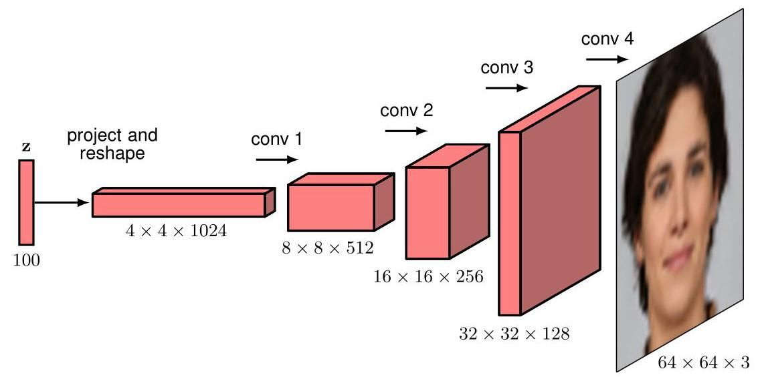

Figure 17.4 Example architecture of a deep convolutional GAN showing the use of transpose convolutions to expand the dimensionality in successive blocks of the network.

图 17.4 深度卷积生成对抗网络(GAN)的示例架构，展示了在网络的连续块中使用转置卷积来扩展维度。

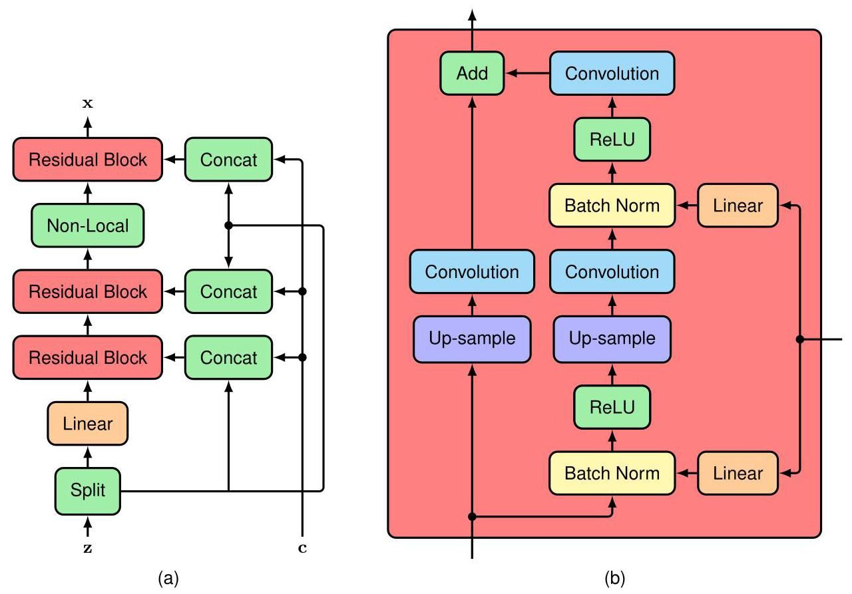

Figure 17.5 (a) Architecture of the generative network in the BigGAN model, which has over 70 million parameters. (b) Details of each of the residual blocks in the generative network. The discriminative network, which has 88 million parameters, has a somewhat analogous structure except that it uses average pooling layers to reduce the dimensionality, instead of using up-sampling to increase the dimensionality. [Based on Brock, Donahue, and Simonyan (2018).]

图 17.5 (a)BigGAN 模型中生成网络的架构，该网络有超过 7000 万个参数。(b)生成网络中每个残差块的细节。判别网络有 8800 万个参数，其结构有些类似，只是它使用平均池化层来降低维度，而不是使用上采样来增加维度。[基于 Brock、Donahue 和 Simonyan(2018)。]

The aim is to learn two bijective (one-to-one) mappings, one that goes from the domain of photographs to the domain of Monet paintings and one in the reverse direction. To achieve this, CycleGAN makes use of two conditional generators, and , and two discriminators, and . The generator takes as input a sample painting and generates a corresponding synthetic photograph, whereas the discriminator distinguishes between synthetic and real photographs. Similarly, the generator takes a photograph as input and generates a synthetic painting , and the discriminator distinguishes between synthetic paintings and real ones. The discriminator is therefore trained on a combination of synthetic photographs generated by and real photographs, whereas is trained on a combination of synthetic paintings generated by and real paintings.

目标是学习两个双射(一一对应)映射，一个是从照片域 到莫奈画作域 的映射，另一个是反向映射。为实现这一目标，CycleGAN 使用了两个条件生成器 和 ，以及两个判别器 和 。生成器 以一幅样本画作 作为输入，生成对应的合成照片，而判别器 用于区分合成照片和真实照片。类似地，生成器 以一张照片 作为输入，生成一幅合成画作 ，判别器 用于区分合成画作和真实画作。因此，判别器 在由 生成的合成照片和真实照片的组合上进行训练，而 在由 生成的合成画作和真实画作的组合上进行训练。

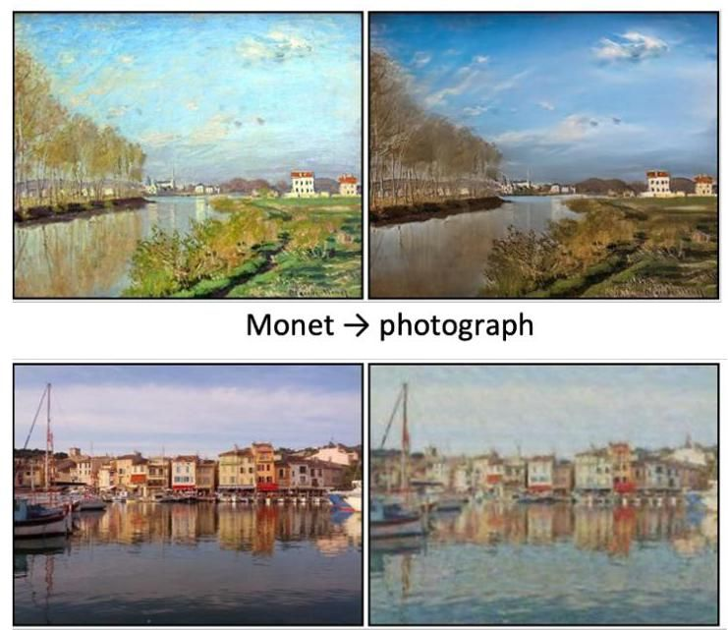

Figure 17.6 Examples of image translation using a CycleGAN showing the synthesis of a photographic-style image from a Monet painting (top row) and the synthesis of an image in the style of a Monet painting from a photograph (bottom row). [From Zhu et al. (2017) with permission.]

图 17.6 使用 CycleGAN 进行图像翻译的示例，展示了从莫奈画作合成摄影风格图像(上排)以及从照片合成莫奈画作风格图像(下排)。[经许可改编自 Zhu 等人(2017)。]

photograph Monet

照片 莫奈

If we train this architecture using the standard GAN loss function, it would learn to generate realistic synthetic Monet paintings and realistic synthetic photographs, but there would be nothing to force a generated painting to look anything like the corresponding photograph, or vice versa. We therefore introduce an additional term in the loss function called the cycle consistency error, containing two terms, whose construction is illustrated in Figure 17.7.

如果我们使用标准的生成对抗网络(GAN)损失函数来训练这个架构，它将学会生成逼真的合成莫奈画作和逼真的合成照片，但没有任何机制能迫使生成的画作与对应的照片相似，反之亦然。因此，我们在损失函数中引入一个额外的项，称为循环一致性误差，它包含两项，其构建过程如图 17.7 所示。

The goal is to ensure that when a photograph is translated into a painting and then back into a photograph it should be close to the original photograph, thereby ensuring that the generated painting retains sufficient information about the photograph to allow the photograph to be reconstructed. Similarly, when a painting is translated into a photograph and then back into a painting it should be close to the

目标是确保当一张照片被转换为一幅画作，然后再转换回照片时，它应该接近原始照片，从而确保生成的画作保留了足够的关于照片的信息，以便能够重建照片。类似地，当一幅画作被转换为一张照片，然后再转换回画作时，它应该接近原始画作。

Figure 17.7 Diagram showing how the cycle consistency error is calculated for an example photograph . The photograph is first mapped into the painting domain using the generator , and the resulting vector is then mapped back into the photograph domain using the generator . The discrepancy between the resulting photograph and the original defines a contribution to the cycle consistency error. An analogous process is used to calculate the contribution to the cycle consistency error from a painting by mapping it to a photograph using and then back to a painting using . original painting. Applying this to all the photographs and paintings in the training set then gives a cycle consistency error of the form

图 17.7 展示了如何为示例照片 计算循环一致性误差的示意图。首先使用生成器 将照片映射到画作域，然后使用生成器 将得到的向量映射回照片域。得到的照片与原始照片 之间的差异构成了循环一致性误差的一部分。通过使用 将一幅画作 映射到照片，然后使用 再映射回画作，采用类似的过程来计算该画作对循环一致性误差的贡献。将此应用于训练集中的所有照片和画作，就得到了如下形式的循环一致性误差。

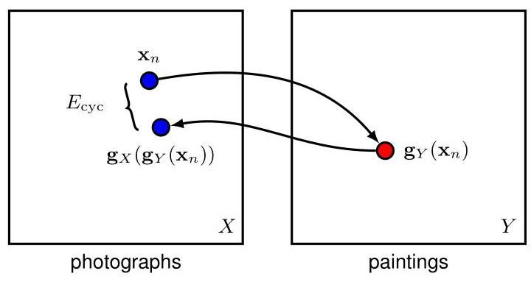

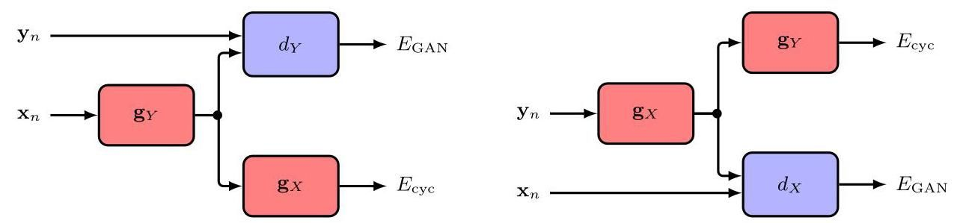

Figure 17.8 Flow of information through a CycleGAN. The total error for the data points and is the sum of the four component errors.

图 17.8 CycleGAN 的信息流。数据点 和 的总误差是四个分量误差之和。

where denotes the L1 norm. The cycle consistency error is added to the usual GAN loss functions defined by (17.6) to give a total error function:

其中 表示 L1 范数。将循环一致性误差添加到由 (17.6) 定义的常规 GAN 损失函数中，得到总误差函数:

where the coefficient determines the relative importance of the GAN errors and the cycle consistency error. Information flow through the CycleGAN when calculating the error function for one image and one painting is shown in Figure 17.8.

其中系数 决定了 GAN 误差和循环一致性误差的相对重要性。图 17.8 展示了在计算一张图像和一幅绘画的误差函数时，CycleGAN 的信息流。

We have seen that GANs can perform well as generative models, but they can also be used for representation learning in which rich statistical structure in a data set is revealed through unsupervised learning. When the deep convolutional GAN shown in Figure 17.4 is trained on a data set of bedroom images (Radford, Metz, and Chintala, 2015) and random samples from the latent space are propagated through the trained network, the generated images also look like bedrooms, as expected. In addition, however, the latent space has become organized in ways that are semantically meaningful. For example, if we follow a smooth trajectory through the latent space and generate the corresponding series of images, we obtain smooth transitions from one image to the next, as seen in Figure 17.9.

我们已经看到，生成对抗网络(GANs)作为生成模型可以表现出色，但它们也可用于表征学习，通过无监督学习揭示数据集中丰富的统计结构。当图 17.4 所示的深度卷积生成对抗网络在卧室图像数据集上进行训练(Radford、Metz 和 Chintala，2015)，并将来自潜在空间的随机样本通过训练好的网络进行传播时，生成的图像也如预期的那样看起来像卧室。然而，此外，潜在空间已经以语义上有意义的方式进行了组织。例如，如果我们沿着潜在空间中的一条平滑轨迹并生成相应的图像序列，我们会得到从一幅图像到下一幅图像的平滑过渡，如图 17.9 所示。

Section 6.3.3

第 6.3.3 节

Moreover, it is possible to identify directions in latent space that correspond to semantically meaningful transformations. For example, for faces, one direction might correspond to changes in the orientation of the face, whereas other directions might correspond to changes in lighting or the degree to which the face is smiling or not. These are called disentangled representations and allow new images to be synthesized having specified properties. Figure 17.10 is an example from a GAN trained on face images, showing that semantic attributes such as gender or the presence of glasses correspond to particular directions in latent space.

此外，有可能识别出潜在空间中对应于语义上有意义的变换的方向。例如，对于人脸，一个方向可能对应于人脸朝向的变化，而其他方向可能对应于光照的变化或人脸微笑程度的变化。这些被称为解纠缠表征，允许合成具有指定属性的新图像。图 17.10 是一个在人脸图像上训练的生成对抗网络的示例，表明诸如性别或是否戴眼镜等语义属性对应于潜在空间中的特定方向。

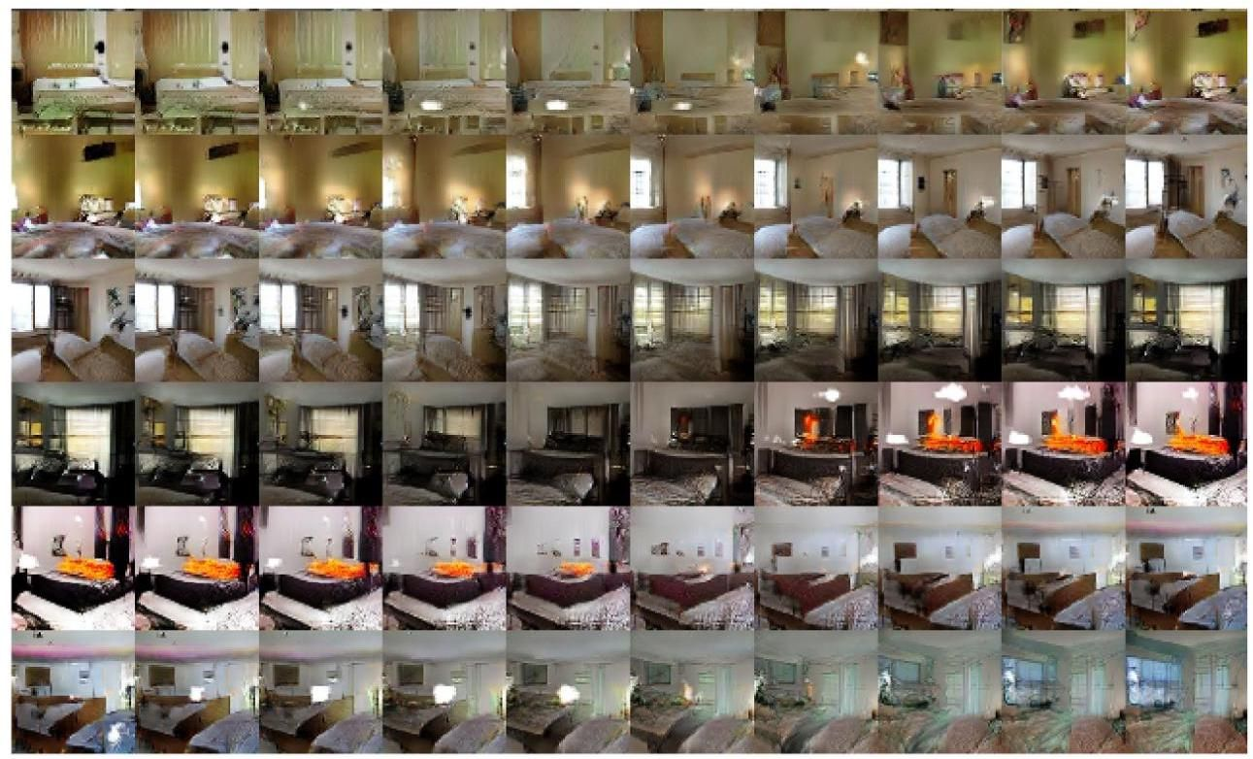

Figure 17.9 Samples generated by a deep convolutional GAN trained on images of bedrooms. Each row is generated by taking a smooth walk through latent space between randomly generated locations. We see smooth transitions, with each image plausibly looking like a bedroom. In the bottom row, for example, we see a TV on the wall gradually morph into a window. [From Radford, Metz, and Chintala (2015) with permission.]

图 17.9 由在卧室图像上训练的深度卷积生成对抗网络(GAN)生成的样本。每一行是通过在随机生成位置之间的潜在空间中进行平滑游走生成的。我们看到了平滑的过渡，每张图像看起来都像是一间卧室。例如，在最下面一行中，我们看到墙上的电视逐渐变成了一扇窗户。[经许可摘自 Radford、Metz 和 Chintala(2015)。]

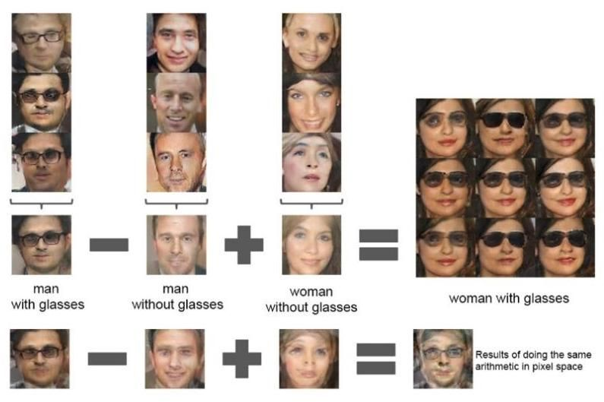

Figure 17.10 An example of vector arithmetic in the latent space of a trained GAN. In each of the three columns, the latent space vectors that generated these images are averaged and then vector arithmetic is applied to the resulting mean vectors to create a new vector corresponding to the central image in the array on the right. Adding noise to this vector generates another eight sample images. The four images on the bottom row show that the same arithmetic applied directly in data space simply results in a blurred image due to misalignment. [From Radford, Metz, and Chin-tala (2015) with permission.]

图 17.10 训练好的生成对抗网络(GAN)潜在空间中向量运算的一个示例。在三列中的每一列中，对生成这些图像的潜在空间向量进行平均，然后对得到的均值向量应用向量运算，以创建一个与右侧 数组中的中心图像相对应的新向量。向该向量添加噪声会生成另外八张样本图像。最下面一行的四张图像表明，直接在数据空间中应用相同的运算只会由于未对齐而导致图像模糊。[经许可摘自 Radford、Metz 和 Chintala(2015)。]

Exercises

练习

17.1 (***) We would like the GAN error function (17.6) to have the property that, given sufficiently flexible neural networks, the stationary point is obtained when the generator distribution matches the true data distribution. In this exercise we prove this result for network models with infinite flexibility by optimizing over the full space of probability distributions and over the full space of functions corresponding to the generative and discriminative networks, respectively. Specifically, we assume that the discriminative model is optimized in an inner loop, giving rise to an effective outer loop error function for the generative model. First, show that, in the limit of an infinite number of data samples, the GAN error function (17.6) can be rewritten in the form

17.1 (***) 我们希望生成对抗网络(GAN)的误差函数(17.6)具有这样的性质:在给定足够灵活的神经网络的情况下，当生成器分布与真实数据分布匹配时，可获得平稳点。在本练习中，我们通过分别在对应于生成网络和判别网络的概率分布 的全空间和函数 的全空间上进行优化，来证明对于具有无限灵活性的网络模型这一结果。具体来说，我们假设判别模型在内循环中进行优化，从而产生一个用于生成模型的有效外循环误差函数。首先，证明在数据样本数量趋于无穷大的极限情况下，生成对抗网络(GAN)的误差函数(17.6)可以重写为以下形式

where is the fixed distribution of real data points. Now consider a variational optimization over all functions . Show that, for a fixed generative network, the solution for the discriminator that minimizes is given by

其中 是真实数据点的固定分布。现在考虑对所有函数 进行变分优化。证明对于一个固定的生成网络，使 最小化的判别器 的解由下式给出

Appendix B

附录 B

Hence, show that the error function can be written as a function of the generator network in the form

因此，证明误差函数 可以写成生成器网络 的函数形式

Now show that this can be rewritten in the form

现在证明它可以重写为以下形式

where the Kullback-Leibler divergence is defined by (2.100). Finally, using the property that with equality if, and only if, for all , show that the minimum of occurs when . Note that the sum of the two Kullback-Leibler divergence terms in (17.17) is known as the Jensen-Shannon divergence between and . Like the Kullback-Leibler divergence, this is a non-negative quantity that vanishes if, and only if, the two distributions are equal, but unlike the KL divergence, it is symmetric with respect to the two distributions.

其中，Kullback - Leibler 散度 由式 (2.100) 定义。最后，利用性质 (当且仅当对于所有 都有 时等号成立)，证明当 时， 取得最小值。注意，式 (17.17) 中的两个 Kullback - Leibler 散度项之和被称为 和 之间的 Jensen - Shannon 散度。与 Kullback - Leibler 散度一样，这是一个非负量，当且仅当两个分布相等时其值为零，但与 KL 散度不同的是，它关于两个分布是对称的。

Section 2.5.5

第 2.5.5 节

17.2 In this exercise we explore the problems that can arise from the adversarial nature of GAN training. Consider a cost function defined over two parameters and , analogous to the parameters of a generative and discriminative network, respectively. Show that the point is a stationary point of the cost function. By considering the second derivatives along the lines and show that the point is a saddle point. Now suppose that we optimize this error function by taking infinitesimal steps, so that the variables become functions of continuous time defined by a continuous-time gradient descent, in which the parameter of the generative network is updated so as to increase , whereas the parameter is updated so as to decrease . Show that the evolution of the parameters is governed by the equations

17.2 在本练习中，我们探讨生成对抗网络(GAN)训练的对抗性质可能引发的问题。考虑一个定义在两个参数 和 上的代价函数 ，分别类似于生成网络和判别网络的参数。证明点 是代价函数的一个驻点。通过考虑沿直线 和 的二阶导数，证明点 是一个鞍点。现在假设我们通过采取无穷小的步骤来优化这个误差函数，使得变量成为由连续时间梯度下降定义的连续时间 的函数，其中生成网络的参数 被更新以增大 ，而参数 被更新以减小 。证明参数的演化由以下方程控制

Hence, show that satisfies the second-order differential equation

因此，证明 满足二阶微分方程

Verify that the following expression is a solution of (17.19):

验证以下表达式是 (17.19) 的一个解:

where and are arbitrary constants. If the system is initialized at with the values , find the values of and and hence show that the resulting values of and trace out a circle of unit radius in space centred on the origin, and that they therefore never converge to the saddle point.

其中 和 是任意常数。如果系统在 时刻以值 初始化，求出 和 的值，从而证明 和 的结果值在 空间中描绘出一个以原点为中心、半径为 1 的圆，并且因此它们永远不会收敛到鞍点。

17.3 (*) Consider a GAN in which the training set consists of equal numbers of cat and dog images and in which the generator network has learned to produce high quality images of dogs. Show that, when presented with a dog image, the optimal output for the discriminator network (trained to generate the probability that the image is real) is .

17.3 (*) 考虑一个生成对抗网络(GAN)，其中训练集包含数量相等的猫和狗的图像，并且生成器网络已经学会生成高质量的狗的图像。证明当向判别器网络(经过训练以生成图像为真实图像的概率)呈现一张狗的图像时，其最优输出是 。

Deep Learning

深度学习



# Chapter 17

# 第 17 章

We have seen how generative adversarial networks (GANs) extend the framework of linear latent-variable models by using deep neural networks to represent highly flexible and learnable nonlinear transformations from the latent space to the data space. However, the likelihood function is generally either intractable, because the network function cannot be inverted, or may not even be defined if the latent space has a lower dimensionality than the data space. In GANs, a second, discriminative network was therefore introduced to facilitate adversarial training.

我们已经了解了生成对抗网络(GANs)如何通过使用深度神经网络来表示从潜在空间到数据空间的高度灵活且可学习的非线性变换，从而扩展线性潜在变量模型的框架。然而，似然函数通常要么难以处理，因为网络函数无法求逆，要么如果潜在空间的维度低于数据空间的维度，甚至可能无法定义。因此，在生成对抗网络中引入了第二个判别网络，以促进对抗训练。

Section 16.4.4

第 16.4.4 节

Here we discuss the second of our four approaches to training nonlinear latent variable models that involves restricting the form of the neural network model such that the likelihood function can be evaluated without approximation while still ensuring that sampling from the trained model is straightforward. Suppose we define a distribution , sometimes also called a base distribution, over a latent variable along with a nonlinear function , given by a deep neural network, that transforms the latent space into the data space. Assuming is a simple distribution such as a Gaussian, sampling from such a model is easy as each latent sample is simply passed through the neural network to generate a corresponding data sample .

在这里，我们讨论训练非线性潜在变量模型的四种方法中的第二种，这种方法涉及限制神经网络模型的形式，使得似然函数可以精确计算，同时仍能确保从训练好的模型中采样很简单。假设我们定义一个关于潜在变量 的分布 (有时也称为基础分布)，以及一个由深度神经网络给出的非线性函数 ，该函数将潜在空间转换为数据空间。假设 是一个简单的分布，如高斯分布，那么从这样的模型中采样很容易，因为每个潜在样本 只需通过神经网络就能生成一个相应的数据样本 。

To calculate the likelihood function for this model, we need the data-space distribution, which depends on the inverse of the neural network function. We write this as , and it satisfies . This requires that, for every value of , the functions and are invertible, also called bijective, so that each value of corresponds to a unique value of and vice versa. We can then use the change of variables formula to calculate the data density:

为了计算该模型的似然函数，我们需要数据空间的分布，这取决于神经网络函数的逆函数。我们将其写为 ，并且它满足 。这要求对于 的每个值，函数 和 是可逆的，也称为双射，这样 的每个值都对应于 的唯一值，反之亦然。然后我们可以使用变量变换公式来计算数据密度:

Section 2.4

第 2.4 节

where is the Jacobian matrix of partial derivatives whose elements are given by

其中 是偏导数的雅可比矩阵，其元素由下式给出

and denotes the modulus or absolute value. We will continue to refer to as a ’latent’ variable even though the deterministic mapping means that any given data value corresponds to a unique value of whose value is therefore no longer uncertain.

并且 表示模或绝对值。即使确定性映射意味着任何给定的数据值 对应于 的唯一值，因此其值不再不确定，我们仍将 称为“潜在”变量。

The mapping function will be defined in terms of a special form of neural network, whose structure we will discuss shortly. One consequence of requiring an invertible mapping is that the dimensionality of the latent space must be the same as that of the data space, which can lead to large models for high-dimensional data such as images. Also, in general, the cost of evaluating the determinant of a matrix is , so we will seek to impose some further restrictions on the model in order that evaluation of the Jacobian matrix determinant is more efficient.

映射函数 将根据神经网络的一种特殊形式来定义，我们将很快讨论其结构。要求映射具有可逆性的一个结果是，潜在空间的维度必须与数据空间的维度相同，这可能会导致针对图像等高维数据的模型规模较大。此外，一般来说，计算 矩阵的行列式的代价为 ，因此我们将寻求对模型施加一些进一步的限制，以便更高效地计算雅可比矩阵的行列式。

If we consider a training set of independent data points, the log likelihood function is given from (18.1) by

如果我们考虑一个由独立数据点组成的训练集 ，则对数似然函数由式 (18.1) 给出:

and our goal is to use the likelihood function to train the neural network. To be able to model a wide range of distributions, we want the transformation function to be highly flexible, and so we use a deep neural network architecture. We can ensure that the overall function is invertible if we make each layer of the network invertible. To see this, consider three successive transformations, each corresponding to one layer, of the form:

我们的目标是使用似然函数来训练神经网络。为了能够对广泛的分布进行建模，我们希望变换函数 具有高度的灵活性，因此我们使用深度神经网络架构。如果我们使网络的每一层都具有可逆性，就可以确保整个函数是可逆的。为了说明这一点，考虑形式如下的三个连续变换，每个变换对应一层:

Exercise 18.2

练习 18.2

Then the inverse function is given by

那么逆函数由下式给出:

where , and are the inverse functions of , and , respectively. Moreover, the determinant of the Jacobian for such a layered structure is also easy to evaluate in terms of the Jacobian determinants for each of the individual layers by making use of the chain rule of calculus:

其中 和 分别是 和 的逆函数。此外，对于这样的分层结构，利用微积分的链式法则，根据每一层的雅可比行列式也很容易计算其雅可比行列式:

We recognize the right-hand side as the product of three matrices, and the determinant of a product is the product of the determinants. Therefore, the log determinant of the overall Jacobian will be the sum of the log determinants corresponding to each layer.

我们将右侧识别为三个矩阵的乘积，而乘积的行列式等于各行列式的乘积。因此，整体雅可比矩阵的对数行列式将是对应于每一层的对数行列式之和。

Appendix A

附录 A

This approach to modelling a flexible distribution is called a normalizing flow because the transformation of a probability distribution through a sequence of mappings is somewhat analogous to the flow of a fluid. Also, the effect of the inverse mapping is to transform the complex data distribution into a normalized form, typically a Gaussian or normal distribution. Normalizing flows have been reviewed by Kobyzev, Prince, and Brubaker (2019) and Papamakarios et al. (2019). Here we discuss the core concepts from the two main classes of normalizing flows used in practice: coupling flows and autoregressive flows. We also look at the use of neural differential equations to define invertible mappings, leading to continuous flows.

这种对灵活分布进行建模的方法被称为归一化流，因为概率分布通过一系列映射的变换有点类似于流体的流动。此外，逆映射的作用是将复杂的数据分布转换为归一化形式，通常是高斯分布或正态分布。Kobyzev、Prince 和 Brubaker(2019 年)以及 Papamakarios 等人(2019 年)对归一化流进行了综述。在这里，我们讨论实践中使用的两类主要归一化流的核心概念:耦合流和自回归流。我们还将探讨如何使用神经微分方程来定义可逆映射，从而得到连续流。

# 18.1. Coupling Flows

# 18.1. 耦合流

Our goal is to design a single invertible function layer, so that we can compose many of them together to define a highly flexible class of invertible functions. Consider first a linear transformation of the form

我们的目标是设计一个单一的可逆函数层，以便我们可以将多个这样的层组合在一起，定义出一类高度灵活的可逆函数。首先考虑以下形式的线性变换

This is easy to invert, giving

这很容易求逆，得到

However, linear transformations are closed under composition, meaning that a sequence of linear transformations is equivalent to a single overall linear transformation. Moreover, a linear transformation of a Gaussian distribution is again Gaussian. So even if we have many such ’layers’ of linear transformation, we will only ever have a Gaussian distribution. The question is whether we can retain the invertability of a linear transformation while allowing additional flexibility so that the resulting distribution can be non-Gaussian.

然而，线性变换在复合运算下是封闭的，这意味着一系列线性变换等同于一个单一的整体线性变换。此外，高斯分布的线性变换仍然是高斯分布。因此，即使我们有许多这样的线性变换“层”，我们最终得到的也只会是高斯分布。问题在于，我们能否在保持线性变换可逆性的同时，增加额外的灵活性，使得最终的分布可以是非高斯分布。

Exercise 3.6

练习 3.6

One solution to this problem is given by a form of normalizing flow model called real NVP (Dinh, Krueger, and Bengio, 2014; Dinh, Sohl-Dickstein, and Bengio, 2016), which is short for ’real-valued non-volume-preserving’. The idea is to partition the latent-variable vector into two parts , so that if has dimension and has dimension , then has dimension . We similarly partition the output vector where has dimension and has dimension . For the first part of the output vector, we simply copy the input:

这个问题的一个解决方案是一种名为实值非体积保持流(real NVP)的归一化流模型(Dinh、Krueger 和 Bengio，2014 年；Dinh、Sohl - Dickstein 和 Bengio，2016 年)，“real NVP”是“实值非体积保持”的缩写。其思路是将潜在变量向量 划分为两部分 ，这样，如果 的维度为 ， 的维度为 ，那么 的维度为 。我们类似地对输出向量 进行划分，其中 的维度为 ， 的维度为 。对于输出向量的第一部分，我们只需复制输入:

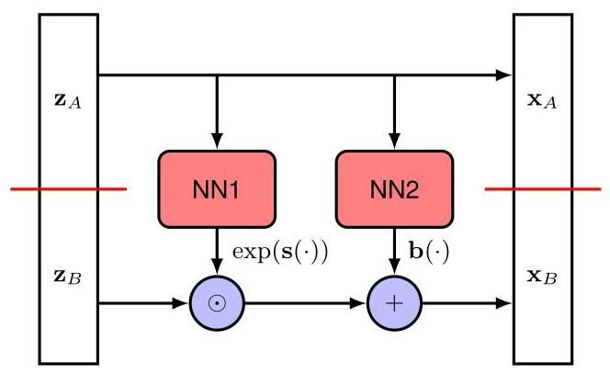

Figure 18.1 A single layer of the real NVP normalizing flow model. Here the network NN1 computes the function and the network NN2 computes the function . The output vector is then defined by (18.10) and (18.11).

图 18.1 实值非体积保持流(real NVP)归一化流模型的单层结构。这里，网络 NN1 计算函数 ，网络 NN2 计算函数 。然后，输出向量由式(18.10)和式(18.11)定义。

The second part of the vector undergoes a linear transformation, but now the coefficients in the linear transformation are given by nonlinear functions of :

向量的第二部分会经历线性变换，但现在线性变换中的系数由 的非线性函数给出:

where and are the real-valued outputs of neural networks, and the exponential ensures that the multiplicative term is non-negative. Here denotes the Hadamard product involving an element-wise multiplication of the two vectors. Similarly, the exponential in (18.11) is taken element-wise. Note that we have shown the same vector in both network functions. In practice, these may be implemented as separate networks with their own parameters, or as one network with two sets of outputs.

其中， 和 是神经网络的实值输出，指数运算确保乘法项为非负。这里， 表示两个向量的逐元素相乘(哈达玛积)。类似地，式(18.11)中的指数运算也是逐元素进行的。请注意，我们在两个网络函数中都展示了相同的向量 。在实践中，这些可以实现为具有各自参数的独立网络，或者实现为具有两组输出的一个网络。

Due to the use of neural network functions, the value of can be a very flexible function of . Nevertheless, the overall transformation is easily invertible: given a value for we first compute

由于使用了神经网络函数， 的值可以是 的非常灵活的函数。然而，整体变换很容易求逆:给定 的一个值，我们首先计算

then we evaluate and , and finally we compute using

然后我们计算 和 ，最后我们使用以下方法计算

The overall transformation is illustrated in Figure 18.1. Note that there is no requirement for the individual neural network functions and to be invertible.

整体变换如图 18.1 所示。请注意，并不要求单个神经网络函数 和 是可逆的。

Now consider the evaluation of the Jacobian defined by (18.2) and its determinant. We can divide the Jacobian matrix into blocks, corresponding to the partitioning of and , giving

现在考虑由式 (18.2) 定义的雅可比矩阵及其行列式的计算。我们可以将雅可比矩阵划分为若干块，对应于 和 的划分，得到

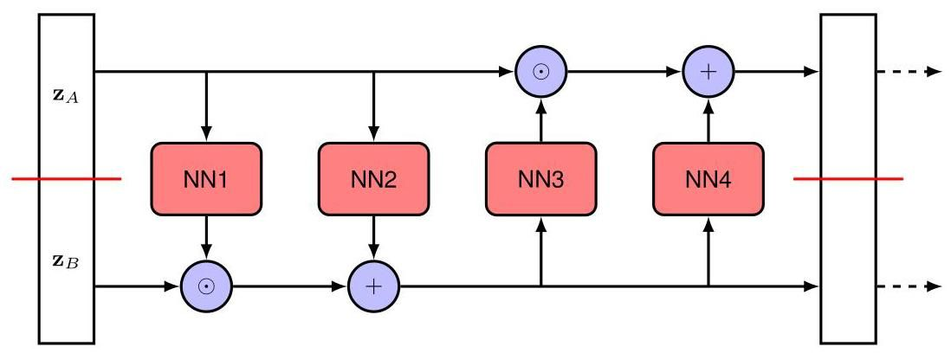

Figure 18.2 By composing two layers of the form shown in Figure 18.1, we obtain a more flexible, but still invertible, nonlinear layer. Each sub-layer is invertible and has an easily evaluated Jacobian, and hence the overall double layer has the same properties.

图 18.2 通过组合两层如图 18.1 所示形式的层，我们得到一个更灵活但仍然可逆的非线性层。每个子层都是可逆的，并且其雅可比矩阵很容易计算，因此整个双层也具有相同的性质。

The top left block corresponds to the derivatives of with respect to and hence from (18.12) is given by the identity matrix. The top right block corresponds to the derivatives of with respect to and these terms vanish, again from (18.12). The bottom left block corresponds to the derivatives of with respect to . From (18.13), these are complicated expressions involving the neural network functions. Finally, the bottom right block corresponds to the derivatives of with respect to , which from (18.13) are given by a diagonal matrix whose diagonal elements are given by the exponentials of the negative elements of . We therefore see that the Jacobian matrix (18.14) is a lower triangular matrix, meaning that all elements above the leading diagonal are zero. For such a matrix, the determinant is just the product of the elements along the leading diagonal, and therefore it does not depend on the complicated expressions in the lower left block. Consequently, the determinant of the Jacobian is simply given by the product of the elements of .

左上角的块对应于 关于 的导数，因此根据式 (18.12)，它由 单位矩阵给出。右上角的块对应于 关于 的导数，根据式 (18.12)，这些项为零。左下角的块对应于 关于 的导数。根据式 (18.13)，这些是涉及神经网络函数的复杂表达式。最后，右下角的块对应于 关于 的导数，根据式 (18.13)，它由一个对角矩阵给出，该对角矩阵的对角元素由 的负元素的指数给出。因此，我们看到雅可比矩阵 (18.14) 是一个下三角矩阵，这意味着主对角线以上的所有元素都为零。对于这样的矩阵，行列式只是主对角线上元素的乘积，因此它不依赖于左下角块中的复杂表达式。因此，雅可比矩阵的行列式简单地由 的元素的乘积给出。

Appendix A

附录 A

A clear limitation of this approach is that the value of is unchanged by the transformation. This is easily resolved by adding another layer in which the roles of and are reversed, as illustrated in Figure 18.2. This double-layer structure can then be repeated multiple times to facilitate a very flexible class of generative models.

这种方法的一个明显局限性是， 的值在变换后保持不变。通过添加另一层来轻松解决这个问题，在这一层中 和 的角色互换，如图 18.2 所示。然后可以多次重复这种双层结构，以构建一类非常灵活的生成模型。

The overall training procedure involves creating mini-batches of data points, in which the contribution of each data point to the log likelihood function is obtained from (18.4). For a latent distribution of the form , the log density is simply up to an additive constant. The inverse transformation is calculated using a sequence of inverse transformations of the form (18.13). Similarly, the log of the Jacobian determinant is given by a sum of log determinants for each layer where each term is itself a sum of terms of the form . Gradients of the log likelihood can be evaluated using automatic differentiation, and the network parameters updated by stochastic gradient descent.

整体训练过程包括创建数据点的小批量，其中每个数据点对对数似然函数的贡献可从式 (18.4) 获得。对于形式为 的潜在分布，对数密度在一个加法常数的意义下就是 。逆变换 使用形式为 (18.13) 的一系列逆变换来计算。类似地，雅可比行列式的对数由每一层的对数行列式之和给出，其中每一项本身又是形式为 的项之和。对数似然的梯度可以使用自动微分来计算，网络参数通过随机梯度下降进行更新。

The real NVP model belongs to a broad class of normalizing flows called coupling flows, in which the linear transformation (18.11) is replaced by a more general

实值非体积保持(real NVP)模型属于一类广泛的归一化流，称为耦合流，其中线性变换 (18.11) 被更一般的变换所取代

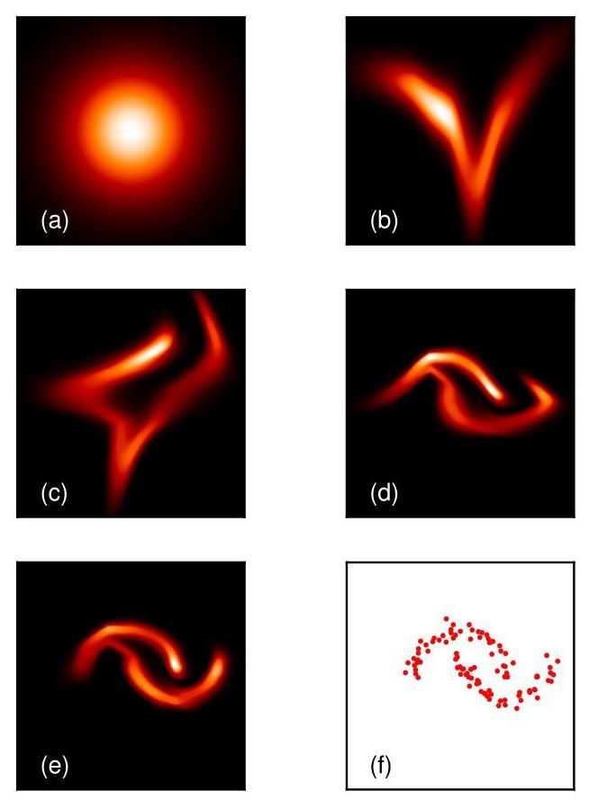

Figure 18.3 Illustration of the real NVP normalizing flow model applied to the two-moons data set showing (a) the Gaussian base distribution, (b) the distribution after a transformation of the vertical axis only, (c) the distribution after a subsequent transformation of the horizontal axis, (d) the distribution after a second transformation of the vertical axis, (e) the distribution after a second transformation of the horizontal axis, and (f) the data set on which the model was trained.

图 18.3 展示了应用于双月数据集的实值非体积保持(real NVP)归一化流模型，显示了 (a) 高斯基础分布，(b) 仅对垂直轴进行变换后的分布，(c) 随后对水平轴进行变换后的分布，(d) 对垂直轴进行第二次变换后的分布，(e) 对水平轴进行第二次变换后的分布，以及 (f) 模型所训练的数据集。

form:

形式:

where is a function of that is efficiently invertible for any given value of and is called the coupling function. The function is called a conditioner and is typically represented by a neural network.

其中 是 的函数，对于 的任何给定值，该函数都可以高效求逆，并且被称为耦合函数。函数 被称为调节器，通常由神经网络表示。

We can illustrate the real NVP normalizing flow using a simple data set, sometimes known as ’two moons’, as shown in Figure 18.3. Here a two-dimensional Gaussian distribution is transformed into a more complex distribution by using two successive layers each of which consists of alternate transformations on each of the two dimensions.

我们可以使用一个简单的数据集(有时称为“双月”数据集)来说明实值非体积保持(real NVP)归一化流，如图 18.3 所示。在这里，通过使用两个连续的层，将二维高斯分布转换为更复杂的分布，每个层由对两个维度中的每个维度进行交替变换组成。

# 18.2. Autoregressive Flows

# 18.2. 自回归流

A related formulation of normalizing flows can be motivated by noting that the joint distribution over a set of variables can always be written as the product of conditional distributions, one for each variable. We first choose an ordering of the variables in the vector , from which we can write, without loss of generality,

归一化流的一种相关公式可以通过以下观察得到启发:一组变量上的联合分布总是可以写成条件分布的乘积，每个变量对应一个条件分布。我们首先选择向量 中变量的一个顺序，由此我们可以不失一般性地写出

Section 11.1

第 11.1 节

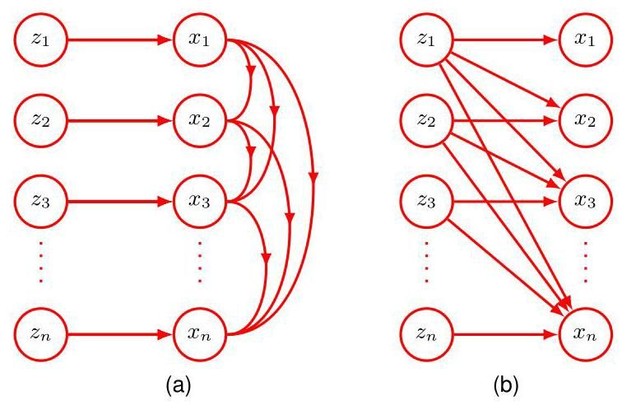

Figure 18.4 Illustration of two alternative structures for autoregressive normalizing flows. The masked autoregressive flow shown in (a) allows efficient evaluation of the likelihood function, whereas the alternative inverse autoregressive flow shown in (b) allows for efficient sampling.

图 18.4 自回归归一化流的两种替代结构的图示。(a) 中所示的掩码自回归流允许高效评估似然函数，而 (b) 中所示的替代逆自回归流允许高效采样。

where denotes . This factorization can be used to construct a class of normalizing flow called a masked autoregressive flow, or MAF (Papamakar-ios, Pavlakou, and Murray, 2017), given by

其中 表示 。这种因式分解可用于构建一类称为掩码自回归流(masked autoregressive flow，简称 MAF)的归一化流(Papamakar-ios、Pavlakou 和 Murray，2017)，其形式为

which is illustrated in Figure 18.4(a). Here is the coupling function, which is chosen to be easily invertible with respect to , and is the conditioner, which is typically represented by a deep neural network. The term masked refers to the use of a single neural network to implement a set of equations of the form (18.17) along with a binary mask (Germain et al., 2015) that force a subset of the network weights to be zero to implement the autoregressive constraint (18.16).

如图 18.4(a) 所示。这里 是耦合函数，选择它是为了使其相对于 易于求逆，而 是调节器，通常由深度神经网络表示。“掩码”一词指的是使用单个神经网络来实现一组形式为 (18.17) 的方程，同时使用一个二进制掩码(Germain 等人，2015)，该掩码强制网络权重的一个子集为零，以实现自回归约束 (18.16)。

In this case the reverse calculations needed to evaluate the likelihood function

在这种情况下，评估似然函数所需的反向计算

are given by

由下式给出

and hence can be performed efficiently on modern hardware since the individual functions in (18.18) needed to evaluate can be evaluated in parallel. The Jacobian matrix corresponding to the set of transformations (18.18) has elements , which form an upper-triangular matrix whose determinant is given by the product of the diagonal elements and can therefore also be evaluated efficiently. However, sampling from this model must be done by evaluating (18.17), which is intrinsically sequential and therefore slow because the values of must be evaluated before can be computed.

因此，由于评估 所需的 (18.18) 中的各个函数可以并行计算，所以可以在现代硬件上高效地执行这些计算。对应于变换集 (18.18) 的雅可比矩阵的元素为 ，它们构成一个上三角矩阵，其行列式由对角元素的乘积给出，因此也可以高效地计算。然而，从这个模型中采样必须通过评估 (18.17) 来完成，这本质上是顺序的，因此速度较慢，因为必须先计算 的值才能计算 。

Exercise 18.4

练习 18.4

To avoid this inefficient sampling, we can instead define an inverse autoregressive flows, or IAF (Kingma et al., 2016), given by

为避免这种低效采样，我们可以定义一个逆自回归流，即 IAF(Kingma 等人，2016)，其定义如下

as illustrated in Figure 18.4(b). Sampling is now efficient since, for a given choice of , the evaluation of the elements using (18.19) can be performed in parallel. However, the inverse function, which is needed to evaluate the likelihood, requires a series of calculations of the form

如图 18.4(b) 所示。现在采样变得高效了，因为对于给定的 选择，使用 (18.19) 式计算元素 可以并行进行。然而，评估似然所需的逆函数需要进行一系列形式如下的计算

which are intrinsically sequential and therefore slow. Whether a masked autoregressive flow or an inverse autoregressive flow is preferred will depend on the specific application.

这些计算本质上是顺序性的，因此速度较慢。选择掩码自回归流还是逆自回归流将取决于具体应用。

We see that coupling flows and autoregressive flows are closely related. Although autoregressive flows introduce considerable flexibility, this comes with a computational cost that grows linearly in the dimensionality of the data space due to the need for sequential ancestral sampling. Coupling flows can be viewed as a special case of autoregressive flows in which some of this generality is sacrificed for efficiency by dividing the variables into two groups instead of groups.

我们发现耦合流和自回归流密切相关。尽管自回归流引入了相当大的灵活性，但由于需要进行顺序祖先采样，这会带来计算成本，且该成本随数据空间的维度 线性增长。耦合流可以看作是自回归流的一种特殊情况，在这种情况下，通过将变量分为两组而非 组，牺牲了一些通用性以提高效率。

# 18.3. Continuous Flows

# 18.3. 连续流

The final approach to normalizing flows that we consider in this chapter will make use of deep neural networks defined in terms of an ordinary differential equation, or ODE. This can be thought of as a deep network with an infinite number of layers. We first introduce the concept of a neural ODE then we see how this can be applied to the formulation of a normalizing flow model.

本章我们要考虑的归一化流的最后一种方法将利用根据常微分方程(ODE)定义的深度神经网络。这可以被视为一个具有无限层的深度网络。我们首先介绍神经 ODE 的概念，然后看看如何将其应用于归一化流模型的构建。

# 18.3.1 Neural differential equations

# 18.3.1 神经微分方程

We have seen that neural networks are especially useful when they comprise many layers of processing, and so we can ask what happens if we explore the limit of an infinitely large number of layers. Consider a residual network where each layer of processing generates an output given by the input vector with the addition of some parameterized nonlinear function of that input vector:

我们已经看到，当神经网络包含多个处理层时，它们特别有用，因此我们可以探讨如果探索层数无限多的极限情况会发生什么。考虑一个残差网络，其中每个处理层根据输入向量生成输出，该输出是输入向量加上该输入向量的某个参数化非线性函数:

where labels the layers in the network. Note that we have used the same function at each layer, with a shared parameter vector , because this allows us to consider an arbitrarily large number of such layers while keeping the number of parameters bounded. Imagine that we increase the number of layers while ensuring that the changes introduced at each layer become correspondingly smaller. In the limit, the hidden-unit activation vector becomes a function of a continuous variable , and we can express the evolution of this vector through the network as a differential equation:

其中 标记网络中的层。请注意，我们在每一层都使用了相同的函数，具有共享的参数向量 ，因为这使我们能够在保持参数数量有限的情况下考虑任意多的此类层。想象一下，我们增加层数，同时确保每一层引入的变化相应变小。在极限情况下，隐藏单元激活向量成为连续变量 的函数 ，我们可以将该向量在网络中的演变表示为一个微分方程:

Exercise 18.5

练习 18.5

where is often referred to as ’time’. The formulation in (18.22) is known as a neural ordinary differential equation or neural ODE (Chen et al., 2018). Here ’ordinary’ means that there is a single variable . If we denote the input to the network by the vector , then the output is obtained by integration of the differential equation

其中 通常被称为“时间”。式 (18.22) 的表述被称为神经常微分方程或神经 ODE(Chen 等人，2018 年)。这里的“常”意味着只有一个变量 。如果我们用向量 表示网络的输入，那么输出 是通过对微分方程进行积分得到的

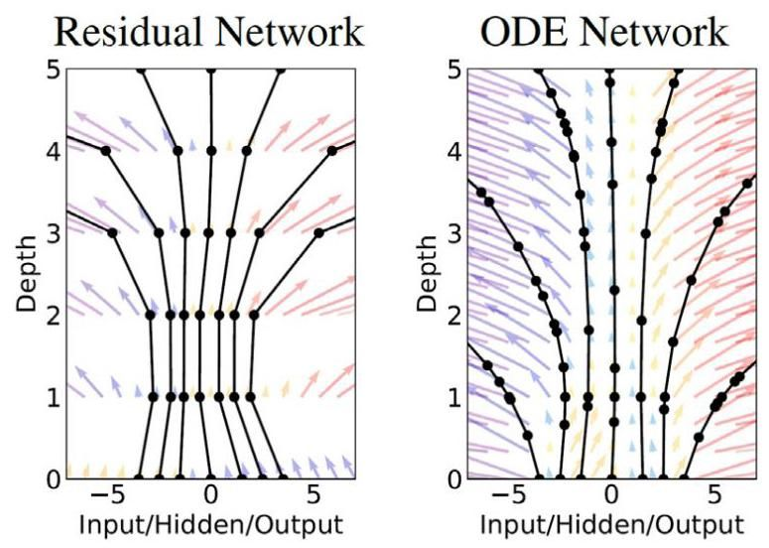

Figure 18.5 Comparison of a conventional layered network with a neural differential equation. The diagram on the left corresponds to a residual network with five layers and shows trajectories for several starting values of a single scalar input. The diagram on the right shows the result of numerical integration of a continuous neural ODE, again for several starting values of the scalar input, in which we see that the function is not evaluated at uniformly-spaced time intervals, but instead the evaluation points are chosen adaptively by the numerical solver and depend on the choice of input value. [From Chen et al. (2018) with permission.]

图 18.5 传统分层网络与神经微分方程的比较。左侧的图对应一个五层的残差网络，并显示了单个标量输入的几个起始值的轨迹。右侧的图显示了连续神经 ODE 的数值积分结果，同样是针对标量输入的几个起始值，我们可以看到函数不是在等间隔的时间点上进行评估的，而是评估点由数值求解器自适应选择，并取决于输入值的选择。[经许可摘自 Chen 等人 (2018 年)。]

This integral can be evaluated using standard numerical integration packages. The simplest method for solving differential equations is Euler’s forward integration method, which corresponds to the expression (18.21). In practice, more powerful numerical integration algorithms can adapt their function evaluation to achieve. In particular, they can adaptively choose values of that typically are not uniformly spaced. The number of such evaluations replaces the concept of depth in a conventional layered network. A comparison of a standard layered neural network and a neural differential equation are shown in Figure 18.5.

这个积分可以使用标准的数值积分软件包来计算。求解微分方程最简单的方法是欧拉前向积分法，它对应于表达式 (18.21)。在实践中，更强大的数值积分算法可以调整其函数计算以实现特定目标。特别是，它们可以自适应地选择 的值，这些值通常不是等间距的。这种计算的次数取代了传统分层网络中深度的概念。标准分层神经网络和神经微分方程的比较如图 18.5 所示。

# 18.3.2 Neural ODE backpropagation

# 18.3.2 神经常微分方程的反向传播

We now need to address the challenge of how to train a neural ODE, that is how to determine the value of by optimizing a loss function. Let us assume that we are given a data set comprising values of the input vector along with an associated output target vector and a loss function that depends on the output vector . One approach would be to use automatic differentiation to differentiate through all of the operations performed by the ODE solver during the forward pass. Although this is straightforward to do, it is costly from a memory perspective and is not optimal in terms of controlling numerical error. Instead, Chen et al. (2018) treat the ODE solver as a black box and use a technique called the adjoint sensitivity method, which can be viewed as the continuous analogue of explicit backpropagation. Recall that backpropagation involves, for each data point, three successive phases: first a forward propagation to evaluate the activation vectors at each layer of the network, second the evaluation of the derivatives of the loss with respect to the activations at each layer starting at the output and propagating backwards through the network by exploiting the chain rule of calculus, and third the evaluation of the derivatives with respect to network parameters by forming products of activations from the forward pass and gradients from the backward pass. We will see that there are analogous steps when computing the gradients for a neural ODE.

现在我们需要解决如何训练神经常微分方程的挑战，即如何通过优化损失函数来确定 的值。假设我们有一个数据集，其中包含输入向量 的值以及相关的输出目标向量，还有一个依赖于输出向量 的损失函数 。一种方法是使用自动微分对常微分方程求解器在前向传播过程中执行的所有操作进行求导。虽然这样做很直接，但从内存角度来看成本很高，并且在控制数值误差方面不是最优的。相反，Chen 等人(2018 年)将常微分方程求解器视为一个黑箱，并使用一种称为伴随灵敏度方法的技术，该方法可以看作是显式反向传播的连续模拟。回想一下，对于每个数据点，反向传播包括三个连续的阶段:首先是前向传播，用于计算网络每一层的激活向量；其次是从输出层开始计算损失函数关于每一层激活的导数，并通过利用微积分的链式法则在网络中反向传播；第三是通过将前向传播的激活值与反向传播的梯度相乘来计算关于网络参数的导数。我们将看到，在计算神经常微分方程的梯度时也有类似的步骤。

Section 8.2

第 8.2 节

Chapter 8

第 8 章

To apply backpropagation to neural ODEs, we define a quantity called the ad-

为了将反向传播应用于神经常微分方程，我们定义一个称为……的量

joint given by

由……给出的联合

We see that corresponds to the usual derivative of the loss with respect to the output vector. The adjoint satisfies its own differential equation given by

我们看到 对应于损失关于输出向量的通常导数。伴随项满足其自身的微分方程，该方程由……给出

Exercise 18.6

练习 18.6

which is a continuous version of the chain rule of calculus. This can be solved by integrating backwards starting from , which again can be done using a black-box ODE solver. In principle, this requires that we have stored the trajectory computed during the forward phase, which could be problematic as the inverse solver might wish to evaluate at different values of compared to the forward solver. Instead we simply allow the backwards solver to recompute any required values of by integrating (18.22) alongside (18.25) starting with the output value .

这是微积分链式法则的连续版本。可以通过从 开始反向积分来求解，这同样可以使用黑箱常微分方程求解器来完成。原则上，这要求我们存储在前向阶段计算得到的轨迹 ，但这可能会有问题，因为反向求解器可能希望在与前向求解器不同的 值处评估 。相反，我们只需允许反向求解器通过从输出值 开始，与 (18.25) 一起对 (18.22) 进行积分来重新计算 的任何所需值。

The third step in the backpropagation method is to evaluate derivatives of the loss with respect to network parameters by forming appropriate products of activations and gradients. When a parameter value is shared across multiple connections in a network, the total derivative is formed from the sum of derivatives for each of the connections. For our neural ODE, in which the same parameter vector is shared throughout the network, this summation becomes an integration over , which takes

反向传播方法的第三步是通过形成激活和梯度的适当乘积来评估损失关于网络参数的导数。当一个参数值在网络中的多个连接之间共享时，总导数由每个连接的导数之和形成。对于我们的神经常微分方程，其中相同的参数向量 在整个网络中共享，这个求和就变成了对 的积分，这需要

Exercise 9.7

练习 9.7

Exercise 18.7

练习 18.7

the form

形式

The derivatives in (18.25) and in (18.26) can be evaluated efficiently using automatic differentiation. Note that the above results can equally be applied to a more general neural network function that has an explicit dependence on in addition to the implicit dependence through .

(18.25) 中的导数 和 (18.26) 中的 可以使用自动微分高效地计算。请注意，上述结果同样可以应用于更一般的神经网络函数 ，该函数除了通过 隐式依赖外，还显式依赖于 。

Section 8.2

第 8.2 节

One benefit of neural ODEs trained using the adjoint method, compared to conventional layered networks, is that there is no need to store the intermediate results of the forward propagation, and hence the memory cost is constant. Furthermore, neural ODEs can naturally handle continuous-time data in which observations occur at arbitrary times. If the error function depends on values of other than the output value, then multiple runs of the reverse-model solver are required, with one run for each consecutive pair of outputs, so that the single solution is broken down into multiple consecutive solutions in order to access the intermediate states (Chen et al., 2018). Note that a high level of accuracy in the solver can be used during training, with a lower accuracy, and hence fewer function evaluations, during inference in applications for which compute resources are limited.

与传统的分层网络相比，使用伴随方法训练的神经常微分方程(neural ODEs)的一个优点是，无需存储前向传播的中间结果，因此内存成本是恒定的。此外，神经常微分方程可以自然地处理连续时间数据，其中观测值在任意时间出现。如果误差函数 依赖于 的值而非输出值，则需要多次运行反向模型求解器，每次运行针对连续的一对输出，以便将单个解分解为多个连续解，从而访问中间状态(Chen 等人，2018)。请注意，在训练期间可以使用求解器的高精度，而在计算资源有限的应用推理期间使用较低的精度，从而减少函数评估次数。

# 18.3.3 Neural ODE flows

# 18.3.3 神经常微分方程流

We can make use of a neural ordinary differential equation to define an alternative approach to the construction of tractable normalizing flow models. A neural ODE defines a highly flexible transformation from an input vector to an output vector in terms of a differential equation of the form

我们可以利用神经常微分方程来定义一种构建易处理的归一化流模型的替代方法。神经常微分方程通过形如的微分方程，定义了从输入向量 到输出向量 的高度灵活的变换

If we define a base distribution over the input vector then the neural ODE propagates this forward through time to give a distribution for each value of , leading to a distribution over the output vector . Chen et al. (2018) showed that for neural ODEs, the transformation of the density can be evaluated by integrating a differential equation given by

如果我们在输入向量 上定义一个基础分布，那么神经常微分方程会随时间将其向前传播，从而为 的每个值给出一个分布 ，进而得到输出向量 上的一个分布。Chen 等人(2018 年)表明，对于神经常微分方程，密度的变换可以通过对给定的微分方程进行积分来评估

Exercise 18.8

练习 18.8

where represents the Jacobian matrix with elements . This integration can be performed using standard ODE solvers. Likewise, samples from this density can be obtained by sampling from the base density , which is chosen to be a simple distribution such as a Gaussian, and propagating the values to the output by integrating (18.27) again using the ODE solver. The resulting framework is known as a continuous normalizing flow and is illustrated in Figure 18.6. Continuous normalizing flows can be trained using the adjoint sensitivity method used for neural ODEs, which can be viewed as the continuous time equivalent of backpropagation.

其中 表示元素为 的雅可比矩阵。这种积分可以使用标准的常微分方程求解器来进行。同样，这个密度的样本可以通过从基础密度 中采样得到，基础密度通常选择为简单的分布，如高斯分布，然后再次使用常微分方程求解器对 (18.27) 进行积分，将这些值传播到输出。由此产生的框架被称为连续归一化流，如图 18.6 所示。连续归一化流可以使用用于神经常微分方程的伴随灵敏度方法进行训练，该方法可以看作是反向传播在连续时间下的等价形式。

Exercise 18.9 Section 18.3.1

练习 18.9 第 18.3.1 节

Since (18.28) involves the trace of the Jacobian rather than the determinant, which arises in discrete normalizing flows, it might appear to be more computationally efficient. In general, evaluating the determinant of a matrix requires operations, whereas evaluating the trace requires operations. However, if the determinant is lower diagonal, as in many forms of normalizing flow, then the determinant is the product of the diagonal terms and therefore also involves operations. Since evaluating the individual elements of the Jacobian matrix requires a separate forward propagation, which itself requires operations, evaluating the trace or the determinant (for a lower triangular matrix) takes operations overall. However, the cost of evaluating the trace can be reduced to by using Hutchinson’s trace estimator (Grathwohl et al., 2018), which for a matrix

由于 (18.28) 涉及雅可比矩阵的迹而不是离散归一化流中出现的行列式，因此它似乎在计算上更高效。一般来说，计算一个 矩阵的行列式需要 次运算，而计算迹需要 次运算。然而，如果行列式是下三角的，就像许多形式的归一化流那样，那么行列式就是对角项的乘积，因此也需要 次运算。由于计算雅可比矩阵的各个元素需要单独的前向传播，而前向传播本身需要 次运算，因此总体而言，计算迹或行列式(对于下三角矩阵)需要 次运算。然而，通过使用 Hutchinson 迹估计器(Grathwohl 等人，2018 年)，计算迹的成本可以降低到 ，该估计器适用于矩阵

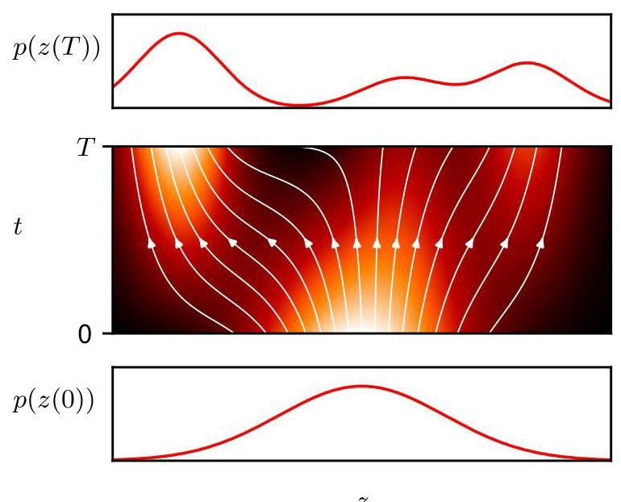

Figure 18.6 Illustration of a continuous normalizing flow showing a simple Gaussian distribution at that is continuously transformed into a multimodal distribution at . The flow lines show how points along the -axis evolve as a function of . Where the flow lines spread apart the density is reduced, and where they move together the density is increased.

图 18.6 连续归一化流的图示，展示了在 处的简单高斯分布如何连续变换为在 处的多峰分布。流线显示了 轴上的点如何随 变化。流线分散的地方密度降低，流线汇聚的地方密度增加。

A takes the form

A 采用以下形式

where is a random vector whose distribution has zero mean and unit covariance, for example, a Gaussian . For a specific , the matrix-vector product can be evaluated efficiently in a single pass using reverse-mode automatic differentiation. We can then approximate the trace using a finite number of samples in the form

其中 是一个随机向量，其分布的均值为零且协方差为单位矩阵，例如，高斯分布 。对于特定的 ，可以使用反向模式自动微分在单次遍历中高效地计算矩阵 - 向量积 。然后，我们可以使用有限数量的样本以以下形式近似迹

In practice we can set and just use a single sample, which is refreshed for each new data point. Although this is a noisy estimate, this might not be too significant since it forms part of a noisy stochastic gradient descent procedure. Importantly it is unbiased, meaning that the expectation of the estimator is equal to the true value.

在实践中，我们可以设置 并仅使用单个样本，该样本会为每个新数据点进行更新。尽管这是一个有噪声的估计，但由于它是有噪声的随机梯度下降过程的一部分，所以可能不会太显著。重要的是，它是无偏的，这意味着估计器的期望等于真实值。

Exercise 18.11

练习 18.11

Significant improvements in training efficiency for continuous normalizing flows can be achieved using a technique called flow matching (Lipman et al., 2022). This brings normalizing flows closer to diffusion models and avoids the need for back-propagation through the integrator while significantly reducing memory requirements and enabling faster inference and more stable training.

使用一种称为流匹配的技术(Lipman 等人，2022)可以显著提高连续归一化流的训练效率。这使得归一化流更接近扩散模型，避免了通过积分器进行反向传播的需要，同时显著降低了内存需求，并实现了更快的推理和更稳定的训练。

Chapter 20

第 20 章

# Exercises

# 练习

18.1 Consider a transformation along with its inverse . By differentiating , show that

18.1 考虑一个变换 及其逆变换 。通过对 求导，证明

where is the identity matrix, and and are matrices with elements

其中 是单位矩阵， 和 是元素为……的矩阵

Using the result that the determinant of a product of matrices is the product of their determinants, show that

利用矩阵乘积的行列式等于它们行列式的乘积这一结果，证明

Hence, show that the formula (18.1) for the transformation of a density under a change of variables can be rewritten as

因此，证明变量变换下密度变换的公式 (18.1) 可以重写为

where is evaluated at .

其中 在 处求值。

18.2 ( ) Consider a sequence of invertible transformations of the form

18.2 ( ) 考虑形如以下的一系列可逆变换

Show that the inverse function is given by

证明其反函数由下式给出

18.3 ( ) Consider a linear change of variables of the form

18.3 ( ) 考虑形如以下的线性变量变换

Show that the Jacobian of this transformation is the identity matrix. Interpret this result by comparing the volume of a small region of -space with the volume of the corresponding region of -space.

证明此变换的雅可比矩阵是单位矩阵。通过比较 空间的一个小区域的体积与 空间中相应区域的体积来解释这一结果。

18.4 Show that the Jacobian of the autoregressive normalizing flow transformation given by (18.18) is a lower triangular matrix. The determinant of such a matrix is given by the product of the terms on the leading diagonal and is therefore easily evaluated.

18.4 证明由 (18.18) 给出的自回归归一化流变换的雅可比矩阵是一个下三角矩阵。这种矩阵的行列式由主对角线上的项的乘积给出，因此很容易计算。

18.5 (★) Consider the forward propagation equation for a residual network given by (18.21) in which we consider a small increment in the ’time’ variable :

18.5 (★) 考虑由式 (18.21) 给出的残差网络的前向传播方程，其中我们考虑 “时间” 变量 的一个小增量 :

Here the additive contribution from the neural network is scaled by . Note that (18.21) corresponds to the case . By taking the limit , derive the forward propagation differential equation given by (18.22).

这里，神经网络的加性贡献由 进行缩放。注意，式 (18.21) 对应于 的情况。通过取极限 ，推导出由式 (18.22) 给出的前向传播微分方程。

18.6 In this exercise and the next we provide an informal derivation of the backpropa-gation and gradient evaluation equations for a neural ODE. A more formal derivation of these results can be found in Chen et al. (2018). Write down the backpropagation equation corresponding to the forward equation (18.38). By taking the limit , derive the backward propagation equation (18.25), where is defined by (18.24).

18.6 在本题和下一题中，我们将对神经常微分方程的反向传播和梯度计算方程进行非形式化推导。这些结果的更形式化推导可参考 Chen 等人 (2018) 的研究。写出与前向方程 (18.38) 对应的反向传播方程。通过取极限 ，推导出反向传播方程 (18.25)，其中 由式 (18.24) 定义。

By making use of the result (8.10), write down an expression for the gradient of a loss function for a multilayered residual network defined by (18.38) in which all layers share the same parameter vector . By taking the limit , derive the equation (18.26) for the derivative of the loss function.

利用结果 (8.10)，写出由式 (18.38) 定义的多层残差网络的损失函数 的梯度表达式，其中所有层共享相同的参数向量 。通过取极限 ，推导出损失函数导数的方程 (18.26)。

18.8 In this exercise we give an informal derivation of (18.28) for one-dimensional distributions. Consider a distribution at time that is transformed to a new distribution at time as a result of a transformation from to . Also consider nearby values and along with corresponding values and as shown in Figure 18.7. First, write down an equation that expresses that the probability mass in the interval is the same as that in the interval . Second, write down an equation that shows how the probability density changes in going from to , expressed in terms of the derivative . Third, write down an equation for in terms of by introducing the function . Finally, by combining these three equations and taking the limit , show that

18.8 在本题中，我们将对一维分布的式 (18.28) 进行非形式化推导。考虑在时间 的分布 ，由于从 到 的变换，它在时间 变换为新的分布 。同时考虑附近的值 和 以及对应的 和 ，如图 18.7 所示。首先，写出一个方程，表示区间 内的概率质量与区间 内的概率质量相同。其次，写出一个方程，表明从 到 概率密度是如何变化的，用导数 表示。第三，通过引入函数 ，写出用 表示 的方程。最后，将这三个方程结合起来并取极限 ，证明

which is the one-dimensional version of (18.28).

这就是式 (18.28) 的一维形式。

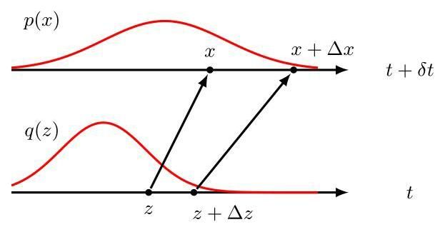

Figure 18.7 Schematic illustration of the transformation of probability densities used to derive the equation for continuous normalizing flows in one dimension.

图 18.7 用于推导一维连续归一化流方程的概率密度变换示意图。

The flow lines in Figure 18.6 were plotted by taking a set of equally spaced values and using the inverse of the cumulative distribution function at each value of to plot the corresponding points in z-space. Show that this is equivalent to using the differential equation (18.27) to compute the flow lines where is defined by (18.28).

通过选取一组等间距的值，并使用累积分布函数在 每个值处的反函数来绘制 z 空间中的对应点，从而绘制出图 18.6 中的流线。证明这等同于使用微分方程 (18.27) 来计算流线，其中 由 (18.28) 定义。

18.10 Using the differential equation (18.27) write down an expression for the base density of a continuous normalizing flow in terms of the output density, expressed as an integral over . Hence, by making use of the fact that changing the sign of a definite integral is equivalent to swapping the limits on that integral, show that the computational cost of inverting a continuous normalizing flow is the same as that needed to evaluate the forward flow.

18.10 使用微分方程 (18.27)，根据输出密度写出连续归一化流的基础密度的表达式，以对 的积分形式表示。因此，利用定积分变号等同于交换积分上下限这一事实，证明反转连续归一化流的计算成本与评估正向流所需的成本相同。

18.11 (★) Show that the expectation of the right-hand side in the Hutchinson trace estimator (18.30) is equal to for any value of . This shows that the estimator is unbiased.

18.11 (★) 证明对于 的任何值，Hutchinson 迹估计器 (18.30) 右侧的期望等于 。这表明该估计器是无偏的。

Deep Learning

深度学习



A central goal of deep learning is to discover representations of data that are useful for one or more subsequent applications. One well-established approach to learning internal representations is called the auto-associative neural network or autoen-coder. This consists of a neural network having the same number of output units as inputs and which is trained to generate an output that is close to the input . Once trained, an internal layer within the neural network gives a representation for each new input. Such a network can be viewed as having two parts. The first is an encoder, which maps the input into a hidden representation , and the second is a decoder, which maps the hidden representation onto the output .

深度学习的一个核心目标是发现对一个或多个后续应用有用的数据表示。一种成熟的学习内部表示的方法称为自联想神经网络或自编码器。它由一个输出单元数量与输入单元数量相同的神经网络组成，并且经过训练以生成接近输入 的输出 。一旦训练完成，神经网络内的一个内部层会为每个新输入提供一个表示 。这样的网络可以看作由两部分组成。第一部分是编码器，它将输入 映射到隐藏表示 ；第二部分是解码器，它将隐藏表示映射到输出 。

If an autoencoder is to find non-trivial solutions, it is necessary to introduce some form of constraint, otherwise the network can simply copy the input values to the outputs. This constraint might be achieved, for example, by restricting the dimensionality of relative to that of or by requiring to have a sparse representation. Alternatively, the network can be forced to discover non-trivial solutions by modifying the training process such that the network has to learn to undo corruptions to the input vectors such as additive noise or missing values. These kinds of constraint encourage the network to discover interesting structure within the data to achieve good training performance.

如果自编码器要找到非平凡解，则有必要引入某种形式的约束，否则网络可以简单地将输入值复制到输出。例如，可以通过限制 相对于 的维度，或者要求 具有稀疏表示来实现这种约束。或者，可以通过修改训练过程来迫使网络发现非平凡解，使得网络必须学会消除输入向量的损坏，如加性噪声或缺失值。这类约束鼓励网络在数据中发现有趣的结构，以实现良好的训练性能。

In this chapter, we start with deterministic autoencoders and then later generalize to stochastic models that learn an encoder distribution together with a decoder distribution . These probabilistic models are known as variational autoencoders and represent the third of our four approaches to learning nonlinear latent variable models.

在本章中，我们从确定性自编码器开始，然后推广到随机模型，该模型学习一个编码器分布 和一个解码器分布 。这些概率模型被称为变分自编码器，是我们学习非线性潜变量模型的四种方法中的第三种。

Section 16.4.4

第 16.4.4 节

# 19.1. Deterministic Autoencoders

# 19.1. 确定性自编码器

We encountered a simple form of autoencoder when we studied principal compo-

我们在研究主成分分析(PCA)时遇到了一种简单形式的自编码器。

Section 16.1 nent analysis (PCA). This is a model that makes a linear transformation of an input vector onto a lower dimensional manifold, and the resulting projection can be approximately reconstructed back in the original data space, again through a linear transformation. We can make use of the nonlinearity of neural networks to define a form of nonlinear PCA in which the latent manifold is no longer a linear subspace of the data space. This is achieved by using a network having the same number of outputs as inputs and by optimizing the weights so as to minimize some measure of the reconstruction error between inputs and outputs with respect to a set of training data.

第 16.1 节 这是一个将输入向量线性变换到低维流形上的模型，并且得到的投影可以再次通过线性变换近似地重构回原始数据空间。我们可以利用神经网络的非线性来定义一种非线性 PCA，其中潜流形不再是数据空间的线性子空间。这可以通过使用一个输出数量与输入数量相同的网络，并优化权重来实现，以便相对于一组训练数据最小化输入和输出之间的某种重构误差度量。

Simple autoencoders are rarely used directly in modern deep learning, as they do not provide semantically meaningful representations in the latent space and they are not able directly to generate new examples from the data distribution. However, they provide an important conceptual foundation for some of the more powerful deep generative models such as variational autoencoders.

在现代深度学习中，简单自编码器很少被直接使用，因为它们在潜在空间中无法提供具有语义意义的表示，并且不能直接从数据分布中生成新的样本。然而，它们为一些更强大的深度生成模型(如变分自编码器)提供了重要的概念基础。

Section 19.2

第 19.2 节

# 19.1.1 Linear autoencoders

# 19.1.1 线性自编码器

Consider first a multilayer perceptron of the form shown in Figure 19.1, having inputs, output units, and hidden units, with . The targets used to train the network are simply the input vectors themselves, so that the network attempts to map each input vector onto itself. Such a network is said to form an auto-associative mapping. Since the number of hidden units is smaller than the number of inputs, a perfect reconstruction of all input vectors is not in general possible. We therefore determine the network parameters by minimizing an error function that captures the degree of mismatch between the input vectors and their reconstructions. In particular, we choose a sum-of-squares error of the form

首先考虑一个如图 19.1 所示形式的多层感知机，它有 个输入、 个输出单元和 个隐藏单元，其中 。用于训练该网络的目标值就是输入向量本身，因此该网络试图将每个输入向量映射到其自身。这样的网络被称为形成自联想映射。由于隐藏单元的数量少于输入的数量，一般来说，不可能对所有输入向量进行完美重构。因此，我们通过最小化一个误差函数来确定网络参数 ，该误差函数反映了输入向量与其重构向量之间的不匹配程度。具体来说，我们选择如下形式的平方和误差

If the hidden units have linear activation functions, then it can be shown that the error function has a unique global minimum and that at this minimum the network performs a projection onto the -dimensional subspace that is spanned by the first principal components of the data (Bourlard and Kamp,1988; Baldi and Hornik, 1989). Thus, the vectors of weights that lead into the hidden units in Figure 19.1 form a basis set that spans the principal subspace. Note, however, that these vectors need not be orthogonal or normalized. This result is unsurprising, since both PCA and neural networks rely on linear dimensionality reduction and minimize the same sum-of-squares error function.

如果隐藏单元具有线性激活函数，那么可以证明误差函数有唯一的全局最小值，并且在这个最小值处，网络会将数据投影到由数据的前 个主成分所张成的 维子空间上(Bourlard 和 Kamp，1988 年；Baldi 和 Hornik，1989 年)。因此，图 19.1 中指向隐藏单元的权重向量构成了一个张成主成分子空间的基集。然而，需要注意的是，这些向量不必是正交的或归一化的。这一结果并不令人意外，因为主成分分析(PCA)和神经网络都依赖于线性降维，并且都最小化相同的平方和误差函数。

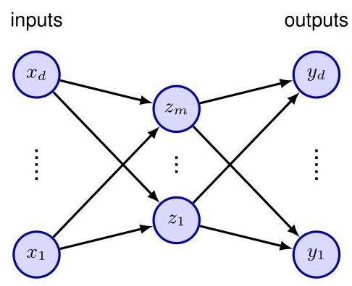

Figure 19.1 An autoencoder neural network having two layers of weights. Such a network is trained to map input vectors onto themselves by minimizing a sum-of-squares error. Even with nonlinear units in the hidden layer, such a network is equivalent to linear principal component analysis. Links representing bias parameters have been omitted for clarity.

图 19.1 一个具有两层权重的自编码器神经网络。通过最小化平方和误差，训练这样的网络将输入向量映射到其自身。即使隐藏层中使用了非线性单元，这样的网络也等同于线性主成分分析。为清晰起见，代表偏置参数的连接已被省略。

It might be thought that the limitations of a linear manifold could be overcome by using nonlinear activation functions for the hidden units in the network in Figure 19.1. However, even with nonlinear hidden units, the minimum error solution is again given by the projection onto the principal component subspace (Bourlard and Kamp, 1988). There is therefore no advantage in using two-layer neural networks to perform dimensionality reduction. Standard techniques for PCA, based on singular-value decomposition (SVD), are guaranteed to give the correct solution in finite time, and they also generate an ordered set of eigenvalues with corresponding orthonormal eigenvectors.

可能有人认为，通过为图 19.1 中网络的隐藏单元使用非线性激活函数，可以克服线性流形的局限性。然而，即使使用非线性隐藏单元，最小误差解仍然是通过投影到主成分子空间得到的(Bourlard 和 Kamp，1988)。因此，使用两层神经网络进行降维并没有优势。基于奇异值分解(SVD)的标准主成分分析(PCA)技术可以保证在有限时间内给出正确的解，并且它们还能生成一组有序的特征值以及对应的正交归一特征向量。

# 19.1.2 Deep autoencoders

# 19.1.2 深度自编码器

The situation is different, however, if additional nonlinear layers are included in the network. Consider the four-layer auto-associative network shown in Figure 19.2. Again, the output units are linear, and the units in the second layer can also be linear. However, the first and third layers have sigmoidal nonlinear activation functions. The network is again trained by minimizing the error function (19.1). We can view this network as two successive functional mappings and , as indicated in Figure 19.2. The first mapping projects the original -dimensional data onto an -dimensional subspace defined by the activations of the units in the second layer. Because of the first layer of nonlinear units, this mapping is very general and is not restricted to being linear. Similarly, the second half of the network defines an arbitrary functional mapping from the -dimensional hidden space back into the original -dimensional input space. This has a simple geometrical interpretation, as indicated for and in Figure 19.3.

然而，如果在网络中加入额外的非线性层，情况就不同了。考虑图 19.2 所示的四层自联想网络。同样，输出单元是线性的，第二层的 个单元也可以是线性的。然而，第一层和第三层具有 S 形非线性激活函数。该网络同样通过最小化误差函数(19.1)来进行训练。我们可以将这个网络看作是两个连续的函数映射 和 ，如图 19.2 所示。第一个映射 将原始的 维数据投影到由第二层单元的激活定义的 维子空间 上。由于第一层是非线性单元，这个映射非常通用，并不局限于线性映射。类似地，网络的后半部分定义了一个从 维隐藏空间到原始 维输入空间的任意函数映射。如图 19.3 中 和 所示，这具有简单的几何解释。

Such a network effectively performs a nonlinear form of PCA. It has the advantage of not being limited to linear transformations, although it contains standard

这样的网络有效地执行了一种非线性形式的主成分分析(PCA)。它的优点是不局限于线性变换，尽管它包含标准的

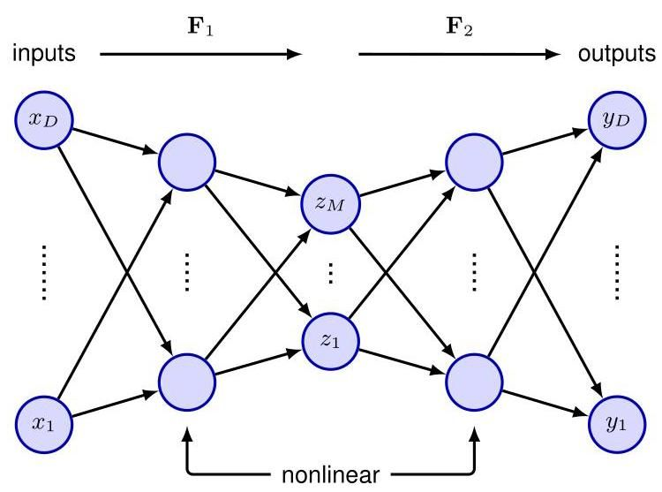

Figure 19.2 Adding extra hidden layers of nonlinear units produces an auto-associative network, which can perform a nonlinear dimensionality reduction.

图 19.2 添加额外的非线性单元隐藏层会产生一个自联想网络，该网络可以执行非线性降维。

PCA as a special case. However, training the network now involves a nonlinear optimization, since the error function (19.1) is no longer a quadratic function of the network parameters. Computationally intensive nonlinear optimization techniques must be used, and there is the risk of finding a sub-optimal local minimum of the error function. Also, the dimensionality of the subspace must be specified before training the network.

PCA 作为一种特殊情况。然而，现在训练网络涉及到非线性优化，因为误差函数(19.1)不再是网络参数的二次函数。必须使用计算密集的非线性优化技术，并且存在找到误差函数次优局部最小值的风险。此外，必须在训练网络之前指定子空间的维度。

# 19.1.3 Sparse autoencoders

# 19.1.3 稀疏自编码器

Instead of limiting the number of nodes in one of the hidden layers in the network, an alternative way to constrain the internal representation is to use a regularizer to encourage a sparse representation, leading to a lower effective dimensionality.

除了限制网络中某个隐藏层的节点数量之外，另一种约束内部表示的方法是使用正则化器来鼓励稀疏表示，从而降低有效维度。

Section 9.2.2 A simple choice is the regularizer since this encourages sparseness, giving a regularized error function of the form

第 9.2.2 节 一个简单的选择是 正则化器，因为它能鼓励稀疏性，得到如下形式的正则化误差函数

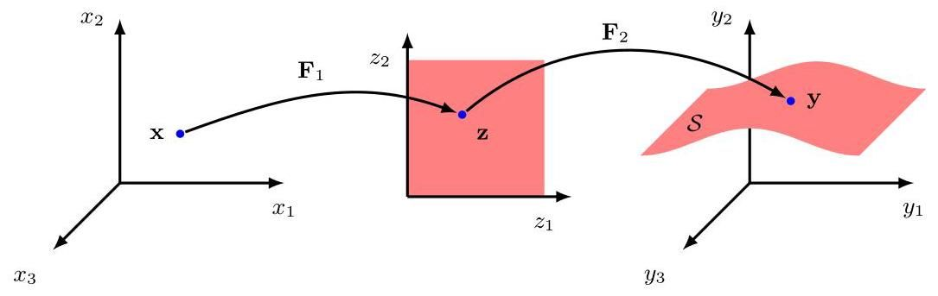

Figure 19.3 Geometrical interpretation of the mappings performed by the network in Figure 19.2 for a model with inputs and units in the second layer. The function from the latent space defines the way in which the manifold is embedded within the higher-dimensional data space. Since can be nonlinear, the embedding of can be non-planar, as indicated in the figure. The function then defines a projection from the original -dimensional data space into the -dimensional latent space.

图 19.3 对于一个具有 个输入和第二层有 个单元的模型，图 19.2 中网络执行的映射的几何解释。来自潜在空间的函数 定义了流形 嵌入到高维数据空间中的方式。由于 可以是非线性的， 的嵌入可以是非平面的，如图所示。然后函数 定义了从原始 维数据空间到 维潜在空间的投影。

where is the unregularized error, and the sum over is taken over the activation values of all the units in one of the hidden layers. Note that regularization is usually applied to the parameters of a network, whereas here it is being used on the unit activations. The derivatives required for gradient descent training can be evaluated using automatic differentiation, as usual.

其中 是未正则化的误差，对 的求和是对某个隐藏层中所有单元的激活值进行的。请注意，正则化通常应用于网络的参数，而这里它应用于单元激活值。像往常一样，可以使用自动微分来计算梯度下降训练所需的导数。

# 19.1.4 Denoising autoencoders

# 19.1.4 去噪自编码器

We have seen the importance of constraining the dimensionality of the latent space layer in a simple autoencoder to avoid the model simply learning the identity mapping. An alternative approach, that also forces the model to discover interesting internal structure in the data, is to use a denoising autoencoder (Vincent et al., 2008). The idea is to take each input vector and to corrupt it with noise to give a modified vector which is then input to an autoencoder to give an output . The network is trained to reconstruct the original noise-free input vector by minimizing an error function such as the sum-of squares given by

我们已经看到，在简单的自编码器中限制潜在空间层的维度以避免模型简单地学习恒等映射的重要性。另一种方法是使用去噪自编码器(Vincent 等人，2008 年)，这种方法同样能迫使模型发现数据中有趣的内部结构。其思路是取每个输入向量 并对其添加噪声进行损坏，得到一个修改后的向量 ，然后将其输入到自编码器中以得到输出 。通过最小化一个误差函数(如下面给出的平方和)来训练网络，以重建原始的无噪声输入向量

One form of noise involves setting a randomly chosen subset of the input variables to zero. The fraction of such inputs represents the noise level, and lies in the range . An alternative approach is to add independent zero-mean Gaussian noise to every input variable, where the scale of the noise is set by the variance of the Gaussian. By learning to denoise the input data, the network is forced to learn aspects of the structure of that data. For example, if the data comprises images, then learning that nearby pixel values are strongly correlated allows noise-corrupted pixels to be corrected.

一种噪声形式是将输入变量的一个随机选择的子集设置为零。此类输入的比例 表示噪声水平，其取值范围为 。另一种方法是向每个输入变量添加独立的零均值高斯噪声，其中噪声的规模由高斯分布的方差设定。通过学习对输入数据进行去噪，网络被迫学习该数据结构的各个方面。例如，如果数据包含图像，那么了解到相邻像素值具有强相关性就可以校正被噪声损坏的像素。

More formally, the training of denoising autoencoders is related to score matching (Vincent,2011) where the score is defined by . Some intuition for this relationship is given in Figure 19.4. The autoencoder learns to reverse the distortion vector and therefore learns a vector for each point in data space that points towards the manifold and therefore towards the region of high data density. The score vector is similarly a vector pointing towards the region of high data density. We will explore the relationship between score matching and de-noising in more depth when we discuss diffusion models which also learn to remove noise from noise-corrupted inputs.

更正式地说，去噪自编码器的训练与得分匹配(Vincent，2011 年)相关，其中得分由 定义。图 19.4 给出了对这种关系的一些直观理解。自编码器学习反转失真向量 ，因此为数据空间中的每个点学习一个指向流形、进而指向高数据密度区域的向量。得分向量 同样是一个指向高数据密度区域的向量。当我们讨论扩散模型时，我们将更深入地探讨得分匹配和去噪之间的关系，扩散模型也学习从被噪声损坏的输入中去除噪声。

Section 20.3

第 20.3 节

# 19.1.5 Masked autoencoders

# 19.1.5 掩码自编码器

We have seen that transformer models such as BERT can learn rich internal representations of natural languages through self-supervision by masking random

我们已经看到，像 BERT 这样的变压器模型可以通过随机掩码进行自监督学习，从而学习自然语言丰富的内部表示

Figure 19.4 In a denoising autoencoder, data

图 19.4 在去噪自编码器中，数据

Section 12.2

第 12.2 节

# Section 12.4.1

# 第 12.4.1 节

tokens to the encoder. The overall algorithm is summarized in Figure 19.5.

将标记传递给编码器。整体算法总结在图 19.5 中。

Compared to language, images have much more redundancy along with strong local correlations. Omitting a single word from a sentence can greatly increase ambiguity whereas removing a random patch from an image typically has little impact on the semantics of the image. Unsurprisingly, the best internal representations are learned when a relatively high proportion of the input image is masked, typically 75% compared with the 15% masking for BERT. In BERT the masked inputs are replaced by a fixed mask token, whereas in the masked autoencoder the masked patches are simply omitted. By omitting a large fraction of the input patches, we can save significant computation, particularly as the computation required for a training instance of a transformer scales poorly with input sequence length, thus making the masked autoencoder a good choice for pre-training large transformer encoders.

与语言相比，图像具有更多的冗余以及强局部相关性。从句子中省略一个单词会大大增加歧义，而从图像中随机移除一个小块通常对图像的语义影响很小。不出所料，当输入图像的相对较高比例被掩码时，能学习到最佳的内部表示，通常为 75%，而 BERT 的掩码比例为 15%。在 BERT 中，被掩码的输入由固定的掩码标记替换，而在掩码自编码器中，被掩码的小块直接被省略。通过省略大部分输入小块，我们可以节省大量计算，特别是因为变压器训练实例所需的计算量随输入序列长度的增加而扩展不佳，因此使掩码自编码器成为预训练大型变压器编码器的不错选择。

As the decoder layer is also a transformer, it needs to work in the dimensionality of the original image. Since the output of a transformer has the same dimensionality as the input, we need to restore the image dimensionality between the output of the encoder and the input of the decoder. This is achieved by reinstating the masked patches, represented by a fixed mask token vector, with each patch token augmented by positional encoding information. Due to the much higher dimensionality of the decoder representation, the decoder transformer has far fewer learnable parameters than the encoder. The output of the decoder is followed by a learnable linear layer that maps the output representation into the space of pixel values, and the training error function is simply the mean squared error averaged over the missing patches for each image. Examples of images reconstructed by a trained masked autoencoder are shown in Figure 19.6 and demonstrate the ability of a trained autoencoder to generate semantically plausible reconstructions. However, the ultimate goal is to learn useful internal representations for subsequent downstream tasks, for which the decoder is discarded and the encoder is applied to the full image with no masking and with a fresh set of output layers that are fine-tuned for the required application. Note also that although this algorithm was initially designed for image data, it can in theory be applied to any modality.

由于解码器层也是一个变压器，它需要在原始图像的维度上工作。由于变压器的输出与输入具有相同的维度，我们需要在编码器的输出和解码器的输入之间恢复图像维度。这是通过恢复被掩码的小块来实现的，这些小块由固定的掩码标记向量表示，每个小块标记都增加了位置编码信息。由于解码器表示的维度要高得多，解码器变压器的可学习参数比编码器少得多。解码器的输出后面是一个可学习的线性层，它将输出表示映射到像素值空间，训练误差函数只是每个图像中缺失小块的均方误差平均值。经过训练的掩码自编码器重建的图像示例如图 19.6 所示，展示了经过训练的自编码器生成语义合理重建的能力。然而，最终目标是为后续的下游任务学习有用的内部表示，为此要丢弃解码器，并将编码器应用于完整图像，不进行掩码，并使用一组新的输出层，这些输出层针对所需应用进行微调。还需注意，尽管该算法最初是为图像数据设计的，但理论上它可以应用于任何模态。

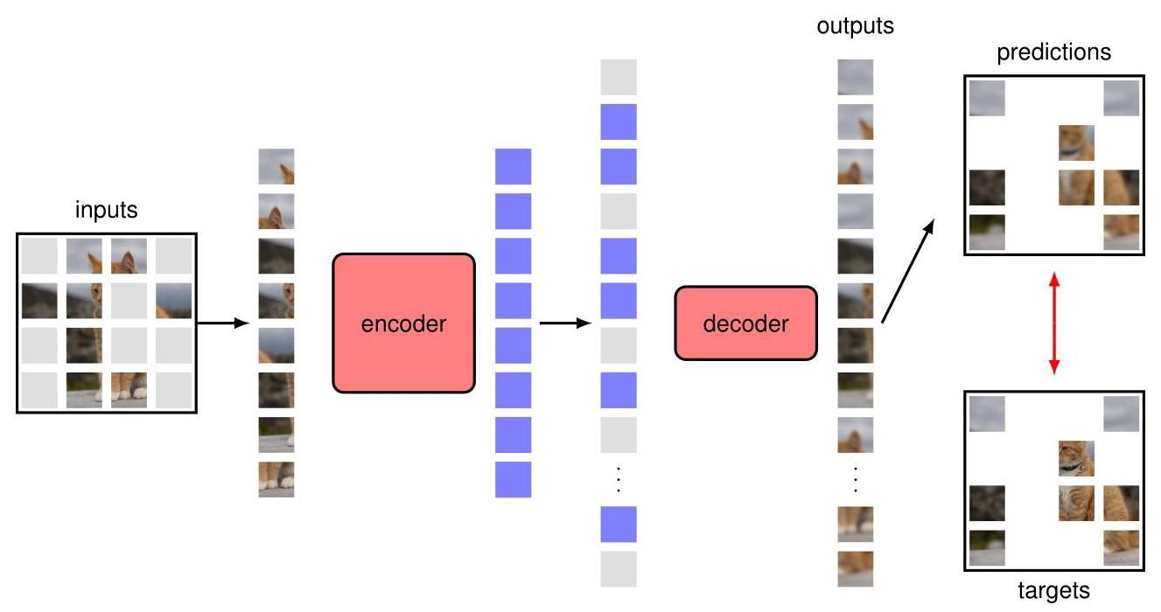

Figure 19.5 Architecture of a masked autoencoder during the training phase. Note that the target is the complement of the input as the loss is only applied on masked patches. After training, the decoder is discarded and the encoder is used to map images to an internal representation for use in downstream tasks.

图 19.5 训练阶段掩码自编码器的架构。请注意，目标是输入的补集，因为损失仅应用于掩码块。训练完成后，解码器被丢弃，编码器用于将图像映射到内部表示，以供下游任务使用。

# 19.2. Variational Autoencoders

# 19.2. 变分自编码器

We have already seen that the likelihood function for a latent-variable model given

我们已经看到，给定的潜在变量模型的似然函数

by

由

in which is defined by a deep neural network, is intractable because the integral over cannot be evaluated analytically. The variational autoencoder, or VAE (Kingma and Welling, 2013; Rezende, Mohamed, and Wierstra, 2014; Doer-sch, 2016; Kingma and Welling, 2019) instead works with an approximation to this likelihood when training the model. There are three key ideas in the VAE: (i) use of the evidence lower bound (ELBO) to approximate the likelihood function, leading to

其中 由深度神经网络定义，由于对 的积分无法进行解析计算，因此难以处理。变分自编码器(VAE)(Kingma 和 Welling，2013 年；Rezende、Mohamed 和 Wierstra，2014 年；Doersch，2016 年；Kingma 和 Welling，2019 年)在训练模型时使用对该似然的近似。VAE 中有三个关键思想:(i)使用证据下界(ELBO)来近似似然函数，从而导致

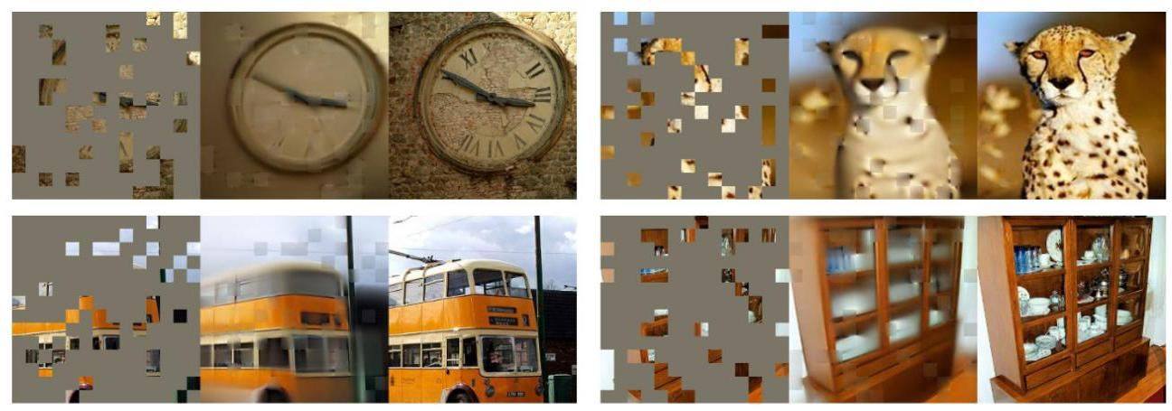

Figure 19.6 Four examples of images reconstructed using a trained masked autoencoder, in which 80% of the input patches are masked. In each case the masked image is on the left, the reconstructed image is in the centre, and the original image is on the right. [From He et al. (2021) with permission.]

图 19.6 使用训练好的掩码自编码器重建的图像的四个示例，其中 80% 的输入块被掩码。在每种情况下，掩码图像在左侧，重建图像在中间，原始图像在右侧。[经许可摘自 He 等人(2021 年)。]

# Section 15.3

# 第15.3节

a close relationship to the EM algorithm, (ii) amortized inference in which a second model, the encoder network, is used to approximate the posterior distributions over latent variables in the E step, rather than evaluating the posterior distribution for each data point exactly, and (iii) making the training of the encoder model tractable using the reparameterization trick.

与 EM 算法密切相关；(ii)摊销推理，其中使用第二个模型，即编码器网络，来近似 E 步中潜在变量的后验分布，而不是精确计算每个数据点的后验分布；(iii)使用重参数化技巧使编码器模型的训练变得可行。

Consider a generative model with a conditional distribution over the -dimensional data variable governed by the output of a deep neural network . For example, might represent the mean of a Gaussian conditional distribution. Also, consider a distribution over the -dimensional latent variable that is given by a zero-mean unit-variance Gaussian:

考虑一个生成模型，其在 维数据变量 上的条件分布为 ，该分布由深度神经网络 的输出控制。例如， 可能表示高斯条件分布的均值。此外，考虑在 维潜在变量 上的分布，该分布由零均值单位方差的高斯分布给出:

To derive the VAE approximation, first recall that, for an arbitrary probability distribution over a space described by the latent variable , the following relationship holds:

为了推导变分自编码器(VAE)近似，首先回顾一下，对于由潜在变量 描述的空间上的任意概率分布 ，以下关系成立:

Section 15.4

第15.4节

where is the evidence lower bound, or ELBO, also known as the variational lower bound, given by

其中 是证据下界，即 ELBO，也称为变分下界，由下式给出

and the Kullback-Leibler divergence is defined by

并且 Kullback-Leibler 散度 定义为

Because the Kullback-Leibler divergence satisfies , it follows that

由于 Kullback-Leibler 散度满足 ，因此可得

and so is a lower bound on . Although the log likelihood is intractable, we will see how the lower bound can be evaluated using a Monte Carlo estimate. Hence it provides an approximation to the true log likelihood.

因此 是 的一个下界。尽管对数似然 难以处理，但我们将看到如何使用蒙特卡罗估计来计算这个下界。因此，它提供了对真实对数似然的近似。

Now consider a set of training data points , which are assumed to be drawn independently from the model distribution . The log likelihood function for this data set is given by

现在考虑一组训练数据点 ，假设这些数据点是从模型分布 中独立抽取的。该数据集的对数似然函数为

where

其中

Note that this introduces a separate latent variable corresponding to each data vector , as we saw with mixture models and with the probabilistic PCA model. Consequently, each latent variable has its own independent distribution , each of which can be optimized separately.

注意，这引入了一个与每个数据向量 相对应的独立隐变量 ，就像我们在混合模型和概率主成分分析(PCA)模型中看到的那样。因此，每个隐变量都有其独立的分布 ，并且每个分布都可以单独进行优化。

Section 15.2

第 15.2 节

Section 16.2

第 16.2 节

Since (19.10) holds for any choice of the distributions , we can choose the distributions that maximize the bound , or equivalently the distributions that minimize the Kullback-Leibler divergences . For the simple Gaussian mixture and probabilistic PCA models considered previously, we were able to evaluate these posterior distributions exactly in the E step of the EM algorithm, which corresponds to setting each equal to the corresponding posterior distribution . This gives zero Kullback-Leibler divergence, and hence the lower bound is equal to the true log likelihood. The interpretation of the posterior distribution is illustrated in Figure 19.7 using the simple example introduced earlier in the context of generative adversarial networks.

由于 (19.10) 对于分布 的任何选择都成立，我们可以选择使边界 最大化的分布，或者等价地，选择使 Kullback-Leibler 散度 最小化的分布。对于之前考虑的简单高斯混合和概率主成分分析模型，我们能够在 EM 算法的 E 步中精确计算这些后验分布，这对应于将每个 设置为相应的后验分布 。这使得 Kullback-Leibler 散度为零，因此下界等于真实对数似然。后验分布的解释在图 19.7 中通过之前在生成对抗网络背景下引入的简单示例进行了说明。

Section 16.4.1

第 16.4.1 节

The exact posterior distribution of is given from Bayes’ theorem by

根据贝叶斯定理， 的精确后验分布由下式给出

The numerator is straightforward to evaluate for our deep generative model. However, we see that the denominator is given by the likelihood function, which as we have already noted, is intractable. We therefore need to find an approximation to the posterior distribution. In principle, we could consider a separate parameterized model for each of the distributions and optimize each model numerically, but this would be computationally very expensive, especially for large data sets, and moreover we would have to re-evaluate the distributions after every update of . Instead, we turn now to a different, more efficient approximation framework based on the introduction of a second neural network.

对于我们的深度生成模型，分子很容易计算。然而，我们看到分母由似然函数给出，正如我们已经指出的，这是难以处理的。因此，我们需要找到后验分布的近似值。原则上，我们可以为每个分布 考虑一个单独的参数化模型，并对每个模型进行数值优化，但这在计算上会非常昂贵，特别是对于大型数据集，而且我们在每次更新 后都必须重新评估这些分布。相反，我们现在转向一个不同的、更有效的近似框架，该框架基于引入第二个神经网络。

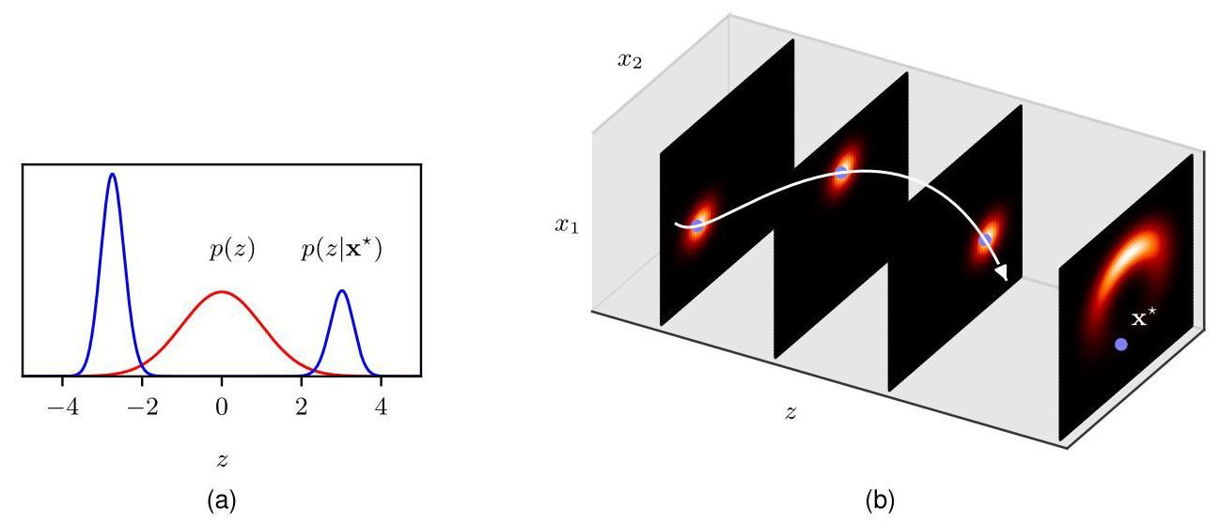

Figure 19.7 Evaluation of the posterior distribution for the same model as shown in Figure 16.13. The marginal distribution , shown in the right-most plot in (b), has a banana shape, and the specific data point is closer to the horns of the shape than to the middle. Consequently the posterior distribution , shown in (a), is bimodal, even though the prior distribution is unimodal. [Based on Prince (2020) with permission.]

图 19.7 对与图 16.13 所示相同模型的后验分布进行评估。边缘分布 (如 (b) 中最右侧的图所示)呈香蕉形状，并且特定数据点 距离该形状的“角”比距离中间更近。因此，(a) 中所示的后验分布 是双峰的，尽管先验分布 是单峰的。[经许可改编自 Prince (2020)。]

# 19.2.1 Amortized inference

# 19.2.1 摊销推理

In the variational autoencoder, instead of trying to evaluate a separate posterior distribution for each of the data points individually, we train a single neural network, called the encoder network, to approximate all these distributions. This technique is called amortized inference and requires an encoder that produces a single distribution that is conditioned on , where represents the parameters of the network. The objective function, given by the evidence lower bound, now has a dependence on as well as on , and we use gradient-based optimization methods to maximize the bound jointly with respect to both sets of parameters.

在变分自编码器中，我们不是尝试为每个数据点 分别评估一个单独的后验分布 ，而是训练一个称为编码器网络的单一神经网络来近似所有这些分布。这种技术称为摊销推理，它需要一个编码器来生成一个以 为条件的单一分布 ，其中 表示网络的参数。由证据下界给出的目标函数现在既依赖于 也依赖于 ，并且我们使用基于梯度的优化方法来联合最大化关于这两组参数的下界。

A VAE therefore comprises two neural networks that have independent parameters but which are trained jointly: an encoder network that takes a data vector and maps it to a latent space, and the original network that takes a latent space vector and maps it back to the data space and which we can therefore interpret as a decoder network. This like the simple neural network autoencoder model, except that we now define a probability distribution over the latent space. We will see that the encoder calculates an approximate probabilistic inverse of the decoder according to Bayes’ theorem.

因此，变分自编码器由两个具有独立参数但联合训练的神经网络组成:一个编码器网络，它接收一个数据向量并将其映射到一个潜在空间；以及原始网络，它接收一个潜在空间向量并将其映射回数据空间，因此我们可以将其解释为解码器网络。这与简单的神经网络自编码器模型类似，只是我们现在在潜在空间上定义了一个概率分布。我们将看到，根据贝叶斯定理，编码器计算解码器的近似概率逆。

Section 19.1

第 19.1 节

A typical choice for the encoder is a Gaussian distribution with a diagonal covariance matrix whose mean and variance parameters, and , are given by the outputs of a neural network that takes as input:

编码器的一个典型选择是具有对角协方差矩阵的高斯分布，其均值和方差参数 和 由以 为输入的神经网络的输出给出:

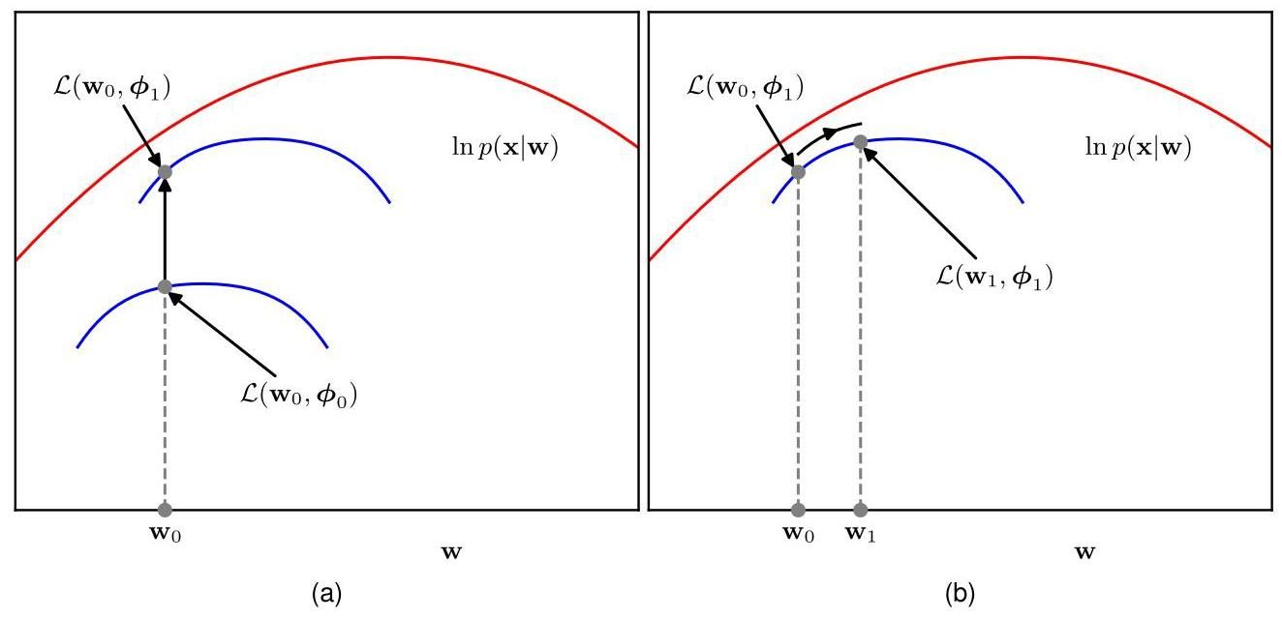

Figure 19.8 Illustration of the optimization of the ELBO (evidence lower bound). (a) For a given value of the decoder network parameters , we can increase the bound by optimizing the parameters of the encoder network. (b) For a given value of , we can increase the value of the ELBO function by optimizing . Note that the ELBO function, shown by the blue curves, always lies somewhat below the log likelihood function, shown in red, because the encoder network is generally not able to match the true posterior distribution exactly.

图 19.8 证据下界(ELBO)优化的图示。(a) 对于解码器网络参数 的给定值 ，我们可以通过优化编码器网络的参数 来提高下界。(b) 对于 的给定值，我们可以通过优化 来提高 ELBO 函数的值。请注意，由蓝色曲线表示的 ELBO 函数总是略低于由红色曲线表示的对数似然函数，因为编码器网络通常无法精确匹配真实的后验分布。

Note that the means lie in the range , and so the corresponding output-unit activation functions can be linear, whereas the variances must be non-negative and so the associated output units typically use as their activation function.

请注意，均值 位于区间 内，因此相应的输出单元激活函数可以是线性的，而方差 必须是非负的，因此相关的输出单元通常使用 作为其激活函数。

The goal is to use gradient-based optimization to maximize the bound with respect to both sets of parameters and , typically by using stochastic gradient descent based on mini-batches. Although we optimize the parameters jointly, conceptually we could imagine alternating between optimizing and optimizing , in the spirit of the EM algorithm, as illustrated in Figure 19.8.

目标是使用基于梯度的优化方法，通常是基于小批量的随机梯度下降，来针对两组参数 和 最大化下界。尽管我们是联合优化这些参数，但从概念上讲，我们可以想象像图 19.8 所示的那样，按照 EM 算法的思路，在优化 和优化 之间交替进行。

A key difference compared to EM is that, for a given value of , optimizing with respect to the parameters of the encoder does not in general reduce the Kullback-Leibler divergence to zero, because the encoder network is not a perfect predictor of the posterior latent distribution and so there is a residual gap between the lower bound and the true log likelihood. Although the encoder is very flexible, since it is based on a deep neural network, it is not expected to model the true posterior distribution exactly because (i) the true conditional posterior distribution will not be a factorized Gaussian, (ii) even a large neural network has limited flexibility, and (iii) the training process is only an approximate optimization. The relation between the EM algorithm and ELBO optimization is summarized in Figure 19.9.

与 EM 算法相比的一个关键区别在于，对于 的给定值，针对编码器的参数 进行优化通常不会将 Kullback-Leibler 散度降为零，因为编码器网络不是后验潜在分布的完美预测器，因此下界和真实对数似然之间存在残余差距。尽管编码器非常灵活，因为它基于深度神经网络，但预计它无法精确建模真实的后验分布，原因如下:(i) 真实的条件后验分布不会是因式分解的高斯分布；(ii) 即使是大型神经网络的灵活性也是有限的；(iii) 训练过程只是一种近似优化。EM 算法和 ELBO 优化之间的关系总结在图 19.9 中。

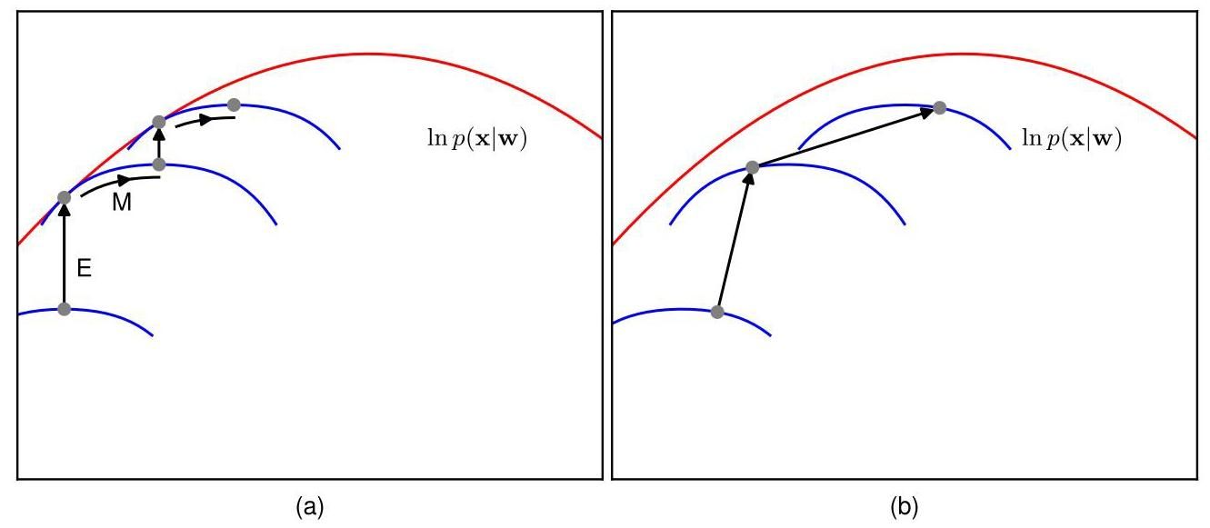

Figure 19.9 Comparison of the EM algorithm with ELBO optimization in a VAE. (a) In the EM algorithm we alternate between updating the variational posterior distribution in the step, and the model parameters in the step. When the step is exact, the gap between the lower bound and the log likelihood is reduced to zero after each E step. (b) In the VAE we perform joint optimization of the encoder network parameters (analogous to the E step) and the decoder network parameters (analogous to the step).

图 19.9 变分自编码器(VAE)中 EM 算法与 ELBO 优化的比较。(a) 在 EM 算法中，我们在 步骤更新变分后验分布和在 步骤更新模型参数之间交替进行。当 步骤精确时，每次 E 步骤后下界和对数似然之间的差距都会降为零。(b) 在 VAE 中，我们联合优化编码器网络参数 (类似于 E 步骤)和解码器网络参数 (类似于 步骤)。

# 19.2.2 The reparameterization trick

# 19.2.2 重参数化技巧

Unfortunately, as it stands, the lower bound (19.11) is still intractable to compute because it involves integrals over the latent variables in which the integrand has a complicated dependence on the latent variables because of the decoder network. For data point we can write the contribution to the lower bound in the form

不幸的是，就目前而言，下界 (19.11) 仍然难以计算，因为它涉及对隐变量 的积分，由于解码器网络的存在，被积函数对隐变量有着复杂的依赖关系。对于数据点 ，我们可以将其对下界的贡献写成如下形式

The second term on the right-hand side is a Kullback-Leibler divergence between two Gaussian distributions and can be evaluated analytically:

右侧的第二项是两个高斯分布之间的 Kullback-Leibler 散度，可以进行解析计算:

Exercise 2.27

练习 2.27

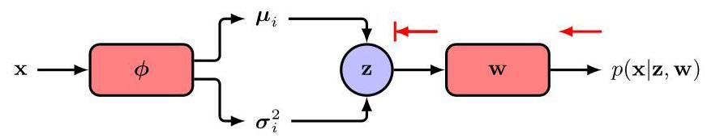

Figure 19.10 When the ELBO is estimated by fixing the latent variable to a sampled value this blocks backpropagation of the error signal to the encoder network.

图 19.10 当通过将隐变量 固定为采样值来估计 ELBO 时，这会阻碍误差信号向编码器网络的反向传播。

For the first term in (19.14), we could try to approximate the integral over with a simple Monte Carlo estimator:

对于 (19.14) 中的第一项，我们可以尝试用一个简单的蒙特卡罗估计器来近似对 的积分:

where are samples drawn from the encoder distribution . This is easily differentiated with respect to , but the gradient with respect to is problematic because changes to will change the distribution from which the samples are drawn and yet these samples are fixed values so that we do not have a way to obtain the derivatives of these samples with respect to . Conceptually, we can think of the process of fixing to a specific sample value as blocking the back-propagation of the error signal to the encoder network, as illustrated in Figure 19.10.

其中 是从编码器分布 中抽取的样本。这很容易对 求导，但对 的梯度存在问题，因为对 的改变会改变抽取样本的分布 ，然而这些样本是固定值，所以我们没有办法获得这些样本对 的导数。从概念上讲，我们可以将将 固定为特定样本值的过程视为阻碍误差信号向编码器网络的反向传播，如图 19.10 所示。

We can resolve this by making use of the reparameterization trick in which we reformulate the Monte Carlo sampling procedure such that derivatives with respect to can be calculated explicitly. First, note that if is a Gaussian random variable with zero mean and unit variance, then the quantity

我们可以通过使用重参数化技巧来解决这个问题，在该技巧中，我们重新表述蒙特卡罗采样过程，以便可以明确计算关于 的导数。首先，注意如果 是一个均值为零且方差为 1 的高斯随机变量，那么这个量

Exercise 19.2

练习 19.2

will have a Gaussian distribution, with mean and variance . We now apply this to the samples in (19.16) in which and are defined by the outputs and of the encoder network, which represent the means and variances in distribution (19.13). Instead of drawing samples of directly, we draw samples for and use (19.17) to evaluate corresponding samples for :

将具有高斯分布，均值为 ，方差为 。现在我们将此应用于 (19.16) 中的样本，其中 和 由编码器网络的输出 和 定义，它们表示分布 (19.13) 中的均值和方差。我们不直接抽取 的样本，而是抽取 的样本，并使用 (19.17) 来计算 的相应样本:

where indexes the samples. This makes the dependence on explicit and allows gradients with respect to to be evaluated, as illustrated in Figure 19.11. The reparameterization trick can be extended to other distributions but is limited to continuous variables. There are techniques to evaluate gradients directly without the reparameterization trick (Williams, 1992), but these estimators have high variance, and so reparameterization can also be viewed as a variance reduction technique.

其中 为样本编号。这使得对 的依赖关系明确，并允许计算关于 的梯度，如图 19.11 所示。重参数化技巧可以扩展到其他分布，但仅限于连续变量。有一些技术可以在不使用重参数化技巧的情况下直接计算梯度(Williams，1992)，但这些估计量具有较高的方差，因此重参数化也可以被视为一种方差缩减技术。

The full error function for the VAE, using our specific modelling assumptions, therefore becomes

因此，使用我们特定的建模假设，变分自编码器(VAE)的完整误差函数变为

where has components , in which and , and the summation over in (19.19) is over the data points in a mini-batch. The number of samples , for each data point , is typically set to 1, so that only a single sample is used. Although this gives a noisy estimate of the bound, it forms part of the stochastic gradient optimization step, which is already noisy, and overall leads to more efficient optimization.

其中 的分量为 ，其中 和 ，并且 (19.19) 中对 的求和是对一个小批量中的数据点进行的。对于每个数据点 ，样本数量 通常设置为 1，以便仅使用单个样本。尽管这会给出边界的有噪声估计，但它是随机梯度优化步骤的一部分，而该步骤本身就有噪声，并且总体上会导致更高效的优化。

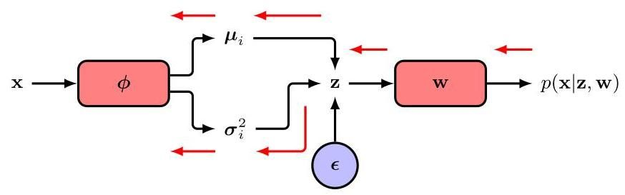

Figure 19.11 The reparameterization trick replaces a direct sample of by one that is calculated from a sample of an independent random variable , thereby allowing the error signal to be back-propagated to the encoder network. The resulting model can be trained using gradient-based optimization to learn the parameters of both the encoder and decoder networks.

图 19.11 重参数化技巧用一个从独立随机变量 的样本计算得到的样本替换了 的直接样本，从而允许误差信号反向传播到编码器网络。由此得到的模型可以使用基于梯度的优化方法进行训练，以学习编码器和解码器网络的参数。

We can summarize VAE training as follows. For each data point in a mini-batch, forward propagate through the encoder network to evaluate the means and variances of the approximate latent distribution, sample from this distribution using the reparameterization trick, and then propagate these samples through the decoder network to evaluate the ELBO (19.19). The gradients with respect to and are then evaluated using automatic differentiation. VAE training is summarized in Algorithm 19.1, where, for clarity, we have omitted that this would generally be done using mini-batches. Once the model is trained, the encoder network is discarded and new data points are generated by sampling from the prior and forward propagating through the decoder network to obtain samples in the data space.

我们可以将变分自编码器(VAE)的训练总结如下。对于小批量中的每个数据点，通过编码器网络进行前向传播，以评估近似潜在分布的均值和方差，使用重参数化技巧从该分布中采样，然后将这些样本通过解码器网络进行传播，以评估证据下界(ELBO)(19.19)。然后使用自动微分来评估关于 和 的梯度。VAE 训练总结在算法 19.1 中，为了清晰起见，我们省略了通常会使用小批量进行训练这一点。一旦模型训练完成，就会丢弃编码器网络，并通过从先验分布 中采样并通过解码器网络进行前向传播来生成新的数据点，从而在数据空间中获得样本。

After training we might want to assess how well the model represents a new test point . Since the log likelihood is intractable, we can use the lower bound as an approximation. To estimate this we can sample from as this gives more accurate estimates than sampling from .

训练完成后，我们可能想评估模型对新测试点 的表示效果如何。由于对数似然难以处理，我们可以使用下界 作为近似。为了估计这个下界，我们可以从 中采样，因为这比从 中采样得到的估计更准确。

There are many variants of VAEs. When applied to image data, the encoder is typically based on convolutions and the decoder based on transpose convolutions. In a conditional VAE both the encoder and decoder take a conditioning variable as an additional input. For example, we might want to generate images of objects, in which represents the object class. The latent-space prior distribution can again be a simple Gaussian, or it can be extended to a conditional distribution given by another neural network. Training and testing proceed as before.

变分自编码器(VAE)有许多变体。当应用于图像数据时，编码器通常基于卷积，解码器基于转置卷积。在条件变分自编码器中，编码器和解码器都将一个条件变量 作为额外输入。例如，我们可能想生成物体的图像，其中 表示物体类别。潜在空间的先验分布 可以再次是简单的高斯分布，也可以扩展为另一个神经网络给出的条件分布 。训练和测试过程与之前相同。

Section 10.5.3

第 10.5.3 节

Note that the first term in the ELBO (19.14) encourages the encoder distribution to be close to the prior , and so the decoder model is encouraged to produce realistic outputs when the trained model is run generatively by sampling from . When training VAEs, a problem can arise in which the variational distribution converges to the prior distribution and therefore becomes uninformative because it no longer depends on . In effect the latent code is ig-

请注意，证据下界(ELBO)(19.14) 中的第一项鼓励编码器分布 接近先验分布 ，因此当通过从 中采样以生成方式运行训练好的模型时，解码器模型会被鼓励产生逼真的输出。在训练变分自编码器(VAE)时，可能会出现一个问题，即变分分布 收敛到先验分布 ，因此变得没有信息价值，因为它不再依赖于 。实际上，潜在代码被忽略了。

Algorithm 19.1: Variational autoencoder training

算法 19.1:变分自编码器训练

Input: Training data set

输入:训练数据集

Encoder network

编码器网络

Decoder network

解码器网络

Initial weight vectors

初始权重向量

Learning rate

学习率

Output: Final weight vectors

输出:最终权重向量

repeat

for do

end for

Update decoder weights

Update encoder weights

until converged

return

nored. This is known as posterior collapse. A symptom of this is that if we take an input and encode it and then decode it, we get a poor reconstruction that looks blurry. In this case the Kullback-Leibler divergence is close to zero.

被忽略。这被称为后验崩溃。这种情况的一个症状是，如果我们取一个输入并对其进行编码，然后再对其进行解码，我们会得到一个看起来模糊的糟糕重建结果。在这种情况下，Kullback - Leibler 散度 接近于零。

A different problem occurs when the latent code is not compressed, which is characterized by highly accurate reconstructions, but such that outputs generated by sampling and passing the samples through the decoder network have poor quality and do not resemble the training data. In this case the Kullback-Leibler divergence is relatively large, and because the trained system has a variational distribution that is very different from the prior, samples from the prior do not generate realistic outputs.

当潜在代码未被压缩时会出现另一个问题，其特征是重建非常准确，但通过采样 生成的输出并将样本通过解码器网络得到的输出质量很差，并且与训练数据不相似。在这种情况下，Kullback - Leibler 散度相对较大，并且由于训练后的系统具有与先验分布非常不同的变分分布，从先验分布中采样不会生成逼真的输出。

Both problems can be addressed by introducing a coefficient in front of the first term in (19.14) to control the regularization effectiveness of the Kullback-Leibler divergence, where typically (Higgins et al.,2017). If the reconstructions look poor then can be increased, whereas if the samples look poor then can be decreased. The value of can also be set to follow an annealing schedule in which it starts with a small value and is gradually increased during training.

这两个问题都可以通过在 (19.14) 中的第一项前面引入一个系数 来解决，以控制 Kullback - Leibler 散度的正则化效果，通常 (Higgins 等人，2017)。如果重建结果看起来很差，那么可以增大 ，而如果采样结果看起来很差，那么可以减小 。 的值也可以设置为遵循退火策略，即它从一个较小的值开始，并在训练过程中逐渐增大。

Finally, note that we have considered a decoder network that represents the mean of a Gaussian output distribution. We can extend the VAE to include outputs representing the variance of the Gaussian or, more generally, the parameters that Section 6.5 characterize other more complex distributions.

最后，请注意，我们考虑了一个解码器网络 ，它表示高斯输出分布的均值。我们可以将变分自编码器扩展为包括表示高斯分布方差的输出，或者更一般地，包括第 6.5 节中表征其他更复杂分布的参数。

Exercises

练习

19.1 Show that, for any distribution and any function , the following relation holds:

19.1 证明，对于任何分布 和任何函数 ，以下关系成立:

Hence, show that the left-hand side of (19.20) can be approximated by the following Monte Carlo estimator:

因此，证明 (19.20) 的左侧可以用以下蒙特卡罗估计量近似:

where the samples are drawn independently from the distribution . Verify that this estimator is unbiased, i.e., that the average value of the right-hand side of (19.21), averaged over the distribution of the samples, is equal to the left-hand side. In principle, by setting , this result would allow the gradient of the second term on the right-hand side of (19.14) with respect to to be evaluated without making use of the reparameterization trick. Also, because this method is unbiased, it will give the exact answer in the limit of an infinite number of samples. However, the reparameterization trick is more efficient, meaning that fewer samples are needed to get good accuracy, because it directly computes the change of due to the change in that results from a change in .

其中样本 是从分布 中独立抽取的。验证这个估计量是无偏的，即 (19.21) 右侧在样本分布上的平均值等于左侧。原则上，通过设置 ，这个结果将允许在不使用重参数化技巧的情况下计算 (19.14) 右侧第二项关于 的梯度。此外，由于这种方法是无偏的，在样本数量趋于无穷大的极限情况下，它将给出精确的答案。然而，重参数化技巧更有效，这意味着需要更少的样本就能获得良好的精度，因为它直接计算了由于 的变化导致 变化而引起的 的变化。

19.2 Verify that if has a zero-mean unit-variance Gaussian distribution, then the variable in (19.17) will have a Gaussian distribution with mean and variance .

19.2 验证如果 具有零均值单位方差的高斯分布，那么 (19.17) 中的变量 将具有均值为 且方差为 的高斯分布。

19.3 (★★) In this exercise we extend the diagonal covariance VAE encoder network (19.13) to one with a general covariance matrix. Consider a -dimensional random vector drawn from a simple Gaussian:

19.3 (★★) 在本练习中，我们将对角协方差变分自编码器(VAE)编码器网络 (19.13) 扩展为具有一般协方差矩阵的网络。考虑一个从简单高斯分布中抽取的 维随机向量:

which is then linearly transformed using the relation

然后使用以下关系对其进行线性变换

where is a lower-triangular matrix (i.e., a matrix with all elements above the leading diagonal being zero). Show that has a distribution , and write down an expression for in terms of . Explain why the diagonal elements of must be non-negative. Describe how and can be expressed as the outputs of a neural network, and discuss suitable choices for output-unit activation functions.

其中 是一个下三角矩阵(即，一个 矩阵，其主对角线以上的所有元素均为零)。证明 具有分布 ，并写出 关于 的表达式。解释为什么 的对角元素必须是非负的。描述如何将 和 表示为神经网络的输出，并讨论输出单元激活函数的合适选择。

19.4 Evaluate the Kullback-Leibler divergence term in (19.14). Hence, show how the gradients of this term with respect to and can be evaluated for training the encoder and decoder networks.

19.4 计算 (19.14) 中的 Kullback-Leibler 散度项。因此，说明如何计算该项关于 和 的梯度，以用于训练编码器和解码器网络。

19.5 (★) We have seen that the ELBO given by (19.11) can be written in the form (19.14). Show that it can also be written as

19.5 (★) 我们已经看到，由 (19.11) 给出的证据下界(ELBO)可以写成 (19.14) 的形式。证明它也可以写成如下形式

19.6 (*) Show that the ELBO given by (19.11) can be written in the form

19.6 (*) 证明由 (19.11) 给出的证据下界(ELBO)可以写成如下形式

Deep Learning

深度学习

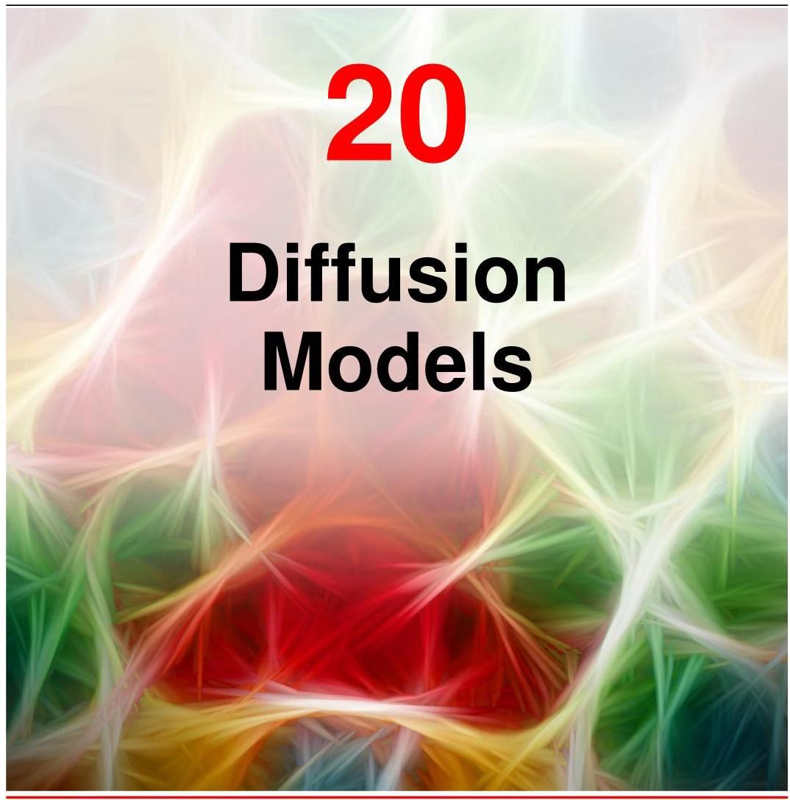

We have seen that a powerful way to construct rich generative models is to introduce a distribution over a latent variable , and then to transform into the data space using a deep neural network. It is sufficient to use a simple, fixed distribution for , such as a Gaussian , since the generality of the neural network transforms this into a highly flexible family of distributions over . In previous chapters we have explored several models which fit within this framework but which take different approaches to defining and training the deep neural network, based on generative adversarial networks, variational autoencoders, and normalizing flows.

我们已经看到，构建丰富生成模型的一种强大方法是引入一个关于潜在变量 的分布 ，然后使用深度神经网络将 转换到数据空间 。对于 ，使用一个简单的固定分布就足够了，比如高斯分布 ，因为神经网络的通用性会将其转换为一个关于 的高度灵活的分布族。在前面的章节中，我们探讨了几种符合这个框架的模型，但它们基于生成对抗网络、变分自编码器和归一化流，采用了不同的方法来定义和训练深度神经网络。

Section 16.4.4

第 16.4.4 节

In this chapter we discuss a fourth class of models within this general framework, known as diffusion models, also called denoising diffusion probabilistic models, or DDPMs (Sohl-Dickstein et al., 2015; Ho, Jain, and Abbeel, 2020), which have emerged as the state of the art for many applications. For illustration we will focus on models of image data although the framework has much broader applicability. The central idea is to take each training image and to corrupt it using a multi-step noise process to transform it into a sample from a Gaussian distribution. This is illustrated in Figure 20.1. A deep neural network is then trained to invert this process, and once trained the network can then generate new images starting with samples from a Gaussian as input.

在本章中，我们将讨论这个通用框架内的第四类模型，即扩散模型，也称为去噪扩散概率模型(DDPMs)(Sohl - Dickstein 等人，2015 年；Ho、Jain 和 Abbeel，2020 年)，这类模型已成为许多应用中的先进技术。为便于说明，我们将重点关注图像数据模型，尽管该框架的应用范围要广泛得多。其核心思想是对每个训练图像进行处理，通过多步噪声过程对其进行破坏，将其转换为来自高斯分布的样本。如图 20.1 所示。然后训练一个深度神经网络来逆转这个过程，训练完成后，该网络就可以以高斯分布的样本作为输入来生成新的图像。

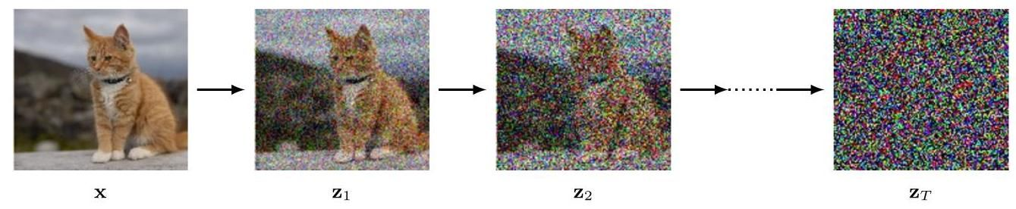

Figure 20.1 Illustration of the encoding process in a diffusion model showing an image that is gradually corrupted with multiple stages of additive Gaussian noise giving a sequence of increasingly noisy images. After a large number of steps the result is indistinguishable from a sample drawn from a Gaussian distribution. A deep neural network is then trained to reverse this process.

图 20.1 展示了扩散模型中的编码过程，显示了一幅图像 逐渐被多阶段加性高斯噪声破坏，形成了一系列噪声越来越大的图像。经过大量 步骤后，结果与从高斯分布中抽取的样本无法区分。然后训练一个深度神经网络来逆转这个过程。

Diffusion models can be viewed as a form of hierarchical variational autoen-

扩散模型可以看作是一种分层变分自动……

Section 19.2 coder in which the encoder distribution is fixed, and defined by the noise process, and only the generative distribution is learned (Luo, 2022). They are easy to train, they scale well on parallel hardware, and they avoid the challenges and instabilities of adversarial training while producing results that have quality comparable to, or better than, generative adversarial networks. However, generating new samples can be computationally expensive due to the need for multiple forward passes through the decoder network (Dhariwal and Nichol, 2021).

第 19.2 节 编码器，其中编码器分布是固定的，由噪声过程定义，并且只学习生成分布(Luo，2022 年)。它们易于训练，在并行硬件上具有良好的扩展性，并且在产生与生成对抗网络相当或更好质量结果的同时，避免了对抗训练的挑战和不稳定性。然而，由于需要多次通过解码器网络进行前向传播，生成新样本的计算成本可能很高(Dhariwal 和 Nichol，2021 年)。

# 20.1. Forward Encoder

# 20.1. 前向编码器

Suppose we take an image from the training set, which we will denote by , and blend it with Gaussian noise independently for each pixel to give a noise-corrupted image defined by

假设我们从训练集中选取一张图像，用 表示它，并对每个像素独立地添加高斯噪声，从而得到一个受噪声干扰的图像 ，其定义如下

where and is the variance of the noise distribution. The choice of coefficients and in (20.1) and (20.3) ensures that the mean of the distribution of is closer to zero than the mean of and that the variance of is closer to the unit matrix than the variance of . We can write the transformation (20.1) in the form

其中 和 是噪声分布的方差。式 (20.1) 和 (20.3) 中系数 和 的选择确保了 分布的均值比 分布的均值更接近零，并且 的方差比 的方差更接近单位矩阵。我们可以将变换 (20.1) 写成如下形式

Exercise 20.1

练习 20.1

Exercise 20.2

练习 20.2

We then repeat the process with additional independent Gaussian noise steps to give a sequence of increasingly noisy images . Note that in the literature on diffusion models, these latent variables are sometimes denoted and the observed variable is denoted . We use the notation of for latent variables and

然后，我们通过额外的独立高斯噪声步骤重复这个过程，得到一系列噪声逐渐增加的图像 。请注意，在关于扩散模型的文献中，这些潜在变量有时用 表示，而观测变量用 表示。我们使用 来表示潜在变量，用

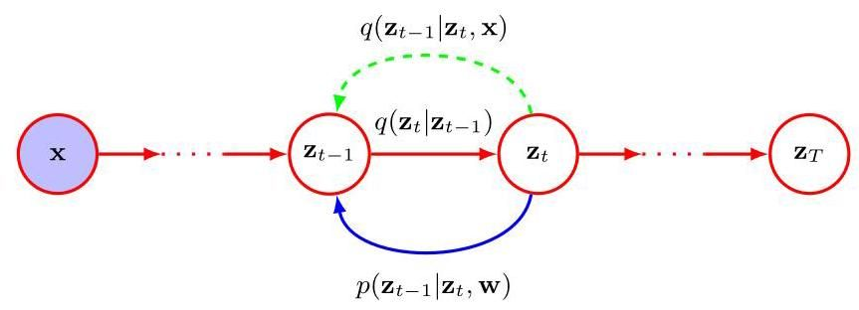

Figure 20.2 A diffusion process represented as a probabilistic graphical model. The original image is shown by the shaded node, since it is an observed variable, whereas the noise-corrupted images are considered to be latent variables. The noise process is defined by the forward distribution and can be viewed as an encoder. Our goal is to learn a model that tries to reverse this noise process and which can be viewed as a decoder. As we will see later, the conditional distribution plays an important role in defining the training procedure.

图 20.2 一个用概率图模型表示的扩散过程。原始图像 用阴影节点表示，因为它是一个观测变量，而受噪声干扰的图像 被视为潜在变量。噪声过程由前向分布 定义，可以看作是一个编码器。我们的目标是学习一个模型 ，它试图逆转这个噪声过程，并且可以看作是一个解码器。正如我们稍后将看到的，条件分布 在定义训练过程中起着重要作用。

for the observed variable for consistency with the rest of the book. Each successive image is given by

为了与本书其余部分保持一致，针对观测变量。每个连续的图像由以下式子给出

where . Again, we can write (20.3) in the form

其中 。同样，我们可以将 (20.3) 写成如下形式

Section 11.3

第 11.3 节

The sequence of conditional distributions (20.4) forms a Markov chain and can be expressed as a probabilistic graphical model as shown in Figure 20.2. The values of the variance parameters are set by hand and are typically chosen such that the variance values increase through the chain according to a prescribed schedule such that .

条件分布序列 (20.4) 构成一个马尔可夫链，并且可以表示为如图 20.2 所示的概率图模型。方差参数 的值是手动设置的，通常选择使得方差值根据规定的时间表在链中递增，即 。

# 20.1.1 Diffusion kernel

# 20.1.1 扩散核

The joint distribution of the latent variables, conditioned on the observed data vector , is given by

潜在变量在给定观测数据向量 条件下的联合分布由以下式子给出

If we now marginalize over the intermediate variables , we obtain the diffusion kernel:

如果我们现在对中间变量 进行边缘化处理，我们将得到扩散核:

Exercise 20.3

练习 20.3

where we have defined

其中我们定义了

We see that each intermediate distribution has a simple closed-form Gaussian expression from which we can directly sample, which will prove useful when training DDPMs as it allows efficient stochastic gradient descent using randomly chosen intermediate terms in the Markov chain without having to run the whole chain. We can also write (20.6) in the form

我们发现每个中间分布都有一个简单的封闭形式的高斯表达式，我们可以直接从中采样。这在训练去噪扩散概率模型(DDPMs)时将被证明是有用的，因为它允许在马尔可夫链中使用随机选择的中间项进行高效的随机梯度下降，而不必运行整个链。我们也可以将式(20.6)写成如下形式

where again . Note that that now represents the total noise added to the original image instead of the incremental noise added at this step of the Markov chain.

其中同样有 。请注意，此时 表示添加到原始图像上的总噪声，而不是在马尔可夫链的这一步添加的增量噪声。

After many steps the image becomes indistinguishable from Gaussian noise, and in the limit we have

经过许多步骤后，图像变得与高斯噪声无法区分，并且在极限情况 下，我们有

Exercise 20.4

练习 20.4

and therefore all information about the original image is lost. The choice of coefficients and in (20.3) ensures that once the Markov chain converges to a distribution with zero mean and unit covariance, further updates will leave this unchanged.

因此，关于原始图像的所有信息都丢失了。(20.3) 中系数 和 的选择确保了一旦马尔可夫链收敛到均值为零且协方差为单位矩阵的分布，进一步的更新将不会改变这一分布。

Exercise 20.5

练习 20.5

Since the right-hand side of (20.9) is independent of , it follows that the marginal distribution of is given by

由于 (20.9) 的右侧与 无关，因此 的边缘分布由下式给出

It is common to refer to the Markov chain (20.4) as the forward process, and it is analogous to the encoder in a VAE, except that here it is fixed rather than learned. Note, however, that the usual terminology in the literature is the opposite of that typically used in the literature regarding normalizing flows, where the mapping from latent space to data space is considered the forward process.

通常将马尔可夫链 (20.4) 称为前向过程，它类似于变分自编码器 (VAE) 中的编码器，不同之处在于这里它是固定的而不是通过学习得到的。然而，需要注意的是，文献中常用的术语与关于归一化流的文献中通常使用的术语相反，在归一化流的文献中，从潜在空间到数据空间的映射被视为前向过程。

# 20.1.2 Conditional distribution

# 20.1.2 条件分布

Our goal is to learn to undo the noise process, and so it is natural to consider the reverse of the conditional distribution , which we can express using Bayes’ theorem in the form

我们的目标是学习消除噪声过程，因此自然会考虑条件分布 的逆过程，我们可以使用贝叶斯定理将其表示为如下形式

We can write the marginal distribution in the form

我们可以将边缘分布 写成如下形式

where is given by the conditional Gaussian (20.6). This distribution is intractable, however, because we must integrate over the unknown data density . If we approximate the integration using samples from the training data set, we obtain a complicated distribution expressed as a mixture of Gaussians.

其中 由条件高斯分布 (20.6) 给出。然而，这个分布是难以处理的，因为我们必须对未知的数据密度 进行积分。如果我们使用训练数据集的样本近似积分，我们会得到一个表示为高斯混合的复杂分布。

Instead, we consider the conditional version of the reverse distribution, conditioned on the data vector , defined by , which as we will see shortly turns out to be a simple Gaussian distribution. Intuitively this is reasonable since, given a noisy image, it is difficult to guess which lower-noise image gave rise to it, whereas if we also know the starting image then the problem becomes much easier. We can calculate this conditional distribution using Bayes’ theorem:

相反，我们考虑逆分布的条件版本，以数据向量 为条件，由 定义，我们很快会看到它是一个简单的高斯分布。直观地说，这是合理的，因为给定一个有噪声的图像，很难猜测是哪个低噪声图像产生了它，而如果我们也知道起始图像，那么问题就变得容易得多。我们可以使用贝叶斯定理计算这个条件分布:

We now make use of the Markov property of the forward process to write

现在我们利用前向过程的马尔可夫性质来表示

where the right-hand side is given by (20.4). As a function of , this takes the form of an exponential of a quadratic form. The term in the numerator of (20.13) is the diffusion kernel given by (20.6), which again involves the exponential of a quadratic form with respect to . We can ignore the denominator in (20.13) since as a function of it is constant. Thus, we see that the right-hand side of (20.13) takes the form of a Gaussian distribution, and we can identify its mean and covariance using the technique of ’completing the square’ to give

其中右侧由 (20.4) 给出。作为 的函数，它采用二次型的指数形式。(20.13) 分子中的项 是由 (20.6) 给出的扩散核，它同样涉及关于 的二次型的指数。由于作为 的函数，(20.13) 中的分母是常数，我们可以忽略它。因此，我们看到 (20.13) 的右侧采用高斯分布的形式，我们可以使用“配方法”来确定其均值和协方差，得到

Exercise 20.6

练习 20.6

where

其中

and we have made use of (20.7).

并且我们使用了式 (20.7)。

# 20.2. Reverse Decoder

# 20.2. 反向解码器

We have seen that the forward encoder model is defined by a sequence of Gaussian conditional distributions but that inverting this directly leads to a distribution that is intractable, as it would require integrating over all possible values of the starting vector whose distribution is the unknown data distribution that we wish to model. Instead, we will learn an approximation to the reverse distribution by using a distribution governed by a deep neural network, where represents the network weights and biases. This reverse step is analogous to the decoder in a variational autoencoder and is illustrated in Figure 20.2. Once the network is trained, we can sample from the simple Gaussian distribution over and transform it into a sample from the data distribution through a sequence of reverse sampling steps by repeated application of the trained network.

我们已经知道，前向编码器模型由一系列高斯条件分布 定义，但直接对其求逆会得到一个难以处理的分布 ，因为这需要对起始向量 的所有可能值进行积分，而该向量的分布是我们希望建模的未知数据分布 。相反，我们将使用一个由深度神经网络控制的分布 来学习反向分布的近似值，其中 表示网络的权重和偏置。这一反向步骤类似于变分自编码器中的解码器，如图 20.2 所示。一旦网络训练完成，我们可以从关于 的简单高斯分布中采样，并通过重复应用训练好的网络进行一系列反向采样步骤，将其转换为来自数据分布 的样本。

Chapter 19

第 19 章

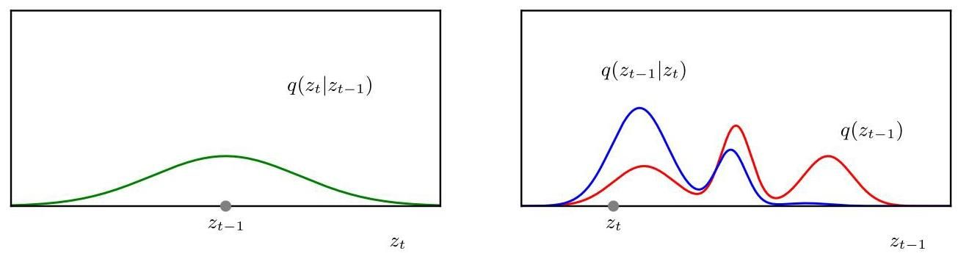

Figure 20.3 Illustration of the evaluation of the reverse distribution using Bayes’ theorem (20.13) for scalar variables. The red curve on the right-hand plot shows the marginal distribution illustrated using a mixture of three Gaussians, whereas the left-hand plot shows the Gaussian forward noise process as a distribution over centred on . By multiplying these together and normalizing, we obtain the distribution shown for a particular choice of by the blue curve. Because the distribution on the left is relatively broad, corresponding to a large variance , the distribution has a complex multimodal structure.

图 20.3 使用贝叶斯定理 (20.13) 对标量变量评估反向分布 的示意图。右侧图中的红色曲线展示了使用三个高斯分布的混合表示的边缘分布 ，而左侧图展示了作为关于以 为中心的 的分布的高斯前向噪声过程 。通过将它们相乘并归一化，我们得到了由蓝色曲线为特定的 选择所展示的分布 。由于左侧的分布相对较宽，对应于较大的方差 ，分布 具有复杂的多峰结构。

Intuitively, if we keep the variances small so that then the change in the latent vector between steps will be relatively small, and hence it should be easier to learn to invert the transformation. More specifically, if then the distribution will be approximately a Gaussian distribution over . This can be seen from (20.11) since the right-hand side depends on through and . If is a sufficiently narrow Gaussian then will vary only a small amount over the region in which has significant mass, and hence will also be approximately Gaussian. This intuition can be confirmed using a simple example as shown in Figures 20.3 and 20.4. However, since the variances at each step are small, we must use a large number of steps to ensure that the distribution over the final latent variable obtained from the forward noising process will still be close to a Gaussian, and this increases the cost of generating new samples. In practice, may be several thousand.

直观地说，如果我们保持方差较小，使得 ，那么步骤之间潜在向量的变化将相对较小，因此学习反转变换应该更容易。更具体地说，如果 ，那么分布 将近似为关于 的高斯分布。从 (20.11) 可以看出这一点，因为右侧通过 和 依赖于 。如果 是一个足够窄的高斯分布，那么 在 具有显著质量的区域内只会有少量变化，因此 也将近似为高斯分布。如图 20.3 和 20.4 所示的简单示例可以证实这种直觉。然而，由于每个步骤的方差较小，我们必须使用大量的步骤来确保从前向加噪过程获得的最终潜在变量 的分布仍然接近高斯分布，这增加了生成新样本的成本。在实践中， 可能是几千。

We can see more formally that will be approximately Gaussian by making a Taylor series expansion of around the point as a function of . This also shows that for small variance, the reverse distribution will have a covariance that is close to the covariance of the forward noise process . We therefore model the reverse process using a Gaussian distribution of the form

通过将 在点 附近作为 的函数进行泰勒级数展开，我们可以更正式地看到 将近似为高斯分布。这也表明，对于小方差，反向分布 的协方差将接近前向噪声过程 的协方差 。因此，我们使用以下形式的高斯分布对反向过程进行建模

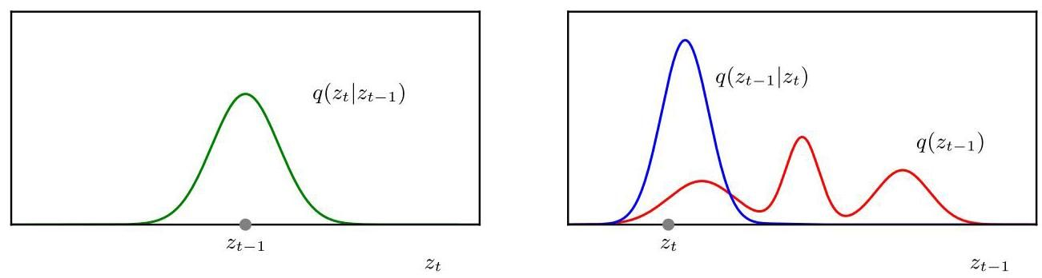

Figure 20.4 As in Figure 20.3 but in which the Gaussian distribution in the left-hand plot has a much smaller variance . We see that the corresponding distribution shown in blue on the right-hand plot is close to being Gaussian, with a similar variance to .

图 20.4 与图 20.3 类似，但左图中的高斯分布 的方差 要小得多。我们看到，右图中用蓝色显示的相应分布 接近高斯分布，其方差与 相似。

Exercise 20.7

练习 20.7

where is a deep neural network governed by a set of parameters . Note that the network takes the step index explicitly as an input so that it can account for the variation of the variance across different steps of the chain. This allows us to use a single network to invert all the steps in the Markov chain, instead of having to learn a separate network for each step. It is also possible to learn the covariances of the denoising process by incorporating further outputs in the network to account for the curvature in the distribution in the neighbourhood of (Nichol and Dhariwal, 2021). There considerable flexibility in the choice of architecture for the neural network used to model provided the output has the same dimensionality as the input. Given this restriction, a U-net architecture is a common choice for image processing applications.

其中 是一个由一组参数 控制的深度神经网络。请注意，该网络明确将步长索引 作为输入，以便它可以解释链中不同步骤的方差 的变化。这使我们能够使用单个网络来反转马尔可夫链中的所有步骤，而不必为每个步骤学习一个单独的网络。也可以通过在网络中加入更多输出来学习去噪过程的协方差，以解释 邻域内分布 的曲率(Nichol 和 Dhariwal，2021)。用于对 进行建模的神经网络的架构选择具有相当大的灵活性，只要输出与输入具有相同的维度即可。在这种限制下，U 型网络架构是图像处理应用中的常见选择。

Section 10.5.4

第 10.5.4 节

The overall reverse denoising process then takes the form of a Markov chain given by

那么，整个反向去噪过程就采用如下马尔可夫链的形式

Here is assumed to be the same as the distribution of and hence is given by . Once the model has been trained, sampling is straightforward because we first sample from the simple Gaussian and then we sample sequentially from each of the conditional distributions in turn, finally sampling from to obtain a sample in the data space.

这里假设 与 的分布相同，因此由 给出。一旦模型训练完成，采样就很简单了，因为我们首先从简单的高斯分布 中采样，然后依次从每个条件分布 中采样，最后从 中采样以在数据空间中获得一个样本 。

# 20.2.1 Training the decoder

# 20.2.1 训练解码器

We next have to decide on an objective function for training the neural network. The obvious choice is the likelihood function, which for data point is given by

接下来，我们必须为神经网络的训练确定一个目标函数。显而易见的选择是似然函数，对于数据点 ，其表达式为

in which is defined by (20.19). This is an instance of the general latent-variable model (16.81) in which the latent variables comprise and the observed variable is . Note that the latent variables all have the same dimensionality as the data space, as was the case for normalizing flows but not for variational autoencoders or generative adversarial networks. We see from (20.20) that the likelihood involves integrating over all possible trajectories by which noise samples could give rise to the observed data point. The integrals in (20.20) are intractable as they involve integrating over the highly complex neural network functions.

其中 由式 (20.19) 定义。这是一般隐变量模型 (16.81) 的一个实例，其中隐变量包含 ，观测变量为 。请注意，与归一化流的情况一样，但与变分自编码器或生成对抗网络不同，所有隐变量的维度都与数据空间的维度相同。从式 (20.20) 中我们可以看出，似然函数涉及对所有可能的轨迹进行积分，通过这些轨迹，噪声样本可以产生观测到的数据点。式 (20.20) 中的积分是难以处理的，因为它们涉及对高度复杂的神经网络函数进行积分。

# 20.2.2 Evidence lower bound

# 20.2.2 证据下界

Since the exact likelihood is intractable, we can adopt a similar approach to that used with variational autoencoders and maximize a lower bound on the log likelihood called the evidence lower bound (ELBO), which we re-derive here in the context of diffusion models. For any choice of distribution , the following relation always holds:

由于精确似然函数难以处理，我们可以采用与变分自编码器类似的方法，最大化对数似然函数的一个下界，称为证据下界 (ELBO)，我们在这里结合扩散模型重新推导它。对于任何分布 的选择，以下关系始终成立:

Section 16.3

第 16.3 节

where is the evidence lower bound, also known as the variational lower bound,

其中 是证据下界，也称为变分下界

given by

由……给出

and the Kullback-Leibler divergence between two probability densities and is defined by

两个概率密度 和 之间的 Kullback-Leibler 散度 定义为

Section 2.5.7

第 2.5.7 节

To verify the relation (20.21) first note that, from the product rule of probability, we have

为了验证关系式 (20.21)，首先注意到，根据概率的乘积法则，我们有

Exercise 20.8

练习 20.8

Section 2.5.7

第2.5.7节

Substituting (20.24) into (20.22) and making use of (20.23) gives (20.21). The Kullback-Leibler divergence has the property from which it follows that

将(20.24)代入(20.22)并利用(20.23)可得(20.21)。Kullback-Leibler散度具有性质 ，由此可推出

Since the log likelihood function is intractable, we train the neural network by maximizing the lower bound .

由于对数似然函数难以处理，我们通过最大化下界 来训练神经网络。

To do this, we first derive an explicit form for the lower bound of the diffusion model. In defining the lower bound we are free to choose any form we like for as long as it is a valid probability distribution, i.e., that it is non-negative and integrates to 1. With many applications of the ELBO, such as the variational autoencoder, we chose a form for that has adjustable parameters, often in the form of a deep neural network, and then we maximize the ELBO with respect to those parameters as well as with respect to the parameters of the distribution . Optimizing the distribution encourages the bound to be tight, which brings the optimization of the parameters in closer to that of maximum likelihood. With diffusion models, however, we chose to be given by the fixed distribution defined by the Markov chain (20.5), and so the only adjustable parameters are those in the model for the reverse Markov chain. Note that we are using the flexibility in the choice of to select a form that depends on .

为此，我们首先推导出扩散模型下界的显式形式。在定义下界时，只要 是一个有效的概率分布，即它是非负的且积分结果为 1，我们可以自由选择任何我们喜欢的形式。在许多证据下界(ELBO)的应用中，如变分自编码器，我们为 选择一种具有可调整参数的形式，通常采用深度神经网络的形式，然后我们针对这些参数以及分布 的参数最大化 ELBO。优化分布 会使边界更紧密，这使得 中参数的优化更接近最大似然估计。然而，对于扩散模型，我们选择 由马尔可夫链 (20.5) 定义的固定分布 给出，因此唯一可调整的参数是反向马尔可夫链模型 中的参数。请注意，我们利用选择 的灵活性来选择一种依赖于 的形式。

We therefore substitute for in (20.21) using (20.5), and likewise we substitute for using (20.19), which allows us to write the

因此，我们使用 (20.5) 来替换 (20.21) 中的 ，同样地，我们使用 (20.19) 来替换 ，这使我们能够将

ELBO in the form

证据下界(ELBO)写成如下形式

where we have defined

其中我们定义了

The first term on the right-hand side of (20.26) is just the fixed distribution . This has no trainable parameters and can therefore be omitted from the ELBO since it represents a fixed additive constant. Similarly, the third term is independent of and so again can be omitted.

(20.26) 右侧的第一项 只是固定分布 。它没有可训练的参数，因此可以从证据下界(ELBO)中省略，因为它代表一个固定的加法常数。类似地，第三项 与 无关，因此也可以省略。

The fourth term on the right-hand side of (20.26) corresponds to the reconstruction term from the variational autoencoder. It can be evaluated by approximating the expectation by a Monte Carlo estimate obtained by drawing samples from the distribution over defined by (20.2) so that

(20.26) 右侧的第四项对应于变分自编码器中的重建项。可以通过蒙特卡罗估计来近似期望 进行评估，该估计是通过从由 (20.2) 定义的关于 的分布中抽取样本得到的，使得

where . Unlike with VAEs we do not need to back-propagate an error signal through the sampled value because the -distribution is fixed and so there is no need here for the reparameterization trick.

其中 。与变分自编码器不同，我们不需要通过采样值反向传播误差信号，因为 分布是固定的，所以这里不需要使用重参数化技巧。

Section 19.2.2

第 19.2.2 节

This leaves the second term on the right-hand side of (20.26), which comprises a sum of terms each of which is dependent on a pair of adjacent latent-variable values and . We saw earlier when we derived the diffusion kernel (20.6) that we can sample from directly as a Gaussian distribution and we could then obtain a corresponding sample of using (20.4), which is also a Gaussian. Although this would be a correct procedure in the limit of an infinite number of samples, the use of pairs of sampled values creates very noisy estimates with high variance, so that an unnecessarily large numbers of samples is required. Instead, we rewrite the ELBO in a form that can be estimated by sampling just one value per term.

这就剩下了 (20.26) 式右侧的第二项，它由一系列项的和组成，每一项都依赖于一对相邻的潜在变量值 和 。我们之前推导扩散核 (20.6) 时看到，我们可以直接从 中以高斯分布的形式采样，然后可以使用 (20.4) 式得到 的相应样本，(20.4) 式也是一个高斯分布。虽然在样本数量无限的极限情况下，这将是一个正确的过程，但使用成对的采样值会产生具有高方差的非常嘈杂的估计，因此需要不必要的大量样本。相反，我们将证据下界 (ELBO) 重写为一种可以通过每项仅采样一个值来估计的形式。

# 20.2.3 Rewriting the ELBO

# 20.2.3 重写证据下界 (ELBO)

Following our discussion of the ELBO for the variational autoencoder, our goal here is to write the ELBO in terms of Kullback-Leibler divergences, which we can then subsequently express in closed form. The neural network is a model of the distribution in the reverse direction whereas the -distribution is expressed in the forward direction , and so we use Bayes’ theorem to

在讨论了变分自编码器的证据下界 (ELBO) 之后，我们这里的目标是用 KL 散度来表示 ELBO，然后我们可以将其以封闭形式表示出来。神经网络是反向分布 的模型，而 分布是用正向 表示的，因此我们使用贝叶斯定理

reverse the conditional distribution by writing

通过以下方式反转条件分布

This allows us to write the second term in (20.26) in the form

这使我们能够将 (20.26) 中的第二项写成如下形式

The second term on the right-hand side of (20.30) is independent of and so can be omitted. Substituting (20.30) into (20.26), we then obtain

(20.30) 右侧的第二项与 无关，因此可以省略。将 (20.30) 代入 (20.26)，我们得到

Exercise 20.9

练习 20.9

Finally, we can rewrite (20.31) in the form

最后，我们可以将 (20.31) 重写为如下形式

reconstruction term

重建项

consistency terms

一致性项

where we have simplified the expectation over in the first term since is the only latent variable appearing in the integrand. Therefore in the expectation defined by (20.27), all the conditional distributions integrate to unity leaving only the integral over . Likewise, in the second term, each integral involves only two adjacent latent variables and , and all remaining variables can be integrated out.

由于 是被积函数中唯一出现的隐变量，我们简化了第一项中对 的期望。因此，在由 (20.27) 定义的期望中，所有条件分布的积分结果为 1，仅剩下对 的积分。同样，在第二项中，每个积分仅涉及两个相邻的隐变量 和 ，其余所有变量都可以被积分掉。

The bound (20.32) is now very similar to the ELBO for the variational autoen-coder given by (19.14), except that there are now multiple encoder and decoder stages. The reconstruction term rewards high probability for the observed data sample and can be trained in the same way as the corresponding term in the VAE by using the sampling approximation (20.28). The consistency terms in (20.32) are defined between pairs of Gaussian distributions and therefore can be expressed in closed form, as follows. The distribution is given by (20.15) whereas the distribution is given by (20.18) and so the Kullback-Leibler divergence becomes

界 (20.32) 现在与由 (19.14) 给出的变分自编码器的证据下界(ELBO)非常相似，只是现在有多个编码器和解码器阶段。重建项奖励观测数据样本的高概率，并且可以像变分自编码器(VAE)中的相应项一样，使用采样近似 (20.28) 进行训练。(20.32) 中的一致性项是在成对的高斯分布之间定义的，因此可以用封闭形式表示，如下所示。分布 由 (20.15) 给出，而分布 由 (20.18) 给出，因此 Kullback-Leibler 散度变为

where is defined by (20.16) and where any additive terms that are independent of the network parameters have been absorbed into the constant term, which plays no role in training. Each of the consistency terms in (20.32) has one remaining integral over , weighted by . This can be approximated by drawing a sample from , which can be done efficiently using the diffusion kernel (20.6).

其中 由 (20.16) 定义，并且任何与网络参数 无关的加性项都被吸收到常数项中，该常数项在训练中不起作用。(20.32) 中的每个一致性项都有一个对 的剩余积分，其权重为 。这可以通过从 中抽取一个样本进行近似，使用扩散核 (20.6) 可以高效地完成此操作。

Chapter 19

第 19 章

Exercise 20.11

练习 20.11

We see that the KL divergence (20.33) takes the form of a simple squared-loss function. Since we adjust the network parameters to maximize the lower bound in (20.32), we will be minimizing this squared error because there is a minus sign in front of the Kullback-Leibler divergence terms in the ELBO.

我们看到 KL 散度 (20.33) 采用了简单的平方损失函数的形式。由于我们调整网络参数以最大化 (20.32) 中的下界，我们将最小化这个平方误差，因为证据下界(ELBO)中 Kullback-Leibler 散度项前面有一个负号。

# 20.2.4 Predicting the noise

# 20.2.4 预测噪声

One modification that leads to higher quality results is to change the role of the neural network so that instead of predicting the denoised image at each step of the Markov chain it predicts the total noise component that was added to the original image to create the noisy image at that step (Ho, Jain, and Abbeel, 2020). To do this we first take (20.8) and rearrange to give

一种能带来更高质量结果的改进方法是改变神经网络的作用，使其在马尔可夫链的每一步不再预测去噪后的图像，而是预测在该步骤中添加到原始图像以生成含噪图像的总噪声分量(Ho、Jain 和 Abbeel，2020)。为此，我们首先对公式 (20.8) 进行整理，得到

If we now substitute this into (20.16) we can rewrite the mean of the reverse conditional distribution in terms of the original data vector and the noise to give

如果我们现在将其代入公式 (20.16)，就可以用原始数据向量 和噪声 来重写反向条件分布 的均值 ，得到

Exercise 20.12

练习 20.12

Similarly, instead of a neural network that predicts the denoised image, we introduce a neural network that aims to predict the total noise that was added to to generate . Following the same steps that led to (20.35) shows that these two network functions are related by

类似地，我们引入一个神经网络 来替代预测去噪图像的神经网络 ，该网络旨在预测添加到 以生成 的总噪声。按照推导出公式 (20.35) 的相同步骤可以发现，这两个网络函数之间存在如下关系

We can now substitute (20.35) and (20.36) into (20.33) to give

我们现在可以将公式 (20.35) 和 (20.36) 代入公式 (20.33)，得到

where in the final line we have substituted for using (20.8).

在最后一行中，我们使用 (20.8) 式代入了 。

The reconstruction term in the ELBO (20.32) can be approximated using (20.28) with a sampled value of . Using the form (20.18) for we have

证据下界 (20.32) 中的重建项可以使用 (20.28) 式，结合 的采样值来近似。使用 的形式 (20.18)，我们得到

If we substitute for using (20.36) and we substitute for using (20.1) and then make use of , which follows from (20.7), we obtain

如果我们使用 (20.36) 式代入 ，使用 (20.1) 式代入 ，然后利用由 (20.7) 式推出的 ，我们可以得到

Exercise 20.13

练习 20.13

This is precisely the same form as (20.37) for the special case , and so the reconstruction and consistency terms can be combined.

对于特殊情况 ，这与 (20.37) 式的形式完全相同，因此重建项和一致性项可以合并。

Ho, Jain, and Abbeel (2020) found empirically that performance is further improved simply by omitting the factor in front of (20.37), so that all steps in the Markov chain have equal weighting. Substituting this simplified version of (20.37) into (20.33) gives a training objective function in the form

Ho、Jain 和 Abbeel(2020 年)通过实验发现，只需省略 (20.37) 式前面的因子 ，性能就能进一步提升，这样马尔可夫链中的所有步骤都具有相同的权重。将 (20.37) 式的这个简化版本代入 (20.33) 式，得到如下形式的训练目标函数

The squared error on the right-hand side of (20.40) has a very simple interpretation: for a given step in the Markov chain and for a given training data point , we sample a noise vector and use this to create the corresponding noisy latent vector for that step. The loss function is then the squared difference between the predicted noise and the actual noise. Note that the network is predicting the total noise added to the original data vector , not just the incremental noise added in step .

(20.40) 式右侧的平方误差有一个非常简单的解释:对于马尔可夫链中的给定步骤 和给定的训练数据点 ，我们采样一个噪声向量 ，并使用它为该步骤创建相应的含噪潜在向量 。损失函数就是预测噪声与实际噪声之间的平方差。请注意，网络 预测的是添加到原始数据向量 中的总噪声，而不仅仅是步骤 中添加的增量噪声。

When we use stochastic gradient descent, we evaluate the gradient vector of the loss function with respect to the network parameters for a randomly selected data point from the training set. Also, for each such data point we randomly select a step along the Markov chain, rather than evaluate the error for every term in the summation over in (20.40). These gradients are accumulated over mini-batches of data samples and then used to update the weights.

当我们使用随机梯度下降时，我们针对训练集中随机选择的数据点 计算损失函数关于网络参数的梯度向量。此外，对于每个这样的数据点，我们沿着马尔可夫链随机选择一个步骤 ，而不是计算 (20.40) 式中对 求和的每一项的误差。这些梯度在小批量数据样本上进行累积，然后用于更新权重。

Also note that this loss function automatically builds in a form of data augmentation, because every time a particular training sample is used it is combined with a fresh sample of noise. All the above relates to a single data point from the training set. The corresponding computation of the gradient is shown in Algorithm 20.1.

还要注意，这个损失函数自动融入了一种数据增强形式，因为每次使用特定的训练样本 时，它都会与一个新的噪声样本 相结合。以上所有内容都与训练集中的单个数据点 相关。相应的梯度计算如算法 20.1 所示。

# 20.2.5 Generating new samples

# 20.2.5 生成新样本

Once the network has been trained we can generate new samples in the data space by first sampling from the Gaussian distribution and then denoising successively through each step of the Markov chain. Given a denoised sample at step , we generate a sample in three steps. First we evaluate the output of the neural network given by . From this we evaluate using (20.36).

一旦网络训练完成，我们可以在数据空间中生成新样本，方法是先从高斯分布 中采样，然后通过马尔可夫链的每一步依次去噪。给定步骤 处的去噪样本 ，我们分三步生成一个样本 。首先，我们计算由 给出的神经网络的输出。然后，我们使用 (20.36) 式计算 。

Algorithm 20.1: Training a denoising diffusion probabilistic model

Input: Training data

Noise schedule

Output: Network parameters

for do

Calculate alphas from betas

end for

repeat

Sample a data point

// Sample a point along the Markov chain

// Sample a noise vector

// Evaluate noisy latent variable

Compute loss term

Take optimizer step

until converged

return

Finally we generate a sample from by adding noise scaled by the variance so that

最后，我们通过添加按方差缩放的噪声从 生成一个样本 ，使得

where . Note that the network predicts the total noise added to the original data vector to obtain , but in the sampling step, we subtract off only a fraction of this noise from and then add additional noise with variance to generate . At the final step when we calculate a synthetic data sample , we do not add additional noise since we are aiming to generate a noise-free output. The sampling procedure is summarized in Algorithm 20.2.

其中 。请注意，网络 预测添加到原始数据向量 以获得 的总噪声，但在采样步骤中，我们仅从 中减去该噪声的一部分 ，然后添加方差为 的额外噪声以生成 。在计算合成数据样本 的最后一步，我们不添加额外噪声，因为我们的目标是生成无噪声的输出。采样过程总结在算法 20.2 中。

The main drawback of diffusion models for generating data is that they require multiple sequential inference passes through the trained network, which can be computationally expensive. One way to speed up the sampling process is first to convert the denoising process to a differential equation over continuous time and then to use alternative efficient discretization methods to solve the equation efficiently.

扩散模型在生成数据方面的主要缺点是，它们需要通过训练好的网络进行多次顺序推理，这在计算上可能成本很高。加速采样过程的一种方法是首先将去噪过程转换为连续时间上的微分方程，然后使用替代的高效离散化方法来高效地求解该方程。

Section 20.3.4

第 20.3.4 节

We have assumed in this chapter that the data and latent variables are continuous and that we can therefore use Gaussian noise models. Diffusion models can also be defined for discrete spaces (Austin et al., 2021), for example, to generate new candidate drug molecules in which part of the generation process involves choosing atom types from a subset of chemical elements.

在本章中，我们假设数据和潜在变量是连续的，因此可以使用高斯噪声模型。扩散模型也可以为离散空间定义(Austin 等人，2021)，例如，用于生成新的候选药物分子，其中部分生成过程涉及从化学元素子集中选择原子类型。

We have seen that diffusion models can be computationally intensive because Algorithm 20.2: Sampling from a denoising diffusion probabilistic model

我们已经看到，扩散模型在计算上可能很密集，因为算法 20.2:从去噪扩散概率模型中采样

Input: Trained denoising network

输入:训练好的去噪网络

Noise schedule

噪声调度

Output: Sample vector in data space

输出:数据空间中的样本向量

// Sample from final latent space

for do

Calculate alpha

// Evaluate network output

// Sample a noise vector

Add scaled noise

end for

Final denoising step

return

they sequentially reverse a noise process that can have hundreds or thousands of steps. Song, Meng, and Ermon (2020) introduced a related technique called de-noising diffusion implicit models that relax the Markovian assumption on the noise process while retaining the same objective function for training. This thereby allows one or two orders of magnitude speed-up during sampling without degrading the quality of the generated samples.

它们按顺序逆转一个可能包含数百或数千步的噪声过程。Song、Meng 和 Ermon(2020 年)引入了一种相关技术，称为去噪扩散隐式模型，该模型在保留相同训练目标函数的同时，放宽了对噪声过程的马尔可夫假设。这样一来，在采样过程中可以实现一到两个数量级的加速，同时不会降低生成样本的质量。

# 20.3. Score Matching

# 20.3. 得分匹配

The denoising diffusion models discussed so far in this chapter are closely related to another class of deep generative models that were developed relatively independently and which are based on score matching (Hyvärinen, 2005; Song and Ermon, 2019). These make use of the score function or Stein score, which is defined as the gradient of the log likelihood with respect to the data vector and is given by

本章到目前为止讨论的去噪扩散模型与另一类深度生成模型密切相关，这类模型是相对独立发展起来的，并且基于得分匹配(Hyvärinen，2005 年；Song 和 Ermon，2019 年)。这些模型利用了得分函数或斯坦因得分，其定义为对数似然关于数据向量 的梯度，表达式如下

Here it is important to emphasize that the gradient is with respect to the data vector, not with respect to any parameter vector. Note that is a vector-valued function of the same dimensionality as and that each element is associated with a corresponding element of . For example, if is an image then can also be represented as an image of the same dimensions with corresponding pixels. Figure 20.5 shows an example of a probability density in two dimensions, along with the corresponding score function.

这里需要强调的是，梯度是关于数据向量的，而不是关于任何参数向量的。请注意， 是一个与 具有相同维度的向量值函数，并且每个元素 都与 的相应元素 相关联。例如，如果 是一幅图像，那么 也可以表示为具有相同尺寸且像素对应的图像。图 20.5 展示了一个二维概率密度及其相应得分函数的示例。

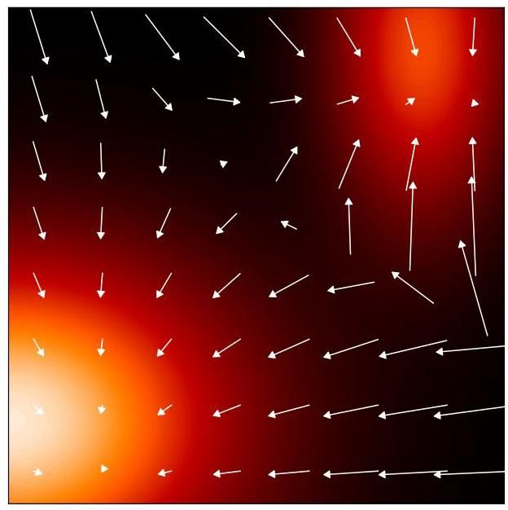

Figure 20.5 Illustration of the score function, showing a distribution in two dimensions comprising a mixture of Gaussians represented as a heat map and the corresponding score function defined by (20.42) plotted as vectors on a regular grid of - values.

图 20.5 分数函数的图示，展示了二维分布，该分布由高斯混合模型组成，以热图表示，以及由 (20.42) 定义的相应分数函数，以向量形式绘制在 值的规则网格上。

To see why the score function is useful, consider two functions and that have the property that their scores are equal, so that for all values of . If we integrate both sides of the equation with respect to and take exponentials, we obtain where is a constant independent of . So if we are able to learn a model of the score function then we have modelled the original data density, up to a multiplicative constant.

为了理解分数函数为何有用，考虑两个函数 和 ，它们具有分数相等的性质，即对于 的所有值都有 。如果我们对该方程两边关于 进行积分并取指数，我们得到 ，其中 是一个与 无关的常数。因此，如果我们能够学习分数函数的模型 ，那么我们就对原始数据密度进行了建模，只差一个乘法常数。

# 20.3.1 Score loss function

# 20.3.1 分数损失函数

To train such a model we need to define a loss function that aims to match the model score function to the score function of the distribution that generated the data. An example of such a loss function is the expected squared error between the model score and the true score, given by

为了训练这样一个模型，我们需要定义一个损失函数，其目标是使模型分数函数 与生成数据的分布 的分数函数 相匹配。这样一个损失函数的例子是模型分数与真实分数之间的期望平方误差，由下式给出

Section 14.3.1

第 14.3.1 节

As we saw in the discussion of energy-based models, the score function does not require the associated probability density to be normalized, because the normalization constant is removed by the gradient operator, and so there is considerable flexibility in the choice of model. There are broadly two ways to represent the score function using a deep neural network. Each element of corresponds to one of the elements of , so the first approach is to have a network with the same number of outputs as inputs. However, the score function is defined to be the gradient of a scalar function (the log probability density), which is a more restricted class of functions. So an alternative approach is to have a network with a single output and then to compute using automatic differentiation. This second approach, however, requires two backpropagation steps and is therefore computationally more expensive. For this reason, most applications simply adopt the first approach.

正如我们在基于能量的模型的讨论中所见，分数函数不需要对相关的概率密度进行归一化，因为归一化常数会被梯度算子消除，因此在模型选择上有相当大的灵活性。使用深度神经网络表示分数函数 大致有两种方法。 的每个元素 对应于 的元素 之一，因此第一种方法是使用一个输出数量与输入数量相同的网络。然而，分数函数被定义为一个标量函数(对数概率密度)的梯度，这是一类更受限制的函数。因此，另一种方法是使用一个具有单个输出 的网络，然后使用自动微分来计算 。然而，第二种方法需要两步反向传播，因此计算成本更高。出于这个原因，大多数应用程序只是采用第一种方法。

Exercise 20.14

练习 20.14

Exercise 20.15

练习 20.15

# 20.3.2 Modified score loss

# 20.3.2 修改后的分数损失

One problem with the loss function (20.43) is that we cannot minimize it directly because we do not know the true data score . All we have is the finite data set from which we can construct an empirical distribution:

损失函数 (20.43) 存在一个问题，即我们无法直接对其进行最小化，因为我们不知道真实的数据分数 。我们仅有的是有限的数据集 ，可以从中构建经验分布:

Here is the Dirac delta function, which can be thought of informally as an infinitely tall ’spike’ at with the properties

这里 是狄拉克δ函数，可以非正式地将其视为在 处的一个无限高的 “尖峰”，具有以下性质

Since (20.44) is not a differentiable function of , we cannot compute its score function. We can address this by introducing a noise model to ’smear out’ the data points and give a smooth, differentiable representation of the density. This is known as a Parzen estimator or kernel density estimator and is defined by

由于 (20.44) 不是 的可微函数，我们无法计算其分数函数。我们可以通过引入一个噪声模型来 “模糊” 数据点，并给出密度的平滑、可微表示来解决这个问题。这被称为帕曾估计器或核密度估计器，其定义为

Section 3.5.2

3.5.2 节

where is the noise kernel. A common choice of kernel is the Gaussian

其中 是噪声核。一种常见的核选择是高斯核

Instead of minimizing the loss function (20.43), we then use the corresponding loss with respect to the smoothed Parzen density in the form

我们不最小化损失函数 (20.43)，而是使用关于平滑后的 Parzen 密度的相应损失，其形式为

A key result is that by substituting (20.47) into (20.49) we can rewrite this loss function in an equivalent form given by (Vincent, 2011)

一个关键结果是，将 (20.47) 代入 (20.49) 后，我们可以将这个损失函数重写为 (Vincent, 2011) 给出的等价形式

(20.50)

Exercise 20.17

练习 20.17

If we substitute for using the empirical density (20.44), we obtain

如果我们使用经验密度 (20.44) 来替代 ，我们得到

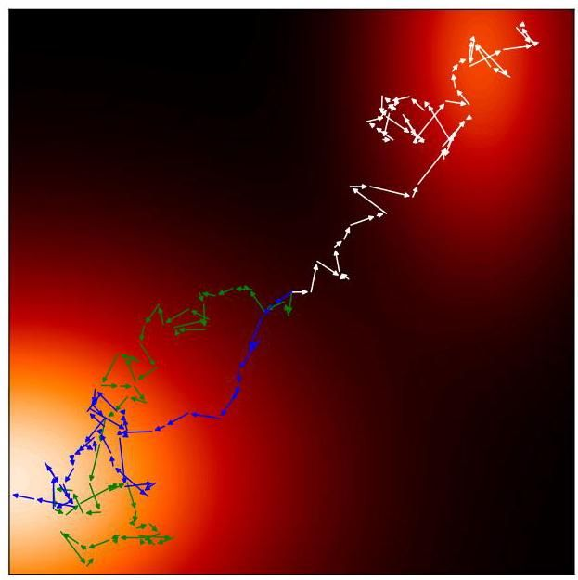

Figure 20.6 Examples of sampling trajectories obtained using Langevin dynamics defined by (14.61) for the distribution shown in Figure 20.5, showing three trajectories all starting at the centre of the plot.

图 20.6 展示了使用由 (14.61) 定义的朗之万动力学为图 20.5 所示分布获取的采样轨迹示例，图中显示了三条均从绘图中心开始的轨迹。

For the Gaussian Parzen kernel (20.48), the score function becomes

对于高斯帕曾核 (20.48)，得分函数变为

where is drawn from . If we consider the specific noise model (20.6) then we obtain

其中 是从 中抽取的。如果我们考虑特定的噪声模型 (20.6)，那么我们得到

We therefore see that the score loss (20.50) measures the difference between the neural network prediction and the noise . Therefore, this loss function has the same minimum as the form (20.37) used in the denoising diffusion model, with the score function playing the same role as the noise prediction network up to a constant scaling (Song and Ermon,2019). Minimizing (20.50) is known as denoising score matching, and we see the close connection to denoising diffusion models. There remains the question of how to choose the noise variance , and we will return to this shortly.

因此，我们看到得分损失 (20.50) 衡量了神经网络预测与噪声 之间的差异。因此，这个损失函数与去噪扩散模型中使用的形式 (20.37) 具有相同的最小值，得分函数 与噪声预测网络 起到相同的作用，只是相差一个常数缩放因子 (Song 和 Ermon，2019)。最小化 (20.50) 被称为去噪得分匹配，我们可以看到它与去噪扩散模型的紧密联系。仍然存在如何选择噪声方差 的问题，我们将很快回到这个问题。

Having trained a score-based model we then need to draw new samples. Langevin dynamics is well-suited to score-based models because it is based on the score function and therefore does not require a normalized probability distribution, and is illustrated in Figure 20.6.

在训练了一个基于得分的模型之后，我们需要生成新的样本。朗之万动力学非常适合基于得分的模型，因为它基于得分函数，因此不需要归一化的概率分布，如图 20.6 所示。

Section 14.3

第 14.3 节

# 20.3.3 Noise variance

# 20.3.3 噪声方差

We have seen how to learn the score function from a set of training data and how to generate new samples from the learned distribution using Langevin sampling. However, we can identify three potential problems with this approach (Song and

我们已经了解了如何从一组训练数据中学习得分函数，以及如何使用朗之万采样从学习到的分布中生成新样本。然而，我们可以发现这种方法存在三个潜在问题(Song 和

Ermon, 2019; Luo, 2022). First, if the data distribution lies on a manifold of lower dimensionality than the data space, the probability density will be zero at points off the manifold and here the score function is undefined since is undefined. Second, in regions of low data density, the estimate of the score function may be inaccurate since the loss function (20.43) is weighted by the density. An inaccurate score function can lead to poor trajectories when using Langevin sampling. Third, even with an accurate model of the score function, the Langevin procedure may not sample correctly if the data distribution comprises a mixture of disjoint distributions.

Ermon，2019；Luo，2022)。首先，如果数据分布位于比数据空间维度更低的流形上，那么在流形之外的点处概率密度将为零，并且由于 未定义，此处的得分函数也未定义。其次，在数据密度较低的区域，得分函数的估计可能不准确，因为损失函数(20.43)是由密度加权的。不准确的得分函数在使用朗之万采样时可能导致较差的轨迹。第三，即使有一个准确的得分函数模型，如果数据分布包含不相交分布的混合，朗之万过程可能无法正确采样。

Chapter 16

第16章

Exercise 20.18

练习20.18

All three problems can be addressed by choosing a sufficiently large value for the noise variance used in the kernel function (20.48), because this smears out the data distribution. However, too large a variance will introduce a significant distortion of the original distribution and this itself introduces inaccuracies in the modelling of the score function. This trade-off can be addressed by considering a sequence of variance values (Song and Ermon,2019), in which is sufficiently small that the data distribution is accurately represented whereas is sufficiently large that the aforementioned problems are avoided. The score network is then modified to take the variance as an additional input and is trained by using a loss function that is a weighted sum of the loss functions of the form (20.51) in which each term represents the error between the associated network and the corresponding perturbed data set. For a data vector , the loss function then takes the form

通过为核函数(20.48)中使用的噪声方差 选择足够大的值，可以解决所有这三个问题，因为这会使数据分布变得平滑。然而，方差过大将导致原始分布出现显著失真，而这本身会在得分函数的建模中引入不准确性。可以通过考虑一系列方差值 来解决这种权衡问题(Song 和 Ermon，2019)，其中 足够小，以便准确表示数据分布，而 足够大，从而避免上述问题。然后修改得分网络，将方差作为额外输入 ，并使用一个损失函数进行训练，该损失函数是形式为(20.51)的损失函数的加权和，其中每个项表示相关网络与相应扰动数据集之间的误差。对于数据向量 ，损失函数则采用以下形式

where are weighting coefficients. We see that this training procedure precisely mirrors that used to train hierarchical denoising networks.

其中 是加权系数。我们看到，这种训练过程与用于训练分层去噪网络的过程完全一致。

Section 20.2.1

第 20.2.1 节

Once trained, samples can be generated by running a few steps of Langevin sampling from each of the models for in turn. This technique is called annealed Langevin dynamics, and is analogous to Algorithm 20.2 used to sample from denoising diffusion models.

训练完成后，可以通过依次对 中的每个模型运行几步朗之万采样来生成样本。这种技术称为退火朗之万动力学，类似于用于从去噪扩散模型中采样的算法 20.2。

# 20.3.4 Stochastic differential equations

# 20.3.4 随机微分方程

We have seen that it is helpful to use a large number of steps, often several thousand, when constructing the noise process for a diffusion model. It is therefore natural to ask what happens if we consider the limit of an infinite number of steps, much as we did for infinitely deep neural networks when we introduced neural differential equations. In taking such a limit, we need to ensure that the noise variance at each step becomes smaller in keeping with the step size. This leads to a formulation of diffusion models for continuous time as stochastic differential equations or SDEs (Song et al., 2020). Both denoising diffusion probabilistic models and score matching models can then be viewed as a discretization of a continuous-time SDE.

我们已经看到，在为扩散模型构建噪声过程时，使用大量步骤(通常是数千步)是有帮助的。因此，很自然地会问，如果我们考虑步数趋于无穷大的极限情况会发生什么，就像我们在引入神经微分方程时对无限深度神经网络所做的那样。在取这样的极限时，我们需要确保每一步的噪声方差 随着步长的减小而变小。这导致将连续时间的扩散模型表述为随机微分方程(SDE)(Song 等人，2020)。然后，去噪扩散概率模型和得分匹配模型都可以被视为连续时间 SDE 的离散化。

Section 18.3.1

第 18.3.1 节

We can write a general SDE as an infinitesimal update to the vector in the form

我们可以将一般的随机微分方程(SDE)写成向量 的无穷小更新形式

where the drift term is deterministic, as in an ODE, but the diffusion term is stochastic, for example given by infinitesimal Gaussian steps. Here the parameter is often called ‘time’ by analogy with physical systems. The forward noise process (20.3) for a diffusion model can be written as an SDE of the form (20.55) by taking the continuous-time limit.

其中，漂移项是确定性的，就像常微分方程(ODE)一样，但扩散项是随机的，例如由无穷小的高斯步长给出。在这里，参数 通常通过与物理系统类比而被称为“时间”。通过取连续时间极限，扩散模型的前向噪声过程(20.3)可以写成形式为(20.55)的随机微分方程。

Exercise 20.19

练习 20.19

For the SDE (20.55), there is a corresponding reverse SDE (Song et al., 2020)

对于随机微分方程(20.55)，存在一个相应的反向随机微分方程(Song 等人，2020)

given by

由下式给出

where we recognize as the score function. The SDE given by (20.55) is to be solved in reverse from to .

其中我们将 识别为得分函数。由(20.55)给出的随机微分方程需要从 到 反向求解。

To solve an SDE numerically, we need to discretize the time variable. The simplest approach is to use fixed, equally spaced time steps, which is known as the Euler-Maruyama solver. For the reverse SDE, we then recover a form of the Langevin equation. However, more sophisticated solvers can be employed that use more flexible forms of discretization (Kloeden and Platen, 2013).

为了对随机微分方程(SDE)进行数值求解，我们需要对时间变量进行离散化。最简单的方法是使用固定的等间距时间步长，这就是所谓的欧拉 - 丸山求解器。对于反向随机微分方程，我们可以得到朗之万方程的一种形式。然而，我们也可以采用更复杂的求解器，它们使用更灵活的离散化形式(Kloeden 和 Platen，2013)。

Section 14.3

第 14.3 节

For all diffusion processes governed by an SDE, there exists a corresponding deterministic process described by an ODE whose trajectories have the same marginal probability densities as the SDE (Song et al.,2020). For an SDE of the form (20.56), the corresponding ODE is given by

对于所有由随机微分方程(SDE)支配的扩散过程，都存在一个由常微分方程(ODE)描述的相应确定性过程，其轨迹与随机微分方程具有相同的边缘概率密度 (Song 等人，2020)。对于形式为(20.56)的随机微分方程，相应的常微分方程为

The ODE formulation allows the use of efficient adaptive-step solvers to reduce the number of function evaluations dramatically. Moreover, it allows probabilistic diffusion models to be related to normalizing flow models, from which the change-of-variables formula (18.1) can be used to provide an exact evaluation of the log likelihood.

常微分方程(ODE)的形式允许使用高效的自适应步长求解器，从而显著减少函数求值的次数。此外，它还允许将概率扩散模型与归一化流模型联系起来，通过变量变换公式(18.1)可以对对数似然进行精确评估。

Chapter 18

第 18 章

# 20.4. Guided Diffusion

# 20.4. 引导扩散

So far, we have considered diffusion models as a way to represent the unconditional density learned from a set of training examples drawn independently from . Once the model has been trained, we can generate new samples from this distribution. We have already seen an example of unconditional sampling from a deep generative model for face images in Figure 1.3, in that case from a GAN model.

到目前为止，我们将扩散模型视为一种表示无条件密度 的方法，该密度是从一组独立地从 中抽取的训练示例 中学习得到的。一旦模型训练完成，我们就可以从这个分布中生成新的样本。我们已经在图 1.3 中看到了一个从用于人脸图像的深度生成模型进行无条件采样的示例，在那个例子中使用的是生成对抗网络(GAN)模型。

In many applications, however, we want to sample from a conditional distribution where the conditioning variable could, for example, be a class label or a textual description of the desired content for an image. This also forms the basis for applications such as image super-resolution, image inpainting, video generation, and many others. The simplest approach to achieving this would be to treat as an additional input into the denoising neural network and then to train the network using matched pairs . The main limitation of this approach is that the network can give insufficient weight to, or even ignore, the conditioning variables, so we need a way to control how much weight is given to the conditioning information and to trade this off against sample diversity. This additional pressure to match the conditioning information is called guidance. There are two main approaches to guidance depending on whether or not a separate classifier model is used.

然而，在许多应用中，我们希望从条件分布 中采样，其中条件变量 例如可以是类别标签或图像所需内容的文本描述。这也构成了诸如图像超分辨率、图像修复、视频生成等许多应用的基础。实现这一点的最简单方法是将 作为去噪神经网络 的额外输入，然后使用匹配对 来训练网络。这种方法的主要局限性在于网络可能对条件变量赋予的权重不足，甚至忽略这些条件变量，因此我们需要一种方法来控制给予条件信息的权重，并在样本多样性之间进行权衡。这种匹配条件信息的额外压力被称为引导。根据是否使用单独的分类器模型，有两种主要的引导方法。

# 20.4.1 Classifier guidance

# 20.4.1 分类器引导

Suppose that a trained classifier is available, and consider a diffusion model from the perspective of the score function. Using Bayes’ theorem we can write the score function for the conditional diffusion model in the form

假设我们有一个训练好的分类器 ，并从得分函数的角度考虑一个扩散模型。使用贝叶斯定理，我们可以将条件扩散模型的得分函数写成如下形式

where we have used since is independent of . The first term on the right-hand side of (20.58) is the usual unconditional score function, whereas the second term pushes the denoising process towards the direction that maximizes the probability of the given label under the classifier model (Dhariwal and Nichol, 2021). The influence of the classifier can be controlled by introducing a hyperpa-rameter , called the guidance scale, which controls the weight given to the classifier gradient. The score function used for sampling then becomes

其中我们使用了 ，因为 与 无关。式(20.58)右侧的第一项是通常的无条件得分函数，而第二项则将去噪过程推向在分类器模型下使给定标签 的概率最大化的方向(Dhariwal 和 Nichol，2021)。可以通过引入一个超参数 来控制分类器的影响，这个超参数称为引导尺度，它控制着给予分类器梯度的权重。然后用于采样的得分函数变为

If we recover the original unconditional diffusion model, whereas if we obtain the score corresponding to the conditional distribution . For the model is strongly encouraged to respect the conditioning label, and values of may be used, for example . However, this comes at the expense of diversity in the samples as the model prefers ’easy’ examples that the classifier is able to classify correctly.

如果 ，我们就恢复到原始的无条件扩散模型；而如果 ，我们就得到对应于条件分布 的得分。对于 ，模型会被强烈鼓励遵循条件标签，例如可以使用 的值 。然而，这是以样本的多样性为代价的，因为模型更喜欢分类器能够正确分类的“简单”示例。

One problem with the classifier-based approach to guidance is that a separate classifier must be trained. Furthermore, this classifier needs to be able to classify examples with varying degrees of noise, whereas standard classifiers are trained on clean examples. We therefore turn to an alternative approach that avoids the use of a separate classifier.

基于分类器的引导方法存在一个问题，即必须训练一个单独的分类器。此外，这个分类器需要能够对具有不同噪声程度的示例进行分类，而标准分类器是在干净的示例上进行训练的。因此，我们转向一种避免使用单独分类器的替代方法。

# 20.4.2 Classifier-free guidance

# 20.4.2 无分类器引导

If we use (20.58) to replace in (20.59), we can write the score function in the form

如果我们使用 (20.58) 来替换 (20.59) 中的 ，我们可以将得分函数写成如下形式

Exercise 20.20

练习 20.20

which for represents a convex combination of the conditional log density and the unconditional density . For the contribution from the unconditional score becomes negative, meaning the model actively reduces the probability of generating samples that ignore the conditioning information in favour of samples that do.

对于 ，它表示条件对数密度 和无条件 密度 的凸组合。对于 ，无条件得分的贡献变为负，这意味着模型会积极降低生成忽略条件信息的样本的概率，而倾向于生成考虑条件信息的样本。

Furthermore, we can avoid training separate networks to model and by training a single conditional model in which the conditioning variable is set to a null value, for example , with some probability during training, typically around . Then is represented by . This is somewhat analogous to dropout in which the conditioning inputs are collectively set to zero for a random subset of training vectors.

此外，我们可以通过训练一个单一的条件模型来避免训练单独的网络来对 和 进行建模。在训练过程中，以一定的概率(通常约为 )将条件变量 设置为一个空值，例如 。然后 由 表示。这有点类似于随机失活，在随机失活中，对于训练向量的一个随机子集，条件输入被集体设置为零。

Section 9.6.1

第9.6.1节

Once trained, the score function (20.60) is then used to encourage a strong weighting of the conditional information. In practice, classifier-free guidance gives much higher quality results than classifier guidance (Nichol et al., 2021; Saharia et al.,2022). The reason is that a classifier can ignore most of the input vector as long as it makes a good prediction of whereas classifier-free guidance is based on the conditional density , which must assign a high probability to all aspects of .

一旦完成训练，得分函数(20.60)便用于强化对条件信息的加权。在实践中，无分类器引导比分类器引导能得到质量更高的结果(Nichol等人，2021年；Saharia等人，2022年)。原因在于，分类器 只要能对 做出良好预测，就可以忽略输入向量 的大部分内容，而无分类器引导基于条件密度 ，它必须为 的所有方面赋予高概率。

Text-guided diffusion models can leverage techniques from large language models to allow the conditioning input to be a general text sequence, known as a prompt, and not simply a selection from a predefined set of class labels. This allows the text input to influence the denoising process in two ways, first by concatenating the internal representation from a transformer-based language model with the input to the de-noising network and second by allowing cross-attention layers within the denoising network to attend to the text token sequence. Classifier-free guidance, conditioned on a text prompt, is illustrated in Figure 20.7.

文本引导的扩散模型可以利用大语言模型的技术，使条件输入成为一个通用的文本序列，即提示词，而不仅仅是从预定义的类别标签集合中进行选择。这使得文本输入能够通过两种方式影响去噪过程，一是将基于Transformer的语言模型的内部表示与去噪网络的输入进行拼接，二是让去噪网络中的交叉注意力层关注文本标记序列。基于文本提示词的无分类器引导如图20.7所示。

Chapter 12

第12章

Another application for conditional diffusion models is image super-resolution in which a low-resolution image is transformed into a corresponding high-resolution image. This is intrinsically an inverse problem, and multiple high-resolution images will be consistent with a given low-resolution image. Super-resolution can be achieved by denoising a high-resolution sample from a Gaussian using the low-resolution image as a conditioning variable (Saharia, Ho, et al., 2021). Examples of this method are shown in Figure 20.8. Such models can be cascaded to achieve very high resolution (Ho et al.,2021), for example going from to , and then from to . Each stage is typically represented by a U-net architecture, with each U-net conditioned on the final denoised output of the previous one.

条件扩散模型的另一个应用是图像超分辨率，即将低分辨率图像转换为相应的高分辨率图像。这本质上是一个逆问题，多个高分辨率图像可能与给定的低分辨率图像相匹配。超分辨率可以通过使用低分辨率图像作为条件变量，对来自高斯分布的高分辨率样本进行去噪来实现(Saharia、Ho等人，2021年)。图20.8展示了该方法的示例。此类模型可以级联使用以实现非常高的分辨率(Ho等人，2021年)，例如从 提升到 ，然后从 提升到 。每个阶段通常由一个U型网络架构表示，每个U型网络都以先前阶段的最终去噪输出为条件。

Section 10.5.4

第10.5.4节

This type of cascade can also be used with image-generation diffusion models, in which the image denoising is performed at a lower resolution and the result is subsequently up-sampled using a separate network (which may also take a text prompt as input) to give a final high-resolution output (Nichol et al., 2021; Saharia et al., 2022). This can significantly reduce the computational cost compared to working directly in a high-dimensional space since the denoising process may involve hundreds of passes through the denoising network. Note that these approaches still work within the image space directly but at lower resolution.

这种级联方式也可用于图像生成扩散模型，在该模型中，图像去噪在较低分辨率下进行，然后使用一个单独的网络(该网络也可以将文本提示作为输入)对结果进行上采样，以得到最终的高分辨率输出(Nichol 等人，2021 年；Saharia 等人，2022 年)。与直接在高维空间中处理相比，这可以显著降低计算成本，因为去噪过程可能需要通过去噪网络进行数百次迭代。请注意，这些方法仍然是直接在图像空间内进行处理，但分辨率较低。

A different approach to addressing the high computational cost of applying diffusion models directly in the space of high-resolution images is called latent diffu-

另一种解决直接在高分辨率图像空间中应用扩散模型计算成本高的方法称为潜在扩散

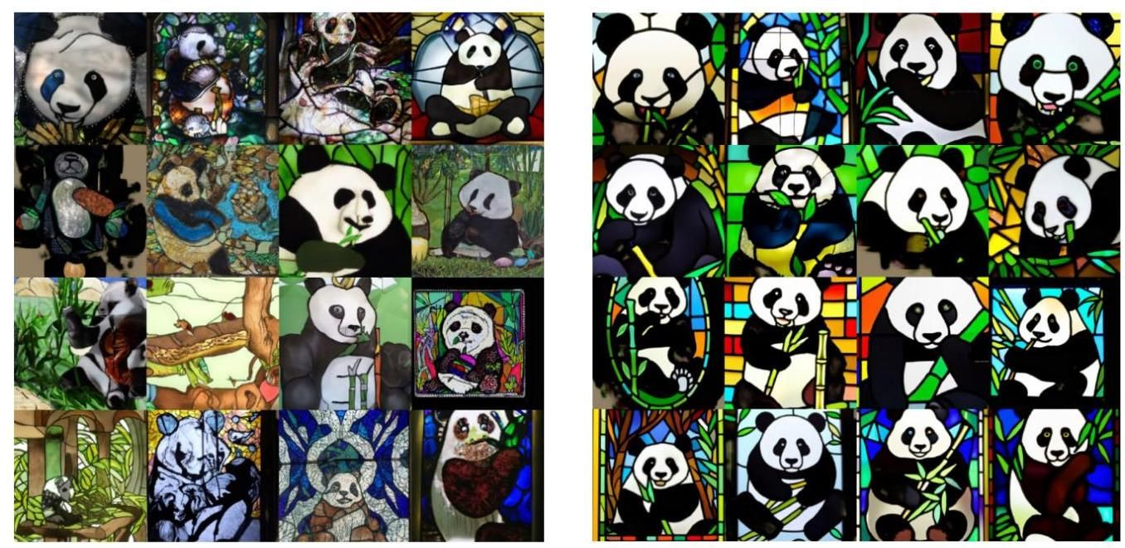

Figure 20.7 Illustration of classifier-free guidance of diffusion models, generated from a model called GLIDE using the conditioning text A stained glass window of a panda eating bamboo. Examples on the left were generated with (no guidance, just the plain conditional model) whereas examples on the right were generated with . [From Nichol et al. (2021) with permission.]

图 20.7 扩散模型无分类器引导的示意图，使用名为 GLIDE 的模型根据条件文本“一只正在吃竹子的熊猫的彩色玻璃窗”生成。左侧的示例是在 (无引导，仅为普通条件模型)下生成的，而右侧的示例是在 下生成的。[经许可改编自 Nichol 等人(2021 年)。]

Section 19.1 sion models (Rombach et al., 2021). Here an autoencoder is first trained on noise-free images to obtain a lower-dimensional representation of the images and is then fixed. A U-net architecture is then trained to perform the denoising within the lower-dimensional space, which itself is not directly interpretable as an image. Finally, the denoised representation is mapped into the high-resolution image space using the output half of the fixed autoencoder network. This approach makes more efficient use of the low-dimensional space, which can then focus on image semantics, leaving the decoder to create a corresponding sharp, high-resolution image from the denoised low-dimensional representation.

第 19.1 节 扩散模型(Rombach 等人，2021 年)。这里，首先在无噪声图像上训练一个自动编码器，以获得图像的低维表示，然后将其固定。接着训练一个 U 型网络架构，在低维空间内进行去噪，该低维空间本身不能直接解释为图像。最后，使用固定自动编码器网络的输出部分将去噪后的表示映射到高分辨率图像空间。这种方法更有效地利用了低维空间，使其能够专注于图像语义，而解码器则根据去噪后的低维表示创建相应的清晰高分辨率图像。

There are many other applications of conditional image generation including inpainting, un-cropping, restoration, image morphing, style transfer, colourization, de-blurring, and video generation (Yang, Srivastava, and Mandt, 2022). An example of inpainting is shown in Figure 20.9. Exercises

条件图像生成还有许多其他应用，包括图像修复、图像扩展、图像恢复、图像变形、风格迁移、图像着色、图像去模糊和视频生成(Yang、Srivastava 和 Mandt，2022 年)。图 20.9 展示了一个图像修复的示例。练习

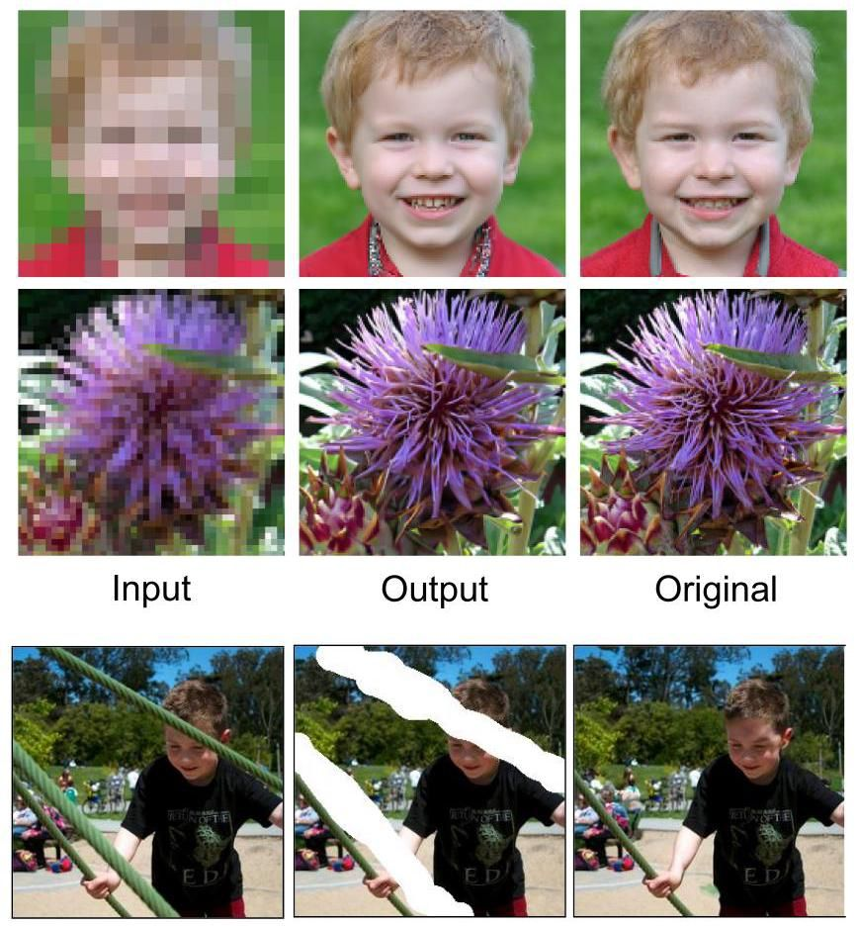

Figure 20.8 Two examples of low-resolution images along with associated samples of corresponding high-resolution images generated by a diffusion model. The top row shows a input image and the corresponding output image along with the original image from which the input image was generated. The bottom row shows a 64 input image with a output image, again with the original image for comparison. [From Saharia, Ho, et al. (2021) with permission.]

图 20.8 低分辨率图像的两个示例以及由扩散模型生成的相应高分辨率图像样本。第一行展示了一个 输入图像和对应的 输出图像，以及生成该输入图像的原始图像。第二行展示了一个 64 输入图像和 输出图像，同样给出了原始图像以供比较。[经许可改编自 Saharia、Ho 等人(2021 年)。]

Figure 20.9 Example of inpaint-ing showing the original image on the left, an image with sections removed in the middle, and the image with inpainting on the right. [From Saharia, Chan, Chang, et al. (2021) with permission.]

图 20.9 图像修复示例，左侧为原始图像，中间为去除部分区域的图像，右侧为修复后的图像。[经许可改编自 Saharia、Chan、Chang 等人(2021 年)的研究。]

20.1 ( ) Using (20.3) write down expressions for the mean and covariance of in terms of the mean and covariance of . Hence, show that for the mean of the distribution of is closer to zero than the mean of and that the covariance of is closer to the unit matrix than the covariance of .

20.1 ( ) 利用式 (20.3)，根据 的均值和协方差写出 的均值和协方差的表达式。因此，证明对于 ， 分布的均值比 的均值更接近零，并且 的协方差比 的协方差更接近单位矩阵 。

20.2 (★) Show that the transformation (20.1) can be written in the equivalent form (20.2).

20.2 (★) 证明变换式 (20.1) 可以写成等价形式 (20.2)。

20.3 In this exercise we use proof by induction to show that the marginal distribution of for the forward process of the diffusion model, as defined by (20.4), is given by (20.6) where is defined by (20.7). First verify that (20.6) holds when . Now assume that (20.6) is true for some particular value of and derive the corresponding result for the value . To do this, it is easiest to write the forward process using the representation (20.3) and to make use of the result (3.212), which shows that the sum of two independent Gaussian random variables is itself a Gaussian in which the means and covariances are additive.

20.3 在本题中，我们使用归纳法证明，如式 (20.4) 所定义的扩散模型前向过程中， 的边缘分布由式 (20.6) 给出，其中 由式 (20.7) 定义。首先验证当 时，式 (20.6) 成立。现在假设对于某个特定的 值，式 (20.6) 成立，并推导出 值对应的结果。为此，使用表达式 (20.3) 来表示前向过程，并利用结果 (3.212) 会更简便，该结果表明两个独立高斯随机变量的和本身也是一个高斯分布，其均值和协方差具有可加性。

20.4 (*) By using the result (20.6), where is defined by (20.7), show that in the limit we obtain (20.9).

20.4 (*) 利用结果 (20.6)，其中 由式 (20.7) 定义，证明在极限 情况下，我们可以得到式 (20.9)。

20.5 Consider two independent random variables and along with a fixed scalar . Show that

20.5 考虑两个独立的随机变量 和 ，以及一个固定标量 。证明

Use these results to show that if the distribution of has zero mean and unit covariance, then the distribution of , defined by (20.3), will also have zero mean and unit covariance, irrespective of the value of .

利用这些结果证明，如果 的分布均值为零且协方差为单位矩阵，那么由 (20.3) 定义的 的分布也将具有零均值和单位协方差，而与 的值无关。

20.6 In this exercise we will use the technique of completing the square to derive the result (20.15) starting from Bayes’ theorem (20.13). First note that the two terms in the numerator on the right-hand side of (20.13), given by (20.4) and (20.6), both take the form of exponentials of quadratic functions of . The required distribution is therefore a Gaussian, and so we need only to find its mean and covariance. To do this, consider only the terms in the exponentials that depend on and note that the product of two exponentials is the exponential of the sum of the two exponents. Gather together all the terms that are quadratic in as well as those that are linear in and then rearrange them in the form . Then, by inspection, find expressions for and . Note that additive terms that are independent of can be ignored.

20.6 在本练习中，我们将使用配方法从贝叶斯定理 (20.13) 推导出结果 (20.15)。首先注意，(20.13) 右侧分子中的两项，分别由 (20.4) 和 (20.6) 给出，都采用了 的二次函数的指数形式。因此，所需的分布是一个高斯分布，所以我们只需要找到它的均值和协方差。为此，只考虑指数中依赖于 的项，并注意到两个指数的乘积是两个指数之和的指数。将所有 的二次项以及 的一次项收集在一起，然后将它们重新排列成 的形式。然后，通过观察，找到 和 的表达式。注意，可以忽略与 无关的加法项。

20.7 In this exercise we show that the reverse of the conditional distribution for the forward noise process in a diffusion model can be approximated by a Gaussian when the noise variance is small. Consider the inverse conditional distribution given by Bayes’ theorem in the form (20.11) where the forward distribution is given by (20.4). By taking the logarithm of both sides of (20.11) and then making a Taylor expansion of centred on the value , show that, for small values of the noise variance , the distribution is approximately a Gaussian with mean and covariance . Find expressions for the lowest-order corrections to the mean and to the covariance as expansions in powers of .

20.7 在本练习中，我们证明当噪声方差较小时，扩散模型中前向噪声过程的条件分布 的逆可以用高斯分布近似。考虑由贝叶斯定理以 (20.11) 形式给出的逆条件分布 ，其中前向分布 由 (20.4) 给出。对 (20.11) 两边取对数，然后对以值 为中心的 进行泰勒展开，证明对于较小的噪声方差 ，分布 近似为均值为 且协方差为 的高斯分布。找到均值和协方差的最低阶修正项，将其表示为 的幂级数展开形式。

20.8 By substituting the product rule of probability in the form (20.24) into the definition (20.22) of the ELBO for the diffusion model and making use of the definition (20.23) of the Kullback-Leibler divergence, verify that the log likelihood function can be written as the sum of a lower bound and a Kullback-Leibler divergence in the form (20.21).

20.8 将概率的乘积法则以 (20.24) 的形式代入扩散模型的证据下界 (ELBO) 的定义 (20.22) 中，并利用 Kullback-Leibler 散度的定义 (20.23)，验证对数似然函数可以写成 (20.21) 形式的下界与 Kullback-Leibler 散度之和。

20.9 Verify that the ELBO for the diffusion model given by (20.31) can be written in the form (20.32) where the Kullback-Leibler divergence is defined by (20.23).

20.9 验证由 (20.31) 给出的扩散模型的证据下界 (ELBO) 可以写成 (20.32) 的形式，其中 Kullback-Leibler 散度由 (20.23) 定义。

20.10 When we derived the ELBO for the diffusion model given by (20.32), we omitted the first and third terms in (20.26) because they are independent of w. Similarly we omitted the second term in the right-hand side of (20.30) because this is also independent of . Show that if all of these omitted terms are retained they lead to an additional term in the ELBO given by

20.10 当我们推导由 (20.32) 给出的扩散模型的证据下界(ELBO)时，我们省略了 (20.26) 中的第一项和第三项，因为它们与 w 无关。类似地，我们省略了 (20.30) 右侧的第二项，因为这一项也与 无关。证明如果保留所有这些被省略的项，它们会在证据下界 中产生一个额外的项，该项由下式给出

Note that the noise process is constructed in such a way that the distribution is equal to the Gaussian . Similarly, the distribution is defined to be equal to , and hence the two distributions in (20.63) are equal and so the Kullback-Leibler divergence vanishes.

注意，噪声过程的构造方式使得分布 等于高斯分布 。类似地，分布 被定义为等于 ，因此 (20.63) 中的两个分布相等，所以库尔贝克 - 莱布勒散度为零。

20.11 By making use of (20.15) for the distribution and (20.18) for the distribution , show that the Kullback-Leibler divergence appearing in the consistency terms in (20.32) is given by (20.33).

20.11 利用关于分布 的 (20.15) 和关于分布 的 (20.18)，证明 (20.32) 中一致性项里出现的库尔贝克 - 莱布勒散度由 (20.33) 给出。

20.12 By substituting (20.34) into (20.16) rewrite the mean in terms of the original data vector and the noise in the form (20.35), where is defined by (20.7).

20.12 通过将 (20.34) 代入 (20.16)，将均值 用原始数据向量 和噪声 重写为 (20.35) 的形式，其中 由 (20.7) 定义。

20.13 Show that the reconstruction term (20.38) in the ELBO for diffusion models can be written in the form (20.39). To do this, substitute for using (20.36) and substitute for using (20.1), and then make use of , which follows from (20.7).

20.13 证明扩散模型的证据下界中的重建项 (20.38) 可以写成 (20.39) 的形式。为此，使用 (20.36) 代入 ，使用 (20.1) 代入 ，然后利用 ，它由 (20.7) 得出。

20.14 (*) The score function is defined by and is therefore a vector of the same dimensionality as the input vector . Consider a matrix whose elements

20.14 (*) 得分函数由 定义，因此它是一个与输入向量 维度相同的向量。考虑一个矩阵，其元素

are given by

由……给出

Show that if the score function is defined by taking the gradient of the output of a neural network with a single output variable , then all the matrix elements for all pairs . Note that if the score function is instead represented directly by a deep neural network with the same number of outputs as inputs, then only the diagonal matrix elements , and so the output of the network does not in general correspond to the gradient of any scalar function.

证明如果得分函数是通过对具有单个输出变量 的神经网络的输出取梯度 来定义的，那么对于所有的对 ，所有的矩阵元素 都满足……。注意，如果得分函数 直接由一个输出数量与输入数量相同的深度神经网络表示，那么只有对角矩阵元素 满足……，因此网络的输出通常并不对应于任何标量函数的梯度。

20.15 Consider a deep neural network representation for the score function defined by (20.42), where and have dimensionality . Compare the computational complexity of evaluating the score for a network with outputs that represents the score function directly with one that computes a single scalar function in which the score function is computed indirectly through automatic differentiation. Show that the latter approach is typically more computationally expensive.

20.15 考虑由 (20.42) 定义的得分函数的深度神经网络表示 ，其中 和 的维度为 。比较直接表示得分函数的具有 个输出的网络与通过自动微分间接计算得分函数的计算单个标量函数 的网络在计算得分时的计算复杂度。证明后一种方法通常在计算上更昂贵。

20.16 We cannot minimize the score function (20.43) directly because we do not know the functional form of the true data density , and therefore we cannot write down an expression for the score function . However, by using integration by parts (Hyvärinen, 2005), we can rewrite (20.43) in the form

20.16 我们不能直接最小化得分函数 (20.43)，因为我们不知道真实数据密度 的函数形式，因此我们无法写出得分函数 的表达式。然而，通过使用分部积分法(Hyvärinen，2005)，我们可以将 (20.43) 重写为以下形式

where the constant term is independent of the network parameters , and the divergence is defined by

其中常数项与网络参数 无关，并且散度 定义为

in which is the dimensionality of . Derive the result (20.65) by first expanding the square in (20.43) and noting that the term involving already appears in (20.43) whereas the term involving can be absorbed into the additive constant, where we have defined . Now consider the formula

其中 是 的维度。通过首先展开 (20.43) 中的平方项，并注意到涉及 的项已经出现在 (20.43) 中，而涉及 的项可以被吸收到加法常数中(我们已经定义了 )，来推导结果 (20.65)。现在考虑公式

for the derivative of the product of two functions. Integrate both sides of this formula with respect to and rearrange to obtain the integration-by-parts formula:

对于两个函数乘积的导数。对该公式两边关于 进行积分，并重新整理以得到分部积分公式:

where we have assumed that . Apply this result together with the definition to the term involving to complete the proof. Note that the evaluation of the second derivatives in (20.66) requires a separate backward propagation pass for each derivative and hence has an overall computational cost that grows quadratically with the dimensionality of the data space (Martens, Sutskever, and Swersky, 2012). This precludes the direct application of this loss function to spaces of high dimensionality, and so techniques such as sliced score matching (Song et al., 2019) have been developed to help address this inefficiency.

在此我们假设 。将此结果与定义 一起应用于涉及 的项，以完成证明。请注意，计算 (20.66) 中的二阶导数时，每个导数都需要单独进行一次反向传播，因此其总体计算成本会随着数据空间的维度 的增加而呈二次方增长(Martens、Sutskever 和 Swersky，2012 年)。这使得该损失函数无法直接应用于高维空间，因此人们开发了诸如切片得分匹配(Song 等人，2019 年)等技术来解决这种低效问题。

20.17 In this exercise we show that the score function loss (20.50) is equivalent, up to an additive constant, to the form (20.49). To do this, first expand the square in (20.49) and by using (20.47) show that the term in from (20.49) is the same as the corresponding term obtained by expanding the square in (20.50). Next note that the term in in (20.49) is independent of and likewise that the corresponding term in (20.50) is also independent of , and so these can be viewed as additive constants in the loss function and play no role in training. Finally, consider the cross-term in (20.49). By substituting for using (20.47), show that this is equal to the corresponding cross-term from (20.50). Hence, show that the two loss functions are equal up to an additive constant.

20.17 在本练习中，我们将证明得分函数损失 (20.50) 与形式 (20.49) 相差一个加法常数。为此，首先展开 (20.49) 中的平方项，并利用 (20.47) 证明 (20.49) 中涉及 的项与展开 (20.50) 中的平方项所得到的相应项相同。接下来，注意到 (20.49) 中涉及 的项与 无关，同样，(20.50) 中的相应项也与 无关，因此这些项可以被视为损失函数中的加法常数，在训练过程中不起作用。最后，考虑 (20.49) 中的交叉项。通过使用 (20.47) 替换 ，证明该项等于 (20.50) 中的相应交叉项。因此，证明这两个损失函数相差一个加法常数。

20.18 Consider a probability distribution that consists of a mixture of two disjoint distributions (i.e., distributions with the property that when one of them is non-zero the other must be zero) of the form

20.18 考虑一个由两个不相交分布(即具有当其中一个分布不为零时另一个分布必须为零这一性质的分布)混合而成的概率分布，其形式为

Show that when the score function, defined by (20.42), is evaluated for any given point , the mixing coefficient does not appear. From this it follows that Langevin dynamics defined by (14.61) will not sample from the two component distributions with the correct proportions. This problem is resolved by adding noise from a broad distribution, as discussed in the text.

证明当对任意给定点 计算由 (20.42) 定义的得分函数时，混合系数 不会出现。由此可知，由 (14.61) 定义的朗之万动力学不会以正确的比例从两个分量分布中采样。如正文所述，通过添加来自广泛分布的噪声可以解决这个问题。

20.19 For discrete steps, the forward noise process in a diffusion model is defined by (20.3). Here we take the continuous-time limit and convert this to an SDE. We first introduce a continuously-changing variance function such that . By making a Taylor expansion of the square root in the first term on the right-hand-side of (20.3), show that the infinitesimal update can be written in the form

20.19 对于离散步骤，扩散模型中的前向噪声过程由 (20.3) 定义。在此我们取连续时间极限并将其转换为随机微分方程(SDE)。首先，我们引入一个连续变化的方差函数 ，使得 。通过对 (20.3) 右侧第一项中的平方根进行泰勒展开，证明无穷小更新可以写成如下形式

We see that this is a special case of the general SDE (20.55).

我们发现这是一般随机微分方程 (20.55) 的一个特殊情况。

20.20 ( ) By using (20.58) to replace , show that the score function in (20.59) can be written in the form (20.60).

20.20 ( ) 通过使用 (20.58) 替换 ，证明 (20.59) 中的得分函数可以写成 (20.60) 的形式。

Deep Learning

深度学习

# Appendix A. Linear Algebra

# 附录 A. 线性代数

In this appendix, we gather together some useful properties and identities involving matrices and determinants. This is not intended to be an introductory tutorial, and it is assumed that the reader is already familiar with basic linear algebra. For some results, we indicate how to prove them, whereas in more complex cases we leave the interested reader to refer to standard textbooks on the subject. In all cases, we assume that inverses exist and that matrix dimensions are such that the formulae are correctly defined. A comprehensive discussion of linear algebra can be found in Golub and Van Loan (1996), and an extensive collection of matrix properties is given by Lütkepohl (1996). Matrix derivatives are discussed in Magnus and Neudecker (1999).

在本附录中，我们汇总了一些涉及矩阵和行列式的有用性质和恒等式。这并非旨在作为入门教程，我们假定读者已经熟悉基础线性代数知识。对于一些结果，我们会指出如何证明它们，而在更复杂的情况下，我们会让感兴趣的读者参考该主题的标准教科书。在所有情况下，我们都假定逆矩阵存在，并且矩阵的维度使得公式定义正确。关于线性代数的全面讨论可参考 Golub 和 Van Loan (1996)，Lütkepohl (1996) 给出了大量的矩阵性质。矩阵导数在 Magnus 和 Neudecker (1999) 中有讨论。

# A.1. Matrix Identities

# A.1. 矩阵恒等式

A matrix has elements where indexes the rows and indexes the columns. We use to denote the identity matrix (also called the unit matrix), and if there is no ambiguity over dimensionality, we simply use . The transpose matrix has elements . From the definition of a transpose, we have

矩阵 的元素为 ，其中 表示行索引， 表示列索引。我们用 表示 单位矩阵(也称为幺矩阵)，如果在维度上没有歧义，我们简单地使用 。转置矩阵 的元素为 。根据转置的定义，我们有

which can be verified by writing out the indices. The inverse of , denoted , satisfies

这可以通过写出指标来验证。 的逆，记为 ，满足

Because , we have

因为 ，我们有

Also we have

此外，我们还有

which is easily proven by taking the transpose of (A.2) and applying (A.1).

通过对 (A.2) 取转置并应用 (A.1) 很容易证明这一点。

[2]

A useful identity involving matrix inverses is the following:

一个涉及矩阵逆的有用恒等式如下:

which is easily verified by right-multiplying both sides by . Suppose that has dimensionality and that has dimensionality , so that is . Then if , it will be much cheaper to evaluate the right-hand side of (A.5) than the left-hand side. A special case that sometimes arises is

通过将两边右乘 很容易验证这一点。假设 的维数为 ， 的维数为 ，使得 是 。那么如果 ，计算 (A.5) 的右侧比左侧要便宜得多。有时会出现的一种特殊情况是

Another useful identity involving inverses is the following:

另一个涉及逆矩阵的有用恒等式如下:

which is known as the Woodbury identity. It can be verified by multiplying both sides by . This is useful, for instance, when is large and diagonal and hence easy to invert, and when has many rows but few columns (and conversely for ), so that the right-hand side is much cheaper to evaluate than the left-hand side.

这被称为伍德伯里恒等式。可以通过将两边同时乘以 来验证。例如，当 很大且为对角矩阵，因此易于求逆，并且当 有很多行但列数很少(反之对于 也是如此)时，这很有用，这样右侧的计算成本比左侧低得多。

A set of vectors is said to be linearly independent if the relation holds only if all . This implies that none of the vectors can be expressed as a linear combination of the remainder. The rank of a matrix is the maximum number of linearly independent rows (or equivalently the maximum number of linearly independent columns).

如果关系 仅在所有 都成立时才成立，则称一组向量 是线性无关的。这意味着这些向量中没有一个可以表示为其余向量的线性组合。矩阵的秩是线性无关行的最大数量(或者等价地，是线性无关列的最大数量)。

# A.2. Traces and Determinants

# A.2. 迹和行列式

Square matrices have traces and determinants. The trace of a matrix is defined as the sum of the elements on the leading diagonal. By writing out the indices, we see that

方阵有迹和行列式。矩阵 的迹 定义为主对角线上元素的和。通过写出下标，我们可以看到

By applying this formula multiple times to the product of three matrices, we see that

通过多次将此公式应用于三个矩阵的乘积，我们可以看到

which is known as the cyclic property of the trace operator. It clearly extends to the product of any number of matrices. The determinant of an matrix is defined by

这就是迹算子的循环性质。显然，它可以推广到任意数量矩阵的乘积。 矩阵 的行列式 定义为

in which the sum is taken over all products consisting of precisely one element from each row and one element from each column, with a coefficient +1 or -1 according to whether the permutation is even or odd, respectively. Note that , and that the determinant of a diagonal matrix is given by the product of the elements on the leading diagonal. Thus, for a matrix, the determinant takes the form

其中，求和是对所有恰好包含每行一个元素和每列一个元素的乘积进行的，系数根据排列 是偶排列还是奇排列分别取 +1 或 -1。注意 ，并且对角矩阵的行列式由主对角线上元素的乘积给出。因此，对于 矩阵，行列式的形式为

The determinant of a product of two matrices is given by

两个矩阵乘积的行列式为

as can be shown from (A.10). Also, the determinant of an inverse matrix is given by

这可以从 (A.10) 得到证明。此外，逆矩阵的行列式为

which can be shown by taking the determinant of (A.2) and applying (A.12).

这可以通过对 (A.2) 取行列式并应用 (A.12) 来证明。

If and are matrices of size , then

如果 和 是 大小的矩阵，那么

A useful special case is

一个有用的特殊情况是

where and are -dimensional column vectors.

其中 和 是 维列向量。

# A.3. Matrix Derivatives

# A.3. 矩阵导数

Sometimes we need to consider derivatives of vectors and matrices with respect to scalars. The derivative of a vector a with respect to a scalar is a vector whose components are given by

有时我们需要考虑向量和矩阵关于标量的导数。向量 a 关于标量 的导数是一个向量，其分量由下式给出

with an analogous definition for the derivative of a matrix. Derivatives with respect to vectors and matrices can also be defined, for instance

矩阵导数的定义与此类似。也可以定义关于向量和矩阵的导数，例如

and similarly

类似地

The following is easily proven by writing out the components:

通过写出各分量，很容易证明以下内容:

Similarly

类似地

The derivative of the inverse of a matrix can be expressed as

矩阵逆的导数可以表示为

as can be shown by differentiating the equation using (A.20) and then right-multiplying by . Also

这可以通过对等式 求导(使用 (A.20))，然后右乘 来证明。此外

which we shall prove later. If we choose to be one of the elements of , we have

我们稍后将证明这一点。如果我们选择 为 的元素之一，我们有

as can be seen by writing out the matrices using index notation. We can write this result more compactly in the form

通过使用指标符号写出矩阵可以看出这一点。我们可以将这个结果更简洁地写成

With this notation, we have the following properties:

使用这种表示法，我们有以下性质:

which can again be proven by writing out the matrix indices. We also have

这可以通过写出矩阵指标再次证明。我们还有

which follows from (A.22) and (A.24).

这由 (A.22) 和 (A.24) 得出。

# A.4. Eigenvectors

# A.4. 特征向量

For a square matrix of size , the eigenvector equation is defined by

对于大小为 的方阵 ，特征向量方程定义为

for , where is an eigenvector and is the corresponding eigenvalue. This can be viewed as a set of simultaneous homogeneous linear equations, and the condition for a solution is that

对于 ，其中 是一个特征向量， 是相应的特征值。这可以看作是一组 个齐次线性方程组，有解的条件是

which is known as the characteristic equation. Because this is a polynomial of order in , it must have solutions (though these need not all be distinct). The rank of is equal to the number of non-zero eigenvalues.

这被称为特征方程。因为这是一个关于 的 阶多项式，所以它必定有 个解(尽管这些解不一定都不同)。 的秩等于非零特征值的数量。

Of particular interest are symmetric matrices, which arise as covariance matrices, kernel matrices, and Hessians. Symmetric matrices have the property that , or equivalently . The inverse of a symmetric matrix is also symmetric, as can be seen by taking the transpose of and using together with the symmetry of .

特别值得关注的是对称矩阵，它们以协方差矩阵、核矩阵和黑塞矩阵的形式出现。对称矩阵具有 的性质，或者等价地具有 的性质。对称矩阵的逆也是对称的，这可以通过对 取转置，并结合 以及 的对称性看出。

In general, the eigenvalues of a matrix are complex numbers, but for symmetric matrices, the eigenvalues are real. This can be seen by first left-multiplying (A.29) by , where denotes the complex conjugate, to give

一般来说，矩阵的特征值是复数，但对于对称矩阵，其特征值 是实数。这可以通过首先用 左乘 (A.29) 看出，其中 表示复共轭，从而得到

Next we take the complex conjugate of (A.29) and left-multiply by to give

接下来，我们对 (A.29) 取复共轭，然后用 左乘，得到

where we have used because we are considering only real matrices . Taking the transpose of the second of these equations and using , we see that the left-hand sides of the two equations are equal and hence that , and so must be real.

这里我们使用了 ，因为我们只考虑实矩阵 。对第二个方程取转置并使用 ，我们发现这两个方程的左边相等，因此 ，所以 必定是实数。

The eigenvectors of a real symmetric matrix can be chosen to be orthonormal (i.e., orthogonal and of unit length) so that

实对称矩阵的特征向量 可以选择为标准正交的(即正交且长度为 1)，使得

where are the elements of the identity matrix . To show this, we first left-multiply (A.29) by to give

其中 是单位矩阵 的元素。为了证明这一点，我们首先用 左乘 (A.29) 式可得

and hence, by exchanging the indices, we have

因此，通过交换指标，我们得到

We now take the transpose of the second equation and make use of the symmetry property , and then subtract the two equations to give

现在我们对第二个方程取转置，并利用对称性 ，然后将两个方程相减可得

Hence, for , we have so that and are orthogonal. If the two eigenvalues are equal, then any linear combination is also an eigenvector with the same eigenvalue, so we can select one linear combination arbitrarily, and then choose the second to be orthogonal to the first (it can be shown that the degenerate eigenvectors are never linearly dependent). Hence, the eigenvectors can be chosen to be orthogonal, and by normalizing can be set to unit length. Because there are eigenvalues, the corresponding orthogonal eigenvectors form a complete set and so any -dimensional vector can be expressed as a linear combination of the eigenvectors.

因此，对于 ，我们有 ，使得 和 正交。如果两个特征值相等，那么任何线性组合 也是具有相同特征值的特征向量，所以我们可以任意选择一个线性组合，然后选择第二个与第一个正交(可以证明简并特征向量永远不会线性相关)。因此，特征向量可以选择为正交的，并且通过归一化可以使其长度为单位长度。因为有 个特征值，相应的 个正交特征向量构成一个完备集，所以任何 维向量都可以表示为特征向量的线性组合。

We can take the eigenvectors to be the columns of an matrix , which from orthonormality satisfies

我们可以将特征向量 作为一个 矩阵 的列，根据正交归一性，该矩阵满足

Such a matrix is said to be orthogonal. Interestingly, the rows of this matrix are also orthogonal, so that . To show this, note that (A.37) implies and so . Using (A.12), it also follows that .

这样的矩阵被称为正交矩阵。有趣的是，这个矩阵的行也是正交的，即 。为了证明这一点，注意到 (A.37) 式意味着 ，因此 。利用 (A.12) 式，还可以得出 。

The eigenvector equation (A.29) can be expressed in terms of in the form

特征向量方程 (A.29) 可以用 表示为以下形式

where is an diagonal matrix whose diagonal elements are given by the eigenvalues .

其中 是一个 对角矩阵，其对角元素由特征值 给出。

If we consider a column vector that is transformed by an orthogonal matrix to give a new vector

如果我们考虑一个列向量 ，它通过一个正交矩阵 进行变换得到一个新的向量

then the length of the vector is preserved because

那么向量的长度保持不变，因为

and similarly the angle between any two such vectors is preserved because

类似地，任意两个这样的向量之间的夹角也保持不变，因为

Thus, multiplication by can be interpreted as a rigid rotation of the coordinate system.

因此，与 相乘可以解释为坐标系的刚性旋转。

From (A.38), it follows that

由 (A.38) 可得

and because is a diagonal matrix, we say that the matrix is diagonalized by the matrix . If we left-multiply by and right-multiply by , we obtain

并且由于 是对角矩阵，我们称矩阵 被矩阵 对角化。如果我们左乘 并右乘 ，我们得到

Taking the inverse of this equation and using (A.3) together with , we

对这个方程取逆，并结合 使用 (A.3)，我们

have

有

These last two equations can also be written in the form

最后这两个方程也可以写成如下形式

If we take the determinant of (A.43) and use (A.12), we obtain

如果我们对 (A.43) 取行列式并使用 (A.12)，我们得到

Similarly, taking the trace of (A.43), and using the cyclic property (A.8) of the trace operator together with , we have

同样地，对 (A.43) 取迹，并结合 使用迹算子的循环性质 (A.8)，我们得到

We leave it as an exercise for the reader to verify (A.22) by making use of the results (A.33), (A.45), (A.46), and (A.47).

我们将利用结果 (A.33)、(A.45)、(A.46) 和 (A.47) 来验证 (A.22) 留给读者作为练习。

A matrix is said to be positive definite, denoted by , if for all non-zero values of the vector . Equivalently, a positive definite matrix has 0 for all of its eigenvalues (as can be seen by setting to each of the eigenvectors in turn and noting that an arbitrary vector can be expanded as a linear combination of the eigenvectors). Note that having all positive elements does not necessarily mean that a matrix is that positive definite. For example, the matrix

如果对于向量 的所有非零值都有 ，则称矩阵 为正定矩阵，记为 。等价地，正定矩阵的所有特征值都满足 > 0(通过依次将 设为每个特征向量，并注意到任意向量都可以展开为特征向量的线性组合即可看出)。请注意，矩阵的所有元素都为正并不一定意味着该矩阵是正定的。例如，矩阵

has eigenvalues and . A matrix is said to be positive semidefinite if holds for all values of , which is denoted and is equivalent to .

的特征值为 和 。如果对于 的所有值都满足 ，则称矩阵为半正定矩阵，记为 ，这等价于 。

The condition number of a matrix is given by

矩阵的条件数由下式给出

where is the largest eigenvalue and is the smallest eigenvalue.

其中 是最大特征值， 是最小特征值。

Deep Learning

深度学习

# Appendix B. Calculus of Variations

# 附录 B. 变分法

We can think of a function as being an operator that, for any input value , returns an output value . In the same way, we can define a functional to be an operator that takes a function and returns an output value . An example of a functional is the length of a curve drawn in a two-dimensional plane in which the path of the curve is defined in terms of a function. In the context of machine learning, a widely used functional is the entropy for a continuous variable because, for any choice of probability density function , it returns a scalar value representing the entropy of under that density. Thus, the entropy of could equally well have been written as .

我们可以将函数 视为一个算子，对于任何输入值 ，它都会返回一个输出值 。同样地，我们可以将泛函 定义为一个算子，它接受一个函数 并返回一个输出值 。泛函的一个例子是二维平面中绘制的曲线的长度，其中曲线的路径是根据一个函数来定义的。在机器学习的背景下，一个广泛使用的泛函是连续变量 的熵 ，因为对于任何概率密度函数 的选择，它都会返回一个标量值，表示 在该密度下的熵。因此， 的熵同样也可以写成 。

A common problem in conventional calculus is to find a value of that maximizes (or minimizes) a function . Similarly, in the calculus of variations we seek a function that maximizes (or minimizes) a functional . That is, of all possible functions , we wish to find the particular function for which the functional is a maximum (or minimum). The calculus of variations can be used, for instance, to show that the shortest path between two points is a straight line or that the maximum entropy distribution is a Gaussian.

传统微积分中的一个常见问题是找到一个 的值，使得函数 达到最大值(或最小值)。类似地，在变分法中，我们寻求一个函数 ，使得泛函 达到最大值(或最小值)。也就是说，在所有可能的函数 中，我们希望找到那个使泛函 达到最大值(或最小值)的特定函数。例如，变分法可以用来证明两点之间的最短路径是直线，或者最大熵分布是高斯分布。

If we were not familiar with the rules of ordinary calculus, we could evaluate a conventional derivative by making a small change to the variable and then expanding in powers of , so that

如果我们不熟悉普通微积分的规则，我们可以通过对变量 进行一个小的改变 ，然后按 的幂次展开来计算常规导数 ，即

and finally taking the limit . Similarly, for a function of several variables , the corresponding partial derivatives are defined by

最后取极限 。类似地，对于多个变量的函数 ，相应的偏导数定义为

The analogous definition of a functional derivative arises when we consider how much a functional changes when we make a small change to the function

当我们考虑对函数进行一个小的改变 时，泛函 会改变多少，就会产生泛函导数的类似定义。

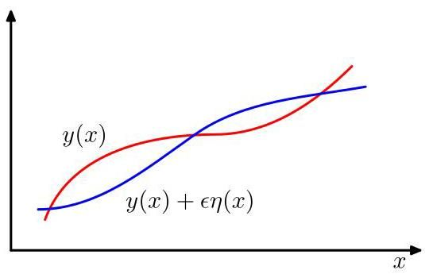

Figure B. 1 A functional derivative can be defined by considering how the value of a functional changes when the function is changed to where is an arbitrary function of .

图 B. 1 可以通过考虑当函数 变为 时，泛函 的值如何变化来定义泛函导数，其中 是 的任意函数。

, where is an arbitrary function of , as illustrated in Figure B.1. We denote the functional derivative of with respect to by and define it by the following relation:

，其中 是 的任意函数，如图 B.1 所示。我们用 表示 关于 的泛函导数，并通过以下关系来定义它:

This can be seen as a natural extension of (B.2) in which now depends on a continuous set of variables, namely the values of at all points . Requiring that the functional be stationary with respect to small variations in the function gives

这可以看作是 (B.2) 的自然扩展，其中 现在依赖于一组连续的变量，即 在所有点 处的值。要求泛函相对于函数 的小变化是平稳的，得到

Because this must hold for an arbitrary choice of , it follows that the functional derivative must vanish. To see this, imagine choosing a perturbation that is zero everywhere except in the neighbourhood of a point , in which case the functional derivative must be zero at . However, because this must be true for every choice of , the functional derivative must vanish for all values of .

因为对于 的任意选择，这都必须成立，所以泛函导数必须为零。为了理解这一点，想象选择一个扰动 ，它在除了点 的邻域之外的所有地方都为零，在这种情况下，泛函导数在 处必须为零。然而，因为对于 的每一种选择都必须如此，所以泛函导数对于 的所有值都必须为零。

Consider a functional that is defined by an integral over a function , which depends on both and its derivative and has a direct dependence on

考虑一个由对函数 的积分定义的泛函，该函数既依赖于 及其导数 ，又直接依赖于

where the value of is assumed to be fixed at the boundary of the region of integration (which might be at infinity). If we now consider variations in the function , we obtain

其中 的值假定在积分区域的边界(可能在无穷远处)是固定的。如果我们现在考虑函数 的变分，我们得到

We now have to cast this in the form (B.3). To do so, we integrate the second term by parts and note that must vanish at the boundary of the integral (because is fixed at the boundary). This gives

现在我们必须将其写成 (B.3) 的形式。为此，我们对第二项进行分部积分，并注意到 在积分边界处必须为零(因为 在边界处是固定的)。这给出

from which we can read off the functional derivative by comparison with (B.3). Requiring that the functional derivative vanishes then gives

通过与 (B.3) 比较，我们可以从中读出泛函导数。要求泛函导数为零则给出

which are known as the Euler-Lagrange equations. For example, if

这些被称为欧拉 - 拉格朗日方程。例如，如果

then the Euler-Lagrange equations take the form

那么欧拉 - 拉格朗日方程具有以下形式

This second-order differential equation can be solved for by making use of the boundary conditions on .

利用 的边界条件，可以求解这个关于 的二阶微分方程。

Often, we consider functionals defined by integrals whose integrands take the form and that do not depend on the derivatives of . In this case, stationarity simply requires that for all values of .

通常，我们考虑由积分定义的泛函，其被积函数形式为 ，且不依赖于 的导数。在这种情况下，平稳性仅要求对于 的所有值， 成立。

If we are optimizing a functional with respect to a probability distribution, then we need to maintain the normalization constraint on the probabilities. This is often most conveniently done using a Lagrange multiplier, which then allows an unconstrained optimization to be performed.

如果我们要针对概率分布优化一个泛函，那么我们需要保持概率的归一化约束。这通常使用拉格朗日乘子来完成最为方便，这样就可以进行无约束优化。

Appendix

附录

The extension of the above results to a multi-dimensional variable is straightforward. For a more comprehensive discussion of the calculus of variations, see Sagan (1969).

将上述结果推广到多维变量 是很直接的。关于变分法的更全面讨论，请参阅 Sagan (1969)。

Deep Learning

深度学习

# Appendix C. Lagrange Multipliers

# 附录 C. 拉格朗日乘子

Lagrange multipliers, also sometimes called undetermined multipliers, are used to find the stationary points of a function of several variables subject to one or more constraints.

拉格朗日乘数，有时也称为待定乘数，用于寻找受一个或多个约束条件限制的多元函数的驻点。

Consider the problem of finding the maximum of a function subject to a constraint relating and , which we write in the form

考虑在满足一个涉及 和 的约束条件下求函数 的最大值问题，我们将该约束条件写成如下形式

One approach would be to solve the constraint equation (C.1) and thus express as a function of in the form . This can then be substituted into to give a function of alone of the form . The maximum with respect to could then be found by differentiation in the usual way, to give the stationary value , with the corresponding value of given by .

一种方法是求解约束方程 (C.1)，从而将 表示为 的函数，形式为 。然后将其代入 中，得到一个仅关于 的函数，形式为 。接着可以按照通常的求导方法找到关于 的最大值，得到驻点值 ，对应的 值由 给出。

One problem with this approach is that it may be difficult to find an analytic solution of the constraint equation that allows to be expressed as an explicit function of . Also, this approach treats and differently and so spoils the natural symmetry between these variables.

这种方法的一个问题是，可能很难找到约束方程的解析解，从而无法将 表示为 的显式函数。此外，这种方法对 和 的处理方式不同，破坏了这些变量之间的自然对称性。

A more elegant, and often simpler, approach introduces a parameter called a Lagrange multiplier. We shall motivate this technique from a geometrical perspective. Consider a -dimensional variable with components . The constraint equation then represents a -dimensional surface in -space as indicated in Figure C.1.

一种更优雅且通常更简单的方法是引入一个称为拉格朗日乘数的参数 。我们将从几何角度来介绍这种技术。考虑一个 维变量 ，其分量为 。约束方程 则表示 空间中的一个 维曲面，如图 C.1 所示。

First note that at any point on the constraint surface, the gradient of the constraint function is orthogonal to the surface. To see this, consider a point that lies on the constraint surface along with a nearby point that also lies on the surface. If we make a Taylor expansion around , we have

首先注意到，在约束曲面上的任何一点，约束函数的梯度 都与该曲面相垂直。为了说明这一点，考虑一个位于约束曲面上的点 以及另一个也位于该曲面上的附近点 。如果我们在 点附近进行泰勒展开，我们有

Because both and lie on the constraint surface, we have and hence . In the limit , we have , and because is then parallel to the constraint surface , we see that the vector is normal to the surface.

因为 和 都位于约束曲面上，所以我们有 ，进而有 。在极限 下，我们有 ，并且由于此时 与约束曲面 平行，我们可以看到向量 垂直于该曲面。

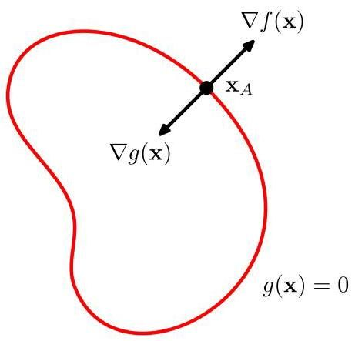

Figure C. 1 A geometrical picture of the technique of Lagrange multipliers in which we seek to maximize a function , subject to the constraint . If is dimensional, the constraint corresponds to a subspace of dimensionality , as indicated by the red curve. The problem can be solved by optimizing the Lagrangian function .

图 C.1 展示了拉格朗日乘数法的几何图像，我们试图在约束条件 下最大化函数 。如果 是 维的，约束条件 对应于一个维数为 的子空间，如红色曲线所示。这个问题可以通过优化拉格朗日函数 来解决。

Next we seek a point on the constraint surface such that is maximized. Such a point must have the property that the vector is also orthogonal to the constraint surface, as illustrated in Figure C.1, because otherwise we could increase the value of by moving a short distance along the constraint surface. Thus, and are parallel (or anti-parallel) vectors, and so there must exist a parameter such that

接下来，我们在约束曲面上寻找一个点 ，使得 达到最大值。这样的点必须满足向量 也垂直于约束曲面这一性质，如图 C.1 所示，因为否则我们可以沿着约束曲面移动一小段距离来增加 的值。因此， 和 是平行(或反平行)向量，所以必然存在一个参数 使得

where is known as a Lagrange multiplier. Note that can have either sign. At this point, it is convenient to introduce the Lagrangian function defined by

其中 被称为拉格朗日乘数。注意， 可以取正号或负号。此时，引入由下式定义的拉格朗日函数会很方便

The constrained stationarity condition (C.3) is obtained by setting . Furthermore, the condition leads to the constraint equation .

通过令 得到约束平稳条件(C.3)。此外，条件 会导出约束方程 。

Thus, to find the maximum of a function subject to the constraint , we define the Lagrangian function given by (C.4) and we then find the stationary point of with respect to both and . For a -dimensional vector , this gives equations that determine both the stationary point and the value of . If we are interested only in , then we can eliminate from the stationarity equations without needing to find its value (hence, the term ’undetermined multiplier’).

因此，为了在约束条件 下找到函数 的最大值，我们定义由(C.4)给出的拉格朗日函数，然后找到 关于 和 的平稳点。对于一个 维向量 ，这会得到 个方程，这些方程可以确定平稳点 和 的值。如果我们只对 感兴趣，那么我们可以从平稳方程中消去 ，而无需知道其值(因此有“未定乘数”这一术语)。

As a simple example, suppose we wish to find the stationary point of the function subject to the constraint , as illustrated in Figure C.2. The corresponding Lagrangian function is given by

作为一个简单的例子，假设我们希望在约束条件 下找到函数 的驻点，如图 C.2 所示。相应的拉格朗日函数为

The conditions for this Lagrangian to be stationary with respect to , and give the following coupled equations:

该拉格朗日函数关于 和 为驻点的条件给出以下耦合方程:

Solving these equations then gives the stationary point as , and the corresponding value for the Lagrange multiplier is .

求解这些方程，得到驻点为 ，相应的拉格朗日乘子的值为 。

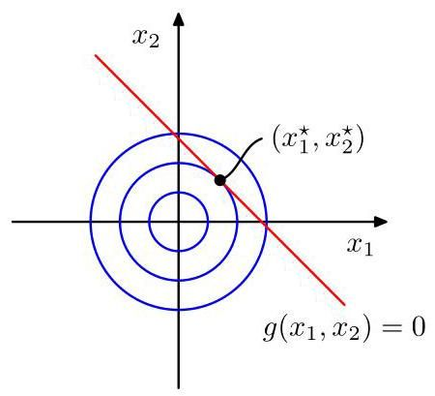

Figure C. 2 A simple example of the use of Lagrange multipliers in which the aim is to maximize subject to the constraint where . The circles show contours of the function , and the diagonal line shows the constraint surface .

图 C.2 是使用拉格朗日乘子的一个简单示例，其目标是在约束条件 (其中 )下最大化 。圆圈表示函数 的等高线，对角线表示约束面 。

So far, we have considered the problem of maximizing a function subject to an equality constraint of the form . We now consider the problem of maximizing subject to an inequality constraint of the form , as illustrated in Figure C.3.

到目前为止，我们已经考虑了在形如 的等式约束下最大化一个函数的问题。现在我们考虑在形如 的不等式约束下最大化 的问题，如图 C.3 所示。

There are now two kinds of solution possible, according to whether the constrained stationary point lies in the region where , in which case the constraint is inactive, or whether it lies on the boundary , in which case the constraint is said to be active. In the former case, the function plays no role and so the stationary condition is simply . This again corresponds to a stationary point of the Lagrange function (C.4) but this time with . The latter case, where the solution lies on the boundary, is analogous to the equality constraint discussed previously and corresponds to a stationary point of the Lagrange function (C.4) with . Now, however, the sign of the Lagrange multiplier is crucial, because the function is at a maximum only if its gradient is oriented away from the region , as illustrated in Figure C.3. We therefore have for some value of .

根据受约束的驻点是位于 的区域(此时约束不起作用)，还是位于边界 上(此时称约束起作用)，现在有两种可能的解。在前一种情况下，函数 不起作用，因此驻点条件简单地为 。这再次对应于拉格朗日函数(C.4)的一个驻点，但此时 。后一种情况，即解位于边界上，类似于前面讨论的等式约束，对应于拉格朗日函数(C.4)在 时的一个驻点。然而，现在拉格朗日乘子的符号至关重要，因为只有当函数 的梯度背离区域 时，它才达到最大值，如图 C.3 所示。因此，对于某个 的值，我们有 。

For either of these two cases, the product . Thus, the solution to the problem of maximizing subject to is obtained by optimizing the Lagrange function (C.4) with respect to and subject to the conditions

对于这两种情况中的任何一种，乘积 。因此，在约束条件 下最大化 这一问题的解，可通过在满足给定条件的情况下，对关于 和 的拉格朗日函数 (C.4) 进行优化得到。

(C.9) (C.10) (C.11)

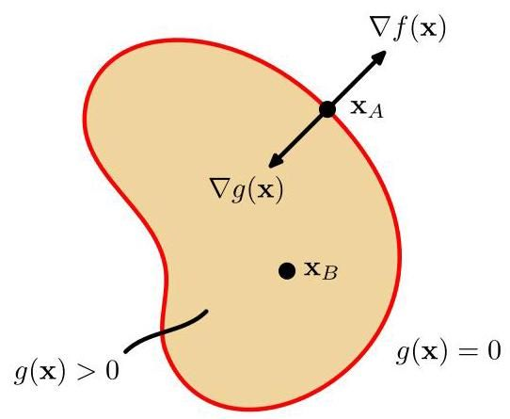

Figure C. 3 Illustration of the problem of maximizing subject to the inequality constraint .

图 C. 3 展示了在不等式约束 下最大化 的问题。

These are known as the Karush-Kuhn-Tucker (KKT) conditions (Karush, 1939; Kuhn and Tucker, 1951).

这些被称为卡罗需 - 库恩 - 塔克 (KKT) 条件(Karush，1939 年；Kuhn 和 Tucker，1951 年)。

Note that if we wish to minimize (rather than maximize) the function subject to an inequality constraint , then we minimize the Lagrangian function with respect to , again subject to .

请注意，如果我们希望在不等式约束 下最小化(而非最大化)函数 ，那么我们要在满足 的条件下，对关于 的拉格朗日函数 进行最小化。

Finally, it is straightforward to extend the technique of Lagrange multipliers to cases with multiple equality and inequality constraints. Suppose we wish to maximize subject to for , and for . We then introduce Lagrange multipliers and , and then optimize the Lagrangian function given by

最后，将拉格朗日乘数法扩展到具有多个等式和不等式约束的情况是很直接的。假设我们希望在 时满足 ，以及在 时满足 的条件下最大化 。然后我们引入拉格朗日乘数 和 ，并对以下给出的拉格朗日函数进行优化

subject to and for . Extensions to constrained functional derivatives are similarly straightforward. For a more detailed discussion of the technique of Lagrange multipliers, see Nocedal and Wright (1999).

满足 以及在 时满足 。将其扩展到约束泛函导数同样很直接。关于拉格朗日乘数法的更详细讨论，请参阅 Nocedal 和 Wright(1999 年)。

Appendix B

附录 B

# Bibliography

# 参考文献

Abramowitz, M., and I. A. Stegun. 1965. Handbook of Mathematical Functions. Dover.

Abramowitz, M. 和 I. A. Stegun. 1965. 《数学函数手册》. Dover 出版社.

Adler, S. L. 1981. "Over-relaxation method for the Monte Carlo evaluation of the partition function for multiquadratic actions." Physical Review D 23:2901-2904.

Adler, S. L. 1981. “用于多二次作用配分函数蒙特卡罗评估的超松弛方法.” 《物理评论 D》23:2901 - 2904.

Aghajanyan, Armen, Bernie Huang, Candace Ross, Vladimir Karpukhin, Hu Xu, Naman Goyal, Dmytro Okhonko, et al. 2022. CM3: A Causal Masked Multimodal Model of the Internet. Technical report. arXiv:2201.07520.

Aghajanyan, Armen、Bernie Huang、Candace Ross、Vladimir Karpukhin、Hu Xu、Naman Goyal、Dmytro Okhonko 等. 2022. CM3:一种互联网的因果掩码多模态模型. 技术报告. arXiv:2201.07520.

Aghajanyan, Armen, Luke Zettlemoyer, and Sonal Gupta. 2020. Intrinsic Dimensionality Explains the Effectiveness of Language Model Fine-Tuning. Technical report. arXiv:2012.13255.

Aghajanyan, Armen、Luke Zettlemoyer 和 Sonal Gupta. 2020. 内在维度解释了语言模型微调的有效性. 技术报告. arXiv:2012.13255.

Ahn, J. H., and J. H. Oh. 2003. "A constrained EM algorithm for principal component analysis." Neural Computation 15 (1): 57-65.

Ahn, J. H. 和 J. H. Oh. 2003. “主成分分析的约束 EM 算法。”《神经计算》15 (1): 57 - 65.

Alayrac, Jean-Baptiste, Jeff Donahue, Pauline Luc, Antoine Miech, Iain Barr, Yana Hasson, Karel Lenc, et al. 2022. Flamingo: a Visual Language Model for Few-Shot Learning. Technical report. arXiv:2204.14198.

Alayrac, Jean - Baptiste、Jeff Donahue、Pauline Luc、Antoine Miech、Iain Barr、Yana Hasson、Karel Lenc 等. 2022. Flamingo:用于少样本学习的视觉语言模型。技术报告。arXiv:2204.14198.

Amari, S., A. Cichocki, and H. H. Yang. 1996. "A new learning algorithm for blind signal separation." In Advances in Neural Information Processing Systems, edited by D. S. Touretzky, M. C. Mozer, and M. E. Hasselmo, 8:757-763. MIT Press.

Amari, S.、A. Cichocki 和 H. H. Yang. 1996. “盲信号分离的新学习算法。” 收录于《神经信息处理系统进展》，由 D. S. Touretzky、M. C. Mozer 和 M. E. Hasselmo 编辑，8:757 - 763. 麻省理工学院出版社.

Anderson, J. A., and E. Rosenfeld. 1988. Neu-rocomputing: Foundations of Research. MIT Press.

Anderson, J. A. 和 E. Rosenfeld. 1988. 《神经计算:研究基础》。麻省理工学院出版社.

Anderson, T. W. 1963. "Asymptotic Theory for Principal Component Analysis." Annals of Mathematical Statistics 34:122-148.

Anderson, T. W. 1963. “主成分分析的渐近理论。”《数理统计年鉴》34:122 - 148.

Arjovsky, M., S. Chintala, and L. Bottou. 2017. Wasserstein GAN. Technical report. arXiv:1701.07875.

Arjovsky, M.、S. Chintala 和 L. Bottou. 2017. 瓦瑟斯坦生成对抗网络。技术报告。arXiv:1701.07875.

Attias, H. 1999. "Independent factor analysis." Neural Computation 11 (4): 803-851.

阿蒂亚斯(Attias)，H. 1999 年。“独立因子分析”。《神经计算》11 (4): 803 - 851。

Austin, Jacob, Daniel D. Johnson, Jonathan Ho, Daniel Tarlow, and Rianne van den Berg. 2021. "Structured Denoising Diffusion Models in Discrete State-Spaces." In Advances in Neural Information Processing Systems, 34:17981- 17993.

奥斯汀(Austin)，雅各布(Jacob)、丹尼尔·D·约翰逊(Daniel D. Johnson)、乔纳森·霍(Jonathan Ho)、丹尼尔·塔洛(Daniel Tarlow)和里安内·范登伯格(Rianne van den Berg)。2021 年。“离散状态空间中的结构化去噪扩散模型”。《神经信息处理系统进展》，34:17981 - 17993。

Ba, Jimmy Lei, Jamie Ryan Kiros, and Geoffrey E Hinton. 2016. Layer Normalization. Technical report. arXiv:1607.06450.

巴(Ba)，吉米·雷(Jimmy Lei)、杰米·瑞安·基罗斯(Jamie Ryan Kiros)和杰弗里·E·辛顿(Geoffrey E Hinton)。2016 年。《层归一化》。技术报告。arXiv:1607.06450。

Bach, F. R., and M. I. Jordan. 2002. "Kernel Independent Component Analysis." Journal of Machine Learning Research 3:1-48.

巴赫(Bach)，F. R. 和 M. I. 乔丹(Jordan)。2002 年。“核独立成分分析”。《机器学习研究杂志》3:1 - 48。

Badrinarayanan, Vijay, Alex Kendall, and Roberto Cipolla. 2015. SegNet: A Deep Convolutional Encoder-Decoder Architecture for Image Segmentation. Technical report. arXiv:1511.00561.

巴德里纳拉亚南(Badrinarayanan)，维杰(Vijay)、亚历克斯·肯德尔(Alex Kendall)和罗伯托·奇波拉(Roberto Cipolla)。2015 年。《SegNet:用于图像分割的深度卷积编码器 - 解码器架构》。技术报告。arXiv:1511.00561。

Bahdanau, Dzmitry, Kyunghyun Cho, and Yoshua Bengio. 2014. Neural Machine Translation by Jointly Learning to Align and Translate. Technical report. arXiv:1409.0473.

巴达纳乌(Bahdanau)，德米特里(Dzmitry)、郑京勋(Kyunghyun Cho)和约书亚·本吉奥(Yoshua Bengio)。2014 年。《通过联合学习对齐和翻译进行神经机器翻译》。技术报告。arXiv:1409.0473。

Baldi, P., and K. Hornik. 1989. "Neural networks and principal component analysis: learning from examples without local minima." Neural Networks 2 (1): 53-58.

Baldi, P., 和 K. Hornik. 1989. "神经网络与主成分分析:从无局部极小值的示例中学习。" 《神经网络》2 (1): 53 - 58.

Balduzzi, David, Marcus Frean, Lennox Leary, JP Lewis, Kurt Wan-Duo Ma, and Brian McWilliams. 2017. The Shattered Gradients Problem: If resnets are the answer, then what is the question? Technical report. arXiv:1702.08591.

Balduzzi, David, Marcus Frean, Lennox Leary, JP Lewis, Kurt Wan - Duo Ma, 和 Brian McWilliams. 2017. 破碎梯度问题:如果残差网络是答案，那么问题是什么？技术报告。arXiv:1702.08591.

Bartholomew, D J. 1987. Latent Variable Models and Factor Analysis. Charles Griffin.

Bartholomew, D J. 1987. 《潜变量模型与因子分析》。Charles Griffin 出版社。

Basilevsky, Alexander. 1994. Statistical Factor Analysis and Related Methods: Theory and Applications. Wiley.

Basilevsky, Alexander. 1994. 《统计因子分析及相关方法:理论与应用》。Wiley 出版社。

Bather, J. 2000. Decision Theory: An Introduction to Dynamic Programming and Sequential Decisions. Wiley.

Bather, J. 2000. 《决策理论:动态规划与序贯决策导论》。Wiley 出版社。

Battaglia, Peter W., Jessica B. Hamrick, Victor Bapst, Alvaro Sanchez-Gonzalez, Vinicius Zambaldi, Mateusz Malinowski, Andrea Tac-chetti, et al. 2018. Relational inductive biases, deep learning, and graph networks. Technical report. arXiv:1806.01261.

Battaglia, Peter W., Jessica B. Hamrick, Victor Bapst, Alvaro Sanchez - Gonzalez, Vinicius Zambaldi, Mateusz Malinowski, Andrea Tac - chetti 等. 2018. 关系归纳偏置、深度学习与图网络。技术报告。arXiv:1806.01261.

Baydin, A. G., B. A. Pearlmutter, A. A. Radul, and J. M. Siskind. 2018. "Automatic differentiation in machine learning: a survey." Journal of Machine Learning Research 18:1-43.

Baydin, A. G., B. A. Pearlmutter, A. A. Radul, 和 J. M. Siskind. 2018. "机器学习中的自动微分:综述." 《机器学习研究杂志》18:1 - 43.

Becker, S., and Y. LeCun. 1989. "Improving the convergence of back-propagation learning with second order methods." In Proceedings of the 1988 Connectionist Models Summer School, edited by D. Touretzky, G. E. Hinton, and T. J. Sejnowski, 29-37. Morgan Kaufmann.

Becker, S., 和 Y. LeCun. 1989. "用二阶方法提高反向传播学习的收敛性." 收录于《1988 年连接主义模型暑期学校会议论文集》, 由 D. Touretzky, G. E. Hinton, 和 T. J. Sejnowski 编辑, 29 - 37. Morgan Kaufmann 出版社.

Belkin, Mikhail, Daniel Hsu, Siyuan Ma, and Soumik Mandal. 2019. "Reconciling modern machine-learning practice and the classical bias-variance trade-off." Proceedings of the National Academy of Sciences 116 (32): 15849-15854.

Belkin, Mikhail, Daniel Hsu, Siyuan Ma, 和 Soumik Mandal. 2019. "调和现代机器学习实践与经典偏差 - 方差权衡." 《美国国家科学院院刊》116 (32): 15849 - 15854.

Bell, A. J., and T. J. Sejnowski. 1995. "An information maximization approach to blind separation and blind deconvolution." Neural Computation 7 (6): 1129-1159.

Bell, A. J., 和 T. J. Sejnowski. 1995. "一种用于盲分离和盲反卷积的信息最大化方法." 《神经计算》7 (6): 1129 - 1159.

Bellman, R. 1961. Adaptive Control Processes: A Guided Tour. Princeton University Press.

Bellman, R. 1961. 《自适应控制过程:指南》. 普林斯顿大学出版社.

Bengio, Yoshua, Aaron Courville, and Pascal Vincent. 2012. Representation Learning: A Review and New Perspectives. Technical report. arXiv:1206.5538.

Bengio, Yoshua, Aaron Courville, 和 Pascal Vincent. 2012. 《表征学习:综述与新视角》. 技术报告. arXiv:1206.5538.

Bengio, Yoshua, Nicholas Léonard, and Aaron Courville. 2013. Estimating or Propagating Gradients Through Stochastic Neurons for Conditional Computation. Technical report. arXiv:1308.3432.

Bengio, Yoshua、Nicholas Léonard 和 Aaron Courville。2013 年。通过随机神经元估计或传播条件计算的梯度。技术报告。arXiv:1308.3432。

Berger, J. O. 1985. Statistical Decision Theory and Bayesian Analysis. Second, Springer.

Berger, J. O. 1985 年。《统计决策理论与贝叶斯分析》。第二版，施普林格出版社。

Bernardo, J. M., and A. F. M. Smith. 1994. Bayesian Theory. Wiley.

Bernardo, J. M. 和 A. F. M. Smith。1994 年。《贝叶斯理论》。威利出版社。

Bishop, C. M. 1995a. "Regularization and Complexity Control in Feed-forward Networks." In Proceedings International Conference on Artificial Neural Networks ICANN’95, edited by F. Fougelman-Soulie and P. Gallinari, 1:141- 148. EC2 et Cie.

Bishop, C. M. 1995a。“前馈网络中的正则化和复杂度控制”。载于 F. Fougelman - Soulie 和 P. Gallinari 编辑的《国际人工神经网络会议 ICANN’95 论文集》，第 1 卷:141 - 148。EC2 et Cie 出版社。

Bishop, Christopher M. 1992. "Exact Calculation of the Hessian Matrix for the Multilayer Percep-tron." Neural Computation 4 (4): 494-501.

Bishop, Christopher M. 1992 年。“多层感知器海森矩阵的精确计算”。《神经计算》4 (4):494 - 501。

Bishop, Christopher M. 1994. "Novelty Detection and Neural Network Validation." IEE Proceedings: Vision, Image and Signal Processing 141 (4): 217-222.

Bishop, Christopher M. 1994 年。“新奇检测与神经网络验证”。《电气工程师协会会刊:视觉、图像与信号处理》141 (4):217 - 222。

Bishop, Christopher M. 1995b. Neural Networks for Pattern Recognition. Oxford University Press.

毕晓普(Bishop)，克里斯托弗·M.(Christopher M.)，1995b。《用于模式识别的神经网络》。牛津大学出版社。

Bishop, Christopher M. 1995c. "Training with noise is equivalent to Tikhonov regularization." Neural Computation 7 (1): 108-116.

毕晓普(Bishop)，克里斯托弗·M.(Christopher M.)，1995c。“带噪声训练等同于蒂霍诺夫正则化”。《神经计算》7(1):108 - 116。

Bishop, Christopher M. 2006. Pattern Recognition and Machine Learning. Springer.

毕晓普(Bishop)，克里斯托弗·M.(Christopher M.)，2006。《模式识别与机器学习》。施普林格出版社。

Bommasani, Rishi, Drew A. Hudson, Ehsan Adeli, Russ Altman, Simran Arora, Sydney von Arx, Michael S. Bernstein, et al. 2021. On the Opportunities and Risks of Foundation Models. Technical report. arXiv:2108.07258.

博马萨尼(Bommasani)，里希(Rishi)，德鲁·A. 哈德森(Drew A. Hudson)，埃桑·阿德利(Ehsan Adeli)，拉斯·奥尔特曼(Russ Altman)，西姆兰·阿罗拉(Simran Arora)，悉尼·冯·阿克斯(Sydney von Arx)，迈克尔·S. 伯恩斯坦(Michael S. Bernstein)等，2021。《基础模型的机遇与风险》。技术报告。arXiv:2108.07258。

Bottou, L. 2010. "Large-scale machine learning with stochastic gradient descent." In Proceedings COMPSTAT 2010, 177-186. Springer.

博图(Bottou)，L.，2010。“随机梯度下降的大规模机器学习”。《2010 年计算统计学会议论文集》，177 - 186。施普林格出版社。

Bourlard, H., and Y. Kamp. 1988. "Auto-association by multilayer perceptrons and singular value decomposition." Biological Cybernetics 59:291-294.

布拉尔(Bourlard)，H.，和 Y. 坎普(Y. Kamp)，1988。“多层感知器的自关联与奇异值分解”。《生物控制论》59:291 - 294。

Breiman, L. 1996. "Bagging predictors." Machine Learning 26:123-140.

Breiman, L. 1996. “装袋预测器。”《机器学习》26:123 - 140。

Brinker, T. J., A. Hekler, A. H. Enk, C. Berking, S Haferkamp, A. Hauschild, M. Weichenthal, et al. 2019. "Deep neural networks are superior to dermatologists in melanoma image classification." European Journal of Cancer 119:11- 17.

Brinker, T. J., A. Hekler, A. H. Enk, C. Berking, S Haferkamp, A. Hauschild, M. Weichenthal 等。2019. “深度神经网络在黑色素瘤图像分类方面优于皮肤科医生。”《欧洲癌症杂志》119:11 - 17。

Brock, Andrew, Jeff Donahue, and Karen Si-monyan. 2018. "Large-Scale GAN Training for High Fidelity Natural Image Synthesis." In Proceedings of the International Conference Learning Representations (ICLR). ArXiv:1809.11096.

Brock, Andrew, Jeff Donahue 和 Karen Si - monyan。2018. “用于高保真自然图像合成的大规模生成对抗网络训练。”《国际学习表征会议(ICLR)论文集》。arXiv:1809.11096。

Bronstein, Michael M., Joan Bruna, Taco Cohen, and Petar Velickovic. 2021. Geometric Deep Learning: Grids, Groups, Graphs, Geodesics, and Gauges. Technical report. arXiv:2104.13478.

Bronstein, Michael M., Joan Bruna, Taco Cohen 和 Petar Velickovic。2021. 《几何深度学习:网格、群、图、测地线和规范》。技术报告。arXiv:2104.13478。

Bronstein, Michael M., Joan Bruna, Yann Le-Cun, Arthur Szlam, and Pierre Vandergheynst. 2017. "Geometric Deep Learning: Going Beyond Eulcidean Data." In IEEE Signal Processing Magazine, vol. 34. 4. IEEE, July.

Bronstein, Michael M., Joan Bruna, Yann Le - Cun, Arthur Szlam 和 Pierre Vandergheynst。2017. “几何深度学习:超越欧几里得数据。”《IEEE 信号处理杂志》，第 34 卷，第 4 期。IEEE，7 月。

Broomhead, D. S., and D. Lowe. 1988. "Multivari-able functional interpolation and adaptive networks." Complex Systems 2:321-355.

Broomhead, D. S. 和 D. Lowe。1988. “多变量函数插值与自适应网络。”《复杂系统》2:321 - 355。

Brown, Tom B., Benjamin Mann, Nick Ryder, Melanie Subbiah, Jared Kaplan, Pra-fulla Dhariwal, Arvind Neelakantan, et al. 2020. Language Models are Few-Shot Learners. Technical report. arXiv:2005.14165.

Brown, Tom B., Benjamin Mann, Nick Ryder, Melanie Subbiah, Jared Kaplan, Pra-fulla Dhariwal, Arvind Neelakantan 等. 2020. 语言模型是少样本学习者. 技术报告. arXiv:2005.14165.

Bubeck, Sébastien, Varun Chandrasekaran, Ronen Eldan, Johannes Gehrke, Eric Horvitz, Ece Ka-mar, Peter Lee, et al. 2023. Sparks of Artificial General Intelligence: Early experiments with GPT-4. Technical report. arXiv:2303.12712.

Bubeck, Sébastien, Varun Chandrasekaran, Ronen Eldan, Johannes Gehrke, Eric Horvitz, Ece Ka-mar, Peter Lee 等. 2023. 通用人工智能的火花:GPT - 4 的早期实验. 技术报告. arXiv:2303.12712.

Cardoso, J-F. 1998. "Blind signal separation: statistical principles." Proceedings of the IEEE 9 (10): 2009-2025.

Cardoso, J - F. 1998. “盲信号分离:统计原理.” 《电气与电子工程师协会汇刊》9 (10): 2009 - 2025.

Caruana, R. 1997. "Multitask learning." Machine Learning 28:41-75.

Caruana, R. 1997. “多任务学习.” 《机器学习》28:41 - 75.

Casella, G., and R. L. Berger. 2002. Statistical Inference. Second, Duxbury.

Casella, G., 和 R. L. Berger. 2002. 《统计推断》. 第二版, Duxbury.

Chan, K., T. Lee, and T. J. Sejnowski. 2003. "Variational Bayesian learning of ICA with missing data." Neural Computation 15 (8): 1991-2011.

Chan, K., T. Lee, 和 T. J. Sejnowski. 2003. “含缺失数据的独立成分分析的变分贝叶斯学习.” 《神经计算》15 (8): 1991 - 2011.

Chen, A. M., H. Lu, and R. Hecht-Nielsen. 1993. "On the geometry of feedforward neural network error surfaces." Neural Computation 5 (6): 910-927.

Chen, A. M., H. Lu, 和 R. Hecht-Nielsen. 1993. “关于前馈神经网络误差曲面的几何性质。”《神经计算》5 (6): 910 - 927.

Chen, Mark, Alec Radford, Rewon Child, Jeffrey Wu, Heewoo Jun, David Luan, and Ilya Sutskever. 2020. “Generative Pretraining From Pixels." Proceedings of Machine Learning Research 119:1691-1703.

Chen, Mark, Alec Radford, Rewon Child, Jeffrey Wu, Heewoo Jun, David Luan, 和 Ilya Sutskever. 2020. “基于像素的生成式预训练。”《机器学习研究会议录》119: 1691 - 1703.

Chen, R. T. Q., Rubanova Y, J. Bettencourt, and D. Duvenaud. 2018. Neural Ordinary Differential Equations. Technical report. arXiv:1806.07366.

Chen, R. T. Q., Rubanova Y, J. Bettencourt, 和 D. Duvenaud. 2018. 神经常微分方程。技术报告。arXiv:1806.07366.

Chen, Ting, Simon Kornblith, Mohammad Norouzi, and Geoffrey Hinton. 2020. A Simple Framework for Contrastive Learning of Visual Representations. Technical report. arXiv:2002.05709.

Chen, Ting, Simon Kornblith, Mohammad Norouzi, 和 Geoffrey Hinton. 2020. 视觉表征对比学习的简单框架。技术报告。arXiv:2002.05709.

Cho, Kyunghyun, Bart van Merrienboer, Çaglar Gülçehre, Fethi Bougares, Holger Schwenk, and Yoshua Bengio. 2014. Learning Phrase Representations using RNN Encoder-Decoder for Statistical Machine Translations. Technical report. arXiv:1406.1078.

Cho, Kyunghyun, Bart van Merrienboer, Çaglar Gülçehre, Fethi Bougares, Holger Schwenk, 和 Yoshua Bengio. 2014. 使用循环神经网络编码器 - 解码器学习短语表征用于统计机器翻译。技术报告。arXiv:1406.1078.

Choudrey, R. A., and S. J. Roberts. 2003. "Variational mixture of Bayesian independent component analyzers." Neural Computation 15 (1): 213-252.

Choudrey, R. A., 和 S. J. Roberts. 2003. “贝叶斯独立成分分析器的变分混合模型。”《神经计算》15 (1): 213 - 252.

Christiano, Paul, Jan Leike, Tom B. Brown, Miljan Martic, Shane Legg, and Dario Amodei. 2017. Deep reinforcement learning from human preferences. Technical report. arXiv:1706.03741.

Christiano, Paul, Jan Leike, Tom B. Brown, Miljan Martic, Shane Legg, 和 Dario Amodei. 2017. 基于人类偏好的深度强化学习。技术报告。arXiv:1706.03741.

Collobert, R. 2004. "Large Scale Machine Learning." PhD diss., Université Paris VI.

Collobert, R. 2004. “大规模机器学习。” 博士学位论文，巴黎第六大学。

Comon, P., C. Jutten, and J. Herault. 1991. "Blind source separation, 2: problems statement." Signal Processing 24 (1): 11-20.

Comon, P., C. Jutten, 和 J. Herault. 1991. “盲源分离，2:问题陈述。” 《信号处理》24 (1): 11 - 20.

Cover, T., and P. Hart. 1967. "Nearest neighbor pattern classification." IEEE Transactions on Information Theory IT-11:21-27.

Cover, T., 和 P. Hart. 1967. “最近邻模式分类。” 《IEEE 信息论汇刊》IT - 11:21 - 27.

Cover, T. M., and J. A. Thomas. 1991. Elements of Information Theory. Wiley.

Cover, T. M., 和 J. A. Thomas. 1991. 《信息论基础》。威利出版社。

Cox, R. T. 1946. "Probability, frequency and reasonable expectation." American Journal of Physics 14 (1): 1-13.

Cox, R. T. 1946. “概率、频率与合理预期。” 《美国物理学期刊》14 (1): 1 - 13.

Cybenko, G. 1989. "Approximation by superpositions of a sigmoidal function." Mathematics of Control, Signals and Systems 2:304-314.

Cybenko, G. 1989. “通过 S 型函数的叠加进行逼近。”《控制、信号与系统数学》2:304 - 314。

Dawid, A. P. 1979. "Conditional Independence in Statistical Theory (with discussion)." Journal of the Royal Statistical Society, Series B 4:1- 31.

Dawid, A. P. 1979. “统计理论中的条件独立性(附讨论)。”《皇家统计学会杂志，B 辑》4:1 - 31。

Dawid, A. P. 1980. "Conditional Independence for Statistical Operations." Annals of Statistics 8:598-617.

Dawid, A. P. 1980. “统计运算的条件独立性。”《统计年鉴》8:598 - 617。

Deisenroth, M. P., A. A. Faisal, and C. S. Ong. 2020. Mathematics for Machine Learning. Cambridge University Press.

Deisenroth, M. P., A. A. Faisal 和 C. S. Ong. 2020. 《机器学习数学》。剑桥大学出版社。

Dempster, A. P., N. M. Laird, and D. B. Rubin. 1977. "Maximum likelihood from incomplete data via the EM algorithm." Journal of the Royal Statistical Society, B 39 (1): 1-38.

Dempster, A. P., N. M. Laird 和 D. B. Rubin. 1977. “通过 EM 算法从不完整数据中求最大似然。”《皇家统计学会杂志，B 辑》39 (1): 1 - 38。

Deng, Jia, Wei Dong, Richard Socher, Li-Jia Li, Kai Li, and Li Fei-Fei. 2009. "ImageNet: A large-scale hierarchical image database." In IEEE Conference on Computer Vision and Pattern Recognition.

Deng, Jia, Wei Dong, Richard Socher, Li - Jia Li, Kai Li 和 Li Fei - Fei. 2009. “ImageNet:一个大规模分层图像数据库。” 见 IEEE 计算机视觉与模式识别会议。

Devlin, Jacob, Ming-Wei Chang, Kenton Lee, and Kristina Toutanova. 2018. BERT: Pretraining of Deep Bidirectional Transformers for Language Understanding. Technical report. arXiv:1810.04805.

Devlin, Jacob、Ming-Wei Chang、Kenton Lee 和 Kristina Toutanova。2018 年。BERT:用于语言理解的深度双向变换器的预训练。技术报告。arXiv:1810.04805。

Dhariwal, Prafulla, and Alex Nichol. 2021. Diffusion Models Beat GANs on Image Synthesis. Technical report. arXiv:2105.05233.

Dhariwal, Prafulla 和 Alex Nichol。2021 年。扩散模型在图像合成方面优于生成对抗网络。技术报告。arXiv:2105.05233。

Dinh, Laurent, David Krueger, and Yoshua Ben-gio. 2014. NICE: Non-linear Independent Components Estimation. Technical report. arXiv:1410.8516.

Dinh, Laurent、David Krueger 和 Yoshua Ben-gio。2014 年。NICE:非线性独立成分估计。技术报告。arXiv:1410.8516。

Dinh, Laurent, Jascha Sohl-Dickstein, and Samy Bengio. 2016. Density estimation using Real NVP. Technical report. arXiv:1605.08803.

Dinh, Laurent、Jascha Sohl-Dickstein 和 Samy Bengio。2016 年。使用实值非体积保存变换进行密度估计。技术报告。arXiv:1605.08803。

Dodge, Samuel, and Lina Karam. 2017. A Study and Comparison of Human and Deep Learning Recognition Performance Under Visual Distortions. Technical report. arXiv:1705.02498.

Dodge, Samuel 和 Lina Karam。2017 年。视觉失真下人类和深度学习识别性能的研究与比较。技术报告。arXiv:1705.02498。

Doersch, C. 2016. Tutorial on Variational Autoen-coders. Technical report. arXiv:1606.05908.

Doersch, C. 2016 年。变分自编码器教程。技术报告。arXiv:1606.05908。

Dosovitskiy, Alexey, Lucas Beyer, Alexander Kolesnikov, Dirk Weissenborn, Xiaohua Zhai, Thomas Unterthiner, Mostafa Dehghani, et al. 2020. An Image is Worth 16 16 Words: Transformers for Image Recognition at Scale. Technical report. arXiv:2010.11929.

Dosovitskiy, Alexey、Lucas Beyer、Alexander Kolesnikov、Dirk Weissenborn、Xiaohua Zhai、Thomas Unterthiner、Mostafa Dehghani 等人，2020 年。《一幅图像价值 16 16 个字:大规模图像识别的 Transformer》。技术报告。arXiv:2010.11929。

Duane, S., A. D. Kennedy, B. J. Pendleton, and D. Roweth. 1987. "Hybrid Monte Carlo." Physics Letters B 195 (2): 216-222.

Duane, S.、A. D. Kennedy、B. J. Pendleton 和 D. Roweth，1987 年。《混合蒙特卡罗方法》。《物理学快报 B》195 (2): 216 - 222。

Duchi, J., E. Hazan, and Y. Singer. 2011. "Adaptive Subgradient Methods for Online Learning and Stochastic Optimization." Journal of Machine Learning Research 12:2121-2159.

Duchi, J.、E. Hazan 和 Y. Singer，2011 年。《在线学习和随机优化的自适应次梯度方法》。《机器学习研究杂志》12:2121 - 2159。

Duda, R. O., and P. E. Hart. 1973. Pattern Classification and Scene Analysis. Wiley.

Duda, R. O. 和 P. E. Hart，1973 年。《模式分类与场景分析》。威利出版社。

Dufter, Philipp, Martin Schmitt, and Hinrich Schütze. 2021. Position Information in Transformers: An Overview. Technical report. arXiv:2102.11090.

Dufter, Philipp、Martin Schmitt 和 Hinrich Schütze，2021 年。《Transformer 中的位置信息:综述》。技术报告。arXiv:2102.11090。

Dumoulin, Vincent, and Francesco Visin. 2016. A guide to convolution arithmetic for deep learning. Technical report. arXiv:1603.07285.

Dumoulin, Vincent 和 Francesco Visin，2016 年。《深度学习卷积算法指南》。技术报告。arXiv:1603.07285。

Elliott, R. J., L. Aggoun, and J. B. Moore. 1995. Hidden Markov Models: Estimation and Control. Springer.

Elliott, R. J., L. Aggoun, 和 J. B. Moore. 1995. 《隐马尔可夫模型:估计与控制》. 施普林格出版社.

Esser, Patrick, Robin Rombach, and Björn Om-mer. 2020. Taming Transformers for High-Resolution Image Synthesis. Technical report. arXiv:2012.09841.

Esser, Patrick, Robin Rombach, 和 Björn Ommer. 2020. 《驯服用于高分辨率图像合成的Transformer》. 技术报告. arXiv:2012.09841.

Esteva, A., B. Kuprel, R. A. Novoa, J. Ko, S. M. Swetter, H. M. Blau, and S. Thrun. 2017. "Dermatologist-level classification of skin cancer with deep neural networks." Nature 542:115-118.

Esteva, A., B. Kuprel, R. A. Novoa, J. Ko, S. M. Swetter, H. M. Blau, 和 S. Thrun. 2017. “利用深度神经网络实现皮肤科医生水平的皮肤癌分类.” 《自然》542:115 - 118.

Everitt, B. S. 1984. An Introduction to Latent Variable Models. Chapman / Hall.

Everitt, B. S. 1984. 《潜变量模型导论》. 查普曼与霍尔出版社.

Eykholt, Kevin, Ivan Evtimov, Earlence Fernandes, Bo Li, Amir Rahmati, Chaowei Xiao, Atul Prakash, Tadayoshi Kohno, and Dawn Song. 2018. "Robust Physical-World Attacks on Deep Learning Visual Classification." In Proceedings of the IEEE Conference on Computer Vision and Pattern Recognition (CVPR).

Eykholt, Kevin, Ivan Evtimov, Earlence Fernandes, Bo Li, Amir Rahmati, Chaowei Xiao, Atul Prakash, Tadayoshi Kohno, 和 Dawn Song. 2018. “对深度学习视觉分类的鲁棒物理世界攻击.” 收录于《电气与电子工程师协会计算机视觉与模式识别会议(CVPR)论文集》.

Fawcett, T. 2006. "An introduction to ROC analysis." Pattern Recognition Letters 27:861-874.

Fawcett, T. 2006. “ROC分析导论.” 《模式识别快报》27:861 - 874.

Feller, W. 1966. An Introduction to Probability Theory and its Applications. Second, Vol. 2. Wiley.

Feller, W. 1966. 《概率论及其应用导论》。第二版，第 2 卷。威利出版社。

Fletcher, R. 1987. Practical Methods of Optimization. Second, Wiley.

Fletcher, R. 1987. 《实用优化方法》。第二版，威利出版社。

Forsyth, D. A., and J. Ponce. 2003. Computer Vision: A Modern Approach. Prentice Hall.

Forsyth, D. A. 和 J. Ponce. 2003. 《计算机视觉:现代方法》。普伦蒂斯·霍尔出版社。

Freund, Y., and R. E. Schapire. 1996. "Experiments with a new boosting algorithm." In Thirteenth International Conference on Machine Learning, edited by L. Saitta, 148-156. Morgan Kaufmann.

Freund, Y. 和 R. E. Schapire. 1996. “一种新的提升算法实验”。载于由 L. Saitta 编辑的《第十三届国际机器学习会议》，第 148 - 156 页。摩根·考夫曼出版社。

Fukushima, K. 1980. "Neocognitron: A Self-organizing Neural Network Model for a Mechanism of Pattern Recognition Unaffected by Shift in Position." Biological Cybernetics 36:193-202.

Fukushima, K. 1980. “神经认知机:一种不受位置偏移影响的模式识别机制的自组织神经网络模型”。《生物控制论》36:193 - 202。

Funahashi, K. 1989. "On the approximate realization of continuous mappings by neural networks." Neural Networks 2 (3): 183-192.

Funahashi, K. 1989. “关于神经网络对连续映射的近似实现”。《神经网络》2 (3): 183 - 192。

Fung, R., and K. C. Chang. 1990. "Weighting and Integrating Evidence for Stochastic Simulation in Bayesian Networks." In Uncertainty in Artificial Intelligence, edited by P. P. Bonissone, M. Henrion, L. N. Kanal, and J. F. Lemmer, 5:208-219. Elsevier.

Fung, R. 和 K. C. Chang. 1990. “贝叶斯网络中随机模拟的证据加权与整合。” 收录于《人工智能中的不确定性》，由 P. P. Bonissone、M. Henrion、L. N. Kanal 和 J. F. Lemmer 编辑，第 5 卷:208 - 219 页。爱思唯尔出版社。

Gatys, Leon A., Alexander S. Ecker, and Matthias Bethge. 2015. A Neural Algorithm of Artistic Style. Technical report. arXiv:1508.06576.

Gatys, Leon A.、Alexander S. Ecker 和 Matthias Bethge. 2015. 《艺术风格的神经算法》。技术报告。arXiv:1508.06576。

Geman, S., and D. Geman. 1984. "Stochastic relaxation, Gibbs distributions, and the Bayesian restoration of images." IEEE PAMI 6 (1): 721- 741.

Geman, S. 和 D. Geman. 1984. “随机松弛、吉布斯分布与图像的贝叶斯恢复。” 《电气与电子工程师协会模式分析与机器智能汇刊》6 (1): 721 - 741。

Gemmeke, Jort F., Daniel P. W. Ellis, Dylan Freedman, Aren Jansen, Wade Lawrence, R. Channing Moore, Manoj Plakal, and Marvin Ritter. 2017. "Audio Set: An ontology and human-labeled dataset for audio events." In Proc. IEEE ICASSP 2017. New Orleans, LA.

Gemmeke, Jort F.、Daniel P. W. Ellis、Dylan Freedman、Aren Jansen、Wade Lawrence、R. Channing Moore、Manoj Plakal 和 Marvin Ritter. 2017. “音频集:音频事件的本体和人工标注数据集。” 收录于《2017 年电气与电子工程师协会国际声学、语音和信号处理会议论文集》。路易斯安那州新奥尔良。

Germain, Mathieu, Karol Gregor, Iain Murray, and Hugo Larochelle. 2015. MADE: Masked Au-toencoder for Distribution Estimation. Technical report. arXiv:1502.03509.

Germain, Mathieu、Karol Gregor、Iain Murray 和 Hugo Larochelle. 2015. 《MADE:用于分布估计的掩码自编码器》。技术报告。arXiv:1502.03509。

Gilks, W. R. 1992. "Derivative-free adaptive rejection sampling for Gibbs sampling." In Bayesian Statistics, edited by J. Bernardo, J. Berger, A. P. Dawid, and A. F. M. Smith, vol. 4. Oxford University Press.

Gilks, W. R. 1992. “用于吉布斯采样的无导数自适应拒绝采样。” 收录于《贝叶斯统计》，由 J. Bernardo、J. Berger、A. P. Dawid 和 A. F. M. Smith 编辑，第 4 卷。牛津大学出版社。

Gilks, W. R., N. G. Best, and K. K. C. Tan. 1995. "Adaptive rejection Metropolis sampling." Applied Statistics 44:455-472.

Gilks, W. R., N. G. Best, 和 K. K. C. Tan. 1995. "自适应拒绝 Metropolis 抽样." 《应用统计学》 44:455 - 472.

Gilks, W. R., S. Richardson, and D. J. Spiegelhalter. 1996. Markov Chain Monte Carlo in Practice. Chapman / Hall.

Gilks, W. R., S. Richardson, 和 D. J. Spiegelhalter. 1996. 《实践中的马尔可夫链蒙特卡罗方法》. Chapman / Hall 出版社.

Gilks, W. R., and P. Wild. 1992. "Adaptive rejection sampling for Gibbs sampling." Applied Statistics 41:337-348.

Gilks, W. R., 和 P. Wild. 1992. "用于吉布斯抽样的自适应拒绝抽样." 《应用统计学》 41:337 - 348.

Gilmer, Justin, Samuel S. Schoenholz, Patrick F. Riley, Oriol Vinyals, and George E. Dahl. 2017. Neural Message Passing for Quantum Chemistry. Technical report. arXiv:1704.01212.

Gilmer, Justin, Samuel S. Schoenholz, Patrick F. Riley, Oriol Vinyals, 和 George E. Dahl. 2017. 《用于量子化学的神经消息传递》. 技术报告. arXiv:1704.01212.

Girshick, Ross B. 2015. Fast R-CNN. Technical report. arXiv:1504.08083.

Girshick, Ross B. 2015. 《快速区域卷积神经网络》. 技术报告. arXiv:1504.08083.

Golub, G. H., and C. F. Van Loan. 1996. Matrix Computations. Third. John Hopkins University Press.

Golub, G. H., 和 C. F. Van Loan. 1996. 《矩阵计算》(第三版). 约翰霍普金斯大学出版社.

Gong, Yuan, Yu-An Chung, and James R. Glass. 2021. AST: Audio Spectrogram Transformer. Technical report. arXiv:2104.01778.

龚、袁、钟宇安和 James R. Glass。2021 年。AST:音频频谱图变换器。技术报告。arXiv:2104.01778。

Goodfellow, Ian, Yoshua Bengio, and Aaron Courville. 2016. Deep Learning. MIT Press.

Ian Goodfellow、Yoshua Bengio 和 Aaron Courville。2016 年。《深度学习》。麻省理工学院出版社。

Goodfellow, Ian J., Jean Pouget-Abadie, Mehdi Mirza, Bing Xu, David Warde-Farley, Sherjil Ozair, Aaron Courville, and Yoshua Bengio. 2014. Generative Adversarial Networks. Technical report. arXiv:1406.2661.

Ian J. Goodfellow、Jean Pouget-Abadie、Mehdi Mirza、徐冰、David Warde-Farley、Sherjil Ozair、Aaron Courville 和 Yoshua Bengio。2014 年。生成对抗网络。技术报告。arXiv:1406.2661。

Goodfellow, Ian J., Jonathon Shlens, and Christian Szegedy. 2014. Explaining and Harnessing Adversarial Examples. Technical report. arXiv:1412.6572.

Ian J. Goodfellow、Jonathon Shlens 和 Christian Szegedy。2014 年。解释和利用对抗样本。技术报告。arXiv:1412.6572。

Grathwohl, Will, Ricky T. Q. Chen, Jesse Bettencourt, Ilya Sutskever, and David Duve-naud. 2018. FFJORD: Free-form Continuous Dynamics for Scalable Reversible Generative Models. Technical report. arXiv:1810.01367.

Will Grathwohl、Ricky T. Q. Chen、Jesse Bettencourt、Ilya Sutskever 和 David Duvenaud。2018 年。FFJORD:可扩展可逆生成模型的自由形式连续动力学。技术报告。arXiv:1810.01367。

Griewank, A., and A Walther. 2008. Evaluating Derivatives: Principles and Techniques of Algorithmic Differentiation. Second, SIAM.

A. Griewank 和 A Walther。2008 年。《导数求值:算法微分原理与技术》。第二版，工业与应用数学学会。

Grosse, R. 2018. Automatic Differentiation. CSC321 Lecture 10. University of Toronto.

格罗斯(Grosse)，R. 2018. 自动微分。多伦多大学(University of Toronto)CSC321 课程第 10 讲。

Gulrajani, I., F. Ahmed, M. Arjovsky, V. Du-moulin, and A. Courville. 2017. Improved training of Wasserstein GANs. Technical report. arXiv:1704.00028.

古拉贾尼(Gulrajani)，I.，艾哈迈德(Ahmed)，F.，阿尔乔夫斯基(Arjovsky)，M.，杜穆兰(Du-moulin)，V.，和库尔维尔(Courville)，A. 2017. 改进的 Wasserstein 生成对抗网络训练。技术报告。arXiv:1704.00028。

Gutmann, Michael, and Aapo Hyvärinen. 2010. "Noise-contrastive estimation: A new estimation principle for unnormalized statistical models." Journal of Machine Learning Research 9:297-304.

古特曼(Gutmann)，迈克尔(Michael)，和海瓦里宁(Hyvärinen)，阿波(Aapo)。2010. “噪声对比估计:非归一化统计模型的一种新估计原则。”《机器学习研究杂志》(Journal of Machine Learning Research)9:297 - 304。

Hamilton, W. L. 2020. Graph Representation Learning. Morgan / Claypool.

汉密尔顿(Hamilton)，W. L. 2020. 图表示学习。摩根与克莱普尔出版社(Morgan / Claypool)。

Hartley, R., and A. Zisserman. 2004. Multiple View Geometry in Computer Vision. Second, Cambridge University Press.

哈特利(Hartley)，R.，和齐瑟曼(Zisserman)，A. 2004. 《计算机视觉中的多视图几何》(Multiple View Geometry in Computer Vision)。第二版，剑桥大学出版社(Cambridge University Press)。

Hassibi, B., and D. G. Stork. 1993. "Second order derivatives for network pruning: optimal brain surgeon." In Proceedings International Conference on Neural Information Processing Systems (NeurIPS), edited by S. J. Hanson, J. D. Cowan, and C. L. Giles, 5:164-171. Morgan Kaufmann.

哈西比(Hassibi)，B.，和斯托克(Stork)，D. G. 1993. “用于网络剪枝的二阶导数:最优脑外科医生。” 载于由汉森(Hanson)，S. J.，考恩(Cowan)，J. D.，和贾尔斯(Giles)，C. L. 编辑的《神经信息处理系统国际会议论文集》(Proceedings International Conference on Neural Information Processing Systems (NeurIPS))，5:164 - 171。摩根考夫曼出版社(Morgan Kaufmann)。

Hastie, T., R. Tibshirani, and J. Friedman. 2009. The Elements of Statistical Learning. Second, Springer.

Hastie, T.，R. Tibshirani 和 J. Friedman. 2009. 《统计学习基础》. 第二版，施普林格出版社。

Hastings, W. K. 1970. "Monte Carlo sampling methods using Markov chains and their applications.” Biometrika 57:97-109.

Hastings, W. K. 1970. “使用马尔可夫链的蒙特卡罗抽样方法及其应用。”《生物统计学》57:97 - 109。

He, Kaiming, Xinlei Chen, Saining Xie, Yanghao Li, Piotr Dollár, and Ross B. Girshick. 2021. Masked Autoencoders Are Scalable Vision Learners. Technical report. arXiv:2111.06377.

何恺明、陈新蕾、谢赛宁、李仰浩、Piotr Dollár 和 Ross B. Girshick. 2021. 《掩码自编码器是可扩展的视觉学习者》. 技术报告. arXiv:2111.06377。

He, Kaiming, Haoqi Fan, Yuxin Wu, Saining Xie, and Ross Girshick. 2019. Momentum Contrast for Unsupervised Visual Representation Learning. Technical report. arXiv:1911.05722.

何恺明、范浩琦、吴雨欣、谢赛宁和 Ross Girshick. 2019. 《无监督视觉表征学习的动量对比》. 技术报告. arXiv:1911.05722。

He, Kaiming, Xiangyu Zhang, Shaoqing Ren, and Jian Sun. 2015a. Deep Residual Learning for Image Recognition. Technical report. arXiv:1512.03385.

何恺明、张祥雨、任少卿和孙剑. 2015a. 《用于图像识别的深度残差学习》. 技术报告. arXiv:1512.03385。

He, Kaiming, Xiangyu Zhang, Shaoqing Ren, and Jian Sun. 2015b. Delving Deep into Rectifiers: Surpassing Human-Level Performance on ImageNet Classification. Technical report. arXiv:1502.01852.

何恺明、张祥雨、任少卿和孙剑. 2015b. 《深入研究整流器:在 ImageNet 分类上超越人类水平的性能》. 技术报告. arXiv:1502.01852。

Henrion, M. 1988. "Propagation of Uncertainty by Logic Sampling in Bayes’ Networks." In - certainty in Artificial Intelligence, edited by J. F. Lemmer and L. N. Kanal, 2:149-164. North Holland.

Henrion, M. 1988. “通过贝叶斯网络中的逻辑采样传播不确定性。” 载于 - 人工智能中的确定性，由 J. F. Lemmer 和 L. N. Kanal 编辑，第 2 卷:149 - 164 页。North Holland。

Higgins, I., L. Matthey, A. Pal, C. Burgess, X. Glo-rot, M. Botvinik, S. Mohamed, and A. Ler-chner. 2017. " -VAE: learning basic visual concepts with a constrained variational framework." In Proceedings of the International Conference Learning Representations (ICLR).

Higgins, I., L. Matthey, A. Pal, C. Burgess, X. Glo - rot, M. Botvinik, S. Mohamed, 和 A. Ler - chner. 2017. “ -VAE:使用受限变分框架学习基本视觉概念。” 载于国际学习表征会议(ICLR)论文集。

Hinton, G. E. 2012. Neural Networks for Machine Learning. Lecture 6.5. Coursera Lectures.

Hinton, G. E. 2012. 机器学习的神经网络。第 6.5 讲。Coursera 讲座。

Hinton, G. E., M. Welling, Y. W. Teh, and S Osin-dero. 2001. "A new view of ICA." In Proceedings of the International Conference on Independent Component Analysis and Blind Signal Separation, vol. 3.

Hinton, G. E., M. Welling, Y. W. Teh, 和 S Osin - dero. 2001. “独立成分分析的新视角。” 载于国际独立成分分析与盲信号分离会议论文集，第 3 卷。

Hinton, Geoffrey, Oriol Vinyals, and Jeff Dean. 2015. Distilling the Knowledge in a Neural Network. Technical report. arXiv:1503.02531.

Hinton, Geoffrey, Oriol Vinyals, 和 Jeff Dean. 2015. 提炼神经网络中的知识。技术报告。arXiv:1503.02531。

Hinton, Geoffrey E. 2002. "Training products of experts by minimizing contrastive divergence." Neural Computation 14:1771-1800.

Hinton, Geoffrey E. 2002. “通过最小化对比散度来训练专家乘积模型。” 《神经计算》14 卷:1771 - 1800 页。

Ho, Jonathan, Ajay Jain, and Pieter Abbeel. 2020. Denoising Diffusion Probabilistic Models. Technical report. arXiv:2006.11239.

Ho, Jonathan, Ajay Jain, 和 Pieter Abbeel. 2020. 去噪扩散概率模型. 技术报告. arXiv:2006.11239.

Ho, Jonathan, Chitwan Saharia, William Chan, David J. Fleet, Mohammad Norouzi, and Tim Salimans. 2021. Cascaded Diffusion Models for High Fidelity Image Generation. Technical report. arXiv:2106.15282.

Ho, Jonathan, Chitwan Saharia, William Chan, David J. Fleet, Mohammad Norouzi, 和 Tim Salimans. 2021. 用于高保真图像生成的级联扩散模型. 技术报告. arXiv:2106.15282.

Hochreiter, S., and J. Schmidhuber. 1997. "Long short-term Memory." Neural Computation 9 (8): 1735-1780.

Hochreiter, S., 和 J. Schmidhuber. 1997. "长短期记忆." 《神经计算》9 (8): 1735 - 1780.

Hojen-Sorensen, P. A., O. Winther, and L. K. Hansen. 2002. "Mean field approaches to independent component analysis." Neural Computation 14 (4): 889-918.

Hojen - Sorensen, P. A., O. Winther, 和 L. K. Hansen. 2002. "独立成分分析的平均场方法." 《神经计算》14 (4): 889 - 918.

Holtzman, Ari, Jan Buys, Maxwell Forbes, and Yejin Choi. 2019. The Curious Case of Neural Text Degeneration. Technical report. arXiv:1904.09751.

Holtzman, Ari, Jan Buys, Maxwell Forbes, 和 Yejin Choi. 2019. 神经文本退化的奇怪案例. 技术报告. arXiv:1904.09751.

Hornik, K., M. Stinchcombe, and H. White. 1989. "Multilayer feedforward networks are universal approximators." Neural Networks 2 (5): 359-366.

Hornik, K., M. Stinchcombe, 和 H. White. 1989. "多层前馈网络是通用逼近器." 《神经网络》2 (5): 359 - 366.

Hospedales, Timothy, Antreas Antoniou, Paul Mi-caelli, and Amos Storkey. 2021. "Meta-learning in neural networks: A survey." IEEE Transactions on Pattern Analysis and Machine Intelligence 44 (9): 5149-5169.

Hospedales, Timothy, Antreas Antoniou, Paul Mi-caelli, 和 Amos Storkey. 2021. "神经网络中的元学习:综述." 《IEEE 模式分析与机器智能汇刊》44 (9): 5149-5169.

Hotelling, H. 1933. "Analysis of a complex of statistical variables into principal components." Journal of Educational Psychology 24:417- 441.

Hotelling, H. 1933. "将一组复杂的统计变量分解为主成分的分析." 《教育心理学杂志》24:417-441.

Hotelling, H. 1936. "Relations between two sets of variables." Biometrika 28:321-377.

Hotelling, H. 1936. "两组变量之间的关系." 《生物统计学》28:321-377.

Hu, Anthony, Lloyd Russell, Hudson Yeo, Zak Murez, George Fedoseev, Alex Kendall, Jamie Shotton, and Gianluca Corrado. 2023. GAIA- 1: A Generative World Model for Autonomous Driving. Technical report. arXiv:2309.17080.

Hu, Anthony, Lloyd Russell, Hudson Yeo, Zak Murez, George Fedoseev, Alex Kendall, Jamie Shotton, 和 Gianluca Corrado. 2023. GAIA - 1:用于自动驾驶的生成式世界模型. 技术报告. arXiv:2309.17080.

Hu, Edward J., Yelong Shen, Phillip Wallis, Zeyuan Allen-Zhu, Yuanzhi Li, Shean Wang, Lu Wang, and Weizhu Chen. 2021. LoRA: Low-Rank Adaptation of Large Language Models. Technical report. arXiv:2106.09685.

Hu, Edward J., Yelong Shen, Phillip Wallis, Zeyuan Allen-Zhu, Yuanzhi Li, Shean Wang, Lu Wang, 和 Weizhu Chen. 2021. LoRA:大型语言模型的低秩自适应. 技术报告. arXiv:2106.09685.

Hubel, D. H., and T. N. Wiesel. 1959. "Receptive fields of single neurons in the cat’s striate cortex." Journal of Physiology 148:574-591.

Hubel, D. H., 和 T. N. Wiesel. 1959. "猫的纹状皮层中单个神经元的感受野." 《生理学杂志》148:574-591.

Hyvärinen, A. 2005. "Estimation of Non-Normalized Statistical Models by Score Matching." Journal of Machine Learning Research 6:695-709.

Hyvärinen, A. 2005 年。“通过得分匹配估计非归一化统计模型。”《机器学习研究杂志》6:695 - 709。

Hyvärinen, A., and E. Oja. 1997. "A fast fixed-point algorithm for independent component analysis." Neural Computation 9 (7): 1483-1492.

Hyvärinen, A. 和 E. Oja。1997 年。“一种用于独立成分分析的快速定点算法。”《神经计算》9 (7): 1483 - 1492。

Hyvärinen, Aapo, Jarmo Hurri, and Patrick O. Hoyer. 2009. Natural Image Statistics: A Probabilistic Approach to Early Computational Vision. Springer.

Hyvärinen, Aapo、Jarmo Hurri 和 Patrick O. Hoyer。2009 年。《自然图像统计:早期计算视觉的概率方法》。施普林格出版社。

Ioffe, S., and C. Szegedy. 2015. "Batch normalization." In Proceedings of the International Conference on Machine Learning (ICML), 448- 456.

Ioffe, S. 和 C. Szegedy。2015 年。“批量归一化。”《国际机器学习会议(ICML)论文集》，448 - 456。

Jacobs, R. A., M. I. Jordan, S. J. Nowlan, and G. E. Hinton. 1991. "Adaptive mixtures of local experts." Neural Computation 3 (1): 79-87.

Jacobs, R. A.、M. I. Jordan、S. J. Nowlan 和 G. E. Hinton。1991 年。“局部专家的自适应混合。”《神经计算》3 (1): 79 - 87。

Jebara, T. 2004. Machine Learning: Discriminative and Generative. Kluwer.

Jebara, T. 2004 年。《机器学习:判别式与生成式》。克鲁维尔出版社。

Jensen, C., A. Kong, and U. Kjaerulff. 1995. “Blocking Gibbs sampling in very large probabilistic expert systems." International Journal of Human Computer Studies. Special Issue on Real-World Applications of Uncertain Reasoning. 42:647-666.

Jensen, C., A. Kong, 和 U. Kjaerulff. 1995. “超大型概率专家系统中的阻塞吉布斯采样。”《国际人机研究杂志》。不确定推理实际应用特刊。42:647 - 666。

Jolliffe, I. T. 2002. Principal Component Analysis. Second, Springer.

Jolliffe, I. T. 2002. 《主成分分析》。第二版，施普林格出版社。

Jumper, John, Richard Evans, Alexander Pritzel, Tim Green, Michael Figurnov, and Olaf Ronneberger. 2021. "Highly accurate protein structure prediction with AlphaFold." Nature 596:583-589.

Jumper, John, Richard Evans, Alexander Pritzel, Tim Green, Michael Figurnov, 和 Olaf Ronneberger. 2021. “使用 AlphaFold 进行高精度蛋白质结构预测。”《自然》596:583 - 589。

Jutten, C., and J. Herault. 1991. "Blind separation of sources, 1: An adaptive algorithm based on neuromimetic architecture." Signal Processing 24 (1): 1-10.

Jutten, C., 和 J. Herault. 1991. “源的盲分离，1:基于类神经架构的自适应算法。”《信号处理》24 (1): 1 - 10。

Kaplan, Jared, Sam McCandlish, Tom Henighan, Tom B. Brown, Benjamin Chess, Rewon Child, Scott Gray, Alec Radford, Jeffrey Wu, and Dario Amodei. 2020. Scaling Laws for Neural Language Models. Technical report. arXiv:2001.08361.

Kaplan, Jared, Sam McCandlish, Tom Henighan, Tom B. Brown, Benjamin Chess, Rewon Child, Scott Gray, Alec Radford, Jeffrey Wu, 和 Dario Amodei. 2020. 《神经语言模型的缩放定律》。技术报告。arXiv:2001.08361。

Karras, Tero, Timo Aila, Samuli Laine, and Jaakko Lehtinen. 2017. Progressive Growing of GANs for Improved Quality, Stability, and Variation. Technical report. arXiv:1710.10196.

Karras, Tero, Timo Aila, Samuli Laine, 和 Jaakko Lehtinen. 2017. 《渐进式生成对抗网络以提高质量、稳定性和多样性》。技术报告。arXiv:1710.10196。

Karush, W. 1939. "Minima of functions of several variables with inequalities as side constraints." Master’s thesis, Department of Mathematics, University of Chicago.

Karush, W. 1939. “具有不等式作为边约束的多变量函数的极小值。” 硕士论文，芝加哥大学数学系。

Khosla, Prannay, Piotr Teterwak, Chen Wang, Aaron Sarna, Yonglong Tian, Phillip Isola, Aaron Maschinot, Ce Liu, and Dilip Krishnan. 2020. Supervised Contrastive Learning. Technical report. arXiv:2004.11362.

Khosla, Prannay、Piotr Teterwak、Chen Wang、Aaron Sarna、Yonglong Tian、Phillip Isola、Aaron Maschinot、Ce Liu 和 Dilip Krishnan. 2020. 有监督对比学习。技术报告。arXiv:2004.11362。

Kingma, D., and J. Ba. 2014. Adam: A method for stochastic optimization. Technical report. arXiv:1412.6980.

Kingma, D. 和 J. Ba. 2014. Adam:一种随机优化方法。技术报告。arXiv:1412.6980。

Kingma, D. P., and M. Welling. 2013. "Auto-encoding variational Bayes." In Proceedings of the International Conference on Machine Learning (ICML). ArXiv:1312.6114.

Kingma, D. P. 和 M. Welling. 2013. “自动编码变分贝叶斯。” 见国际机器学习会议(ICML)论文集。ArXiv:1312.6114。

Kingma, Diederik P., and Max Welling. 2019. An Introduction to Variational Autoencoders. Technical report. arXiv:1906.02691.

Kingma, Diederik P. 和 Max Welling. 2019. 变分自编码器简介。技术报告。arXiv:1906.02691。

Kingma, Durk P, Tim Salimans, Rafal Jozefowicz, Xi Chen, Ilya Sutskever, and Max Welling. 2016. "Improved variational inference with inverse autoregressive flow." Advances in Neural Information Processing Systems 29.

Kingma, Durk P、Tim Salimans、Rafal Jozefowicz、Xi Chen、Ilya Sutskever 和 Max Welling. 2016. “使用逆自回归流改进变分推理。” 《神经信息处理系统进展》29。

Kipf, Thomas N., and Max Welling. 2016. Semi-Supervised Classification with Graph Convolutional Networks. Technical report. arXiv:1609.02907.

Kipf, Thomas N., 和 Max Welling. 2016. 图卷积网络的半监督分类. 技术报告. arXiv:1609.02907.

Kloeden, Peter E, and Eckhard Platen. 2013. Numerical solution of stochastic differential equations. Vol. 23. Stochastic Modelling and Applied Probability. Springer.

Kloeden, Peter E, 和 Eckhard Platen. 2013. 随机微分方程的数值解. 第23卷. 随机建模与应用概率. 施普林格出版社.

Kobyzev, I., S. J. D. Prince, and M. A. Brubaker. 2019. "Normalizing flows: an introduction and review of current methods." IEEE Transactions on Pattern Analysis and Machine Intelligence 43 (11): 3964-3979.

Kobyzev, I., S. J. D. Prince, 和 M. A. Brubaker. 2019. "归一化流:当前方法介绍与综述." 《IEEE模式分析与机器智能汇刊》43 (11): 3964 - 3979.

Krizhevsky, Alex, Ilya Sutskever, and Geoffrey E. Hinton. 2012. "Imagenet classification with deep convolutional neural networks." In - vances in Neural Information Processing Systems, vol. 25.

Krizhevsky, Alex, Ilya Sutskever, 和 Geoffrey E. Hinton. 2012. "使用深度卷积神经网络进行ImageNet分类." 收录于 - 《神经信息处理系统进展》, 第25卷.

Kuhn, H. W., and A. W. Tucker. 1951. "Nonlinear programming." In Proceedings of the 2nd Berkeley Symposium on Mathematical Statistics and Probabilities, 481-492. University of California Press.

Kuhn, H. W., 和 A. W. Tucker. 1951. "非线性规划." 收录于《第二届伯克利数学统计与概率研讨会会议录》, 481 - 492. 加利福尼亚大学出版社.

Kullback, S., and R. A. Leibler. 1951. "On information and sufficiency." Annals of Mathematical Statistics 22 (1): 79-86.

Kullback, S., 和 R. A. Leibler. 1951. "关于信息与充分性." 《数理统计年鉴》22 (1): 79 - 86.

Kurková, V., and P. C. Kainen. 1994. "Functionally Equivalent Feed-forward Neural Networks." Neural Computation 6 (3): 543-558.

Kurková, V. 和 P. C. Kainen. 1994. “功能等效的前馈神经网络。”《神经计算》6 (3): 543 - 558。

Lasserre, J., Christopher M. Bishop, and T. Minka. 2006. "Principled hybrids of generative and discriminative models." In Proceedings 2006 IEEE Conference on Computer Vision and Pattern Recognition, New York.

Lasserre, J.、Christopher M. Bishop 和 T. Minka. 2006. “生成模型和判别模型的原则性混合。” 收录于《2006 年 IEEE 计算机视觉与模式识别会议论文集》，纽约。

Lauritzen, S. L. 1996. Graphical Models. Oxford University Press.

Lauritzen, S. L. 1996. 《图形模型》。牛津大学出版社。

Lawley, D. N. 1953. "A Modified Method of Estimation in Factor Analysis and Some Large Sample Results." In Uppsala Symposium on Psychological Factor Analysis, 35-42. Number 3 in Nordisk Psykologi Monograph Series. Uppsala: Almqvist / Wiksell.

Lawley, D. N. 1953. “因子分析中的一种修正估计方法及一些大样本结果。” 收录于《乌普萨拉心理因子分析研讨会论文集》，35 - 42。《北欧心理学专论系列》第 3 号。乌普萨拉:Almqvist / Wiksell。

Lazarsfeld, P. F., and N. W. Henry. 1968. Latent Structure Analysis. Houghton Mifflin.

Lazarsfeld, P. F. 和 N. W. Henry. 1968. 《潜在结构分析》。霍顿·米夫林出版社。

LeCun, Y., B. Boser, J. S. Denker, D. Henderson, R. E. Howard, W. Hubbard, and L. D. Jackel. 1989. "Backpropagation Applied to Handwritten ZIP Code Recognition." Neural Computation 1 (4): 541-551.

LeCun, Y.、B. Boser、J. S. Denker、D. Henderson、R. E. Howard、W. Hubbard 和 L. D. Jackel. 1989. “反向传播在手写邮政编码识别中的应用。”《神经计算》1 (4): 541 - 551。

LeCun, Y., L. Bottou, Y. Bengio, and P. Haffner. 1998. "Gradient-Based Learning Applied to Document Recognition." Proceedings of the IEEE 86:2278-2324.

LeCun, Y., L. Bottou, Y. Bengio, 和 P. Haffner. 1998. "基于梯度的学习在文档识别中的应用." 《电气与电子工程师协会汇刊》86:2278 - 2324.

LeCun, Y., J. S. Denker, and S. A. Solla. 1990. "Optimal Brain Damage." In Proceedings International Conference on Neural Information Processing Systems (NeurIPS), edited by D. S. Touretzky, 2:598-605. Morgan Kaufmann.

LeCun, Y., J. S. Denker, 和 S. A. Solla. 1990. "最优脑损伤." 见《神经信息处理系统国际会议论文集》(NeurIPS)，由 D. S. Touretzky 编辑，2:598 - 605. Morgan Kaufmann 出版社.

LeCun, Yann, Yoshua Bengio, and Geoffrey Hinton. 2015. "Deep Learning." Nature 512:436-444.

LeCun, Yann, Yoshua Bengio, 和 Geoffrey Hinton. 2015. "深度学习." 《自然》512:436 - 444.

LeCun, Yann, Sumit Chopra, Raia Hadsell, Marc’Aurelio Ranzato, and Fu-Jie Huang. 2006. "A Tutorial on Energy-Based Learning." In Predicting Structured Data, edited by G. Bakir, T. Hofman, B. Schölkopf, A. Smola, and B. Taskar. MIT Press.

LeCun, Yann, Sumit Chopra, Raia Hadsell, Marc’Aurelio Ranzato, 和 Fu - Jie Huang. 2006. "基于能量学习教程." 见《预测结构化数据》，由 G. Bakir, T. Hofman, B. Schölkopf, A. Smola, 和 B. Taskar 编辑. 麻省理工学院出版社.

Leen, T. K. 1995. "From data distributions to regularization in invariant learning." Neural Computation 7:974-981.

Leen, T. K. 1995. "从数据分布到不变学习中的正则化." 《神经计算》7:974 - 981.

Leshno, M., V. Y. Lin, A. Pinkus, and S. Schocken. 1993. "Multilayer feedforward networks with a polynomial activation function can approximate any function." Neural Networks 6:861- 867.

Leshno, M., V. Y. Lin, A. Pinkus, 和 S. Schocken. 1993. "具有多项式激活函数的多层前馈网络可以逼近任何函数." 《神经网络》6:861 - 867.

Li, Hao, Zheng Xu, Gavin Taylor, Christoph Studer, and Tom Goldstein. 2017. Visualizing the Loss Landscape of Neural Nets. Technical report. arXiv:1712.09913.

Li, Hao、Zheng Xu、Gavin Taylor、Christoph Studer和Tom Goldstein。2017年。可视化神经网络的损失景观。技术报告。arXiv:1712.09913。

Li, Junnan, Dongxu Li, Caiming Xiong, and Steven Hoi. 2022. BLIP: Bootstrapping Language-Image Pre-training for Unified Vision-Language Understanding and Generation. Technical report. arXiv:2201.12086.

Li, Junnan、Dongxu Li、Caiming Xiong和Steven Hoi。2022年。BLIP:引导语言 - 图像预训练以实现统一的视觉 - 语言理解和生成。技术报告。arXiv:2201.12086。

Lin, Min, Qiang Chen, and Shuicheng Yan. 2013. Network in Network. Technical report. arXiv:1312.4400.

Lin, Min、Qiang Chen和Shuicheng Yan。2013年。网络中的网络。技术报告。arXiv:1312.4400。

Lin, Tianyang, Yuxin Wang, Xiangyang Liu, and Xipeng Qiu. 2021. A Survey of Transformers. Technical report. arXiv:2106.04554.

Lin, Tianyang、Yuxin Wang、Xiangyang Liu和Xipeng Qiu。2021年。Transformer综述。技术报告。arXiv:2106.04554。

Lipman, Yaron, Ricky T. Q. Chen, Heli Ben-Hamu, Maximilian Nickel, and Matt Le. 2022. Flow Matching for Generative Modeling. Technical report arXiv:2210.02747. https://arxiv.org/.

Lipman, Yaron、Ricky T. Q. Chen、Heli Ben - Hamu、Maximilian Nickel和Matt Le。2022年。用于生成式建模的流匹配。技术报告arXiv:2210.02747。https://arxiv.org/。

Liu, Pengfei, Weizhe Yuan, Jinlan Fu, Zhengbao Jiang, Hiroaki Hayashi, and Graham Neubig. 2021. Pre-train, Prompt, and Predict: A Systematic Survey of Prompting Methods in Natural Language Processing. Technical report. arXiv:2107.13586.

Liu, Pengfei、Weizhe Yuan、Jinlan Fu、Zhengbao Jiang、Hiroaki Hayashi和Graham Neubig。2021年。预训练、提示和预测:自然语言处理中提示方法的系统综述。技术报告。arXiv:2107.13586。

Lloyd, S. P. 1982. "Least squares quantization in PCM." IEEE Transactions on Information Theory 28 (2): 129-137.

Lloyd, S. P. 1982. “脉冲编码调制中的最小二乘量化。”《IEEE 信息论汇刊》28 (2): 129 - 137。

Long, Jonathan, Evan Shelhamer, and Trevor Darrell. 2014. Fully Convolutional Networks for Semantic Segmentation. Technical report. arXiv:1411.4038.

Long, Jonathan、Evan Shelhamer 和 Trevor Darrell. 2014. 用于语义分割的全卷积网络。技术报告。arXiv:1411.4038。

Luo, Calvin. 2022. Understanding Diffusion Models: A Unified Perspective. Technical report. arXiv:2208.11970.

Luo, Calvin. 2022. 理解扩散模型:统一视角。技术报告。arXiv:2208.11970。

Lütkepohl, H. 1996. Handbook of Matrices. Wiley.

Lütkepohl, H. 1996. 《矩阵手册》。威利出版社。

MacKay, D. J. C. 1992. "A Practical Bayesian Framework for Back-propagation Networks." Neural Computation 4 (3): 448-472.

MacKay, D. J. C. 1992. “反向传播网络的实用贝叶斯框架。”《神经计算》4 (3): 448 - 472。

MacKay, D. J. C. 2003. Information Theory, Inference and Learning Algorithms. Cambridge University Press.

MacKay, D. J. C. 2003. 《信息论、推理与学习算法》。剑桥大学出版社。

MacQueen, J. 1967. "Some methods for classification and analysis of multivariate observations." In Proceedings of the Fifth Berkeley Symposium on Mathematical Statistics and Probability, edited by L. M. LeCam and J. Neyman, I:281-297. University of California Press.

MacQueen, J. 1967. “多元观测的分类与分析方法。” 载于 L. M. LeCam 和 J. Neyman 编辑的《第五届伯克利数学统计与概率研讨会会议记录》，I:281 - 297。加利福尼亚大学出版社。

Magnus, J. R., and H. Neudecker. 1999. Matrix Differential Calculus with Applications in Statistics and Econometrics. Wiley.

Magnus, J. R. 和 H. Neudecker. 1999. 《矩阵微分学及其在统计学和计量经济学中的应用》。威利出版社。

Mallat, S. 1999. A Wavelet Tour of Signal Processing. Second, Academic Press.

Mallat, S. 1999. 《信号处理的小波之旅》(第二版)。学术出版社。

Mao, X., Q. Li, H. Xie, R. Lau, Z. Wang, and S. Smolley. 2016. Least Squares Generative Adversarial Networks. Technical report. arXiv:1611.04076.

Mao, X., Q. Li, H. Xie, R. Lau, Z. Wang 和 S. Smolley. 2016. 《最小二乘生成对抗网络》。技术报告。arXiv:1611.04076。

Mardia, K. V., and P. E. Jupp. 2000. Directional Statistics. Wiley.

Mardia, K. V. 和 P. E. Jupp. 2000. 《方向统计学》。威利出版社。

Martens, James, Ilya Sutskever, and Kevin Swer-sky. 2012. "Estimating the Hessian by Back-propagating Curvature." In Proceedings of the International Conference on Machine Learning (ICML). ArXiv:1206.6464.

Martens, James, Ilya Sutskever 和 Kevin Swer - sky. 2012. “通过反向传播曲率估计海森矩阵。” 载于《国际机器学习会议(ICML)会议记录》。arXiv:1206.6464。

McCullagh, P., and J. A. Nelder. 1989. Generalized Linear Models. Second, Chapman / Hall.

McCullagh, P. 和 J. A. Nelder. 1989. 《广义线性模型》. 第二版, Chapman / Hall.

McCulloch, W. S., and W. Pitts. 1943. "A Logical Calculus of the Ideas Immanent in Nervous Activity." Reprinted in Anderson and Rosenfeld (1988), Bulletin of Mathematical Biophysics 5:115-133.

McCulloch, W. S. 和 W. Pitts. 1943. “神经活动内在思想的逻辑演算”. 转载于 Anderson 和 Rosenfeld (1988), 《数学生物物理学公报》5:115 - 133.

McLachlan, G. J., and T. Krishnan. 1997. The EM Algorithm and its Extensions. Wiley.

McLachlan, G. J. 和 T. Krishnan. 1997. 《EM 算法及其扩展》. Wiley.

McLachlan, G. J., and D. Peel. 2000. Finite Mixture Models. Wiley.

McLachlan, G. J. 和 D. Peel. 2000. 《有限混合模型》. Wiley.

Meng, X. L., and D. B. Rubin. 1993. "Maximum likelihood estimation via the ECM algorithm: a general framework." Biometrika 80:267-278.

Meng, X. L. 和 D. B. Rubin. 1993. “通过 ECM 算法进行最大似然估计:一个通用框架”. 《生物统计学》80:267 - 278.

Mescheder, L., A. Geiger, and S. Nowozin. 2018. Which Training Methods for GANs do actually Converge? Technical report. arXiv:1801.04406.

Mescheder, L., A. Geiger 和 S. Nowozin. 2018. 哪些生成对抗网络(GANs)的训练方法实际上是收敛的？技术报告. arXiv:1801.04406.

Metropolis, N., A. W. Rosenbluth, M. N. Rosen-bluth, A. H. Teller, and E. Teller. 1953. "Equation of State Calculations by Fast Computing Machines." Journal of Chemical Physics 21 (6): 1087-1092.

Metropolis, N., A. W. Rosenbluth, M. N. Rosen-bluth, A. H. Teller, 和 E. Teller. 1953. “通过快速计算机进行状态方程计算。”《化学物理杂志》21 (6): 1087 - 1092。

Metropolis, N., and S. Ulam. 1949. "The Monte Carlo method." Journal of the American Statistical Association 44 (247): 335-341.

Metropolis, N., 和 S. Ulam. 1949. “蒙特卡罗方法。”《美国统计协会杂志》44 (247): 335 - 341。

Mikolov, Tomas, Kai Chen, Greg Corrado, and Jeffrey Dean. 2013. Efficient Estimation of Word Representations in Vector Space. Technical report. arXiv:1301.3781.

Mikolov, Tomas, Kai Chen, Greg Corrado, 和 Jeffrey Dean. 2013. 向量空间中词表示的高效估计。技术报告。arXiv:1301.3781。

Minsky, M. L., and S. A. Papert. 1969. Perceptrons. Expanded edition 1990. MIT Press.

Minsky, M. L., 和 S. A. Papert. 1969. 《感知机》。1990 年扩充版。麻省理工学院出版社。

Mirza, M., and S. Osindero. 2014. Conditional Generative Adversarial Nets. Technical report. arXiv:1411.1784.

Mirza, M., 和 S. Osindero. 2014. 条件生成对抗网络。技术报告。arXiv:1411.1784。

Miskin, J. W., and D. J. C. MacKay. 2001. "Ensemble learning for blind source separation." In Independent Component Analysis: Principles and Practice, edited by S. J. Roberts and R. M. Everson. Cambridge University Press.

Miskin, J. W., 和 D. J. C. MacKay. 2001. “盲源分离的集成学习。” 见《独立成分分析:原理与实践》，由 S. J. Roberts 和 R. M. Everson 编辑。剑桥大学出版社。

Møller, M. 1993. "Efficient Training of Feed-Forward Neural Networks." PhD diss., Aarhus University, Denmark.

Møller, M. 1993. “前馈神经网络的高效训练。” 博士学位论文，丹麦奥胡斯大学。

Montúfar, G. F., R. Pascanu, K. Cho, and Y. Bengio. 2014. "On the number of linear regions of deep neural networks." In Proceedings of the International Conference on Neural Information Processing Systems (NeurIPS). ArXiv:1402.1869.

Montúfar, G. F., R. Pascanu, K. Cho, 和 Y. Bengio. 2014. “关于深度神经网络的线性区域数量。” 收录于《神经信息处理系统国际会议论文集》(NeurIPS)。预印本编号:1402.1869。

Mordvintsev, Alexander, Christopher Olah, and Mike Tyka. 2015. Inceptionism: Going Deeper into Neural Networks. Google AI blog.

Mordvintsev, Alexander, Christopher Olah, 和 Mike Tyka. 2015. 《Inceptionism:深入探索神经网络》。谷歌人工智能博客。

Murphy, Kevin P. 2022. Probabilistic Machine Learning: An introduction. MIT Press. probml. ai.

Murphy, Kevin P. 2022. 《概率机器学习:导论》。麻省理工学院出版社。probml. ai。

Murphy, Kevin P. 2023. Probabilistic Machine Learning: Advanced Topics. MIT Press. http: //probml.github.io/book2.

Murphy, Kevin P. 2023. 《概率机器学习:高级主题》。麻省理工学院出版社。http: //probml.github.io/book2。

Nakkiran, Preetum, Gal Kaplun, Yamini Bansal, Tristan Yang, Boaz Barak, and Ilya Sutskever. 2019. Deep Double Descent: Where Bigger Models and More Data Hurt. Technical report. arXiv:1912.02292.

Nakkiran, Preetum, Gal Kaplun, Yamini Bansal, Tristan Yang, Boaz Barak, 和 Ilya Sutskever. 2019. 《深度双重下降:更大的模型和更多的数据何时会产生负面影响》。技术报告。预印本编号:1912.02292。

Neal, R. M. 1993. Probabilistic inference using Markov chain Monte Carlo methods. Technical report CRG-TR-93-1. Department of Computer Science, University of Toronto, Canada.

Neal, R. M. 1993. 使用马尔可夫链蒙特卡罗方法进行概率推断。技术报告 CRG-TR-93-1。加拿大多伦多大学计算机科学系。

Neal, R. M. 1999. "Suppressing random walks in Markov chain Monte Carlo using ordered over-relaxation." In Learning in Graphical Models, edited by Michael I. Jordan, 205-228. MIT Press.

Neal, R. M. 1999. “使用有序过松弛抑制马尔可夫链蒙特卡罗中的随机游走。” 载于 Michael I. Jordan 编辑的《图模型中的学习》，第 205 - 228 页。麻省理工学院出版社。

Neal, R. M., and G. E. Hinton. 1999. "A new view of the EM algorithm that justifies incremental and other variants." In Learning in Graphical Models, edited by M. I. Jordan, 355-368. MIT Press.

Neal, R. M. 和 G. E. Hinton. 1999. “对 EM 算法的新视角，证明增量式及其他变体的合理性。” 载于 M. I. Jordan 编辑的《图模型中的学习》，第 355 - 368 页。麻省理工学院出版社。

Nelder, J. A., and R. W. M. Wedderburn. 1972. "Generalized linear models." Journal of the Royal Statistical Society, A 135:370-384.

Nelder, J. A. 和 R. W. M. Wedderburn. 1972. “广义线性模型。” 《皇家统计学会杂志》，A 辑 135:370 - 384。

Nesterov, Y. 2004. Introductory Lectures on Convex Optimization: A Basic Course. Kluwer.

Nesterov, Y. 2004. 《凸优化入门讲座:基础课程》。Kluwer 出版社。

Nichol, Alex, and Prafulla Dhariwal. 2021. Improved Denoising Diffusion Probabilistic Models. Technical report. arXiv:2102.09672.

Nichol, Alex 和 Prafulla Dhariwal. 2021. 改进的去噪扩散概率模型。技术报告。arXiv:2102.09672。

Nichol, Alex, Prafulla Dhariwal, Aditya Ramesh, Pranav Shyam, Pamela Mishkin, Bob McGrew, Ilya Sutskever, and Mark Chen. 2021. GLIDE: Towards Photorealistic Image Generation and Editing with Text-Guided Diffusion Models. Technical report. arXiv:2112.10741.

Nichol, Alex, Prafulla Dhariwal, Aditya Ramesh, Pranav Shyam, Pamela Mishkin, Bob McGrew, Ilya Sutskever, 和 Mark Chen. 2021. GLIDE:使用文本引导的扩散模型实现逼真图像生成与编辑。技术报告。arXiv:2112.10741.

Nocedal, J., and S. J. Wright. 1999. Numerical Optimization. Springer.

Nocedal, J., 和 S. J. Wright. 1999. 数值优化。施普林格出版社。

Noh, Hyeonwoo, Seunghoon Hong, and Bohyung Han. 2015. Learning Deconvolution Network for Semantic Segmentation. Technical report. arXiv:1505.04366.

Noh, Hyeonwoo, Seunghoon Hong, 和 Bohyung Han. 2015. 学习用于语义分割的反卷积网络。技术报告。arXiv:1505.04366.

Nowlan, S. J., and G. E. Hinton. 1992. "Simplifying neural networks by soft weight sharing." Neural Computation 4 (4): 473-493.

Nowlan, S. J., 和 G. E. Hinton. 1992. “通过软权重共享简化神经网络。”《神经计算》4 (4): 473 - 493.

Ogden, R. T. 1997. Essential Wavelets for Statistical Applications and Data Analysis. Birkhäuser.

Ogden, R. T. 1997. 统计应用与数据分析的基础小波。伯克霍夫出版社。

Oord, Aaron van den, Nal Kalchbrenner, and Koray Kavukcuoglu. 2016. Pixel Recurrent Neural Networks. Technical report. arXiv:1601.06759.

Oord, Aaron van den, Nal Kalchbrenner, 和 Koray Kavukcuoglu. 2016. 像素循环神经网络。技术报告。arXiv:1601.06759.

Oord, Aaron van den, Nal Kalchbrenner, Oriol Vinyals, Lasse Espeholt, Alex Graves, and Ko-ray Kavukcuoglu. 2016. Conditional Image Generation with PixelCNN Decoders. Technical report. arXiv:1606.05328.

Oord, Aaron van den、Nal Kalchbrenner、Oriol Vinyals、Lasse Espeholt、Alex Graves 和 Ko-ray Kavukcuoglu。2016 年。使用 PixelCNN 解码器进行条件图像生成。技术报告。arXiv:1606.05328。

Oord, Aaron van den, Yazhe Li, and Oriol Vinyals. 2018. Representation Learning with Contrastive Predictive Coding. Technical report. arXiv:1807.03748.

Oord, Aaron van den、Yazhe Li 和 Oriol Vinyals。2018 年。使用对比预测编码进行表征学习。技术报告。arXiv:1807.03748。

Oord, Aaron van den, Oriol Vinyals, and Ko-ray Kavukcuoglu. 2017. Neural Discrete Representation Learning. Technical report. arXiv:1711.00937.

Oord, Aaron van den、Oriol Vinyals 和 Ko-ray Kavukcuoglu。2017 年。神经离散表征学习。技术报告。arXiv:1711.00937。

OpenAI. 2023. GPT-4 Technical Report. Technical report. arXiv:2303.08774.

OpenAI。2023 年。GPT - 4 技术报告。技术报告。arXiv:2303.08774。

Opper, M., and O. Winther. 2000. "Gaussian processes and SVM: mean field theory and leave-one-out." In Advances in Large Margin Classifiers, edited by A. J. Smola, P. L. Bartlett, B. Schölkopf, and D. Shuurmans, 311-326. MIT Press.

Opper, M. 和 O. Winther。2000 年。“高斯过程和支持向量机:平均场理论和留一法。”载于《大间隔分类器进展》，由 A. J. Smola、P. L. Bartlett、B. Schölkopf 和 D. Shuurmans 编辑，第 311 - 326 页。麻省理工学院出版社。

Papamakarios, G., T. Pavlakou, and Iain Murray. 2017. "Masked Autoregressive Flow for Density Estimation." In Proceedings of the International Conference on Neural Information Processing Systems (NeurIPS), vol. 30.

Papamakarios, G.、T. Pavlakou 和 Iain Murray。2017 年。“用于密度估计的掩码自回归流。”载于《神经信息处理系统国际会议(NeurIPS)论文集》，第 30 卷。

Papamakarios, George, Eric Nalisnick, Danilo Jimenez Rezende, Shakir Mohamed, and Balaji Lakshminarayanan. 2019. Normalizing Flows for Probabilistic Modeling and Inference. Technical report. arXiv:1912.02762.

Papamakarios, George, Eric Nalisnick, Danilo Jimenez Rezende, Shakir Mohamed, 和 Balaji Lakshminarayanan. 2019. 用于概率建模和推理的归一化流. 技术报告. arXiv:1912.02762.

Parisi, Giorgio. 1981. "Correlation functions and computer simulations." Nuclear Physics B 180:378-384.

Parisi, Giorgio. 1981. "相关函数与计算机模拟." 《核物理 B》180:378 - 384.

Pearl, J. 1988. Probabilistic Reasoning in Intelligent Systems. Morgan Kaufmann.

Pearl, J. 1988. 《智能系统中的概率推理》. Morgan Kaufmann 出版社.

Pearlmutter, B. A. 1994. "Fast exact multiplication by the Hessian." Neural Computation 6 (1): 147-160.

Pearlmutter, B. A. 1994. "快速精确的海森矩阵乘法." 《神经计算》6 (1): 147 - 160.

Pearlmutter, B. A., and L. C. Parra. 1997. "Maximum likelihood source separation: a context-sensitive generalization of ICA." In Advances in Neural Information Processing Systems, edited by M. C. Mozer, M. I. Jordan, and T. Petsche, 9:613-619. MIT Press.

Pearlmutter, B. A., 和 L. C. Parra. 1997. "最大似然源分离:独立成分分析的上下文敏感推广." 收录于《神经信息处理系统进展》, 由 M. C. Mozer、M. I. Jordan 和 T. Petsche 编辑, 9:613 - 619. 麻省理工学院出版社.

Pearson, Karl. 1901. "On lines and planes of closest fit to systems of points in space." The London, Edinburgh and Dublin Philosophical Magazine and Journal of Science, Sixth Series 2:559-572.

Pearson, Karl. 1901. "关于空间中点集的最优拟合直线和平面." 《伦敦、爱丁堡和都柏林哲学杂志与科学期刊》, 第六辑 2:559 - 572.

Phuong, Mary, and Marcus Hutter. 2022. Formal Algorithms for Transformers. Technical report. arXiv:2207.09238.

Phuong、Mary 和 Marcus Hutter。2022 年。Transformer 的形式算法。技术报告。arXiv:2207.09238。

Prince, Simon J.D. 2020. Variational autoen-coders. Https://www.borealisai.com/research-blogs/tutorial-5-variational-auto-encoders.

Prince, Simon J.D. 2020 年。变分自编码器。https://www.borealisai.com/research-blogs/tutorial-5-variational-auto-encoders。

Prince, Simon J.D. 2023. Understanding Deep Learning. MIT Press. http://udlbook.com.

Prince, Simon J.D. 2023 年。理解深度学习。麻省理工学院出版社。http://udlbook.com。

Radford, A., L. Metz, and S. Chintala. 2015. Unsupervised representation learning with deep convolutional generative adversarial networks. Technical report. arXiv:1511.06434.

Radford, A.、L. Metz 和 S. Chintala。2015 年。使用深度卷积生成对抗网络进行无监督表征学习。技术报告。arXiv:1511.06434。

Radford, Alec, Jong Wook Kim, Chris Hal-lacy, Aditya Ramesh, Gabriel Goh, Sandhini Agarwal, Girish Sastry, et al. 2021. Learning Transferable Visual Models From Natural Language Supervision. Technical report. arXiv:2103.00020.

Radford, Alec、Jong Wook Kim、Chris Hallacy、Aditya Ramesh、Gabriel Goh、Sandhini Agarwal、Girish Sastry 等。2021 年。从自然语言监督中学习可迁移的视觉模型。技术报告。arXiv:2103.00020。

Radford, Alec, Jeff Wu, Rewon Child, David Luan, Dario Amodei, and Ilya Sutskever. 2019. Language Models are Unsupervised Multitask Learners. Technical report. OpenAI.

Radford, Alec、Jeff Wu、Rewon Child、David Luan、Dario Amodei 和 Ilya Sutskever。2019 年。语言模型是无监督多任务学习者。技术报告。OpenAI。

Rakhimov, Ruslan, Denis Volkhonskiy, Alexey Artemov, Denis Zorin, and Evgeny Burnaev. 2020. Latent Video Transformer. Technical report. arXiv:2006.10704.

Rakhimov, Ruslan、Denis Volkhonskiy、Alexey Artemov、Denis Zorin 和 Evgeny Burnaev。2020 年。潜视频变压器。技术报告。arXiv:2006.10704。

Ramachandran, P., B. Zoph, and Q. V. Le. 2017. Searching for Activation Functions. Technical report. arXiv:1710.05941v2.

Ramachandran, P.、B. Zoph 和 Q. V. Le。2017 年。搜索激活函数。技术报告。arXiv:1710.05941v2。

Rao, C. R., and S. K. Mitra. 1971. Generalized Inverse of Matrices and Its Applications. Wiley.

Rao, C. R. 和 S. K. Mitra。1971 年。矩阵的广义逆及其应用。威利出版社。

Redmon, Joseph, Santosh Kumar Divvala, Ross B. Girshick, and Ali Farhadi. 2015. You Only Look Once: Unified, Real-Time Object Detection. Technical report. arxiv:1506.02640.

Redmon, Joseph、Santosh Kumar Divvala、Ross B. Girshick 和 Ali Farhadi。2015 年。你只看一次:统一的实时目标检测。技术报告。arxiv:1506.02640。

Ren, Shaoqing, Kaiming He, Ross B. Girshick, and Jian Sun. 2015. Faster R-CNN: Towards Real-Time Object Detection with Region Proposal Networks. Technical report. arxiv:1506.01497.

Ren, Shaoqing、Kaiming He、Ross B. Girshick 和 Jian Sun。2015 年。更快的 R-CNN:利用区域建议网络实现实时目标检测。技术报告。arxiv:1506.01497。

Rezende, Danilo J, Shakir Mohamed, and Daan Wierstra. 2014. "Stochastic backpropagation and approximate inference in deep generative models." In Proceedings of the 31st International Conference on Machine Learning (ICML-14), 1278-1286.

Rezende, Danilo J、Shakir Mohamed 和 Daan Wierstra。2014 年。“深度生成模型中的随机反向传播和近似推理。”见第 31 届国际机器学习会议(ICML - 14)论文集，第 1278 - 1286 页。

Ricotti, L. P., S. Ragazzini, and G. Martinelli. 1988. "Learning of word stress in a sub-optimal second order backpropagation neural network." In Proceedings of the IEEE International Conference on Neural Networks, 1:355-361. IEEE.

Ricotti, L. P., S. Ragazzini, 和 G. Martinelli. 1988. “在次优二阶反向传播神经网络中学习单词重音。” 见《电气与电子工程师协会国际神经网络会议论文集》，1:355 - 361. 电气与电子工程师协会。

Robert, C. P., and G. Casella. 1999. Monte Carlo Statistical Methods. Springer.

Robert, C. P., 和 G. Casella. 1999. 《蒙特卡罗统计方法》. 施普林格出版社。

Rombach, Robin, Andreas Blattmann, Dominik Lorenz, Patrick Esser, and Björn Ommer. 2021. High-Resolution Image Synthesis with Latent Diffusion Models. Technical report. arXiv:2112.10752.

Robin Rombach、Andreas Blattmann、Dominik Lorenz、Patrick Esser 和 Björn Ommer. 2021. 《使用潜在扩散模型进行高分辨率图像合成》. 技术报告. arXiv:2112.10752。

Ronneberger, Olaf, Philipp Fischer, and Thomas Brox. 2015. "U-Net: Convolutional Networks for Biomedical Image Segmentation." In Medical Image Computing and Computer-Assisted Intervention – MICCAI, edited by N. Navab, J. Hornegger, W. Wells, and A. Frangi. Springer.

Olaf Ronneberger、Philipp Fischer 和 Thomas Brox. 2015. “U-Net:用于生物医学图像分割的卷积网络。” 见《医学图像计算与计算机辅助干预 - MICCAI》，由 N. Navab、J. Hornegger、W. Wells 和 A. Frangi 编辑. 施普林格出版社。

Rosenblatt, F. 1962. Principles of Neurodynamics: Perceptrons and the Theory of Brain Mechanisms. Spartan.

Rosenblatt, F. 1962. 《神经动力学原理:感知器与大脑机制理论》. 斯巴达出版社。

Roweis, S. 1998. "EM algorithms for PCA and SPCA." In Advances in Neural Information Processing Systems, edited by M. I. Jordan, M. J. Kearns, and S. A. Solla, 10:626-632. MIT Press.

Roweis, S. 1998. “用于主成分分析和稀疏主成分分析的期望最大化算法。” 见《神经信息处理系统进展》，由 M. I. Jordan、M. J. Kearns 和 S. A. Solla 编辑，10:626 - 632. 麻省理工学院出版社。

Roweis, S., and Z. Ghahramani. 1999. "A unifying review of linear Gaussian models." Neural Computation 11 (2): 305-345.

Roweis, S. 和 Z. Ghahramani。1999 年。“线性高斯模型的统一综述。”《神经计算》11 (2): 305 - 345。

Rubin, D. B., and D. T. Thayer. 1982. "EM algorithms for ML factor analysis." Psychometrika 47 (1): 69-76.

Rubin, D. B. 和 D. T. Thayer。1982 年。“用于最大似然因子分析的 EM 算法。”《心理测量学》47 (1): 69 - 76。

Rumelhart, D. E., G. E. Hinton, and R. J. Williams. 1986. "Learning internal representations by error propagation." In Parallel Distributed Processing: Explorations in the Microstructure of Cognition, edited by D. E. Rumelhart, J. L. McClelland, and the PDP Research Group, vol. 1: Foundations, 318-362. Reprinted in Anderson and Rosenfeld (1988). MIT Press.

Rumelhart, D. E.、G. E. Hinton 和 R. J. Williams。1986 年。“通过误差传播学习内部表征。”载于《并行分布式处理:认知微观结构探索》，由 D. E. Rumelhart、J. L. McClelland 和 PDP 研究小组编辑，第 1 卷:基础，318 - 362。转载于 Anderson 和 Rosenfeld (1988)。麻省理工学院出版社。

Ruthotto, L., and E. Haber. 2021. An introduction to deep generative modeling. Technical report. arXiv:2103.05180.

Ruthotto, L. 和 E. Haber。2021 年。深度生成建模导论。技术报告。arXiv:2103.05180。

Sagan, H. 1969. Introduction to the Calculus of Variations. Dover.

Sagan, H. 1969 年。《变分法导论》。多佛出版社。

Saharia, Chitwan, William Chan, Huiwen Chang, Chris A. Lee, Jonathan Ho, Tim Salimans, David J. Fleet, and Mohammad Norouzi. 2021. Palette: Image-to-Image Diffusion Models. Technical report. arXiv:2111.05826.

Saharia, Chitwan、William Chan、Huiwen Chang、Chris A. Lee、Jonathan Ho、Tim Salimans、David J. Fleet 和 Mohammad Norouzi。2021 年。Palette:图像到图像扩散模型。技术报告。arXiv:2111.05826。

Saharia, Chitwan, William Chan, Saurabh Saxena, Lala Li, Jay Whang, Emily Denton, Seyed Kamyar Seyed Ghasemipour, et al. 2022. Photorealistic Text-to-Image Diffusion Models with Deep Language Understanding. Technical report. arXiv:2205.11487.

Saharia, Chitwan、William Chan、Saurabh Saxena、Lala Li、Jay Whang、Emily Denton、Seyed Kamyar Seyed Ghasemipour 等，2022 年。具有深度语言理解能力的逼真文本到图像扩散模型。技术报告。arXiv:2205.11487。

Saharia, Chitwan, Jonathan Ho, William Chan, Tim Salimans, David J. Fleet, and Mohammad Norouzi. 2021. Image Super-Resolution via Iterative Refinement. Technical report. arXiv:2104.07636.

Saharia, Chitwan、Jonathan Ho、William Chan、Tim Salimans、David J. Fleet 和 Mohammad Norouzi，2021 年。通过迭代细化实现图像超分辨率。技术报告。arXiv:2104.07636。

Santurkar, S., D. Tsipras, A. Ilyas, and A. Madry. 2018. How does batch normalization help optimization? Technical report. arXiv:1805.11604.

Santurkar, S.、D. Tsipras、A. Ilyas 和 A. Madry，2018 年。批量归一化如何助力优化？技术报告。arXiv:1805.11604。

Satorras, Victor Garcia, Emiel Hoogeboom, and Max Welling. 2021. Equivariant Graph Neural Networks. Technical report. arXiv:2102.09844.

Satorras, Victor Garcia、Emiel Hoogeboom 和 Max Welling，2021 年。 等变图神经网络。技术报告。arXiv:2102.09844。

Schölkopf, B., and A. J. Smola. 2002. Learning with Kernels. MIT Press.

Schölkopf, B. 和 A. J. Smola，2002 年。核学习。麻省理工学院出版社。

Schuhmann, Christoph, Richard Vencu, Romain Beaumont, Robert Kaczmarczyk, Clayton Mullis, Aarush Katta, Theo Coombes, Jenia Jitsev, and Aran Komatsuzaki. 2021. LAION- 400M: Open Dataset of CLIP-Filtered 400 Million Image-Text Pairs. Technical report. arXiv:2111.02114.

Schuhmann, Christoph、Richard Vencu、Romain Beaumont、Robert Kaczmarczyk、Clayton Mullis、Aarush Katta、Theo Coombes、Jenia Jitsev 和 Aran Komatsuzaki，2021 年。LAION - 400M:经过 CLIP 过滤的 4 亿个图像 - 文本对开放数据集。技术报告。arXiv:2111.02114。

Schuster, Mike, and Kaisuke Nakajima. 2012. "Japanese and Korean voice search." In 2012 IEEE International Conference on Acoustics, Speech and Signal Processing (ICASSP), 5149-5152.

Schuster, Mike 和 Kaisuke Nakajima. 2012. "日语和韩语语音搜索." 见 2012 年电气与电子工程师协会国际声学、语音和信号处理会议 (ICASSP)，5149 - 5152.

Selvaraju, Ramprasaath R., Abhishek Das, Ramakrishna Vedantam, Michael Cogswell, Devi Parikh, and Dhruv Batra. 2016. Grad-CAM: Visual Explanations from Deep Networks via Gradient-based Localization. Technical report. arXiv:1610.02391.

Selvaraju, Ramprasaath R., Abhishek Das, Ramakrishna Vedantam, Michael Cogswell, Devi Parikh 和 Dhruv Batra. 2016. Grad - CAM:通过基于梯度的定位从深度网络获得可视化解释. 技术报告. arXiv:1610.02391.

Sennrich, Rico, Barry Haddow, and Alexandra Birch. 2015. Neural Machine Translation of Rare Words with Subword Units. Technical report. arXiv:1508.07909.

Sennrich, Rico, Barry Haddow 和 Alexandra Birch. 2015. 基于子词单元的稀有词神经机器翻译. 技术报告. arXiv:1508.07909.

Sermanet, Pierre, David Eigen, Xiang Zhang, Michael Mathieu, Rob Fergus, and Yann LeCun. 2013. OverFeat: Integrated Recognition, Localization and Detection using Convolutional Networks. Technical report. arXiv:1312.6229.

Sermanet, Pierre, David Eigen, Xiang Zhang, Michael Mathieu, Rob Fergus 和 Yann LeCun. 2013. OverFeat:使用卷积网络进行集成识别、定位和检测. 技术报告. arXiv:1312.6229.

Shachter, R. D., and M. Peot. 1990. "Simulation Approaches to General Probabilistic Inference on Belief Networks." In Uncertainty in Artificial Intelligence, edited by P. P. Bonissone, M. Henrion, L. N. Kanal, and J. F. Lemmer, vol. 5. Elsevier.

Shachter, R. D. 和 M. Peot. 1990. "信念网络上通用概率推理的模拟方法." 见《人工智能中的不确定性》，由 P. P. Bonissone、M. Henrion、L. N. Kanal 和 J. F. Lemmer 编辑，第 5 卷. 爱思唯尔出版社.

Shannon, C. E. 1948. "A mathematical theory of communication." The Bell System Technical Journal 27 (3): 379-423 and 623-656.

Shannon, C. E. 1948. "通信的数学理论." 《贝尔系统技术杂志》27 (3): 379 - 423 和 623 - 656.

Shen, Sheng, Zhen Dong, Jiayu Ye, Linjian Ma, Zhewei Yao, Amir Gholami, Michael W. Mahoney, and Kurt Keutzer. 2019. Q-BERT: Hessian Based Ultra Low Precision Quantization of BERT. Technical report. arXiv:1909.05840.

沈、盛、董震、叶佳宇、马临建、姚哲伟、Amir Gholami、Michael W. Mahoney 和 Kurt Keutzer。2019 年。Q - BERT:基于海森矩阵的 BERT 超低精度量化。技术报告。arXiv:1909.05840。

Simard, P., B. Victorri, Y. LeCun, and J. Denker. 1992. "Tangent prop - a formalism for specifying selected invariances in an adaptive network." In Advances in Neural Information Processing Systems, edited by J. E. Moody, S. J. Hanson, and R. P. Lippmann, 4:895-903. Morgan Kaufmann.

Simard, P.、B. Victorri、Y. LeCun 和 J. Denker。1992 年。“切线传播——一种在自适应网络中指定选定不变性的形式体系。”载于《神经信息处理系统进展》，由 J. E. Moody、S. J. Hanson 和 R. P. Lippmann 编辑，第 4 卷:895 - 903 页。Morgan Kaufmann 出版社。

Simard, P. Y., D. Steinkraus, and J. Platt. 2003. "Best practice for convolutional neural networks applied to visual document analysis." In Proceedings International Conference on Document Analysis and Recognition (ICDAR), 958-962. IEEE Computer Society.

Simard, P. Y.、D. Steinkraus 和 J. Platt。2003 年。“应用于视觉文档分析的卷积神经网络最佳实践。”载于《国际文档分析与识别会议(ICDAR)论文集》，第 958 - 962 页。IEEE 计算机协会。

Simonyan, Karen, Andrea Vedaldi, and Andrew Zisserman. 2013. "Deep Inside Convolutional Networks: Visualising Image Classification Models and Saliency Maps." In Computer Vision and Pattern Recognition. ArXiv:1312.6034.

Simonyan, Karen、Andrea Vedaldi 和 Andrew Zisserman。2013 年。“深入卷积网络内部:可视化图像分类模型和显著性图。”载于《计算机视觉与模式识别》。ArXiv:1312.6034。

Simonyan, Karen, and Andrew Zisserman. 2014. Very Deep Convolutional Networks for Large-Scale Image Recognition. Technical report. arXiv:1409.1556.

Simonyan, Karen 和 Andrew Zisserman。2014 年。用于大规模图像识别的非常深的卷积网络。技术报告。arXiv:1409.1556。

Sirovich, L. 1987. "Turbulence and the Dynamics of Coherent Structures." Quarterly Applied Mathematics 45 (3): 561-590.

Sirovich, L. 1987 年。“湍流与相干结构的动力学。”《应用数学季刊》45(3):561 - 590。

Sohl-Dickstein, Jascha, Eric A. Weiss, Niru Ma-heswaranathan, and Surya Ganguli. 2015. Deep Unsupervised Learning using Nonequilibrium Thermodynamics. Technical report. arXiv:1503.03585.

Sohl-Dickstein, Jascha、Eric A. Weiss、Niru Ma-heswaranathan 和 Surya Ganguli。2015 年。使用非平衡热力学的深度无监督学习。技术报告。arXiv:1503.03585。

Sønderby, C., J. Caballero, L. Theis, W. Shi, and F. Huszár. 2016. Amortised MAP inference for image super-resolution. Technical report. arXiv:1610.04490.

Sønderby, C.、J. Caballero、L. Theis、W. Shi 和 F. Huszár。2016 年。图像超分辨率的摊销最大后验推断。技术报告。arXiv:1610.04490。

Song, Jiaming, Chenlin Meng, and Stefano Ermon. 2020. Denoising Diffusion Implicit Models. Technical report. arXiv:2010.02502.

Song, Jiaming、Chenlin Meng 和 Stefano Ermon。2020 年。去噪扩散隐式模型。技术报告。arXiv:2010.02502。

Song, Yang, and Stefano Ermon. 2019. "Generative Modeling by Estimating Gradients of the Data Distribution." In Advances in Neural Information Processing Systems, 11895-11907. ArXiv:1907.05600.

Song, Yang 和 Stefano Ermon。2019 年。“通过估计数据分布的梯度进行生成式建模。”《神经信息处理系统进展》，第 11895 - 11907 页。ArXiv:1907.05600。

Song, Yang, Sahaj Garg, Jiaxin Shi, and Stefano Ermon. 2019. "Sliced score matching: A scalable approach to density and score estimation." In Uncertainty in Artificial Intelligence, 204. ArXiv:1905.07088.

Song, Yang、Sahaj Garg、Jiaxin Shi 和 Stefano Ermon。2019 年。“切片得分匹配:一种可扩展的密度和得分估计方法。”《人工智能中的不确定性》，第 204 页。ArXiv:1905.07088。

Song, Yang, and Diederik P. Kingma. 2021. How to Train Your Energy-Based Models. Technical report. arXiv:2101.03288.

Song, Yang 和 Diederik P. Kingma。2021 年。如何训练基于能量的模型。技术报告。arXiv:2101.03288。

Song, Yang, Jascha Sohl-Dickstein, Diederik P. Kingma, Abhishek Kumar, Stefano Er-mon, and Ben Poole. 2020. Score-Based Generative Modeling through Stochastic Differential Equations. Technical report. arXiv:2011.13456.

Song, Yang, Jascha Sohl-Dickstein, Diederik P. Kingma, Abhishek Kumar, Stefano Er-mon, 和 Ben Poole. 2020. 通过随机微分方程进行基于分数的生成式建模. 技术报告. arXiv:2011.13456.

Srivastava, N., G. Hinton, A. Krizhevsky, I. Sutskever, and R. Salakhutdinov. 2014. "Dropout: A Simple Way to Prevent Neural Networks from Overfitting." Journal of Machine Learning Research 15:1929-1958.

Srivastava, N., G. Hinton, A. Krizhevsky, I. Sutskever, 和 R. Salakhutdinov. 2014. "Dropout: 一种防止神经网络过拟合的简单方法." 《机器学习研究杂志》15:1929 - 1958.

Stone, J. V. 2004. Independent Component Analysis: A Tutorial Introduction. MIT Press.

Stone, J. V. 2004. 独立成分分析: 教程介绍. 麻省理工学院出版社.

Sutskever, I., J. Martens, G. Dahl, and G. E. Hinton. 2013. "On the importance of initialization and momentum in deep learning." In Proceedings of the International Conference on Machine Learning (ICML).

Sutskever, I., J. Martens, G. Dahl, 和 G. E. Hinton. 2013. "初始化和动量在深度学习中的重要性." 见《国际机器学习会议 (ICML) 论文集》.

Sutton, R. 2019. The Bitter Lesson. URL: incom-pleteideas.net/IncIdeas/BitterLesson.html.

Sutton, R. 2019. 惨痛的教训. 网址: incom-pleteideas.net/IncIdeas/BitterLesson.html.

Szegedy, Christian, Wojciech Zaremba, Ilya Sutskever, Joan Bruna, Dumitru Erhan, Ian Goodfellow, and Rob Fergus. 2013. Intriguing properties of neural networks. Technical report. arXiv:1312.6199.

Szegedy, Christian, Wojciech Zaremba, Ilya Sutskever, Joan Bruna, Dumitru Erhan, Ian Goodfellow, 和 Rob Fergus. 2013. 神经网络的有趣特性. 技术报告. arXiv:1312.6199.

Szeliski, R. 2022. Computer Vision: Algorithms and Applications. Second, Springer.

Szeliski, R. 2022. 《计算机视觉:算法与应用》。第二版，施普林格出版社。

Tarassenko, L. 1995. "Novelty detection for the identification of masses in mamograms." In Proceedings of the Fourth IEE International Conference on Artificial Neural Networks, 4:442-447. IEE.

Tarassenko, L. 1995. “乳腺X光片中肿块识别的新奇检测”。见《第四届电气工程师协会国际人工神经网络会议论文集》，4:442 - 447。电气工程师协会。

Tay, Yi, Mostafa Dehghani, Dara Bahri, and Donald Metzler. 2020. Efficient Transformers: A Survey. Technical report. arXiv:2009.06732.

Tay, Yi、Mostafa Dehghani、Dara Bahri和Donald Metzler. 2020. 《高效Transformer:综述》。技术报告。arXiv:2009.06732。

Tibshirani, R. 1996. "Regression shrinkage and selection via the lasso." Journal of the Royal Statistical Society, B 58:267-288.

Tibshirani, R. 1996. “通过套索进行回归收缩和选择”。《皇家统计学会杂志》，B辑 58:267 - 288。

Tipping, M. E., and Christopher M. Bishop. 1997. Probabilistic Principal Component Analysis. Technical report NCRG/97/010. Neural Computing Research Group, Aston University.

Tipping, M. E.和Christopher M. Bishop. 1997. 《概率主成分分析》。技术报告NCRG/97/010。阿斯顿大学神经计算研究小组。

Tipping, M. E., and Christopher M. Bishop. 1999. “Probabilistic Principal Component Analysis.” Journal of the Royal Statistical Society, Series (3): 611-622.

Tipping, M. E.和Christopher M. Bishop. 1999. “概率主成分分析”。《皇家统计学会杂志》， 辑 (3): 611 - 622。

Vapnik, V. N. 1995. The nature of statistical learning theory. Springer.

瓦普尼克(Vapnik)，V. N. 1995. 统计学习理论的本质. 施普林格出版社(Springer).

Vaswani, Ashish, Noam Shazeer, Niki Parmar, Jakob Uszkoreit, Llion Jones, Aidan N. Gomez, Lukasz Kaiser, and Illia Polosukhin. 2017. Attention Is All You Need. Technical report. arXiv:1706.03762.

瓦斯瓦尼(Vaswani)，阿什什(Ashish)，诺姆·沙泽尔(Noam Shazeer)，尼基·帕尔马尔(Niki Parmar)，雅各布·乌斯库雷特(Jakob Uszkoreit)，利昂·琼斯(Llion Jones)，艾丹·N·戈麦斯(Aidan N. Gomez)，卢卡斯·凯泽(Lukasz Kaiser)和伊利亚·波洛苏欣(Illia Polosukhin). 2017. 注意力是你所需要的一切. 技术报告. arXiv:1706.03762.

Veličković, Petar. 2023. Everything is Connected: Graph Neural Networks. Technical report. arXiv:2301.08210.

韦利奇科维奇(Veličković)，彼得(Petar). 2023. 万物皆相连:图神经网络. 技术报告. arXiv:2301.08210.

Veličković, Petar, Guillem Cucurull, Arantxa Casanova, Adriana Romero, Pietro Liò, and Yoshua Bengio. 2017. Graph Attention Networks. Technical report. arXiv:1710.10903.

韦利奇科维奇(Veličković)，彼得(Petar)，吉列姆·库库鲁尔(Guillem Cucurull)，阿兰特萨·卡萨诺瓦(Arantxa Casanova)，阿德里亚娜·罗梅罗(Adriana Romero)，彼得罗·利奥(Pietro Liò)和约书亚·本吉奥(Yoshua Bengio). 2017. 图注意力网络. 技术报告. arXiv:1710.10903.

Vidakovic, B. 1999. Statistical Modelling by Wavelets. Wiley.

维达科维奇(Vidakovic)，B. 1999. 基于小波的统计建模. 威利出版社(Wiley).

Vig, Jesse, Ali Madani, Lav R. Varshney, Caiming Xiong, Richard Socher, and Nazneen Fatema Rajani. 2020. BERTology Meets Biology: Interpreting Attention in Protein Language Models. Technical report. arXiv:2006.15222.

维格(Vig)，杰西(Jesse)，阿里·马达尼(Ali Madani)，拉夫·R·瓦尔什尼(Lav R. Varshney)，熊彩明(Caiming Xiong)，理查德·索切尔(Richard Socher)和纳兹妮恩·法蒂玛·拉贾尼(Nazneen Fatema Rajani). 2020. BERT 理论遇见生物学:解读蛋白质语言模型中的注意力机制. 技术报告. arXiv:2006.15222.

Vincent, P. 2011. "A connection between score matching and denoising autoencoders." Neural Computation 23:1661-1674.

Vincent, P. 2011. “得分匹配与去噪自编码器之间的联系。”《神经计算》23:1661 - 1674。

Vincent, Pascal, Hugo Larochelle, Yoshua Bengio, and Pierre-Antoine Manzagol. 2008. "Extracting and Composing Robust Features with De-noising Autoencoders." In Proceedings of the International Conference on Machine Learning (ICML).

Vincent, Pascal、Hugo Larochelle、Yoshua Bengio 和 Pierre - Antoine Manzagol. 2008. “使用去噪自编码器提取和组合鲁棒特征。”《机器学习国际会议(ICML)论文集》。

Walker, A. M. 1969. "On the asymptotic behaviour of posterior distributions." Journal of the Royal Statistical Society, B 31 (1): 80-88.

Walker, A. M. 1969. “后验分布的渐近行为。”《皇家统计学会杂志，B辑》31 (1): 80 - 88。

Wang, Chengyi, Sanyuan Chen, Yu Wu, Ziqiang Zhang, Long Zhou, Shujie Liu, Zhuo Chen, et al. 2023. Neural Codec Language Models are Zero-Shot Text to Speech Synthesizers. Technical report. arXiv:2301.02111.

Wang, Chengyi、Sanyuan Chen、Yu Wu、Ziqiang Zhang、Long Zhou、Shujie Liu、Zhuo Chen 等. 2023. 神经编解码语言模型是零样本文本到语音合成器。技术报告。arXiv:2301.02111。

Weisstein, E. W. 1999. CRC Concise Encyclopedia of Mathematics. Chapman / Hall, / CRC.

Weisstein, E. W. 1999. 《CRC 数学简明百科全书》。Chapman / Hall, / CRC。

Welling, Max, and Yee Whye Teh. 2011. "Bayesian Learning via Stochastic Gradient Langevin Dynamics." In Proceedings of the International Conference on Machine Learning (ICML).

Welling, Max 和 Yee Whye Teh. 2011. “通过随机梯度朗之万动力学进行贝叶斯学习。”《机器学习国际会议(ICML)论文集》。

Williams, P. M. 1996. "Using neural networks to model conditional multivariate densities." Neural Computation 8 (4): 843-854.

Williams, P. M. 1996. “使用神经网络对条件多元密度进行建模。”《神经计算》8 (4): 843 - 854。

Williams, R J. 1992. "Simple statistical gradient-following algorithms for connectionist reinforcement learning." Machine Learning 8:229-256.

Williams, R J. 1992. “用于连接主义强化学习的简单统计梯度跟踪算法。”《机器学习》8:229 - 256。

Winn, J., C. M. Bishop, T. Diethe, J. Guiver, and Y. Zaykov. 2023. Model-Based Machine Learning. Www.mbmlbook.com. Chapman / Hall.

Winn, J., C. M. Bishop, T. Diethe, J. Guiver, 和 Y. Zaykov. 2023. 《基于模型的机器学习》。Www.mbmlbook.com. Chapman / Hall。

Wolpert, D. H. 1996. "The lack of a-priori distinctions between learning algorithms." Neural Computation 8:1341-1390.

Wolpert, D. H. 1996. “学习算法之间缺乏先验区分。”《神经计算》8:1341 - 1390。

Wu, Zhirong, Yuanjun Xiong, Stella Yu, and Dahua Lin. 2018. Unsupervised Feature Learning via Non-Parametric Instance-level Discrimination. Technical report. arXiv:1805.01978.

Wu, Zhirong, Yuanjun Xiong, Stella Yu, 和 Dahua Lin. 2018. 《通过非参数实例级判别进行无监督特征学习》。技术报告。arXiv:1805.01978。

Wu, Zonghan, Shirui Pan, Fengwen Chen, Guodong Long, Chengqi Zhang, and Philip S. Yu. 2019. A Comprehensive Survey on Graph Neural Networks. Technical report. arXiv:1901.00596.

Wu, Zonghan, Shirui Pan, Fengwen Chen, Guodong Long, Chengqi Zhang, 和 Philip S. Yu. 2019. 《图神经网络综合调查》。技术报告。arXiv:1901.00596。

Yan, Wilson, Yunzhi Zhang, Pieter Abbeel, and Ar-avind Srinivas. 2021. VideoGPT: Video Generation using VQ-VAE and Transformers. Technical report. arXiv:2104.10157.

Yan、Wilson、Yunzhi Zhang、Pieter Abbeel 和 Ar-avind Srinivas。2021 年。VideoGPT:使用 VQ-VAE 和 Transformer 进行视频生成。技术报告。arXiv:2104.10157。

Yang, Ruihan, Prakhar Srivastava, and Stephan Mandt. 2022. Diffusion Probabilistic Modeling for Video Generation. Technical report. arXiv:2203.09481.

Yang、Ruihan、Prakhar Srivastava 和 Stephan Mandt。2022 年。用于视频生成的扩散概率建模。技术报告。arXiv:2203.09481。

Yilmaz, Fatih Furkan, and Reinhard Heckel. 2022. Regularization-wise double descent: Why it occurs and how to eliminate it. Technical report. arXiv:2206.01378.

Yilmaz、Fatih Furkan 和 Reinhard Heckel。2022 年。正则化方面的双重下降:为何会出现以及如何消除它。技术报告。arXiv:2206.01378。

Yosinski, Jason, Jeff Clune, Anh Mai Nguyen, Thomas J. Fuchs, and Hod Lipson. 2015. Understanding Neural Networks Through Deep Visualization. Technical report. arXiv:1506.06579.

Yosinski、Jason、Jeff Clune、Anh Mai Nguyen、Thomas J. Fuchs 和 Hod Lipson。2015 年。通过深度可视化理解神经网络。技术报告。arXiv:1506.06579。

Yu, Jiahui, Xin Li, Jing Yu Koh, Han Zhang, Ruoming Pang, James Qin, Alexander Ku, Yuanzhong Xu, Jason Baldridge, and Yonghui Wu. 2021. Vector-quantized Image Modeling with Improved VQGAN. Technical report. arXiv:2110.04627.

Yu、Jiahui、Xin Li、Jing Yu Koh、Han Zhang、Ruoming Pang、James Qin、Alexander Ku、Yuanzhong Xu、Jason Baldridge 和 Yonghui Wu。2021 年。使用改进的 VQGAN 进行矢量量化图像建模。技术报告。arXiv:2110.04627。

Yu, Jiahui, Yuanzhong Xu, Jing Yu Koh, Thang Luong, Gunjan Baid, Zirui Wang, Vijay Va-sudevan, et al. 2022. Scaling Autoregressive Models for Content-Rich Text-to-Image Generation. Technical report. arXiv:2206.10789.

Yu、Jiahui、Yuanzhong Xu、Jing Yu Koh、Thang Luong、Gunjan Baid、Zirui Wang、Vijay Va-sudevan 等。2022 年。扩展自回归模型以实现内容丰富的文本到图像生成。技术报告。arXiv:2206.10789。

Yu, Lili, Bowen Shi, Ramakanth Pasunuru, Benjamin Muller, Olga Golovneva, Tianlu Wang, Arun Babu, et al. 2023. Scaling Autoregressive Multi-Modal Models: Pretraining and Instruction Tuning. Technical report. arXiv:2309.02591.

Yu, Lili、Bowen Shi、Ramakanth Pasunuru、Benjamin Muller、Olga Golovneva、Tianlu Wang、Arun Babu 等。2023 年。扩展自回归多模态模型:预训练和指令调优。技术报告。arXiv:2309.02591。

Zaheer, Manzil, Satwik Kottur, Siamak Ravan-bakhsh, Barnabas Poczos, Ruslan Salakhutdi-nov, and Alexander Smola. 2017. Deep Sets. Technical report. arXiv:1703.06114.

Zaheer, Manzil、Satwik Kottur、Siamak Ravan-bakhsh、Barnabas Poczos、Ruslan Salakhutdinov 和 Alexander Smola。2017 年。深度集合。技术报告。arXiv:1703.06114。

Zarchan, P., and H. Musoff. 2005. Fundamentals of Kalman Filtering: A Practical Approach. Second. AIAA.

Zarchan, P. 和 H. Musoff。2005 年。卡尔曼滤波基础:实用方法。第二版。美国航空航天学会。

Zeiler, Matthew D., and Rob Fergus. 2013. Visualizing and Understanding Convolutional Networks. Technical report. arXiv:1311.2901.

Zeiler, Matthew D. 和 Rob Fergus。2013 年。可视化和理解卷积网络。技术报告。arXiv:1311.2901。

Zhang, Chiyuan, Samy Bengio, Moritz Hardt, Benjamin Recht, and Oriol Vinyals. 2016. Understanding deep learning requires rethinking generalization. Technical report. arXiv:1611.03530.

Zhang, Chiyuan、Samy Bengio、Moritz Hardt、Benjamin Recht 和 Oriol Vinyals。2016 年。理解深度学习需要重新思考泛化性。技术报告。arXiv:1611.03530。

Zhao, Wayne Xin, Kun Zhou, Junyi Li, Tianyi Tang, Xiaolei Wang, Yupeng Hou, Yingqian Min, et al. 2023. A Survey of Large Language Models. Technical report. arXiv:2303.18223.

Zhao, Wayne Xin、Kun Zhou、Junyi Li、Tianyi Tang、Xiaolei Wang、Yupeng Hou、Yingqian Min 等。2023 年。大语言模型综述。技术报告。arXiv:2303.18223。

Zhou, Jie, Ganqu Cui, Shengding Hu, Zhengyan Zhang, Cheng Yang, Zhiyuan Liu, Lifeng Wang, Changcheng Li, and Maosong Sun. 2018. Graph Neural Networks: A Review of Methods and Applications. Technical report. arXiv:1812.08434.

Zhou, Jie, Ganqu Cui, Shengding Hu, Zhengyan Zhang, Cheng Yang, Zhiyuan Liu, Lifeng Wang, Changcheng Li, and Maosong Sun. 2018. 图神经网络:方法与应用综述。技术报告。arXiv:1812.08434。

Zhou, Y., and R. Chellappa. 1988. "Computation of optic flow using a neural network." In International Conference on Neural Networks, 71-78. IEEE.

Zhou, Y., and R. Chellappa. 1988. “使用神经网络计算光流。” 见国际神经网络会议，71 - 78。IEEE。

Zhu, J-Y, T. Park, P. Isola, and A. Efros. 2017. Unpaired Image-to-Image Translation using Cycle-Consistent Adversarial Networks. Technical report. arXiv:1703.10593.

Zhu, J - Y, T. Park, P. Isola, and A. Efros. 2017. 使用循环一致对抗网络进行无配对图像到图像的翻译。技术报告。arXiv:1703.10593。

# Index

# 索引

Page numbers in bold indicate the primary source of information for the corresponding topic.

粗体页码表示相应主题的主要信息来源。

convolution,296

卷积，296

1-of- coding, 68, 135, 460 acceptance criterion, 441, 445, 448 activation, 17 activation function, 17, 158, 180, 182 active constraint, 623 AdaGrad, 223 Adam optimization, 224 adaptive rejection sampling, 435 adjacency matrix, 410 adjoint sensitivity method, 556 adversarial attack, 306 aggregation, 415 aleatoric uncertainty, 23 AlexNet, 300 alpha family, 61 amortized inference, 572 ancestral sampling, 450 anchor, 191 annealed Langevin dynamics, 598 AR model, see autoregressive model area under the ROC curve, 149 artificial intelligence, 1 attention, 358 attention head, 366 audio data, 399 auto-associative neural network, see autoencoder

1-of- 编码，68、135、460；接受准则，441、445、448；激活，17；激活函数，17、158、180、182；有效约束，623；AdaGrad，223；Adam 优化，224；自适应拒绝采样，435；邻接矩阵，410；伴随灵敏度方法，556；对抗攻击，306；聚合，415；偶然不确定性，23；AlexNet，300；α 族，61；摊销推理，572；祖先采样，450；锚点，191；退火朗之万动力学，598；AR 模型，见自回归模型；ROC 曲线下面积，149；人工智能，1；注意力，358；注意力头，366；音频数据，399；自联想神经网络，见自编码器

(C) The Author(s), under exclusive license to Springer Nature Switzerland AG 2024

(C) 作者，2024 年独家授权给施普林格自然瑞士股份公司

C. M. Bishop, H. Bishop, Deep Learning, https://doi.org/10.1007/978-3-031-45468-4

C. M. Bishop、H. Bishop，《深度学习》，https://doi.org/10.1007/978-3-031-45468-4

autoencoder, 188, 563

自编码器，188、563

automatic differentiation, 22, 233, 244

自动微分，22、233、244

autoregressive flow, 552

自回归流，552

autoregressive model, 5, 350, 379

自回归模型，5，350，379

average pooling, 297

平均池化，297

backpropagation, 19, 233

反向传播，19，233

backpropagation through time, 381

时间反向传播，381

bag of words, 378

词袋模型，378

bagging, 278

装袋法，278

base distribution, 547

基础分布，547

basis function, 112, 158, 172, 172

基函数，112，158，172，172

batch gradient descent, 214

批量梯度下降，214

batch learning, 117

批量学习，117

batch normalization, 227

批量归一化，227

Bayes net, 326

贝叶斯网络，326

Bayes’ theorem, 28

贝叶斯定理，28

Bayesian network, 326

贝叶斯网络，326

Bayesian probability, 54

贝叶斯概率，54

beam search, 386

束搜索，386

Bernoulli distribution, 66, 94

伯努利分布，66，94

Bernoulli mixture model, 481

伯努利混合模型，481

BERT, 388

bi-gram model, 379

二元语法模型，379

bias, 39, 125

偏差，39，125

bias parameter, 112, 132, 180

偏差参数，112，132，180

bias-variance trade-off, 123

偏差 - 方差权衡，123

BigGAN, 539 642 INDEX

BigGAN，539 642 索引

bijective function, 548

双射函数，548

binomial distribution, 67

二项分布，67

bits, 46

比特，46

blind source separation, 514

盲源分离，514

blocked path, 339, 343

阻塞路径，339，343

boosting, 279

提升算法，279

bootstrap, 278

自助法，278

bottleneck, 382

瓶颈，382

bounding box, 309

边界框，309

Box-Muller method, 432

Box - Muller 方法，432

byte pair encoding, 377

字节对编码，377

canonical correlation analysis, 501

典型相关分析，501

canonical link function, 164

典范连接函数，164

Cauchy distribution, 432

柯西分布，432

causal attention, 384

因果注意力，384

causality, 347

因果关系，347

central differences, 239

中心差分，239

central limit theorem, 71

中心极限定理，71

ChatGPT, 394

ChatGPT，394

child node, 249, 327

子节点，249，327

Cholesky decomposition, 433

乔列斯基分解，433

circular normal distribution, 89

圆正态分布，89

classical probability, 54

经典概率，54

classification, 3

分类，3

CLIP, 192

co-parents, 348

共同父节点，348

codebook vector, 398, 465

码本向量，398，465

collider node, 341

对撞节点，341

combining models, 146

组合模型，146

committee, 277

委员会，277

complete data set, 476

完整数据集，476

completing the square, 77

配方法，77

computer vision, 288

计算机视觉，288

concave function, 52

凹函数，52

concentration parameter, 92

浓度参数，92

condition number, 220

条件数，220

conditional entropy, 53

条件熵，53

conditional expectation, 35

条件期望，35

conditional independence, 146, 337

条件独立性，146，337

conditional mixture model, 199

条件混合模型，199

conditional probability, 27

条件概率，27

conditional VAE, 576

条件变分自编码器(conditional VAE)，576

conditioner, 552

调节器，552

confusion matrix, 147

混淆矩阵，147

continuous bag of words, 375

连续词袋模型，375

continuous normalizing flow, 557

连续归一化流，557

contrastive divergence, 455

对比散度，455

contrastive learning, 191

对比学习，191

convex function, 51

凸函数，51

convolution, 290, 322

卷积，290，322

convolutional network, 287

卷积网络，287

correlation matrix, 503

相关矩阵，503

cost function, 140

代价函数，140

coupling flow, 549

耦合流，549

coupling function, 552

耦合函数，552

covariance, 35

协方差，35

Cox’s axioms, 54

考克斯公理，54

cross attention, 390

交叉注意力，390

cross-correlation, 292, 322

互相关，292，322

cross-entropy error function, 160, 162, 196

交叉熵误差函数，160，162，196

cross-validation, 14

交叉验证，14

cumulative distribution function, 32

累积分布函数，32

curse of dimensionality, 172

维度灾难，172

curve fitting, 6

曲线拟合，6

CycleGAN, 539

CycleGAN，539

d-separation, 338, 343, 479

d-分离，338，343，479

DAG, see directed acyclic graph

DAG，参见有向无环图

data augmentation, 192, 257

数据增强，192，257

data compression, 465

数据压缩，465

DDIM, 594

DDPM, 581

decision, 120

决策，120

decision boundary, 131, 139

决策边界，131，139

decision region, 131, 139

决策区域，131，139

decision surface, see decision boundary

决策面，见决策边界

decision theory, 120, 138

决策理论，120，138

decoder, 563

解码器，563

deep double descent, 268

深度双重下降，268

deep learning, 20

深度学习，20

deep neural networks, 20

深度神经网络，20

deep sets, 417

深度集合，417

DeepDream, 308

深度梦境，308

degrees of freedom, 495

自由度，495

denoising, 581

去噪，581

denoising autoencoder, 567

去噪自编码器，567

denoising diffusion implicit model, 594

去噪扩散隐式模型，594

denoising diffusion probabilistic model, 581

去噪扩散概率模型，581

denoising score matching, 597

去噪得分匹配，597

density estimation, 37, 65

密度估计，37，65

dequantization, 526

反量化，526

descendant node, 341

后代节点，341

design matrix, 116

设计矩阵，116

development set, 14

开发集，14

diagonal covariance matrix, 75

对角协方差矩阵，75

differential entropy, 50

微分熵，50

diffusion kernel, 583

扩散核，583

diffusion model, 581

扩散模型，581

Dirac delta function, 34

狄拉克δ函数，34

directed acyclic graph, 329

有向无环图，329

directed cycle, 329

有向环，329

directed factorization, 349

有向因式分解，349

directed graph, 326

有向图，326

directed graphical model, 326

有向图模型，326

discriminant function, 132, 143

判别函数，132，143

discriminative model, 144, 157, 346

判别模型，144，157，346

disentangled representations, 542

解纠缠表示，542

distributed representation, 187

分布式表示，187

dot-product attention, 363

点积注意力，363

double descent, 268

双重下降，268

dropout, 279

随机失活，279

E step, 472, 476

E 步，472，476

early stopping, 266

提前停止，266

earth mover’s distance, 538

推土机距离，538

ECM, see expectation conditional maximization

ECM，参见期望条件最大化

edge, 326, 410

边，326，410

edge detection, 292

边缘检测，292

ELBO, see evidence lower bound

ELBO，参见证据下界

EM, see expectation maximization

EM，参见期望最大化

embedding space, 188

嵌入空间，188

embedding vector, 409

嵌入向量，409

encoder, 563

编码器，563

energy function, 452

能量函数，452

energy-based models, 452

基于能量的模型，452

ensemble methods, 277

集成方法，277

entropy, 46

熵，46

epistemic uncertainty, 23

认知不确定性，23

epoch, 215

轮次，215

equality constraint, 623

等式约束，623

equivariance, 259, 292, 296, 371, 412

等变性，259，292，296，371，412

erf function, 164

误差函数，164

error backpropagation, see backpropagation

误差反向传播，参见反向传播

error function, 8, 55, 194, 210

误差函数，8，55，194，210

643

Euler-Lagrange equations, 619

欧拉 - 拉格朗日方程，619

evaluation trace, 247

评估轨迹，247

evidence lower bound, 485, 516, 570, 588

证据下界，485，516，570，588

expectation, 34

期望，34

expectation conditional maximization, 489

期望条件最大化，489

expectation maximization, 470, 474, 517, 519

期望最大化，470，474，517，519

expectation step, see E step

期望步骤，见 E 步骤

expectations, 430

期望，430

explaining away, 343

解释消除，343

exploding gradient, 227, 382

梯度爆炸，227，382

exponential distribution, 34, 431

指数分布，34，431

exponential family, 94, 156, 329

指数族，94，156，329

expression swell, 245

表达式膨胀，245

factor analysis, 513

因子分析，513

factor graph, 327

因子图，327

factor loading, 513

因子载荷，513

false negative, 25

假阴性，25

false positive, 25

假阳性，25

fast gradient sign method, 306

快速梯度符号法，306

fast R-CNN, 314

快速区域卷积神经网络(Fast R-CNN)，314

feature extraction, 20, 113

特征提取，20，113

feature map, 291

特征图，291

features, 179

特征，179

feed-forward network, 172, 193

前馈网络，172，193

feed-forward networks, 19

前馈网络，19

few-shot learning, 191, 394

少样本学习，191，394

filter, 291

滤波器，291

fine-tuning, 3, 22, 189, 392

微调，3，22，189，392

flow matching, 558

流匹配，558

forward kinematics, 199

正向运动学，199

forward problem, 198

正问题，198

forward propagation, 235

前向传播，235

foundation model, 22, 358, 392, 409

基础模型，22，358，392，409

frequentist probability, 54

频率学派概率，54

fuel system, 341

燃油系统，341

fully connected graphical model, 328

全连接图模型，328

fully convolutional network, 318

全卷积网络，318

functional, 617

泛函，617

Gabor filters, 302

加博尔滤波器，302

gamma distribution, 434

伽马分布，434

GAN, see generative adversarial network

GAN，参见生成对抗网络

gated recurrent unit, 382

门控循环单元，382

Gaussian, 36, 70

高斯分布，36，70

Gaussian mixture, 86, 200, 271, 466

高斯混合，86，200，271，466

644 INDEX

GEM, see generalized EM algorithm

GEM，参见广义 EM 算法

generalization, 6

泛化，6

generalized EM algorithm, 489

广义 EM 算法，489

generalized linear model, 158, 165

广义线性模型，158，165

generative adversarial network, 533

生成对抗网络，533

generative AI, 4

生成式人工智能，4

generative model, 4, 144, 346, 533

生成模型，4，144，346，533

generative pre-trained transformer, 6, 383

生成式预训练变换器，6，383

geometric deep learning, 424

几何深度学习，424

Gibbs sampling, 446

吉布斯采样，446

global minimum, 211

全局最小值，211

GNN, see graph neural network

图神经网络(GNN)，参见图神经网络

GPT, see generative pre-trained transformer

生成式预训练变换器(GPT)，参见生成式预训练变换器

GPU, see graphics processing unit

图形处理单元(GPU)，参见图形处理单元

gradient descent, 209

梯度下降，209

graph attention network, 421

图注意力网络，421

graph convolutional network, 414

图卷积网络，414

graph neural network, 407

图神经网络，407

graph representation learning, 409

图表示学习，409

graphical model, 326

图模型，326

graphical model factorization, 329

图形模型因式分解，329

graphics processing unit, 20, 358

图形处理单元，20，358

group theory, 256

群论，256

guidance, 600

引导，600

Hadamard product, 550

哈达玛积，550

Hamiltonian Monte Carlo, 451

哈密顿蒙特卡罗方法，451

handwritten digit, 501

手写数字，501

He initialization, 216

He 初始化，216

head-to-head path, 341

头对头路径，341

head-to-tail path, 340

头对尾路径，340

Heaviside step function, 161

海维赛德阶跃函数，161

Hessian matrix, 211, 242

海森矩阵，211，242

Hessian outer product approximation, 243

海森外积近似，243

heteroscedastic, 200

异方差，200

hidden Markov model, 380, 480

隐马尔可夫模型，380，480

hidden unit, 19, 180

隐藏单元，19，180

hidden variable, see latent variable

隐藏变量，见潜在变量

hierarchical representation, 187

分层表示，187

histogram density estimation, 98

直方图密度估计，98

history of machine learning, 16

机器学习的历史，16

hold-out set, 14

留出集，14

homogeneous Markov chain, 443

齐次马尔可夫链，443

Hooke’s law, 520

胡克定律，520

Hutchinson’s trace estimator, 557

哈钦森迹估计器，557

hybrid Monte Carlo, 451

混合蒙特卡罗方法，451

hyperparameter, 14

超参数，14

IAF, see inverse autoregressive flow

IAF，参见逆自回归流

ICA, see independent component analysis

ICA，参见独立成分分析

identifiability, 470

可识别性，470

IID, see independent and identically distributed

IID，参见独立同分布

image segmentation, 315

图像分割，315

ImageNet data set, 299

ImageNet 数据集，299

importance sampling, 437, 450

重要性采样，437，450

importance weight, 437

重要性权重，437

improper distribution, 33

非正常分布，33

improper prior, 263

非正则先验，263

inactive constraint, 623

非活动约束，623

incomplete data set, 476

不完整数据集，476

independent and identically distributed, 37, 344

独立同分布，37，344

independent component analysis, 514

独立成分分析，514

independent factor analysis, 515

独立因子分析，515

independent variables, 31

自变量，31

inductive bias, 19, 254

归纳偏置，19，254

inductive learning, 409, 420

归纳学习，409，420

inequality constraint, 623

不等式约束，623

inference, 120, 138, 143, 336

推理，120，138，143，336

InfoNCE, 191

InfoNCE，191

information theory, 46

信息论，46

instance discrimination, 192

实例判别，192

internal covariate shift, 229

内部协变量偏移，229

internal representation, 308

内部表征，308

intersection-over-union, 310

交并比，310

intrinsic dimensionality, 496

本征维数，496

invariance, 256, 256, 297, 412

不变性，256，256，297，412

inverse autoregressive flow, 553

逆自回归流，553

inverse kinematics, 199

逆运动学，199

inverse problem, 123, 198, 254, 346

逆问题，123，198，254，346

Iris data, 173

鸢尾花数据集，173

IRLS, see iterative reweighted least squares

IRLS，参见迭代加权最小二乘法

isotropic covariance matrix, 75

各向同性协方差矩阵，75

iterative reweighted least squares, 160

迭代加权最小二乘法，160

Jacobian matrix, 44, 240

雅可比矩阵，44，240

Jensen’s inequality, 52

詹森不等式，52

Jensen-Shannon divergence, 544

詹森 - 香农散度，544

nearest neighbours,103

最近邻，103

-means clustering algorithm,460,480

- 均值聚类算法，460，480

Kalman filter, 353, 515

卡尔曼滤波器，353，515

Karush-Kuhn-Tucker conditions, 624

卡罗需-库恩-塔克条件，624

kernel density estimator, 100, 596

核密度估计量，100，596

kernel function, 101

核函数，101

kernel image, 291

核像，291

KKT, see Karush-Kuhn-Tucker conditions

KKT，参见卡罗需-库恩-塔克条件

KL divergence, see Kullback-Leibler divergence

KL 散度，请参阅 库尔贝克-莱布勒散度

Kosambi-Karhunen-Loève transform, 497

科桑比-卡尔胡宁-洛埃夫变换，497

Kullback-Leibler divergence, 51, 486

库尔贝克-莱布勒散度，51，486

Lagrange multiplier, 621

拉格朗日乘数，621

Lagrangian, 622

拉格朗日函数，622

Langevin dynamics, 454

朗之万动力学，454

Langevin sampling, 455

朗之万采样，455

language model, 382

语言模型，382

Laplace distribution, 34

拉普拉斯分布，34

large language model, 5, 382, 390

大语言模型，5，382，390

lasso, 264

套索回归，264

latent class analysis, 481

潜在类别分析，481

latent diffusion model, 601

潜在扩散模型，601

latent variable, 76, 335, 459, 495

潜在变量，76，335，459，495

layer normalization, 229, 369

层归一化，229，369

LDM, see latent diffusion model

LDM，见潜在扩散模型

LDS, see linear dynamical system

LDS，见线性动态系统

leaky ReLU, 185

带泄漏线性整流单元，185

learning curve, 223, 266

学习曲线，223，266

learning rate parameter, 214

学习率参数，214

learning to learn, 190

学会学习，190

least-mean-squares algorithm, 118

最小均方算法，118

least-squares GAN, 537

最小二乘生成对抗网络，537

leave-one-out, 15

留一法，15

LeNet convolutional network, 299

LeNet 卷积网络，299

Levenberg-Marquardt approximation, 244

Levenberg - Marquardt 近似，244

likelihood function, 38, 468

似然函数，38，468

likelihood weighted sampling, 451

似然加权采样，451

linear discriminant, 132

线性判别式，132

linear dynamical system, 515

线性动态系统，515

linear independence, 610

线性无关，610

linear regression, 6, 112

线性回归，6，112

linear-Gaussian model, 79, 332, 332

线性高斯模型，79，332，332

linearly separable, 132

线性可分，132

link, see edge

链接，参见边

link function, 158, 165

链接函数，158，165

LLM, see large language model

LLM，参见大语言模型

LMS, see least-mean-squares algorithm

LMS，参见最小均方算法

local minimum, 211

局部最小值，211

INDEX 645

log odds, 151

对数优势比，151

logic sampling, 450

逻辑采样，450

logistic regression, 159

逻辑回归，159

logistic sigmoid, 95, 113, 151, 159

逻辑 sigmoid 函数，95，113，151，159

logit function, 151

对数几率函数，151

long short-term memory, 382

长短期记忆网络，382

LoRA, see low-rank adaptation

LoRA，参见低秩自适应

loss function, 120, 140

损失函数，120，140

loss matrix, 142

损失矩阵，142

lossless data compression, 465

无损数据压缩，465

lossy data compression, 465

有损数据压缩，465

low-rank adaptation, 392

低秩自适应，392

LSGAN, see least-squares GAN

LSGAN，请参阅最小二乘生成对抗网络

LSTM, see long short-term memory

LSTM，请参阅长短期记忆网络

M step, 472, 477

M 步，472，477

macrostate, 48

宏观态，48

MAE, see masked autoencoder

MAE，参见掩码自编码器

MAF, see masked autoregressive flow

MAF，参见掩码自回归流

Mahalanobis distance, 71

马氏距离，71

manifold, 177, 522

流形，177，522

MAP, see maximum a posteriori

MAP，参见最大后验概率

marginal probability, 27

边缘概率，27

Markov blanket, 347, 449

马尔可夫毯，347，449

Markov boundary, see Markov blanket

马尔可夫边界，见马尔可夫毯

Markov chain, 351, 442

马尔可夫链，351，442

Markov chain Monte Carlo, 440

马尔可夫链蒙特卡罗，440

Markov model, 351

马尔可夫模型，351

Markov random field, 327

马尔可夫随机场，327

masked attention, 384

掩码注意力机制，384

masked autoencoder, 567

掩码自编码器，567

masked autoregressive flow, 553

掩码自回归流，553

max-pooling, 297

最大池化，297

max-unpooling, 317

最大反池化，317

maximization step, see M step

最大化步骤，请参阅 M 步骤

maximum a posteriori, 56, 477

最大后验，56，477

maximum likelihood, 38, 84, 115, 153

最大似然，38，84，115，153

MCMC, see Markov chain Monte Carlo

MCMC，请参阅马尔可夫链蒙特卡罗

MDN, see mixture density network

MDN，请参阅混合密度网络

mean, 36

均值，36

mean value theorem, 49

中值定理，49

measure theory, 33

测度论，33

mel spectrogram, 399

梅尔频谱图，399

message-passing, 414

消息传递，414

message-passing neural network, 415

消息传递神经网络，415

646 INDEX

meta-learning, 190

元学习，190

Metropolis algorithm, 441

Metropolis 算法，441

Metropolis-Hastings algorithm, 445

Metropolis-Hastings 算法，445

microstate, 48

微观状态，48

mini-batches, 216

小批量，216

minimum risk, 145

最小风险，145

Minkowski loss, 122

闵可夫斯基损失，122

missing at random, 477, 519

随机缺失，477，519

missing data, 519

缺失数据，519

mixing coefficient, 87

混合系数，87

mixture component, 87

混合成分，87

mixture density network, 198

混合密度网络，198

mixture distribution, 459

混合分布，459

mixture model, 459

混合模型，459

mixture of Gaussians, 86, 200, 271, 466

高斯混合模型，86，200，271，466

MLP, see multilayer perceptron

多层感知器(MLP)，参见多层感知器

MNIST data, 495

MNIST 数据集，495

mode collapse, 536

模式崩溃，536

model averaging, 277

模型平均，277

model comparison, 9

模型比较，9

model selection, 14

模型选择，14

moment, 37

矩，37

momentum, 220

动量，220

Monte Carlo dropout, 280

蒙特卡罗随机失活，280

Monte Carlo sampling, 429

蒙特卡罗采样，429

Moore-Penrose pseudo-inverse, see pseudo-inverse

Moore-Penrose 伪逆，参见伪逆

MRF, see Markov random field

MRF，参见马尔可夫随机场

multi-class logistic regression, 161

多类逻辑回归，161

multi-head attention, 366

多头注意力机制，366

multilayer perceptron, 18, 172

多层感知机，18，172

multimodal transformer, 394

多模态transformer，394

multimodality, 199

多模态，199

multinomial distribution, 70, 95

多项分布，70，95

multiplicity, 48

重数，48

multitask learning, 190

多任务学习，190

mutual information, 54

互信息，54

n-gram model, 379

n-gram 模型，379

naive Bayes model, 147, 344, 378

朴素贝叶斯模型，147，344，378

nats, 47

奈特(nats)，47

natural language processing, 374

自然语言处理，374

natural parameter, 94

自然参数，94

nearest-neighbours, 103

最近邻，103

neocognitron, 302

神经认知机，302

Nesterov momentum, 221

涅斯捷罗夫动量，221

neural ordinary differential equation, 554

神经常微分方程，554

neuroscience, 302

神经科学，302

NLP, see natural language processing

自然语言处理，参见自然语言处理

no free lunch theorem, 255

没有免费午餐定理，255

node, 326, 410

节点，326，410

noise, 23

噪声，23

noiseless coding theorem, 47

无噪声编码定理，47

noisy-OR, 354

噪声或门，354

non-identifiability, 513

不可识别性，513

non-max suppression, 314

非极大值抑制，314

nonparametric methods, 66, 98

非参数方法，66，98

normal distribution, see Gaussian

正态分布，参见高斯分布

normal equations, 116

正规方程，116

normalized exponential, see softmax function

归一化指数，参见 softmax 函数

novelty detection, 144

新奇性检测，144

object detection, 308

目标检测，308

observed variable, 335

观测变量，335

Old Faithful data, 86

老忠实泉数据，86

on-hot encoding, see 1-of- encoding

独热编码，参见 1-of- 编码

one-shot learning, 191

一次性学习，191

one-versus-one classifier, 134

一对一分类器，134

one-versus-the-rest classifier, 134

一对其余分类器，134

online gradient descent, 215

在线梯度下降，215

online learning, 117

在线学习，117

ordered over-relaxation, 449

有序超松弛法，449

outer product approximation, 244

外积近似，244

outlier, 137, 144, 164

离群值，137，144，164

over-fitting, 10, 123, 470

过拟合，10，123，470

over-relaxation, 449

超松弛法，449

over-smoothing, 422

过平滑，422

padding, 294

填充，294

parameter sharing, 270, 331

参数共享，270，331

parameter shrinkage, 118

参数收缩，118

parameter tying, see parameter sharing

参数绑定，参见参数共享

parent node, 247, 327

父节点，247，327

partition function, 452

配分函数，452

Parzen estimator, see kernel density estimator

Parzen 估计器，参见核密度估计器

Parzen window, 101

Parzen 窗，101

PCA, see principal component analysis

PCA，参见主成分分析

perceptron, 17

感知机，17

periodic variables, 89

周期变量，89

permutation matrix, 411

置换矩阵，411

PixelCNN, 397

PixelCNN，397

PixelRNN, 397

PixelRNN，397

plate, 334

板块，334

polynomial curve fitting, 6

多项式曲线拟合，6

pooling, 296

池化，296

positional encoding, 371

位置编码，371

positive definite covariance, 72

正定协方差，72

positive definite matrix, 615

正定矩阵，615

posterior collapse, 577

后验坍缩，577

posterior probability, 31

后验概率，31

power method, 498

幂法，498

pre-activation, 17

预激活，17

pre-processing, 20

预处理，20

pre-training, 189, 392

预训练，189，392

precision matrix, 77

精度矩阵，77

precision parameter, 36

精度参数，36

predictive distribution, 42, 120

预测分布，42，120

prefix prompt, 394

前缀提示，394

principal component analysis, 497, 506, 565

主成分分析，497，506，565

principal subspace, 497

主子空间，497

prior, 263

先验，263

prior knowledge, 19, 255

先验知识，19，255

prior probability, 31, 145

先验概率，31，145

probabilistic graphical model, see graphical model

概率图模型，请参阅图模型

probabilistic PCA, 506

概率主成分分析，506

probability, 25

概率，25

probability density, 32

概率密度，32

probability theory, 23

概率论，23

probit function, 164

概率单位函数，164

probit regression, 163

概率单位回归，163

product rule of probability, 26, 28, 326

概率的乘法法则，26，28，326

prompt, 394, 601

提示，394，601

prompt engineering, 394

提示工程，394

proposal distribution, 433, 437, 441

提议分布，433，437，441

pseudo-inverse, 116, 136

伪逆，116，136

pseudo-random numbers, 430

伪随机数，430

quadratic discriminant, 153

二次判别式，153

radial basis functions, 179

径向基函数，179

random variable, 26

随机变量，26

raster scan, 397

光栅扫描，397

readout layer, 419

读出层，419

real NVP normalizing flow, 549

实值非体积保留(real NVP)归一化流，549

receiver operating characteristic, see ROC curve

受试者工作特征，见 ROC 曲线

receptive field, 290, 416

感受野，290，416

recurrent neural network, 380

循环神经网络，380

regression, 3

回归，3

INDEX 647

regression function, 121

回归函数，121

regularization, 12, 253

正则化，12，253

regularized least squares, 118

正则化最小二乘法，118

reject option, 142, 145

拒绝选项，142，145

rejection sampling, 433

拒绝采样，433

relative entropy, 51

相对熵，51

reparameterization trick, 574

重参数化技巧，574

representation learning, 22, 188

表征学习，22，188

residual block, 275

残差块，275

residual connection, 22, 274

残差连接，22，274

residual network, 275

残差网络，275

resnet, see residual network

ResNet，参见残差网络

responsibility, 88, 468

责任，88，468

RLHF, 394

RMS error, see root-mean-square error

均方根误差，参见均方根误差

RMSProp, 223

RMSProp，223

RNN, see recurrent neural network

RNN，参见循环神经网络

robot arm, 198

机械臂，198

robustness, 137

鲁棒性，137

ROC curve, 148

ROC 曲线，148

root-mean-square error, 10

均方根误差，10

saliency map, 305

显著性图，305

same convolution, 294

同卷积，294

sample mean, 39

样本均值，39

sample variance, 39

样本方差，39

sampling, 429

采样，429

sampling-importance-resampling, 439

采样-重要性重采样，439

scale invariance, 256

尺度不变性，256

scaled self-attention, 366

缩放点积自注意力，366

scaling hypothesis, 358

缩放假设，358

Schur complement, 79

舒尔补，79

score function, 455, 594

得分函数，455，594

score matching, 594

得分匹配，594

self-attention, 362

自注意力机制，362

self-supervised learning, 5, 375

自监督学习，5，375

semi-supervised learning, 420

半监督学习，420

sequential estimation, 85

顺序估计，85

sequential gradient descent, 118

顺序梯度下降，118

sequential learning, 117

顺序学习，117

SGD, see stochastic gradient descent

SGD，参见随机梯度下降

shared parameters, see parameter sharing

共享参数，参见参数共享

shared weights, 292

共享权重，292

shattered gradients, 274

破碎梯度，274

shrinkage, 13

收缩，13

648 INDEX

sigmoid, see logistic sigmoid

sigmoid 函数，参见逻辑 sigmoid 函数

singular value decomposition, 117

奇异值分解，117

SIR, see sampling-importance-resampling

SIR，参见采样 - 重要性 - 重采样

skip-grams, 375

跳跃词模型，375

skip-layer connections, 274

跨层连接，274

sliding window, 311

滑动窗口，311

smoothing parameter, 100

平滑参数，100

soft ReLU, 185

软修正线性单元，185

soft weight sharing, 271

软权重共享，271

softmax function, 96, 152, 197, 201, 363

softmax 函数，96，152，197，201，363

softplus activation function, 185

softplus 激活函数，185

sparse autoencoders, 566

稀疏自编码器，566

sparse connections, 292

稀疏连接，292

sparsity, 264

稀疏性，264

sphering, 504

球化，504

standard deviation, 36

标准差，36

standardizing, 462, 503

标准化，462，503

state-space model, 352

状态空间模型，352

statistical bias, see bias

统计偏差，参见偏差

statistical independence, see independent variables

统计独立性，参见独立变量

steepest descent, 214

最速下降法，214

Stein score, see score function

斯坦因得分，参见得分函数

Stirling’s approximation, 48

斯特林近似，48

stochastic, 8

随机的，8

stochastic differential equation, 598

随机微分方程，598

stochastic gradient descent, 19, 214, 215

随机梯度下降，19，214，215

stochastic variable, 26

随机变量，26

strided convolution, 294

步幅卷积，294

strides, 311

步幅，311

structured data, 287, 407

结构化数据，287，407

style transfer, 320

风格迁移，320

sufficient statistics, 67, 69, 84, 97

充分统计量，67，69，84，97

sum rule of probability, 26, 28, 326

概率的加和规则，26，28，326

sum-of-squares error,8,41,136

平方和误差，8，41，136

supervised learning, 3, 420

监督学习，3，420

support vector machine, 179

支持向量机，179

SVD, see singular value decomposition

SVD，参见奇异值分解

SVM, see support vector machine

SVM，参见支持向量机

swish activation function, 205

Swish 激活函数，205

symmetry, 256

对称性，256

symmetry breaking, 216

对称性破缺，216

tail-to-tail path, 339

尾对尾路径，339

tangent propagation, 258

切线传播，258

temperature, 387

温度，387

tensor, 194, 295

张量，194，295

test set, 10, 14

测试集，10，14

text-to-speech, 400

文本转语音，400

tied parameters, see parameter sharing

绑定参数，请参阅参数共享

token, 360

标记，360

tokenization, 377

标记化，377

training set, 3

训练集，3

transductive, 409, 419

直推式，409，419

transductive learning, 420

直推式学习，420

transfer learning, 3, 189, 218, 388

迁移学习，3，189，218，388

transformers, 357

transformers，357

transition probability, 443

转移概率，443

translation invariance, 256

平移不变性，256

transpose convolution, 318

转置卷积，318

tri-gram model, 379

三元语法模型，379

TTS, see text-to-speech

TTS，参见文本转语音

U-net, 319

U-net，319

undetermined multiplier, see Lagrange multiplier

待定乘数，见拉格朗日乘数

undirected graphical model, 327

无向图模型，327

uniquenesses, 513

唯一性，513

universal approximation theorems, 182

通用逼近定理，182

unobserved variable, see latent variable

未观测变量，见潜在变量

unsupervised learning, 4, 188

无监督学习，4，188

utility function, 140

效用函数，140

VAE, see variational autoencoder

VAE，参见变分自编码器

valid convolution, 294

有效卷积，294

validation set, 14

验证集，14

vanishing gradient, 227, 382

梯度消失，227，382

variance, 35, 36, 125

方差，35，36，125

variational autoencoder, 569

变分自编码器，569

variational inference, 485

变分推断，485

variational lower bound, see evidence lower bound

变分下界，见证据下界

vector quantization, 398, 465

矢量量化，398，465

vertex, see node

顶点，见节点

vision transformer, 395

视觉变压器，395

von Mises distribution, 89

冯·米塞斯分布，89

voxel, 289

体素，289

Wasserstein distance, 538

瓦瑟斯坦距离，538

Wasserstein GAN, 538

瓦瑟斯坦生成对抗网络，538

wavelets, 114

小波，114

weakly supervised, 192

弱监督，192

weight decay, 13, 260

权重衰减，13，260

weight parameter, 17, 180

权重参数，17，180

INDEX 649

weight sharing, see parameter sharing

权重共享，参见参数共享

weight vector, 132

权重向量，132

weight-space symmetry, 185

权重空间对称性，185

WGAN, see Wasserstein GAN

WGAN，请参阅 Wasserstein 生成对抗网络

whitening, 502

白化，502

Woodbury identity, 610

伍德伯里恒等式，610

word embedding, 375

词嵌入，375

word2vec, 375

word2vec，375

wrapped distribution, 94

包裹分布，94

Deep Learning

深度学习

1. Deep Learning

   深度学习
2. 609